HOSTE D BY

Available online at [www.sciencedirect.com](http://www.sciencedirect.com/science/journal/2314808X)

**ScienceDirect**

journal homepage: [http://ees.elsevier.com/ejbas/default.asp](http://http//ees.elsevier.com/ejbas/default.asp)

egyptian journal of basic and applied sciences 2

(201 5 ) 268–280



**Full Length Article**

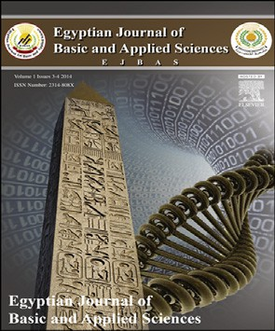**Antimicrobial, analgesic, antioxidant and *in silico* study of synthesized salicylic acid congeners and their structural interpretation**



***Jyotirmaya Sahoo*** ***\*******, Sudhir Kumar Paidesetty***

*Department of Pharmaceutical Chemistry, School of Pharmaceutical Sciences, Siksha‘O’Anusandhan University, Bhubaneswar Pin-751003, Odisha, India*

A R T I C L E I N F O A B S T R A C T

*Article history:*

Received 26 March 2015 Received in revised form 25 July 2015

Accepted 28 July 2015

Available online 31 August 2015

*Keywords:* Spectroscopic Antibacterial Molecular docking Analgesic Antioxidant

A series of azosalicylic acid analogs were newly synthesized by coupling various aryl and heteroarylamine functionalities with salicylic acid nucleus. All the synthesized com- pounds were structurally confirmed by various modern analytical methods. The said synthesized compounds were screened to investigate their antimicrobial, analgesic and an- tioxidant activities. The compounds **4e** and **4h** showed excellent significant antibacterial activity against most of the bacterial strains as no compounds showed significant antifun- gal activity against *Cryptococcus neoformans*. The bromine substituted molecule **4e** (4-bromo- 3-methyl phenyl azosalicylic acid analog) showed the highest significant analgesic activity with 46.10% of inhibition. The results of *in vitro* antibacterial and analgesic activity were justified with the outcome of *in-silico* investigation. The results of biological activities were statistically interpreted. The compounds substituted with antipyrinylazo and 4-carboxy phenylazo moiety exhibited potential antioxidant activity.

© 2015 Mansoura University. Production and hosting by Elsevier B.V. This is an open access article under the CC BY-NC-ND license (<http://creativecommons.org/licenses/by->

nc-nd/4.0/).

# Introduction

The writings of Greek physician Hippocrates revealed that the leaves and barks of willow tree were used as analgesic and an- tipyretic in early days. The active constituent responsible in this natural source, later identified as salicin, contains both sugar and aromatic component, initially called as spirasure and later salicylic acid. The *de-novo* synthesis of salicylic acid was first performed in 1852 and its structure was deduced as

1. hydroxy benzoic acid [1]. The salicylic acid derivatives ex- hibited antioxidant, antiproliferative [2] and cytotoxic activities [3]. The azo salicylic acid derivative sulfasalazine is a proven drug for the last 40 years which is effective against ulcerative colitis (inflammatory bowel disease) [4]. There has been an in- crease in the side-effects due to the sulfapyridine portion which acts as a carrier. The azo bond breaks due to the bacterial enzyme azo-reductase present at the site of lumen of the colon leaving the 5-aminosalicylic acid. The azobis-salicylic acid de- rivative olsalazine could be a better alternative for sulfasalazine.

* *Corresponding author.* Tel.: +91 09861433157.

*E-mail address:* [jjyotisahoo@rediffmail.com](mailto:jjyotisahoo@rediffmail.com) (J. Sahoo). <http://dx.doi.org/10.1016/j.ejbas.2015.07.006>

2314-808X/© 2015 Mansoura University. Production and hosting by Elsevier B.V. This is an open access article under the CC BY-NC-ND license ([http://creativecommons.org/licenses/by-nc-nd/4.0/).](http://creativecommons.org/licenses/by-nc-nd/4.0/))

egyptian journal of basic and applied sciences 2

(201 5 ) 268–280

**269**

Literature survey supports that azo-salicylic acids have bio- logical activity and also are useful precursors for the synthesis of anticarcinogenic, antiviral, antimicrobial and antimalarial agents [3]. Salicylates have analgesic effects similar to that of other NSAIDs to inhibit the enzyme cyclooxygenase (COX) [5]. NSAIDs inhibit both the activity of COX-1 and COX-2 and thereby synthesis of prostaglandin and thromboxane [6]. Lit-

Ar/Heteroaryl-NH2 1(a-h)

i

O

OH+ Ar/Heteroaryl-N=N-Cl

Heteroaryl/Ar

N O

ii N OH

OH

erature support also suggests that bromine substituted 3

molecules can show potential analgesic activity [7]. Further,

2(a-h)

OH

4(a-h)

literature survey indicates that pyrazolone nucleus is the key pharmacophore and is responsible for various pharmacologi- cal activities such as analgesic [8] and antimicrobial activity [9]. The N-phenyl substituted anthranyl congeners also have analgesic, antirheumatic and antiinflammatory activities [10]. The above information encouraged us to synthesize a new range of azo-salicylic acid congeners with different aryl and heteroaryl functionalities and to investigate the antibacterial, analgesic and antioxidant activities. The structures were confirmed by

**Scheme 1 – 4-Benzenesulfoamido-(4a),**

**4-Sulfonic phenyl-(4b), 4-nitro phenyl-(4c), 4-methoxy phenyl-(4d), 4-bromo,3-methyl phenyl-(4e),**

**4-(1,5 dimethyl-2-phenyl)-pyrazol-3-one-(4f), 4-carboxy phenyl-(4g), N-(5-methylisoxazol-3-yl)benzene sulfonamide-(4h). Reactions: i.) NaNO2/HCl, 0–5 °C, diazotization; ii.) 10% NaOH, coupling reaction.**

Structures of some newly synthesized azosalicylic acid congeners.

spectral characterization. The synthesized azosalicylic acid con-

geners act as ligands individually against the targeted proteins (PDB ID: 3SPU of NDM-1 and 1CX2 of COX-2) by computa-

tional docking method for the evaluation of antibacterial and analgesic activities respectively.

#### Structures of some newly synthesized azosalicylic acid congeners

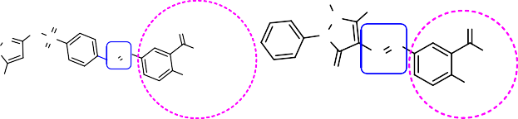H3C CH

N 3

## *2-hydroxy-5-(4-sulfamoylphenylazo)-benzoic acid* (*4a)*

Dark red color powder; yield 75%; Rf 0.8; mp (°C); 297–300; UV–

vis (λmax, ethanol): 366 nm; IR (KBr, γ, cm−1): 3374 (O—H str.), 1676 (C=O str.), 1587 (C=C str.), 1482 (—N=N—), 1331, 1160 (SO2

str.SO NH ), 910 (S-N str.), 1096 (C—O str.); 1H NMR (CDCl , δppm,

H O O

O 2 2 3

N N S

N N 400 *MHz*): 7.46 (s, 2H, SO NH ), 8.01–8.10 (m, 4H, Ar H), 12.10 (sb.

O O N OH

N OH 2 2

N

H3C OH

O 1H, COOH), 11.69 (sb, 1H, OH), 7.36 (d, 1H, salicylic H-3), 8.11

OH (d, 1H, salicylic H-4), 8.34 (s, 1H, salicylic H-6); LC–MS (% area);

77.65; *m/z*; 320.13 (M-1); Analysis for C13H11N3O5S: Calcd % C,

48.59; H, 3.45; N, 13.08; S, 9.98; Found %: C, 48.19; H, 3.48; N,

13.11; S, 9.95.

# Materials and methods

All the chemicals used in the present study were of synthetic grade and sourced from Merck Specialties Ltd. (Mumbai, India). The structural conformation of the synthesized compounds from salicylic acid is conducted by various modern analytical techniques viz. FT/IR (JASCO FT/IR 4100 Spectrophotometer using KBr disc), 1H NMR (Bruker 1H NMR 400 *MHz*) using TMS as an internal standard, LC–MS (Shimadzu-mass spectrom- eter) and Differential Scanning calorimetric analysis (METTLER TOLEDO STARe system at a heating rate of 10 °C min−1, tem- perature range 30–350 °C using aluminum cans calibrated with indium) and elemental analysis (Perkin Elmer-2400 CHNO/S ana- lyzer system). Solvent behavior of the compounds was studied by UV–Visible spectrophotometer (JASCO V-630 Spectropho- tometer). The melting points were determined by open capillary method (Elico) and were uncorrected. The synthesized ligands were evaluated for their *in vitro* antimicrobial activity against different pathogens by Agar Well Diffusion method. The results of the potential antibacterial and analgesic activity of the se- lected ligands were rationalized by molecular docking.

The synthesis of the aryl/heteroaryl azo salicylic acid analogs was carried out on the basis of our earlier reported work [11] (Scheme 1).

## *2-hydroxy-5-(4-sulfamoylphenylazo)-benzoic acid* (*4b)*

Yellow color powder; yield 72%; Rf 0.8; mp (°C); 328–330; UV–

vis (λmax, ethanol): 361 nm; IR (KBr, γ, cm−1): 3431 (O—H str.), 1671 (C=O str.), 1628 (C=C str.), 1448 (—N=N—), 1389, 1206 (SO2 str.SO3H), 1127 (C—O str.); 1H NMR (DMSO-*d6*, δppm, 400 *MHz*):

7.83–8.34 (m, 4H, Ar H), 11.69 (sb. 1H, OH), 12.10 (sb, 1H, COOH),

7.28 (d, 1H, salicylic H-3), 8.08 (d, 1H, salicylic H-4), 8.34 (s, 1H, salicylic H-6); LC–MS (% area); 52.33; *m/z*; 321.08 (M-1); Analy- sis for C13H10N2O6S: Calcd % C, 48.45; H, 3.13; N, 8.69; S, 9.95;

Found %: C, 48.42; H, 3.09; N, 8.62; S, 9.91.

## *2-hydroxy-5-(4-nitrophenylazo)-benzoic acid (4c)*

Dark red color powder; yield 92%; Rf 0.7; mp (°C); 243–245; UV–

vis (λmax, ethanol): 388 nm; IR (KBr, γ, cm−1): 3456, 3210 (O—H str.), 1672 (C=O str.), 1610 (C=C str.), 1482 (—N=N—), 1530, 1344 (NO2 str.), 1106 (C—O str.); 1H NMR (DMSO-*d6*, δppm, 400 *MHz*):

7.75–8.25 (m, 4H, Ar H), 11.75 (sb. 1H, OH), 12.09 (sb, 1H, COOH),

7.31 (d, 1H, salicylic H-3), 8.13 (d, 1H, salicylic H-4), 8.35 (s, 1H, salicylic H-6); LC–MS (% area); 91.62; *m/z*; 286.12 (M-1); Analy- sis for C13H9N3O5: Calcd % C, 54.36; H, 3.16; N, 14.63; Found % C, 54.26; H, 3.11; N, 14.60.

**270** egyptian journal of basic and applied sciences 2

(201 5 ) 268–280

## *2-hydroxy-5-(4-methoxyphenylazo)-benzoic acid (4d)*

Black color powder; yield 95%; Rf 0.8; mp (°C); 238–240; UV–

vis (λmax, ethanol): 374 nm; IR (KBr, γ, cm−1): 3464 (O—H str.), 2926 (CH2 str.), 1667 (C=O str.), 1596 (C=C str.), 1491 (—N=N—), 1111

(C—O str.); 1H NMR (DMSO-*d6*, δppm, 400 *MHz*): 7.05–7.75 (m,

4H, Ar H), 3.83 (s, 3H, ArOCH3), 11.37 (sb. 1H, OH), 12.13 (sb, 1H,

COOH), 7.37 (d, 1H, salicylic H-3), 8.11 (d, 1H, salicylic H-4), 8.27 (s, 1H, salicylic H-6); LC–MS (% area); 71.88; *m/z*; 273.21 (M+1); Analysis for C14H12N2O4: Calcd % C, 61.76; H, 4.44; N, 10.29; Found

%: C, 61.86; H, 4.34; N, 10.19.

## *5-(4-bromo-3-methylphenylazo)-2-hydroxybenzoic* acid (*4e)*

Brown color powder; yield 85%; Rf 0.8; mp (°C); 288–290; UV–

vis (λmax, ethanol): 361 nm; IR (KBr, γ, cm−1): 3451 (O—H str.), 2937 (CH str.), 1661 (C=O str.), 1587 (C=C str.), 1489 (—N=N—), 1147

(C—O str.), 748 (C—Br str ); 1H NMR (CDCl3, δppm, 400 *MHz*): 7.54–

7.72 (m, 3H, Ar H), 2.44 (s, 3H, ArCH3), 11.49 (sb. 1H, OH), 11.87

(sb, 1H, COOH), 6.86 (d, 1H, salicylic H-3), 7.86 (d, 1H, salicylic H-4), 8.28 (s, 1H, salicylic H-6); LC–MS (% area); 100; *m/z*; 333.03 (M-1); Analysis for C14H11BrN2O3: Calcd % C, 50.17; H, 3.31; N,

8.36; Found %: C, 50.27; H, 3.41; N, 8.56.

## *5-((1,5-dimethyl-3-oxo-2-phenyl-2,3-dihydro-* 1H-pyrazol-4-yl)azo)-2- hydroxybenzoic acid (*4f)*

Brown color powder, yield 85%; Rf 0.7; mp (°C); 256–260, UV–

vis (λmax, ethanol): 368 nm; IR (KBr, γ, cm−1): 3410 (O—H str.), 2926 (CH str.), 1662 (C=O str. of carboxylic group), 1606 (C=C str.), 1486 (—N=N—), 1153 (C—O str); 1H NMR (DMSO, δppm,

400 *MHz*): 6.85–7.30 (m, 5H, —N—C6H5), 2.66 (s, 3H, =C-CH3), 3.15

(s, 3H, —N—CH3), 11.65 (sb. 1H, OH), 12.17 (sb, 1H, COOH), 7.32

(d, 1H, salicylic H-3), 7.41 (d, 1H, salicylic H-4), 7.87 (s, 1H, sali- cylic H-6); LC–MS (% area); 39.20; *m/z*; 353.07 (M+1); Analysis for C18H16N4O4: Calcd % C, 61.36; H, 4.58; N, 15.90; Found % C,

61.46; H, 4.38; N, 15.87.

## *5-(4-carboxyphenylazo)-2-hydroxybenzoic acid (4g)*

Black color powder; yield 95%; Rf 0.7; mp (°C); 286–290, UV–

vis (λmax, ethanol): 360 nm; IR (KBr, γ, cm−1): 3481 (O—H str.), 1692 (C=O str.), 1608 (C=C str.), 1493 (—N=N—), 1180 (C—O str.); 1H NMR (DMSO-*d6*, δppm, 400 *MHz*): 8.13–8.41 (m, 4H, Ar H), 11.33 (sb. 1H, OH), 12.54 (sb, 1H, COOH), 7.33 (d, 1H, salicylic H-3), 8.11

(d, 1H, salicylic H-4), 8.29 (s, 1H, salicylic H-6); LC–MS (% area); 100; *m/z*; 285.00 (M-2); Analysis for C14H10N2O5: Calcd % C, 58.74; H, 3.52; N, 9.79; Found % C, 58.77; H, 3.12; N, 9.49.

## *2-hydroxy-5-((4-(N-(5-methylisoxazol-3-yl)-* sulfamoyl)-phenyl) azo) benzoic acid (*4h)*

Black color powder; yield 73%; Rf 0.8; mp (°C); 227–230; UV–

vis (λmax, ethanol): 370 nm; IR (KBr, γ, cm−1): 3461 (O—H str.), 3138 (NH str.), 2922 (CH2 str.), 1668 (C=O str.), 1614 (C=C str.), 1473 (—N=N—), 1315, 1170 (SO2 str.SO2NH), 928 (S—N str.); 1H NMR (DMSO-*d6*, δppm, 400 *MHz*): 8.02–8.34 (m, 4H, Ar H), 11.69 (sb.

1H, OH), 12.11 (sb, 1H, COOH), 11.12 (s, 1H, SO2NH), 2.30 (s, 3H,

CH3), 6.17 (s, 1H, isoxazolyl H-4), 7.00 (d, 1H, salicylic H-3), 7.97

(d, 1H, salicylic H-4), 8.34 (s, 1H, salicylic H-6); LC–MS (% area); 100; *m/z*; 403.04 (M+1); Analysis for C17H14N4O6S: Calcd % C, 50.74; H, 3.51; N, 13.92; S, 7.97; Found %: C, 50.54; H, 3.55; N, 13.96; S,

7.89.

## *Microbiological evaluation*

### *Antimicrobial activity*

The above newly synthesized azosalicylic acid congeners were investigated over different microbial strains viz. *Escherichia coli* (MTCC 614), *Salmonella enterica ser. typhi* (MTCC 773), *Salmo- nella enterica typhimurium* (MTCC 98), *Salmonella enterica paratyphi* (MTCC 3220), *Shigella flexneri* (MTCC 1457), *Pseudomonas aeruginosa* (MTCC 1035), *Vibrio cholera* (MTCC 3906), *Micrococcus luteus* (MTCC 1809), *Klebsiella pneumoniae* (MTCC 109), *Bacillus circulans* (MTCC 490), *Streptococcus mitis* (MTCC 2695), *Aspergillus niger* (MTCC 9933), *Candida albicans* (MTCC 3017), *Candida glabrata*, *Cryptococcus neoformans* and *Trichophyton rubrum*, sourced from the Insti- tute of Microbial Technology and Gene bank (IMTECH), Chandigarh, India. *Staphylococcus aureus* and *Bacillus subtilis* strain hswx88 [12] were isolated in the Pharmaceutical Biotechnol- ogy Division of the University Department of Pharmaceutical Sciences, Utkal University. Freshly subcultured microorgan- isms were used. Ampicillin and Fluconazole were used as reference antibiotics.

The antimicrobial activities of the novel azosalicylic acid congeners (**4a**–**4h**) were performed by agar well diffusion method using sterile molten nutrient agar (antibacterial ac- tivity) and Sabouraud dextrose agar (antifungal activity) [13]. The solidified mediums were inoculated and punched in to wells of 6 mm diameter. Each well was filled with stock solu-

tion of test and reference compounds (1 μg/μL concentration)

of definite volume and incubated for 24 h and 72 h for bacte- rial and fungal strains respectively at 37 °C. The compounds showing significant activity against most of the bacterial strains were subjected to investigation of their activity against differ- ent fungal strains. The diameter of zone of inhibition was measured using the Hi-Antibiotic Zone Scale (Hi-Media).

### *Minimum inhibitory concentration (MIC)*

One milligram per milliliter stock solution of synthesized com- pounds and reference antibiotic was prepared using 10% DMF solution. Further, five different concentrations (500–31.25 μg/mL) were prepared by serial dilution method. The different con- centrations for respective test compounds were loaded into the wells made on bacterial inoculated mediums and incubated at 37 °C for 18–24 h. MIC was defined as the lowest concen- tration of the test compounds that inhibited the visible growth on agar medium. After incubation, minimum inhibitory con- centration was determined [14].

## *Pharmacological activity*

### *Animals*

In this work, female Wistar rats of 180–200 g (for acute toxic- ity study) and Swiss albino mice 25–30 g (analgesic evaluation) of either sex of appropriate age were used. The experiments were carried out under the guidelines of Committee for the Purpose of Control and Supervision of Experiments on Animals

egyptian journal of basic and applied sciences 2

(201 5 ) 268–280

**271**

and approved by the Institutional Animal Ethical Committee with registration number 1171/C/08/CPCSEA and Ref. No. 60/SPS/IAEC/SOAU.

### *Acute toxicity study*

Acute Oral Toxicity study was performed on female Wistar rats to establish the safety dose of the synthesized compounds. OECD guideline No.420 (2000) for Acute Oral Toxicity-Fixed Dose Procedure was followed (sighting study and main study) for a period of 14 days to study the acute toxic symptoms and the behavioral changes within the animals.

### *Writhing model induced by acetic acid*

Albino mice of appropriate weight of either sex were kept under controlled conditions of light and temperature. The animals were divided into 10 groups, each carrying 6 animals. Group-1 was treated as control, group-2 served as positive control where they were administered with standard acetyl salicylic acid at a dose of 50 mg/kg body weight, (intra-peritoneal). Animals from groups 3 to 10 were provided with test (**4e**, **4f**, **4g** and **4h**) com- pounds respectively at a dose level of 50 and 100 mg/kg body weight orally. Thirty minutes after the administration of acetyl salicylic acid in group 2 and 1 h after administration of test drugs in groups 3–10, all the groups were administered with 0.6% v/v acetic acid solution at a dose level of 1 mL/100 g of body weight (intra-peritoneal) [15]. The onset of writhing was noted. Finally, the percentage of analgesic activity was calcu- lated.

% Analgesic activity

 Mean writhing count Control group  Treated group Mean writhing count of control group  100.

The reaction time was expressed as mean ± SEM. The sta- tistical analysis was done by one way-ANOVA followed by Dunnett’s *t*-test.

### *Antioxidant activity assay by DPPH model*

The free radical scavenging activity of novel azosalicylic acid analogs (**4e**–**4h**) was measured by DPPH method with some

* 1. **In silico *studies***

For the computational approach by tools of bioinformatics, docking is employed for locating a suitable or leading syn- thetic compound against a particular target retrieved from Protein Data Bank (PDB), New Delhi Metallo-β-lactamase-1 (NDM-1) of *K. pneumoniae* with PDB ID: 3SPU as a bacterial target protein [16] and cyclooxygenase-2 of *Mos musculus* with PDB ID: 1CX2 as an analgesic target protein [7] for docking study. The structures of the synthesized compounds (**4e**, **4f**, **4g**, and **4h**) are prepared by using Chem Draw ultra 10.0 and con- verted from .mol file format to pdb format for docking. *In silico* protein–ligand interaction of the newly synthesized com- pounds (**4e**, **4f**, **4g**, and **4h**) was investigated individually using Arugus Lab 4.0 docking software. The protein–ligand interac- tion was carried out by Discovery studio Visualizer 3.1 software. The resulting score obtained by molecular docking predicts the strongest binders.

## *Statistical analysis*

The observed data on zone of inhibitions were subjected to one way-analysis of variance. The mean zone of inhibition for each compound on each strain was compared with the reference antibiotic through Dunnett’s Post Hoc test ([https://www](https://www.statsdodo.com/SSizAOV_Pgm.php)

[.statsdodo.com/SSizAOV_Pgm.php](https://www.statsdodo.com/SSizAOV_Pgm.php)). The test of significance was done at 5% level of type one error. The research hypothesis was ‘the zone of inhibition for test compound was higher than the reference antibiotic against the hypothesis of no difference (null hypotheses)’, which states that there is no significant differ- ence between the zone of inhibition of the test compound and the reference antibiotics.

## *Sample size determination*

A minimum sample size of five was calculated taking prob- ability of type 1 error (d) = 0.05, Power (1-β) = 0.8, Number of groups 13 within group SD = 2. However a sample size of six has been taken in the study for each compound against each strain.

modification [13]. The reaction mixture of synthesized com-

pounds at different concentration aliquots was taken and the volume was adjusted up to 3 mL with methanol. To this mixture 1 mL of 0.1 mM solution of DPPH in methanol was added. The mixture was kept in the dark for 30 min. The free radical scav- enging activity of synthesized compounds was compared with standard Butylated Hydroxytoluene (BHT). Optical density was measured at 517 nm and the inhibition of concentration was calculated. One milliliter of 0.1 mM of methanolic solution of DPPH and 3 mL of methanol was considered as control.

% of inhibition  Acont  Atest Acont   100

where Acont is the absorbance of control and Atest is the absor- bance of the test sample. The sample concentration providing 50% inhibition (IC50) was determined. All the experiments were carried out in triplicate and IC50 values were expressed as mean ± SD.

# Results and discussion

## *Chemistry*

A series of azosalicylic acid analogs were synthesized by cou- pling of diazonium salt of eight different aryl and hetero aryl amine derivatives with salicylic acid in presence of 10% sodium hydroxide solution (Scheme 1). Diazotization was carried out in presence of nitrosyl chloride and excess nitrous acid was destroyed by the addition of urea. The crude products were re- crystallized from absolute ethanol. The structures of prepared compounds have been confirmed by FT/IR, 1H NMR, UV, LC– MS, DSC and elemental analysis.

The FT/IR spectrum of the salicylic acid congeners (**4a**–

**4h**) showed two strong absorption bands at range of 3374– 3481 and 1661–1692 cm−1 with respect to ν OH str. and ν C=O str. of salicylic acid. Compound **4h** showed strong absorption

**272** egyptian journal of basic and applied sciences 2

(201 5 ) 268–280

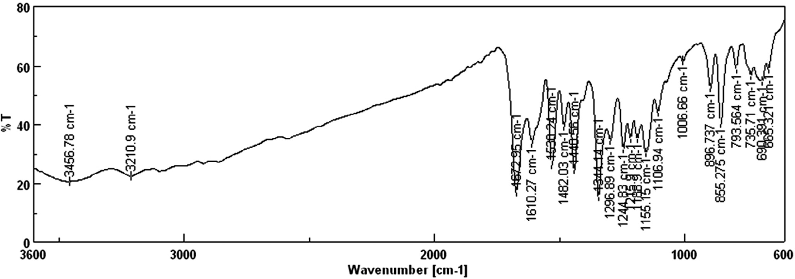

#### Fig. 1 – FT/IR of compound 4c.

bands at 1668, 1315, 1170, 928 and 3138 cm−1 due to the pres- ence of ν C=O str; ν SO2 str.; ν S-N str. and ν NH str. respectively. The medium vibration bands at 1473 and 2922 cm−1 which in- dicates to ν —N=N— and ν CH2 str. of methyl group in

compound 4h. Compound **4c** showed medium absorption bands at 1482, 1530 and 1344 cm−1 which attributed the presence of

ν —N=N— and ν NO2 str. respectively (Fig. 1).

The 1H NMR data of the newly synthesized 5-heteroaryl/ arylazo salicylic acid congeners were analyzed in CDCl3 and

DMSO *d6*. All the compounds showed two broad singlet peaks at range of δ 12.08–12.06 ppm and δ 11.09–11.65 ppm which in- dicates the presence of carboxylic protons and phenolic

hydroxyl protons of salicylic acids respectively. The presence of salicylic H-6 protons was observed with sharp singlet peaks at a range of δ 8.29–8.37 ppm in all the congeners. Other aro-

matic protons of salicylic acid in all the congeners appeared

with two sets of doublet signals at a range of δ 6.86–7.36 ppm and δ 7.86–8.13 ppm. In addition to above spectral data, com- pound **4e** appeared with three similar environmental protons at δ 2.44 ppm which attributed the presence of methyl proton.

Compound **4f**, which appeared with two sharp singlets at δ

2.60 ppm and δ 3.15 ppm, may be due to the presence of N—CH3 and =C—CH3 respectively. The aromatic multiplet signals in the said compound appeared at a range of δ 6.85–7.30 ppm. Compound **4h** appeared with a singlet signal at δ 6.17 ppm of

isoxazole H-4. The 1H NMR data of compounds **4e** and **4a** are reported in Fig. 2.

### *Solvatochromic behavior*

The solvatochromic behavior of the products was studied on UV–Visible spectrophotometer. The absorption spectra of the newly synthesized 5-heteroaryl/arylazo salicylic acid conge- ners (**4a**–**4h**) were investigated in different solvents at concentration of 10−5 to 10−6 M. According to illustrated data in Table 1, all the synthesized compounds showed red shift in

DMSO and DMF except compound **4a** with respect to the λmax

as compared to the other polar solvents. Introduction of 4-nitro phenylazo substituent on salicylic acid at the C-5 position gives the largest bathochromic shift compared to other azo salicylic acid analogs. The electron withdrawing substituent NO2 on sali- cylic acid bearing molecules (**4c**) gives rise to more bathochromic

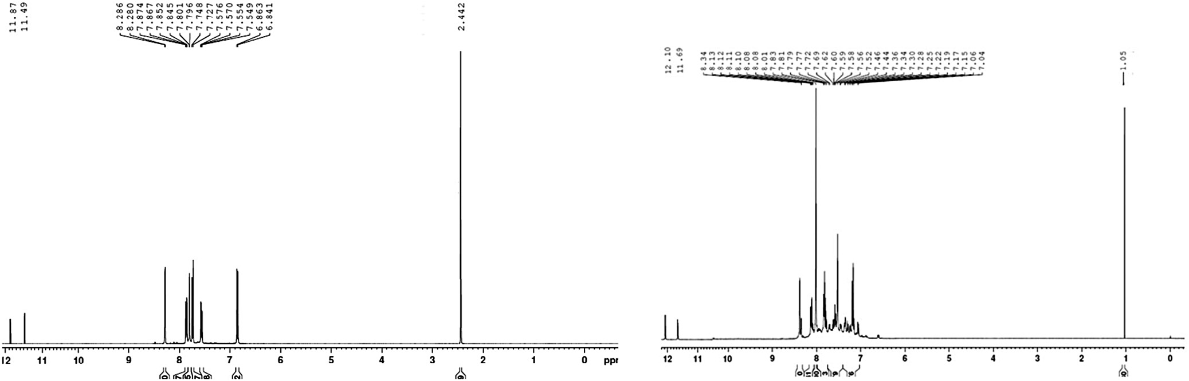

#### Fig. 2 – 1H NMR of compounds 4e and 4a.

egyptian journal of basic and applied sciences 2

(201 5 ) 268–280

**273**

|  |  |  |  |  |  |
| --- | --- | --- | --- | --- | --- |
| **Table 1 – UV–Visible spectral data (λmax) of newly synthesized azosalicylic acid analogs (**4a**–**4h**).** | | | | | |
| Compds. | λmax (Ethanol) | λmax (DMSO) | λmax (DMF) | λmax (Dioxan) | λmax (Acetonitrile) |
| **4a** | 262,366 | 393 | 272,396 | 354 | 263,395 |
| **4b** | 264,361 | 380 | 271,381 | 306 | 301,365 |
| **4c** | 273,388 | 281,428 | 430 | 366 | 409 |
| **4d** | 374 | 383 | 383 | 358 | 373 |
| **4e** | 361 | 386 | 389 | 290,354 | 376 |
| **4f** | 368 | 383 | 381 | 368 | 296,375 |
| **4g** | 360 | 392 | 401 | 342 | 265,340,390 |
| **4h** | 370 | 399 | 410 | 359 | 258,383 |

shifts in comparison to compound **4d** having electron donat- ing methoxy substituent in all the solvents. All the synthesized

compounds observed with λmax at a range of 306–396 nm in all the solvents confirm the formation of —N=N— group. The

solvatochromic effect of compound **4h** in all the solvents and all the synthesized compounds in DMF is illustrated in Fig. 3.

### *LC–MS and thermal analysis*

The predicted molecular weight of synthesized compounds was confirmed by LC–MS and strongly reveals their molecular formula. Compounds **4a**, **4b**, **4c**, **4d**, **4e**, **4f**, **4g** and **4h** having *m/z* values 320.13, 321.08, 286.12, 273.21, 333.03, 353.07, 284.98

and 403.04 respectively strongly reveal their molecular formula. The LC–MS of compound **4g** is given in Fig. 4.

The DSC thermogram reported sharp and narrow endo- thermic peak by compound **4c** evidenced with peak temperature of (245.39 °C) corresponding to its melting point Fig. 5.

## *Microbiology*

### *Antimicrobial activity*

Most of the synthesized salicylic acid congeners have effec- tive antibacterial activity. The mean ± SD of zone of inhibition for each bacterial strain has been compared by one way-analysis

of variance and the resulting *p* value. The mean zone of inhi- bition among the different compounds was found to be significantly different with *p* value of 0.00.

The results of the antibacterial activity of the newly syn- thesized compounds compared with standard, expressed in mean ± SD, were reported in Table 2. The reported results

revealed that the compounds *2-hydroxy-5-((4-(N-(5-methylisoxazol-*

1. *yl) sulfamoyl) phenyl) diazenyl) benzoic acid* (**4h**) and *5-((4-bromo- 3- methylphenyl)diazenyl)-2-hydroxybenzoic acid* (**4e**) showing excellent significant antibacterial activity in comparison to standard against *E. coli*, *S. ser.typhi*, *S. typhimurium*, *S. paratyphi*,

*S. flexneri*, *V. cholera*, *K. pneumoniae*, *M. luteus*, *S. mitis* and

*B. subtilis* may be due to the structural conjugation of 5-methyl isoxazolyl and 4-bromo-3-methyl phenylazo moiety at C-5 po- sition of salicylic acid respectively. The compound *5-((4- carboxyphenyl)diazenyl)-2-hydroxybenzoic acid* (**4g**) showing good significant antibacterial activity against *S. flexneri*, *K. pneumoniae*,

*B. circulans* and *S. aureus* may be due to the structural conju- gation of 4-carboxyphenylazo moiety at C-5 position of salicylic acid. The zone of inhibition of salicylic acid analogs (**4e**–**4h**) against *S. flexneri* and *B. subtilis* is given in Fig. 6. The salicylic

acid congeners **4g** and **4h** showing excellent significant anti- fungal activity (*p* < 0.05) against *A. niger*, *T. rubrum* and *C. glabrata* may be due to the structural presence of azo linkage bearing

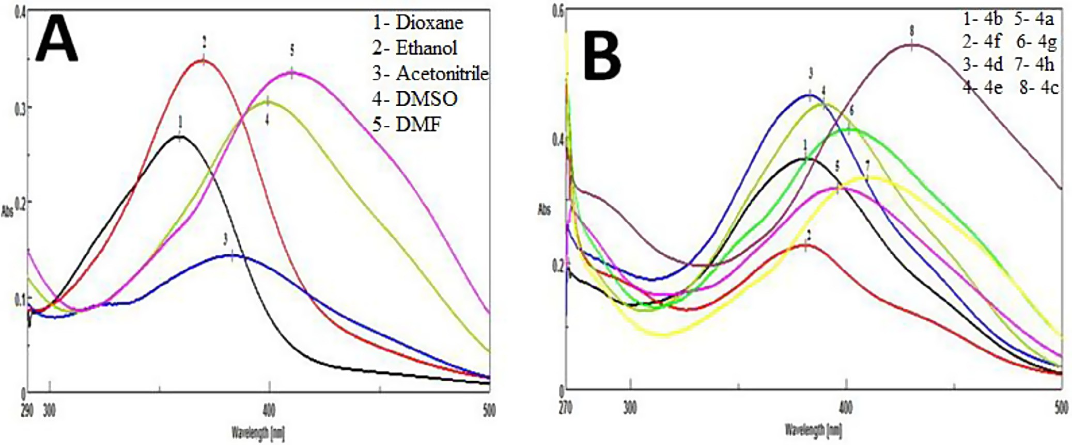

#### Fig. 3 – Solvatochromic effect of compound 4h in different solvents (A) and salicylic acid analogs (4a–4h) in DMF (B).

**274** egyptian journal of basic and applied sciences 2

(201 5 ) 268–280

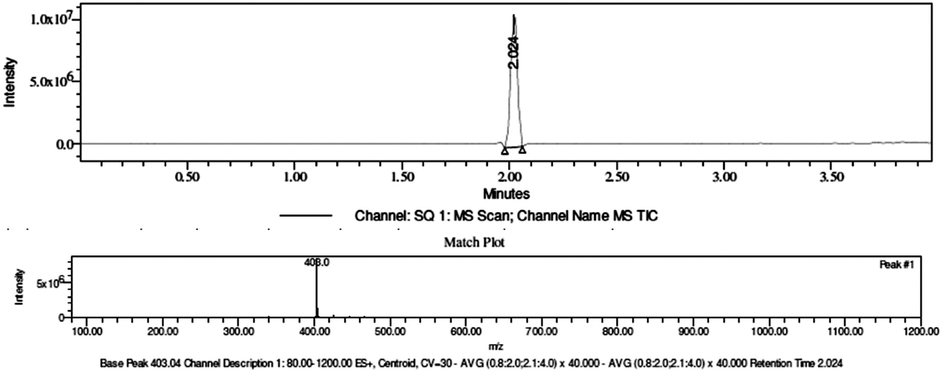

#### Fig. 4 – LC–MS of compound 4h.

substituent such as 4-carboxy phenylazo and 5-methyl isoxazolylazo at C-5 position of salicylic acid respectively. Com- pound **4e** showed good significant antifungal activity (*p* < 0.05) against *C. albicans* and *C. glabrata* Table 3*.* The graphical inter- pretation of significant antimicrobial activity of compound *5-((4- bromo-3-methylphenyl) diazenyl)-2-hydroxybenzoic acid* (**4e**) and *2-hydroxy-5-((4-(N-(5-methylisoxazol-3-yl) sulfamoyl) phenyl) diazenyl) benzoic acid* (**4h**) respectively in comparison to standard is il- lustrated in Fig. 7.

### *Evaluation of minimum inhibitory concentrations*

The inhibitory property of the salicylic acid congeners was de- termined in terms of MIC (μg/mL). The MIC values of the test analogs against different bacterial strains were investigated to determine the minimum level of concentration at which the compound is able to exert its activity (Table 4). All the sali- cylic acid congeners exhibited potential antibacterial activity by inhibiting the growth of different bacterial strains among which the salicylic acid congeners **4h** and **4e** inhibited the

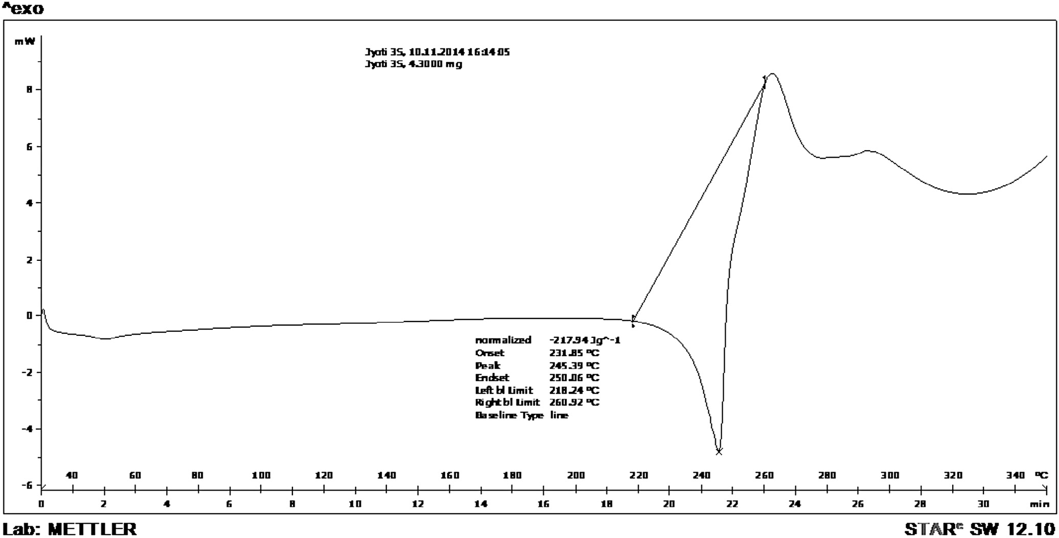

#### Fig. 5 – DSC of compound 4c.

egyptian journal of basic and applied sciences 2

(201 5 ) 268–280

**275**

|  |  |  |  |  |
| --- | --- | --- | --- | --- |
| **Table 2 – Antibacterial activity of azosalicylic acid analogs (**4a–4h**), Zone of Inhibition (mm).** | | | | |
| Compds. | *E. coli S. ser.typhi S. typhimurium S. paratyphi* | *S. flexneri* | *P. aeruginosa* | *V. cholera* |
| **4a** | – 11.5 ± 0.84 8.83 ± 1.17 9 ± 1.55 | 12 ± 0.63 | – | – |
| **4b** | – 8.17 ± 0.41 11.33 ± 1.51 9.17 ± 0.41 | 13.17 ± 0.98 | – | – |
| **4c** | 13.17 ± 1.17 8.83 ± 1.17 13.17 ± 0.98* 8.5 ± 0.84 | 14.17 ± 1.6 | 12.33 ± 1.37 | – |
| **4d** | 10.5 ± 0.55 8.83 ± 1.17 13.5 ± 1.23* 8.83 ± 1.17 | 12.33 ± 1.37 | 9.67 ± 2.88 | 11.5 ± 1.23 |
| **4e** | 20.17 ± 0.75* 18.67 ± 1.21* 18.5 ± 1.38* 19 ± 2.1* | 21.5 ± 1.76* | – | 25 ± 1.1* |
| **4f** | – – – – | – | – | – |
| **4g** | 10 ± 1.67 – – – | 15 ± 1.27* | – | – |
| **4h** | 22 ± 1.55* 18.33 ± 1.51* 16.67 ± 1.37* 18 ± 0.63* | 31.33 ± 1.03* | – | 30.33 ± 0.82* |
| **RA(Ampicillin)** | 12.67 ± 1.51 12 ± 0.89 10 ± 1.1 14 ± 2.28 | 13 ± 0.63 | 15 ± 2.1 | 15 ± 2.1 |
| Compds. | *K. pneumoniae M. luteus B. circulans* | *S. mitis* | *B. subtilis* | *S. aureus* |
| **4a** | 20 ± 0.63* – – | – | 8.33 ± 0.52 | – |
| **4b** | 11.67 ± 1.03 9.67 ± 1.03 – | 12.67 ± 1.21 | 9.33 ± 2.16 | – |
| **4c** | – – – | 9.5 ± 0.84 | 8.83 ± 1.17 | – |
| **4d** | – – – | 9 ± 1.1 | 9 ± 1.27 | 11.5 ± 1.76 |
| **4e** | 21.17 ± 1.33* 18.67 ± 1.21* 25.83 ± 0.75* | 22.33 ± 1.03* | 22.67 ± 1.37* | – |
| **4f** | 18 ± 0.63* 8.5 ± 0.84 – | 9.17 ± 0.98 | 10.33 ± 1.37 | – |
| **4g** | 20 ± 1.1* 8.83 ± 1.17 18 ± 1.1* | 12 ± 0 | 11.67 ± 1.51 | 15.17 ± 1.17* |
| **4h** | 25 ± 1.1* 16 ± 1.41* – | 32.5 ± 1.52* | 22.17 ± 1.94* | – |
| **RA (Ampicillin)** | 15.33 ± 1.97 13.17 ± 2.56 15.67 ± 1.21 | 14 ± 0.63 | 15 ± 1.27 | 13 ± 1.67 |
| Results expressed in mean ± SD, n = 6.  * p < 0.05 (statistical significance in comparison to RA). –, no zone of inhibition.  *E. coli – Escherichia coli*, *S. ser.typhi – Salmonella enterica ser.typhi*, *S. typhimurium – Salmonella enterica typhimurium*, *S. paratyphi – Salmonella enterica paratyphi, S. flexneri – Shigella flexneri*, *P. aeruginosa – Pseudomonas aeruginosa*, *V. cholera – Vibrio cholera*, *M. luteus – Micrococcus luteus*, *– K. pneumoniae – Klebsiella pneumoniae*, *B. circulans – Bacillus circulans*, *S. mitis – Streptococcus mitis, B. subtilis – Bacillus subtilis*, *S. aureus – Staphylococcus aureus.* | | | | |

growth of most of the organisms at a concentration 31.25 μg/mL. The 4-carboxy phenylazo substituted salicylic acid congener **4g** comes next in inhibiting the growth of four bacterial patho- gens at a concentration 31.25 μg/mL. The reference antibiotic (Ampicillin) is able to exhibit its MIC against all the bacterial strains at 31.25 μg/mL.

## *Pharmacology*

### *Analgesic activity*

The test compounds were safe up to 2000 mg/kg body weight. No toxic symptoms, gross behavioral changes and mortality

were observed. The compounds with different functionalities like substituted 4-bromo-3-methyl phenylazo (**4e**), pyrazolylazo (**4f**), 4-carboxy phenylazo (**4g**) and isoxazolylazo (**4h**) substi- tuted 5-heteroaryl/arylazo salicylic acid congeners were subjected for evaluation of their analgesic activity on the basis of literature.

In the control group, acetic acid produced an average of

83.5 ± 2.40 writhes in 10 min of observation. Standard acetyl salicylic acid showed 66.07% of inhibition with 28.33 ± 1.89*** writhing response at a dose of 50 mg/kg body weight, while the newly synthesized 5-heteroaryl/arylazo salicylic acid con- geners (**4e**, **4f**, **4g** and **4h**) showed 46.10%, 16.97%, 31.13% and

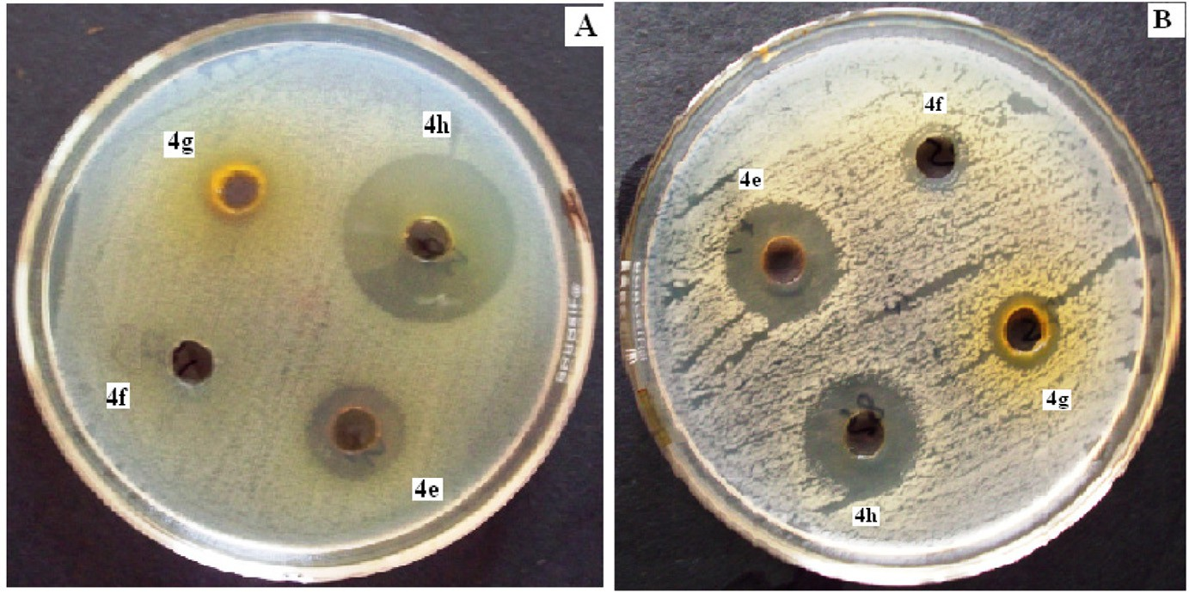

**Fig. 6 – Zone of inhibition of salicilic acid analogs (**4e**–**4h**) against (A) *S. flexneri* and (B) *B. subtilis.***

**276** egyptian journal of basic and applied sciences 2

(201 5 ) 268–280

|  |  |  |  |  |  |
| --- | --- | --- | --- | --- | --- |
| **Table 3 – Antifungal activity of azosalicylic acid analogs (**4e, 4g **and** 4h**), Zone of Inhibition (mm).** | | | | | |
| Compds. | *A. niger* | *T. rubrum* | *C. albicans* | *C. glabrata* | *C. neoformans* |
| **4e** | 19 ± 2.76 | 12.17 ± 0.98 | 23.33 ± 1.51* | 20 ± 2* | 13.67 ± 1.97 |
| **4g** | 21 ± 0.63* | 18.5 ± 1.52* | 21.67 ± 2.42 | 21.83 ± 2.56* | 17.17 ± 0.75 |
| **4h** | 19.83 ± 1.84* | 18.5 ± 1.52* | 21 ± 2.83 | 20.33 ± 2.07* | 21.17 ± 0.98 |
| **RA (Fluconazole)** | 17 ± 0.63 | 13 ± 1.41 | 19.33 ± 4.68 | 15 ± 1.79 | 24 ± 1.67 |
| Results expressed in mean ± SD, n = 6.  * p < 0.05 (statistical significance in comparison to RA). –, no zone of inhibition.  *A*. *niger-Aspergillus niger, T. rubrum – Trichophyton rubrum, C. albicans – Candida albicans, C. glabrata – Candida glabrata, C. neoformans – Cryptococcus neoformans*. | | | | | |

16.76% of inhibition respectively at a dose of 100 mg/kg body weight (Table 5). The writhing responses observed at a dose of 100 mg/kg body weight in the compounds (**4e**, **4f**, **4g** and **4h**) were 45 ± 4.86***, 69.33 ± 5.23, 57.5 ± 5.60** and 69.5 ± 4.12.

Azosalicylic acid congener bearing 4-bromo, 3-methyl phenyl and 4-carboxy phenyl substituent (**4e** and **4g**) reported the highest % of inhibition (46.10% and 31.13%) respectively at a dose of 100 mg/kg body weight (Table 5). Compounds **4e** and **4g** showed significant analgesic activity (writhing response) both at a dose of 50 and 100 mg/kg body weight, but compound **4e**

showed the highest significant analgesic activity 45 ± 4.86*** (p < 0.001) at a dose of 100 mg/kg body weight, which may be

due to the structural presence of azolinked 4-bromo,3-methyl phenyl at C-5 position of salicylic acid.

* + 1. In vitro *antioxidant screening*

The structural elucidation of the titled synthesized com- pounds showed the presence of phenolic groups. In general, phenolic compounds and nitrogen-bearing heterocyclic rings have free radical scavenging activity. DPPH radicals accept the hydrogen atom or electron from the organic molecules and can form stable diamagnetic molecules. Scavenging effect of newly synthesized 5-heteroaryl/arylazo salicylic acid congeners (**4e**,

**4f**, **4g** and **4h**) showed 50% of inhibition (IC50) at a concentra- tion level of 47.47 ± 0.02, 37.34 ± 0.02, 39.3 ± 0.05 and

59.7 ± 0.03 μg/mL respectively, whereas standard BHT showed

at 33.5 ± 0.05 μg/mL (Table 6). The results of percentage of in- hibition of the compounds included for evaluation of their

antioxidant activity revealed that the test compound **4g** showed

significant DPPH scavenging activity (>20%) at a concentra- tion of 10 μg/mL in comparison to standard, whereas compound **4f** showed significant DPPH scavenging activity (>79%) at a concentration of 60 μg/mL. The free radical scavenging activ- ity of synthesized analogs **4e**, **4f**, **4g** and **4h** is mentioned in

Fig. 8. The azosalicylic acid analog **4f** showed IC50 at lowest con- centration in comparison to other three compounds which may be due to the structural presence of 4-antipyrinylazo func- tionality at the C-5 position of salicylic acid.

1. ***In-silico* studies**

Docking is widely used in modern drug discovery process and is an effective tool capable of quickly and accurately predict- ing biomolecular conformations with binding energies of protein–ligand complexes. The molecular docking work is aimed at finding out the effective synthetic compounds against in- dividual target protein viz. NDM-1 and COX-2 (Table 7).

Individually the ligands **4e**–**4h** were docked with protein NDM-1 of *K. pneumoniae*. The docking energies of the salicylic acid congeners were obtained in negative value out of which

**4h** and **4e** are potent inhibitors of β-lactamase-1. The protein–

ligand interaction of compound **4h** against NDM-1 is reported in Fig. 9. The ligand **4h** binds to the amino acids of NDM-1 protein such as, ASP 34, ARG 52, GLN 53, TRP 59, ARG 81, TRP

104, GLU 108, ILE 109. Individually the ligands **4e**–**4h** were docked with COX-2. Compounds **4e** and **4h** are potent inhibi- tors of cyclooxygenase-2. The ligand **4e** binds to the amino acids

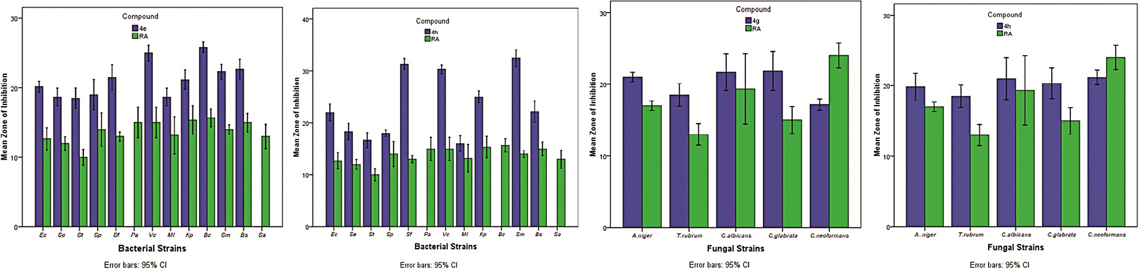

#### Fig. 7 – Graphical presentation of significant antimicrobial activity of azosalicylic acid congeners (4e, 4g and 4h).

**277**

egyptian journal of basic and applied sciences 2 (201 5 ) 268–280

|  |  |  |  |  |  |  |  |  |  |  |  |  |  |
| --- | --- | --- | --- | --- | --- | --- | --- | --- | --- | --- | --- | --- | --- |
| **Table 4 – Minimum inhibitory concentration MIC (gg/mL) of azosalicylic acid analogs (**4a**–**4h**) against different bacterial strains.** | | | | | | | | | | | | | |
| Compd. | *E. coli* | *S. ser.typhi* | *S. typhimurium* | *S. paratyphi* | *S. flexneri* | *P. aeruginosa* | *V. cholera* | *M. luteus* | *K. pneumoniae* | *B. circulans* | *S. mitis* | *B. subtilis* | *S. aureus* |
| **4a** | – | 125 | 250 | 125 | 62.5 | – | – | – | 31.25 | – | – | 250 | – |
| **4b** | – | 250 | 125 | 250 | 125 | – | – | 250 | 125 | – | 31.25 | 125 | – |
| **4c** | 125 | 250 | 250 | 125 | 125 | 125 | – | – | – | – | 125 | 250 | – |
| **4d** | 250 | 250 | 125 | 250 | 125 | >500 | 125 | – | – | – | 250 | >500 | 125 |
| **4e** | 31.25 | 31.25 | 31.25 | 31.25 | 31.25 | – | 31.25 | 31.25 | 31.25 | 31.25 | 31.25 | 31.25 | – |
| **4f** | – | – | – | – | – | – | – | 250 | 31.25 | – | 125 | 250 | – |
| **4g** | 250 | – | – | – | 31.25 | – | – | 125 | 31.25 | 31.25 | 125 | 250 | 31.25 |
| **4h** | 31.25 | 31.25 | 31.25 | 31.25 | 31.25 | – | 31.25 | 31.25 | 31.25 | – | 31.25 | 31.25 | – |
| **RA (Ampicillin)** | 31.25 | 31.25 | 31.25 | 31.25 | 31.25 | 31.25 | 31.25 | 31.25 | 31.25 | 31.25 | 31.25 | 31.25 | 31.25 |
| –, no zone of inhibition.  *E. coli – Escherichia coli*, *S. ser.typhi – Salmonella enterica ser.typhi*, *S. typhimurium – Salmonella enterica typhimurium*, *S. paratyphi – Salmonella enterica paratyphi, S. flexneri – Shigella flexneri, P. aeruginosa – Pseudomonas aeruginosa*, *V. cholera – Vibrio cholera*, *M. luteus – Micrococcus luteus, – K. pneumoniae – Klebsiella pneumoniae, B. circulans – Bacillus circulans, S. mitis – Streptococcus mitis, B. subtilis – Bacillus subtilis, S. aureus – Staphylococcus aureus.* | | | | | | | | | | | | | |

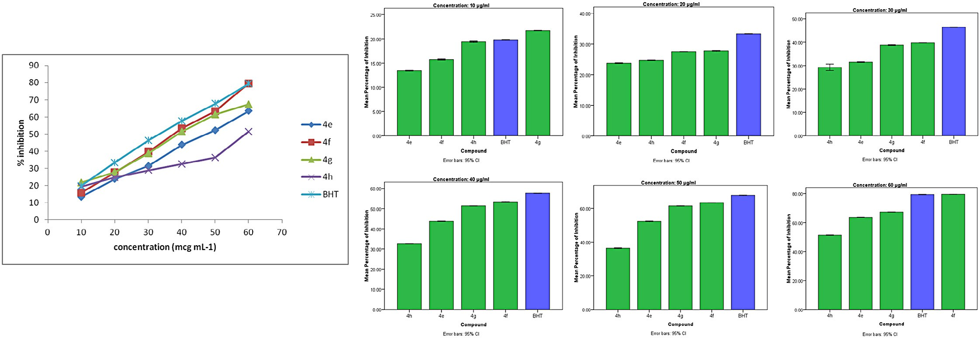**Fig. 8 – DPPH radical scavenging effect of azosalicylic acid analogs with standard Butylated hydroxy toluene (BHT).**

**278** egyptian journal of basic and applied sciences 2

(201 5 ) 268–280

Literature survey indicated that bromine substituted mol- ecules have analgesic effect [7]. The results of analgesic activity of salicylic acid congeners also revealed that the substituted bromo-compound **4e** (4-bromo-3-methyl phenyl substituted azosalicylic acid) has highest significant analgesic activity. The *in silico* investigation of azosalicylic acid congeners (**4e**–**4h**) also predicted that the 4-bromo-3-methyl phenylazo substituted sali- cylic acid analog (**4e)** has highest binding energy i.e.

|  |  |  |  |
| --- | --- | --- | --- |
| **Table 5 – Analgesic effect of newly synthesized azosalicylic acid analogs (**4e**–**4h**) on acetic acid induced writhing response.** | | | |
| Compounds | Group | Dose | Acetic acid induced writhing response  Writhing % of inhibition |
| Control (distilled | 1 |  | 83.5 ± 2.40 – |
| water) |  |  |  |
| Standard (acetyl | 2 | 50 | 28.33 ± 1.89*** 66.07 |
| salicylic acid) |  |  |  |
| **4e** | 3 | 50 | 57.16 ± 5.23** 31.54 |
| **4e** | 4 | 100 | 45 ± 4.86*** 46.10 |
| **4f** | 5 | 50 | 70.33 ± 5.20 15.77 |
| **4f** | 6 | 100 | 69.33 ± 5.23 16.97 |
| **4g** | 7 | 50 | 64.16 ± 6.20* 23.16 |
| **4g** | 8 | 100 | 57.5 ± 5.60** 31.13 |
| **4h** | 9 | 50 | 75.33 ± 4.77 9.78 |
| **4h** | 10 | 100 | 69.5 ± 4.12 16.76 |
| For acetic acid induced writhing model F = 27.57; df = 9, 50; n = 6, values are expressed as mean ± SEM. The data were analyzed by One Way ANOVA followed by Dunnett’s *t*-test. F-value denotes statisti- cal significance at *p < 0.05, **p < 0.01, ***p < 0.001 in comparison to control. | | | |

−12.00 kcal/mol against Cyclooxygenase-2 which also sup-

ports the results obtained by acetic acid induced method.

# Conclusion

of COX-2 protein viz. VAL 295, TRP 387, HIS 388, LEU 391, PHE

395, PHE 404, PHE 407, LEU 408. The protein–ligand interac- tion of compound **4e** against COX-2 is reported in Fig. 9.

The salicylic acid congeners exhibited with significant po- tential antibacterial and analgesic effect (**4e**–**4h**) were subjected to molecular docking. Docking results between salicylic acid

congeners and selected receptor β-lactamase-1 enzyme of

*K. pneumoniae* and Cyclooxygenase-2 of *M. musculus* are re- ported in Table 6. The ligand receptor fits best with the highest binding energy for compounds **4h** and **4e** at docking

energy value (−9.64) and (−12.00) with β-lactamase-1 and

Cyclooxygenase-2 respectively. The ligand **4f** showed least binding energy at energy value of −8.23 and −9.64 against

β-lactamase-1 and Cyclooxygenase-2 respectively which strongly

reveals the results of biological action.

In this research, a series of azosalicylic acid analogs were syn- thesized. The structures and their composition were confirmed by means of different spectral analysis. The 4-bromo-3- methyl phenylazo and isoxazolylazo substituted salicylic acid analogs **4e** and **4h** showed highest potent antibacterial activ- ity, whereas the 4-carboxy phenylazo substituted salicylic acid analog **4g** showed good significant antibacterial activity which justifies the prediction by *in silico* studies. No compounds ex- hibited significant antifungal activity against *C*. *neoformans*. However, the 4-bromo-3-methyl phenylazo and 4-carboxy phenylazo substituted salicylic acid analogs **4e** and **4g** showed highest significant analgesic activity which also justifies the *in silico* prediction. The antipyrinylazo and 4-carboxy phenylazo substituted salicylic analogs **4f** and **4g** showed potential an- tioxidant activity.

# Acknowledgements

The authors acknowledge the Dean, School of Pharmaceuti- cal Sciences, Siksha ‘O’ Anusandhan University, Director of NISER, IMMT and Deputy Director Regional Institute for Plan- ning, Applied Economics and Statistics, Bhubaneswar, India. Sincere thanks to the Faculty in English, IHSE, S’O’A Univer- sity for the kind cooperation in proof-reading.

|  |  |  |  |  |  |  |  |
| --- | --- | --- | --- | --- | --- | --- | --- |
| **Table 6 – Antioxidant activity of newly synthesized azosalicylic acid analogs (**4e**–**4h**).** | | | | | | | |
| Compds. | 10 | 20 | Conc. μg/mL  30 40  % Inhibition | | 50 | 60 | IC50 |
| 4e | 13.43 ± 0.03 | 23.79 ± 0.04 | 31.54 ± 0.05 | 43.76 ± 0.05 | 52.35 ± 0.07 | 63.48 ± 0.02 | 47.4 ± 0.02 |
| 4f | 15.73 ± 0.05 | 27.56 ± 0.02 | 39.73 ± 0.02 | 53.38 ± 0.03 | 63.38 ± 0.01 | 79.53 ± 0.02* | 37.3 ± 0.02 |
| 4g | 21.68 ± 0.02* | 27.83 ± 0.05 | 38.78 ± 0.07 | 51.37 ± 0.02 | 61.48 ± 0.03 | 67.35 ± 0.03 | 39.3 ± 0.05 |
| 4h | 19.38 ± 0.05 | 24.71 ± 0.03 | 29.26 ± 0.56 | 32.53 ± 0.03 | 36.41 ± 0.07 | 51.38 ± 0.05 | 59.7 ± 0.03 |
| BHT | 19.83 ± 0.01 | 33.35 ± 0.02 | 46.43 ± 0.03 | 57.67 ± 0.01 | 67.78 ± 0.03 | 79.39 ± 0.05 | 33.5 ± 0.05 |
| Results expressed in Mean ± SD, (n = 3). The data were analyzed by One Way ANOVA followed by Dunnett’s Post Hoc test.  * p < 0.05 (statistical significance in comparison to standard). | | | | | | | |

egyptian journal of basic and applied sciences 2

(201 5 ) 268–280

**279**

|  |  |  |  |
| --- | --- | --- | --- |
| **Table 7 – Converted synthesized structures (**4e**–**4h**) to *K. pneumoniae* PDB ID: 3SPU NDM-1**  **(structure of enzyme-β-lactamase-1) and *Mos musculus* PDB ID: 1CX2 of COX-2 (structure of enzyme-Cyclooxygenase-2).** | | | |
| Compound | 3D-structure | Docking score (kcal/mol)/interactive amino acids  PDB ID: 3SPU PDB ID:1CX2  NDM-1 COX-2 | |
| **4e** |  | −8.59 | −12.00 |
|  |  | LEU 65, MET 67, PRO 68, VAL 73, TRP 93, HIS | VAL 295, TRP 387, HIS 388, LEU 391, PHE 395, |
|  |  | 250 | PHE 404, PHE 407, LEU 408 |
| **4f** |  | −8.23 | −9.64 |
|  |  | TRP 168, VAL 169, LYS 181, PRO 241, LYS, 241 | PHE 200, HIS 207, LEU 298, VAL 295, LEU 298, |
|  |  | LEU 391, PHE 395, PHE 404, TYR 409 | |
| **4g** |  | −8.54 | −9.88 |
|  |  | LEU 65, MET 67, VAL 73, TRP 93, HIS 120, HIS | ILE 124, ASP 125, ALA 151, PHE 209, VAL 228, |
|  |  | 122, HIS 189, CYS 208, HIS 250 | ILE 377, ALA 378, PHE 529, GLY 536 |
| **4h** |  | −9.64 | −9.94 |
|  |  | ASP 34, ARG 52, GLN 53, TRP 59, ARG 81, TRP | ASN39, CYS 41, GLY 45, CYS 47, MET 48, TYR |
|  |  | 104, GLU 108, ILE 109 | 136, LYS 137, SER 138, PRO 153 |

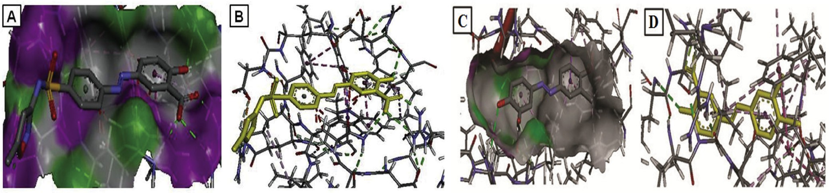

#### Fig. 9 – (A) Three-dimensional structure of protein–ligand interaction as 4h against New Delhi metallo-β-lactamase-1 (NDM-1) of *Klebsiella pneumoniae* (PDB ID: 3SPU) with target surface, (B) structure of the same protein–ligand interaction of 4h with Discovery studio Visualizer 3.1 software without target protein surface. (C) Three-dimensional structure of protein–ligand interaction as 4e against Cyclooxygenase-2(COX-2) of *Mos musculus* (PDB ID: 1CX2) with target surface and

**(D) structure the same protein–ligand interaction of** 4e **with Discovery studio Visualizer 3.1 software without target protein surface.**

R E F E R E N C E S

1. [Jack DB. One hundred years of aspirin. Lancet 1997;350:437–](http://refhub.elsevier.com/S2314-808X(15)00060-3/sr0010) [9.](http://refhub.elsevier.com/S2314-808X(15)00060-3/sr0010)
2. [Al-Dabbas MM, Suganuma T, Kitahara K, Hou DX, Fujii M.](http://refhub.elsevier.com/S2314-808X(15)00060-3/sr0015) [Cytotoxic, antioxidant and antibacterial activities of](http://refhub.elsevier.com/S2314-808X(15)00060-3/sr0015) [*Varthemia iphionoides* Boiss. extracts. J Ethnopharmacol](http://refhub.elsevier.com/S2314-808X(15)00060-3/sr0015) [2006;108:287–93.](http://refhub.elsevier.com/S2314-808X(15)00060-3/sr0015)
3. [Djurendic E, Vujaskovic SD, Sakac M, Ajdukovic J, Gakovic A,](http://refhub.elsevier.com/S2314-808X(15)00060-3/sr0020) [Kojic V, et al. Synthesis and biological evaluation of some](http://refhub.elsevier.com/S2314-808X(15)00060-3/sr0020) [new 2-oxazoline and salicylic acid derivatives. ARKIVOC](http://refhub.elsevier.com/S2314-808X(15)00060-3/sr0020) [2011;ii:83–102.](http://refhub.elsevier.com/S2314-808X(15)00060-3/sr0020)
4. [Mohsen AQM, Mulvey D, Priddle JD, Parsons DS, Jewell DP.](http://refhub.elsevier.com/S2314-808X(15)00060-3/sr0025) [Effects of olsalazine in the jejunum of the rat. Gut](http://refhub.elsevier.com/S2314-808X(15)00060-3/sr0025) [1987;28:346–52.](http://refhub.elsevier.com/S2314-808X(15)00060-3/sr0025)
5. [Bruke A, Smyth E, Fitz G, Garret A. Goodman and Gilman’s](http://refhub.elsevier.com/S2314-808X(15)00060-3/sr0030) [the pharmacological basis of therapeutics. 11th ed. New](http://refhub.elsevier.com/S2314-808X(15)00060-3/sr0030) [York: McGraw-Hill; 2006.](http://refhub.elsevier.com/S2314-808X(15)00060-3/sr0030)
6. [Clive PP, Michael JC, Morley S, Michael W, Brian H.](http://refhub.elsevier.com/S2314-808X(15)00060-3/sr0035) [Farmacogia integrada. España: Elsevier; 1998.](http://refhub.elsevier.com/S2314-808X(15)00060-3/sr0035)
7. [Mosaad SM, Mohsen MK, Emad MMK, Nageh A, Khedr M,](http://refhub.elsevier.com/S2314-808X(15)00060-3/sr0040) [Marwa FA. Synthesis, biological evaluation and molecular](http://refhub.elsevier.com/S2314-808X(15)00060-3/sr0040) [docking of quinazoline-4(1*H*)-one derivatives as anti-](http://refhub.elsevier.com/S2314-808X(15)00060-3/sr0040) [inflammatory and analgesic agents. Acta Pol Pharm](http://refhub.elsevier.com/S2314-808X(15)00060-3/sr0040) [2011;68(5):665–75.](http://refhub.elsevier.com/S2314-808X(15)00060-3/sr0040)
8. [Mariappan BP, Saha BP, Sutharson L, Haldar A. Synthesis](http://refhub.elsevier.com/S2314-808X(15)00060-3/sr0045) [and bioactive evaluation of pyrazolone derivatives. Ind J](http://refhub.elsevier.com/S2314-808X(15)00060-3/sr0045) [Chem 2010;49B:1671–4.](http://refhub.elsevier.com/S2314-808X(15)00060-3/sr0045)
9. [Samir B, Ramy R, Hassan AE, Ahmed AF. Synthesis and](http://refhub.elsevier.com/S2314-808X(15)00060-3/sr0050) [antimicrobial activity of some new heterocycles](http://refhub.elsevier.com/S2314-808X(15)00060-3/sr0050) [incorporating antipyrine moiety. Eur J Med Chem](http://refhub.elsevier.com/S2314-808X(15)00060-3/sr0050) [2008;43:2122–9.](http://refhub.elsevier.com/S2314-808X(15)00060-3/sr0050)

**280** egyptian journal of basic and applied sciences 2

(201 5 ) 268–280

1. [Keinenen S, Simila S, Kouvalainen K. Oral antipyretic](http://refhub.elsevier.com/S2314-808X(15)00060-3/sr0055) [therapy: evaluation of the N-aryl-anthranilic acid derivatives](http://refhub.elsevier.com/S2314-808X(15)00060-3/sr0055) [mefenamic acid, tolfenamic acid and fulfenamic acid. Eur J](http://refhub.elsevier.com/S2314-808X(15)00060-3/sr0055) [Clin Pharmacol 1978;13:331–4.](http://refhub.elsevier.com/S2314-808X(15)00060-3/sr0055)
2. [Sahoo J, Mekap SK, Sudhir Kumar P. Synthesis, spectral](http://refhub.elsevier.com/S2314-808X(15)00060-3/sr0060) [characterization of some new 3-Heteroaryl azo 4-Hydroxy](http://refhub.elsevier.com/S2314-808X(15)00060-3/sr0060) [coumarin derivatives and their antimicrobial evaluation. J](http://refhub.elsevier.com/S2314-808X(15)00060-3/sr0060) Taibah Univ Sci 2014;http://dx.doi.org/doi:10.1016/j.jtusci.
3. [Pradhan B, Dash SK, Sahoo S. Screening and](http://refhub.elsevier.com/S2314-808X(15)00060-3/sr0065) [characterization of extracellular L-asparaginase producing](http://refhub.elsevier.com/S2314-808X(15)00060-3/sr0065) [*Bacillus subtilis* strain hswx88, isolated from Taptapani hot](http://refhub.elsevier.com/S2314-808X(15)00060-3/sr0065) [spring of Odisha, India. Asian Pac J Trop Biomed 2013;3:936–](http://refhub.elsevier.com/S2314-808X(15)00060-3/sr0065) [41.](http://refhub.elsevier.com/S2314-808X(15)00060-3/sr0065)
4. [Shridhar AH, Keshavayya J, Peethambar SK, Joy Hoskeri H.](http://refhub.elsevier.com/S2314-808X(15)00060-3/sr0070) [Synthesis and biological activities of Bis alkyl 1, 3,](http://refhub.elsevier.com/S2314-808X(15)00060-3/sr0070)
5. [oxadiazole incorporated azo dye derivatives. Arab J Chem](http://refhub.elsevier.com/S2314-808X(15)00060-3/sr0070) 2012;<http://dx.doi.org/10.1016/j.arabjc.2012.04.018>.
6. [Andrews M. Determination of minimum inhibitory](http://refhub.elsevier.com/S2314-808X(15)00060-3/sr0075) [concentrations. J Antimicrob Chemother 2001;48:5–](http://refhub.elsevier.com/S2314-808X(15)00060-3/sr0075) [16.](http://refhub.elsevier.com/S2314-808X(15)00060-3/sr0075)
7. [Jagtap AG, Fernandes BB. Analgesic potential of *Pterocarpus*](http://refhub.elsevier.com/S2314-808X(15)00060-3/sr0080)[*indicus*. Ind Drug 2008;45(8):649–54.](http://refhub.elsevier.com/S2314-808X(15)00060-3/sr0080)
8. [Dustin K, Natalie S. Crystal structure of New Delhi metallo-](http://refhub.elsevier.com/S2314-808X(15)00060-3/sr0085) [b-lactamase reveals molecular basis for antibiotic](http://refhub.elsevier.com/S2314-808X(15)00060-3/sr0085) [resistance. Protein 2011;20:1484–91.](http://refhub.elsevier.com/S2314-808X(15)00060-3/sr0085)