[Egyptian Journal of Basic and Applied Sciences 5 (2018) 228–233](https://doi.org/10.1016/j.ejbas.2018.05.005)

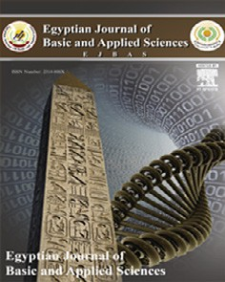

Contents lists available at [ScienceDirect](http://www.sciencedirect.com/science/journal/2314808X)

Egyptian Journal of Basic and Applied Sciences

journal homepage: [www.elsevier.com/locate/ejbas](http://www.elsevier.com/locate/ejbas)

Full Length Article

[](http://crossmark.crossref.org/dialog/?doi=10.1016/j.ejbas.2018.05.005&domain=pdf)Antimicrobial activity of silver nanoparticles biosynthesised by *Rhodotorula* sp*.* strain ATL72

Hoda Soliman ⇑, Ashraf Elsayed, Amira Dyaa

*Botany Department, Faculty of Science, Mansoura University, Egypt*

# a r t i c l e i n f o

*Article history:*

Received 1 February 2018

Received in revised form 12 April 2018 Accepted 13 May 2018

Available online 26 May 2018

*Keywords:* Antimicrobial Biosynthesis *Rhodotorula* AgNPs

# a b s t r a c t

In this study, the pink yeast *Rhodotorula* sp. strain ATL72 was isolated from salt marches near Mediterranean Sea, Egypt. From phylogenetic analysis, the isolated strain ATL72 was closely related to *Rhodotorula bloemfonteinensis* EU075187 by similarity of 40%. The biological synthesis of nanosilver (AgNPs) using the marine pink yeast *Rhodotorula* sp. strain ATL72 was established. The UV–Visible spec- tral analysis confirmed the synthesis of AgNPs showing a characteristic peak around 400–500 nm. TEM analysis not only confirmed the synthesis of AgNPs but also described the spherical and oval shaped nanoparticle besides size measurements ranged from 8.8 to 21.4 nm. The biosynthesized AgNPs showed a strong antimicrobial activity by causing a complete inhibition of growth for a wide range of Gram pos- itive and Gram negative bacteria as well as fungi with low MIC value. In conclusion, the pink yeast *Rhodotorula* sp., strain ATL72 isolated from Egypt is a promising new biological source for the synthesis of silver nanoparticles having a potent antimicrobial activity against a wide range of pathogenic bacteria and fungi.

© 2018 Mansoura University. Production and hosting by Elsevier B.V. This is an open access article under

the CC BY-NC-ND license (<http://creativecommons.org/licenses/by-nc-nd/4.0/>).

1. Introduction

*Rhodotorula* sp*.* is unicellular yeast, characterized by a high growth rate. It has a yellow, orange or red color and known as care- togenic yeast or pink yeast due to its production of carotenoids [1]. It is widely distributed and isolated from several sources such as soil, fresh water, flowers, sea water, and food [2].

A lot of studies have been discussed about the importance of genus *Rhodotorula* in the field of biotechnology and its vital appli- cations in the future of industry, which negates the thought that genus *Rhodotorula* is considered as saprophytes [3]. Metal nanoparticles such as silver nanoparticles (AgNPs) possess diverse technological applications due to their particular chemical, optical, electronic and magnetic characteristics that are completely differ- ent from the characters of the bulk metals [4]. One of the synthesis techniques of AgNPs is the biological synthesis [5]. It is high yield, low cost, non-toxic and eco-friendly process which can use differ- ent biological resources such as plants, bacteria, fungi, yeast, algae and viruses in the synthesis of nanoparticles [6]. Recent studies confirmed the ability of genus *Rhodotorula* such as *Rhodotorula minuta* [7] *and Rhodotorula glutinis* [8] to synthesis metal nanoparticles.

* Corresponding author.

*E-mail address:* [dr.hodasoliman_1964@yahoo.com](mailto:dr.hodasoliman_1964@yahoo.com) (H. Soliman).

One of the most vital applications of the metal nanoparticles, especially silver nanoparticles, in the field of medicine is using these nanoparticles as antimicrobial agents. The lethal activity of nanoparticles against broad spectrum of Gram-positive bacteria, Gram-negative bacteria and fungi has been approved [9]. This study aimed to add a new biological source for the synthesis of sil- ver nanoparticles besides monitoring the microbial biochemical changes and evaluating the antimicrobial activity of variable silver nanoparticles separated at different centrifugation speeds.

1. Materials and methods
   1. *Isolation and purification of marine pink yeast*

Water samples were collected from salt marches near Mediter- ranean Sea and then diluted via serial dilution method. From the dilutions; 10—5, 10—6 and 10—7, 100 mL were inoculated into 50 ml of liquid enriched medium (yeast extract 5 g/l, glucose 10 g/l and

1 L of sea water) [10]. Antibacterial antibiotics were added by the recommended concentrations immediately before the inoculation

process to control the bacterial growth. The flasks were incubated on an incubator shaker at 30 °C and 180 rpm. Each week, samples from each dilution were taken to inoculate a plate of agar enriched medium using the compound streaking method till the appearance of pure pink colonies.

<https://doi.org/10.1016/j.ejbas.2018.05.005>

2314-808X/© 2018 Mansoura University. Production and hosting by Elsevier B.V.

This is an open access article under the CC BY-NC-ND license (<http://creativecommons.org/licenses/by-nc-nd/4.0/>).

* 1. *Molecular identification of the isolated yeast*

Total genomic DNA (gDNA) from the strain ATL72was extracted using the Fast DNA® Spin Kit, after that18S rRNA gene was ampli- fied by PCR reaction using the universal forward and reverse pri- mers; 18S rRNA-F:50 -TACCTGGTTGATCCTGCCAG-30 and 18S rRNA-R: 50 - CCTTCCGCAGGTTCACCTAC-30 [11]. The sequencing of

the PCR product was done using ABI PRISM®BigDyeTM Terminator

Cycle Sequencing Kits, followed by basic local alignment search tool (BLAST) and SeqMatch analysis. The quality and quantity of the obtained sequence was examined by Finch TV version 1.4.0. While, assembling the gene contiguous sequences was done by CAP3 software. The 18S rRNA gene sequence of the isolate ATL72 was submitted to the Gene bank under the accession number MG021304 and used for construction of the phylogenetic tree using Sea view software and automated BLAST search for detecting the closest type strain to the isolate ATL72.

* 1. *Preparation of AgNPs*

Into 100 ml of liquid optimized medium (1 g/l yeast extract, 3.7 g/l malt extract, 35 g/l Nacl, 7.7 g/l fructose and 9 g/l urea), pink

yeast were inoculated and incubated in shaking incubator for 72 h at 28 °C with 150 rpm. After that, the liquid culture was centrifuged and the pellet washed extensively three times with sterile distilled water to remove any residues from the media. To have cell free water extract, pellet was added to 100 ml of sterile deionized water in a shaker incubator at 27.5 °C at 150 rpm for overnight and then centrifuged to remove the biomass by decantation- centrifugation. AgNO3 (1 mM) was added to the water extract and kept for 24 h in dark conditions [8]. Control flasks contain

deionized water and AgNO3 without cell filtrate. After 24 h the samples showed any change in color were subjected to further analysis.

* 1. *UV–Visible spectral analysis of AgNPs*

The formation of nanoparticles was monitored using both visual observation of the color and UV–visible spectral analysis (Unicam UV–VIS. Spectrometer UV2, U.S.A). It was noticed that the filtrate was colorless before incubation with silver nitrate then the color turned to dark brown after complete reduction of silver ions. Silver nanoparticles were scanned using spectrophotometer at wave- lengths from 200 to 800 nm [12]. The filtrate without silver nitrate was used as a blank sample.

* 1. *Transmission electron microscopic (TEM) analysis of AgNPs*

For determination of size and the shape of AgNPs, Transmission Electron Microscope (JEOL JEM-2100, U.S.A) was used. The process was performed by coating of AgNPs onto carbon coated grid (Type G 200, 3.05 mmdiameter, TAAP, U.S.A) [13].

* 1. *Selected area diffraction pattern (SADP) analysis for AgNPs*

SADP is a crystallographic technique accomplished using the transmission electron micrographs and requires a very thin sec- tioned specimen about 100 nm and about 100–400 KeV as an energy electron volt [14].

* 1. *Antimicrobial activity and determination of MIC of AgNPs*

AgNPs were centrifuged at three different speeds 4000, 8000 and 14000 rpm to study their activity at each speed. The precipi- tate of nanoparticles was dried, weighted and suspended in 1 ml

of deionized water and subjected to sonication for getting homog- enized suspension [15].

*Streptococcus* sp., *Bacillus* sp., *Staph* sp., *Shigella* sp., *Escherichia coli*, *Pseudomonas aeruginosa*, *Klebsiella* sp. and *Candida* sp. were provided from Genetic Engineering and Biotechnology Unit, Fac- ulty of Science, Mansoura University, Egypt, to study the antimi- crobial activity of the biosynthesized AgNPs [16]. These pathogens were activated by culturing 100 mL of each in 10 ml LB

medium (10 g/l Pepton, 10 g/l NaCl, 5 g/l Yeast Extract) and incu-

bated at 37 °C for 24 h with shaking at 150 rpm [17]. In 10 ml LB broth, 100 mL of AgNPs from each speed (4000, 8000 and 14,000 rpm) and 100 mL of each pathogen were added. The microbial growth was monitored by measuring the optical density (OD) at 600 nm [18].

For MIC determination [19] of the biosynthesized AgNPs, 100 mL AgNPs from different concentrations (50, 25, 10,5,1,0.5 and 0.25

mg/ml) from each speed (4000, 8000 and 14000 rpm) and 100 mL from each test organism (*E. Coli*, *Candida* sp. and *Bacillus* sp.) were applied to 5 ml LB broth medium and incubated at 37 °C with shak- ing for 24 h. AgNPs with inoculum in broth media were used as a positive control. The results were monitored by measuring the mean OD at 600 nm [20].

* 1. *Sodium dodecyl sulphate polyacrylamide gel electrophoresis (SDS–PAGE)*

SDS-PAGE was used to investigate the effect of AgNPs collected at different centrifugation speeds (4000 and 14,000 rpm) on selected pathogens *E. coli*, *Candida* sp. and *Bacillus* sp.. Total pro- teins from pellets of the treated microorganisms were extracted in 100 mM phosphate buffer at pH 7. For loading protein over

the acrylamide gel, 10 mg protein concentrations from each sample were boiled in 2X sample buffer (2.5 ml Tris-HCl pH 6.8, 10 ml Dis- tilled water, 4 ml 10%SDS, 2 ml Glycerol and 1 ml b- mercaptoethanol) for 2 min. Acrylamide gel was prepared in two

layers; 4%stacking gel above 12% separating gel [21].The elec- trophoresis was applied for 2 h at 100 V, then the gel was stained in Commassie Brilliant Blue R250 overnight, followed by de- staining on shaker for few hours. Using Gel Analyzer3 Program, the gel was analyzed.

1. Results
   1. *Isolation and purification of marine pink yeast*

Under light microscope, the stained cells of the isolated yeast strain were circular in shape and the colonies were smooth, soft and orange in color (Fig. 1).

* 1. *Molecular identification*

By analysis of the phylogenetic tree, the phylogenetic position of the isolate ATL72 was compared to the closely related species of the genus *Rhodotorula*. Strain ATL72. It was found that, the clo- sely related species is *Rhodotorula bloemfonteinensis* EU075187 with percentage similarity of 40% as shown in Fig. 2.

* 1. *Biosynthesis of AgNPs*

After incubation of cell free water extract with 1 mM silver nitrate, the color changed from orange into dark brown color which indicates for the formation of nanosilver as shown in Fig. 3.

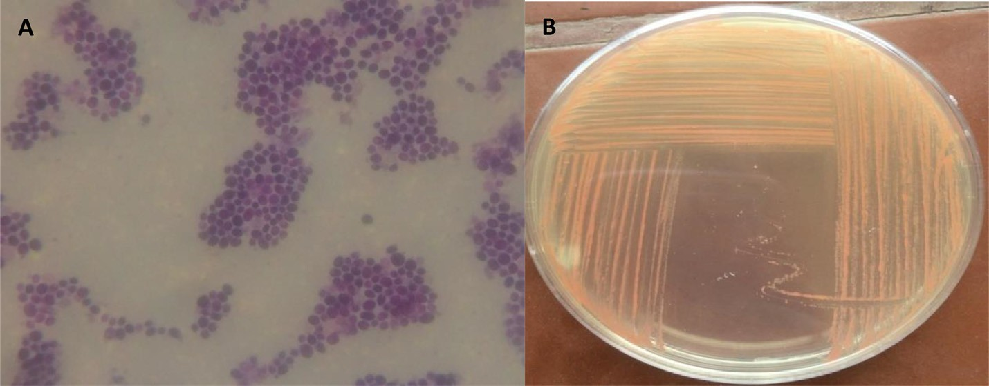

Fig. 1. Microscopic image of *Rhodotorula* sp. strain ATL72 stained by simple stain under light microscope (A) and on plate (B).

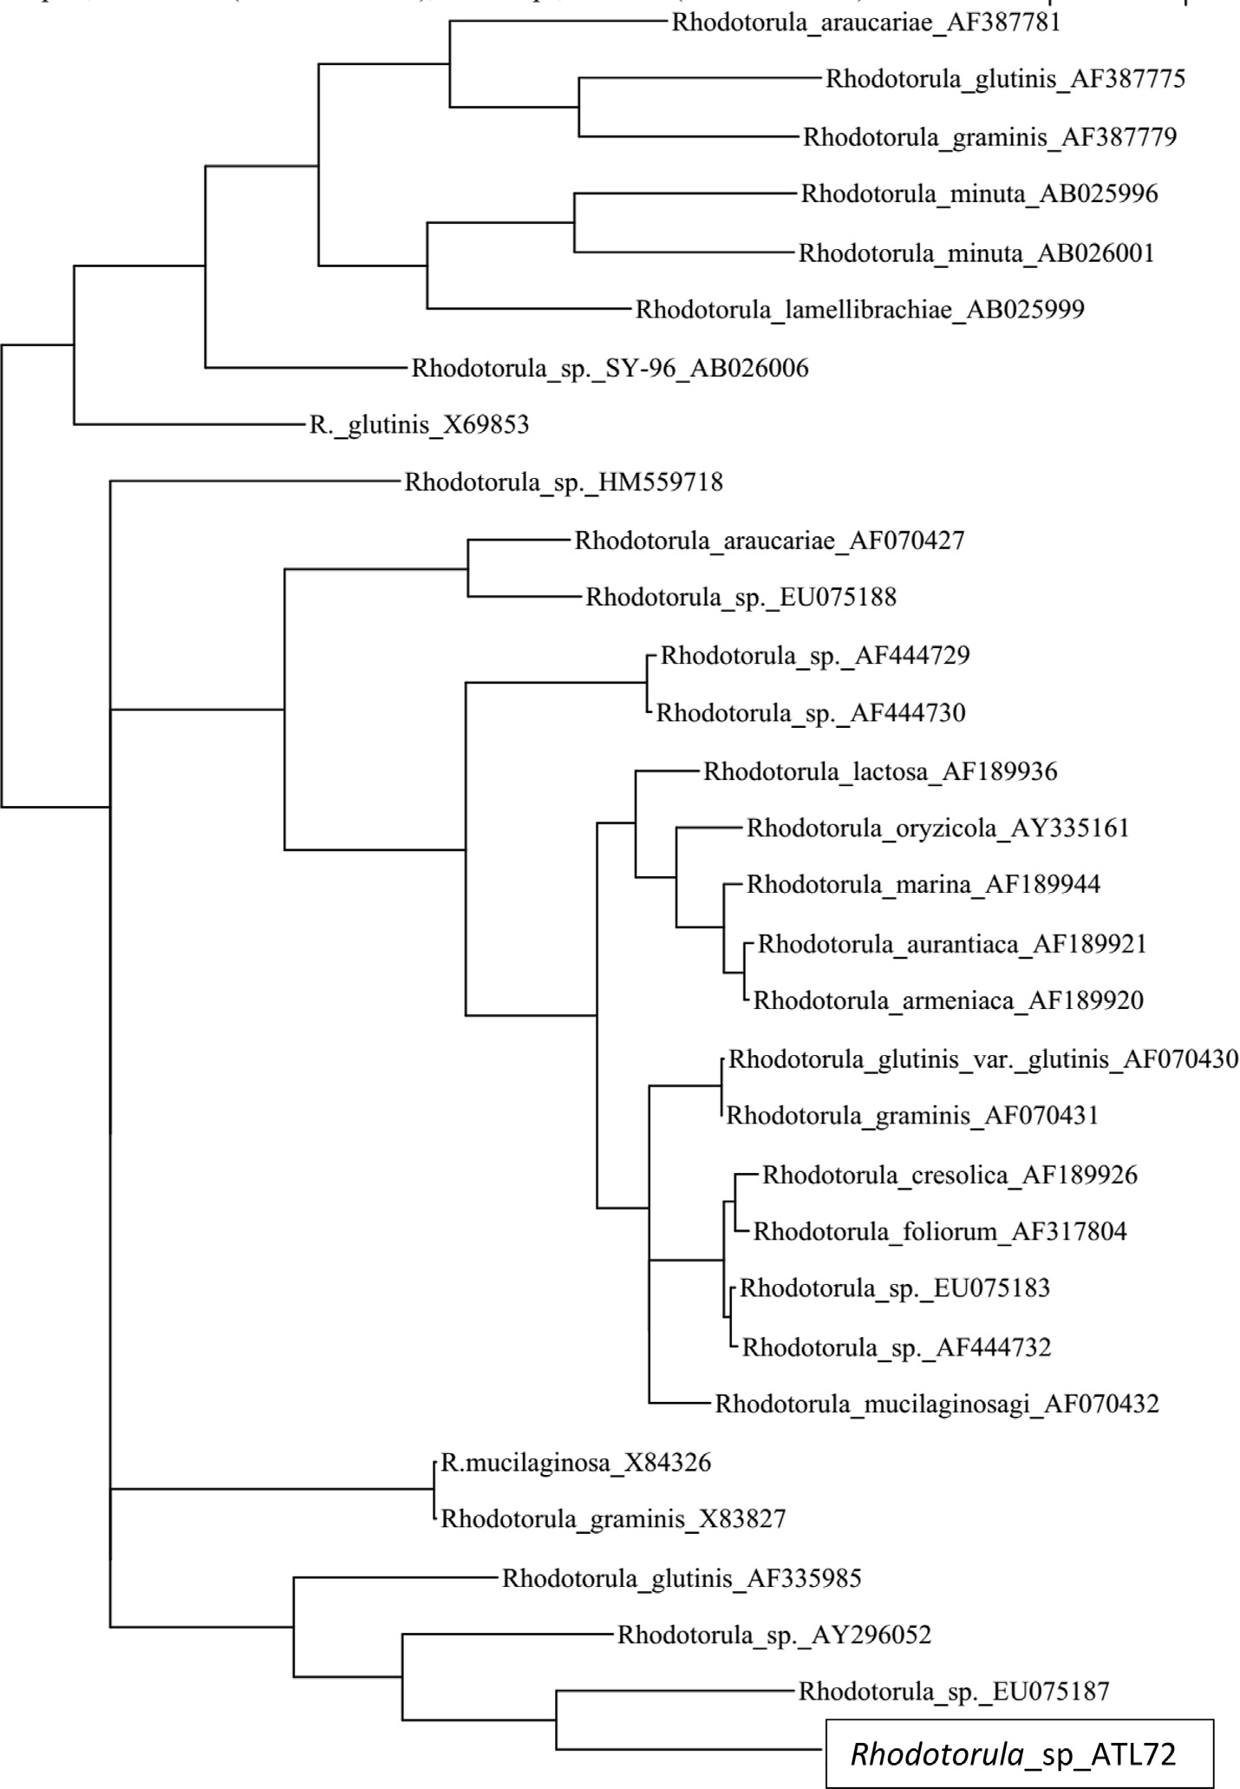

Fig. 2. A phylogenetic tree based on 18S rRNA gene sequence, analysis showing the position of the yeast isolate ATL72 compared to the closest related species of the genus

*Rhodotorula.*

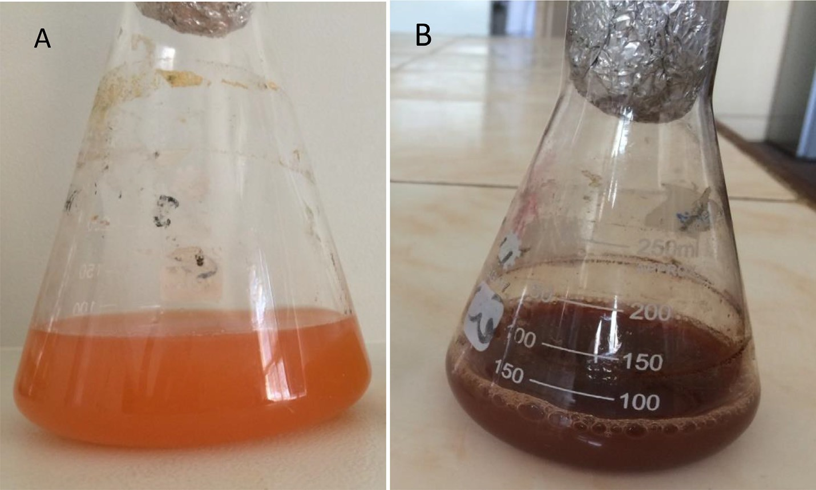

Fig. 3. Cell free water extract of *Rhodotorula* sp. strain ATL72 (A) and colloidal solution of silver nanoparticles (B).

* 1. *UV–Visible spectral analysis of AgNPs*

The absorption spectrum of the dark brown AgNPs suspension represented in Fig. 4 showed a surface Plasmon absorption band with a peak of at450nm, which indicates the formation of nano- sized particles and another beak ~350.

* 1. *TEM analysis of AgNPs*

The TEM analysis of AgNPs showed that, the nanoparticles have variable shapes as spherical or oval shaped and the size is ranged between 8.8 and 21.4 nm as shown in Fig. 5.

* 1. *SADP analysis of AgNPs*

The diffraction pattern of the nanosilver particles (Fig. 6) appeared as lighted spots on the dark field also reflect the crys- talline structure and the diffraction rings of the nanoparticles of silver.

* 1. *Antimicrobial activity of AgNPs and determination of its MIC*

At OD600, the growth of all pathogens including Gram positive bacteria (*Streptococcus* sp., *Bacillus* sp*.*, *Staphylococcus* sp*.*) and Gram negative bacteria (*Shigella* sp., *Escherichia coli*, *Pseudomonas areuginosa* and *Klebsiella* sp.) as well as one fungus *Candida* sp. were completely inhibited after treatments by all AgNPs collected

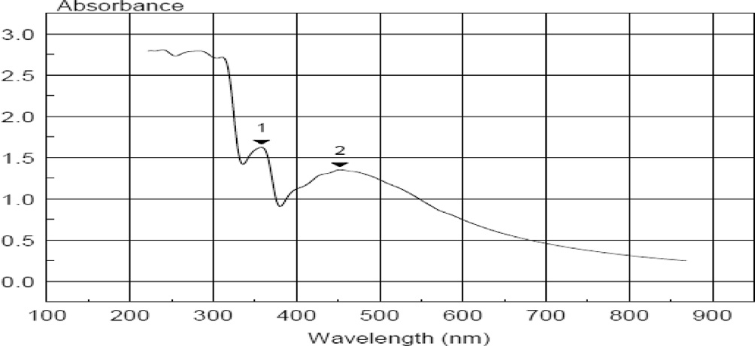

Fig. 4. UV–Vis spectra of AgNPs colloidal solution synthesized by the yeast strain

*Rhodotorula*ATL72with mean peak around 500 nm.

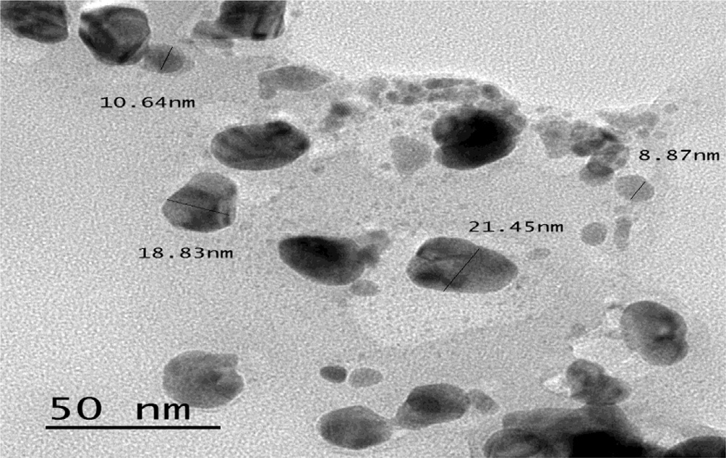

Fig. 5. TEM micrograph shows spherical or oval shaped of nano colloids with average size (8.8–2.4) nm.

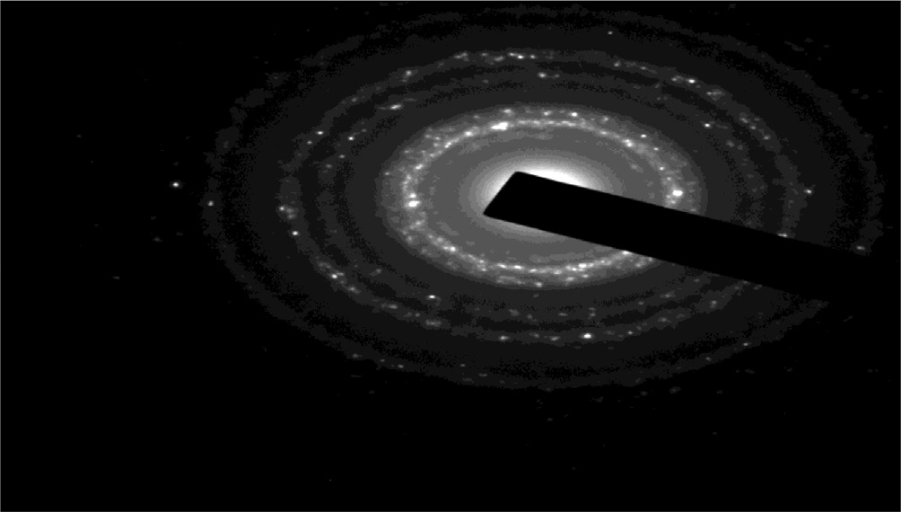

Fig. 6. Selected area electron diffraction pattern for AgNPs. The diffraction rings contained silver atoms which appeared as lighted spots.

at the three different centrifugation speeds 4000, 8000 and 14,000 rpm (Table 1).

The concentration 1 mg/ml of AgNPs precipitated by any speed is the MIC concentration that completely inhibits the growth of the three selected pathogens *Bacillus* sp., *E. coli* and *Candida* sp. (Table 2).

Table 1

Effect of AgNPs synthesized by pink yeast on microbial growth.

|  |  |  |  |  |
| --- | --- | --- | --- | --- |
| Organism | Speed |  | | |
|  | 4000 rpm | 8000 rpm | 14,000 rpm |  |
|  | OD600 |  |  |  |
| *Streptococcus* sp. | 0.00 | 0.00 | 0.00 |  |
| *Bacillus* sp. | 0.00 | 0.00 | 0.00 |  |
| *Staphelococcus* sp. | 0.00 | 0.00 | 0.00 |  |
| *Shigella* sp. | 0.00 | 0.00 | 0.00 |  |
| *Escherichia coli* | 0.00 | 0.00 | 0.00 |  |
| *Pseudomonas areuginosa* | 0.00 | 0.00 | 0.00 |  |
| *Klebsiella* sp. | 0.00 | 0.00 | 0.00 |  |
| *Candida* sp. | 0.00 | 0.00 | 0.00 |  |

* 1. *Sodium dodecyl sulphate-polyacrylamide gel electrophoresis (SDS–PAGE)*

SDS-PAGE analysis of proteins extracted from *Candida* sp., *E. coli* and *Bacillus* sp. control and treated with AgNPs at two separation speeds showed variable changes in the protein pattern (Fig. 7). These changes were highly pronounced with treatments of AgNPs at the high speed separation whereas the change is low at the low speed separation. Generally, the presence of new protein bands and increasing in band intensity of samples treated with AgNPs were more than in untreated samples. In *E. coli,* there was no change in the protein profile or the intensity of the bands in treated and untreated samples of that separated at 4000 rpm speed.

1. Discussion

Nanobiotechnology is a branch of the science which manipu- lates the properties and the behavior of materials at nanoscale for numerous applications for serving the mankind [5]. In the pre- sent study, a *Rhodotorula* sp., strain ATL72, a carotenoid producing yeast, was isolated from different localities of salt marches near Mediterranean sea, Egypt. Morphological and molecular tools were used for identification of the strain. The dendogram analysis of its 18S rRNA gene showed the similarity between it and *Rhodotorula bloemfonteinensis* EU075187 with percentage of 40%. This result indicated the possibility that the isolated *Rhodotorula* Strain ATL72 might be a new strain.

Biosynthesis of silver nanoparticles from the isolated strain *Rhodotorula* sp. ATL72 was performed using the cell free water extract approach. The dark brown color of the supernatant raised due to the bio-reduction of AgNO3 by the reducing proteins in the water extract of the yeast [22] and other microorganisms [23]. A novel technique depending on differential freezing and thawing of samples was applied for separating metallic nanoparti- cles from a culture of yeast MKY3 [24].Yeast strains possess more benefits over bacteria in the mass production of NPs due to the easiness of controlling yeasts in laboratory circumstances besides the synthesis of numerous enzymes and rapid growth with the use of simple nutrients [25].

Silver nanoparticles were characterized by UV–vis spec- troscopy, giving a strong broad surface Plasmon peak ~450 which

Table 2

MIC of AgNPs synthesized by pink yeast on growth (OD600) of *E. coli*, *Bacillus* sp. And *Candida* sp.

|  |  |  |  |  |  |  |  |  |  |  |  |  |
| --- | --- | --- | --- | --- | --- | --- | --- | --- | --- | --- | --- | --- |
| Speed of precipitation | 4000 rpm |  |  |  | 8000 rpm |  |  |  | 14,000 rpm |  | | |
| Organism | *E. coli* | *Bacillus* sp. | *Candida* sp. |  | *E. coli* | *Bacillus* sp. | *Candida* sp. |  | *E. coli* | *Bacillus* sp. | *Candida* sp. |  |
| Conc.  1 mg/ml | OD600 0.00 | 0.00 | 0.00 |  | 0.00 | 0.00 | 0.00 |  | 0.00 | 0.00 | 0.00 |  |
| 0.5 mg/ml | 0.00 | 0.20 | 0.30 |  | 0.10 | 0.01 | 0.30 |  | 0.30 | 0.02 | 0.02 |  |
| 0.25 mg/ml | 0.20 | 0.00 | 0.17 |  | 0.30 | 0.20 | 0.12 |  | 0.30 | 0.20 | 0.30 |  |

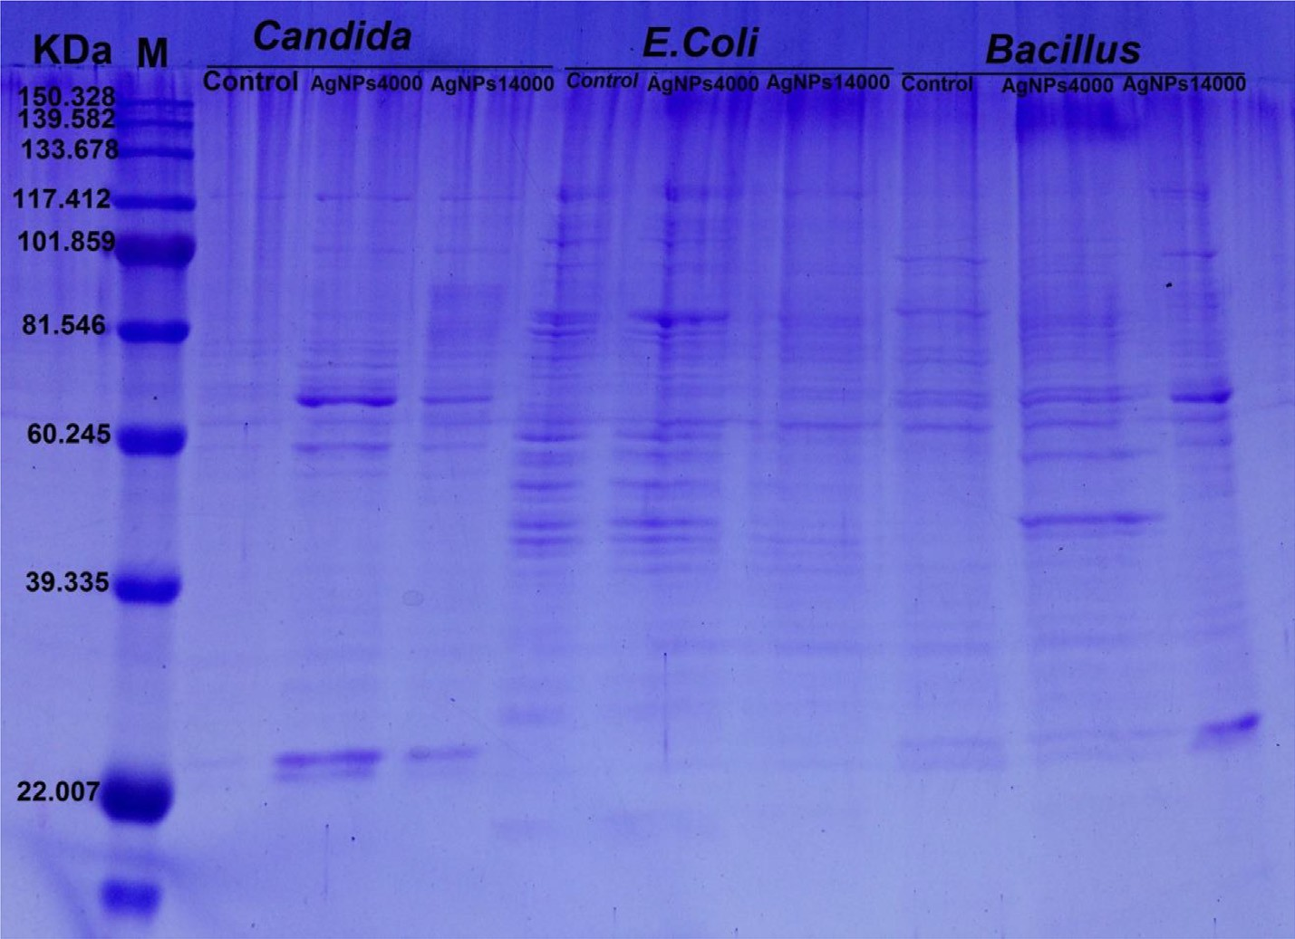

Fig. 7. SDS-polyacrylamide gel electrophoresis of proteins from *Candida* spp., *E. coli* and *Bacillus* sp. before and after treatment with AgNPs at 2 separatin speeds.

has been documented for various metal nanoparticles [26]while the other peak ~ 350 may attributed to the presence of contami- nating proteins in the sample. TEM analysis of silver nanoparticles showed irregular oval or rounded shapes exhibiting sizes ranging from 8.8 to 21.4 nm as pronounced in several publications [7,8,24]. The results of antimicrobial activity of AgNPs on different Gram positive, Gram negative bacteria and yeast indicated the complete inhibition of growth of these organisms. These results were con- firmed by previous extensive studies on *Candida albicans*, *Sal-* *monella enterica*, *E. coli*, and *Vibrio parahaemolyticus* [27]. Also, AgNPs can be definitely used as effective antibiotics against

*E. coli*, *Salmonella typhimurium*, *Staphylococcus epidermidis* and *Staphylococcus aureus* [28]*.* The effect of AgNPs as antimicrobial agent depends on the shape of nanoparticles as encountered from the work monitoring the effect of different shapes of AgNPs (spherical, rod-like and triangular) on *E. coli* and found that triangular-shaped nanoparticles are the most effective shape [29].

The obtained MIC results (1mg/ml) of AgNPs are the same at any separating speed. This result is more or less similar to what

reported for *Candida albicans* treated with a MIC value of 2 mg/ml AgNPs [30] and with that for both *E. coli* and *Bacillus* sp. treated with MIC value of 1 mg/ml AgNPs[16]. On the other hand, high

MIC value of 10 mg/ml was reported for *E. coli* [31,20].

The SDS-PAGE analysis showed qualitative and quantitative changes in protein profile after treatment of *Candida sp*. and *Bacil-* *lus* sp. by AgNPs. The appearance of new bands and the increasing in band intensity might be attributed to the ability of AgNPs to induce new proteins as a stress response [32]. While in case of

*E. coli* treated with AgNPs the protein profile remain unchanged, although the band intensities were comparatively less than those of the control. This implies that the affinity of AgNPs to the thiol groups of the proteins causing unfolding of the protein chain might cause degradation of the proteins. Also, previous studies reported that AgNPs may implicate in preventing the synthesis of the pro- teins by inhibiting many translation factors [33,34].

In conclusion, the pink yeast *Rhodotorula* sp., strain ATL72 iso- lated from Egyptis a promising new biological source for the syn- thesis of silver nanoparticles having a potent antimicrobial activity against a wide range of pathogenic bacteria and fungi.

Acknowledgments

Many thanks to Prof. Samia Ali Haroun, the former head of Bot- any Department, Faculty of Science, Mansoura University, for con- tinuous support and valuable discussion.

Competing interests

The authors declare that they have no competing interests.

This research did not receive any specific grant from funding agencies in the public, commercial, or not-for-profit sectors.

References

1. Marova I, Certik M, Breierova E. Production of enriched biomass by carotenogenic yeasts-application of whole-cell yeast biomass to production of pigments and other lipid compounds. In: Dr. Darko Matovic, editor. Biomass-detection, production and usage. InTech; 2011. ISBN: 978-953-307- 492-4.
2. [El-banna AAE, El-razek AM, El-mahdy AR. Isolation, identification and](http://refhub.elsevier.com/S2314-808X(18)30051-4/h0010) [screening of carotenoid-producing strains of *Rhodotorula glutinis*. Food Nutr](http://refhub.elsevier.com/S2314-808X(18)30051-4/h0010) [Sci 2012;3:627–33](http://refhub.elsevier.com/S2314-808X(18)30051-4/h0010).
3. [Kot AM, Bła](http://refhub.elsevier.com/S2314-808X(18)30051-4/h0015)z_ [ejak S, Kurcz A, Gientka I, Kieliszek M. *Rhodotorula glutinis*—](http://refhub.elsevier.com/S2314-808X(18)30051-4/h0015)

[potential source of lipids, carotenoids, and enzymes for use in industries. Appl](http://refhub.elsevier.com/S2314-808X(18)30051-4/h0015) [Microbiol Biotechnol 2016;100(14):6103–17](http://refhub.elsevier.com/S2314-808X(18)30051-4/h0015).

1. [Das R, Gangand S, Nath S. Preparation and anti-bacterial activity of silver](http://refhub.elsevier.com/S2314-808X(18)30051-4/h0020) [nanoparticles. J Biomater Nanobiotechnol 2011;2(4):472](http://refhub.elsevier.com/S2314-808X(18)30051-4/h0020).
2. [Sarsar V, Selwal KK, Selwal MK. Nanosilver: potent antimicrobial agent and its](http://refhub.elsevier.com/S2314-808X(18)30051-4/h0025) [biosynthesis. Afr J Biotechnol 2014;13(4):546–54](http://refhub.elsevier.com/S2314-808X(18)30051-4/h0025).
3. [Thakkar KN, Mhatre SS, Parikh RY. Biological synthesis of metallic](http://refhub.elsevier.com/S2314-808X(18)30051-4/h0030) [nanoparticles. Nanomed Nanotechnol Biol Med 2010;6(2):257–62](http://refhub.elsevier.com/S2314-808X(18)30051-4/h0030).
4. [Subramanian M, Alikunhi NM, Kandasamy K. In vitro synthesis of silver](http://refhub.elsevier.com/S2314-808X(18)30051-4/h0035) [nanoparticles by marine yeasts from coastal mangrove sediment. Adv Sci Lett](http://refhub.elsevier.com/S2314-808X(18)30051-4/h0035) [2010;3(4):428–33](http://refhub.elsevier.com/S2314-808X(18)30051-4/h0035).
5. [Zahran M, Mohamed A, Mohamed F, El-Rafie M. Optimization of biological](http://refhub.elsevier.com/S2314-808X(18)30051-4/h0040) [synthesis of silver nanoparticles by some yeast fungi. Egypt J Chem 2013;56](http://refhub.elsevier.com/S2314-808X(18)30051-4/h0040) [(1):91–110](http://refhub.elsevier.com/S2314-808X(18)30051-4/h0040).
6. [Dhand V, Soumya L, Bharadwaj S, Chakra S, Bhatt D, Sreedhar B. Green](http://refhub.elsevier.com/S2314-808X(18)30051-4/h0045) [synthesis of silver nanoparticles using Coffea arabica seed extract and its](http://refhub.elsevier.com/S2314-808X(18)30051-4/h0045) [antibacterial activity. Mater Sci Eng, C 2016;58:36–43](http://refhub.elsevier.com/S2314-808X(18)30051-4/h0045).
7. [Gunde-Cimerman N, Zalar P, de Hoog S, Plemenitaš A. Hypersaline waters in](http://refhub.elsevier.com/S2314-808X(18)30051-4/h0050) [salterns–natural ecological niches for halophilic black yeasts. FEMS Microbiol](http://refhub.elsevier.com/S2314-808X(18)30051-4/h0050) [Ecol 2000;32(3):235–40](http://refhub.elsevier.com/S2314-808X(18)30051-4/h0050).
8. [Gupta A, Vongsvivut J, Barrow CJ, Puri M. Molecular identification of marine](http://refhub.elsevier.com/S2314-808X(18)30051-4/h0055) [yeast and its spectroscopic analysis establishes unsaturated fatty acid](http://refhub.elsevier.com/S2314-808X(18)30051-4/h0055) [accumulation. J Biosci Bioeng 2012;114(4):411–7](http://refhub.elsevier.com/S2314-808X(18)30051-4/h0055).
9. [Mahmoud MA, Al-Sohaibani SA, Al-Othman MR, Abd El-Aziz A, Eifan SA.](http://refhub.elsevier.com/S2314-808X(18)30051-4/h0060) [Synthesis of extracellular silver nanoparticles using Fusarium semitectum](http://refhub.elsevier.com/S2314-808X(18)30051-4/h0060) [(KSU-4) isolated from Saudi Arabia. Digest J Nanomat Biostruct 2013;8](http://refhub.elsevier.com/S2314-808X(18)30051-4/h0060) [(2):589–96](http://refhub.elsevier.com/S2314-808X(18)30051-4/h0060).
10. [Wang Z. Transmission electron microscopy of shape-controlled nanocrystals](http://refhub.elsevier.com/S2314-808X(18)30051-4/h0065) [and their assemblies. J Phys Chem B 2000;104(6):1153–75](http://refhub.elsevier.com/S2314-808X(18)30051-4/h0065).
11. [Ahmad A, Mukherjee P, Senapati S, Mandal D, IslamKhan M, Kumar R, et al.](http://refhub.elsevier.com/S2314-808X(18)30051-4/h0070) [Extracellular biosynthesis of silver nanoparticles using the fungus Fusarium](http://refhub.elsevier.com/S2314-808X(18)30051-4/h0070) [oxysporum. Colloids Surf, B 2003;28:313–8](http://refhub.elsevier.com/S2314-808X(18)30051-4/h0070).
12. [Morones JR, Elechiguerra JL, Camacho A, Holt K, Kouri JB, Ramírez JT, et al. The](http://refhub.elsevier.com/S2314-808X(18)30051-4/h0075) [bactericidal effect of silver nanoparticles. Nanotechnology 2005;16](http://refhub.elsevier.com/S2314-808X(18)30051-4/h0075) [(10):2346–53](http://refhub.elsevier.com/S2314-808X(18)30051-4/h0075).
13. [Shahrokh S, Emtiazi G. Toxicity and unusual biological behavior of nanosilver](http://refhub.elsevier.com/S2314-808X(18)30051-4/h0080) [on gram positive and negative bacteria assayed by microtiter-plate. Eur J Biol](http://refhub.elsevier.com/S2314-808X(18)30051-4/h0080) [Sci 2009;1(3):28–31](http://refhub.elsevier.com/S2314-808X(18)30051-4/h0080).
14. [Zarei M, Jamnejad A, Khajehali E. Antibacterial effect of silver nanoparticles](http://refhub.elsevier.com/S2314-808X(18)30051-4/h0085) [against four foodborne pathogens. Jundishapur J Microbiol 2014;7](http://refhub.elsevier.com/S2314-808X(18)30051-4/h0085) [(1):2008–4161](http://refhub.elsevier.com/S2314-808X(18)30051-4/h0085).
15. [Li WR, Xie XB, Shi QS, Zeng HY, You-Sheng OY, Chen YB. Antibacterial activity](http://refhub.elsevier.com/S2314-808X(18)30051-4/h0090) [and mechanism of silver nanoparticles on Escherichia coli. Appli Microbiol](http://refhub.elsevier.com/S2314-808X(18)30051-4/h0090) [Biotechnol 2010;85(4):1115–22](http://refhub.elsevier.com/S2314-808X(18)30051-4/h0090).
16. [Krishnan R, Arumugam V, Vasaviah SK. The MIC and MBC of silver](http://refhub.elsevier.com/S2314-808X(18)30051-4/h0095) [nanoparticles against enterococcus faecalis-a facultative anaerobe. J](http://refhub.elsevier.com/S2314-808X(18)30051-4/h0095) [Nanomed Nanotechnol 2015;6(3):2157–7439](http://refhub.elsevier.com/S2314-808X(18)30051-4/h0095).
17. [Li WR, Xie XB, Shi QS, Zeng HY, You-Sheng OY, Chen YB. Antibacterial activity](http://refhub.elsevier.com/S2314-808X(18)30051-4/h0100) [and mechanism of silver nanoparticles on Escherichia coli. Appl Microbiol](http://refhub.elsevier.com/S2314-808X(18)30051-4/h0100) [Biotechnol 2010;85(4):1115–22](http://refhub.elsevier.com/S2314-808X(18)30051-4/h0100).
18. [Laemmli UK. Cleavage of structural proteins during the assembly of the head](http://refhub.elsevier.com/S2314-808X(18)30051-4/h0105) [of bacteriophage T4. Nature 1970;227:680–5](http://refhub.elsevier.com/S2314-808X(18)30051-4/h0105).
19. [Asmathunisha N, Kathiresan K. A review on biosynthesis of nanoparticles by](http://refhub.elsevier.com/S2314-808X(18)30051-4/h0110) [marine organisms. Colloids Surf, B 2013;103:283–7](http://refhub.elsevier.com/S2314-808X(18)30051-4/h0110).
20. Rai M, Duran N. Biogenic nanoparticles: an introduction to what they are, how they are synthesized and their applications. In: Rai M, Duran N, editors. Metal nanoparticles in microbiology. Springer Science & Business Media; 2011. ISBN: 978-3-642-18311-9.
21. [Kowshik M, Ashtaputre S, Kharrazi S, Vogel W, Urban J, Kulkarni SK, et al.](http://refhub.elsevier.com/S2314-808X(18)30051-4/h0120) [Extracellular synthesis of silver nanoparticles by a silver-tolerant yeast strain](http://refhub.elsevier.com/S2314-808X(18)30051-4/h0120) [MKY3. Nanotechnology 2002;14(1):95–100](http://refhub.elsevier.com/S2314-808X(18)30051-4/h0120).
22. [Kumar D, Karthik L, Kumar G, Roa KB. Biosynthesis of silver anoparticles from](http://refhub.elsevier.com/S2314-808X(18)30051-4/h0125) [marine yeast and their antimicrobial activity against multidrug resistant](http://refhub.elsevier.com/S2314-808X(18)30051-4/h0125) [pathogens. Pharmacologyonline 2011;3:1100–11](http://refhub.elsevier.com/S2314-808X(18)30051-4/h0125).
23. [Henglein A. Physicochemical properties of small metal particles in solution:](http://refhub.elsevier.com/S2314-808X(18)30051-4/h0130) [microelectrode reactions, chemisorption, composite metal particles, and the](http://refhub.elsevier.com/S2314-808X(18)30051-4/h0130) [atom-to-metal transition. J Phys Chem 1993;97(21):5457–71](http://refhub.elsevier.com/S2314-808X(18)30051-4/h0130).
24. Wang C., Kim Y.J., Singh P., Mathiyalagan R., Jin, Yang DC. Green synthesis of silver nanoparticles by Bacillus methylotrophicus, and their antimicrobial activity. Artif Cells Nanomed Biotechnol 2016;44(4):1127–113.
25. [Jain J, Arora S, Rajwade JM, Omray P, Khandelwal S, Paknikar KM. Silver](http://refhub.elsevier.com/S2314-808X(18)30051-4/h0140) [nanoparticles in therapeutics: development of an antimicrobial gel](http://refhub.elsevier.com/S2314-808X(18)30051-4/h0140) [formulation for topical use. Mol Pharm 2009;6(5):1388–401](http://refhub.elsevier.com/S2314-808X(18)30051-4/h0140).
26. [Pal S, Tak YK, Song JM. Does the antibacterial activity of silver nanoparticles](http://refhub.elsevier.com/S2314-808X(18)30051-4/h0145) [depend on the shape of the nanoparticle? A study of the gram-negative](http://refhub.elsevier.com/S2314-808X(18)30051-4/h0145) [bacterium Escherichia coli. Appl Environ Microbiol 2007;73(6):1712–20](http://refhub.elsevier.com/S2314-808X(18)30051-4/h0145).
27. [Kim J, Kuk S, Yu E, NamKim K, HoPark J, Jin Lee S, et al. Antimicrobial effects of](http://refhub.elsevier.com/S2314-808X(18)30051-4/h0150) [silver nanoparticles. Nanomed Nanotechnol Biol Med 2007;3:95–101](http://refhub.elsevier.com/S2314-808X(18)30051-4/h0150).
28. [Sadeghi M, Jamali SK, Amininia A, Ghafari S. Synthesis and characterization of](http://refhub.elsevier.com/S2314-808X(18)30051-4/h0155) [silver nanoparticles for antibacterial activity. Int J Nano Dimension 2010;1](http://refhub.elsevier.com/S2314-808X(18)30051-4/h0155) [(2):119–24](http://refhub.elsevier.com/S2314-808X(18)30051-4/h0155).
29. [Markowska K, Grudniak AM, Krawczyk K, Wrobeland I, Wolska KI. Modulation](http://refhub.elsevier.com/S2314-808X(18)30051-4/h0160) [of antibiotic resistance and induction of a stress response in Pseudomonas](http://refhub.elsevier.com/S2314-808X(18)30051-4/h0160) [aeruginosa by silver nanoparticles. J Med Microbiol 2014;63(6):849–54](http://refhub.elsevier.com/S2314-808X(18)30051-4/h0160).
30. [Velusamy P, Kumar GV, Jeyanthi V, Das J, Pachaiappan R. Bio-inspired green](http://refhub.elsevier.com/S2314-808X(18)30051-4/h0165) [nanoparticles: synthesis, mechanism, and antibacterial application.](http://refhub.elsevier.com/S2314-808X(18)30051-4/h0165) [Toxicological Res 2016;32(2):95–102](http://refhub.elsevier.com/S2314-808X(18)30051-4/h0165).
31. [Gogoi SK, Gopinath P, Paul A, Ramesh A, Ghosh SS, Chattopadhyay A. Green](http://refhub.elsevier.com/S2314-808X(18)30051-4/h0170) [fluorescent protein-expressing escherichia c oli as a model system for](http://refhub.elsevier.com/S2314-808X(18)30051-4/h0170) [investigating the antimicrobial activities of silver nanoparticles. Langmuir](http://refhub.elsevier.com/S2314-808X(18)30051-4/h0170) [2006;22(22):9322–8](http://refhub.elsevier.com/S2314-808X(18)30051-4/h0170).