[Egyptian Journal of Basic and Applied Sciences 4 (2017) 288–296](https://doi.org/10.1016/j.ejbas.2017.10.002)



Contents lists available at [ScienceDirect](http://www.sciencedirect.com/science/journal/2314808X)

Egyptian Journal of Basic and Applied Sciences

journal homepage: [www.elsevier.com/locate/ejbas](http://www.elsevier.com/locate/ejbas)

Full Length Article

*Ariadne merione* ecdysone receptor (*AmEcR*) protein: An *in silico* approach for comparison of agonist and antagonist compounds



Chandran Sundaravadivelan a, Easwaran Murugesh b, Mathew Preethy c, Prabu Sivaprasath c,⇑

a *Department of Zoology, Padmavani Arts and Science College for Women, Salem 636 011, Tamil Nadu, India*

b *Department of Bioinformatics, Bharathiar University, Coimbatore 641 046, Tamil Nadu, India*

c *Department of Biotechnology, School of Life Sciences, Karpagam University, Karpagam Academy of Higher Education, Eachanari Post, Coimbatore 641 021, Tamil Nadu, India*

# a r t i c l e i n f o

*Article history:*

Received 2 July 2017

Received in revised form 8 October 2017 Accepted 8 October 2017

Available online 18 October 2017

*Keywords:*

*Ariadne merione*

20 Hydroxyecdysone (20E) Etoxazole

Schrödinger

# a b s t r a c t

Ecdysteroid signal transduction plays a major role in insect metamorphosis, 20-hydroxyecdysone (20E) binds to the nuclear receptor composed of the ecdysone receptor ligand binding domine (EcR-LBD) and triggers the developmental transitions. *Ariadne merione* ecdysone receptor (*AmEcR*) cDNA was ampli- fied and partially sequenced of about 553 bp, which encodes a polypeptide of 184 amino acids (aa). The theoretical molecular weight (MW), isoelectric point (pI) and aliphatic index of the deduced *AmEcR* pro- tein were predicted using BIOEDIT (v7.2.5) to be 21.192 kDa, 9.31 and 101.739 respectively. Identified ecdysone receptor gene of *A. merione* showed maximum similarity with *Precis coenia* gene. In this research, we have employed ligand-receptor engineering technique to screen a specific compound which plays antagonist role and assist to formulate an insect specific pesticide. The EcR protein 3D structure of *AmEcR* modeled using Schrödinger maestro and virtual screening was performed using 5554 molecules from Zinc database, where ZINC20031812 showed highest glide score of —6.257 and Etoxazole chosen on literature basis and showed best glide score —6.671. We have compared the antagonist with agonist (20E) by molecular dynamics (MD) simulation. Root Mean Square Deviation (RMSD) value of agonist and antagonist indicates the binding were stable in water with a range of distance from 2.3 to 2.6 Å, 1.8 to

2.3 Å and 1.9 to 2.3 Å with a variation over the time scale of 1 ps. Since Etoxazole and ZINC20031812 are antagonists, computationally they were more stable than 20E.

© 2017 Mansoura University. Production and hosting by Elsevier B.V. This is an open access article under

the CC BY-NC-ND license (<http://creativecommons.org/licenses/by-nc-nd/4.0/>).

1. Introduction

A common feature between both types of hemimetabolous and holometabolous insect development is that the periodic pulses of the steroid hormone 20 hydroxyecdysone (20E) which dictate each developmental transition. The ecdysone receptor complex is the key element, which enacts the ecdysteroid-induced physiological and morphological changes during insect moulting regulated by ecdysteroid hormones like 20-hydroxyecdysone (20E) and its ana- logs that bind to the ligand-binding domain of the ecdysone recep- tor [1]. Although the molecular action of 20E has been extensively studied in holometabolous insects and the data on hemimetabo- lous is scarce [2]. The hormone 20E is lipophilic in nature, which synthesized and released into the hemolymph, and enters into the cells are responsible for metamorphosis. The Ecdysone receptor gene is a nuclear receptor with 2 major domain named as ligand binding domain (LBD) and DNA binding domain (DBD), it is seen

* Corresponding author.

*E-mail address:* [sivaprasathibt@gmail.com](mailto:sivaprasathibt@gmail.com) (P. Sivaprasath).

in cytoplasm at inactive state. The 20E binds to LBD of ecdysone receptor gene and it activates the DBD. The basic structure of ecdysone receptor protein (EcR) consists of five domains referred to as A/B-transcriptional activation domain, C-DNA-binding domain, D-hinge region and E-ligand-binding domain [3].

The moulting process is initiated by a number of transcription factors in the nuclear receptor super family. This result showed in the up-regulation of several late genes in the hormone pathway and help in mediating the moulting process [4]. These nuclear receptors have ability to travel through the nuclear pores due to its heterodimeric nature, and bind to specific sites of DNA, which undergoes active replication, chromosome remodeling and finally results in translation. Cuticle degradation and formation of new cuticle are one of the major signaling functions of ecdysone during moulting and N*-*acetyl-b-D-glucosamine (chitin) is a major compo- nent of the insect cuticle [5].

Some of the members belonging to lepidopteran order are seri- ous agriculture pests, which destroys the crops by defoliating. The present study is hypothesized based on the bioinformatics analysis of specific developmental gene and protein encoded by the same.

<https://doi.org/10.1016/j.ejbas.2017.10.002>

2314-808X/© 2017 Mansoura University. Production and hosting by Elsevier B.V.

This is an open access article under the CC BY-NC-ND license (<http://creativecommons.org/licenses/by-nc-nd/4.0/>).

The targeting of specific developmental protein (insect specific) may help in controlling the target pests. The screened compounds mimic 20 hydroxyecdysone which precisely interfere with recep- tor functions and helps to control the mass number of agriculture pests. This could be achieved by using an effective bioinformatics tools to design a perfect molecule to dock with ecdysone receptor proteins.

1. Materials and methods
   1. *RNA isolation*

Total RNA was isolated from fourth instar of *A. merione* (at inter- moult stage) using TRIzol Reagent (Ambion®, Life Technology, USA). One individual (=100 mg) of *A. merione* fourth instar was ground well with 1 ml of TRIzol reagent using sterile Teflon hand

homogenizer. The tubes containing the homogenate were incu- bated for 5 min at RT to permit complete dissociation of the nucle-

oprotein complex, 200 ll of pre-chilled chloroform was added, mixed vigorously for 15 s and the suspension was incubated at RT for 2–3 min followed by centrifugation (7500×*g*, 4 °C, 15 min). The supernatant (~500 ll) was transferred to a sterile tube, after which 500 ll of 75% isopropanol was added and incubated at RT for 10 min, followed by centrifugation (7500×*g*, 4 °C, 15 min).

The supernatant was discarded, then 1 ml of 75% ethanol was added to the pellet, vortexed and centrifuged (6800×*g*, 4 °C, 5 min). The supernatant was completely discarded, finally the pellet was air-dried, re-suspended in 20 ll of DEPC water and stored at

—80 °C for further use.

* 1. *Polymerase chain reaction*

The isolated total RNA from *A. merione* larvae was reverse tran- scribed according to the manufacturer’s protocol using first strand cDNA Synthesis Kit (Roche, Germany). Two gene specific primers, forward primer (50 -AGATGACCATCCTCACCGTG-30 ) and reverse pri-

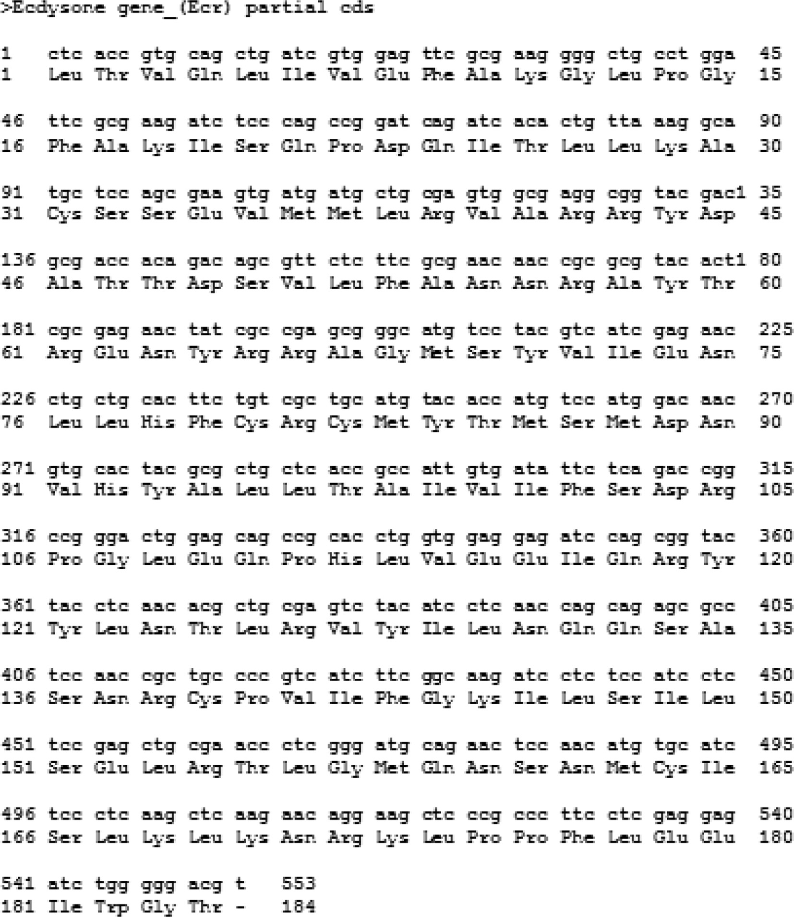

Fig. 1. Partial nucleotide sequence that encodes ecdysone receptor protein of *Ariadne merione* (1–553).

* 1. 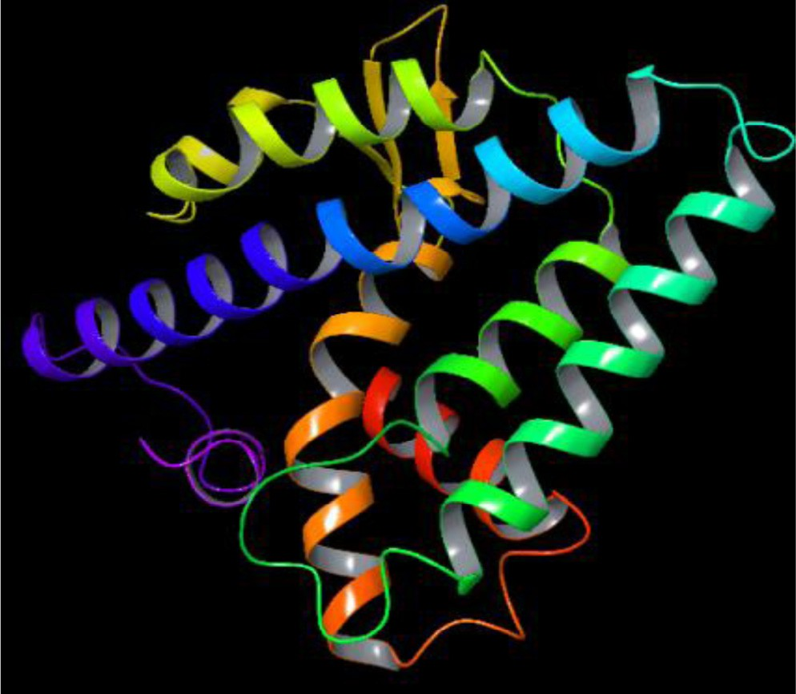*DNA sequencing and sequence analysis*

The purified and extracted sample was sequenced at Eurofins Scientific Ltd. (Bangalore, India) using Sanger dideoxy technology. The obtained sequence was analyzed using BIOEDIT software (ver.7.2.5) and alignment was done for *AmEcR* nucleotide and its encoding protein.

* 1. *Homology modeling and structural validation*

Table 1

Fig. 2. 3D modeled structure of *AmEcR* protein.

The method to predict *ab initio* modeling for *AmEcR* translated protein sequence by using the Schrödinger maestro (ver.9.3) (Schrödinger Inc.). The Prime-SP (ver.3.1) (Standard Precision) is used and it facilitates the comparative modeling that includes alignment, build structure, fold recognition and molecular mechanics-generalized born model augmented with the hydrophobic solvent accessible surface area calculations. Modeled structure was validated for its property in the range and structural similarity from sequence using ProCheck. The residues of Glycine and Proline were analyzed against total number of amino acids present in *AmEcR* modeled structure. This *AmEcR* modeled struc- ture was subjected to refinement and validation using Ramachan- dran plot.

Percent residues of *AmEcR* localized in Ramachandran Plot.

Stereochemical stability EcR Receptor

|  |  |  |  |
| --- | --- | --- | --- |
|  | Residues | Similarity (%) |  |
| Residues in most favoured regions | 158 | 94 |  |
| Residues in additional allowed regions | 10 | 6 |  |
| Residues in generously allowed regions | 0 | 0 |  |
| Residues in disallowed regions | 0 | 0 |  |
| Number of non-glycine and non-proline residues | 168 |  |  |
| Number of end-residues (excl. Gly and Pro) | 2 |  |  |
| Number of glycine residues (shown as triangles) | 7 |  |  |
| Number of proline residues | 7 |  |  |
| Total number of residues and similarity | 184 | 100.00 |  |

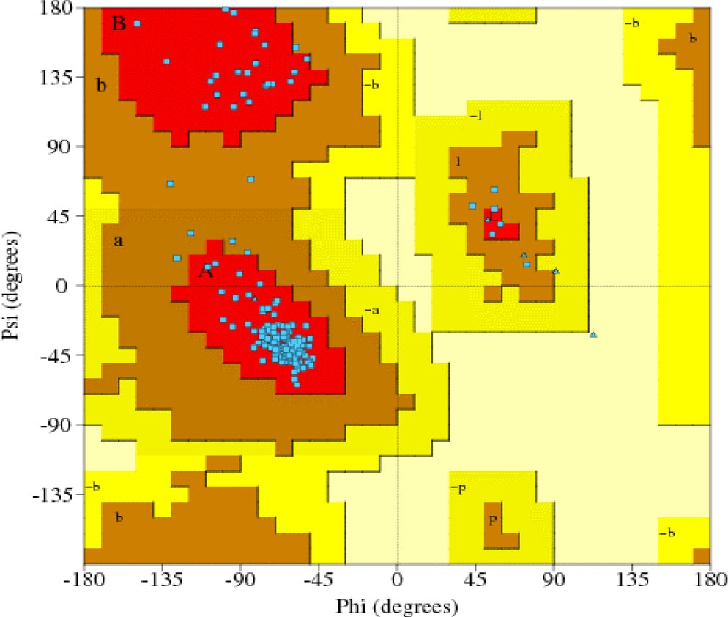

Fig. 3. Ramachandran Plot for modeled *AmEcR* protein showing 94% similar to that of the template structure in the alignment procedure.

mer (50 -ACGTCCCAGATCTCCTCGAG-30 ) were designed based on the conserved region of gene sequences in the other lepidopterans EcRs. The annealing temperature was fixed at 57 °C for 35 cycles. PCR products were purified by QIAquick gel extraction kit (Qiagen).

* 1. *Grid generation*

Glide program was employed to set up the Receptor Grid Gen- eration by clicking the Receptor Grid Generation Panel. Default parameters were used and no special constraints were incorpo- rated during grid generation. Default grid size was adopted for all the active sites.

* 1. *Ligand retrieval*

Acetamiprid, Chromafenozide, Dibenzoylhydrazines, Etoxazole, Fenpyroximate, Methoxyfenozide, Pyriproxyfen and Tebufenozide were selected for the study on the basis of literature survey [6,7], retrieved from PubChem database. On the other hand, structure data file (SDF) was downloaded from ZINC database by setting the compounds property based on Tice rule. Tice rule states that the potential insecticidal compounds should have: (1) molecular weight less ≤ 500 g/mol, (2) number of hydrogen donors ≤ 3, (3) number of hydrogen bond acceptors ≤ 12, (4) log P partition co-efficient (lipophilicity) ≤ 5, and (5) number of rotatable bonds

≤ 12 [7,8]. A single SDF file with 29 Mega byte was downloaded, which contained 5554 compounds. 20 Hydroxyecdysone (20E) was retrieved from PubChem database and served as control for comparison study.

* 1. *Virtual screening and docking*

Virtual screening was performed in Schrödinger module using SDF file of 5554 compounds from Zinc data base. This SDF file was imported into the system. Virtual screening was initiated, then 500 iteration was given to analyze the ligand structure and ability to bind in the receptor. Based on virtual screening the top scored, single ligand was utilized for docking studies. The Virtual Screen- ing workflow panel sets up the input files for LigPrep (ver.2.6), Qik- Prop (ver.3.5), and Glide (ver.5.8) ligand docking and submits them to the selected host in order. Glide results were examined with an emphasis on visual rather than numerical appraisal. The first set of exercises used the Project Table to display the results of the Stan- dard Precision (SP) Glide docking job, examined individual ligand poses and their contacts with the input receptor structure. The sec- ond set of exercises used the Glide express precision (XP) visualizer

Table 2

The molecular property of selected agonist and antagonist molecule for docking studies based upon Tice rule.

|  |  |  |  |  |  |  |  |  |
| --- | --- | --- | --- | --- | --- | --- | --- | --- |
| Ligands | pH | xlogP | Topological polar surface area (Å2) | Hydrogen bond donors | Hydrogen bond acceptors | Net charge | Molecular weight (g/mol) | Rotatable bonds |
| 20E (control) | 7.0 | 1.36 | 60.2 | 3 | 7 | 0 | 480.642 | 5 |
| Etoxazole | 6.2 | 3.56 | 53.3 | 0 | 5 | 0 | 359.40 | 5 |
| ZINC20031812 | 7.0 | 2.97 | 56 | 1 | 5 | 0 | 393.512 | 5 |

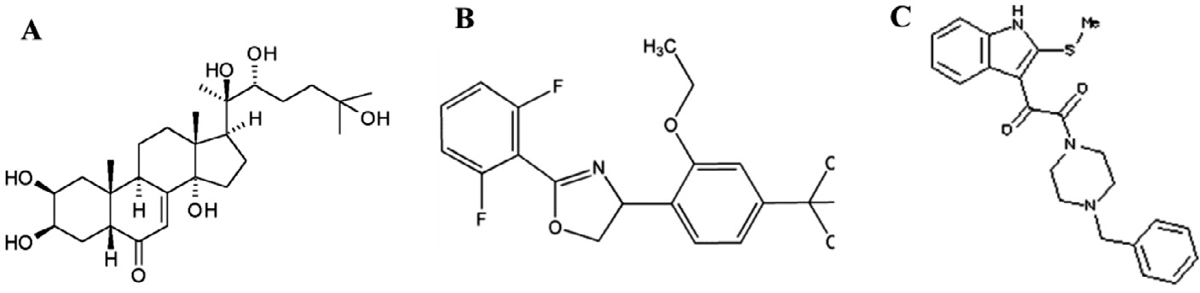

Fig. 4. 2D structure of selected agonist and antagonist, A) 20-Hydroxyecdysone, B) Etoxazole and C) ZINC20031812.

Table 3

*AmEcR* modeled protein and ligands interaction profile.

|  |  |  |  |  |  |
| --- | --- | --- | --- | --- | --- |
| Ligands Name | Interaction Part |  |  | Bond Length (Å) | Glide Score |
|  | Amino Acid Position | Amino Acid Part | Ligand Part |  |  |
| 20E | ALA 54 | H | O | 2.02 | —8.248 |
|  | THR 2 | H | O | 2.37 |  |
|  | TYR 64 | H | O | 2.08 |  |
|  | ASN 160 | O | H | 1.81 |  |
|  | ARG 39 | H | O | 2.33, 2.13 |  |
| Etoxazole | PHE 53 | C | H | 2.70 | —6.671 |
|  | TYR 64 | H | O | 1.96 |  |
|  | THR 2 | H | O | 1.75 |  |
| ZINC20031812 | ASN 160 | O | H | 1.97 | —6.257 |
|  | TYR 64 | H | O | 1.74 |  |

panel to display information on the terms in the Glide XP scoring function that contribute to the ligand binding.

* 1. *Methodology and parameterization for molecular simulation of protein and ligand complex*

The molecular simulations were performed using Desmond (ver.3.1) (D.E. Shaw Research, New York) with an inbuilt Optimized Potential Ligand Simulation (OPLS-2005), which provides a strong framework for the calculation of bonding energies between the biomolecular structures. In the current study, molecular dynamics was performed to detect the stability of *AmEcR* – 20E complex, *AmEcR* – Etoxazole and *AmEcR* – ZINC20031812 complex in water solvent. After 1000 ps equilibration, a trajectory for 1000 ps was generated for 100 samples. The Root Mean Square Deviation (RMSD) is used to measure the scalar distance between atoms of the same type for two structures. In the current study, we used the RMSD between C (alpha) atoms to measure the fit between protein homologs. In this calculation, we used the RMSD of heavy-atoms to compare the spatial deviation between structures in time and the original structure (at time = 0 ps). Typically, the RMSD on heavy-atoms should not change more than 3 Å within a nanosecond of molecular simulation time.

1. Results and discussion
   1. *DNA sequencing and sequence analysis*

On subsequent gene cleaning and sequencing of the PCR pro- duct, nucleic acid content using BIOEDIT (ver.7.2.5) revealed the

presence of 32.91% cytosine followed by 26.58, 21.70 and 18.81% guanine, adenine and thymine respectively. Based on these num- bers of nucleotides, the length of the partial Coding sequence region (CDS) of *EcR* possessed 553 bp and alignment was done for *AmEcR* nucleotide and its encoding protein (Fig. 1). *AmEcR* gene sequences were submitted in NCBI database (Accession number KJ652504).

* 1. *Homology modeling and structural validation*

*AmEcR* sequence was subjected to perform homology modeling against Protein Databank which has the structural conformation of each atom’s configuration. Schrödinger (ver.9.3) module chosed the ECR-LBD protein structure of *Heliothis virescens* (PDB accession code – 1R1K_D) sequence as a template to construct the *AmEcR* protein structure (Fig. 2). This *AmEcR* exhibited 89.31% similarity with template protein. Modeled structure of *AmEcR* was validated using ProCheck. An ideally, the structure showed about 86% of the residues in their core region, which is about 94% similar to that of the template structure in the alignment procedure. The percentage of residues in the core regions is the better guide to stereo- chemical quality (Table 1; Fig. 3).

* 1. *Screening of compounds*

The known 20E ligand was involved during the metamorphosis for binding to the receptor. Subsequently, 5554 compounds were screened out of which two compounds namely Etoxazole and ZINC20031812 showed docking compatibility and hence utilized for further studies (Table 2, Fig. 4). The molecules have been

assigned biologically relevant protonation states and are annotated with properties such as molecular weight, calculated Log P, and number of rotatable bonds. This database is available for free download ([http://zinc.docking.org](http://zinc.docking.org/)) in several common file formats including SMILES, mol2, 3D SDF, and DOCK flexibase format [9]. Virtual screening helps to identify novel non-steroidal ligand that are similar to the known EcR ligand [10].

* 1. *Docking and protein-ligand interaction profile*

The docking of 20E to the receptor model revealed that the ligand molecule can interact with the receptor in a similar manner to other steroid hormone-receptor complexes [11]. In the current study, *in silico* docking shows the binding domain in protein and interaction of ligands in particular pockets were shown in the Table 3. Tyrosine in the 64th position was common binding amino acid with all ligands that shows these antagonists binds in the same pocket where the authentic 20E binds*.* After analysis of sev- eral crystal structures, it revealed that the DNA-binding domain (DBD) and ligand binding domain (LBD) are highly conserved in insect EcRs [12]. An approach was initiated by using the crystal structure of the ligand-binding domain of the ecdysone receptor (EcR) of the moth *Heliotis virescens* as well as virtual molecule libraries of analogues of known diacyl-hydrazine (DAH) type ecdysteroid agonists. By docking DAH with binding pocket of EcR followed by CoMFA (Comparative Molecular Field Analysis) and CoMSIA (Comparative Molecular Similarity Indices Analysis) of the docked conformations, hitherto unexplored regions of the receptor cavity could be mapped [13].

* 1. *Modeled AmEcR vs 20E*

Molecular docking between *AmEcR* with 20E showed the ligand interacted at 5 sites of *AmEcR* having residual atom types ALA 54 (H), THR 2 (H), TYR 64 (H), ASN 160 (O), ARG 39 (H) receptor via

C (Carbon), H (Hydrogen) and O (Oxygen) forming carbon, hydro- gen and oxygen bonds with the bond distance of 2.02, 2.37, 2.08, 1.81, 2.33 and 2.13 Å (Fig. 5A). The higher interaction of *AmEcR* with 20E can be noticed from the Glide score —8.248 (Table 3). The hydrogen bonding is one of the important physicochemical properties for ligand binding to the ecdysteroid receptor, the num- ber of possible hydrogen bonding between the ligand molecule and the receptor was manually counted in the modeled ligand–recep- tor complex [10]. During the metamorphosis, the LBD plays major roles, acts as a receptor dimerization, ligand recognition and cofac- tor interactions [14]. Ecdysone receptor and ligand binding models attempt to explain how 20E and dibenzoylhydrazines interact with the ligand-binding pocket and homology model complexes offers new insights that can be exploited in the rational design of new environmentally safe insecticides [11–15].

* 1. *Modeled AmEcR vs Etoxazole*

Interaction of *AmEcR* with Etoxazole showed that this ligand interacted at 3 sites of the *AmEcR* having residual atom types PHE 53 (C), TYR 64(H) and THR 2(H) with the binding distance of 2.70,1.96 and1.75 Å (Fig. 5B). The Glide score —6.671 indicated the highest interaction of *AmEcR* with Etoxazole (Table 3). The LBD contains the ligand-binding pocket (LBP), which binds ecdys-

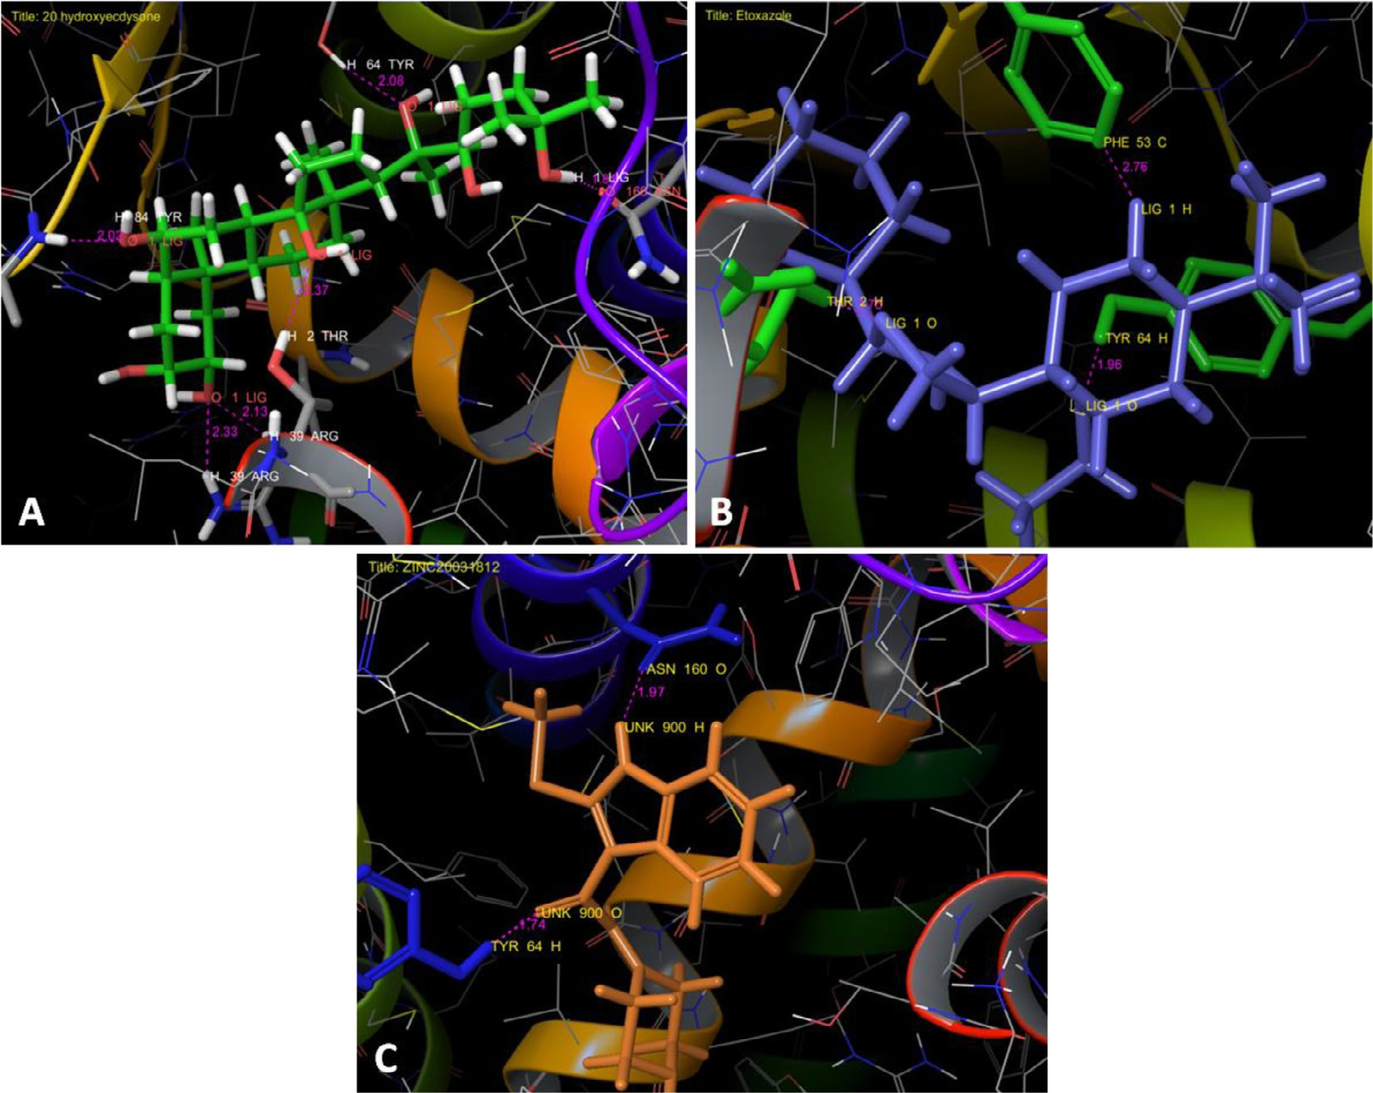

Fig. 5. Interaction profile of *AmEcR* with the tested ligands, A) *AmEcR* vs 20 hydroxyecdysone (20E), B) *AmEcR* vs Etoxazole and C) *AmEcR* vs ZINC20031812. Tyrosine in 64th position was a common binding amino acid with all ligands that shows the Etoxazole and ZINC20031812 (antagonist) binds in the same pocket where the 20E binds.

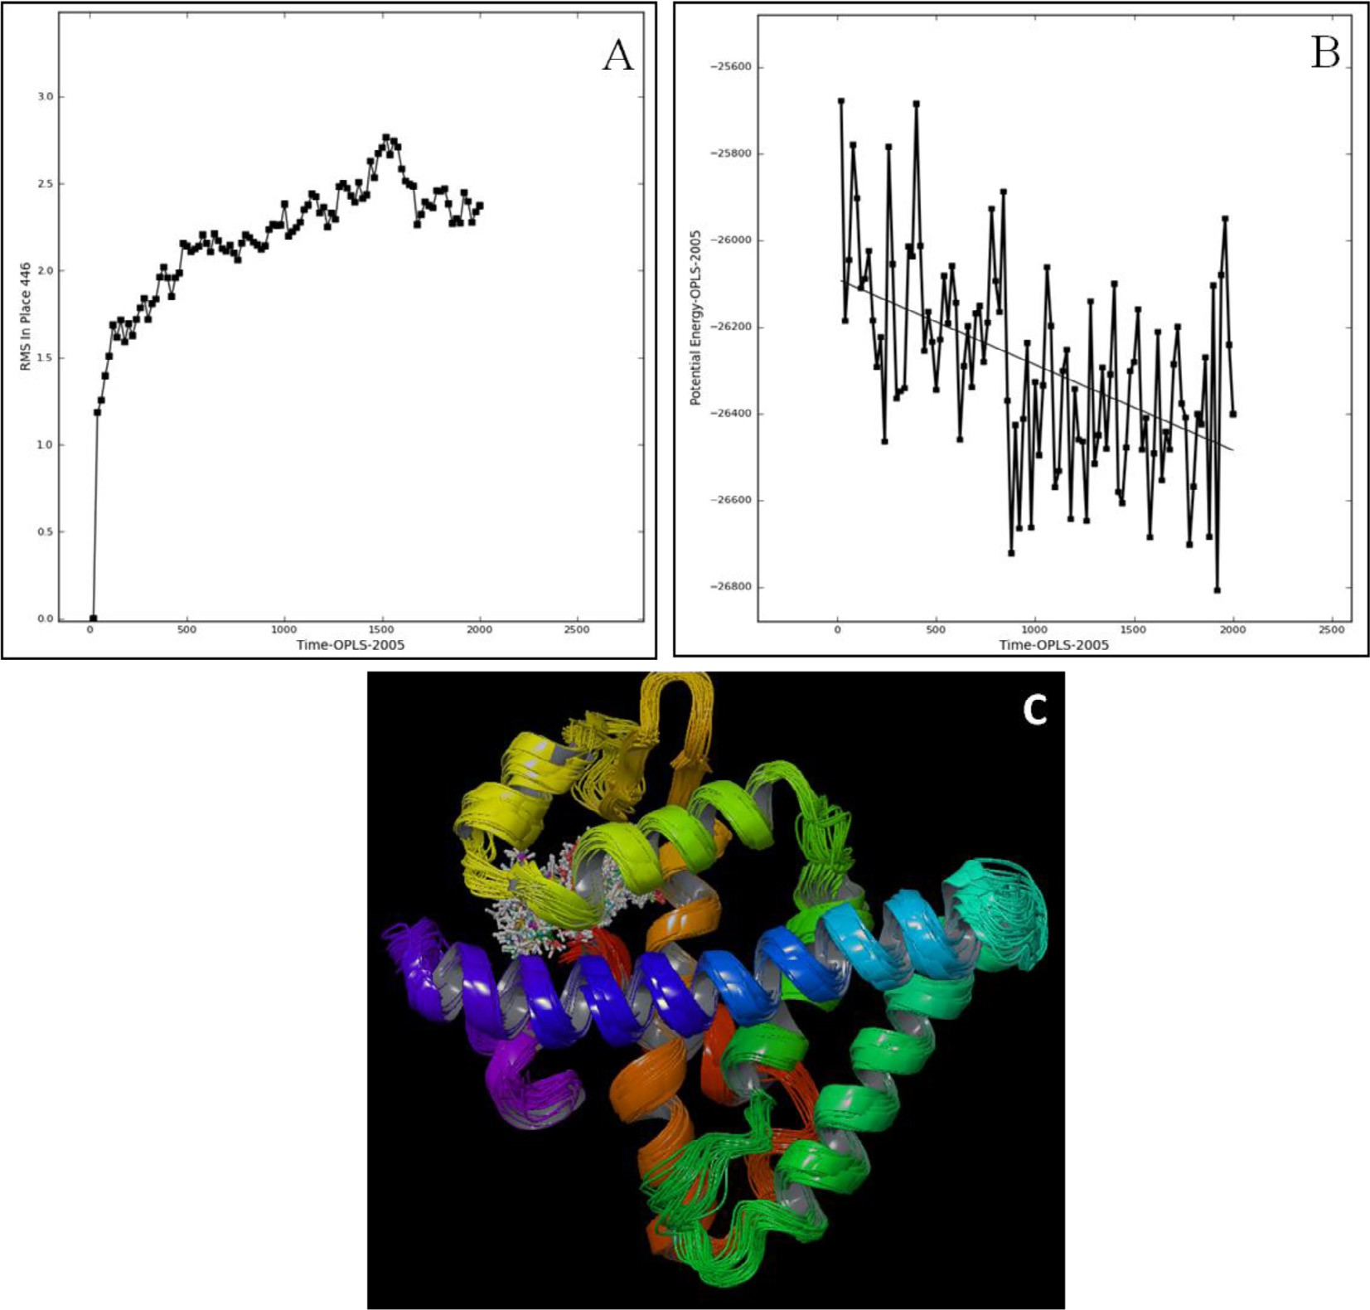

Fig. 6. Molecular dynamics of *AmEcR-*20E complex, A) RMSD graph B) Potential energy graph and C) 1–100 sample super-imposed structure of *AmEcR* and agonist 20E. *AmEcR* and 20E complex showed that *AmEcR* was stable in water between the distances of 2.3 and 2.6 Å variations. Potential deviation of this complex shows low potential energy ranging from —26100E to —26500E.

teroids as well as certain nonsteroidal EcR agonists such as the DAH-based insecticides [16].

* 1. *Modeled AmEcR vs ZINC20031812*

Docking ZINC20031812 with *AmEcR* model showed that the ligand interacted at 2 sites of the *AmEcR* having residual atom types ASN 160 (O), THR 64 (H) and its binding distance are 1.97 and 1.74 Å (Fig. 5C). The Glide score of —6.257 indicated the poten- tial interaction of *AmEcR* with ZINC20031812 (Table 3).

* 1. *Molecular simulation of AmEcR with agonist and antagonist complexes*

Molecular simulation, the positions and velocities of particles corresponding to atoms evolve according to the laws of classical physics [17]. In this paper, we showed the super-imposed conformational structure for *AmEcR*-20E, *AmEcR*-Etoxazole and *AmEcR*-ZINC20031812 complex by calculating RMSD value. RMSD measures the average change in displacement of selected atoms for a specified frame with comparison to a reference frame, which is intended for all frames in the trajectory. In protein RMSD, pro- tein frames would be aligned initially on the reference frame back- bone where the RMSD is calculated based on the atomic selection.

This provides a clear insight on the structural conformation of the protein throughout the simulation. Further RMSD analysis would also illustrate the equilibrated simulation if any, its fluctuations towards the end of simulation around thermal average structure. During simulation, changes of order from 1 to 3 Å for small, glob- ular proteins are tolerable. The changes are much greater than the above specified value indicates large conformational change of the protein during simulation.

It is to be noted that if the simulation converges, the RMSD val- ues stabilize around a fixed value. The increasing or decreasing pattern of RMSD of the protein at the end of the simulation, indexes that the system is not equilibrated. Ligand RMSD indicates the stability of the ligand with respect to the protein and its bind- ing pocket. RMSD of protein-ligand complex is aligned on the pro- tein backbone of the reference and later to which, the same for the ligand heavy atoms is measured. It is suggested that if the values are significantly larger than the RMSD of the protein, it is likely that the ligand has diffused away from its initial binding site [18].

* 1. *Molecular simulation analysis of AmEcR-20E complex*

RMSD was drawn from the super-imposed conformational structure for *AmEcR* and 20E complex, it showed that *AmEcR* was stable in water between the distances of 2.3 and 2.6 Å variations

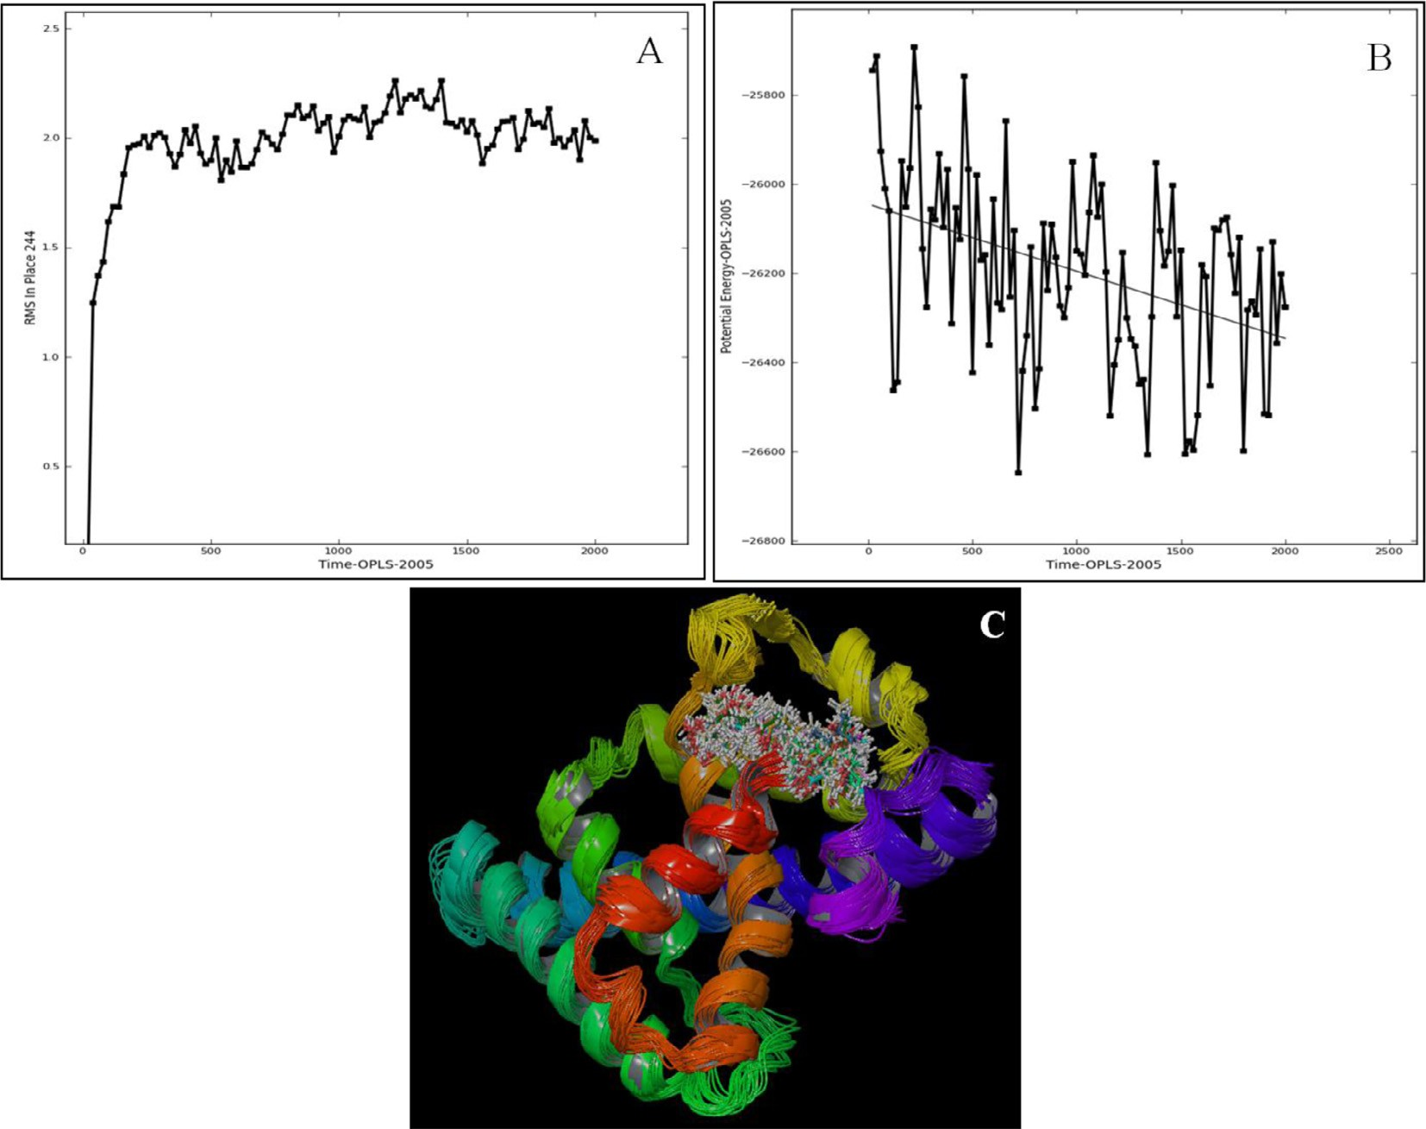

Fig. 7. Molecular simulation of *AmEcR-*Etoxazole complex, A) RMSD graph B) Potential energy graph and C) 1–100 sample super-imposed structure of *AmEcR* and antagonist Etoxazole. Super imposed conformational of *AmEcR* and Etoxazole complex shows the structural stability in water between the distances 1.8 and 2.3 Å and potential deviation ranging from —26000E to —26400E, lower potential energy confirms the binding stability.

(Fig. 6A). Analysis of *AmEcR* and 20E complex with potential devi- ation showed that it was simulated and had low potential energy ranging from —26100E to —26500E for the observed complex structure (Fig. 6B). Lowering in potential energy indicated for the increase in complexity in intermolecular bonding. The trajectories from 1 to 100 were super-imposed and checked for the movement of the complex structure. The structure alignment exhibited more complexity with respect to the water environment, since the envi- ronment was hydrophobic and the ligand had more effect in the internal bonding with *AmEcR* (Fig. 6C). The accurate prediction of protein-ligand binding free energies is a primary objective in com- putational drug design. Using the Optimise potential for liquid sim- ulation (OPLS-2005) force field and obtain high correlation with experimental solvation free energies and low average unsigned errors for a majority of the functional groups [19].

* 1. *Molecular simulation analysis of AmEcR-Antagonist complex*

Super imposed conformational structure for *AmEcR* and Etoxa- zole complex showed that *AmEcR* was stable in water between the distances of 1.8 and 2.3 Å (Fig. 7A) and ZINC20031812 showed from 1.9 to 2.3 Å variation (Fig. 8A). The mode of action of Etoxa- zole reveals the chitin biosynthesis inhibitor activity. The moulting defects were observed in fall armyworm *Spodoptera frugiperda* lar- vae [20].

Simulated *AmEcR* and both antagonist complex with same potential deviation ranging from —26000E to —26400E, lower potential energy confirms the binding stability (Fig. 7B, Fig. 8B). The trajectories from 1 to 100 were super-imposed and checked for the movement of the complex structure. The structure align-

ment exhibited more complexity with respect to the water envi- ronment, since the environment was hydrophobic, and the ligand had more effect in the internal bonding with *AmEcR* (Fig. 7C, Fig. 8C). Chitin synthesis inhibitor activity of Etoxazole was tested against major insect pest of vegetables, beet armyworm (*Spodop- tera exigua*), diamondback moth (*Plutella xylostella*), bean aphid (*Aphis craccivora*) and carmine spider mite (*Tetranychus cinnabari- nus*) and its effective with LC50 also recorded [21].

On comparing the RMSD value of agonist and antagonist indi- cates that they were stable in water with a range of distance from

2.3 to 2.6 Å, 1.8 to 2.3 Å and 1.9 to 2.3 Å with a variation over the time scale of 1 ps. Since Etoxazole and ZINC20031812 are antago- nists, computationally they were more stable than 20E. In current work, we proposed a target selective potential compounds are cap- able for controlling specific insect pests, without causing consider- able harm to other non-target organisms in the environment. *In silico* analysis enable more information on screening, possible mode of action and selecting a controlling agent before *in vitro* or *in vivo* studies. A novel caterpillar controlling agent named tebufe- nozide that poses very minimal hazard on non-target organisms and safe an ecosystem. It can be used on wide range of agricultural pests, and effectively replacing the environmentally toxic broad spectrum insecticides [22]. Comparison of the EcR structures in complex with steroidal and non-steroidal ligands reveals radically different and only partially overlapping ligand-binding pockets that could not be predicted by molecular modeling and docking studies [23]. The non-steroidal compound such as RH 5849 (1,2-dibenzoyl-1-*tert*-butylhydrazine) causes the premature initia- tion of moulting at all larval development stages of tobacco horn- worm, *Manduca sexta*. The RH 5849 was 30 to >670 times as active

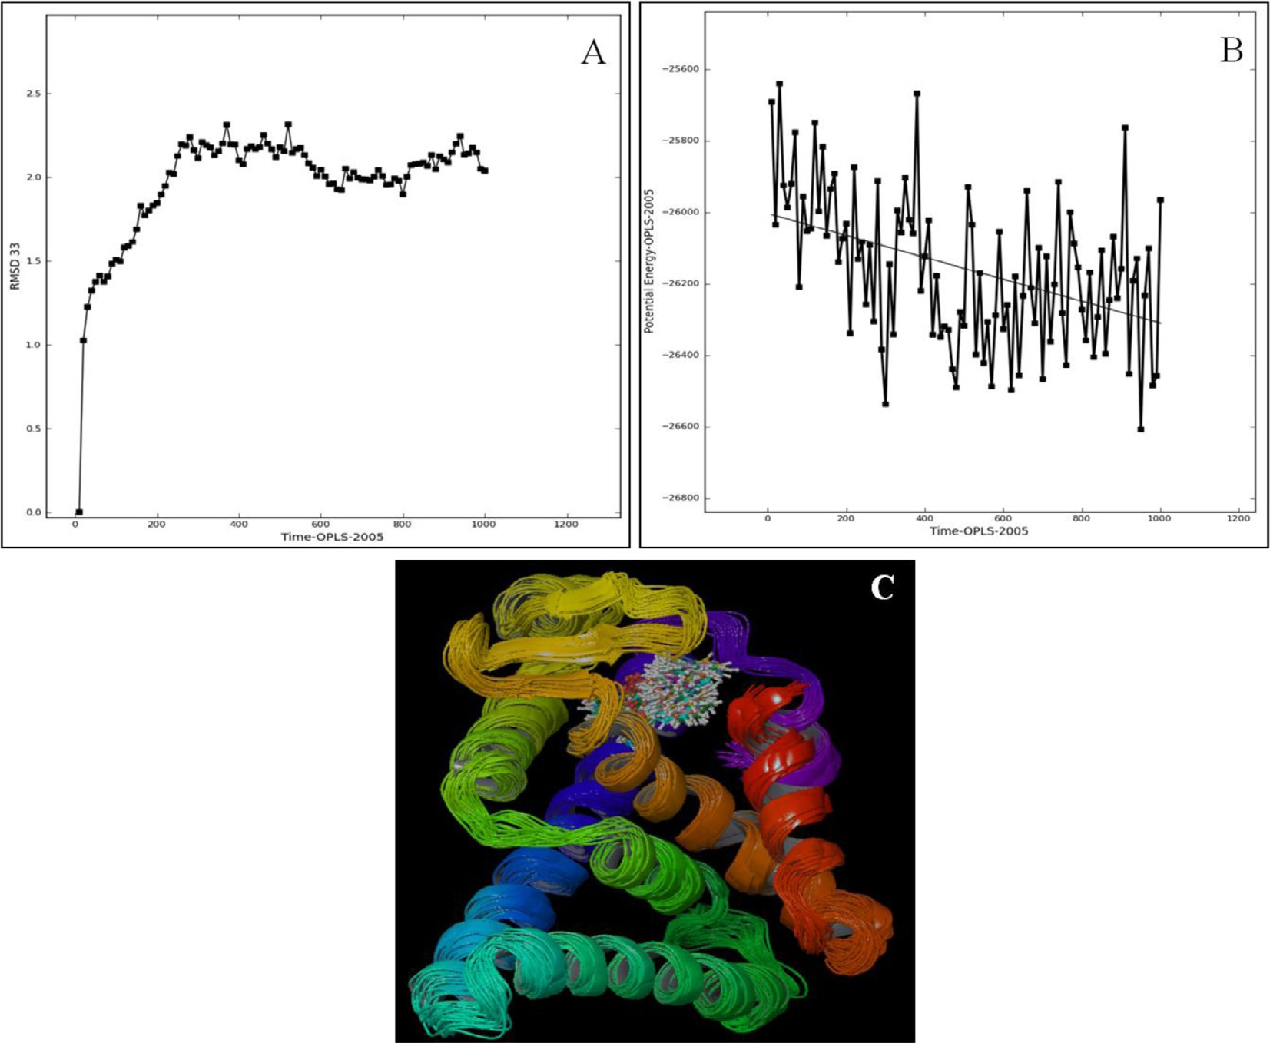

Fig. 8. Molecular simulation of *AmEcR*-ZINC20031812 complex A) RMSD graph B) Potential energy graph and C) 1–100 sample super-imposed structure of *AmEcR* and ZINC20031812. Super imposed structure for *AmEcR* and ZINC20031812 showed 1.9–2.3 Å variation which is stable in water and with lower potential energy ranging from

—26000E to —26400E.

as like the 20-hydroxyecdysone moulting hormone [24]. By docking of 20E and dibenzoylhydrazines to the ecdysone receptor, a possible novel superposition of the natural and synthetic mole- cules are enabling for the designing of environment friendly insec- ticides [15].

In the past, the control of arthropods depended mostly on chemical insecticides and these chemical pesticides are known to pollute the environment and also effects on non-target species. Chemical pesticides are not only depleting the nutritional value of our food, also it accumulates. Research has consistently found pesticide residues in food, by consuming it leads to myriad of dis- eases. The World Health Organization (WHO) estimates that there are 3 million cases of pesticide poisoning each year and up to 220,000 deaths, primarily in developing countries and children are more vulnerable to the chemical pesticides.

Now-a-days, there is more number of databases which provide thousands of plant based compound. These bioactive compounds may be potent in controlling the serious agricultural pest and also they are eco-friendly. These bioactive compounds may have allos- teric regulation property, it can target the protein in other poten- tial binding sites which may be effectively changes the conformational structure of protein and inhibits the binding of nat- ural 20-hydroxyecdysone hormone in its dedicated pocket. The limonoids a compound belonging to tetranortriterpenoid group, in general, compounds belong to this group exhibits a wide range of biological activities like insecticidal, anti-feedant and growth regulating activity on insects [25]. Cytotoxic effect of nimbolide (a limonoid) was analyzed on *Sf9* (insect) cell lines, whereas the concentration at 9.8 lM acts fast on the *Sf* cells lines and induced

disruption of plasma membranes [26]. Also, Cucurbitacins B and D, isolated from seeds of *Iberis umbellata* (Cruciferae) have been shown to be responsible for the antagonistic activity in preventing the 20E induced morphological changes in *Drosophila melanogaster* BII permanent cell line [27].

The larvae of many Lepidopteron species are major pests in agriculture. The major pest family belongs to Noctuidae, Pyralidae and Tortricidae. *Ariadne merione* belongs to the order Lepidoptera and family Nymphalidae. Although it is not considered as a serious pest, the *in silico* studies facilitates to maintain the data on target protein, compounds and an insight to design insect specific biopesticide.

1. Conclusion

*AmEcR* gene was amplified, sequenced and computational pro- teomics analysis were done to understand the mechanism of ago- nist and antagonist molecule in biocontrol perspective. Biocontrol method will be more precise due to the receptor specific antagonist designed using bioinformatic tools and this concept will be insect specific and it helps in preserving beneficial insect and the environment.

Acknowledgement

The authors are thankful to The Management, Karpagam University, Karpagam Academy of Higher Education, Coimbatore for providing all facilities required during this study.

References

1. [Jayachandran B, Hussain M, Asgari S. Regulation of *Helicoverpa armigera*](http://refhub.elsevier.com/S2314-808X(17)30303-2/h0005)[ecdysone receptor by miR-14 and its potential link to baculovirus infection. J](http://refhub.elsevier.com/S2314-808X(17)30303-2/h0005) [Invertebr Pathol 2013;114:151–7](http://refhub.elsevier.com/S2314-808X(17)30303-2/h0005).
2. [Mané-Padrós D, Borràs-Castells F, Belles X, Martín D. Nuclear receptor HR4](http://refhub.elsevier.com/S2314-808X(17)30303-2/h0010) [plays an essential role in the ecdysteroid-triggered gene cascade in the](http://refhub.elsevier.com/S2314-808X(17)30303-2/h0010) [development of the hemimetabolous insect *Blattella germanica*. Mol Cell](http://refhub.elsevier.com/S2314-808X(17)30303-2/h0010) [Endocrinol 2012;348:322–30](http://refhub.elsevier.com/S2314-808X(17)30303-2/h0010).
3. [Thummel CS. From embryogenesis to metamorphosis: the regulation and](http://refhub.elsevier.com/S2314-808X(17)30303-2/h0015) [function of *Drosophila* nuclear receptor superfamily members. Cell 1995;83:](http://refhub.elsevier.com/S2314-808X(17)30303-2/h0015) [871–7](http://refhub.elsevier.com/S2314-808X(17)30303-2/h0015).
4. [Zheng WW, Yang DT, Wang JX, Song SQ, Gilbert LI, Zhao XF. Hsc70 binds to](http://refhub.elsevier.com/S2314-808X(17)30303-2/h0020) [ultraspiracle resulting in the upregulation of 20-hydroxyecdsone-responsive](http://refhub.elsevier.com/S2314-808X(17)30303-2/h0020) [genes in *Helicoverpa armigera*. Mol Cell Endocrinol 2010;315:282–91](http://refhub.elsevier.com/S2314-808X(17)30303-2/h0020).
5. [Merzendorfer H, Zimoch L. Chitin metabolism in insects: structure, function](http://refhub.elsevier.com/S2314-808X(17)30303-2/h0025) [and regulation of chitin synthases and chitinases. J Exp Biol 2003;206. 4393-](http://refhub.elsevier.com/S2314-808X(17)30303-2/h0025) [12](http://refhub.elsevier.com/S2314-808X(17)30303-2/h0025).
6. [Smagghe G, Decombel L, Tirry L. Significance of absorption, oxidation, and](http://refhub.elsevier.com/S2314-808X(17)30303-2/h0030) [binding to toxicity of four ecdysone agonists in multi-resistant cotton](http://refhub.elsevier.com/S2314-808X(17)30303-2/h0030) [leafworm. Arch Insect Biochem Physiol 2001;46:127–9](http://refhub.elsevier.com/S2314-808X(17)30303-2/h0030).
7. [Tice CM. Selecting the right compounds for screening: does Lipinski’s Rule of 5](http://refhub.elsevier.com/S2314-808X(17)30303-2/h0035) [for pharmaceuticals apply to agrochemicals? Pest Manage Sci 2001;57:3–16](http://refhub.elsevier.com/S2314-808X(17)30303-2/h0035).
8. [Yadav RP, Ibrahim KS, Gurusubramanian G, Senthilkumar N. In silico docking](http://refhub.elsevier.com/S2314-808X(17)30303-2/h0040) [studies of non-azadirachtin limonoids against ecdysone receptor of](http://refhub.elsevier.com/S2314-808X(17)30303-2/h0040) [*Helicoverpa armigera* (Hubner) (Lepidoptera: Noctuidae). Med Chem Res](http://refhub.elsevier.com/S2314-808X(17)30303-2/h0040) [2015;24:2621–31](http://refhub.elsevier.com/S2314-808X(17)30303-2/h0040).
9. [Irwin JJ, Shoichet BK. ZINC – a free database of commercially available](http://refhub.elsevier.com/S2314-808X(17)30303-2/h0045) [compounds for virtual screening. J Chem Inf Model 2005;45:177–82](http://refhub.elsevier.com/S2314-808X(17)30303-2/h0045).
10. [Harada T, Nakagawa Y, Akamatsu M, Miyagawa H. Evaluation of hydrogen](http://refhub.elsevier.com/S2314-808X(17)30303-2/h0050) [bonds of ecdysteroids in the ligand–receptor interactions using a protein](http://refhub.elsevier.com/S2314-808X(17)30303-2/h0050) [modeling system. Bioorg Med Chem 2011;17:5868–73](http://refhub.elsevier.com/S2314-808X(17)30303-2/h0050).
11. [Kasuya A, Sawada Y, Tsukamoto Y, Tanaka K, Toya T, Yanagi M. Binding mode](http://refhub.elsevier.com/S2314-808X(17)30303-2/h0055) [of ecdysone agonists to the receptor: comparative modeling and docking](http://refhub.elsevier.com/S2314-808X(17)30303-2/h0055) [studies. J Mol Model 2003;9:58–65](http://refhub.elsevier.com/S2314-808X(17)30303-2/h0055).
12. [Iwema T, Chaumot A, Studer RA, Rechavi MR, Billas IML, Moras D, et al.](http://refhub.elsevier.com/S2314-808X(17)30303-2/h0060) [Structural and evolutionary innovation of the heterodimerization interface](http://refhub.elsevier.com/S2314-808X(17)30303-2/h0060) [between USP and the ecdysone receptor EcR in insects. Mol Biol Evol](http://refhub.elsevier.com/S2314-808X(17)30303-2/h0060) [2009;26:753–68](http://refhub.elsevier.com/S2314-808X(17)30303-2/h0060).
13. [Bordas B, Belai I, Lopata A, Szanto Z. Interpretation of scoring functions using](http://refhub.elsevier.com/S2314-808X(17)30303-2/h0065) [3D molecular fields. Mapping the diacyl-hydrazine-binding pocket of an insect](http://refhub.elsevier.com/S2314-808X(17)30303-2/h0065) [ecdysone receptor. J Chem Inf Model 2007;47:176–85](http://refhub.elsevier.com/S2314-808X(17)30303-2/h0065).
14. [Nakagawa Y, Henrich VC. Arthropods nuclear receptors and their role in](http://refhub.elsevier.com/S2314-808X(17)30303-2/h0070) [moulting. FEBS J 2009;276:6128–57](http://refhub.elsevier.com/S2314-808X(17)30303-2/h0070).
15. [Wurtz JM, Guillot B, Fagart J, Moras D, Tietjen K, Schindler M. A new model for](http://refhub.elsevier.com/S2314-808X(17)30303-2/h0075) [20-hydroxyecdysone and dibenzoylhydrazine binding: A homology modeling](http://refhub.elsevier.com/S2314-808X(17)30303-2/h0075) [and docking approach. Protein Sci 2000;9:1073–84](http://refhub.elsevier.com/S2314-808X(17)30303-2/h0075).
16. [Tohidi-Esfahani D, Lawrence MC, Graham LD, Hannan GN, Simpson AM, Hill RJ.](http://refhub.elsevier.com/S2314-808X(17)30303-2/h0080) [Isoforms of the heteropteran *Nezara viridula* ecdysone receptor: protein](http://refhub.elsevier.com/S2314-808X(17)30303-2/h0080) [characterisation, RH5992 insecticide binding and homology modelling. Pest](http://refhub.elsevier.com/S2314-808X(17)30303-2/h0080) [Manage Sci 2011;67:1457–67](http://refhub.elsevier.com/S2314-808X(17)30303-2/h0080).
17. Bowers KJ, Chow E, Xu H, Dror RO, Eastwood MP, Gregersen BA et al. Scalable algorithms for molecular dynamics simulations on commodity clusters, Proceedings of the ACM/IEEE conference on supercomputing (SC06), Tampa, Florida; 2006. p. 11–17.
18. Schrödinger release, Maestro-Desmond interoperability tools, version 3.6, Schrödinger. D.E. Shaw Research, New York; 2013.
19. [Shivakumar D, Williams J, Wu Y, Damm W, Shelley J, Sherman W. Prediction of](http://refhub.elsevier.com/S2314-808X(17)30303-2/h0095) [absolute solvation free energies using molecular dynamics free energy](http://refhub.elsevier.com/S2314-808X(17)30303-2/h0095) [perturbation and the OPLS force field. J Chem Theory Comput 2010;6:](http://refhub.elsevier.com/S2314-808X(17)30303-2/h0095) [1509–19](http://refhub.elsevier.com/S2314-808X(17)30303-2/h0095).
20. [Nauen R, Smagghe G. Mode of action of etoxazole. Pest Manage Sci 2004;62:](http://refhub.elsevier.com/S2314-808X(17)30303-2/h0100) [379–82](http://refhub.elsevier.com/S2314-808X(17)30303-2/h0100).
21. [Li Y, Yang N, Wei X, Ling Y, Yang X, Wang Q. Evaluation of etoxazole against](http://refhub.elsevier.com/S2314-808X(17)30303-2/h0105) [insects and acari in vegetables in China. J Insect Sci 2014;14:1–14](http://refhub.elsevier.com/S2314-808X(17)30303-2/h0105).
22. Carlson GR. Tebufenozide: a novel caterpillar control agent with unusually high target selectivity. Green chemical syntheses and processes. In: ACS symposium series, Pennsylvania; 2000. p. 8–17.
23. [Billas IML, Iwema T, Garnier JM, Mitschler A, Rochel N, Moras D. Structural](http://refhub.elsevier.com/S2314-808X(17)30303-2/h0115) [adaptability in the ligand-binding pocket of the ecdysone hormone receptor.](http://refhub.elsevier.com/S2314-808X(17)30303-2/h0115) [Lett Nat 2003;426:91–6](http://refhub.elsevier.com/S2314-808X(17)30303-2/h0115).
24. [Wing KD, Slawecki RA, Carlson GR. RH-5849, nonsteroidal ecdysone agonist:](http://refhub.elsevier.com/S2314-808X(17)30303-2/h0120) [effects on larval Lepidoptera. Science 1988;241:470–2](http://refhub.elsevier.com/S2314-808X(17)30303-2/h0120).
25. [Roy A, Saraf S. Limonoids: overview of significant bioactive triterpenes](http://refhub.elsevier.com/S2314-808X(17)30303-2/h0125) [distributed in plants kingdom. Biol Pharm Bull 2006;29:191–201](http://refhub.elsevier.com/S2314-808X(17)30303-2/h0125).
26. [Cohen E, Quistad GB, Casida JE. Cytotoxicity of nimbolide, epoxyazadiradione](http://refhub.elsevier.com/S2314-808X(17)30303-2/h0130) [and other limonoids from neem insecticide. Life Sci 1996;58:1075–81](http://refhub.elsevier.com/S2314-808X(17)30303-2/h0130).
27. [Dinan L, Whiting P, Girault JP, Lafont R, Dhadialla TS, Cress DE, et al.](http://refhub.elsevier.com/S2314-808X(17)30303-2/h0135) [Cucurbitacins are insect steroid hormone antagonists acting at the ecdysteroid](http://refhub.elsevier.com/S2314-808X(17)30303-2/h0135) [receptor. Biochem J 1997;327:643–50](http://refhub.elsevier.com/S2314-808X(17)30303-2/h0135).