[Computers](https://doi.org/10.1016/j.cexr.2023.100017) & [Education: X Reality 2 (2023) 100017](https://doi.org/10.1016/j.cexr.2023.100017)

 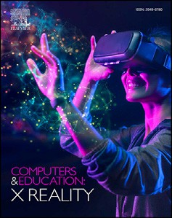

Contents lists available at [ScienceDirect](http://www.sciencedirect.com/science/journal/29496780)

Computers & Education: X Reality

journal homepage: [www.journals.elsevier.com/computers-and-education-x-reality](http://www.journals.elsevier.com/computers-and-education-x-reality)

[](http://crossmark.crossref.org/dialog/?doi=10.1016/j.cexr.2023.100017&domain=pdf)Authentic learning and fidelity in virtual reality learning experiences for self-efficacy and transfer

Victoria Lynn Lowell a,*, Deepti Tagare b

a *Purdue University, College of Education, 100 N. University St., Beering Hall 3130, West Lafayette, IN, 47907, USA*

b *Purdue University, College of Education, 100 N. University St, West Lafayette, IN, 47907, USA*

A R T I C L E I N F O

*Keywords:* Authentic learning Authenticity Fidelity

Virtual reality Learning experience VRLE

Collaborative learning Self-efficacy

Transfer

A B S T R A C T

Authentic learning is an instructional approach that best occurs when the learning activities are set in real-world contexts. The authenticity of the learning experience increases when learning is situated in a context akin to the real world, and realistic learning experiences are created by carefully designing the learning tasks, context, and environment. The fidelity of a learning task's psychological, physical, functional, and social aspects and envi- ronment is the design attributes that contribute to the authenticity of the learning experience. The social context, or the social environment during learning, is essential in engaging learners in authentic learning tasks. In this mixed-method study, we investigate whether the collaborative nature of the learning activities, the authentic design of the learning experience and tasks, and the social environment impact the learner's perceptions of their learning experience and confidence in learning transfer. Two instruments were used to collect quantitative and qualitative data. The quantitative and qualitative data were analyzed separately and then together through triangulation. The findings of this study suggest that learners perceived the tasks and environment as realistic and the learning activities' collaborative aspect as helpful. The authentic learning environment did not significantly impact learners' confidence to transfer. However, the experience led to valuable metacognitive reflection and change in self-efficacy beliefs about their learning and practice needs. This experience may result in better self- regulation in long-term learning. This paper presents the findings of this study and discusses future research implications.

1. Introduction

Authentic learning is an instructional approach that often situates learning in a context akin to the real world. Authenticity in learning occurs through the dynamic interactions between the learner, the task, and the environment where the learning occurs (Barab et al., 2000). The attainment that occurs due to these dynamic interactions allows the learner to apply the knowledge gained in a similar context in the future. The authenticity of learning experiences has been of interest to re- searchers for decades as such experiences engage learners as they can connect what learners are learning in their classroom to real world problems, applications, and contexts (Falconer, 2010, 2013, 2014; Kno-

bloch, 2003; Lombardi, 2007; McDermott & Daniels, 2021; Ornellas et al., 2019; Roach et al., 2018).

Creating realistic learning experiences involves careful consideration of the tasks that the learners will complete and the context and envi- ronment in which the learning will occur (Falconer, 2013; Holt et al.,

2012; Mainey et al., 2018; Zuo, Josephson, & Scheitrum, 2019). Fidelity is a design attribute that refers to the “degree of detail and quality replicated” in a design (Cambridge DictionaryCambridge Dictionary, n.d.). The fidelity of the tasks coupled with the fidelity of the psycho- logical, physical, functional, and social aspects of the learning environ- ment are design attributes that contribute to the authenticity of learning experiences (Bland et al., 2014; Branch, 2013; Champney et al., 2017; Maran & Glavin, 2003; Sinatra et al., 2021). In addition to the learning environment, some researchers (i.e., Hanks, 1991; Lave & Wenger, 1991) noted that the social context or environment is essential to engage learners in authentic learning tasks (ALTs).

In this paper, we discuss a study where graduate students completed learning activities to practice specific skills (e.g., asking a patient ques- tions during an interview) within a virtual reality learning environment (VRLE). In the study, we investigate whether the collaborative nature of the learning activities and the authentic design of the learning experi- ence, including the learning tasks, learning environment, and the social

* Corresponding author.

*E-mail addresses:* [vllowell@purdue.edu](mailto:vllowell@purdue.edu) (V.L. Lowell), [dtagare@purdue.edu](mailto:dtagare@purdue.edu) (D. Tagare).

<https://doi.org/10.1016/j.cexr.2023.100017>

Received 7 August 2022; Received in revised form 20 March 2023; Accepted 20 March 2023

2949-6780/© 2023 The Authors. Published by Elsevier Ltd. This is an open access article under the CC BY-NC-ND license ([http://creativecommons.org/licenses/by-](http://creativecommons.org/licenses/by-nc-nd/4.0/) [nc-nd/4.0/](http://creativecommons.org/licenses/by-nc-nd/4.0/)).

environment in the VRLE, impact the learner's perceptions of their learning experience and their confidence in their ability to take what they have learned and apply it in real life (i.e., learning transfer).

* 1. *Authentic learning and authentic learning tasks*

Using an authentic learning method can allow learners to “explore, discuss, and meaningfully construct concepts and relationships in con- texts that involve real-world problems and projects that are relevant to the learner” (Mims, 2003, p. 2). In authentic learning experiences, stu- dents “learn by doing” authentic learning tasks (ALTs), which help them acquire the foundational skills, knowledge, and understandings they will need and use in other contexts (e.g., their job site). Engaging in ALTs encourages learner participation and immersion (Bhagat & Huang, 2018; Herrington et al., 2003a; Lowell & Yang, 2022). ALTs resemble tasks such as those performed in real life (e.g., interviewing a patient in a non-educational setting) and serve as a vehicle for learning a broad range of knowledge and skills (Bhagat & Huang, 2018; Holt et al., 2012; Mueller, 2005, Roth, 1995; Woo et al., 2007). ALTs also allow teachers to assess whether students have constructed an accurate interpretation of the information they have been taught (Mueller, 2005, 2018).

One of the many strengths of an authentic learning method is that it often allows students to interact with the complexities and ambiguities of real life and “the messiness of real life decision making” that are impossible to create many traditional teaching and learning approaches (Lombardi, 2007, p. 10; Lowell & Yang, 2022). For example, in real life, a counselor may have a patient who is scared or uncooperative, lashes out during a therapy session, or has evidence of physical harm. When a concept or skill is still being learned, (e.g., working with an uncoopera- tive patient), learning such a skill in an abstract or disconnected way from how a learner will apply that skill in real life, it can be difficult for learners to transfer the skill then and feel confident in their ability to transfer. Therefore, providing students with authentic learning experi- ences (e.g., working with an uncooperative patient) in a realistic envi- ronment may help them feel more confident and remember the correct procedures to apply what they learned in a real-life counseling session.

From a teaching standpoint, completing ALTs through authentic learning experiences can assist teachers in assessing whether students can exhibit needed knowledge and skills and, therefore, can potentially transfer learning from ALTs to real-life situations. Herrington et al. (2014) explain that assessing ALTs in an authentic learning environment has several requirements. First, the assessment must be tied to success- fully completing a task with opportunities to collaborate with others. Second, the assessment must occur by allowing students to demonstrate performance using acquired knowledge and collaborate with others in creating those performances or products. In addition, assessments of ALTs must be integrated with ALTs, and the criteria for scoring the performance or products must be based on the ALTs (Linn et al., 1991; Herrington et al., 2014; Reeves & Okey, 1996; Wiggins, 1993).

* 1. *Situating learners for authentic learning experiences with sociocultural opportunities*

As per the situated cognition theory, learning is a sociocultural ac- tivity (social interaction and cultural play a role) that occurs with others in a situated context (physical and social environment), rather than an activity where an individual acquires information alone and from a decontextualized body of knowledge (Kirshner & Whitson, 1997; Stein, 1998). Therefore, the relationship between learning and a social situa- tion is essential to situated learning (Hanks, 1991), and learning activ- ities should be completed in a context with the support of a community of other learners and the guidance of experts as a sociocultural activity (Allman, 2018; Miller, 2011; Vygotsky, 1978). It is through such activ- ities that a learning community can be created and students can build their knowledge individually while the community builds knowledge by taking collective responsibility to improve their understanding of

authentic problems (Scardamalia & Bereiter, 2014). Situated learning theory (i.e., situated cognition theory) holds that knowledge should be delivered in authentic contexts (Brown et al., 1989), which involves placing learners into learning contexts where learners can observe, evaluate, participate, and interact with others, including experts who can model behaviors (Lave & Wenger, 1991). Situating learners in an authentic learning context offers them opportunities to develop knowl- edge and skills for real-world situations while the support of a classroom instructional context with a teacher and peers (Lowell & Yang, 2022; Radinsky et al., 2001; Stefaniak, 2015).

* 1. *Authenticity of the learning context*

An authentic learning context, also referred to as a learning envi- ronment, consists of the task, the environment, and the culture and should reflect how the knowledge and skills learned will be used for authentic tasks in real life (Gulikers et al., 2005; Herrington et al., 2014; Holt et al., 2012; Onda, 2012; Smeds et al., 2015; Zuo et al., 2019). The learning context could be physical or virtual, and it should resemble the real world with the complexity, limitations, options, and possibilities found in real life (Gulikers et al., 2005) and it may include simulated and immersive tasks and a realistic environment (Zuo et al., 2019).

When creating instruction and learning experiences, designing a realistic learning environment based on a real-world context is an important goal, as replicating real-world complexities is essential to maximize a significantly higher recall of learned content and better skill transfer (Imuta et al., 2018). Human memory is highly dependent on the environment in which the learning or event occurs (Smith & Vela, 2001), as recall of concepts learned occurs best when the learning context is replicated in the test environment (Imuta et al., 2018). Thus, carefully designing the instructional context to the real-world context is essential to maximize the knowledge or skill learned for potential transfer.

However, while the authenticity of a learning task is based on a learner's subjective experience with the learning task and the learning environment, fidelity is the design attribute (degree of detail and quality replicated - Cambridge Dictionary, n.d.) that enables and facilitates the design of authenticity in learning (Bland et al., 2014; Kinney & Hen- derson, 2008). The ability to replicate a real-world context in an envi- ronment using learning technologies is offered by the fidelity of the virtual environment's physical, functional, psychological, and social as- pects (Branch, 2013; Champney et al., 2017; Maran & Glavin, 2003; McMahan et al., 2012; Rogers et al., 2019; Sinatra et al., 2021). A com- bination of these aspects of fidelity is thus a potential attribute (Bland et al., 2014; Sinatra et al., 2021) that cannot be isolated from human interactions and the emotional aspects of learning (Berragan, 2011; Hung & Chen, 2007) (See Table 1).

Table 1

Aspects of fidelity design.

Aspect Definition/Description

Physical The degree to which the spatial and sensory attributes of an environment are replicated in the virtual environment (Champney et al., 2017). This represents the physical surroundings that stimulate the human senses - touch, visual, auditory, taste, and smell.

Functional The degree to which the virtual environment simulates the stimulus- response characteristics of the real world (Champney et al., 2017). For example, the response of the environment when the user presses a switch or pushes a door. Does the virtual environment replicate the real-world response to such actions?

Psychological The degree to which the user can believe the realness of the situation presented in the virtual world. It allows the user to immerse themself in it and demonstrate situational awareness (Endsley, 1998).

Social The extent to which the social aspects of the real world are depicted accurately in the virtual environment (Sinatra et al., 2021). Does the social interaction in the virtual world closely represent that in the real-world setting?

* 1. *Fidelity when learning*

Fidelity is "the degree to which the detail and quality of an original, such as a picture, sound, or story, is copied exactly" (Cambridge Dictio- nary, n.d.). A learning environment's physical, functional, psychological, and social fidelity governs how closely it replicates the real-life/performance environment, creating a complex and realistic learning environment that provides the safety of formal learning (Bland et al., 2014; Branch, 2013; Champney et al., 2017; Maran & Glavin, 2003; Sinatra et al., 2021).

* + 1. *Fidelity of technology learning environments*

In simulation-based learning, fidelity enables accurate replication of the appearance and behavior of the objective reality it represents (Bland et al., 2014; Kinney & Henderson, 2008). Objective reality can be a subjective perception of the learner or participant interacting with it. This perception is based on their interaction with the context, peers, instructors, and technology with varying degrees of fidelity (Bland et al., 2014). Therefore, authenticity is governed by the complexity and unpredictability of the real-world setting reproduced in the learning context (Maran & Glavin, 2003). A high-fidelity environment that rep- licates the real scenario accurately but makes the experience predictable, in turn challenging for the learner to relate to, will not be an authentic experience (McKenna et al., 2011; Ricketts, 2011). Hence, each aspect of fidelity (physical, functional, psychological, interactive, social) (see Table 1) requires optimization to suit the needs of the learning task.

A fidelity higher or lower than optimum in any of these aspects can

lead to a higher cognitive load (Champney et al., 2017). For example, a very high physical or functional fidelity can overwhelm and distract learners from declarative and procedural knowledge (accumulating facts and knowing how to do something from practice) (Champney et al., 2017). In contrast, for higher-order thinking skills (skills that go beyond basic observation of facts and memorization – Bloom et al., 1956), low fidelity can be a hindrance to practicing and consolidating knowledge. Some studies have shown that very high functional fidelity hindered student performance or increased student anxiety due to students' lack of technological comfort in handling the simulated environment (Branch, 2013; Cobbett & Snelgrove-Clarke, 2016). In a nursing course, Cobbett and Snelgrove-Clarke (2016) found that learners prefer face-to-face learning environments to high-fidelity virtual environments because of the ease of practicing skills, applying learning, collaboration, and hands-on work. This demonstrates another challenge; high fidelity does not guarantee an authentic experience for the learner. Hence, the level of fidelity should be chosen based on the type of task to be learned. Further, for maximum skill transfer, the focus should be on achieving an authentic learning environment that replicates the complexity and unpredictability of the performance context and creates a safe environment for learners to learn rather than on increasing fidelity.

* 1. *Virtual reality learning environments for authentic learning experiences*

Virtual Reality (VR) refers to a computer-generated simulation of a three-dimensional environment (Bryson, 1995). VR is one of several types of technology (i.e., virtual reality, augmented reality) that can be referred to as mixed reality (MR) or extended reality (x-reality). VR uses hardware (e.g., headsets, gloves) with VR software to increase the sense of being in and interacting within the VR environment. A VR environ- ment can be similar, or completely different from the real world and real-life experiences (Lowell & Ilobinso, 2023). Further, VR experiences can be categorized into three levels of immersion (fully immersive, semi-immersive, and non-immersive). Immersion in VR refers to a user's perception of being physically present in a non-physical virtual world by surrounding the user with images, sounds, or other stimuli (Freina & Ott, 2015). Fully immersive VR simulations require hardware to provide users with the most realistic experience possible (Dilmegani, 2023).

Lowell & Ilobinso, 2023 wrote, “When a user is fully immersed, they may feel they have been transported to a virtual environment that looks and feels indistinguishable from reality, providing sight, hearing, and touch experiences”. Semi-immersive VR simulations provide users with a partially immersive experience. Users can move about independently, and activities are geared toward the user. Examples of semi-immersive VR include a driving or flight simulator. While using semi-immersive VR, users may still feel like they are in a different reality, but they are still aware of the real world. Non-immersive VR simulations are often experienced through a desktop or laptop screen; an example is the video game World of WarCraft. In a non-immersive VR simulation, the user controls characters, and some activities in the environment, but the user is not the center of the action. Overall, non-immersive VR can provide a VR experience without the challenges of obtaining, setting up, or wearing special equipment (e.g., cost, fit).

Virtual reality learning environments (VRLE) have demonstrated educational affordances such as visualizing learning content, interaction with the learning environment and others, learner autonomy through identity construction/presence, and VR's ability to provide an engaging environment for experiential learning (Lowell & Ilobinso, 2023). These affordances are attributed to the technological features of representa- tional fidelity, the immediacy of control, and immersion. These affor- dances offer unique pedagogical benefits, such as a three-dimensional (3D) representation of learning content, real-time multisensory user interaction channels, and learner immersion (Dalgarno & Lee, 2010; Mikropoulos & Natsis, 2011). The benefits of VRLEs encourage constructivist learning, active participants, and experiential learning (Lee et al., 2010). A learning outcome is found to be a cumulative effect of immersion, representational fidelity, immediacy of control, and ease of use through the mediation of authenticity, relevance, and learner au- tonomy resulting in a positive affective outcome (Harley et al., 2016; Lee et al., 2010; Pekrun, 2006). Some challenges of VRLEs may include the cost of both time and money to develop the programming, the usability of the technology, and the student's perceived “realness” of their learning experience.

* 1. *Impact of authenticity and fidelity of VR on learners*

Authenticity is important in enhancing the learning outcome in a virtual reality-based learning environment. Several studies have shown that the authenticity of a VRLE impacts the cognitive, affective, and social learning processes (Harley et al., 2016; Lee et al., 2010; Makransky et al., 2019a & b; Salzman et al., 1999). A VRLE where the authentic learning experience is created would impact processes. Therefore, it is necessary to study how the media and technology features of the VRLE impact cognitive, affective, and social learning (Kozma, 1994).

* + 1. *Affective factors of learning*

Researchers have found that efficient learning and maximized learning outcomes require nurturing positive emotions and regulating negative emotions during learning (Brosch et al., 2013; Graziano et al., 2007; Rechly et al., 2008). VRLEs have a positive affective impact on the learner through the features of representational fidelity, immersion, the immediacy of control and autonomy, the authenticity of the learning environment, and the relevance of the learning content to the learner (Bursali & Yilmaz, 2019; Huang et al., 2010; Lee et al., 2010).

Learner motivation regulates the energy and attention assigned to a task or activity (Ratey, 2001), and higher satisfaction leads to higher motivation and learner engagement (Bhagat et al., 2019; VanMeerten & Varma, 2017). Enjoyment is an activity-related emotion and can be observed as a by-product of motivation and learner engagement (Pekrun, 2006; Harley et al., 2016; Lee et al., 2010). Studies that measure the affective outcome of a VRLE have shown that ease of use and relevance of learning content leads to higher levels of satisfaction among learners (Bursali & Yilmaz, 2019; Lee et al., 2010). Moreover, enjoyment levels were higher in a more authentic learning environment (Harley et al.,

2016). Affective factors are also effective in arousing and enhancing attention –presence, and engagement (Huang et al., 2010; Mikropoulos & Natsis, 2011). Thus, it can be seen that positive emotions are mutually interdependent so that favorable levels in one contribute towards increasing the others. Keller's ARCS model (Keller, 2010) defines a closed-loop relationship between attention, relevance, confidence, and satisfaction. It is evident that this impact of VRLEs on attention, rele- vance, and satisfaction also affects learners' confidence in each task or activity.

* + 1. *Learner confidence*

Confidence is the degree of certainty a person displays regarding a certain outcome, perception, or event (Bandura, 1997; Cramer et al., 2009). Learning content that focuses learners’ attention on learning and makes the activity relevant to the learner leads to better confidence among learners (Keller, 2010). Fidelity and authenticity of the learning environment play an important role in arousing learner attention and sustaining it by keeping the learner engaged and motivated through immersion and learner autonomy (Brosch et al., 2013; Makransky, Borre-Gude et al., 2019a; Makransky; Terkildsen et al., 2019b; Mikro- poulos & Natsis, 2011). Learner confidence can be promoted by carefully designing the learning experience to have optimal fidelity and an authentic and relevant environment that allows the learners autonomy and control during the learning activity.

* + 1. *Skill transfer*

In education, ‘transfer of learning’ refers to a learner's capacity to recombine, adapt, and use knowledge in a similar or new context (Bos- sard et al., 2008). In psycho-procedural skills like mental health coun- seling interview procedures, the learner must apply the knowledge of mental health conditions to diagnose the patient and learn the appro- priate procedural skills for interviewing a patient. Thus, in a real-world counseling setting, every patient would be different, and learners would need to transfer their knowledge and skills to a relatively similar yet different context. It has been observed that improved conceptual understanding leads to enhanced procedural skills (Kollo€ffel & de Jong, 2013).

Handling learned knowledge and skills in different ways and under other circumstances are learner behaviors that support conceptual transfer, and these behaviors must be encouraged through instruction (Georghiades, 2000). Smith and Vela (2001) recommend that learning activities and instruction should have context-agnostic cues and encourage introspective and reflective thought processes to minimize context-dependency in the transfer of learning. Thus, planned meta- cognitive instruction, which provides opportunities to reflect and act in varying contexts, can support skill transfer (Georghiades, 2000). A VRLE can generate similar and dissimilar simulated contexts that facilitate repetition of what is learned in related contexts. This allows the learner to take the risk of making mistakes during the learning process without bearing the consequences (Bossard et al., 2008). Procedural knowledge developed based on conceptual understanding within simulations is robust enough to transfer to real experiences of a similar nature (Falloon, 2020).

* 1. *Research purpose and gap*

The previous section has discussed how ALTs in authentic contexts, such as VRLEs, provide many benefits, including motivating and encouraging learner participation and immersing students in a learning setting (Bhagat & Huang, 2018; Herrington et al., 2003). Using VRLEs in learning can impact affective factors of learning (i.e., motivation, satis- faction, enjoyment) (Bursali & Yilmaz, 2019; Huang et al., 2010; Lee et al., 2010). Studies have shown that the authenticity of a VRLE impacts learners' cognitive, affective, and social learning processes (Harley et al., 2016; Lee et al., 2010; Makransky et al., 2019a; Makransky et al., 2019b; Salzman et al., 1999). Further, planned instruction, including those in a

VRLE, that provides students with opportunities to reflect and act in varying contexts can support skill transfer (Georghiades, 2000). It can also be purported that the authentic design and level of fidelity of the environment, including the learning context and learning tasks, could affect the overall confidence of the learner during the learning activities and the potential transfer of learning from the VRLE learning to a real-world context. Existing research is focused on descriptive knowledge recall or procedural skills. For example, using VR for procedural skill development has been conducted in other healthcare workers fields such as surgeons (Logishetty et al., 2020; Mandal & Ambade, 2022), nurses (Bracq et al., 2019; Butt et. al, 2018; Edwards et al., 2021), and para- medics (Birt et al., 2017; Lim et al., 2014). Similar research needs to be conducted using VR technology for more complex learning tasks of counselors, such as psycho-affective procedural skills during mental health diagnostic interviews, to study the effect of the authenticity and realism of the context on learners' confidence to transfer this skill. Con- ducting such research will enable replication of the design of VRLEs for different educational programs. In addition, we also need to evaluate whether VRLE is an effective learning tool for the learning tasks associ- ated with these programs. Thus, how an authentic, situated, and collaborative VRLE impacts counseling students’ perceived affective and cognitive learning outcomes and self-confidence in their ability to transfer psycho-affective procedural skills needs to be investigated. Such research will inform the design of ALTs and virtual environments to create experiences that maximize student learning, confidence, and po- tential for transfer of learning to other contexts. This research study addresses this research gap.

* 1. *Theoretical background*

This study uses the lens of social constructivism and situated cogni- tion to understand the impact of an authentic, collaborative learning environment in a VR setting on learners’ learning experience and their confidence to transfer the learned skill. Fig. 1 demonstrates a visual representation of the theoretical foundation of the study.

The following research questions guide the study.

R1. How authentic is the learning context (in the VRLE), comprising the learning environment and learning tasks?

R1a. How did students perceive the authenticity of the learning context and learning tasks?

R1b. How did students perceive the fidelity of the design of the learning environment and learning tasks?

R2. What is the impact of the authenticity of the learning context (in the VRLE), comprising the learning environment and learning tasks, on the confidence of the learner to transfer their learning to real life? R3. How does collaborative learning in a simulation learning expe- rience improve or hinder learning?

To investigate these questions, we analyzed data collected from graduate-level counseling students who participated in learning activities in a VRLE where the environment and the learning tasks were designed to be authentic to environments and tasks students would engage in as professional counselors.

1. Methodology

In this mixed-method study, graduate students in a mental health and diagnosis course completed learning activities to develop conceptual understanding and skills. These learning activities for each unit include

(1) completing readings and a literature review on the unit topic, (2) watching videos on the unit topic and discussing it in class, and (3) role- playing exercises on the unit topic in a VRLE to practice interviewing and mental health diagnosis techniques. Students completed the three learning activities for two units in the course: (1) self-injury and (2) eating disorders. Students were introduced to the VRLE during the first

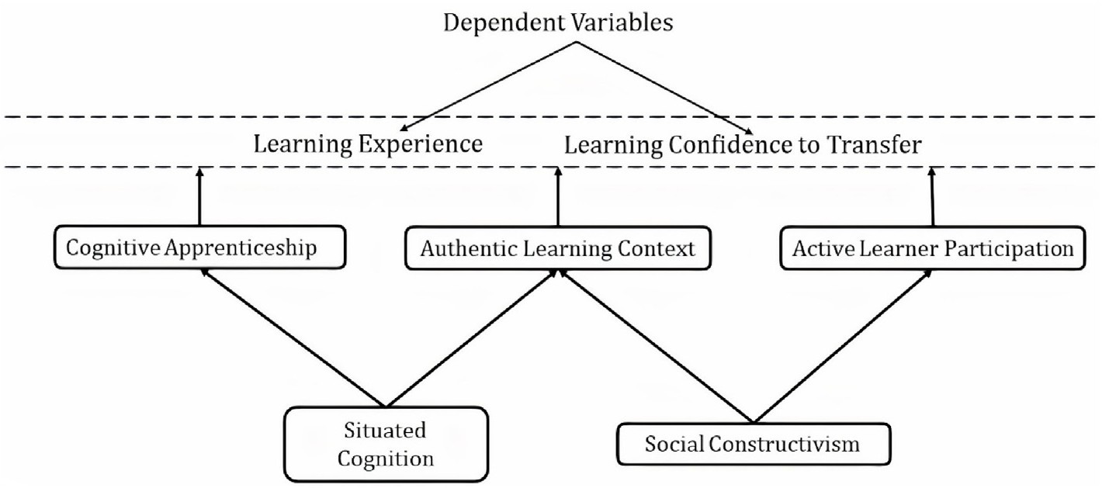

Fig. 1. Theoretical foundation.

week of their Diagnosis of Mental Health Issues in Counseling course and provided several scaffolds, including tutorials on using the technology. The two units were chosen near the end of the course to provide students time to become familiar with the instructional methods of the course and the VRLE environment. Further, two units were used in this study, rather than one, to account for the possibility of unit content making a differ- ence in students' experiences, perceptions, and learning. We compared role-playing activities in a simulated context and environment to stan- dard methods (i.e., assigned readings, videos, class discussions) used to instruct students on the disorders and the procedures for interviewing and diagnosing patients.

* 1. *Participants and the course*

The sample for this study were graduate students enrolled in the Diagnosis of Mental Health Issues in Counseling course, a required course in the Master of Counseling program at a Midwestern university. The focus of the course is to provide students with an opportunity to study mental health concepts, practice diagnosis of mental health disorders, and understand the dynamics of human behavior. The objectives for the course follow the learning outcomes required by the Council for Accreditation of Counseling and Related Programs (CACREP) (CACREP, 2009). These include learning diagnostic terminology, conducting a diagnostic interview, recognizing signs and symptoms of various mental disorders, and documenting the case conceptualization and diagnosis (CACREP). Although 23 students agreed to participate, some missed a class or did not complete a survey and were removed from the study. The total number of students who completed the study was 16, or 70%.

The participants in the study ranged in age, technology experience, and time in their graduate program. The participants’ ages ranged from 22 to 51, with the majority (75%) below 35 years of age. Most partici- pants (12/16–75%) were in their first year, while four students reported they were further into their program. There were participants with various online technology experiences, from little experience to very experienced. Two participants said they had never used any Web 2.0 tools, while all other participants had some experience with at least one web-based tool. Eleven students (68.75%) claimed they were somewhat technology literate. Yet only half of the participants (50%) reported they had experience in an online or hybrid course. Three participants claimed they had never played a computer game. Despite the learners being moderately comfortable with technology, 87.5% (14/16) found the VRLE easy or very easy to use.

We looked at participants' ages to see if their age impacted their perceived technology literacy, perceived ease of use of the 3D environ- ment, and perceived realism of the environment. No noticeable patterns were found in this data. However, we noticed that participants’ reported time taken to develop comfort with the technology increased as their age increased, indicating that those in their 40s and 50s took longer than

those in their 20s to get comfortable with the Second Life environment. However, when completing our quantitative analysis, we found that this did not seem to impact their perception of realism, their perception of the effectiveness of the VR environment in gaining knowledge, and their ease of use.

* 1. *Virtual reality counselor training facility*

When designing authentic virtual experiences, the authenticity of the learning environment, task, and culture is important. The virtual coun- selor training facility was created in the VR environment, Second Life. The students downloaded the client software to their computers to access the VR environment. Once logged in, they could explore the virtual world with an avatar they choose, interact with others, build things, and pur- chase items with in-world funds. There was no cost for users to download the client software, explore, or interact with others. Second Life provided many benefits for activities in the Diagnosis of Mental Health Issues in Counseling course, including ease of access for the instructor and stu- dents during and outside of scheduled learning times and options to design the environment and avatars to meet instructional and learner needs. The physical and functional authenticity of the environment was achieved by closely recreating the structure and complexity of the building where students would normally apply their skills.

The building had three floors (see Fig. 2), with the first floor offering a welcome area (see Fig. 3) and the second floor having six counseling rooms (Lowell & Alshammari, 2017). The counseling rooms were designed to imitate a room that may be used in a real-life clinical

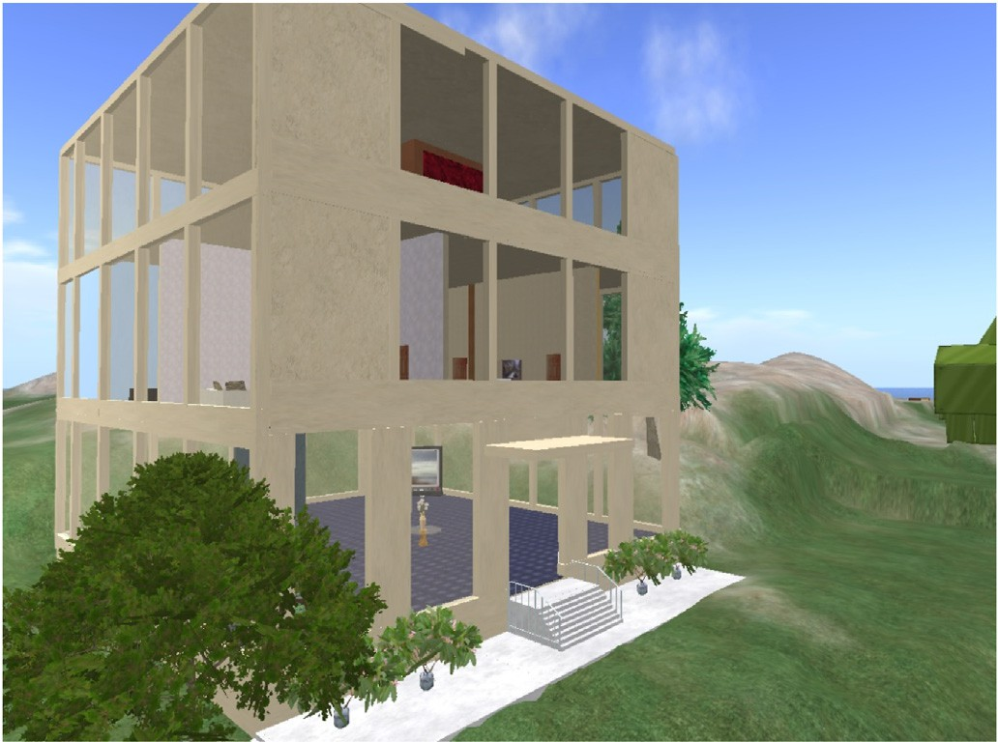

Fig. 2. Virtual counselor training facility building.

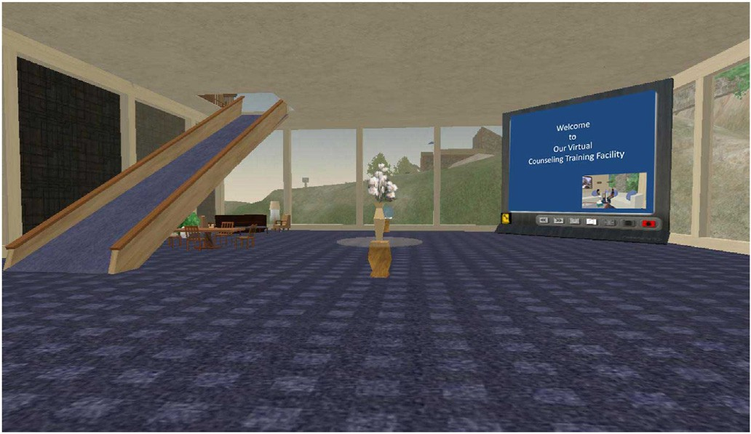 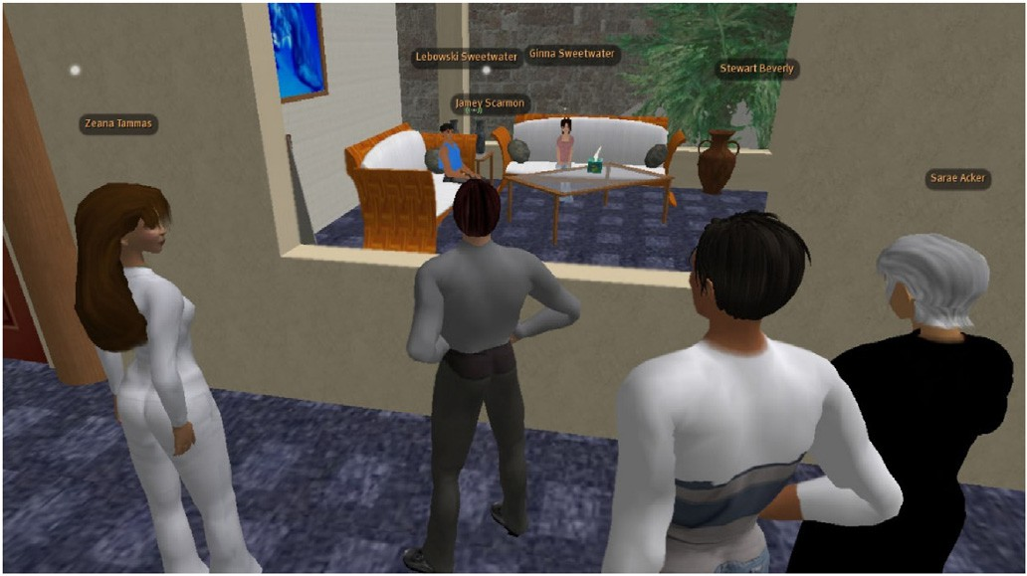

Fig. 3. First floor.

counseling facility or a school counseling office (see Fig. 4). There were three lab rooms on each side of the building's second floor, with a large hallway running down the middle. Five were designed to simulate a general clinical counseling room. They contained two couches, a coffee table, a side table, couch pillows, and pictures. One counseling lab room replicated a school counselor's office, containing a desk, desk items including a computer monitor, pens, papers, and a stapler, and other general office items such as a desk chair, a trash can, and two bookshelves with books. There were four additional chairs in the school counseling office, with two in front of the desk and two slightly facing each other on the side of the room (Lowell & Alshammari, 2017). All of the counseling lab rooms had windows, an interactive door, a functioning clock, an interactive box of Kleenex tissues, and a one-way mirror. Students could enter and exit the rooms using the doorknobs, Kleenex tissues could be taken from the box with a new tissue popping up, and the clocks ticked and provided the current time (Lowell & Alshammari, 2017) (see Fig. 5).

* 1. *Virtual learning activities and tasks*

Learning outcomes for the VRLE activities include developing inter- viewing and diagnosis skills and correct procedural application. Two different skill sets are needed for interviewing: facilitative and clinical skills. Facilitative skills focus on developing rapport with a patient and building a therapeutic alliance. Clinical skills concentrate on information gathering and diagnosis (case conceptualization). Specific skills needed to conduct diagnostic interviews include determining the presenting problem(s), observing signs, listening for symptoms, gathering informa- tion to differentiate one disorder from other disorders, and determining if the presenting problem impairs personal functioning (American Psychi- atric Association, 2013).

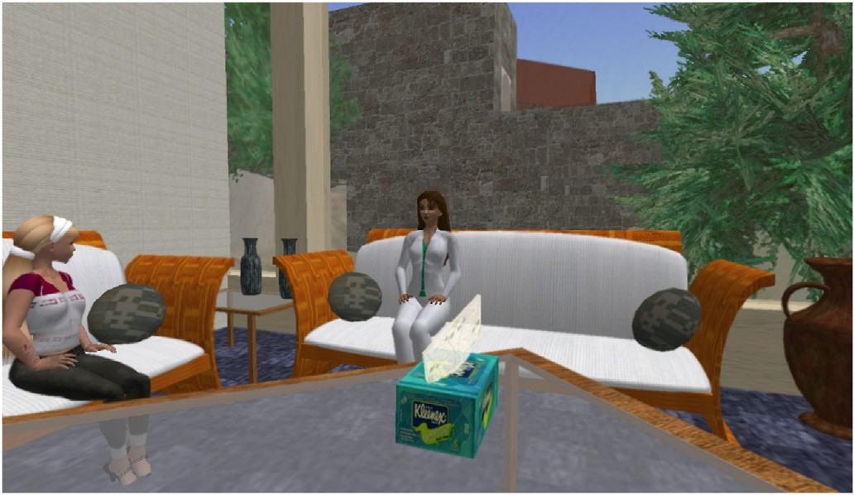

Fig. 4. Counseling lab room.

Fig. 5. Observation of session.

The real-life application, such as that in a VRLE, requires simulta- neous use of both types of skill sets. The complexity of developing rapport and conducting diagnostic assessment makes the task challenging as counselors-in-training are too new to the helping process to connect ethically with real clients.

The VR environment used was accessed through students’ computers. Although hardware can be used with Second Life, it was not used during this study, and therefore we can consider this a non-immersive VR environment. The main objective of the learning activity was for students to apply knowledge and skills learned in the course through specific authentic tasks and procedures in the virtual environment. This included knowledge of various mental health disorders, procedures when completing interviews, and interview techniques such as casual conver- sation style, careful use of voice intonations, and open-ended questions. The units included in the study (self-injury and eating disorders) occurred over approximately two weeks. Each course unit was covered in approximately one week. During each unit week, students were asked to sign up for a day when they would participate in a 2-h virtual activity. This ensured the instructor was present for support and scaffolding. In addition, we limited the number of students to six for each day to help ensure students had sufficient time to practice and to receive instruction from the instructor at the beginning and after the they had practiced interviewing (e.g., debriefing). The activity occurred in the evenings

during the week.

During each unit, (1) eating disorders and (2) self-injury, the students and their instructor met in a virtual counseling facility, using avatars to represent themselves, where they discussed the objectives for the activity during a debriefing. During the debriefing, the instructor asked the stu- dents to consider what they had learned from the other activities that occurred previously (e.g., literature review, videos), and the students were allowed to ask questions. Once the debriefing was complete, stu- dents entered the counseling room individually and engaged with the "patient" avatar. They completed several interview procedures, including asking general questions, observing the patient, and taking notes to gather the information they could analyze to determine the patient's condition and needs. The instructor and other students remained in the hallway, observing the counseling session through a one-way mirror, and assisting the student interviewer as needed. A licensed counselor acted as the patient during one of the units, and an upper-class student in the graduate program served as the patient for the other unit. Although the patient had an initial script to start with, they did engage in slightly different conversations with each student, encouraging them to think critically about their follow-up questions. During the activity, students would present questions, the patient would respond, and the student would then ask follow-up questions. The instructor and other students observed the counseling session. Students observing a session often assisted the student interviewing the patient. During and after the ses- sions, the students discussed the interviews and shared their observations allowing for a collaborative learning environment.

* 1. *Study instruments*
     1. *Perceived cognitive, affective, and psychomotor (CAP) learning scale* The Perceived Cognitive, Affective, and Psychomotor (CAP) Learning Scale (Rovai et al., 2009) is a 9-item self-report instrument with a min- imum and maximum perceived learning scale of 0–54. Reliability anal- ysis of this scale by (Rovai et al., 2009) determined all alpha coefficients were above 0.70. The instrument is divided into subscales that evaluate perceived cognitive learning, affective learning, and psychomotor learning. This instrument assists in determining students perceived learning after completing each learning activity: the literature review, video and discussion, and application of skills in a 3D environment. Rovai et al. (2009), in their CAP scale, defined the indicators of cognitive learning based on Bloom's levels of learning, namely, the ability to recall, understand, apply, analyze, evaluate, and create knowledge (Bloom et al., 1956). They defined the indicators of affective learning as the ability to pay and sustain attention, perceive value and relevance in the task, and be motivated. These indicators align with the ARCS model (Keller, 2010). Thus, the cognitive and affective subscales in the CAP

scale have been used as an indicator of student confidence.

The CAP scale was administered after each of the three learning ac- tivities for both units. We thus had three data sets for each unit - one for the literature review, video, and the VRLE. The data from the cognitive and affective subscales were summed to get a cumulative score for every learner for the data collected after each activity in both units. We thus had cumulative scores for three activities in each unit.

* + 1. *Attitudinal survey*

After completing the two units, participants were also administered an attitudinal survey, created by the researcher, to determine students’ attitudes towards using a VRLE in developing and practicing their counseling skills. This survey was reviewed by two counselor educators, pilot tested by the researcher in a study before this project, and then reviewed by the course instructor. The attitudinal survey included 47 multiple-choice, Likert scale, and open-ended questions. Question topics included participant demographics, prior experience using online tech- nology (e.g., social media, computer games) and 3D VR technology (e.g., online multiple-user virtual environments), and participant attitudes and perceptions of the 3D VR technology and learning experiences in the 3D VR environment. Example questions include, “Prior to this course, have you ever played an online multiple-user virtual reality game?”, “What did you find most beneficial about using a 3D virtual environment in your course?”, “Do you think you learned more because your group members could support each other during the role-playing activities in the 3D environment?”, and “What content can be added to improve this or similar activities to improve your learning experience?”.

* 1. *Data collection and analysis*

A mixed-method research design was chosen because qualitative and quantitative research approaches offer opportunities to analyze and interpret the data using different methods. This research design will provide a complete picture (O'Cathain et al., 2010), and including both approaches will strengthen the validity of the study design (Oleinik, 2011).

The quantitative research strand in this study is based on objective methods and numeric data that explore a research query from a hu- manistic or idealistic approach to understand the participant's beliefs, experiences, attitudes, behavior, and interactions (Pathak et al., 2013). By triangulating the data from a qualitative and a quantitative approach, we can analyze the data objectively and through a humanistic view.

The data was collected through the CAP scale and attitudinal survey instruments. The CAP scale was administered after each VRLE learning activity for each unit (self-injury and eating disorders), and the attitu- dinal survey was administered once the learning activities had been completed. Triangulation of quantitative and qualitative data was used at

the interpretation phase after the quantitative and qualitative data sets were each analyzed separately (Oleinik, 2011). Fig. 6 displays our research design.

* + 1. *Quantitative data strand*

For the quantitative strand, we performed Inferential Statistical Analysis using (ANOVA) T-Tests on the CAP scale perceived learning surveys for both units.

* + 1. *Qualitative data strand*

For the qualitative strand, both researchers were equally involved in coding the data and identifying the themes. This included reviewing the data, member-checking, agreement of the codes and identified themes, and triangulation of the data. Using multi-coders in qualitative data analysis is encouraged to reduce subjectivity or bias and improve the reliability and trustworthiness of the data analysis. Church et al. (2019) argues that “multi-coder teams can improve data quality, and reporting data analysis procedures can mitigate implications of subjectivity in qualitative methods” (p. 1).

When reviewing the qualitative data, we completed a content analysis of the open-ended questions from the attitudinal survey using both an inductive (Denzin, 2012; Thomas, 2006) and a semantic approach (Oleinik, 2011), allowing the data to determine the themes. Next, we used a descriptive exploratory approach to complete the thematic anal- ysis. Our theoretical lens in our qualitative data collection and analysis is based on past research on authentic and situated learning, as well as observations of students during the learning activities, and our review of the data collected with the goal that aspects of the theory will guide us in determining what is most important in the data (Noble & Smith, 2014). Content analysis is a widely used research approach for making repli- cable and valid inferences from texts (or other meaningful matter) to the context of their use (Salkind, 2010).

We started with coding the text content from the open-ended ques- tions from the attitudinal survey highlighting sections of the text, words, phrases, and sentences, and labeling the text (i.e., coded). Each code describes an idea or feeling participants expressed in one of their re- sponses. For the initial coding cycle, one researcher first coded the data, and then the second coded the data. We then compared and discussed coding to ensure there was an agreement. Then one researcher created and applied labels for grouping several elements (including words or statements) under one coded concept (e.g., Learning with Peers, Tech- nical Problems). Next, we compared and discussed the codes and labels to ensure collective agreement on the coded data and the labels given to the coded data. We then reviewed the data to look for any other data that needed to be coded and potential changes to our code labels.

In the second cycle, one researcher collated the coded data into groups referred to as categories. The categories included several coded items (i.e., Engaging, Interesting Fun, Enjoyable) under one category label (Learning Experience). Next, we discussed the coded data and categories to ensure a collective agreement on the categories. Then we analyzed the categories we created and identified patterns among them, which were our themes (see Table 5). Next, we reviewed our data and the themes to ensure the themes were representative of the data. Lastly, we finalized the theme names and defined our themes.

* 1. *Analysis strategies to answer the research questions*

Our analysis strategies to answer our research questions include examining the quantitative and qualitative data separately and through triangulation.

For our first research questions (RQ1, RQ1a, and RQ1b), we sought to understand whether students perceived the learning context (including the learning environment and tasks) as authentic and “real.” When analyzing the data, we looked at students' responses where they rated the level of realness or explained their perceptions of authenticity and fi- delity of the learning environment and tasks. We then triangulated the

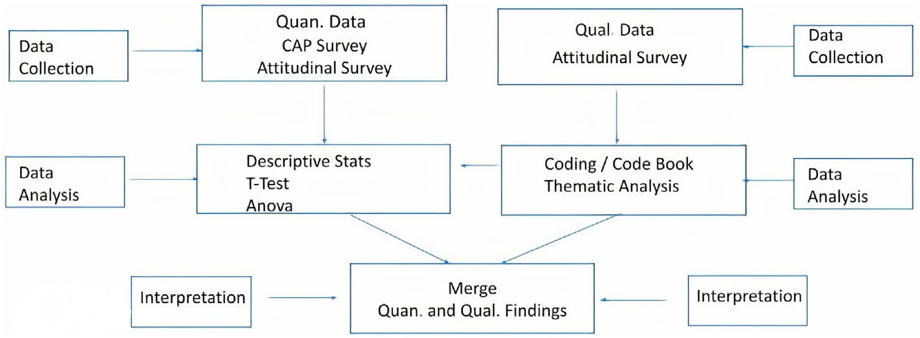

Fig. 6. Research design.

quantitative data where students rated the realness, with the students’ responses to open-ended questions, where they described their perceptions.

For our research question RQ2, investigating the impact of the authenticity of the learning context (learning environment and learning tasks) on the students' confidence to transfer their learning to real life, we triangulated the quantitative analysis of the findings of the CAP scale with the qualitative data from the attitudinal instrument. The Cognitive, Affective, and Psychomotor Scale for perceived learning has three sub- scales - cognitive, affective, and psychomotor. The cognitive subscale uses Bloom's taxonomy (Bloom et al., 1956) to evaluate the perceived conceptual knowledge, development of skills, and intellectual abilities to apply/transfer the knowledge (Rovai et al., 2009). Since mental health counseling is a psycho-procedural skill that requires both conceptual and procedural knowledge to transfer skills, the CAP cognitive subscale is a good measure of the learners' perceived ability to transfer counseling skills. The affective subscale is based on learners' attention, relevance, and value of the content to the learner, and motivation as the vital af- fective factors that promote learning (Rovai et al., 2009). We have defined confidence based on Keller's 2010 ARCS model (Keller, 2010), which states that attention, relevance, satisfaction, and confidence affect the learner's motivation in a symbiotic closed-loop system. Thus, the CAP instrument's affective subscale measures factors contributing to learner confidence. In this paper, we use the cumulative data from this in- strument's cognitive and affective subscales to determine the impact of the learning units on the learners' confidence to transfer their learning to real life.

The perceived learning scale was administered after each of the three

learning activities for both units. We thus had three data sets for each unit

- one for literature review, video, and a 3D virtual environment. The data from the cognitive and affective subscales were summed to get a cumu- lative score for every learner for the data collected after each of the three activities in both units. A one-way ANOVA was conducted on scores for every unit to compare the mean confidence level for each of the three activities in that unit.

The results of the quantitative analysis were triangulated with the findings from the qualitative data on learner confidence from the *Perceived Change in Self-Efficacy/Confidence* category in the theme of *Metacognitive Experience Due to VR-Based 3D Environment.*

For our research questions, RQ3 and RQ4, we investigated whether the collaborative learning design of the learning activities in a simulated learning experience improved or hindered students' learning during that experience and if they impacted their confidence. To answer these questions, we examined the students' responses to quantitative and qualitative questions on the surveys focused on the collaborative design of the learning activities. For example, students were asked to rate the learning benefits of using the 3D virtual environment for collaboration and cooperation while completing the role-playing simulation learning activities. In addition, students were also asked, ‘Did you think the 3D environment was conducive to group learning?,” “Do you think you

learned more because your group members could support each other during the role-playing activities in the 3D environment?”, and “Do you think you would have learned as much if you had practiced the activities without your peers and your instructor?”

1. Results
   1. *Quantitative data results*

ANOVA can be used for a sample size equal to or greater than 15; however, any outliers found must be removed (Moore et al., 2016). Every learner in this study had a cumulative score (affective + cognitive sub- scales) for the three learning activities in each unit. A one-way ANOVA

was conducted on these scores to compare the mean level of perceived confidence for each of the three activities in a unit. This was followed by the Bonferroni T-test to make a pair-wise comparison of each activity in the unit. The confidence levels of the learners after each type of activity for both units were statistically at par with each other, showing no sig- nificant difference in confidence levels in any of the units. These results showed that the VR-based activity was at par with their regular learning activities in developing confidence in learning transfer.

In unit 2 (self-injury), an outlier was found in the data that affected the outcome of the results (see Fig. 7). After carefully reviewing the outlier's responses, we removed the outlier from all three datasets and reran the ANOVA and Bonferroni T-tests. The results of the ANOVA for the CAP scale outcome after removing the outlier are in Tables 2 and 3. After removing the outlier, we found that in unit 2, the perceived learner confidence after the 3D virtual learning activity was significantly higher than after the literature review session. However, the R2 value for this test was found to be low (0.15), which indicates that the significantly

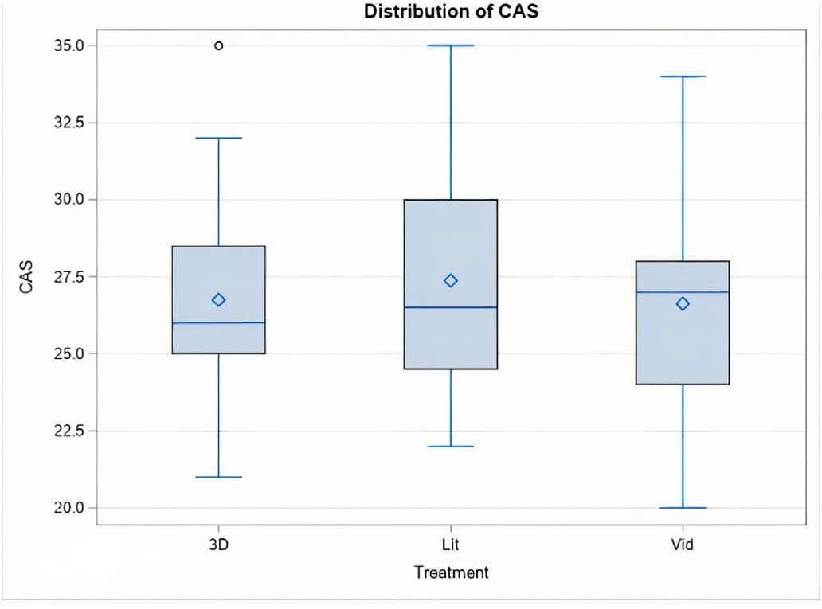

Fig. 7. Outlier in data.

Table 2

Results of one-way ANOVA on unit 1 - eating disorder.

Table 5

Thematic analysis categories and themes.

Table 3

Results of one-way ANOVA on unit 2 - self-injury after removal of outlier.

Confidence

Learning with Others/Peers Social Learning Learning with the Instructor

|  |  |  |  |  |  |  |  |  |
| --- | --- | --- | --- | --- | --- | --- | --- | --- |
|  | Df | Sum of | Mean | F | Sig (P) |  | Categories | Themes |
|  | Squares | Square | value |  |  | Positive Learning Experience | Positive Affective Impact |
| Between Groups  Within Groups | 2  45 | 5.167  612.5 | 2.583  13.611 | 0.19 | 0.8278 (*α* =  0.05) |  | Learners' Self-Reflection  Desire for More Training/Practice in Counseling Skills | Metacognitive Experience Due to VR- Based VRLE |
| Total | 47 | 617.67 |  |  |  |  | Perceived Change in Self-Efficacy/ |  |

Authenticity of Learning Experience Authentic Learning Realism of Learning Experience

Awareness of the VRLE as an Instructional Tool

|  |  |  |  |  |  |
| --- | --- | --- | --- | --- | --- |
|  | Df | Sum of Squares | Mean Square | F  value | Sig (P) |
| Between Groups  Within Groups | 2  42 | 81.911  437.73 | 40.955  10.422 | 3.93 | 0.0273 (*α* =  0.05) |
| Total | 44 | 519.644 |  |  |  |

Issues Due to Technical Problems Desire for Training and Practice with the

Tool

Impact of Technology on the Authenticity of Experience

higher confidence seen in this case may not be explained by the type of intervention they received. In all other cases, there was no significant difference in the confidence level of learners after each activity. The re- sults of the Bonferroni T-test after removing the outlier are given in Table 4.

* 1. *Qualitative Data results*

Qualitative data was collected using an attitudinal survey adminis- tered after the students had completed both of their units in the VRLE. Students completed the survey in person. The inductive and semantic content analysis led us to explore codes, categories, and themes within the survey answers. The categories and themes that emerged from the content analysis are summarized in Table 5. Each of these themes was identified through coding and categorizing to represent the meaningful “essence” that runs through the data for that theme. The themes are described in Table 6. For a detailed map of the codes-categories-themes analysis, please see Fig. 8 in Appendix A.

* 1. *Convergence of quantitative and qualitative data findings*

This section presents the triangulated findings of the quantitative and qualitative data and is organized by research questions, quantitative findings, qualitative findings, and integrated findings.

* + 1. *RQ1: How authentic (real) is the learning context comprising the learning environment and learning tasks?*

R1a - How did students perceive the authenticity (realness) of the learning context and learning tasks?

R1b - How did students perceive the fidelity of the design of the learning environment and learning tasks?

Table 4

Results of Bonferroni T-test for unit 2 - self-injury.

Comparisons significant at the 0.05 level are indicated by ***.

Treatment Comparison Difference between means Simultaneous 95%

confidence limits Min Max

VRLE – Video 2.067 —0.873 5.006

VRLE – Lit 3.267 0.327 6.206 ***

Vid – Lit 1.200 —1.740 4.140

* + - 1. *Quan findings.* Eighty-one percent of the students rated the learning benefits of the VRLE activities based on the realism of the learning activities as ‘very good’ or ‘good’. (Seven students responded that the realism was very good, five students responded that realism was good, two students responded that the realism was satisfactory, and one student responded that it was poor).
      2. *Qual findings.* Several students reported that the activities were “very realistic.” The students also reported their affective responses to the activity. One student reported that they experienced “genuine nervous- ness” during the activity, and another wrote they were “experiencing the genuine nervousness of sitting in front of a client you do not know.” The VR and task felt very realistic to learners as they “challenged them to think at the moment” and “on the spot.” Learners felt “compelled to be prepared” for the interview process. One student thought the activity made the interview process more “tangible.”

Many students who reported that the VR activities were realistic also recognized that they were completing learning activities within a safe learning context where they could make mistakes and receive support from their peers and instructor.

Interestingly, the learner who rated the realism of the VR activities as ‘poor’ also noted that the activity was an opportunity for “learning by doing”. This learner also reported that their experience of realism was negatively impacted by the technology issues they faced during the activity.

* + - 1. *Integrated findings.* The physical, functional, affective, interac- tive, and social experiences noted by the learners reflect that the VR- based learning activity and the environment were perceived as very realistic and authentic by the students. This outcome is confirmed by what was captured in the quantitative data, thus verifying our results.

The learners who reported the realism of the context and task as satisfactory or poor also reported technical issues, trouble getting familiar with the technology, or a desire for other interactive features such as control over facial expressions. Comfort with technology can play an essential role in a VR environment's perceived realism/authenticity (Branch, 2013; Cobbett & Snelgrove-Clarke, 2016). This is corroborated by the qualitative theme of ‘*Impact of technology on the authenticity of the experience*’ that emerged from the data. Most students showed awareness of the VR platform as a learning tool. Some voiced concerns regarding the quality of experience due to technical glitches or the inability to repro- duce some physical actions (e.g., facial expressions). Lack of comfort with the technology, technical glitches, and technical ability during the ac- tivity may have hindered the seamlessness of the experience, making the experience ‘less real.’

Table 6

Identified themes and their descriptions.

Theme Description

Positive Affective Impact This *theme* represents instances where the students used descriptive words or phrases of positive experiences while completing tasks in the learning environment. For example, “it was an amazing experience” or other expressions indicate interest, engagement, enjoyment, and other positive emotions.

Metacognitive Experience Due to VR- Based 3D Environment

This *theme* captures students' feelings of self-observation and introspection of their current and desired knowledge, skills, and self-efficacy both in the 3D virtual environment and in the learning subject matter.

Sub Theme Description

Learners' Self-Reflection of Their Learning

Desire for More Training/Practice in Counseling Skills Perceived Change in Self-Efficacy/ Confidence

Although students enjoyed the learning experience and believed they did well, many reflected on where they needed to learn or practice beyond the 3D virtual environment. For example, one student stated: “I think I have a start and there is still a lot I need to learn!”

Students recognized and expressed a desire for additional training and practice of their counseling skills in the 3D virtual environment and real settings.

The student's perception of the change in their confidence For e.g., “… activity has enhanced my knowledge and confidence”. As students expressed their confidence levels to transfer the skill, they also described their perception of their self-efficacy in performing the specific skills within the counseling practice. E.g., “… I am much more confident in my ability to assess and diagnose”. We thus named the code as perceived change in self-efficacy/confidence.

Social Learning This *theme* represents the student's observations and feelings about their learning experience while completing the learning activities in a context where their peers and professor were present and involved.

Learning with Others/Peers This *category* captures learners' reactions to their experience of learning with their peers within the 3D learning environment. Learners expressed positive and not-so-positive reactions toward observing and interacting with their peers.

Learning with the Instructor This *category* includes students' comments and reflections on the presence of their instructor as a supportive mentor who also served as an expert during the 3D virtual learning activities.

Authentic Learning This *theme* captured students' responses focused on the realness of their experience in terms of the psychological fidelity of the environment and their thoughts on the authenticity of the learning environment and tasks related to the physical and functional fidelity of the learning activity.

Authenticity of Learning Experience

This *category* includes students' comments and reflections on their learning when completing authentic learning tasks in the 3D virtual environment. It focuses on students' responses to the physical and functional fidelity of the learning environment. They were discussing things such as “the way” or “how” they were learning (perhaps due to the instructional method) and how this helped them to practice or do things that would be like activities they would complete as professionals in real life. Some reflected on “hands-on learning,” “learning by doing,” or having an opportunity to “practice” what they were learning.

Impact of Technology on the Authenticity of Experience

Realism of Learning Experience This *category* encompasses students' comments and reflections on the realness of their learning experience, including their learning tasks and the environment they were completing the tasks in. It shows how the learning experience affected their psychological thoughts and beliefs during the learning activities. For example, “… experienced genuine nervousness ….”

This *theme* represents the learners' responses that reflect the impact of using VR-based technology on their perception of the authenticity of the learning experience.

Awareness of VRLE as an Instructional Tool

This *category* reflects students' awareness of the 3D virtual environment as an instructional tool, including their awareness during the learning activities.

Issues Due to Technical Problems This *category* represents the technical issues students incurred with the 3D virtual environment while using the tool during the learning activities.

A Desire for Training and Practice with the Tool

This *category* represents students' desire for additional training and practice using the VR platform or other resources or support.

* + 1. *R2 - What is the impact of the authenticity of the learning context, comprising the learning environment and learning tasks, on the confidence of the learner to transfer their learning to real-life?*
       1. *Quan findings.* The findings from the quantitative data analysis of the CAP scale show that learners' perceived confidence to transfer the skill of counseling interviews and diagnostics after a VR-based simulated learning activity was on par with their perceived confidence when learning from a non-VR-based activity. Learners did not demonstrate a significant increase or decrease in confidence immediately after learning activities. This indicates no immediate impact of the VR-based learning activity on the learners’ confidence. However, from the qualitative data analysis, it is apparent that the VR-based experience led to a meta- cognitive reflection among learners regarding their learning, training, and practice needs for specific counseling skills. This indicated a change in the perceived self-efficacy.
       2. *Qual findings.* When asked about the benefits of using a VRLE for their learning and the learning experience, some students expressed

that they felt more confident in their ability and knowledge in assessing and diagnosing mental health patients. Some others said that they ‘realized’ that there is much more to learn and practice to conduct in- terviews successfully. Several students expressed the need for more practice in the interview process, indicating a lack of self-efficacy in performing the interviews. Few students said the interview process was much more difficult than they had thought. This range of responses observed in the qualitative data aligns with the quantitative data findings that the average impact on the learner confidence was not significant.

* + - 1. *Integrated findings.* It is evident from the qualitative data anal- ysis for the second research question that students' self-efficacy beliefs for individual tasks in the counseling and diagnosis practice varied a lot after the experience within the VR environment. The perceived confidence was also distributed on a broad spectrum after the VR activity. Moreover, students experienced metacognitive reflection about their learning and practice needs because of the VR activity. The realization of what the interview process entails and what skills and knowledge they need to build on was evident through the qualitative data. In conclusion,

although no significant increase or decrease in perceived confidence was seen immediately after the VR activity, the VR activity impacted their self-efficacy beliefs and learning process by improving their meta- cognitive experience about the skills and knowledge needed in the interview process.

* + 1. *R3 - How does collaborative learning in a simulated learning experience improve or hinder learning?*
       1. *Quan findings.* All learners agreed that the VRLE was conducive to group learning. All except one thought they learned more because they practiced the activities as a group where they could observe their peers’ performance and believed peer support was conducive to their learning. All except one (the outlier) thought that instructor support was important to their learning. All learners felt that they would not have learned as much without the presence of their peers or instructor.
       2. *Qual findings.* Learners explained their answers to the quanti- tative survey questions saying that peer support and feedback helped the learning process and professional growth. Observing peers in the inter- view process helped them learn better. Working with peers in a group ‘felt like teamwork’ to the learners, which was ‘comfortable and validating.’

Learners also said that the instructor offered tips and immediate feedback, which was essential for their learning process. Instructor intervention in moments where learners would get ‘stuck’ was very important for professional growth. The instructor offered new ideas and techniques which helped learners tackle the situation better.

One learner thought that at some points in the learning experience, some learners ‘monopolized’ the peer interaction as they were very vocal and ‘interjected too much’ during the process, which hindered their learning process. They said they learned better by observing others rather than doing the interview themselves. However, they agreed that instructor support was very valuable.

* + - 1. *Integrated findings.* The qualitative and quantitative data find- ings suggest that collaborative learning within the 3D virtual environ- ment enhanced the overall learning experience. The presence of peers and the instructor was conducive to learning and positively impacted the learning process. It is important to note that learners' perception of the activity as ‘teamwork’ led to them supporting each other and giving feedback. While most of the learners found this helpful, one learner pointed out that too much interjection from the peers was unhelpful to their process.

1. Discussion

This study aimed to investigate whether the authenticity and the collaborative learning experience in a 3D VRLE affected students' learning and confidence in learning transfer. This mainly focuses on the ‘construction’ stage based on Mayes and Fowler's (1999) framework. This stage entails acquiring and applying skills and knowledge needed to perform in real-world settings. The learning task within the 3D VRLE allowed learners to apply the concepts and theories learned in class to a real-life interview setting. The learning task required students to practice diagnostic and interview skills for mental health counseling, observe, analyze, and reflect upon the patient's avatar's behavior and response to the patient. They could also watch and learn from their peers' responses to the patient and get feedback from peers and instructors. The collab- orative nature of the activity allowed them to also engage in the ‘dia- logue’ stage (Mayes & Fowler, 1999), as learners could interact during and after the activity to share ideas and receive feedback from others. This study investigates whether these two stages of learning experience created within the 3D VRLE led to a pedagogically sound and innovative learning experience, as Fowler (2015) proposed.

We found that learners perceived the learning experience in the 3D VR environment as realistic and the task within the environment as authentic to the physical, functional, social, and affective aspects of the actual task of mental health counseling and diagnostic interviews. Their perception of the authenticity and realness of the learning environment and the task was affected by their comfort with technology and techno- logical glitches during the learning experience. Learners have been known to dislike learning experiences using VR-based simulations due to discomfort with technology and technology issues during the experience (Branch, 2013; Cobbett & Snelgrove-Clarke, 2016). We found that this affective reaction may change learners’ perception of the authenticity of the VR learning environment. Thus, technology comfort and onboarding sessions play an important role when introducing an authentic task within a VR learning environment.

We also found that the average confidence of learners to perform the task after the VR learning activity was on par with their confidence after other pedagogical approaches used during the course. Qualitative data revealed a broad spectrum of confidence levels among learners after the task. While some learners experienced increased confidence and others said their confidence had decreased, several learners expressed a change in self-efficacy beliefs about specific tasks such as diagnosing, inter- viewing, and assessing as well as experienced metacognitive realizations about the skill and knowledge they needed to work on for the actual performance context of counseling interviews. These self-efficacy beliefs and metacognitive realizations were unexpected in this study that may help understand how VRLEs affect the learning process. For further un- derstanding of this finding, we will define each of these constructs theoretically and then discuss the implications of the same from the findings.

* 1. *Implications of metacognition and self-efficacy beliefs*

Metacognition refers “to people's awareness of their cognitive pro- cesses” (Schunk, 2020, p. 259). In learning, metacognition involves un- derstanding the goal of the task and the cognitive processes, skills, and knowledge required to complete the task (Nelson & Narens, 1990). Self-efficacy is the perceived ability to perform or accomplish a certain behavior (Bandura, 1997). It is the belief in one's competence to achieve a target behavior (Cramer et al., 2009). In this study, learners demon- strated both levels of metacognitive knowledge as they reflected that doing this activity helped them understand the rationale for the diag- nostic interview processes and dislodged false beliefs about the actual interview process. They noted recognition of what areas they need further practice in. Although their confidence did not increase, these realizations led to a metacognitive experience, such as finding the task more difficult than expected and a change in self-efficacy beliefs based on personal perceptions. Lee et al. (2010) verified that reflective thinking positively mediates perceived learning effectiveness in a VR-based learning environment. It is also known that metacognitive knowledge, experiences, and self-efficacy beliefs contribute to self-regulated learning processes (Efklides, 2006; Gaskill & Woolfolk Hoy, 2002; Lee et al., 2021; Toharudin et al., 2019). Whether this self-regulation positively impacts the learning outcome is determined by several factors in the learning process, including affective response, external stimuli, and accuracy of metacognitive judgment (Efklides, 2006). Hence the metacognitive re- alizations and change in self-efficacy beliefs afforded by the experience in the 3D VR activity may result in self-regulated learning and, in turn, in better learning outcomes if an appropriate longitudinal learning envi- ronment is facilitated.

This finding may be particularly useful in furthering research around the long-term retention and transferability of skills learned in a VR-based learning environment. Research in VR-based education shows that stu- dents demonstrate better retention and transfer of skills post-VR-based activities when tested immediately after the learning activity rather than a delayed assessment (Birt et al., 2017; Merchant et al., 2014). Hence, more research is needed to identify how long-term retention and

transfer can be facilitated using VR-based learning environments. Investigating the phenomenon of metacognitive realizations and change in self-efficacy seen in this study may lead to how continued longitudinal learning facilitated using VR-based education and reflective activities may result in self-regulated learning and long-term retention and transfer of skills.

* 1. *Implications for social fidelity*

There is a relationship between learning and the social situation in which learning occurs (Hanks, 1991). Fowler (2015) describes this stage as ‘dialogue.’ Interactions with others in a learning environment allow learners to test their new understanding and reflect critically on their competence. It enables a discussion among various team members and instructors to share ideas and negotiate their roles within the team (Fowler, 2015). This was reflected in our findings for the third research question. Learners noted that the collaborative nature of the activity helped in the overall learning process through observing peers, getting feedback from peers and the instructor, giving feedback to the peers, and getting guidance during their performance. Instructor and peer presence increased comfort for most learners, gave structure to the activity, and offered new ideas and techniques. This confirms Lave and Wenger's (1991) learning process benefits when learners observe, evaluate, participate, and interact with others, including experts who can model behaviors. It also shows that a simulated learning environment situates learners in a socio-cultural setting (Hanks, 1991; Kirshner & Whitson, 1997; Stein, 1998) and places the learner's needs at the focus of the learning environment (Berragan, 2011). Although this contrasts with a real clinical setting where the patient's healthcare needs take priority, it allows the learner to take the risk of making mistakes during the learning process without bearing the consequences (Bossard et al., 2008).

One learner believed that too much intervention from peers worked

against their learning process. This can be explained by the fact that in our attempt to replicate the real-world interview in a situated setting, the learner's perception of the social fidelity was reduced when there was an elevated level of intervention from the peers (Sinatra et al., 2021), in turn reducing the authenticity of the learning task. Therefore, the learning environment designer must consider the nature of the task and the environment while choosing a fidelity level. For example, a fire rescue operation requires high psychological fidelity that creates an authentic emotional experience as the firefighters need to be situationally aware (Endsley, 1998). However, as the physical environment in which the fire hazard occurs may vary in real life, such a task may not require high levels of physical fidelity.

To summarize, the overall interaction with peers and the pedagogical and technological affordance of this 3D VR activity positively impacted learners’ learning process. This resulted in an innovative learning expe- rience perhaps they would not get using the traditional pedagogical methods used in classrooms. Collaborative learning plays an integral part in the learning process, and keen attention needs to be paid to designing collaboration in a VR-based learning activity to foster an optimum learning environment for innovative learning experiences.

* 1. *Limitations*

Like all studies, some limitations must be considered when reviewing the results of this study. First, relevant prior research studies on our topic were limited. Although a pilot study was completed to develop a theory, our research topic had yet to be studied to provide a theoretical foun- dation for our research questions. Second, this study was conducted in one course with one set of students and one instructor, potentially limiting the generalizability of the results. We encourage additional studies to examine similar questions with other populations. Other lim- itations involve the capabilities of the technology to produce high- fidelity rendering of content and interaction fidelity. Specifically, the lack of control of avatar body movements (e.g., facial expressions, hand

movements) may have impacted the students' perception of the envi- ronment's “realness.” As the aspect of fidelity needs to be optimized to the needs of the learning task (see Fig. 1), the learning environment designer needs to consider the nature of the task and the environment when choosing the fidelity levels. Fourth, a study participant who dis- agreed with the instructor was an unanticipated challenge. This partici- pant proceeded to cause challenges for the instructor, and the instructor indicated we might see a difference in this participant's responses to the surveys than other students. In careful review, we found that this participant responded negatively to most survey items. Tests were run on the data with and without the outlier. We acknowledge that having a small sample size may affect the power of the statistical inference of statistical tests; however, since our sample size is 15 after the removal of the outlier, the use of t-tests and ANOVA is permissible in this case (Moore et al., 2016). Our findings from the quantitative analysis are also fortified by triangulation with our qualitative data sources.

1. Conclusion and recommendations

Students perceived the learning context in the VRLE, comprising the learning environment and the learning tasks, as authentic. Further, stu- dents perceived the fidelity of the design of the learning environment and learning tasks as authentic. However, some students did have technology challenges that impacted their perceived fidelity and authenticity. Thus, learning experiences in a VR environment need to be designed and tested to ensure optimum technological performance in the learning context. For example, checking whether the VR experience will function well at the location of the training facilitation when multiple users are engaging with it simultaneously. It is also important to ensure that learners are provided onboarding to the VR platform or environment to familiarize them with the technology before they experience the intended learning activity.

The impact of the authenticity of the learning context in the VRLE on students' confidence to transfer their knowledge and skills was mixed. Some students reported increased confidence in their comprehension of the required knowledge and abilities, some noted no change, and a few noted it decreased their confidence. Several students reflected on the need for additional practice before professional practice indicating a metacognitive realization during learning. Some students also indicated a change in their perceived self-efficacy in specific tasks in the learning activity. This is likely to impact learners' process of learning through self- regulation. We hypothesize that continuous long-term exposure to VR- based learning contexts, comprising relevant learning tasks and envi- ronment, will enhance learners’ self-regulation and impact their learning outcome in a psycho-affective procedural skill like mental health coun- seling. Further longitudinal studies are needed to test this hypothesis.

In this study, collaborative learning in a simulated learning experi- ence substantially impacted the students' perceived learning and enjoy- ment of the activities. Students repeatedly reported their appreciation of their peers' presence and support during the activities, and several stu- dents noted they would not have learned as much without their peers. Although one student felt their peers were too willing to assist, they still appreciated their assistance and watched their peers. Many students re- ported feeling more confident during the practice with their peers' assistance and watching their peers’ practice. Future research and instructional design should consider the impact of social fidelity while designing learning activities. Collaborative engagement with the learning context and collaborative reflection on the learning experience should be encouraged in VR-based learning contexts, especially for pro- cedural skills.

Immersing students in an authentic setting, such as a VRLE can pro-

vide many benefits, including improving student engagement with learning tasks and opportunities to participate in realistic scenarios in a safe environment. We found that students can also feel like they are *really there* when participating in such activities in a non-immersive VR envi- ronment if the learning tasks can provide a feeling of immersion in the

activities. This feeling of *being there* and the *realness* of the experience can impact the learning experience. Therefore, researchers must consider the coherence of the overall experience when assessing learner experience in VR (or MR) and the impact that experience has on their learning and performance. This would include “the mediating technology, content conveyed, and resulting user experience” (Skarbez et al., 2021, p. 2).

Based on the results of this study, possible areas for further research/ investigation include further investigation into 1) the effect of authen- ticity and fidelity of design on learners' metacognition and self-efficacy,

2) the effect of fidelity of design in VR and other extended reality

environments on students’ learning and self-regulation, and 3) the effect of fidelity of design in VR and other extended reality environments on the transfer of learning from the learning context to the performance context.

Declaration of competing interest

The authors declare that they have no known competing financial interests or personal relationships that could have appeared to influence the work reported in this paper.

List of Abbreviations

*Abbreviation Definition*

VRLE Virtual Reality Learning Environment ALT Authentic Learning Task

VR Virtual Reality

MR Mixed Reality

X-reality Extended Reality 3D Three-dimensional

CACREP Council for Accreditation of Counseling and Related Programs RQ Research Question

CAP Cognitive, Affective, and Psychomotor

Appendix A

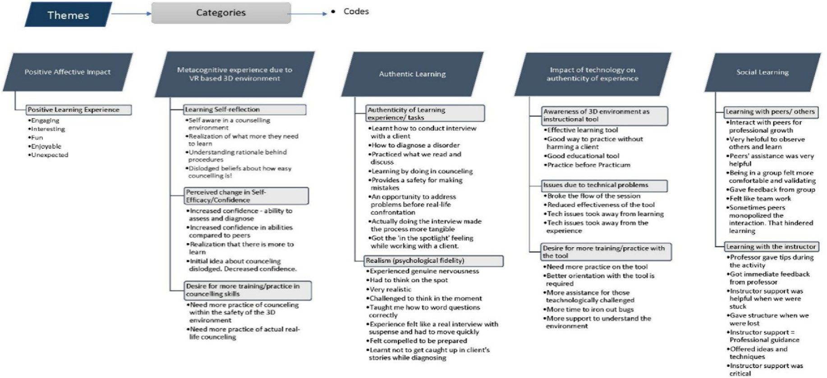

Fig. 8. Coding Tree for Qualitative Data

References

Allman, B. (2018). Socioculturalism. In R. Kimmons (Ed.), *The students' guide to learning design and research*. EdTech Books. [https://edtechbooks.org/studentguide/sociocultu](https://edtechbooks.org/studentguide/socioculturalism)

[ralism](https://edtechbooks.org/studentguide/socioculturalism).

American Psychiatric Association. (2013). *Diagnostic and statistical manual* (*5th* ed.). <https://doi.org/10.1176/appi.books.9780890425596> Washington DC.

[Bandura, A. (1997). *Self-efficacy: The exercise of control*. New York: Freeman](http://refhub.elsevier.com/S2949-6780(23)00011-9/sref3).

Barab, S. A., Squire, K., & Dueber, W. (2000). A co-evolutionary model for supporting the emergence of authenticity. *Educational Technology Research* & *Development, 48*(2), 37–62. <https://doi.org/10.1007/BF02313400>

Berragan, L. (2011). Simulation: An effective pedagogical approach for nursing? *Nurse* *Education Today, 31*(7), 660–663. <https://doi.org/10.1016/j.nedt.2011.01.019>

[Bhagat, K. K., & Huang, R. (2018). Improving learners' experiences through authentic](http://refhub.elsevier.com/S2949-6780(23)00011-9/sref6) [learning in a technology-rich classroom. In T.-W. Chang, R. Huang, & Kinshuk (Eds.),](http://refhub.elsevier.com/S2949-6780(23)00011-9/sref6) [*Authentic learning through advances in technologies* (pp. 3](http://refhub.elsevier.com/S2949-6780(23)00011-9/sref6)–[15). Springer](http://refhub.elsevier.com/S2949-6780(23)00011-9/sref6).

[Bhagat, K. K., Liou, W. K., Spector, M. J., & Chang, C. Y. (2019). To use augmented reality](http://refhub.elsevier.com/S2949-6780(23)00011-9/sref7) [or not in formative assessment: A comparative study. *Interactive Learning*](http://refhub.elsevier.com/S2949-6780(23)00011-9/sref7)[*Environments, 27*(5](http://refhub.elsevier.com/S2949-6780(23)00011-9/sref7)–[6), 830](http://refhub.elsevier.com/S2949-6780(23)00011-9/sref7)–[840](http://refhub.elsevier.com/S2949-6780(23)00011-9/sref7).

Birt, J., Moore, E., & Cowling, M. (2017). Improving paramedic distance education through mobile mixed reality simulation. *Australasian Journal of Educational Technology, 33*(6), 69–83. <https://doi.org/10.14742/ajet.3596>

[Bland, A. J., Topping, A., & Tobbell, J. (2014). Time to unravel the conceptual confusion](http://refhub.elsevier.com/S2949-6780(23)00011-9/sref9) [of authenticity and](http://refhub.elsevier.com/S2949-6780(23)00011-9/sref9) fi[delity and their contribution to learning within simulation-based](http://refhub.elsevier.com/S2949-6780(23)00011-9/sref9) [nurse education. A discussion paper. *Nurse Education Today, 34*(7), 1112](http://refhub.elsevier.com/S2949-6780(23)00011-9/sref9)–[1118](http://refhub.elsevier.com/S2949-6780(23)00011-9/sref9).

[Bloom, B. S., Engelhart, M. D., Furst, E. J., Hill, W. H., & Krathwohl, D. R. (1956).](http://refhub.elsevier.com/S2949-6780(23)00011-9/sref13) [*Taxonomy of educational objectives: The classification of educational goals. Book 1:*](http://refhub.elsevier.com/S2949-6780(23)00011-9/sref13)[*Cognitive domain*. David McKay Company](http://refhub.elsevier.com/S2949-6780(23)00011-9/sref13).

Bossard, C., Kermarrec, G., Buche, C., & Tisseau, J. (2008). Transfer of learning in virtual environments: A new challenge? *Virtual Reality, 12*, 151–161. [https://doi.org/](https://doi.org/10.1007/s10055-008-0093-y) [10.1007/s10055-008-0093-y](https://doi.org/10.1007/s10055-008-0093-y)

Bracq, M. S., Michinov, E., Arnaldi, B., Caillaud, B., Gibaud, B., Gouranton, V., et al. (2019). Learning procedural skills with a virtual reality simulator: An acceptability

study. *Nurse Education Today, 79*(8), 153–160. [https://doi.org/10.1016/](https://doi.org/10.1016/j.nedt.2019.05.026) [j.nedt.2019.05.026](https://doi.org/10.1016/j.nedt.2019.05.026). Epub 2019 May 19. PMID: 31132727.

Branch, C. (2013). Pharmacy students' learning and satisfaction with high-fidelity

simulation to teach drug-induced dyspepsia. *American Journal of Pharmaceutical Education, 77*(2), 30. [https://link.gale.com/apps/doc/A347293384/AONE?u](https://link.gale.com/apps/doc/A347293384/AONE?u=purdue_main&amp%3Bsid=AONE&amp%3Bxid=c81eb863)=[purd](https://link.gale.com/apps/doc/A347293384/AONE?u=purdue_main&amp%3Bsid=AONE&amp%3Bxid=c81eb863) [ue_main](https://link.gale.com/apps/doc/A347293384/AONE?u=purdue_main&amp%3Bsid=AONE&amp%3Bxid=c81eb863)&[amp;sid](https://link.gale.com/apps/doc/A347293384/AONE?u=purdue_main&amp%3Bsid=AONE&amp%3Bxid=c81eb863)=[AONE](https://link.gale.com/apps/doc/A347293384/AONE?u=purdue_main&amp%3Bsid=AONE&amp%3Bxid=c81eb863)&[amp;xid](https://link.gale.com/apps/doc/A347293384/AONE?u=purdue_main&amp%3Bsid=AONE&amp%3Bxid=c81eb863)=[c81eb863](https://link.gale.com/apps/doc/A347293384/AONE?u=purdue_main&amp%3Bsid=AONE&amp%3Bxid=c81eb863).

Brosch, T., Scherer, K. R., Grandjean, D., & Sander, D. (2013). The impact of emotion on

perception, attention, memory, and decision-making. *Swiss Medical Weekly, 143*, 1–10. <https://doi.org/10.4414/smw.2013.13786>

[Brown, J. S., Collins, A., & Duguid, P. (1989). Situated cognition and the culture of](http://refhub.elsevier.com/S2949-6780(23)00011-9/sref18) [learning. *Educational Researcher, 18*(1), 32](http://refhub.elsevier.com/S2949-6780(23)00011-9/sref18)–[41](http://refhub.elsevier.com/S2949-6780(23)00011-9/sref18).

[Bryson, S. (1995). Approaches to the successful design and implementation of VR](http://refhub.elsevier.com/S2949-6780(23)00011-9/sref19) [applications. *Virtual reality applications*, 3](http://refhub.elsevier.com/S2949-6780(23)00011-9/sref19)–[15](http://refhub.elsevier.com/S2949-6780(23)00011-9/sref19).

Bursali, H., & Yilmaz, R. M. (2019). Effect of augmented reality applications on secondary school students' reading comprehension and learning permanency. *Computers in* *Human Behavior, 95*, 126–135. <https://doi.org/10.1016/j.chb.2019.01.035>

Butt, A. L., Kardong-Edgren, S., & Ellertson, A. (2018). Using game-based virtual reality with haptics for skill acquisition. *Clinical Simulation in Nursing, 16*(3), 25–32. [https://](https://doi.org/10.1016/j.ecns.2017.09.010) [doi.org/10.1016/j.ecns.2017.09.010](https://doi.org/10.1016/j.ecns.2017.09.010)

Cambridge Dictionary (n.d.). Fidelity. [https://dictionary.cambridge.org/us/dictionar](https://dictionary.cambridge.org/us/dictionary/english/fidelity) [y/english/fidelity](https://dictionary.cambridge.org/us/dictionary/english/fidelity).

Champney, R., Stanney, K., Milham, L., Carroll, M., & Cohn, J. (2017). An examination of virtual environment training fidelity on training effectiveness. *International Journal of Learning Technology, 12*(1), 42–65. <https://doi.org/10.1504/IJLT.2017.083997>

Church, S., Dunn, M., & Prokopy, L. (2019). Benefits to qualitative data quality with multiple coders: Two case studies in multi-coder data analysis. *Journal of Rural Social Sciences, 34*(1). <https://egrove.olemiss.edu/jrss/vol34/iss1/2>.

[Cobbett, S., & Snelgrove-Clarke, E. (2016). Virtual versus face-to-face clinical simulation](http://refhub.elsevier.com/S2949-6780(23)00011-9/sref25) [in relation to student knowledge, anxiety, and self-con](http://refhub.elsevier.com/S2949-6780(23)00011-9/sref25)fi[dence in maternal-newborn](http://refhub.elsevier.com/S2949-6780(23)00011-9/sref25) [nursing: A randomized controlled trial. *Nurse Education Today, 45*, 179](http://refhub.elsevier.com/S2949-6780(23)00011-9/sref25)–[184](http://refhub.elsevier.com/S2949-6780(23)00011-9/sref25).

[Council for the accreditation of counseling and related educational programs [CACREP].](http://refhub.elsevier.com/S2949-6780(23)00011-9/sref26)

[*2009 standards for accreditation*, (2009) (Alexandria, VA: Author)](http://refhub.elsevier.com/S2949-6780(23)00011-9/sref26).

Cramer, R. J., Neal, T. M. S., & Brodsky, S. L. (2009). Self-efficacy and confidence: Theoretical distinctions and implications for trial consultation. *Consulting Psychology Journal, 61*(4), 319–334. <https://doi.org/10.1037/a0017310>

Dalgarno, B., & Lee, M. J. W. (2010). What are the learning affordances of 3-D virtual environments? *British Journal of Educational Technology, 41*(1), 10–32. [https://](https://doi.org/10.1111/j.1467-8535.2009.01038.x) [doi.org/10.1111/j.1467-8535.2009.01038.x](https://doi.org/10.1111/j.1467-8535.2009.01038.x)

[Denzin, N. K. (2012). Triangulation 2.0. *Journal of Mixed Methods Research, 6*, 80](http://refhub.elsevier.com/S2949-6780(23)00011-9/sref29)–[88](http://refhub.elsevier.com/S2949-6780(23)00011-9/sref29). Dilmegani, C. (2023). Ultimate guide to virtual reality (VR) in 2023: Types & uses.

<https://research.aimultiple.com/virtual-reality/>.

Edwards, T. C., Patel, A., Szyszka, B., Coombs, A. W., Liddle, A. D., Kucheria, R., et al. (2021). Immersive virtual reality enables technical skill acquisition for scrub nurses in complex revision total knee arthroplasty. *Archives of Orthopaedic and Trauma Surgery, 141*(12), 2313–2321. <https://doi.org/10.1007/s00402-021-04050-4>. PMID:

34319473; PMCID: PMC8317146.

Efklides, A. (2006). Metacognition and affect: What can metacognitive experiences tell us about the learning process? *Educational Research Review, 1*(1), 3–14. [https://doi.org/](https://doi.org/10.1016/j.edurev.2005.11.001) [10.1016/j.edurev.2005.11.001](https://doi.org/10.1016/j.edurev.2005.11.001)

[Endsley, M. R. (1998). *A comparative analysis of SAGAT and SART for evaluations of*](http://refhub.elsevier.com/S2949-6780(23)00011-9/sref33)[*situation awareness. Proceedings of the human factors and ergonomics society 42 annual*](http://refhub.elsevier.com/S2949-6780(23)00011-9/sref33)[*meeting* (pp. 82](http://refhub.elsevier.com/S2949-6780(23)00011-9/sref33)–[96). Santa Monica, CA: The Human Factors and Ergonomics Society](http://refhub.elsevier.com/S2949-6780(23)00011-9/sref33).

[Falconer, L. (2013). Situated learning in virtual simulations: Researching the authentic](http://refhub.elsevier.com/S2949-6780(23)00011-9/sref34) [dimension in virtual worlds. *Journal of Interactive Learning Research, 24*, 285](http://refhub.elsevier.com/S2949-6780(23)00011-9/sref34)–[300](http://refhub.elsevier.com/S2949-6780(23)00011-9/sref34).

[Falloon, G. (2020). From simulations to real: Investigating young students' learning and](http://refhub.elsevier.com/S2949-6780(23)00011-9/sref35) [transfer from simulations to real tasks. *British Journal of Educational Technology,*](http://refhub.elsevier.com/S2949-6780(23)00011-9/sref35)[*51*(3), 778](http://refhub.elsevier.com/S2949-6780(23)00011-9/sref35)–[797](http://refhub.elsevier.com/S2949-6780(23)00011-9/sref35).

Fowler, C. (2015). Virtual reality and learning: Where is the pedagogy? *British Journal of Educational Technology, 46*(2), 412–422. <https://doi.org/10.1111/bjet.12885>

[Freina, L., & Ott, M. (2015). A literature review on immersive virtual reality in education:](http://refhub.elsevier.com/S2949-6780(23)00011-9/sref37) [State of the art and perspectives. In *Proceedings of the international scientific conference*](http://refhub.elsevier.com/S2949-6780(23)00011-9/sref37)[*eLearning and software for education* (Vol. 1, pp. 133](http://refhub.elsevier.com/S2949-6780(23)00011-9/sref37)–[141). Carol I NDU Publishing](http://refhub.elsevier.com/S2949-6780(23)00011-9/sref37) [House](http://refhub.elsevier.com/S2949-6780(23)00011-9/sref37).

Gaskill, P. J., & Woolfolk Hoy, A. (2002). Chapter 9 - self-efficacy and self-regulated learning: The dynamic duo in school performance. In *Improving academic achievement* (pp. 185–208). Academic Press. [https://doi.org/10.1016/B978-012064455-1/](https://doi.org/10.1016/B978-012064455-1/50012-9) [50012-9](https://doi.org/10.1016/B978-012064455-1/50012-9).

Georghiades, P. (2000). Beyond conceptual change learning in science education: Focusing on transfer, durability and metacognition. *Educational Research, 42*(2), 119–139. <https://doi.org/10.1080/001318800363773>

Graziano, P. A., Reavis, R. D., Keane, S. P., & Calkins, S. D. (2007). The role of emotion regulation in children's early academic success. *Journal of School Psychology, 45*(1), 3–19. <https://doi.org/10.1016/j.jsp.2006.09.002>

[Gulikers, J. T., Bastiaens, T. J., & Martens, R. L. (2005). The surplus value of an authentic](http://refhub.elsevier.com/S2949-6780(23)00011-9/sref41) [learning environment. *Computers in Human Behavior, 21*(3), 509](http://refhub.elsevier.com/S2949-6780(23)00011-9/sref41)–[521](http://refhub.elsevier.com/S2949-6780(23)00011-9/sref41).

[Hanks, W. F. (1991). Foreword. In *Lave*](http://refhub.elsevier.com/S2949-6780(23)00011-9/sref42)& [*wenger. Communities of practice: Creating learning*](http://refhub.elsevier.com/S2949-6780(23)00011-9/sref42)[*Environments for educators*. Cambridge University Press](http://refhub.elsevier.com/S2949-6780(23)00011-9/sref42).

Harley, J. M., Poitras, E. G., Jarrell, A., Duffy, M. C., & Lajoie, S. P. (2016). Comparing virtual and location-based augmented reality mobile learning: Emotions and learning outcomes. *Educational Technology Research* & *Development, 64*(3), 359–388. [https://](https://doi.org/10.1007/s11423-015-9420-7) [doi.org/10.1007/s11423-015-9420-7](https://doi.org/10.1007/s11423-015-9420-7)

[Herrington, J., Oliver, R., & Reeves, T. (2003). Patterns of engagement in authentic online](http://refhub.elsevier.com/S2949-6780(23)00011-9/sref44) [learning environments. *Australasian Journal of Educational Technology, 19*(1),](http://refhub.elsevier.com/S2949-6780(23)00011-9/sref44)

[279](http://refhub.elsevier.com/S2949-6780(23)00011-9/sref44)–[286](http://refhub.elsevier.com/S2949-6780(23)00011-9/sref44).

[Herrington, J., Reeves, T. C., & Oliver, R. (2010). *A guide to authentic e-learning*. Routledge](http://refhub.elsevier.com/S2949-6780(23)00011-9/sref46).

Herrington, J., Reeves, T. C., & Oliver, R. (2014). Authentic learning environments. In

J. Spector, M. Merrill, J. Elen, & M. Bishop (Eds.), *Handbook of research on educational communications and technology*. Springer. [https://doi.org/10.1007/978-1-4614-3185-](https://doi.org/10.1007/978-1-4614-3185-5_32) [5_32](https://doi.org/10.1007/978-1-4614-3185-5_32).

Holt, D., Segrave, S., & Cybulski, J. (2012). E-Simulations for educating the professions in blended learning environments. In D. Holt, S. Segrave, & J. Cybulski (Eds.), *IGI globalProfessional education using e-simulations: Benefits of blended learning design* (pp. 1–23). <https://doi.org/10.4018/978-1-61350-189-4.ch001>

Huang, H. M., Rauch, U., & Liaw, S. S. (2010). Investigating learners' attitudes toward virtual reality learning environments: Based on a constructivist approach. *Computers* & *Education, 55*(3), 1171–1182. <https://doi.org/10.1016/j.compedu.2010.05.014>

[Hung, D., & Chen, D. V. (2007). Context-process authenticity in learning: Implications for](http://refhub.elsevier.com/S2949-6780(23)00011-9/sref50) [identity enculturation and boundary crossing. *Educational Technology Research*](http://refhub.elsevier.com/S2949-6780(23)00011-9/sref50)& [*Development, 55*(2), 147](http://refhub.elsevier.com/S2949-6780(23)00011-9/sref50)–[167](http://refhub.elsevier.com/S2949-6780(23)00011-9/sref50).

[Imuta, K., Scarf, D., Carson, S., & Hayne, H. (2018). Children's learning and memory of an](http://refhub.elsevier.com/S2949-6780(23)00011-9/sref51) [interactive science lesson: Does the context matter? *Developmental Psychology, 54*(6),](http://refhub.elsevier.com/S2949-6780(23)00011-9/sref51) [1029](http://refhub.elsevier.com/S2949-6780(23)00011-9/sref51)–[1037](http://refhub.elsevier.com/S2949-6780(23)00011-9/sref51).

[Keller, J. (2010). *Motivational design for learning and performance the ARCS model approach*](http://refhub.elsevier.com/S2949-6780(23)00011-9/sref52)

[(1st ed.). Springer](http://refhub.elsevier.com/S2949-6780(23)00011-9/sref52).

Kinney, S., & Henderson, D. (2008). Comparison of low fidelity simulation learning strategy with traditional lecture. *Clinical Simulation in Nursing, 4*(2), 15–18. [https://](https://doi.org/10.1016/j.ecns.2008.06.005) [doi.org/10.1016/j.ecns.2008.06.005](https://doi.org/10.1016/j.ecns.2008.06.005)

[Kirshner, D. I., & Whitson, J. A. (Eds.). (1997). *Situated cognition: Social, semiotic, and*](http://refhub.elsevier.com/S2949-6780(23)00011-9/sref54)[*psychological perspectives*. Lawrence Erlbaum Associates Publishers](http://refhub.elsevier.com/S2949-6780(23)00011-9/sref54).

Knobloch, N. A. (2003). Is experiential learning authentic? *Journal of Agricultural Education, 44*(4), 22–34. <https://doi.org/10.5032/jae.2003.04022>

Kollo€ffel, B., & de Jong, T. (2013). Conceptual understanding of electrical circuits in

secondary vocational engineering education: Combining traditional instruction with inquiry learning in a virtual lab. *Journal of Engineering Education, 102*, 375–393. <https://doi.org/10.1002/jee.20022>

Kozma, R. B. (1994). Will media influence learning? Reframing the debate. *Educational Technology Research* & *Development, 42*(2), 7–19. [https://doi.org/10.1007/](https://doi.org/10.1007/BF02299087) [BF02299087](https://doi.org/10.1007/BF02299087)

[Lave, J., & Wenger, E. (1991). *Situated learning: Legitimate peripheral participation*.](http://refhub.elsevier.com/S2949-6780(23)00011-9/sref58)

[Cambridge University Press](http://refhub.elsevier.com/S2949-6780(23)00011-9/sref58).

Lee, D., Allen, M., Cheng, L., Watson, S., & Watson, W. (2021). Exploring the relationships between self-efficacy and self-regulated learning strategies of English language learners in a college setting. *Journal of International Students, 11*(3), 567–585. [https://](https://doi.org/10.32674/jis.v11i3.2145) [doi.org/10.32674/jis.v11i3.2145](https://doi.org/10.32674/jis.v11i3.2145)

Lee, E., Wong, K. W., & Fung, C. C. (2010). How does desktop virtual reality enhance learning outcomes? A structural equation modeling approach. *Computers* & *Education,* *55*(4), 1424–1442. <https://doi.org/10.1016/j.compedu.2010.06.006>

Lim, D., Bartlett, S., Horrocks, P., Grant-Wakefield, C., Kelly, J., & Tippett, V. (2014).

Enhancing paramedics procedural skills using a cadaveric model. *BMC Medical* *Education, 14*(138). <https://doi.org/10.1186/1472-6920-14-138>

[Linn, R. L., Baker, E. L., & Dunbar, S. B. (1991). Complex, performance-based assessment:](http://refhub.elsevier.com/S2949-6780(23)00011-9/sref62) [Expectations and validation criteria. *Educational Researcher, 20*(8), 15](http://refhub.elsevier.com/S2949-6780(23)00011-9/sref62)–[21](http://refhub.elsevier.com/S2949-6780(23)00011-9/sref62).

Logishetty, K., Gofton, W. T., Rudran, B., Beaul´e, P. E., & Cobb, J. P. (2020). Fully

immersive virtual reality for total hip arthroplasty: Objective measurement of skills and transfer of visuospatial performance after a competency-based simulation curriculum. *The Journal of Bone and Joint Surgery, 102*(6), e27. [https://doi.org/](https://doi.org/10.2106/JBJS.19.00629) [10.2106/JBJS.19.00629](https://doi.org/10.2106/JBJS.19.00629). PMID: 31929324.

Lombardi, M. (2007). Authentic learning for the 21st century: An overview. Educause Learning Initiative. [https://library.educause.edu/resources/2007/1/authentic-learn](https://library.educause.edu/resources/2007/1/authentic-learning-for-the-21st-century-an-overview) [ing-for-the-21st-century-an-overview](https://library.educause.edu/resources/2007/1/authentic-learning-for-the-21st-century-an-overview).

Lowell, V. L., & Alshammari, A. (2017). Experiential learning experiences in an online 3-D virtual environment for skill development: Interviewing and mental health diagnosis role-playing. *Educational Technology Research and Development, 67*(4), 825–854. <http://doi.org/10.1007/s11423-018-9632-8>.

[Lowell, V. L., & Ilobinso, A. (2023). Virtual reality in higher education: Creating authentic](http://refhub.elsevier.com/S2949-6780(23)00011-9/sref12) [learning experiences. In S. Wa-Mbaleka, K. Thompson, & L. Casimiro (Eds.), *The Sage*](http://refhub.elsevier.com/S2949-6780(23)00011-9/sref12)[*handbook of online higher education*](http://refhub.elsevier.com/S2949-6780(23)00011-9/sref12).

Lowell, V. L., & Yang, M. (2022). Authentic learning experiences to improve online instructor’s performance and self-efficacy: The design of an online mentoring program. *TechTrends, 67*(1), 112–123. [https://doi.org/10.1007/s11528-022-00770-](https://doi.org/10.1007/s11528-022-00770-5)

[5](https://doi.org/10.1007/s11528-022-00770-5)

Mainey, L., Dwyer, T., Reid-Searl, K., & Bassett, J. (2018). High-level realism in simulation: A catalyst for providing intimate care. *Clinical Simulation in Nursing, 17*, 47–57. <https://doi.org/10.1016/j.ecns.2017.12.001>

Makransky, G., Borre-Gude, S., & Mayer, R. E. (2019a). Motivational and cognitive benefits of training in immersive virtual reality based on multiple assessments. *Journal of Computer Assisted Learning, 35*(6), 691–707. [https://doi.org/10.1111/](https://doi.org/10.1111/jcal.12375) [jcal.12375](https://doi.org/10.1111/jcal.12375)

Makransky, G., Terkildsen, T., & Mayer, R. (2019b). Adding immersive virtual reality to a science lab simulation causes more presence but less learning. *Instructional design for* *virtual reality, 60*, 225–236. <https://doi.org/10.1016/j.learninstruc.2017.12.007>

Mandal, P., & Ambade, R. (2022). Surgery training and simulation using virtual and augmented reality for knee arthroplasty. *Cureus, 14*(9), Article e28823. [https://](https://doi.org/10.7759/cureus.28823) [doi.org/10.7759/cureus.28823](https://doi.org/10.7759/cureus.28823). PMID: 36225417; PMCID: PMC9535617.

[Maran, N. J., & Glavin, R. J. (2003). Low- to high-](http://refhub.elsevier.com/S2949-6780(23)00011-9/sref69)fi[delity simulation](http://refhub.elsevier.com/S2949-6780(23)00011-9/sref69) – [a continuum of](http://refhub.elsevier.com/S2949-6780(23)00011-9/sref69) [medical education? *Medical Education, 37*(S1), 22](http://refhub.elsevier.com/S2949-6780(23)00011-9/sref69)–[28](http://refhub.elsevier.com/S2949-6780(23)00011-9/sref69).

[Mayes, J. T., & Fowler, C. J. H. (1999). Learning technology and usability: A framework](http://refhub.elsevier.com/S2949-6780(23)00011-9/sref70) [for understanding courseware. *Interacting with Computers, 11*, 485](http://refhub.elsevier.com/S2949-6780(23)00011-9/sref70)–[497](http://refhub.elsevier.com/S2949-6780(23)00011-9/sref70).

McDermott, R., & Daniels, M. (2021). Context, competency and authenticity in STEM education. In *2021 IEEE frontiers in education conference* (pp. 1–9). [https://doi.org/](https://doi.org/10.1109/FIE49875.2021.9637197) [10.1109/FIE49875.2021.9637197](https://doi.org/10.1109/FIE49875.2021.9637197)

[McKenna, L., Bogossian, F., Hall, H., Brady, S., Fox-Young, S., & Cooper, S. (2011). Is](http://refhub.elsevier.com/S2949-6780(23)00011-9/sref72) [simulation a substitute for real-life clinical experience in midwifery? A qualitative](http://refhub.elsevier.com/S2949-6780(23)00011-9/sref72) [examination of perceptions of educational leaders. *Nurse Education Today, 31*(7),](http://refhub.elsevier.com/S2949-6780(23)00011-9/sref72) [682](http://refhub.elsevier.com/S2949-6780(23)00011-9/sref72)–[686](http://refhub.elsevier.com/S2949-6780(23)00011-9/sref72).

McMahan, R. P., Bowman, D. A., Zielinski, D. J., & Brady, R. B. (2012). Evaluating display fidelity and interaction fidelity in a virtual reality game. *IEEE Transactions on Visualization and Computer Graphics, 18*(4), 626–633. [https://doi.org/10.1109/](https://doi.org/10.1109/TVCG.2012.43) [TVCG.2012.43](https://doi.org/10.1109/TVCG.2012.43)

Merchant, Z., Ernest, T. G., Cifuentes, L., Keeney-Kennicutt, W., & Davis, T. (2014).

Effectiveness of virtual reality-based instruction on students' learning outcomes in K- 12 and higher education: A meta-analysis. *Computers* & *Education, 70*, 29–40. [https://](https://doi.org/10.1016/j.compedu.2013.07.033) [doi.org/10.1016/j.compedu.2013.07.033](https://doi.org/10.1016/j.compedu.2013.07.033)

Mikropoulos, T. A., & Natsis, A. (2011). Educational virtual environments: A ten-year review of empirical research (1999-2009). *Computers* & *Education, 56*(3), 769–780. <https://doi.org/10.1016/j.compedu.2010.10.020>

[Miller, P. (2011). *Theories of developmental psychology* (5th ed.). Worth Publishers](http://refhub.elsevier.com/S2949-6780(23)00011-9/sref77).

Mims, C. (2003). Authentic learning: A practical introduction and guide for implementation. *Middle School Computer Technology Journal, 6*(1). [http://www.ncsu.e](http://www.ncsu.edu/meridian/win2003/authentic_learning/) [du/meridian/win2003/authentic_learning/](http://www.ncsu.edu/meridian/win2003/authentic_learning/).

[Moore, D. S., McCabe, G. P., & Craig, B. A. (2016). *Introduction to the practice of statistics*](http://refhub.elsevier.com/S2949-6780(23)00011-9/sref79)

[(9th](http://refhub.elsevier.com/S2949-6780(23)00011-9/sref79) [ed.). W. H. Freeman Publishing](http://refhub.elsevier.com/S2949-6780(23)00011-9/sref79).

Mueller, J. (2005). Authentic assessment toolbox: Enhancing student learning through online faculty development. *Journal of Online Learning and Teaching, 1*(1). [https://jolt](https://jolt.merlot.org/documents/vol1_no1_mueller_001.pdf)

[.merlot.org/documents/vol1_no1_mueller_001.pdf](https://jolt.merlot.org/documents/vol1_no1_mueller_001.pdf).

Mueller, J. (2018). Authentic tasks. Authentic assessment toolbox. [http://jfmueller.facul](http://jfmueller.faculty.noctrl.edu/toolbox/tasks.htm) [ty.noctrl.edu/toolbox/tasks.htm](http://jfmueller.faculty.noctrl.edu/toolbox/tasks.htm).

[Nelson, T. O., & Narens, L. (1990). Metamemory: A theoretical framework and new](http://refhub.elsevier.com/S2949-6780(23)00011-9/sref82) fi[ndings. In G. H. Bower (Ed.), *The psychology of learning and motivation* (Vol. 26, pp.](http://refhub.elsevier.com/S2949-6780(23)00011-9/sref82) [125](http://refhub.elsevier.com/S2949-6780(23)00011-9/sref82)–[173). Academic Press](http://refhub.elsevier.com/S2949-6780(23)00011-9/sref82).

Noble, H., & Smith, J. (2014). Qualitative data analysis: A practical example. *Evidenced- Based Nursing, 17*(1), 2–3. <https://doi.org/10.1136/eb-2013-101603>. PMID:

24257909.

O'Cathain, A., Murphy, E., & Nicholl, J. (2010). Three techniques for integrating data in mixed methods studies. *British Medical Journal, 341*(1), 1147–1150. https://doi.org/ 10.1136/bmj.c4587.PMID:20851841

Oleinik, A. (2011). Mixing quantitative and qualitative content analysis: Triangulation at work. *Quality and Quantity, 45*, 859–873. [https://doi.org/10.1007/s11135-010-](https://doi.org/10.1007/s11135-010-9399-4) [9399-4](https://doi.org/10.1007/s11135-010-9399-4)

Onda, E. L. (2012). Situated cognition: Its relationship to simulation in nursing education.

*Clinical Simulation in Nursing, 8*(7), 273–280. [https://doi.org/10.1016/](https://doi.org/10.1016/j.ecns.2010.11.004) [j.ecns.2010.11.004](https://doi.org/10.1016/j.ecns.2010.11.004)

Ornellas, A., Falkner, K., & Edman Stålbrandt, E. (2019). Enhancing graduates' employability skills through authentic learning approaches. *Higher Education, Skills and Work-based Learning, 9*(1), 107–120. [https://doi.org/10.1108/HESWBL-04-2018-](https://doi.org/10.1108/HESWBL-04-2018-0049)

[0049](https://doi.org/10.1108/HESWBL-04-2018-0049)

Pathak, V., Jena, B., & Kalra, S. (2013). Qualitative research. *Perspectives in Clinical* *Research, 4*(3), 192–194. <https://doi.org/10.4103/2229-3485.115389>

Pekrun, R. (2006). The control-value theory of achievement emotions: Assumptions, corollaries, and implications for educational research and practice. *Educational* *Psychology Review, 18*(4), 315–341. <https://doi.org/10.1007/s10648-006-9029-9>

Radinsky, J., Bouillion, L., Lento, E. M., & Gomez, L. M. (2001). Mutual benefit partnership: A curricular design for authenticity. *Journal of Curriculum Studies, 33*(4), 405–430. <https://doi.org/10.1080/002202701300200902>

[Ratey, J. J. (2001). *The user's guide to the brain: Perception, attention, and the four theaters of*](http://refhub.elsevier.com/S2949-6780(23)00011-9/sref91)[*the brain*. Antheon](http://refhub.elsevier.com/S2949-6780(23)00011-9/sref91).

Rechly, A. L., Huebner, S. E., Appleton, J. J., & Antaramian, S. (2008). Engagement as flourishing: The contribution of positive emotions and coping to adolescents' engagement at school and with learning. *Psychology in the Schools, 45*(5), 419–431. <https://doi.org/10.1002/pits>

[Reeves, T. C., & Okey, J. R. (1996). Alternative assessment for constructivist learning](http://refhub.elsevier.com/S2949-6780(23)00011-9/sref93) [environments. In B. G. Wilson (Ed.), *Constructivist learning environments: Case studies in*](http://refhub.elsevier.com/S2949-6780(23)00011-9/sref93)[*instructional design* (pp. 191](http://refhub.elsevier.com/S2949-6780(23)00011-9/sref93)–[202). Educational Technology](http://refhub.elsevier.com/S2949-6780(23)00011-9/sref93).

Ricketts, B. (2011). The role of simulation for learning within pre-registration nursing education - a literature review. *Nurse Education Today, 31*(7), 650–654. https:// doi.org/10.1016/j.nedt.2010.10.029.PMID:21074297

Roach, K., Emanuela, T., & Mitchell, J. (2018). How authentic does authentic learning have to be? *Higher Education Pedagogies, 3*(1), 495–509. [https://doi.org/10.1080/](https://doi.org/10.1080/23752696.2018.1462099) [23752696.2018.1462099](https://doi.org/10.1080/23752696.2018.1462099)

[Rogers, K., Funke, J., Frommel, J., Stamm, S., & Weber, M. (2019). Exploring interaction](http://refhub.elsevier.com/S2949-6780(23)00011-9/sref96) fi[delity in virtual reality: Object manipulation and whole-body movements. In](http://refhub.elsevier.com/S2949-6780(23)00011-9/sref96) [*Proceedings of the 2019 CHI conference on human factors in computing systems*, 10/](http://refhub.elsevier.com/S2949-6780(23)00011-9/sref96) [gf2hj3](http://refhub.elsevier.com/S2949-6780(23)00011-9/sref96).

[Roth, W. M. (1995). *Authentic school science: Knowing and learning in open-inquiry science*](http://refhub.elsevier.com/S2949-6780(23)00011-9/sref97)[*laboratories*. Kluwer Academic Press](http://refhub.elsevier.com/S2949-6780(23)00011-9/sref97).

[Rovai, A. P., Wighting, M. J., Baker, J. D., & Grooms, L. D. (2009). Development of an](http://refhub.elsevier.com/S2949-6780(23)00011-9/sref98) [instrument to measure perceived cognitive, affective, and psychomotor learning in](http://refhub.elsevier.com/S2949-6780(23)00011-9/sref98) [traditional and virtual higher education classrooms. *The Internet and Higher Education,*](http://refhub.elsevier.com/S2949-6780(23)00011-9/sref98)[*12*(1), 7](http://refhub.elsevier.com/S2949-6780(23)00011-9/sref98)–[13](http://refhub.elsevier.com/S2949-6780(23)00011-9/sref98).

Salkind, N. J. (2010). *Encyclopedia of research design* (Vols. 1–0). Sage Publications, Inc. <https://doi.org/10.4135/9781412961288>

Salzman, M. C., Dede, C., Loftin, R. B., & Chen, J. (1999). A model for understanding how virtual reality aids complex conceptual learning. *Presence: Teleoperators and Virtual* *Environments, 8*, 293–316. <https://doi.org/10.1162/105474699566242>

[Scardamalia, M., & Bereiter, C. (2014). Knowledge building and knowledge creation:](http://refhub.elsevier.com/S2949-6780(23)00011-9/sref101) [Theory, pedagogy, and technology. In L. Sawyer (Ed.), *Cambridge handbook of the*](http://refhub.elsevier.com/S2949-6780(23)00011-9/sref101)[*learning sciences* (pp. 397](http://refhub.elsevier.com/S2949-6780(23)00011-9/sref101)–[417). Cambridge University Press](http://refhub.elsevier.com/S2949-6780(23)00011-9/sref101).

[Schunk, D. H. (2020). *Learning theories: An educational perspective* (8th ed.). Pearson](http://refhub.elsevier.com/S2949-6780(23)00011-9/sref102). Sinatra, A. M., Pollard, K. A., Files, B. T., Oiknine, A. H., Ericson, M., & Khooshabeh, P.

(2021). Social fidelity in virtual agents: Impacts on presence and learning. *Computers in Human Behavior, 114*. <https://doi.org/10.1016/j.chb.2020.106562>

Skarbez, R., Smith, M., & Whitton, M. (2021). Revisiting milgram and kishinoa's reality- virtuality continuum. *Frontiers in Virtual Reality, 2*. [https://doi.org/10.3389/](https://doi.org/10.3389/frvir.2021.647997) [frvir.2021.647997](https://doi.org/10.3389/frvir.2021.647997)

[Smeds, P., Jeronen, E., & Kurppa, S. (2015). Farm education and the value of learning in](http://refhub.elsevier.com/S2949-6780(23)00011-9/sref105) [an authentic learning environment. *International Journal of Environmental*](http://refhub.elsevier.com/S2949-6780(23)00011-9/sref105)& [*Science*](http://refhub.elsevier.com/S2949-6780(23)00011-9/sref105)[*Education, 10*(3), 381](http://refhub.elsevier.com/S2949-6780(23)00011-9/sref105)–[404](http://refhub.elsevier.com/S2949-6780(23)00011-9/sref105).

Smith, S. M., & Vela, E. (2001). Environmental context-dependent memory: A review and meta-analysis. *Psychonomic Bulletin* & *Review, 8*(2), 203–220. [https://doi.org/](https://doi.org/10.3758/BF03196157) [10.3758/BF03196157](https://doi.org/10.3758/BF03196157)

Stefaniak, J. (2015). Promoting learner-centered instruction through the design of contextually relevant experiences. In B. Hokanson, G. Clinton, & M. Tracey (Eds.), *The design of the learning experience*. Springer. [https://doi.org/10.1007/978-3-319-16504-](https://doi.org/10.1007/978-3-319-16504-2_4) [2_4](https://doi.org/10.1007/978-3-319-16504-2_4).

Stein, D. (1998). *Situated learning in adult education. ERIC Digest No. 195*. Washington, DC: ERIC Clearinghouse. <https://files.eric.ed.gov/fulltext/ED418250.pdf>.

Thomas, D. R. (2006). A general inductive approach for analyzing qualitative evaluation data. *American Journal of Evaluation, 27*(2), 237–246. [https://doi.org/10.1177/](https://doi.org/10.1177/1098214005283748) [1098214005283748](https://doi.org/10.1177/1098214005283748)

Toharudin, U., Rahmat, A., & Kurniawan, I. S. (2019). The important of self-efficacy and self-regulation in learning: How should a student be? Journal of physics. *Conference* *Series, 1157*(2), Article 22074. <https://doi.org/10.1088/1742-6596/1157/2/022074>

VanMeerten, N., & Varma, K. (2017). Exploring student engagement in an augmented reality learning game. *International Journal of Gaming and Computer-Mediated* *Simulations, 9*(4), 44–61. <https://doi.org/10.4018/IJGCMS.2017100103>

[Vygotsky, L. S. (1978). In M. Cole, V. John-Steiner, S. Scribner, & E. Souberman (Eds.),](http://refhub.elsevier.com/S2949-6780(23)00011-9/sref112) [*Mind in society: The development of higher psychological processes*. Harvard University](http://refhub.elsevier.com/S2949-6780(23)00011-9/sref112) [Press](http://refhub.elsevier.com/S2949-6780(23)00011-9/sref112).

[Wiggins, G. (1993). *Assessing student performance: Exploring the purpose and limits of testing*.](http://refhub.elsevier.com/S2949-6780(23)00011-9/sref113)

[Jossey-Bass](http://refhub.elsevier.com/S2949-6780(23)00011-9/sref113).

[Woo, Y., Herrington, J., Agostinho, S., & Reeves, T. (2007). Implementing authentic tasks](http://refhub.elsevier.com/S2949-6780(23)00011-9/sref114) [in web-based learning environments. *Educause Quarterly, 3*, 36](http://refhub.elsevier.com/S2949-6780(23)00011-9/sref114)–[43](http://refhub.elsevier.com/S2949-6780(23)00011-9/sref114).

[Zuo, N., Josephson, A., & Scheitrum, D. (2019). Engaging students in global agriculture:](http://refhub.elsevier.com/S2949-6780(23)00011-9/sref115) [Three authentic-learning classroom interventions. *North American Colleges and*](http://refhub.elsevier.com/S2949-6780(23)00011-9/sref115)[*Teachers of Agriculture Journal, 63*(1A), 99](http://refhub.elsevier.com/S2949-6780(23)00011-9/sref115)–[107](http://refhub.elsevier.com/S2949-6780(23)00011-9/sref115).