[Egyptian Journal of Basic and Applied Sciences 4 (2017) 315–322](http://dx.doi.org/10.1016/j.ejbas.2017.07.007)

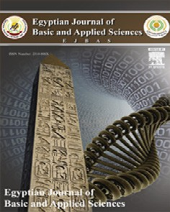

Contents lists available at [ScienceDirect](http://www.sciencedirect.com/science/journal/2314808X)

Egyptian Journal of Basic and Applied Sciences

journal homepage: [www.elsevier.com/locate/ejbas](http://www.elsevier.com/locate/ejbas)

Full Length Article

Azoreductase kinetics and gene expression in the synthetic dyes-degrading *Pseudomonas*



# Ameer Elfarash a,⇑, Asmaa M.M. Mawad b, Naeima M.M. Yousef b, Ahmed A.M. Shoreit b

a *Genetics Departments, Faculty of Agriculture, Assiut University, 71526 Assiut, Egypt*

b *Botany and Microbiology Department, Faculty of Science, Assiut University, 71516 Assiut, Egypt*

### a r t i c l e i n f o

*Article history:*

Received 30 March 2017

Received in revised form 12 July 2017 Accepted 21 July 2017

Available online 31 July 2017

*Keywords:* Azoreductase Kinetics

*Pseudomonas aeruginosa*

Synthetic dyes

### a b s t r a c t

Microorganisms have an effective capability to degrade synthetic dyestuff enzymatically. In this study, two 16S rRNA identified *Pseudomonas aeruginosa* bacterial isolates (ASU3 and ASU6) have been screened to enzymatically degrade both Disperse Blue 64 (DB64) and Acid Yellow 17 (AY17) which resembles 2 of the synthetic dyes that causes aquatic environmental pollution. The expression of the *azoR1* gene has been detected in the strains, the degradation percentage of DB64 and AY17 by stain ASU6 was found to exceed the ASU3. This returned to the differences in the expression levels of *azoR1* between the ASU6 and the ASU3 which was confirmed by RT-PCR. In addition, the specific activity (U/mg protein) of azoreductase in ASU6 was higher than ASU3 when MethylRed (MR), DB64 and AY17 were used as a substrate, separately. The azoreductase kinetics was studied to find the optimum condition for maintain- ing the stability of the enzyme. The degraded products separated by HPLC/MS were tested for their tox- icity on two crop plants and they were nontoxic to the plants.

© 2017 Mansoura University. Production and hosting by Elsevier B.V. This is an open access article under

the CC BY-NC-ND license (<http://creativecommons.org/licenses/by-nc-nd/4.0/>).

1. Introduction

Most of the colored substances present in the environment and resistant to decomposition by light, water, chemicals and microbial activity are identified as synthetic dyes [1,2]. Azodyes are a large group of aromatic compounds that consist of one or more chro- mophoric azo group (AN@N) that are present in the water body due to many industrial activities and causes aquatic environmental pollutants. Disperse blue (DB64) is an anthraquinone dye represent the second most important class of commercial dyes which mainly used for dyeing wool, polyamide and leather [3]. Acid Yellow 17 (AY17) is a commercial organic azodye that have a genotoxic effect [4]. They cause skin irritation, allergy [5], mutagenicity and car- cinogenicity [6] in humans. Many strategies have been developed to remove the industrial dyes from the water body, such as chem- ical oxidation and reduction [7], adsorption [8] and membrane fil- tration [9], photo-catalytic degradation [10], coagulation and precipitation [11], electrocogulation [12], photoelectrocatalysis

[13] and electrochemical oxidation [14]. Unfortunately, these strategies are expensive and may produce toxic products [2]. On

* Corresponding author.

*E-mail address:* [aelfarash@aun.edu.eg](mailto:aelfarash@aun.edu.eg) (A. Elfarash).

the other hand, Using of microorganisms to remove these dyes are fast [15,16], inexpensive, and the end products are safe [17].

Different microorganisms, including bacteria [18–20], fungi [21,22] algae [23,24], are able to remove different type dye stuff. The removal of the dyes is carried out by different mechanisms. Biosorption on the cell wall due to the presence of different func- tional groups is one way to remove the dyes [16,25]. Another way is the enzymatically microbial degradation by the azodye– catabolic enzymes like azoreductase [26], laccase [27] and peroxi- dase [28]. Azoreductases of microorganisms are favorable for the development of biodegradation systems for azo dyes, because these enzymes catalyze reductive cleavage of azo groups (AN@NA) under mild conditions [29]. However, the aerobic treatment of azo- dyes requires a special aerobic azoreductase system which cat- alyzes the NADH or NAD(P)H-dependent reduction of azo compounds to the corresponding amines [30]. This enzyme could not only reduce the carboxylic bacterial substrate but also it could reduce the sulfonated analogoes. A small number of bacterial spe- cies have been reported to degrade azodyes under aerobic condi- tion such as *Bacillus* sp*.* OY1-2 [31]. *Pseudomonas* [32], *Xenophilusazovorans* [33], and *Sphingomonas* sp. [34]. This study aims to: (i) isolate and identify the azodyes- degrading *Pseu- domonas* species, (ii) detect the *azoR1* gene in isolated strains (iii) compare azoreductase activity, kinetics and gene expression at the RNA level.

<http://dx.doi.org/10.1016/j.ejbas.2017.07.007>

2314-808X/© 2017 Mansoura University. Production and hosting by Elsevier B.V.

This is an open access article under the CC BY-NC-ND license (<http://creativecommons.org/licenses/by-nc-nd/4.0/>).

1. Materials and methods
   1. *Strains isolation*

The isolation of the dye decolorizing bacterial species was car- ried out according to Hesham et al. [35] with some modifications. About 10 mL or mg of water effluent or sludge sample, respectively were suspended in 90 ml (MBS) medium. The medium was supple-

mented with 100 mg l—1 of DB64 or AY17 and 0.1% of glucose as a

carbon source. The flasks were incubated on orbital shaker at 150 rpm at 30 °C. After 7 days incubation, an aliquot of 10% enriched cultures were transferred to a new flasks containing 90 ml fresh autoclaved MBS medium supplemented with previ- ously mentioned dyes. This step was repeated five times to attain well-adapted dye decolorizing microorganisms.

To select *Pseudomonas* dye degrading strains, cultures were transferred to a King A agar medium supplemented with 100 mg l—1 of dye at pH 7.0 and 30 °C. *Pseudomonas* colonies were individually selected, purified and evaluated for their dye decol-

orizing ability.

* 1. *Identification of azodye–degrading Pseudomonas spp*

Colony-PCR was performed to amplify the 16S rRNA gene using the 27F (5-AGAGTTTGATCCTGGCTCAG-3) and 1492R (5-CGGCTA

CCTTGTTACGACTT-3) primers [36]. PCR was programmed as following: 5 min at 95 °C, followed by 35 cycles of 1 min at 94 °C, 1 min at 55 °C and 1 min at 72 °C and then one cycle of final exten- sion at 72 °C for 10 min. PCR product was then analyzed on 1.5% agarose gel electrophoresis and then sequenced in both directions.

The obtained sequences were aligned and compared using the BLAST search tool at the (<http://www.pseudomonas.com/>). To determine the taxonomic position of the isolate, a phylogenetic tree was constructed by MEGA version 4.0 software.

* 1. *Measuring azodye degradation by the UV-vis Spectrophotometer*

An overnight culture were inoculated in MBS medium supple- mented with 0.1% of glucose and 100 mg l—1of the tested dyes at 30 °C under static condition. The percentage of decolorization was estimated from the following equation [37]:

A0 — At

% of decolorization = A0 * 100 (1)

where A0; is the initial absorbance of dyes and At is the absorbance of dye at (t) time. The blank sample is the cultivation medium.

For determination the concentration of dye in the medium, standard curves of DB64 and AY17 with different concentrations (5–300 mg l—1) were made.

* 1. *Crude enzyme extraction*

Strains was grown in MBS liquid medium amended with 0.1% glucose and 100 mg l—1of methyl red to enhance the production of azoreductase enzyme. The cells were harvested by centrifuga- tion and suspended in potassium phosphate buffer (50 mM, pH

7.4). The cells were crushed by sonication at 35 amplitude for 2 min (30-s interval) at 4 °C. The homogenate was then centrifuged at 5000 rpm for 30 min under cooling and the supernatant was transferred to a new tube and the pellet was removed. The total protein concentration was determined by Bradford method [38], with bovine serum albumin as standard.

* 1. *Azoreductase specific activity and substrate specificity*

The azoreductase specific activity was assessed by the reduction of methyl red (MR) as the main substrate and oxidation of NADH using a modified procedure described by Zhao et al. [39]. An enzyme assays mixture was prepared by mixing 600 mL phosphate

buffer (50 mM and pH 7.5), 100 mL of dye substrate (50 mM), 100 mL

of the crude enzyme and 200 mL of NADH (200 mM). MR, DB64 and AY17 were used as a specific substrate to determine the specific azoreductase activity and detect substrate specificity.

One unit of azoreductase activity was defined as one microgram of methyl reduced protein per minute per milligram. All enzyme assays were run in triplicate.

* 1. *Factors affecting on azoreductase stability*

Different pHs and temperatures were tested to determine their effect on the azoreductase stability. To determine the pH effect, the NADH and MR buffers was prepared with a range of different pH (from pH 5 to 9), while the acetate buffer was pH 5.5, the phos- phate buffer was pH (6.5–7.5) and Tris-HCl buffer was pH [8–9].

The temperature effect was determined by using variable tem- perature values ranged from 20 to 60 °C during the measurement with the UV-Vis Spectrophotometer. The temperature of all enzymes reaction mixture was adjusted to the desired temperature except the NADH.

* 1. *Azoreductase kinetics*

Different concentrations of MR (ranged from 17 to 3500 mM) were prepared to determine the azoreductase kinetics. All other constituents of reaction mixture were constant. Kinetic values such as Michaelis–Menten constant (K max) and maximal velocity (Vmax) were calculated from Lineweaver–Burk double reciprocal plots [40].

* 1. *The expression of the azoR1 gene*

Reverse transcriptase PCR (RT-PCR) technique was used to determine the *azoR1* gene expression. RNA was extracted by using SV Total RNA Isolation System (Promega). First-strand cDNA was reverse transcribed from one microgram of total RNA by using First-strand cDNA Synthesis Kit (Amersham Biosciences, GE

Healthcare). RT-PCR was performed using (*azoR1*Fw: 5'-AACAGCG

TTCGCTGGCGATG-3' and *azoR1*1Rv: 5'- AGGGATCGGCGTGG

TTCATC-3') primers which were designed to specifically amplify a 303 bp sequence in the *azoR1* gene. PCR conditions were: initial denaturation for 5 min at 95 °C, 36 cycles with 1 min at 94 °C,

40 s at 56 °C, 60 s at 72 °C, and final extension for 10 min at

72 °C. The reaction products were analyzed on 1% agarose gel elec- trophoresis. The intensity of the bands was analyzed using Gene Profiler 4.03 computer software to determine the OD of each band and consequently calculate the concentration of DNA in the band.

* 1. *Toxicity of metabolic products*

The toxicity of the dyes and its metabolic products were deter- mined by acute toxicity test on 2 popular crop plants in Egypt; monocot seed (*Triticum aestivum*) and dicot seed (*Vicia faba*). Briefly, the dyes degraded broths were centrifuged at 10000 rpm for 20 min under cooling. The supernatant was collected and ster- ilized by filtering. About 10 plant seeds were germinated in steril-

ized Petri dish and irrigated with dye filtrate (10 mL) at 30 °C for

7 days. Then the germination percentage, the root and shoot length were calculated. A positive and a negative control were included in the experiment. The positive was irrigated with the dyes buffers

without the bacterial treatment while the negative control was irrigated with sterilized distilled water.

* 1. *Determination of the metabolic products by LC-MS*

10 mL of the metabolites were extracted with three equal vol- umes of Ethyl Acetate. The residual extracts were dried over anhy- drous Sodium Sulfate and evaporated with rotary evaporator at 40 °C to 10 ml. The samples were dried in vacuum and stored at

—20 °C until used. The metabolic products were analyzed by Waters

Alliance Acquity UPLC - Xevo G2S-QTof instrument. Extracts were dissolved in 1 ml of 1:1 MeCN:H2O. 10 ml aliquot was taken and diluted with 90 ml 1:1 MeCN: H2O. 2 ml was injected for LC-MS anal- ysis. The LC conditions: A = H2O + 0.1% HCOOH; B = MeCN + 0.1% HCOOH. 5% B–95% B: 0–12 min 95% B: 12–17 min 5% B: 17–

20 min. The flow rate was 0.2 ml/min, column temperature was 40 °C and the Acquity UPLC BEH C18 column, 1.7 mm, 2.1 × 50 mm. The MS conditions: Range: 100–1200 Da, Capillary: 3.5 V, Sam- pling cone: 40 V, Source temperature: 120 °C, Desolvation temper- ature: 200 °C, Cone gas: 25 L/hr, Desolvation: 600 L/hr and MSe: ramp collision energy from 15 to 45 V. The MS detector was per-

formed by electrospray ionization in positive mode [ESI+].

1. Results and discussion
   1. *Azodye–degrading Pseudomonas spp isolation and identification*

Twenty *Pseudomonas* strains were isolated from different textile dye effluent and screened for azodye degrading capability (results are not shown). Two strains ASU3 and ASU6 exhibited hyber azo- dye degrading capability. The strains were identified based on some morphological and biochemical activity using Bergey’s Man- ual of Systematic Bacteriology as *Pseudomonas aeruginosa*. The cell shape was short rods and gram-negative. They showed high growth on the different *Pseudomonas* selective media like Cetrim- ide, King A and King B and produce green pyocyanin pigment. They are oxidase and catalase positive strains and can oxidize glucose.

Moreover, we used the 16S rRNA gene sequencing to molecu- larly identify the ASU3 and ASU6 strains. The 16S rRNA identifica- tions is more robust, reproducible, accurate and less subjective test results [1,41]. Based on the Blast results and the dendrogram demonstrating the relationship among some *Pseudomonas* strains

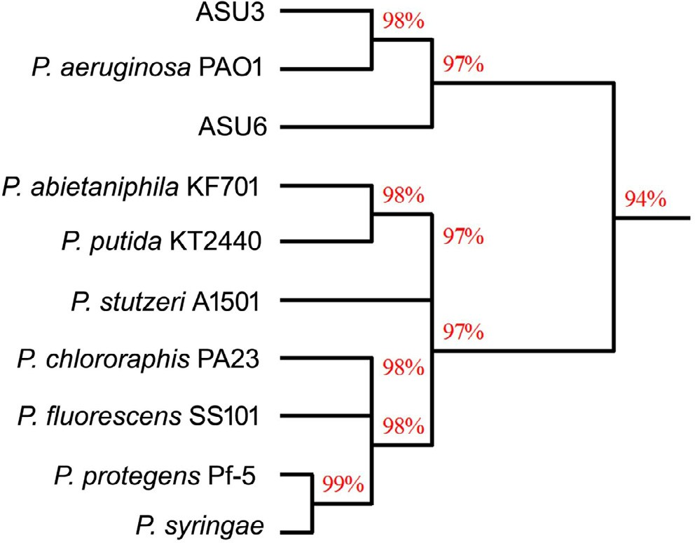

Fig. 1. Dendrogram demonstrating the relationship among the isolated strains (ASU3 and ASU6) and some *Pseudomonas* strains.

(Fig. 1), ASU6 and ASU3 strains were highly similar to *Pseudomonas aeruginosa* with a similarity of 97–98%, respectively.

* + 1. *Degradation of azodyes*

The capacity of *Pseudomonas* strains for the decolorization of various dyes has been studied in detail [42] who reported that, the azo dyes (Acid Violet 7, Acid Red 151 and Reactive Black 5) were degraded at higher extent (>90%) than Indigo Carmin, Acid Red 183 (chromium complex) and anthraquinones (Reactive Blue 2 and Acid Green 27). Decolorization of waste waters containing reactive azo dyes was achieved by a culture of the bacteria *P. lute- ola* that reduced the azo bond in Red G [43].

Using the UV-Vis Spectrophotometer, the degradation percent-

age of each dye was estimated for the two selected strains at the maximum absorbance (kmax) using equation [1]. DB64 and AY17

were monitored at 600, and 398 nm, respectively. Strains ASU3 and ASU6 could degrade 61.2 and 96.8% of DB64 within 48 h and under static condition, respectively. At the same time, they could remove 38.6 and 91.2% of AY17, respectively (Fig. 2).

The results showed that the efficiency of two strains to degrade DB64 was higher than AY17. In addition, the ability of the strain ASU6 to degrade the two distinct types of azodyes exceeded the ability of ASU3.

* + 1. *azoR1 gene expression in isolated strains*

To evaluate the effects of different substrate on the transcrip- tion of azoreductase gene, cells were cultured in media supple- mented with 100mg l-1of either DB64, AY17 or MR for 48 h. RNA was directly extracted from cultivated strains after the decoloriza- tion of dye using the SV total RNA Isolation system (Promega). The expression of *azoR*1 gene was used to detect the activity of the ASU3 and ASU6 strains on the azodyes.

The transcription of *azoR1* gene was variable from strain to another and from substrate to other. In this study, the expression of *azoR1* gene in strain ASU6 was higher than its expression in ASU3 when they consumed MR and AY17 and the opposite occurred when the DB64 was consumed. When using AY17 as the main substrate, the transcription of *azoR*1 gene was signifi- cantly weak in the strain ASU6 with lnt OD 1.82 and band concen- tration was about 35.1 ng but it was hardly detected in ASU3; the band concentration was about 12.5 ng (Fig. 3 and Table 1).

Regarding the DB64-containing medium, the two strain exhibit a bright band. Interestingly, the gene expression as well as the band concentration in the strain ASU3 (93.3 ng) was more than ASU6 (63.97 ng). Moreover, the highest expression was detected when the strains were separately cultivated on the medium sup- plemented with MR (212.07 and 98.8 ng for ASU6 and ASU3, respectively) (Fig. 3 and Table 1).

In addition, the transcription of *azoR1* seemed to be subjected to the type and chemistry of the dye. The results of gene expression were highly supported the results of azoreductase specific activity and the degradation percentage except with the degradation of DB64. When the DB64 was used as a substrate, the RNA expression of *azoR1* gene in strain ASU6 was lower than ASU3. However, the enzyme specific activity and the degradation percentage were higher. The reason of this phenomena may be due to the presence of other co-enzymes or cofactors cooperated to enhance the activ- ity of azoreductase as well as the degradation of the DB64 in strain ASU6 rather than *azoR1* encoding azoreductase as mentioned by (1).

Leelakriangsak et al. [44] reported the increase in the expres- sion of genes (*ppazoR1*, *ppazoR2* and *ppazoR3*) on the mRNA levels in *P. aeruginosa*. Töwe et al. [45] also observed more significant increases in *azoR1* and *azoR2* gene expression in *Bacillus subtilis* in the presence of quinines.

120



DB 64 (ASU-3)

DB 64 (ASU-6)

AY 17 (ASU-3)

AY 17 (ASU-6)

100

80

**% of Dye Degradation**

60

40

20

0

0 6 12 18 24 30 36 42 48 54

## T/hrs

Fig. 2. Percentage of DB64 and AY17 degradation by strains ASU3 and ASU6 at pH 7.0, 30 °C and 100 mg l—1dye under static condition.

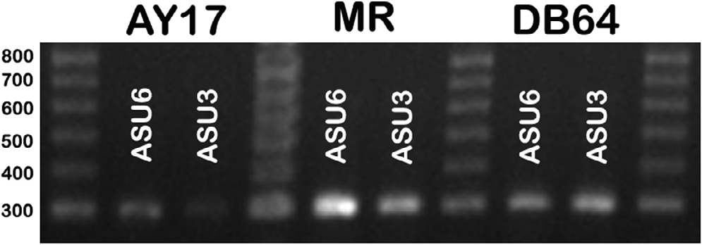Table 2

The aerobic azoreductase specific activity (U/ mg protein) of two strains on different substrates at 30 °C, pH 7.0, 50 mM substrate concentration and 200 mM NADH.

Substrate Stain

ASU-3 ASU-6

Azoreductase specific activity (U/mg protein)

|  |  |  |
| --- | --- | --- |
| MR | 0.3 ± 0.005 | 0.92 ± 0.11 |
| DB 64 | 0.254 ± 0.042 | 0.54 ± 0.102 |
| AY 17 | 0.125 ± 0.025 | 0.312 ± 0.058 |

Fig. 3. Agarose electrophoresis of the RT-PCR product to test the expression of the

*azoR1* gene in both ASU6 and ASU3 isolates growing in different substrates (AY17, MR, and DB64).

Table 1

The data of lnt OD and band concentration (ng) that extracted from gene profiler software.

|  |  |  |  |
| --- | --- | --- | --- |
| Substrate | Strain | DNA concentration (ng) | Int OD |
| AY 17 | ASU- 6 | 35.085 | 1.82 |
|  | ASU-3 | 12.516 | 0.56 |
| MR | ASU- 6 | 211.072 | 11.65 |
|  | ASU-3 | 98.803 | 5.38 |
| DB 64 | ASU- 6 | 63.971 | 3.44 |
|  | ASU-3 | 93.315 | 5.07 |

* 1. *Determination azoreductase specific activity and substrate specificity*

Azoreductase is a key enzyme catalyzes the reduction of azo- dyes in versatile microorganisms. This enzyme could be inhibited by oxygen [46]. The specific activity of azoreductase enzyme (U/ mg protein) was monitored for the two strains during the growth of strains on methyl red (MR), DB64 or AY17 as specific substrates in the presence of NADH as the electron donor (oxidative media-

tors). The experiment was carried out under a static condition at 30 °C. The maximum specific activity of ASU3 and ASU6 on differ- ent substrates was summarized in Table 2. The strains recorded highest values of azoreductase specific activity when the MR dye

was applied as a specific substrate (0.92 and 0.3 U/mg protein for ASU6 and ASU3, respectively). On the other hand, the specific activity of azoreductase enzyme was at the lowest value when the AY17 was used. It was observed that, the specific activity of azoreductase producing strain ASU6 higher than strain ASU3. Thus, it could be said that, the specific substrate that will be applied to find the enzyme kinetics was MR.

Due to a competition for consumption of NADH by aerobic res- piration, which make the electron transfer from NADH to oxygen in order to form ATP [47]. Many bacteria possess a specific cytoplas- mic azoreductases system that catalyzed the electron transfer from NADH (electron donor) to azo bonds. So, the presence of NADH is very significant in the reduction of azodyes by aerobic bacteria [46]. Thus, it could be concluded that, the aerobic azoreductase enzyme is an inducible enzyme required redox mediator for per- fect performance. Likewise, that the presence of dyes as substrates stimulate the induction of this enzyme. Azoreductase activity in azodyes decolorizing bacteria has been extensively examined to elucidate azo dye reduction mechanism [30,39,44,48].

* 1. *Factors affecting azoreductase activity*

Azoreductase reaction should take place at optimum condition. The most important condition affecting on the activity of the enzymes is pH and temperature. Hence, it is rattling important to determine the optimal conditions for the operation of enzymes.

The activity of azoreductase was maximum at pH 7.5 for ASU3 and ASU6 at 30 °C (Fig. 4a). Thus, the optimal pH value for azoreductase enzyme was pH 7.5 when MR was used as a specific substrate. While the optimum temperature for azoreductase was at 40 °C for the two strains (Fig. 4b). No significant activity has been observed at 60 °C for strain ASU6. These came in context with many literatures which study the optimum condition for azoreduc- tase [46,47].

* 1. *Kinetics of azoreductase*

Using a different concentration of the substrate (MR) is a main factor to determine the enzyme kinetics. The kinetics parameters like Vmax (maximum velocity) and Km (Michaelis constant) were estimated and the velocity of azoreductase in ASU6 (10.6 mM/

min/mg) was higher than ASU3 (0.5 mM/min/mg). However, the

value Km were 125 and 3240 mM. The low value of km indicated that the affinity of substrate to azoreductase in ASU3 was higher than its affinity in ASU6 (Fig. 5).

Many literatures reported that azoreductase enzyme is not only capable of reduction of azo dyes, but also it could reduce several naphtho-, benzo-, and anthraquinone compounds. In some cases, these compounds act as a better substrate than methyl red due

to higher value of Km and Vmax than MR [49]. The enzyme kinetics in two isolated strains indicated that the velocity Vmax and Km of the enzyme in ASU6 was higher than ASU3. Nevertheless, an enzyme has a low value of km it achieves its maximum catalytic efficiency at low substrate concentrations. ASU3 azoreductase was more effective as a catalyst than ASU6.

* 1. *Phytotoxicity test*

The use of untreated or treated wastewater contaminated with dyes in the land may have a harmful effect on the soil fertility and productivity. Thus, it was important to consider the effect of dyes and its product on two different crop plants. Because the strain ASU6 exhibited higher degradation ability to synthetic dyes than ASU3, it was selected for phytotoxicity studies. The results demon- strated that, the percentages of germination were significantly low when the seeds treated with the crude dyes compared to that trea- ted with the metabolic products. The highest germination percent- age achieved when the DB64 metabolic products were applied on monocot and dicot seeds 87% and 80%, respectively (Table 3). The length of shoot and root was also significantly affected.

The results showed that, the toxicity of dyes and its degradation products on the plant was different according the type and

0.16

0.14

0.12

**Azoreductase activity (U/min)**

0.10

0.08

0.06

0.04

0.02

0.18

0.16

**(a)**

**(b)**

0.14

**Azoreductase activity (U/min)**

0.12

0.10

0.08

0.06

0.04

0.02

0.00

5 6 7 8 9 10

**pH**

0.00

10 20 30 40 50 60 70

**T/°C**

Fig. 4. The effects of pH (a) and temperature (b) on the azoreductase activity (U/min) in strains ASU3 (solid bullet) and ASU6 (hollow bullet) when the MR was a specific substrate at 430 nm.

ASU-3

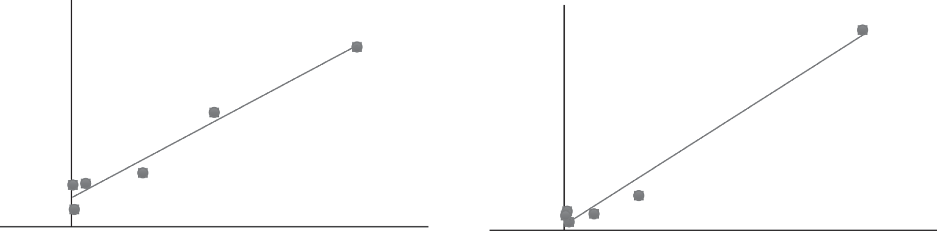

60

50

40

30

20

10

0

90 ASU-6

80

70

60

50

40

30

20

10

0

**1/[ v]**

**1[V]**

|  |  |  |  |  |  |  |  |  |  |  |  |  |
| --- | --- | --- | --- | --- | --- | --- | --- | --- | --- | --- | --- | --- |
| -0.05 | 0 | 0.05 | 0.1 | 0.15 | 0.2 | 0.25 | -0.05 | 0 | 0.05 | 0.1 | 0.15 | 0.2 0.25 |
|  |  |  | **1[S]** |  |  |  |  |  |  | **1/[S]** |  |  |

Fig. 5. A Lineweaver-Burk plot for determination the kinetic parameters of azoreductase in ASU3 and ASU6 at pH 7.0 and temperature 40 °C.

Table 3

The phytotoxicity test on *Triricum endobyoticum* and *Vicia faba* plant rowing on the tested dyes and its metabolic products.

|  |  |  |  |  |  |  |  |  |  |  |  |
| --- | --- | --- | --- | --- | --- | --- | --- | --- | --- | --- | --- |
| Parameters | *Triticum endobyoticum* |  |  |  |  | *Vicia faba* |  | | | | |
|  | DB 64  Cont. Prod. |  | AY 17  Cont. | Prod. |  | DB 64  Cont. | Prod. |  | AY 17  Cont. | Prod. |  |
| %Germination | 21 ± 6 87 ± 5.8 |  | 24 ± 7 | 75 ± 6 |  | 27 ± 6 | 80 ± 10 |  | 40 ± 10 | 70 ± 0 |  |
| Shoot length | 4.2 ± 0.78 16 ± 1 |  | 4.1 ± 1.3 | 15.2 ± 1.3 |  | 2.8 ± 1.2 | 11.4 ± 1.7 |  | 3.9 ± 0.9 | 7.9 ± 1.9 |  |
| Root length | 3.1 ± 0.44 7.3 ± 3.8 |  | 4 ± 0.57 | 12.5 ± 1.7 |  | 3.4 ± 0.7 | 8.3 ± 2.5 |  | 3.8 ± 0.4 | 5.4 ± 1.42 |  |

Values were means of triplicate determinations, standard deviation (±). The highest germination percentage archived are in Bold.

Table 4

Intermediate metabolites identified by HPLC/MS.

Product NO. Chemical structure ES + Chemical formula

1 (cont.) DB 64 452 C28H22N2O4

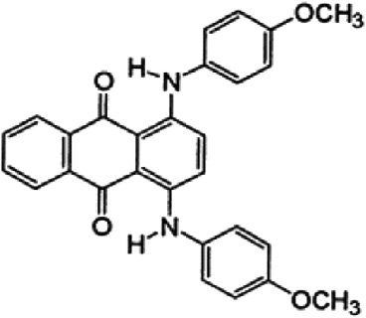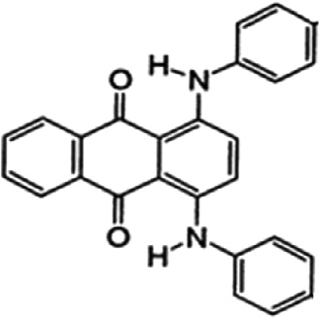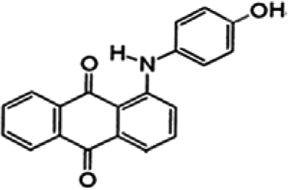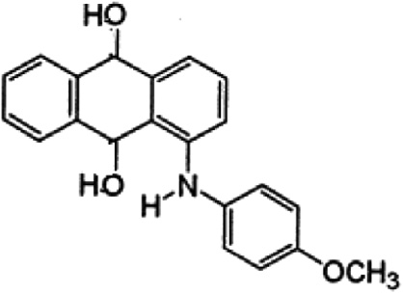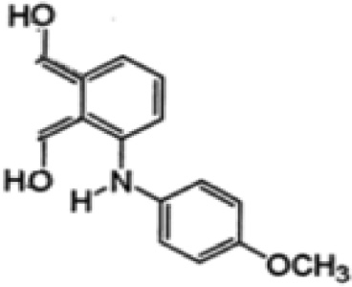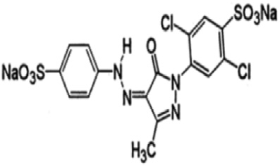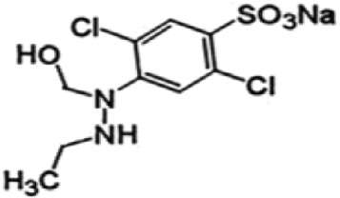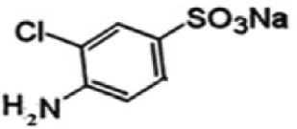

2 387 C26H18N2O2

3 317 C20H13NO3

4 338 C21H17NO3

5 256 C15H13NO2

6 AY 17 ES-554 C16H10Cl2N4Na2O7S2

7 ES-339 C9H8Cl2N2NaO4S

8 ES-233 C6H5ClNNaO3S

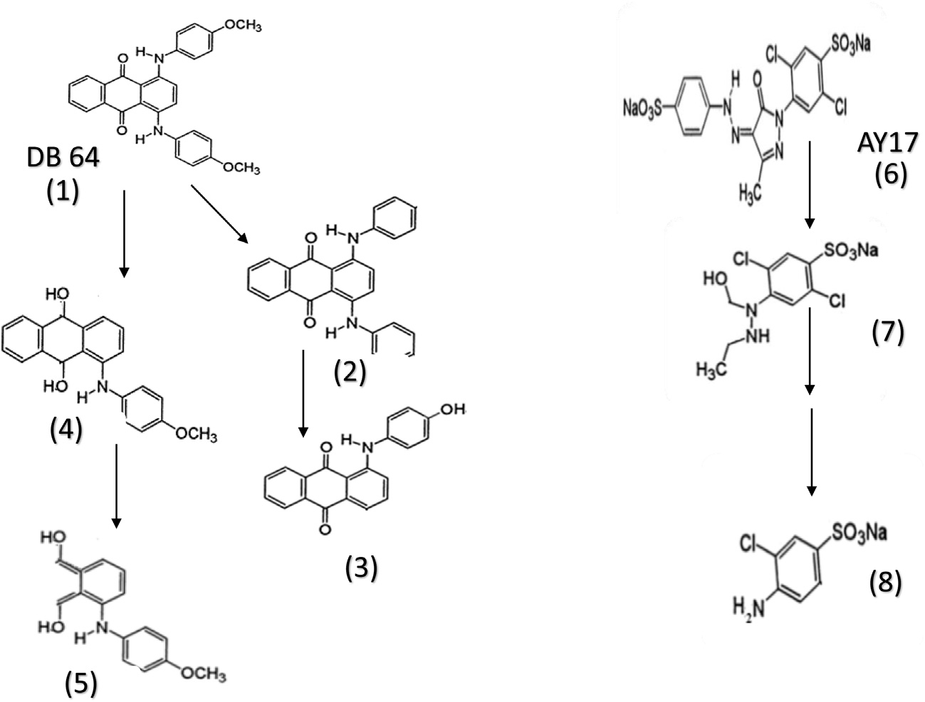

Fig. 6. A suggested degradative pathway of both DB64 and AY17.

chemistry of these compounds. The effective microbial degradation of dyes will lead to safe metabolic products.

* 1. *Metabolic products by HPLC–MS*

The metabolic products that produced from the degradation of DB64 by strain ASU6 was analyzed by HPLC–MS for tentative iden- tification of intermediate compounds. The HPLC–MS chro- matogram showed that, there were many tentative products produces after incubation of dye with strain ASU6. Four tentative compounds have a good match with the structure of DB64 that were listed in Table 4. These compounds indicated that the main behavior of the strain ASU6 for degradation of DB64 was the reduc- tion of anthraquinone ring.

The tentative products gave an impression that, there were two expected metabolic pathways (Fig. 6) for degradation of DB64. The first one was that the DB64 can undergo reduction through azore- ductase via two electrons transfer that lead to formation of hydro- quinone (Table 4; No. 4). The subsequent reduction mechanism finally leads to ring cleavage (Table 4; No. 5). The second pathway was to eliminate the methoxy groups from the dye (Table 4; No. 2) and subsequently one of the amino benzene was liberated and the other was hydrated (Table 4; No. 3).

The mechanism of hyrdoquinone formation was that NADH acted as redox mediators which were enzymatically reduced by the cells to form hydroquinones, which in turn reduced the azo dye. The quinine reductase activity was observed in the cell mem- brane and hence the transport of the hydroquinone /quinine redox mediator and the highly polar sulfonated azo dye across the cell membrane was not required.

The metabolites could be detected from the degradation of AY 17(Table 4 & Fig. 6) were only two metabolites (Table 4 No; 7&8) indicating the cleavage of diazo bond and formation of sulfonated aromatic amines.

1. Conclusion

The percentage of degradation of many dyes is controlled by the type and chemistry of dye and the ability of bacteria to produce the

azoreductase enzyme. The percentage of dye degradation was vari- able within the two isolated strains why the strain ASU3 and ASU6 could degrade anthraquinone dye DB64 with higher efficiency than AY17. May be due to the anthraquinone dyes are easier to degrade than azodyes one or the presence complex structure of AY17 make obstacle its degradation. Other causes may be due to the bacterial *azoR1*gene expressions in the presence of DB64 was higher than AY17.

Azoreductase is the main enzyme responsible for degradation of DB64 and AY17. When the transcription of *azoR1* gene decreases, it led to decrease the azoreductase activity and its velocity toward the substrate and consequently, depletion in the degradation rate. Along the DB64 degradation process by ASU6, four metabolites can be detected that indicated the reduction of the anthraquinone ring by azoreductase. These metabolites were proved to be non-toxic to the crop plants.

Acknowledgments

A great acknowledge to the Assiut University Mycological Center (AUMC) for helping in the identification and preservation of sam- ples in (AUMC) culture collection. Also, the authors thank Prof. Dr. Mostafa Fouad, and Dr. Usama Ramadan, Faculty of Pharmacy, El Minia University, Egypt for their help in the HPLC/MS analysis and identifications.

Conflict of interest

The authors declare that there is no conflict of interest regard- ing the publication of this paper.

References

1. [Leelakriangsak M. Molecular approaches for bacterial azoreductases.](http://refhub.elsevier.com/S2314-808X(17)30147-1/h0005) [Songklanakarin J Sci Technol 2013;35(6):647–57](http://refhub.elsevier.com/S2314-808X(17)30147-1/h0005).
2. [Singh P, Iyengar L, Pandey A. Bacterial decolorization and degradation of azo](http://refhub.elsevier.com/S2314-808X(17)30147-1/h0010) [dyes. Microbial degradation of xenobiotics. Springer; 2012. p. 101–33](http://refhub.elsevier.com/S2314-808X(17)30147-1/h0010).
3. [Reife A, Freeman HS. Carbon adsorption of dyes and selected intermediates.](http://refhub.elsevier.com/S2314-808X(17)30147-1/h0015) [Environ Chem Dyes Pigm 1996:3–31](http://refhub.elsevier.com/S2314-808X(17)30147-1/h0015).
4. [Mansour HB, Corroler D, Barillier D, Ghedira K, Chekir L, Mosrati R. Evaluation](http://refhub.elsevier.com/S2314-808X(17)30147-1/h0020) [of genotoxicity and pro-oxidant effect of the azo dyes: acids yellow 17, violet 7](http://refhub.elsevier.com/S2314-808X(17)30147-1/h0020)

[and orange 52, and of their degradation products by *Pseudomonas putida* mt-2.](http://refhub.elsevier.com/S2314-808X(17)30147-1/h0020) [Food Chem Toxicol 2007;45(9):1670–7](http://refhub.elsevier.com/S2314-808X(17)30147-1/h0020).

1. [Soriano JJ, Mathieu-Denoncourt J, Norman G, de Solla SR, Langlois VS. Toxicity](http://refhub.elsevier.com/S2314-808X(17)30147-1/h0025) [of the azo dyes Acid Red 97 and Bismarck Brown Y to Western clawed frog](http://refhub.elsevier.com/S2314-808X(17)30147-1/h0025) [(*Silurana tropicalis*). Environ Sci Pollut Res 2014;21(5):3582–91](http://refhub.elsevier.com/S2314-808X(17)30147-1/h0025).
2. [Wang C, Yediler A, Lienert D, Wang Z, Kettrup A. Ozonation of an azo dye CI](http://refhub.elsevier.com/S2314-808X(17)30147-1/h0030) [Remazol Black 5 and toxicological assessment of its oxidation products.](http://refhub.elsevier.com/S2314-808X(17)30147-1/h0030) [Chemosphere 2003;52(7):1225–32](http://refhub.elsevier.com/S2314-808X(17)30147-1/h0030).
3. [Florenza X, Solano AMS, Centellas F, Martínez-Huitle CA, Brillas E, Garcia-](http://refhub.elsevier.com/S2314-808X(17)30147-1/h0035) [Segura S. Degradation of the azo dye Acid Red 1 by anodic oxidation and](http://refhub.elsevier.com/S2314-808X(17)30147-1/h0035) [indirect electrochemical processes based on Fenton’s reaction chemistry.](http://refhub.elsevier.com/S2314-808X(17)30147-1/h0035) [Relationship between decolorization, mineralization and products.](http://refhub.elsevier.com/S2314-808X(17)30147-1/h0035) [Electrochim Acta 2014;142:276–88](http://refhub.elsevier.com/S2314-808X(17)30147-1/h0035).
4. [Gupta V, Gupta B, Rastogi A, Agarwal S, Nayak A. A comparative investigation](http://refhub.elsevier.com/S2314-808X(17)30147-1/h0040) [on adsorption performances of mesoporous activated carbon prepared from](http://refhub.elsevier.com/S2314-808X(17)30147-1/h0040) [waste rubber tire and activated carbon for a hazardous azo dye—Acid Blue 113.](http://refhub.elsevier.com/S2314-808X(17)30147-1/h0040) [J Hazard Mater 2011;186(1):891–901](http://refhub.elsevier.com/S2314-808X(17)30147-1/h0040).
5. [Mittal A, Thakur V, Gajbe V. Evaluation of adsorption characteristics of an](http://refhub.elsevier.com/S2314-808X(17)30147-1/h0045) [anionic azo dye Brilliant Yellow onto hen feathers in aqueous solutions.](http://refhub.elsevier.com/S2314-808X(17)30147-1/h0045) [Environ Sci Pollut Res 2012;19(6):2438–47](http://refhub.elsevier.com/S2314-808X(17)30147-1/h0045).
6. [Cai Y, Stromme M, Melhus A, Engqvist H, Welch K. Photocatalytic inactivation](http://refhub.elsevier.com/S2314-808X(17)30147-1/h0050) [of biofilms on bioactive dental adhesives. J Biomed Mater Res B Appl Biomater](http://refhub.elsevier.com/S2314-808X(17)30147-1/h0050) [2014;102(1):62–7](http://refhub.elsevier.com/S2314-808X(17)30147-1/h0050).
7. [Verma AK, Dash RR, Bhunia P. A review on chemical coagulation/flocculation](http://refhub.elsevier.com/S2314-808X(17)30147-1/h0055) [technologies for removal of colour from textile wastewaters. J Environ Manage](http://refhub.elsevier.com/S2314-808X(17)30147-1/h0055) [2012;93(1):154–68](http://refhub.elsevier.com/S2314-808X(17)30147-1/h0055).
8. [Fajardo AS, Rodrigues RF, Martins RC, Castro LM, Quinta-Ferreira RM. Phenolic](http://refhub.elsevier.com/S2314-808X(17)30147-1/h0060) [wastewaters treatment by electrocoagulation process using Zn anode. Chem](http://refhub.elsevier.com/S2314-808X(17)30147-1/h0060) [Eng J 2015;275:331–41](http://refhub.elsevier.com/S2314-808X(17)30147-1/h0060).
9. [Garcia-Segura S, Brillas E. Applied photoelectrocatalysis on the degradation of](http://refhub.elsevier.com/S2314-808X(17)30147-1/h0065) [organic pollutants in wastewaters. J Photochem Photobiol C: Photochem Rev](http://refhub.elsevier.com/S2314-808X(17)30147-1/h0065) [2017](http://refhub.elsevier.com/S2314-808X(17)30147-1/h0065).
10. [Solano AMS, Garcia-Segura S, Martínez-Huitle CA, Brillas E. Degradation of](http://refhub.elsevier.com/S2314-808X(17)30147-1/h0070) [acidic aqueous solutions of the diazo dye Congo Red by photo-assisted](http://refhub.elsevier.com/S2314-808X(17)30147-1/h0070) [electrochemical processes based on Fenton’s reaction chemistry. Appl Catal B](http://refhub.elsevier.com/S2314-808X(17)30147-1/h0070) [2015;168:559–71](http://refhub.elsevier.com/S2314-808X(17)30147-1/h0070).
11. [Khalid A, Arshad M, Crowley DE. Accelerated decolorization of structurally](http://refhub.elsevier.com/S2314-808X(17)30147-1/h0075) [different azo dyes by newly isolated bacterial strains. Appl Microbiol](http://refhub.elsevier.com/S2314-808X(17)30147-1/h0075) [Biotechnol 2008;78(2):361–9](http://refhub.elsevier.com/S2314-808X(17)30147-1/h0075).
12. [Solís M, Solís A, Pérez HI, Manjarrez N, Flores M. Microbial decolouration of azo](http://refhub.elsevier.com/S2314-808X(17)30147-1/h0080) [dyes: a review. Process Biochem 2012;47(12):1723–48](http://refhub.elsevier.com/S2314-808X(17)30147-1/h0080).
13. [Ogugbue CJ, Sawidis T. Bioremediation and detoxification of synthetic](http://refhub.elsevier.com/S2314-808X(17)30147-1/h0085) [wastewater containing triarylmethane dyes by Aeromonas hydrophila](http://refhub.elsevier.com/S2314-808X(17)30147-1/h0085) [isolated from industrial effluent. Biotechnol Res Int 2011;2011](http://refhub.elsevier.com/S2314-808X(17)30147-1/h0085).
14. [Elisangela F, Andrea Z, Fabio DG, de Menezes Cristiano R, Regina DL, Artur C-P.](http://refhub.elsevier.com/S2314-808X(17)30147-1/h0090) [Biodegradation of textile azo dyes by a facultative *Staphylococcus arlettae*](http://refhub.elsevier.com/S2314-808X(17)30147-1/h0090)[strain VN-11 using a sequential microaerophilic/aerobic process. Int](http://refhub.elsevier.com/S2314-808X(17)30147-1/h0090) [Biodeterior Biodegradation 2009;63(3):280–8](http://refhub.elsevier.com/S2314-808X(17)30147-1/h0090).
15. [Ghodake G, Jadhav S, Dawkar V, Govindwar S. Biodegradation of diazo dye](http://refhub.elsevier.com/S2314-808X(17)30147-1/h0095) [Direct brown MR by *Acinetobacter calcoaceticus* NCIM 2890. Int Biodeterior](http://refhub.elsevier.com/S2314-808X(17)30147-1/h0095) [Biodegradation 2009;63(4):433–9](http://refhub.elsevier.com/S2314-808X(17)30147-1/h0095).
16. [Saratale R, Saratale G, Kalyani D, Chang J-S, Govindwar S. Enhanced](http://refhub.elsevier.com/S2314-808X(17)30147-1/h0100) [decolorization and biodegradation of textile azo dye Scarlet R by using](http://refhub.elsevier.com/S2314-808X(17)30147-1/h0100) [developed microbial consortium-GR. Bioresour Technol 2009;100](http://refhub.elsevier.com/S2314-808X(17)30147-1/h0100) [(9):2493–500](http://refhub.elsevier.com/S2314-808X(17)30147-1/h0100).
17. [Maurya NS, Mittal AK, Cornel P, Rother E. Biosorption of dyes using dead macro](http://refhub.elsevier.com/S2314-808X(17)30147-1/h0105) [fungi: effect of dye structure, ionic strength and pH. Bioresour Technol](http://refhub.elsevier.com/S2314-808X(17)30147-1/h0105) [2006;97(3):512–21](http://refhub.elsevier.com/S2314-808X(17)30147-1/h0105).
18. [Kaushik P, Malik A. Fungal dye decolourization: recent advances and future](http://refhub.elsevier.com/S2314-808X(17)30147-1/h0110) [potential. Environ Int 2009;35(1):127–41](http://refhub.elsevier.com/S2314-808X(17)30147-1/h0110).
19. [Omar HH. Algal decolorization and degradation of monoazo and diazo dyes.](http://refhub.elsevier.com/S2314-808X(17)30147-1/h0115) [Pak J Biol Sci 2008;11(10):1310–6](http://refhub.elsevier.com/S2314-808X(17)30147-1/h0115).
20. [Daneshvar E, Kousha M, Sohrabi MS, Khataee A, Converti A. Biosorption of](http://refhub.elsevier.com/S2314-808X(17)30147-1/h0120) [three acid dyes by the brown macroalga *Stoechospermum marginatum*:](http://refhub.elsevier.com/S2314-808X(17)30147-1/h0120) [isotherm, kinetic and thermodynamic studies. Chem Eng J 2012;195:297–306](http://refhub.elsevier.com/S2314-808X(17)30147-1/h0120).
21. [Mawad AM, Yousef NM, Shoreit AA. Bioremediation of Acid blue 25 dye by](http://refhub.elsevier.com/S2314-808X(17)30147-1/h0125) [anthracene degrading *Pseudomonas pseudoalcaligenes* ASU-016. Catrina Int J](http://refhub.elsevier.com/S2314-808X(17)30147-1/h0125) [Environ Sci 2015;10:53–60](http://refhub.elsevier.com/S2314-808X(17)30147-1/h0125).
22. Puvaneswari N, Muthukrishnan J, Gunasekaran P. Toxicity assessment and microbial degradation of azo dyes. 2006.
23. [Mirzadeh S-S, Khezri S-M, Rezaei S, Forootanfar H, Mahvi AH, Faramarzi MA.](http://refhub.elsevier.com/S2314-808X(17)30147-1/h0135) [Decolorization of two synthetic dyes using the purified laccase of](http://refhub.elsevier.com/S2314-808X(17)30147-1/h0135) [*Paraconiothyrium variabile* immobilized on porous silica beads. J Environ](http://refhub.elsevier.com/S2314-808X(17)30147-1/h0135) [Health Sci Eng 2014;12(1):6](http://refhub.elsevier.com/S2314-808X(17)30147-1/h0135).
24. [Saroj S, Kumar K, Prasad M, Singh R. Differential expression of peroxidase and](http://refhub.elsevier.com/S2314-808X(17)30147-1/h0140) [ABC transporter as the key regulatory components for degradation of azo dyes](http://refhub.elsevier.com/S2314-808X(17)30147-1/h0140) [by *Penicillium oxalicum* SAR-3. Funct Integr Genomics 2014;14(4):631–42](http://refhub.elsevier.com/S2314-808X(17)30147-1/h0140).
25. [Nakanishi M, Yatome C, Ishida N, Kitade Y. Putative ACP phosphodiesterase](http://refhub.elsevier.com/S2314-808X(17)30147-1/h0145) [gene (*acpD*) encodes an azoreductase. J Biol Chem 2001;276(49):46394–9](http://refhub.elsevier.com/S2314-808X(17)30147-1/h0145).
26. [Chen H, Hopper SL, Cerniglia CE. Biochemical and molecular characterization](http://refhub.elsevier.com/S2314-808X(17)30147-1/h0150) [of an azoreductase from *Staphylococcus aureus*, a tetrameric NADPH-](http://refhub.elsevier.com/S2314-808X(17)30147-1/h0150) [dependent flavoprotein. Microbiology 2005;151(Pt 5):1433–41](http://refhub.elsevier.com/S2314-808X(17)30147-1/h0150).
27. [Suzuki Y, Yoda T, Ruhul A, Sugiura W. Molecular cloning and characterization](http://refhub.elsevier.com/S2314-808X(17)30147-1/h0155) [of the gene coding for azoreductase from *Bacillus* sp. OY1-2 isolated from soil. J](http://refhub.elsevier.com/S2314-808X(17)30147-1/h0155) [Biol Chem 2001;276(12):9059–65](http://refhub.elsevier.com/S2314-808X(17)30147-1/h0155).
28. [Telke AA, Joshi SM, Jadhav SU, Tamboli DP, Govindwar SP. Decolorization and](http://refhub.elsevier.com/S2314-808X(17)30147-1/h0160) [detoxification of Congo red and textile industry effluent by an isolated](http://refhub.elsevier.com/S2314-808X(17)30147-1/h0160) [bacterium *Pseudomonas* sp. SU-EBT. Biodegradation 2010;21(2):283–96](http://refhub.elsevier.com/S2314-808X(17)30147-1/h0160).
29. [Blumel S, Knackmuss HJ, Stolz A. Molecular cloning and characterization of the](http://refhub.elsevier.com/S2314-808X(17)30147-1/h0165) [gene coding for the aerobic azoreductase from *Xenophilus azovorans* KF46F.](http://refhub.elsevier.com/S2314-808X(17)30147-1/h0165) [Appl Environ Microbiol 2002;68(8):3948–55](http://refhub.elsevier.com/S2314-808X(17)30147-1/h0165).
30. [Stolz A. Basic and applied aspects in the microbial degradation of azo dyes.](http://refhub.elsevier.com/S2314-808X(17)30147-1/h0170) [Appl Microbiol Biotechnol 2001;56(1):69–80](http://refhub.elsevier.com/S2314-808X(17)30147-1/h0170).
31. [Hesham AE-L, Mawad AM, Mostafa YM, Shoreit A. Study of enhancement and](http://refhub.elsevier.com/S2314-808X(17)30147-1/h0175) [inhibition phenomena and genes relating to degradation of petroleum](http://refhub.elsevier.com/S2314-808X(17)30147-1/h0175) [polycyclic aromatic hydrocarbons in isolated bacteria. Microbiology. 2014;83](http://refhub.elsevier.com/S2314-808X(17)30147-1/h0175) [(5):599–607](http://refhub.elsevier.com/S2314-808X(17)30147-1/h0175).
32. [Magray M, Kumar A, Rawat AK, Srivastava S, Kangueane P. Identification of](http://refhub.elsevier.com/S2314-808X(17)30147-1/h0180) [*Escherichia coli* through analysis of 16 S rRNA and 16 S-23 S rRNA internal](http://refhub.elsevier.com/S2314-808X(17)30147-1/h0180) [transcribed spacer region sequences. Bioinformation 2011;6(10):370–1](http://refhub.elsevier.com/S2314-808X(17)30147-1/h0180).
33. [Garcia-Segura S, Brillas E. Combustion of textile monoazo, diazo and triazo](http://refhub.elsevier.com/S2314-808X(17)30147-1/h0185) [dyes by solar photoelectro-Fenton: decolorization, kinetics and degradation](http://refhub.elsevier.com/S2314-808X(17)30147-1/h0185) [routes. Appl Catal B 2016;181:681–91](http://refhub.elsevier.com/S2314-808X(17)30147-1/h0185).
34. [Bradford MM. A rapid and sensitive method for the quantitation of microgram](http://refhub.elsevier.com/S2314-808X(17)30147-1/h0190) [quantities of protein utilizing the principle of protein-dye binding. Anal](http://refhub.elsevier.com/S2314-808X(17)30147-1/h0190) [Biochem 1976;72:248–54](http://refhub.elsevier.com/S2314-808X(17)30147-1/h0190).
35. [Zhao M, Sun P-F, Du, L-N, Wang G, Jia X-M, Zhao Y-H. Biodegradation of methyl](http://refhub.elsevier.com/S2314-808X(17)30147-1/h0195) [red by *Bacillus* sp. strain UN2: decolorization capacity, metabolites](http://refhub.elsevier.com/S2314-808X(17)30147-1/h0195) [characterization, and enzyme analysis. Environ Sci Pollut Res 2014;21](http://refhub.elsevier.com/S2314-808X(17)30147-1/h0195) [(9):6136–45](http://refhub.elsevier.com/S2314-808X(17)30147-1/h0195).
36. [Wilkinson G. Statistical estimations in enzyme kinetics. Biochem J 1961;80](http://refhub.elsevier.com/S2314-808X(17)30147-1/h0200) [(2):324](http://refhub.elsevier.com/S2314-808X(17)30147-1/h0200).
37. [Woo P, Lau S, Teng J, Tse H, Yuen KY. Then and now: use of 16S rDNA gene](http://refhub.elsevier.com/S2314-808X(17)30147-1/h0205) [sequencing for bacterial identification and discovery of novel bacteria in](http://refhub.elsevier.com/S2314-808X(17)30147-1/h0205) [clinical microbiology laboratories. Clin Microbiol Infect 2008;14(10):908–34](http://refhub.elsevier.com/S2314-808X(17)30147-1/h0205).
38. [Chang J-S, Chou C, Chen S-Y. Decolorization of azo dyes with immobilized](http://refhub.elsevier.com/S2314-808X(17)30147-1/h0210)

[*Pseudomonas luteola*. Process Biochem 2001;36(8):757–63](http://refhub.elsevier.com/S2314-808X(17)30147-1/h0210).

1. [Chang JS, Chou C, Lin YC, Lin PJ, Ho JY, Hu TL. Kinetic characteristics of bacterial](http://refhub.elsevier.com/S2314-808X(17)30147-1/h0215) [azo-dye decolorization by *Pseudomonas luteola*. Water Res 2001;35](http://refhub.elsevier.com/S2314-808X(17)30147-1/h0215) [(12):2841–50](http://refhub.elsevier.com/S2314-808X(17)30147-1/h0215).
2. [Leelakriangsak M, Huyen NTT, Töwe S, Van Duy N, Becher D, Hecker M, et al.](http://refhub.elsevier.com/S2314-808X(17)30147-1/h0220) [Regulation of quinone detoxification by the thiol stress sensing DUF24/MarR-](http://refhub.elsevier.com/S2314-808X(17)30147-1/h0220) [like repressor, YodB in *Bacillus subtilis*. Mol Microbiol 2008;67(5):1108–24](http://refhub.elsevier.com/S2314-808X(17)30147-1/h0220).
3. [Töwe S, Leelakriangsak M, Kobayashi K, Van Duy N, Hecker M, Zuber P, et al.](http://refhub.elsevier.com/S2314-808X(17)30147-1/h0225) [The MarR-type repressor MhqR (YkvE) regulates multiple dioxygenases/](http://refhub.elsevier.com/S2314-808X(17)30147-1/h0225) [glyoxalases and an azoreductase which confer resistance to 2-](http://refhub.elsevier.com/S2314-808X(17)30147-1/h0225) [methylhydroquinone and catechol in Bacillus subtilis. Mol Microbiol](http://refhub.elsevier.com/S2314-808X(17)30147-1/h0225) [2007;66(1):40–54](http://refhub.elsevier.com/S2314-808X(17)30147-1/h0225).
4. [Shah MP, Patel KA, Nair SS, Darji A, Maharaul S. Microbial degradation of azo](http://refhub.elsevier.com/S2314-808X(17)30147-1/h0230) [dye by Pseudomonas spp. MPS-2 by an application of sequential](http://refhub.elsevier.com/S2314-808X(17)30147-1/h0230) [microaerophilic & aerobic process. Am J Microbiol Res 2013;1(4):105–12](http://refhub.elsevier.com/S2314-808X(17)30147-1/h0230).
5. [Supaka N, Juntongjin K, Damronglerd S, Delia M-L, Strehaiano P. Microbial](http://refhub.elsevier.com/S2314-808X(17)30147-1/h0235) [decolorization of reactive azo dyes in a sequential anaerobic–aerobic system.](http://refhub.elsevier.com/S2314-808X(17)30147-1/h0235) [Chem Eng J 2004;99(2):169–76](http://refhub.elsevier.com/S2314-808X(17)30147-1/h0235).
6. [Deller S, Sollner S, Trenker-El-Toukhy R, Jelesarov I, Gubitz GM, Macheroux P.](http://refhub.elsevier.com/S2314-808X(17)30147-1/h0240) [Characterization of a thermostable NADPH:FMN oxidoreductase from the](http://refhub.elsevier.com/S2314-808X(17)30147-1/h0240) [mesophilic bacterium *Bacillus subtilis*. Biochemistry 2006;45(23):7083–91](http://refhub.elsevier.com/S2314-808X(17)30147-1/h0240).
7. [Leelakriangsak M, Borisut S. Characterization of the decolorizing activity of azo](http://refhub.elsevier.com/S2314-808X(17)30147-1/h0245) [dyes by *Bacillus subtilis* azoreductase AzoR1. Songklanakarin J Sci Technol](http://refhub.elsevier.com/S2314-808X(17)30147-1/h0245) [2012;34(5):509–16](http://refhub.elsevier.com/S2314-808X(17)30147-1/h0245).