HOSTE D BY

Available online at [www.sciencedirect.com](http://www.sciencedirect.com/science/journal/2314808X)

ScienceDirect

journal homepage: <http://ees.elsevier.com/ejbas/default.asp>

[e g ypti an j o ur nal o f b a sic and a pp l i e d sci en c e s 1 ( 2014) 16 7](http://dx.doi.org/10.1016/j.ejbas.2014.06.002) e[1 7](http://dx.doi.org/10.1016/j.ejbas.2014.06.002) 6



Full Length Article

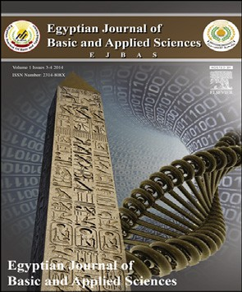Biochemical and molecular genetic characterization of some species of family Malvaceae, Egypt



*Rehab M. Rizk*\**, Magda I. Soliman*

*Botany Department, Faculty of science, Mansoura University, Egypt*

## a r t i c l e i n f o

*Article history:*

Received 23 October 2013 Received in revised form 20 June 2014

Accepted 21 June 2014

Available online 1 August 2014

*Keywords:* Malvaceae Protein profile RAPD

*Malva Hibiscus Sida Abutilon Lavatera*

## a b s t r a c t

The aim of the present study intended mainly to investigate the interrelationships between the six studied taxa namely *Abutilon theophrasti*, *Lavatera cretica*, *Hibiscus trionum*, *Hibiscus sabdariffa*, *Malva parviflora* and *Sida alba* collected from ten different accessions in Egypt belonging to family Malvaceae. Biochemical studies include protein profile using SDS-PAGE technique and three isozymes (esterase, peroxidase and acid phosphatase). The electro- phoretic analysis revealed the presence of eighteen bands of molecular weight ranging from 11.3 to 115.3 KD. The highest number of bands 15 was observed in *H. sabdariffa* (Hs1) collected from Menia el-Kamh district and the two accessions of *M. parviflora* where as the lowest number 11 bands were recorded in *H. trionum* collected from Talkha district. Four loci of peroxidase isozyme distinguished, three loci of acid phosphatase isozyme and two loci of esterase isozyme. In regarding to random amplified polymorphic DNA technique (RAPD), ten primers were used to differentiate between these accessions. Primer OPA-4 gave the highest percentage of polymorphism (100%), while primer OP-B6 produced the lowest percentage (50%).

Copyright 2014, Mansoura University. Production and hosting by Elsevier B.V. All rights

reserved.

# Introduction

Malvaceae or the mallow family is the family of flowering plants containing over 200 genera with close to 2300 species.

The largest genera *Hibiscus* (300 species), *Streculia* (250 species), *Dombeya* (225 species), *Pavonia* (200 species) and *Sida* (200 species). The principle economic use of Malvaceae plants is as a source of natural fibers, the family providing perhaps the

* *Corresponding author*. Tel.: +20 1096644147.

E-mail address: [new_fm8@yahoo.com](mailto:new_fm8@yahoo.com) (R.M. Rizk).

Peer review under responsibility of Mansoura University. <http://dx.doi.org/10.1016/j.ejbas.2014.06.002>

2314-808X/Copyright 2014, Mansoura University. Production and hosting by Elsevier B.V. All rights reserved.

168 [e gypti an j o ur nal o f b a sic and a p p l i ed sci e n c e s 1 ( 2014) 16 7](http://dx.doi.org/10.1016/j.ejbas.2014.06.002) e[1 7](http://dx.doi.org/10.1016/j.ejbas.2014.06.002) 6

|  |  |  |  |  |
| --- | --- | --- | --- | --- |
| Table 1 | e | Names and localities of ten accessions of the six studied taxa collected from Egypt. | | |
| No. | Taxa | | Codes | Locality |
| 1 | *Abutilon Theophrasti* Medik. | | At | El-Behera governorate (Abo homos district) |
| 2 | *Hibiscus sabdariffa* L. | | Hs1 | El-sharkyia governorate (Menia el-kamh district) |
| 3 | *Hibiscus sabdariffa* L. | | Hs2 | El-Dakahlyia governorate (Talkha district) |
| 4 | *Hibiscus trionum* L. | | Ht1 | Kafr el-sheikh governorate (El-Riyad district) |
| 5 | *Hibiscus trionum* L. | | Ht2 | El-Dakahlyia governorate (Talkha district) |
| 6 | *Lavatera cretica* L. | | Lc | El-Behera governorate (Rashid district) |
| 7 | *Malva parviflora* L. | | Mp1 | El-sharkyia governorate (Menia el-kamh district) |
| 8 | *Malva parviflora* L. | | Mp2 | El-Dakahlyia governorate (Nabrooh district) |
| 9 | *Sida alba* L. | | Sa1 | El-sharkyia governorate (Menia el-kamh district) |
| 10 | *Sida alba* L. | | Sa2 | El-Dakahlyia governorate (Nabrooh district) |

worlds three most important fiber crops plants of the family are also used for food, beverages, timber, in traditional med- icine and in horticulture [1].

Many researches have been published on the ecology, taxonomy, genetic, cytology, chemotaxonomy, physiology, seed germination and economic uses of family Malvaceae such as [2] in ecology; in taxonomy [3], in chemotaxonomy [4] and in genetic researches [5] studied the pollen.

Aerial parts of many species belong to family Malvaceae have Betaines, Glycine betaines were obtained in high yield (0.5e4.6% dry weight). Also, trigonelline was recorded, but the yield was low (0.005e0.07% dry weight) [4].

Isozymes have been widely used as a molecular markers for the identification the genetic relationships among genera, species and varieties. The phylogenetic relationships in many genera have been studied by isozymes electrophoresis [6] and [7].

Seed protein electrophoresis has been successfully used in define species relationships in various groups of plants [8].

The technology of the molecular biology has been devel-

### *Native PAGE for isozymes*

Isozymes variations identified using native polyacrylamide gel electrophoresis. Three isozymes (esterase, peroxidase and acid phosphatase) studied. These isozymes were separated on polyacrylamide gel according to [13].

### *DNA extraction*

Genomic DNA of the ten accessions of six taxa was extracted from fresh young leaves according to [14].

### *Random amplified polymorphic DNA (RAPD-DNA)*

Ten primers were used to generate RAPD markers according to

[15] with some modifications. The sequence of these primers is given in Table 2. The percentage of polymorphism can be calculated according to this equation.

polymorphic bands

oped over the 20 years and provided new methods for observing the genetic differences among species. These techniques offer and give many advantages over the con- ventional methods [9].

% of polymorphism ¼

### *Data analysis*

total bands × 100

Therefore, the present study was designed to clarify the genetic relationships among six taxa belong to family Malva- ceae collected from ten different accessions from Egypt. This work is very important to document in gene banks for sus- tainable conservation of plant genetic resources.

# Materials and methods

### *Accessions selection*

Ten accessions of the six studied taxa Table 1 subjected to analysis using available characterization methods. Viable seeds of the studied taxa were collected from 50 mature in- dividuals. Identification and nomenclature of studied species were according to [10] and [11].

### *Protein analysis*

Electrophoresis analysis of seed proteins followed the method for discontinuous SDS-PAGE technique of [12].

All gels were photographed and analyzed using Bio-Rad video Documentation system Model Gel Doc 2000. The presence or absence of each band was treated as a binary character in a data matrix (coded 1 and 0 respectively). Data analyses were performed using SYSTAT version 7.0 program [16].

|  |  |
| --- | --- |
| Table 2 e Primers and their composition used in RAPD analysis. | |
| Primer names | Sequences |
| OP-AO1 | CAGGCCCTTC |
| OP-AO4 | AATCGGGCTG |
| OP-AO7 | GAAACGGGTG |
| OP-A10 | GTGATCGCAG |
| OP-A15 | TTCCGAACCC |
| OP-BO1 | GTTTCGCTCC |
| OP-BO4 | GGACTGGAGT |
| OP-BO6 | TGCTCTGCCC |
| OP-BO7 | GGTGACGCAG |
| OP-B17 | AGGGAACGAG |

[e g ypti an j o ur nal o f b a sic and a pp l i e d sci en c e s 1 ( 2014) 16 7](http://dx.doi.org/10.1016/j.ejbas.2014.06.002) e[1 7](http://dx.doi.org/10.1016/j.ejbas.2014.06.002) 6

169

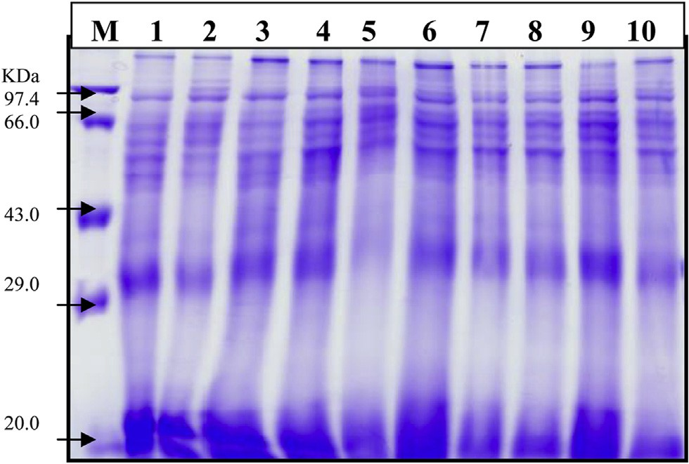Fig. 1 e Polyacrylasmide gel illustrating seed proteins bands of some taxa belonging to family Malvaceae. (M) marker, 1 (At), 2 (Hs1), 3 (Hs2), 4 (Ht1), 5 (Ht2), 6 (Lc), 7 (MP1), 8 (Mp2), 9 (Sa1) and 10 (Sa2).

# Results

### *Protein analysis*

The electrophoretic banding patterns of extracted proteins have been studied in the ten accessions of the six taxa. These patterns were shown in Fig. 1. The distribution of protein bands in the different accessions of the six taxa based on their molecular weight range was shown in Table 3. The following is a brief description of the banding profiles for all accessions. The electrophoretic protein profile of Mp1, Mp2 and Hs1 accessions consist 15 bands, 14 bands in At and Sa1, 13 bands in Hs2 and Ht1, 12 bands in Lc and Sa2, 11 bands in Ht2. the molecular weight bands for all accessions of the six studied taxa ranging from 11.3 to 115.3 KDa Table 3. The percentage of

polymorphism was given in Table 3.

### *Isozymes*

The electrophoretic analysis of peroxidase, acid phosphatase and esterase isozymes using native PAGE gel for the ten ac- cessions of the six studied taxa recorded in Tables 4e6 and Plate 1.

Four loci of peroxidase isozyme distinguished which differ in their amount and relative migration distance. Locus 1 and locus 4 recorded in all taxa under study. Locus 2 recorded in all

Table 3 e Seed protein attributes of some species of family Malvaceae collected from different accessions, for accessions names see Table 1.



|  |  |  |  |  |  |  |  |  |  |  |  |
| --- | --- | --- | --- | --- | --- | --- | --- | --- | --- | --- | --- |
|  |  |  |  |  |  |  |  |  |  |  |  |
|  |  |  |  |  |  |  |  |  |  |  |  |
|  |  |  |  |  |  |  |  |  |  |  |  |
|  |  |  |  |  |  |  |  |  |  |  |  |
|  |  |  |  |  |  |  |  |  |  |  |  |
|  |  |  |  |  |  |  |  |  |  |  |  |
|  |  |  |  |  |  |  |  |  |  |  |  |
|  |  |  |  |  |  |  |  |  |  |  |  |
|  |  |  |  |  |  |  |  |  |  |  |  |
|  |  |  |  |  |  |  |  |  |  |  |  |
|  |  |  |  |  |  |  |  |  |  |  |  |
|  |  |  |  |  |  |  |  |  |  |  |  |
|  |  |  |  |  |  |  |  |  |  |  |  |
|  |  |  |  |  |  |  |  |  |  |  |  |
|  |  |  |  |  |  |  |  |  |  |  |  |
|  |  |  |  |  |  |  |  |  |  |  |  |
|  |  |  |  |  |  |  |  |  |  |  |  |
|  |  |  |  |  |  |  |  |  |  |  |  |
|  |  |  |  |  |  |  |  |  |  |  |  |
|  |  |  |  |  |  |  |  |  |  |  |  |
|  |  |  |  |  |  |  |  |  |  |  |  |

170 [e gypti an j o ur nal o f b a sic and a p p l i ed sci e n c e s 1 ( 2014) 16 7](http://dx.doi.org/10.1016/j.ejbas.2014.06.002) e[1 7](http://dx.doi.org/10.1016/j.ejbas.2014.06.002) 6

Table 4 e Bands of Acid phosphatase isozyme (ACPH.) for some species of family Malvaceae collected from Egypt.

|  |  |  |  |  |  |  |  |  |  |  |
| --- | --- | --- | --- | --- | --- | --- | --- | --- | --- | --- |
|  |  |  |  |  |  |  |  |  |  |  |
|  |  |  |  |  |  |  |  |  |  |  |
|  |  |  |  |  |  |  |  |  |  |  |
|  |  |  |  |  |  |  |  |  |  |  |
|  |  |  |  |  |  |  |  |  |  |  |

|  |  |  |  |  |  |  |  |  |  |  |
| --- | --- | --- | --- | --- | --- | --- | --- | --- | --- | --- |
|  |  |  |  |  |  |  |  |  |  |  |
|  |  |  |  |  |  |  |  |  |  |  |
|  |  |  |  |  |  |  |  |  |  |  |
|  |  |  |  |  |  |  |  |  |  |  |
|  |  |  |  |  |  |  |  |  |  |  |
|  |  |  |  |  |  |  |  |  |  |  |

|  |  |  |  |  |  |  |  |  |  |  |
| --- | --- | --- | --- | --- | --- | --- | --- | --- | --- | --- |
|  |  |  |  |  |  |  |  |  |  |  |
|  |  |  |  |  |  |  |  |  |  |  |
|  |  |  |  |  |  |  |  |  |  |  |
|  |  |  |  |  |  |  |  |  |  |  |

taxa under study except *H. sabdariffa* collected from Talka, El- Dakahlyia Governorate. Locus 3 recorded in all taxa under study except *Abutilon theophartis* and the two accessions of *Hibiscus sabdariffa*. A total of three loci of acid phosphatase

Table 5 e Bands of peroxidase isozyme (per.) for some species of family Malvaceae collected from Egypt.

Table 6 e Bands of Esterase isozyme (ACPH.) for some species of family Malvaceae collected from Egypt.



Hs2 Hs1

At Lc Ht2 Ht1

Mp2 Mp1

Sa2 Sa1

0.0 0.1 0.2 0.3 0.4

Distances

Fig. 2 e Phenogram showing the relationships among the six studied species of family Malvaceae from ten different accession in Egypt using distance metric 1 Gamma coefficient and average linkage method (for accessions name see Table 1).

isozyme distinguished which differ in their amount and relative migration distance. Locus 1 found in all taxa under study, locus 2 recorded in all taxa except *Hibiscus trionum* collected from El- Riyad- Kafr El-Sheikh. Locus 3 found only in *Sida alba* collected from Menia El-Kamh El-Sharkyia Table 5. Two loci of esterase isozyme were found in all studied taxa Table 6. Concerning all accessions of the six studied taxa, the highest percentage of polymorphism 66.6% recorded in acid phosphatase isozyme, 50% in peroxidase isozyme and 0% in esterase Table 7.

### *DNA fingerprint*

In the present study ten primers used to differentiate among the ten accessions of the six studied taxa as recorded in Table 8 and Plate 2. The percentages of polymorphisms were recorded in Table 9. The results were reported as follow:

### *Primer OPA-1*

The results revealed that this primer produced a total number of 12 bands. Bands of molecular size 830 bp and 370 bp were recorded in all taxa under study. Bands of molecular size 600 bp and 680 bp were recorded only in *Lavatera cretica* so that this band could be used as a positive molecular marker for *L. cretica*. The band of a molecular size 700 bp recorded in all taxa

[e g ypti an j o ur nal o f b a sic and a pp l i e d sci en c e s 1 ( 2014) 16 7](http://dx.doi.org/10.1016/j.ejbas.2014.06.002) e[1 7](http://dx.doi.org/10.1016/j.ejbas.2014.06.002) 6

171

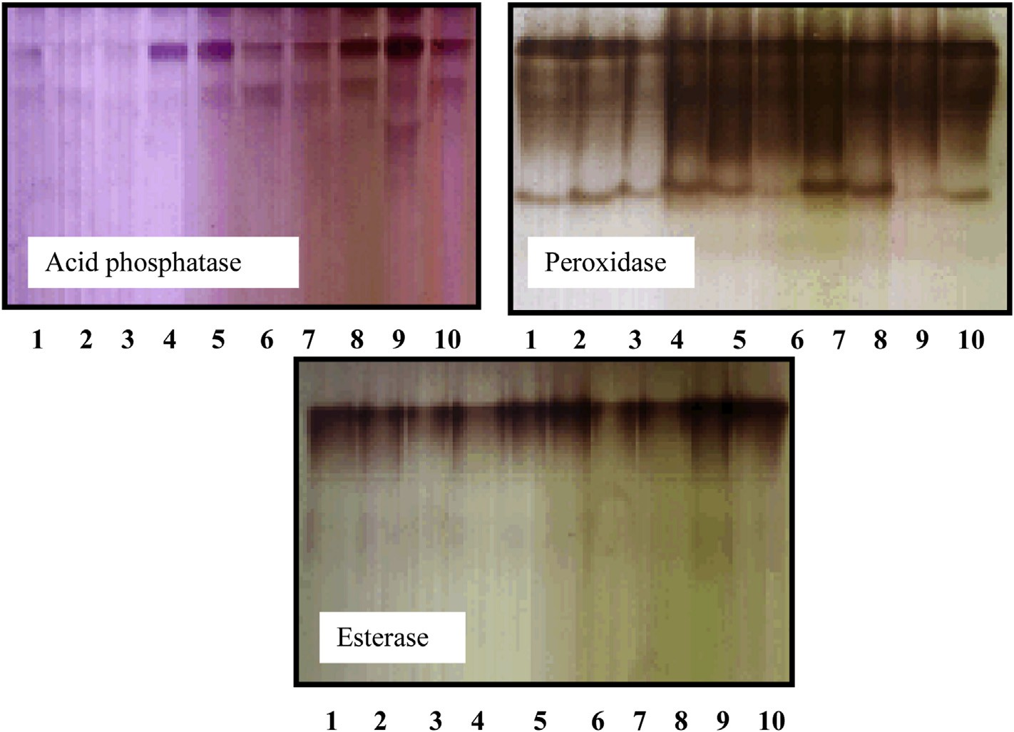

Plate 1 e The electrophoresis patterns of three isozymes of some taxa belonging to family Malvaceae. 1 (At), 2 (Hs1), 3 (Hs2), 4 (Ht1), 5 (Ht2), 6 (Lc), 7 (MP1), 8 (Mp2), 9 (Sa1) and 10 (Sa2).

under study except *L. cretica* so that this band could be used as a negative molecular marker for this species. The band of a molecular size 1260 bp recorded in *H. trionum*, *H. sabdariffa*, *Malva parviflora* and *S. alba*.

### *Primer OPA-4*

The results revealed that this primer produced 12 bands among the ten accessions of the six studied taxa with a mo- lecular size ranging from 310 to 2500 bp. The band of a mo- lecular size 1500 bp recorded only in *M. parviflora* collected from Menia El-Kamh El-Sharkyia, it could be used as a positive molecular marker for this accession. The band of molecular weight 590 bp recorded in all taxa except two accessions of *S. alba*.

### *Primer OPA-7*

The molecular size of the PCR products ranged from 230 bp to 850 bp. Bands of molecular size 680 bp and 420 bp recorded in all accessions of the studied taxa and missed in *A. theophartis* and the two accessions of *H. trionum*.

### *Primer OPA-10*

The primer gave five polymorphic bands and two common bands with molecular size 420 bp and 680 bp. Band of a mo- lecular size 330 bp recorded in all taxa under study except *H. sabdariffa* collected from Nabrooh eEl-Dakahlyia Governorate. Band of a molecular size 550 bp recorded only in *M. parviflora* collected from Nabrooh, this band could be used as a molec- ular marker for *M. parviflora* collected from Nabrooh.

### *Primer OPA-15*

The molecular sizes of PCR products ranged from 200 to 2900 bp. This primer gave seven polymorphic bands and four common bands with molecular sizes 200, 850, 990 and 2900 bp. Band with a molecular size 500 bp restricted to *M. parviflora* collected from Nabrooh and the band with molecular size 1680 bp restricted to *H. sabdariffa* collected from Menia El- Kamh El-Sharkyia Governorate. Band of a molecular size 620 bp recorded in all taxa under study except *H. sabdariffa* collected from Talkha- El-Dakahlyia Governorate. This band could be used as a negative molecular marker for *H. sabdariffa*

|  |  |  |  |  |
| --- | --- | --- | --- | --- |
| Table 7 e polymorphic bands of some species of family Malvaceae collected from Egypt. | | | | |
| Bands | Monomorphic bands | Polymorphic bands  Unique Non-unique | Total bands | Polymorphism % |
| *Isozymes* |  |  |  |  |
| Peroxidase | 2 | 0 2 | 4 | 50% |
| Acid phosphatase | 1 | 0 2 | 3 | 66.6% |
| Esterase | 2 | 0 0 | 2 | 0% |

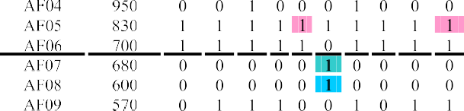172 [e gypti an j o ur nal o f b a sic and a p p l i ed sci e n c e s 1 ( 2014) 16 7](http://dx.doi.org/10.1016/j.ejbas.2014.06.002) e[1 7](http://dx.doi.org/10.1016/j.ejbas.2014.06.002) 6



|  |  |  |  |  |  |  |  |  |  |  |  |  |  |
| --- | --- | --- | --- | --- | --- | --- | --- | --- | --- | --- | --- | --- | --- |
| Table 8 e Data matrix of RAPD- PCR for some species of family Malvaceae collected from Egypt. | | | | | | | | | | | | | |
|  | | | | | | | | | | | | | |
|  |  |  |  | | | | | | | | | | |
|  |  |  |  |  |  |  |  |  | |  |
|  | | | | | | | | | | | | |
|  |  |  |  |  |  |  |  |  |  |  | |  |
|  |  |  |  |  |  |  |  |  |  |  | |  |
|  |  |  |  |  |  |  |  |  |  |  | |  |
|  |  |  |  |  |  |  |  |  |  |  | |  |
|  |  |  |  |  |  |  |  |  |  |  | |  |
|  |  |  |  |  |  |  |  |  |  |  | |  |
|  |
|  |  |  |  |  |  |  |  |  |  |  | |  |
|  |  |  |  |  |  |  |  |  |  |  | |  |
|  |  |  |  |  |  |  |  |  |  |  | |  |
|  |  |  |  |  |  |  |  |  |  |  | |  |
|  |  |  |  |  |  |  |  |  |  |  | |  |
|  |  |  |  |  |  |  |  |  |  |  | |  |
|  | | | | | | | | | | | | |
|  |  |  |  |  |  |  |  |  |  |  | |  |
|  |  |  |  |  |  |  |  |  |  |  | |  |
|  |  |  |  |  |  |  |  |  |  |  | |  |
|  |  |  |  |  |  |  |  |  |  |  | |  |
|  |  |  |  |  |  |  |  |  |  |  | |  |
|  |  |  |  |  |  |  |  |  |  |  | |  |
|  |  |  |  |  |  |  |  |  |  |  | |  |
|  |  |  |  |  |  |  |  |  |  |  | |  |
|  |  |  |  |  |  |  |  |  |  |  | |  |
|  |  |  |  |  |  |  |  |  |  |  | |  |
|  |  |  |  |  |  |  |  |  |  |  | |  |
|  |  |  |  |  |  |  |  |  |  |  | |  |
|  |  |  |  |  |  |  |  |  |  |  | |  |
|  |  | | | | | | | | | | | |
|  |  |  |  |  |  |  |  |  |  |  | |  |
|  |  |  |  |  |  |  |  |  |  |  | |  |
|  |  |  |  |  |  |  |  |  |  |  | |  |
|  |  |  |  |  |  |  |  |  |  |  | |  |
|  |  |  |  |  |  |  |  |  |  |  | |  |
|  |  |  |  |  |  |  |  |  |  |  | |  |
|  |  |  |  |  |  |  |  |  |  |  | |  |
|  | | | | | | | | | | | | |
|  |  |  |  |  |  |  |  |  |  | |  |  |
|  |  |  |  |  |  |  |  |  |  | |  |  |
|  |  |  |  |  |  |  |  |  |  | |  |  |
|  |  |  |  |  |  |  |  |  |  | |  |  |
|  |  |  |  |  |  |  |  |  |  | |  |  |
|  |  |  |  |  |  |  |  |  |  | |  |  |
|  |  |  |  |  |  |  |  |  |  | |  |  |
|  |  |  |  |  |  |  |  |  |  | |  |  |
|  | | | | | | | |  |  | |  |  |
|  |  |  |  |  |  |  |  |  |  | |  |  |
|  |  |  |  |  |  |  |  |  |  | |  |  |
|  |  |  |  |  |  |  |  |  |  | |  |  |
|  |  |  |  |  |  |  |  |  |  | |  |  |
|  |  |  |  |  |  |  |  |  |  | |  |  |
|  |  |  |  |  |  |  |  |  |  | |  |  |
|  |  |  |  |  |  |  |  |  |  | |  |  |
|  |  |  |  |  |  |  |  |  |  | |  |  |
|  |  |  |  |  |  |  |  |  |  | |  |  |
|  |  |  |  |  |  |  |  |  |  | |  |  |
|  |  |  |  |  |  |  |  |  |  | |  |  |
|  |  |  |  |  |  |  |  |  |  | |  |  |
|  |  | | | | | | | | | | | | |

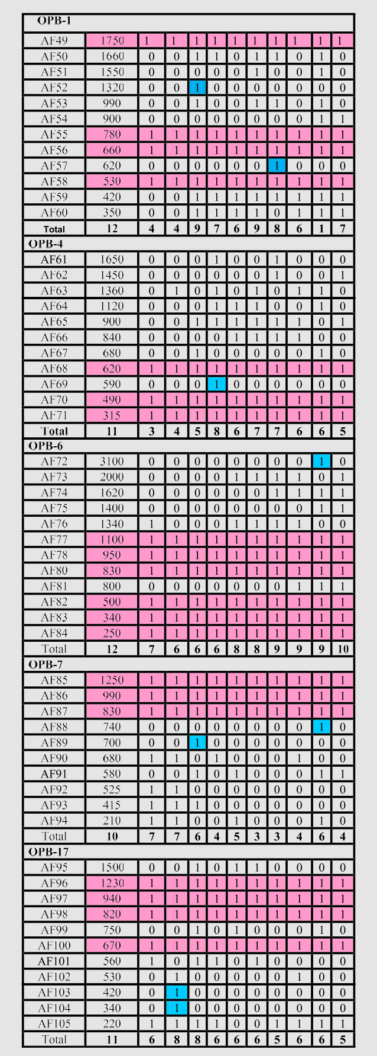

Table 8 e (*Continued*).

[e g ypti an j o ur nal o f b a sic and a pp l i e d sci en c e s 1 ( 2014) 16 7](http://dx.doi.org/10.1016/j.ejbas.2014.06.002) e[1 7](http://dx.doi.org/10.1016/j.ejbas.2014.06.002) 6

173

collected from Talkha- El- Dakahlyia. Band of a molecular size 1380 bp recorded in all taxa except *M. parviflora* collected from Menia El-Kamh. This band could be used as a negative mo- lecular marker for *M. parviflora* collected from Menia El-Kamh.

### *Primer OPB-1*

The results revealed that this primer produced a total number of 12 bands. Band of a molecular size 620 bp recorded only in

*M. parviflora* collected from Menia El-Kamh. It could be used as a positive molecular marker for *M. parviflora* collected from this accession. Band of a molecular size 1320 bp recorded only in *H. sabdariffa* collected from Talkha- El-Dakahlyia Gover- norate. This band could be used as a molecular marker for *H. sabdariffa* collected from this accession. This primer gave four common bands with molecular sizes 530 bp, 660 bp, 780 bp and 1750 bp.

### *Primer OPB-4*

The molecular size of the PCR products ranged from 315 bp to 1650 bp. This primer gave three common bands with molec- ular sizes 315 bp, 490 bp, 620 bp and eight polymorphic bands. Band of a molecular size 590 bp recorded only in *H. trionum* collected from El- Riyad- Kafr El-Sheikh Governorate. It could be used as a positive marker for *H. trionum* collected from this accession.

### *Primer OPB-6*

This primer produced a total number of 12 bands. Six bands are common and six polymorphic bands. Band of a molecular size 3100 bp recorded only in *S. alba* collected from Menia El- Kamh. This band could be used as a positive marker for *S. alba* collected from Menia El-Kamh.

### *Primer OPB-7*

This primer produced a total number of ten bands, three of which common bands and seven polymorphic bands. The band of a molecular size 740 bp recorded only in *S. alba* collected from Menia El-Kamh so that, this band could be used as a molecular marker for *S. alba* collected from Menia El- Kamh. The band of a molecular size 700 bp recorded only in

*H. sabdariffa* collected from Talkha- El- Dakahlyia. This band could be used as a positive marker for *H. sabdariffa* collected from Talkha e El-Dakahlyia.

### *Primer OPB-17*

The molecular size of the PCR products from 220 bp to 1500 bp. This primer OPB-17 gave seven polymorphic bands and four common bands. Bands of molecular sizes 420, 340 bp recorded only in *H. sabdariffa* collected from Menia El-Kamh El-Shar- kyia. These bands could be used as positive molecular markers for *H. sabdariffa* collected from Menia El-Kamh El- Sharkyia.

Regarding the polymorphism of all accessions of the six studied taxa, the maximum value of polymorphism 100% recorded in primer OPA-4. However, the remaining

percentages of polymorphism took specific trends where 83.3% in primer OPA-1, 72.7% in primer OPB-4, 71.4 in primer OPA-10, 70% in primer OPB-7, 66.6% in primers (OPA-7, OPB- 1), 63.3% in primers (OPB-17, OPA-15) and 50% in primer OPB-6.

# Discussion

Biochemical and molecular techniques are provided ap- proaches for evaluating genetic diversity in plants. These methods are favored because they are independent of the developmental stage of the plant [17]. Biochemical evidences such as seed storage protein electrophoresis and isozyme polymorphisms are convenient evidences for assessing ge- netic relationships [18] and [19].

The variation in SDS-PAGE of seed protein profiles have successfully been used to differentiate between species [20] and provide a valid source of taxonomic evidence for addressing the relationships at the different taxonomic levels [21].

The electro-phenogram of the examined ten accessions of the six studied taxa revealed a total number of eighteen bands. The highest number of bands 15 was observed in *H. sabdariffa* collected from Menia El-Kamh, El-Sharkyia and the two accessions of *M. parviflora*. The molecular weight of these bands ranging from 11.3 to 115.3 KDa, where as the lowest number 11 bands were recorded in *H. trionum* collected from Talkha- El-Dakahlyia Governorate the molecular weight of these eleven bands ranging from 11.3 KDa to 115.3 KDa.

Isozymes polymorphisms are used effectively to assess genetic relationships among individuals, populations and closely related species [22] and [23]. The applications of iso- zymes polymorphism are still important for population ge- netic studies and in addressing infra-specific relationships [24].

There are three isozymes (esterase, peroxidase and acid phosphatase) were used to differentiate among the ten ac- cessions of the six studied taxa belonging to family Malvaceae. It was found that acid phosphatase and peroxidase isozymes are more effectively in differentiation among these accessions of the studied taxa, while esterase isozyme was not able to differentiate.

Proteins and isozymes electrophoretic markers have been used in many crops to some extent. The major limitation of these two procedures is the lack of enough polymorphism among closely related cultivars [25]. For this reason, DNA based genetic markers have been integrated into several plant systems and are playing a very important role in molecular genetics and plant breeding [25] and [26].

Randomly amplified polymorphic DNA (RAPD) technique has been used in many different applications involving the detection of DNA sequence polymorphisms [27] to identify varieties [28] and to assess the genetic diversity [29] and [30]. In this study ten primers used to differentiate among the ten accessions of the six studied taxa belonging to family Malva- ceae. The primers gave reproducible results but the best primer used to differentiate was primer OPA-4 and gave the highest percentage of polymorphism. Primers OPA-7 and OPB- 1 gave the same percentages of polymorphism, primers OPB-

174 [e gypti an j o ur nal o f b a sic and a p p l i ed sci e n c e s 1 ( 2014) 16 7](http://dx.doi.org/10.1016/j.ejbas.2014.06.002) e[1 7](http://dx.doi.org/10.1016/j.ejbas.2014.06.002) 6

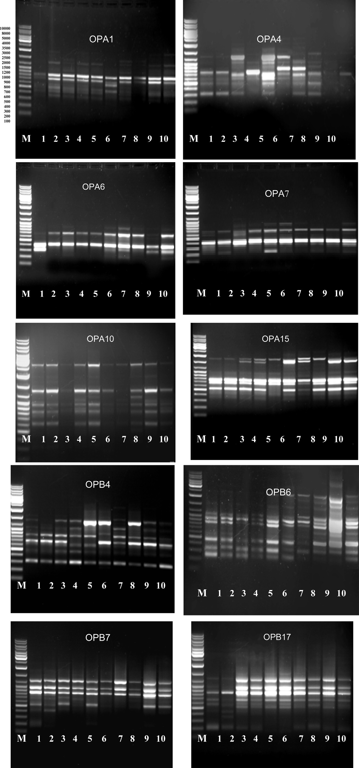

Plate 2 e DNA polymorphism based on RAPD- PCR analysis of some species of family Malvaceae, Egypt. (M) marker, 1 (At), 2 (Hs1), 3 (Hs2), 4 (Ht1), 5 (Ht2), 6 (Lc), 7 (MP1), 8 (Mp2), 9 (Sa1) and 10 (Sa2).

[e g ypti an j o ur nal o f b a sic and a pp l i e d sci en c e s 1 ( 2014) 16 7](http://dx.doi.org/10.1016/j.ejbas.2014.06.002) e[1 7](http://dx.doi.org/10.1016/j.ejbas.2014.06.002) 6

175

|  |  |  |  |  |  |
| --- | --- | --- | --- | --- | --- |
| Table 9 e Polymorphic bands of some species of family Malvaceae collected from Egypt. | | | | | |
| Bands | Monomorphic bands | Unique | Polymorphic  Non-unique | Total bands | Polymorphic % |
| *Primers* |  |  |  |  |  |
| OP-A1 | 2 | 3 | 7 | 12 | 83.3% |
| OP-A4 | e | 1 | 11 | 12 | 100% |
| OP-A7 | 2 | e | 4 | 6 | 66.6% |
| OP-A10 | 2 | 2 | 3 | 7 | 71.4% |
| OP-A15 | 4 | 4 | 3 | 11 | 63.6% |
| OP-B1 | 4 | 2 | 6 | 12 | 66.6% |
| OP-B4 | 3 | 1 | 7 | 11 | 72.7% |
| OP-B6 | 6 | 1 | 5 | 12 | 50% |
| OP-B7 | 3 | 1 | 6 | 10 | 70% |
| OP-B17 | 4 | 2 | 5 | 11 | 63.6% |

17 and OPA-15 also gave the same percentages of polymorphism.

Cluster analysis was conducted to generate a dendrogram Fig. 2 clustering possible relationships among the ten studied accessions of six species of family Malvaceae in Egypt based on compiled all matrix data. Investigated accessions were divided into two groups at 0.315, the first group includes Hs2 collected from Talkha district, and the second group is divided into two subgroups at a distance of 0.266. The first subgroup includes Hs1 and At, while the second subgroup includes Lc, Ht1, Ht2, Mp1, Mp2, Sa1 and Sa2. In the second subgroup Sa1 and Sa2 were separated from the rest at a distance 0.218.

## referen c es

1. [Tackholm V. Students' flora of Egypt. 2nd ed. Cairo](http://refhub.elsevier.com/S2314-808X(14)00027-X/sref9) [University, Press; 1974. p. 523](http://refhub.elsevier.com/S2314-808X(14)00027-X/sref9)e[610](http://refhub.elsevier.com/S2314-808X(14)00027-X/sref9).
2. [Boulos L. Flora of Egypt. Checklist. Cairo, Egypt: Al-Hadara](http://refhub.elsevier.com/S2314-808X(14)00027-X/sref10) [Publishing; 2009](http://refhub.elsevier.com/S2314-808X(14)00027-X/sref10).
3. [Laemmli UK. Cleavage of structural proteins during the](http://refhub.elsevier.com/S2314-808X(14)00027-X/sref11) [assembly of the head of the bacteriophage T4. Nature](http://refhub.elsevier.com/S2314-808X(14)00027-X/sref11) [1970;27:680](http://refhub.elsevier.com/S2314-808X(14)00027-X/sref11)e[5](http://refhub.elsevier.com/S2314-808X(14)00027-X/sref11).
4. [Stegmann H, Burgermeister W, Frankcksen HE,](http://refhub.elsevier.com/S2314-808X(14)00027-X/sref12) [Krogerrecklenfort E. Manual of gel electrophoresis and](http://refhub.elsevier.com/S2314-808X(14)00027-X/sref12) [isoelectric focusing with the apparatus PANTA- PHOR. Inst](http://refhub.elsevier.com/S2314-808X(14)00027-X/sref12) [Biochem Messeweg 1985;11:D-3300. Braunsxhweig West-](http://refhub.elsevier.com/S2314-808X(14)00027-X/sref12) [Germany](http://refhub.elsevier.com/S2314-808X(14)00027-X/sref12).
5. [Dellaporta SL, Wood J, Hicks JB. A plant DNA mini](http://refhub.elsevier.com/S2314-808X(14)00027-X/sref13) [preparation. Version III. Plant Mol Biol Rep 1983;1:19](http://refhub.elsevier.com/S2314-808X(14)00027-X/sref13)e[21](http://refhub.elsevier.com/S2314-808X(14)00027-X/sref13).
6. [William JGK, Kubelik AR, Livak KJ, Rafalski JA, Tingey SV.](http://refhub.elsevier.com/S2314-808X(14)00027-X/sref14) [DNA polymorphisms amplified by arbitary primers are](http://refhub.elsevier.com/S2314-808X(14)00027-X/sref14) [useful as genetic markers. Nucl Acids Res](http://refhub.elsevier.com/S2314-808X(14)00027-X/sref14) [1990;18:6531](http://refhub.elsevier.com/S2314-808X(14)00027-X/sref14)e[5](http://refhub.elsevier.com/S2314-808X(14)00027-X/sref14).

[16] [Wilkinson L. SYSTAT: the system analysis for statistics](http://refhub.elsevier.com/S2314-808X(14)00027-X/sref15)

[SYSTAT, Evaston III; 1997](http://refhub.elsevier.com/S2314-808X(14)00027-X/sref15).

1. Hinsely RS. Economic uses of Malvaceae- Overview. 2004 and 2008.
2. [El-Rjoob AO, Omari MN. Heavy metal contamination in *Malva*](http://refhub.elsevier.com/S2314-808X(14)00027-X/sref1)[*parviflora*, (Malvaceae) grown in soils near the Irbid-Amman](http://refhub.elsevier.com/S2314-808X(14)00027-X/sref1) [high way. J Bot Environ Appl Sci 2009;4(4):433](http://refhub.elsevier.com/S2314-808X(14)00027-X/sref1)e[41](http://refhub.elsevier.com/S2314-808X(14)00027-X/sref1).
3. [Tate JA, Aguilar JF, Wagstaff SJ, La Duke JC, Bodo Slotta TA,](http://refhub.elsevier.com/S2314-808X(14)00027-X/sref2) [Simpson BB. Phylogenetic relationships within the *Malveae*](http://refhub.elsevier.com/S2314-808X(14)00027-X/sref2)[(*Malvaceae*, subfamily *Malvoideae*). Amer J Bot](http://refhub.elsevier.com/S2314-808X(14)00027-X/sref2) [2005;92:584](http://refhub.elsevier.com/S2314-808X(14)00027-X/sref2)e[602](http://refhub.elsevier.com/S2314-808X(14)00027-X/sref2).
4. [Blunden G, Patel AV, Armstrong NJ, Gorham J. Betaine](http://refhub.elsevier.com/S2314-808X(14)00027-X/sref3) [distribution in the Malvaceae. Phytochemistry](http://refhub.elsevier.com/S2314-808X(14)00027-X/sref3) [2001;58:451](http://refhub.elsevier.com/S2314-808X(14)00027-X/sref3)e[4](http://refhub.elsevier.com/S2314-808X(14)00027-X/sref3).
5. [Baum DA, Smith SD, Yen A, Alverson WS, Nyffeler R,](http://refhub.elsevier.com/S2314-808X(14)00027-X/sref4) [Whitlock BA, et al. Phylogenetic relationships of Malvatheca (](http://refhub.elsevier.com/S2314-808X(14)00027-X/sref4) [Bombacoideae and Malvoideae; Malvaceae sensu Lato) as](http://refhub.elsevier.com/S2314-808X(14)00027-X/sref4) [inferred from plastid DNA sequences. Ameri J Bot](http://refhub.elsevier.com/S2314-808X(14)00027-X/sref4) [2004;91:1863](http://refhub.elsevier.com/S2314-808X(14)00027-X/sref4)e[71](http://refhub.elsevier.com/S2314-808X(14)00027-X/sref4).
6. [ADe Vries, Bramer JPJ, Bovan Zanten, Hofman A, BijIsma R.](http://refhub.elsevier.com/S2314-808X(14)00027-X/sref5) [Allozyme variation in populations of four *Racopilum* species,](http://refhub.elsevier.com/S2314-808X(14)00027-X/sref5) [including the polyploidy *R. tomentosum*. Lindbergia](http://refhub.elsevier.com/S2314-808X(14)00027-X/sref5) [1990;15:47](http://refhub.elsevier.com/S2314-808X(14)00027-X/sref5)e[59](http://refhub.elsevier.com/S2314-808X(14)00027-X/sref5).
7. [Cronberg N. Isozyme evidence of relationships within](http://refhub.elsevier.com/S2314-808X(14)00027-X/sref6) [*Sphagnum* sect. *Acutifolia* (Sphagnaceae, Bryophyta). PI Syst](http://refhub.elsevier.com/S2314-808X(14)00027-X/sref6) [Evol 1990;203:41](http://refhub.elsevier.com/S2314-808X(14)00027-X/sref6)e[6](http://refhub.elsevier.com/S2314-808X(14)00027-X/sref6).
8. [Ladizinsky G. Seed protein electrophoresis of the wild and](http://refhub.elsevier.com/S2314-808X(14)00027-X/sref7) [cultivated species of section *Faba* of *Vicia*. Euphytica](http://refhub.elsevier.com/S2314-808X(14)00027-X/sref7) [1975;24:785](http://refhub.elsevier.com/S2314-808X(14)00027-X/sref7)e[8](http://refhub.elsevier.com/S2314-808X(14)00027-X/sref7).
9. [Rajapakse S, Ballard RE. Cultivar identification using](http://refhub.elsevier.com/S2314-808X(14)00027-X/sref8) [molecular methods. In: Genevew RL, Preece JE, Markle SA,](http://refhub.elsevier.com/S2314-808X(14)00027-X/sref8) [editors. Biotechnology of ornamental plants, vol. 153. CAB](http://refhub.elsevier.com/S2314-808X(14)00027-X/sref8) [International Publishers; 1997](http://refhub.elsevier.com/S2314-808X(14)00027-X/sref8).
10. [Swoboda I, Bhalla PL. RAPD analysis of genetic variation in](http://refhub.elsevier.com/S2314-808X(14)00027-X/sref16) [the Australian fan flower, Scaevola. Genome 1997;40:600](http://refhub.elsevier.com/S2314-808X(14)00027-X/sref16)e[6](http://refhub.elsevier.com/S2314-808X(14)00027-X/sref16).
11. [El-Din Nour, Nahed M, El-Saied FM, Ahmed AM.](http://refhub.elsevier.com/S2314-808X(14)00027-X/sref17) [Ecophysiological responses and genetic variants in some](http://refhub.elsevier.com/S2314-808X(14)00027-X/sref17) [species of the genus Zygophyllum. J Agric Sci Mansoura Univ](http://refhub.elsevier.com/S2314-808X(14)00027-X/sref17) [2004;29:2345](http://refhub.elsevier.com/S2314-808X(14)00027-X/sref17)e[62](http://refhub.elsevier.com/S2314-808X(14)00027-X/sref17).
12. [Simova-Stoilova L, Vassileva V, Pterova T, Tsenov N,](http://refhub.elsevier.com/S2314-808X(14)00027-X/sref18) [Demievska K, Feller U. Proteolytic activity in wheat leaves](http://refhub.elsevier.com/S2314-808X(14)00027-X/sref18) [during draught stress and recovery. Gen Appl Plant Physiol](http://refhub.elsevier.com/S2314-808X(14)00027-X/sref18) [2006:91](http://refhub.elsevier.com/S2314-808X(14)00027-X/sref18)e[100. Special Issue](http://refhub.elsevier.com/S2314-808X(14)00027-X/sref18).
13. [Badr A, El-Shazly HH, Abou El-Enain MM. Seed protein](http://refhub.elsevier.com/S2314-808X(14)00027-X/sref19) [diversity and its implications on the relationships in the](http://refhub.elsevier.com/S2314-808X(14)00027-X/sref19) [genus *Lathyrus*. In: Ist Int. Conf Biol Sci Tanta University May](http://refhub.elsevier.com/S2314-808X(14)00027-X/sref19) [7-8; 2000](http://refhub.elsevier.com/S2314-808X(14)00027-X/sref19).
14. [Badr A, Abou El-Enain MM, El- Shazly HH. Variation in seed](http://refhub.elsevier.com/S2314-808X(14)00027-X/sref20) [protein electrophoretic pattern and species relationships in](http://refhub.elsevier.com/S2314-808X(14)00027-X/sref20) [*Sesbania*. In: 6th Egypt. Bot. Conf. Cairo University ,November](http://refhub.elsevier.com/S2314-808X(14)00027-X/sref20) [24](http://refhub.elsevier.com/S2314-808X(14)00027-X/sref20)e[26III; 1998. p. 493](http://refhub.elsevier.com/S2314-808X(14)00027-X/sref20)e[501](http://refhub.elsevier.com/S2314-808X(14)00027-X/sref20).
15. [Soltis DE, Soltis PE. Isozymes in plant Biology. Advances in](http://refhub.elsevier.com/S2314-808X(14)00027-X/sref21) [plant Science, vol. 4. Portland: Dioscorides Press; 1989](http://refhub.elsevier.com/S2314-808X(14)00027-X/sref21).
16. [Murphy RW, Sites JWJ, Buth DJ, Haufler CH. Proteins,](http://refhub.elsevier.com/S2314-808X(14)00027-X/sref22) [isozymes electrophoresis. In: Hillis DM, Morrtz C, Mable Bk,](http://refhub.elsevier.com/S2314-808X(14)00027-X/sref22) [editors. Molecular systematics. Sunderland, MA: Dinauer](http://refhub.elsevier.com/S2314-808X(14)00027-X/sref22) [Associates; 1996](http://refhub.elsevier.com/S2314-808X(14)00027-X/sref22).
17. [Mustafa AMA, Badr A, El-Galaly MA, Mobarak A, Hassan MG.](http://refhub.elsevier.com/S2314-808X(14)00027-X/sref23) [Genetic diversity among *Mentha* populations in Egypt as](http://refhub.elsevier.com/S2314-808X(14)00027-X/sref23) [reflected by isozyme polymorphism. Intern J Bot](http://refhub.elsevier.com/S2314-808X(14)00027-X/sref23) [2005;1:188](http://refhub.elsevier.com/S2314-808X(14)00027-X/sref23)e[95](http://refhub.elsevier.com/S2314-808X(14)00027-X/sref23).
18. [Beckmann J, Soller M. Restriction fragment length](http://refhub.elsevier.com/S2314-808X(14)00027-X/sref24) [polymorphism in genetic improvement methodology.](http://refhub.elsevier.com/S2314-808X(14)00027-X/sref24) [Mapping and Cost. Theor Appl Genet 1993;67:33](http://refhub.elsevier.com/S2314-808X(14)00027-X/sref24)e[43](http://refhub.elsevier.com/S2314-808X(14)00027-X/sref24).

176 [e gypti an j o ur nal o f b a sic and a p p l i ed sci e n c e s 1 ( 2014) 16 7](http://dx.doi.org/10.1016/j.ejbas.2014.06.002) e[1 7](http://dx.doi.org/10.1016/j.ejbas.2014.06.002) 6

1. [Beckmann J, Soller M. Restriction fragment length](http://refhub.elsevier.com/S2314-808X(14)00027-X/sref25) [polymorphism in genetic improvement. In: Miflin BJ, editor.](http://refhub.elsevier.com/S2314-808X(14)00027-X/sref25) [Oxford survey of plant, molecular biology, vol. 3; 1990.](http://refhub.elsevier.com/S2314-808X(14)00027-X/sref25)

[p. 196](http://refhub.elsevier.com/S2314-808X(14)00027-X/sref25)e[250](http://refhub.elsevier.com/S2314-808X(14)00027-X/sref25).

1. [Reiter RS, Williams JGK, Feldmann KA, Rafalski JA,](http://refhub.elsevier.com/S2314-808X(14)00027-X/sref26)

[Tingey SV, Scolink PA. Global and local genome mapping in](http://refhub.elsevier.com/S2314-808X(14)00027-X/sref26) [*Arabidopsis thaliana* by using recombinant inbred lines and](http://refhub.elsevier.com/S2314-808X(14)00027-X/sref26) [random amplified polymorphic DNA. Proc Natl Acad Sci U S](http://refhub.elsevier.com/S2314-808X(14)00027-X/sref26) [A 1992;89:1477](http://refhub.elsevier.com/S2314-808X(14)00027-X/sref26)e[81](http://refhub.elsevier.com/S2314-808X(14)00027-X/sref26).

1. [He S, Ohm H, Mackenzie S. Detection of DNA sequence](http://refhub.elsevier.com/S2314-808X(14)00027-X/sref27) [polymorphisms among wheat varieties. Theor Appl Genet](http://refhub.elsevier.com/S2314-808X(14)00027-X/sref27) [1992;84(5](http://refhub.elsevier.com/S2314-808X(14)00027-X/sref27)e[6):573](http://refhub.elsevier.com/S2314-808X(14)00027-X/sref27)e[8](http://refhub.elsevier.com/S2314-808X(14)00027-X/sref27).
2. [Abdel- Tawab FM, Rashed MA, Dhindsa RS, Bahi El-Din A,](http://refhub.elsevier.com/S2314-808X(14)00027-X/sref28) [Abo-Doma A. Molecular markers for salt tolerance in](http://refhub.elsevier.com/S2314-808X(14)00027-X/sref28) [sorghum bicolor. Inter Cong Mol Gent 1998:195](http://refhub.elsevier.com/S2314-808X(14)00027-X/sref28)e[204](http://refhub.elsevier.com/S2314-808X(14)00027-X/sref28).
3. [Abdel- Tawab FM, Abo-Doma A, Allam A. Stability of](http://refhub.elsevier.com/S2314-808X(14)00027-X/sref29) [microsatellite markers in *Sorghum bicolor* L. Egypt J Genet](http://refhub.elsevier.com/S2314-808X(14)00027-X/sref29) [Cytol 2001;30:189](http://refhub.elsevier.com/S2314-808X(14)00027-X/sref29)e[200](http://refhub.elsevier.com/S2314-808X(14)00027-X/sref29).