[Egyptian Journal of Basic and Applied Sciences 4 (2017) 297–302](https://doi.org/10.1016/j.ejbas.2017.10.001)

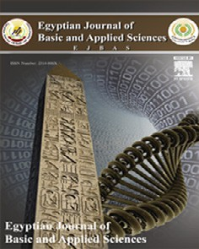

Contents lists available at [ScienceDirect](http://www.sciencedirect.com/science/journal/2314808X)

Egyptian Journal of Basic and Applied Sciences

journal homepage: [www.elsevier.com/locate/ejbas](http://www.elsevier.com/locate/ejbas)

Full Length Article

Biochemical composition of Predatory carp (*Chanodichthys erythropterus*) from Lake Dianshan, Shanghai, China



Kindong Richard a, Nagarajan Prithiviraj b, Apraku Andrews b, Christian Larbi Ayisi b, Dai Xiaojie a,⇑

a *College of Marine Sciences, Shanghai Ocean University, Shanghai, China*

b *Key Laboratory of Exploration and Utilization of Aquatic Genetic Resources, Department of Biology, College of Fisheries and Life Science, Shanghai Ocean University, China*

# a r t i c l e i n f o

*Article history:*

Received 24 June 2017

Received in revised form 27 September 2017

Accepted 6 October 2017

Available online 18 October 2017

*Keywords:*

*Chanodichthys erythropterus*

Chemical composition Lake Dianshan Nutrient quality

# a b s t r a c t

Information related to the chemical composition of fish species is very much necessary to ensure that they meet requirements of man’s diet. This study is focused on providing nutrient contents information of the wild east Asian native species Predatory carp (*Chanodichthys erythropterus*). The specimens were collected from Lake Dianshan, Shanghai-China. The body muscles of randomly selected fish species were dried at 105 °C in an oven and used for biochemical analysis. Protein, carbohydrate, ash, and moisture contents found in the experimental fish and their proportions were 48.7%, 14.1%, 5.1%, and 9.4%, respec- tively. Methionine is the major essential acid determined whiles Alanine was also the abundant for non-

essential amino acids although ten of the most essentials were present. Stearic acid, a saturated fatty acid had the highest proportion while oleic acid was the main monounsaturated fatty acid. Alpha-linolenic acid was the dominant polyunsaturated fatty acid determined. The ratio of n3/n6 fatty acids was 2.82 showing that this species meat is optimal for nutritional purpose. The results of this study showed *Chanodichthys erythropterus* muscle is a valuable food with high quality protein and well balanced amino acids for promoting good health, prevention and healing of diseases in the human body.

© 2017 Mansoura University. Production and hosting by Elsevier B.V. This is an open access article under

the CC BY-NC-ND license (<http://creativecommons.org/licenses/by-nc-nd/4.0/>).

Introduction

Fishes are valuable sources of high-grade protein and other organic products. Its consumption offers important nutrients to many communities around the world. Information related to the chemical composition of fishes is very much necessary to ensure that they meet requirements of man’s diet. The contents of proxi- mate composition are traditionally used as indicators of the nutri- tional value of fish [1]. Proximate composition varies widely and depends on several factors, like species, size, sex, maturity, season and feeding regimes. Information on daily dietary intake of nutri- ents, especially cholesterol, is quite important for especially those with cardiovascular problems [2].

Fish is a good source of essential fatty acids such as polyunsat- urated fatty acids (PUFAs), which are known to regulate prosta- glandin synthesis and hereafter induce wound healing [3,4]. PUFAs such as n—3 and n—6, have been considered essential fatty acids and have been shown to have curative and preventive effects

* Corresponding author at: College of Marine Sciences, Shanghai Ocean Univer- sity, 999 Huchenghuan Road, Lingang City, Shanghai 201306, China.

*E-mail addresses:* [kindong_richard@yahoo.com](mailto:kindong_richard@yahoo.com) (R. Kindong), prithivinaga@ gmail.com (N. Prithiviraj), [apranium@myself.com](mailto:apranium@myself.com) (A. Apraku), [1687087640@qq.](mailto:1687087640@qq.com) [com](mailto:1687087640@qq.com) (C. Larbi Ayisi), [xjdai@shou.edu.cn](mailto:xjdai@shou.edu.cn) (X. Dai).

on cardiovascular diseases, neurodevelopment in infants, cancers and fat glycemic control [5,6]. Essential fatty acids are (n—3 and n—6 PUFAs); are known to have curative and preventive effects on human diseases such as cardiovascular diseases, neuro- development in infants, cancers, fat glycemic control, rheumatoid arthritis, and inflammation [7]. Health experts suggest two to three servings per week of seafood consumption by pregnant women, children and elderly people in order to meet the recommended level of essential fatty acids. The protein quality of food depends on their digestibility and content of essential amino acids like leu- cine, Lysine and Phenylalanine [8–10]. Certain amino acids like aspartic acid, glycine and glutamic acid are also known to play a key role in the process of wound healing [11]. However, the com- position of fish amino acids as one of the main protein component is influenced by various factors such as species, size, food resource, fishing season, water salinity and temperature [10].

Cyprinids are largely concentrated in lakes although they mul- tifariously located worldwide in various water bodies. Predatory carp *Chanodichthys erythropterus* (Cypriniformes, Cyprinidae, Cultrinae) is a small-sized cyprinid fish, widely distributed in East Asia. It is one of the most important commercial freshwater fish in China [12,13]. This East Asian freshwater cyprinid ranges from the Amur River south to Taiwan and the Red River, as well as Lake Buir in Mongolia. This species reaches 102 cm in length and 9 kg in

<https://doi.org/10.1016/j.ejbas.2017.10.001>

2314-808X/© 2017 Mansoura University. Production and hosting by Elsevier B.V.

This is an open access article under the CC BY-NC-ND license (<http://creativecommons.org/licenses/by-nc-nd/4.0/>).

weight [14]. The Dianshan lake is composed of about 40 fish spe- cies belonging to more than 15 families. Amongst these species, members belonging to the family Cyprinidae are always very dom- inant in the Lake and are often preferred by the population as a food source. It is therefore important to know its nutrient contents. The flesh of this species is used for the preparation of good recipes in most east Asian homes; because of health cognizance, these days many people are interested in consuming more fish in view of its relatively higher nutritious qualities. The preference for its con- sumption therefore makes it important specie to study and to know its nutritional make up.

Presently, the composition of fishery products has been widely investigated to analyze their nutritional quality [15]. However, no study has been carried out focusing on the chemical composition of this fish species. This study is expected to provide the nutrient qualities of the Predatory carp (*Chanodichthys erythropterus*) for the benefit of consumers and scientific community as a whole. Therefore, the present study was carried out to analyze the proxi- mate composition, fatty and amino acids compositions of the *Chan- odichthys erythropterus* captured from lake Dianshan, China as one of the main commercial fish species (native in China).

Materials and methods

*Description of study area*

Geographically, the Dianshan Lake is found on Latitude 31°11' N and longitude 120°96' E. It is the largest freshwater lake in Shang-

hai with a total area of 63.7 square kilometers at an average depth of 2.5 m, and also with the deepest recorded depth to be 6.39 m. It is located in between Shanghai, Zhejiang and Kunshan of Jiangsu Province. This Lake supports a lucrative fishery in Shanghai, and fishermen involved in fishing bring in commercially important fish species.

*Sampling design and sample preparation*

A total of 20 fish species were selected from catches between October and December 2016. They were caught with the help of gillnets and trawls. Gillnets (10 m length; 1.5 m width) ranging from 2.0 to 10.0 cm mesh size were employed at each sampling point. Trawl nets (1.5 m height; 3.0 m length; 2.0 m width), 2.0 cm mesh size, was also used. The sampling was done during morn- ing hours and the randomly captured samples were selected, mor- phometrically identified and measured. Specimens collected were quickly sorted out then stored in coolers containing ice and later transported to the laboratory. The separated muscle samples were

homogenized and stored at —2 °C temperature. These muscle tis-

sues were dried in a lyophilizer (VIRTIS 6KBEL85) for 24 h to remove the water content in the samples. The samples were then ground in an agate pestle and mortar in order to obtain muscle

powder. The muscle powder was then later used for proximate composition, fatty and amino acids analyses.

*Proximate composition*

To determine the moisture contents, fish muscle duplicate sam- ples were kept in an oven, at 105 °C for 24 h. Fat content muscle sample was determined with the help of Soxhlet apparatus (Ger- many) using the non-polar organic solvent hexane. Both moisture and fat contents analyses were carried out according to the method in AOAC [16]. For the protein determination, nitrogen (N) contents

of the fish muscle samples were determined by the method in AOAC [17]. The N content was multiplied by 6.25 to estimate the protein of these samples. Ash content was determined by burning the organic components from the known weight of the homoge- nized dried fish muscle by using a furnace at 550 °C [17]. On the other hand, total Carbohydrates was estimated by Phenol- Sulphuric acid method [18].

*Amino acid composition analysis*

The finely ground dried samples were used for estimating the amino acids in high performance liquid chromatography (HPLC) (Merck hitachedL-7400) following the method of Baker and Han’s [19].

*Fatty acid profile-GC–MS analysis*

Fatty acid composition of the powdered muscle sample was analyzed by GC–MS using a Varian Saturn 2000R gas chro- matograph (Hewlett Packard 5890 model) equipped with an OV-

225 capillary column (30 m × 0.25 mm), programmed from 500 °C

to 2250 °C (400 °C min—1), then kept constant for 30 min. FAMEs were identified by their typical electron impact MS spectra and retention times (*R*t), shown by comparison with standards (Sigma), and quantified according to their relative peak areas [20].

Results

*Proximate composition*

Protein, carbohydrate, ash, and moisture contents were found in the experimental fish and their proportions were 48.7%, 14.1%, 5.1%, and 9.4%, respectively.

*Amino acid composition*

The percentage composition of essential and non-essential amino acids is shown in Table 1. A total of twenty amino acids were found from *Chanodichthys erythropterus*. The levels of different amino acids (essential and non-essential) were found

Table 1

Amino acid composition of the muscle of *Chanodichthys erythropterus* (mg/100 g).

Essential amino acid Ratio (mg/100 g) Non-essential amino acid Ratio (mg/100 g)

1. Methionine 1432.3 Alanine 3173.8
2. Valine 1035.7 Aspartic Acid 1345.6
3. Tryptophan 908.7 Proline 704.95
4. Phenylalanine 903.2 Glutamic Acid 596.7
5. Glutamine 785.9 Serine 493.7
6. Iso-Leucine 784.6 Tyrosine 301.8
7. Leucine 693.4 Cysteine 293.3
8. Histidine 403.4 Asparagine 190.3
9. Lysine 356.9 Arginine 189.6
10. Threonine 329.3 Glycine 136.7

Total essential amino acid 7633.4 Total non-essential amino acid 7426.45

Total amino acid (essential + non-essential amino acids) 15059.85 mg

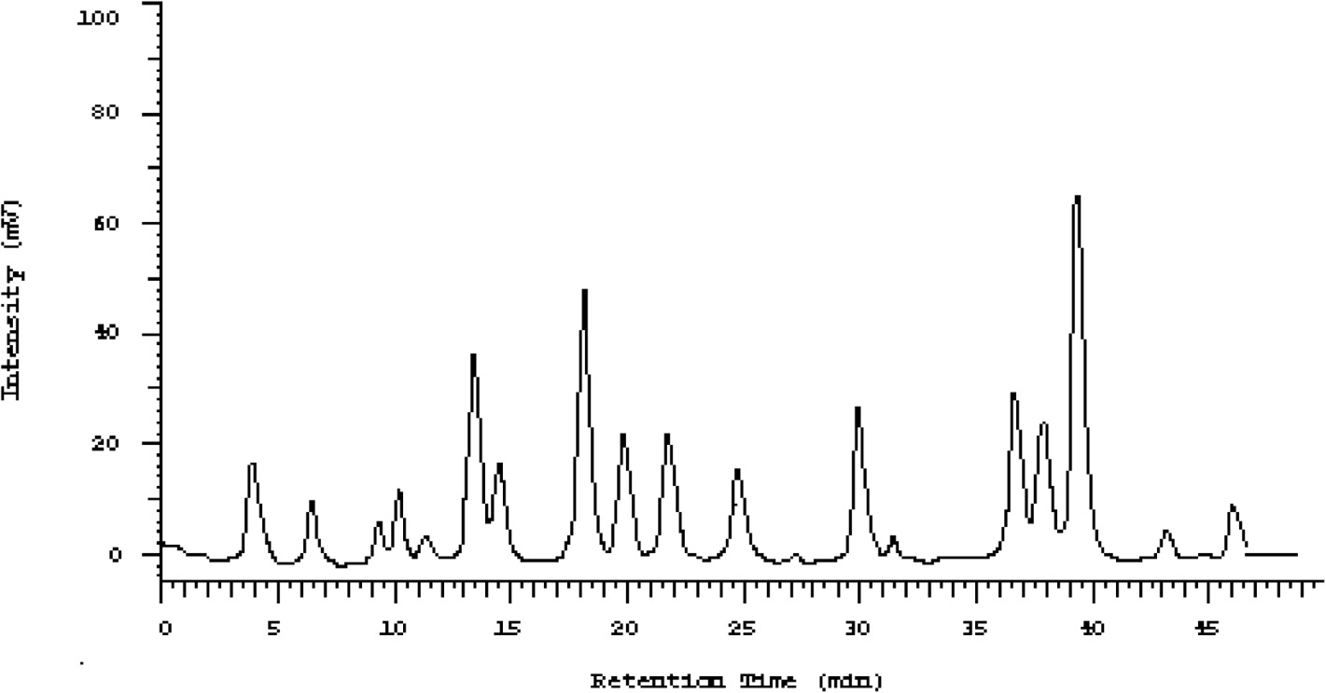

Fig. 1. The standard graph of amino acids.

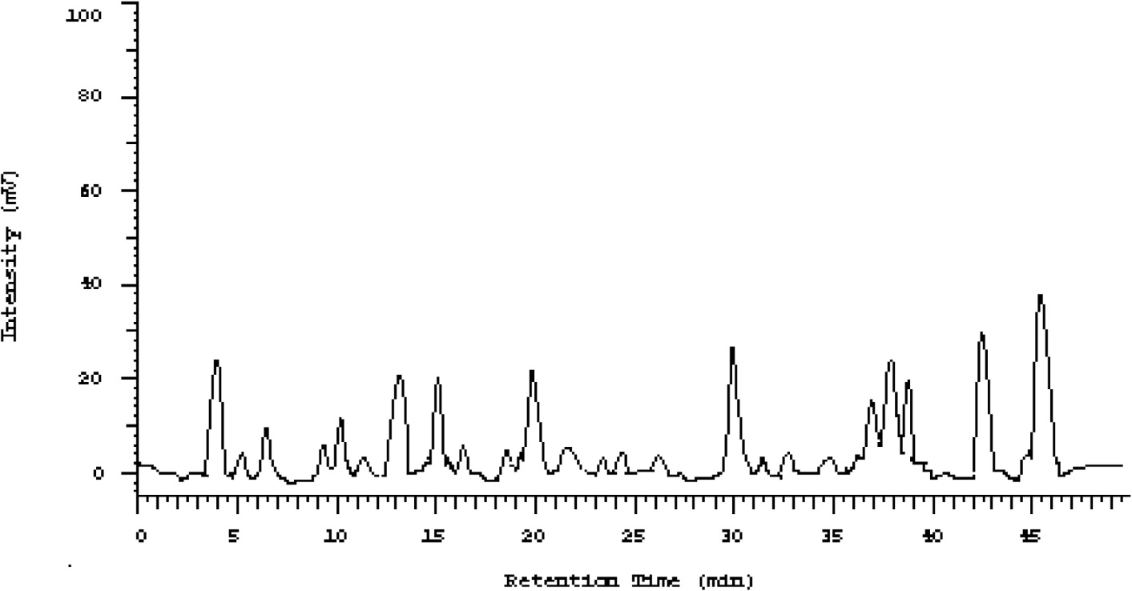

Fig. 2. Estimation of amino acids in *Chanodichthys erythropterus* muscle.

fluctuating between 136.7 mg (Glycine) and 3173.8 mg (Figs. 1 and 2). The major essential amino acid was Methionine (1432.3 mg) while Alanine (3173.8 mg) ranked the first in the list of non-essential amino acids.

*Fatty acid composition*

The fatty acid composition (mg/100 g) of *Chanodichthys ery- thropterus* is summarized in Table 2. Fatty acids were found fluctu- ating between 7834.3 mg and 34.251 mg (Figs. 3 and 4). A total of

seven fatty acids were analysed for the fish samples. For the satu- rated fatty acids (SFA), Stearic acid (C18:0) had the highest propor- tion while Oleic acid (C18:1) was the main monounsaturated fatty acid (MUFA). Alpha Linolenic acid (n—3) (C18:3) was the dominant polyunsaturated fatty acid (PUFA).

Discussion

Biochemical studies from the nutritional point of view are very important. Protein exists in large quantities in all nutrients to form

Table 2

Fatty acid composition of the muscle of *Chanodichthys erythropterus* (mg/100 g).

|  |  |  |  |
| --- | --- | --- | --- |
| Fatty acids | No. of carbon atoms | Fatty acid type | Ratio (mg/100 g) |
| 1 Oleic acid | C18:1 | MUFA | 7834.3 |
| Total monounsaturated fatty acids |  |  | 7834.3 |
| 2 Margaric acid | C17:0 | SFA | 893.3 |
| 3 Palmitic acid | C16:0 | SFA | 4857.3 |
| 4 Stearic acid  Total Saturated fatty acids | C18:0 | SFA | 5493.9  11244.5 mg |
| 5 Alpha Linolenic acid (n—3) | C18:3 | PUFA | 3085.9 |
| 6 Linoleic acid (n—6) | C18:2 | PUFA | 1093.78 |
| 7 Stearidonic acid (SDA) (Morotic acid) Total polyunsaturated fatty acids | C18:4 | PUFA | 136.8  4316.48 mg |

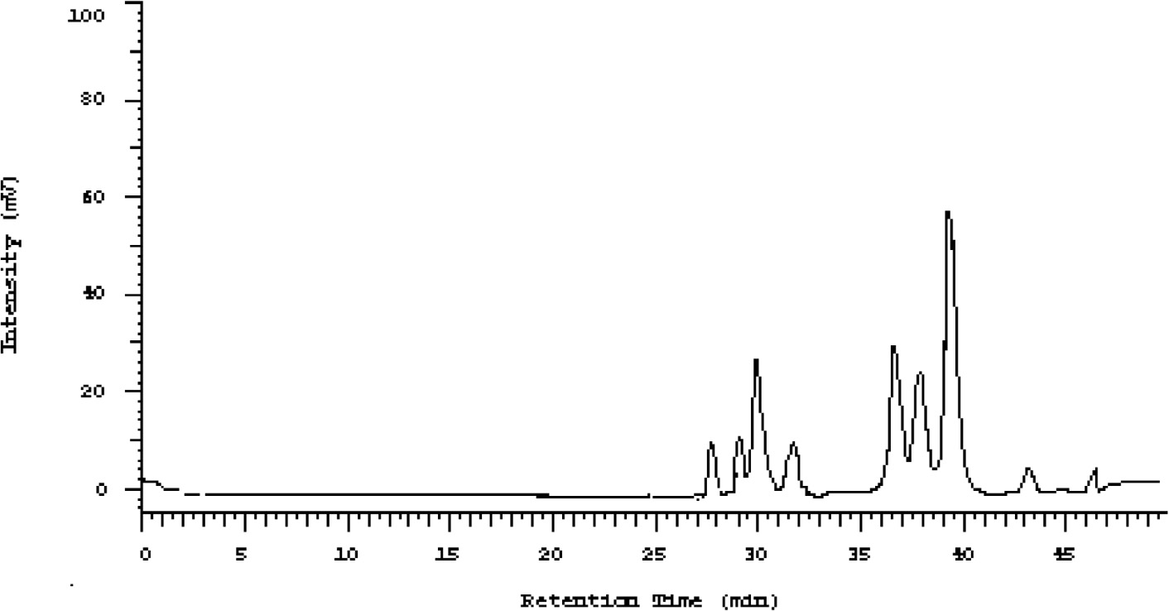

Fig. 3. The standard graph of fatty acids.

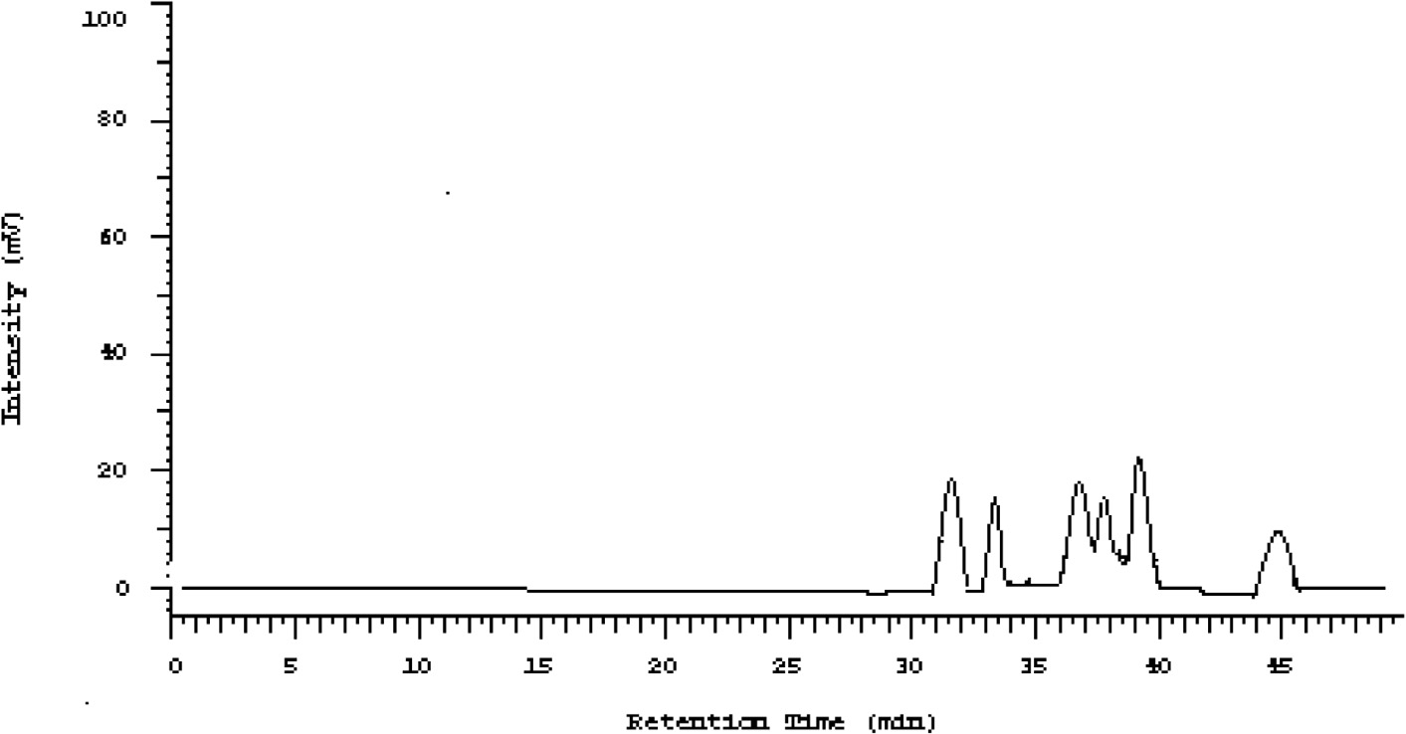

Fig. 4. Estimation of fatty acids in *Chanodichthys erythropterus* muscle.

the components of the human body which is essential for the sus- tenance of life. Information concerning the chemical composition of freshwater fishes in general is valuable to nutritionists con- cerned with readily available sources of low-fat, high protein foods such as most freshwater fishes [21,22]. The adequacy and easy digestibility of fish proteins make it very valuable in combating protein malnutrition, especially in children. The protein of fish has a high biological value with its capacity of promoting growth. Fish occupy an important part in the world protein supply, accounting for about 10% of the total protein supply [2]. About 60% of the population in developing countries depends on 40% or more of their total animal protein supplies from fish.

*Proximate composition*

It was indicated that, *Chanodichthys erythropterus* contain a higher proportion of protein and lower ash content as indicated from the results obtained. Previous studies on proximate analy- sis by Buchtová et al. [23] on a different fish species from the same family confirms the results obtained in this research, how- ever, reports from Ashraf et al. [24] are not in concordance with it as they reported higher moisture content and relatively lower protein content for silver carp. This difference might be due to genetical factors as well as extrinsic factors such as feeding

regimes and/or exercise significant change in some structural and flesh quality parameters of different fish species. Thus, there is no hard and fast rule applicable universally to all the fish species.

*Amino acid composition*

Amino acids are the building blocks of protein, and are key to building strong, healthy muscles. Fish muscle consist of an excel- lent amino acid composition and is a unique source for nutrients and easily digestible protein [22]. Besides, the constituent of amino acids of protein act as precursors of many coenzymes, hormones, nucleic acids, and other molecules essential for life. Thus, an ade- quate supply of dietary protein is essential to maintain cellular integrity and function, and for health and reproduction. There is growing recognition that besides their role as building blocks of proteins and polypeptides, some amino acids (functional amino acids) such as arginine, cysteine, glutamine, leucine, proline, and tryptophan regulate key metabolic pathways that are necessary for maintenance, growth, reproduction, and immunity [25]. The amount of non-essential amino acids in *Chanodichthys ery- thropterus* muscle was equal to the essential amino acids (Table 1) from the twenty different amino acids identified. The essential amino acid identified is within the spectrum of an index of

biological value of fish protein; this shows that fish protein is well balanced with essential amino acids. According to FAO/WHO/UNU Expert Consultation on Protein and Amino Acid Requirements in Human Nutrition [26], essential amino acids are required daily by humans for healthy living. This fish therefore provides a good source of EAA for human consumption since the human system cannot synthesize it.

Özden [27], and Iwasaki and Harada [28] reported aspartic acid, glutamic acid and lysine as the main amino acids of fishes. How- ever, this is very different from the results obtained in this study. The predominant amino acids recorded were Alanine, Methionine, Aspartic acid and Valine acids. Glycine, proline and arginine play an important role in metabolic regulation, anti-oxidative reactions and neurological function. Thus, these nutrients have been used to prevent tissue injury, enhance anti-oxidative capacity, promote protein synthesis and wound healing, and improve immunity to various inflammatory diseases [29]. In aquaculture, the concentra- tions of lysine and methionine in fish food are regarded as impor- tant indicators of nutritional value of the diet [30]. They are known to have significant antioxidant properties as synergists or primary antioxidants and believed to be important metal chelators present in fish and most amino acids had significant antioxidative potential in linoleic acid and methyl esters of linoleic acid system. It is there- fore highly recommended that Amino acids necessary for growth and maintenance must be included in diets. Accordingly, *Chanodichthys erythropterus* fish muscle is wealthy in both essen- tial and non-essential important amino acids and could be used as a valuable food source for human beings.

*Fatty acid composition*

Fatty acids are the main components of food fats, oils and fat deposits in animals and man. Result obtained in this study is in accordance with those presented by Özden [27] and Testi et al.

[31] who found that, PUFA was the highest in rainbow trout. Osi- bona [32] reported that, similar studies on tropical and temperate freshwater fishes showed the dominance of these fatty acids (SFA, MUFA, PUFA) in their tissues. Although alpha-linolenic acid seems to benefit the cardiovascular system and might reduce the risk of heart disease, further studies is yet to be done in order to confirm its effectiveness in cholesterol reduction. Palmitic Acid is a com- mon fatty acid found in plants and animals. The body converts excess carbohydrates into Palmitic Acid, thus Palmitic Acid is the first fatty acid produced during fatty acid synthesis as well as a precursor for longer fatty acids. In humans, one analysis found it to make up 21–30% (molar) of human depot fat [33] and it is a major, but highly variable, lipid component of human breast milk [34]. Omega-6 and omega-3 fatty acids influence gene expression which may be modulated by amino acids. According to Piggott and Tucker [35], the n—3/n—6 ratio is a better index in identifying nutritional value of fish oils of different species. In the present study, the n—3/n—6 ratio was found to be 2.82 in *Chanodichthys erythropterus* meat, while a ratio from 1:1 and higher is considered to be optimal for nutritional purpose [36,37]. The compositions of fatty acids in fish are also highly depending on feeding conditions, their habitats, and physiological conditions such as maturity stage.

Conclusion

This study has provided scientific information and detailed knowledge of the proximate composition of this important com- mercial fish species, *Chanodichthys erythropterus* from the lake Dianshan, China. The results obtained from this study show that, *Chanodichthys erythropterus* harvested from Lake Dianshan has high-quality protein, presents a good source of fatty acids and

essential amino acids which provides a good source of nutrients for its consumers.

Conflict of interest

None declared.

Acknowledgement

The authors are thankful to staffs of Shanghai Ocean University who took part in one way or the other in the accomplishment of this research be it in data collection or laboratory works. Special thanks go to the Shanghai Municipal Council’s Agricultural com- mittee for supporting financially this research. Authors declare no conflict of interest.

References

1. [Stansby ME. Proximate composition of Fish. Fish in nutrition. Lond.: Fish News](http://refhub.elsevier.com/S2314-808X(17)30290-7/h0005) [(Books) Ltd.; 1962. 55–60](http://refhub.elsevier.com/S2314-808X(17)30290-7/h0005).
2. Periyasamy N, Srinivasan M, Devanathan K, Balakrishnan S. Nutritional value of gastropod Babylonia spirata (Linnaeus, 1758) from Thazhanguda, Southeast coast of India. Asian Pac J Trop Biomed 2011:S249–52. doi: [https://doi.org/](https://doi.org/10.1016/S2221-1691(11)60164-0) [10.1016/S2221-1691(11)60164-0](https://doi.org/10.1016/S2221-1691(11)60164-0).
3. Kryzhanovskii S, Vititnova M. x-3 polyunsaturated fatty acids and the

cardiovascular system. Hum Physiol 2009;35:491–501. doi: [https://doi.org/](https://doi.org/10.1134/S036211970904015X) [10.1134/S036211970904015X](https://doi.org/10.1134/S036211970904015X).

1. Zhang Z, Wang S, Diao Y, Zhang J, Decheng LV. Fatty acid extracts from Lucilia sericata larvae promote murine cutaneous wound healing by angiogenic activity. Lipids Health Dis 2010;9:1–9. doi: [https://doi.org/10.1186/1476-](https://doi.org/10.1186/1476-511X-9-24) [511X-9-24](https://doi.org/10.1186/1476-511X-9-24).
2. Marchioli R, Silletta M, Levantesi G, Pioggiarella R. Omega-3 fatty acids and heart failure. Curr Atheroscler Rep 2009;11:440–7. doi: [https://doi.org/](https://doi.org/10.1007/s11883-009-0066-y) [10.1007/s11883-009-0066-y](https://doi.org/10.1007/s11883-009-0066-y).
3. Jiang W, Oken H, Fiuzat M, Shaw L, Martsberger C, Kuchibhatla M, et al. Plasma omega-3 polyunsaturated fatty acids and survival in patients with chronic heart failure and major depressive disorder. J Cardiovasc Transl Res 2012;5:92–9. doi: <https://doi.org/10.1007/s12265-011-9325-8>.
4. Limbourg AJ, Nichols PD. Lipid, fatty acid and protein content of late larval to early juvenile stages of the western rock lobster *Panulirus cygnus*. Comp Biochem Physiol B 2009;152:292–8. doi: [https://doi.org/10.1016/j.](https://doi.org/10.1016/j.cbpb.2008.12.009) [cbpb.2008.12.009](https://doi.org/10.1016/j.cbpb.2008.12.009).
5. Usydus Z, Szlinder-Richert J, Adamczyk M. Protein quality and amino acid profiles of fish products available in Poland. Food Chem 2009;112:139–45. doi: <https://doi.org/10.1016/j.foodchem.2008.05.050>.
6. Robbins C, Felicetti L, Florin S. The impact of protein quality on stable nitrogen isotope ratio discrimination and assimilated diet estimation. Oecologia 2010;162(3):571–9. doi: <https://doi.org/10.1007/s00442-009-1485-8>.
7. Maryam S, Somayeh TD, Sohrab M, Houman RI, Abbasali M. Identification of fatty acid content, amino acid profile and proximate composition in rainbow trout (Oncorhynchus mykiss). J Am Sci 2012;8(4):670–7. doi: [https://doi.org/](https://doi.org/10.7537/marsjas080412.90) [10.7537/marsjas080412.90](https://doi.org/10.7537/marsjas080412.90) (ISSN: 1545-1003).
8. Zuraini A, Somchit MN, Solihah MH, Goh YM, Arifah AK, Zakaria MS, et al. Fatty acid and amino acid composition of three local Malaysian *Channa* spp. fish. Food Chem 2006;97:674–8. doi: [https://doi.org/10.1016/](https://doi.org/10.1016/j.foodchem.2005.04.031) [j.foodchem.2005.04.031](https://doi.org/10.1016/j.foodchem.2005.04.031).
9. [Chen YY, Chu XL, Luo YL, Chen YL, Chen YR, Liu HZ, He MC. Fauna Sinica](http://refhub.elsevier.com/S2314-808X(17)30290-7/h0060) [Osteichthyes, Cypriniformes II. first ed. Beijing: Sciences Press; 1998](http://refhub.elsevier.com/S2314-808X(17)30290-7/h0060).
10. Chen L, Bo L, Lizhi Z, Guanghong Z. The complete mitochondrial genome sequence of Predatory carp *Chanodichthys erythropterus* (Cypriniformes: Cyprinidae). Mitochondrial DNA J DNA Mapp Seq Anal 2015. doi: [https://doi.](https://doi.org/10.3109/19401736.2014.933328) [org/10.3109/19401736.2014.933328](https://doi.org/10.3109/19401736.2014.933328).
11. Froese, R, Pauly, D (eds.). Chanodichthys erythropterus. Availavle from: [www.](http://www.FishBase.com/) [FishBase.com](http://www.FishBase.com/); 2006.
12. Jing W, Ling Z, Youhou X, Yulin S, Ziming C, Sigang F. Proximate composition, amino acid and fatty acid composition of fish maws. Nat Prod Res 2015. doi: <https://doi.org/10.1080/14786419.2015.1040790>.
13. [AOAC. Official methods of analysis of the association of official analysis](http://refhub.elsevier.com/S2314-808X(17)30290-7/h0080) [chemists. 14th ed. Washington DC: Association of Official Analytical Chemists;](http://refhub.elsevier.com/S2314-808X(17)30290-7/h0080) [1984](http://refhub.elsevier.com/S2314-808X(17)30290-7/h0080).
14. [AOAC. Official and tentative methods of analysis of the](http://refhub.elsevier.com/S2314-808X(17)30290-7/h0085) [AOAC. Washington: AOAC; 1990. 978](http://refhub.elsevier.com/S2314-808X(17)30290-7/h0085).
15. Dubois M, Giles KA, Hamilton JK, Rebors PA, Smith F. Calorimetric method for determination of sugars and related substances. Anal Chem 1956;28:350–6. doi: <https://doi.org/10.1021/ac60111a017>.
16. Baker DH, Han Y. Ideal amino acid profile for chicks during the first three weeks’ post hatching. Poultr Sci 1994;73:1441–7. doi: [https://doi.org/10.3382/](https://doi.org/10.3382/ps.0731441) [ps.0731441](https://doi.org/10.3382/ps.0731441).
17. Bligh EG, Dyer WJ. A rapid method of total lipid extraction and purification. Can J Biochem Physiol 1959;37:911–7. doi: <https://doi.org/10.1139/o59-099>. 533-533.
18. Foran AJ, Carpenter DO, Hamilton MC, Knuth BA, Schwager SJ. Risk-based consumption advice for farmed Atlantic and Wild Pacific salmon contaminated with dioxins and dioxin-like compounds. Environ Health Perspect 2005;113

(5):552–7. doi: <https://doi.org/10.1289/chp.7626>.

1. Hawaibam R, Abdul H, Sarojnalini C. Proximate composition and amino acid profile of some hill-stream fishes of Manipur, India. Int J Sci Res 2014;3(8). doi: <https://doi.org/10.15373/22778179>. 2277-8179.
2. [Buchtová H, František J. A new look at the assessment of the silver carp](http://refhub.elsevier.com/S2314-808X(17)30290-7/h0115) [(Hypophthalmichthys molitrix Val.) as a food fish. Czech J Food Sci 2011;29](http://refhub.elsevier.com/S2314-808X(17)30290-7/h0115) [(5):487–97](http://refhub.elsevier.com/S2314-808X(17)30290-7/h0115).
3. [Ashraf M, Zafar A, Rauf A, Mehboob S, Qureshi NA. Nutritional values of wild](http://refhub.elsevier.com/S2314-808X(17)30290-7/h0120) [and cultivated silver carp (*Hypophthalmichthys molitrix*) and grass carp](http://refhub.elsevier.com/S2314-808X(17)30290-7/h0120) [(*Ctenopharyngodon idella*). Int J Agric Biol 2011;13:210–4](http://refhub.elsevier.com/S2314-808X(17)30290-7/h0120).
4. Takahashi T, Toda E, Ram B, Singh FM, Agnieszka W, Douglas W, et al. Essential and non-essential amino acids in relation to Glutamate. Open Nutraceuticals J 2011;4:205–12. doi: <https://doi.org/10.2174/1876396001104010205>.
5. FAO/WHO/UNU Expert Consultation on Protein and Amino Acid Requirements in human Nutrition. WHO Technical Report Series No. 935; 2007.
6. Ozden. Changes in amino acid and fatty acid composition during shelf-life of marinated fish. J Sci Food Agric 2005;85:2015–20. doi: [https://doi.org/](https://doi.org/10.1002/jsfa.2207) [10.1002/jsfa.2207](https://doi.org/10.1002/jsfa.2207). Sci. 4:325-329.
7. Iwasaki M, Harada R. Proximate and amino acid composition of the roe and muscle of selected marine species. J Food Sci 1985;50:1585–7. doi: [https://doi.](https://doi.org/10.1111/j.1365-2621.1985.tb10539.x) [org/10.1111/j.1365-2621. 1985.tb10539. x](https://doi.org/10.1111/j.1365-2621.1985.tb10539.x).
8. Wu G. Functional amino acids in nutrition and health. Amino Acids 2013;45 (3):407–11. doi: <https://doi.org/10.1007/s00726-013-1500-6>.
9. Yang HJ, Lie YJ, Tian LX, Liang GY, Lin HR. Effects of supplemental lysine and methionine on growth performance and body composition for grass carp (*Ctenopharyngodon idella*). Am J Agric Biol Sci 2010;5:222–7. doi: [https://doi.](https://doi.org/10.3844/ajabssp.2010.222.227) [org/10.3844/ajabssp.2010.222.227](https://doi.org/10.3844/ajabssp.2010.222.227).
10. Testi S, Bonaldo A, Gatta PP, Badiani A. Nutritional traits of dorsal and ventral fillets from three farmed fish species. Food Chem 2006;98(1):104–11. doi: <https://doi.org/10.1016/j.foodchem.2005.05.053>.
11. Osibona AO. Comparative study of proximate composition, amino and fatty acids of some economically important fish species in Lagos Nigeria. Afr J Food Sci 2011;5(10):581–8. doi: <https://doi.org/10.5897/AJFS2011.0896>.
12. Kingsbury KJ, Paul S, Crossley A, Morgan DM. The fatty acid composition of human depot fat. Biochem J 1961;78:541–50. doi: [https://doi.org/10.1042/](https://doi.org/10.1042/bj0780541) [bj0780541](https://doi.org/10.1042/bj0780541).
13. [Jensen RG, Hagerty MM, McMahon KE. Lipids of human milk and infant](http://refhub.elsevier.com/S2314-808X(17)30290-7/h0170) [formulas: a review. Am J Clin Nutr 1978;31:990–1016. PMID 352132](http://refhub.elsevier.com/S2314-808X(17)30290-7/h0170).
14. [Piggott GM, Tucker BW. Effects of technology on nutrition. New York,](http://refhub.elsevier.com/S2314-808X(17)30290-7/h0175) [NY: Marcel Dekker; 1990. p. 32–65](http://refhub.elsevier.com/S2314-808X(17)30290-7/h0175).
15. [Simopoulos AP. Summary of NATO advanced research workshop on dietary](http://refhub.elsevier.com/S2314-808X(17)30290-7/h0180) [n](http://refhub.elsevier.com/S2314-808X(17)30290-7/h0180)—[3 and n](http://refhub.elsevier.com/S2314-808X(17)30290-7/h0180)—[6 fatty acids: biological effects nutritional essentiality. Nutrition](http://refhub.elsevier.com/S2314-808X(17)30290-7/h0180) [1989;199:512–28](http://refhub.elsevier.com/S2314-808X(17)30290-7/h0180).
16. Burghardt PR, Kemmerer ES, Buck BJ, Osetek AJ, Yan C, Koch LG, et al. Dietary n—3: n—6 fatty acid ratios differentially influence hormonal signature in a rodent model of metabolic syndrome relative to healthy controls. Nutr Metab 2010;7:53. doi: <https://doi.org/10.1186/1743-7075-7-53>.