[Egyptian Journal of Basic and Applied Sciences 5 (2018) 31–40](https://doi.org/10.1016/j.ejbas.2018.01.004)

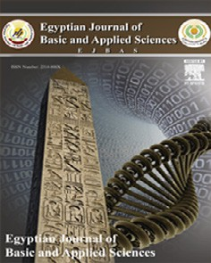

Contents lists available at [ScienceDirect](http://www.sciencedirect.com/science/journal/2314808X)

Egyptian Journal of Basic and Applied Sciences

journal homepage: [www.elsevier.com/locate/ejbas](http://www.elsevier.com/locate/ejbas)

Full Length Article

[](http://crossmark.crossref.org/dialog/?doi=10.1016/j.ejbas.2018.01.004&domain=pdf)Carob extract attenuates brain and lung injury in rats exposed to waterpipe smoke

Mona Abdel-Rahman, Amira A. Bauomy ⇑, Fatma Elzahraa H. Salem, Mona Ahmed Khalifa

*Department of Zoology and Entomology, Faculty of Science, Helwan University, Cairo, Egypt*

a r t i c l e i n f o

*Article history:*

Received 27 September 2017

Received in revised form 19 January 2018 Accepted 21 January 2018

Available online 19 February 2018

*Keywords:* Waterpipe smoke Amiodarone

Carob aqueous extract Brain

Lung Rat

a b s t r a c t

Waterpipe smoking is one of the most popular methods of tobacco consumption world-wide which induces many health problems. In the present study; we evaluated the toxic effects of waterpipe smoke by using amiodarone as a model for lung toxicity in adult male albino rats. Also, the protective and ther- apeutic effects of carob aqueous extract on these toxicity which produced by daily exposure to waterpipe smoke for 8 weeks. The amiodarone gavage significantly increased serotonin content in brainstem and cerebral cortex after 8 and 2 weeks respectively and dopamine content at most of time intervals. Moreover, waterpipe smoke exposure induced a significant decrease in dopamine content after 2 weeks in brainstem and in serotonin content after 4, 6 weeks in brainstem and 6, 8 weeks in cerebral cortex. While, increment in dopamine content after 4, 6 weeks in brainstem and 6, 8 weeks in cerebral cortex may be due to increase its synthesis which strengthens the coughing reflex. Amiodarone gavage and waterpipe smoke exposure induced a significant increase in myeloperoxidase activity, hydroxyproline content and nitric oxide level in lung; while, catalase activity was decreased significantly. Consequently, waterpipe smoke exposure for long time caused serious harmful effects on brain and lung nearly like amiodarone. Carob extract pre-and post-treatment has the ability to protect and ameliorate these effects due to its antioxidant and anti-coughing effects. So, further studies are necessary to eluci- date the mechanism of action of the effective components in the extract.

© 2018 Production and hosting by Elsevier B.V. on behalf of Mansoura University. This is an open access

article under the CC BY-NC-ND license (<http://creativecommons.org/licenses/by-nc-nd/4.0/>).

1. Introduction

Waterpipe smoking is among the most popular methods of tobacco consumption world-wide especially among youth [1,2]; which cause more than 5 million deaths each year [3]. Tobacco is smoked in cigarette, cigar and waterpipe (shisha or narghile). Many people consider the waterpipe is less harmful than cigarette smoke [4]. In addition, the occasional waterpipe tobacco smoking may lead to tissue inflammation.

Tobacco smoke induces cancer, inflammation, oxidative stress in lung and other organs [5,6]. Waterpipe smokers have increased levels of carbon monoxide, so concentrations of carboxyhe- moglobin are elevated and lead to tissue hypoxia [7]. However, Virués-Ortega et al. [8] reported that hypoxia affects cognitive functions and cause abnormal motor function.

*Abbreviations:* 5-HT, serotonin; DA, dopamine; MPO, myeloperoxidase; NO, nitric oxide; CAT, catalase; H2O2, hydrogenperoxide; ROS, reactive oxygen species.

* Corresponding author at: Zoology and Entomology Department, Faculty of

Science, Helwan University, Ain Helwan 11790, Egypt.

*E-mail address:* [amiraanwar1@gmail.com](mailto:amiraanwar1@gmail.com) (A.A. Bauomy).

Chronic tobacco smoking is associated with cognitive flexibility and intellectual abilities. In addition, it affects mood, learning and/ or memory processing speed and working memory. Moreover, chronic smoking induces allover brain atrophy, abnormal decline in reasoning, structural and biochemical abnormalities in anterior frontal regions. Generally, it is associated with an increased risk for various forms of neurodegenerative diseases [9].

Amiodarone is an antiarrhythmic agent and is an iodine- containing drug which accumulates in lungs and in other several organs. In addition, amiodarone induces pulmonary toxicity [10]. The carob tree (*Ceratonia siliqua* L.) has been widely cultivated in Mediterranean regions. The carob pods have a prospect role in human healthy. Pods contain a large amount of tannins. Carob extracts have antioxidant and antimutagenic properties, antidiar- rheal, cholesterol lowering activities and ameliorate the mice nephrotoxicity [11–14]. Carob is used in cough syrup due to its expectorant effect. However, traditional use of carob cures did not cause any toxicological effects in lung, brain and other organs in male rabbit [15].

According to Khabour et al. [16] the short-term and long-term health effects of waterpipe smoke still need to be investigated.

<https://doi.org/10.1016/j.ejbas.2018.01.004>

2314-808X/© 2018 Production and hosting by Elsevier B.V. on behalf of Mansoura University.

This is an open access article under the CC BY-NC-ND license (<http://creativecommons.org/licenses/by-nc-nd/4.0/>).

Consequently, the object of the present study is to explore the waterpipe smoke toxicity in brains and lungs of rats using amio- darone as model of lung toxicity. Furthermore, to investigate the effect of carob aqueous extract pre-and post-treatment on rats exposed to waterpipe smoke.

1. Materials and methods

Adult male albino rats used in the present study were pur- chased from National Organization for Drug Control and Research. One hundred forty-four rats (120–150 g) were housed in clean transparent cages maintained in laboratory of physiology in Faculty of Science, Helwan University under normal environmental conditions of temperature, humidity and light. The standard pelled diet was allowed *ad libitum*. Before experimentation; the rats were kept for about one week to adapt the laboratory conditions and were approved by state authorities and followed Egyptian rules for animal protection.

* 1. *Materials*
     1. *Amiodarone*

Amiodarone tablets were obtained from Sanofi-Aventis, Mont- pellier, France (Commercially found in the form of cordarone). Rats were received daily oral administration of 30 mg/kg b. wt. [17]. Amiodarone was used as a lung toxicity model in rats.

* + 1. *Waterpipe tobacco smoke*

Tobacco (moassal) was obtained from Egyptian stores. In an iso- lated room; rats were transported in clean, isolated, transparent box to be daily exposed to waterpipe smoke (10 g) for 15 min

[18]; thereafter, rats were returned to their room.

* + 1. *Carob (Ceratonia siliqua) pods aqueous extract preparation*

Carob pods were obtained from Egyptian herbal markets, Cairo, Egypt. The pods were grinded and weighted. Thereafter, the rotary evaporator was used to prepare the aqueous extract according to Ayaz et al. [19]. Rats were received daily oral gavage of 600 mg/ kg b. wt. [20].

* 1. *Study design*

Rats were divided into 6 groups (6 rats per group); 1st group was served as a control group, rats were orally received distilled water daily for 8 weeks. The 2nd group was considered to be ‘‘lung toxicity model”; rats were orally administered amiodarone tablets at a dose level of 30 mg/kg b. wt. daily for 8 weeks. The rats of the 3rd group were daily exposed to waterpipe smoke 10 mg (15 min) for 8 weeks. In addition, carob aqueous extract (600 mg/kg b. wt.) was daily administered to rats for 8 weeks (4th group).

Finally, the remaining two groups (5th & 6th) are protective and therapeutic groups respectively. In protective group; rats were daily gavaged aqueous extract of carob (600 mg/kg b. wt.) then 30 min after rats were exposed to waterpipe smoke (15 min) for 8 weeks. However, rats of therapeutic group were daily exposed to waterpipe smoke 10 mg (15 min) then 30 min afterwards rats were daily gavaged carob aqueous extract (600 mg/kg b. wt.) for 8 weeks.

* 1. *Methods*

For neuro- and biochemical investigations; rats were killed by sudden decapitation at different time intervals ‘‘2nd, 4th, 6th and 8th” weeks during the experiment.

* + 1. *Brain tissue preparation and neuro-investigations*

Brains were rapidly excised from skulls, blotted with filter paper then dissection was performed on an ice cooled glass plate. Brains were divided into two hemispheres; each one was separated into brainstem and cerebral cortex according to Glowinski and Iversen [21]. The selected brain areas were weighed, wrapped in

plastic films then in aluminum foil and quickly frozen in a refriger- ator (—70 °C) till used for estimation of monoamines (serotonin ‘‘5-HT” and dopamine ‘‘DA”) according to the method of Ciarlone [22].

* + 1. *Lung tissue preparation and biochemical investigations*

Lungs were excised and only 0.40 g were weighed to be homog- enized in ice-cold Tris-HCl buffer solution (pH 7.4) and centrifuged at 2000 r.p.m. for 10 min to separate the supernatant and quickly frozen in dry ice (—70 °C) till use for further determination for myeloperoxidase (MPO) activity, hydroxyproline content, nitric oxide (NO) level and catalase (CAT) activity.

* + 1. *Monoamines estimation*

In acidified n-butanol; cerebral cortex and brainstem were homogenized to be centrifuged (2000 r.p.m.; 5 min); then the supernatant fluid (2.5 ml) were transferred to tubes containing

1.6 ml of 0.2 N acetic acid and n-heptane (5 ml). The tubes were placed in a vortex mixer for 30 sec. After centrifugation (1000 r.p. m. 5 min); the aqueous phase was separated and stored at —70 °C for 5-HT & DA estimations [22].

* + 1. *Estimation of 5-HT content*

1. Three external standards for 5-HT were prepared in different concentrations in 0.2 N acetic acid and made up to a total volume of 0.3 ml.
2. To all 5-HT tubes 1.2 ml of OPT (4 mg/100 ml, 10 N HCl) was added and mixed well. The tubes placed in a boiling water bath for 10 min, all tubes were cooled by tap water and read the flo- rescence in a fluorometer. Excitation and emission were 355 and 470 nm, respectively [22].
   * 1. *Estimation of DA content*
3. The external standards were prepared for DA using three differ- ent concentrations in 0.1 N HCl and completed to a final volume of 1.6 ml and followed by adding 2.5 ml n-butanol and 5 ml n-heptane to the tubes. Thereafter; to be acted as samples to get the aqueous phase.
4. To all the tubes and reagent blank (1 ml of 0.1 N HCl), 0.2 ml of

0.1 M EDTA was added, the mixture was adjusted to a pH 6.5; then 0.1 ml of (0.1 N) iodine was added to oxidize the catecholamine.

1. Exactly after 2 min; the oxidation was stopped by the addition of 0.2 ml of alkaline sulfite and exactly 2 min. Later, the solution was adjusted to a pH 5.4 by the addition 0.2 ml of 5 N acetic acid.
2. To assay DA, read the florescence after heating in a boiling water bath for exactly 5 min. and cooling all tubes by using tap water. Excitation and emission were 320 and 372 nm, respectively [22].
   * 1. *Estimation of lung MPO activity*

By a sandwich enzyme immunoassay for *in vitro* quantitative measurement of myeloperoxidase activity in tissue homogenate [23], at the end of the experiment the color change is measured spectrophotometrically at a wavelength of 450 nm ± 10 nm.

* + 1. *Estimation of lung hydroxyproline content*

According to Woessner [24]; the content of hydroxyproline in tissue homogenates was measured quantitatively by a competitive inhibition enzyme immunoassay technique.

* + 1. *Determination of NO level*

The level of NO was determined in pulmonary tissue according to Green et al. [25]; where, nitrous acid diazotize sulfanilamide was formed in an acid medium and in the presence of nitrite. Then nitrous acid diazotize sulfanilamide is coupled with N-(1- naphthyl) ethylene diamine forming Azo dye (a bright reddish- purple color) and it can be measured at 540 nm.

* + 1. *Determination of CAT activity*

The pulmonary CAT activity was determined by the method of Bock et al. [26], where; CAT decomposes H2O2 which can be fol- lowed directly by a decrease in the absorbance at 240 nm. The dif- ference in the absorbance per unit time is a measure of the CAT activity.

* 1. *Statistical analysis*

The obtained data were presented as means ± standard error. The statistical comparisons among the groups were carried out by using one-way ANOVA (Duncan’s test); (SPSS version17.0). P

≤ 0.05 was considered as significant for all statistical analysis in this study.

1. Results

As shown in Fig. 1, 5-HT content in brainstem recorded a non- significant change as a result of daily oral administration each of amiodarone (30 mg/kg), carob aqueous extract (600 mg/kg) as well as exposure to waterpipe smoke (10 mg of tobacco) after 2 weeks. Similarly, the pre-treatment group showed a non-significant increase in 5-HT content as compared to control group. Moreover, a significant increase was observed in post-treatment group in 5-HT content of brainstem versus control group after 2 weeks. Likewise, a non-significant change was found in both pre- and post-treatment groups versus waterpipe smoke group.

After 4 weeks; 5-HT content in brainstem decreased signifi- cantly at *P* ≤ 0.05 as a result of daily amiodarone gavage and daily exposure to waterpipe smoke recording —23.44% and —22.51% as a percentage change respectively. In the same manner, a significant decrease was noticed in both pre- and post-treatment groups (—21.60% and —23.20%, respectively) as compared to control value. However, versus waterpipe smoke group; a significant decrease was cleared (—12.61%) in post-treatment group.

The daily amiodarone gavage for 6 weeks induced a significant reduction in 5-HT content in brainstem with a percentage change

—16.00%. Likewise, daily exposure to waterpipe smoke induced a significant reduction (—19.00%) versus control group. Carob extract administration before waterpipe smoke exposure caused a non- significant increase in 5-HT content versus control value, however as compared to waterpipe smoke group; 5-HT content showed a significant increase (*P* ≤ 0.05) recording 34.61% as a percentage change. Meanwhile, rats exposed to waterpipe smoke before gav- age of carob aqueous extract influenced a significant increase in 5-HT content of brainstem after 6 weeks recording 24.50% and 53.74% as a percentage change as compared to control and water- pipe smoke groups respectively.

On the other hand, the daily oral administration of amiodarone caused a significant increase at *P* ≤ 0.05 in 5-HT content in brain- stem on 8th week with a percentage change 27.00% versus control group (Fig. 1). Moreover, a non-significant change was observed in 5-HT content after 8 weeks of daily waterpipe exposure, carob extract administration and pre-/post-treatment group.

In cerebral cortex; 5-HT content recorded a significant increase (14.40%) after 2 weeks at *P* ≤ 0.05 as a result of daily oral adminis- tration of amiodarone (30 mg/kg). However, after 6 weeks 5-HT content cleared a significant decrease recording —22.50% as a per- centage change as compared to control group (Fig. 2). 5-HT content showed an increase in cerebral cortex in rats exposed to waterpipe smoke; it was non-significant on 2nd week while it was a signifi- cant on 4th week (14.60%). On contrary; the daily exposure to waterpipe smoke decreased 5-HT content significantly on 6th and 8th weeks with a percentage change (—36.70%) and (—25.10%) respectively versus control group.

Moreover, a significant reduction in 5-HT content was started on 4th week till 8th week in cerebral cortex as a result of daily oral administration of aqueous carob extract (600 mg/kg). The maxi- mum reduction was found after 8 weeks. The pre-treatment with carob extract influenced a significant decrease in 5-HT content (*P* ≤ 0.05) on 8th week versus control group. However, in a compar- ison to waterpipe smoke group; 5-HT content decreased signifi- cantly on 4th week. On the other hand; the carob extract pre- treatment caused a significant increase in 5-HT content on 6th week. However, the post-treatment of carob extract induced a sig- nificant decrease in 5-HT content started from 6th week as com- pared to control group. Meanwhile, a significant decrease was recorded on 4th week (—14.51%) in 5-HT as compared to waterpipe smoke group as shown in Fig. 2.

Amiodarone administration (30 mg/kg) induced a significant decrease in DA content in brainstem after 2 weeks recording

—24.90% at p ≤ 0.05 as cleared in Fig. 3. On the other hand, amiodarone increased the content of DA in brainstem; it was

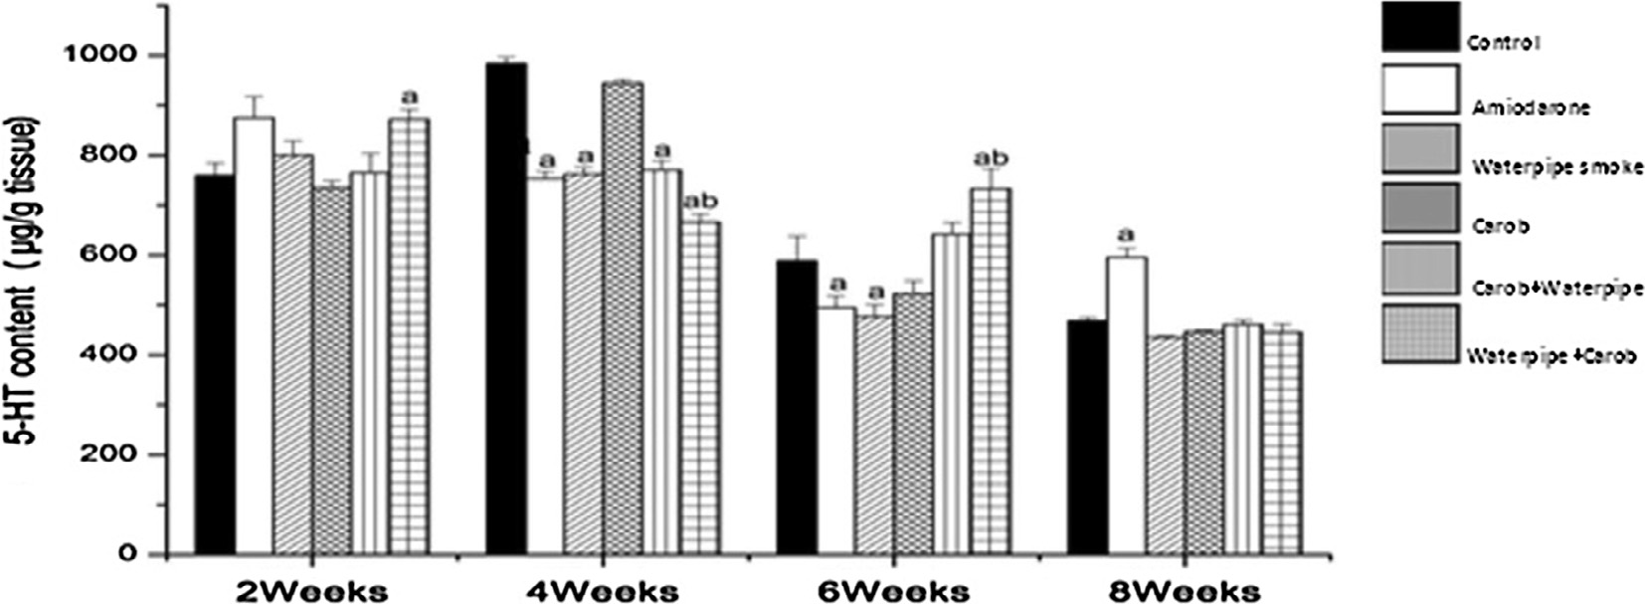

Fig. 1. Effect of daily exposure to waterpipe smoke on 5-HT content in brainstem of adult male albino rat pre- and post-treated with carob extract (600 mg/kg) for 8 weeks. Significant change at p ≤ 0.05 comparing to control group, (b) significant change at p ≤ 0.05 comparing to waterpipe smoking group.

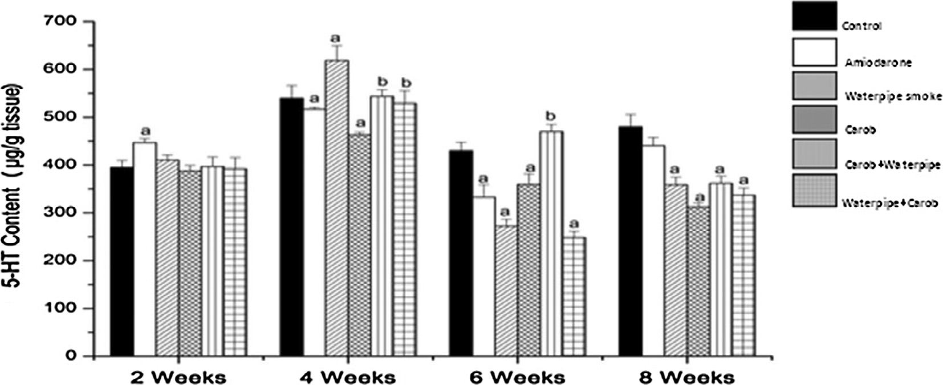

Fig. 2. Effect of daily exposure to waterpipe smoke on 5-HT content in cerebral cortex of adult male albino rat pre- and post-treated with carob extract (600 mg/kg) for 8 weeks. Significant change at p ≤ 0.05 comparing to control group, (b) significant change at p ≤ 0.05 comparing to waterpipe smoking group.

non-significant after 4 weeks; while, it was a significant on 6th and 8th weeks as compared to its corresponding control. However, there was a significant decrease in DA content in brainstem on 2nd week as a result of waterpipe smoke exposure. On contrary, there was a significant increase in DA content on 4th and 6th week versus corresponding control group. Moreover, the daily gavage of carob aqueous extract decreased the content of DA in brainstem significantly on 2nd, 6th and 8th week. The maximum reduction was found on 2nd week recording —38.20% as a percentage change. The pre-treatment of carob aqueous extract revealed a significant decrease in DA content on 2nd week, a significant increase on 6th week (11.33%); while the pre-treatment decreased DA content sig- nificantly on 8th week as compared to corresponding control. In a comparison to waterpipe smoke group; there was a significant decrease on 2nd and 8th week in DA content of brainstem.

In post-treatment group; DA content recorded a significant decrease on 2nd, 6th and 8th week versus corresponding control value. The maximum reduction was observed on 2nd week (—35.50%). Similarly, the rats were gavaged carob aqueous extract after the exposure to waterpipe smoke influenced a significant decrease in DA content in brainstem on 2nd, 6th and 8th week versus corresponding waterpipe smoke group. The maximum reduction was found on 8th week with a percentage change —21.60%.

DA content in cerebral cortex revealed a significant increase on 2nd, 4th and 8th weeks as a result of daily administration of 30 mg/ kg of amiodarone (Fig. 4). Meanwhile, rats exposed to waterpipe smoke showed a significant increase in DA content of cerebral cor- tex on 6th and 8th weeks recording 10.57% and 11.62% as a percent- age change versus corresponding control value. Moreover, the daily oral administration of aqueous carob extract caused a signif- icant increase in the content of DA in cerebral cortex on 2nd and 4th weeks. On contrary, a significant decrease in DA content was observed on 8th week as a result of carob extract (600 mg/kg) gavage.

A significant increase in DA content of cerebral cortex was started from 2nd till 6th week of the carob pre-treatment group; as compared to corresponding control group. The maximum increase was found on 2nd week with a percentage change (32.14%). In a comparison to waterpipe smoke group; carob extract pre-treatment induced a significant increase in cerebral cortex DA content on 2nd week; while it induced a significant decrease (p ≤ 0.05) in DA content on 8th week (—19.41%). The daily treatment of carob extract after rats being exposed to waterpipe smoke (post-treatment group) resulted in a significant increase after 2 and 4 weeks with percentage change 31.18% and 10.50% respec- tively, while a significant decrease was observed on 8 week

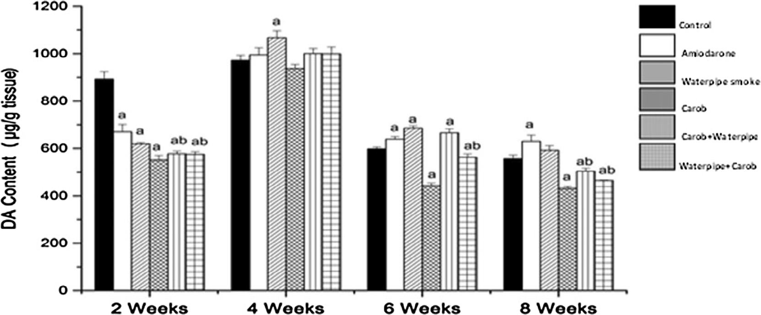

Fig. 3. Effect of daily exposure to waterpipe smoke on DA content in brainstem of adult male albino rat pre- and post-treated with carob extract (600 mg/kg) for 8 weeks. Significant change at p ≤ 0.05 comparing to control group, (b) significant change at p ≤ 0.05 comparing to waterpipe smoking group.

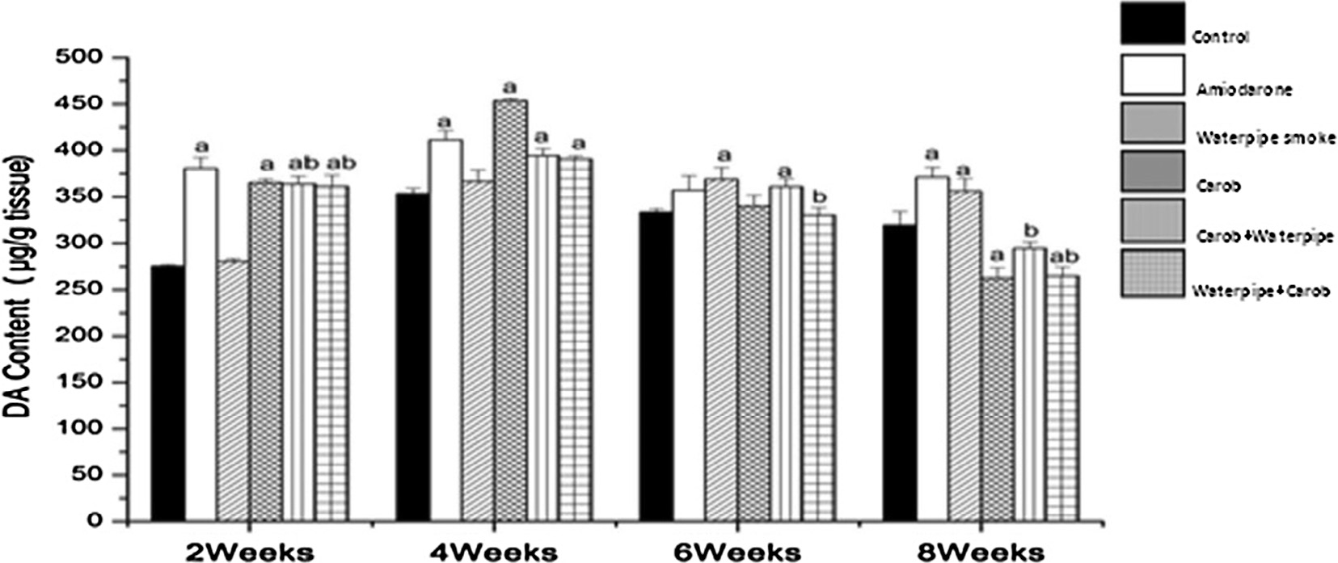

Fig. 4. Effect of daily exposure to waterpipe smoke on DA content in cerebral cortex of adult male albino rat pre- and post-treated with carob extract (600 mg/kg) for 8 weeks. Significant change at p ≤ 0.05 comparing to control group, (b) significant change at p ≤ 0.05 comparing to waterpipe smoking group.

(—17.14%) as compared to corresponding control group. On the other hand, when compared with waterpipe smoke group, DA con- tent was significantly increased on 2 week (28.80%), on contrary; DA content was significantly decreased after 6 and 8 weeks (—10.40% and —25.77%) respectively (Fig. 4).

The daily oral administration of ‘‘30 mg/kg” of amiodarone caused a gradual and a significant increase in MPO activity in lung tissue all over the experimental period as compared to correspond- ing control value (Fig. 5). The maximum increase was observed at the end of treatment recording 136.50% as a percentage change. In the same manner, MPO activity revealed a gradual and a significant increase as a result of waterpipe smoke exposure (10 mg) allover experimental time. The rats were daily gavaged 600 mg/kg of carob aqueous extract showed a reduction in the activity of MPO allover the experimental time; it was a significant on 4th week with a per- centage change (—18.00%). The rats were administered carob aque- ous extract before their exposure to waterpipe smoke showed a significant decrease in the activity of MPO on 4th week (—17.48%) versus control group. Meanwhile, a significant decrease was noticed in pulmonary MPO activity all the experimental time inter- val as compared to waterpipe smoke group. The maximum reduc- tion was recorded on 8th week.

Moreover, the treatment of carob extract after the waterpipe smoke exposure induced a significant increase on 6th week versus control value. While; in a comparison to waterpipe smoke the

carob extract treatment induced a significant reduction in pulmonary MPO activity allover the time interval of the experi- ment. The maximum reduction was found on 8th week with a per- centage change —53.16%.

As shown in Fig. 6; the daily administration of 30 mg/kg of amiodarone induced a significant elevation in pulmonary hydrox- yproline content allover time intervals of the experiment with a percentage change 164.78%, 173.50%, 229.00% and 333.66% on 2nd, 4th, 6th and 8th weeks respectively. Likewise, a gradual and a significant elevation was obtained in hydroxyproline content at p ≤ 0.05 as a result of exposure to waterpipe smoke allover exper- imental time as compared to control group. The maximum eleva- tion was recorded on 8th week (260.79%). On the other hand, the daily administration of carob extract caused a non-significant change in hydroxyproline content all time intervals of the experi- ment. Moreover, in both pre- and post-treatment groups hydrox- yproline content showed a significant increase on 6th week (55.50% and 60.64%) respectively versus control group. While; a significant decrease was observed in hydroxyproline content started from 2nd till 8th week versus waterpipe smoke group.

In Fig. 7; daily oral gavage of amiodarone/or daily exposure to waterpipe smoke induced a gradual and a significant increase in pulmonary NO level started from 2nd till 8th week as compared to corresponding control value. A non-significant change was found in NO level resulting from daily oral administration of 600 mg/kg

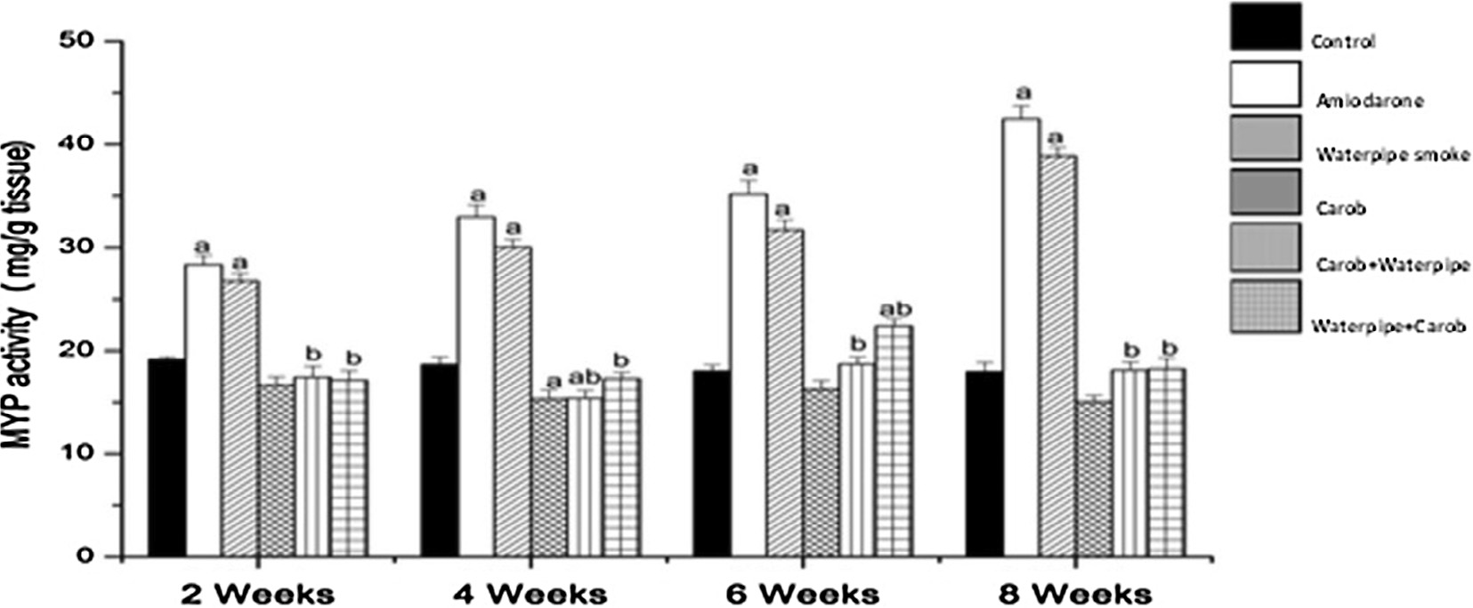

Fig. 5. Effect of daily exposure to waterpipe smoke on myeloperoxidase (MPO) activity in lung tissue of adult male albino rat pre- and post-treated with carob extract (600 mg/kg) for 8 weeks. (a) Significant change at p ≤ 0.05 comparing to control group, (b) significant change at p ≤ 0.05 comparing to waterpipe smoking group.

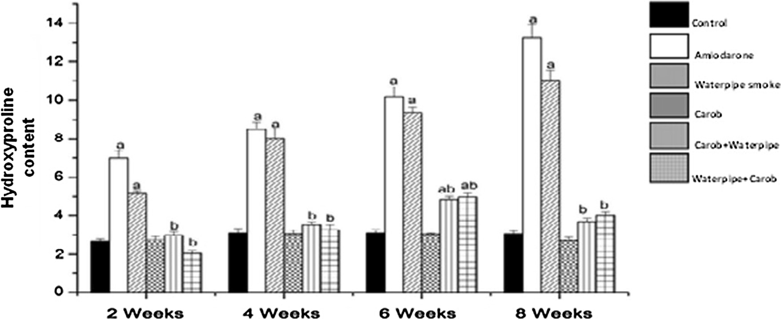

Fig. 6. Effect of daily exposure to waterpipe smoke on Hydroxyproline content in lung tissue of adult male albino rat pre- and post-treated with carob extract (600 mg/kg) for 8 week. Significant change at p ≤ 0.05 comparing to control group, (b) significant change at p ≤ 0.05 comparing to waterpipe smoking group.

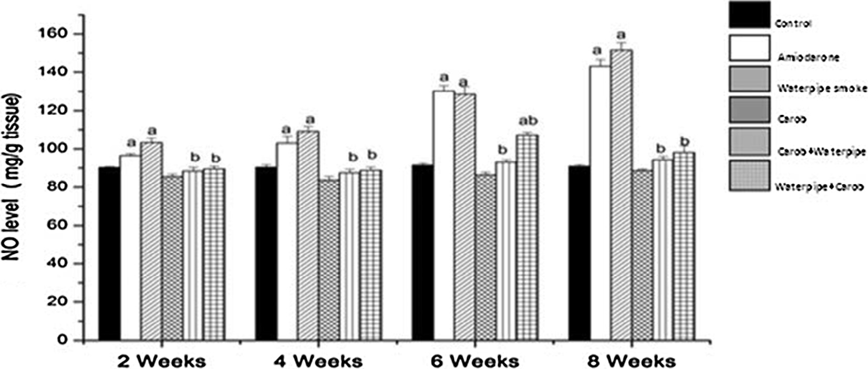

Fig. 7. Effect of daily exposure to waterpipe smoke on NO level in lung tissue of adult male albino rat pre and post-treated with carob extract (600 mg/kg) for 8 weeks. Significant change at p ≤ 0.05 comparing to control group, (b) significant change at p ≤ 0.05 comparing to waterpipe smoking group.

carob aqueous extract before waterpipe smoke exposure (pre-treatment); versus corresponding control group. While, a sig- nificant decrease was recorded in NO level allover experimental time intervals as compared to waterpipe smoke values in pre- treatment group. The maximum reduction was observed on 8th week with a percentage change —37.72%. Moreover, the post- treatment caused a non-significant change in NO level on 2nd, 4th and 8th week, meanwhile, a significant increase was obtained on 6th week (18.60%) as compared to control group. Oppositely; the post-treatment induced a significant decrease in NO level allover the experimental time interval as compared to corresponding waterpipe smoke group.

CAT activity in lung tissue was shown in Fig. 8; the daily gavage of amiodarone to rats induced a gradual and a significant decrease in CAT activity started from 4th till 8th week as compared to corre- sponding control value. Moreover, the daily exposure to 10 mg of waterpipe smoke for (15 min) caused a gradual and a significant decrease in CAT activity started on 4th and 6th week with a percent- age change —10.86% and —33.33% respectively. However, the con- tinuous exposure to waterpipe smoke recorded a constant and a significant reduction at p ≤ 0.05 in pulmonary CAT activity on 8th week (—33.33%) versus control group. On contrary, pulmonary CAT activity was increased significantly in rats were orally admin- istered the aqueous extract of carob for 8 weeks; where the maxi-

mum increment was found on 8th week with a percentage change 101.85% as compared to control group. The pre-treatment with carob extract increased CAT activity in lung significantly allover time intervals as compared to control and waterpipe smoke groups. In the same line; post-treatment resulted in a significant increase in CAT activity at p ≤ 0.05 at all experimental time inter- vals versus both control and waterpipe smoke groups.

1. Discussion

The oral administration of amiodarone caused a significant increase in 5-HT content after 8 weeks in brainstem and 2 weeks in cerebral cortex while, it caused a significant decrease in its con- tent after 4 and 6 weeks in brainstem and 6 weeks in cerebral cor- tex. Also it caused a significant increase in DA content in brainstem and cerebral cortex at most of time intervals.

Wyss et al. [27] reported that amiodarone pass into the brain and it has an anticonvulsant and hypnotic effects. Moreover, amio- darone prolonged the sleeping time and behaved as central ner- vous system depressant drug in pentobarbital-induced sleeping in rat model [28]. Many reports attributed the anticonvulsant activity of amiodarone to its activity as a multiple ion-channel blocker drug which inhibit Na+, Ca2+ inward and K+ outward cur- rents [28,29]. It well known that when action potentials depolarize

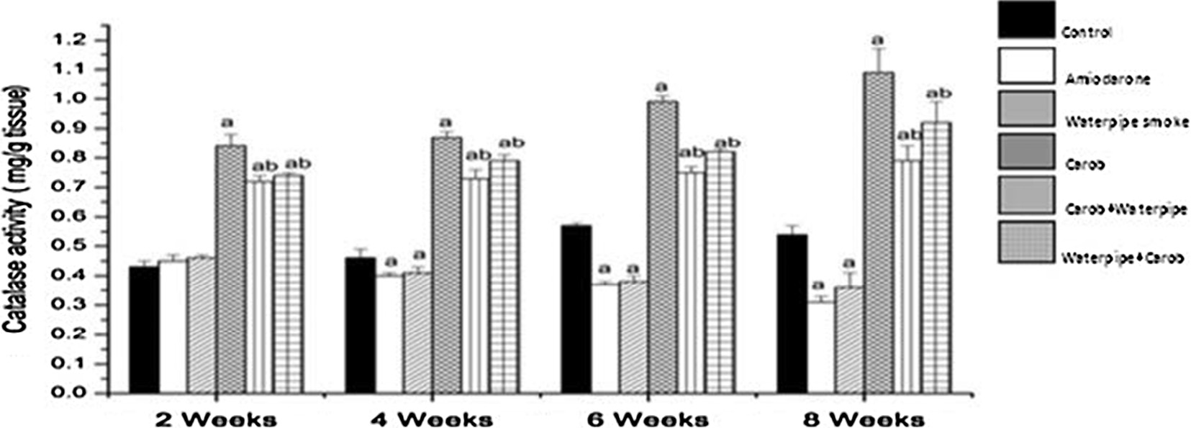

Fig. 8. Effect of daily exposure to waterpipe smoke on catalase activity in lung tissue of adult male albino rat pre and post-treated with carob extract (600 mg/kg) for 8 weeks.

(a) Significant change at p ≤ 0.05 comparing to control group, (b) significant change at p ≤ 0.05 comparing to waterpipe smoking group.

the plasma membrane of the axon terminal, voltage-gated Ca2+ channels is open. This permits Ca2+ to diffuse down its concentra- tion gradient into the cytoplasm, where it stimulates the release of neurotransmitters which stored in synaptic vesicles by exocytosis [30]. Because of the amiodarone is a calcium ion-channel blocker

[29]; so the neurotransmitters release is inhibited and as the result their content is increased in brain which may explain the incre- ment in neurotransmitters content in some time intervals in the present study.

In laboratory animals, intravenous nicotine increases the sensi- tivity of brain reward systems and imprints an indelible memory of its effects; an action that appears unique to nicotine among drugs of abuse .This may partially explain the rapid return to former levels of smoking that frequently follows a relapse after a pro- longed period of smoking abstinence [31]. Waterpipe smokers can be exposed to sufficient doses of nicotine which rapidly dis- tribute to the brain and changes its structure and function so; it results in physical mood-altering effects by acting as a stimulant and a relaxant as well [32]. Moreover, nicotine is a psychomotor stimulant that binds to acetylcholine receptors and has short- and long-term effects. In the short-term, it can produce nausea or dizziness in new users and mild euphoria in experienced users. The mood effects are directly attributable to nicotine-mediated neurotransmitter release such as DA and 5-HT [32,33].

From the present results, it is clear that DA content is decreased after 2 weeks in brainstem of rats exposed to waterpipe smoke.

The primary target for nicotine in the central nervous system is the a4b2 nicotinic acetylcholine receptor, which when activated by nicotine binding, results in the release of DA in the brain’s ‘‘reward center” and provides the positive reinforcement observed

with cigarette smoking [34].

However, the present study revealed that 5-HT content signifi- cantly decreased after 4 and 6 weeks in brainstem and 6 and 8 weeks in cerebral cortex after exposure to waterpipe smoke. It is clear that when nicotine binds to its receptors, which are ligand-gated ion channels, these channels are open in allowing the entry of Na+ and Ca2+ ions which facilitate the release of neu- rotransmitters [32] and as results the contents of DA and 5-HT were decreased as shown in the present results.

The waterpipe smokers had increased cough and biologic abnormalities in several anatomic components in the lung com- pared to nonsmokers [35]. The cough reflex can be initiated by a wide variety of stimuli [36]. The vagal fibers for cough enter the brainstem (cough center) and relay in the nucleus of the solitary tract with connections to second-order neurons [37,38]. Afferent impulses travel to the dorsal medulla where the reflex is subject to cortical control where cerebral cortex has a role in influencing

cough. The brain then sends signals back to the lungs and respira- tory muscles [39,40]. Neurotransmitters which involved in the cen- tral cough complex are tachykinins, glutamate, g-aminobutyric acid, N-methyl-D-aspartate, 5-HT and DA [37,38,41]. Increased release of substance P is involved in the development of cough and inflammation of the airway, and its production is regulated by dopaminergic neurons in the brainstem.

Previous study indicated that L-dopa (a precursor of DA) strengthens the coughing reflex [42]. So, the increment in DA con- tent in the present study after exposure to waterpipe smoke after 4, 6 weeks in brainstem and after 6, 8 weeks in cerebral cortex may be due to increase its synthesis from L-dopa. In addition, Long-term use of nicotine can produce tolerance and dependence [43,44]. Neuroadaptation of the mesolimbic system in smokers occur. So, long term use of nicotine can produce tolerance and dependence [44], which may explain why there was a non- significant change in DA content in brainstem at the end of exper- iment in the present study.

From present results, it is clear that the oral administration of aqueous extract of carob induced a significant decrease in DA con- tent in brainstem at almost time intervals while, in cerebral cortex, it caused a significant decrease after 8 weeks and a significant increase after 2 and 4 weeks. It also caused a significant decrease in 5-HT content at almost time intervals in cerebral cortex.

Previous studies indicated that carob has some medicinal uses where it is used in cough syrup [45,46] which may be due to decrease in DA synthesis via decrease in L- dopa to inhibit cough reflex as a result its content is decreased. Agrawal et al. [47] demonstrated that carob exhibited significant antidepressant effect in both tail suspension test and forced swim test. It also inhi- bits haloperidol-induced catalepsy and potentiates apomorphine- induced sniffing in rats. Grabowska et al. [48] indicated that apo- morphine has been found to elevate 5-hydroxyindoleacetic acid content in rat and mouse brain. These findings were confirmed by the study of Scheel-Kriiger and Hasselager [49] which indicated that the turnover of brain 5-HT is increased under the influence of apomorphine [48,50,51]. So, the decrement in 5-HT content after oral administration of carob extract in the present study may be due to increase in its turnover or inhibit its reuptake.

The most serious side effect of amiodarone is pulmonary toxic- ity [52]. So, it is used in this study as a model for pulmonary tox- icity [53,54]. The present results revealed that the oral administration of amiodarone and the exposure to waterpipe smoke caused an increase in lung MPO activity. It is known that MPO was suggested as an early marker of systemic inflammation in smokers [55]. It is one of the most abundant proteins in neu- trophils [56]. It stored in granules and released when neutrophils

are stimulated, it catalyzes the oxidation of chloride and other halide ions in the presence of hydrogen peroxide [57,58] to gener- ate hypochlorous acid and other highly reactive products that mediate efficient antimicrobial action [59,60].

Previous studies revealed that amiodarone is metabolized to an aryl radical that may give rise to other reactive oxygen species (ROS) [61,62] which cause endothelial injury leading to oedema, thrombosis and inflammation contributing to morbidity and mor- tality in acute lung injury [63]. The activation of macrophages and release of inflammatory and cytotoxic mediators drive amiodarone-induced lung fibrosis [64]. *In vitro* studies have shown that alveolar leucocytes and macrophages from cigarette smokers spontaneously increase the release of oxidants amounts such as

O— and hydrogen peroxide (H O ) compared with non-smokers

highly reactive metabolite, peroxynitrite, which is presumed to be largely responsible for most of the adverse effects of excessive gen- eration of NO [79]. So, the increment of NO level in the present study may be due to increase in lipid peroxidation as a result of increasing the production of ROS and the presence of heavy metals and NO in waterpipe smoke.

The potential damage that can be caused by free radicals is nor- mally minimized by a combination of biological antioxidant sys- tems including enzymatic and non-enzymatic reactions [80]. An imbalance between oxidants and antioxidants has been proposed in the pathogenesis of chronic obstructive pulmonary disease [81]. CAT acts as preventive antioxidant [82]; its primary role is to scavenge H2O2 that has been generated by free radicals and con-

vert it to water [83]. The present results showed that the adminis-

2 2 2

[65]. Neutrophils sequestered in the pulmonary circulation follow- ing cigarette smoke inhalation in the rabbit [66]. Also, in hamsters; the cigarette smoke inhalation activates neutrophils, increasing their adhesion to the endothelium of both arterioles and venules which is mediated by superoxide anion [67]. Thus, by several mechanisms involving oxidants, cigarette smoke causes neutrophil sequestration in the pulmonary microcirculation [68].

Also, Anderson et al. [69] demonstrated that passive cigarette smoking has been associated with increasing peripheral blood leu- cocytes counts and enhancement the release of ROS which directly damage the surrounding tissues and participate in inflammatory disorders [70]. In addition to the ROS production, the cytoplasmic granules of the neutrophils discharge hydrolytic, proteolytic enzymes and MPO [71]. So, the activation of neutrophils as a result of inflammation occurred by administration of amiodarone or exposure to waterpipe smoke may cause the increment in the activity of lung MPO as shown in the present study.

Moreover, the present results demonstrated that both amio- darone administration and exposure to waterpipe smoke increased pulmonary hydroxyproline content. These results are consistent with the previous study which demonstrated that amiodarone ele- vated hydroxyproline content in rats [64]. Oxidative stress, in par- ticular lipid peroxidation, induces collagen synthesis [72]. Collagen constitutes measured by hydroxyproline, might serve as an index of lung tissue damage in the rat exposed to the various irritants present in waterpipe smoke for a period of time [73]. So, the incre- ment in hydroxyproline content in the present results may be due to its mobilization for collagen formation by the fibroblasts which surrounding the injured lung tissues.

In the present study; NO level was significantly increased after amiodarone administration and the exposure to waterpipe smoke. Verifying that both amiodarone and waterpipe smoke induce markedly excessive ROS production that lead to serious oxidative damage. Punithavathi et al. [64] reported that amiodarone increased cellular oxidant production in treated rats. Moreover, amiodarone impaired lipid metabolism in lungs which damaged the endothelium and increased ROS production [62].

Nicotine, a major toxic component of cigarette smoke, is a well- established procarcinogen. In addition; it disrupts the mitochon- drial respiratory chain leading to an increase in generation of superoxide anion and H2O2 [74]. This may lead to oxidative dam- age of macromolecules including lipid, DNA and RNA [75]. More- over; the heavy metals such as lead and cadmium which present in smoke are also capable of inducing lipid peroxidation and hence provokes damage of organs [76].

However, NO which is present in the gas phase of cigarette smoke, reacts with tyrosine to form nitrotyrosine products of pro- teins in plasma *in vitro* [77], these products can interfere with cell signaling pathways involving tyrosine phosphorylation and impli- cated in many lung diseases [78]. The increase in NO level is indica- tive of oxidant related tissue injury by formation of highly reactive nitrogen intermediates. NO reacts with superoxide and generates a

tration of amiodarone and the exposure to waterpipe smoke caused a significant decrease in CAT activity these results are con- sistent with the previous study of Ozbakis-Dengiz and Bakirci [28]; which demonstrated that administration of amiodarone decreased the activity of CAT in male mice and rats. Also, Al-Shammari et al.

[52] postulated that the decrement in CAT activity in amiodarone administered group resulting from induction of oxidative stress.

In the experiment described by Baskaran et al. [84] showed that the limited time exposure of rats to tobacco smoke resulted in the induction of CAT and super oxide dismutase as adaptation to the oxidative insult. In the same line, Luchese et al. [85] demonstrated that the reduction of CAT activity may be related to excess H2O2 pro- duction. Also, Mahapatra et al. [86] attributed the decreased the antioxidant enzymes activity to increase in their utilization to scav- enge the free radicals generated from cigarette smoke. So, these may explain the decrement in CAT activity in rats treated with amio- darone and exposed to waterpipe smoke in the present study which may be due to its utilization to scavenge generated free radicals.

In the present study; the oral administration of aqueous extract of carob pod caused a significant increase in CAT activity while, it caused a non-significant change in the other studied parameter. Pre- and post-treatment with carob aqueous extract protected and ameliorated the variations in the levels of different investi- gated parameters in rats exposed to waterpipe smoke. These results are agreement with the study of Gulay et al. [15] which demonstrated that carob bean extract is non-toxic and have no sig- nificant adverse effects with its traditional use in male rabbits.

Previous studies indicated that carob possess antioxidant activ- ity, where; Kumazawa et al. [87] reported that carob pod crude polyphenol had high antioxidant activity which acting as scav- engers of singlet oxygen and free radicals [13]. It was reported that the carob powder is considered as a rich source of Fe, Ca, Na, K, P and S [88] and the trace element Cu, Zn and Se which act as cofac- tors of antioxidant enzymes to protect the body from oxygen free radicals that are produced during oxidative stress [89].

Rtibi et al. [71] reported that the aqueous extract of carob pod inhibited the MPO activity in a concentration dependent manner by its ability to reduce the production of hypochlorous acid from H2O2 that could attenuate the inflammatory reactions. Also, it inhi- bits ROS, superoxide anion and H2O2 production in a concentration dependent manner. Sebai et al. [13] showed that subacute (7 days) treatment with aqueous extract carob pod is able to alleviate lipid peroxidation in brain and heart. Consequently, it is involved in pro- tection against several diseases such as cardiovascular, neuronal and others [89].

So, the pre- and post-treatment with carob aqueous extract pro- tect and ameliorate the variations in the levels of different param- eters in rats exposed to waterpipe smoke which may be due to its high levels of dietary fiber and polyphenol compounds. Besides the antioxidant activity the polyphenols, which mainly prevent or delay the oxidative damage, also the presence of trace element enhance the activity of antioxidant enzymes.

1. Conclusion

It is clear that the exposure to waterpipe smoke (passive smoking) caused serious side effects on brain and lung nearly like amiodarone which is used as a model for lung toxicity in rats. The pre-and post-treatment with carob aqueous extract ameliorated these effects due to its antioxidant effects. Moreover, the aware- ness about the usage or exposure to waterpipe smoke for all ages must be increased by Ministry of Health, the media and Schools. Also, the Government must be put hard rules for smoking in open areas. Carob is being acclaimed as an ingredient with a marked nutritional value due to its antidepressant, anti-inflammatory effects and its high levels of dietary fiber and phenol compounds as well as inhibit caugh reflex which carob exert a preventative role against many diseases. So, carob powder should be increasing as an ingredient in the healthy food industry such as biscuits, bread and cakes.

Conflict of interest

We declare that we have no conflict of interest with anyone.

Funding

This research did not receive any specific grant from funding agencies in the public, commercial, or not-for-profit sectors.

References

1. [Azab M, Khabour OF, Alkaraki AK, Eissenberg T, Alzoubi KH, Primack BA. Water](http://refhub.elsevier.com/S2314-808X(17)30450-5/h0005) [pipe tobacco smoking among university students in Jordan. Nicotine Tob Res](http://refhub.elsevier.com/S2314-808X(17)30450-5/h0005) [2010;12(6):606–12](http://refhub.elsevier.com/S2314-808X(17)30450-5/h0005).
2. [Alzoubi KH, Khabour OF, Alharahshah EA, Alhashimi FH, Shihadeh A,](http://refhub.elsevier.com/S2314-808X(17)30450-5/h0010) [Eissenberg T. The effect of waterpipe tobacco smoke exposure on learning](http://refhub.elsevier.com/S2314-808X(17)30450-5/h0010) [and memory functions in the rat model. J Mol Neurosci 2015;57(2):249–56](http://refhub.elsevier.com/S2314-808X(17)30450-5/h0010).
3. World Health Organization (2009). Global Adult Tobacco Survey Bangladesh Report 2009.
4. [Primack BA, Fertman CI, Rice KR, Adachi-Mejia AM, Fine MJ. Waterpipe and](http://refhub.elsevier.com/S2314-808X(17)30450-5/h0020) [cigarette smoking among U.S. college athletes. J Adolesc Health 2010;1:45–51](http://refhub.elsevier.com/S2314-808X(17)30450-5/h0020).
5. [Jha P. Avoidable global cancer deaths and total deaths from smoking. Nat Rev](http://refhub.elsevier.com/S2314-808X(17)30450-5/h0025) [Cancer 2009;9:655–64](http://refhub.elsevier.com/S2314-808X(17)30450-5/h0025).
6. [Khabour OF, Alsatari ES, Azab M, Alzoubi KH, Sadiq MF. Assessment of](http://refhub.elsevier.com/S2314-808X(17)30450-5/h0030) [genotoxicity of waterpipe and cigarette smoking in lymphocytes using the](http://refhub.elsevier.com/S2314-808X(17)30450-5/h0030) [sister-chromatid exchange assay: a comparative study. Environ Mol Mutagen](http://refhub.elsevier.com/S2314-808X(17)30450-5/h0030) [2011;52:224–8](http://refhub.elsevier.com/S2314-808X(17)30450-5/h0030).
7. [Sajid KM, Akhter M, Malik GQ. Carbon monoxide fractions in cigarette and](http://refhub.elsevier.com/S2314-808X(17)30450-5/h0035) [hookah (hubble bubble) smoke. J Pak Med Assoc 1993;43(9):179–82](http://refhub.elsevier.com/S2314-808X(17)30450-5/h0035).
8. [Virués-Ortega J, Buela-Casal G, Garrido E, Alcázar B. Neuropsychological](http://refhub.elsevier.com/S2314-808X(17)30450-5/h0040) [functioning associated with high-altitude exposure. Neuropsychopharmacol](http://refhub.elsevier.com/S2314-808X(17)30450-5/h0040) [Rev 2004;14:197–224](http://refhub.elsevier.com/S2314-808X(17)30450-5/h0040).
9. [Durazzo TC, Meyerhoff DJ, Jo Nixon S. Chronic cigarette smoking: implications](http://refhub.elsevier.com/S2314-808X(17)30450-5/h0045) [for neurocognition and brain neurobiology. Int J Environ Res Public Health](http://refhub.elsevier.com/S2314-808X(17)30450-5/h0045) [2010;7:3769–91](http://refhub.elsevier.com/S2314-808X(17)30450-5/h0045).
10. [Wolkove N, Baltzan M. Amiodarone pulmonary toxicity. Can Respir J](http://refhub.elsevier.com/S2314-808X(17)30450-5/h0050) [2009;16:43–8](http://refhub.elsevier.com/S2314-808X(17)30450-5/h0050).
11. [Yamagishi M, Natsume M, Nagaki A, Adachi T, Osakabe N, Takizawa T, et al.](http://refhub.elsevier.com/S2314-808X(17)30450-5/h0055) [Antimutagenic activity of cacao: inhibitory effect of cacao liquor polyphenols](http://refhub.elsevier.com/S2314-808X(17)30450-5/h0055) [on the mutagenic action of heterocyclic amines. J Agric Food Chem](http://refhub.elsevier.com/S2314-808X(17)30450-5/h0055) [2000;48:5074–8](http://refhub.elsevier.com/S2314-808X(17)30450-5/h0055).
12. [Ahmed MM. Biochemical studies on nephroprotective effect of carob](http://refhub.elsevier.com/S2314-808X(17)30450-5/h0060) [(*Ceratonia siliqua* L.) growing in Egypt. Nat Sci 2010;8:41–7](http://refhub.elsevier.com/S2314-808X(17)30450-5/h0060).
13. [Sebai H, Souli A, Chehimi L, Rtibi K, Amri M, El-Benna J, et al. *In vitro* and *in vivo*](http://refhub.elsevier.com/S2314-808X(17)30450-5/h0065)[antioxidant properties of Tunisian carob (*Ceratonia siliqua* L.). J Med Food Res](http://refhub.elsevier.com/S2314-808X(17)30450-5/h0065) [2013;7(2):85–90](http://refhub.elsevier.com/S2314-808X(17)30450-5/h0065).
14. [Lachkar N, Al-Sobarry M, El Hajaji H, Lamkinsi T, Lachkar M, Cherrah Y, et al.](http://refhub.elsevier.com/S2314-808X(17)30450-5/h0070) [Anti-inflammatory and antioxidant effect of *Ceratonia siliqua* L. methanol](http://refhub.elsevier.com/S2314-808X(17)30450-5/h0070) [barks extract. J Chem Pharm Res 2016;8:202–10](http://refhub.elsevier.com/S2314-808X(17)30450-5/h0070).
15. [Gulay MS, Yildiz-Gulay O, Ata A, Balic A, Demirtas A. Toxicological evaluation](http://refhub.elsevier.com/S2314-808X(17)30450-5/h0075) [of carob (*Ceratonia siliqua*) bean extracts in male New Zealand white rabbits. J](http://refhub.elsevier.com/S2314-808X(17)30450-5/h0075) [Anim Vet Adv 2012;11(11):1853–7](http://refhub.elsevier.com/S2314-808X(17)30450-5/h0075).
16. [Khabour OF, Alzoubi KH, Eissenberg T, Mehrotra P, Azab M, Carroll MV, et al.](http://refhub.elsevier.com/S2314-808X(17)30450-5/h0080) [Waterpipe tobacco and cigarette smoking among university students in](http://refhub.elsevier.com/S2314-808X(17)30450-5/h0080) [Jordan. Int J Tuberc Lung Dis 2012;16:986–92](http://refhub.elsevier.com/S2314-808X(17)30450-5/h0080).
17. [Agelaki MG, Pantos C, Korantzopoulos P, Tsalikakis DG, Baltogiannis GG,](http://refhub.elsevier.com/S2314-808X(17)30450-5/h0085) [Fotopoulos A, et al. Comparative antiarrhythmic efficacy of amiodarone and](http://refhub.elsevier.com/S2314-808X(17)30450-5/h0085) [dronedarone during acute myocardial infarction in rats. Eur J Pharmacol](http://refhub.elsevier.com/S2314-808X(17)30450-5/h0085) [2007;564:150–7](http://refhub.elsevier.com/S2314-808X(17)30450-5/h0085).
18. [Miri-Moghaddam E, Mirzaei R, Arab MR, Kaikha S. The effects of water pipe](http://refhub.elsevier.com/S2314-808X(17)30450-5/h0090) [smoking on hematological parameters in rats. Int J Hematol Oncol Stem Cell](http://refhub.elsevier.com/S2314-808X(17)30450-5/h0090) [Res 2014;8(3):37–43](http://refhub.elsevier.com/S2314-808X(17)30450-5/h0090).
19. [Ayaz FA, Torun H, Ayaz S, Correia PJ, Alaiz M, Sanz C, et al. Determination of](http://refhub.elsevier.com/S2314-808X(17)30450-5/h0095) [chemical composition of anatolian carob pod (*Ceratonia siliqua* L.): sugars,](http://refhub.elsevier.com/S2314-808X(17)30450-5/h0095) [amino and organic acids, minerals and phenolic compounds. Food Qual](http://refhub.elsevier.com/S2314-808X(17)30450-5/h0095) [2007;30:1040–55](http://refhub.elsevier.com/S2314-808X(17)30450-5/h0095).
20. [Mokhtary M, Sharifi E, Shahamir-tabatabaee M. The effect of carob extract on](http://refhub.elsevier.com/S2314-808X(17)30450-5/h0100) [liver function test in the diabetic male rat. J Shahrekord Univ Med Sci](http://refhub.elsevier.com/S2314-808X(17)30450-5/h0100) [2013;15:40–7](http://refhub.elsevier.com/S2314-808X(17)30450-5/h0100).
21. [Glowinski J, Iversen L. Regional studies of catecholamines in the rat brain. I.](http://refhub.elsevier.com/S2314-808X(17)30450-5/h0105) [The disposition of [3H] norepinephrine, [3H] dopamine and [3H] dopa in](http://refhub.elsevier.com/S2314-808X(17)30450-5/h0105) [various regions of the brain. J Neurochem 1966;13(8):655–69](http://refhub.elsevier.com/S2314-808X(17)30450-5/h0105).
22. [Ciarlone AF. Further modification of a fluorometric method for analyzing brain](http://refhub.elsevier.com/S2314-808X(17)30450-5/h0110) [amines. Microchem J 1978;23:9–12](http://refhub.elsevier.com/S2314-808X(17)30450-5/h0110).
23. [Pulli B, Ali M, Forghani R, Schob S, Hsieh KLC, Wojtkiewicz G, et al. Measuring](http://refhub.elsevier.com/S2314-808X(17)30450-5/h0115) [myeloperoxidase activity in biological samples. PLoS One 2013;8(7):e67976](http://refhub.elsevier.com/S2314-808X(17)30450-5/h0115).
24. [Woessner JFJR. The determination of hydroxyproline in tissue and protein](http://refhub.elsevier.com/S2314-808X(17)30450-5/h0120) [samples containing small proportions of this amino acid. Arch Biochem](http://refhub.elsevier.com/S2314-808X(17)30450-5/h0120) [Biophys 1961;93:440–7](http://refhub.elsevier.com/S2314-808X(17)30450-5/h0120).
25. [Green LC, Wagner DA, Glogowski J, Skipper PL, Wishnok JS, Tannenbaum SR.](http://refhub.elsevier.com/S2314-808X(17)30450-5/h0125) [Analysis of nitrate, nitrite and (15N) nitrate in biological fluids. Anal Biochem](http://refhub.elsevier.com/S2314-808X(17)30450-5/h0125) [1982;126:131–8](http://refhub.elsevier.com/S2314-808X(17)30450-5/h0125).
26. [Bock P, Kramais R, Pavelka M. Peroxisomes and related particles in animal](http://refhub.elsevier.com/S2314-808X(17)30450-5/h0130) [tissues. New York: Springer Verlag; 1980. p. 58–9](http://refhub.elsevier.com/S2314-808X(17)30450-5/h0130).
27. [Wyss PA, Moor MJ, Bickel MH. Single-dose kinetics of tissue distribution,](http://refhub.elsevier.com/S2314-808X(17)30450-5/h0135) [excretion and metabolism of amiodarone in rats. J Pharmacol Exp Ther](http://refhub.elsevier.com/S2314-808X(17)30450-5/h0135) [1990;254:502–7](http://refhub.elsevier.com/S2314-808X(17)30450-5/h0135).
28. [Ozbakis-Dengiz G, Bakirci A. Anticonvulsant and Hypnotic effects of](http://refhub.elsevier.com/S2314-808X(17)30450-5/h0140) [amiodarone. J Zhejiang Univ Sci B 2009;10(4):317–22](http://refhub.elsevier.com/S2314-808X(17)30450-5/h0140).
29. [Roden DM. Antiarrhythmic drugs. In: Brunton LL, Lazo JS, Parker KL, editors.](http://refhub.elsevier.com/S2314-808X(17)30450-5/h0145) [Goodman & Gilman’s: the pharmacological basis of therapeutics. New York,](http://refhub.elsevier.com/S2314-808X(17)30450-5/h0145) [USA: The McGraw-Hill Companies; 2006. p. 899–932](http://refhub.elsevier.com/S2314-808X(17)30450-5/h0145).
30. Fox SI. Nervous system: neurons and synapses. In Fundamentals of Human Physiology. Singapore: McGraw-Hill; 2009. p. 86–112 [ch.4].
31. [Kenny PJ, Markou A. Conditioned nicotine withdrawal profoundly decreases](http://refhub.elsevier.com/S2314-808X(17)30450-5/h0155) [the activity of brain reward systems. J Neurosci 2005;25:6208–12](http://refhub.elsevier.com/S2314-808X(17)30450-5/h0155).
32. [Benowitz NL. Clinical pharmacology of nicotine: implications for](http://refhub.elsevier.com/S2314-808X(17)30450-5/h0160) [understanding, preventing, and treating tobacco addiction. Clin Pharmacol](http://refhub.elsevier.com/S2314-808X(17)30450-5/h0160) [Ther 2008;83(4):531–41](http://refhub.elsevier.com/S2314-808X(17)30450-5/h0160).
33. [Salameh P, Waked M, Aoun Z. Narguileh smoking: construction and validation](http://refhub.elsevier.com/S2314-808X(17)30450-5/h0165) [of the LWDS-11 dependence scale. Nicotine Tob Res 2008;10:148–59](http://refhub.elsevier.com/S2314-808X(17)30450-5/h0165).
34. [Brody AL, Mandelkern MA. Cigarette smoking saturates brain alpha 4 beta 2](http://refhub.elsevier.com/S2314-808X(17)30450-5/h0170) [nicotinic acetylcholine receptors. Arch Gen Psychiatry 2006;63:907–15](http://refhub.elsevier.com/S2314-808X(17)30450-5/h0170).
35. [Hogg JC, Macklem PT, Thurlbeck WM. Site and nature of airway obstruction in](http://refhub.elsevier.com/S2314-808X(17)30450-5/h0175) [chronic obstructive lung disease. N Engl J Med 1968;278:1355–60](http://refhub.elsevier.com/S2314-808X(17)30450-5/h0175).
36. [Gordon C, Gudi K, Krause A, Sackrowitz R, Harvey BG, Strulovici-Barel Y,](http://refhub.elsevier.com/S2314-808X(17)30450-5/h0180) [Crystal RG, et al. Circulating endothelial microparticles as a measure of early](http://refhub.elsevier.com/S2314-808X(17)30450-5/h0180) [lung destruction in cigarette smokers. Am J Respir Crit Care Med](http://refhub.elsevier.com/S2314-808X(17)30450-5/h0180) [2011;184:224–32](http://refhub.elsevier.com/S2314-808X(17)30450-5/h0180).
37. [Mazzone SB, Canning BJ. Central nervous system control of the airways:](http://refhub.elsevier.com/S2314-808X(17)30450-5/h0185) [pharmacological implications. Curr Opin Pharmacol 2002;2:220–8](http://refhub.elsevier.com/S2314-808X(17)30450-5/h0185).
38. [Widdicombe JG. Functional morphology and physiology of rapidly adapting](http://refhub.elsevier.com/S2314-808X(17)30450-5/h0190) [receptors (RARs). Anat Rec 2003;270A:2–10](http://refhub.elsevier.com/S2314-808X(17)30450-5/h0190).
39. [Shannon R, Baekey DM, Morris KF, Li Z, Lindsey BG. Functional connectivity](http://refhub.elsevier.com/S2314-808X(17)30450-5/h0195) [among ventrolateral medullary respiratory neurones and responses during](http://refhub.elsevier.com/S2314-808X(17)30450-5/h0195) [fictive cough in the cat. J Physiol 2000;525(1):207–24](http://refhub.elsevier.com/S2314-808X(17)30450-5/h0195).
40. [Shannon R, Baekey DM, Morris KF, Nuding SC, Segers LS, Lindsey BG.](http://refhub.elsevier.com/S2314-808X(17)30450-5/h0200) [Production of reflex cough by brainstem respiratory networks. Pulm](http://refhub.elsevier.com/S2314-808X(17)30450-5/h0200) [Pharmacol Ther 2004;17(6):369–76](http://refhub.elsevier.com/S2314-808X(17)30450-5/h0200).
41. [Widdicombe JG. Neuroregulation of cough: implications for drug therapy. Curr](http://refhub.elsevier.com/S2314-808X(17)30450-5/h0205) [Opin Pharmacol 2002;2:256–63](http://refhub.elsevier.com/S2314-808X(17)30450-5/h0205).
42. [Takahama K, Shirasaki TF, Soeda F. Central mechanisms III: neuronal](http://refhub.elsevier.com/S2314-808X(17)30450-5/h0210) [mechanisms of action of centrally acting antitussives using](http://refhub.elsevier.com/S2314-808X(17)30450-5/h0210) [electrophysiological and neurochemical study approaches. Pharmacol Ther](http://refhub.elsevier.com/S2314-808X(17)30450-5/h0210) [Cough 2009;138:219–37. ch.3](http://refhub.elsevier.com/S2314-808X(17)30450-5/h0210).
43. [Perry DC, Davila-Garcia MI, Stockmeier CA, Kellar KJ. Increased nicotinic](http://refhub.elsevier.com/S2314-808X(17)30450-5/h0215) [receptors in brains from smokers: membrane binding and autoradiography](http://refhub.elsevier.com/S2314-808X(17)30450-5/h0215) [studies. J Pharmacol Exp Ther 1999;289:1545–52](http://refhub.elsevier.com/S2314-808X(17)30450-5/h0215).
44. [Javid B, Rahmani KJ. The effect of the cigarette smoke on activities of some](http://refhub.elsevier.com/S2314-808X(17)30450-5/h0220) [serum enzymes in diabetic rats. Cibtech J Zool 2014;3(3):120–3](http://refhub.elsevier.com/S2314-808X(17)30450-5/h0220).
45. [Amico FP, Source EG. Medical plants and phytotherapy in Mussomeli area](http://refhub.elsevier.com/S2314-808X(17)30450-5/h0225) [(Caltenissetta Sicily, Italy). Fitoterapia 1997;68:143–59](http://refhub.elsevier.com/S2314-808X(17)30450-5/h0225).
46. [Merzouki A, Derfoufi E, Molero Mesa JM. Wild medicinal plants used by local](http://refhub.elsevier.com/S2314-808X(17)30450-5/h0230) [Bouhmed population (Morocco). Fitoterapia 1997;68:444–60](http://refhub.elsevier.com/S2314-808X(17)30450-5/h0230).
47. [Agrawal A, Mohan M, Kasture S, Foddis C, Frau MA, Loi MC, et al.](http://refhub.elsevier.com/S2314-808X(17)30450-5/h0235) [Antidepressant activity of *Ceratonia Siliqua* L. fruit extract, a source of](http://refhub.elsevier.com/S2314-808X(17)30450-5/h0235) [polyphenols. Nat Prod Res 2011;25(4):450–6](http://refhub.elsevier.com/S2314-808X(17)30450-5/h0235).
48. [Grabowska M, Antkiewicz L, Maj J, Michaluk J. Apomorphine and central](http://refhub.elsevier.com/S2314-808X(17)30450-5/h0240) [serotonin neurons. Pol J Pharmac Pharm 1973;25:29–39](http://refhub.elsevier.com/S2314-808X(17)30450-5/h0240).
49. [Scheel-Kriiger J, Hasselager E. Studies of various amphetamines, apomorphine](http://refhub.elsevier.com/S2314-808X(17)30450-5/h0245) [and clonidine on body temperature and brain 5-hydroxytryptamime](http://refhub.elsevier.com/S2314-808X(17)30450-5/h0245) [metabolism in rats. Psychopharmacol 1974;36:189–202](http://refhub.elsevier.com/S2314-808X(17)30450-5/h0245).
50. [Grabowska M, Michaluk J, Antkiewicz L. Possible involvement of brain](http://refhub.elsevier.com/S2314-808X(17)30450-5/h0250) [serotonin in apomorphine induced hypothermia. Eur Z Pharmac](http://refhub.elsevier.com/S2314-808X(17)30450-5/h0250) [1973;23:82–9](http://refhub.elsevier.com/S2314-808X(17)30450-5/h0250).
51. [Grabowska M. Influence of Apomorphine on brain serotonin turnover rate.](http://refhub.elsevier.com/S2314-808X(17)30450-5/h0255) [Pharmacol Biochem Behav 1974;3:589–91](http://refhub.elsevier.com/S2314-808X(17)30450-5/h0255).
52. [Al-Shammari B, Khalifa M, Bakheet SA, Yasser M. A mechanistic study on the](http://refhub.elsevier.com/S2314-808X(17)30450-5/h0260) [amiodarone-induced pulmonary toxicity. Hindawi publishing corporation. Oxi](http://refhub.elsevier.com/S2314-808X(17)30450-5/h0260) [Med Cell Long 2016;2016:1–10](http://refhub.elsevier.com/S2314-808X(17)30450-5/h0260).
53. [Kaushik S, Hussain A, Clarke P, Lazer HL. Acute pulmonary toxicity after low-](http://refhub.elsevier.com/S2314-808X(17)30450-5/h0265) [dose amiodarone therapy. Ann Thorac Surg 2001;72:1760–1](http://refhub.elsevier.com/S2314-808X(17)30450-5/h0265).
54. [Vasic N, Milenkovic B, Stevic R, Jovanovic D, Djukanovic V. Amiodarone-](http://refhub.elsevier.com/S2314-808X(17)30450-5/h0270) [induced pulmonary toxicity mimicking metastatic lung disease: case report. J](http://refhub.elsevier.com/S2314-808X(17)30450-5/h0270) [Pharmacovigilance 2014;2(4):2–4](http://refhub.elsevier.com/S2314-808X(17)30450-5/h0270).
55. [Andelid K, Bake B, Rak S, Lindén A, Rosengren A, Ekberg-Jansson A.](http://refhub.elsevier.com/S2314-808X(17)30450-5/h0275) [Myeloperoxidase as a marker of increasing systemic inflammation in](http://refhub.elsevier.com/S2314-808X(17)30450-5/h0275) [smokers without severe airway symptoms. Respir Med 2007;101:888–95](http://refhub.elsevier.com/S2314-808X(17)30450-5/h0275).
56. [Schultz J, Kaminker K. Myeloperoxidase of leucocyte of normal human blood.](http://refhub.elsevier.com/S2314-808X(17)30450-5/h0280)
    1. [Content and localization. Arch Biochem Biophys 1962;96(3):465–7](http://refhub.elsevier.com/S2314-808X(17)30450-5/h0280).
57. [Klebanoff SJ. Myeloperoxidase – halide – hydrogen peroxide antibacterial](http://refhub.elsevier.com/S2314-808X(17)30450-5/h0285) [system. J Bacteriol 1968;95(6):2131–8](http://refhub.elsevier.com/S2314-808X(17)30450-5/h0285).
58. [Harrison JE, Schultz J. Studies on chlorinating activity of myeloperoxidase. J](http://refhub.elsevier.com/S2314-808X(17)30450-5/h0290) [Biol Chem 1976;251(5):1371–4](http://refhub.elsevier.com/S2314-808X(17)30450-5/h0290).
59. [Klebanoff SJ. Role of myeloperoxidase-mediated antimicrobial systems in](http://refhub.elsevier.com/S2314-808X(17)30450-5/h0295) [intact leukocytes. J Reticuloendothel Soc 1972;12(2):170–96](http://refhub.elsevier.com/S2314-808X(17)30450-5/h0295).
60. [Klebanoff SJ. Myeloperoxidase: friend and foe. J Leukoc Biol 2005;77](http://refhub.elsevier.com/S2314-808X(17)30450-5/h0300) [(5):598–625](http://refhub.elsevier.com/S2314-808X(17)30450-5/h0300).
61. [Vereckei A, Blazovics A, Gyorgy I, Feher E, Toth M, Szenasi G, et al. The role of](http://refhub.elsevier.com/S2314-808X(17)30450-5/h0305) [free radicals in the pathogenesis of amiodarone toxicity. J Cardiovasc](http://refhub.elsevier.com/S2314-808X(17)30450-5/h0305) [Electrophysiol 1993;4(2):161–77](http://refhub.elsevier.com/S2314-808X(17)30450-5/h0305).
62. [Nicolescu AC, Comeau JL, Hill BC, Bedard LL, TakahashiT BrienF, et al. Aryl](http://refhub.elsevier.com/S2314-808X(17)30450-5/h0310) [radical involvement in amiodarone induced pulmonary toxicity: Investigation](http://refhub.elsevier.com/S2314-808X(17)30450-5/h0310) [of protection by spin-trapping nitrones. Toxicol Appl Pharmacol 2007;220](http://refhub.elsevier.com/S2314-808X(17)30450-5/h0310) [(1):60–71](http://refhub.elsevier.com/S2314-808X(17)30450-5/h0310).
63. [Siflinger-Birnboim A, Malik AB. Neutrophil adhesion to endothelial cells](http://refhub.elsevier.com/S2314-808X(17)30450-5/h0315) [impairs the effects of catalase and glutathione in preventing endothelial](http://refhub.elsevier.com/S2314-808X(17)30450-5/h0315) [injury. J Cell Physiol 1993;155(2):234–9](http://refhub.elsevier.com/S2314-808X(17)30450-5/h0315).
64. [Punithavathi D, Venkatesan N, Babu M. Protective effects of curcumin against](http://refhub.elsevier.com/S2314-808X(17)30450-5/h0320) [amiodarone induced pulmonary fibrosis in rats. Br J Pharmacol](http://refhub.elsevier.com/S2314-808X(17)30450-5/h0320) [2003;139:1342–50](http://refhub.elsevier.com/S2314-808X(17)30450-5/h0320).
65. [Drost EM, Selby C, Bridgeman MME, MacNee W. Decreased leukocyte](http://refhub.elsevier.com/S2314-808X(17)30450-5/h0325) [deformability after acute cigarette smoking in humans. Am Rev Respir Dis](http://refhub.elsevier.com/S2314-808X(17)30450-5/h0325) [1993;148:1277–83](http://refhub.elsevier.com/S2314-808X(17)30450-5/h0325).
66. [Klut ME, Doerschuk CM, Hogg JC, Vaneedon SF, Burns AR. Activation of](http://refhub.elsevier.com/S2314-808X(17)30450-5/h0330) [neutrophils within pulmonary microvessels of rabbits exposed to cigarette](http://refhub.elsevier.com/S2314-808X(17)30450-5/h0330) [smoke. Am Y Respir Cell Mol Biol 1993;9:82–90](http://refhub.elsevier.com/S2314-808X(17)30450-5/h0330).
67. [Lehr HA, Kress E, Menger MD, Friedl HP, Hubner C, Arfors KE, et al. Cigarette](http://refhub.elsevier.com/S2314-808X(17)30450-5/h0335) [smoke elicits leukocyte adhesion to endothelium in hamsters: inhibition by Cu](http://refhub.elsevier.com/S2314-808X(17)30450-5/h0335) [Zn SOD. Free Rad Biol Med 1993;14:573–81](http://refhub.elsevier.com/S2314-808X(17)30450-5/h0335).
68. [MacNee W, Wiggs B, Berzberg AS, Hogg JC. The effects of cigarette smoking on](http://refhub.elsevier.com/S2314-808X(17)30450-5/h0340) [neutrophil kinetics in human lungs. N Engl Med 1989;321:924–8](http://refhub.elsevier.com/S2314-808X(17)30450-5/h0340).
69. [Anderson R, Theron AJ, Richards GA, Myers MS, Rensburg AJV. Passive smoking](http://refhub.elsevier.com/S2314-808X(17)30450-5/h0345) [by human sensitizes circulating neutrophils. Am Rev Respir Dis](http://refhub.elsevier.com/S2314-808X(17)30450-5/h0345) [1991;144:570–4](http://refhub.elsevier.com/S2314-808X(17)30450-5/h0345).
70. [Babior BM. Oxidants from phagocytes: agents of defense and destruction.](http://refhub.elsevier.com/S2314-808X(17)30450-5/h0350) [Blood 1984;64:959–66](http://refhub.elsevier.com/S2314-808X(17)30450-5/h0350).
71. [Rtibi K, Jabri MA, Selmi S, Souli A, Sebai H, El-Benna G, et al. Carob pods](http://refhub.elsevier.com/S2314-808X(17)30450-5/h0355) [(*Ceratonia siliqua* L.) inhibit human neutrophils myeloperoxidase and *in vitro*](http://refhub.elsevier.com/S2314-808X(17)30450-5/h0355)[ROS-scavenging activity. RSC Adv 2015;5:84207–15](http://refhub.elsevier.com/S2314-808X(17)30450-5/h0355).
72. [Muriel P, Moreno MG. Effects of silymarin and vitamins E and C on liver](http://refhub.elsevier.com/S2314-808X(17)30450-5/h0360) [damage induced by prolonged biliary obstruction in the rat. Basic Clin](http://refhub.elsevier.com/S2314-808X(17)30450-5/h0360) [Pharmacol Toxicol 2004;94(2):99–104](http://refhub.elsevier.com/S2314-808X(17)30450-5/h0360).
73. [Rosenkrantz H, Esber HJ, Sprague R. Lung hydroxyproline levels in mice](http://refhub.elsevier.com/S2314-808X(17)30450-5/h0365) [exposed to cigarette smoke. Life Sci 1969;8(1):571–8](http://refhub.elsevier.com/S2314-808X(17)30450-5/h0365).
74. [Yildiz D, Liu YS, Ercal N, Armstrong DW. Comparison of pure nicotine and](http://refhub.elsevier.com/S2314-808X(17)30450-5/h0370) [smokeless tobacco extract induced toxicities and oxidative stress. Arch](http://refhub.elsevier.com/S2314-808X(17)30450-5/h0370) [Environ Contam Toxicol 1999;37:434–9](http://refhub.elsevier.com/S2314-808X(17)30450-5/h0370).
75. [Freeman BA, Crapo JD. Biology of disease: free radicals and tissue injury. Lab](http://refhub.elsevier.com/S2314-808X(17)30450-5/h0375) [Invest 1982;47(5):412–26](http://refhub.elsevier.com/S2314-808X(17)30450-5/h0375).
76. [Fraga R. Lipid peroxidation and free radical damage in cell. Free Radical Biol](http://refhub.elsevier.com/S2314-808X(17)30450-5/h0380) [Med 1992;3:329–39](http://refhub.elsevier.com/S2314-808X(17)30450-5/h0380).
77. [Eiserich JP, Vossen V, O’Neill CA, Halliwell B, Cross CE, Van der Vliet A.](http://refhub.elsevier.com/S2314-808X(17)30450-5/h0385) [Molecular mechanisms of damage by excess nitrogen oxides: nitration of](http://refhub.elsevier.com/S2314-808X(17)30450-5/h0385) [tyrosine by gas-phase cigarette smoke. FEBS Leut 1994;353:53–6](http://refhub.elsevier.com/S2314-808X(17)30450-5/h0385).
78. [Haddad IY, Pataki G, Hu P, Galliani C, Beckman JS, Matalon S. Quantitation of](http://refhub.elsevier.com/S2314-808X(17)30450-5/h0390) [nitrotyrosine levels in lung sections of patients and animals with acute lung](http://refhub.elsevier.com/S2314-808X(17)30450-5/h0390) [injury. J Clin Invest 1994;94:2407–13](http://refhub.elsevier.com/S2314-808X(17)30450-5/h0390).
79. [Beckman JS, Koppenol WH. Nitric oxide, superoxide, and peroxynitrite: the](http://refhub.elsevier.com/S2314-808X(17)30450-5/h0395) [good, the bad, and the ugly. Am J Physiol 1996;271(5):1424–37](http://refhub.elsevier.com/S2314-808X(17)30450-5/h0395).
80. [Halliwell B. Free radicals, antioxidants, and human disease: curiosity, cause, or](http://refhub.elsevier.com/S2314-808X(17)30450-5/h0400) [consequence? Lancet 1994;344:721–4](http://refhub.elsevier.com/S2314-808X(17)30450-5/h0400).
81. [MacNee W. Accelerated lung ageing: a novel pathogenic mechanism of COPD.](http://refhub.elsevier.com/S2314-808X(17)30450-5/h0405) [Biochem Soc Trans 2009;37:819–23](http://refhub.elsevier.com/S2314-808X(17)30450-5/h0405).
82. [Dinkovo-Kostova AT. Protection against cancer by plant phenyl propenoids:](http://refhub.elsevier.com/S2314-808X(17)30450-5/h0410) [induction of mammalian anticarcinogenic enzymes. Mini Rev Med Chem](http://refhub.elsevier.com/S2314-808X(17)30450-5/h0410) [2002;2:595–610](http://refhub.elsevier.com/S2314-808X(17)30450-5/h0410).
83. [Ignatowicz E, WoŸniak A, Kulza M, Senczuk-Przybyowska M, Cimino F,](http://refhub.elsevier.com/S2314-808X(17)30450-5/h0415) [Piekoszewski W, et al. Exposure to alcohol and tobacco smoke causes oxidative](http://refhub.elsevier.com/S2314-808X(17)30450-5/h0415) [stress in rats. Pharmacol Rep 2013;65:906–13](http://refhub.elsevier.com/S2314-808X(17)30450-5/h0415).
84. [Baskaran S, Lakshmi S, Prasad PR. Effect of cigarette smoke on lipid](http://refhub.elsevier.com/S2314-808X(17)30450-5/h0420) [peroxidation and antioxidant enzymes in albino rat. Ind J Exp Biol](http://refhub.elsevier.com/S2314-808X(17)30450-5/h0420) [1999;37:1196–200](http://refhub.elsevier.com/S2314-808X(17)30450-5/h0420).
85. [Luchese C, Pinton S, Nogueira CW. Brain and lungs of rats are differently](http://refhub.elsevier.com/S2314-808X(17)30450-5/h0425) [affected by cigarette smoke exposure: antioxidant effect of an organo](http://refhub.elsevier.com/S2314-808X(17)30450-5/h0425) [selenium compound. Pharmacol Res 2009;59:194–201](http://refhub.elsevier.com/S2314-808X(17)30450-5/h0425).
86. [Mahapatra KS, Das S, Dey KS, Roy S. Smoking induced oxidative stress in serum](http://refhub.elsevier.com/S2314-808X(17)30450-5/h0430) [and neutrophil of the university students. Al Ameen. J Med Sci 2008;1](http://refhub.elsevier.com/S2314-808X(17)30450-5/h0430) [(1):20–31](http://refhub.elsevier.com/S2314-808X(17)30450-5/h0430).
87. [Kumazawa S, Taniguchi M, Suzuki Y, Shimura M, Kwon MS, Nakayama T.](http://refhub.elsevier.com/S2314-808X(17)30450-5/h0435) [Antioxidant activity of polyphenols in carob pods. J Agric Food Chem](http://refhub.elsevier.com/S2314-808X(17)30450-5/h0435) [2002;50:373–7](http://refhub.elsevier.com/S2314-808X(17)30450-5/h0435).
88. [El-Shatnawi MJ, Erifi KI. Chemical composition and livestock ingestion of carob](http://refhub.elsevier.com/S2314-808X(17)30450-5/h0440) [(*Ceratonia siliqua* L.) seeds. J Range Manage 2001;54(8):669–73](http://refhub.elsevier.com/S2314-808X(17)30450-5/h0440).
89. [Youssef MKE, El-manfaloty MM, Ali HM. Assessment of proximate chemical](http://refhub.elsevier.com/S2314-808X(17)30450-5/h0445) [composition, nutritional status, fatty acid composition and phenolic](http://refhub.elsevier.com/S2314-808X(17)30450-5/h0445) [compounds of carob (*Ceratonia Siliqua* L). Food Pub Health 2013;3(6):304–8](http://refhub.elsevier.com/S2314-808X(17)30450-5/h0445).