

Electronic Notes in Theoretical Computer Science 227 (2009) 127–141

[www.elsevier.com/locate/entcs](http://www.elsevier.com/locate/entcs)

Cell Cycle and Tumor Growth in Membrane Systems with Peripheral Proteins

Tommaso Mazza1 and Matteo Cavaliere2

*The Microsoft Research-University of Trento Centre for Computational and Systems Biology, CoSBi*

*Trento, Italy*

**Abstract**

Membrane systems with peripheral proteins are essentially standard membrane systems with the possibility of having multisets of objects (proteins) embedded in the membranes and with the presence of rules that control the transport and the change of configurations of these proteins. The model intends to abstract the activities of the receptors embedded in the cellular membranes. In this paper we use an extension of this paradigm to model and simulate some of the mechanisms underlying cell cycle and breast tumor growth. In particular we have defined a membrane system that abstracts the G2/M cell cycle phase transition and extends the corresponding *Reactome* model. The model has been then simulated by using the software Cyto-Sim and we have monitored the interplay between activators and inhibitors of the cell cycle.

*Keywords:* membrane systems, proteins, stochastic, cell cycle, tumor growth.

# Introduction: Membrane Systems with Peripheral Proteins

In the membrane systems area (also referred to as P systems), it is usual to represent a membrane (that models a biological membrane) by a pair of square brackets, [ ]. As done in [19], to each topological *side* of a membrane, we associate the multisets *u* and *v* (over a particular alphabet *V* ) and this is denoted by [ *u*]*v*. We say that the membrane is *marked* by *u* and *v*; *v* is called the *external marking* and *u* the *internal marking*; in general, we refer to them as *markings* of the membrane. The objects of the alphabet *V* are called *proteins* or, simply, *objects*. An object is called *free* if it is not attached to the sides of a membrane, so is not part of a marking.

Each membrane encloses a *region* and the *contents* of a region can consist of free objects and/or other membranes (we also say that the region *contains* free objects

1 Email: [mazza@cosbi.eu](mailto:mazza@cosbi.eu)

2 Email: [cavaliere@cosbi.eu](mailto:cavaliere@cosbi.eu)

1571-0661/© 2008 Elsevier B.V. Open access under [CC BY-NC-ND license.](http://creativecommons.org/licenses/by-nc-nd/3.0/)

doi:10.1016/j.entcs.2008.12.108

and/or other membranes).

Moreover, each membrane has an associated label that is written as a superscript of the square brackets. If a membrane is associated to the label *i* we call it membrane

*i*. Each membrane encloses a unique region, so we also say region *i* to identify the region enclosed by membrane *i*. The *set of all labels* is denoted by *Lab*.

For instance, in the system [*abbbbc*[*abb ba*]2 *ab*]1 , the external membrane, la-

*b*

*ab*

belled by 1, is marked by *ab* (internal an external marking). The contents of the re- gion enclosed by the external membrane is composed by the free objects *a, b, b, b, b, c* and the membrane [*abb ba*]*b*. The configuration of the system is graphically repre- sented in Fig. 1.

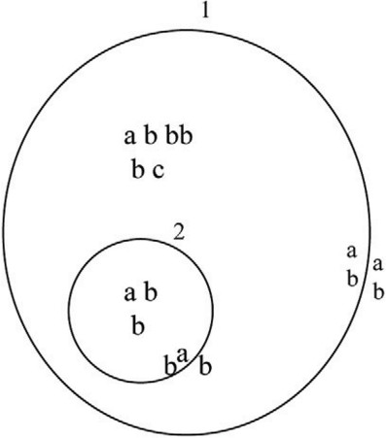

Fig. 1. Graphical representation of the configuration [*abbbbc*[*abb ba*]2 *ab*]1 . It has multiset of floating

*b*

*ab*

molecules, in the regions, and objects (proteins) attached to the topological sides of the membranes.

We consider rules that model the attachment of objects to the sides of the mem- branes ([19]).

*attach* : [ *a u*]*i →* [ *ua*]*i , a*[ *u*]*i →* [ *u*]*i*

*v v v va*

*detach* : [ *ua*]*i →* [*a u*]*i ,* [ *u*]*i →* [ *u*]*i a*

*v v va* *v*

with *a ∈ V* , *u, v ∈ V ∗* and *i ∈ Lab*.

The semantics of the attachment rules (*attach*) is as follows.

For the first case, the rule is *applicable* to the membrane *i* if the membrane is marked by multisets *containing* the multisets *u* and *v* on the appropriate sides, and region *i* contains an object *a*. In the second case, the rule is applicable to membrane *i* if it is marked by multisets containing the multisets *u* and *v*, as before, and is contained in a region (or in the environment) that contains an object *a*. If the rule is applicable we say that the objects defined by *u, v* and *a* can be *assigned* to the rule (so that it may be executed).

In both cases, if a rule is applicable and the objects given in *u, v* and *a* are assigned to the rule, then the rule can be executed (applied) and the object *a* is added to the appropriate marking in the way specified. The objects not involved in the application of a rule are left unchanged in their original positions.

The semantics of the detachment rule (*detach*) is similar, with the difference that the attached object *a* is detached from the specified marking and added to the contents of either the internal or external region.

An example of the application of an attachment rule is shown in Fig. 2.

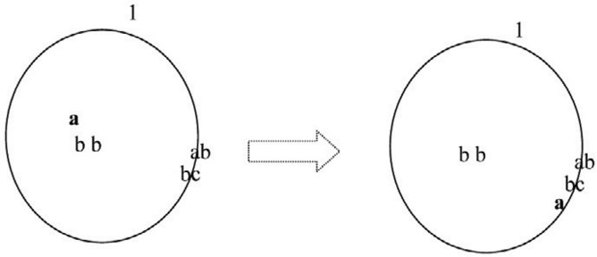

Fig. 2. Graphical representation of the attach rule [*a b*]1 *→* [ *ba*]1 .

As it is biologically relevant, we also consider rules associated to the membranes that control the passage of objects across the membranes (again, from [19]). Precisely:

*cb*

*cb*

*movein* : *a*[ *u*]*i →* [ *a u*]*i*

*v* *v*

*moveout* : [ *a u*]*i → a*[ *u*]*i*

*v* *v*

with *a ∈ V* , *u, v ∈ V ∗* and *i ∈ Lab*.

The semantics of the rules is as follows.

In the first case, the rule is applicable to membrane *i* if it is marked by multisets containing the multisets *u* and *v*, on the appropriate sides, and the membrane is contained in a region containing an object *a*. The objects defined by *u, v* and *a* can thus be assigned to the rule. If the rule is applicable and the objects *a*, *u* and *v* are assigned to the rule then the rule can be executed (applied) and, in this case, the object *a* is removed from the contents of the region surrounding membrane *i* and added to the contents of region *i*.

In the second case, the semantics is similar, but here the object *a* is moved from region *i* to its surrounding region (or environment).

An example of the execution of a movement rule (*moveout*) is shown in Fig. 3.

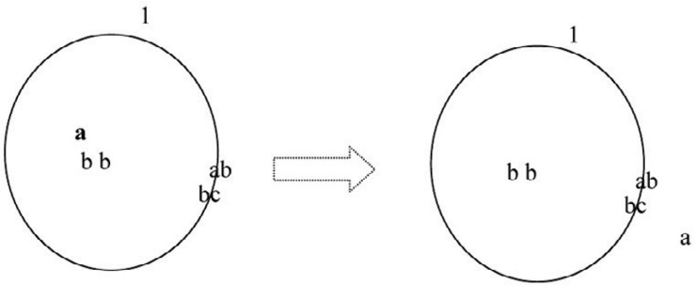

Fig. 3. Graphical representation of the *moveout* rule [*a b*]1 *→ a*[ *b*]1 .

*cb*

*cb*

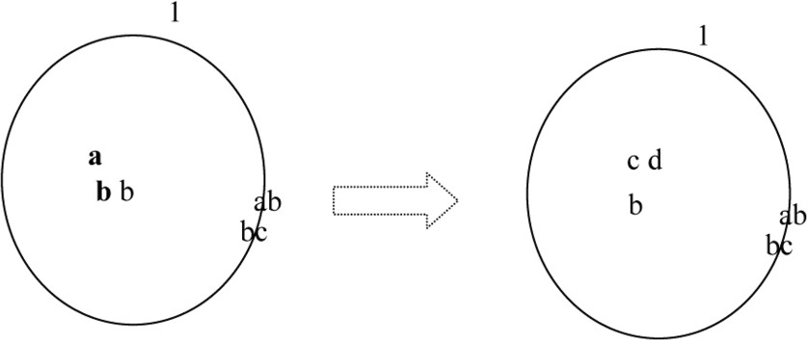

Fig. 4. Graphical representation of the evolution rule [*ab → cd*]1.

The rules of attach, detach, move*in*, move*out* are generally called *membrane rules* (denoted collectively as *memrul*) over the alphabet *V* and the set of labels *Lab*. Sev- eral restrictions have been defined in [19]. In particular, membrane rules for which

*|uv|≥* 2 are called *cooperative* membrane rules (in short, *coomem*). Membrane rules

for which *|uv|* = 1 are called *non-cooperative* membrane rules (in short, *ncoomem*). Membrane rules for which *|uv|* = 0 are called *simple* membrane rules (in short, *simm*).

We also admit *evolution rules* that involve objects but not membranes. These can be considered to model the biochemical reactions that take place inside the compartments of the cell. They are evolution rules over the alphabet *V* and set of labels *Lab* (no indication on the destination of the produced objects is present). We define

*evol* : [*u → v*]*i*

with *u ∈ V* +*,v ∈ V ∗* and *i ∈ Lab*. An evolution rule is called *cooperative* (in short,

*cooe*) if *|u| >* 1, otherwise the rule is called *non-cooperative* (*ncooe*).

The rule is applicable to region *i* if the region *contains* a multiset of free objects that *includes* the multiset *u*. The objects defined by *u* can thus be assigned to the rule.

If the rule is applicable and the objects defined by *u* are assigned to the rule, then the rule can be executed. In this case the objects specified by *u* are subtracted from the contents of region *i* while the objects specified by *v* are added to the contents of the region *i*.

An example of the application of an evolution rule is shown in Fig. 4.

A *membrane system with peripheral proteins* (in short, a *Ppp* system) and *n*

membranes, is then a construct, [19]

Π = (*V, μ,* (*u*1*, v*1)*,...,* (*un, vn*)*, w*1*,..., wn, R, Rm*)

where:

* *V* is a finite, non-empty alphabet of objects (proteins).
* *μ* is a membrane structure with *n ≥* 1 membranes, injectively labelled by 1*,* 2*,..., n*.
  + (*u*1*, v*1)*, ··· ,* (*un, vn*) *∈ V ∗ × V ∗* are the markings associated, at the beginning of any evolution, to the membranes 1*,* 2*, ··· , n*, respectively. They are called *initial markings* of Π; the first element of each pair specifies the internal marking, while the second one specifies the external marking.
  + *w*1*, ··· , wn* specify the multisets of free objects contained in regions 1*,* 2*, ··· , n*, respectively, at the beginning of any evolution and they are called *initial contents* of the regions.
  + *R* is a finite set of evolution rules over *V* and the set of labels *Lab* = *{*1*,..., n}*.
  + *Rm* is a finite set of membrane rules over the alphabet *V* and set of labels *Lab* =

*{*1*,..., n}*.

A *conﬁguration* of Π consists of a membrane structure, the markings of the membranes (internal and external) and the multisets of free objects present inside the regions. In what follows, configurations are denoted by writing the markings as subscripts (internal and external) of the parentheses which identify the membranes. The labels of the membranes are written as superscripts and the contents of the regions as string, e.g.,

[ [ *aa*]4 [*aaa aa*]2 [ *b* ]3 *a* ]1

*ab b bb a*

We suppose a standard labelling: 0 is the label of the *environment* that surrounds the entire system Π; 1 is the label of the *skin* membrane that separates Π from the *environment*.

The *initial conﬁguration* consists of the membrane structure *μ*, the initial mark- ings of the membranes and the initial contents of the regions; the environment is empty at the beginning of the evolution.

We denote by C(Π) the *set of all possible conﬁgurations* of Π.

We assume the existence of a clock which marks the timing of steps (single

*transitions*) for the whole system.

A *transition* from a configuration *C ∈* C(Π) to a new one is obtained by as- signing the objects present in the configuration to the rules of the system and then executing the rules as previously described. One can define several ways of assign- ing the objects to the rules. In [19] and [20] two different ways of assigning the objects have been defined and investigated: free-parallel and maximally-parallel. In the *free parallel mode*, in each region and for each marking, *an arbitrary number* of applicable rules is executed (this mode is also called asynchronous in the P systems area). In the *maximally parallel way*, in each region and for each marking, appli- cable rules chosen in a non-deterministic way are assigned objects, also chosen in a non-deterministic way, such that after the assignment no further rule is applicable using the unassigned objects. These two ways, conceptualize two ways of abstract- ing the application of biochemical reactions. Equivalence with Petri nets, counter machines and decision problems concerning these two classes of systems have been studied in [20]. We only mention here the following results: In the free-parallel case it is decidable whether or not an arbitrary membrane system with peripheral pro- teins can reach an arbitrary configuration or marking; the same problem becomes

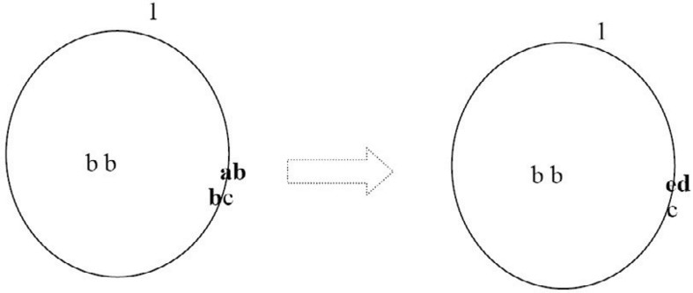

Fig. 5. Graphical representation of the membrane-evolution rule [ *ab*]1 *→* [ *e*]1.

*b d*

undecidable when the systems evolves in the maximally parallel way (the proofs of such results and other intermediate cases can be found in [20]).

It is known that membrane proteins can cluster and form more complex molecules whose activity is very distinct from the original components; moreover proteins can cross sides of a membrane and proteins on opposite sides can influence each other, in a “synchronized” manner. To capture all these aspects we extend the consid- ered paradigm by admitting evolution rules also for the proteins embedded in the membranes.

This can be done in a rather natural manner since membrane proteins are rep- resented as multisets of objects, and then we can still use multiset rewriting rules to represent these membrane processes.

Precisely, we can introduce *membrane-evolution rules* in this form:

*mem − evol* : [ *u*]*i →* [ *u'* ]*i '*

*v* *v*

with *u, v, u', v' ∈ V ∗* and *i ∈ Lab*; if *u* = *λ* or *v* = *λ* then *u'* = *λ* or *v'* = *λ*, respectively.

The rule is applicable to membrane *i* if the internal marking of the membrane

*contains* the multiset of proteins *u* and the external marking contains the multiset

*v*. The proteins defined by *u* and *v* can thus be assigned to the rule. If the rule is applicable and the objects defined by *u* and *v* are assigned to the rule, then the rule can be executed. In this case the objects specified by *u* are subtracted from the internal marking of membrane *i*, the objects specified by *v* are subtracted from the external marking of membrane *i*, while the objects specified by *u'* are added to the internal marking of membrane *i* and the objects specified by *v'* are added to the external marking of membrane *i*. An example of the application of an internal membrane-evolution rule is shown in Fig. 5.

As we will see in the next Section, such extension will be extremely useful to describe cellular processes that involve membrane receptors.

Looking into the details of the proof of Theorem 6.2 in [20], one can see that is easy to extend the result and prove that is possible to decide the reachability of ar- bitrary configurations and markings for membrane systems with peripheral proteins and membrane-evolution rules, when the systems work in a free-parallel manner. In fact, in Theorem 6.2, all floating and attached objects are indexed with the labels

of the membranes in which they float or to which they are attached. Membrane- evolution rules can be then rewritten as cooperative evolution rules acting only on the attached objects.

However, from a computational point of view, it is not clear if the inclusion of membrane-evolution rules lead to higher complexity algorithms. The computational study of membrane systems with peripheral proteins and membrane evolution-rules is not the goal of this paper and is then left as research topic. The proposed membrane evolution rules can also be seen as a generalization of the protein rules used in [22], where only one single protein can be rewritten, on one side of the membrane. Moreover, similar types of rules have been included in the stochastic simulator presented in [21], [17]: in that case the attachment of an object can allow the rewriting of the multiset of embedded proteins. A survey of membrane systems with embedded proteins is [18].

# Cell Cycle and Breast Tumor Growth Control

The paradigm proposed in Section 1, extended with evolution-membrane rules, can be used as specification language for cellular processes. In particular, we use it to describe the cellular control mechanism in response to genotoxic stresses. This mechanism endlessly coordinates the cycling life of cells. The rhythm of their life is beaten by four repetitive phases: Gap 1 (G1), S, Gap 2 (G2), and M (see Fig. 6). G1 is in between mitosis and DNA replication and is responsible for cell growth. The transition occurring at the restriction point (called R) during the G1 phase commits a cell to the proliferative cycle. If the conditions that enforce this transition are not present, the cell exits the cell cycle and enters a non-proliferative phase (called G0) during which cell growth, segregation and apoptosis occur. Replication of DNA takes place during the synthesis phase (called S). It is followed by a second gap phase responsible for cell growth and preparation for division. Mitosis and production of two daughter cells occur in the M phase. Switches from one phase to the next one are critical checkpoints of the basic cyclic mechanism and they are under constant investigation [6], [7].

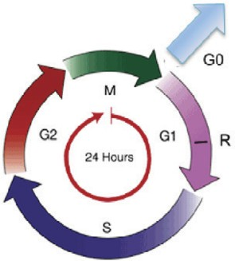

Fig. 6. Phases of the cell cycle.

Passage through these four phases is regulated by a family of *cyclins* 3 that act as regulatory subunits for the *Cyclin-dependent kinases* (Cdk*s*). Cyclins complex activate Cdk*s*, with the aim to promote the next phase transition. Such activation is due to sequential phosphorylations and dephosphorylations 4 of the key residues mostly located on each Cdk complex subunit. Therefore, the activity of the various Cyclin-Cdk complexes results to be controlled by the synthesis of the appropriate cyclins during each specific phase of the cell cycle.

In a previous work [14], the inhibition of Cdk2 5 in response to DNA damage has been identified as a way to interfere with the G1/S transition. Indeed, it has been shown that the elimination of Cdc25A evokes a cell cycle arrest, promotes the repair of the DNA cross-links and protects cells from DNA strand breaks. The response of human cells to phosphorylation of Cdc25A due to ultraviolet light or ionizing radiation leads to an evident decreasing of the Cdc25A activity. The destruction of Cdc25A prevents the entry into S-phase, by maintaining the CyclinE_Cdk2 com- plexes phosphorylated and inactive. Such a degradation takes place within the cytosol and is mediated by the ‘endopeptidase activity’ of 26Sproteosome [10].

In a preceding paper [16], a p53-dependent pathway has been considered as a means to block cell cycle in the G1/S phase. p53 6 is a transcription factor whose role is to induce the transcription of genes that encode proteins involved in apoptosis,

of genes that encode proteins in charge to stop the cell cycle and proteins involved in the DNA repair machinery. In particular, whenever the DNA double strand is broken, p53 is activated by the ATM protein kinase. The oncoprotein Mdm2 7

binds the transcription factor and blocks its activity through a dual mechanism: it conceals the p53 transactivation domain and promotes the p53 degradation after

ubiquitination 8 [9]. ATM activates p53 preventing the Mdm2 binding, so its inhibitory

effect cannot occur. This action allows p53 to shuttle to the nucleus and promote the transcription of different target genes; one of them is a *Cyclin-dependent kinase* *inhibitor* : p21. p21 is in charge to suppress the CyclinE_Cdk2 kinase activity

thereby resulting in G1 arrest.

Instead, G2/M transition is modulated by the CyclinB_Cdk1 activity. We have employed here some of its direct and undirect partners and linked them to create a functional protein network governing the phase transition. In particular, we have extended the corresponding *Reactome* 9 [12] model (written in the Systems Biology

3 Cyclins are a family of proteins involved in the progression of cells through the whole cell cycle. They are so named because their concentrations vary in a cyclical fashion. They are produced or degraded as needed in order to drive the cell through the different phases of its life cycle.

4 In eukaryotes, protein phosphorylation is probably the most important regulatory event. Many enzymes and receptors are switched *on* or *off* by phosphorylation and dephosphorylation. Phosphorylation is cat- alyzed by various specific protein kinases, whereas phosphatases dephosphorylate.

5 Cdk2 is the kinase (complexed with CyclinE) activated by Cdc25A.

6 p53 is a key regulator of cellular responses to genotoxic stresses; for this reason it is named: *the guardian of the genome* [11].

7 Mdm2 is the pivotal negative regulator of p53.

8 Ubiquitin-mediated proteolysis of regulatory proteins controls a variety of biological processes. A protein molecule doomed for destruction is marked with a chain of ubiquitin molecules. Proteins displaying this ubiquitin death tag are promptly destroyed by the proteosome.

9 Reactome is a knowledgebase of biological pathways. It offers significant literature references and pic- torial representations of reactants and reactions. (Part of) the pathway under investigation is available in numerous data formats.

Markup Language, SBML [13]). Moreover, we have translated [15] the pathway in the formalism introduced in Section 1 and simulated in a stochastic manner ([23]). More precisely, we have added to the rules of the system, constants that define their rates of applications (kinetic rates). The evolution of the overall system has been then obtained by using the Gillespie algorithm (we refer the reader to [21] for details). In what follows we survey the obtained results.

* 1. *Cell Cycle Progression Inhibition in G*2*/M*

14-3-3*σ*, also known as *stratiﬁn*, is a p53 inducible gene that inactivates mitotic- Cdk*s* by cytoplasmatic sequestration [2], [1]. Since the accumulation of mitotic-Cdk*s* is required for mitotic entry, the overexpression of 14-3-3*σ* leads to cycle arrest in G2. On the other side, the inhibitory effect of 14-3-3*σ* is usually balanced by the 14-3-3*σ*-Efp 10 binding which results in ubiquination of 14-3-3*σ*, enhanced turnover of 14-3-3*σ* by the proteosome and cycle progression [3], [8]. BRCA1 11 balances the Efp-mediated cycle progression enhancing activity by monitoring the regulatory effects of the estrogen receptor ER*α*. It inhibits the ER*α* signaling cascade and blocks its AF-2 transcriptional activation [5], [3]. Moreover, in presence of wild type p53, BRCA1 induces 14-3-3*σ* (see Fig. 7). Loss of this control may contribute to tumorigenesis.

*Estrogens* are a group of steroid compounds functioning as the primary female sex hormone. They are involved in cell cycle progression and generation/promotion of tumors as *breast, uterus* and *prostate cancers*. Estrogens actions are assumed to be mediated by estrogen receptors which are found in different ratios in the different tissues of the body and which regulate the transcription of some target genes. A certain stimulation of Efp by estrogen has been shown to promote genetic instability.

* + 1. *The Role of Estrogen Receptors*

Receptors are proteins located on the cell membrane or within the cytoplasm or cell nucleus that bind to specific molecules (ligands 12 ) and initiate the cellular responses. Estrogen receptors are intracellular proteins present both on the cell surface membrane and in the cytosol. Those localized within the cytosol have a DNA-binding domain and can function as transcription factors to regulate the production of proteins. Their signaling effects depend on several factors: (i) the structure of the ligand or drug, (ii) the receptor subtype, (iii) the gene regulatory elements, and the (iv) cell-type specific proteins.

10 Efp (estrogen responsive finger protein) gene is predominantly expressed in female reproductive organs (uterus, ovary and mammary glands). It acts as one of the primary estrogen responsive genes in Er*α* and/or Er*β* positive breast tumor and would mediate estrogen functions such as cell proliferation. Efp controls ubiquitin-mediated destruction of a cell cycle inhibition and may regulate a switch from hormone- dependent to hormone-independent growth of breast tumors.

11 BRCA1 belongs to a class of genes known as tumor suppressors. The multifactorial BRCA1 protein product is involved in DNA damage repair, ubiquitination, transcriptional regulation as well as other func- tions. Variations in the gene are implicated in a number of hereditary cancers, namely breast, ovarian and prostate. The majority (70%) of BRCA1-related breast cancers are negative for *ERα*.

12 Ligands introduce changes in the behaviour of the receptor proteins resulting in physiological changes and constituting their biological actions.

There are two different ER proteins produced from ESR1 and ESR2 genes: ER*α*

and ER*β*. ER*s* are widely distributed throughout the human body:

* ER*α*: endometrium, breast cancer cells, ovarian stroma cells and hypothalamus.
* ER*β*: kidney, brain, bone, heart, lungs, intestinal mucosa, prostate and endothelial cells.

ER*s* actions can be selectively enhanced or disabled by some estrogen receptor, *modulators*, in accordance with the binding affinities level of each estrogenic com- pounds. In particular, in many breast cancers, tumor cells grow in response to *estradiol*, the natural hormone that activates both ER*s* [4]. Estradiol (“female” hor- mone, but also present in men) represents the major estrogen in humans. Although estrogen is a well known promoting factor of sporadic breast carcinoma (because the estrogen-ER binding stimulates the proliferation of mammary cells with the result- ing increasing of cell division and DNA replication), its effects on risk modification about hereditary breast cancers are still not clear.

* + 1. *G2/M transition control*

In healthy conditions, DNA damages induce the increase of p53 levels. p53 pro- motes transcription of Cdk inhibitors (e.g. 14-3-3*σ*), which recruit CyclinB-Cdk complexes leading to cell cycle arrest and DNA repair. We have modelled the pro- teolysis of 14-3-3*σ* modulated by Efp. The degradation of 14-3-3*σ* is subsequently followed by the protein dissociation of the CyclinB-Cdk complexes, leading to cell cycle progression and tumor growth. Finally, we have considered the compensative role of BRCA1 in (i) suppressing any estrogen-dependent transcriptional pathway and in (ii) inducing 14-3-3*σ*. To test whether altered checkpoints can modulate sensi- tivity to treatment in vivo, we have constructed a model for this signaling pathway. The corresponding model is reported in Fig. 8.

Whenever a healthy cell divides, its free Cdc2_CyclinB dimers shuttle to the nucleus (*r*6) and induce the G2/M transition (*r*16). During the simulation we have monitored the accumulation of Efp into the nucleus (*r*14) and its migration to the cytoplasm (*r*5) (red dashed line in Fig. 9) caused by the activation of the ER*s* (*r*7*−*8) and the consequent migration into the nucleus (*r*1*−*2*,*4) (yellow bell curve).

Cdc2_CyclinB complexes accumulate into the nucleus (blue bell curve) and pro- mote entry in mitosis (green square caps line). On the other hand (see Fig. 10), when a DNA damage occurs, p53 starts to accumulate (*r*12). p53 and BRCA1 co-

induce 14-3-3*σ* (*r*13) which is free to migrate out to the cytoplasm (*r*3). Here, it sequesters the Cdc2_CyclinB complexes (*r*9) and prevents their shuttling to the

nucleus. Consequently, the cell stops its cycle. Therefore, to allow cell-cycle pro- gression, estrogens stimulate production of Efp (see Fig. 11). This is obtained by

enabling the ER*s* placed on the cell surface (because of the interaction with the es- trogens hormones (*r*7*−*8) and then by moving the receptors into the nucleus (*r*1*−*2*,*4). Here, they can bind DNA and enhance the Efp production (*r*14). BRCA1 balances

this process by disabling the receptors moved into the nucleus and then controlling their Efp induction (*r*17). The level of Efp in Fig. 11 is significantly lower than that

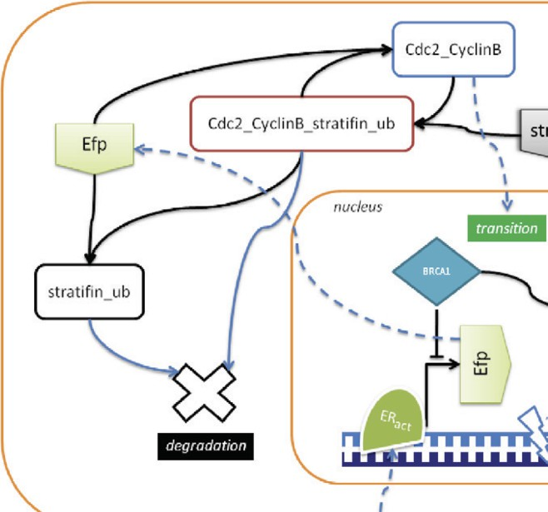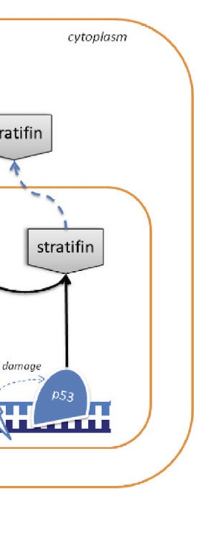

Fig. 7. Cell cycle progression mediated by Efp and BRCA1

in Fig. 9. This is due to the BRCA1 inhibitory control. The resulting Efp is free to shuttle to the cytoplasm (*r*5) and bind 14-3-3*σ* for ubiquination (*r*10). 14-3-3*σ* marked with ubiquitin chains is recognized and destroyed by the proteosome (*r*11). Released Cdc2_CyclinB dimers can then escape into the nucleus (*r*6) and promote mitotic entry (*r*16). Finally, the transition process of Fig. 11 is observed to be slower and less effective than that of the healthy system shown in Fig. 10.

* 1. *Qualitative Aspects of the Simulations*

*Pathways cross-talk* is a fundamental factor that has to be taken into account when modelling biological processes. In fact, very often, chemicals are involved in more than one living function and they are logically and physically implicated in different pathways. In other words, thy are never fully disconnected by each other. There- fore, without an exhaustive knowledge on what happens *around* the processes of interest, any quantitative analysis on isolated pathways results to be unfeasible and unrealistic.

The components of described system are central in many other pathways and, therefore, we have described them only in a “qualitatively” manner. In fact, we have used the same constants for both kinetics rates (except for *rate*(*r*12), that has been set 1000 times greater than the others with the aim to give immediate effect to the damage event within the system) and for the starting population (all the starting chemicals populations are 0 except for those which are in charge to “start” the system). We have then set all the kinetics rates to 1 and the starting

Π= (*O, μ, ws, wc, wn,* (*us, vs*)*,* (*uc, vc*)*,* (*un, vn*)*, Rm, R*), where

*O* = *{damage, p*53*,BRCA*1*, stratif in, estrogen, ER, ER estrogen, ER act, Efp, Cdc*2 *CyclinB, stratifin Cdc*2 *CyclinB, stratifin Cdc*2 *CyclinB ub, T RANSIT ION},*

*μ* = [*s*[*c*[*n*]*n*]*c*]*s*,

*ws* = *estrogen*1000,

*wc* = *Cdc*2 *CyclinB*1000, *wn* = *BRCA*11000,

*us* = *λ, vs* = *λ, uc* = *λ, vc* = *ER*1000*, un* = *λ, vn* = *λ*, *Rm* =

*{*

*c*

*r*1 :[ ]

*ER act*

*→* [*ER act*]*c rate*(*r*1)= 1,

*r*2 : [*ER act*]*c →* [*ER act*]*c rate*(*r*2)= 1,

*r*3 : [*stratif in*]*n →* [ ]*n stratifin rate*(*r*3)= 1,

*r*4 :[ ]*n ERact →* [*ERact*]*n rate*(*r*4)= 1,

*r*5 : [*Ef p*]*n →* [ ]*n Efp rate*(*r*5)= 1,

*r*6 :[ ]*n Cdc*2 *CyclinB →* [*Cdc*2 *CyclinB*]*n rate*(*r*6)=1

*}*

*R* =

*{*

*r*7 :[ ]*c* + *estrogen →* [ ]*c*

*ER*

*ER estrogen*

*r*8 :[ ]*c →* [ ]*c*

*rate*(*r*7)= 1*,*

*rate*(*r*8)= 1*,*

*ER estrogen ER act*

*r*9 : [*stratif in* + *Cdc*2 *CyclinB → stratifin Cdc*2 *CyclinB*]*c rate*(*r*9)= 1*, r*10 : [*Ef p* + *stratifin Cdc*2 *CyclinB → stratifin Cdc*2 *CyclinB ub*]*c rate*(*r*10)= 1*, r*11 : [*stratif in Cdc*2 *CyclinB ub → Cdc*2 *CyclinB*]*c rate*(*r*11)= 1*,*

*r*12 : [*damage → p*53]*n rate*(*r*12) = 1000*,*

*r*13 : [*p*53 + *BRCA*1 *→ stratifin*]*n rate*(*r*13)= 1*,*

*r*14 : [*ER act → Efp*]*n rate*(*r*14)= 1*,*

*r*15 : [*ER act → λ*]*n rate*(*r*15)= 1*,*

*r*16 : [*Cdc*2 *CyclinB → T RANSITION* ]*n rate*(*r*16)= 1*,*

*r*17 : [*damage* + *BRCA*1+ *ERact → BRCA*1+ *ER* + *damage*]*n rate*(*r*17)=1

*}*

Fig. 8. G2/M transition control. The system is written as described in Section 1. To be closer to bio- chemistry we use the symbol + for the rules, instead of just concatenating the symbols (as usually done in the P systems area and in Section 1). For instance, an evolution rule [*u*1*u*2 *→ v*1*v*2]1 is written as [*u*1 + *u*2 *→ v*1 + *v*2]1 . Kinetic rates are added to the rules.

populations of the pathway upstream chemicals to 1000.

The carried out simulations reflect real biological circumstances and respect, qualitatively, the behaviours presented in the corresponding literature.

# Concluding Remarks

Membrane systems with peripheral proteins can specify cellular processes where the role of cellular receptors is important. We have presented an example by studying the pathways underlying cell cycle and breast tumor growth. In such a case protein binding to membrane receptors is a fundamental activity accomplished by cells to trigger the responses to extracellular or endogenous stresses. Membrane systems with peripheral proteins, working in the free-parallel manner, have been shown to be equivalent to Petri nets (see [20]). Such results should be extended to the

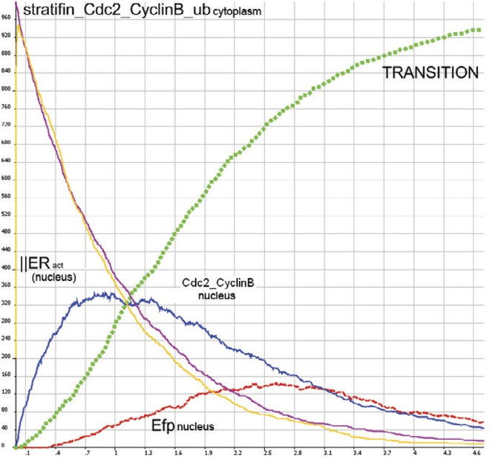

Fig. 9. Healthy G2/M phase transition.

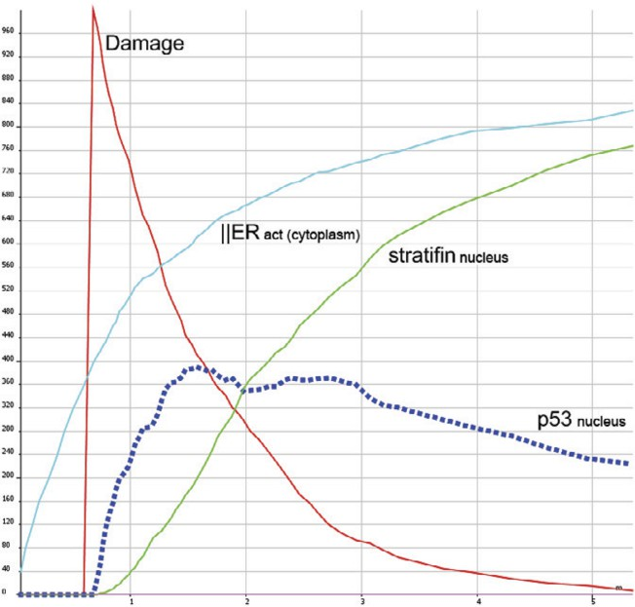

Fig. 10. Stratifin induction by p53 accumulation and ER*s* activation and migration into the cytoplasm in response to stress.

model with the introduction of membrane-evolution rules, introduced in Section

1. Moreover, the stochastic variant of the model should also be investigated, and, possibly, in view of the results in [20] equivalence with stochastic Petri nets could be found.

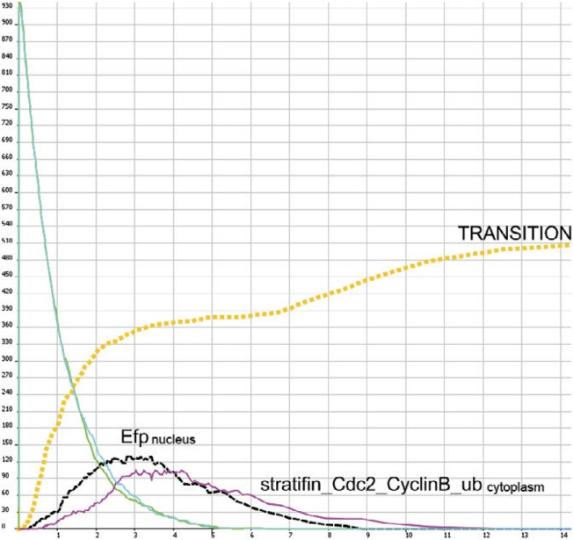

# References

Fig. 11. G2/M phase transition in response to stress.

1. A. Benzinger, N. Muster, H. B. Koch, J. R. Yates, H. Hermeking, *Targeted proteomic analysis of 14-3-3* *sigma, a p53 effector commonly silenced in cancer*. Mol. Cell. Proteomics, **4(6)** (2005), 785–95.
2. H.-Y. Yang, Y.-Y. Wen, C.-H. Chen, G. Lozano, M.-H. Lee, *14-3-3sigma positively regulates p53 and* *suppresses tumor growth.* Mol. Cell. Biol., **23(20)** (2003), 7096–7107.
3. K. Ikeda, A. Orimo, Y. Higashi, M. Muramatsu, S. Inoue, *Efp as a primary estrogen-responsive gene* *in human breast cancer.* FEBS Lett., **472(1)** (2000), 9–13.
4. D. Zivadinovic, B. Gametchu, C.S. Watson, *Membrane estrogen receptor-alpha levels in MCF-7 breast* *cancer cells predict cAMP and proliferation responses.* Breast Cancer Res., **7(1)** (2005), R101–12.
5. T. Ouchi, A. N. A. Monteiro, A. August, S. A. Aaronson, H. Hanafusa, *BRCA1 regulates p53-dependent* *gene expression.* Proc. Natl. Acad. Sci. USA, **95(5)** (1998), 2302–2306.
6. R. E. Shackelford, W. K. Kaufmann, R. S. Paules, *Cell cycle control, checkpoint mechanisms, and* *genotoxic stress.* Environ. Health Perspect. Suppl., **107(S1)** (1999), 5–24.
7. B. Nov´ak, J. C. Sible, T. T. Tyson, *Checkpoints in the cell cycle.* in Encyclopedia of Life Sciences, London, Nature Publishing Group (2002), 1–8.
8. T. Urano, T. Saito, T. Tsukui, M. Fujita, T. Hosoi, M. Muramatsu, Y. Ouchi, S. Inoue, *Efp targets 14-3-3 sigma for proteolysis and promotes breast tumour growth.* Nature, **417(6891)** (2002), 871–875.
9. Y. Haupt, R. Maya, A. Kazaz, M. Oren, *Mdm2 promotes the rapid degradation of p53.* Nature, **387**

(1997), 296–299.

1. N. Mailand, J. Falck, C. Lukas, R.G. Syljuasen, M. Welcker, J. Bartek, and J. Lukas, *Rapid destruction of human cdc25a in response to dna damage.* Science **288(5470)** (2000), 1425–1429.
2. D. P. Lane, *p53, guardian of the genome.* Nature, **358(6381)** (1992), 15–16.
3. I. Vastrik, P. D’Eustachio, E. Schmidt, G. Joshi-Tope, G. Gopinath, D. Croft, B. de Bono, M. Gillespie,

B. Jassal, S. Lewis, L. Matthews, G. Wu, E. Birney, L. Stein, *Reactome: a knowledge base of biologic pathways and processes.* Genome Biology, **8(3)** (2007), R39.

1. M. Hucka, A. Finney, et al, *The Systems Biology Markup Language (SBML): a medium for representation and exchange of biochemical network models.* Bioinformatics, **5(19)** (2003), 524–531.
2. G. Franco, P.H. Guzzi, T. Mazza, V. Manca, *Mitotic oscillators as MP graphs.* in Proceedings of the seventh Workshop on Membrane Computing (WMC7), LNCS, **4361** (2006), 382–394.
3. T. Mazza, *Towards a complete covering of SBML functionalities.* in Proceedings of the eight Workshop on Membrane Computing (WMC8), LNCS, **4860** (2007), 425–444.
4. T. Mazza, A. Nocera, *A formal lightweight view of the p53-dependent G1/S checkpoint control.* in Proceedings of Prague International Workshop on Membrane Computing (2008), 35–46.
5. S. Sedwards, T. Mazza, *Cyto-Sim: a formal language model and stochastic simulator of membrane- enclosed biochemical processes.* Bioinformatics, **20(23)** (2007), 2800–2802.
6. M. Cavaliere, S.N. Krishna, Gh. P˘aun, A. P˘aun, *P systems with objects on membranes.* In *The Handbook of Membrane Computing*, Oxford University Press, to appear.
7. M. Cavaliere, S. Sedwards, *Membrane systems with peripheral proteins: transport and evolution*, CoSBi Technical Report **04/2006**, [www.cosbi.eu,](http://www.cosbi.eu/) and Electronic Notes in Theoretical Computer Science, ENTCS, **171(2)** (2007), 37–53.
8. M. Cavaliere, S. Sedwards, *Decision problems in membrane systems with peripheral proteins, transport and evolution*, CoSBi Technical Report **12/2006**, [www.cosbi.eu,](http://www.cosbi.eu/) and Theoretical Computer Science, to appear.
9. M. Cavaliere, S. Sedwards, *Modelling cellular processes using membrane systems with peripheral and integral proteins*, Computational Methods in Systems Biology, Intern. Conference, Trento (2006), LNCS

- LNBI **4210**, Springer (2006), 108–126.

1. A. P˘aun, B. Popa, *P systems with proteins on membranes*, Fundamentae Informaticae, **72(4)** (2006), 467–483.
2. Cyto-Sim is available at <http://www.cosbi.eu/>