

Electronic Notes in Theoretical Computer Science

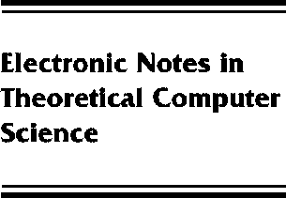[www.elsevier.com/locate/entcs](http://www.elsevier.com/locate/entcs)

Classifying Classification

Rainer Osswald

**Abstract**

Different types of linguistic classification, ranging from simple inheritance hierarchies to systemic networks, are classified algebraically and order-theoretically.To this end, classifications are refor- mulated as observational theories. Classifications that do not involve disjunction correspond to Horn theories, whose generic universe ordered by specialization is known to be a Scott domain. Several subtypes of Horn theories, corresponding to simple inheritance with exclusions, are clas- sified with respect to their domains. Systemic classification is shown to have a flat domain. In particular, every finite systemic classification can be translated into a Horn theory. The infinite case turns out to be more subtle since non-equivalent observational theories may induce isomorphic specialization orders.

1571-0661 *⃝*c 2013 Published by Elsevier Ltd. Open access under [CC BY-NC-ND license.](http://creativecommons.org/licenses/by-nc-nd/3.0/)

10.1016/S1571-0661(05)82587-3