[Egyptian Journal of Basic and Applied Sciences 5 (2018) 197–203](https://doi.org/10.1016/j.ejbas.2018.05.010)

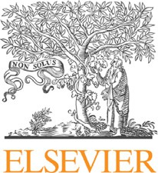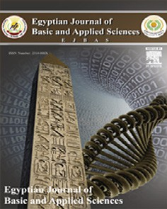

Contents lists available at [ScienceDirect](http://www.sciencedirect.com/science/journal/2314808X)

Egyptian Journal of Basic and Applied Sciences

journal homepage: [www.elsevier.com/locate/ejbas](http://www.elsevier.com/locate/ejbas)

Full Length Article

[](http://crossmark.crossref.org/dialog/?doi=10.1016/j.ejbas.2018.05.010&domain=pdf)Column chromatography and HPLC analysis of phenolic compounds in the fractions of *Salvinia molesta* mitchell

T.G. Gini ⇑, G. Jeya Jothi

*Department of Plant Biology and Biotechnology, Loyola College (University of Madras), Sterling Road, Nungambakkam, Chennai 600034, Tamil Nadu, India*

# a r t i c l e i n f o

*Article history:*

Received 7 January 2018

Received in revised form 16 May 2018 Accepted 30 May 2018

Available online 9 June 2018

*Keywords:*

*Salvinia molesta* Antioxidants Phenolic compounds

Column chromatography Fractionation

Free radicals

# a b s t r a c t

*Salvinia molesta*, commonly known as giant *Salvinia*, is a floating fern belonging to the family of Salviniaceae. In this study the active fractions of the fern extract were separated using column chro- matography and phenolic compounds present in the active fractions were determined by RP-HPLC. Ethyl acetate extract was found to possess significant pharmacological activity when compared to other extracts under study and therefore an attempt was made to fractionate ethyl acetate extract. The analysis was performed through two different mobile phases involving solvent A (acetonitrile) and solvent B (0.1% phosphoric acid in water) and solvent A (methanol) and Solvent B (4% acetic acid). HPLC analysis indi- cated the presence of phenolic compounds namely ascorbic acid, quercetin, gallic acid, resorcinol, cate- chol, vanillin and benzoic acid with specific retention times. The detected compounds possess antioxidant and antitumour activities. The results of the present study suggests the possibility to use

*S. molesta* as a source for a plausible antioxidant agent which could be isolated and used as a lead candi- date for the development of antioxidant drugs that help stop or limit damage caused by free radicals and to counteract oxidative stress leading to the prevention of a variety of chronic and degenerative diseases.

© 2018 Mansoura University. Production and hosting by Elsevier B.V. This is an open access article under

the CC BY-NC-ND license (<http://creativecommons.org/licenses/by-nc-nd/4.0/>).

1. Introduction

The phenolic compounds are ubiquitous in plant kingdom. They synthesize several thousand different chemical structures and are characterized by hydroxylated aromatic rings. These compounds are secondary metabolites which are derived from the pentose phosphate, shikimate and phenylpropanoid pathways in plants [1]. These are one of the most widely occurring groups of pyto- chemicals which are of appreciable physiological and morphologi- cal importance in plants [2]. A number of studies have been aimed to characterize the health promoting activities of phenolic com- pounds due to their antioxidant properties. They are useful in treatment and management of cancer, cardiovascular and neurodegenerative diseases or as components in anti-aging or cos- metic products [3].

The antioxidant activity of phenolic compounds are mainly due to their redox potential which empower them to function as reduc- ing agents, donors of hydrogen atoms or electrons, singlet oxygen quenchers or metal chelators [4–6]. Phenolic compounds exhibit a wide range of physiological properties such as anti-allergic, anti-microbial, anti-thrombotic, anti-inflammatory, anti-arthritic,

* Corresponding author.

*E-mail address:* [ginigeorgehc@gmail.com](mailto:ginigeorgehc@gmail.com) (T.G. Gini).

antipyretic, analgesic, antioxidant, cardio-protective, immunomodulatory and vasodilatory effects [7–11]. These activities of phenolic-flavonoidic compounds may be due to the presence of gallic acid, ellagic acid, ascorbic acid, quercetin, tannic acid, vanillin, resorcinol, catechin etc. [12–14].

Modern studies have shown that ferns possess biological properties such as anti-microbial, antioxidant, anti-proliferative, anti-inflammatory, antitussive, antitumor, anti-HIV, enzyme mod- ulation and stimulation, hormonal action, interference of DNA replication and physiological action [15,16]. Iqbal Choudhary et al. [17] have isolated phenolic compounds together with few other phytoconstituents for the first time from the aquatic fern *S. molesta*. The isolated compounds were two glycosides, 60 -O-(3,4- dihydroxy benzoyl)-b-D-glucopyranosyl ester and 4-O-b-D- glucopyranoside-3-hydroxy methyl benzoate, along with five already known compounds viz., methyl benzoate, hypogallic acid, caffeic acid, paeoniflorin and pikuroside. They exhibited potent free radical scavenging activity in a non-physiological assay. These compounds possess interesting characteristics, noteworthy of further study.

Basing on these data the aim of the present study was to frac- tionate ethyl acetate extract of *S. molesta* using column chromatog- raphy and to quantify the phenolic compounds present in the fractions by RP-HPLC with photo diode array detection (PDA). This

<https://doi.org/10.1016/j.ejbas.2018.05.010>

2314-808X/© 2018 Mansoura University. Production and hosting by Elsevier B.V.

This is an open access article under the CC BY-NC-ND license (<http://creativecommons.org/licenses/by-nc-nd/4.0/>).

study was the first to quantify seven antioxidant phenolic com- pounds in the fern extract applying two different mobile phases.

1. Materials and methods
   1. *Chemicals and phenolic standards*

Hexane, ethyl acetate, ethanol, methanol, acetone, vanillin-H2SO4 spray, acetonitrile, phosphoric acid, acetic acid, chromanorm water, gallic acid, catechol, benzoic acid, resorcinol, ascorbic acid, vanillin, quercetin, silica gel and sea sand. All the above chemicals were of analytical grade and were purchased from Hi media, Pvt. Ltd., Mumbai, India.

* 1. *Plant materials*

Plants of *S. molesta* were collected from the paddy fields, rivers and ponds of Kalliyad and Kaiyamkulam, Kaithachira, Thrissur, Kerala, India. The specimen was identified and authenticated by Dr. G. Jeya Jothi, Taxonomist, Loyola College, Chennai, Tamil Nadu, India. The voucher specimen (No: LCH-130) of the plant has been preserved in Loyola College Herbarium for further reference. The plant materials were cleansed under running tap water three to four times, after which it was shade dried at room temperature for three weeks. The dried plant materials were pulverized into fine powder, passed through a sieve (mesh No. 40) and were stored in airtight containers [18].

* 1. *Preparation of plant extracts*

The extraction from the plant materials was performed by maceration. Four different solvents namely hexane, ethyl acetate, ethanol and methanol were used for the sequential extraction starting from low polarity to high polarity. 50 g of the powdered plant materials were soaked in 200 ml of hexane in a stoppered container and was placed on the orbital shaker at 120 rpm for 72 h at room temp. The mixture was then pressed and filtered through Whatman No.1 filter paper and was concentrated under reduced pressure using a rotary evaporator. The same procedure was followed for the other three solvents. The extraction process was carried out in triplicates with each solvent. The dried crude

extracts were stored in amber vials and were placed in a refriger- ator at 4 °C [18,19].

* 1. *Column chromatographic fractionation of ethyl acetate extract*

The ethyl acetate extract (EAE) was subjected to Silica gel col- umn chromatography for the isolation of phytoconstituents. A ver- tical glass column (40 mm width × 60 mm length) made of borosilicate material was used for the fractionation. The column was rinsed well with acetone and was completely dried before packing. A piece of glass wool was placed at the bottom of the col- umn with the help of a glass rod. Sea sand (50–70 particle size) was added to the top of the glass wool to 1 cm height. The sand parti-

was maintained to prevent drying of the column. Gradient elution method was followed to separate fractions from EAE by using sol- vents from low polarity to high polarity (i.e. hexane to methanol) in varying ratios. The flow rate was adjusted to 5 ml/min and 40 ml solvent was collected for each fraction.

* + 1. *TLC of fractions*

The fractions were collected separately and subjected to TLC (20 × 20 cm aluminium sheets coated with silica gel 60 F254) to detect the presence of phytocompounds. The TLC plates were sprayed with vanillin-con. H2SO4 spray (15 g of vanillin in 250 ml of ethanol + 2.5 ml of con. H2SO4) and dried at 100 °C in hot air oven for 20–30 min. The Rf value of each spot was calculated.

Fractions with the same Rf values were pooled and concentrated to dryness using rotary evaporator. The dry weight of the fractions was measured. The condensed fractions and EAE were further ana- lyzed by HPLC for the presence of antioxidant phenolic compounds.

* 1. *HPLC analyses of fractions and EAE*

HPLC profiles of EAE and isolated fractions of *S. molesta* were determined by two methods using two different mobile phases selected on the basis of varying gradations of solvent systems in specific retention times and elute detections [20]. Analysis of all samples was performed using Shimadzu LC-10 AT VP, Luna 5u C18 reverse-phase analytical column (250 × 4.6 mm) with binary gradient mode, SPD-M10A VP photo diode array detector (PDA), injection volume 20 ml, total flow 1 ml/min, column oven temper-

ature 25 °C and detection wavelength 280 nm. 55 mg of EAE and

each fraction were dissolved in 3 ml of methanol for the analysis. The solvents used for the mobile phases were previously filtered through millipore and degassed prior to use. Quercetin, ascorbic acid, benzoic acid, gallic acid, vanillin, resorcinol and catechol were used as standard solutions for the quantification of phenolic compounds.

* + 1. *Method A*

HPLC analyses of ascorbic acid, benzoic acid, gallic acid, vanillin, resorcinol and catechol were performed by Method A. Gradient elution of two solvents was used for the quantification of ascorbic acid, benzoic acid, gallic acid, vanillin, resorcinol and catechol: Sol- vent A (acetonitrile) and solvent B (0.1% phosphoric acid in water) [21]. Gradient elution program was begun with 92% of solvent B and was held at this concentration for 0–35 min. This was followed by 78% of solvent B for the next 35–45 min. Total run time was 45 min.

* + 1. *Method B*

HPLC analysis of quercetin was performed by Method B. Gradient elution of two solvents was used for the quantification

Table 1

Experimental yield of *S. molesta* fractions.

cles were rinsed down using the solvent. Hexane was poured into the column up to 3/4th level by closing the stopcock. 200 g of silica gel (60–120 mesh size) was used as the packing material. Silica

Number of elutes (aliquots of 40 ml each)

Solvent system Name of Fractions

Yield of Fractions (g)

slurry was prepared with hexane and was poured from the top of the column approximately 2/3rd of the column with simultaneous draining of the solvent to aid proper packing of the column. Sea sand was added to the top of silica slurry to 1 cm height and the sand particles were rinsed down with the solvent. 20 g of EAE was mixed with minimum quantity of hexane and was poured down from the top of the column along the sides and was rinsed down with the solvent. Sea sand was added to the top of the extract to 1 cm height. Solvent level 6 cm from above the extract

1–164 H: EA (100:0 and

90:10)

165–375 H: EA (80:20, 70:30

and 60:40)

376–531 H: EA (50:50, 40:60

and 30:70)

532–583 H: EA (20:80, 10:90

and 0:100)

584–650 EA: MEOH (100:0,

90:10 and 80:20)

Fraction A 6.06

Fraction B 1.24

Fraction C 2.22

Fraction D 2.03

Fraction E 3.62

Table 2

Retention times of phenolic compounds present in EAE and Fraction A of *S. molesta*.

*Salvinia molesta* ethyl acetate extract *Salvinia molesta* Fraction A

|  |  |  |  |  |  |  |  |  |  |  |  |  |
| --- | --- | --- | --- | --- | --- | --- | --- | --- | --- | --- | --- | --- |
|  | Phenolic compounds | Retention time | Area | Height | Concentration |  | Phenolic compounds | Retention time | Area | Height | Concentration |  |
|  | Ascorbic acid | 2.875 | 52,900 | 16,881 | 84.446 |  | Ascorbic acid | 2.909 | 29,381 | 10,031 | 46.901 |  |
|  | Gallic acid | 6.097 | 3353 | 227 | 0.534 |  | Gallic acid | – | – | – | – |  |
|  | Resorcinol | 12.850 | 1638 | 154 | 0.625 |  | Resorcinol | – | – | – | – |  |
|  | Catechol | 16.200 | 559,222 | 26,580 | 24.276 |  | Catechol | 15.966 | 18,129 | 869 | 0.787 |  |
|  | Vanillin | 28.254 | 294,220 | 14,324 | 22.544 |  | Vanillin | 28.116 | 198,708 | 9586 | 15.225 |  |
|  | Benzoic acid | 39.809 | 517,865 | 19,835 | 348.303 |  | Benzoic acid | 40.074 | 302,338 | 7069 | 203.345 |  |
|  | Quercetin | 13.694 | 60,048 | 9719 | 5.526 |  | Quercetin | 14.004 | 60,473 | 13,269 | 5566 |  |

Table 3

Retention times of phenolic compounds present in Fractions B and C of *S. molesta*.

|  |  |  |  |  |  |  |  |  |  |  |  |  |
| --- | --- | --- | --- | --- | --- | --- | --- | --- | --- | --- | --- | --- |
|  | *Salvinia molesta* Fraction | B |  |  |  |  | *Salvinia molesta* Fraction | C |  | | | |
| Phenolic compounds | Retention time | Area | Height | Concentration |  | Phenolic compounds | Retention time | Area | Height | Concentration |  |
|  | Ascorbic acid | 2.879 | 42,561 | 12,368 | 67.941 |  | Ascorbic acid | 2.888 | 30,576 | 10,512 | 48.810 |  |
|  | Gallic acid | 5.977 | 7289 | 516 | 1.162 |  | Gallic acid | 5.795 | 1518 | 159 | 0.242 |  |
|  | Resorcinol | 12.629 | 2841 | 175 | 1.083 |  | Resorcinol | 12.746 | 3074 | 197 | 1.172 |  |
|  | Catechol | 15.849 | 78,369 | 3542 | 3.402 |  | Catechol | 15.428 | 488,423 | 23,863 | 21.202 |  |
|  | Vanillin | 27.853 | 1,838,376 | 87,042 | 140.860 |  | Vanillin | 28.104 | 192,995 | 10,775 | 14.788 |  |
|  | Benzoic acid | 40.710 | 58,049 | 2684 | 39.042 |  | Benzoic acid | – | – | – | – |  |
|  | Quercetin | 13.859 | 72,028 | 10,079 | 6.629 |  | Quercetin | 13.714 | 621,928 | 82,695 | 57.238 |  |

Table 4

Retention times of phenolic compounds present in Fractions D and E of *S. molesta*.

|  |  |  |  |  |  |  |  |  |  |  |
| --- | --- | --- | --- | --- | --- | --- | --- | --- | --- | --- |
|  | *Salvinia molesta* Fraction D |  |  |  |  | *Salvinia molesta* Fraction E |  | | | |
| Phenolic compounds Retention time | Area | Height | Concentration |  | Phenolic compounds Retention time | Area | Height | Concentration |  |
|  | Ascorbic acid 2.862 | 30,467 | 10,426 | 48.634 |  | Ascorbic acid 2.868 | 67,443 | 22,903 | 107.661 |  |
|  | Gallic acid – | – | – | – |  | Gallic acid 5.994 | 15,293 | 1254 | 2.437 |  |
|  | Resorcinol 12.469 | 55,965 | 2147 | 21.343 |  | Resorcinol 12.585 | 6887 | 579 | 2.627 |  |
|  | Catechol 15.732 | 2,048,513 | 104,860 | 88.926 |  | Catechol 15.849 | 888,986 | 46,236 | 38.591 |  |
|  | Vanillin 28.579 | 302,747 | 16,275 | 23.197 |  | Vanillin 28.782 | 84,590 | 4880 | 6.481 |  |
|  | Benzoic acid 39.918 | 8956 | 650 | 6.024 |  | Benzoic acid 40.557 | 12,752 | 1113 | 8.577 |  |
|  | Quercetin 13.958 | 90,999 | 12,975 | 8.375 |  | Quercetin 13.656 | 128,313 | 28,609 | 11.809 |  |

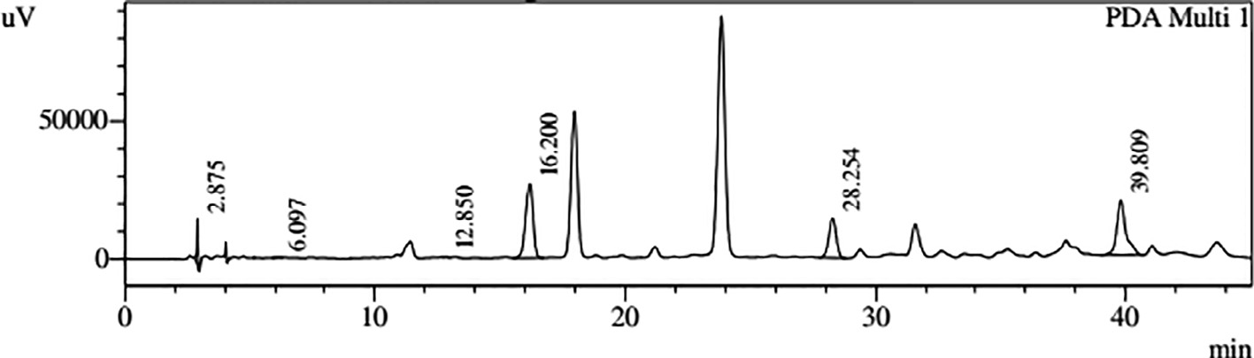

Fig. 1. HPLC profiles of phenolic compounds present in EAE of *S. molesta*.

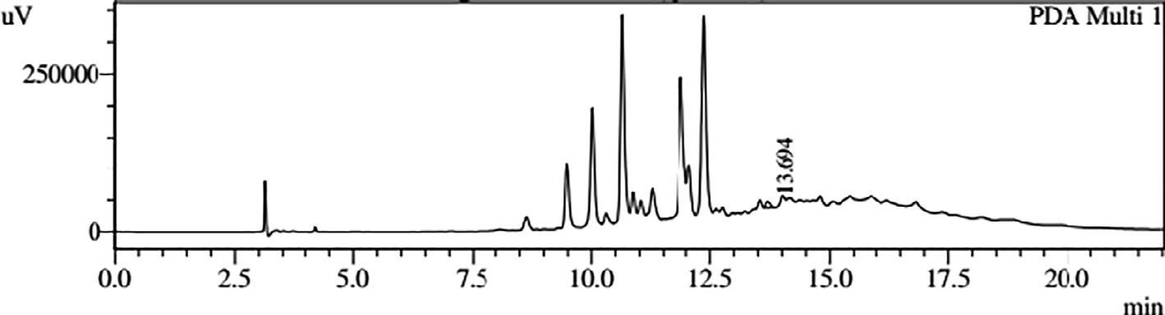

Fig. 2. HPLC profile of quercetin present in EAE of *S. molesta*.

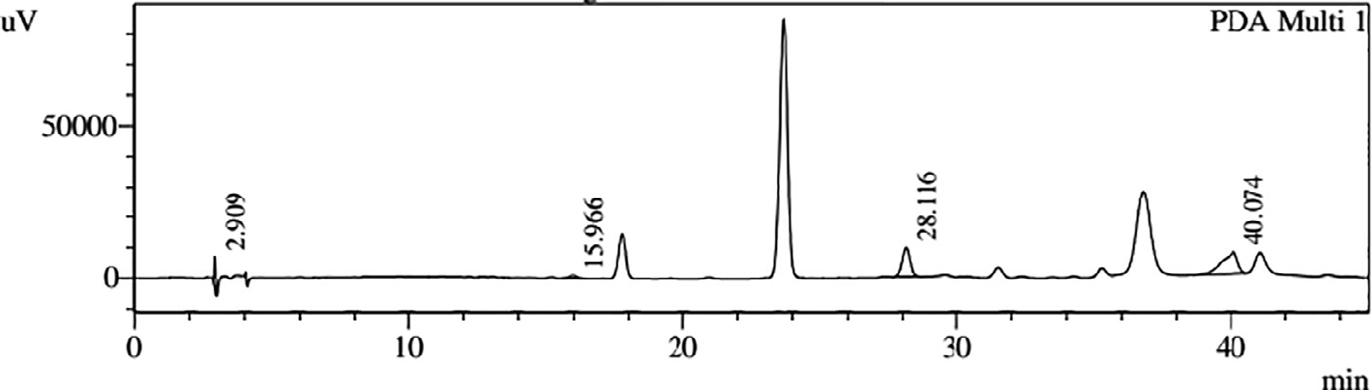

Fig. 3. HPLC profiles of phenolic compounds present in Fraction A of *S. molesta*.

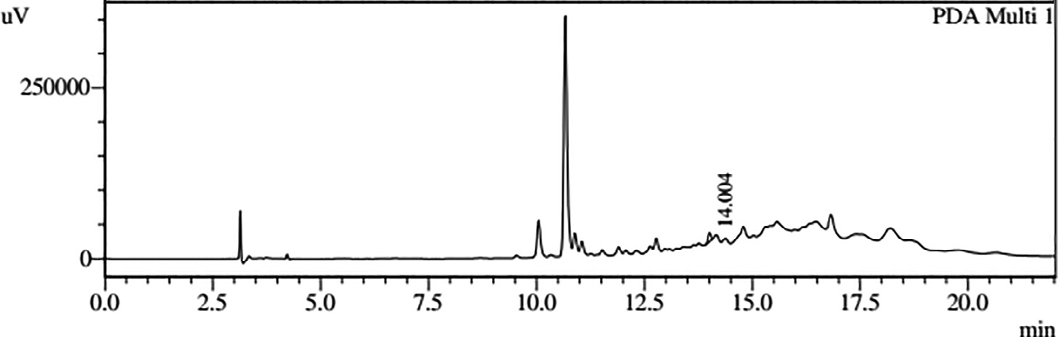

Fig. 4. HPLC profile of quercetin present in Fraction A of *S. molesta*.

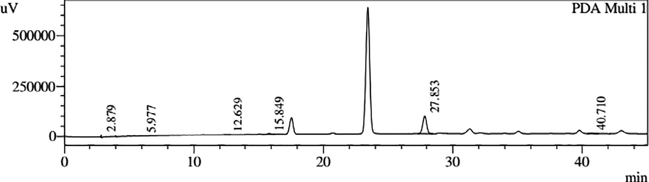

Fig. 5. HPLC profiles of phenolic compounds present in Fraction B of *S. molesta*.

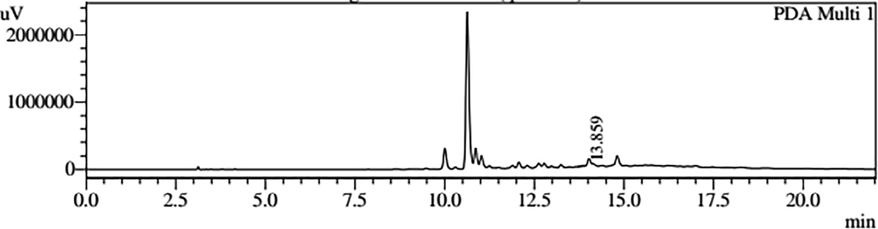

Fig. 6. HPLC profile of quercetin present in Fraction B of *S. molesta*.

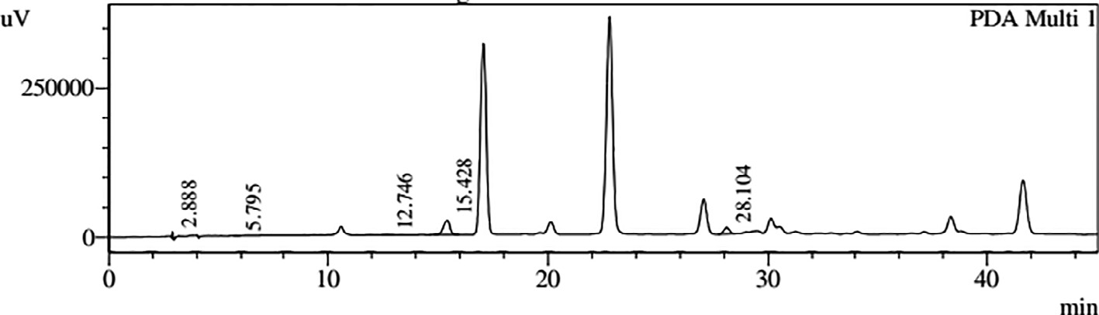

Fig. 7. HPLC profiles of phenolic compounds present in Fraction C of *S. molesta*.

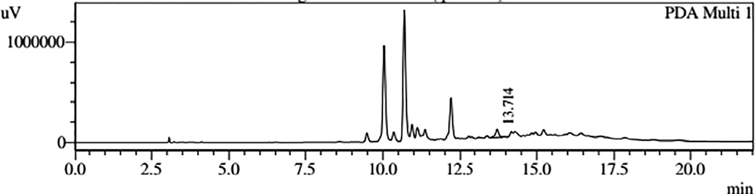

Fig. 8. HPLC profile of quercetin present in Fraction C of *S. molesta*.

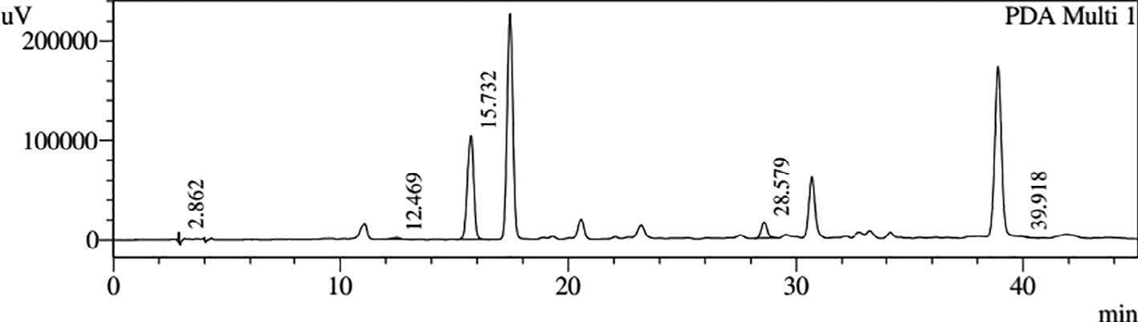

Fig. 9. HPLC profiles of phenolic compounds present in Fraction D of *S. molesta*.

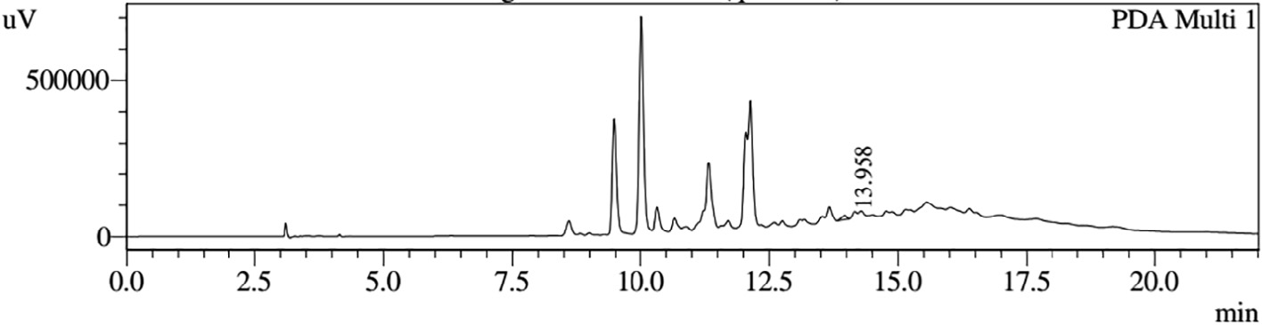

Fig. 10. HPLC profile of quercetin present in Fraction D of *S. molesta*.

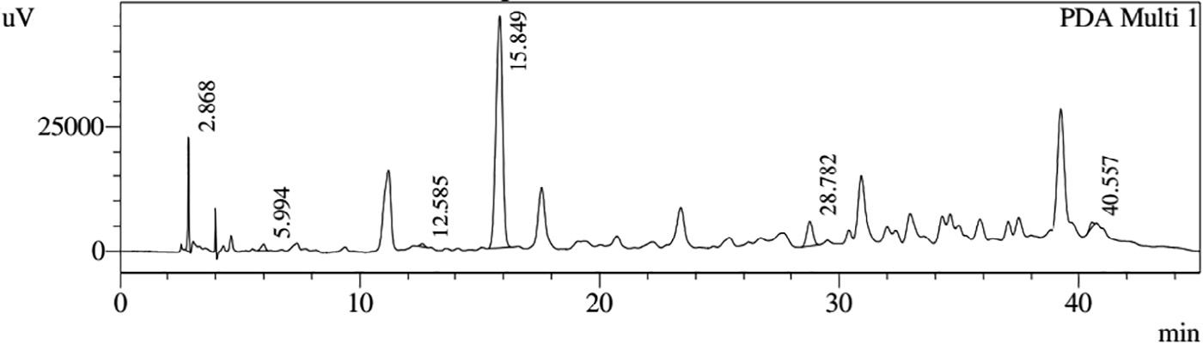

Fig. 11. HPLC profiles of phenolic compounds present in Fraction E of *S. molesta*.

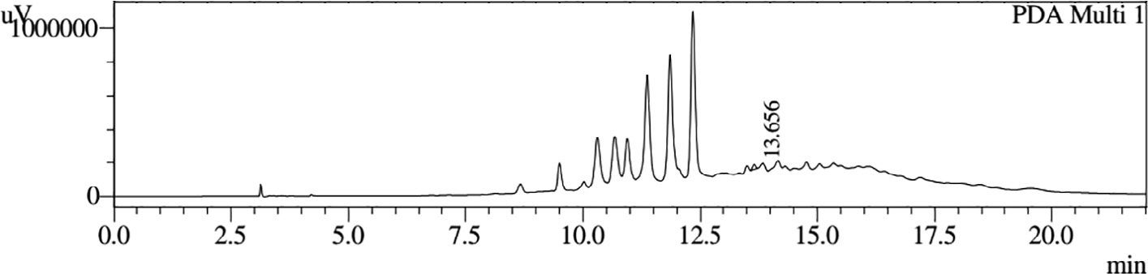

Fig. 12. HPLC profile of quercetin present in Fraction E of *S. molesta*.

of quercetin: Solvent A (methanol) and Solvent B (4% acetic acid) [22]. Gradient elution program was begun with 100% of solvent B and was held at this concentration for 0–4 min. This was followed

by 50% of solvent B for 4–10 min and then reduced to 20% of sol- vent B for the next 10–20 min and then increased to 50% of solvent B for the next 20–22 min. Total run time was 22 min.

1. Results

The fractions obtained from silica gel column chromatography of *S. molesta* EAE were tested for the detection of various phyto- compounds using TLC and sprayed with vanillin-con. H2SO4 spray and dried at 100 °C in hot air oven for 20–30 min. The phytocom- pounds showing the same Rf values were pooled into a single frac- tion. The total number of active fractions obtained after pooling

were as follows: The elutes 1–164 aliquots of 40 ml each in solvent systems H:EA (100:0 and 90:10) formed Fraction A; the elutes 165–375 aliquots of 40 ml each in solvent systems H:EA (80:20, 70:30 and 60:40) formed Fraction B; the elutes 376–531 aliquots of 40 ml each in solvent systems H:EA (50:50, 40:60 and 30:70) formed Fraction C; the elutes 532–583 aliquots of 40 ml each in solvent systems H:EA (20:80, 10:90 and 0:100) formed Fraction D and the elutes 584–650 aliquots of 40 ml each in solvent systems EA:MEOH (100:0, 90:10 and 80:20) formed Fraction E. The yields of the fractions obtained are shown in Table 1.

HPLC profiles of *S. molesta* fractions and EAE were analyzed for seven phenolic compounds viz., ascorbic acid, quercetin, gallic acid, resorcinol, catechol, vanillin and benzoic acid. Phenolic compounds present in each fraction and EAE are shown in Tables 2, 3 and 4 with peaks showing different retention times (RT). Phenolic com- pounds present in EAE (Figs. 1 and 2) were vanillin (28.254 min), benzoic acid (39.809 min), quercetin (13.694 min), ascorbic acid (2.875 min), gallic acid (6.097 min), resorcinol (12.850 min) and catechol (16.200 min). Quercetin (14.0 min), ascorbic acid (2.909 min), catechol (15.966 min), vanillin (28.116 min) and benzoic acid (40.074 min) were present in Fraction A (Figs. 3 and 4). Ascorbic acid (2.879 min), quercetin (13.859 min), gallic acid (5.977 min), resorcinol (12.629 min), catechol (15.849 min), vanillin (27.853 min) and benzoic acid (40.710 min) were present in Fraction B (Figs. 5 and 6). Gallic acid (5.795 min), ascorbic acid (2.888 min), quercetin (13.714 min), resorcinol (12.746 min), catechol (15.428 min) and vanillin (28.104 min) were present in Fraction C (Figs. 7 and 8). Catechol (15.732 min), ascorbic acid (2.862 min), resorcinol (12.469 min), quercetin (13.958 min), vanillin (28.579 min) and benzoic acid (39.918 min) were present in Fraction D (Figs. 9 and 10). Resorcinol (12.585 min), catechol (15.849 min), vanillin (28.782 min), benzoic acid (40.557 min), quercetin (13.656 min), ascorbic acid (2.868 min) and gallic acid (5.994 min) were present in Fraction E (Figs. 11 and 12).

1. Discussion

A major study conducted in *S. molesta* by Li et al. [23] using bioac- tivity guided fractionation of ethanol extract yielded 50 compounds, including 17 abietane diterpenes (1, 17–22), nine phenolics (2–4,

29–32, 49 and 50), five fatty acids (24–28), five triterpenes (35–

39), four apocarotenoids (42–45), two acyclic sesquiterpenoids (6

and 23), two monoterpenes (5 and 46), two jasmonates (33 and

34), two steroids (40 and 41) and two coumarins (47 and 48). All the abietane diterpenes were isolated from *S. molesta* for the first time, and out of the 6 compounds, (1–6), salviniol (1) was a rare abi- etane diterpene with new ferruginol-menthol coupled skeleton and both salviniside I (2) and salviniside II (3) were novel benzofuran glucose conjugates with unique 10-membered macrodiolide struc- tures. Another study has shown that naringinin was the major phe- nolic compound present in acetone: methanol (1:1) extract of *S. molesta* which was identified and quantified by HPLC followed by myricetin along with rutin, epicatechin, catechin, quercetin, kaemp- ferol and vanillin. These compounds were also found to have free radical scavenging potential [24].

A study by Cary and Weerts [25] showed that *S. molesta* grew most rapidly in high concentration of phosphorous and nitrogen

(2–20 mg N 1—1 and 2 mg PO4-P 1—1). Since this plant can uptake nitrogen and other minerals from the aquatic environment, it is presumed that this plant contains nutritious biomass which could serve as an alternative unconventional plant protein source. It also possesses high crude fiber, tannin, lignin, and ash content which could limit its usage in the non-ruminant animal feeding opera- tions [26]. According to Moozhiyil and Pallauf, [27] the crude pro- tein content of *S. molesta* is relatively high in all stages of growth (young: 32.2%; medium: 37.5% and mature: 36.8%) compared to terrestrial forages. It was also found out that lignin content was as high as 13.7% while the average crude ash was 17.3% and the crude fiber was 35.2%. According to the result of the above study the level of tannin increased as the plant matured. The present study has identified seven penolic compounds such as ascorbic acid, quercetin, gallic acid, resorcinol, catechol, vanillin and ben- zoic acid in *S. molesta* and, therefore it can be concluded that this plant is one of the plausible natural antioxidants that could be used as a lead candidate for synthesizing antioxidant drugs which can be used for the treatment of many oxidative stress related diseases.

1. Conclusion

The present study has reported the presence of phenolic com- pounds such as ascorbic acid, quercetin, gallic acid, resorcinol, cat- echol, vanillin and benzoic acid in the fractions of ethyl acetate extract of *S. molesta*. Ethyl acetate extract was found to possess sig- nificant pharmacological activities; hence it was fractionated using silica gel column chromatography using different solvents in vary- ing polarity. The study has found that *S. molesta*, an aquatic fern has promising medicinal properties and is a potent natural antiox- idant owing to the presence of a number of phenolic compounds. Therefore, further investigation is needed to purify these phenolic components to be used as lead compounds for the development of novel antioxidant drugs.

Conflict of interest

We declare that we have no conflict of interest.

Acknowledgements

This study was financially supported by University Grants Com- mission Maulana Azad National Fellowship Scheme (F1-17.1/2012- 13/MANF-2012-13-CHR-KER-7693), Ministry of Minority Affairs, New Delhi, India. We thank Dr. Jayaraj, CIU, KFRI, Peechi, Thrissur, India, for helping us with HPLC analyses. We are immensely grate- ful to Prof. Cinzia Forni (Italy), Dr. Sr. Ignatius Mary (France) and Dr. T.V. Poonguzhali (Chennai) for their valuable suggestions and comments.

References

1. [Randhir R, Lin YT, Shetty K. Phenolics, their antioxidant and antimicrobial](http://refhub.elsevier.com/S2314-808X(18)30013-7/h0005) [activity in dark germinated fenugreek sprouts in response to peptide and](http://refhub.elsevier.com/S2314-808X(18)30013-7/h0005) [phytochemical elicitors. Asia Pac J Clin Nutr 2004;13:295–307](http://refhub.elsevier.com/S2314-808X(18)30013-7/h0005).
2. [Bravo L. Polyphenols: chemistry, dietary sources, metabolism and nutritional](http://refhub.elsevier.com/S2314-808X(18)30013-7/h0010) [significance. Nutr Rev 1998;56:317–33](http://refhub.elsevier.com/S2314-808X(18)30013-7/h0010).
3. [Boudet AM. Evolution and current status of research in phenolic compounds.](http://refhub.elsevier.com/S2314-808X(18)30013-7/h0015) [Phytochem 2007;68(22–24):2722–35](http://refhub.elsevier.com/S2314-808X(18)30013-7/h0015).
4. [Jacob RA. The integrated antioxidant system. Nutr Res 1995;15:755–66](http://refhub.elsevier.com/S2314-808X(18)30013-7/h0020).
5. [Afanasev IB, Dorozhko AI, Brodskii AV, Kostyuk VA, Potapovitch AI. Chelating](http://refhub.elsevier.com/S2314-808X(18)30013-7/h0025) [and free radical scavenging mechanisms of inhibitory action of rutin and](http://refhub.elsevier.com/S2314-808X(18)30013-7/h0025) [quercetin in lipid peroxidation. Biochem Pharmacol 1989;38:1763–9](http://refhub.elsevier.com/S2314-808X(18)30013-7/h0025).
6. [Amarowicz R, Pegg RB, Rahimi-Moghaddam P, Barl B, Weil JA. Free radical](http://refhub.elsevier.com/S2314-808X(18)30013-7/h0030) [scavenging capacity and antioxidant activity of selected plant species from the](http://refhub.elsevier.com/S2314-808X(18)30013-7/h0030) [Canadian prairies. Food Chem 2004;84:551–62](http://refhub.elsevier.com/S2314-808X(18)30013-7/h0030).
7. [Benavente-Garcia O, Castillo J, Marin FR, Ortuno A, Del Rio JA. Uses and](http://refhub.elsevier.com/S2314-808X(18)30013-7/h0035) [properties of *Citrus* flavonoids. J Agric Food Chem 1997;45:4505–15](http://refhub.elsevier.com/S2314-808X(18)30013-7/h0035).
8. [Manach C, Mazur A, Scalbert A. Polyphenols and prevention of cardiovascular](http://refhub.elsevier.com/S2314-808X(18)30013-7/h0040) [diseases. Curr Opin Lipidol 2005;16:77–84](http://refhub.elsevier.com/S2314-808X(18)30013-7/h0040).
9. [Middleton E, Kandaswami C, Theoharides TC. The effects of plant flavonoids on](http://refhub.elsevier.com/S2314-808X(18)30013-7/h0045) [mammalian cells: implications for inflammation, heart disease and cancer.](http://refhub.elsevier.com/S2314-808X(18)30013-7/h0045) [Pharmacol Rev 2000;52:673–751](http://refhub.elsevier.com/S2314-808X(18)30013-7/h0045).
10. [Puupponen-Pimia R, Nohynek L, Meier C, Kahkonen M, Heinonen M, Hopia A,](http://refhub.elsevier.com/S2314-808X(18)30013-7/h0050) [Oksman-Caldentey KM. Antimicrobial properties of phenolic compounds from](http://refhub.elsevier.com/S2314-808X(18)30013-7/h0050) [berries. J Appl Microbiol 2001;90:494–507](http://refhub.elsevier.com/S2314-808X(18)30013-7/h0050).
11. [Samman S, Lyons Wall PM, Cook NC. Flavonoids and coronary heart disease:](http://refhub.elsevier.com/S2314-808X(18)30013-7/h0055) [Dietary perspectives. In: Rice Evans CA, Packer L, editors. Flavonoids in health](http://refhub.elsevier.com/S2314-808X(18)30013-7/h0055) [and disease. New York: Marcel Dekker; 1998. p. 469–82](http://refhub.elsevier.com/S2314-808X(18)30013-7/h0055).
12. [Wang M, Li K, Nie Y, Wei Y, Li X. Antirheumatoid arthritis activities and](http://refhub.elsevier.com/S2314-808X(18)30013-7/h0060) [chemical compositions of phenolic compounds-rich fraction from *Urtica*](http://refhub.elsevier.com/S2314-808X(18)30013-7/h0060)[*atrichocaulis*, an endemic plant to China. Evid Based Complement Altern Med](http://refhub.elsevier.com/S2314-808X(18)30013-7/h0060) [2012;2012:1–10](http://refhub.elsevier.com/S2314-808X(18)30013-7/h0060).
13. [Balasundram N, Sundram K, Samman S. Analytical, nutritional and clinical](http://refhub.elsevier.com/S2314-808X(18)30013-7/h0065) [phenolic compounds in plants and agri-industrial by-products: antioxidant](http://refhub.elsevier.com/S2314-808X(18)30013-7/h0065) [activity, occurrence and potential uses. Food Chem 2006;99(1):191–203](http://refhub.elsevier.com/S2314-808X(18)30013-7/h0065).
14. [Gill NS, Arora R, Kumar SR. Evaluation of antioxidant, anti-inflammatory and](http://refhub.elsevier.com/S2314-808X(18)30013-7/h0070) [analgesic potential of *Luffa acutangula* Roxb. var. amara. Res. J Phytochem](http://refhub.elsevier.com/S2314-808X(18)30013-7/h0070) [2011;5:201–8](http://refhub.elsevier.com/S2314-808X(18)30013-7/h0070).
15. [Chang HC, Sushim KG, Tsay HS. Studies on folk medicinal fern: an example of](http://refhub.elsevier.com/S2314-808X(18)30013-7/h0075) [‘‘Gu-Sui-Bu”.](http://refhub.elsevier.com/S2314-808X(18)30013-7/h0075) [In: Fernandez H, Kumar A, Revilla MA, editors. Working with](http://refhub.elsevier.com/S2314-808X(18)30013-7/h0075) [ferns: issues and applications. New York: Springer; 2010. p. 285–93](http://refhub.elsevier.com/S2314-808X(18)30013-7/h0075).
16. [Sospeter NN, Josphat M, Charles GM, Charles MM, George KK. A review of some](http://refhub.elsevier.com/S2314-808X(18)30013-7/h0080) [phytochemicals commonly found in medicinal plants. Photon Int J Med Plants](http://refhub.elsevier.com/S2314-808X(18)30013-7/h0080) [2013;105:135–40](http://refhub.elsevier.com/S2314-808X(18)30013-7/h0080).
17. [Iqbal Choudhary M, Naheed Nadra, Abbaskhan Ahmed, Musharraf Syed](http://refhub.elsevier.com/S2314-808X(18)30013-7/h0085) [Ghulam, Siddiqui Hina, Atta-ur-Rahman. Phenolic and other constituents of](http://refhub.elsevier.com/S2314-808X(18)30013-7/h0085) [fresh water fern *Salvinia molesta*. Phytochem 2008;69:1018–23](http://refhub.elsevier.com/S2314-808X(18)30013-7/h0085).
18. [Gini TG, Jeya Jothi G. Preliminary phytochemical screening of whole plant](http://refhub.elsevier.com/S2314-808X(18)30013-7/h0090) [extracts of *Peperomia pellucida* (Linn.) HBK (Piperaceae) and *Marsilea*](http://refhub.elsevier.com/S2314-808X(18)30013-7/h0090)

[*quadrifolia* Linn. (Marsileaceae). Int J Pharmacog Phytochem Res 2013;5](http://refhub.elsevier.com/S2314-808X(18)30013-7/h0090) [(3):200–14](http://refhub.elsevier.com/S2314-808X(18)30013-7/h0090).

1. Handa SS, Khanuja SPS, Longo G, Rakesh DD. Extraction technologies for medicinal plants and aromatic plants. United Nations Industrial Development Organization and the International Centre for Science and High Technology. 1st ed. Italy, No. 66, 2008.
2. [Boligon AA, De Brum TF, Frolhich JK, Froeder ALF, Athayde ML. HPLC/DAD](http://refhub.elsevier.com/S2314-808X(18)30013-7/h0100) [Profile and determination of total phenolics, flavonoids, tannins and alkaloids](http://refhub.elsevier.com/S2314-808X(18)30013-7/h0100) [contents of *Scutia buxifolia* Reissek stem bark. Res J Phytochem 2012;6](http://refhub.elsevier.com/S2314-808X(18)30013-7/h0100) [(3):84–91](http://refhub.elsevier.com/S2314-808X(18)30013-7/h0100).
3. [Samee W, Vorarat S. Simultaneous determination of gallic acid, catechin, rutin,](http://refhub.elsevier.com/S2314-808X(18)30013-7/h0105) [ellagic acid and quercetin in flower extracts of *Michelia alba*, *Caesalpinia*](http://refhub.elsevier.com/S2314-808X(18)30013-7/h0105)[*pulcherrima* and *Nelumbo nucifera* by HPLC. Thai Pharm Health Sci J](http://refhub.elsevier.com/S2314-808X(18)30013-7/h0105) [2007;2:131–7](http://refhub.elsevier.com/S2314-808X(18)30013-7/h0105).
4. [Lin YL, Chen YL, Liang YC, Lin JK. Composition of polyphenols in fresh tea](http://refhub.elsevier.com/S2314-808X(18)30013-7/h0110) [leaves and associations of their oxygen radical absorbing capacity with anti-](http://refhub.elsevier.com/S2314-808X(18)30013-7/h0110) [proliferative actions in fibroblast cells. J Agric Food Chem 1996;44:1387–94](http://refhub.elsevier.com/S2314-808X(18)30013-7/h0110).
5. [Li Shiyou, Wang Ping, Deng Guangrui, Yuan Wei, Zushang Su. Cytotoxic](http://refhub.elsevier.com/S2314-808X(18)30013-7/h0115) [compounds from invasive Giant *Salvinia* (*Salvinia molesta*) against human](http://refhub.elsevier.com/S2314-808X(18)30013-7/h0115) [tumor cells. Bioorg Med Chem Lett 2013;23:6682–7](http://refhub.elsevier.com/S2314-808X(18)30013-7/h0115).
6. [Chantiratikul P, Meechai P, Nakbanpotec W. Antioxidant activities and](http://refhub.elsevier.com/S2314-808X(18)30013-7/h0120) [phenolic contents of extracts from *Salvinia molesta* and *Eichornia crassipes*.](http://refhub.elsevier.com/S2314-808X(18)30013-7/h0120) [Res J Biol Sci 2009;4(10):1113–7](http://refhub.elsevier.com/S2314-808X(18)30013-7/h0120).
7. [Cary PR, Weerts PGJ. Growth of Salvinia molesta as affected by water](http://refhub.elsevier.com/S2314-808X(18)30013-7/h0125) [temperature and nutrition. II. Effects of phosphorus level. Aquat Bot](http://refhub.elsevier.com/S2314-808X(18)30013-7/h0125) [1983;17:61–70](http://refhub.elsevier.com/S2314-808X(18)30013-7/h0125).
8. NRC. Nutrient requirements for poultry. 9th ed., Natl. Acad. Press, Washington, DC; 1994.
9. [Moozhiyil M, Pallauf J. Chemical composition of the water fern, *Salvinia*](http://refhub.elsevier.com/S2314-808X(18)30013-7/h0135)[*molesta*, and its potential as feed source for ruminants. Econ Bot](http://refhub.elsevier.com/S2314-808X(18)30013-7/h0135) [1986;40:375–83](http://refhub.elsevier.com/S2314-808X(18)30013-7/h0135).