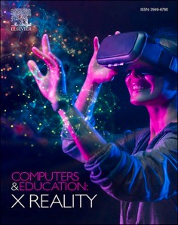[Computers & Education: X Reality 3 (2023) 100040](https://doi.org/10.1016/j.cexr.2023.100040)

Contents lists available at [ScienceDirect](http://www.sciencedirect.com/science/journal/29496780)

Computers & Education: X Reality

journal homepage: [www.journals.elsevier.com/computers-and-education-x-reality](https://www.journals.elsevier.com/computers-and-education-x-reality)

Communicating engineering heritage through immersive technology: A VR [](http://crossmark.crossref.org/dialog/?doi=10.1016/j.cexr.2023.100040&domain=pdf) framework for enhancing users’ interpretation process in virtual

immersive environments

Saif Alatrash a,*, Sylvester Arnab a, Kaja Antlej b

a *Coventry University, Priory Street, Coventry, CV1 5FB, UK*

b *Deakin University, 75 Pigdons Road, Waurn Ponds, VIC, 3216, Geelong, Australia*

A R T I C L E I N F O

*Keywords:*

Virtual reality Immersive environments Storytelling Gamification

Digital heritage Museum experience

A B S T R A C T

The recent advancement in immersive technologies opens up opportunities for the way individuals perceive and engage with information in public spaces to be innovated. This article discusses a study that investigates the application of Virtual Reality (VR) as an instrument for communicating engineering heritage in museum envi-

ronments with the aim to enhance visitor experience. The study adopted Shannon’s communication theory as the main principle for contextualising heritage objects within virtual environments. This approach can benefit cu-

rators in informing the way the intended meaning, value, and context behind museum artefacts to be delivered through visual narratives and aesthetics. In this study, three VR scenarios have been developed using the Unreal engine to investigate the aspects of learning, interaction, and immersion during the virtual experience. One-way ANOVA approach was used to determine the significant differences between the proposed factors in the study. The study found that the absence of interaction in the immersive scenario reduced the mean score leading to a lack of constructive guidance during navigation. Whereas using Gamified and narrated approaches significantly increased the mean value of the participants compared to the control group. While many researchers argue that

the utilisation of VR could improve the users’ level of presence, the study outcomes suggest that there are certain

conditions that should be structured during the development process to facilitate better engagement with virtual content. To achieve these conditions, gamification and storytelling strategies have been found to be effective in delivering an interactive immersive experience for engaging with heritage artefacts and contents.

# Introduction

The role of immersive technologies, such as virtual reality (VR), is becoming more popular within the museum sector due to their novel potential for communicating and representing contents and artefacts through digital narratives. Museum professionals are also compelled to integrate innovative methods to enhance the interpretation process of

exhibits during visitors’ tours (Lee, Jung, tom Dieck, & Chung, 2020). Such technology enables a virtual connection between past cultures and

present societies by representing historical stories that are challenging for the general public to imagine, transporting them to an alternate digital reality (Zhou et al., 2022). For instance, Puig et al. (2020) demonstrated that incorporating VR technology can improve visitors’

satisfaction and enjoyment, and the use of wearable equipment con-

tributes to a more personalized learning experience. Moreover, museum

spaces with multisensory augmentation have the potential to enhance users’ empathy by enabling learners to experience diverse historical situations from a direct viewpoint.

Utilising VR as a storytelling tool can expand the reach of heritage content to a broader audience by offering an engaging experience that enables users to interact with digital objects on display, thereby pro- moting both education and entertainment (S. Rizvic et al., 2019). This can prospectively make heritage artefacts more widely accessible beyond the ordinary tour guides’ techniques such as text displays or

audio narratives. However, museum institutions need to be more

informed and aware of the way immersive technologies can be inte- grated within its fabric to make the digitally-enabled experience seam- lessly embedded within the heritage context (Shehade & Stylianou-Lambert, 2020). This means the integration of technology should be designed to align with the overall museum mission and

* Corresponding author.

*E-mail addresses:* [alatrashs@coventry.ac.uk](mailto:alatrashs@coventry.ac.uk) (S. Alatrash), [s.arnab@coventry.ac.uk](mailto:s.arnab@coventry.ac.uk) (S. Arnab), [Kaja.antlej@deakin.edu.au](mailto:Kaja.antlej@deakin.edu.au) (K. Antlej).

<https://doi.org/10.1016/j.cexr.2023.100040>

Received 3 May 2023; Received in revised form 8 September 2023; Accepted 9 September 2023

Available online 16 September 2023

2949-6780/© 2023 The Authors. Published by Elsevier Ltd. This is an open access article under the CC BY license (<http://creativecommons.org/licenses/by/4.0/>).

strategies, rather than being treated as an isolated entity from the whole visiting experience to contribute to the museum’s mission.

This article presents a study that aims to investigate the means for

enhancing museum visitors’ experience by implementing an interactive VR experience based on storytelling and gamification theories towards

better contextualisation of heritage objects and contents (Fig. 1). To enhance the communication process between visitors and the heritage objects presented in virtual environments, this study developed a communication model based on Shannon-Weaver’s mathematical the-

ory. Three VR experiments were conducted to measure the level of

interaction, immersion, and learning of visitors while engaged with the subject matter. Although some scholars argue that VR can improve the visitor experience, specific factors must be considered to enhance their engagement with virtual content. Therefore, gamification and story- telling strategies were employed to elevate the level of engagement of visitors inside virtual environments. The inclusion of such elements motivated individuals during their interaction, leading to a more seamless flow towards the intended destination in the game.

The research questions are (1) How can the implementation of sto- rytelling and gamification in immersive environments enhance the interpretation process of engineering heritage in relation to participants’

experiences in terms of learning, interaction, and immersion? And (2)

How can storytelling contextualise the visitor experience in a virtual museum through the utilisation of gamified immersive technologies?

# Background

Museum institutions are increasingly interested to use immersive technologies to facilitate engaging meaningful experiences for their visitors while exploring the exhibits (Vrettakis et al., 2019). There is existing evidence that supports this observation, demonstrating how interactive virtual environments encourage active participation whilst engaging with the story that museum professionals are looking to tell (Bozzelli et al., 2019). A study by Lee, Jung, tom Dieck, and Chung

(2020) revealed that the use of VR technologies could support visitors’ sensory experience. The current digitisation of heritage objects in mu-

seums, however, lacks an immersive demonstration, which hinders higher engagement with the stories they represent (Rizvi´c et al., 2021). Therefore, it is necessary to introduce certain measures that can facili- tate greater engagement with these stories. As each heritage object holds

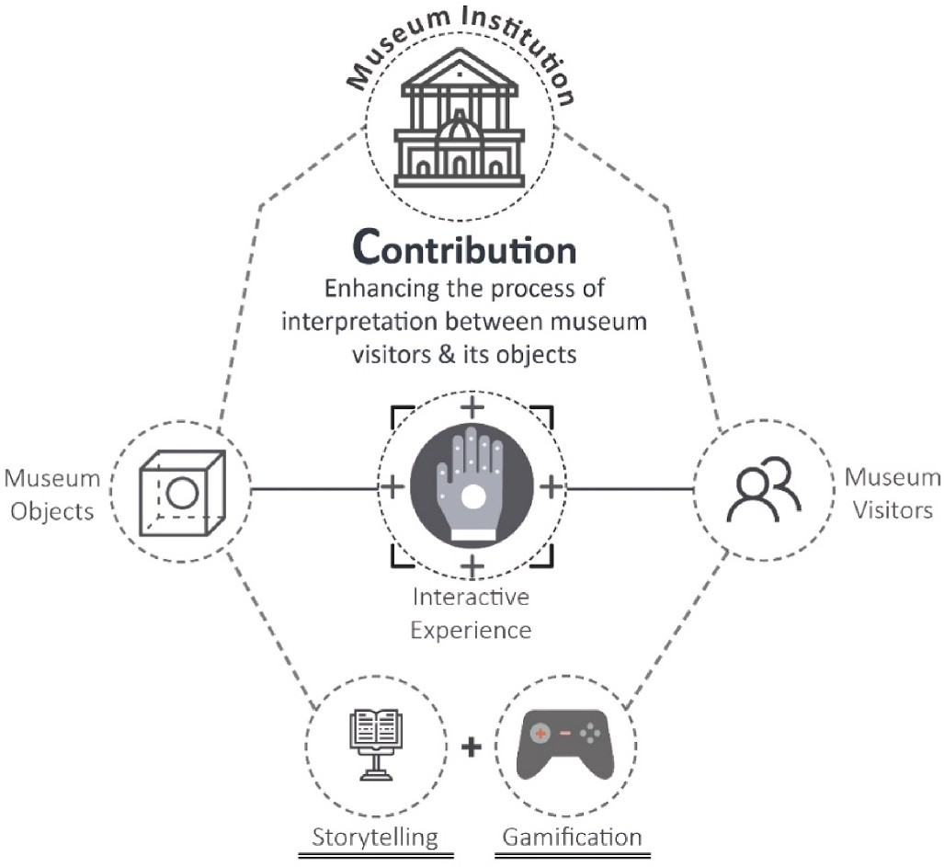

**Fig. 1.** This illustration demonstrates the relationship between the research- embedded elements.

particular evidence of the past, the use of VR technology could serve as an apparatus for better interpreting and expressing its stories. There is no doubt that the employment of VR technology in museums could improve public accessibility to heritage content.

However, there are some aspects that still require further in- vestigations associated with the impact of VR technology on museums’ social experience (Parker & Saker, 2020). Falk and Dierking (2013)

classified museum interactive experience into three contexts: personal, sociocultural, and physical. These classifications could provide insights into how interactive VR experiences can be meaningfully designed and investigated by measuring the interaction connection between museum objects and visitors (Fig. 1).

The following sections further discuss immersive technologies and explore the interpretation principles in museums, the communication theory, and the specific case study that has informed the study.

* 1. *Immersive technologies*

With recent advancements in immersive technology, virtual reality has been proven to increase general knowledge about the presented subject in both educational and training environments (Shehade & Stylianou-Lambert, 2020). The term VR refers to the simulation of three-dimensional environments designed to facilitate realistic in- teractions within digital environments (Lamb & Firestone, 2022). The integration of VR as a tool for contextualising museums contents has seen an immense rise, particularly after the 2010s as a result of software and hardware tech boom developments (Zhou et al., 2022). The use of VR technology allows individuals to experience inaccessible locations or historical events that are challenging to recreate physically. Research indicates that visitors were able to immerse themselves in the experience of train travel during World War I (Shehade & Stylianou-Lambert, 2020), demonstrating how VR can act as a "time machine" by providing a sense of presence that enables visitors to participate in the narrative. Additionally, exhibitions that transform paintings into virtual experiences allow users to explore a new dimension of art by gaining a deeper understanding of the underlying meaning. This suggests that immersive technologies can facilitate innovative ways of comprehend- ing heritage objects by enhancing visual aesthetics to improve in- dividuals’ understanding and appreciation of the subject matter.

Generally, immersion in VR is subjective to the user’s cognitive

ability while engaging with virtual environments. Brown and Cairns (2005) established three criteria for assessing the degree of immersion. The first criterion is the level of engagement, which is linked to the

user’s level of interaction with game-related tasks. The second criterion is the level of engrossment, which refers to the emotional attachment

that users develop towards the virtual task, resulting in reduced awareness of their physical surroundings. Finally, the third criterion is total immersion, which is considered the highest level of immersion, where users attain a complete sense of presence due to the detachment from physical reality. In VR, users typically achieve a total level of im- mersion, as the entire experience is reliant on digital representation and narratives, unlike Augmented Reality (AR) approaches. VR enables users to observe the story angle from a first-person perspective, where the users become the main character as experienced from the VR headset point of view.

Numerous studies have highlighted the effectiveness of gamification in the heritage sector, particularly in motivating users during virtual reality (VR) interactions with digital objects (Wei et al., 2023). VR can also include gamification in its design, where this often involves problem-solving activities that can enhance cognitive thinking and lead to better performance in achieving game objectives (Karahan & Gül, 2021). Professionals in the heritage sector have widely adopted gami- fication strategies since 2010 (Liu & Idris, 2019). Gamification refers to the incorporation of game elements in non-gaming contexts to motivate users and engage them with the subject matter (Deterding et al., 2011). By incorporating gamification elements in narrated scenarios as

explored in this paper, users can acquire knowledge in a positive and enjoyable way (Ferguson et al., 2019).

VR technology offers a unique and immersive approach to represent historical artefacts and content. This technology has the potential to revolutionize the way we learn about and appreciate heritage objects.

* 1. *Interpretation principles in museums*

The mission of a museum is two-fold: to acquire cultural artefacts of historical value while preserving them, and to educate the public about the significance of its collection, including its potential impact on society (Bachiller et al., 2023). The relationship between museum collections and their visitors demands a high level of interpretation for communi- cating their cultural value. The capability of VR technology has created opportunities for museums to showcase their collections in new and innovative ways, thereby expanding the range of interpretations and experimentation available to the public (Shehade & Stylianou-Lambert, 2020).

The emergence of VR technology in museums has raised questions about how to effectively present heritage collections to visitors to facilitate effective communication of the values and contexts of the collections that will encourage meaningful interpretations by the visi- tors. Weng et al. (2020) classified digital interpretations into two types: interpersonal and non-personal interpretations. Inter-personal inter- pretation involves two ways of communication as face-to-face interac- tion, such as the intercourse between the visitors and tour guides. Non-personal interpretation is considered as one-way communication

intercourse which involves a visitor’s interaction with physical materials such as museum information points. Hooper-Greenhill (2007: 189)

states "The post-museum will be shaped through a more sophisticated understanding of the complex relationships between culture, commu- nication, learning and identity that will support a new approach to museum audiences … ". Hooper-Greenhill defines communication as the

process of explaining something to make sense of the overall experience.

To enhance the interpretation process between the visitors and the museum collection, utilising the theory of communication is essential to strengthen the intended meaning behind the heritage context.

* 1. *VR communication theory*

One of the most respected models of interpretation in museums was developed by Cheng and Hsiao-ChingAnnetta (2014). The model dem- onstrates the communication process between the museum curators, designers, and developers inside the medium to enhance the interpre- tation process for the audience (Veverka, 2018). Terms such as herme- neutics strategies are essential to process the feedback outcome during the experiments. The hermeneutic circle concept relies on a progressive informative discourse between the present and the past. This discourse forms an interpretation processing circle that allows further potential to process the information, indicating that the narrative is a circular model and not linear (Hooper-Greenhill 2007). The use of the hermeneutic circle provides a better understanding of things, as it allows the audience to observe the details in terms of whole and vice versa. Although pre- vious studies by Veverka (2018) and Hooper-Greenhill (2005) show that museums and exhibitions can improve the communication process with their audience, still many traditional heritage institutions face chal- lenges in communicating with their audience. Therefore, there is a need for a new model of communication-based on previous studies to be implemented within the museum environment in order to enhance the interpretation and interaction process between the displayed objects and the visitor’s experience.

The study in this article embedded Shannon and Weaver’s commu-

nication model as the main approach for communicating engineering heritage in museum environments as this framework is considered the basis of all recent transmission approaches in modern history (Petersons & Khalimzoda, 2016). As stated by Shannon and Weaver (1964) the

concept evolved from the necessity to approach effective interpretation outcomes between the sender and the receiver during information ex- change. The Shannon and Weaver model is widely used in the field of communication and information theory to describe the process of in- formation transmission between a sender and a receiver (Veverka, 2018). However, this concept model lacks feedback functionality as once the message approaches the receiver the model mission is to be considered accomplished. Therefore, the study adapted the original model and embedded a feedback loop to gather the information while encoding and decoding the data between the two channels as illustrated by Fig. 2. The information transmitted through the Head-mounted dis- plays (HMDs) as digital signals entities between the visitors and the digital object creates a digital bridge of data exchange between the two channels. The feedback loop provides further narrative clarity by enhancing the experience based on the visitor’s response and decision

making while navigating a VR environment through storytelling and

gamification techniques.

* 1. *Case study for an engineering heritage*

Engineering heritage comprises historical aspects that are funda- mental to be preserved for future generations. According to Baker’s (2005) study, there is an obligation to preserve engineering heritage

objects because the restoration process could harm their material integrity and mislead the general public about their original state. Therefore, it is important to ensure that any preservation efforts are

undertaken with care and consideration to avoid damaging the object’s historical significance. Exposing fragile objects to the public could be

precarious due to their delicate nature (Kyriakou & Hermon, 2019). In light of this, VR can serve as a means of preserving heritage stories by constructing a detailed virtual image of the physical object. This process of digitising real physical spaces is a crucial step in the preservation and survival of engineering heritage. Novel approaches such as those described by Baker (2005) can enable museum visitors to visualise heritage objects in their original states and understand their intended meaning. The use of mixed reality can also provide further access to artefacts that are no longer physically present in museum environments, offering additional explanations about their significance, as noted by Bachiller et al. (2023).

The study in this paper focuses on the Lanchester Petrol-Electric car as an example of an engineering heritage object. With the growing de- mand for knowledge about automotive history, visitors are increasingly interested in exploring the stories behind such collections. Cudny and Jolliffe (2019) have shown that past transportation marvels are considered to be engineering heritage objects and represent a symbol of social status. To fully encompass the legacy of this chosen heritage ob- ject, specific strategies of communication and interpretation through the use of VR technology have been adapted in the study to provide an informative and interactive experience during visits. These strategies aim to engage visitors in a deeper understanding of the technological advancements and societal significance of the Lanchester Petrol-Electric car. By providing a comprehensive context for this heritage object, vis- itors can appreciate the value and importance of preserving such pieces of engineering history for future generations.

# Materials and methods

The investigation focuses on delivering an immersive interactive museum experience for the visitors to have a better understanding of the heritage content. To this extent, the study consisted of three experiment scenarios: (1) Gamified, (2) Narrated, and (3) Immersive. Each scenario

offers aspects that will enable the comparisons of the users’ level of interaction, learning, and immersion whilst experiencing the virtual

museum visit. The immersive scenario considered as the control group, while in the Gamified and Narrated scenarios, participants are part of the experimental groups.

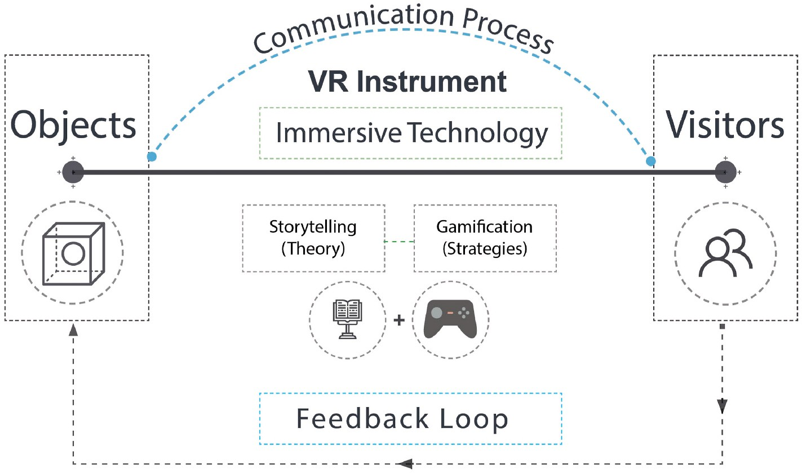

**Fig. 2.** The communication framework adapted to investigate the interpretation process within the VR experiments.

The default scenario is ‘Immersive’ (Scenario 3), which consists of an immersive virtual environment representing the Lanchester workshop

(see Fig. 3 for the environment layout). Artefacts related to Lanchester and the petrol-electric car such as the blueprint design are displayed within various locations, where they can be viewed by the users as they navigate through the space. This emulates the usual museum visit but in a virtual environment. It thus has the least amount of interaction apart from the navigation within the environment.

The ‘Narrated’ scenario (Scenario 2) enhances the default VR experiment with narratives based on the storytelling perspectives,

accompanying the users as they navigate the space. The narratives add context to the artefacts that the users are discovering during their tour. This emulates a museum tour guide through interaction with the visual elements.

The ‘Gamified’ scenario (Scenario 1) embeds gamification strategies on top of the narrated version, encouraging more interactivity with the

heritage artefacts and context in terms of the users’ progress within the environment. Users experience the museum tour as a series of quests,

where they also engage with gamified elements, such as star collecting as part of their navigation across the locations in the environment and puzzles associated with Lanchester’s blueprint.

* 1. *Design and developments*

This section discusses the production process of the scenarios. Fig. 4 summarises the aspects of the scenarios.

The study adopted the production strategies based on the game- based intervention development process as discussed by Arnab and Clarke (2017). The pre-production phase of the development involved collecting heritage and historical information and digital artefacts from the Lanchester subject experts, especially key information on the petrol-electric car. Copies of the original blueprints, photos, and infor- mation sheets were located at the Lanchester archives which informed the design process of the 3D contents, including a depiction of the in- dustrial environments and the petrol-electric car object from the year 1927. The same educational artefacts were embedded across the pro- posed three scenarios, however, the interaction and narrative methods varied from one to another. Short tutorials are provided at the beginning to help users familiarise themselves with the controllers and navigation process within the VR environment (Fig. 5).

All the 3D content used in the experiment was created using the Maya application software to ensure consistency in the workflow. The 3D models were then exported to Substance Painter to apply appropriate

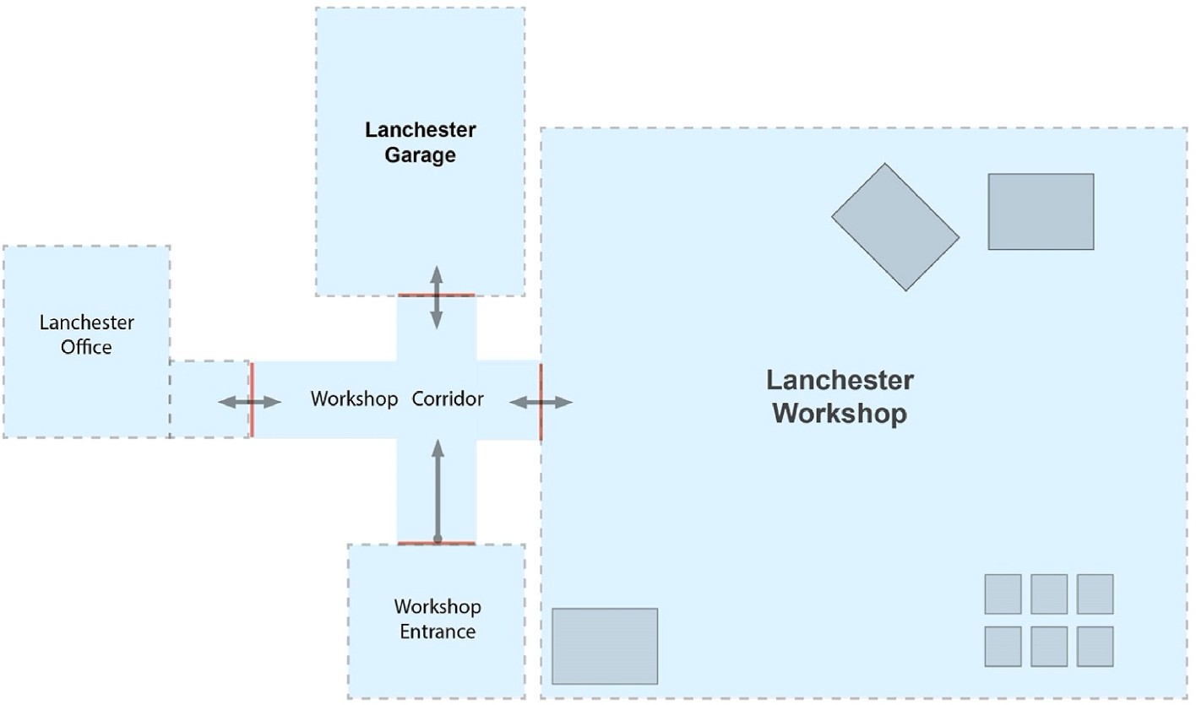

**Fig. 3.** The VR experiments layout where the users have to navigate inside the virtual environments.

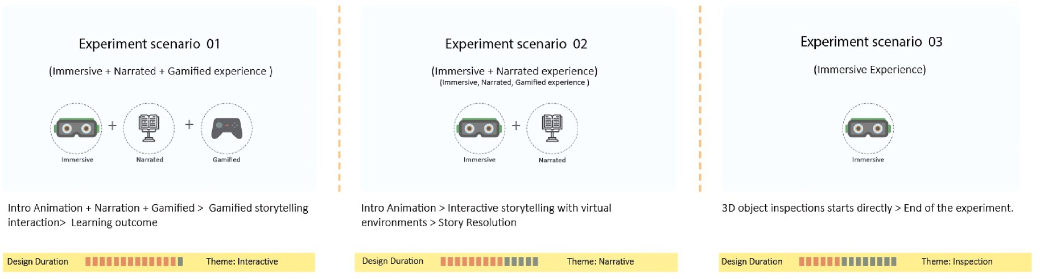

**Fig. 4.** Three scenarios designed to capture the participant’s interaction in VR environments.

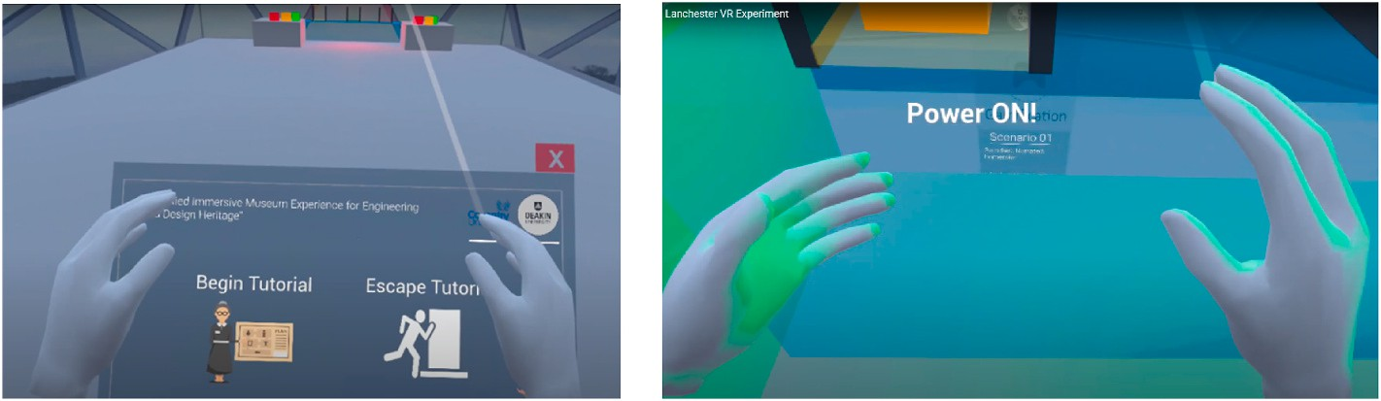

**Fig. 5.** Tutorials to familiarise the users with the experiment nature before the actual story begins.

textures to each object, simulating real-world materials such as dust and corroded industrial materials to create realistic surface details. Finally, the models were exported to Unreal Engine (UE) to build the experi- ments in real-time. In order to achieve a coherent interaction, the level design was constructed in parallel layouts to provide a sense of explo- ration during navigation. Level design is a crucial stage in the design process as it orients users and guides them towards the objectives of the

VR experience. By following guided paths, users’ behaviours can be influenced, leading them towards the desired destination.

Informed by the immersive marketplace trends at the time of the development (2021), the study selected the Meta Quest 2 as the main instrument for delivering the three scenarios for the investigation. The reason behind incorporating such a headset is due to its high fidelity, supporting 1832x1920 pixels and 90 Hz refresh rate per eye (Ebnali et al., 2021). It is also easy to set up as the trackers are already embedded within the headset itself. The headset supports 6 DOF functionality which makes the navigation more responsive and intuitive in virtual environments. Before deploying the experience in public spaces, the prototype version was tested in closed environments with expert users (Fig. 6). The findings informed further improvement of the technicality of the VR scenarios.

On top of the default immersive version, storytelling and gamifica- tion approaches were embedded in the experience to promote interac- tive narratives during navigation. The narrated scenario contains a story structure that is based on the three-act structure comprised of the following elements: Exposition, Climax and Resolution (Putria & Nur- hadi, 2020). Mystery is the main theme of the story, complementing the navigation through the game levels. Act One (Exposition) introduces the player to the Lanchester laboratory, establishing the main objectives of the game. Users are required to enter the laboratory through the main door, which leads to the hallway where posters containing educational

content are located. Act Two (Climax) focuses on the user’s ability to solve puzzles and explore educational content by interacting with or

reading information from visual panels. Depending on the scenario re- quirements, the player reaches the climax phase in Act Two, where challenges may increase as they gain knowledge while exploring the contents of the levels. Act Three (Resolution) is concluded when the player reaches the final destination in the game. To reduce the risk of motion sickness while navigating within the VR environments, the study selected ‘teleportation’ as the main locomotion method (Fig. 7).

The immersive scenario is focused solely on immersion, with no

interaction involved except navigation. The player can still navigate the

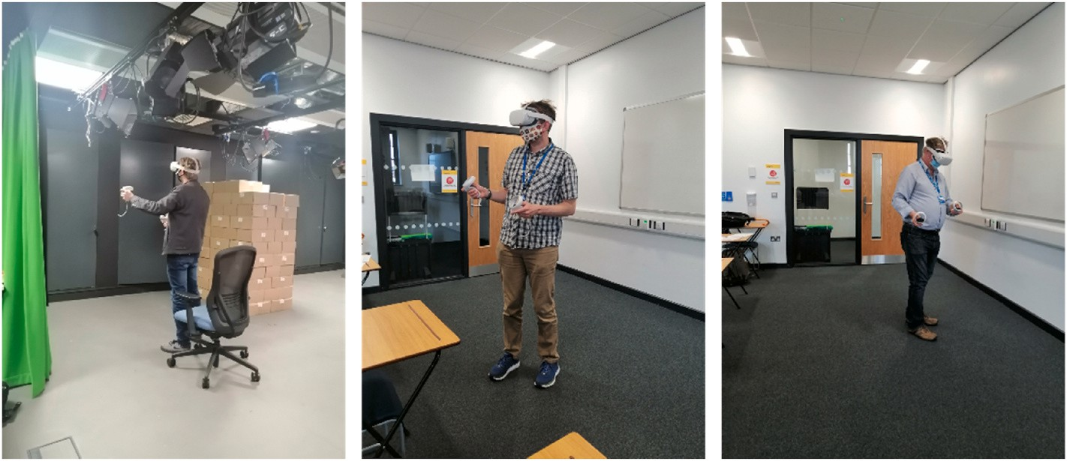

**Fig. 6.** Subject experts testing the experiment elements in closed environments.

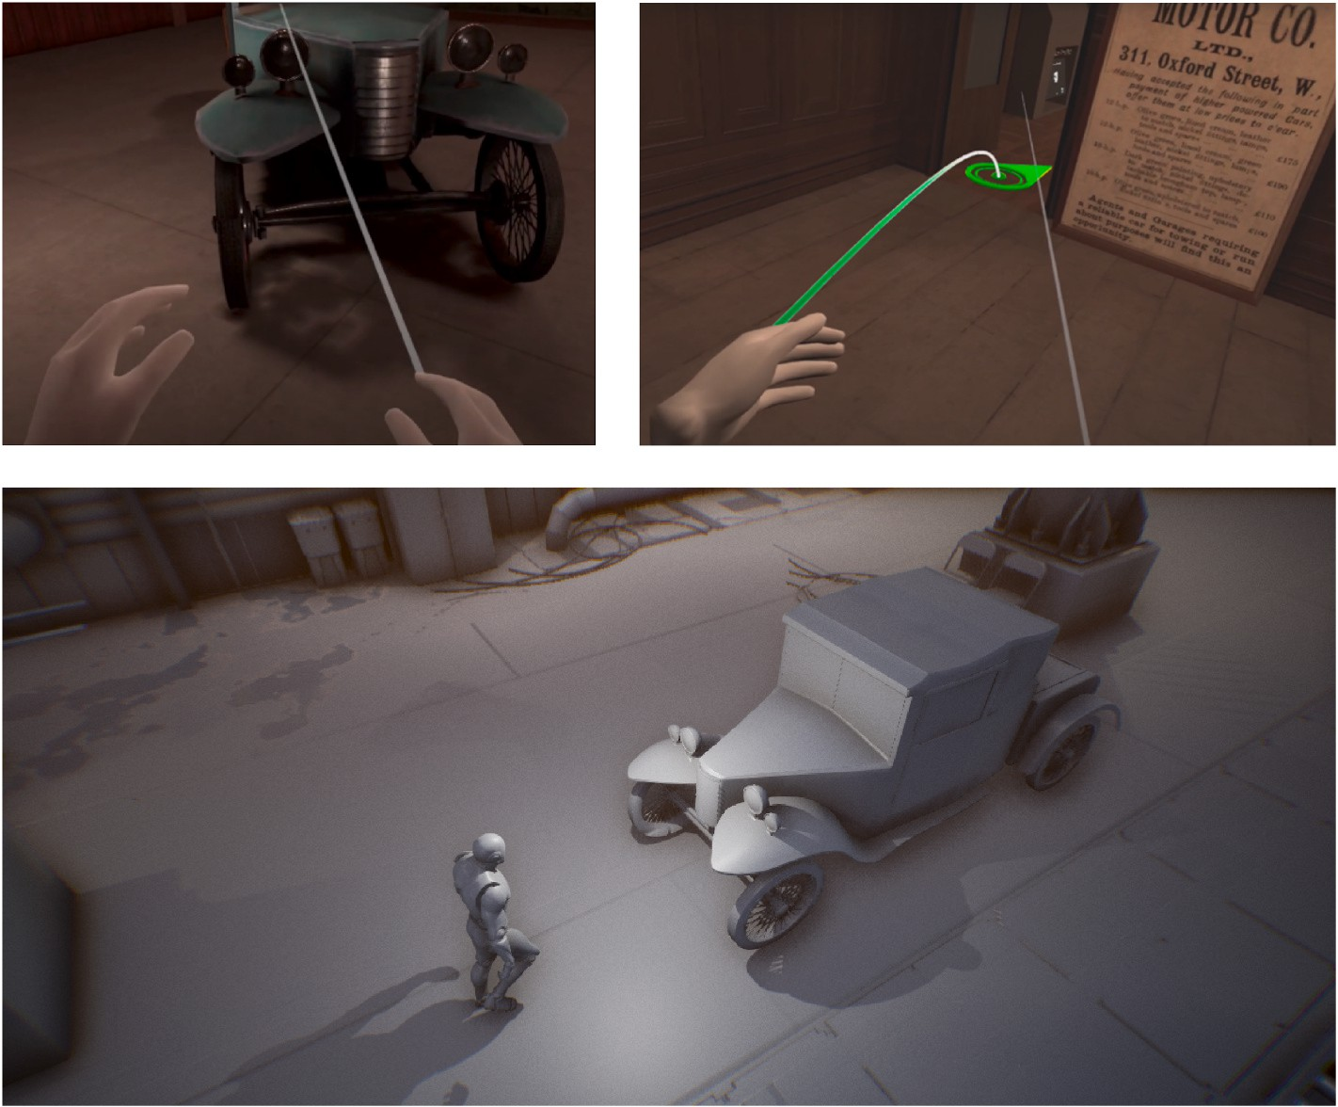

**Fig. 7.** This diagram shows the virtual Lanchester Workshop and the navigation technique – teleportation.

levels and explore the map through teleportation and by reading educational content from posters and text-based panels (see Table 1). The narrated scenario relies on a storytelling strategy that allows users to explore heritage contents through narration, using a three-act struc- ture approach on top of the immersive version. The user listens to the avatar, which acts as a guide across the map. Interaction is still

**Table 1**

This table demonstrates the scenario type objective stages against the controller mechanism.

Scenario Type Scenario Objective Mechanism Methods

accessible in the narrated scenario, except for puzzle-solving and score collection. The Mechanics, Dynamics, and Aesthetics (MDA) framework (Kusuma et al., 2018) informed the design of the gamified scenario, building on the narrative structure. Scores and achievements were used as the main feedback mechanics in the gamified scenario to motivate the

users as they progress in the VR environment. The gamified scenario’s objectives involve self-exploration and puzzle-solving, which require

users to navigate the map and interact with its 3D objects in a structured sequence by unlocking the experiment levels to achieve the game endpoint. Users can gain scores while progressing towards the game targets. The game mechanism varies from previous scenarios due to the additional functions and tasks, such as the points system and

**Immersive Scenario 3**

**Narrated Scenario 2**

**Gamified Scenario 1**

* + 1. Navigates through the hallways.
    2. Read the poster’s information.
    3. Explore the Office and read posters.
    4. Navigates to the Workshop and read the displayed posters.
    5. Explore the Lanchester Car from a different angle

1. Navigates through the hallways.
2. Hear and read the posters’ information.
3. Interact with the Office objects and posters.
4. Explore the Workshop and interact with posters.
5. Explore the Lanchester Car from a different angle and hear the character narratives.
6. Navigates through the hallways.
7. Interact with posters and hear and read posters’ information.
8. Collect score points during navigation.
9. Find the Office and solve the book puzzle.

6 Unlock the workshop gate, explore and interact with the posters.

1. Switch the power by manipulating the Crane puzzle.
2. Achieve the Lanchester Garage hear the character narratives, and assemble the engine parts to run the car.

*Analogue Button*

*Trigger Button*

*Analogue Button*

*Trigger Button Grip Button*

*Analogue Button*

*Trigger Button Grip Button Select Button*

puzzle-solving.

* 1. *Participants*

A total of ninety six (96) participants were recruited, which included experts and public users in two phases. The first phase was conducted in closed lab environments, while the second phase was conducted in public spaces as museum environments. This paper demonstrates phase two analysis taken from the public users.

The study initially involved inviting 15 VR experts with sufficient knowledge in the VR domain, to a private laboratory. Based on their feedback, the results from the first phase of the study were used to improve the experience before deploying it in public spaces. The experts recommended adjusting the VR controller’s inputs as they were too

complex for non-expert users, and it might take them a long time to

adapt to the experiment’s nature. Consequently, further developments

were carried out to make the experience more intuitive for public users. In the second phase of the study, public recruitment was conducted at the Coventry Transport Museum, using a random sampling approach (Stockemer, 2019) to avoid biased consequences from the population during the recruitment process. Ethical approval was granted before proceeding with the investigation.

* 1. *Measures*

The study utilised three factors, namely learning, interaction, and immersion, to measure participants’ experiences. The questionnaire list was divided into categories based on these three factors, using a five-

point Likert scale from 1 (Strongly Disagree) to 5 (Strongly Agree). The measured items were adopted from previous studies and adapted to suit the investigation’s purpose, drawing from Cheng et al., 2014,

Tcha-Tokey et al., 2015, and Lee et al., 2020). The survey included 40

items divided into three sections: (1) Immersion, (2) Interaction, and (3) Learning. In this paper, the most highlighted items have been selected from each factor, based on the users’ feedback results from the original

study. Nine items were selected in relevance to the research question

and objectives, prioritizing those that offer comprehensive and mean- ingful insights related to the paper’s theme, as follows:

1. Immersion factor items
   * Item 1 - I was focused on the task at hand I feel an emotional attachment with the activity.
   * Item 2 - I felt I was the main character in the activity, as the activity could be shaped according to my actions.
   * Item 3 - The activity became the unique and only thought occu- pying my mind.
2. Interaction factor items
   * Item 1 - I thought the interaction devices (Oculus headset) were easy to use.
   * Item 2 –I felt confident selecting objects in the virtual environment.
   * Item 3- My interaction with the environment would be clear and understandable for me.
3. Learning factor items
   * Item 1 - I can memorise the experience with educational contents.
   * Item 2- The experiment increases my overall knowledge about the presented object.
   * Item 3 - I tried to apply the gained knowledge while navigating in the VR environments.

Prior to the VR experiments, participants were provided with a short induction about the experiment’s nature, along with information sheets and consent forms to read and sign. To minimise external noise and

distractions, the study recruited only one participant at a time, allowing more space to focus on each case. The users required additional assis- tance and supervision while navigating in virtual environments. Overall, the average duration of the experience was approximately 20 min.

Power analysis was conducted to determine the required sample size for our study. The actual statistical power achieved was (0.80). This indicates that the study had an 80% probability of correctly detecting significant effects, given the sample size and effect size estimates. The critical F-value was calculated as 3.129, which allowed to assess the significance of the observed effects. In total, 81 participants were recruited from the public, with 27 equally assigned to each of the three scenarios. After completing the experience, participants were provided with a questionnaire to fill out on the provided tablets. All responses were collected anonymously to keep user identities confidential.

The data collected were analysed using the One-way ANOVA approach in SPSS to determine the significant differences between factor items and to compare the three scenarios. Additionally, to investigate the potential relationships between the variables under the study factors (interaction, immersion, and learning), Pearson correlation analysis was performed to measure and assess the strength of the linear association between variables under the three scenarios.

# Results

This section presents a descriptive analysis of the three scenarios to compare the independent variables, and the demographics criteria used in this research to evaluate the results. The demographic distribution of

the 81 participants who took part in the VR experience is demonstrated in Table 2. The results show that the majority of the participants were male (60%) and female (40%), and their ages ranged from 18 to 75 years old, with the majority falling within the 18–35 age group.

* 1. *Descriptive analysis*

This section compares the survey findings across the three scenarios based on the mean value under three main factors (Interaction, Im- mersion, and Learning). The survey was divided into five sections which contained 47 questions to measure different aspects from the user’s

perspective as the following: Immersive Experiences, Interaction Expe-

riences, Learning Experiences, Gamification & Storytelling, and Comfort and Safety. Before implementing the ANOVA test, Cronbach’s alpha (α) test was conducted for each construct to see the scale estimated re-

liabilities, and to confirm there is consistency and equal weight between the proposed construct’s items (Bagozzi & Yi, 2012). The results (Table 3) show that the sum variable was above (0.70), indicating that

the factors items can be combined to run the ANOVA test.

The ANOVA statistical analysis indicates significant values between the three scenarios. There are significant differences between the three scenarios under the immersion factor with a value of (p = 0.001). Similarly for the interaction factor with a significant value (p = 0.005). In contrast, no significant value can be concluded for the learning factor (p = 0.204). The ANOVA results presented in Table 4 demonstrate the overall mean results according to the three main factors (Interaction, Immersion, and Learning). The mean value indicates that the users gained higher interaction under the narrated scenario (Mean = 4.0468) compared to the gamified and immersive scenarios. Similarly, to the immersion factor, the data shows that the majority of the users perceived higher immersion under the narrated scenario (Mean = 4.2704). However, the analysis shows that the users managed to gain high knowledge under the gamified scenario compared to the other two. The users indicated the lowest learning under the default immersive scenario (Mean = 2.8114).

Tukey Post hoc test was conducted to highlight the differences be-

tween the group samples in more depth. The results show there is a significant difference between the dependent variables in each scenario. Statistically significant differences were found under the immersion factor across the three scenarios. There was a significant difference be- tween the narrated and immersive scenarios (p = 0.001). This indicates that participants in both scenarios have experienced different amounts of immersion according to their engagement in each experiment. There was no statistically significant difference between the gamified and

narrated scenarios under the immersion factor. In terms of the interac- tion factor, the analysis shows that there was no significant difference between the gamified and the other two scenarios (P > 0.05). However, there was a significant difference between the narrated and immersive

scenarios (P = 0.004). The analysis shows that the learning differences in the gamified and the narrated scenario were not significant with a value of (0.263). Based on this assumption there is no need to run a Post

**Table 2**

Demographics criteria analysis.

|  |  |  |  |  |  |  |  |  |
| --- | --- | --- | --- | --- | --- | --- | --- | --- |
|  | Factor |  | Characteristics |  | **Number of participants** |  | Percentage |  |
|  | **Gender** |  | Male |  | 47 |  | 60% |  |
|  |  |  | Female |  | 34 |  | 40% |  |
|  | **Age** |  | (18–24) |  | 33 |  | 40.7% |  |
|  |  |  | (25–35) |  | 19 |  | 23.5% |  |
|  |  |  | (36–44) |  | 10 |  | 12.3% |  |
|  |  |  | (45–54) |  | 10 |  | 12.3% |  |
|  |  |  | (55–64) |  | 06 |  | 7.4% |  |
|  |  |  | (65–74) |  | 02 |  | 2.5% |  |
|  |  |  | (75 and above) |  | 01 |  | 1.2% |  |
|  | **Total** |  |  |  | 81 |  |  |  |

**Table 3**

Cronbach’s Alpha items reliabilities between the three factors.

Factor type Cronbach’s Alpha N of Items

Immersion 0.942 10

|  |  |  |  |
| --- | --- | --- | --- |
| Interaction | 0.955 | 19 | the correlation plots indicating the significant values of the item re- |
| Learning | 0.830 | 11 | lationships between the three scenarios. |

* 1. *VR items correlations*

Correlation analysis were conducted to find the regression score to- wards understanding the relationships between items. Tables 6–8 shows

**Table 4**

ANOVA results highlighted differences between the three scenarios based on the study factors.

|  |  |  |  |  |
| --- | --- | --- | --- | --- |
| Factor type | Sig. | Scenario 1 (Gamified Mean) | Scenario 2 (Narrated Mean) | Scenario 3 (Immersive Mean) |
| Immersion | 0.001 | 3.9148 | 4.2704 | 3.3963 |
| Interaction | 0.005 | 3.6530 | 4.0468 | 3.3431 |
| Learning | 0.204 | 3.1212 | 2.8384 | 2.8114 |

Hoc test compression across the three scenarios for the learning factor. This finding was unexpected and suggests that there is a close significant difference between the gamified and the immersive scenario with a score of (0.062) which is slightly higher than the (0.05). This is perhaps due to the interactive aspects and interaction mechanics in the gamified scenario compared to the default immersive one; for instance, the gamified scenario includes interaction with puzzle and mystery solving as part of the story and journey towards the final destination in the game, while the immersive scenario was designed with less number of controllers input that has perhaps produce less distraction from external environments and requirements (Table 5).

Nevertheless, the general mean values indicate that learning is still higher under the gamified compared to the immersive and narrated scenarios even though the difference across these was not highly sig- nificant. Thus, the design flow and the story structure that had been implemented in each experiment affected the learning process between the three scenarios. Contrary to expectations, no significant difference was found between the narrated and the immersive scenario in term of

learning as the value (p = 0.989 > 0.05), which indicates the learning process between the narrated and immersive scenario were the same. Despite the learning insignificant value across the three scenarios, the Kruskal Wallis graphs (Fig. 8) indicate that the gamified scenario is still

more reliable for encouraging learning due to the design consideration and mechanism. The interaction experience was lower in gamified compared to narrated as were more items to interact with in gamified scenario which resulting more distraction to focus during navigation.

**Table 5**

Post Hoc test results highlighted differences between the three scenarios.



The first correlation values between interaction and immersion indicate that there is a high association between the items with a value of (R2 Linear = 0.719). Furthermore, the correlation values between learning and interaction received a regression score of (R2 = 0.561). This indicates that there is a positive relation between the learning and the interaction items in the gamified scenario. Another strong correla- tion value between the learning and immersion with a regression value of (R2 = 0.519). Overall, the results show a positive correlation between the items in the gamified scenario, indicating strongly that participants managed to achieve a higher learning outcome as highlighted in the data. On the other hand, the narrated scenario indicates strong corre- lations between the interaction and immersion with a value (R2 = 0.572), and sufficient correlation values between the learning and interaction factors (R2 = 0.261), followed by the immersive and learning factors (R2 = 0.154). Similarly, the immersive scenario received a high correlation between the interaction and immersion factors with a regression score (R2 = 0.895), and a low correlation be- tween the learning and interaction factors (R2 = 0.035), followed by the immersive and learning factors (R2 = 0.026) (see Table 9).

# Discussions

This section discusses the findings that address the research ques- tions of how storytelling can contextualise the visitor experience in a virtual museum through the utilisation of gamified immersive technol- ogies, and how the implementation of storytelling and gamification can enhance the interpretation process for visitors in museums. The analysis demonstrates that the use of immersive technology, along with gamifi- cation and narrative strategies, has received positive responses from visitors. These strategies have facilitated an environment that enhances

visitors’ ability to interpret the heritage content while interacting with the subject matter.

The study demonstrates the value of the VR communication model (Fig. 10) that has informed the design considerations, facilitating a communication process between visitors and engineering heritage ob- jects by forming a coherent structure of information within the scenarios.

* 1. *Immersive scenario (default scenario 3)*

In the default immersive scenario, users were able to navigate freely without any instructions or guidelines, mimicking a default museum experience but virtually. The immersion, interaction, and learning fac- tors are lower in this scenario compared to the other two. Further analysis suggests that the level of interactivity significantly influenced immersion with a regression value of (R2 Linear = 0.895), indicated by the high correlation between the interaction factor and the immersion

factor (Table 7). Users had no interactive experience apart from the tutorials and the navigation across the locations within the VR envi- ronment. Learning has also been impacted by this. There are low cor- relations recorded between the learning and immersions factors with regression score (R2 Linear = 0.026). Similarly, between the learning and interaction factor as the value were closer to zero with a regression score of (R2 Linear = 0.035) which indicate a bad model fit. However, there are some correlations between items 2 and 3 of the learning factor and item 1 of the interaction factor that suggests that the memorisation of educational content and the application of knowledge were impacted by the ease of use of the devices. Further correlation between item 3 of the learning factor and item 2 of the immersion factor indicates that the application of knowledge in the environment was impacted by the level

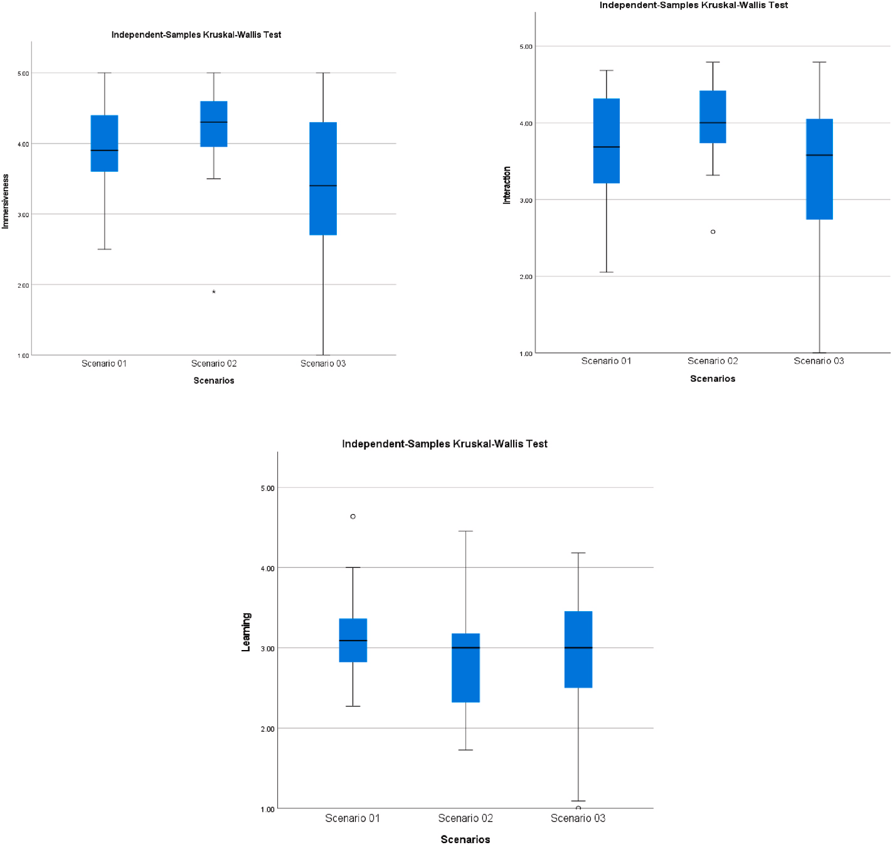

**Fig. 8.** The differences between the experiments factors across the three scenarios.

**Table 6**

Gamified Scenario items correlations value (Learning, interaction, and immersion).

|  |  |  |  |  |  |  |  |  |  |  |  |  |  |  |  |  |  |  |  |
| --- | --- | --- | --- | --- | --- | --- | --- | --- | --- | --- | --- | --- | --- | --- | --- | --- | --- | --- | --- |
| N | Correlated | Item (1) |  | Item (2) |  | Item (3) |  | Item (4) |  | Item (5) |  | Item (6) |  | Item (7) |  | Item (8) |  | Item (9) |  |
|  | Items | Immersion (1) |  | Immersion (2) |  | Immersion (3) |  | Interaction (1) |  | Interaction (2) |  | Interaction (3) |  | Learning (1) |  | Learning (2) |  | Learning (3) |
| (1) | Immersion (1) | 1 |  |  |  |  |  |  |  |  |  |  |  |  |  |  |  |  |  |
| (2) | Immersion (2) | **.599\*\*** |  | 1 |  |  |  |  |  |  |  |  |  |  |  |  |  |  |  |
| (3) | Immersion (3) | .332 |  | 0.191 |  | 1 |  |  |  |  |  |  |  |  |  |  |  |  |  |
| (4) | Interaction (1) | **.500\*\*** |  | **.492\*\*** |  | **.427\*** |  | 1 |  |  |  |  |  |  |  |  |  |  |  |
| (5) | Interaction (2) | **.545\*\*** |  | **.483\*** |  | .358 |  | **.770\*\*** |  | 1 |  |  |  |  |  |  |  |  |  |
| (6) | Interaction (3) | **.625\*\*** |  | **.605\*\*** |  | .302 |  | **.700\*\*** |  | **.785\*\*** |  | 1 |  |  |  |  |  |  |  |
| (7) | Learning (1) | **.446\*** |  | .289 |  | 0.313 |  | **.716\*\*** |  | **.656\*\*** |  | **.524\*\*** |  | 1 |  |  |  |  |  |
| (8) | Learning (2) | **.526\*\*** |  | **.582\*\*** |  | **.490\*\*** |  | **.651\*\*** |  | **.403\*** |  | **.439\*** |  | **.551\*\*** |  | 1 |  |  |  |
| (9) | Learning (3) | **.495\*** |  | .315 |  | **.544\*\*** |  | **.527\*\*** |  | **.473\*** |  | **.412\*** |  | **.492\*\*** |  | **.477\*** |  | 1 |  |

*Correlation is significant at the 0.05 level (2-tailed).

**Correlation is significant at the 0.01 level (2-tailed).

of influence the use had in shaping the activities in the environment. Even though the device was deemed to be easy to use, the learning aspect has been impacted by the users’ more passive role. The analysis of

the user pathway tracked within the VR environment including the time

spent on each location while navigating the VR environments (Fig. 9) indicates that the participants’ journeys were more inconsistent within the environment when compared to the other scenarios. The minimal

amount of directions in the environment impacted participant experi- ence and engagement with the artefacts.

* 1. *Narrated scenario (scenario 2)*

Storytelling is the main key factor in this scenario building on top of the default scenario 3 as it allows individuals to interact with objects by

following a structured narrative during the navigation process, mimicking a guided tour. The main principle behind the narrated sce- nario is to deliver an educational storytelling experience through visual narratives structured across the map to comprehend the precise meaning behind museum content while being entertained simultaneously. This aligns with S. Rizvic et al. (2019) findings that suggest that the use of VR technology can produce a high level of immersion when communicating cultural heritage stories within the experience. The regression data in- dicates a good model fit for the narrated scenario. Analysis shows that the interaction and immersion mean values that are significantly higher than the other two scenarios. Further analysis demonstrates correlations between the interaction and the immersion factors (Table 7). High correlations between interaction factor item 2 and immersive factor items 1, 2, and 3 suggest that the participants’ confidence in interacting

**Table 7**

Narrated scenario items correlations value (Learning, interaction, and immersion).

|  |  |  |  |  |  |  |  |  |  |  |  |  |  |  |  |  |  |  |  |
| --- | --- | --- | --- | --- | --- | --- | --- | --- | --- | --- | --- | --- | --- | --- | --- | --- | --- | --- | --- |
| N | Correlated | Item (1) |  | Item (2) |  | Item (3) |  | Item (4) |  | Item (5) |  | Item (6) |  | Item (7) |  | Item (8) |  | Item (9) |  |
|  | Items | Immersion (1) |  | Immersion (2) |  | Immersion (3) |  | Interaction (1) |  | Interaction (2) |  | Interaction (3) |  | Learning (1) |  | Learning (2) |  | Learning (3) |  |
| (1) | Immersion (1) | 1 |  |  |  |  |  |  |  |  |  |  |  |  |  |  |  |  |  |
| (2) | Immersion (2) | **.512\*\*** |  | 1 |  |  |  |  |  |  |  |  |  |  |  |  |  |  |  |
| (3) | Immersion (3) | .612** |  | **.565\*\*** |  | 1 |  |  |  |  |  |  |  |  |  |  |  |  |  |
| (4) | Interaction (1) | .149 |  | .286 |  | 0.326 |  | 1 |  |  |  |  |  |  |  |  |  |  |  |
| (5) | Interaction (2) | **.600\*\*** |  | **.629\*\*** |  | **.612\*\*** |  | **.480\*** |  | 1 |  |  |  |  |  |  |  |  |  |
| (6) | Interaction (3) | .212 |  | .030 |  | 0.217 |  | **.603\*\*** |  | 0.354 |  | 1 |  |  |  |  |  |  |  |
| (7) | Learning (1) | **.441\*** |  | .289 |  | 0.313 |  | **.424\*** |  | **.726\*\*** |  | .304 |  | 1 |  |  |  |  |  |
| (8) | Learning (2) | **.500\*\*** |  | **.520\*\*** |  | **.490\*\*** |  | .298 |  | **.800\*\*** |  | .283 |  | **.753\*\*** |  | 1 |  |  |  |
| (9) | Learning (3) | **.440\*** |  | .315 |  | **.504\*\*** |  | .196 |  | **.581\*\*** |  | .120 |  | **.497\*\*** |  | **.590\*** |  | 1 |  |

*Correlation is significant at the 0.05 level (2-tailed).

**Correlation is significant at the 0.01 level (2-tailed).

**Table 8**

Immersive scenario items correlations value (Learning, interaction, and immersion).

|  |  |  |  |  |  |  |  |  |  |  |  |  |  |  |  |  |  |  |  |
| --- | --- | --- | --- | --- | --- | --- | --- | --- | --- | --- | --- | --- | --- | --- | --- | --- | --- | --- | --- |
| N | Correlated | Item (1) |  | Item (2) |  | Item (3) |  | Item (4) |  | Item (5) |  | Item (6) |  | Item (7) |  | Item (8) |  | Item (9) |  |
|  | Items | Immersion (1) |  | Immersion (2) |  | Immersion (3) |  | Interaction (1) |  | Interaction (2) |  | Interaction (3) |  | Learning (1) |  | Learning (2) |  | Learning (3) |
| (1) | Immersion (1) | 1 |  |  |  |  |  |  |  |  |  |  |  |  |  |  |  |  |  |
| (2) | Immersion (2) | **.728\*\*** |  | 1 |  |  |  |  |  |  |  |  |  |  |  |  |  |  |  |
| (3) | Immersion (3) | **.803\*\*** |  | **.880\*\*** |  | 1 |  |  |  |  |  |  |  |  |  |  |  |  |  |
| (4) | Interaction (1) | **.749\*\*** |  | **.826\*\*** |  | **.821\*\*** |  | **1** |  |  |  |  |  |  |  |  |  |  |  |
| (5) | Interaction (2) | **.755\*\*** |  | **.850\*\*** |  | **.891\*\*** |  | **.922\*\*** |  | 1 |  |  |  |  |  |  |  |  |  |
| (6) | Interaction (3) | **.685\*\*** |  | **.903\*\*** |  | **.788\*\*** |  | **.816\*\*** |  | **.771\*\*** |  | 1 |  |  |  |  |  |  |  |
| (7) | Learning (1) | .255 |  | .368 |  | .297 |  | .281 |  | .197 |  | .305 |  | 1 |  |  |  |  |  |
| (8) | Learning (2) | .250 |  | .379 |  | .364 |  | **.413\*** |  | .360 |  | .307 |  | **.788\*\*** |  | 1 |  |  |  |
| (9) | Learning (3) | .309 |  | **.429\*** |  | .284 |  | **.436\*** |  | .309 |  | **.391\*** |  | **.807\*\*** |  | **.778\*** |  | 1 |  |

*Correlation is significant at the 0.05 level (2-tailed).

**Correlation is significant at the 0.01 level (2-tailed).

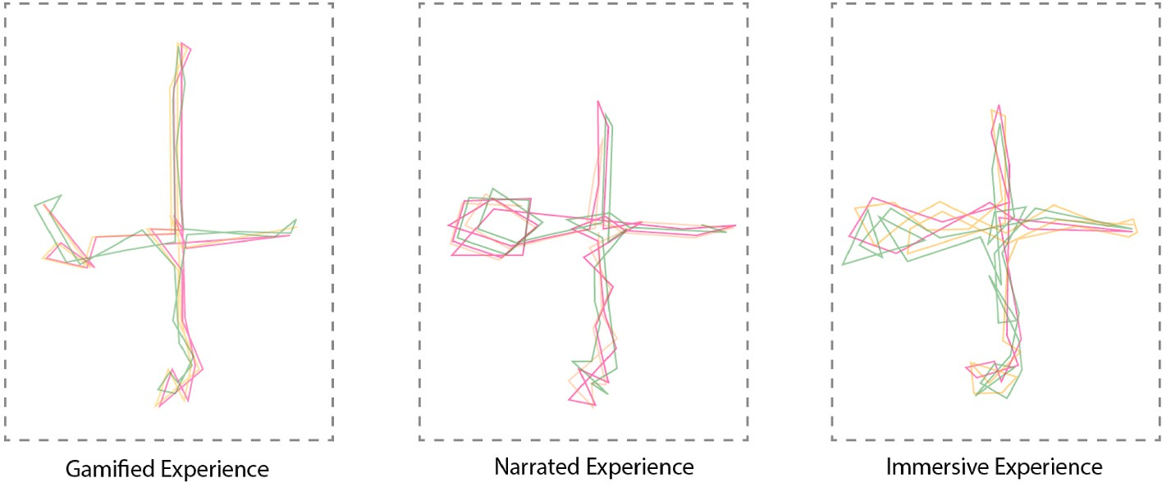

**Fig. 9.** Top view of the VR level depicts the overlapping user paths across the three scenarios.

with objects in the environment highly impacted their focus and engagement in the tasks at hand, acknowledging their active roles in shaping their experience and vice versa. This has impacted learning as the learning factor is higher in this scenario compared to the other two. Analysis indicates positive correlations between the learning factor items 1, 2, and 3 and the immersion factor item 1 with an average value of (R2 = 0.500). That suggests that memorisation of knowledge, overall learning experience, and application of knowledge gains were highly

influenced by the high focus in the tasks at hand that produced attach- ment to the experience. This high immersion was impacted by the interactivity factor, indicating that the narrative structure in this sce- nario influenced the user’s decision making through visual clarity. This

structure has also led to more consistent participants’ journeys within

the environment (Fig. 9).

* 1. *Gamified scenario (scenario 1)*

The overall analysis shows that the gamified approach that was built on top of the narrated scenario motivated participants’ navigation and engagement with artefacts and contents within the VR environment.

Findings indicate that participants were fully engaged and intrinsically motivated, leading to enhancing the learning experience as well. High correlations between the items of the immersive factor and the items of the interaction factor (Table 5) indicate that the usability of the device influenced the level of immersion, where the majority of the users thought that the interaction process was easily comprehensible. This is also supported by high correlations between the learning factor and the interaction factor, indicating that the interactivity level of the environ- ments influenced the extent to which the users applied the gained knowledge in the environment such as through puzzles solving. Overall,

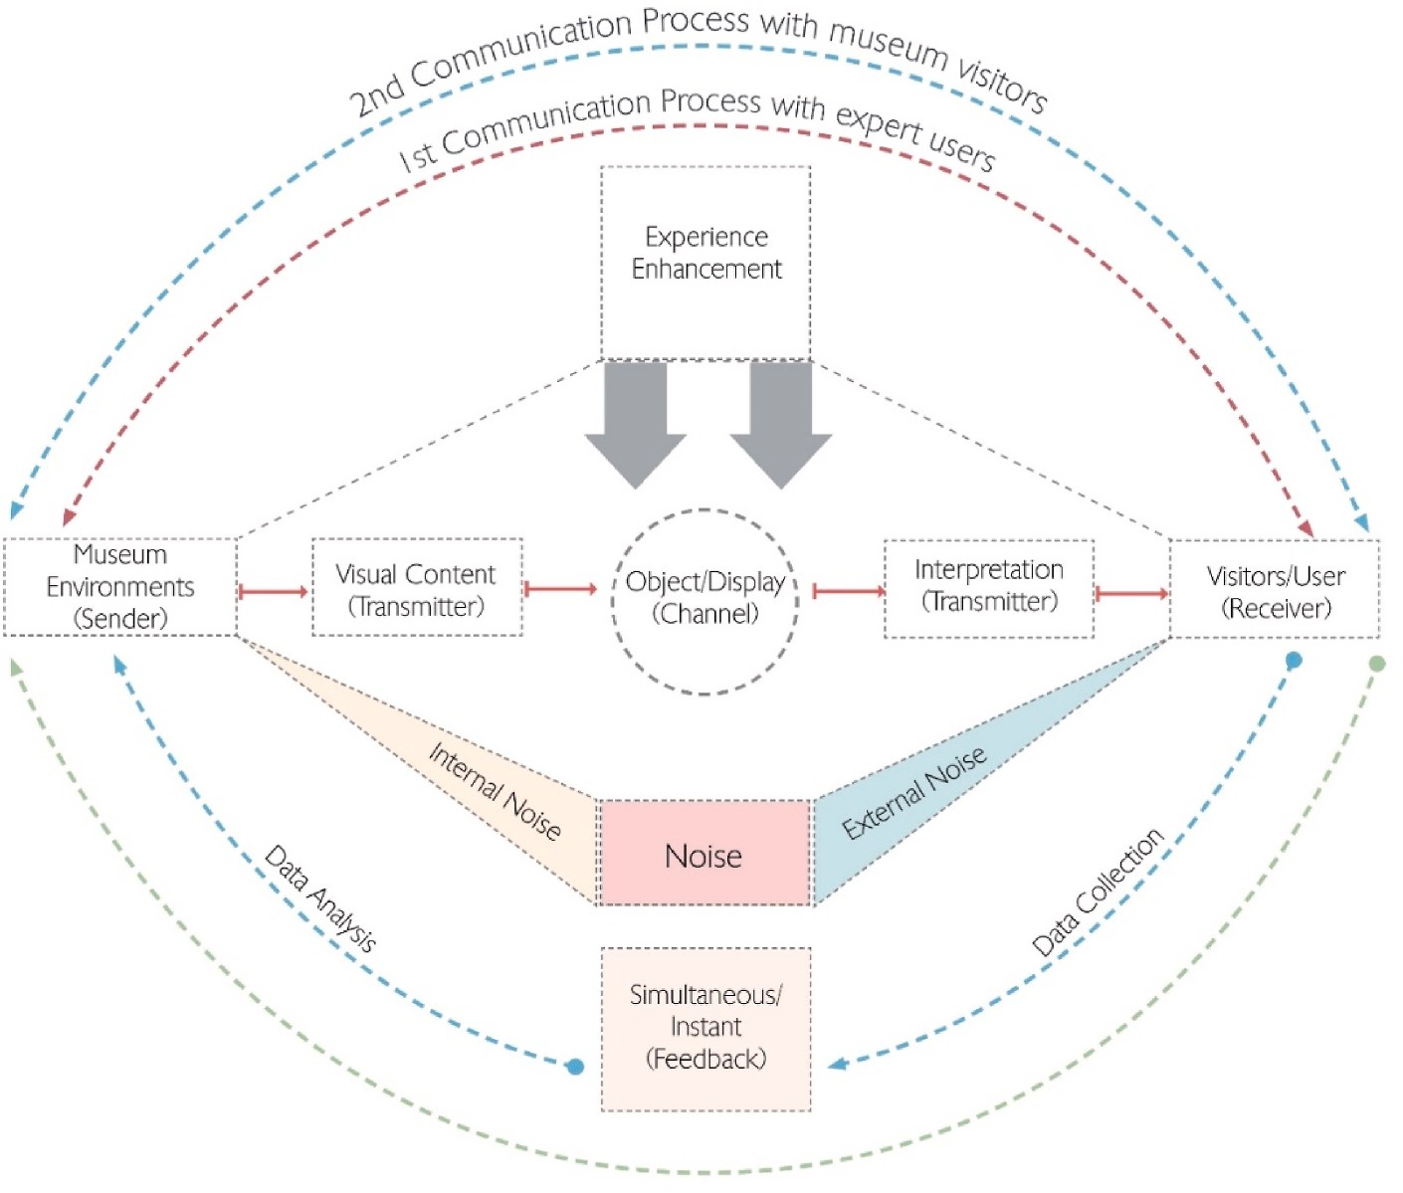

**Fig. 10.** The interpretation process enhancement based on informative dialogue exchange between the users and the heritage object using the study VR commu- nication model.

the data sets indicate a good model fit was achieved under the gamified scenario. The overlapping user pathways (Fig. 9) were more consistent in the gamified scenario compared to the other two scenarios. Correla- tion analysis shows that there are sufficient correlations between the learning factor and the immersion factor, indicating that the gamified

activities increased the user’s overall knowledge during the navigation process. Similarly, sufficient correlations are achieved between the

interaction factor and the immersion factor that suggest that the inter- activity of the virtual artefacts and the associated gamified activities influenced participant engagement with the virtual tasks leading to higher immersion compared to the default immersive scenario. The immersion and interaction factors of the gamified scenarios are lower than the narrated version. Based on the correlation analysis of the three scenarios, the level of interactivity highly influenced immersion which suggests that a good balance of interactivity is required to remove any

“noise” from the complexity of control devices for navigation. The additional interactions required for puzzle solving may have impacted

the level of immersion as participants may break their focus to get the

**Table 9**

General correlations results highlighted the differences between the scenarios factors.

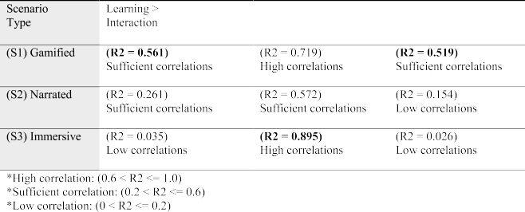

virtual actions correct. Nonetheless, the learning factor mean is much higher than the other scenarios, which demonstrates the value of gamified interactions in such an environment. Future work can include a more comprehensive tutorial session for on boarding users to the con- troller’s features.

* 1. *Overall findings*

This section discusses how the communication model has helped inform the design and development of the experiences, including in- sights into how the communication process in the context of museum environments can be improved. The proposed VR communication model implemented in the scenarios demonstrates the interpretation process for participants whilst navigating the VR environments. Fig. 10 illus- trates the communication feedback loops based on engagement with the expert and public users towards enhancing the VR experience for the end users.

The pilot experiment data was first taken to optimise the experiments further for the end users. Then the public users managed to expire the enhanced version at the Transport Museum. Two loops were taken to improve the final experience for the end users based on the mean and significance value from each experiment as described in section 4. VR instruments are the central core of communication in this model, where the loop starts by transmitting the contents from the HMD to the end users as a signal entity of information. Then the signal is decoded ac-

cording to the user’s comprehension ability on interpreting the data. To elaborate further, the information can be transmitted in frequency form

as a sequence of visual entities, where each signal encompasses a sig- nificant fact about the subject matter and the total signal quantity forms a chain of information. This chain of information holds the key factor towards envisaging the heritage contents that museum professionals are looking to tell. Visual clarity is associated with the signal transmission consistency between the sender and the receiver as it represents the narratives. However, the data shows that the information can be affected

by external or internal noise during the transition process. The study tried to reduce such effects by conducting experiments away from the visitor’s pathway for the chosen testing location. Consequently, the

visitors managed to experience a higher level of immersion due to the

reduced amount of distraction.

Acknowledging that effective communication of engineering heri- tage to visitors requires accuracy in terms of preserving and con- textualising its contents, this study found positive outcomes from representing heritage objects and their context through the use of sto- rytelling and gamification principles. The analysis shows that engage- ment and immersion among participants during the visiting experience were encouraged. Specifically, the game’s visual aesthetics, com-

plemented by the storytelling approach, evoked an atmospheric sensa-

tion for users while navigating. This was evident in the visitors’ positive response, demonstrating strong indications on their learning experience,

particularly under gamified and narrated scenarios. These elements facilitated motivation during the interaction process and allowed in- dividuals to process information coherently. Additionally, the gamifi- cation element helped users perceive a sense of accomplishment upon achieving certain objectives in the game.

The use of 6DOF technology in VR applications when paired with storytelling and gamification approaches has been found to significantly increase users’ immersion and engagement compared to the one

without. Research by Shim (2023) suggests that the type of VR appli-

cation and the involvement of advanced sensorial channels in the interaction process can influence the level of immersion experienced by users. The gamified scenarios adds another layer of interactions that were contextualised as quest mechanics within the environment that include star collecting and puzzle solving. Shehade and Stylianou-Lambert (2020) argue that advanced VR interactions can

result in positive effects on users’ sensory immersion, which can improve their ability to comprehend new knowledge while engaging

with the content. The study echoes Jonassen (2013) conclusions that using VR as a learning tool can stimulate users’ imagination and result in a more meaningful learning experience by perceiving content aestheti-

cally. This highlights the connection between the level of immersion perceived in VR and individuals’ mental awareness of their surround- ings. The use of gamification and narrative together adds more context

and active participation in the environments, providing a more guided navigation within the environment while building the stories around the heritage objects and contents.

The data collected from users of the experiments indicate that they were able to experience a sense of escapism while fully engaged with the subject matter. This suggests that this approach can bring visitors to experience events that are difficult to replicate and envisage in museum environments. Additionally, users became fully attached to the visual elements related to the engineering heritage object, which were evoked through the VR experience, and were less aware of their physical sur- roundings. The sense of escapism experienced by users while fully engaged with the subject matter can bring visitors back to experiencing events that are challenging to replicate and envisage in museum environments.

# Conclusion

This paper presented a VR framework solution towards enhancing user experience in virtual museum environments with the assistance of immersive technology. Three scenarios were developed using Unreal Engine towards facilitating a better interpretation of the heritage object. Overall, the study shows that the use of such an approach encourages users’ learning ability and memorisation inside virtual environments,

especially under gamified and narrated scenarios. Additionally, the

utilised gamified storytelling strategies can evoke individual motiva- tions towards accomplishing the experiment’s tasks, indicating that the visual narratives structured within the game flow help individuals to

progress through a sequence of events. On the other hand, the absence of

interaction and narratives have reduced participants’ ability to

comprehend the observed contents due to the lack of constructive guidance while navigating in VR environments. One of the technical constraints in this study is related to the visual aesthetics quality, which was limited by the hardware capabilities. The chosen HMD Quest 2 processor has a capacity to handle a specific number of 3D elements, and surpassing these limits can overload the processor, leading to glitches and program failure.

Despite the technical challenges accrued during the navigation pro- cess for non-expert users, adaptation is still possible if the manipulation methods were sufficient enough to facilitate an intuitive experience. Thus, constructing appropriate VR experiences can formulate a comprehensive state of immersion to actively participate in the past through the headset lenses and control devices.

# Statements on open data and ethics

Two ethical approvals were granted for this study before proceeding with participant recruitment and experiment testing in public spaces from both institutions: Deakin University and Coventry University. In this study, the participants were protected by hiding their personal in- formation. They were voluntary and understood that they could with- draw from the experiment at any time. The data can be provided upon requests by contacting the corresponding author.

# Declaration of competing interest

The authors declare that they have no known competing financial interests or personal relationships that could have appeared to influence the work reported in this paper.

# Acknowledgements

Financial support was granted for this project under a collaborative doctoral Cotutelle programme between Deakin University and Coventry University and technical support was also received from the Game- Changers Initiative. Special thanks to the associated contributors to the research: Ben Horan and Meghan Kelly at Deakin University, and Neil Forbes and Jacqueline Cawston at Coventry University for their assis- tance and advice throughout the investigation period.

# References

Arnab, S., & Clarke, S. (2017). Towards a trans-disciplinary methodology for a game- based intervention development process. *British Journal of Educational Technology, 48*

(2), 279–312. <https://doi.org/10.1111/bjet.12377>

Bachiller, C., Monzo, J. M., & Rey, B. (2023). Augmented and virtual reality to enhance the didactical experience of technological heritage museums. *Applied Sciences, 13*, 3539. <https://doi.org/10.3390/app13063539>

Bagozzi, R. P., & Yi, Y. (2012). Specification, evaluation, and interpretation of structural equation models. *Journal of the Academy of Marketing Science, 40*, 8–34. [https://doi.](https://doi.org/10.1007/s11747-011-0278-x) [org/10.1007/s11747-011-0278-x](https://doi.org/10.1007/s11747-011-0278-x)

Baker, K. (2005). Why engineering heritage matters. *Australian Journal of Multi- Disciplinary Engineering, 3*(1), 1–10. [https://doi.org/10.1080/](https://doi.org/10.1080/14488388.2005.11464727)

[14488388.2005.11464727](https://doi.org/10.1080/14488388.2005.11464727)

[Bozzelli, G., Raia, A., Ricciardi, S., De Nino, M., Barile, N., Perrella, M., Tramontano, M.,](http://refhub.elsevier.com/S2949-6780(23)00034-X/sref5) [Pagano, A., & Palombini, A. (2019). An integrated VR/AR framework for user-](http://refhub.elsevier.com/S2949-6780(23)00034-X/sref5) [centric interactive experience of cultural heritage: The ArkaeVision project. *Digital*](http://refhub.elsevier.com/S2949-6780(23)00034-X/sref5)[*Applications in Archaeology and Cultural Heritage, 15*, Article e00124](http://refhub.elsevier.com/S2949-6780(23)00034-X/sref5).

Cheng, M.-T.&S., Hsiao-Ching, & Annetta, L. (2014). Game immersion experience: Its hierarchical structure and impact on game-based science learning. *Journal of Computer Assisted Learning, 31*. <https://doi.org/10.1111/jcal.12066>

Cudny, W., & Jolliffe, L. (2019). Car tourism – conceptualization and research advancement. *Geografický C*ˇ*asopis - Geographical Journal, 71*. [https://www.sav.](https://www.sav.sk/journals/uploads/12200937Cudny%2C%20Jolliffe.pdf)

[sk/journals/uploads/12200937Cudny,%20Jolliffe.pdf](https://www.sav.sk/journals/uploads/12200937Cudny%2C%20Jolliffe.pdf).

[Deterding, S., Dixon, D., Khaled, R., & Nacke, L. (2011). From game design elements to](http://refhub.elsevier.com/S2949-6780(23)00034-X/sref8) [gamefulness: Defining “gamification. In *Paper presented at the proceedings of the 15th*](http://refhub.elsevier.com/S2949-6780(23)00034-X/sref8)[*international academic MindTrek conference: Envisioning future media environments*.](http://refhub.elsevier.com/S2949-6780(23)00034-X/sref8)

[tampere: Finland](http://refhub.elsevier.com/S2949-6780(23)00034-X/sref8).

Ebnali, M., Lamb, R., Fathi, R., & Hulme, K. (2021). Virtual reality tour for first-time users of highly automated cars: Comparing the effects of virtual environments with different levels of interaction fidelity. *Applied Ergonomics, 90*, Article 103226. <https://doi.org/10.1016/j.apergo.2020.103226>

Falk, J. H., & Dierking, L. D. (2013). *The museum experience revisited* (1st ed.). Routledge. <https://doi.org/10.4324/9781315417851>

[Jonassen, D. H. (2013). Transforming learning with technology: Beyond modernism and](http://refhub.elsevier.com/S2949-6780(23)00034-X/sref12) [post-modernism, or whoever controls the technology creates the reality. In](http://refhub.elsevier.com/S2949-6780(23)00034-X/sref12)

[M. P. Clough, J. K. Olson, & D. S. Niederhauser (Eds.), *The nature of technology* (pp.](http://refhub.elsevier.com/S2949-6780(23)00034-X/sref12) [101–110). Brill Sense](http://refhub.elsevier.com/S2949-6780(23)00034-X/sref12).

Karahan, S., & Gül, L. F. (2021). Mapping current trends on gamification of cultural

heritage. In O¨ . Cordan, D. A. Dinçay, Ç. Yurdakul Toker, E. B. O¨ ksüz, & S. Semizog˘lu (Eds.), *Game* + *design education. Springer series in design and innovation* (Vol. 13).

Cham: Springer. <https://doi.org/10.1007/978-3-030-65060-5_23>.

[Kusuma, G. P., Wigati, E. K., Utomo, Y., & Putera Suryapranata, L. K. (2018). Analysis of](http://refhub.elsevier.com/S2949-6780(23)00034-X/sref14)

[gamification models in education using MDA framework. *Procedia Computer Science,*](http://refhub.elsevier.com/S2949-6780(23)00034-X/sref14)[*135*, 385–392](http://refhub.elsevier.com/S2949-6780(23)00034-X/sref14).

Kyriakou, P., & Hermon, S. (2019). Can I touch this? Using natural interaction in a

museum augmented reality system. *Digit. Appl. Archaeol. Cult. Herit., 12*, Article e00088. <https://doi.org/10.1016/j.daach.2018.e00088>

[Lamb, R., & Firestone, J. (2022). The moderating role of creativity and the effect of](http://refhub.elsevier.com/S2949-6780(23)00034-X/sref16) [virtual reality on stress and cognitive demand during preservice teacher learning.](http://refhub.elsevier.com/S2949-6780(23)00034-X/sref16) [*Computers & Education: X Reality, 1*, Article 100003](http://refhub.elsevier.com/S2949-6780(23)00034-X/sref16).

Lee, H., Jung, T. H., tom Dieck, M. C., & Chung, N. (2020). Experiencing immersive virtual reality in museums. *Information & Management, 57*(5), Article 103229. <https://doi.org/10.1016/j.cexr.2022.100003>

Lee, H., Jung, T., Tom, D., Claudia, M., & Chung, N. (2020). Experiencing immersive virtual reality in museums. *Information & Management, 57*, Article 103229. [https://](https://doi.org/10.1016/j.im.2019.103229) [doi.org/10.1016/j.im.2019.103229](https://doi.org/10.1016/j.im.2019.103229)

Liu, S., & Idris, M. Z. (2019). Exploring museum service experience using gamification- based personas with distinct motivations. *IOP Conference Series: Materials Science and Engineering, 573*, Article 012020. [https://doi.org/10.1088/1757-899X/573/1/](https://doi.org/10.1088/1757-899X/573/1/012020)

[012020](https://doi.org/10.1088/1757-899X/573/1/012020)

Parker, E., & Saker, M. (2020). Art museums and the incorporation of virtual reality: Examining the impact of VR on spatial and social norms. *Convergence, 26*(5–6), 1159–1173. <https://doi.org/10.1177/1354856519897251>

[Petersons, A., & Khalimzoda, I. (2016). ’Communication models and common basis for](http://refhub.elsevier.com/S2949-6780(23)00034-X/sref21) [multicultural communication in Latvia’. SOCIETY. INTEGRATION. EDUCATION. In](http://refhub.elsevier.com/S2949-6780(23)00034-X/sref21)

[*Proceedings of the international scientific conference* (Vol. 4, p. 423)](http://refhub.elsevier.com/S2949-6780(23)00034-X/sref21).

[Putria, A., & Nurhadi, M. (2020). Dramatic elements in Dashner’s maze runner novel and](http://refhub.elsevier.com/S2949-6780(23)00034-X/sref22) [film adaptation. *Anaphora. J. Lang. Literary Cult. Stud., 2*, 80–88](http://refhub.elsevier.com/S2949-6780(23)00034-X/sref22).

Rizvic, S., Boskovic, D., Bruno, F., Petriaggi, B. D., Sljivo, S., & Cozza, M. (2019). Actors

in VR storytelling. In *2019 11th international conference on virtual worlds and games for serious applications* (pp. 1–8). Vienna, Austria: VS-Games). [https://doi.org/10.1109/](https://doi.org/10.1109/VS-Games.2019.8864520) [VS-Games.2019.8864520](https://doi.org/10.1109/VS-Games.2019.8864520).

[Rizvi´c, S., Boˇskovi´c, D., Okanovi´c, V., Kihi´c, I. I., Prazina, I., & Mijatovi´c, B. (2021). *Time*](http://refhub.elsevier.com/S2949-6780(23)00034-X/sref24)[*travel to the past of Bosnia and Herzegovina through virtual and augmented reality*](http://refhub.elsevier.com/S2949-6780(23)00034-X/sref24).

Shehade, M., & Stylianou-Lambert, T. (2020). Virtual reality in museums: Exploring the experiences of museum professionals. *Applied Sciences, 10*, 4031. [https://doi.org/](https://doi.org/10.3390/app10114031) [10.3390/app10114031](https://doi.org/10.3390/app10114031)

Shim, J. (2023). Investigating the effectiveness of introducing virtual reality to elementary school students’ moral education. *Computers & Education: X Reality, 2*, Article 100010. <https://doi.org/10.1016/j.cexr.2023.100010>. ISSN 2949-6780.

Tcha-Tokey, K., Loup-Escande, E., Christmann, O., Canac, G., Farin, F., & Richir, S. (2015). Towards a user experience in immersive virtual environment model: A review. In *Proceedings of the 27th conference on l’Interaction homme-machine (IHM ’15)* (pp. 1–6). New York, NY, USA: Association for Computing Machinery. [https://](https://doi.org/10.1145/2820619.2825006)

[doi.org/10.1145/2820619.2825006](https://doi.org/10.1145/2820619.2825006), 26.

[Vrettakis, E., Kourtis, V., Katifori, A., Karvounis, M., Lougiakis, C., & Ioannidis, Y.](http://refhub.elsevier.com/S2949-6780(23)00034-X/sref28) [(2019). Narralive – creating and experiencing mobile digital storytelling in cultural](http://refhub.elsevier.com/S2949-6780(23)00034-X/sref28) [heritage. *Digital Applications in Archaeology and Cultural Heritage, 15*, Article e00114](http://refhub.elsevier.com/S2949-6780(23)00034-X/sref28).

Wei, Z., Zhang, J., Huang, X., & Qiu, H. (2023). Can gamification improve the virtual reality tourism experience? Analyzing the mediating role of tourism fatigue. *Tourism Management, 96*, Article 104715. <https://doi.org/10.1016/j.tourman.2022.104715>

[Weng, L., Liang, Z., & Bao, J. (2020). The effect of tour interpretation on perceived](http://refhub.elsevier.com/S2949-6780(23)00034-X/sref30) [heritage values: A comparison of tourists with and without tour guiding](http://refhub.elsevier.com/S2949-6780(23)00034-X/sref30) [interpretation at a heritage destination. *Journal of Destination Marketing &*](http://refhub.elsevier.com/S2949-6780(23)00034-X/sref30)[*Management, 16*, Article 100431](http://refhub.elsevier.com/S2949-6780(23)00034-X/sref30).

[Zhou, Y., Chen, J., & Wang, M. (2022). A meta-analytic review on incorporating virtual](http://refhub.elsevier.com/S2949-6780(23)00034-X/sref31) [and augmented reality in museum learning. *Educational Research Review, 36*, Article](http://refhub.elsevier.com/S2949-6780(23)00034-X/sref31) [100454 [CrossRef] A meta-analytic review on incorporating virtual and augmented](http://refhub.elsevier.com/S2949-6780(23)00034-X/sref31) [reality in museum learning - ScienceDirect](http://refhub.elsevier.com/S2949-6780(23)00034-X/sref31).