

[Egyptian Informatics Journal (2015) 16, 1–7](http://dx.doi.org/10.1016/j.eij.2014.11.001)

Cairo University

Egyptian Informatics Journal

[www.elsevier.com/locate/eij](http://www.elsevier.com/locate/eij) [www.sciencedirect.com](http://www.sciencedirect.com/science/journal/11108665)

ORIGINAL ARTICLE

Cross-Layer Design Approach for Power Control in Mobile Ad Hoc Networks



A. Sarfaraz Ahmed a,1, T. Senthil Kumaran b,*, S. Syed Abdul Syed a,1,

S. Subburam b

a *AMET University, Chennai, Tamil Nadu, India*

b *ACS College of Engineering, Bangalore, Karnataka, India*

Received 12 January 2014; revised 27 October 2014; accepted 5 November 2014

Available online 15 December 2014

Abstract In mobile ad hoc networks, communication among mobile nodes occurs through wireless medium The design of ad hoc network protocol, generally based on a traditional ‘‘layered approach’’, has been found ineffective to deal with receiving signal strength (RSS)-related problems, affecting the physical layer, the network layer and transport layer. This paper proposes a design approach, deviating from the traditional network design, toward enhancing the cross-layer interac- tion among different layers, namely physical, MAC and network. The Cross-Layer design approach for Power control (CLPC) would help to enhance the transmission power by averaging the RSS val- ues and to find an effective route between the source and the destination. This cross-layer design approach was tested by simulation (NS2 simulator) and its performance over AODV was found to be better.



1. Introduction

KEYWORDS

RSS; AODV; CLPC

* Corresponding author.

E-mail addresses: [asarfarazahmed@gmail.com](mailto:asarfarazahmed@gmail.com) (A. Sarfaraz Ahmed), [senthilvts@gmail.com](mailto:senthilvts@gmail.com) (T. Senthil Kumaran), [saeedabdul4u@gmail.](mailto:saeedabdul4u@gmail.com) [com](mailto:saeedabdul4u@gmail.com) (S. Syed Abdul Syed), [subburam.kayal@gmail.com](mailto:subburam.kayal@gmail.com) (S. Subburam).

1 Research Scholar.

Peer review under responsibility of Faculty of Computers and Information, Cairo University.

**Production and hosting by Elsevier**

A mobile ad hoc network is a collection of wireless nodes that can transfer data without the use of network infrastructure or administration. Such networks have many potential applica- tions, including in disaster mitigation, defense, health care, academia and business. In such a network, every node acts both as a host and a router.

A major limitation with mobile nodes is that they have high mobility, causing links to be frequently broken and reestab- lished. Moreover, the bandwidth of a wireless channel is also limited, and nodes operate on limited battery power, which will eventually be exhausted. Therefore, the design of a mobile ad hoc network is highly challenging, but this technology has

<http://dx.doi.org/10.1016/j.eij.2014.11.001>

1110-8665 © 2014 Production and hosting by Elsevier B.V. on behalf of Faculty of Computers and Information, Cairo University. This is an open access article under the CC BY-NC-ND license [(http://creativecommons.org/licenses/by-nc-nd/4.0/).](http://creativecommons.org/licenses/by-nc-nd/4.0/)

high prospects to be able to manage communication protocols of the future [1].

A wireless ad hoc network works on the principle of one-hop neighbor node broadcasting, in which a transmission signal from the source node propagates to all neighbor nodes within its communication region [2]. Transmission power- related problems are a common feature affecting the function- ing of wireless ad hoc networks. The inability to maintain a steady transmission power, thus, degrades the transmission range and signal strength, and hence the reliability of wireless ad hoc networks is disputed [3,4].

At the transport layer, the node interference affects the level of transmission power and causes network congestion. In such networks, TCP-supported congestion control has been unreli- able, the well known transport protocols, such as UDP are unreliable, since no mechanism of congestion detection has been provided. Even TCP supported control is unreliable [5–8]. Transmission power-related problems can affect all the lay- ers of the stack, from physical to transport, and include the fol- lowing: (i) long delay, (ii) packet losses and (iii) low throughput. Previously, the design of ad hoc network protocol has been largely based on the ‘‘layered approach’’. In layered architec- ture, the designer or implementers of the protocol or algorithm focuses on a particular layer, without being required to con- sider the parameters of the rest of the stack [1,9,10]. However, this has generally resulted in suboptimal performance of appli- cations. To overcome this, the ‘‘cross-layer’’ approach has been found to address transmission power-related issues in

wireless ad hoc networks.

The cross-layer design deviates from the traditional net- work design approach in which each layer of the stack would be made to operate independently. A workgroup of the Internet Engineering Task Force [1,11] has been studying inter-layer interactions and performances in mobile ad hoc net- works. The inter-layer interaction metrics and the benefits of information exchange among the lower layers, network layer and transport layer were also reported.

In this paper, a new cross-layer optimization framework is proposed that gathers information about a node’s receiver sig- nal strength (RSS) by using hello packet. Using a dynamic transmission power control mechanism, every node computes minimum RSS, average RSS and maximum RSS. This infor- mation can help each node to know its neighbor positions and guide it to dynamically manage its power levels. As a result, optimal transmission power and reliable communica- tion range can be achieved.

The remainder of this paper is organized as follows. The cross-layer design approach is presented in section 3. NS2 sim- ulation results are presented in Section 4. Section 5 concludes this paper.

1. Related work

Conti et al. [10] discuss that protocols belonging to different layers can cooperate by sharing the network status informa- tion but at the same time maintaining the separation of layers for protocol design.

Al-Khwildi et al. [12] have proposed a routing protocol called Adaptive Link-Weight (ALW), which selects an optimum route based on low delay, long route time and avail- able bandwidth. The technique adapts a cross-layer framework

where the ALW is integrated with application and physical layer. This design allows applications to convey preferences to the ALW protocol so as to override the default path selec- tion mechanism.

Addressing the issues related to transmission power, Rama- chandran and Shanmugavel [13] have proposed a cross-layer design approach for power conservation based on transmission power control.

Mahlknecht et al. [14] have introduced a method called Energy Aware Distance Vector Routing for Wireless Sensor Networks, which would decrease the impact of mobility and link disconnection. This method relies on route failure notification and route reestablishment notification from the intermediate nodes.

Sergi et al. [15] have also discussed a novel architecture for cooperative communication in wireless ad-hoc networks capa- ble of offering reliable and low-latency services efficiently.

Xia et al. [16] have demonstrated that layer triggers are not sufficient to fix ad hoc network problems due to TCP–IP– MAC interactions.

Sangman Moh [17] proposed a link quality aware routing protocol for MANETs that exploits the strong links by for- warding the RREQ packet with the highest Signal to Noise Ratio (SINR) among the multiple RREQ packets received during route discovery. The performance of the protocol is not appealing in high mobility scenarios.

Sakhaee et al. [18] proposed a self-adaptive and mobility- aware path selection in mobile ad-hoc networks. The limita- tion of this protocol is that it cannot perform on high mobility scenarios.

Qi and Chakrabarti [19] proposed a routing protocol, tak- ing the node power as the major consideration when selecting paths. In their protocol, either link failure or a too low value in node power may trigger route maintenance.

Qin and Kunz [20] proposed a link breakage prediction algorithm by using signal power strength for DSR protocol. This technique used speed of the node which helped to antici- pate link break.

1. Cross-layer design framework

The proposed cross-layer optimization framework allows modification of transmission power to be made at physical layer after knowing a node’s one-hop neighbor’s RSS informa- tion. The modified transmission power will help that node to dynamically vary its propagation range at the physical layer. This is because the propagation distance is always directionally proportional to transmission power. This information is passed from the physical layer to the network layer so that it can take optimal decisions in routing protocols. A major advantage of this framework is that it allows access of information between physical layer and top layers (MAC and network layer). Fig. 1 illustrates the cross-layer interaction between lower and higher layers.

* 1. *Dynamic transmission power control*

Much of work on power management protocols for mobile ad hoc networks is yet to reflect in the literature. Without an effective transmission power control mechanism in place, packet transmissions can be affected by link instability, weak

transmission distance (Weak RSS can cover maximum transmission distance). AMin_RSS covers the maximum com- munication region, while Amax_RSS covers the minimum communication region. Fig. 2 illustrates the communication regions based on neighbors’ RSS values.

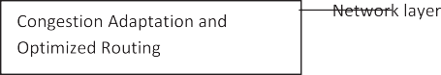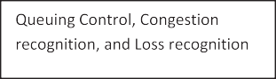

Figure 1 Cross-layer interaction between lower layers and higher layers.

Algorithm 1: Adjusting transmission power control

1. Node initiates Hello packet for gathering Neighbors RSS value
2. Get number of neighbors and their RSS value
3. Receiving node checks its routing table neighbors RSS value
4. If value present

Update routing table

1. Else

Store as a new value

1. Calculate Average of RSS
2. If neighbors RSS value < Average RSS

Find Lower Average value say AMin_RSS

1. Else if neighbors RSS value > Average RSS Find Upper Average value say AMax_RSS.
2. Segregate three Transmission regions
   1. Average of RSS region
   2. Amax_RSS region
   3. Amin_RSS region
3. Every node adjusts its transmission Power based on Amax_RSS val

of receiving signal strength (RSS) and, network interference. As noted above, the quality of RSS always depends on a broadcasting node’s transmission power. It is known that the broadcasting signal from one node travels omnidirectionally to its 1-hop neighbors.

This paper assumes that all nodes have the same propaga- tion range, which can be altered depending on the 1-hop neigh- bors’ coverage. The node’s receiving signal strength has taken from MAC layer. This information helps to decide whether a current node is placed either in high or low signal strength area. After computing the RSS, the node broadcasts this infor- mation to its 1-hop neighbors by hello packets (see Algorithm 1). These hello packets will also help to update all nodes’ RSS in the routing table. Then, each node computes the average of its neighbors’ RSS values and determines three communication regions (minimum range, average range and maximum range). Eqs. (1)–(3) are used to find three threshold values (AMin_RSS, AMax_RSS, and A_RSS). Let n be the number of 1-hop neighbors of node *X*i and let RSSi represent the receiving signal strength of all neighbors of node *X*i: Average

RSS(A_RSS) of neighbors computed as follows:

* 1. *Primary route discovery*

The main objective of routing protocols in ad hoc networks is to find the shortest path between the source and the destina- tion. A majority of routing protocols are able to choose the shortest path but not a reliable path, because these routing protocols do not consider neighbor’s RSS value. To overcome this limitation, as well as to reduce unnecessary RREQ packets and save network resources (link, buffer, battery), in this

Pn RSSi

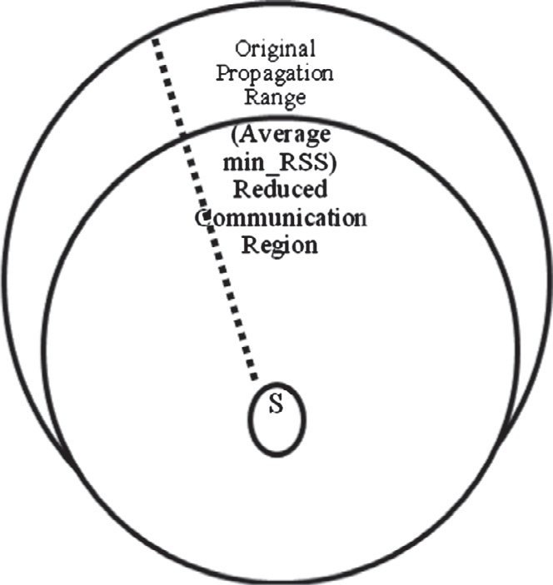

A RSS = i=1

*n*

(1)

From two sets of nodes––Min_node (minimum RSS neigh- bors which is less than A_RSS) and Max_node (maximum RSS neighbors which is greater than A_RSS)––two averages, AMin_RSS and AMax_RSS, for both sets are computed as follows.

Min node

P RSSi

A Min RSS = i=1 ; where RSSi < A RSS (2)

Min node

Max node

P RSSi

A Max RSS = i=1 ; where RSSi > A RSS (3)

Max node

Using these values (AMin_RSS, AMax_RSS and A_RSS), every node then determines its communication region. The RSS values are always in-directionally proportional to

Reduced Transmission Range  Original Communication Range

Figure 2 Classification of communication regions according to neighbor’s RSS value.

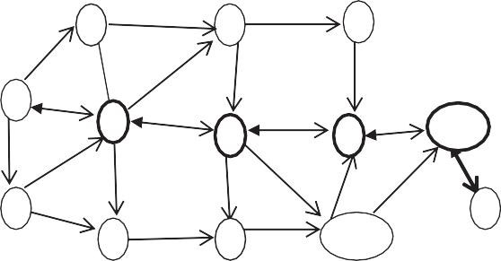

2

5

8

S

3

6

9

1

1

D

4

7

10

RREQ packet RREP packet

Figure 3 Route discovery process.

cross-layer optimization framework, every node applies a dynamic transmission power control mechanism and identifies three communication regions (minimum communication region, average communication region and maximum commu- nication region).

All nodes in the network alter their transmission power based on a maximum communication region. When a source node broadcasts a RREQ packet to its maximum communication region neighbors, the neighbors shall decide whether or not to rebroadcast the RREQ packet. In case the RREQ packet has come from a weaker node (node’s RSS value = Amin_RSS), the receiving neighbors should drop the RREQ and avoid to retransmit it. On the other hand, if RREQ packets have come from reliable nodes (node’s RSS value > Amin_RSS), these are retransmitted to the destination node, which in turn gener- ates the RREP packet and sends to the source node. Finally, the source node has identified a reliable link to the destination, which now becomes a primary route. Fig. 3 illustrates the route discovery process and Fig. 4 explains this in a flow diagram.

As in Fig. 3, the source node S broadcasts the RREQ packet to its neighbors {1, 2, 3}. Actually node 4 is a neighbor of S but not present in average maximum communication region. The source node chooses node 3 as a reliable node because it is present in maximum communication region. Then, node 3 forwards RREQ to next maximum communication region, that is node 6, which then forwards RREQ to the next maximum communication region, that is node 9, and finally to node 11, which transmits the RREQ to destination node D. Now D responds by sending a RREP packet to the source. It is to be noted that D responds only to the first RREQ packet and dupli- cate RREQ packets are discarded. The RREP follows the

reverse path of RREQ to the reach the host. Thus, the route S → 3 → 6 → 9 → 11 → D is a reliable path between the source and the destination nodes.

* 1. *Route rediscovery*

All nodes in the primary path periodically calculate their RSS values by using a dynamic transmission power control algo- rithm. If a node’s RSS value is equal to AMin_RSS, then there is a possibility an intermediate node move out of a maximum communication region, due to which a link breakage can occur. In such an event, the node preceding that intermediate node initiates a route discovery mechanism to reestablish a route to the destination. Algorithm 2 is for route rediscovery.

Figure 4 Flow diagrams for route discovery process.

Y

Is any Minimum RSS node present? In 1-

Intermediate check Destination

Forward RREQ

Y

RREQ TTL

Expires

Stop

Intermediate

Send Reply packet to

Chose Avg_RSS node from (1 – hop neighbors) list and unicast RREQ packet

Destination

NO

Chose Reliable node (lowest RSS value) and uni- cast RREQ packet

Source node initiates Route request process

All nodes in an Adhoc network, initiate Dynamic transmission power control algorithms to fix their range

N



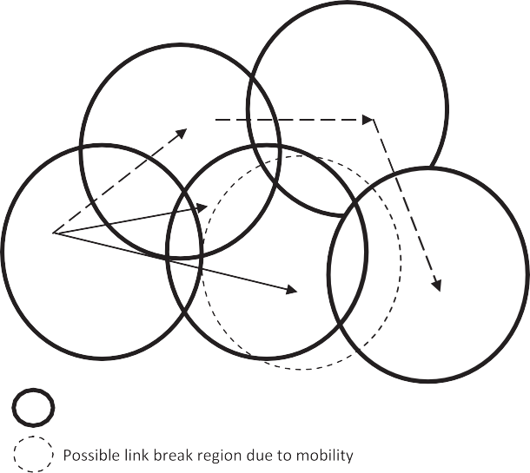

2

5

3

S

Figure 5 Route rediscovery.

In Fig. 5, node 3 moves from a primary path to a new posi- tion, say 30. The RSS value of node 3 would decrease, which is now equal to Amin_RSS of node S. As soon as node S predicts link breakage between itself and node 3, it attempts to identify another node in a maximum communication region and

reestablish a route. Now node S establishes a new route by using intermediate nodes 2 and 5. Therefore, the new primary route is S → 2 → 5 → 6 → 10 → 11 → D. In case node S is not

able to find a maximum communication region’s neighbor, it

may choose either an Avg_region node or Amin_RSS node.

Algorithm 2: Route rediscovery begin

1. Primary path node calculates RSS value using
2. Dynamic transmission power control algorithm
3. if(current RSS value == predecessor node Ave_min RSS)

/*chance of Link break*/

1. Predecessor node initiates route discovery
   1. If(alternate route found)
      1. Packet transmission through alternate route
   2. Else
      1. Continue with existing path until route break.

End

*Packet delivery ratio (PDR):* The ratio between the number of packets received by the destination and the number of pack- ets sent by the source.

*End-to-end delay:* The end-to-end delay is calculated by obtaining time delay of a packet between the transceiver.

*Routing overhead:* The total number of control packets transmitted during simulation. For packets sent over multiple hops, each transmission over one hop is counted as one transmission.

1. *2. Ns2.34 simulation configuration* *[21]*
2. Performance analysis

Network parameters Range

Speed 10–35 m/s

Load 20% network size

Packet rate 4 Packets/s

Terrain size 1000 * 1000

Max propagation range 250 m

Receiver sensitivity (Min RSS) —90 dBm (Milli watts in decibel) Mac protocol IEEE 802.11

Routing protocol CLPC,AODV

Packet size 512 bytes

Transport layer protocol UDP

Application CBR (constant bit rate)

Simulation time 900 s

Node density 100–200

Channel propagation model Two Ray Model Mobility Continues Mobility

* 1. *Performance metrics*

We considered the following important metrics for the evalua- tion by simulation:

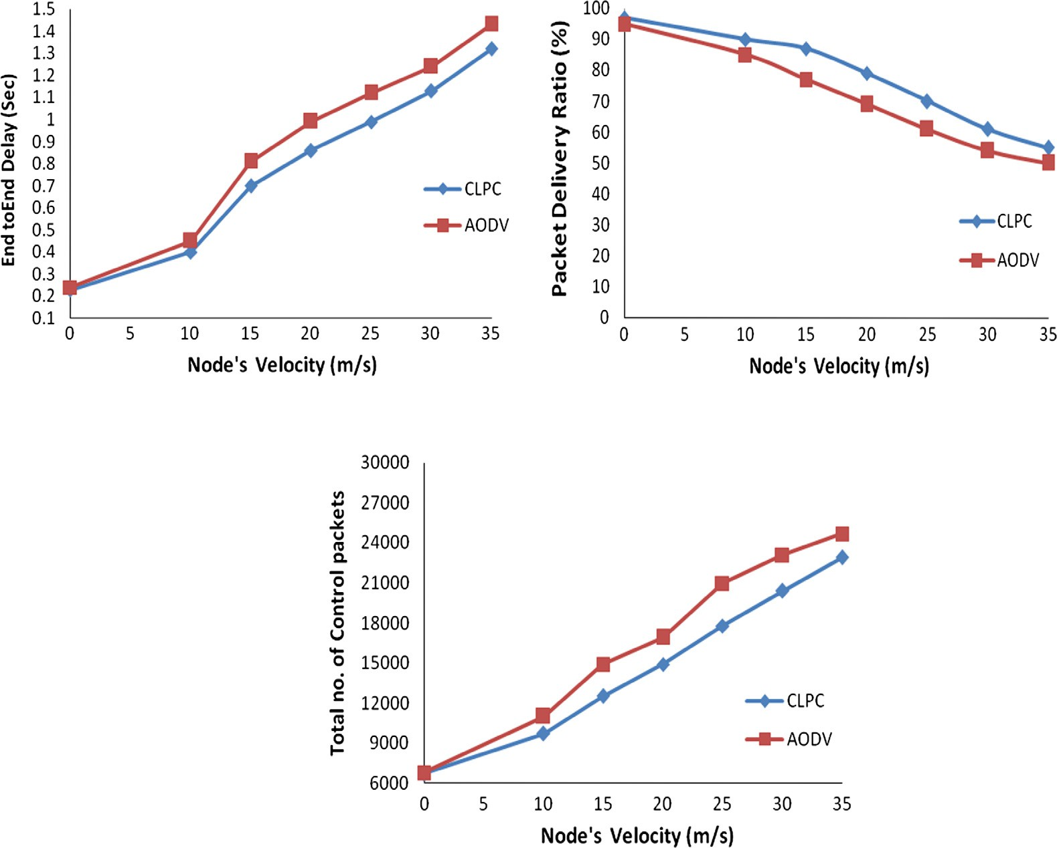

(a) End-to-end delay

(b) Packet delivery ratio

# (c) Routing Overhead

Figure 6 Performance when maximum node speed changes: 100 nodes, number of flows 20.

*4.3. Varying the node velocity*

Fig. 6 shows a comparison of end-to-end delay, packet delivery ratio and routing overhead between CLPC and AODV. When a node’s mobility was low (0–10 m/s), the delay incurred by both protocols increased almost linearly, with little variation between the two. When the speed of a node was increased from 15 to 35 m/s, link breakage occurred frequently. In AODV, after receiving a link break message, the source node would initiate a route request process to destination node, causing additional delay. However, in the proposed model (CLPC), a dynamic power control algorithm would predict if link break- age is likely to happen. In this event, the algorithm will redis- cover a new route and reestablish a route locally. Therefore, When CLPC is compared with AODV at node speed between

15 and 30 m/s, the delay is reduced by around 13% over AODV. When the speed of node was high (from 30 to 35 m/ s), the nodes were moving continuously in the network with frequent link breaks. In this situation, CLPC’s delay was reduced by around 7% than AODV.

From Fig. 6(b), the packet delivery ratio of both protocols is almost similar at normal node speed (0–10 m/s). When node speed was increased from 15 to 35 m/s, it caused frequent link breaks and data packet losses, requiring to construct a fresh route between the source and the destination. This new route discovery process is costlier because numerous RREQ packets need to be generated and transmitted, leading to network congestion.

This retransmission of RREQ packets will consume more network resources and pull down the network performance.

One reason that CLPC was able to deliver more data packets than AODV is that the former uses three transmission regions (minimum, average, maximum) based on receiver node’s signal strength, and that a source node can chose a maximum trans- mission region node for broadcasting. As a result, it had lost fewer data packets as compared with AODV. At node speed of 15–30 m/s, the packet delivery of CLPC was improved by around 12.5% than AODV. When the speed of node was very high (30–35 m/s), CLPC performed better by around 7% than AODV.

With regard to routing overhead (Fig. 6c), when the speed of the node is normal (0–10 m/s), CLPC did not seem to perform better than AODV. This is because at 10 m/s the possibility of link break is low and the new route discovery is minimized. When nodes move faster in a network (15–35 m/s), frequent link breaks happen. The AODV then initiates a new route request process by using RREQ packets. More number of RREQ pack- ets being broadcasted leads to routing overhead in a network and degrades network performance. Our proposed algorithm (CLPC) has a dynamic power control mechanism that helps all nodes to predict link breaks well in advance.

This information will support nodes to make early decisions to resolve link breaks locally. The advantage of this mecha- nism to adjust their transmission power based on node’s receiving signal strength. This helped to segregate node based on weak link node and strong link node. The RREQ packets are forwarding only from strong link node and dropped weak link node. Therefore, the routing overhead is decreased, when compare with AODV. When the speed of node was 15–30, the

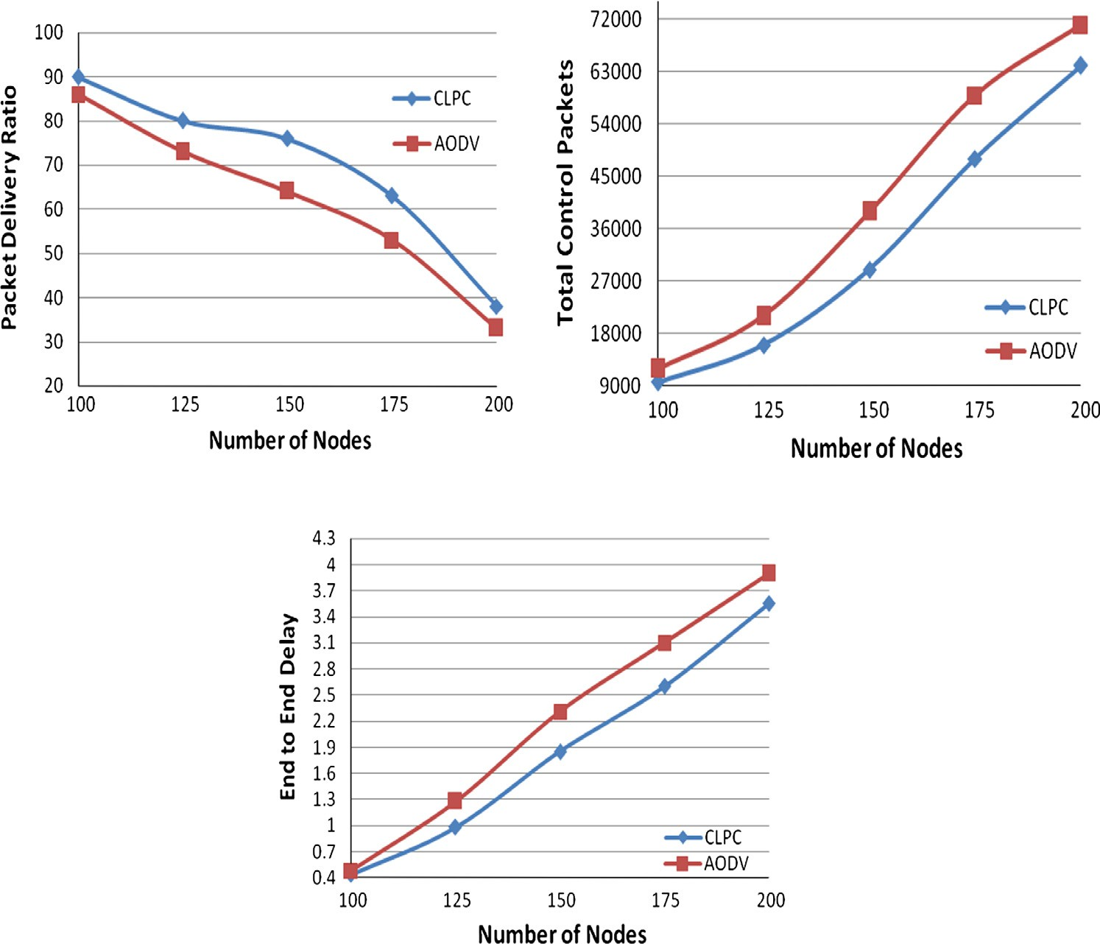

(a) Packet delivery ratio

(b) Routing overhead

# (c) End to End Delay

Figure 7 Performance when network size increases.

CLPC was consumed around 15% less control packets than AODV. When the speed of node was very high (30–35 m/s), CLPC performed better by around 9% than AODV.

*4.4. Varying network size*

It was also the objective of this study to compare the perfor- mance between small network size and large network size. Accordingly, the sizes of the networks were chosen as 100 nodes and 200 nodes with data flow in up to 20% of network size, maximum speed 10 m/s and pause time 30 s.

From Fig. 7(a), for the network with 100 nodes, the CLPC and the AODV demonstrated the least difference. Whereas, when the size of the network was increased to 175 nodes, the CLPC executes a dynamic transmission control algorithm to reduce transmission power and an alternative path discovery algorithm to reduce link breakage. That is why the packet deliv- ery ratio of CLPC improved by 10–15% than AODV. More- over, when the size of the network was increased to 200 nodes, the CLPC shows a 9% performance improvement over AODV. Fig. 7(b) compares the routing overhead between CLPC and AODV. When the size of the network is 100 nodes, the routing overhead of CLPC is considerably lesser than that of AODV. When the size of the network is increased to 175 nodes, the routing overhead was lesser by 24% than AODV. This improvement is due to the dynamic transmission power control mechanism in CLPC that helped to alter a node’s transmission power according to its RSS, which in turn would help to reduce packet collision and unnecessary rebroadcasting of control packets. Moreover, with the size of the network was increased to 200 nodes, the CLPC demonstrated around 10%

reduction in control packets than AODV.

Fig. 7(c) compares the end-to-end delay between CLPC and AODV. When the size of the network is 100 nodes, the delay variation between CLPC and AODV is minimum. When the size of the network grows to 175 nodes, the CLPC uses a dynamic power control mechanism to detect probable link breaks and quickly apply an alternative path finding mechanism. On the other hand, the AODV would respond only when a link break has actually occurred. Due to this, the delay in AODV is more than 20% that of CLPC. Moreover, when the network size is increased to 200 only nodes, the CLPC demonstrated a reduc- tion in delay by only around 9.5% than in AODV.

1. Conclusion

Link breakage can cause serious impairment in network per- formance because the cost of new route finding is very high. In traditional route finding methods, the source node (or inter- mediate node) floods the entire network with RREQ packets to obtain the new route to destination. Whereas, in the pro- posed model (CLPC), a dynamic transmission power control algorithm predicts a link breakage if likely to happen and dis- covers a new route to be updated in the routing table. Firstly, each node gathers its neighbors’ RSS and constructs three transmission (maximum, average, minimum) ranges. Secondly, each node alters its transmission power based on maximum transmission range. Since the path finding process is based on neighbor’s RSS value and transmission range, the approach

is least likely to fail. By simulation, the performance of CLPC was appreciably better than AODV in terms of end-to-dnd delay, packet delivery ratio and routing overhead.

References

1. [Srivastava V, Motani M. Cross layer design: a survey and the road](http://refhub.elsevier.com/S1110-8665(14)00035-8/h0005) [ahead. IEEE Commun Mag 2005;43(12):112–9](http://refhub.elsevier.com/S1110-8665(14)00035-8/h0005).
2. [Park Seungjin, Yoo Seong-Moo. An efficient reliable one-hop](http://refhub.elsevier.com/S1110-8665(14)00035-8/h0010) [broadcast in mobile ad hoc networks. Ad Hoc Netw 2013;11(1):19–28](http://refhub.elsevier.com/S1110-8665(14)00035-8/h0010).
3. [Goldsmith J, Wicker SB. Design challenges for energy constrained](http://refhub.elsevier.com/S1110-8665(14)00035-8/h0015) [ad-hoc wireless networks. IEEE Wireless Commun 2002;9:8–27](http://refhub.elsevier.com/S1110-8665(14)00035-8/h0015).
4. [Kawadia V, Kumar PR. Principles and protocols for power](http://refhub.elsevier.com/S1110-8665(14)00035-8/h0020) [control in wireless ad-hoc networks. IEEE J Selected Areas](http://refhub.elsevier.com/S1110-8665(14)00035-8/h0020) [Commun, Part I 2005;23(1):78–88](http://refhub.elsevier.com/S1110-8665(14)00035-8/h0020).
5. [Lochert Christian, Scheuermann Bjo¨rn, Mauve Martin. A survey](http://refhub.elsevier.com/S1110-8665(14)00035-8/h0025) [on congestion control for mobile ad-hoc networks. Wireless](http://refhub.elsevier.com/S1110-8665(14)00035-8/h0025) [Commun Mob Comput 2007;7(5):655–76](http://refhub.elsevier.com/S1110-8665(14)00035-8/h0025).
6. [Senthilkumaran T, Sankaranarayanan V. Dynamic congestion](http://refhub.elsevier.com/S1110-8665(14)00035-8/h0030) [detection and control routing in ad hoc networks. J King Saud](http://refhub.elsevier.com/S1110-8665(14)00035-8/h0030) [Univ – Comput Inform Sci 2013;25(1):65–175](http://refhub.elsevier.com/S1110-8665(14)00035-8/h0030).
7. [Senthilkumaran T, Sankaranarayanan V. Early congestion detec-](http://refhub.elsevier.com/S1110-8665(14)00035-8/h0035) [tion and adaptive routing in MANET. Egypt Inform J](http://refhub.elsevier.com/S1110-8665(14)00035-8/h0035) [2011;12(3):165–75](http://refhub.elsevier.com/S1110-8665(14)00035-8/h0035).
8. Senthilkumaran T, Sankaranarayanan V. Early detection conges- tion and control routing in MANET. In: Proceedings of the seventh IEEE and IFIP international conference on wireless and optical communications networks (WOCN 2010). p. 1–5.
9. [Foukalas Fotis, Vangelis Gazis, Alonistioti Nancy. University of](http://refhub.elsevier.com/S1110-8665(14)00035-8/h0045) [Athens, cross-layer design proposals for wireless mobile networks: a](http://refhub.elsevier.com/S1110-8665(14)00035-8/h0045) [survey and taxonomy. IEEE Commun Surv Tutor 2008;10(1):70–84](http://refhub.elsevier.com/S1110-8665(14)00035-8/h0045).
10. [Conti M, Maselli G, Turi G. Cross-layering in mobile ad-hoc](http://refhub.elsevier.com/S1110-8665(14)00035-8/h0050) [network design. IEEE Comput Soc Feb. 2004:48–51](http://refhub.elsevier.com/S1110-8665(14)00035-8/h0050).
11. The National Science Foundation and Office of Naval Research jointly held a workshop on Cross-Layer Design in Adaptive Ad Hoc Networks [Qian Zhang et al., 2008] in 2001.
12. Alkhwildi N, Khan S, Loo KK, Al-Raweshidy HS. Adaptive link with routing protocols using cross-layer communication for MANET. ISSN: 1109-2742. vol. 6, no. 11; 2007.
13. [Ramachandran, Shanmugavel S. Received signal strength based](http://refhub.elsevier.com/S1110-8665(14)00035-8/h0065) [cross-layer designs in mobile ad-hoc networks. IETE Tech Rev](http://refhub.elsevier.com/S1110-8665(14)00035-8/h0065) [2009;25(4):192–200](http://refhub.elsevier.com/S1110-8665(14)00035-8/h0065).
14. [Mahlknecht S, Madani SA, Roetzer M. Energy aware distance](http://refhub.elsevier.com/S1110-8665(14)00035-8/h0070) [vector routing scheme for data centric low-power wireless sensor](http://refhub.elsevier.com/S1110-8665(14)00035-8/h0070) [networks. IEEE Commun Mag Oct. 2005;40:70–6](http://refhub.elsevier.com/S1110-8665(14)00035-8/h0070).
15. [Sergi S, Pancaldi F, Vitetta GM. Cross-layer design for double-](http://refhub.elsevier.com/S1110-8665(14)00035-8/h0075) [string cooperative communications in wireless ad-hoc networks.](http://refhub.elsevier.com/S1110-8665(14)00035-8/h0075) [Eur Trans Telecommun 2011;22(8):471–86](http://refhub.elsevier.com/S1110-8665(14)00035-8/h0075).
16. Xia X, Ren Q, Liang Q. Cross-layer design for mobile ad-hoc networks: energy, throughput, and delay aware approach. In: Proc. of IEEE conference on wireless communications and networking. vol. 2; 2006. p. 770–5.
17. Moh Sangman. Link quality aware route discovery for robust routing and high performance in mobile ad hoc networks. In: Proc. HPCC; 2009.
18. Sakhaee E, Leibnitz K, Wakamiya N. Self-adaptive and mobility- aware path selection in mobile ad hoc networks. In: Proc. BIONETICS; 2008.
19. Qi Q, Chakrabarti C. Improving the battery performance of adhoc routing protocols. In: Proc. SIPS; 2005.
20. Qin L, Kunz T, 2002. Increasing packet delivery ratio in DSR by link prediction; HICSS 03. IEEE, Hawaii; 2002.
21. NS2 Network Simulator. <<http://www.isi.edu/nsnam/ns/>> [accessed 04.11.11.].