

Electronic Notes in Theoretical Computer Science

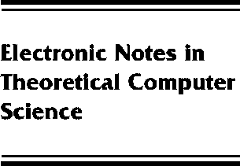[www.elsevier.com/locate/entcs](http://www.elsevier.com/locate/entcs)

Data Field Haskell

Holmerin Jonas and Bjo¨rn Lisper

**Abstract**

Data fields provide a flexible and highly general model for indexed collections of data. Data Field Haskell is a Haskell dialect that provides an instance of data fields. It can be used for very generic collection-oriented programming, with a special emphasis on multidimensional structures. We give a brief description of the data field model and its underlying theory. We then describe Data Field Haskell, and an implementation.

1571-0661 *⃝*c Elsevier B.V. Open access under [CC BY-NC-ND license.](http://creativecommons.org/licenses/by-nc-nd/3.0/)

10.1016/S1571-0661(05)80541-9