

Electronic Notes in Theoretical Computer Science 225 (2009) 221–237

[www.elsevier.com/locate/entcs](http://www.elsevier.com/locate/entcs)

Developing the Method of Server Controlled Outcomes Management and Variance Analysis

# Kazuyuki Matsumoto 1 Tetsuya Tanioka2 Kyoko Osaka Ai Kawamura Syu-ichi Ueno

*The University of Tokushima Tokushima, Japan*

# Fuji Ren 3

*The University of Tokushima Tokushima, Japan*

*Beijing University of Posts and Telecommunications Beijing, China*

# Yoichiro Takasaka

*Hosogi Unity Hospital Kochi, Japan*

# Alan Barnard

*Queensland University of Technology Brisbane, Australia*

# Rozzano C. Locsin

*Florida Atlantic University Florida, USA*

# Mitsuko Omori

*Kagawa University Kagawa, Japan*

1571-0661/© 2008 Elsevier B.V. Open access under [CC BY-NC-ND license.](http://creativecommons.org/licenses/by-nc-nd/3.0/)

doi:10.1016/j.entcs.2008.12.076

Abstract

This paper is to describe a way to develop the Psychoms process for mental health patient management and variance analysis system has been developed using artificial intelligence. Although it is agreed that there is a need for clinical pathway variance analysis, methods for creating a system are less well defined. The procedure and systematic process described aims to improve patients’ quality of life through consistent and timely care. Ultimately, its potential influence is to assist in the improvement of quality health care services. This paper illustrates a method of outcomes management and variance analysis as the prospective development of future research.

*Keywords:* Outcomes management, technology, variance analysis, nursing administration, team care, artificial intelligence, mental health

# Introduction

Contemporary Japanese mental health services have improved considerably, how- ever there is more development needed in a range of areas including length of stay in health care facilities. Although the average length of stay (LOS) in a Japanese psychiatric hospital had exceeded 490 days in 1991, it had shortened to 432 days in 1999. When compared with the United States, Japanese LOS in 1999 remained 48 times longer in length. LOS remains 100 days fewer for all 24 member nations of the Organization for Economic Co-operation and Development [5]. In order to overcome problems associated with LOS, we have developed an Outcome Manage- ment System for mental health care called “Psychoms.” The Psychoms system aims to improve interdisciplinary team coordination and completion of care in a mental health hospital [7][4]. The goal is to emphasize that through care management an inter-disciplinary team can achieve a higher quality care management through re- duction in LOS. A case in point is that of a patient with an acute hospitalization. Interdisciplinary care can be performed and monitored through current organiza- tional systems in which post-discharge care planning such as social support in the community is critical. In the case of a patient with a chronic mental health con- dition, it can be difficult for nurses to collectively set health goals. However when goals are identified through an appropriate support system care can be aided by structuring nursing management in order to increase consistency of management and communication across a team. The Psychoms system aims to improve a pa- tient’s quality of life through consistent and timely care and has potential to assist in the improvement of quality health care services and reduce the economic demands of care provision through timely and appropriate discharge into the community. Through research that develops the method of supporting nursing management ef- ficiently with a computer using Artificial Intelligence (AI) the goal of the Psychoms Management system is to improve care provision through a method of outcomes management and variance analysis.

In previous work, there have been attempts to manage clinical pathways (CP) by using computers. In Wakamiya et. al’s research [9], they constructed the paper

based CP management system for organizations that can not introduce a comput-

1 Email:[matumoto@is.tokushima-u.ac.jp](mailto:matumoto@is.tokushima-u.ac.jp)

2 Email:[tanioka@medsci.tokushima-u.ac.jp](mailto:tanioka@medsci.tokushima-u.ac.jp)

3 Email:[ren@is.tokushima-u.ac.jp](mailto:ren@is.tokushima-u.ac.jp)

erized pathway’s system because of financial problem. A new system was developed and incorporated into an existing network at a hospital with a paper-based clinical pathway management system. This system provides functions as print out CP, cre- ate and edit CP, and submit the variances. The aim of this system is to make the existing system convenient to operate a paper based CP. Since this system is free software, anyone can use it. A problem with this method is that the staff does not submit the variance data because it is troublesome work. However, in this method, staff doesn’t submit the variance data because it is troublesome work.

Therefore, the problem is the inability to collect variance data using this method.

Hayward and others [1] focused on the design, implementation and evaluation of an electronic integrated care pathway (eICP), within a Mother and Baby Unit. The eICP was developed using the Microsoft Access program. They reported op- erational effectiveness by questionnaire and discussion groups regarding the initial eICP development.

In previous research, there were no reports about the unified system from which CP, variance and outcome management were based and managed by a server system.

# Outcome Management and its Process

Outcome management [8] is the enhancement of physiologic and psychosocial pa- tient outcomes through the development and implementation of exemplary health practices and services, driven by outcomes assessment. To effectively apply a clinical pathway, the case manager must coordinate interdisciplinary activities in an effec- tive and appropriate manner. As part of the process, it may be necessary to deal with the emergence of variance immediately by confirming the need for intervention, alteration and its associated result. The process requires that the outcome manager seeks to set in place mechanisms to administer not only specific care but also each patient’s outcomes comprehensively. For example, the outcome manager analyzes the results that emerge at the time of hospitalization, during a stabilization period, and at discharge from hospital. Their role is to integrate a range of care services provided by the interdisciplinary team for the purpose of distinguishing where, and in what order, the services should be provided for the best total care service [10] [11]. Outcome management has four phases that focus on continuous quality en- hancements [12]. Outcomes and their measurement are clarified in phase one, while in phase two, practice is standardized by the interdisciplinary team. Implementa- tion of practice standards and data collection of outcomes related to standardized practice occurs in phase three and interdisciplinary data analysis is performed in phase four in order to assess whether or not further intervention is needed in the person’s care management. If during phase four it is judged that further improve- ment is required, then the decision is relayed back to the interdisciplinary team for continuation of phase two.

# Psychoms: An Outcome Management and Variance Analysis System Using AI

The support ’Psychoms’ system outlined in this paper uses AI technology for plan- ning and monitoring phases related to care outcomes in mental health care manage- ment. The CP database of Psychoms has four CP based files for: acute schizophre- nia, depression, dementia, and chronic schizophrenia and all are linked to social rehabilitation. The mechanism of outcome management and variance analysis in the Psychoms is described as follows:

* 1. *The Structure of Hierarchical Outcome Management*

Hospital team members input to the CP of each patient and management is under- taken as a function of the Psychoms outcome management system. Individual staff can input and check the progress of the CP for a patient in their charge (CP system user). Management of progress of the CPs in each hospital ward can be undertaken by the nurse in charge of a ward who can input and check the progress of all patients whom the staff in the ward take charge. Management of the number of completed and incomplete practice interventions noted in the CP can be reviewed on a regular and timely basis by an outcome manager ( Fig.1).

The management of the outcomes across an entire hospital can be overviewed and managed by the hospital director, the nursing service department director, and the general manager who possess the management administrator status to the system across the organization. People employed in managerial positions with administrator status can check practice and staff effectiveness in relation to CPs in all of the wards in the hospital.

In figure 1, “Clinical pathway system users” are managed by “Outcome Man- agers.” “Outcome Managers” are managed by “Administrator.”

“Clinical pathway system users” have only authority to manage patients in one’s charge of his/her hospital ward. Therefore, they can manage the state of implemen- tation of care services. Not only psychiatrists and nurses that work in a psychiatric hospital but other specialists can manage the state of implementation of care ser- vices using computerized clinical pathways.

* 1. *The Mechanism of Psychoms Outcome Management System*

Section (A) in Fig.2 refers to inputting items related to a CP and relates to each professional’s intervention. Section (B) highlights outcome items in relation to care intervention items such as it can check whether the psychiatrist has issued directions of rehabilitation. Section (C) is a list of incomplete practice items and may refer to issues such as a nursing assessment that has not been completed. The practice items of outcome management that are related to each item in CP (A) are shown in section

(B) on the right side of the screen. After completing each of the highlighted care interventions of each item in the CP, the items shown in the section (B) are marked

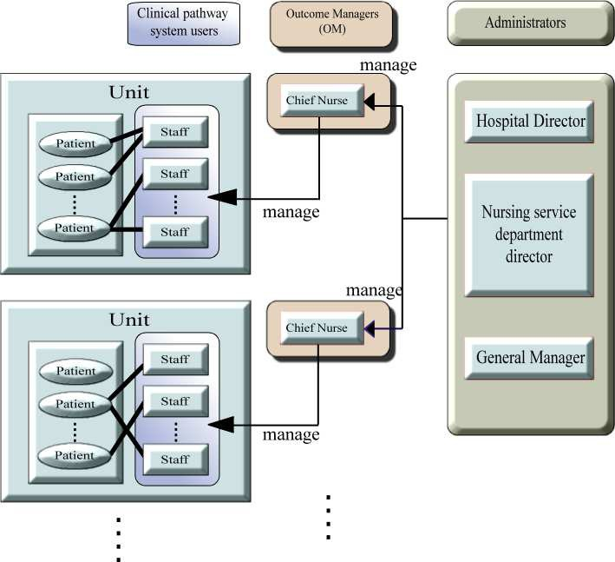

Fig. 1. Structure of Hierarchical Outcome Management

as complete, and a message which states that outcomes have been obtained (the items have been completed) is displayed for the viewer. When there is an incomplete practice item in section (B), then it is possible to determine the intervention item in a CP necessary in order to complete care and advance a person’s treatment trajectory toward completion. For instance, if it is necessary to conduct a blood test, then the necessity for the test and the doctor in charge of the specific patient are displayed. Also, in such a case, an e-mail message (reminder) such as “an order for a blood test has not been signed, please respond immediately” will be displayed for the relevant doctor or nurse practitioner (attention calling function), and if staff register for the e-mail list they too can receive the messages as an e-mail (contacting function). The intention of this function is to alert relevant members of the team that additional work needs to be undertaken as part of care being provided for the person.

* 1. *The Mechanism of Variance Analysis*

In cases where intervention items are not completed by a scheduled date, the system is programmed to request the user to let staff in charge input the following infor- mation about the causes of the variance: “keyword,” “the contents of variance,”

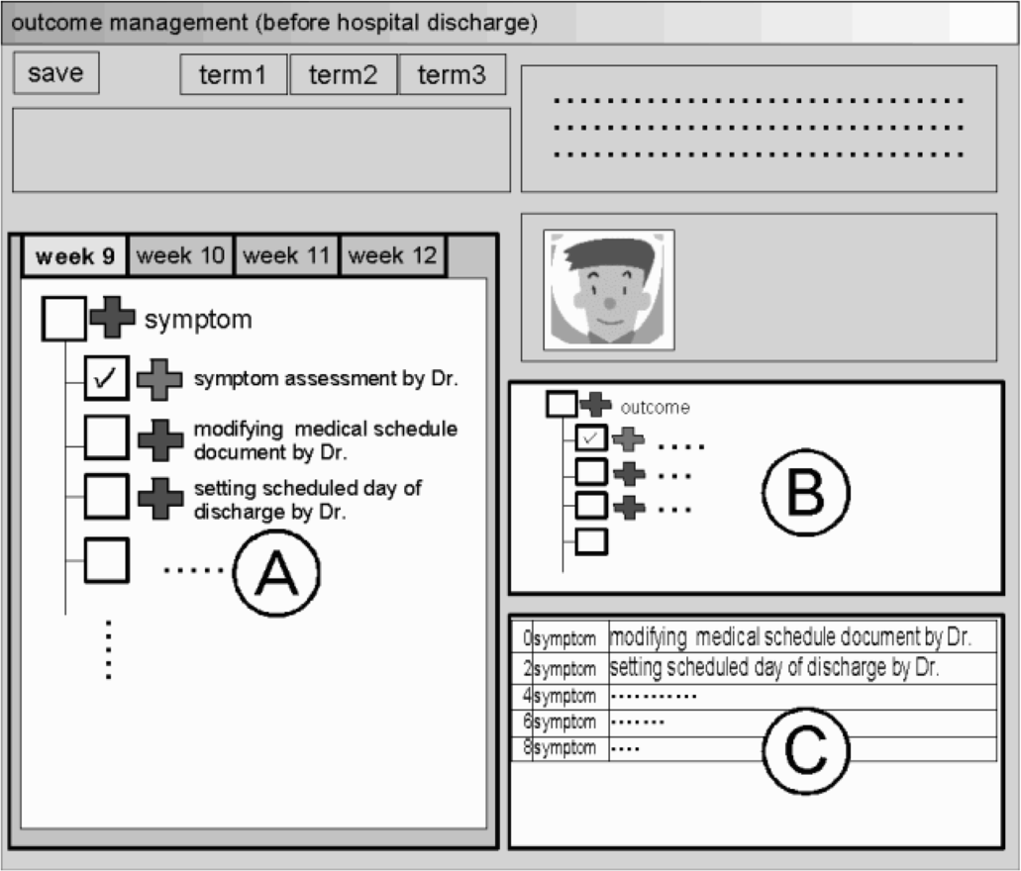

Fig. 2. Clinical Pathway and Outcome Management Screen

and “the actual causes of variance.” From this, variance data is accumulated, and standardization of a CP is performed through this data accumulation learning func- tion. Below is an explanation of the mechanism of analysis related to accumulated variance data.

Step-1: First, the cause of variance category is determined from the content of a variance and its keyword. An example of variance categories are; A) Patient Condition (e.g., Patient refused other treatment), B) Hospital System (e.g., De- lay in tests), C) Caregiver Related (e.g., Discharge teaching not done), D) Family Placement (e.g., Family will not accept responsibility for the discharge plan), and

E) Community Related (e.g., the support center for people with mental disorders has no vacancy).

At Step-2: keywords are extracted from the sentence that refers to the actual cause of the variance inputted by the user. The extracted keywords are decomposed into the three factors of Subject, Object, and Predicate according to the case struc- ture of the sentence and on the described contents of the causes of the variance. Keywords to arise from our example might be that: Department is not open on the weekend; Delay in patient teaching; Family non-compliant; etc.

At Step-3: the relation between the concepts of some keywords extracted is

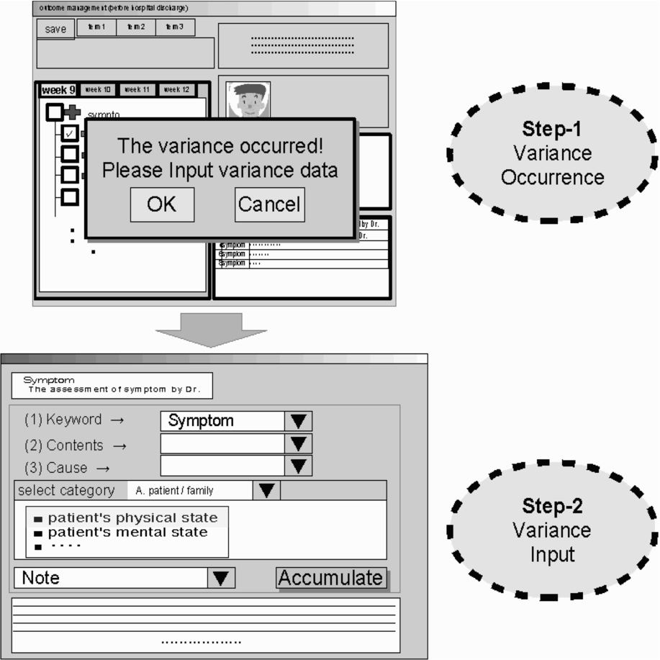

Fig. 3. Screen for Occurrence of Variance and Inputting Variance Data

determined by a semantic network. An example of the relation between keywords extracted that “Doctor’s instruction was delayed.”, “Insufficient explanation to the nurse by doctor.”, and “Doctor did not to explain to the nurse.” etc. can be classified into the cause group of same variance. To examine the variance in the in- terdisciplinary team, Psychoms displays the causes, the contents, and the incidence of variance on the screen. In variance that generates “Delay in medical treatment” and “Medical errors” is high frequency, interdisciplinary team can solve the problem by priority. In case of delayed tests, there is a possibility that the “CT scan” plan which described in CP was too early. For that case, Psychoms presents the message of “Please examine the implementation time.” as information to standardize CP (Refer to the Table 1). However, it is decided whether to change the implementa- tion time at the committee of examine CP. Relevance to accumulated factors and the variance category are calculated in order to construct a model to identify the occurrence sources of the variance as they relate to each of the categories of item, keyword, staff and CP.

Finally at Step 4: the variance model enables specific items to which variance is likely to occur to be identified, along with related factors which can cause the variance (for example, if a variance occurrence factor is classified in the category of

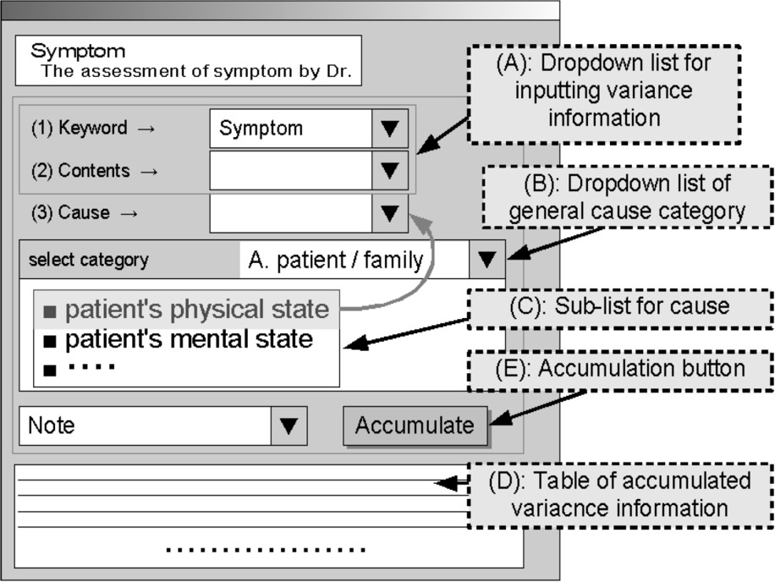

Fig. 4. Interface for Variance Data Input and Data Accumulation Process

“family”, then it is possible to specify its further causes) (Fig.3, Fig.4).

* 1. *Describing the details of variance database and the details of proposed variance analysis mechanism*

Each record of the Psychoms variance database consisted of “occurred date,” “oc- curred week,” “inputted staff ID,” “disease name (pathway’s name),” “keyword,” “variance contents,” “variance cause,” “remarks,” “element of occurred variance” and “patient ID.” An example of variance database’s contents is shown in Table 2. The elements “variance contents” and “variance cause” are available for filling in freely. Next, we consider “variance cause,” “variance contents,” “occurred week” and “keyword” as four elements of variance database. Inputted texts of “variance cause” and “variance contents” are converted into the pattern of “S+O+P.” The pattern of “S+O+P” means the combination of “Subject,” “Object” and “Predi- cate” of the cause or the content.

* + 1. *Converting Process of S+O+P Pattern*

Step-1: Accumulated texts in the variance database are split into morpheme unit (Fig.5).

Then, the basic forms of morphemes are integrated into unit of case element

case element. Consequently, it is reconstructed as three elements of the “medical | (Fig.6). The morpheme whose part of speech is “particle” is regard as delimiter for staff,” “performing | task,” and “delay.”

In Figure 6, the process for identifying the compound noun is necessary. Explain-

Table 1

Display Example of Variances Analysis Results of the Clinical Pathway for Patient with schizophrenia; Acute Period

|  |  |  |  |  |
| --- | --- | --- | --- | --- |
| Categories | Causes | Contents | requency | Message from Psychoms |
| Medical rs | ctor’s in- struction was  ayed. | The nurse inappro- ate use of  dications. | 45% | siness im- ement  uld be  ely to be amined. |
| Insufficient  anation the nurse doctor. | nurse was able to ex- n to the tient. |  |
| Doctor forgot plaining to e nurse. | Likely case of edication er- r. | 30% |
| Delay in tests | atient’s ental status as unstable. | .. . | 10% | ease examine e implemen-  tation time. |
| CT scan can- ot have been ne. | 55% |
| .. . | 35% |
| .. . | .. . | .. . | .. . | .. . |

|  |  |  |  |
| --- | --- | --- | --- |
| surface form | basic form | reading | part of speech |
|  |  |  | - |
|  |  |  | - |
|  |  |  | - |
|  |  |  | - |
|  |  |  | - |
|  |  |  | - |

Fig. 5. Example of Morphological Analysis in Japanese

ing briefly, by morphological analysis, the expression “medical staff” or “performing a task” are split up into “medical” and “staff,” “task” and “performing.” However, because these nouns should be judged as one noun, the system requires processing to identify the position of delimiter for compound noun.

Step-3: Obtained case elements are judged which element “Subject” or “Object”

Table 2

Example of Variance Database Contents

|  |  |  |  |
| --- | --- | --- | --- |
| Week | Keyword | Contents | Causes |
| 10 | Symptom | The nurse did inappro- ate use of medica-  tions. | Doctor’s instruction as delayed. |
| 4 | Symptom | he nurse was not able explain to the pa-  tient. | sufficient explanation the nurse by doctor. |
| 8 | Environment | ikely case of medica- ion error. | Doctor forgot explain- ing to the nurse. |
| 12 | Test | CT scan cannot have een done. | atient’s mental status was unstable. |
| .. . | .. . | .. . | .. . |

*-no*

*-no*

**element-1**

**element-2**

**element-3**

delay

performing task

medical staff

Fig. 6. Example of the Case Elemet Integrated Basic Forms of Morphemes in the Sentence

or “Predicate” by referring the case element dictionary which defined word’s po- tential of case type. Generally, for analyzing the case structure, the method based on “case frame” is often used. The obtained three case elements (here, “medical staff,” “performing a task,” “delay”) are cross-checked with the case element dictio- nary. The system decides the case according to the kind of particle. The variance cause can be chosen from the multiple choices such as “Other causes related to patient/family.” In this case, the phrase of the choice is transformed into simple form such as “patient/family.”

Step-4: As the result, a pattern such as { ⟨*S*⟩ medical staff ⟨*/S*⟩, ⟨*O*⟩ performing a task ⟨*/O*⟩, ⟨*P* ⟩ delay ⟨*/P* ⟩ } is generated. In this way, four kinds of sets are created: PV (pattern of variance contents), PC (pattern of variance cause), W

(week), K (keyword). The system registers the data with these description formats as the VAKB (Variance Analysis Knowledge Base), and output the result according to the condition of analysis.



(ii) extract

VAKB

Analysis System

week-7

(iii) output

symptom

◼ ◼ ◼ ◼

<S>patient/family</S>

<O/>

<P/>

<S>Dr.</S>

<O>input</O>

<P>forgot</P>

<S>medical staff</S>

<O>performing a task</O>

<P>delay</P>

◼◼◼◼

(i) input

W = '7' & K = 'symptom'

analysis condition

Fig. 7. VAKB (Variance Analysis Knowledge Base) Flow

* + 1. *Process of Analysis*

The authors explain the analytic procedure with different kinds of examples (a), (b) and (c) because different procedure differ depending on the contents.

* + - 1. In the case of identify a variance contents about “symptom (Keyword)” at 7th week. This system searches as search keyword that W=‘7’ and K=‘symptom’ matching the criteria specified records from VAKB (in Fig.7 (i), (ii)). We obtain the combination of “PV+PC” matching the condition as the output data from VAKB. In this step, because each PV has PC as cause, these distributions of PC are presented too.
      2. In the case of identify a variance contents about “medical staff” occurred in week-7.

conditions. As extracted variance “cause of no discussion with family → (delay of We collate it with VAKB with an analysis system of Psychoms under stated contacting with patient’s family by medical staff),” analytically-extracted variance

content is output that “Family didn’t agree to meet with patient because medi- cal staff late for contacting with patient’s family.” Concretely output of variance contents was “F.”

* + - 1. In the case of identify a variance cause for the content: “Psychiatrist forgot input order.”

For this case, the inputted phrase of “Psychiatrist forgot input variance order” is converted into the pattern of “S+O+P” then the system refers to the VAKB for the pattern of variance content (PV) that matches the pattern. The conditions of W and K are not designated, then the distributions of the major causes are obtained. Since

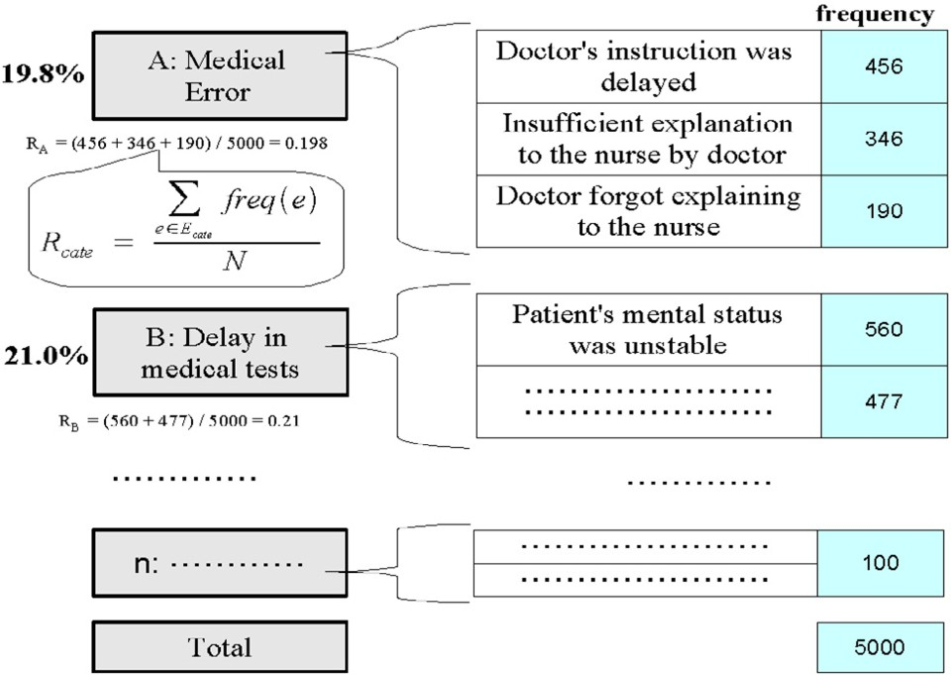

Fig. 8. Example of Variance Cause Analysis

W and K do not have specification condition, the items of the cause of variance are obtained as broad categories like “Medical Error (19.8%)” and “Delay in medical tests (20%).” In this process of variance analysis, texts indicating each variance cause obtained as search results are classified into subcategories. Then, the rate of the major category to the whole examples is calculated as *R*cate. *Freq*(*e*) is the frequency of the examples classified into subcategory ’*e*.’ *E*cate indicates a set of the subcategories belonging to the major category. *N* shows the number of the whole examples (Fig. 8).

* + 1. *An Existing Method for Variance Analysis by Data Sorting*

As shown in the Fig.9, method of extraction of required variances by step-by-step approach according to a search condition is an analysis process by the conventional condition search. First, narrow down a search condition from accumulated all vari- ance data (limit the search-1). Disease name (pathway’s name) is set as search condition. Next, restrict the search more tightly (limit the search-2). Keyword of pathway is set as search condition. As the result, we can get the desired variance data. By sorting obtained variance data, we can get the distribution of variance cause.

* + 1. *Difference between Stop-down Analysis by Conventional Condition Search, and Automatic Analysis by VAKB*

As an existing method for variance analysis (manual data sorting method), we have to sort variance data by search condition, and we group together “variance con-

Refine-(1)

Ex.) disease name (path's name)

* schizophrenia (acute phase )
* schizophrenia (chronic phase)
* depression
* dementia

Refined variances

All acumulated variances

Fig. 9. Variance Extracting Process by Data Sorting

Refine-(2)

Ex.) path's keyword

* symptom
* drug
* family

Necessary variances

tents” by manual check. This method of analysis can be based on empirical data. A problem of this method is the heavy burden of analysis in which many mistakes of classification can occur because texts are judged manually. Words and expres- sions need to be groupd allowing for variant notations. This requires professional knowledge. In contrast, in the proposed method (automatic variance analysis based on VAKB), we can obtain the desired data (variance causes) from VAKB by set- ting “week,” “keyword,” “variance contents” text as search condition. The cause of variance can be shown in order with much frequency in the analysis system of Psychoms. Moreover, if variance causes are categorized, we can obtain the rough category of variance. Merit is possible to obtain desired data easily because the search condition is able to input by natural language. Therefore a beginner analysis can handle the analysis system easily. If data(VAKB) increases, the system can use a flexible analysis. Also demerit is error of morphological analysis or case decision and quality of dictionary have an influence to analysis accuracy.

* 1. *Discussions*

If medical information in relation to mental health care is computerized with the advantage of Psychoms, it will be relatively straight forward to obtain care provision information and to coordinate care delivery for the benefit of patients, practitioners and the organization. A merit for using the Psychoms system is the capability to understand interdisciplinary intervention and match this with each patient’s symp- tom management and care provision. The goal is to improve coordination of care, reduce LOS, improve resource use, and enhance the effectiveness and quality of care for the community. Further to these outcomes it is possible to use the Psychoms sys- tem for educational purposes especially for orientating new staff and organizational in-service, and for research related to mental health care. The use of the system in the mental health hospital can lead to improvement in the quality of life of patients,

their families, and reduction in hospital costs associated with length of stay. The Psychoms method of Outcome Management and Variance Analysis is based on the following key developments: 1) the installation of a schedule management function for each ward, aiming for adequate notification of incomplete practice; 2) provi- sion of a function to enable the user to select a similar content (cause of variances) and factors from accumulated variance data; and 3) the provision of a method of identifying variances is developed by natural language processing. The direction of development in future research which applies AI technology is hopefully the actual- ization of the auto-standardizing function of CP which applies the result of variance analysis.

At the present stage, because the quantity of variance database is very few, the system can not cover many examples. As the future work, we consider to expand the database for automatic analysis. With conversion to pattern, we can only ob- tain the effect of fuzzy search. Therefore, we consider conversion to pattern using semantic concept is necessary For example, “Forgetting input by Dr.” and “Dr. forgot input the data.” is the same. However, these sentences are not converted to same pattern. Therefore, the knowledge such as “Dr.” and “by Dr.,” “Forget- ting” and “forgot” are synonymous and necessary. For this reason, with semantic analysis by using the thesaurus, these expressions can be identified as synonym. As the relevant study of medical term thesaurus, in research, they extracted English and Japanese terms used in life science field based on the quantitative analysis of literature corpus [2][6]. They constructed an original bilingual dictionary as the life science dictionary, and evaluated it. As the conclusion, they describe that new bilingual thesaurus is necessary for analyzing a large quantity of text generated at medical scene with computer. Current research indicates, they constructed medical term ontology and identify semantic relation of compound word. Also Klavans and Muresan [3], evaluated the quantitative and qualitative evaluation of DEFINDER which is an automatic lexicon construction system, by comparing to the definition in an online technical terminology dictionary. The DEFINDER, a rule-based sys- tem that mines consumer-oriented full text articles in order to extract definitions and the terms they define. The output of DEFINDER can be used to enhance these dictionaries. DEFINDER output is being incorporated in a system to clarify technical terms to non-specialist users in understandable non-technical language. Some lexicons or thesaurus which constructed in these researches are available to the public. Therefore, we can use these lexicons or thesaurus. However, there are not so many lexicons which are constructed systematically with domain. It would be difficult to use these lexicon or thesaurus without change.

In the future, we will collect terms used in psychiatry by carrying on accumu- lating variance data. And, we will construct the small thesaurus manually. The

system which combined published thesaurus and small psychiatry thesaurus will be construct to process unknown words. Here, unknown words were not registered in variance database. We would evaluate the proposed method for variance analysis. Specifically, we will compare the proposed method and existing method (manually sorting). In this paper, we described the development of the psychiatric patient

outcome management and variances analysis system using AI, and proposal of the variance analysis mechanism based on natural language processing. Future research in this field is to develop interface designed for editing CPs, aiming to relieve of the patient’s and user’s burden occurred in the process of editing his/her CP. Currently, CPs are being used in hospitals using a paper based system. CPs that are managed using computer systems which are used to analyze outcomes, progress and variance are not found in the literature at this time. Further research is planned to im- prove the Psychoms’s performance so that can be applied to assist roles in nursing administration and the efficient and effective performance of health care practice.

* + 1. *Limitations*

Following are concerns regarding the development of prototype system of the Psy- choms.

* At the same time, two or more users wrote data of a patient’s pathway. Then, data contradiction occurred. Therefore, we introduced the exclusive access control for patient pathway file into Psychoms. However, while the user operated patient pathway, Psychoms freezes and/or locked by performing mistaken operation. In this case, unless locked condition has been canceled by the manager’s authority, the user was not able to operate this pathway. Therefore, the problem occurred which user cannot smooth operation of pathway management.
* There was a problem which cannot upgrade pathway while using the pathway. This problem was generated for the following reason; there was no mapping func- tion of the present progress situation to a new file at every upgrade of patient pathway file. In order to use pathways in clinical practice, pathways must be improved continuously, and extensive renovations of pathway’s structure were re- quired. Also, reexamination of program structure was required to respond to structure-changing of pathway.
* Several upgrades were performed as the request of a user about improvement of user interface design. However, in order to take incorporate the opinion of user every time, user interface specification became complicated. Since operation was complicated, bug patch also took time. It is necessary to separate the structure of user interface and internal processing, and to simplify a function from now on.
* User inputs the cause of variance in busy clinical practice. Therefore, even when the data input by free description was possible, the user chose from previously provided decision branch in many cases. User answered that it took a long time because it is difficult to select from a menu of choices following reasons, the variance category is unsuitable and previously provided decision branch included unsuitable elements. As these, we recognized necessity of reconsidering previously provided decision branch of variance.

We must solve above-mentioned problems in order to make higher utility value system. Also, it is necessary to collect variance data and error reports, and to make improvements system as needed using Psychoms in the psychiatric hospital.

# Conclusion

In this research, we developed the outcome management system “Psychoms” for managing the CP by digitizing former paper-based CP management. We had run this system in two hospitals for evaluating effectiveness. Then we found the prob- lems; (1) multiple access of same patient, (2) general versatility of change of CP structures, (3) user-interface and (4) the method of variance collection.

Also, we proposed the automatic variance analysis based on VAKB (Variance Analysis Knowledge Base). Proposed variance analysis method will be able to complement analysis process which depended on experience (seat-of-the-pants ap- proach) of the analyst. However, we have to collect a large number of variance data in order to establish this analysis method. Therefore, it is the important subject for study that thesaurus development from accumulated variance data because this classification method depends on using the thesaurus. In the future, we collect the system error, bug and variance data for system improvement.

# Acknowledgement

This research has been partly supported by Japan Foundation for Neuroscience and Mental Health.

# References

1. Hayward-Rowse, L. and Whittle, T. J, “A pilot project to design, implement and evaluate an electronic integrated care pathway,” Journal of Nursing Management 14 (2006), pp.564–571.
2. Kaneko, S., Fujita, N., “Evaluation of an English-Japanese Thesaurus Based on the Analysis of Biomedical Corpora,” Japan Journal of Medical Informatics 25 (2006), pp.475–483.
3. Klavans, J.L. and Muresan, S., “Evaluation of the DEFINDER system for fully automatic glossary construction,” in: *Proceedings of the American Medical Informatics Association Symposium* (2001), pp.324–328.
4. Matsumoto, K., Tanioka, T., Ren, F., Takasaka, Y., Matsuda, T., Tada, T., Kawanishi, C., Barnard, A., Osaka, K. and Ueno, S., “Development of the psychiatric patient outcome management and variances analysis system using artificial intelligence,” in: *MFCSIT’06: Proceedings of the Fourth International* *Conference on Information and The Fourth Irish Conference on the Mathematical Foundations of Computer Science and Information Technology* (2006), pp.73–77.
5. Mizuno, M., Sakuma, K., Ryu, Y., Munakata, S., Takebayashi, T., Murakami, M., Falloon, I.R. and Kashima, H., “The Sasagawa project: a model for deinstitutionalisation in Japan,” The Keio Journal of Medicine 54 (2005), pp.95–101.
6. Nishimoto, N., Terae, S., Jiang, G., Uesugi, M., Terashita, T., Tanikawa, T., Endou, A., Ogasawara,

K. and Sakurai, T., “Retrieving Issue of Identifying Semantic Relation between Atomic Medical Terms in Noun-noun Compounds in Reports of Computerized Tomography,” Japan Journal of Medical Informatics 25 (2006), pp.413–420.

1. Tanioka, T., Ren, F., Takasaka, Y., Matsumoto, K., et al., “Research on development of the Hospital Management Outcomes Analysis System for using in psychiatric hospitals,” in: *ASC’05: Proceedings of the Ninth IASTED International Conference on Artificial Intelligence and Soft Computing* 1 (2005), pp.434–438.
2. Urden, L.D., “Outcomes management: A role for everyone,” Outcomes Management 7 (2003), pp.45–47.
3. Wakamiya, S. and Yamauchi, K., “A new approach to systematization of the management of paper- based clinical pathways,” Computer Methods and Programs in Biomedicine 82 (2006), pp.169–176.
4. Wojner, A.W., “Outcomes management: an interdisciplinary search for best practice,” AACN Clin Issues 7 (1996), pp.133–145.
5. Wojner, A.W., Kite-Powell D, “Outcomes manager: a role for the advanced practice nurse,” Crit Care Nurs Q 19 (1997), pp.16–24.
6. Wojner, A.W., “Outcome management: from theory to practice, Crit Care Nurs Quarterly, ” 19 (1997), pp.1–15.