[Egyptian Journal of Basic and Applied Sciences 5 (2018) 130–137](https://doi.org/10.1016/j.ejbas.2018.05.004)

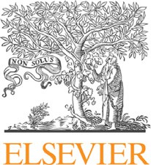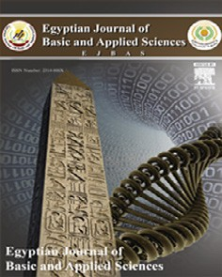

Contents lists available at [ScienceDirect](http://www.sciencedirect.com/science/journal/2314808X)

Egyptian Journal of Basic and Applied Sciences

journal homepage: [www.elsevier.com/locate/ejbas](http://www.elsevier.com/locate/ejbas)

Full Length Article

[](http://crossmark.crossref.org/dialog/?doi=10.1016/j.ejbas.2018.05.004&domain=pdf)Diphyllin: An effective anticandidal agent isolated from *Cleistanthus collinus* leaf extract

Thamburaj Suman a,b,⇑, Ramraj Elangomathavan a, Muniyandi Kasipandi b, Kamalanathan Chakkaravarthi c,

Dhanapal Tamilvendan d, Thangaraj Parimelazhagan b

a *Department of Biotechnology, Faculty of Engineering and Technology, PRIST University, Thanjavur, Tamil Nadu 614904, India*

b *Bioprospecting Laboratory, Department of Botany, Bharathiar University, Coimbatore, Tamil Nadu 641046, India*

c *Department of Chemistry, T.U.K Arts and Science College, Thanjavur, Tamil Nadu 613002, India*

d *Department of Chemistry, National Institute of Technology, Trichirappalli, Tamil Nadu 620015, India*

# a r t i c l e i n f o

*Article history:*

Received 5 July 2017

Received in revised form 8 February 2018 Accepted 7 May 2018

Available online 16 May 2018

*Keywords:* Anticandidal Diphyllin Fraction Yeast

# a b s t r a c t

In this study, diphyllin [9-(1,3-benzodioxol-5-yl)-4-hydroxy-6,7-dimethoxynaphtho[2,3-*c*]furan-1(3*H*)- one] was isolated from *Cleistanthus collinus* leaf extract. The isolated compound and leaf extract were evaluated for their *in vitro* anticandidal activity against Candida strains such as *Candida albicans*, *C. trop- icalis*, and *C. glabrata*. Diphyllin was found to possess higher anticandidal activity against various *Candida* species with the Minimal Fungicidal Concentration (MFC) of 85–145 lg and inhibition zone of 9.5 ± 0.5–

13.5 ± 0.5 mm at 200 lg concentration against the yeast pathogens studied. Thus, diphyllin was twice

more active than miconazole against *C. glabrata*.

© 2018 Mansoura University. Production and hosting by Elsevier B.V. This is an open access article under the CC BY-NC-ND license (<http://creativecommons.org/licenses/by-nc-nd/4.0/>).

1. Introduction

In recent years, candidiasis is a major fungal infection caused by *Candida* species in humans and veterinary animals. Among them, 90% of nosocomial candidemia cases were due to *C. albicans* as cau- sative agent associated with other candidal species such as *C. glab- rata*, *C. tropicalis*, *C. parapsilosis*, *C. dubliniensis*, and *C. krusei* in the subcontinent [1–3]. In recent years, although a number of syn- thetic and natural derivative antifungal drugs developed in phar- macological industries were effective in controlling *Candida* infections, the toxicity, high cost, side effects, and development of drug-resistant strains due to frequent use of the drugs have led to several problems in candidiasis management [4–6]. Hence- forth, a plant-derived novel agent with low toxicity and side effects has been examined to overcome and enhance the efficiency of treatment of fungal infections [7,8].

Anticandidal activities of plant extracts, oils, toxicants, metals, synthetic drugs, and natural products have been reported by many researchers and the frequency of discovery of new antifungal agents from plant sources emphasizes the increasing interest in the broad spectrum of activity against *Candida* species [9,10].

* Corresponding author at: Department of Botany, Bharathiar University, Coimbatore 641046, Tamil Nadu, India.

*E-mail address:* [sumanthamburaj@gmail.com](mailto:sumanthamburaj@gmail.com) (T. Suman).

Bioactive compounds are extracted from aromatic, toxic, and medicinal plants in pure or crude forms were considered recently as effective agents in controlling bacterial and fungal pathogens. Review of literature and the examination of botanicals against *Can- dida* species were significantly increased in the last decade [11,12]. The population of the Indian subcontinent has been traditionally using many plants as medicine for treatment of several microbial infections.

*Cleistanthus collinus* (Euphorbiaceae) is distributed in Asian countries with many potential pharmacological properties [13–](#_bookmark24) [16]. In this work, anticandidal activity of *C. collinus* leaf extract and its fraction against *C. albicans*, *C. tropicalis*, and *C. glabrata* have been examined*.* To the best of our knowledge, no study has been investigated the inhibitory effects of *C. collinus* extract and its frac- tion against different *Candida* species till date.

1. Materials and methods
   1. *Preparation of extracts*

*C. collinus* samples were collected from Viralimalai, Tamil Nadu, India, in August 2011. The plant leaves were carefully separated and washed with running tap water and subsequently with dis- tilled water to remove pollutants. The samples were shade-dried and minced to precede extraction. About 2 kg dried plant material

<https://doi.org/10.1016/j.ejbas.2018.05.004>

2314-808X/© 2018 Mansoura University. Production and hosting by Elsevier B.V.

This is an open access article under the CC BY-NC-ND license (<http://creativecommons.org/licenses/by-nc-nd/4.0/>).

was subjected to crude extract preparation using Soxhlet appara- tus (Sigma Soxhlet Mantle, Tamil Nadu, India). Distilled water and ethyl acetate (Merck, Darmstadt, Germany) were used as sol- vents. Crude extracts were concentrated under reduced vacuum and stored for further analysis.

* 1. *Isolation and characterization of diphyllin*

About 87 g of ethyl acetate extract was obtained and exactly 7 g was mixed with activated silica and filled at the top of the column. It was then subjected to first elution with 50 ml toluene. There- after, toluene was mixed with ethyl acetate in different ratios (9:1–1:9, and 0:10). Eighty-one fractions of 5 ml were collected in test tubes. These fractions were concentrated by evaporation and subjected to thin-layer chromatography (TLC). After TLC, com- parable fractions (14–21) were obtained as a single compound. The isolated compound was further subjected to column chromatogra- phy and TLC for verifying the purity of the compound. This isolated compound was named as compound TE (toluene/ethyl acetate fractions). Fractionated compound TE was characterized using TLC, ultraviolet–visible (UV–Vis) spectral analysis, Fourier trans- form infrared (FTIR) spectral, nuclear magnetic resonance spec- troscopy, mass spectrometry, and elemental analyses.

* 1. *Anticandidal activity*

*C. albicans* (NCIM 3471), *C. tropicalis* (NCIM 3118), and *C. glab- rata* (NCIM 3236) were obtained from National Collection of Indus- trial Microorganisms (NCIM), National Chemical Laboratory, Maharashtra, India, and used for anticandidal analysis. A primarily anticandidal test was carried out for aqueous, ethyl acetate extracts, and fractioned compound by well-diffusion method as described by Magaldi et al. [17]. Yeast was inocula prepared from 18-h-old mother cultures. Yeast inocula were spread on petri dishes containing Sabouraud dextrose agar and wells were made using a sterile cork borer. Extracts and fractioned compound were dissolved in sterile 4% dimethyl sulfoxide (DMSO). Thereafter, 100, 200, 400, and 800 mg extracts and fractions were loaded on the

wells. Standard antifungal agent miconazole 50 mg and 4% DMSO were used as positive and negative controls. The plates were incu- bated at 37 °C for 24–48 h and the zone of inhibition (ZOI) was measured.

* 1. *Minimal fungicidal concentration*

Minimal fungicidal concentration of the fractioned compound was evaluated by the broth macro dilution method, to determine the minimum inhibitory concentration (MIC) of the fractioned compound that inhibited visible growth of test pathogens. Mid exponential culture (10 ml) was seeded with the fractioned com-

pound at concentrations of 2–200 mg in 1 ml total volume of

Sabouraud dextrose broth incubated at 37 °C for 24 h with mild

agitation at 100 rpm. After the incubation, the culture pellets were obtained by centrifugation (REMI, Maharashtra, India), resus- pended in 100 ml sterile broth, and the total suspension swabbed onto the Sabouraud dextrose agar plates and allowed to incubate for a further 24–48 h at 37 °C [18].

1. Results
   1. *Characterization of isolated compound TE*
      1. *Physical properties of compound TE*

About 179 mg dry weight of the residue was obtained from identified fractions. Fractionated compound was crystal in nature and green in color, soluble in all organic solvents. The *R*f value of this compound was 0.37 in toluene/ethyl acetate (4:1) in mobile phase.

* + 1. *Ultraviolet–visible spectral analysis*

The UV–vis spectra exhibited an absorption bond at 278 nm, which can be assigned to p–p⁄ transition of carboxyl and aromatic groups. This gives an idea about the structured compound contain- ing hetero atom having nonbonding electrons (Fig. 1).

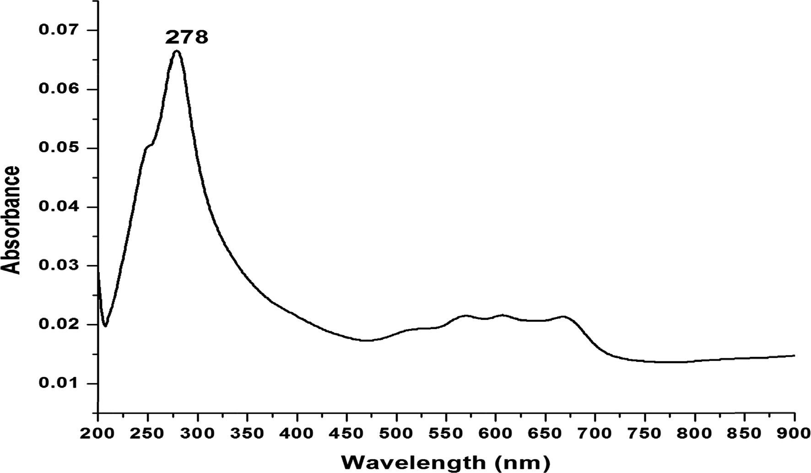

Fig. 1. UV–Visible spectra of fractioned compound TE (Diphyllin).

* + 1. *FTIR spectral analysis of compound TE*

Infrared spectrum of TE recorded in KBr medium (4000–450 cm—1) showed a number of bands (Fig. 2). The tentative assign- ments of various stretching and bending frequencies for fractioned compound TE are listed in Table 1. A broad band observed at 3437 cm—1 can be assigned to the OH stretching vibration. The medium bands at 3037 and 3031 cm—1 are attributed to aromatic C@H stretching vibration. The ketonic bond observed due to stretching vibration, that is C @ O, appears at 1764 cm—1. In in-plane bending, bands appear in the region 1378 cm—1. The median band observed at 1086 cm—1 can be attributed to CAOAC bending vibration. The presence of absorption bands in the region 846–727 cm—1 is due to out-of-plane bending vibrations of CAH bands at 727 cm—1. The aromatic substituted vibration appears as a strong absorption band at 626 cm—1.

* + 1. *1H NMR spectral studies of compound TE*

The proton magnetic resonance spectra of the fractioned com- pound TE was recorded (Table 2) in CDCl3 solvent (Fig. 3) and the resonance signals were given in. The integration of the spectra indicates the number of proton to be 16. Resonance signal at d 3.98 ppm is due to OACH3 protons. The aromatic proton appears as multiples in the range of d 6.83–6.56 ppm and the substitute ben- zene ring appears in the range of d 6.40–6.37 ppm. The OH proton appears at d 7.76 ppm signal. The signal due to methoxy proton appears, that is OACH2AO, at d 5.995.95 ppm and the ACH2AO proton appears at d 5.27 ppm. Thus, the 1H NMR spectra reveal the presence of aromatic, methoxy, OACH2AO, and ACH2AO groups in the compound. The intensity ratio obtained for signals correlates well with the total number of protons under chemically equivalent and magnetically active nuclei.

* + 1. *13C NMR spectral studies of compound TE*

The spectra of the fractioned compound TE were recorded in the CDCl3 solvent, as shown in Fig. 4, and the data are presented in Table 3. A spectrum shows absorption of carboxyl carbon at

169.55 and 169.44 ppm. The chemical shift of aromatic carbons appear at 146.71, 129.8–118.35 ppm. The substitute’s aromatic carbon can be distinguished from other carbons by its decreased peak height. Its lacks a proton and hence suffers from longer relax- ation time with a diminished nuclear Overhauser effect. The peak at 149.52 ppm may be assigned to the substitute’s carbon in the

Table 1

FT-IR spectrum of fractioned compound TE.

Absorption (cm—1) Assignment

3437 OH(b)

3037–3031 CAH aromatic

2931 CAH aliphatic

1764 C@O

1378 In plan bending bass of aromatic ring

1056 CAOAC

846–727 Out of plan bending of aromatic

727 Substitutes aromatic ring

Table 2

1H NMR spectra of fractioned compound TE.

Resonance signals Assignment

3.98 OACH3

6.83–6.56 Aromatic proton

6.40–6.37 Substitutes benzene ring

7.76 OH

5.99–5.95 OACH2AO

5.27 ACH2AO

ring. The peaks at 151.09 and 149.52 are due to aromatic carbon with O atom. The sharp signal at 149.71 is due to aromatic *ortho*- carbon bond with OH group. Peaks at 134.76 and 129.82 ppm are due to aromatic ring attached with another aromatic ring as a sin- gle O bond carbon. The peaks at 11.08–100.59 are due to aromatic carbons. The peak at 69.02 ppm is due to ArACAO carbon. The chemical shifts of 13C atoms of the fractioned compound have been assigned relative to the assignments available for individuals of the compound. The 13C NMR signals of the compound and various assignments to different carbon atoms are in good agreement with the 1H NMR.

* + 1. *Mass spectrum analysis of compound TE*

The mass spectrum of the fractionated compound was obtained on element ionization mode. The molecular mass was observed at 378 *m*/*z*, which is close to the expected value of 380 *m*/*z* (Fig. 5). The mass spectral fragment studies show that the molecular ions peak at *m*/*z* 378, that is M—2 peak (C21H16O7), which confirms the molecular mass of the compound. The peak at *m*/*z* 366, 345, 319,

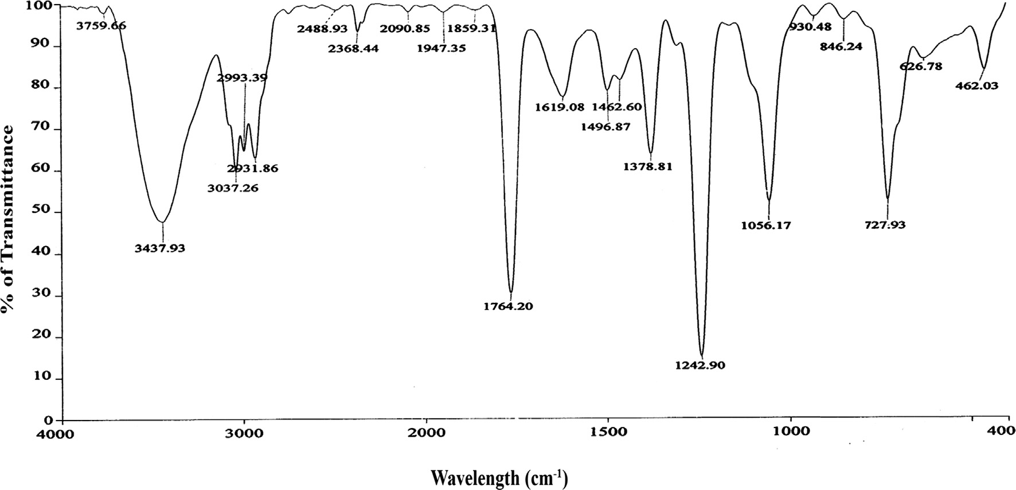

Fig. 2. FT-IR spectrum of fractioned compound TE (Diphyllin).

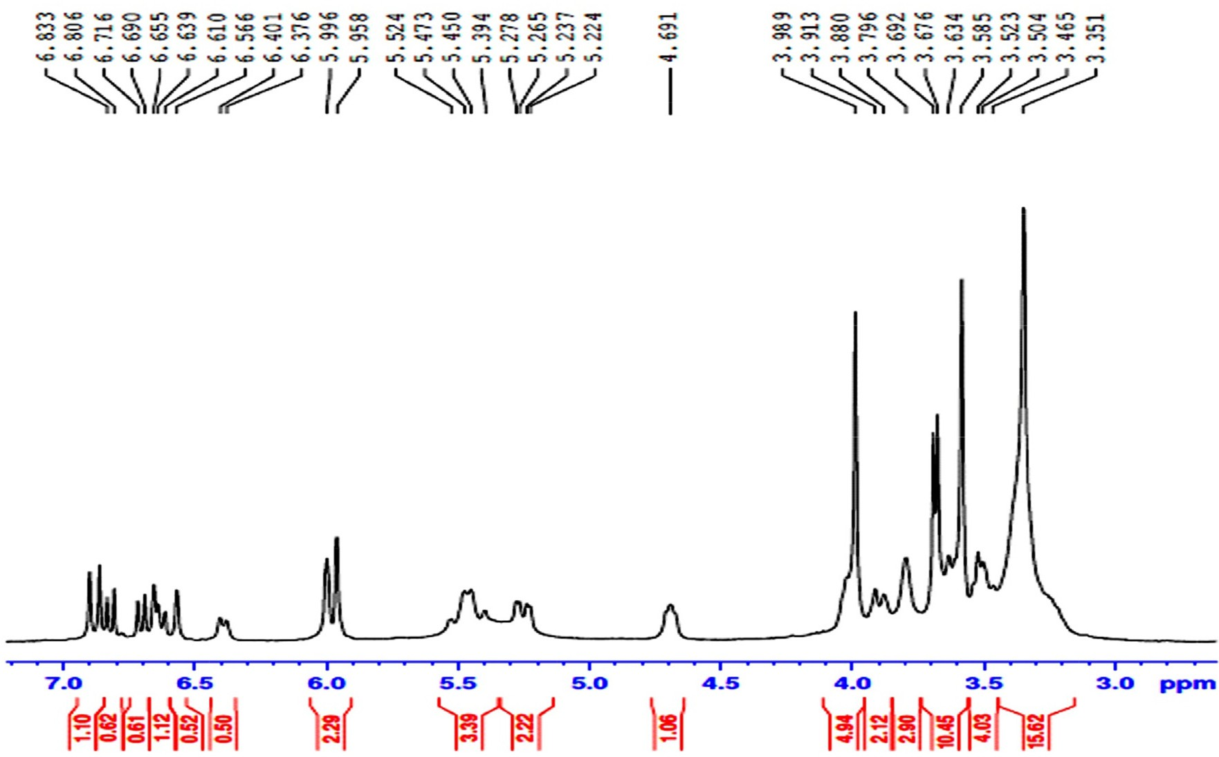

Fig. 3. 1H NMR spectra of fractioned compound TE (Diphyllin).

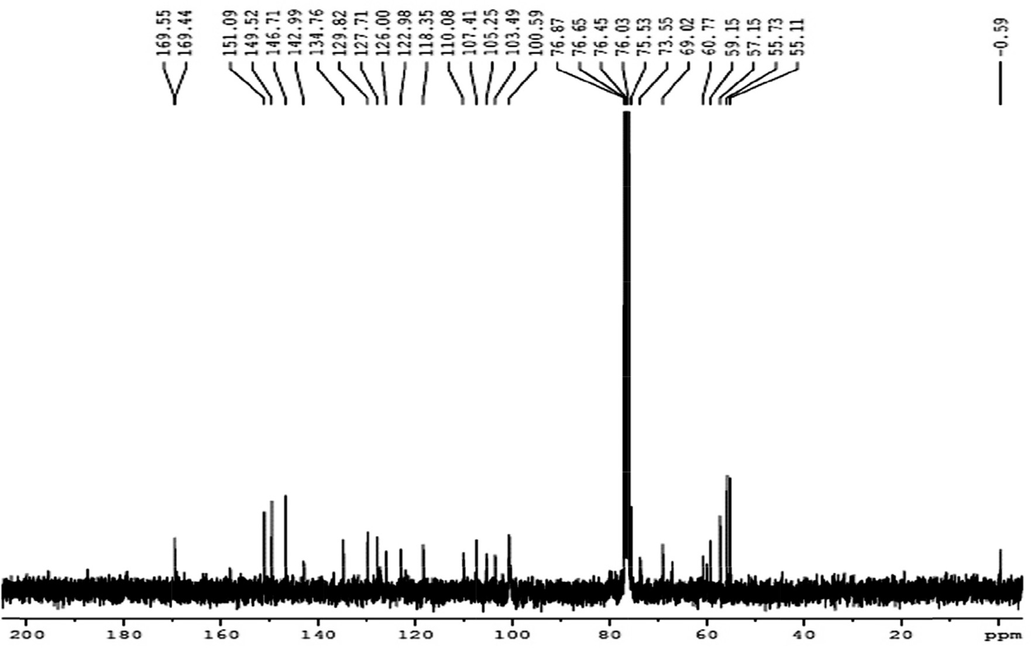

Fig. 4. 13C NMR spectra of fractioned compound TE (Diphyllin).

and 285 are due to C

H O+, C H

O+, C H

O+, and C

H O+,

respectively.

21 15 6

20 14 5

19 11 5

18 8 4

C% H% O%

Calculated 66.31 4.24 29.45

* + 1. *Elemental analysis of compound TE*

The compound TE was analyzed for carbon, hydrogen, and nitrogen. The results of elemental analyses are given below

Observed 66.29 4.24 29.27

Table 3

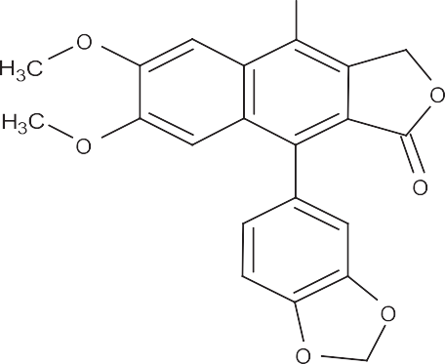

13C NMR spectra of fractioned compound TE.

Resonance signals Assignment

169.55 & 169.47 C@O

146.71 & 129.82, 129.82–118.35 Aromatic carbon

118.85 Substitutes aromatic carbon

149.52 ArAOACH2

55.73, 55.11 OACH3

151.09 & 149.52 Aromatic carbon bonded with OACH3

142.99 ArAOH

134.76 & 129.82 ArAAr carbon

60.77 & 59.15 ArACH2AO

69.02 ArACAO

The above data indicate that the molecular formula of the frac- tioned compound TE is C21H16O7 and the molecular weight of the compound is 380.

*3.1.8. 2D structure elucidation and name of the compound TE*

On the basis of the spectral studies, the fractioned compound TE was successfully drawn in the ChemDraw® Standard 14.0 software and the name was identified as 9-(1,3-benzodioxol-5-yl)-4- hydroxy-6,7dimethoxynaphtho[2,3-*c*]furan-1(3*H*)-one (diphyllin)

(Fig. 6). The name and synonyms of the diphyllin and the source of the plant and properties of the compound are given in Table 4.

* 1. *Anticandidal activity*

The anticandidal activity was determined against *C. albicans*, *C. tropicalis*, and *C. glabrata* from the aqueous and ethyl acetate solvent-based *C. collinus* leaf extracts*.* The ethyl acetate extract

only showed activity against *C. albicans* at 800 mg and other patho- gens were resistant (Table 5)*.* Further, the ethyl acetate extract was fractionated with toluene/ethyl acetate (3:2) solvents to get one

single compound. Thereafter, the fraction, identified as a com- pound diphyllin, was tested against selected yeast pathogens (Fig. 7). All selected *Candida* species were found to be highly sensi- tive to the fractionated compound at 200 mg. *C. glabrata* and *C. albi-*

*cans* were found to be highly susceptible (11–13.5 ± 0.5 mm ZOI at

200 mg) to the isolated botanicals. The MFC values of the compound

Fig. 6. Structure of Diphyllin (9-(1,3-benzodioxol-5-yl)-4-hydroxy-6,7-dimethoxy- naphtho[2,3-*c*]furan-1(3*H*)-one).

were observed at 85–145 mg/ml (Table 5) against all tested *Candida* species. For the standard antifungal drug miconazole used in the test, zones of inhibition in the range of 17.5 ± 0.5–20.5 ± 0.5 mm were observed against the tested pathogens.

1. Discussion

In recent years, the number of researches focused on drug development from plant sources to treat infectious has notably increased. This plant material has been used in various biological studies [19,20]. Among all the properties, antifungal activity has received the most attention. *Candida* species are normal flora, harmless yeast-like fungi in healthy humans, but they can cause infections in skin and mucosal membranes under immune- compromised situations [21]. In this study, we evaluated the anti- candidal activity of *C. collinus* leaf extracts and its fractions.

Hot aqueous extract of *C. collinus* did not show any activity against different species at least concentration but its displayed moderate anticandidal activity against only *C. albicans* at 800 mg*.* But earlier it was reported that cold aqueous extract if *C. collinus*

exhibited good anticandidal activity (>11 mm as maximum ZOI)

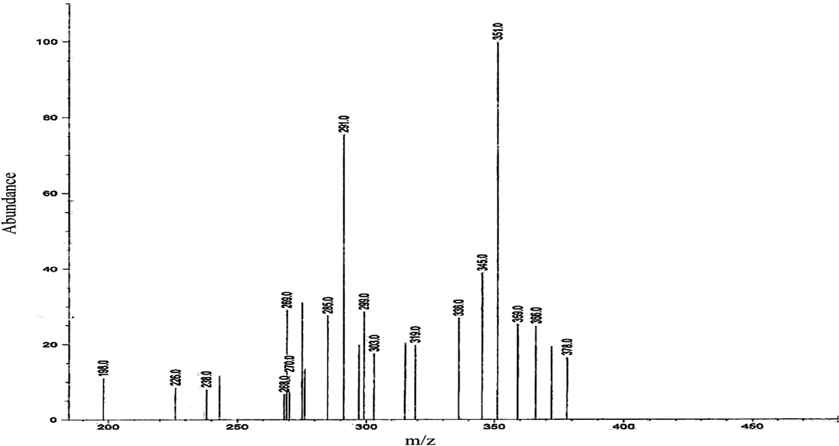

Fig. 5. The mass spectrum of fractioned compound TE (Diphyllin).

Table 4

Isolated compound name and synonyms, compound source and bio activity.

1. Name and synonyms Compound source Bio activity no
   1. 4-Hydroxy-6,7-dimethoxy-9-[3,4-(methylenedioxy) phenyl]-naphtho[2,3-*c*]furan-1(3H)-one
   2. 9-(1,3-Benzodioxol-5-yl)-4-hydroxy-6,7- dimethoxynaphtho[2,3-*c*]furan-1(3H) on *[German] [ACD/IUPAC Name]*
   3. 9-(1,3-Benzodioxol-5-yl)-4-hydroxy-6,7- dimethoxynaphtho[2,3-*c*]furan-1(3H)-one *[ACD/IUPAC Name]*
   4. 9-(1,3-Benzodioxol-5-yl)-4-hydroxy-6,7- diméthoxynaphto[2,3-*c*]furan-1(3H)-one *[French] [ACD/IUPAC Name]*
   5. Naphtho(2,3-c)furan-1(3H)-one, 4-hydroxy-6,7- dimethoxy-9-(3,4-(methylenedioxy)phenyl)-
   6. Naphtho(2,3-c)furan-1(3H)-one, 9-(1,3-benzodioxol- 5-yl)-4-hydroxy-6,7-dimethoxy-
   7. Naphtho[2,3-*c*]furan-1(3H)-one, 9-(1,3-benzodioxol- 5-yl)-4-hydroxy-6,7-dimethoxy- *[ACD/Index Name]* 22055-22-7 *[RN]*
   8. 9-(13-Benzodioxol-5-yl)-4-hydroxy-6,7- dimethoxynaphtho(2,3-c)furan-1(3H)-one
   9. 9-(Benzo[d][1,3]dioxol-5-yl)-4-hydroxy-6,7- dimethoxynaphtho[2,3-*c*]furan-1(3H)-one
   10. 9-Benzo[1,3]dioxol-5-yl-4-hydroxy-6,7-dimethoxy- 3H-naphtho[2,3-*c*]furan-1-one
   11. Diphyllin

Lignan from roots of *Diphylleia grayi,* leaves of *Cleistanthus collinus, Justicia procumbens* and *Haplophyllum hispanicum* Zerenex Molecular [ZBioX-0173]

Cytotoxin; Zerenex Molecular [ZBioX- 0173]

Source of information: <http://www.chemspider.com/Chemical-Structure.90798.html?rid=86c435ce-27e1-4d77-9f1d-1d1410b5091b>.

Table 5

Anticandidal activity of *C. collinus* extracts and Diphyllin.

|  |  |  |  |  |  |  |  |  |  |  |  |
| --- | --- | --- | --- | --- | --- | --- | --- | --- | --- | --- | --- |
|  | Yeast pathogens |  |  | *Candida albicans* |  |  | *Candida tropicalis* |  |  | *Candida glabrata* |  |
| Samples | Concentrations (mg) |  | ZI* | MFC** (mg/mL) |  | ZI* | MFC** (mg/mL) |  | ZI* MFC**  (mg/mL) |
|  | Aqueous | 100 |  | – | – |  | – | – |  | – – |  |
|  | extracts | 200 |  | – |  |  | – |  |  | – |  |
|  | | 400 | – | |  | – | |  | – |  | |
|  | | 800 | M | |  | – | |  | – |  | |
| Ethyl acetate extract | | 100 | – | | – | – | | – | – | – | |
|  | | 200 | – | |  | – | |  | – |  | |
|  | | 400 | M | |  | – | |  | – |  | |
|  | | 800 | 9.5 ± 0.5 | |  | M | |  | – |  | |
| Diphyllin | | 100 | M | | ≥85 | M | | ≥110 | M | ≥145 | |
|  | | 200 | 11 ± 0 | |  | 9.5 ± 0.5 | |  | 13.5 ± 0.5 |  | |
|  | | 400 | 13.25 ± 0.25 | |  | 11.25 ± 0.25 | |  | 14.5 ± 0.5 |  | |
|  | | 800 | 15 ± 0.5 | |  | 12.5 ± 0.5 | |  | 17.5 ± 0.5 |  | |
| 4% DMSO | |  | – | | – | – | | – | – | – | |
| Micoconazole (50 mg) (Positive control) | |  | 19.5 ± 0.5 | |  | 17.5 ± 0.5 | |  | 22.5 ± 0.5 |  | |

* Results are expressed as mean ± standard deviation of values from triplicate experiments.

** Average (MFC) minimal fungal inhibition concentration; M – Moderate activity; DMSO – Dimethyl sulphoxide

and exhibited MICs 600 mg/ml and MFC 750 mg/ml against *C. albi- cans* [13]. Significant ZOI was observed in ethyl acetate extract at 800 mg compared to the aqueous extract. From this study, it was found that some important phytocompounds might be present in ethyl acetate extract. Earlier, we investigated the preliminary phy- tochemicals, and aqueous and ethyl acetate extracts were qualita- tively screened using gas chromatography–mass spectrometry

(GC–MS). Fifteen major phytocompounds were found to be present in ethyl acetate extract, major compounds among them being silane, trimethyl[5-methyl-2-(1-methyl ethyl)phenoxy]- anthracene (7.06%). Tannins, terpenoids, flavonoids, saponins, gly- cosides, steroids, and alkaloids were also found in ethyl acetate

extract. Tannins, terpenoids, glycosides, flavonoids, and saponins were observed in the aqueous extract [22]. The major compounds were observed in the ethyl acetate extract other than aqueous extract by TLC and GC–MS analyses [23,24]. The isolated phyto- compound diphyllin showed higher level of inhibition against all

tested *Candida* species at 200 mg. Before that many researcher reported good anticandidal activity of medicinal plants. They reported only the anticandidal activity of crude extracts and did not find any promising fractionated compounds [25,26].

Diphyllin is a major glycoside compound present in *C. collinus* plant. Anjaneyulu et al. [27] reported a new diphyllin diglycoside from *C. collinus* heartwood. From the methanolic extract, the CHCl3

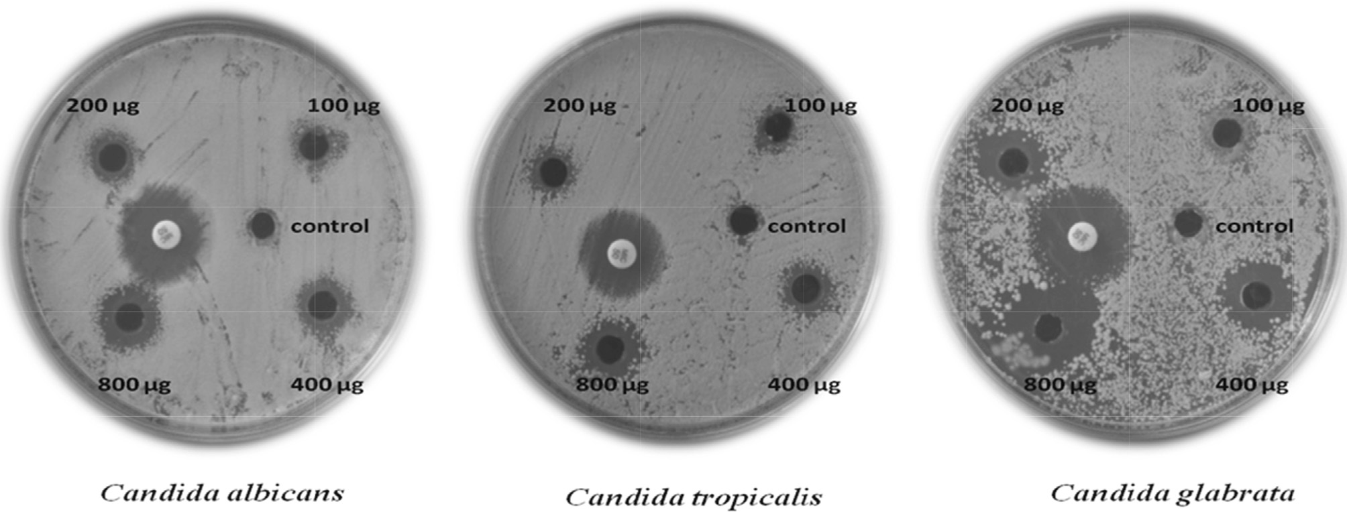

Fig. 7. Anticandidal activity of Diphyllin.

soluble fraction was treated with benzene and the benzene- insoluble residues were crystallized (CHCl3–MeOH) as colorless plates. As the isolated fraction of methanol extract showed Molisch’s test as positive, the glycoside was hydrolyzed and the aglycone was identified as diphyllin through spectral analyses. Two glycosides of diphyllin containing 2,3- and 3,4-di-*O*-methyl xyloses were identified for this plant. Similarly, 4-*O*-(300 -*O*- methy1-b-D-glucopyranosyl)diphyllin and Cleistanthoside-A were successfully isolated and identified in *C. collinus* fruits [28].

Investigations of extracts from *C. collinus* plant leaves revealed a complex group of compounds [29,30]. The toxic active principles of

*C. collinus* in the leaves are arylnaphthalene lignin lactones—di- phyllin and its glycoside derivatives Cleistanthin A and B, and Colli- nusin [31,32]. Diphyllin and Cleistanthin A and B were commonly known as ‘‘Oduvin” in the past. Also, the lignans Cleistanone, Cleis- tanthin C, and Cleistanthin D are present in *C. collinus*. The toxicity of the *C. collinus* leaves have been primarily due to Cleistanthin A and B [33]. Diphyllin was isolated free and also as 3,4-di-*O*- methylxylopyranoside from *C. collinus* leaves and as its fi-D- glucopyranoside from its bark [34]. The fruits of *C. collinus* have been shown to contain sitosterol and lupeol [35].

Aligiannis et al. [36] proposed a classification on MIC of plant material extracts (strong inhibitors, MIC up to 500 mg/ml); moder- ate inhibitors (MIC between 600 and 1500 mg/ml); and weak inhi- bitors (MIC above 1600 mg/ml). On the basis of our MIC results,

fractionated compound of *C. collinus* extract showed strong inhibi-

tion (85–145 lg/ml) against *C. albicans* followed by *C. tropicalis* and

*C. glabrata. Candida* species is responsible for the majority of yeast infections in humans and veterinary animals at immune- compromised situations. Among them, in 90% of cases, *C. albicans* is the most causative agent associated with disease to serious fun- gal infection. Moreover, *C. albicans* form biofilm with *C. tropicalis*, *C. glabrata*, and other *Candida* species, which has also been associated with disease [37,38]. Previously, the toxicity property of fractioned compound was studied against mouse 3 T3–L1 preadipocytes cell proliferation. The ethyl acetate fraction (diphyllin) showed 23– 59% anti-proliferative activity (concentration necessary to inhibit

cell growth at 50% is ~180 mg/ml) [39]. From our study, we found an assured isolated compound with anticandidal activity against *Candida* species with less toxicity.

In conclusion, it can be said that the results of this study indi- cated that diphyllin, the fractionated compound of *C. collinus* ethyl acetate extract, exhibited strong inhibition against *C. albicans*, *C. tropicalis*, and *C. glabrata*. Also, to the best of our knowledge, this

is the first detailed study of *C. collinus* extract and its fractioned compound against *Candida* species*.* Further studies on the mode of action of diphyllin are required to understand its anticandidal effects.

Conflict of interest

The authors declared that no conflict of interest.

Acknowledgement

The author Thamburaj Suman acknowledges the financial assis- tance provided by University Grants Commission, New Delhi, India in the form of UGC-RGNF.

References

1. [Horn DL, Neofytos D, Anaissie EJ, Fishman JA, Steinbach WJ, Olyaei AJ.](http://refhub.elsevier.com/S2314-808X(17)30310-X/h0005) [Epidemiology and outcomes of candidemia in 2019 patients: data from the](http://refhub.elsevier.com/S2314-808X(17)30310-X/h0005) [Prospective Antifungal Therapy Alliance Registry. Clin Infect Dis](http://refhub.elsevier.com/S2314-808X(17)30310-X/h0005) [2009;48:1695–703](http://refhub.elsevier.com/S2314-808X(17)30310-X/h0005).
2. [Douglas LJ. Candida biofilms and their role in infection. Trends Microbiol](http://refhub.elsevier.com/S2314-808X(17)30310-X/h0010) [2003;11:30–6](http://refhub.elsevier.com/S2314-808X(17)30310-X/h0010).
3. [Edwards JE. Candida species. In: Mandell, Douglas, Bennett, editors. Principles](http://refhub.elsevier.com/S2314-808X(17)30310-X/h0015) [and practice of infectious diseases. New York, USA: Churchill Livingstone;](http://refhub.elsevier.com/S2314-808X(17)30310-X/h0015) [1995. p. 2289–301](http://refhub.elsevier.com/S2314-808X(17)30310-X/h0015).
4. [Khan ZU, Chandy R, Metwali KE. *Candida albicans* strain carriage in patients](http://refhub.elsevier.com/S2314-808X(17)30310-X/h0020) [and nursing staff of an intensive care unit: a study of morphotypes and](http://refhub.elsevier.com/S2314-808X(17)30310-X/h0020) [resistotypes. Mycoses 2003;46:476–86](http://refhub.elsevier.com/S2314-808X(17)30310-X/h0020).
5. [Klepser ME. Antifungal resistance among Candida species. Pharmacotherapy](http://refhub.elsevier.com/S2314-808X(17)30310-X/h0025) [2001;21:124S–32S](http://refhub.elsevier.com/S2314-808X(17)30310-X/h0025).
6. [Runyoro DKB, Matee MIN, Ngassapa OD, Joseph CC, Mbwambo ZH. Screening](http://refhub.elsevier.com/S2314-808X(17)30310-X/h0030) [of Tanzanian medicinal plants for anti-candida activity. BMC Complement](http://refhub.elsevier.com/S2314-808X(17)30310-X/h0030) [Altern Med 2006;30:6–11](http://refhub.elsevier.com/S2314-808X(17)30310-X/h0030).
7. [Wagner H. Synergy research: approaching a new generation of](http://refhub.elsevier.com/S2314-808X(17)30310-X/h0035) [phytopharmaceuticals. Fitoterapia 2011;82:34–7](http://refhub.elsevier.com/S2314-808X(17)30310-X/h0035).
8. [Hassan STS, Masarcˇíková R, Berchová K. Bioactive natural products with anti-](http://refhub.elsevier.com/S2314-808X(17)30310-X/h0040) [herpes simplex virus properties. J Pharm Pharmacol 2015;67:1325–36](http://refhub.elsevier.com/S2314-808X(17)30310-X/h0040).
9. [Ali NA, Julich WD, Kusnick C, Lindequist U. Screening of Yemeni medicinal](http://refhub.elsevier.com/S2314-808X(17)30310-X/h0045) [plants for antibacterial and cytotoxic activities. J Ethnopharmacol](http://refhub.elsevier.com/S2314-808X(17)30310-X/h0045) [2001;74:173–9](http://refhub.elsevier.com/S2314-808X(17)30310-X/h0045).
10. [Sanjenbam P et al. Anticandidal activity of silver nanoparticles synthesized](http://refhub.elsevier.com/S2314-808X(17)30310-X/h0050) [using Streptomyces sp. VITPK1. J Mycol Med 2014;24(3):211–9](http://refhub.elsevier.com/S2314-808X(17)30310-X/h0050).
11. [Duarte MCT, Figueira GM, Rehder VLG, Delarmelina C. Anti-Candida activity of](http://refhub.elsevier.com/S2314-808X(17)30310-X/h0055) [Brazilian medicinal plants. J Ethnopharmacol 2005;97:305–11](http://refhub.elsevier.com/S2314-808X(17)30310-X/h0055).
12. [Feldmesser M. New and emerging antifungal agents: impact on respiratory](http://refhub.elsevier.com/S2314-808X(17)30310-X/h0060) [infections. Am J Respir Med 2003;2:371–83](http://refhub.elsevier.com/S2314-808X(17)30310-X/h0060).
13. [Maji S, Dandapat P, Ojha D, Maity C, Halder SK, Das Mohapatra PK, et al. *In vitro*](http://refhub.elsevier.com/S2314-808X(17)30310-X/h0065)[antimicrobial potentialities of different solvent extracts of ethnomedicinal](http://refhub.elsevier.com/S2314-808X(17)30310-X/h0065) [plants against clinically isolated human pathogens. J Phytol 2010;2(4):57–64](http://refhub.elsevier.com/S2314-808X(17)30310-X/h0065).
14. [Govindachari TR, Sathe SS, Viswanathan N, Pai BR, Srinivasan M. Chemical](http://refhub.elsevier.com/S2314-808X(17)30310-X/h0070) [constituents of *Cleistanthus collinus* (Roxb.). Tetrahedron 1969;25:2815–21](http://refhub.elsevier.com/S2314-808X(17)30310-X/h0070).
15. [Arivoli S, Samuel T. Larvicidal efficacy of *Cleistanthus collinus* (Roxb.)](http://refhub.elsevier.com/S2314-808X(17)30310-X/h0075) [(Euphorbiaceae) leaf extracts against vector mosquitoes (Diptera: Culicidae).](http://refhub.elsevier.com/S2314-808X(17)30310-X/h0075) [Asian Pac J Trop Biomed 2011;1(2):281–3](http://refhub.elsevier.com/S2314-808X(17)30310-X/h0075).
16. [Maity S. Ethnobotany of lateritic West Bengal [Ph.D.](http://refhub.elsevier.com/S2314-808X(17)30310-X/h0080) [Thesis]. Midnapore: Vidyasagar University; 2002](http://refhub.elsevier.com/S2314-808X(17)30310-X/h0080).
17. [Magaldi S, Mata-Essayag S, Hartung de Capriles C, Perez C, Colella MT, Carolina](http://refhub.elsevier.com/S2314-808X(17)30310-X/h0085) [O, et al. Well diffusion for antifungal susceptibility testing. In J Infect Dis](http://refhub.elsevier.com/S2314-808X(17)30310-X/h0085) [2004;8:39–45](http://refhub.elsevier.com/S2314-808X(17)30310-X/h0085).
18. CLSI. Reference Method for Broth Dilution Antifungal Susceptibility Testing of Yeasts, 3rd edn. Approved standard M27-A3. Wayne, PA: Clinical and Laboratory Standards Institute; 2008.
19. [Pinho PM, Kijjoa A. Chemical constituents of the plants of the genus](http://refhub.elsevier.com/S2314-808X(17)30310-X/h0095)

[*Cleistanthus* and their biological activity. Phytochem Rev 2007;6:175–82](http://refhub.elsevier.com/S2314-808X(17)30310-X/h0095).

1. [Pradheep Kumar CP, Panneerselvam N, Rajesh S, Shanmugam G. Cytotoxic and](http://refhub.elsevier.com/S2314-808X(17)30310-X/h0100) [genotoxic effects of cleistanthin B in normal and tumour cells. Mutagenesis](http://refhub.elsevier.com/S2314-808X(17)30310-X/h0100) [1996;11:543–7](http://refhub.elsevier.com/S2314-808X(17)30310-X/h0100).
2. [Staib P, Kretschmar M, Nichterlein T, Hof H, Morschhauser J. Differential](http://refhub.elsevier.com/S2314-808X(17)30310-X/h0105) [activation of a *Candida albicans* virulence gene family during infection. Proc](http://refhub.elsevier.com/S2314-808X(17)30310-X/h0105) [Natl Acad Sci USA 2000;97:6102–7](http://refhub.elsevier.com/S2314-808X(17)30310-X/h0105).
3. [Suman T, Elangomathavan R. Bio-prospecting of *Cleistanthus collinus* and its](http://refhub.elsevier.com/S2314-808X(17)30310-X/h0110) [antibacterial activity. Asian J Pharm Clin Res 2013;6(4):206–9](http://refhub.elsevier.com/S2314-808X(17)30310-X/h0110).
4. [Parasuraman S, Raveendran R, Madhavravo C. GC–MS analysis of leaf extracts](http://refhub.elsevier.com/S2314-808X(17)30310-X/h0115) [of *Cleistanthus collinus* Roxb. (Euphorbiaceae). Int J Ph Sci 2009;1(2):284–486](http://refhub.elsevier.com/S2314-808X(17)30310-X/h0115).
5. [Suman T, Chakkaravarthi K, Elangomathavan R. Phyto-chemical profiling of](http://refhub.elsevier.com/S2314-808X(17)30310-X/h0120) [*Cleistanthus collinus* leaf extracts using GC–MS analysis. Res J Pharm Tech](http://refhub.elsevier.com/S2314-808X(17)30310-X/h0120) [2013;6(11):1173–7](http://refhub.elsevier.com/S2314-808X(17)30310-X/h0120).
6. [Naeini A, Jalayer Naderi N, Shokri H. Analysis and in vitro anti-Candida](http://refhub.elsevier.com/S2314-808X(17)30310-X/h0125) [antifungal activity of *Cuminum cyminum* and *Salvadora persica* herbs extracts](http://refhub.elsevier.com/S2314-808X(17)30310-X/h0125) [against pathogenic Candida strains. J Myco Méd 2014;24:13–8](http://refhub.elsevier.com/S2314-808X(17)30310-X/h0125).
7. [Naeini A, Khosravi AR, Chitsaz M, Shokri H, Kamlnejad M. Anti-Candida](http://refhub.elsevier.com/S2314-808X(17)30310-X/h0130) [albicans activity of some Iranian plants used in traditional medicine. J Myco](http://refhub.elsevier.com/S2314-808X(17)30310-X/h0130) [Méd 2009;19:168–72](http://refhub.elsevier.com/S2314-808X(17)30310-X/h0130).
8. [Anjaneyulu ASR, Atchljta R, Ramachandra R. A new diphyllin glycoside from](http://refhub.elsevier.com/S2314-808X(17)30310-X/h0135)

[*Cleistanthus collinus*. Phytochemistry 1975;14. 187-76](http://refhub.elsevier.com/S2314-808X(17)30310-X/h0135).

1. [Devi CJ, Vasantha KPK. Chemical examination of fruits of *Cleistanthus collinus*.](http://refhub.elsevier.com/S2314-808X(17)30310-X/h0140) [Der Pharm Chem 2011;3(6):160–4](http://refhub.elsevier.com/S2314-808X(17)30310-X/h0140).
2. [Rajagopal Naidu S, Venkat Rao P, Subrahmanyam CA. The microscopy and](http://refhub.elsevier.com/S2314-808X(17)30310-X/h0145) [chemistry of oduvin. J Proc Inst Chem India 1944;16:59–63](http://refhub.elsevier.com/S2314-808X(17)30310-X/h0145).
3. [Maiti PC, Das AK. Chemical examination of the fruits of *Cleistanthus collinus*.](http://refhub.elsevier.com/S2314-808X(17)30310-X/h0150) [Curr Sci 1965;34:79–81](http://refhub.elsevier.com/S2314-808X(17)30310-X/h0150).
4. [Anjaneyulu AS, Ramaiah PA, Row LR, Venkateswarlu R, Pelter A, Ward RS. New](http://refhub.elsevier.com/S2314-808X(17)30310-X/h0155) [lignans from the heartwood of *Cleistanthus collinus*. Tetrahedron](http://refhub.elsevier.com/S2314-808X(17)30310-X/h0155) [1981;37:3641–52](http://refhub.elsevier.com/S2314-808X(17)30310-X/h0155).
5. [Anjaneyulu AS, Ramaiah PA, Rao R. Crystalline constituents of Euphorbiaceae;](http://refhub.elsevier.com/S2314-808X(17)30310-X/h0160) [Part XVI A new Diphyllin glycoside from *Cleistanthus collinus*. Indian J Chem](http://refhub.elsevier.com/S2314-808X(17)30310-X/h0160) [1977;15:10–1](http://refhub.elsevier.com/S2314-808X(17)30310-X/h0160).
6. [Ramesh C, Ravindranath N, Ram TS, Das B. Arylnaphthalide lignans from](http://refhub.elsevier.com/S2314-808X(17)30310-X/h0165)

[*Cleistanthus collinus*. Chem Pharm Bull (Tokyo) 2003;51:1299–300](http://refhub.elsevier.com/S2314-808X(17)30310-X/h0165).

1. [Govindachari TR, Sathe SS, Viswanathan N, Pai BR, Srinivasan M. Chemical](http://refhub.elsevier.com/S2314-808X(17)30310-X/h0170) [constituents of *Cleistanthus collinus*. Tetrahedron 1969;25:2815–21](http://refhub.elsevier.com/S2314-808X(17)30310-X/h0170).
2. [Lakshmi TG, Srimannarayan G, Subbarao NV. A new glucoside from](http://refhub.elsevier.com/S2314-808X(17)30310-X/h0175)

[*Cleistanthus collinus*. Curr Sci 1970;39:395–6](http://refhub.elsevier.com/S2314-808X(17)30310-X/h0175).

1. [Aligiannis N, Kalpotzakis E, Mitaku S, Chinou IB. Composition and](http://refhub.elsevier.com/S2314-808X(17)30310-X/h0180) [antimicrobial activity of the essential oils of two *Origanum* species. J Agric](http://refhub.elsevier.com/S2314-808X(17)30310-X/h0180) [Food Chem 2001;40:4168–70](http://refhub.elsevier.com/S2314-808X(17)30310-X/h0180).
2. [Staib P, Kretschmar M, Nichterlein T, Hof H, Morschhauser J. Differential](http://refhub.elsevier.com/S2314-808X(17)30310-X/h0185) [activation of a *Candida albicans* virulence gene family during infection. Proc](http://refhub.elsevier.com/S2314-808X(17)30310-X/h0185) [Natl Acad Sci USA 2000;97:6102–7](http://refhub.elsevier.com/S2314-808X(17)30310-X/h0185).
3. [Heinig MJ, Francis J, Pappagiansis D. Mammary candidosis in lactating women.](http://refhub.elsevier.com/S2314-808X(17)30310-X/h0190) [J Hum Lact 1999;15:281–8](http://refhub.elsevier.com/S2314-808X(17)30310-X/h0190).
4. [Suman T, Elangomathavan R, Ilavenil S, Ramesh S. In vitro cytotoxic effect of](http://refhub.elsevier.com/S2314-808X(17)30310-X/h0195) [*Cleistanthus collinus* extracts and fractions on mouse cell line. J App Pharm Sci](http://refhub.elsevier.com/S2314-808X(17)30310-X/h0195) [2014;4(10):044–6](http://refhub.elsevier.com/S2314-808X(17)30310-X/h0195).