

Electronic Notes in Theoretical Computer Science 252 (2009) 157–180

[www.elsevier.com/locate/entcs](http://www.elsevier.com/locate/entcs)

Dynamics of Quality Perception in a Social Network: A Cellular Automaton Based Model in Aesthetics Services

# Rubens A. Zimbres1

*Universidade Presbiteriana Mackenzie Centro de Ciˆencias Sociais e Aplicadas Rua da Consolac¸˜ao 896, Consola¸c˜ao 01302-907 Sa˜o Paulo, SP - Brazil*

# Pedro P.B. de Oliveira2

*Universidade Presbiteriana Mackenzie*

*Faculdade de Computac¸˜ao e Informa´tica & Po´s-Graduac¸a˜o em Engenharia El´etrica Rua da Consolac¸˜ao 896, Consola¸c˜ao*

*01302-907 Sa˜o Paulo, SP - Brazil*

Abstract

An attempt was carried out to simulate interactions between customers and providers, and understand the rationality of a social network using a cellular automata model. A longitudinal research study was conducted, based on a dyadic perspective in aesthetics clinics, approaching clients and service providers. The evolution of opinions regarding the associated service quality was then modeled with a cellular automaton. Based on an existing and valid scale of service quality, six semi-structured interviews with clients and service providers were carried out. The indicators were then refined and two quantitative surveys were performed, with a time interval of four months. A cellular automaton rule was then searched for that could simulate the network rationality between the two surveys. The proposed cellular automaton model achieved an accuracy of 73*.*80%, a higher value than the ones typically found in linear regression models of the service quality literature. The simulation allowed to understand which behaviours adopted by providers and customers generate an improved perception of service quality. The simulation also identified dissatisfied individuals in the social network and the way they influence the network. These findings may help managers to control employees’ conducts and the service performance.

*Keywords:* Cellular automata modelling, social networks, dynamics of quality perception, aesthetics services, management, role theory.

# Introduction

Complexity in social sciences is an emerging field of research. In complex systems, processes that occur simultaneously at different levels are important and complex

1 Email: [rubenszmm@gmail.com](mailto:rubenszmm@gmail.com)

2 Email: [pedrob@mackenzie.br](mailto:pedrob@mackenzie.br)

1571-0661 © 2009 Elsevier B.V. Open access under [CC BY-NC-ND license](http://creativecommons.org/licenses/by-nc-nd/3.0/).

doi:10.1016/j.entcs.2009.09.020

behaviour of the system depends on its sub-units in a non-trivial way. So, there may be a change of paradigms in an attempt to understand our world, because laws governing the whole cannot be reduced simply by the mere observation of the details of its components [35]. Besides, social sciences literature usually adopts a linear approach to these complex systems. This is the reason why many regression models in service quality literature present limited variance explanation.

Natural systems are fairly unpredictable, and small changes in their configura- tion can cause large effects. One could assume that this unpredictability prevents any control attempts, but this is not right, because the parameters of a given system can be controlled. However, traditional methods of forecasting cannot be consid- ered reliable for this type of system. Systems are considered complex when it is difficult to predict outcomes not because of its randomness, but because its reg- ularities cannot be easily described. The understanding of these systems includes two areas, quantitative (forecasting and generalisation of results) and qualitative (understanding the process underlying the phenomenon) [1], [2].

Agent-based models (ABMs) provide a useful tool for modeling such complex systems. An ABM constitute a set of computational agents that operate in paral- lel, according to their internal states and rules of behaviour, specifications of the environment, and use of a communication language between agents and their envi- ronment. So, we specify a network of connectivity and then activate agents in order to observe the emergent macro-behaviours [16]. ABMs allow the creation of arti- ficial societies, systems where basic social structures and group behaviours emerge from the interaction between individual agents, in artificial environments, based on limited information and computational ability ([16], [24], [25]).

Cellular automata (CAs) can be regarded as a specific type of ABM, composed of finite state machines, that use an abstract method of study to analyse simul- taneous implementation of local rules with an emergent global pattern ([20], [38]). CAs have three notable features: massive parallelism, local interactions and sim- plicity of basic components [32]. Due to their simplicity and enormous potential in modeling complex systems, they are widely used in the hard sciences. CAs can be viewed as simple models of spatially decentralised systems consisting of individual components, their cells.

The communication between the constituent cells is limited by local interac- tion. Each cell has a discrete state that varies according to the states of its local neighbourhood. Each cell communicates with a finite number of others in its neigh- bourhood. This communication is local, uniform, deterministic and synchronous, setting the overall development of the system over time in discrete steps [20]. The evolution is determined by the previous state of the cell, its neighbourhood and the associated local transition function, i.e., its rule ([17], [32]).

The simultaneous implementation of a simple rule in successive time steps can generate a complex global behaviour [17], what is interesting because each individual has access only to its local neighbourhood but engages in long distance communi- cation based on a transitivity principle [18].

Commercial systems can be seen as complex systems, constituted by simple

elements that interact with each other. Examples of these elements are clients and service providers, that interact during the service delivery. The social structure generated by their interaction can be simplified with a model, in order to understand the factors and behaviours that affect the service cycle.

This article presents a simulation model using cellular automata. The result of an initial quantitative survey on service quality in aesthetics clinics provided the initial condition for the simulation. From this initial condition, we applied the cellular automaton simulation in order to get to the second quantitative survey data, case by case. Furthermore, the rationale for this social network was analised, thus leading to an understanding of the dynamics of information exchange in the network of clients and providers, which may allow managers to adjust the conduct of its employees and manage the expectations of their customers so that there is a positive perception of service quality.

Next, the paper introduces the theoretical background, with aspects of service quality, and present role theory concepts that guided the cellular automata based abstraction. Subsequently, the methodological procedures are presented, followed by the proposed model. Concluding the paper, the results of the model and its statistical analysis are discussed.

# Background

* 1. *Service quality*

Quality is a construct that has a difficult operationalisation, because it contains intangible aspects. Customers try to make the service tangible in order to make it easier to evaluate. The facilities, equipment, employees, materials for communi- cation, other customers, prices and available technology are tangible elements that provide clues to the customer on the intangible portion of the service, especially at the beginning of the relationship.

In the service encounter this means that service providers and customers judge service quality according to the provider’s ability to respond to customer needs. Usually, one can identify two types of quality, technical and functional ([19], [5], [14]). Functional quality refers to how the service is delivered to the customer, including social and relationship aspects [13]. The technical quality is difficult to be assessed by customers, since customers rarely have the expertise to evaluate professional services. Functional quality is “how” the service is delivered, the nature of the interaction between the service provider and the client, the process by which the main service is delivered.

Communication and effective transmission of information play an important role in perceptions of technical and functional quality [30]. Therefore, the correct and effective transmission of information is important to establish the patterns that lead to a positive evaluation of service quality. Through the interactions, i.e., the exchange of information, customers can develop a positive or negative feeling, which can lead to success or failure in the sale [7].

The service quality literature in Marketing is divided into two trends. One led

by the studies of [29], who propose the measurement of quality by the difference between expectations and perceptions of service quality by customers (SERVQUAL scale), and another proposed by [11], which measure quality only by the perfor- mance, the outcome of the service (SERVPERF scale). Based on their research, [11] argue that the perceived quality of service at a time t depends on the perceived qual- ity of service and level of the customer’s (dis)satisfaction with the performance of the service at time *t* − 1.

[15] states that SERVPERF measures the performance, explaining better the variance of perceived service quality (i.e., their perception by the final consumer), without considering the expectations of consumers. Regarding the variance ex- plained by the two scales, [11] obtained maximum *R*2 (variance explanation) of

0.47 for SERVPERF and 0.46 for SERVQUAL, [15] obtained maximum *R*2 of 0.65 for SERVPERF and 0.42 for SERVQUAL, and [23] obtained maximum *R*2 of 0.53 for SERVPERF and 0.35 for SERVQUAL.

[22] argue that the SERVQUAL scale appears to be better than SERVPERF, but presents problems of variability between different types of service and extensive collection of data, due to the existence of 44 indicators, which can prevent its operation, while it requires a larger size of the sample. Furthermore, literature findings show that there is not a universal scale for services.

The SERVPERF scale has one advantage. It can be used in different services and assesses the overall quality of service. On its part, SERVQUAL scale measures the differences between perceptions and expectations, where the assessment of quality is the sum of the differences between them. This scale received criticism because of its alleged potential to be used in any service, the length of the questionnaire it requires, the predictive power of the instrument and psychometric inconsistencies. Due to the reasons described above, the conceptual and paradigmatic base of SERVQUAL scale has been criticised, as it focuses on processes and not on quality results. That is, it has two opposing currents: one that focuses on processes and

another that focuses on the results of quality of service.

* 1. *Role theory*

Organisations can be seen as theaters [8] and role theory is a theatrical metaphor, where the participants of the service encounter act as agents, i.e., a group of so- cial insinuations that guide and direct the behaviour of the individual in a given situation [31]. A role can be defined as a set of social responsibilities that guide and direct the behaviour of an individual in a given environmental setting, usually associated with socially defined positions. A role can also be defined as an internally consistent series of conditioned responses by a member of a social situation which represents the pattern of stimulation to similar and internally consistent series of conditioned responses of others in that situation [36].

An interesting feature of role theory is the proposal to manage interactions and collaboration between agents through the use of common behaviours that can be used as a paradigm for modeling the vision of a complex system, and deal with situations and interactions that evolve in time.

A role is a set of scripts. The script can be defined as a coherent sequence of events expected by the individual, involving him as an observer or participant, and for each event there is an expected role by both the provider and the client. Accord- ing to time and the demands of the situation, these roles can become automatic, without much cognitive effort [6].

Despite its great utility, role theory is subject to criticism. [26] criticise its use- fulness, arguing that it does not provide sufficient understanding to evaluate the quality of communication, since this theory sees the communicative behaviour and the performance as standardised sets of behaviours. This critique of the simplicity of the approach contradicts complexity theory, because today it is clear that a complex phenomenon is not always related to the complexity of its components. Often the simplicity of the components of a system can generate complex phenomena through interactions and nonlinear effects.

According to [6] role theory has a weakness that can be attributed to the lack of consensus on the scope or attitude in the study of a particular role. It is un- clear whether the theory of roles focuses on the person as a representative of a social position or as an individual separate from his position. The idea of being a representative of a social position sees the role as patterns of behaviour associ- ated to a particular social position. From this perspective, roles are seen as fixed and static. Both the economic and the sociological perspective share the common premise that the actors play a unique role in their decisions, according to a fixed pattern [21]. However, in our view, the standardisation and consensus seem to be outcomes, and not assumptions of the systems, given that the result of interactions is the emergence of consensus.

# Methodological procedures

We used a scale adapted from [11] to measure quality of aesthetic services. After analysing qualitative data collected through 6 semi-structured interviews with 3 clients and 3 providers, we created a list of possible indicators, building a scale with 74 items. A qualitative pre-test with 6 customers and 2 marketing specialists was then made, which led us to filter the scale items to 54. Then the quantitative pre-test was made, with 27 providers and 6 customers. After statistical analyses of variance, correlation, factor analysis and reliability, the final questionnaire was built with 45 indicators. After that, the first stage of quantitative research was carried out, with data collection from customers and service providers, resulting in 115 responses from clients and 96 responses from providers. A 5-point Likert scale (an ordinal scale that measures graduations of responses) was used, with the following meanings: ‘totally disagree’, ‘disagree’, ‘neither agree nor disagree’, ‘agree’ and ‘totally agree’.

Regarding the internal consistency of the quantitative indicators of the initial search, the following results were obtained for customers: Cronbach’s Alpha equals 0.937; two-dimensional factor, containing issues of tangible assets in one factor and intangible assets in another factor, with minimum load of 0.521; KMO measure

of 0.913; and 66*.*44% of extracted variance. For providers, Cronbach’s Alpha was 0.772; a multi-dimensional factor with minimum load of 0.512; KMO measure of 0.680; and 64*.*08% of extracted variance. Four months after this phase, the second phase of quantitative survey was conducted, obtaining 36 responses. Regarding the internal consistency of the final indicators of the quantitative research, Cronbach’s Alpha was 0.892 for clients and 0.631 for providers.

For customers, linear regression relied on current perception of quality as the dependent variable, and quality indicators as independent variables, and resulted in: *R*2 of 0.760; sum of the squares of the regression of 88.77; residuals of 27.99, significant to 0.000; high tolerance; variance inflation factor lower than 10; standard error of 0.907; and normality of the residuals. For providers, linear regression used current perception of quality as the dependent variable, and quality indicators as independent variables, and resulted in: *R*2 of 0.873; sum of the squares of the regression of 50.05; residuals of 7.30, significant at 0.001; high tolerance; variance inflation factor lower than 10; standard error of 0.780; and normality of the residuals. Furthermore, we knew that the most important aspect in the quality perception for customers are the intangible aspects and the attention given by the provider, while tangible aspects such as comfort of the facilities seem to be more important for providers.

These findings are supported by the Resource Based View [4], which states that the resources that generate sustainable competitive advantage are those that are rare, valuable and hard to copy, namely, the intangibles.

# Proposed model

The proposed model had two goals. The first was to predict the final outcome (in the case, the second quantitative survey) from the initial conditions (the first quantitative survey). That is, the data from the first quantitative survey would provide the initial parameters for the cellular automaton model. Data from the second phase of the research would provide the final state for comparison with the model’s results. Between the two collections of quantitative data customers and providers interacted in their social environment following specific rules of decision. The second goal was to understand the decision process, finding a rationale for its evolution, from the phase of the first survey to that of the second.

We tried to obtain a rule that would simulate the interaction process so that the final configuration of the model could be provided with maximum accuracy compared with the final configuration (the second quantitative data). This rule of behaviour would then simulate decisions regarding intangible aspects of service quality in the service encounter. The selected variables were composed of by the intangible dimension of service quality due to the smaller number of indicators and its high reliability and robustness in the statistical analysis. Another reason is its usefulness for management, because it is known that intangible aspects of quality are more relevant to customers in their evaluation of service quality.

The lattice was composed of by 36 subjects (columns) and 7 intangible indicators

of service quality (rows), that is, 36 strings, each one containing 7 values of the indicators (attention, trust, willingness to help, honesty, concern, responsibility, and adaptation to client’s needs). Hence, each row of the lattice contained the values of the same indicator and each column represented one individual. Due to the fact that interactions occurred between these indicators and there was no multicollinearity among the variables, it is sensible to rely on a one-dimensional CA rule to operate at each row, the same rule being used independently at each. Another reason for this is that this kind of CA facilitates to unveil the rationale embedded in the transition table. And, finally, the characteristics of the CA model is supported by role theory, which argues that all individuals in a social network adopt a pattern of behaviour, that is, all of them decide and act following the same behaviour rule, which means a uniform cellular automaton.

The same respondents were selected in the first and second phase of the quanti- tative research. The CA contained 5 possible states, as the Likert scale has 5 points, as made explicit earlier. A CA rule with radius one was used, thus yielding 125 possible rationales associated to each rule and a search space of 553 ∼= 2*.*35 × 1087 possible rules. Radius 1 entails that each individual interacts only with the nearest- neighbours on the right-hand and left-hand sides. Due to computational and time constraints, a random search policy for the rules was adopted. For such, a majority rule of the space was taken as the starting point of the search; in this case the major- ity rule was the one whose next state of the centre cell is the prevailing state of the neighbourhood, or no change is made if no prevailing state exists. This seemed to be a reasonable choice because of the evidences that human beings tend to behave in ‘herds’, as seen in the stock market, crowds, and various other situations [33].

Starting with the rule number of the majority rule, the search was carried out in blocks of 1500 rules, and picking the next rule with uniformly distributed random steps in the range from 110 and 1084. The closer the search would get to a pre- specified minimum, target accuracy rate, the search intervals were reduced, in order to get a closer inspection of the rules. Two constraints guided the search: the rule should simulate the evolution of the initial condition with an accuracy rate greater than 70% (that is, the final outcome of the model should be identical to the data of quantitative research in 70% of the cells of the lattice), and the rule should not present a cyclic atractor.

The rate of success was calculated as the difference between the final state of the model and the data from the second quantitative survey, cell by cell, and then normalised by the number of indicators and by the number of respondents. The number of iterations required for the CA was established according to the elapsed time between the two phases of the quantitative research. Considering that the time between the two data collections was 4 months (or 16 weeks), and that the average frequency of interaction among the customers was once a week, 16 interactions would happen in the period. So, 20 iterations was chosen for the model as the iteration of reference for probing the predictive quality of a rule.

Customers and providers were classified according to their similarity of response to the seventh indicator, ‘adaptation to customer’s needs’, since it turned out to

display the highest variance. Customers and providers were then allocated to each CA lattice position according to their affinity in that indicator, thus creating an artificial situation where service providers and customers could interact. The allo- cation was based on the seventh indicator criterion because higher variance reflects less consensus and higher diversity of opinions, a situation that might trigger richer dynamics if customers and providers could be closer.

So, at the end of 20 iterations of every probed CA rule, the result of the model was compared with the data collected from the second quantitative research, cell by cell, and rules with accuracy rate lower than 70% were discarded. Another ‘filter’ was also used, discarding rules whose variance would be 0.5 point higher or lower the variance found in second quantitative research. At the end of the process, approximately 1.8 million rules had been searched for.

Starting from the values of the indicators, various statistical quantities were analised: mean, variance, standard deviation, median, increase in perception of the model and real increase in perception. We also analised the rate of settlement over the iterations, accuracy of the model, total sum and mean of the indicators, ending with the rationality analysis of the more appropriate rule.

For instance, a rule could have the following logic: if a given customer evaluates the service quality offered by one provider as bad (Likert scale value equal to 1 and cell state equal to 1) and the service quality offered by another provider in the same way, this could generate a regular assessment of quality (cell state equal to 2), which could interfere with future intentions of the client to remain with the provider, given the inconsistency of the attitudes.

# Results of the modeling

Figure 1 illustrates the accuracy rate of the simulation model when compared with real data from the second quantitative research. After a decline in ac- curacy in the second cycle (which can be interpreted as post-consumption cognitive dissonance; [34]), the success rate oscillates and reached the accuracy of 73.80% in the 16th iteration. Thus, the simulation generated an S-shaped curve, which is clear evidence for being considered solid, according to [9]. The selected rule number, in Wolfram’s lexicographic ordering scheme [38], was 215906251256498764481945521911689394589595852815202122870575256380795923

7655911950549124. Its transition table is shown in Fig. 2. The rule can be seen as the role adopted by the social network, each state transition being the corresponding script for that role.

Compared to regression results obtained in the service quality literature, our model offers higher explanatory power than those found in [11] that had maximum *R*2 (variance explained) of 47%, [15] with maximum *R*2 of 65%, [23] with maximum *R*2 of 53%, and [10] that yielded maximum *R*2 of 71*.*6%. Besides, linear regression models account for variance explanation, which is based on mean values, while our model explains 73*.*80% of the results, case by case; if we consider explanatory power based on mean, our model offers even more accuracy (Table 1).

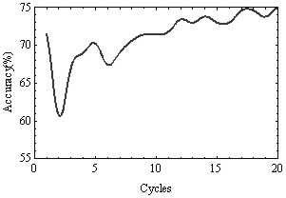

Fig. 1. Model accuracy over 20 iterations of the CA rule.



Fig. 2. Transition table for the chosen rule.

Table 1

Total per indicator.

|  |  |  |  |  |  |  |  |
| --- | --- | --- | --- | --- | --- | --- | --- |
| Indicator | 1 | 2 | 3 | 4 | 5 | 6 | 7 |
| Phase 2 - Phase 1 (c) | 137 | 136 | 140 | 135 | 132 | 138 | 129 |
| Simulation - Phase 1 (d) | 130 | 135 | 136 | 134 | 127 | 133 | 126 |
| Difference (c)-(d) | 7 | 1 | 4 | 1 | 5 | 5 | 3 |
| Accuracy (%) | 94.89% | 99.26% | 97.14% | 99.26% | 96.21% | 96.38% | 97.67% |

A key question that emerges from the explanatory power of the model is to know what part of reality is being explained. In Fig. 3A, both the linear regression model and the proposed cellular automaton model explain the same reality aspect, with different success rates. This means that the CA model offers an additional explanatory power of 8.80 percentage points (73*.*80% 65%). Thus, nonlinear effects appear to contribute with 8*.*80 percentage points in the model.

—

In the second case, Fig. 3B, the linear regression model and the CA model ex- plain different reality aspects, sharing only 38*.*80% in common, i.e., the intersection

between the two models. This last argument seem to be more valid, as long as we have linear relations, nonlinear relations, and the intersection between linear and nonlinear relations, that may represent the interaction among individuals. This finding offers a new perspective in the study of causal relations in management research.

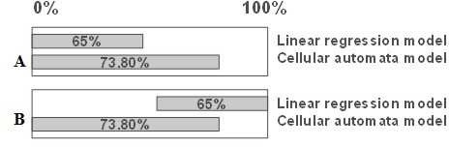

Fig. 3. Different approaches for the models’ explanation.

Figure 4 shows the average Euclidean distances between the individuals in the first quantitative survey (A), in the second (B), and the outcome of the model. Every dot in the graphic represents the average Euclidean distance between every individual and every other, also averaged for all 7 indicators:

Σ36

7

*i*=1

P

√(*ij* −*ik*)2

(1)

*D* = *j*=1 7

36

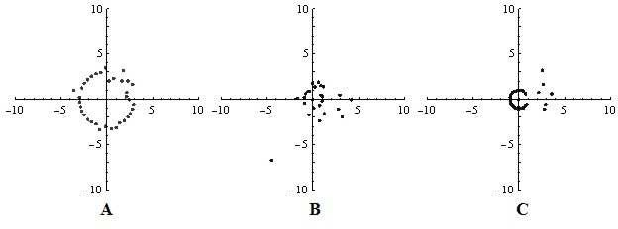

Fig. 4. Euclidean distance in the initial survey (A), in the final (B) and at the 16th cycle of the simulation model (C).

Initially the average Euclidean distance was 2.97. In the second survey it went down to 1.38, and in the result of the simulation, the value became 1.54. That is, there was an approximation of the subjects, showing greater similarity and consen- sus between them, due to successive interactions. Hence, the multiple interactions in the social network seem to approximate individuals who think similarly (at the perception level). This greater intimacy (as the indicators relate to the relation- ship) can support the congruence of perceptions about a given topic, and may facilitate mutual understanding between customers and providers. Table 2 shows the Euclidean distance for all indicators of intangible quality. The indicator with

the largest discrepancy is the adaptation of the provider. This was exactly the in- dicator chosen for the classification, as it presented greater variance. Therefore, the variance of the data appears to affect the outcome of the simulation through the change of initial conditions.

Table 2

Euclidean distances for the 7 indicators.

|  |  |  |  |  |  |  |  |
| --- | --- | --- | --- | --- | --- | --- | --- |
| Indicator | 1 | 2 | 3 | 4 | 5 | 6 | 7 |
| Phase 2 - Phase 1 (c) | 5.74 | 3.31 | 4.24 | 4.35 | 5 | 4.58 | 6.55 |
| Simulation - Phase 1 (d) | 5.56 | 3.46 | 2 | 3 | 4 | 2.44 | 21.93 |
| Difference (c)-(d) | 0.18 | -0.15 | 2.24 | 1.35 | 1 | 2.14 | -15.38 |

Figure 5 illustrates the colours for different states of the CA, each one corre- sponding to a possible answer in the Likert scale. So, if we consider the question “The provider is honest” we have different response graduations.



Fig. 5. Degree of colour to the Likert scale.

Figure 6 illustrates the various CA lattice configurations, from time zero to 16, each row associated to a different indicator. The classification of individuals accord- ing to the seventh indicator (as discussed earlier) becomes evident in it, because it starts from a dark gray color and becomes lighter in the right-hand side of the figure. As a result of the classification of the individuals, each one is assigned a cell position as follows, with ‘P’ meaning a provider and ‘C’, a client: PPCPPPC- CCCCPPPPPPPPPPPPPPPPPCCCCCCCC. Time zero is identical to the initial research because it is the initial condition of the CA. At time step 5 there are dark- gray and black areas, meaning poor quality perception in some individuals, except regarding responsibility. It is remarkable that the larger the dark-gray and black areas, the greater the likelihood of perceived poor quality of the relationship. In the right-hand of the lattice there are also individuals with poor quality perceptions.

At time step 10, dissatisfied individuals are scattered in isolated clusters, ‘con- taminating’ just adjacent individuals. At time step 16, those with negative per- ceptions are isolated by the social network, a similar phenomenon to that observed in the research, where there is only one (individual 25) extremely dissatisfied per- son, who presents ‘totally disagree’ responses in three of the seven indicators in the second quantitative research.

Figure 7 illustrates the evolution of the CA for each indicator, considering all individuals. In the first indicator, attention, there is an outbreak of negative per- ceptions (black areas) in various subjects, that remain in time (successive downward lines) and affects the right-most ‘end’ of the lattice at the 13th time step (in quotes, given the periodic condition, as the lattice is circular, with no beginning nor end). The dissatisfied ones lose their strength and follow the rest of the network, that presents a positive quality perception.

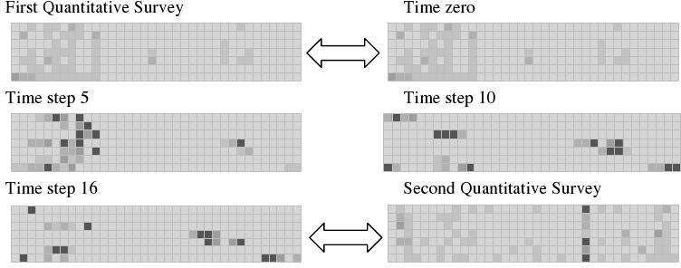

Fig. 6. Lattice configuration along the CA iterations.

The outbreak was generated by customers (individuals 8, 10 and 30) at the 2nd time step, contaminating providers at the 3rd. From the 5th to the 16th time steps the dissatisfaction moves to providers, which in turn contaminate the individuals with whom they interact.

It is worth noticing that the dissatisfied individuals form a cross in the right-hand of the lattice but do not propagate their dissatisfaction because they are minority. This indicator reached stability at time step 17, converging to a fixed point attractor. The homogeneous colour areas mean fixed states achieved by individuals, i.e. the equilibrium. At time step 2, subjects 8 and 10 contaminated individual 9, located between them, worsening his evaluation of service quality at time step 3.

The simulation has identified exactly which clients need attention, which are the most sensitive and, as a result, identify which providers are failing in the relational aspect. In the second indicator, trust, there is an outbreak of dissatisfaction, smaller than the first indicator, also started from customers and spreading over 7 time steps, achieving stability at the 8th.

In the third indicator, willingness to help, there is an outbreak of dissatisfaction, smaller than the first indicator, started by one client (9) and two providers (12 and 28), spreads over more than 20 time steps, and does not reach stability.

In the fourth indicator, honesty, there is an outbreak of dissatisfaction that spreads to a greater area of the network, at the left-hand side, starting with cus- tomers and suppliers, spreading over 20 time steps, and not reaching stability. The contaminated area is wider than those for the previous indicators, meaning a greater spread in space between individuals. This may be due to the fact that honesty is a critical factor in building confidence between client and provider. When the in- tegrity of a client or provider is left in doubt, the effects spread to a larger area of the social network, when compared to something less critical, like the attention given by the provider.

It is worth noticing that the rule displays a cyclic behaviour of period 9 that starts at time step 3. At time step 5, the first completely dissatisfied individual appears, followed by two others at iteration 6. At time steps 7 and 8 there is only one completely dissatisfied individual. At the 10th there are two dissatisfied

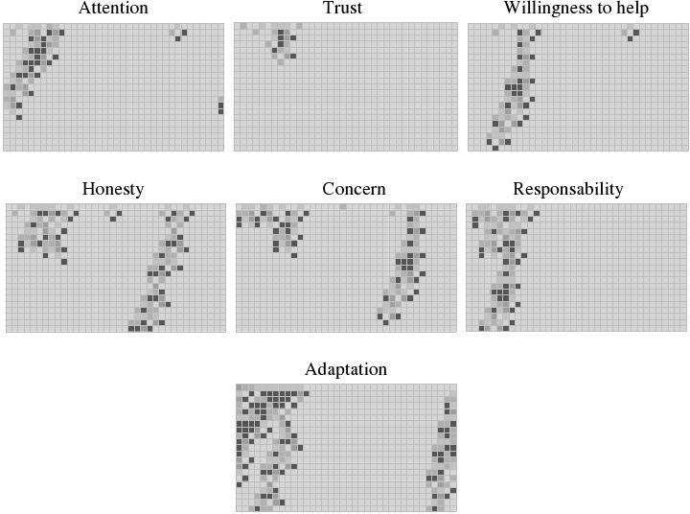

Fig. 7. Evolution of CAs.

individuals, and at the 11th, three of them. It is worth noticing that there are never three dissatisfied individuals side by side. The maximum number of individuals dissatisfied with honesty that keep in touch with each other is two. This finding may mean that when there are two individuals that interact with each other, and honesty is put in doubt, they change their internal states, maybe from cooperation to defeat, depending on the situation, in order to maximise their utility, in tune with what is stated in game theory [28].

In the fifth indicator, concern with the client, there is an outbreak of dissat- isfaction that achieves a great area of the network, started by two customers and two providers, lasting 19 time steps, and achieving stability at the 20th time step. Perhaps some providers forget or do not have time to worry about customers, which is perceived by the latter. In the left-hand area the dissatisfaction is generated by two providers and one customer, and ends at the 9th time step. In the right-hand area of the figure, dissatisfaction is generated by a customer, reaches other cus- tomers and providers, and then finally ceases. One can assign the fast end of the dissatisfaction of providers because they cannot be dissatisfied to satisfy customers, otherwise they would lose them, while the client has the option to switch providers. It is important to know that, among all customers of the simulation, none changed provider, despite the existence of perceived poor quality in the relationship.

In the sixth indicator, responsibility, there is an outbreak of dissatisfaction that reaches a greater area of the network, started by two customers and one provider, spreading beyond the 20th time step, and contaminating many customers. In other

words, it spreads more in time than in space.

Finally, the seventh indicator, adaptation to customer’s needs, a large outbreak of dissatisfaction achieves a greater area of the network, started by four customers and three providers, and spreading beyond the 20th time step. This is an artifact (due to this indicator having defined the classification of the individuals in the lattice), evident in the first line of this indicator, where dissatisfied individuals are grouped, thus giving the appearance of a ‘rebellion’.

From this fact one could conclude that extremely problematic customers should not be in contact with each other, otherwise they would spread the dissatisfaction to everyone they have contact with, customers or providers. The same goes for employees. Dissatisfied employees should be isolated in order to avoid an insur- gency, such as a strike. Besides, problematic or dissatisfied customers should not be attended by dissatisfied providers, because this can potentialise the dissatisfaction of both, contaminating the network. Perhaps this lack of adaptation to customer needs is due to focus on the outcome and volume of work, which prevents a greater personalisation of it. The simulation model investigated not only the dynamics of opinions, but also and more importantly, which individuals create dissatisfaction in a social network. This can enable managers to identify problematic customers and employees who are not fulfilling their role properly or sowing dissatisfaction in the social network. With this result, the manager can adapt the service cycle, in order to isolate dissatisfied individuals, so that their opinion become minority, losing strength and eventually dissipating.

It is interesting to note that the beginning of the individuals’ dissatisfaction happens always in the customer-provider interface, that is, in the left-hand in the right-hand of the lattice. Maybe this occurs due to different expectations and perception regarding the service, as seen in the linear regression results.

In Fig. 8, each number and colour means the degree of discrepancy between the results of the model and the data of the second survey. Since the Likert scale has 5 points, the range of differences between the results of the simulation and the quantitative research lies between -4 and 4. Fig. 9 shows the success rate of the simulation time step 16, represented by the brighter gray colour. The darker the colour, the greater the degree of discrepancy between the results of the simulation and the second quantitative research. The indicator with the lowest degree of success was the last, probably also an artifact of the classification, due to a concentration of dissatisfied individuals, as mentioned above.



Fig. 8. Colour grades for model fitness.

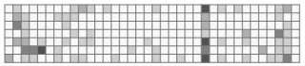

Fig. 9. Rate of success (brighter areas) of the proposed model.

Figure 10 presents the outcome of grouping individuals with the same opinion. When individuals are isolated, a decreased level of satisfaction (values 1, 2, 3 and 4) usually disappears in one time step, except for the individuals with value 2 (disagree). When individuals are grouped with the same perception of quality, the dissatisfaction remains in time, worsens and contaminates adjacent individuals. In order to mitigate this harmful effect of grouping, initially one could think about inserting a person with extremely positive quality perception (value equal to 5, light gray cell, at the arrows) in the dissatisfied group (Fig. 11B).

However, this conduct seems to potentialise the dissatisfaction in the group, maybe because the dissatisfied group may become conscious they could be much happier about the service outcome. So, counter-intuitively, the best way to mitigate the dissatisfaction would be to insert an even more dissatisfied individual (value equal to 1, black cell, arrow at Fig. 11A) in the group of individuals, with value equal to 2. The outcome of this conduct is the decrease of dissatisfaction, as can be seen in Fig. 11A, when compared to Fig. 11B. Maybe this happens because individuals with perception equal to 2 try to be sympathetic with the dissatisfied individual, in order to make the inserted individual more satisfied about the service outcome. However, by placing an extremely satisfied individual one cell to the right in the group, with value 1 (arrow in Fig. 12), the dissatisfaction spreads and collide with the group with value 2, at the right, potentialising the effect in the network, that is greater than that in Fig. 11B.

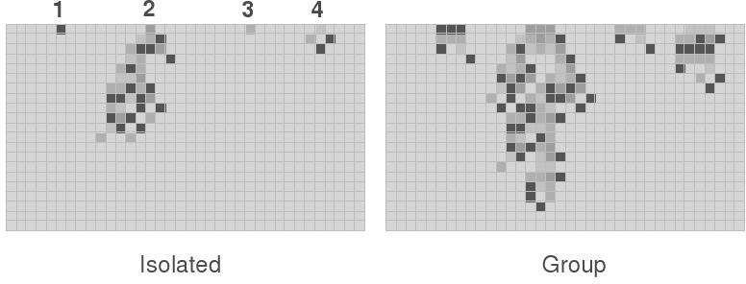

Fig. 10. Influence of grouping dissatisfied individuals.

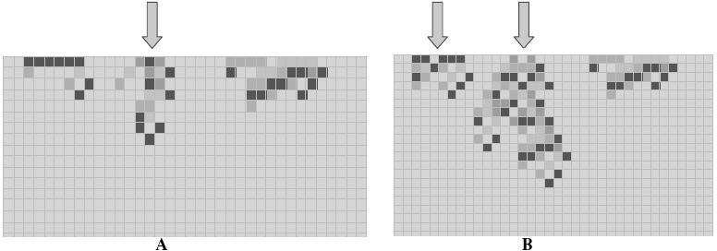

Fig. 11. Attempts to mitigate dissatisfaction in a social network.

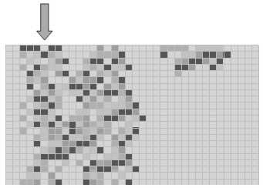

Fig. 12. Attempt to mitigate dissatisfaction in a social network.

# Statistical analysis of the results

For the descriptive analysis, we picked up the state of the lattice at the 16th time step. Initially, the mean of the indicators in the lattice was 3.75 (Table 3). In the second phase of the research, the mean dropped to 3.65. This probably hap- pened because of the discrepancies in perceptions between customers and service providers about service quality. Customers value the relational aspects of quality and providers value technical aspects of service quality. The mean of the simulation model also fell, down to 3.67, a difference of only 0.02 when compared with the second quantitative survey.

Regarding the variance, the initial research yielded 0.16 and the final, 0.25. Thus, the model appears to have potentialised this increase, because it presented variance of 0.97. This increase also occurred in the standard deviation. The increase of the variance shows a lack of consensus and a wide diversity of views on the indicators of relational quality. The median was the same for the three conditions, equal to

4. Data evolution also showed an increase in kurtosis, showing a more extreme behaviour, characteristic of environments with high service involvement [3]. The skewness also increased its negative value in the real data and in the simulation. Values regarding perception decreased to 0.10, when comparing the final data of

the research with those from the initial research. The result of simulation showed a decrease of perception of 0.08. Table 3 shows the total sum per indicator at different stages of the research and the result of the simulation.

Table 3

Descriptive statistics of the data of the researches and model.

|  |  |  |  |
| --- | --- | --- | --- |
|  | Initial Research | Final Research | Simulation Result |
| Mean | 3.75 | 3.65 | 3.67 |
| Variance | 0.16 | 0.25 | 0.97 |
| Std deviation | 0.25 | 0.37 | 0.98 |
| Median | 4.00 | 4.00 | 4.00 |
| Kurtosis | 8.03 | 11.82 | 10.84 |
| Skewness | -2.21 | -2.72 | -3.03 |
| Increase in perception |  | -0.10 | -0.08 |

Graphic 3 presents the ‘indicators’ mean per time step. At time step 2 there is a reduction of the mean from 4.7 to 4.2 and then an increase to 4.8 at the 3rd time step. This decrease appears to be related to the process of post-consumption cognitive dissonance. This dissonance may have happened because the sample is new, related to clients who have purchased business services for less than 2 years, and so they may not be completely sure about their choice. So, many individuals are not certain about their choice of provider. Over the time steps, or weeks, this cognitive dissonance seems to disappear, allowing a better perception of intangible aspects of service quality. The simulation did not achieve stability until time step

16. By analising the shape of the curve, we found that the system shows a nonlinear and oscillatory behaviour, confirming the findings of [12] in their study about the relationship between attitude and behaviour.

Although relations between variables are linear in a cross sectional study, the interactive effects do not seem to be linear. The oscillation creates an essential doubt in attitude research. As attitudes may present nonlinear and oscillatory behaviour, consider for instance the longitudinal research done between time steps 1 and 16 in Fig. 13, which may suggest an involution and dissatisfaction with the relational service quality (since there would be a reduction of the indicators mean), when, in fact, it may not be occurring in the long term. This observation highlights the importance of understanding the process behind the two surveys in order to validate the results obtained by the research or even understand an unexpected result. Thus, an increase in service quality perception may be happening in the long term, but in the short term this increase may be hidden by the oscillatory behaviour. So, researchers should take care in analysing unexpected results, so as not to be misled in their interpretations.

This oscillatory movement may be due to several aspects. First, inconsistencies in mood of customers and providers, who may perceive the quality of the relation- ship differently, according to their emotional state. Second, inconsistencies in the delivery of service by the provider, who may not always offer the same service qual- ity. Third, there may be a process of mutual adaptation over the interactions, and the provider cannot always meet the expectations of customers and vice versa.

The oscillatory movement shows a nonlinear relationship in the intangible as-

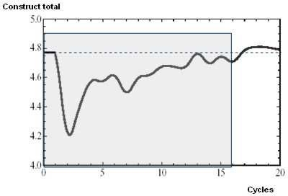

Fig. 13. Means of the construct (that is, sum of indicators), over the 20 time steps of the CA.

pects of quality and this is probably due to an affective component, involvement. It is known that the involvement determines the rationality in the interaction, the relative importance of each one of the attributes of the service and the intention to repurchasing the service by the customer [39]. Although the variables have lin- ear relationships and correlations in a cross-sectional study, we found no significant correlation between the first and the second quantitative surveys.

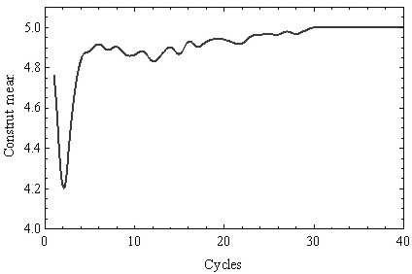

Fig. 14. Construct means over 40 time step of the CA.

The simulation did not achieve stability until time step 16. As displayed in Fig. 14, the system converged in 30 time steps, representing the consensus. Thus, we suggest to increase the interval between longitudinal researches to 30 time steps, that is, 30 weeks or 8 months, so as to verify the emergence of consensus and

stability. One limitation of the model is that competition was not considered. If that had been done, maybe the model would not have achieved stability, as it did at time step 30, because customers would have the option to change their service providers.

Figure 15 presents the variances found in the first quantitative research (gray) and in the second one (black). There was a decrease in variance in all indicators and the CA model simulated this decrease properly (Fig. 16). Five of seven in- dicators presented variance equal to zero in the third cycle. The fifth indicator (concern) became zero at the 21st time step, and the seventh indicator (adaptation to customer’s needs) became zero at the 30th. So, these two indicators took longer to converge, and this means that these are more critical aspects in service quality perception.

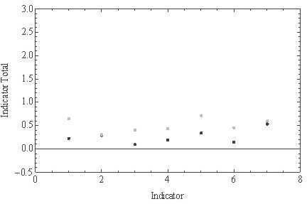

Fig. 15. Variances found in the first quantitative research (gray) and in the second (black).

Figure 17 depicts the transition table of the CA rule of the model so as to highlight the possibilities the rule supports in perception increase of the centre cell, that is, the rationales that lead to greater satisfaction of customers and suppliers; these cases are displayed in light gray. For example, if the centre cell state is 1, its left-hand neighbour’s state is 3, and its right-hand neighbour’s state is 2, the centre cell state does not change, remaining 1. In order to improve its perception of service quality without changes to its neighbour on the left, it is necessary that the neighbour on the right takes on one of the values 1, 3, 4 or 5, in which case the opinion of the individual at the centre would evolve to 3, 4, 2 or 2, respectively.

In this particular case the best rationale would be that the neighbour on the right assumes value 3. This can be interpreted as that, sometimes, the best performance cannot generate the best service quality perception, because, if that would happen (through the right-hand neighbour taking on value 5), the centre cell would rise its value only from 1 to 2. But if the right-hand neighbour on the right takes on value 3, the following state of the centre cell would be 4. In other words, if the individual

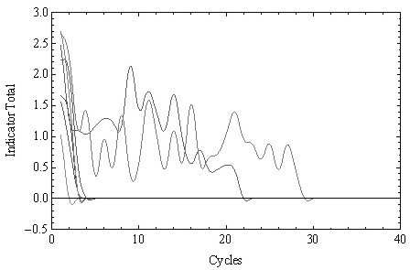

Fig. 16. Evolution of variances in the model.

at the centre cell is dissatisfied (value 1) with the attention given by a provider, this individual would be better off if the other provider would not become excessively attentive, but only moderately attentive. Acting this way, this individual would have the maximum increase in its quality perception. This finding is unusual in linear researches, but easily explained when adopting a nonlinear approach in the study of attitudes, as allowed by the present model.

The rule allows to understand that the only way to always satisfy customers is to adopt a conduct equal to 5, i.e., the provider must always offer his best effort, to make sure that there is an increase in quality perception by the customer.

# Concluding remarks

The validation of an empirical agent-based model involves understanding the extent to which the model is a good representation of the processes that generated the observed data ([27], [37]). The qualitative phase of the research allowed us to deeply understand the processes involved in aesthetic services delivery as well as the most relevant issues of service quality perception. The quality of quantitative phase data was confirmed by the results of statistical analysis performed.

Various types of validation of agent-based models can be identified [9], and we believe the proposed model abides by all of them. First, it seems adequate as a fair characterisation of its related real world, in particular to aspects of role theory; second, the model implementation is very straightforward and has been thoroughly tested to prevent any errors; third, the analysis of the correspondence between the simulated data and real data, achieved through graphics and statistical analyses, was performed at length; and finally, truthful comparison was carried out between the model-generated data with those provided by reality, obtained through the detailed surveys with clients and providers.

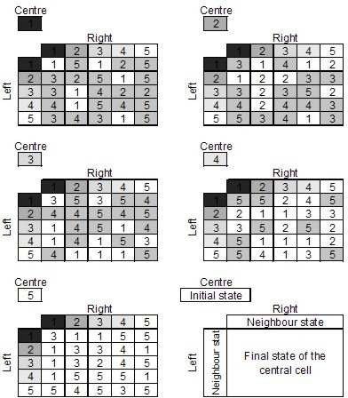

Fig. 17. Transition table of the CA rule chosen as the model.

The cellular automaton model allowed us to investigate the rationality of the network of clients and providers. This was interesting and useful because, usually, the traditional statistical methods and linear regression, determine which variables are relevant to a favourable perception and its magnitude. Instead, the cellular automaton models allows us to discover which combination of providers’ behaviours are more beneficial to a positive perception of the client. It also allowed to identify which individuals are responsible for dissatisfaction in the social network and how to manage them. If we consider a linear regression equation applied to an ordinal scale, we know which variables are most important in the formation of the perception of the customer and their level of importance. The cellular automaton model overcame this conceptual limitation, because it allowed to discover which was the most appropriate provider’s behaviour to generate a positive perception of quality in the mind of the customer. In this sense, the cellular automata model serves as a complement to linear regression.

The proposed model simulated the evolution of opinions with an accuracy of 73.80% and allowed a better understanding of the process involved between the first and the second quantitative research. Through the simulation we found what types of conduct provide an improvement in perception of quality and how the

information spreads in a particular social network. The statistical analysis made in the simulation model showed that it is consistent with real data. The simulation identified dissatisfied individuals and their influence on the network. Once identified, these individuals can be managed so as not to be in contact with other members of the social network, so that the adverse impact does not contaminate the system and harm the business.

The present work brings significant enhancements over the study of [40], where model data was not compared to real data of empirical research, which may have compromised that model’s validity. Besides, their statistical analysis was not as deep as the one shown here. Also, a larger number of states in the cellular automata model was used herein, an alteration that increased the rule search space, but led to a much richer content. Furthermore, the rationale analysis of the transition table now derived turned out to be amenable for a translation into practical orientations for managers.

Nevertheless, the proposed model still offers possibilities for improvement. One of them might be the creation of an amorphous and non-uniform CA model, with an utility function for partner selection, in order to allow more freedom to the system and get closer to reality. Alterations in the ordering of the individuals in the lattice could also be explored, with corresponding analyses of their effects in individuals’ perceptions and dynamics. Finally, the use of search methods, like evolutionary algorithms, is also a potential way to go, in order to replace the manual rule search performed herein.

# Acknowledgement

PPBO thanks research grants by FAPESP - Funda¸c˜ao de Amparo `a Pesquisa do Estado de Sa˜o Paulo (Proc. 2005/04696-3), MackPesquisa - Fundo Mackenzie de Pesquisa (Edital 2007), and Wolfram Research (Mathematica Academic Grant No. 1149). RAZ thanks MackPesquisa and Wolfram Research for financial support. We thank Rodrigo Freitas for LaTex-ing our original manuscript.

# References

1. Axelrod, R. “Advancing the Art of Simulation in the Social Sciences. Forthcoming in Handbook of Research on Nature Inspired Computing for Economy and Management”, Jean-Philippe Rennard (Ed.).Hersey, PA: Idea Group, 1997.
2. Axelrod, R.; Tesfatsion, L. On-line guide for newcomers to agent-based modeling in the social sciences. Available at <http://www.econ.iastate.edu/tesfatsi/abmread.htm> . Access in December 12, 2004.
3. Barki , H.; Hartwick, J. *Rethinking the concept of user involvement.* MIS Quarterly, v.13 n.1, p.53-63, March 1989.
4. Barney. J. *Is the resource-based “view” a useful perspective for strategic management research? Yes.*

The Academy of Management Review, v. 26, n.1, p. 41-56, 2001.

1. Bell, S.J.; AUH, S.; Smalley, K. *Customer relationships dynamics: service quality and customer loyalty in the context of varying levels of customer expertise and switching costs.* Academy of Marketing Science, v. 33, n. 2, 2005.
2. Biddle, B. J. *Recent Development in Role Theory.* Annual Review of Sociology, v. 12, p. 67-92, 1986.
3. Bloemer, J.; Ruyter, K. *Customer loyalty in high e low involvement service settings: The moderating* *impact of positive emotions.* Journal of Marketing Management, v. 15, p. 315-330, 1999.
4. Burrel,G; Morgan, G. “Sociological paradigms and organisational analysis.” London: Heinemann, 1979.
5. Carley, K.M. *Validating Computational Models.* Working Paper, Carnegie Mellon University, September 1996.
6. Carrillet, F.A.; Jaramillo, F.; Mulki, J.P. *The validity of the SERVQUAL and SERVPERF scales: A meta-analytic view of 17 years of research across five continents.* International Journal of Service Industry Management, v. 18, n. 5, pp. 472-490, 2007.
7. Cronin, J.J.; Taylor, S.A. *Measuring service quality: a reexamination and extension.* Journal of Marketing, v. 56, July 1992.
8. Doorn, J.V.; Verhoef, P.C.; Bumolt, T.H.A. *The importance of non-linear relationships between attitude* *and behaviour in policy research.* Journal of Consumer Policy, v. 30, 2007.
9. Driver,C.; Johnston, R. *Understanding service customers: The value of hard and soft attributes.* Journal of Service Research, v. 4, n.2, Nov 2001.
10. Eisingerich, A.B.; Bell, S.J. *Maintaining customer relationships in high credence services.* Journal of Services Marketing, v. 21, n. 4, p. 253–262, 2007.
11. Elliott, K.M. *SERVPERF versus SERVQUAL: A marketing management dilemma when assessing* *service quality.* Journal of Marketing Management, v. 4, n. 2, p. 56-61, Fall/Winter 1994.
12. Epstein, J.M.; Axtell, R. “Growing artificial societies: Social science from the bottom up.” Cambridge: MIT Press, 1996.
13. Ganguly, N.; Sikdar, B.K.; Deutch, A.; Canright, G.; Chadhuri, P.P. “A survey on cellular automata.” Available at: [www.cs.unibo.it/bison/publications/CAsurvey.pdf](http://www.cs.unibo.it/bison/publications/CAsurvey.pdf) . Access in january, 15, 2004.
14. Granovetter, M.S. *The strength of weak ties.* American Journal of Sociology, v. 78, May 1973.
15. Gr¨onroos, C. *A service quality model and its Marketing implications.* European Journal of Marketing,

v. 18, n. 4, 1984.

1. Hegselmenn, R.; Flache, A. *Understanding Complex Social Dynamics: A Plea for Cellular Automata Based Modelling*, Journal of Artificial Societies and Social Simulation, v.1, 1998. Available at: <http://www.soc.surrey.ac.uk/JASSS/1/3/1.html>. Access in August 20, 2006.
2. Heide, J.B.; Wathne, K.H. *Friends, Businesspeople, and Relationship Roles: A Conceptual Framework and a Research Agenda.* Journal of Marketing, v. 70, July 2006.
3. Jain, S.K.; Gupta, G. *Measuring service quality: SERVQUAL vs. SERVPERF scales.* The Journal for Decision Makers, v. 29, n. 2, Apr-Jun 2004.
4. Lee, H.; Lee, Y.; Yoo, D. *The determinants of perceived service quality and its relationship with* *satisfaction.* Journal of Services Marketing, v. 14, n. 3, 2000.
5. Leobruni, R.; Richiardi, M.; Saam, N.J.; Sonessa, M. *A Common Protocol for Agent- Based Social* *Simulation.* Journal of Artificial Societies and Social Simulation, v. 9, n. 1, 2006.
6. Macy, M.W.; Willer, R. *From factors to actors: Computational sociology and agent-based modeling.*

Annual Review of Sociology, v. 28, 2002.

1. Mattsson, J.; Haring, M.J. *Communication dynamics in the service encounter: A linguistic study in a hotel conference department.* International Journal of Service Industry Management, v. 9, n. 5, 1998.
2. Miller, J.H.; Page, S.E. *The standing ovation problem.* Complexity, v. 9, n. 5, 2004.
3. Morgenstern, O.; von Neumann, J. “Theory of Games and Economic Behavior.” New Jersey: Princeton, 1980.
4. Parasuraman, A.; Zeithaml, V.A.; Berry, L.L. *A conceptual model of service quality and its implications for future research.* Journal of Marketing, v. 49, Fall 1985.
5. Sharma, N.; Patterson, P.G. *The impact of communication effectiveness and service quality on relationship commitment in consumer, professional services.* The Journal of Services Marketing, v. 13, n.2, 1999.
6. Shoemaker, S. *Scripts: Precursor of consumer expectations.* Cornell Hotel and Restaurant Administration Quarterly, v. 37, n. 1, Feb 1996.
7. Sipper, M. “Evolution of parallel cellular machines: The cellular programming approach.” Heidelberg: Springer, 1997. Available at [http://www.cs.bgu.ac.il/~ sipper/papabs/epcm.pdf](http://www.cs.bgu.ac.il/~sipper/papabs/epcm.pdf) . Access in January 12, 2005.
8. Teraji, S. *Herd behaviour and the quality of opinions.* Journal of Socio-Economics, v. 32, n. 6, December 2003.
9. Tsa, D.K.; Wilton, P.C.. *Models of Consumer Satisfaction Formation: An Extension.* Journal of Marketing Research, v. 25, n. 2, May 1988.
10. Vicsek, T. *Complexity: The Bigger Picture.* Nature, v. 418, July 2002.
11. Williams, D. *Uses of role theory in management and supervisory training.* Journal of Management Studies, v. 6, n. 3, Oct 1969.
12. Windrum, P.; Fagiolo, G.; Moneta, A. *Empirical Validation of Agent-Based Models: Alternatives and Prospects.* Journal of Artificial Societies and Social Simulation, v. 10, n. 2, 2007.
13. Wolfram, S. A new kind of science. Canada: Wolfram Media Inc., 2002.
14. Zaichowsky, J. *Measuring The Involvement Construct.* Journal of Consumer Research, v. 12, p. 341-352, 1985.
15. Zimbres, R.A.; Brito, E.P.Z.; Oliveira, P.P.B. *Cellular automata based modeling of the formation and evolution of social networks: A case in Dentistry.* In: J. Cordeiro and J. Filipe, eds. Proc. of the 10th Int. Conf. on Enterprise Information Systems, INSTICC Press: Setu`bal-Portugal, Vol. III: Artificial Intelligence and Decision Support Systems, pp. 333-339, 2008.