[e g ypti an j o ur nal o f b a sic and a pp l i e d sci en c e s 1 ( 2014) 29](http://dx.doi.org/10.1016/j.ejbas.2014.02.003) e[3](http://dx.doi.org/10.1016/j.ejbas.2014.02.003) 7

 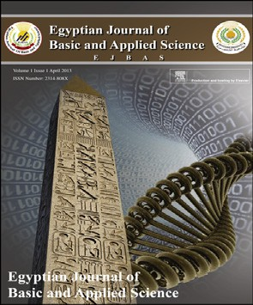

Available online at [www.sciencedirect.com](http://www.sciencedirect.com/science/journal/2314808X)

ScienceDirect

journal homepage: <http://ees.elsevier.com/ejbas/default.asp>

Ecology and development of *Mesembryanthemum crystallinum* L. in the Deltaic Mediterranean coast of Egypt

*Ahmed M. Abd El-Gawad* *a**,**\***, Hanaa S. Shehata* *b*



a *Botany Department, Faculty of Science, Mansura University, Al-Dakahllia, Egypt*

b *Botany Department, Faculty of Science, Zagazig University, Al-Sharqia, Egypt*

## a r t i c l e i n f o

*Article history:*

Received 4 October 2013 Received in revised form 24 January 2014

Accepted 28 February 2014

Available online 22 March 2014

*Keywords:*

Ecology Halophyte

*Mesembryanthemum crystallinum*

Relative growth rate Nile delta Conservation

## a b s t r a c t

Ice plant (*Mesembryanthemum crystallinum* L.) is an important stress-tolerant halophyte distributed in saline areas along the Mediterranean coast of the Nile delta, Egypt. Plant communities dominated by *M. crystallinum* were studied in different habitats. The appli- cation of TWINSPAN classification based on 77 species recorded in 50 stands, led to the recognition of four vegetative groups, which are categorized under three communities. The first is salt marsh community co-dominated by *M. crystallinum* and *Senecio glaucus* L. The second is sand dune community dominated by *Hordium murinum* L. The third is sand flat community dominated by *M. crystallinum*. Electrical conductivity (EC), sodium ion con- centration, Sodium Absorption Ratio (SAR) and sand fraction are the main controlling factors in the distribution of the different vegetative community. The distribution of *M. crystallinum* community was influenced by calcium carbonate, pH, E.C. and calcium. Various growth parameters including root, shoot and total fresh weight, diameter, leaf area, number of flowers and fruits were measured at two-week interval in the three hab- itats (sand dune, sand flat and salt marsh). The sand dune and salt marsh habitats, which are threatened by anthropogenic activities, were optimizing growth, flowering and fruiting of *M. crystallinum*.

Copyright ª 2013, Mansoura University. Production and hosting by Elsevier B.V. All rights

reserved.

# Introduction

Salinity is one of the major problems in Egypt where about 1.8 million ha of the total area of our country are affected by salt.

Salt marshes are important habitats; inhabited by a large number of halophytic plants, which are considered as a great potential source for many raw materials such as human food, animal feeds, fiber materials, ornamental, wood, as a habitat for fish or insects, a sink for carbon dioxide sequestration etc.

* *Corresponding author*. Tel.: +20 1003438980.

E-mail addresses: [dgawad84@yahoo.com](mailto:dgawad84@yahoo.com), [dgawad84@mans.edu.eg](mailto:dgawad84@mans.edu.eg) (A.M. Abd El-Gawad).

Peer review under responsibility of Mansoura University

**Production and hosting by Elsevier**

<http://dx.doi.org/10.1016/j.ejbas.2014.02.003>

2314-808X/Copyright ª 2013, Mansoura University. Production and hosting by Elsevier B.V. All rights reserved.

30 [e gypti an j o ur nal o f b a sic and a pp l i ed sci e n c e s 1 ( 2014) 29](http://dx.doi.org/10.1016/j.ejbas.2014.02.003) e[3](http://dx.doi.org/10.1016/j.ejbas.2014.02.003) 7

Therefore revegetation of these habitats with halophytes could be highly beneficial for the natural ecosystem and lessens the risk of degradation [1]. Phytosociological assess- ment of halophytes and their environmental demands are required for the implementation of saline production systems [2].

*Mesembryanthemum crystallinum* belongs to Aizoaceae, and it is an extremely stress-tolerant halophyte. Not only salinity and drought, but also high temperature, initiate a complex network of hormonal and transcriptional responses leading to induction and/or repression of gene expression, including transition from C3 photosynthesis to the Crassulacean acid metabolism [3]. It shows five distinct growth phases during its life cycle namely: germinating seedlings, juvenile, adult, flowering fruiting and seed formation [4].

The ice plant has many important uses and it has been used in desalination of salt affecting soil [5]. Its leaves and stems are used raw or cooked as a spinach substitute and pickled like cucumbers. Also, crushed foliage is a soap sub- stitute [6]. Therefore, *M. crystallinum* has many biological ac- tivities such as antioxidant and antimicrobial [7,8]. Historically, physicians used leaf juice to soothe inflammation of the mucous membranes of the respiratory or urinary sys- tem. Also, leaves of the ice plant are used in treatment of as- cites, dysentery and diseases of the liver and kidney. It is used in dermatologicl and cosmetic preparations [9]. In Europe, the fresh juice has been used to treat water retention and painful urination and to soothe lung inflammation [10]. The ability to accumulate salt by *M. crystallinum*, may be useful for bio- remediation [11].

The habitats of *M. crystallinum* are under threat due to

uncontrolled human and other biotic interferences. There- fore, this study aimed to evaluate the ecological amplitude of

*M. crystallinum* communities and soil factors controlling its distribution along the Deltaic Mediterranean coast of Egypt. In addition, it aimed to study the growth behavior of ice plant in three different habitats: sand dune, sand flat and salt marsh.

# Materials and methods

### *Study area*

The coastal area bordering the Nile Delta (Fig. 1) is charac- terized by coarse and fine sand, silt and clay, deposited by the

perature above 10 ◦C and the rainy season during the winter. river Nile [12]. The climate is arid, with a mean winter tem- The annual rainfall ranges from 91.6 to 175.2 mm. Mean

relative humidity is lower in summer than in winter (65% and 81%) and evaporation is higher in summer than in winter (7.8 and 2.8 mm Piche/day) [13]. The main habitats of the study area are salt marsh, sand formation, reed swamp and fertile non-cultivated land. The salt marshes extend along the whole coast. They are connected with the three natural lakes Idku, Burullus and Manzala. The sand formation includes sand dunes and sand flats. The swamps were found in depressions where water accumulated through seepage from the nearby lakes and cultivated land. The fertile non-cultivated land is found in the southern part of the area; it has slightly higher soil salinity than the cultivated land [14].

### *Estimation of species abundance*

The sampled stands are distributed along the Deltaic Medi- terranean coastal region e Egypt, represented in three Gov- ernorates namely: Al-Dakahlia, Damietta, Kafr El-Sheikh

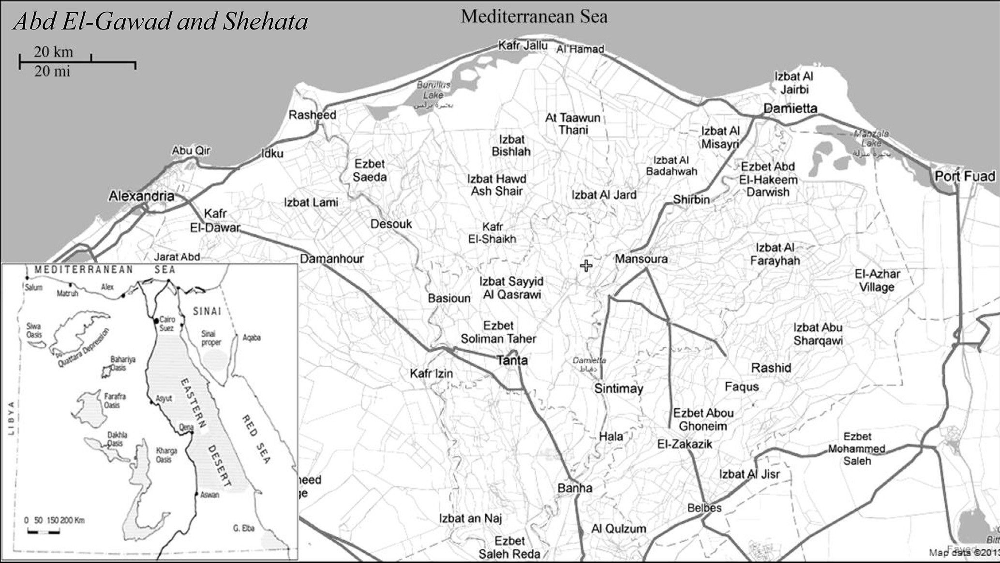

Fig. 1 e Map of the studied sites of *Mesembryanthemum crystallinum* along the Deltaic Mediterranean coast of Egypt.

[e g ypti an j o ur nal o f b a sic and a pp l i e d sci en c e s 1 ( 2014) 29](http://dx.doi.org/10.1016/j.ejbas.2014.02.003) e[3](http://dx.doi.org/10.1016/j.ejbas.2014.02.003) 7 31

(Fig. 1). After regular visits to the different sites of the studied area between Feb 2011 and Jun 2012, fifty stands (50 m2 each) were selected for sampling from different habitats (sand dune, sand flat and salt marsh) of the studied area. Plant density was measured according to Shukla and Chandel [15] while the plant cover of each species estimated in each selected stand according to the line-intercept method of Canfield [16]. Rela- tive values of density and cover were calculated for each species and the importance value in each stand was esti- mated. Nomenclature of the species follows Boulos [17]. Voucher specimens of plant material were collected, and deposited at the herbarium of Mansoura University.

### *Soil analysis*

A composite soil sample was collected from each stand (trip- licates) as a profile from three holes of 0e50 cm depth, air- dried and passed through a 2 mm sieve to separate gravel and debris [18]. Soil texture, water holding capacity (WHC), soil porosity, organic carbon and sulphate were determined according to Piper [19]. Calcium carbonate content was determined by titration against 1 N NaOH and expressed as a percentage [18,20]. The soil solution (1:5) was prepared for each soil sample. The electrical conductivity, pH and chloride were determined by the method adopted by Jackson [20]. Carbonate and bicarbonate were determined by titration

using 0.1 N HCl [21]. The extractable cations Na+ and K+

PHF 80 Biologie Spectrophotometer), while Ca2+ and Mg2+ contents were determined using Flame Photometer (Model were estimated using atomic absorption spectrometer (A

Perkin-Elmer, Model 2380.USA) [22]. The sodium adsorption ratio (SAR) and potassium adsorption ratio (PAR) were calcu- lated to express the combined effects of different ions in the soil [23].

### *Growth analysis*

The different growth parameters including root, shoot and total fresh weight, plant diameter, leaf area, number of flowers and number of fruits of *M. crystallinum* were measured in three permanent stands for the three habitats (sand dune, sand flat and salt marsh) distributed along the study area. The data were recorded in regular visits at a two-week interval. The leaf area was determined by weight method according to [24].

Plant growth measurements were estimated according to Evans [25] and Hunt [26]. Relative growth rate (RGR) was esti-

(mg g—1 day—1) according to Eq. (1): mated as the difference in dry weight over time interval

RGR = (ln *W*2 — ln *W*1)/(*t*2 — *t*1) (1)

*W*1 and *W*2: weight at time *t*1 and *t*2, respectively.

Net assimilation rate (NAR) was estimated as the differ- ence in dry weight over a time interval versus leaf area

(mg cm—2 day—1) according to Eq. (2):

NAR = [(*W*2 — *W*1)/(*t*2 — *t*1)] × [(ln *A*2 — ln *A*1)/(*A*2 — *A*1)] (2)

*A*1 and *A*2: leaf area at time *t*1 and *t*2, respectively.

weight of plant (cm2 g—1) according to Eq. (3): Leaf area ratio (LAR) was measured as the total leaf area per

LAR = (*A*2 — *A*1)/(*W*2 — *W*1) (3)

*A*1 and *A*2: leaf area at time *t*1 and *t*2, respectively and *W*1 and

*W*2 are weight at time *t*1 and *t*2, respectively.

### *Multivariate analyses and statistical testing*

Vegetation classification and ordination techniques were employed. The stand-species data matrix was classified into groups using the importance values (IV) of species by means of the Two Way Indicator Species Analysis (TWINSPAN) com- puter program according to Hill and Smilauer [27]. Canonical Correspondence Analysis (CCA) that was used to examine the relationships of the floristic composition and the measured environmental variables according to Ter Braak [28]. Data of soil analyses were subjected to analysis of variance (ANOVA) and the mean values were separated based on Least Signifi- cant Difference (LSD) at 0.05 probability level using COSTAT

6.3 program.

# Results

### *Classification of stands*

The application of TWINSPAN classification based on the importance values of 77 plant species recorded in 50 sampled stands led to the recognition of four vegetation groups (Table 1 & Fig. 2). Group A comprises five stands (representing sand flat habitat) dominated by *M. crystallinum* which has the highest

IV = 34.28. The other important indicator species which

*fortii* (IV = 22.57), *Melilotus indicus* (IV = 18.45), *Emex spinosa* attained relatively high IVs in this group are *Brassica tourne-* (IV = 13.85), *Polygonum equisetiforme* (IV = 13.40) and *Malva parviflora* (IV = 13.03). Group B represents salt marsh habitat and includes 12 stands dominated by *M. crystallinum*

(IV = 30.98). The other important species in this group are *Chenopodium murale* (IV = 18.06), *M. nodiflorum* (IV = 17.93), *Senecio glaucus* (IV = 15.46) and *Cynodon dactylon* (IV = 13.98). Group C is the largest group and represents salt marsh habitat

(IV = 29.68) and *S. glaucus* (IV = 29.13). *M. nodiflorum* (IV = 23.66) comprising 22 stands co-dominated by *M. crystallinum* and *Cakile maritime* (IV = 15.00) are considered as important

species in this group. Group D represents sand dune habitat

(IV = 29.91), followed by *S. glaucus* (IV = 17.58), *Rumex pictus* and comprises 11 stands dominated by *Hordeum murinum* (IV = 16.66), *M. crystallinum* (IV = 14.69) and *Launea mucronata* (IV = 13.26).

### *Vegetation-soil relationship*

The soil variables of the four clusters derived from TWINSPAN classification indicate considerable variation in the edaphic factors among the stands of the different groups (Table 2). Soil

showed significant variation (*P* ≤ *0.1*) between the different texture in the four groups is formed mainly of sand and it vegetation clusters. EC, sodium and SAR showed high signif-

icant variation among the vegetation groups. Group B and C attained the highest value of EC (237 and 245 mmhos/cm, respectively) as these groups represent the salt marsh

32 [e gypti an j o ur nal o f b a sic and a pp l i ed sci e n c e s 1 ( 2014) 29](http://dx.doi.org/10.1016/j.ejbas.2014.02.003) e[3](http://dx.doi.org/10.1016/j.ejbas.2014.02.003) 7

|  |  |  |  |  |  |
| --- | --- | --- | --- | --- | --- |
| Table 1 e Characteristics of the different vegetation clusters from TWINSPAN classification of the studied area. | | | | | |
| Cluster | No. of stands | Total Spp. | Habitats | Dominant Species | Other important species |
| A | 5 | 28 | SF | *Mesembryanthemum crystallinum* (34.28 [0.43])a | *Brassica tournefortii* (22.57[0.43])  *Melilotus indicus* (18.45[1.10])  *Emex spinosa* (13.85[0.99])  *Polygonum equisetiforme* (13.40[0.94])  *Malva parviflora* (13.03[0.63])  *Cressa cretica* (10.65[2.24])  *Chenopodium murale* (18.06[0.76])  *Mesembryanthemum nodiflorum* (17.93[1.13])  *Senecio glaucus* (15.46[0.92])  *Cynodon dactylon* (13.98[1.92])  *Phragmites australis* (10.48[1.25])  *Malva parviflora* (10.16[1.02])  *Mesembryanthemum nodiflorum* (23.66[1.01])  *Cakile maritime* Scop. subsp.  *aegyptiaca* (15.00[1.14])  *Zygophyllum album* (10.62[1.41])  *Rumex pictus* (10.34[1.42])  *Senecio glaucus* (17.58[0.58])  *Rumex pictus* (16.66[0.50])  *Mesembryanthemum crystallinum* (14.69[1.16])  *Launea mucronata* (13.26[1.00]) |
| B | 12 | 43 | SM | *Mesembryanthemum crystallinum* (30.98[0.84]) |
| C | 22 | 36 | SM | *Mesembryanthemum crystallinum* (29.68[0.66])  *Senecio glaucus* (29.13 [0.72]) |
| D | 11 | 46 | SD | *Hordeum murinum* (29.91[0.64]) |
| a (Important value [coefficient of variation]), SD: sand dune, SF: sand flat, SM: salt marsh. | | | | | |

habitats. Group C attained the highest value of sodium (31.34 mg/100 g dry soil). The other variables (soil porosity, pH, WHC), calcium carbonate, organic carbon, chloride, sulphate, carbonate, bicarbonate, potassium, calcium, magnesium and PAR are comparable to each other between the four vegetation clusters.

### *Correlation between soil variables and vegetational* gradients

The correlation between vegetation and soil characteristics is indicated in Fig. 3. The most effective soil variables are chlo- ride, pH, calcium carbonate, calcium, EC, sodium and WHC.

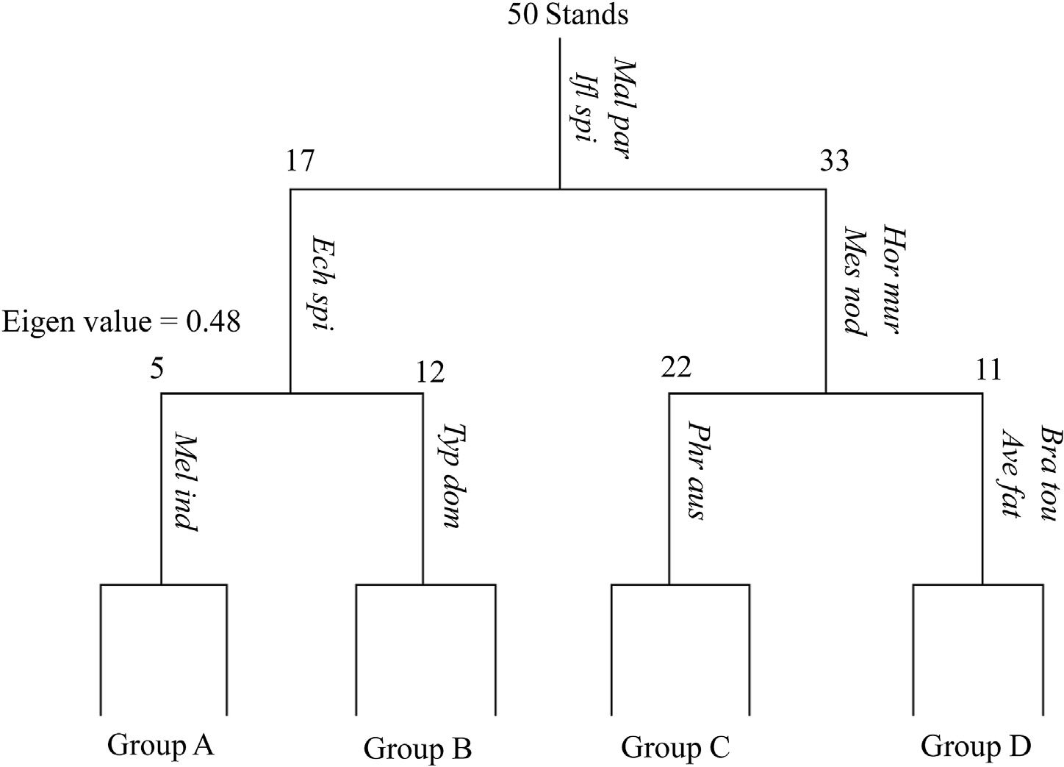

Fig. 2 e TWINSPAN dendrogram of 50 stands based on the importance value of the species. Indicator species names are abbreviated to the first three letters of both genus and species. *Mal par: Malva parviflora*, *Ifl spi: Ifloga spicata*, *Hor mur: Hordeum murinum*, *Mes nod: Mesembryanthemum nodiflorum*, *Ech spi: Echinops spinosus*, *Bra tou: Brassica tournefortii*, *Ave fat: Avena fatua*, *Phr aus: Phragmites australis*, *Typ dom: Typha domingensis*, *Mel ind: Melilotus indicus*.

[e g ypti an j o ur nal o f b a sic and a pp l i e d sci en c e s 1 ( 2014) 29](http://dx.doi.org/10.1016/j.ejbas.2014.02.003) e[3](http://dx.doi.org/10.1016/j.ejbas.2014.02.003) 7 33

Calcium carbonate and pH are correlated with each other, while chloride, EC, sodium and WHC showed close relation. The distribution of *M. crystallinum* (dominant species of group A, B and C and important species with relatively IV of group D) was influenced by calcium carbonate, pH, EC and calcium. The cluster group A was affected mainly by calcium, potassium, pH and calcium carbonate, while the cluster group B and C

|  |  |  |  |  |  |  |  |  |  |  |  |  |
| --- | --- | --- | --- | --- | --- | --- | --- | --- | --- | --- | --- | --- |
| Table 2 e Mean value and standard error of the different soil variables at a depth of 0e50 cm in the sampled stands representing the different vegetation groups obtained by TWINSPAN. | | | | | | | | | | | | |
| Soil | variable | A |  | TWINSPAN vegetation groups  B C | | | |  | D |  | F-value | LSD0.1 |
| Sand (%) | | 97.00 | 0.56 | 96.99 | 0.43 | 95.41 | 0.48 | 96.62 |  | 0.70 | 2.957* | 1.56 |
| Silt (%) | | 2.48 | 0.47 | 2.44 | 0.33 | 3.92 | 0.42 | 2.92 |  | 0.62 | 2.791 | 1.35 |
| Clay (%) | | 0.52 | 0.11 | 0.57 | 0.12 | 0.67 | 0.09 | 0.45 |  | 0.09 | 2.492 | 0.31 |
| Porosity (%) | | 30.90 | 3.55 | 33.06 | 1.41 | 32.35 | 0.91 | 34.64 |  | 1.31 | 0.771 | 3.91 |
| W.H.C. (%) | | 20.18 | 0.61 | 18.73 | 0.80 | 18.33 | 0.50 | 17.82 |  | 0.73 | 1.603 | 1.85 |
| pH | | 7.72 | 0.16 | 7.81 | 0.07 | 7.87 | 0.02 | 7.88 |  | 0.02 | 1.252 | 0.16 |
| EC (mmhos/cm) | | 111.32 | 31.02 | 237.36 | 65.23 | 244.56 | 56.36 | 117.38 |  | 39.48 | 5.721* | 152.82 |
| CaCO3 (%) | | 3.52 | 0.74 | 3.27 | 0.46 | 5.35 | 0.99 | 3.42 |  | 0.79 | 0.634 | 1.42 |
| O.C. (%) | | 0.64 | 0.24 | 0.75 | 0.22 | 0.70 | 0.13 | 0.83 |  | 0.24 | 0.363 | 0.50 |
| Cl— (%) | | 0.01 | 0.00 | 0.01 | 0.00 | 0.01 | 0.00 | 0.01 |  | 0.00 | 0.745 | 0.01 |
| SO2— (%) | | 0.25 | 0.10 | 0.12 | 0.03 | 0.12 | 0.02 | 0.15 |  | 0.05 | 3.321* | 0.10 |
|  | |  |  |  | | | |  |  |  |  |  |
| CO2— (%) | | 0.03 | 0.03 | 0.03 | 0.01 | 0.02 | 0.01 | 0.01 |  | 0.01 | 0.201 | 0.04 |
|  | |  |  |  | | | |  |  |  |  |  |
| HCO— (%) | | 0.07 | 0.02 | 0.07 | 0.01 | 0.07 | 0.00 | 0.08 |  | 0.01 | 0.459 | 0.02 |
|  | |  |  |  | | | |  |  |  |  |  |
| Na+ | (mg/100 g dry soil) | 14.81 | 3.17 | 27.04 | 6.84 | 31.34 | 5.84 | 19.43 |  | 2.43 | 6.506* | 15.07 |
| K+ | | 26.60 | 11.31 | 18.38 | 6.67 | 14.91 | 4.00 | 14.98 |  | 5.20 | 0.625 | 17.18 |
| Ca2+ | | 4.61 | 0.75 | 8.35 | 2.18 | 6.38 | 0.66 | 7.35 |  | 1.05 | 1.129 | 3.03 |
| Mg2+ | | 55.45 | 35.17 | 25.04 | 8.26 | 16.19 | 8.32 | 26.43 |  | 16.38 | 1.417 | 37.52 |
| SAR | | 9.00 | 1.94 | 4.72 | 1.46 | 8.59 | 2.73 | 12.27 |  | 2.48 | 6.664* | 6.46 |
| PAR | | 4.65 | 1.05 | 6.14 | 2.52 | 5.96 | 2.31 | 5.74 |  | 1.60 | 0.046 | 5.72 |
| Abbreviations: W.H.C. = water-holding capacity, O.C. = organic carbon, SAR = sodium adsorption ratio, EC = electrical conductivity, PAR = potassium adsorption ratio.  * indicate values significant at *P* ≤ 0.1. | | | | | | | | | | | | |

was controlled by chloride, EC, WHC, PAR, silt and organic carbon.

### *Growth analysis*

The different growth parameters including root, shoot and total fresh weight, plant diameter, leaf area, number of

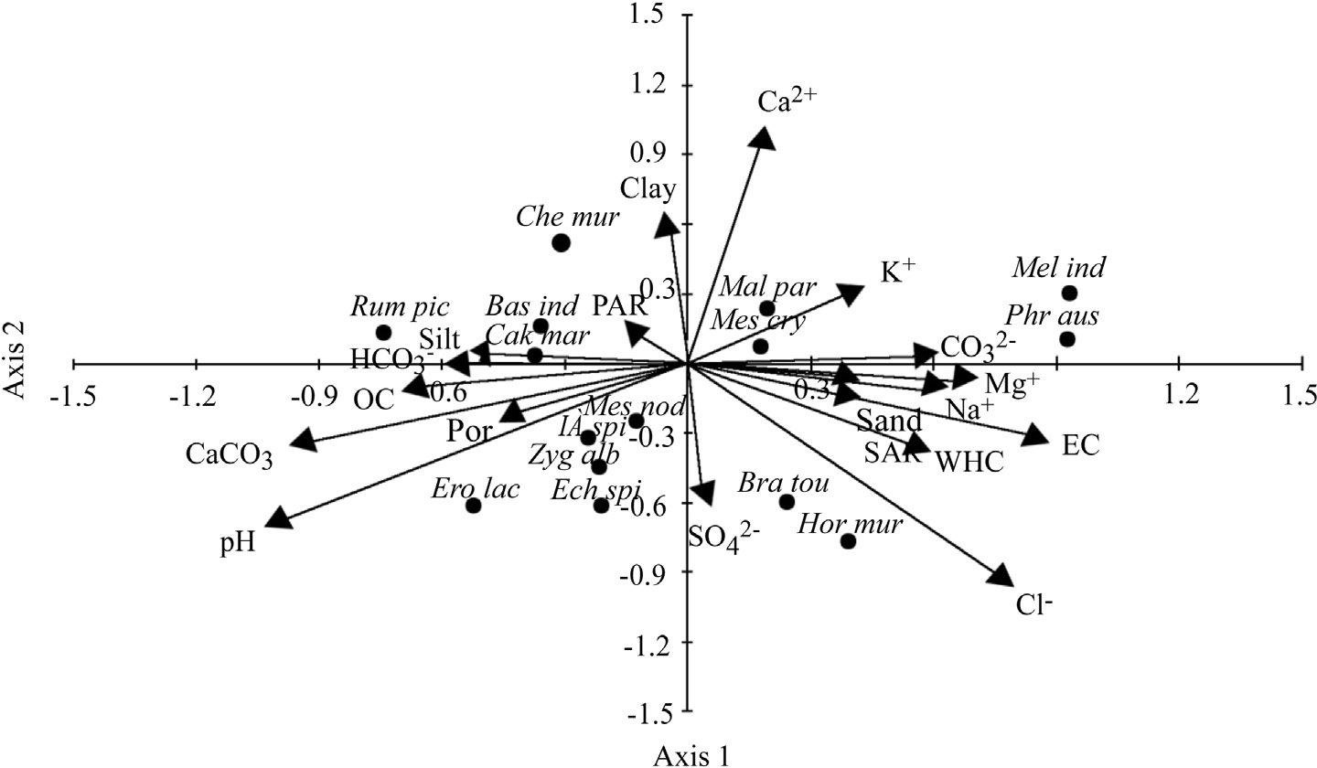

Fig. 3 e CCA species-soil variable biplot in different habitat types of the study area. EC: electrical conductivity, OC: organic carbon, SAR:sodium adsorption ratio, PAR; potassium adsorption ratio, Por: porosity, WHC: water holding capacity, *Bas ind: Baassia indica, Bra tou: Brassica tournefortii, Cak mar: Cakile maritime, Che mur: Chenopodium murale, Ech spi: Echinops spinosus, Ero lac: Erodium laciniatum, Hor mur*: Hordeum murinum, Ifl spi: Ifloga spicata, Mal par: Malva parviflora, Mel ind: Melilotus indicus, Mes cry: *Mesembryanthemum crystalinum, Mes nod: Mesembryanthemum nodiflorum, Phr aus: Phragmites australis, Rum pic: Rumex pictus, Zyg alb: Zygophyllum album*.

34 [e gypti an j o ur nal o f b a sic and a pp l i ed sci e n c e s 1 ( 2014) 29](http://dx.doi.org/10.1016/j.ejbas.2014.02.003) e[3](http://dx.doi.org/10.1016/j.ejbas.2014.02.003) 7

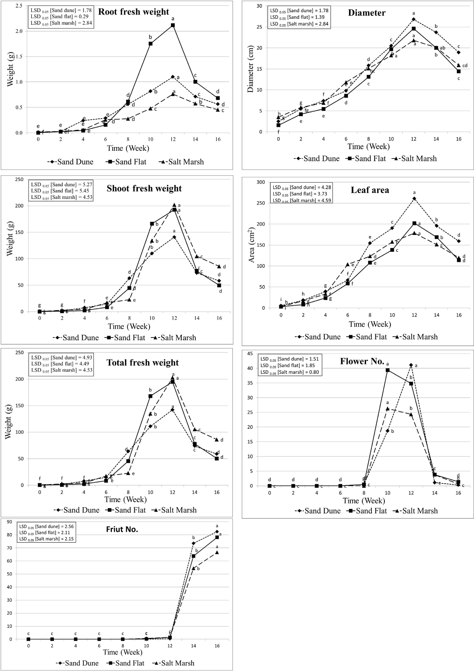

Fig. 4 e Different growth attributes (root, shoot and total fresh weight (g); plant diameter (cm); leaf area (cm2); flower number; fruit number) of *Mesembryanthemum crystallinum* in different habitat types (sand dune, sand flat and salt marsh).

[e g ypti an j o ur nal o f b a sic and a pp l i e d sci en c e s 1 ( 2014) 29](http://dx.doi.org/10.1016/j.ejbas.2014.02.003) e[3](http://dx.doi.org/10.1016/j.ejbas.2014.02.003) 7 35

flowers and number of seed capsule of *M. crystallinum* are

cantly increased gradually (*P* ≤ *0.05*), but after 12 weeks of presented in Fig. 4. From this figure, plant diameter signifi- development, it decreased. In addition, there is a slight sig-

nificant variance between the different habitats, while the highest plant diameter was 26.8 cm, after 12 weeks (Fig. 4a).

The fresh weight of the root system of *M. crystallinum* showed slight significant variations in the three habitats at the first 8 weeks, but it showed high significant variation after 10 weeks. Generally, the sand flat habitats support the growth of *M. crystallinum* root (Fig. 4). The fresh weight *M. crystallinum* shoot was increased gradually during the early period of growth, but after 6 weeks, its growth rate increased sharply until 12 weeks, where it showed significant decrease as the

variation (*P* ≤ *0.05*) between the different habitats at the first plant entered the seed forming stage. There is no significant weeks of growth, but after 6 weeks the fresh weight showed

significant variation (Fig. 4c). The sand dune habitats attained the highest values of shoot fresh weights of *M. crystallinum* during the earlier week, but at 12 weeks, the salt marsh hab- itats showed the highest values (202 g).

Leaf area of the small secondary leaves of *M. crystallinum* increased sharply during the early weeks, but after 12 weeks, it decreased as the plant entered in the seed forming stage. There was a slight significant difference in the leaf area after two weeks between the three habitats; afterwards it showed high significant variations. The sand dune habitat showed the highest leaf area (261 cm2) after 12 weeks (Fig. 4e). Blossoming

150

**a**

2

4

6

8

10

12

14

16

Sand Dune Habitat Sand Flat Habitat Salt Marsh Habitat

100

Relative Growth REate ( RGR )

50

0

-50

100

-

60

40

Time (Week)

20

**b**

2

4

6

8

10

12

14

16

Sand Dune Habitat Sand Flat Habitat Salt Marsh Habitat

The net assimilation rate ( NAR )

0

-20

-40

25

20

Time (Week)

15

**c**

2

4

6

8

10

12

14

16

Sand Dune Habitat Sand Flat Habitat Salt Marsh Habitat

Leaf Area Ratio ( LAR )

10

5

0

-5

Time (Week)

Fig. 5 e RGR (gL1 dayL1), NAR (mg cmL2 dayL1) and LAR (cm2 gL1) of *Mesembryanthemum crystallinum* growing in sand dune, sand flat and salt marsh.

36 [e gypti an j o ur nal o f b a sic and a pp l i ed sci e n c e s 1 ( 2014) 29](http://dx.doi.org/10.1016/j.ejbas.2014.02.003) e[3](http://dx.doi.org/10.1016/j.ejbas.2014.02.003) 7

of *M. crystallinum* started after 8 weeks. The different habitats showed significant variations in the number of flowers at 0.05 probability level. The sand dune habitat demonstrated the highest value (41 flowers/plant). In addition, the number of seed capsule showed slight significant variations in the three habitats after 14 weeks (Fig. 4g).

Growth attributes of the three habitats including RGR, NAR and LAR are illustrated in Fig. 5. RGRs of the three habitats were found higher at early vegetative stage than at

dune (128 g—1 day—1 and 112 g—1 day—1, respectively) were seed forming stage, the highest RGR of sand flat and sand habitat (127 g—1 day—1) was recorded after 10 weeks. RGR of *M.* recorded after 8 weeks, while the highest RGR of salt marsh *crystallinum* were below zero after 14 weeks for sand dune

and salt marsh habitats and after 12 weeks for sand flat (Fig. 5a).

NAR demonstrated irregular pattern of change during growth, it reached maxima after 10 weeks as it attained 50, 40

and 24 mg cm—2 day—1 for sand flat, salt marsh and sand dune,

respectively. NAR decreased at the seed forming stage

(Fig. 5b). LAR of the three habitats decreased with the time, while it was increased slightly at the seed forming stage (Fig. 5c).

# Discussion

The multivariate analysis of the sampled stands representing the different habitats led to recognition of four vegetation groups. Group A and B were dominated by *M. crystallinum*. Group C was co-dominated by *M. crystallinum* and *S. glaucus*. Group D was dominated by *H. murinum*. These groups could be categorized under three communities; salt marsh community co-dominated by *M. crystallinum* and *S. glaucus*; sand dune community dominated by *H. murinum* and sand flat commu- nity dominated by *M. crystallinum*. These results reflect the domination (high ecological amplitude) of *M. crystallinum* in the present study that may be attributed to its adaptation to the environment (anatomical, physiological, biochemical and molecular). This species is very tolerant to saline soils, salt spray and coastal conditions [4,29]. In addition, it can accu- mulate salt in the top soil, which prevents the growth of non- tolerant species and subsequently increases its abundance and success in the invaded site [30,31].

The community of *H. murinum* appeared more species rich

than that of *M. crystallinum*, which is probably attributed to the salinity tolerance of *M. crystallinum*; this result is in agreement with those reported in other studies [14,32,33].

Sodium ion concentration, EC, SAR and sand fraction are the most controlling factors in the differentiation and distri- bution of the different vegetation groups. These results reflect the coastal-marshy habitat in the studied area and it has been reported in other studies [14,34]. The distribution of *M. crys- tallinum* was influenced by calcium carbonate, pH, EC and calcium [35,36].

increases gradually by the time (*P* ≤ *0.05*). However, after 14 In the present study, *M. crystallinum* diameter significantly and 16 weeks it was decreased; also leaf area of *M. crystallinum*

increased sharply during the early weeks, but it was decreased during the seed forming stage, after 12 weeks [4].

The fresh weights of *M. crystallinum* increased gradually during the early period of growth (juvenile period), but after 6 weeks, it increased sharply until 14 weeks, where it showed significant decrease as the plant entered the flowering stage. Highest root growth was recorded in the sand flat habitats, where the root can reach deeply toward the watercourses and the superficial root spread vigorously to absorb the water vapor [37,38]. On the other hand, root growth retarded under salinity (salt marsh habitat), indicating that water uptake by the root system is not essential for plant survival at the late developmental stages under high salinity, because they already switch to CAM [39]. The measured growth parameters in the present study decreased progressively from juvenile, adult, flowering and seed production. During the later stage, older portions of the ice plant progressively senesce dry out, die and the plants change from C3 to CAM [4,40].

Generally, the sand dune habitats are preferred for the

growth, flowering and fruiting of *M. crystallinum*, due to low concentration of salts [29]. In addition, the plant probably flourished in salt marsh habitat by synthesis of osmolytes and antioxidant molecules such as betacyanins, mesembryanthin and other flavonoids [41](#_bookmark45)e[44]. The flowering and seed forming stages starts rapidly in salt marsh habitat after 8 weeks in response to salt stress [4]. The habitats of *M. crystallinum* are under threat by human and other biotic interferences espe- cially the establishing of new villages. It is recommended to establish a protectorate along the Deltaic Mediterranean coast of Egypt, extended from Ashtum El Gamil protectorate to Burullus protectorate in the north of Egypt.

## r e f e r e n c e s

1. [El Shaer HM. Potential role of Sabkhas in Egypt: an overview.](http://refhub.elsevier.com/S2314-808X(14)00009-8/sref1) [In: Ashraf M, Ozturk M, Athar HR, editors. Salinity and water](http://refhub.elsevier.com/S2314-808X(14)00009-8/sref1) [stress improving crop efficiency. Netherlands: Springer](http://refhub.elsevier.com/S2314-808X(14)00009-8/sref1) [Science and Business Media BV; 2009. pp. 221](http://refhub.elsevier.com/S2314-808X(14)00009-8/sref1)e[8](http://refhub.elsevier.com/S2314-808X(14)00009-8/sref1).
2. [El Shaer HM. Potential role of salt marshes in the sabkhas of](http://refhub.elsevier.com/S2314-808X(14)00009-8/sref2) [Egypt. In: Ozturk M, Boer B, Barth H, Breckle S, Clusener-](http://refhub.elsevier.com/S2314-808X(14)00009-8/sref2) [Godt M, editors. Sabkha ecosystems. New York: Springer-](http://refhub.elsevier.com/S2314-808X(14)00009-8/sref2) [Verlag; 2011. pp. 95](http://refhub.elsevier.com/S2314-808X(14)00009-8/sref2)e[8](http://refhub.elsevier.com/S2314-808X(14)00009-8/sref2).
3. [Niewiadomska E, Karpinska B, Romanowska E, Slesak I,](http://refhub.elsevier.com/S2314-808X(14)00009-8/sref3) [Karpinski S. A salinity-induced C3-CAM transition increases](http://refhub.elsevier.com/S2314-808X(14)00009-8/sref3) [energy conservation in the halophyte *Mesembryanthemum*](http://refhub.elsevier.com/S2314-808X(14)00009-8/sref3)[*crystallinum* L. Plant Cell Physiol 2004;45:789](http://refhub.elsevier.com/S2314-808X(14)00009-8/sref3)e[94](http://refhub.elsevier.com/S2314-808X(14)00009-8/sref3).
4. [Adams P, Nelson DE, Yamada S, Chmara W, Jensen RG,](http://refhub.elsevier.com/S2314-808X(14)00009-8/sref4) [Bohnert HJ, et al. Growth and development of](http://refhub.elsevier.com/S2314-808X(14)00009-8/sref4) [*Mesembryanthemum crystallinum* (Aizoaceae). New Phytol](http://refhub.elsevier.com/S2314-808X(14)00009-8/sref4) [1998;138:171](http://refhub.elsevier.com/S2314-808X(14)00009-8/sref4)e[90](http://refhub.elsevier.com/S2314-808X(14)00009-8/sref4).
5. [Hegazy AK. Plant succession and its optimization on tar-](http://refhub.elsevier.com/S2314-808X(14)00009-8/sref5) [polluted coasts in the Arabian Gulf region. Environ Conserv](http://refhub.elsevier.com/S2314-808X(14)00009-8/sref5) [1997;24:149](http://refhub.elsevier.com/S2314-808X(14)00009-8/sref5)e[58](http://refhub.elsevier.com/S2314-808X(14)00009-8/sref5).
6. [Coyle J, Roberts NC. A Field Guide to the Common and](http://refhub.elsevier.com/S2314-808X(14)00009-8/sref6) [Interesting Plants of Baja California. La Jolla, Calif., USA:](http://refhub.elsevier.com/S2314-808X(14)00009-8/sref6) [Natural History Publishing Company; 1975](http://refhub.elsevier.com/S2314-808X(14)00009-8/sref6).
7. [Abdel Rahman SM, Abd-Ellatif SA, Deraz SF, Khalil AA.](http://refhub.elsevier.com/S2314-808X(14)00009-8/sref7) [Antibacterial activity of some wild medicinal plants collected](http://refhub.elsevier.com/S2314-808X(14)00009-8/sref7) [from western Mediterranean coast, Egypt: natural](http://refhub.elsevier.com/S2314-808X(14)00009-8/sref7) [alternatives for infectious disease treatment. Afr J Biotech](http://refhub.elsevier.com/S2314-808X(14)00009-8/sref7) [2011;10:10733](http://refhub.elsevier.com/S2314-808X(14)00009-8/sref7)e[43](http://refhub.elsevier.com/S2314-808X(14)00009-8/sref7).
8. [Ibtissem B, Abdelly C, Sfar S. Antioxidant and antibacterial](http://refhub.elsevier.com/S2314-808X(14)00009-8/sref8) [properties of *Mesembryanthemum crystallinum* and *Carpobrotus*](http://refhub.elsevier.com/S2314-808X(14)00009-8/sref8)[*edulis* extracts. Adv Chem Eng Sci 2012;2:359](http://refhub.elsevier.com/S2314-808X(14)00009-8/sref8)e[65](http://refhub.elsevier.com/S2314-808X(14)00009-8/sref8).

[e g ypti an j o ur nal o f b a sic and a pp l i e d sci en c e s 1 ( 2014) 29](http://dx.doi.org/10.1016/j.ejbas.2014.02.003) e[3](http://dx.doi.org/10.1016/j.ejbas.2014.02.003) 7 37

1. [Deters A, Meyer U, Stintzing F. Time-dependent bioactivity of](http://refhub.elsevier.com/S2314-808X(14)00009-8/sref9) [preparations from cactus pear (*Opuntia ficus indica*) and ice](http://refhub.elsevier.com/S2314-808X(14)00009-8/sref9) [plant (*Mesembryanthemum crystallinum*) on human skin](http://refhub.elsevier.com/S2314-808X(14)00009-8/sref9) [fibroblasts and keratinocytes. J Ethnopharmacol](http://refhub.elsevier.com/S2314-808X(14)00009-8/sref9) [2012;142:438](http://refhub.elsevier.com/S2314-808X(14)00009-8/sref9)e[44](http://refhub.elsevier.com/S2314-808X(14)00009-8/sref9).
2. [Hobbs C, Foster S. A field guide to western medicinal plants](http://refhub.elsevier.com/S2314-808X(14)00009-8/sref10) [and herbs. USA: Houghton Mifflin Harcourt; 2002](http://refhub.elsevier.com/S2314-808X(14)00009-8/sref10).
3. [Bohnert HJ, Cushman JC. The ice plant cometh: lessons in](http://refhub.elsevier.com/S2314-808X(14)00009-8/sref11) [abiotic stress tolerance. J Plant Growth Regul 2000;19:334](http://refhub.elsevier.com/S2314-808X(14)00009-8/sref11)e[46](http://refhub.elsevier.com/S2314-808X(14)00009-8/sref11).
4. [Abu Al-Izz MS. Land forms of Egypt. Cairo, Egypt: The](http://refhub.elsevier.com/S2314-808X(14)00009-8/sref12) [American University in Cairo Press, Dar Al Maaref; 1971](http://refhub.elsevier.com/S2314-808X(14)00009-8/sref12).
5. [Anonymous. Annual environmental report. General](http://refhub.elsevier.com/S2314-808X(14)00009-8/sref13) [Directorate of Meteorology. Ministry of Defense and](http://refhub.elsevier.com/S2314-808X(14)00009-8/sref13) [Aviations Part I. Surface climatologically report. Kingdom of](http://refhub.elsevier.com/S2314-808X(14)00009-8/sref13) [Saudi Arabia; 1977. pp. 35](http://refhub.elsevier.com/S2314-808X(14)00009-8/sref13)e[90](http://refhub.elsevier.com/S2314-808X(14)00009-8/sref13).
6. [Zahran MA, Willis AJ. The vegetation of Egypt. Netherlands:](http://refhub.elsevier.com/S2314-808X(14)00009-8/sref14) [Springer; 2009](http://refhub.elsevier.com/S2314-808X(14)00009-8/sref14).
7. [Shukla RS, Chandel PS. Plant Ecology and Soil Science. New](http://refhub.elsevier.com/S2314-808X(14)00009-8/sref15) [Delhi, India: S. Chand & Company LTD. Ram Nagar; 1989](http://refhub.elsevier.com/S2314-808X(14)00009-8/sref15).
8. [Canfield R. Application of the line interception method in](http://refhub.elsevier.com/S2314-808X(14)00009-8/sref16) [sampling range vegetation. J For 1941;39:288](http://refhub.elsevier.com/S2314-808X(14)00009-8/sref16)e[394](http://refhub.elsevier.com/S2314-808X(14)00009-8/sref16).
9. [Boulos L. Flora of Egypt checklist. Cairo, Egypt: Al-Hadara](http://refhub.elsevier.com/S2314-808X(14)00009-8/sref17) [Publishing; 2009](http://refhub.elsevier.com/S2314-808X(14)00009-8/sref17).
10. [Ryan J, Estefan G, Rashid A. Soil and plant analysis laboratory](http://refhub.elsevier.com/S2314-808X(14)00009-8/sref18) manual. 2[nd](http://refhub.elsevier.com/S2314-808X(14)00009-8/sref18) [ed. New Delhi, India: ICARDA; 2007](http://refhub.elsevier.com/S2314-808X(14)00009-8/sref18).
11. [Piper CS. Soil and plant analysis. New York: Interscience](http://refhub.elsevier.com/S2314-808X(14)00009-8/sref19) [Publishers, Inc; 1947](http://refhub.elsevier.com/S2314-808X(14)00009-8/sref19).
12. [Jackson ML. Soil chemical analysis. London: Constable and](http://refhub.elsevier.com/S2314-808X(14)00009-8/sref20) [Co. LTD; 1962](http://refhub.elsevier.com/S2314-808X(14)00009-8/sref20).
13. [Pierce WC, Haenisch EL, Sawyer DT. Quantitative analysis.](http://refhub.elsevier.com/S2314-808X(14)00009-8/sref21) [Tokyo: Wiley Toppen; 1958](http://refhub.elsevier.com/S2314-808X(14)00009-8/sref21).
14. [Allen SE, Grimshaw H, Parkinson JA, Quarmby C. Chemical](http://refhub.elsevier.com/S2314-808X(14)00009-8/sref22) [analysis of ecological materials. London: Blackwell Scientific](http://refhub.elsevier.com/S2314-808X(14)00009-8/sref22) [Publications; 1974](http://refhub.elsevier.com/S2314-808X(14)00009-8/sref22).
15. [Mckell C, Goodin J. A brief overview of the saline lands of the](http://refhub.elsevier.com/S2314-808X(14)00009-8/sref23) [USA. In: Research and Development Seminar on Forage and](http://refhub.elsevier.com/S2314-808X(14)00009-8/sref23) [Fuel Production from Salt Affected Wasteland Western](http://refhub.elsevier.com/S2314-808X(14)00009-8/sref23) [Australia. Department of Agriculture; May 1984. pp. 19](http://refhub.elsevier.com/S2314-808X(14)00009-8/sref23)e[27](http://refhub.elsevier.com/S2314-808X(14)00009-8/sref23).
16. [Pandey SK, Singh H. A simple, cost-effective method for leaf](http://refhub.elsevier.com/S2314-808X(14)00009-8/sref24) [area estimation. J Bot 2011;2011:1](http://refhub.elsevier.com/S2314-808X(14)00009-8/sref24)e[6](http://refhub.elsevier.com/S2314-808X(14)00009-8/sref24).
17. [Evans GC. The quantitative analysis of plant growth. Studies](http://refhub.elsevier.com/S2314-808X(14)00009-8/sref25) [in ecology. Oxford: Blackwell Scientific Publications; 1972](http://refhub.elsevier.com/S2314-808X(14)00009-8/sref25).
18. [Hunt R. Plant growth analysis. Studies in Biology. London:](http://refhub.elsevier.com/S2314-808X(14)00009-8/sref26) [Edward Arnold Press; 1981](http://refhub.elsevier.com/S2314-808X(14)00009-8/sref26).
19. [Hill MO, Smilauer P. TWINSPAN for Windows version 2.3](http://refhub.elsevier.com/S2314-808X(14)00009-8/sref27) [Centre for Ecology and Hydrology and University of South](http://refhub.elsevier.com/S2314-808X(14)00009-8/sref27) [Bohemia, Huntingdon and Ceske Budejovice; 2005](http://refhub.elsevier.com/S2314-808X(14)00009-8/sref27).
20. [Ter Braak CJF. CANOCO-aFORTRAN program for canonical](http://refhub.elsevier.com/S2314-808X(14)00009-8/sref28) [community ordination by partial detrended correspondence](http://refhub.elsevier.com/S2314-808X(14)00009-8/sref28) [analysis, principal.component analysis and redunancy](http://refhub.elsevier.com/S2314-808X(14)00009-8/sref28) [analysis (Version 2.1). Netherlands): Agriculture](http://refhub.elsevier.com/S2314-808X(14)00009-8/sref28) [Mathematics Group, Wageninigen; 1988](http://refhub.elsevier.com/S2314-808X(14)00009-8/sref28).
21. [El Shayeb FM, El Tantawy H, El Kholi A. Phytosociological](http://refhub.elsevier.com/S2314-808X(14)00009-8/sref29) [studies on the wild *Mesembryanthemum* species in Egypt 1.](http://refhub.elsevier.com/S2314-808X(14)00009-8/sref29) [Quantitative analysis of the representative communities. J](http://refhub.elsevier.com/S2314-808X(14)00009-8/sref29) [Biol Sci 2002;2:275](http://refhub.elsevier.com/S2314-808X(14)00009-8/sref29)e[9](http://refhub.elsevier.com/S2314-808X(14)00009-8/sref29).
22. [Dassonville N, Vanderhoeven S, Gruber W, Meerts P.](http://refhub.elsevier.com/S2314-808X(14)00009-8/sref30) [Invasion by *Fallopia japonica* increases topsoil mineral](http://refhub.elsevier.com/S2314-808X(14)00009-8/sref30) [nutrient concentration. Ecoscience 2007;14:230](http://refhub.elsevier.com/S2314-808X(14)00009-8/sref30)e[40](http://refhub.elsevier.com/S2314-808X(14)00009-8/sref30).
23. [Vivrette N, Muller C. Mechanisms of invasion and](http://refhub.elsevier.com/S2314-808X(14)00009-8/sref31) [dominance of coastal grassland by *Mesembryanthemum*](http://refhub.elsevier.com/S2314-808X(14)00009-8/sref31)[*crystallinum*. Eco Monogr 1977;47:301](http://refhub.elsevier.com/S2314-808X(14)00009-8/sref31)e[18](http://refhub.elsevier.com/S2314-808X(14)00009-8/sref31).
24. [Bui EN. Soil salinity: a neglected factor in plant ecology and](http://refhub.elsevier.com/S2314-808X(14)00009-8/sref32) [biogeography. J Arid Environ 2013;92:14](http://refhub.elsevier.com/S2314-808X(14)00009-8/sref32)e[25](http://refhub.elsevier.com/S2314-808X(14)00009-8/sref32).
25. [El-Ghareeb RM, El-Sheikh MA, Testi A. Diversity of plant](http://refhub.elsevier.com/S2314-808X(14)00009-8/sref33) [communities in coastal salt marshes habitat in Kuwait.](http://refhub.elsevier.com/S2314-808X(14)00009-8/sref33) [Rendiconti Lincei 2006;17:311](http://refhub.elsevier.com/S2314-808X(14)00009-8/sref33)e[31](http://refhub.elsevier.com/S2314-808X(14)00009-8/sref33).
26. [Hegazy AK, Mussa SA, Farrag HF. Invasive plant](http://refhub.elsevier.com/S2314-808X(14)00009-8/sref34) [communities in the Nile Delta coast. Glob J Environ Res](http://refhub.elsevier.com/S2314-808X(14)00009-8/sref34) [2008;2:53](http://refhub.elsevier.com/S2314-808X(14)00009-8/sref34)e[61](http://refhub.elsevier.com/S2314-808X(14)00009-8/sref34).
27. [Gomaa NH. Soil seed bank in different habitats of the Eastern](http://refhub.elsevier.com/S2314-808X(14)00009-8/sref35) [Desert of Egypt. Saudi J Biol Sci 2012;19:211](http://refhub.elsevier.com/S2314-808X(14)00009-8/sref35)e[20](http://refhub.elsevier.com/S2314-808X(14)00009-8/sref35).
28. [Libik M, Pater B, Elliot S, Slesak I, Miszalski Z. Malate](http://refhub.elsevier.com/S2314-808X(14)00009-8/sref36) [accumulation in different organs of *Mesembryanthemum*](http://refhub.elsevier.com/S2314-808X(14)00009-8/sref36)[*crystallinum* L. following age-dependent or salinity-triggered](http://refhub.elsevier.com/S2314-808X(14)00009-8/sref36) [CAM metabolism. Z Naturforsch C 2004;59:223](http://refhub.elsevier.com/S2314-808X(14)00009-8/sref36)e[8](http://refhub.elsevier.com/S2314-808X(14)00009-8/sref36).
29. [Persson H, Baitulin IO. Plant Root Systems and Natural](http://refhub.elsevier.com/S2314-808X(14)00009-8/sref37) [Vegetation. Uppsala, Sweden: Opulus Press AB; 1996](http://refhub.elsevier.com/S2314-808X(14)00009-8/sref37).
30. [Zahran MA. Climate-vegetation: Afro-Asian mediterranean](http://refhub.elsevier.com/S2314-808X(14)00009-8/sref38) [and Red Sea coastal lands. New York: Springer; 2010](http://refhub.elsevier.com/S2314-808X(14)00009-8/sref38).
31. [Kholodova V, Neto D, Meshcheryakov A, Borisova N,](http://refhub.elsevier.com/S2314-808X(14)00009-8/sref39) [Aleksandrova S, Kuznetsov VV. Can stress-induced CAM](http://refhub.elsevier.com/S2314-808X(14)00009-8/sref39) [provide for performing the developmental program in](http://refhub.elsevier.com/S2314-808X(14)00009-8/sref39) [*Mesembryanthemum crystallinum* plants under long-term](http://refhub.elsevier.com/S2314-808X(14)00009-8/sref39) [salinity? Russ J Plant Physiol 2002;49:336](http://refhub.elsevier.com/S2314-808X(14)00009-8/sref39)e[43](http://refhub.elsevier.com/S2314-808X(14)00009-8/sref39).
32. [Cushman JC, Bohnert HJ. Crassulacean acid metabolism:](http://refhub.elsevier.com/S2314-808X(14)00009-8/sref40) [molecular genetics. Ann Rev Plant Physiol Plant Mol Biol](http://refhub.elsevier.com/S2314-808X(14)00009-8/sref40) [1999;50:305](http://refhub.elsevier.com/S2314-808X(14)00009-8/sref40)e[32](http://refhub.elsevier.com/S2314-808X(14)00009-8/sref40).
33. [Gad MRM, El-Hadidy ME, El-Nabarawy AA. Comparative](http://refhub.elsevier.com/S2314-808X(14)00009-8/sref41) [study on the adaptation of some natural plants grown under](http://refhub.elsevier.com/S2314-808X(14)00009-8/sref41) [macronutrients limitation at North Sinai sand dunes (Egypt).](http://refhub.elsevier.com/S2314-808X(14)00009-8/sref41) [Ann Agric Sci 2012;57:81](http://refhub.elsevier.com/S2314-808X(14)00009-8/sref41)e[90](http://refhub.elsevier.com/S2314-808X(14)00009-8/sref41).
34. [Hanen F, Riadh K, Samia O, Sylvain G, Christian M, Chedly A.](http://refhub.elsevier.com/S2314-808X(14)00009-8/sref42) [Interspecific variability of antioxidant activities and phenolic](http://refhub.elsevier.com/S2314-808X(14)00009-8/sref42) [composition in *Mesembryanthemum* genus. Food Chem](http://refhub.elsevier.com/S2314-808X(14)00009-8/sref42) [Toxicol 2009;47:2308](http://refhub.elsevier.com/S2314-808X(14)00009-8/sref42)e[13](http://refhub.elsevier.com/S2314-808X(14)00009-8/sref42).
35. [Herppich WB, Herppich M. Influence of leaf water content on](http://refhub.elsevier.com/S2314-808X(14)00009-8/sref43) [the C3-CAM transition in *Mesembryanthemum crystallinum*.](http://refhub.elsevier.com/S2314-808X(14)00009-8/sref43) [New Phytol 2008;136:425](http://refhub.elsevier.com/S2314-808X(14)00009-8/sref43)e[32](http://refhub.elsevier.com/S2314-808X(14)00009-8/sref43).
36. [Radic S, Peharec P, Lepedus H, Roje V, Pevalek-Kozlina B. Salt](http://refhub.elsevier.com/S2314-808X(14)00009-8/sref44) [tolerance of *Centaurea ragusina* L. is associated with efficient](http://refhub.elsevier.com/S2314-808X(14)00009-8/sref44) [osmotic adjustment and increased antioxidative capacity.](http://refhub.elsevier.com/S2314-808X(14)00009-8/sref44) [Environ Exp Bot 2013;87:39](http://refhub.elsevier.com/S2314-808X(14)00009-8/sref44)e[48](http://refhub.elsevier.com/S2314-808X(14)00009-8/sref44).