[e g ypti an j o ur nal o f b a sic and a pp l i e d sci en c e s 1 ( 2014) 10 7](http://dx.doi.org/10.1016/j.ejbas.2014.04.001) e[114](http://dx.doi.org/10.1016/j.ejbas.2014.04.001)

 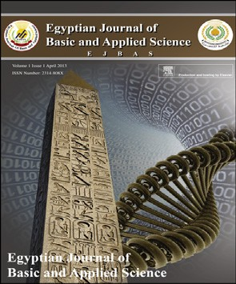

Available online at [www.sciencedirect.com](http://www.sciencedirect.com/science/journal/2314808X)

ScienceDirect

journal homepage: <http://ees.elsevier.com/ejbas/default.asp>

Full Length Article

Effect coal ash on some refractory properties of alumino-silicate (Kankara) clay for furnace lining



*S.B. Hassan* *a**, V.S. Aigbodion* *b**,**\**

a *Department of Metallurgical and Materials Engineering, University of Lagos, Lagos, Nigeria*

b *Department of Metallurgical and Materials Engineering, University of Nigeria, Nsukka, Nigeria*

## a r t i c l e i n f o

*Article history:*

Received 6 December 2013 Received in revised form 24 March 2014

Accepted 3 April 2014

Available online 2 May 2014

*Keywords:*

Coal ash Kankara clay

Refractory properties Fireclay brick

## a b s t r a c t

The work aimed on the improving the refractory properties of Kankara clay (alumino-sil- icate) found in Kankara Village, Katsina State, Nigeria by blending with coal ash for the production of refractory bricks was investigated. Coal ash additions were varied from 5 to 25 wt% in the blend. Refractory properties such as: linear shrinkage, apparent porosity, bulk density, cold crushing strength and thermal shock resistance were tested. The results were compared with standard refractory properties for fireclay bricks. All the values ob- tained from the blends are within the recommended values for medium fireclay bricks. Hence, addition of coal ash to Kankara clay enhanced the refractory properties; the bricks were used in the production of heat treatment furnace with good thermal resistance.

Copyright 2014, Mansoura University. Production and hosting by Elsevier B.V. All rights

reserved.

# Introduction

The term “clay” refers to a naturally occurring material composed primarily of fine-grained minerals, which is generally plastic at appropriate water contents and will harden when dried or fired [1]. Although clay usually contains phyllosilicates, it may contain other materials that impart plasticity and harden when dried or fired [2,3].

Clay is a complex mixture, which varies in composition depending upon the geological location. It is a natural sub- stance which occurs in great abundance [4]. The origin of clay may be traced to either of the two geological processes namely sedimentation and weathering [4]. According to Chester [5] clay is a natural source of many industrial finished products. One of such products that have proved indispensable in the metallurgical industries is the refractory material [6].

* *Corresponding author*. Tel.: +234 8028433576.

E-mail address: [aigbodionv@yahoo.com](mailto:aigbodionv@yahoo.com) (V.S. Aigbodion).

Peer review under responsibility of Mansoura University

**Production and hosting by Elsevier**

<http://dx.doi.org/10.1016/j.ejbas.2014.04.001>

2314-808X/Copyright 2014, Mansoura University. Production and hosting by Elsevier B.V. All rights reserved.

108 [e gypti an j o ur nal o f b a sic and a p p l i ed sci e n c e s 1 ( 2014) 10 7](http://dx.doi.org/10.1016/j.ejbas.2014.04.001) e[114](http://dx.doi.org/10.1016/j.ejbas.2014.04.001)

The raw materials for the production of various refractory products include kaolinite (Al2O3$2SiO2$2H2O), chromite (FeOCr2O3), magnesite (MgCO3) and various types of clays. alumino-silicate and magnesite refractory products are the major types of refractories used in the metallurgical industries [7]. There are vast deposits of clay spread across every region in world, each differing from site to site on account of geological differences.

Earlier works on various Nigerian refractory clay deposits have showed many of them to be unsuitable for refractory works in the as-mined states. They are either high or low in one or more of the important refractory properties desired for good refractory works, or they are completely lacking in both of them [8,9]. The unsuitability of the local clay deposits for refractory works in the as-mined states has therefore prompted the need for this work.

Kankara clay is located in Katsina state of Nigeria precisely around longitudes 7◦26E and 7◦28E and latitude11◦53 [10]. The clay is a weathering product of a unit of the basement rocks in this area, most likely feldspars. The clay sequence overlies

mica schists and underlain by marble [10].

Coal is a readily combustible sedimentary rock containing more than 50% by weight or more than 70% by volume of carbonaceous materials including inherent moisture [11]. The largest single use of coal in the steel industry is as a fuel for the blast furnace, either for the production of metallurgical coke or for injection with the hot blast [11]. For pulverized injection, the coal must deliver a known and consistent calorific value, be reasonably low in ash and meet environmental require- ment for sulphur and nitrogen oxide emissions. Only a certain class of coals possessing very specific properties and compo- sition are suitable for the production of a metallurgical grade coke [12].

The ash in coal is also of great importance in ironmaking.

High ash in coke lowers the carbon content and also demands the use of more fluxes and hence consumes more energy for slagging. This increases coke rate and leads to lower efficiency of the metallurgical process. It has been reported that 1% in- crease in ash content in coke leads to an increase of 1.5e2% in coke rate, 1.5% in the flux rate and lowers blast furnace effi- ciency by 3e5% [12].

Earlier works on Kankara clay (alumino-silicate) as a re- fractory materials showed that it has a low refractoriness, thermal resistance and high apparent porosity [13], which are not satisfactory. Hence, there is need to improve the re- fractory properties of this clay. It is in the light of the fore- going research, that the investigation of the effects of coal ash on some refractory properties of Kankara clay was motivated.

# Materials and method

### *Materials*

As-mind samples of (Kankara clay) and coal ash were ob- tained from the stockyard of the refractory Department of the National Metallurgical Development Center, Jos, Nigeria. The average size of the clay samples was between 20 and 30 cm.

### *Method*

The raw clay was soaked in water for three days and dried in open air for a week, this treatment was necessary to remove dead organic matters. The dried clay was then crushed and ground into powder using jaw crushers and pulverizing ma- chine. The ground clay was sieved to pass through sieve 300 mm aperture. The coal ash was also sieved to 100 mm sieve size.

The X-ray diffractograms was taken using Cu Ka radiation at scan speed of 3◦/min. The clay and the refractory were rotated at precisely one-half of the angular speed of the receiving slit, so that a constant angle between the incident

and reflected beams is maintained. The receiving slit is mounted in front of the counter on the counter tube arm, and behind it is usually fixed a scatter slit to ensure that the counter receives radiation only from the portion of the spec- imen illuminated by the primary beam. The intensity dif- fracted at the various angles was recorded automatically on a

chart and the appropriate (q) and (*d*) values were then obtained.

A chemical analysis of the clay and coal ash were deter- mined in the scientific section of the National Metallurgical Development Center, Jos, Nigeria using Mini Pal compact en- ergy dispersive X-ray spectrometer (XRF).

Test samples were prepared by mixing freshly sieved clay with various percentage of coal ash between 5 and 25 wt%. The clay mixture was found to be plastic at 10% water content. The blend was packed into a metal moulding box and pressed using hydraulic press. A pressure of 10 kg/cm2 was applied to enhance homogeneity and surface smoothness of the samples.

The mould bricks were dried on the laboratory floor for three days, followed by oven drying for 12 h at 110 ◦C to expel any moisture left in the bricks and to avoid crack during firing.

Firing was carried out in electric heating furnace preset at heating rate of 7 ◦C/min. The firing procedure used involved heating and soaking the samples at various temperatures [8]: 250 ◦C for 6 h; 650 ◦C for 4 h; 950 ◦C for 3 h; 1100 ◦C for 8 h and 1600 ◦C for 8 h. After firing the bricks were allowed to cool in the furnace at a cooling rate of 7 ◦C/min. The fired bricks were tested for linear shrinkage, apparent porosity, bulk density,

cold crushing strength and thermal shock resistance accord- ing to the recommended standard [14].

The linear shrinkage of the fired bricks was determined by measuring green and fired dimensions of the bricks. The linear shrinkage was then calculated as a percentage of the original wet length as shown in equation (1) [15]:

Percentage of fried shrinkage = *l*b — *l*c × 100(%) (1)

*l*b

*l*b = dimension of green bricks

*l*c = dimension of fired bricks

The apparent porosity and bulk density of the fired bricks were determined by keeping the fired bricks in the oven at 110 ◦C for 3 h to obtained constant weight *D*. The brick was then suspended in distilled water and boiled on a hot plate for 30 min, while still in hot water, the water was displaced with

[e g ypti an j o ur nal o f b a sic and a pp l i e d sci en c e s 1 ( 2014) 10 7](http://dx.doi.org/10.1016/j.ejbas.2014.04.001) e[114](http://dx.doi.org/10.1016/j.ejbas.2014.04.001) 109



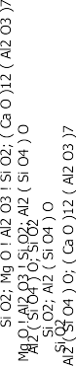

Fig. 1 e XRD pattern of Kankara clay.

cold water and the weight W was measured on a spring bal- ance hinged on a tripod stand. The test samples were removed from the water and the extra water wiped off from the surface

by lightly blotting the sample with wet towel and the weight *S*

The fried bricks were tested for cold crushing strength, using hydraulic strength testing machine. The crushing strength was then calculated using equation (4) [16]:

in air was measured. The apparent porosity (*P*a) of the bricks was determined from equation (2) [15]:

Cold crushing strength = load (kN)

Area (m2)

(4)

*W* — *D*

*P*a = *W* — *S* × 100(%) (2)

*P*a = apparent porosity

*D* = weight of sample (g)

*W* = suspended weight of sample in water (g)

*S* = dry weight after remove from water (g) The bulk density (*B*d) was also calculated from equation (3):

Thermal shock resistance test, samples were put in the furnace that was maintained at a temperature of 1300 ◦C and soaked at this temperature for 30 min, after this the brick was brought out to cool for 10 min. The brick was then tested for

failure using a standard rig, if failure did not occur the brick was then put back inside the furnace and heated for a period of 10 min. This cycle of heating, cooling and testing was repeated until failure occurred [16]. The number of complete cycles to produce failure in each sample was noted.

*D B*d = *W* — *S*

g,cm3 (3)

# Results and discussion

*B*d = bulk density, *D* = dried weight, *W* = soaked weight,

*S* = suspended weight.

The X-ray diffraction patterns of the oriented clay, scanned from 0 to 90◦(2q) showed several peaks due to the different

|  |  |  |  |  |  |
| --- | --- | --- | --- | --- | --- |
| Table 1 e XRD identified patterns list of the Kankara clay. | | | | | |
| Visible Ref. code | Score | Compound name | Displacement [◦2Th.] | Scale factor | Chemical formula |
| * 01-086-1560 | 86 | Quartz low | 0.027 | 1.004 | SiO2 |
| * 00-014-0346 | 30 | Magnesium aluminium silicate | 0.082 | 0.043 | MgOAl2O3SiO2 |
| * 01-089-0888 | 20 | Sillimanite | —0.001 | 0.234 | Al2(SiO4)O |
| * 01-070-2144 | 24 | Mayenite, syn | —0.234 | 0.017 | (CaO)12(Al2O3)7 |
| * 00-050-1432 | 25 | Silicon oxide | —0.474 | 0.047 | SiO2 |

110 [e gypti an j o ur nal o f b a sic and a p p l i ed sci e n c e s 1 ( 2014) 10 7](http://dx.doi.org/10.1016/j.ejbas.2014.04.001) e[114](http://dx.doi.org/10.1016/j.ejbas.2014.04.001)





Fig. 2 e XRD pattern of the refractory at 25 wt% coal ash.

minerals (Fig. 1). The major diffraction peaks were 10.29, 29.03, 31.08, 32.08 and 49.76◦ and their inter-planar distance are: 9.98, 3.57, 3.34, 3.23 and 2.12 ˚A, and their relative intensity of

X-ray scattering were 1.43, 9.31, 100.00, 0.65 and 4.19, phases at these peaks were: magnesium aluminium silicate (MgOA- l2O3SiO2), sillimanite (Al2(SiO4)O), quartz low (SiO2), mayenite, syn ((CaO)12(Al2O3)7), silicon oxide (SiO2), while each of these phases has a score of 30, 20, 86, 24 and 25 respectively (see Table 1). This is in par with the earlier of other clays by [3,17]. The X-ray diffraction patterns of the oriented refractory brick, scanned from 0 to 90◦(2q) showed several peaks due to the different minerals (Fig. 2 and Table 2). From Fig. 2, it was observed that the phases in the refractory brick are quite

different from that of the clay. The major phase different are SiC and calcium silicate which is of resulted of the interfacial reaction of silica in the clay with carbon in the coal ash.

The XRF chemical composition of the clay and coal ash is presented in Table 3. The XRF analysis confirmed that SiO2 and Al2O3 were found to be the major constituents of the clay and coal ash. Silicon dioxide and alumina were known to be among the hardest substances. Some other oxides viz. Fe2O3, MgO, K2O, Na2O was also found to be present in traces. The presence of hard elements like SiO2, Al2O3 suggested that, the Kankara clay belong to alumino-silicate clay [8]. The presence of high alumina content in coal ash support that coal ash can be used in strengthening the refractory properties of Kankara clay [9]. There is also presence of carbon in the coal ash but

XRF cannot detect carbon. This result of XRF is in agreement with the resulted of XRD analysis.

The surface appearance of the firebricks produced from Kankara clay blended with coal ash, dried at 110 ◦C and fired at 1600 ◦C is showed in Table 4.

The brick produced with no coal ash addition had no crack with whitish colour, when dried at 110 ◦C and light pink with slightly crack when fired at 1600 ◦C. As the percentage of coal

ash increased in the blend, the bricks produced have no crack and the light pink colour of the brick turned pink colour at firing temperature of 1600 ◦C (see Table 4).

The linear shrinkage of 100 wt% Kankara clay was found out to be 12.8%. On addition of 10 wt% coal ash, there was decreased in the linear shrinkage from 12.80% to 9.51%. This decreased continuously beyond this level up to 7.8% at 25 wt% addition of coal ash (see Fig. 3). This means that coal ash does not burn off in the clay during firing.]

The apparent porosity of the brick made from 100 wt% Kankara clay was 31.040%. This decreased to 24.05% at 5 wt% additions of coal ash. This decreased continuously beyond this level to 23.7% at 25 wt% additions of coal ash (see Fig. 4). This indicates that coal ash does not burn off during the firing of the bricks samples and blocked the voids and enhanced the porosity of the bricks. Hence, the apparent porosity of the clay found from the blends fall within the acceptable level of 22e25% for medium heat duty and 23e26%

for high heat duty fireclay refractory [9].

|  |  |  |  |  |  |  |  |
| --- | --- | --- | --- | --- | --- | --- | --- |
| Table 2 | e | Identified patterns of the refractory brick. | | | | | |
| Visible | Ref. code | | Score | Compound name | Displacement [◦2Th.] | Scale factor | Chemical formula |
| * | 41-1480 | | 48 | Albite, Ca-rich, ordered | 0.000 | 0.108 | (Na, Ca)Al(Si, Al)3O8 |
| * | 83-2466 | | 31 | Silicon carbide | 0.000 | 0.377 | SiC |
| * | 33-0303 | | 27 | Calcium silicate | 0.000 | 0.033 | Ca2SiO4 |

[e g ypti an j o ur nal o f b a sic and a pp l i e d sci en c e s 1 ( 2014) 10 7](http://dx.doi.org/10.1016/j.ejbas.2014.04.001) e[114](http://dx.doi.org/10.1016/j.ejbas.2014.04.001) 111

|  |  |  |  |  |  |  |
| --- | --- | --- | --- | --- | --- | --- |
| Table 3 e Chemical analysis of the Kankara clay and coal ash. | | | | | | |
| Compound | Al2O3 | SiO2 | Fe2O3 | CaO | MgO | Ka2O |
| Kankara clay (wt%) | 36.40 | 46.48 | 1.09 | 0.73 | 0.87 | 0.10 |
| Coal ash (wt%) | 42.40 | 47.60 | 0.25 | 0.72 | 0.30 | 0.97 |

|  |  |  |  |  |
| --- | --- | --- | --- | --- |
| Table 4 e | Surface appearance of the bricks. | | | |
| Coal ash  % | After being dried at 110 ◦C for 24 h  Colour Crack formation | | After being fired at 1600 ◦C  Colour Crack formation | |
| 0 | White | No crack | Light pink | Slightly crack |
| 5 | White | No crack | Light pink | No crack |
| 10 | Whitish | No crack | Pink | No crack |
| 15 | Whitish | No crack | Pink | No crack |
| 20 | Whitish | No crack | Pink | No crack |
| 25 | Whitish | No crack | Pink | No crack |

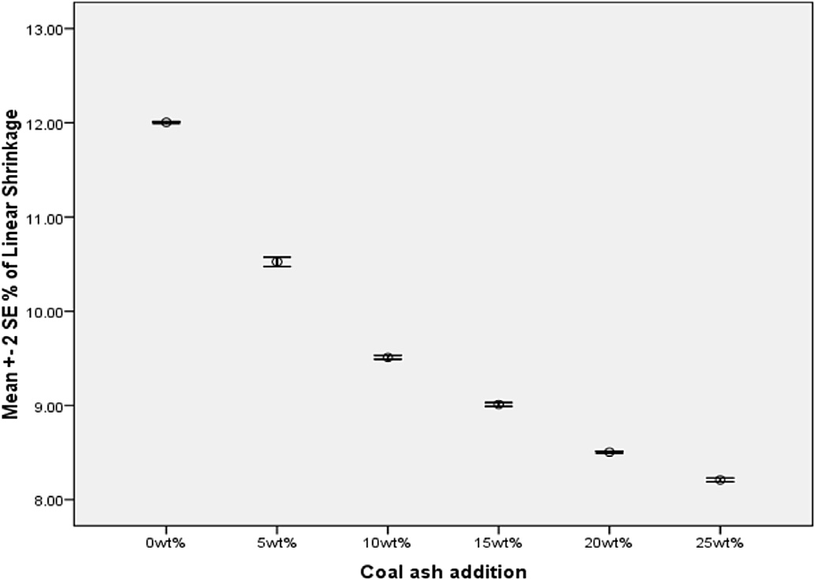

Fig. 3 e Variation of linear shrinkage with coal ash addition.

The bulk density increased as the percentage of coal ash increases in the clay. The average values of bulk density ob- tained in this blend are between 1.88 and 2.05 g/cm3 (see Fig. 5). All the values were within the standard recommended value for fire- clay, since the typical value of bulk density for

medium high duty fireclay bricks were about 1.95e2.05 g/cm3 [18].

The cold crushing strength of 100 wt% Kankara clay is 24,800 kN/m2. This value increased to 34,400 kN/m2 at 25 wt% addition of coal ash (see Fig. 6). From the resulted, it is clear

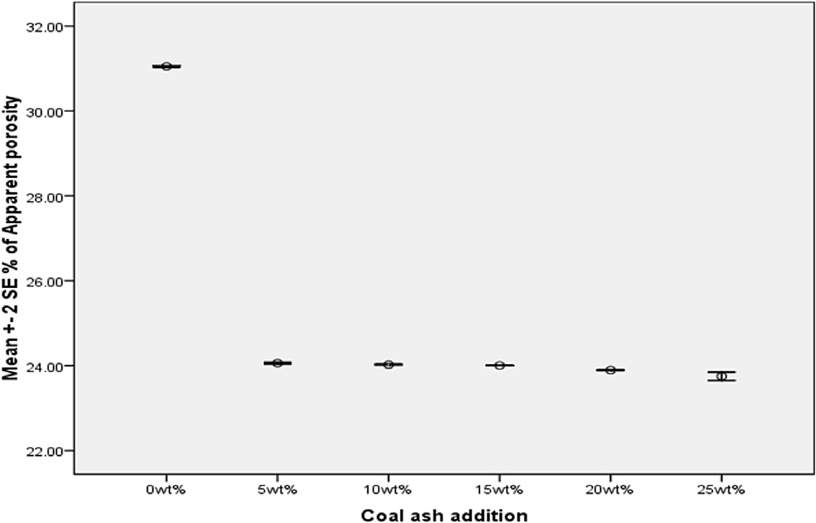

Fig. 4 e Variation of apparent porosity with coal ash addition.

112 [e gypti an j o ur nal o f b a sic and a p p l i ed sci e n c e s 1 ( 2014) 10 7](http://dx.doi.org/10.1016/j.ejbas.2014.04.001) e[114](http://dx.doi.org/10.1016/j.ejbas.2014.04.001)

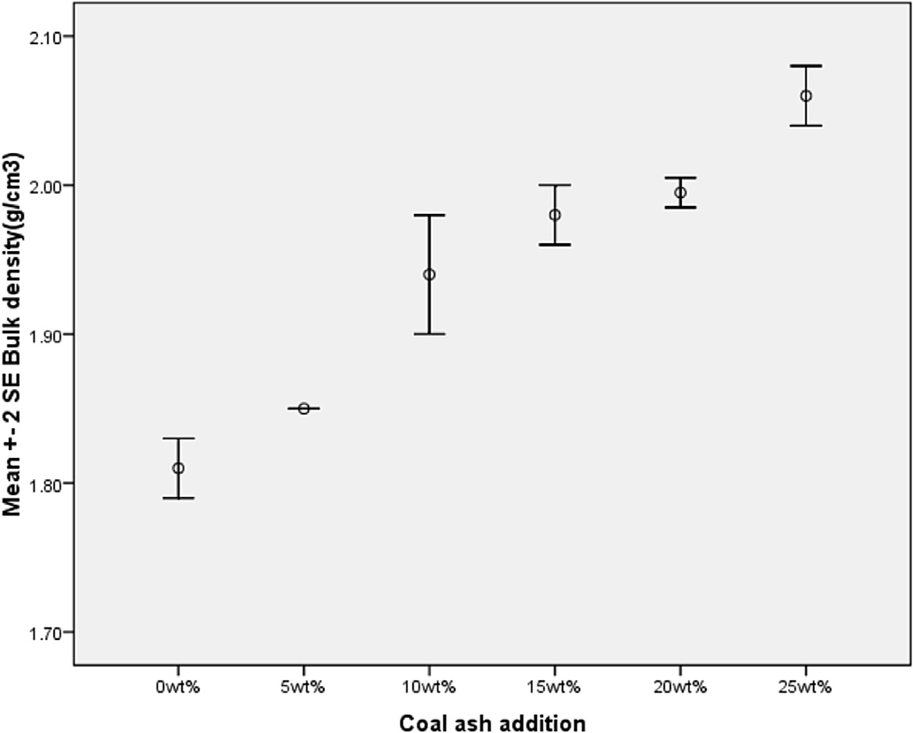

Fig. 5 e Variation of bulk density with coal ash addition.

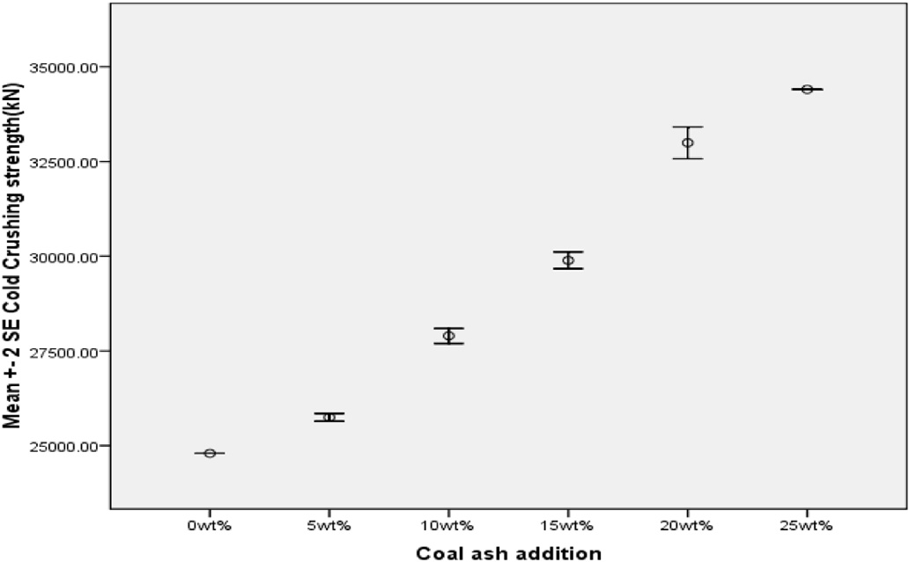

Fig. 6 e Variation of cold crushing strength with coal ash addition.

that the addition of coal ash to Kankara clay increased the cold crushing strength characteristic. These values obtained for all the blends are high enough for a refractory material, this accounted for good bonding and vitrification during firing These resulted obtained agreed with the standard cold crushing strength of 12,000 kN/m2 minimum for fireclay [19,20].

The thermal shock resistance of 100 wt% Kankara clay and that of the blended upto 15 wt% additions of coal ash were fair at 1300 ◦C. However, there is increased in the thermal shock

resistance of the bricks as the additions of coal ash were increased from 20 to 25 wt% coal ash additions at 1300 ◦C. These blends gave values that fall within the acceptable ranges of 25+ cycles. The high number of cycles (+28) was

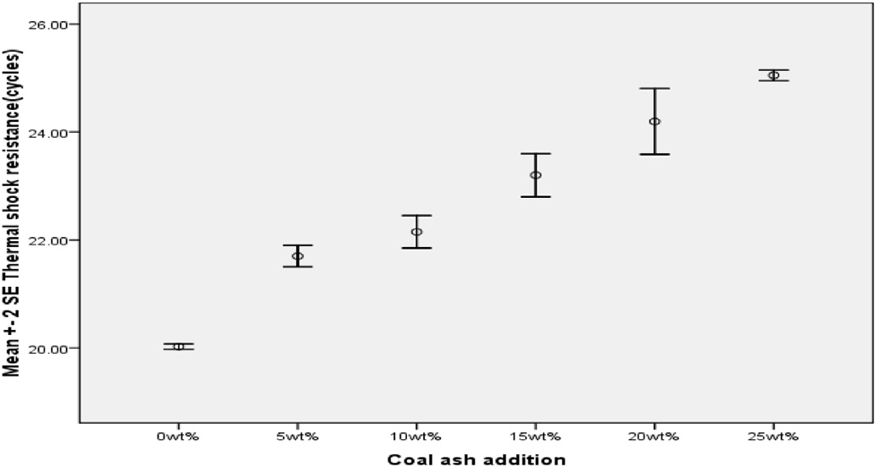

Fig. 7 e Variation of thermal shock resistance with coal ash addition.

[e g ypti an j o ur nal o f b a sic and a pp l i e d sci en c e s 1 ( 2014) 10 7](http://dx.doi.org/10.1016/j.ejbas.2014.04.001) e[114](http://dx.doi.org/10.1016/j.ejbas.2014.04.001) 113

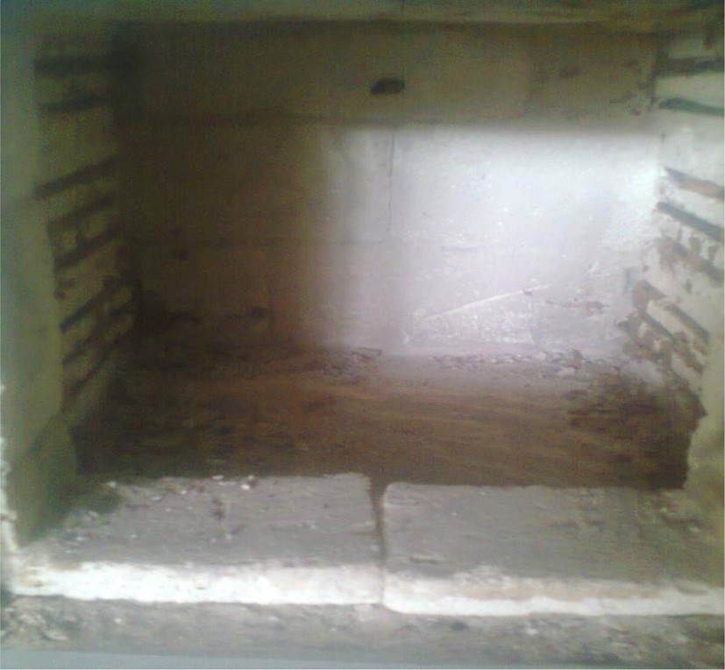

Fig. 8 e Protype furnace produced with the blend at 25 wt% coal ash.

obtained at 25 wt% coal ash addition. This is attributed to the fact that no degree of fusion might have taken place. Higher percentage of coal ash beyond 25 wt% in the blend might have resulted in excellent thermal shock resistance (see Fig. 7). This mean that this bricks can be used in area of good shock resistance [12,21].

Taking into consideration, all the desired dimensions of a mini heat treatment furnace, a prototype of laboratory heat treatment furnace was produced with the formulation at 25 wt% coal ash (see Fig. 8). The produced prototype furnace was used to show that the formulation can be used in the production of heat treatment furnace without adding any binders to this formulation. The furnace is currently used in the heat treatment laboratory of our Department.

# Conclusions

From the results of the investigation the following conclu- sions can be made:

1. The linear shrinkage and apparent porosity of the bricks produced from Kankara clay blended with coal ash decreased with increasing percentages of coal ash addi- tions. This means that coal ash does not easily burn off during firing.
2. The thermal shock resistance of the refractory bricks increased as the percentage of coal ash increased in the clay. It implies that bricks produced from these blends will be suitable for batch furnaces application.
3. The cold crushing strength of the refractory bricks increased as the percentage of coal ash increases in the clay.
4. The work has found out that medium duty fireclay brick capable of possessing good thermal shock resistance was made with this blend at 25 wt% coal ash. Since all the value obtained are within the recommended values for fireclay bricks.

# Acknowledgements

The authors acknowledged with thanks the National Metal- lurgical Development Center, Jos, Nigeria for allowing us to used their equipment. The laboratory assistance of Mr. David Garba of the Department of Metallurgical and Materials En- gineering, Ahmadu Bello University, Zaria, Nigeria is highly acknowledged as well.

## references

1. [Ameh EM, Obasi NL. Effect of rice husk on insulating bricks](http://refhub.elsevier.com/S2314-808X(14)00012-8/sref1) [produced with Nafuta and Nsu clays. Glob J Eng Technol;](http://refhub.elsevier.com/S2314-808X(14)00012-8/sref1) [2009:661](http://refhub.elsevier.com/S2314-808X(14)00012-8/sref1)e[8](http://refhub.elsevier.com/S2314-808X(14)00012-8/sref1).
2. [Irabor PSA. Physical and chemical investigation on some](http://refhub.elsevier.com/S2314-808X(14)00012-8/sref2) [Nigerian kaolinite clays for use in the ceramics and allied](http://refhub.elsevier.com/S2314-808X(14)00012-8/sref2) [industries. Niger J Eng Res Dev 2002;1(1):54](http://refhub.elsevier.com/S2314-808X(14)00012-8/sref2)e[9](http://refhub.elsevier.com/S2314-808X(14)00012-8/sref2).
3. [Odo JU, Nwajagu CO. Possible application of Eha-Alumona](http://refhub.elsevier.com/S2314-808X(14)00012-8/sref3) [clay deposit in the production of refractories and ceramic](http://refhub.elsevier.com/S2314-808X(14)00012-8/sref3) [ware. In: Proceedings of the Nigerian materials congress and](http://refhub.elsevier.com/S2314-808X(14)00012-8/sref3) [meeting of the Nigerian Materials Research Society at](http://refhub.elsevier.com/S2314-808X(14)00012-8/sref3) [conference hall; 2003. pp. 109](http://refhub.elsevier.com/S2314-808X(14)00012-8/sref3)e[11](http://refhub.elsevier.com/S2314-808X(14)00012-8/sref3).
4. [Abolarin MS, Olugboji OA, Ugwoke IC. Experimental](http://refhub.elsevier.com/S2314-808X(14)00012-8/sref4) [investigation on local refractory materials for furnace](http://refhub.elsevier.com/S2314-808X(14)00012-8/sref4) [construction. In: 5th Annual engineering conference](http://refhub.elsevier.com/S2314-808X(14)00012-8/sref4) [proceedings; 2004. pp. 82](http://refhub.elsevier.com/S2314-808X(14)00012-8/sref4)e[5. Minna](http://refhub.elsevier.com/S2314-808X(14)00012-8/sref4).
5. [Chesters JH. Refractory production and properties. London:](http://refhub.elsevier.com/S2314-808X(14)00012-8/sref5) [The Iron and Steel Institute; 1975. pp. 4](http://refhub.elsevier.com/S2314-808X(14)00012-8/sref5)e[13. 295](http://refhub.elsevier.com/S2314-808X(14)00012-8/sref5)e[315](http://refhub.elsevier.com/S2314-808X(14)00012-8/sref5).
6. [Omowumi OJ. Characterization of some Nigerian clays as](http://refhub.elsevier.com/S2314-808X(14)00012-8/sref6) [refractory materials for furnace lining. Niger J Eng Manag](http://refhub.elsevier.com/S2314-808X(14)00012-8/sref6) [2001;2(3):4](http://refhub.elsevier.com/S2314-808X(14)00012-8/sref6).
7. [Alrawi A. Improvement of properties of refractory castables](http://refhub.elsevier.com/S2314-808X(14)00012-8/sref7) [using steel fibers [M.Sc. thesis]. Department of Civil](http://refhub.elsevier.com/S2314-808X(14)00012-8/sref7) [Engineering, University of Baghdad; 2000](http://refhub.elsevier.com/S2314-808X(14)00012-8/sref7).
8. [Hassan SB. Effects of silicon carbide on some refractory](http://refhub.elsevier.com/S2314-808X(14)00012-8/sref8) [properties of Kankara clay. In: Proceedings of Nigerian](http://refhub.elsevier.com/S2314-808X(14)00012-8/sref8) [Metallurgical Society; 2001. pp. 46](http://refhub.elsevier.com/S2314-808X(14)00012-8/sref8)e[52](http://refhub.elsevier.com/S2314-808X(14)00012-8/sref8).
9. [Orumwense FFO, Nwajagu CO. The status of the refractory](http://refhub.elsevier.com/S2314-808X(14)00012-8/sref9) [industry in Nigeria. In: Proceedings of Nigerian Metallurgical](http://refhub.elsevier.com/S2314-808X(14)00012-8/sref9) [Society; 1992. pp. 34](http://refhub.elsevier.com/S2314-808X(14)00012-8/sref9)e[9](http://refhub.elsevier.com/S2314-808X(14)00012-8/sref9).
10. [Macload W. Kaolin deposit near Kankara, Katsina state.](http://refhub.elsevier.com/S2314-808X(14)00012-8/sref10) [Geological survey report no. 1442; 1979](http://refhub.elsevier.com/S2314-808X(14)00012-8/sref10).
11. [Patil MD, Eaton HC, Tittlebaum ME. Mo¨ ssbauer spectroscopic](http://refhub.elsevier.com/S2314-808X(14)00012-8/sref11) [studies of fly ash from coal-fired power plants and bottom](http://refhub.elsevier.com/S2314-808X(14)00012-8/sref11) [ash from lignite](http://refhub.elsevier.com/S2314-808X(14)00012-8/sref11)e[natural gas combustion. Fuel](http://refhub.elsevier.com/S2314-808X(14)00012-8/sref11) [1984;63(6):788](http://refhub.elsevier.com/S2314-808X(14)00012-8/sref11).
12. [Spiro CL, Wong J, Lytle FW, Greegor RB, Maylotte DH,](http://refhub.elsevier.com/S2314-808X(14)00012-8/sref12) [Lamson SH. Forms of potassium in coal and its combustion](http://refhub.elsevier.com/S2314-808X(14)00012-8/sref12) [products. Fuel 1986;65:327](http://refhub.elsevier.com/S2314-808X(14)00012-8/sref12).
13. [Hassan SB. The study of the refractory properties of some](http://refhub.elsevier.com/S2314-808X(14)00012-8/sref13) [Nigerian clay [M.Sc thesis]. Zaria, Nigeria: Department of](http://refhub.elsevier.com/S2314-808X(14)00012-8/sref13) [Mechanical Engineering, Ahmadu Bello University; 1990](http://refhub.elsevier.com/S2314-808X(14)00012-8/sref13).
14. American Society for Testing and Materials C71-2008. Standard terminology relating to refractories, vol. 15.1.
15. American Society of Testing and Materials C 20-2000. Standard test method for apparent porosity, water absorption, apparent specific gravity and bulk density, vol. 15.1.
16. American Society for Testing and Materials C133 e 1997. Standard test methods for cold crushing strength and modulus of rupture of refractories, vol. 15.1.
17. [Lee WE, Zhang S, Karakus M. Refractories: controlled](http://refhub.elsevier.com/S2314-808X(14)00012-8/sref14) [microstructure composites for extreme environments. J](http://refhub.elsevier.com/S2314-808X(14)00012-8/sref14) [Mater Sci 2004;39:6675](http://refhub.elsevier.com/S2314-808X(14)00012-8/sref14)e[85](http://refhub.elsevier.com/S2314-808X(14)00012-8/sref14).

114 [e gypti an j o ur nal o f b a sic and a p p l i ed sci e n c e s 1 ( 2014) 10 7](http://dx.doi.org/10.1016/j.ejbas.2014.04.001) e[114](http://dx.doi.org/10.1016/j.ejbas.2014.04.001)

1. [Chesti AR. Refractories, manufacture, properties and](http://refhub.elsevier.com/S2314-808X(14)00012-8/sref15) [applications. New Delhi: Prentice-Hall of India; 1986.](http://refhub.elsevier.com/S2314-808X(14)00012-8/sref15)

[pp. 25](http://refhub.elsevier.com/S2314-808X(14)00012-8/sref15)e[7. 60](http://refhub.elsevier.com/S2314-808X(14)00012-8/sref15)e[90](http://refhub.elsevier.com/S2314-808X(14)00012-8/sref15).

1. [Borde JO, Oluwadare GO, Olasupo OA. Development of](http://refhub.elsevier.com/S2314-808X(14)00012-8/sref16) [ramming mass from Nigerian refractory raw materials. In:](http://refhub.elsevier.com/S2314-808X(14)00012-8/sref16) [Proceedings of Materials Society of Nigeria; 2002. pp. 93](http://refhub.elsevier.com/S2314-808X(14)00012-8/sref16)e[8](http://refhub.elsevier.com/S2314-808X(14)00012-8/sref16).
2. [Borode JO, Onyemaobi OO, Omotoyinbo JA. Suitability of](http://refhub.elsevier.com/S2314-808X(14)00012-8/sref17) [some Nigeria clays as refractory raw materials. Niger J Eng](http://refhub.elsevier.com/S2314-808X(14)00012-8/sref17) [Manag 2000;3:14](http://refhub.elsevier.com/S2314-808X(14)00012-8/sref17)e[8](http://refhub.elsevier.com/S2314-808X(14)00012-8/sref17).
3. [Odo JU, Neife SI. The effect of additives on some refractories](http://refhub.elsevier.com/S2314-808X(14)00012-8/sref18) [properties of Enugu fire-clay. In: Nigerian materials congress](http://refhub.elsevier.com/S2314-808X(14)00012-8/sref18) [proceedings; 2002. pp. 89](http://refhub.elsevier.com/S2314-808X(14)00012-8/sref18)e[92](http://refhub.elsevier.com/S2314-808X(14)00012-8/sref18).