[Egyptian Journal of Basic and Applied Sciences 4 (2017) 212–218](http://dx.doi.org/10.1016/j.ejbas.2017.04.005)

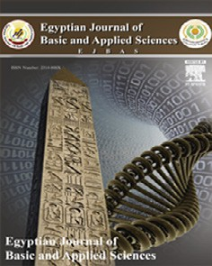

Contents lists available at [ScienceDirect](http://www.sciencedirect.com/science/journal/2314808X)

Egyptian Journal of Basic and Applied Sciences

journal homepage: [www.elsevier.com/locate/ejbas](http://www.elsevier.com/locate/ejbas)

Full Length Article

Effect of phyto-synthesized silver nanoparticles on developmental stages of malaria vector, *Anopheles stephensi* and dengue vector, *Aedes aegypti*



Madanagopal Nalini a, Mahalingam Lena b, Palanisamy Sumathi c, Chandran Sundaravadivelan d,⇑

a *PG & Research Department of Zoology, Poompuhar College (Autonomous), Melaiyur 609 107, Tamil Nadu, India*

b *Department of Zoology, Sri Sarada College for Women (Autonomous), Salem 636 016, Tamil Nadu, India*

c *Department of Zoology, L.R.G. Govt Arts College for Women, Tirupur 641 604, Tamil Nadu, India*

d *Department of Zoology, School of Life Sciences, Karpagam University, Karpagam Academy of Higher Education, Eachanari Post, Coimbatore 641 021, Tamil Nadu, India*

# a r t i c l e i n f o

*Article history:*

Received 31 December 2016

Received in revised form 28 March 2017 Accepted 30 April 2017

Available online 11 May 2017

*Keywords:*

*Artemisia nilagirica*

Silver nanoparticles (Ag NPs)

*Anopheles stephensi Aedes aegypti* Larvicidal activity

# a b s t r a c t

Rapidly synthesized phyto-mediated silver nanoparticles (Ag NPs) using *Artemisia nilagirica* aqueous leaf filtrate has been confirmed through UV–visible spectrophotometer. The synthesized Ag NPs were further characterized using Fourier transform infra-red (FTIR), X-ray diffraction analysis (XRD) to determine the present of functional groups and average particle size (6.723 nm with cubic nature), respectively.

Spherical shape (≤30 nm) of Ag NPs was confirmed by scanning electron microscopy (SEM). Bio-

efficacy of these nanoparticles showed larvicidal and pupicidal properties than the aqueous leaf extract

treatment alone against developmental stages (I–IV instars and pupa) of malaria vector *Anopheles ste- phensi* and dengue vector *Aedes aegypti* at 0.25% concentration level. The LC50 (LCL:UCL at 95% confidence limit) values of I–IV instar and pupa of *An. stephensi* were recorded at 0.343 (0.261:0.405), 0.169 (0.025:0.263), 0.198 (0.105:0.265), 0.141 (0.045:0.205) and 0.050 (0.606:0.224) % respectively and for

*Ae. aegypti* (I–IV instar and pupa) 0.460 (0.364:0.537), 0.352 (0.239:0.432), 0.331 (0.833:0.549), 0.217

(0.228:0.378) and 0.161 (0.630:0.356) % were observed, after 24 h exposure. The first report of present investigation revealed that the rapid biological synthesis of silver nanoparticles using *A. nilagirica* leaf fil- trate would be an effective potential alternative green larvicide for the control of mosquitoes at the devel- opmental stages with eco-friendly approach.

© 2017 Mansoura University. Production and hosting by Elsevier B.V. This is an open access article under

the CC BY-NC-ND license (<http://creativecommons.org/licenses/by-nc-nd/4.0/>).

1. Introduction

At present, mosquitoes are well known for their public health importance as vector for causing dreadful diseases such as malaria, chikungunya, dengue, Zika fever, yellow fever, lymphatic filariasis and Japanese encephalitis by transmitting host specific parasite *Plasmodium falciparum* and *Wuchereria bancrofti* by *Anopheles ste- phensi* and *Culex quinquefasciatus* respectively, and pathogens alphavirus and flavivirus by *Aedes aegypti*. *Anopheles stephensi* and *Aedes aegypti* are the primary vectors of malaria and dengue fever in tropical and subtropical regions, respectively. World Health Organization received summarized information from 106 malaria-endemic countries that about 3.3 billion people are at risk of malaria cases and 655,000 malaria deaths were reported [1]. Recently, WHO estimated nearly 50–100 million dengue infections

* Corresponding author.

*E-mail addresses:* [csundaravadivelan@yahoo.com](mailto:csundaravadivelan@yahoo.com), [sundarsudharsh@gmail.com](mailto:sundarsudharsh@gmail.com) (C. Sundaravadivelan).

with 20,000 deaths occurring annually worldwide, 75% of which occurs in Asia Pacific Region [2].

The spreading of these diseases by mosquito is mainly due to the ever increasing urbanization and associated anthropogenic activities. No effective drug or vaccine is available so far, but con- trol of mosquito population in their breeding sites may directly contribute as an alternative source to prevent these mosquito- borne diseases [3]. In this respect, different control strategies using

synthetic insecticide Lufenuron (Match®) [4], plant extract of

*Knema attenuata* [5], *Acalypha alnifolia* and microbial insecticide *Metarhizium anisopliae* [6], essential oils [7], and nereistoxin from marine annelid *Lumbriconereis heteropoda* [8] have been reported against adult and developmental stages of *Aedes*, *Anopheles* and *Culex*. But these treatments exhibits its default like lower efficacy, development of resistance, chronic effects in non-target organisms and its long-term residual accumulation in the environment, thereby ecological imbalance through food chain and harm cattle and human beings. Hence, there is a constant need for developing biologically active larvicides from natural products which are biodegradable.

<http://dx.doi.org/10.1016/j.ejbas.2017.04.005>

2314-808X/© 2017 Mansoura University. Production and hosting by Elsevier B.V.

This is an open access article under the CC BY-NC-ND license (<http://creativecommons.org/licenses/by-nc-nd/4.0/>).

In this respect, the complex nature of environmentally haz- ardous synthetic chemicals, on reduction into micro or nano sized particles using bio-precursors possessed wide applications and has attracted considerable attention of many researchers to synthesis nanoparticles using plants like *Cissus quadrangularis* [9], leaves of *Cassia auriculata* [10], *Euphorbia hirta* and *Nerium indicum* [11], *Ipo- moea aquatica*, *Enhydra fluctuans*, *Ludwigia adscendens* [12] and fruits of *Carica papaya* [13], fungi *Chrysosporium tropicum* [14], *Cochliobolus lunatus* [15] and *Puccinia graminis* [16], bacteria *Ureibacillus thermosphaericus* [17] and *Rhodococcus* sp. [18] to sub- sidise the use of physical and chemical methods, which require high cost, pressure, energy, temperature and chemical precursors that leads to toxic accumulation in environment.

Due to lack of data on the effect of synthesis of Ag NPs from weeds, the current study first preferred a weed plant with medic- inal value, *Artemisia nilagirica* (C.B. Clarke) Pamp. (Fig. 1) belongs to family *Asteraceae*, is an aromatic shrub, ovate leaves and com- monly found in mountainous regions of India, was selected. It has been characterized for its antimicrobial [19,20], anthelmintic, antiseptic, and larvicidal [21] properties. Interestingly, this plant aqueous leaf filtrate mediated synthesis mechanism of Ag NPS were predicted and shown in Fig. 2.

The synthesis of bio-metal nanoparticles is a vital source of active area of academic and application research in many fields like industrial, pharmaceutical and medical, especially in diagnostics and therapeutics. Their diverse *in vitro* properties like, antioxidant [22], antibacterial [23], cytotoxic and antibiofilm efficacy [24], inflammatory response and coagulation [25], target drug delivery [26], antiplasmodial activity [27] and very recently mosquito larvi- cidal activity [28] towards medically challenged pathogens and dreadful vectors like mosquito have been reported. Based on these analyses, the present report primarily focused on the synthesis, characterization and bio-efficacy of the Ag NPs synthesized from

*A. nilagirica* aqueous leaf filtrate against developmental stages of *An. stephensi* and *Ae. aegypti* for the prevention of malaria and dengue.

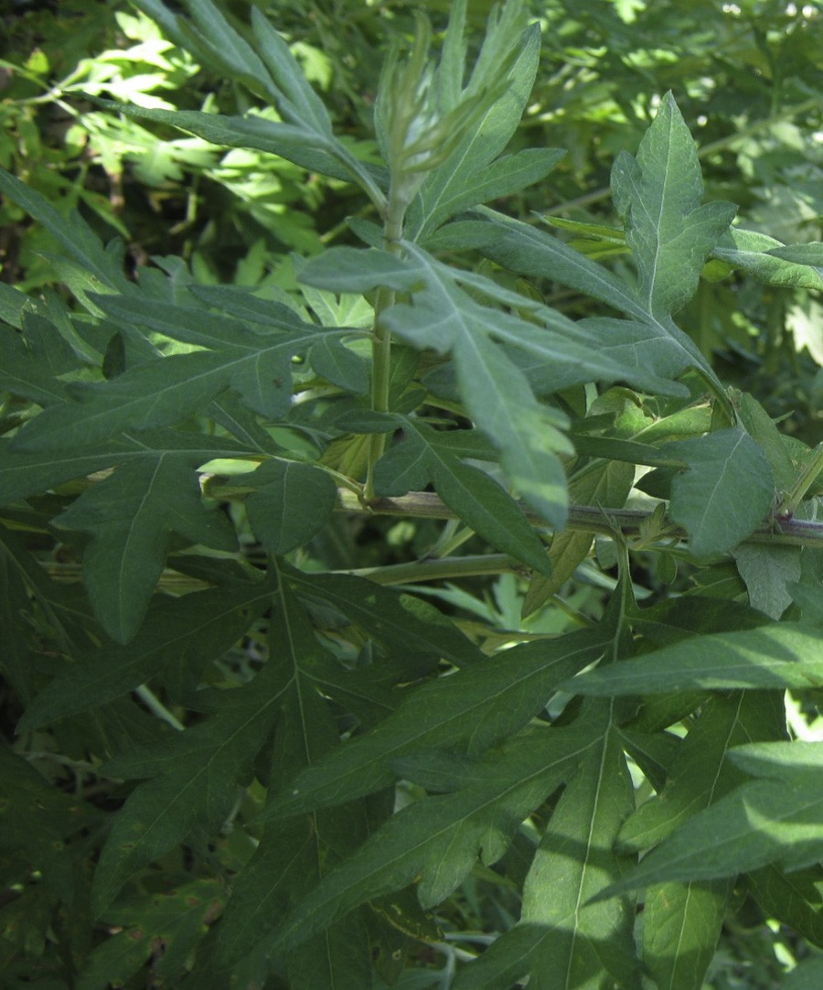

Fig. 1. *Artemisia nilagirica* (C.B. Clarke) Pamp.

1. Materials and methods
   1. *Vectors (An. stephensi and Ae. aegypti) collection and maintenance*

Vectors used in this study were reared according to Sundar- avadivelan et al. [3]. Briefly, they were collected from National Centre for Disease Control (NCDC), Mettupalayam, Coimbatore, and maintained in enamel trays containing distilled water in the laboratory at room temperature.

* 1. *Preparation of A. nilagirica aqueous leaf extract*

Fresh and healthy leaves of *A. nilagirica* were collected nearby UPASI Tea Research Institute, Valparai, Coimbatore and identified by Prof. R. Gopalan, Department of Botany, Karpagam University, Coimbatore. The collected leaves were washed with running tap water to remove dust materials and rinsed in large volumes of

deionized water and allowed to shade dry at room temperature (RT: 27 ± 2 °C). These dried leaves were powdered mechanically using electrical mixer and stored in airtight glass bottle for further use. One gram of leaves powder was dissolved in 100 mL of double

distilled water and left for 5 h without disturbance, then filtered through Whatman filter paper (No. 1). The filtrate (=aqueous leaf extract) was considered as 1% stock solution. From this stock solu- tion, concentrations were prepared ranging from 0.2, 0.4, 0.6, 0.8, and 1.0% for an effective bioassay.

* 1. *Synthesis of silver nanoparticles (Ag NPs)*

For the synthesis of Ag NPs, initially *A. nilagirica* aqueous leaf fil- trate was prepared by using 10 g of fresh clean leaves; cut into very fine pieces and suspended in flask containing 100 mL of distilled

water which was held in water bath at 60 °C for 60 min. The boiled

extract was filtered through Whatman (No. 1) filter paper and this aqueous filtrate (Fig. 3A) was used for synthesis of Ag NPs. Freshly prepared 10 mL aqueous leaf filtrate was mixed with 90 mL of sil- ver nitrate (AgNO3; HiMedia) solution (final concentra- tion = 1 mM). This reaction mixture was held in dark at RT.

* 1. *Characterization of Ag NPs*

The synthesized Ag NPs were confirmed by visual observation due to color change in the reaction mixture. UV–vis spectrum (UV-2450 Shimadzu, Japan) was performed at different time inter- vals (30 min, 1, 2, 3 and 4 h) and the surface plasmon vibration was analyzed at a wavelength of 300–800 nm at a resolution of 1 nm.

NPs were pelleted by centrifugation (20,000×*g*, 30 min, 4 °C), and For further conformational characterization, the synthesized Ag the obtained pellet was washed thrice using sterile deionized

spectra cm—1 (IRAffinity-1, Shimadzu). Further, for X-ray diffrac- water. Finally, the pellet was dried and mixed with KBr for FTIR tion analysis (XRD X’Pert PRO, PANalytical) the powder was coated

an XRD grid and the spectra were recorded from 10° to 90° at 2h angles. The obtained pattern was calculated using Scherrer’s equa- tion to determine the size of Ag NPs. Morphology and shape of the particles were confirmed by SEM (FEI Quanta 200, Icon Analytical).

* 1. *Effect of A. nilagirica aqueous leaf extract and Ag NPs on vectors*

Larvicidal and pupicidal activity of *A. nilagirica* aqueous leaf extract and synthesized Ag NPs were performed against larvae (I–IV instar) and pupa of *An. stephensi* and *Ae. aegypti*, in accor- dance with World Health Organization standard protocols [29] with slight modifications. For bioassay, different test concentra-

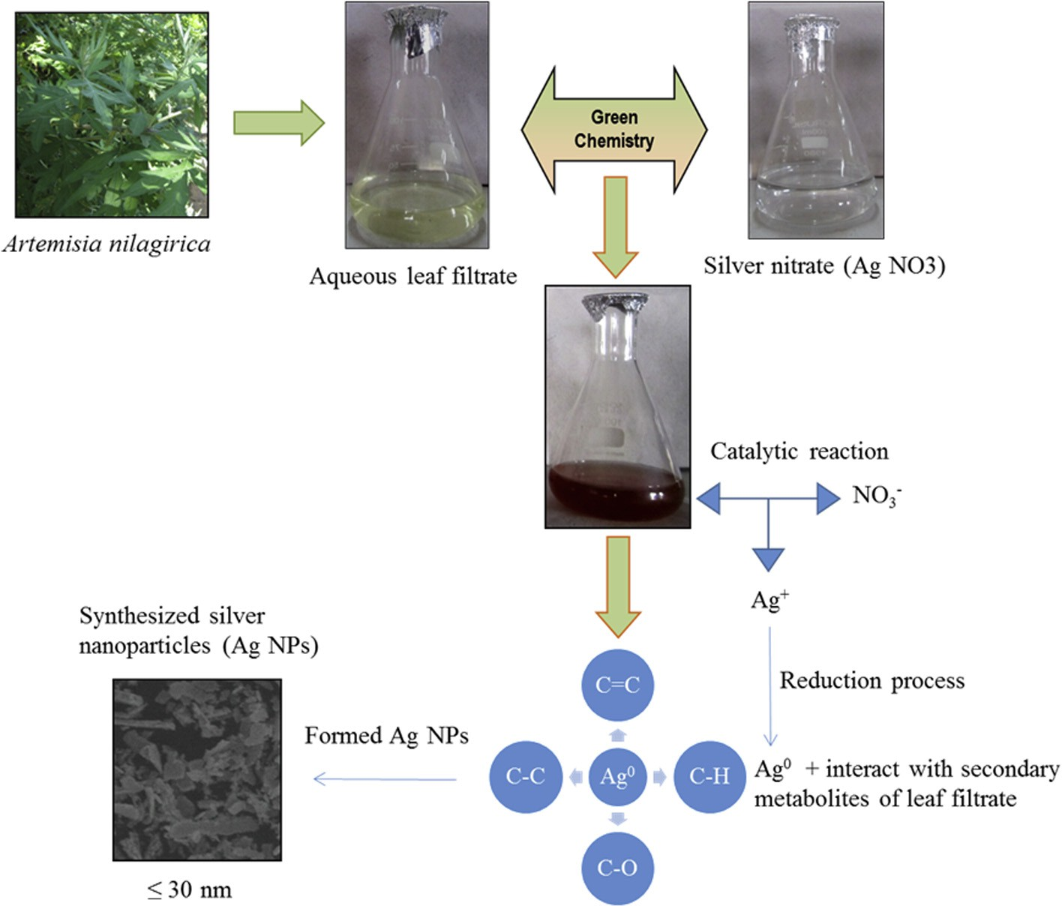

Fig. 2. Synthesis mechanism of Ag NPs using aqueous leaf filtrates of *Artemisia nilagirica*.

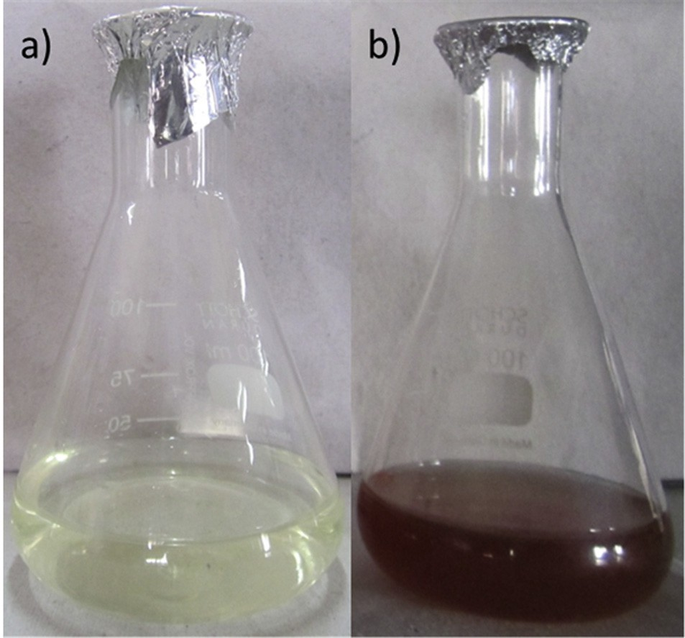

Fig. 3. a) Aqueous leaf filtrate (Pale yellow) of *Artemisia nilagirica*, b) Synthesized Ag NPs (Brown color) after adding silver nitrate (1 mM).

tions of aqueous leaf extract (0.2, 0.4, 0.6, 0.8 and 1.0%) and synthe- sized Ag NPs (0.05, 0.10, 0.15, 0.20 and 0.25%) in 200 mL deionized water were prepared in autoclaved glass bottles. Twenty larvae of each instar and pupa were exposed to each concentration of aque- ous leaf extract and Ag NPs separately. Five replicates were per- formed for each test concentration and each vector with controls run concurrently by substitution of distilled water against test solutions. No food was provided during the experiment. The num-

ber of dead larvae (I–IV instars) and pupa were counted after 24 h exposure. The percent mortality rates of different instars and pupa were determined using the formula given below:

Percent mortality (%)= Number of dead larvae/pupa

Number of larvae/pupa introduced

× 100

* 1. *Data analysis*

The average crystallite domain size of synthesized nanoparti- cles was calculated using Scherrer’s formula (*D* = *n* k/b Cos h) where, *D* = average crystallite domain size, *n* = shape factor (0.94), k = X-ray wavelength, b = Full width at half maximum (FWHM) and h = diffraction angle. The average larvae and pupa mortality data were subjected to profit analysis for calculating LC50 and 95% confidence limit (upper and lower) and compared with Duncan’s multiple range tests to determine the differences between test substances and chi-square values using statistical analysis tool SPSS 9.0 version [30].

1. Results
   1. *Visual analysis and microscan of Ag NPs*

Biogenic Ag NPs were synthesized using 10% aqueous leaf fil- trate of *A. nilagirica* within 60 min, bringing in change of color from pale yellow to brown in the reaction mixture (Fig. 3B). The absorp- tion spectra were recorded as early as 30 min and thereafter at every 1 h interval up to 4 h (Fig. 4). A peak value at 463.50 nm with intensity of 1.839 was observed corresponding to Ag NPs.

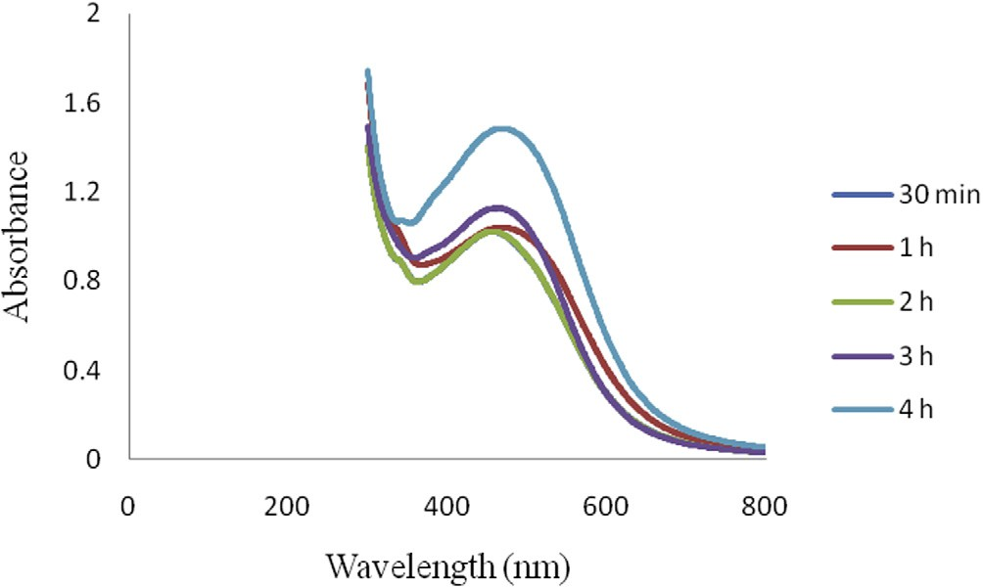

Fig. 4. UV–visible spectrum of Ag NPs synthesized from aqueous leaf filtrate of

*Artemisia nilagirica*.

* 1. *FTIR analysis*

Infra-red (IR) spectra of Ag NPs synthesized using *A. nilagirica*

were recorded between 500 and 2000 cm—1 (Fig. 5). Troughs were observed at 1635.69 cm—1, 1381.08 cm—1, 1280.78 cm—1, aqueous leaf filtrate after bioreduction of silver obtained by FTIR 1118.75 cm—1, 1064.74 cm—1, 709.83 cm—1 and 609.53 cm—1,

wherein, the signals at 1635.69 cm—1 and 1381.08 cm—1 are associ-

(alkenes) respectively. The band at 1280.78 cm—1 is due to CAO stretch mode of carboxylic acids, 1118.75 cm—1, 1064.74 cm—1, ated with the stretching vibrations at C@C and CAH in-plane bend

709.83 cm—1 and 609.53 cm—1 specifically associated with the

stretching vibrations for CAC, CAO, CH2 and CAH bend responsible

to functional groups like ketones, alcohols, alkenes and alkynes. The energy of these vibrations is sensitive to the secondary and ter- tiary structure of protein.

* 1. *XRD and SEM analysis*

On the basis of face-centered cubic structure, Bragg’s reflection is indexed by XRD of Ag NPs. The XRD pattern showed four intense

peaks at 28.00°, 32.50°, 38.50° and 46.75° in the whole spectrum of 2h values ranging from 10 to 90°. The diffraction features were in accord with the crystal data of silver and corresponded to (98),

(101), (111) and (200) as per lattice plane index (Fig. 6). The mean size of Ag NPs was calculated using the Scherrer’s formula (*D* = *n* k/b Cos h), which was about 6.723 nm and monocrystalline in nature. Furthermore, SEM images showed the high-density of Ag NPs synthesized without aggregation by using *A. nilagirica* aqueous leaf filtrate (Fig. 7) and their size was measured about

≤30 nm.

* 1. *Larvicidal and pupicidal effect of Ag NPs*

Larvicidal and pupicidal effect of synthesized Ag NPs were recorded against I–IV instar larvae and pupa of malaria vector *An. stephensi* and dengue vector *Ae. aegypti*. A cent percent mortality of third, fourth instar and pupa was observed against malaria vec- tor *An. stephensi* treated with Ag NPs at a concentration of 0.25% and given in Table 1. On the other hand, only 92% and 96% mortal- ity was observed with first and second instar at the same concen- tration, their LC50 values were found to determine the dose to cause 50% mortality in the treated larvae and pupa, where LC50 (LCL:UCL at 95% confidence limit) was noted in first instar 0.343 (0.261:0.405), second instar 0.169 (0.025:0.263), third instar

0.198 (0.105:0.265), fourth instar 0.141 (0.045:0.205) and pupa

0.050 (0.606:0.224). Mortality rates (%) and LC50 (LCL:UCL at 95% confidence limit) values of first, second, third, fourth instars and pupa were observed about 64%, 0.722 (0.653:0.806), 68%, 0.599

(0.485:0.714), 74%, 0.381 (0.222:0.484), 82%, 0.224 (0.003:0.348)

and 88%, 0.066 (0.514:0.136) respectively while exposed to 1% aqueous leaf extract alone, which is the highest concentration in the treatment.

Similarly, Ag NPs treatment on larvae and pupa of *Ae. aegypti* resulted in 100% mortality of third, fourth instar and pupa followed by 80% in first and 88% in second instar were recorded (Table 2). The LC50 (LCL:UCL at 95% confidence limit) values of I–IV instar and pupa were recorded 0.460 (0.364:0.537), 0.352 (0.239:0.432),

0.331 (0.833:0.549), 0.217 (0.228:0.378) and 0.160 (0.630:0.356)

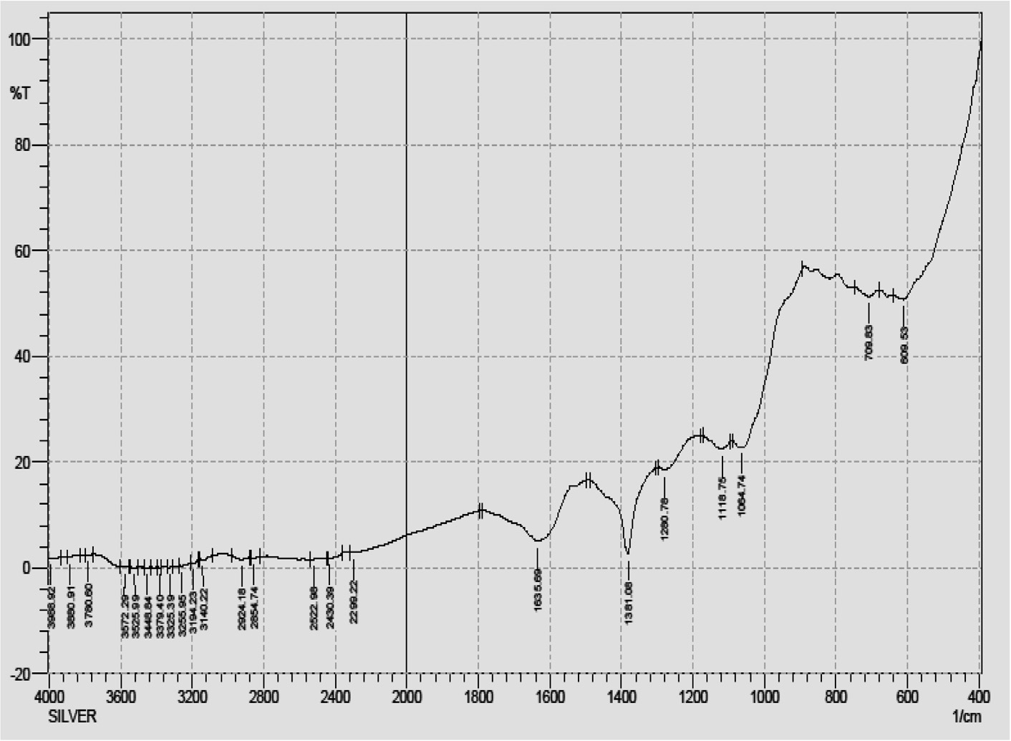

Fig. 5. FTIR spectra of Ag NPs synthesized from aqueous leaf filtrate of *Artemisia nilagirica*.

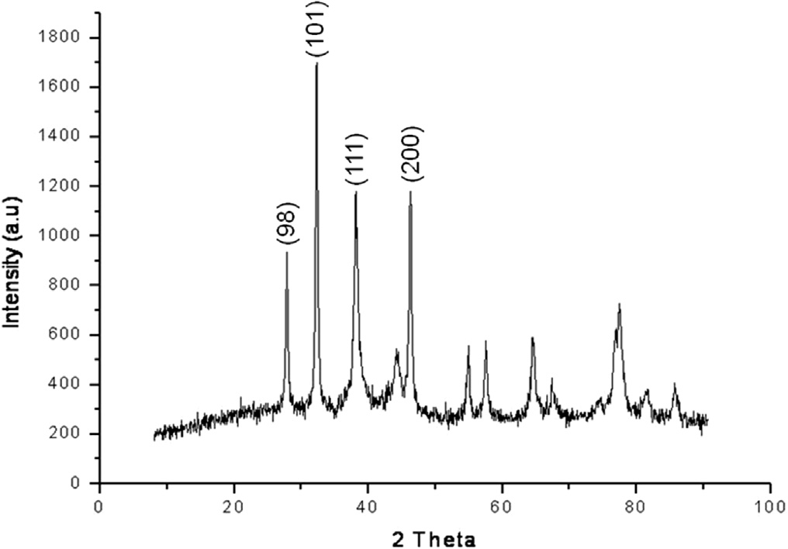

Fig. 6. XRD analysis of Ag NPs synthesized from aqueous leaf filtrate of *Artemisia nilagirica*.

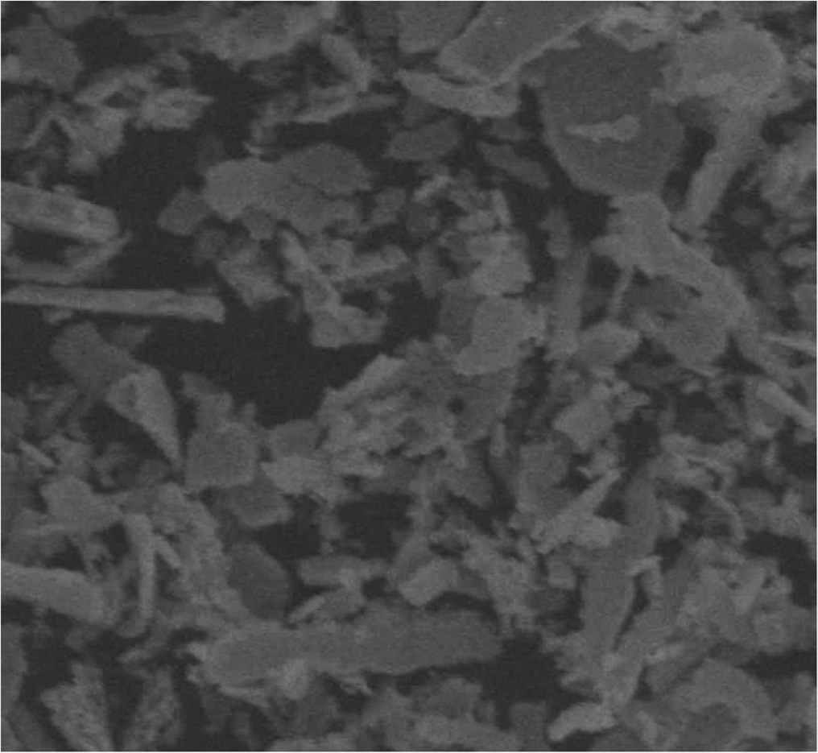

Fig. 7. SEM image of Ag NPs synthesized from aqueous leaf filtrate of *Artemisia nilagirica*.

% respectively, at 0.25% concentration which was the initial con- centration of aqueous leaf extract treatment alone, where only 52% (LC50 = 0.167%) pupa mortality was observed after 24 h expo- sure. On the other hand, no mortality was observed in control. The chi-square value was significant at *p* < 0.05.

1. Discussion

Control of human vector populations have been studied by sev- eral researchers using botanicals which comprises of leaf extracts [31], essential oils [7], isolated compounds [32] and recently, syn- thesized silver nanoparticles [33]. In the present study the Ag NPs synthesized using aqueous leaf filtrate of *A. nilagirica* as a biopre- cursor was investigated in two cases: characterization of the syn- thesized Ag NPs, and its bioactivity towards lethal effect against larvae and pupae of two vector species, *An. stephensi* and *Ae. aegypti*. The rapid color change from pale yellow to brown within 60 min in the reaction mixture strongly indicates the formation of biosilver due to effective reduction with active compounds

and the color intensity for silver biometal recorded is due to exci- tation of surface Plasmon resonance [34]. The different peaks of absorption spectra of phyto-reduced bio-silver (Ag+ ? Ag0) recorded at different time intervals (30 min, 1, 2, 3 and 4 h), indi- cated the continuous involvement of phyto-constituents towards stable the NPs deliverable. Interestingly, the obtained broadened peak value during absorption exhibits the size, shape and its distri- bution of the Ag NPs in the reaction aqueous suspensions and observed Ag NPs could be stable with very little aggregation. The steadily increased surface Plasmon peak of Ag NPs with reaction time became saturated at 480 nm indicating complete reduction of the silver nitrate was observed with myco-synthesized Ag NPs [14].

The FTIR spectra showed the formation of phyto-synthesized Ag NPs from proteins and water soluble active compounds of *A. nila-*

*girica* aqueous leaf filtrates. The signals at 1635.69 cm—1, 1381.08 cm—1, 1280.78 cm—1, 1118.75 cm—1, 1064.74 cm—1,

709.83 cm—1 and 609.53 cm—1 showed evidence of bio-precursor

being responsible for functional groups like alkenes, carboxylic

acids, ketones, alcohols and alkynes in the reduction mixture, which has the strongest ability to bind with reduced non-ionic Ag metal for avoiding the agglomeration and holding stabilization in the medium. Udayasoorian et al. [10] have also observed the possible functional groups like primary and secondary proteins, alcohols, ethers, carboxylic acids, esters and anhydrides existing

responsible peaks at the region of 3400–1000 cm—1 using *Cassia auriculata* leaf extract. The polyols responsible peak at 1650 cm—1 for reduction of silver ions due to oxidation process by black tea

leaf extracts was observed and it was predicted that polyphenols or flavonoids were the main metabolites/biomolecules for synthe- sis of silver and gold nanoparticles [35]. It is also observed that presence of nitrate reductase in the reaction mixture enabled stable production of Ag NPs using *P. tithymaloides* stem extract [36].

X-ray diffraction analysis performed to determine the nature and structure of synthesized Ag NPs by aqueous leaf filtrate showed four intense peaks in the spectrum of 2h values between

25° and 50° corresponding to full width half maximum of Bragg’s

reflection based on the face-centered-cubic (fcc) structure of Ag NPs. The average size of particles calculated (*D* = 6.723 nm) using Scherrer’s formula, clearly indicated the phyto-synthesized Ag NPs were crystalline in nature and could determine the monocrys- tallinity of particles formed in the reaction mixture [37]. Moreover,

few insignificant peaks were also recorded that ranged between 50° and 80°, which can be attributed to other organic molecules of culture supernatant.

With reference to Sintubin et al. [38], the synthesized Ag NPs from plants, algae, yeasts, fungi and bacteria posses varied size and shapes. Similarly, the morphology of phyto-synthesized Ag NPs was documented using scanning electron microscopy wherein the particles were relatively spherical to irregular shape which indicates that the Ag NPs were distributed uniformly in the col- loidal form.

The phyto-synthesized Ag NPs showed strong larvicidal and pupicidal activity against developmental stages (I–IV instar larvae and pupa) of *An. stephensi* and *Ae. aegypti*. In *An. stephensi*, pupa was highly susceptible to treatment with Ag NPs, which was con- firmed by values of LC50 = 0.050% followed by fourth to first instar ranging from 0.141% to 0.343%. But there was a twofold increase in LC50 and the concentration ranged between 0.066% and 0.722% (Pupa – I instar) on treatment with aqueous leaf extract alone. In *Ae. aegypti*, higher rate of susceptible range with values of LC50 = 0.160% was observed with pupa and it linearly increased to 0.460% in first instar treated with Ag NPs. On the other hand, second instar required a higher dose at 0.701% to cause lethal effect when tested with aqueous leaf extract alone after 24 h exposure,

Table 1

Larvicidal and pupicidal activity of phyto-synthesized Ag NPs from *Artemisia nilagirica* aqueous leaf filtrate against *Anopheles stephensi*.

Developmental stages of *An. stephensi* Extracts Percent mortality (%) ± SE LC50 95% confidence limit

v2 (*df* = 3)#

|  |  |  |  |  |  |  |  |  |  |  |
| --- | --- | --- | --- | --- | --- | --- | --- | --- | --- | --- |
|  | | 0.2 | 0.4 | 0.6 | 0.8 | 1.0 |  | LCL | UCL |  |
| I | Aqueous leaf extract | 16 ± 1.337 | 30 ± 1.189 | 48 ± 1.614 | 56 ± 1.046 | 64 ± 1.337 | 0.722 | 0.653 | 0.806 | 2.883 |
| II |  | 36 ± 1.337 | 40 ± 1.681 | 48 ± 1.480 | 58 ± 1.812 | 68 ± 0.945 | 0.599 | 0.485 | 0.714 | 0.645 |
| III |  | 40 ± 1.414 | 52 ± 1.480 | 60 ± 1.189 | 72 ± 1.614 | 74 ± 1.906 | 0.381 | 0.222 | 0.484 | 0.997 |
| IV |  | 48 ± 1.614 | 58 ± 1.480 | 70 ± 0.000 | 74 ± 1.829 | 82 ± 1.293 | 0.224 | 0.003 | 0.348 | 0.472 |
| Pupa |  | 60 ± 1.565 | 72 ± 1.293 | 76 ± 1.046 | 82 ± 1.293 | 88 ± 1.293 | 0.066 | 0.514 | 0.136 | 0.461 |
| Concentrations (%) |  | 0.05 | 0.10 | 0.15 | 0.20 | 0.25 |  |  |  |  |
| I | Synthesized Ag NPs | 40 ± 1.861 | 52 ± 1.293 | 70 ± 1.565 | 86 ± 1.046 | 92 ± 0.945 | 0.343 | 0.261 | 0.405 | 0.942 |
| II |  | 54 ± 1.046 | 66 ± 1.741 | 78 ± 1.614 | 86 ± 1.337 | 96 ± 1.046 | 0.169 | 0.025 | 0.263 | 1.335 |
| III |  | 50 ± 1.681 | 72 ± 1.480 | 86 ± 1.337 | 92 ± 0.945 | 100 ± 0.00 | 0.198 | 0.105 | 0.265 | 3.178 |
| IV |  | 60 ± 1.189 | 80 ± 0.000 | 92 ± 1.293 | 100 ± 0.000 | 100 ± 0.00 | 0.141 | 0.045 | 0.205 | 2.535 |
| Pupa |  | 70 ± 1.681 | 80 ± 1.189 | 90 ± 0.000 | 100 ± 0.000 | 100 ± 0.00 | 0.050 | 0.606 | 0.224 | 5.848 |

*Values are mean of five replicates with ±SE. LC50 – Lethal Concentration 50.

LCL – Lower Confidence Limit. UCL – Upper Confidence Limit. v2 – Chi-square value.

*df* – degrees of freedom.

# Significant at *p* < 0.05 level.

Table 2

Larvicidal and pupicidal activity of phyto-synthesized Ag NPs from *Artemisia Nilagirica* aqueous leaf filtrate against *Aedes aegypti*.

Developmental stages of *Ae. aegypti* Extracts Percent mortality (%) ± SE LC50 95% confidence limit

v2 (*df* = 3)#

|  |  |  |  |  |  |  |  |  |  |  |
| --- | --- | --- | --- | --- | --- | --- | --- | --- | --- | --- |
|  | | 0.2 | 0.4 | 0.6 | 0.8 | 1.0 |  | LCL | UCL |  |
| I | Aqueous leaf extract | 22 ± 1.722 | 38 ± 1.293 | 54 ± 1.510 | 60 ± 1.778 | 70 ± 1.189 | 0.622 | 0.547 | 0.699 | 2.193 |
| II |  | 30 ± 1.681 | 38 ± 1.614 | 46 ± 1.510 | 54 ± 2.036 | 62 ± 1.293 | 0.701 | 0.593 | 0.843 | 0.006 |
| III |  | 34 ± 1.510 | 44 ± 1.510 | 52 ± 1.293 | 66 ± 2.036 | 74 ± 1.906 | 0.519 | 0.420 | 0.603 | 0.312 |
| IV |  | 40 ± 1.414 | 52 ± 1.961 | 66 ± 1.337 | 70 ± 1.778 | 80 ± 1.189 | 0.363 | 0.225 | 0.457 | 0.833 |
| Pupa |  | 52 ± 1.961 | 62 ± 1.293 | 70 ± 1.414 | 80 ± 1.414 | 86 ± 1.046 | 0.167 | 0.056 | 0.294 | 0.104 |
| Concentrations (%) |  | 0.05 | 0.10 | 0.15 | 0.20 | 0.25 |  |  |  |  |
| I | Synthesized Ag NPs | 36 ± 1.741 | 44 ± 1.337 | 60 ± 1.414 | 68 ± 1.614 | 80 ± 1.414 | 0.460 | 0.364 | 0.537 | 0.565 |
| II |  | 46 ± 1.510 | 50 ± 1.414 | 58 ± 1.812 | 78 ± 1.961 | 88 ± 0.945 | 0.352 | 0.239 | 0.432 | 4.981 |
| III |  | 46 ± 1.510 | 54 ± 1.638 | 64 ± 1.337 | 78 ± 1.480 | 100 ± 0.000 | 0.331 | 0.833 | 0.549 | 6.306 |
| IV |  | 54 ± 1.510 | 62 ± 1.812 | 78 ± 1.293 | 88 ± 1.480 | 100 ± 0.000 | 0.217 | 0.228 | 0.378 | 7.358 |
| Pupa |  | 58 ± 1.293 | 68 ± 1.614 | 76 ± 1.510 | 88 ± 1.480 | 100 ± 0.000 | 0.160 | 0.630 | 0.356 | 8.323 |

*Values are mean of five replicates with ±SE. LC50 – Lethal Concentration 50.

LCL – Lower Confidence Limit. UCL – Upper Confidence Limit. v2 – Chi-square value.

*df* – degrees of freedom.

# Significant at *p* < 0.05 level.

which is a twofold increased concentration required to cause mor- tality in larvae compared to Ag NPs treatment. Based on these observations, we found that developmental stages of *An. stephensi* were more susceptible to Ag NPs derived from *A. nilagirica* aqueous leaf filtrate compared to *Ae. aegypti*. This is in accordance with our earlier report that *Ae. aegypti* is susceptible to synthesized Ag NPs (LC50:0.046–0.054%) using stem filtrate of *Pedilanthus tithymaloides* on developmental stages (I–IV instars and pupa) compared to aqueous stem extracts (LC50:1.529–1.455%) alone [36]. Similar findings were observed with Ag NPs produced from aqueous leaf filtrate of *Catharanthus roseus* and *Cissus quadrangularis* against parasites *Plasmodium falciparum* and *Hippobosca maculata* and *Rhipicephalus* (*Boophilus*) *microplus* [27,39]. Interestingly, the sur- vival ability and adult emergence of Ag NPs treated larvae and pupa of both vectors were observed periodically, where delay in pupation and abnormal adult development with poorly developed wings were also noted and the further investigation is in process.

The beginning of this research is mainly focused on the produc- tion of biogenic nanosilver and finding an effective reducing agent and its potential application in the control of mosquito vectors as well as host parasites. The exact mechanisms of larvicidal effect of Ag NPs are unknown. Interestingly, penetration of Ag NPs through treated larval membrane due to interaction with cell molecules resulting in death of larvae was also reported [36]. In addition, after Ag NPs reach their midgut epithelial membrane, the enzymes were inactivated and generate peroxide leading to cell death [40,41]. It is believed with report of Guzman et al. [42] that during anti-bacterial effect of biosilver, the particles highly interacted with sulfur and phosphorus, which are found in abun- dance throughout the cell membrane and utilize these essential elements for displaying antibacterial properties. Based on this study we revealed that, aqueous leaf filtrate of *A. nilagirica* (*Aster- aceae*) is very good bioreductant for the synthesis of Ag NPs and synthesized nanoparticles showed their highly potential against

dreadful disease causing vectors *An. stephensi* and *Ae. aegypti* cau- sative of malaria and dengue, respectively.

1. Conclusion

Phyto-synthesized Ag NPs using a weed, *A. nilagirica* aqueous leaf filtrate exhibits a rapid synthesis, time consumable, quick pro- cess for large scale production, cost-effective, stable, viable, non- toxic, bio-degradable, recyclable and environmentally acceptable green approach and serves as a strong larvicidal and pupicidal agent against developmental stages of *An. stephensi* and *Ae. aegypti*. This novel approach would be a boon for the development of alter- native biopesticide by utilizing natural resources and an affordable method useful in preventing filariasis, malaria, chikungunya and dengue vectors of public health importance.

Acknowledgements

The authors are thankful to The Management, Karpagam University, Karpagam Academy of Higher Education, Coimbatore for providing all facilities required during this study.

References

1. World Health Organization, World Malaria Report, 10 facts on malaria. <[www.](http://www.who.int/features/factfiles/malaria/en/index.html) [who.int/features/factfiles/malaria/en/index.html](http://www.who.int/features/factfiles/malaria/en/index.html)>. 2011; [Accessed 14 March

2013].

1. World Health Organization, Action against dengue: Dengue Day Campaigns Across Asia. WHO library cataloguing in publication data. 2011;92.
2. [Sundaravadivelan C, Nalini M, Sivaprasath P, Kishmu L. Biosynthesized silver](http://refhub.elsevier.com/S2314-808X(16)30212-3/h0015) [nanoparticles from *Pedilanthus tithymaloides* leaf extract with anti-](http://refhub.elsevier.com/S2314-808X(16)30212-3/h0015) [developmental activity against larval instars of *Aedes aegypti* L. (Diptera;](http://refhub.elsevier.com/S2314-808X(16)30212-3/h0015) [Culicidae). Parasitol Res 2013;112:303–11](http://refhub.elsevier.com/S2314-808X(16)30212-3/h0015).
3. [Salokhe SG, Deshpande SG, Mukherjee SN. Evolution of the insect growth](http://refhub.elsevier.com/S2314-808X(16)30212-3/h0020) [regulator Lufenuron (Match®) for control of *Aedes aegypti* by simulated field](http://refhub.elsevier.com/S2314-808X(16)30212-3/h0020) [trials. Parasitol Res 2012;111:1325–9](http://refhub.elsevier.com/S2314-808X(16)30212-3/h0020).
4. [Vinayachandra, Shwetha R, Chandrashekar KR. Larvicidal activities of Knema](http://refhub.elsevier.com/S2314-808X(16)30212-3/h0025) [attenuate (Hook.f.&Thomson) Warb. (Myristicaceae) extracts against Aedes](http://refhub.elsevier.com/S2314-808X(16)30212-3/h0025) [albopictus Skuse and Anopheles stephensi Liston. Parasitol Res](http://refhub.elsevier.com/S2314-808X(16)30212-3/h0025) [2011;109:1671–6](http://refhub.elsevier.com/S2314-808X(16)30212-3/h0025).
5. [Murugan K, Kovendan K, Vincent S, Barnard DR. Biolarvicidal and pupicidal](http://refhub.elsevier.com/S2314-808X(16)30212-3/h0030) [activity of *Acalypha alnifolia* Klein ex Willd. (Family: Euphorbiaceae) leaf](http://refhub.elsevier.com/S2314-808X(16)30212-3/h0030) [extract and microbial insecticide, *Metarhizium anisopliae* (Metsch.) against](http://refhub.elsevier.com/S2314-808X(16)30212-3/h0030) [malaria fever mosquito, *Anopheles stephensi* Liston. (Diptera:Culicidae).](http://refhub.elsevier.com/S2314-808X(16)30212-3/h0030) [Parasitol Res 2012;110:2263–70](http://refhub.elsevier.com/S2314-808X(16)30212-3/h0030).
6. [Amer A, Mehlhorn H. Larvicidal effects of various essential oils against Aedes,](http://refhub.elsevier.com/S2314-808X(16)30212-3/h0035) [Anopheles and Culex larvae (Diptera, Culicidae). Parasitol Res](http://refhub.elsevier.com/S2314-808X(16)30212-3/h0035) [2006;99:466–72](http://refhub.elsevier.com/S2314-808X(16)30212-3/h0035).
7. [Samidurai K, Saravanakumar A. Mosquitocidal properties of nereistoxin](http://refhub.elsevier.com/S2314-808X(16)30212-3/h0040) [against *Anopheles stephensi*, *Aedes aegypti* and *Culex quinquefasciatus*](http://refhub.elsevier.com/S2314-808X(16)30212-3/h0040)[(Diptera: Culicidae). Parasitol Res 2011;109:1107–12](http://refhub.elsevier.com/S2314-808X(16)30212-3/h0040).
8. [Sivakama Valli J, Vaseeharan B. Biosynthesis of silver nanoparticles by *Cissus*](http://refhub.elsevier.com/S2314-808X(16)30212-3/h0045)[*quadrangularis* extracts. Mater Lett 2012;82:171–3](http://refhub.elsevier.com/S2314-808X(16)30212-3/h0045).
9. [Udayasoorian C, Vinoth Kumar K, Jayabalakrishnan RM. Extracellular synthesis](http://refhub.elsevier.com/S2314-808X(16)30212-3/h0050) [of silver nanoparticles using leaf extract of *Cassia auriculata*. Digest J Nano](http://refhub.elsevier.com/S2314-808X(16)30212-3/h0050) [Biostruct 2011;6:279–83](http://refhub.elsevier.com/S2314-808X(16)30212-3/h0050).
10. [Mano Priya M, Karunai Selvi B, John Paul JA. Green synthesis of silver](http://refhub.elsevier.com/S2314-808X(16)30212-3/h0055) [nanoparticles from the leaf extracts of *Euphorbia hirta* and *Nerium indicum*.](http://refhub.elsevier.com/S2314-808X(16)30212-3/h0055) [Digest J Nano Biostruct 2011;6:869–77](http://refhub.elsevier.com/S2314-808X(16)30212-3/h0055).
11. [Roy N, Barik A. Green synthesis of silver nanoparticles from the unexploited](http://refhub.elsevier.com/S2314-808X(16)30212-3/h0060) [weed resources. Int J Nanotech Appl 2010;4:95–101](http://refhub.elsevier.com/S2314-808X(16)30212-3/h0060).
12. [Jain D, Kumar Daima H, Kachhwala S, Kothari SL. Synthesis of plant-mediated](http://refhub.elsevier.com/S2314-808X(16)30212-3/h0065) [silver nanoparticles using papaya fruit extract and evaluation of their](http://refhub.elsevier.com/S2314-808X(16)30212-3/h0065) [antimicrobial activities. Digest J Nano Biostruct 2009;4:557–63](http://refhub.elsevier.com/S2314-808X(16)30212-3/h0065).
13. [Soni N, Prakash S. Efficacy of fungus mediated silver and gold nanoparticles](http://refhub.elsevier.com/S2314-808X(16)30212-3/h0070) [against *Aedes aegypti* larvae. Parasitol Res 2012;110:175–84](http://refhub.elsevier.com/S2314-808X(16)30212-3/h0070).
14. [Salunkhe RB, Patil SV, Patil CD, Salunke BK. Larvicidal potential of silver](http://refhub.elsevier.com/S2314-808X(16)30212-3/h0075) [nanoparticles synthesized using fungus *Cochliobolus lunatus* against *Aedes*](http://refhub.elsevier.com/S2314-808X(16)30212-3/h0075)[*aegypti* (Linnaeus, 1762) and *Anopheles stephensi* Liston (Diptera; Culicidae).](http://refhub.elsevier.com/S2314-808X(16)30212-3/h0075) [Parasitol Res 2011;109:823–31](http://refhub.elsevier.com/S2314-808X(16)30212-3/h0075).
15. [Kirthi AV, Rahuman AA, Jayaseelan C, Karthik L, Marimuthu S, Santhoshkumar](http://refhub.elsevier.com/S2314-808X(16)30212-3/h0080) [T, et al. Novel approach to synthesis silver nanoparticles using plant](http://refhub.elsevier.com/S2314-808X(16)30212-3/h0080) [pathogenic fungi, *Puccinia graminis*. Mater Lett 2012;81:69–72](http://refhub.elsevier.com/S2314-808X(16)30212-3/h0080).
16. [Motamedi Juibari M, Abbasalizadeh S, Salehi Jouzani Gh, Noruzi M. Intensified](http://refhub.elsevier.com/S2314-808X(16)30212-3/h0085) [biosynthesis of silver nanoparticles using a native extremophilic *Ureibacillus*](http://refhub.elsevier.com/S2314-808X(16)30212-3/h0085)[*thermosphaericus* strain. Mater Lett 2011;65:1014–7](http://refhub.elsevier.com/S2314-808X(16)30212-3/h0085).
17. [Otari SV, Patil RM, Nadaf NH, Ghosh SJ, Pawar SH. Green biosynthesis of silver](http://refhub.elsevier.com/S2314-808X(16)30212-3/h0090) [nanoparticles from an actinobacteria *Rhodococcus* sp. Mater Lett](http://refhub.elsevier.com/S2314-808X(16)30212-3/h0090) [2012;72:92–4](http://refhub.elsevier.com/S2314-808X(16)30212-3/h0090).
18. [Shafi PM, Geetha Nambier MK, Clery RA, Sarma YR, Veena SS. Composition and](http://refhub.elsevier.com/S2314-808X(16)30212-3/h0095) [antifungal activity of the oil of *Artemisia nilagirica* (Clarke) Pamp. J Essent Oil](http://refhub.elsevier.com/S2314-808X(16)30212-3/h0095) [Res 2004;16:377–9](http://refhub.elsevier.com/S2314-808X(16)30212-3/h0095).
19. [Ahameethunisa AR, Hopper W. Antibacterial activity of *Artemisia nilagirica* leaf](http://refhub.elsevier.com/S2314-808X(16)30212-3/h0100) [extracts against clinical and phytopathogenic bacteria. BMC Comp Altern Med](http://refhub.elsevier.com/S2314-808X(16)30212-3/h0100) [2010;10:1–6](http://refhub.elsevier.com/S2314-808X(16)30212-3/h0100).
20. [Panneerselvam C, Murugan K, Kovendan K, Mahesh Kumar P. Mosquito](http://refhub.elsevier.com/S2314-808X(16)30212-3/h0105) [larvicidal, pupicidal, adulticidal, and repellent activity of *Artemisia nilagirica*](http://refhub.elsevier.com/S2314-808X(16)30212-3/h0105)[(Family: Compositae) against *Anopheles stephensi* and *Aedes aegypti*. Parasitol](http://refhub.elsevier.com/S2314-808X(16)30212-3/h0105) [Res 2012;111:2241–51](http://refhub.elsevier.com/S2314-808X(16)30212-3/h0105).
21. [Banerjee J, Narendhirakannan RT. Biosynthesis of silver nanoparticles from](http://refhub.elsevier.com/S2314-808X(16)30212-3/h0110) [*Syzygium cumini* (L.) seed extract and evaluation of their *in vitro* antioxidant](http://refhub.elsevier.com/S2314-808X(16)30212-3/h0110) [activities. Digest J Nano Biostruct 2011;6:961–8](http://refhub.elsevier.com/S2314-808X(16)30212-3/h0110).
22. [Krishnaraj C, Jagan EG, Rajasekar S, Selvakumar P, Kalaichelvan PT, Mohan N.](http://refhub.elsevier.com/S2314-808X(16)30212-3/h0115) [Synthesis of silver nanoparticles using *Acalypha indica* leaf extracts and its](http://refhub.elsevier.com/S2314-808X(16)30212-3/h0115) [antibacterial activity against water borne pathogens. Colloids Surf B](http://refhub.elsevier.com/S2314-808X(16)30212-3/h0115) [2010;76:50–6](http://refhub.elsevier.com/S2314-808X(16)30212-3/h0115).
23. [Mohanty S, Mishra S, Jena P, Jacob B, Sarkar B, Sonawane A. An investigation on](http://refhub.elsevier.com/S2314-808X(16)30212-3/h0120) [the antibacterial, cytotoxic and antibiofilm efficacy of starch-stabilized silver](http://refhub.elsevier.com/S2314-808X(16)30212-3/h0120) [nanoparticles. Nanomedicine:NBM 2011;9:1–9](http://refhub.elsevier.com/S2314-808X(16)30212-3/h0120).
24. [Martinez-Gutierrez F, Thi EP, Silverman JM, de Oliveira CC, Svensson SL, Hoek](http://refhub.elsevier.com/S2314-808X(16)30212-3/h0125) [AV, et al. Antibacterial activity, inflammatory response, coagulation and](http://refhub.elsevier.com/S2314-808X(16)30212-3/h0125) [cytotoxicity effects of silver nanoparticles. Nanomedicine:NBM](http://refhub.elsevier.com/S2314-808X(16)30212-3/h0125) [2012;8:328–36](http://refhub.elsevier.com/S2314-808X(16)30212-3/h0125).
25. [Papasani MR, Wang G, Hill RA. Gold nanoparticles: the importance of](http://refhub.elsevier.com/S2314-808X(16)30212-3/h0130) [physiological principles to devise strategies for targeted drug delivery.](http://refhub.elsevier.com/S2314-808X(16)30212-3/h0130) [Nanomedicine:NBM 2012;8:804–14](http://refhub.elsevier.com/S2314-808X(16)30212-3/h0130).
26. [Ponarulselvam S, Panneerselvam C, Murugan K, Aarthi N, Kalimuthu K,](http://refhub.elsevier.com/S2314-808X(16)30212-3/h0135) [Thangamani S. Synthesis of silver nanoparticles using leaves of *Catharanthus*](http://refhub.elsevier.com/S2314-808X(16)30212-3/h0135)[*roseus* Linn. G. Don and their antiplasmodial activities. Asian Pac J Trop Biomed](http://refhub.elsevier.com/S2314-808X(16)30212-3/h0135) [2012:574–80](http://refhub.elsevier.com/S2314-808X(16)30212-3/h0135).
27. [Ramanibai R, Velayutham K. Bioactive compound synthesis of Ag](http://refhub.elsevier.com/S2314-808X(16)30212-3/h0140) [nanoparticles from leaves of *Melia azedarach* and its control for mosquito](http://refhub.elsevier.com/S2314-808X(16)30212-3/h0140) [larvae. Res Vet Sci 2015;98:82–8](http://refhub.elsevier.com/S2314-808X(16)30212-3/h0140).
28. World Health Organization, Report of the WHO informal consultation on the evaluation on the testing of insecticides.CTD/ WHO PES/IC/96.l. WHO, Geneva, 1996; 69.
29. SPSS (2007) SPSS for Windows. Version 13.0. SPSS, Chicago.
30. [Maheswaran R, Sathish S, Ignacimuthu S. Larvicidal activity of Leucas aspera](http://refhub.elsevier.com/S2314-808X(16)30212-3/h0155) [(Willd.) against the larvae of Culex quinquefasciatus Say. and *Aedes aegypti* L.](http://refhub.elsevier.com/S2314-808X(16)30212-3/h0155) [Int J Integr Biol 2008;2:214–7](http://refhub.elsevier.com/S2314-808X(16)30212-3/h0155).
31. [Gopiesh Khanna V, Kannabiran K, Rajakumar G, Abdul Rahuman A,](http://refhub.elsevier.com/S2314-808X(16)30212-3/h0160) [Santhoshkumar T. Biolarvicidal compound gymnemagenol isolated from leaf](http://refhub.elsevier.com/S2314-808X(16)30212-3/h0160) [extract of miracle fruit plant, *Gymnema sylvestre* (Retz) Schult against malaria](http://refhub.elsevier.com/S2314-808X(16)30212-3/h0160) [and filariasis vectors. Parasitol Res 2011;109:1373–86](http://refhub.elsevier.com/S2314-808X(16)30212-3/h0160).
32. [Velayutham K, Ramanibai R. Larvicidal activity of synthesized silver](http://refhub.elsevier.com/S2314-808X(16)30212-3/h0165) [nanoparticles using isoamyl acetate identified in *Annona squamosa* leaves](http://refhub.elsevier.com/S2314-808X(16)30212-3/h0165) [against *Aedes aegypti* and *Culex quinquefasciatus*. J Basic Appl Zool](http://refhub.elsevier.com/S2314-808X(16)30212-3/h0165) [2016;74:16–22](http://refhub.elsevier.com/S2314-808X(16)30212-3/h0165).
33. [Rajakumar C, Abdul Rahuman A. Larvicidal activity of synthesized silver](http://refhub.elsevier.com/S2314-808X(16)30212-3/h0170) [nanoparticles using *Eclipta prostrate* leaf extract against filariasis and malaria](http://refhub.elsevier.com/S2314-808X(16)30212-3/h0170) [vectors. Acta Trop 2011;118:196–203](http://refhub.elsevier.com/S2314-808X(16)30212-3/h0170).
34. [Begum NA, Mondal S, Basu S, Laskar RA, Mandal D. Biogenic synthesis of Au](http://refhub.elsevier.com/S2314-808X(16)30212-3/h0175) [and Ag nanoparticles using aqueous solution of black tea leaf extracts. Colloids](http://refhub.elsevier.com/S2314-808X(16)30212-3/h0175) [Surf B 2009;71:113–8](http://refhub.elsevier.com/S2314-808X(16)30212-3/h0175).
35. [Sundaravadivelan C, Nalini M. Biolarvicidal effect of phyto-synthesized silver](http://refhub.elsevier.com/S2314-808X(16)30212-3/h0180) [nanoparticles using *Pedilanthus tithymaloides* (L.) Poit stem extract against the](http://refhub.elsevier.com/S2314-808X(16)30212-3/h0180) [dengue vector *Aedes aegypti* L. (Diptera; Culicidae). Asian Pac J Trop Biomed](http://refhub.elsevier.com/S2314-808X(16)30212-3/h0180) [2012:1–8](http://refhub.elsevier.com/S2314-808X(16)30212-3/h0180).
36. [Marimuthu S, Abdul Rahuman A, Rajakumar G, Santhoshkumar T, Kirthi AV,](http://refhub.elsevier.com/S2314-808X(16)30212-3/h0185) [Jayaseelan C, et al. Evaluation of green synthesized silver nanoparticles against](http://refhub.elsevier.com/S2314-808X(16)30212-3/h0185) [parasites. Parasitol Res 2011;108:1541–9](http://refhub.elsevier.com/S2314-808X(16)30212-3/h0185).
37. [Sintubin L, Verstraete W, Boon N. Biologically produced nanosilver: current](http://refhub.elsevier.com/S2314-808X(16)30212-3/h0190) [state and future perspectives. Biotechnol Bioeng 2012:1–15](http://refhub.elsevier.com/S2314-808X(16)30212-3/h0190).
38. [Santhoshkumar T, Abdul Rahuman A, Bagavan A, Marimuthu S, Jayaseelan C,](http://refhub.elsevier.com/S2314-808X(16)30212-3/h0195) [Vishnu Kirthi A, et al. Evaluation of stem aqueous extract and synthesized](http://refhub.elsevier.com/S2314-808X(16)30212-3/h0195) [silver nanoparticles using *Cissus quadrangularis* against *Hippobosca maculate*](http://refhub.elsevier.com/S2314-808X(16)30212-3/h0195)[and *Rhipicephalus* (*Boophilus*) *microplus*. Exp Parasitol 2012;132:156–65](http://refhub.elsevier.com/S2314-808X(16)30212-3/h0195).
39. [Raffi M, Hussain F, Bhatti TM, Akhter JI, Hameed A, Hasan MM. Antibacterial](http://refhub.elsevier.com/S2314-808X(16)30212-3/h0200) [characterization of silver nanoparticles against *E. coli* ATCC-15224. J Mater Sci](http://refhub.elsevier.com/S2314-808X(16)30212-3/h0200) [Technol 2008;24:192–6](http://refhub.elsevier.com/S2314-808X(16)30212-3/h0200).
40. [Shockman GD, Barrett JF. Structure, function, and assembly of cell walls of](http://refhub.elsevier.com/S2314-808X(16)30212-3/h0205) [gram-positive bacteria. Ann Rev Microbiol 1983;37:501–27](http://refhub.elsevier.com/S2314-808X(16)30212-3/h0205).
41. [Guzman M, Dille J, Godet S. Synthesis and antibacterial activity of silver](http://refhub.elsevier.com/S2314-808X(16)30212-3/h0210) [nanoparticles against gram-positive and gram-negative bacteria.](http://refhub.elsevier.com/S2314-808X(16)30212-3/h0210) [Nanomedicine:NBM 2012;8:37–45](http://refhub.elsevier.com/S2314-808X(16)30212-3/h0210).