 HOSTE D BY

Available online at [www.sciencedirect.com](http://www.sciencedirect.com/science/journal/2314808X)

**ScienceDirect**

journal homepage: [http://ees.elsevier.com/ejbas/default.asp](http://http//ees.elsevier.com/ejbas/default.asp)

**Full Length Article**

**Effect of soil disinfection with chemical and biological methods on bacterial communities**



***Md Rokunuzzaman*** ***a******, Ayumi Hayakawa*** ***b******, Shinzo Yamane*** ***b******,***

***Sota Tanaka*** ***c******, Kouhei Ohnishi*** ***d******,******\****

a *The United Graduate School of Agricultural Sciences, Ehime University, Matsuyama, Ehime, Japan*

b *Faculty of Agriculture, Kochi University, Nankoku, Kochi, Japan*

c *Graduate School of Kuroshio Science, Kochi University, Nankoku, Kochi, Japan*

d *Research Institute of Molecular Genetics, Kochi University, Nankoku, Kochi, Japan*

A R T I C L E I N F O A B S T R A C T

*Article history:*

Received 14 December 2015 Received in revised form 13 January 2016

Accepted 20 January 2016

Available online 11 February 2016

*Keywords:* Pyrosequencing Chloropicrin Mustard greens Disinfection

Little is known about the effect of soil disinfection on bacterial communities. Soils were treated with an effective chemical fumigant chloropicrin and biofumigant mustard greens (*Brassica juncea*). While mustard greens did not affect the soil bacterial community struc- tures very much, chloropicrin greatly reduced soil biomass and bacterial species richness. Chloropicrin also influenced the bacterial community structure, making the phylum *Firmicutes* dominant by occupying about 75%. In more than two months, the proportion of *Firmicutes* was reduced to the basal level, and the phyla *Bacteroidetes* and *Proteobacteria* became domi- nant. Since mustard greens worked as carbon sources for soil reduction, soils were treated with wheat bran and a low concentration of ethanol. Soil reduction with wheat bran and ethanol did not influence the soil bacterial community structures. Beta diversity analyzed by Principal Coordinate Analysis showed that bacterial communities in the soils except chloropicrin-applied soils formed a cluster. All together, biofumigant mustard greens, a prob- able substitute for chloropicrin, were demonstrated to cause much less damage on soil bacterial community than chemical chloropicrin.

© 2016 Mansoura University. Production and hosting by Elsevier B.V. This is an open access article under the CC BY-NC-ND license (<http://creativecommons.org/licenses/by->

nc-nd/4.0/).

# Introduction

Soil bacteria play important roles for the maintenance of the soil ecosystem by regulating several significant soil pro- cesses, such as decomposition of organic materials, nutrient recycling and mineralization, and inducing pollutant

degradation. Many studies have already revealed that agro- nomic and crop protection practices significantly influence both function and structure of soil microbial communities [1–3].

Soil disinfection with chemical methods, such as pesti- cides, herbicides and fumigants, has been applied to control weeds, plant diseases and soil borne toxic pathogens all over the world [4]. Some of these chemicals are known to damage

* *Corresponding author.* Tel.: +81 888645213.

*E-mail address:* [kouheio@kochi-u.ac.jp](mailto:kouheio@kochi-u.ac.jp) (K. Ohnishi).

<http://dx.doi.org/10.1016/j.ejbas.2016.01.003>

2314-808X/© 2016 Mansoura University. Production and hosting by Elsevier B.V. This is an open access article under the CC BY-NC-ND license ([http://creativecommons.org/licenses/by-nc-nd/4.0/).](http://creativecommons.org/licenses/by-nc-nd/4.0/))

the environment, be toxic to human, and have some nega- tive effects on soil microorganisms [5–7]. Methyl bromide, one of the highly effective fumigants, is banned in several devel- oped countries because it damages the ozone layer [8]. Chloropicrin, which is widely used in green houses, is also banned by EU as a pesticide for agricultural purposes due to its carcinogenic effects [9]. Chloropicrin is generally regarded as effective on fungal pests, but less effective on nematodes and weeds than Methyl bromide [10].

For the promotion of environment friendly agriculture, the use of organic compounds and green materials such as rice bran [11], oil cake [12], charcoal and ashes are now increas- ingly attempted in controlling weeds and soil borne pathogens. For the search of alternatives of chemical fumigants, studies are initiated on various aspects to find out the suitable biofumigants. Biofumigation is the agronomic practice of using volatile chemicals (allelochemicals) released from decompos- ing plant tissues to suppress pests [13,14]. Most of the studies have been done to search for biofumigants with *Brassica* fami- lies [15] plants containing isothiocyanate, which has the biocidal effects to nematodes, bacteria, fungi, insects and germinat- ing seeds of weeds. However, very few information is available for the effects of biofumigants on whole soil bacterial com- munities. On the basis of these consequences, the main objective of this study was to figure out the effects of biofumigants and chemical fumigant chloropicrin applica- tion on the bacterial community structures along with soil reduction treatments. *Brassica* family plants for biofumigation are used as carbon sources for soil reduction. Wheat bran and a low concentration of ethanol were used for soil reduction.

Next-generation DNA sequencing technology, in particu- lar pyrosequencing using the Roche/454 platform, has been applied to studies in microbial ecology [16–18]. In this study, we surveyed the bacterial community composition by using barcoded 16S rRNA gene 454-pyrosequencing technology. We found that the chloropicrin fumigants greatly affect the natural soil bacterial composition, whereas the application of biofumigant and reductive treatment did not affect the natural soil bacterial communities too much.

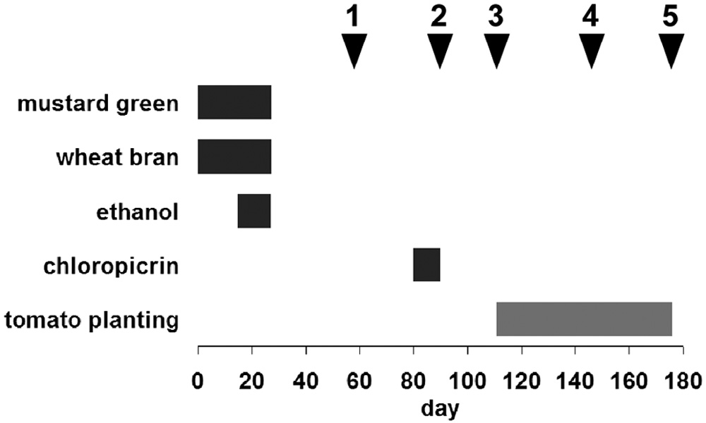

**Fig. 1 – Time schedule of soil treatments and soil sampling. Soil was treated with materials shown on the left throughout time indicated by black bars. Tomato plants were grown in the soil during time shown by a gray bar.**

**Soils were collected on the day shown by arrowheads.**

periodically collected at 5 cm depth from the surface. Time sched- ule of soil treatment and soil sampling was summarized (Fig. 1).

*2.1.2. Analysis of soil physicochemical properties* Physicochemical properties of soil were analyzed with the fol- lowing methods. Soil samples were air-dried and passed through a sieve with 2 mm mesh. Soil particle size was determined by the pipette method with sodium hexametaphosphate as dis- persing agent. Soil pH was determined in water in a soil solution ratio of 1:5 using the glass electrode. Total carbon and nitro- gen contents were analyzed using an NC analyzer (JM1000CN, J-Science). After fresh soil samples were passed through a sieve with 4 mm mesh, soil organic carbon was extracted with a 0.5 M K2SO4 solution in a soil to solution ratio of 1:5 and the C con- centration was determined by a TOC meter (TOC-VCPH, Shimadzu) [19].

## *2.2. 454 pyrosequencing and data analysis*

DNA was extracted from soil using ISOIL for Beads Beating

# Materials and methods

## *Soil sampling, preparation and* physicochemical properties

* + 1. *Soil preparation and soil sample collection*

Plastic containers containing approximately 45 kg of soil were used for the experiment. The soil was sampled from the farm of Education and Research Center for Subtropical Field Science, Kochi University. Each treatment was conducted in five repli- cates. 1.4 kg of small pieces of shoots and 100 g of roots from two-month-old mustard greens (*Brassica juncea*) were mixed with soil (mustard greens). Soils were mixed with 0.24 kg of wheat bran (wheat bran) and 2% ethanol (ethanol). Containers were covered by plastic sheets and submerged in water for about one month for soil reduction disinfection. Soils were treated with 4 ml of chloropicrin in two holes and covered by plastic sheets for 10 days (chloropicrin). Two tomato seedlings were planted in each container after the first treatment. Soil samples were

(Nippon Gene). 0.5 g of soil was disrupted at 5500 rpm for 45 seconds using a Micro Smash MS-100 (Tomy Seiko). The ex- tracted DNA was diluted, sonicated for 5 min, and used as PCR template. The hyper variable V4- and V5-region of 16S rRNA gene was PCR-amplified. The forward primer F563-LXA contained a

sequence (CCATCTCATCCCTGCGTGTCTCCGAC) in its 5′ end and

a key sequence (TCAG), followed by titanium adaptor (MID1 to MID6, Roche) and specific sequence (AYTGGGYDTAAAGNG). The

reverse primer was BSR926-LB (5′-CCTATCCCCTGTGTGCC

TTGGCAGTCTCAGCCGTCAATTYYTTTRAGTTT-3′). The PCR

product (about 450-bp in size) was purified by Agencourt AMPure XP using sizing buffer (7% PEG6000 and 1 M NaCl). Emulsion PCR was done with Lib-L kit (Roche) and amplicons were analyzed on GS Junior 454 system (Roche).

Raw sequence data were processed and analyzed using QIIME 1.8 [20] through OTUMAMi 3.13 [21]. RDP was used in classifying the sequences into phylum/class and clustering the sequences into operational taxonomic units (OTUs). Repre- sentative sequences were selected from each OTU and used

|  |  |  |  |  |  |  |  |  |
| --- | --- | --- | --- | --- | --- | --- | --- | --- |
| **Table 1 – Physical characteristics of the soil samples.****a** | | | | | | | | |
| Soil treatment | Dateb | pH | Organic C | Total C  (g kg−1) | Total N | C/N ratio | Particle size (%)  Sand Silt | Clay |
| Before treatment |  | 5.95 | 0.85 | 16.4 | 1.37 | 11.9 | 58.2 22.0 | 19.8 |
| None | 2 | 5.94 | 0.64 | 16.7 | 1.39 | 12.0 | 60.5 20.8 | 18.6 |
|  | 3 | 6.22 | 0.58 | 15.6 | 1.41 | 11.1 |  |  |
|  | 4 | 5.88 | 0.58 | 16.1 | 1.45 | 11.1 |  |  |
|  | 5 | 5.85 | 0.59 | 16.1 | 1.44 | 11.2 |  |  |
| Mustard green | 1 | 5.98 | 0.68 | 17.2 | 1.54 | 11.2 | 61.0 21.0 | 18.0 |
|  | 2 | 6.03 | 0.77 | 17.1 | 1.40 | 12.2 | 59.7 21.1 | 19.2 |
|  | 3 | 6.29 | 0.64 | 16.5 | 1.48 | 11.2 |  |  |
|  | 4 | 5.89 | 0.66 | 16.6 | 1.52 | 10.9 |  |  |
|  | 5 | 6.02 | 0.71 | 17.0 | 1.53 | 11.1 |  |  |
| Wheat bran | 1 | 5.90 | 0.74 | 17.5 | 1.52 | 11.5 | 59.5 22.1 | 18.4 |
|  | 2 | 5.95 | 0.85 | 17.8 | 1.42 | 12.5 | 59.6 21.6 | 18.8 |
|  | 3 | 6.13 | 0.60 | 16.5 | 1.50 | 11.0 |  |  |
|  | 4 | 5.75 | 0.63 | 16.5 | 1.52 | 10.9 |  |  |
|  | 5 | 5.85 | 0.68 | 16.2 | 1.50 | 10.8 |  |  |
| Ethanol | 1 | 5.84 | 0.69 | 16.6 | 1.43 | 11.6 | 60.5 21.4 | 18.1 |
|  | 2 | 5.81 | 0.50 | 17.2 | 1.43 | 12.1 | 59.7 21.8 | 18.4 |
|  | 3 | 6.09 | 0.37 | 15.9 | 1.42 | 11.2 |  |  |
|  | 4 | 5.69 | 0.43 | 15.7 | 1.44 | 10.9 |  |  |
|  | 5 | 5.70 | 0.47 | 15.9 | 1.45 | 10.9 |  |  |
| Chloropicrin | 3 | 5.90 | 0.07 | 15.5 | 1.41 | 11.0 |  |  |
|  | 4 | 6.17 | 0.11 | 15.3 | 1.44 | 10.7 |  |  |
|  | 5 | 5.83 | 0.09 | 15.7 | 1.42 | 11.0 |  |  |
| a Average of triplicate measurements.  b Date corresponds to the sampling time in Fig. 1. | | | | | | | | |

for calculation of Chao I richness estimates [22] by using RDP pipeline [23]. The observed species data were picked form QIIME pipeline used in generating rarefaction graph by using Microsoft Excel program. The hierarchical heatmap was drawn by using OTUMAMi [21]. The bar plot for relative abundance of major phylum was performed by R command generated in OTUMAMi and visualized by statistical package R 3.0.2. The Jackknifed Prin- cipal Coordinate (PCoA) analysis plot was generated by using the UniFrac distance [24] in QIIME pipeline and visualized by incorporated EMPEROR software. The sequenced read data have been deposited in DDBJ Sequence Read Archive (DRA) under accession numbers DRA003990 and DRA003993.

# Results

## *Soil physical properties*

The physical properties of the studied soils were determined and no remarkable difference was observed among different treatments (Table 1). The study soil was classified as sandy clay loam soil and weakly acidic.

## *Soil organic carbon content*

The organic carbon in the soil could be derived from the mi- crobial biomass [19]. The organic carbon slightly increased during initial steps of soil reduction with wheat bran and mustard greens (Fig. 2), indicating that during these steps, the microbial biomasses increased. In the chloropicrin-treated soil, the soil biomass was drastically lower and remained low

throughout the study (Fig. 2 and Table 1). Tomato plants grew well in all the soils. No significant difference was observed in growth rates (data not shown).

## *Bacterial richness and diversity in soils with* different treatments

Large-scale pyrosequencing of 16S rRNA genes provides more sequence information in terms of profiling of phylogenetic

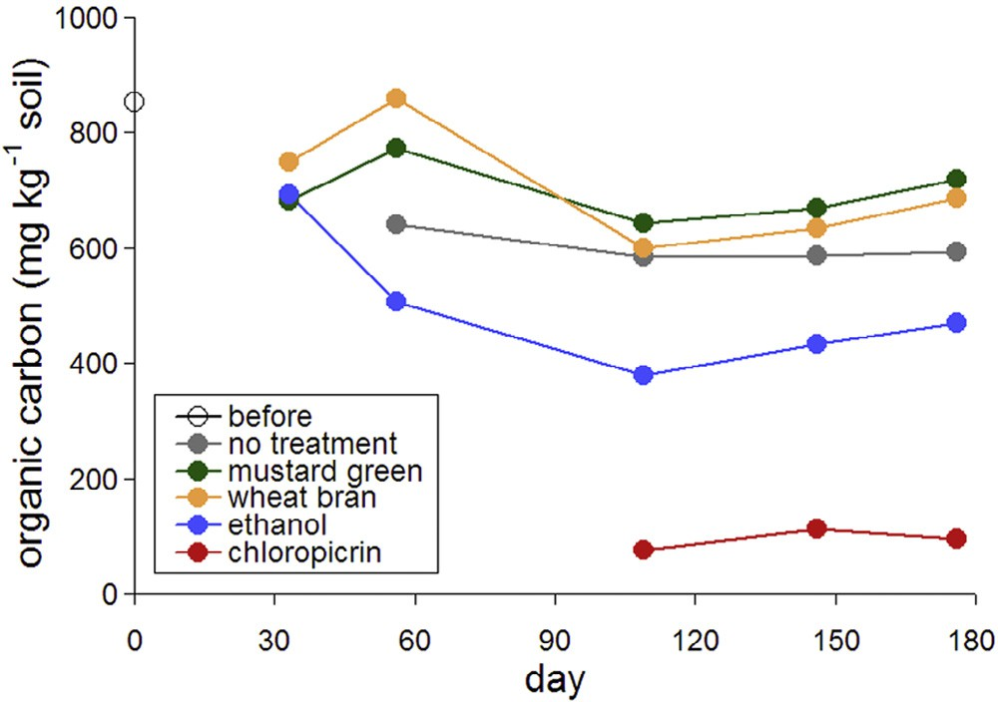

**Fig. 2 – Organic carbon contents in the soil with different treatments. Soils with different treatments were collected at days indicated by circles. Soil organic carbon was extracted with a 0.5 M K2SO4 solution in a soil to solution ratio of 1:5, and the carbon concentration was determined by a TOC meter.**

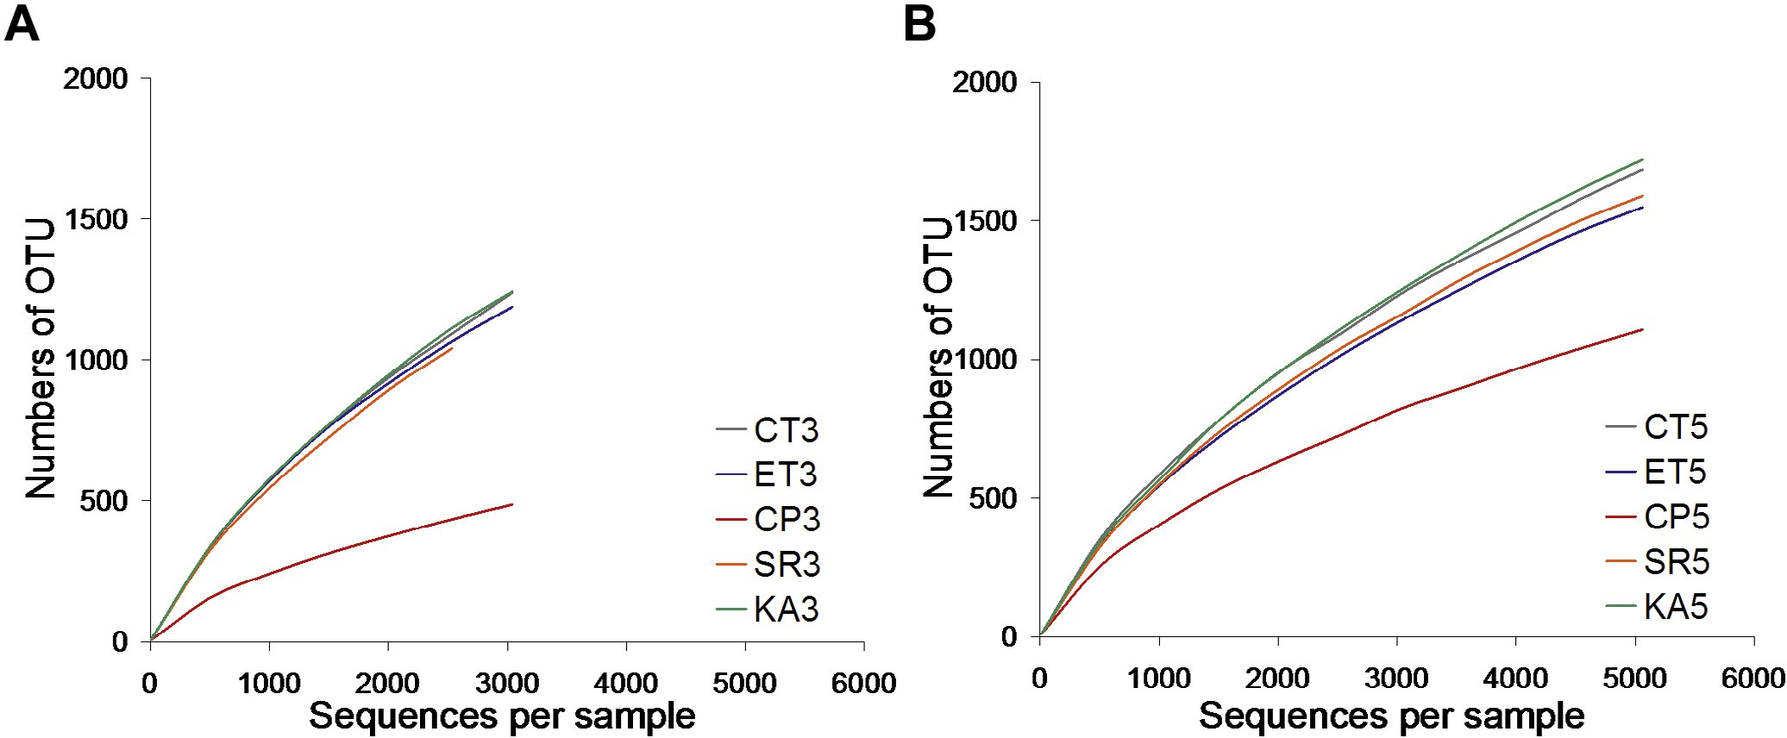

**Fig. 3 – Rarefaction analysis of soils treated with different materials. Rarefaction for observed and estimated species richness was calculated, and rarefaction curves were drawn with QIIME. (A) CT3, KA3, SR3, ET3, and CP3 used soils treated with none, mustard greens, wheat bran, ethanol, and chloropicrin, respectively, at sampling time 3. (B) CT5, KA5, SR5, ET5, and CP5 used soils treated with none, mustard greens, wheat bran, ethanol, and chloropicrin, respectively, at sampling time 5.**

diversity and community composition compared to the tra- ditional Sanger-based sequencing of clone libraries [16]. The pyrosequencing-based analyses of the V3–V4 regions of 16S rRNA genes were conducted at two stages (at sampling times 3 and 5). Species richness was estimated with both rarefac- tion curves (Fig. 3) and Chao 1 indices (Table 2). Bacterial species richness among soils with different treatments was almost the same, except chloropicrin treatment. Species richness in the chloropicrin-applied soils was about half of those in the other soils at sampling time 3, and slightly increased at sampling time 5 (Fig. 3). Bacterial diversity in the chloropicrin-applied soils was much lower than those in the other soils estimated by Shannon diversity index (Table 2). These observations are consistent with less contents of organic carbon (Fig. 2) in the chloropicrin-applied soils.

|  |  |  |  |  |
| --- | --- | --- | --- | --- |
| **Table 2 – Richness and diversity of the microbial communities.** | | | | |
| Sample | No. of sequences | No. of OTUsa | Chao 1b | H′c |
| CT3 | 2,021 | 656 | 1,229 | 5.73 |
| KA3 | 1,514 | 621 | 117 | 5.87 |
| SR3 | 1,434 | 542 | 1,253 | 5.62 |
| ET3 | 1,449 | 547 | 1,092 | 5.75 |
| CP3 | 1,219 | 225 | 548 | 4.01 |
| CT5 | 8,050 | 2,335 | 3,806 | 7.05 |
| KA5 | 10,639 | 2,787 | 4,551 | 7.09 |
| SR5 | 14,047 | 2,986 | 4,664 | 6.96 |
| ET5 | 11,582 | 2,596 | 4,050 | 6.90 |
| CP5 | 4,473 | 1,075 | 2,073 | 5.86 |
| a Number of OTUs at a maximum distance of 0.03.  b Chao 1 index at a maximum distance of 0.03.  c Shannon diversity index at a maximum distance of 0.03. | | | | |

## *Alpha diversity at phylum level*

Major phyla detected in the soils were *Chloroflexi*, *Planctomycetes*, *Verrucomicrobia*, *Firmicutes*, *Acidobacteria*, *Gemmatimonadetes*, *Proteobacteria*, *Bacteroidetes*, *Actinobacteria*, *Cyanobacteria*, and *Nitrospirae* (Fig. 4). *Acidobacteria* and *Proteobacteria* were the most abundant phyla in the control soil without any treatment at both sampling times. These two phyla were also dominant in the other soils except the chloropicrin-applied soils. The domi- nance of *Acidobacteria* was slightly reduced after planting tomato. This might be due to the incorporation of some bac- teria in the tomato rhizosphere. When chloropicrin was applied to the soil, *Firmicutes* became predominant, occupying about 75% of the soil bacterial community. At sampling time 5, the abundance of *Firmicutes* was reduced and *Bacteroidetes* ap- peared. Although *Proteobacteria* became most abundant, the bacterial community composition in the chloropicrin-applied soils was still different from those in the other soils (Fig. 4).

## *Alpha diversity at OTU level*

Bacterial community compositions of the soils were exam- ined at descending levels of biological classification. The heatmap was constructed with OTUs, which were relatively abundant at more than 1% in any of the soils. Most of the abun- dant OTUs belonged to *Firmicutes* in the chloropicrin-applied soils just three weeks after treatment (Fig. 5A), which is in good

agreement with α diversity at phylum level. The most domi-

nant OTU #3024 belonged to genus *Alicyclobacillus*. The member of genus *Flavisolibacter* (OTU #904) was observed as major OTU. In two months after chloropicrin treatment, most of the *Firmicutes* disappeared or became less abundant. OTUs belong- ing to phylum *Bacteroidetes* became dominant (Fig. 5A). The

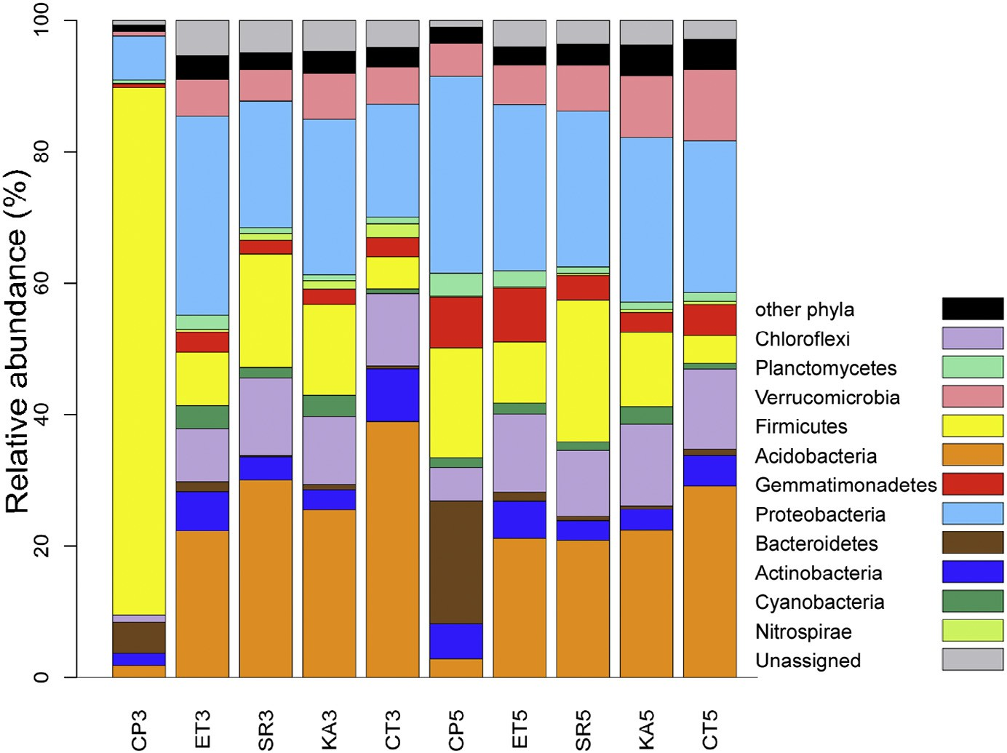

**Fig. 4 – Relative abundance of major phylum groups in the soils treated with different materials. Soils were treated with materials shown on the bottom. The abbreviations are the same as** **Fig. 3****.**

dominant OTU was genus *Flavihumibacter* (OTU #2988). Several OTUs belonging to *Proteobacteria* also became abundant.

OTU #3551 belonging to genus *Bradyrhizobium* was one of the dominant bacteria in the other soils (Fig. 5B). Since this OTU dominantly existed in the control soil and even in the chloropicrin-applied soils (Fig. 5A), this bacterium appeared to be dominated in the soils used in this experiment. The other dominant OTU #2871 belonged to genus *Candidatus Solibacter*. *Candidatus Solibacter* is a member of *Acidobacteria*, which agrees

with α diversity in phylum level (data not shown). OTU #1467

belonging to genus *Clostridium* was dominant in both soils treated with wheat bran and mustard greens. Compositions of dominant bacteria were stable for two months between sam- pling times 3 and 5 (Fig. 5B).

## *Beta diversity*

β Diversity was calculated with the Jackknifed PCoA. As indi- cated with α diversity analysis, bacterial community

compositions in the soils treated with ethanol, wheat bran, and mustard greens formed one cluster with those in the un- treated soils (Fig. 6). This phenomenon could be explained as follows: the application of chloropicrin killed most of the domi- nant bacteria species, and the bacterial community structure was reorganized in two months. However, the community struc- ture did not move back to the original soil bacterial composition.

# Discussion

This study investigated the effects of several materials for soil disinfection on the structure of the soil bacterial community.

Two biomaterials, wheat bran and mustard greens, and one chemi- cal, ethanol at low concentration, were used for soil reduction. One chemical, chloropicrin, was used for fumigation. DGGE is a fast and relatively easy way to observe the overall bacterial com- munity structure and composition [25]. DGGE results were almost compatible with the results of another pyrosequencing method (data not shown), indicating that the combination of these two methods could be an effective way to analyze bacterial com- munity structure. We demonstrated that the chloropicrin- applied soil contained a very different bacterial composition from the other soils. *Firmicutes* became dominant with about 75% of bacterial species in the chloropicrin-applied soils. Drastic re- duction of organic carbon corresponding to biomass was also observed in the chloropicrin-applied soils. Despite these much differences of the bacterial community structures, planted tomato plants grew and formed pericarps in the chloropicrin-treated soils as normal as in other soils (data not shown). We are going to elucidate the relationship between bacterial diversity in the soil and impacts on the agriculture, such as plant growth and productivity, in the next step.

Chloropicrin is a toxic gas, which directly kills the soil living organisms and decreases the biomass [26]. Chemical fumi- gant disrupts the cell walls of microorganisms [5]. Since *Firmicutes* forms spores, the spore form could be resistant to chloropicrin and survive even after chloropicrin treatment. Al- though we did not test the effectiveness of chloropicrin on the pests, no weeds grew on the soils. Chloropicrin is demon- strated to be effective against several weeds in a commercial strawberry field [27]. Even three months later after chloropic- rin treatment, the bacterial community structure did not go back to the original state, although *Firmicutes* was no longer dominant. All together, we conclude that chloropicrin com- pletely disturbs the bacterial community structure.

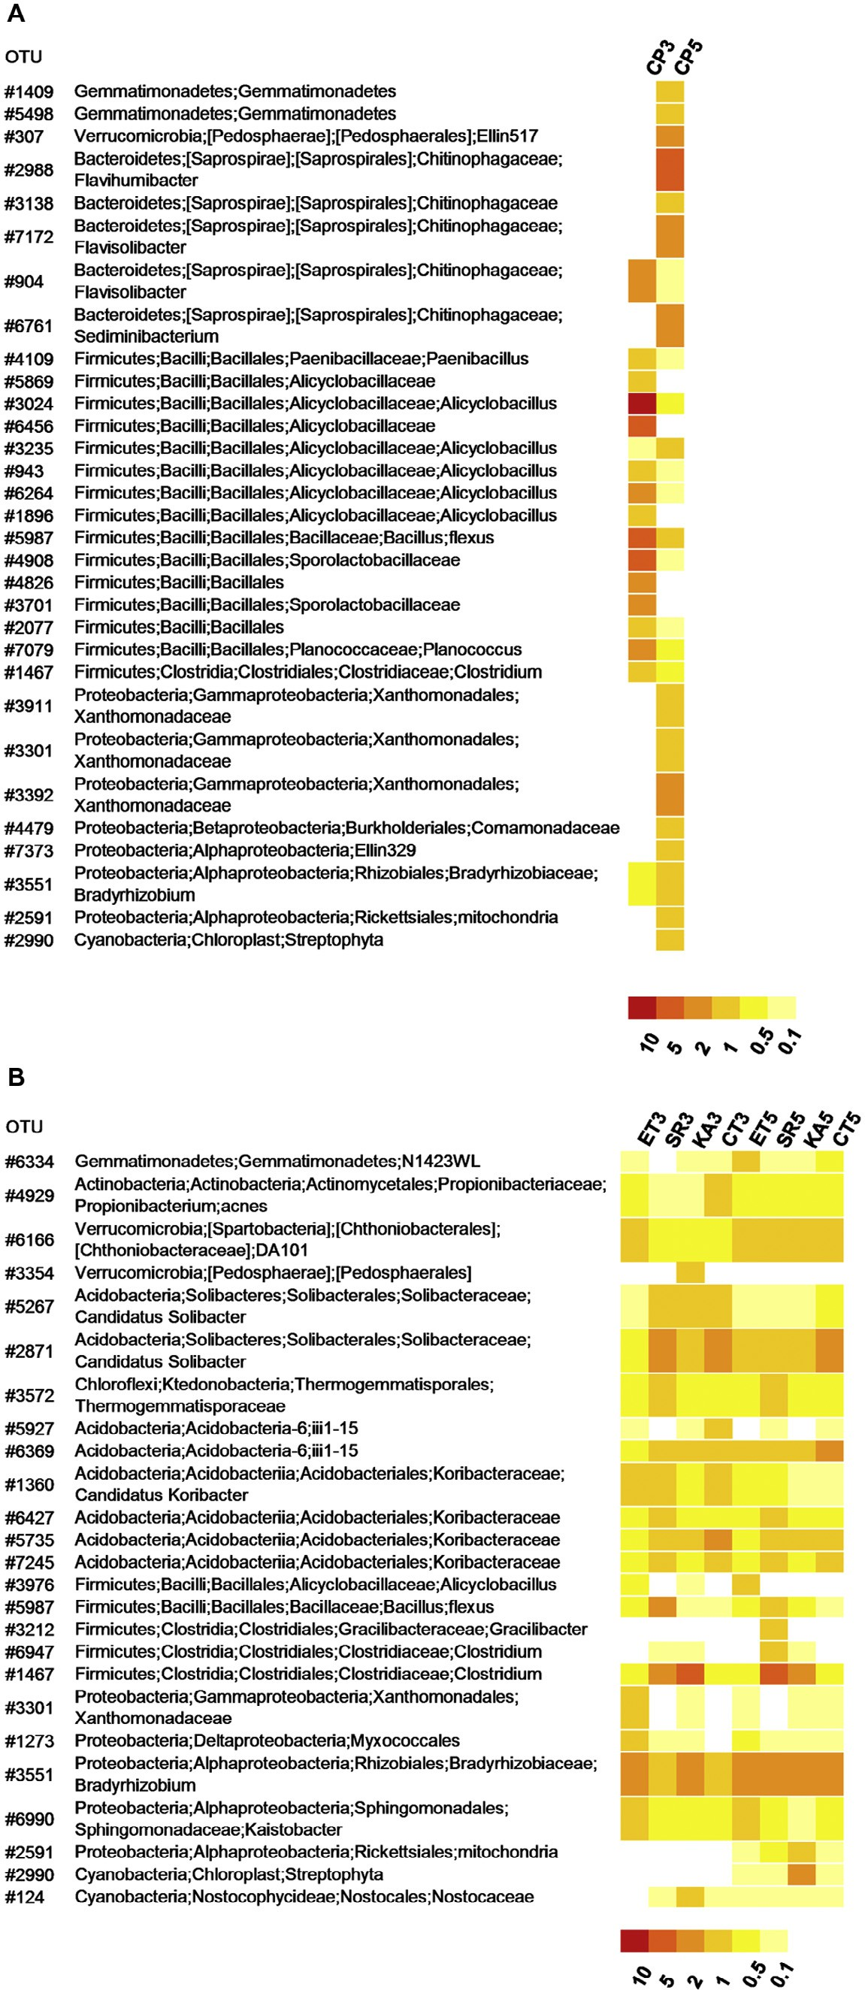

**Fig. 5 – Relative abundance of major OTUs in the soils. OTUs, which existed more than 1% in the selected soil, were picked and the heatmap was constructed. OTUs in (A) chloropicrin-applied soils and (B) other soils were indicated.**

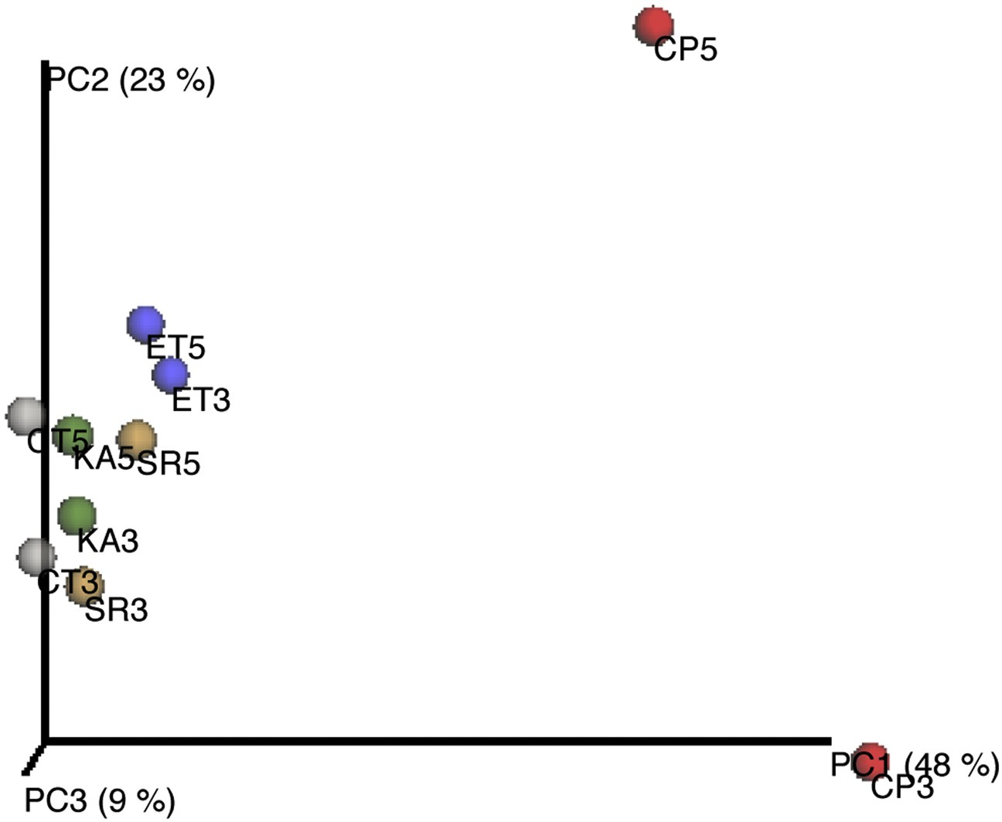

**Fig. 6 – Weighted Jackknifed PCoA. PCoA visualized the difference of bacterial compositions. The Jackknifed plot was illustrated based on the calculated weighted UniFrac distance metrics.**

The bacterial community structures of the soils were not affected by soil reduction with several carbon sources, wheat bran, ethanol, and mustard greens. Soil reduction consumes oxygen in the soil, so the eukaryotes such as fungi cannot survive in such reduced atmosphere, although we did not measure the number of eukaryotic microorganisms. Many of the soil bacteria are facultative anaerobic and could survive even after soil reduction with carbon sources. This is why the bacterial compositions in the soils treated with wheat bran, ethanol, and mustard greens were almost similar to that in the control soil. Weeds grew in the wheat bran-applied and mustard greens-applied soils (data not shown), indicating that wheat bran and mustard greens are not as strong as chloropicrin, which completely inhibited weed growth, at least for weed control.

Mustard greens work as biofumigant as long as carbon sources for soil reduction. A biotoxic element isothiocyanate is formed from the *Brassica* plants decomposition [28,29]. Volatiles released from chopped leaf materials of *Brassica* plants inhibit growth of a variety of plant pathogenic fungus of potato, including *Rhizoctonia solani*, *Phytophthora erythroseptica*, *Pythium ultimum*, *Sclerotinia sclerotiorum*, and *Fusarium sambucinum* [30].

*B. juncea* and *Brassica rapa* cause over 91–95% mortality of encysted eggs of nematode *Globodera pallida* [31,32].

*B. juncea* and *B. rapa* contain 2-propenylglucosinolate and 3-butenylglucosinolate as main glucosinolates, respectively. The biocidal activity of these glucosinolates is comparable with the efficacy of synthetic pesticides and antibiotics gentamicin [31,32]. In this sense, synthetic pesticides, such as methyl bromide and chloropicrin, could be replaced by *Brassica* plants. *Brassica* plants are attractive materials for both soil reduction and biofumigation.

# Acknowledgements

We thank Masatoshi Shirota for pyrosequencing using GS Junior system.

R E F E R E N C E S

1. [Tu C, Ristaino BJ, Hu S. Soil microbial biomass and activity in](http://refhub.elsevier.com/S2314-808X(16)00005-1/sr0010) [organic tomato farming systems: effect of organic inputs](http://refhub.elsevier.com/S2314-808X(16)00005-1/sr0010) [and straw mulching. Soil Biol Biochem 2006;38:247–55.](http://refhub.elsevier.com/S2314-808X(16)00005-1/sr0010)
2. [Clegg CD, Lovell RDL, Hobbs PJ. The impact of grassland](http://refhub.elsevier.com/S2314-808X(16)00005-1/sr0015) [management regime on the community structure of](http://refhub.elsevier.com/S2314-808X(16)00005-1/sr0015) [selected bacterial groups in soils. FEMS Microbiol Ecol](http://refhub.elsevier.com/S2314-808X(16)00005-1/sr0015) [2003;43:263–70.](http://refhub.elsevier.com/S2314-808X(16)00005-1/sr0015)
3. [Peacock AD, Mullen MD, Ringelberg DB, Tyler DD, Hedrick](http://refhub.elsevier.com/S2314-808X(16)00005-1/sr0020) [DB, Gale PM, et al. Soil microbial community responses to](http://refhub.elsevier.com/S2314-808X(16)00005-1/sr0020) [dairy manure or ammonium nitrate applications. Soil Biol](http://refhub.elsevier.com/S2314-808X(16)00005-1/sr0020) [Biochem 2001;33:1011–19.](http://refhub.elsevier.com/S2314-808X(16)00005-1/sr0020)
4. [Pimentel D. Environmental and economic costs of the](http://refhub.elsevier.com/S2314-808X(16)00005-1/sr0025) [application of pesticides primarily in the United States.](http://refhub.elsevier.com/S2314-808X(16)00005-1/sr0025) [Environ Dev Sustain 2005;7:229–52.](http://refhub.elsevier.com/S2314-808X(16)00005-1/sr0025)
5. [Navarro G, Vela N, Navarro S. An overview on the](http://refhub.elsevier.com/S2314-808X(16)00005-1/sr0030) [environmental behavior of pesticide residues in soils. Span J](http://refhub.elsevier.com/S2314-808X(16)00005-1/sr0030) [Agric Res 2007;5:357–75.](http://refhub.elsevier.com/S2314-808X(16)00005-1/sr0030)
6. [Frank MP, Graebing P, Chib JS. Effect of soil moisture and](http://refhub.elsevier.com/S2314-808X(16)00005-1/sr0035) [sample depth on pesticide photolysis. J Agric Food Chem](http://refhub.elsevier.com/S2314-808X(16)00005-1/sr0035) [2002;50:2607–14.](http://refhub.elsevier.com/S2314-808X(16)00005-1/sr0035)
7. [Rodríguez-Cruz MS, Jones JE, Bending GD. Field-scale study](http://refhub.elsevier.com/S2314-808X(16)00005-1/sr0040) [of the variability in pesticide degradation with soil depth](http://refhub.elsevier.com/S2314-808X(16)00005-1/sr0040) [and its relationship with soil characteristics. Soil Biol](http://refhub.elsevier.com/S2314-808X(16)00005-1/sr0040) [Biochem 2006;38:2910–18.](http://refhub.elsevier.com/S2314-808X(16)00005-1/sr0040)
8. [Tateya A. Japan’s big effort to phase-out of methyl bromide](http://refhub.elsevier.com/S2314-808X(16)00005-1/sr0045) [by 2013. Acta Hortic 2010;883:83–9.](http://refhub.elsevier.com/S2314-808X(16)00005-1/sr0045)
9. [Himelrick DG, Dozier WA Jr. Soil fumigation and soil](http://refhub.elsevier.com/S2314-808X(16)00005-1/sr0050) [solarization in strawberry production. Adv Straw Prod](http://refhub.elsevier.com/S2314-808X(16)00005-1/sr0050) [1991;10:12–28.](http://refhub.elsevier.com/S2314-808X(16)00005-1/sr0050)
10. [Noling JW, Becker JO. The challenge of research and](http://refhub.elsevier.com/S2314-808X(16)00005-1/sr0055) [extension to define and implement alternatives to methyl](http://refhub.elsevier.com/S2314-808X(16)00005-1/sr0055) [bromide. J Nematol 1994;26:573–86.](http://refhub.elsevier.com/S2314-808X(16)00005-1/sr0055)
11. [Doi T, Abe J, Shiotsu F, Morita S. Study on rhizosphere](http://refhub.elsevier.com/S2314-808X(16)00005-1/sr0060) [bacterial community in lowland rice grown with organic](http://refhub.elsevier.com/S2314-808X(16)00005-1/sr0060) [fertilizers by using PCR-denaturing gradient gel](http://refhub.elsevier.com/S2314-808X(16)00005-1/sr0060) [electrophoresis. Plant Root 2011;5:5–16.](http://refhub.elsevier.com/S2314-808X(16)00005-1/sr0060)
12. [Anis M, Zaki MJ, Dawar S. Effect of oil seed cakes alone or in](http://refhub.elsevier.com/S2314-808X(16)00005-1/sr0065) [combination with *Trichoderma* species for the control of](http://refhub.elsevier.com/S2314-808X(16)00005-1/sr0065) [charcoal rot of sunflower (*Helianthus annus* L.). Pak J Bot](http://refhub.elsevier.com/S2314-808X(16)00005-1/sr0065) [2010;42:4329–33.](http://refhub.elsevier.com/S2314-808X(16)00005-1/sr0065)
13. [Brown PD, Morra MJ. Control of soil-borne plant pests using](http://refhub.elsevier.com/S2314-808X(16)00005-1/sr0070) [glucosinate containing plants. Adv Agron 1997;61:167–231.](http://refhub.elsevier.com/S2314-808X(16)00005-1/sr0070)
14. [Rosa EAS, Heaney RK, Fenwick GR. Glucosinolates in crop](http://refhub.elsevier.com/S2314-808X(16)00005-1/sr0075) [plants. Hortic Rev 1997;19:99–215.](http://refhub.elsevier.com/S2314-808X(16)00005-1/sr0075)
15. [Ramirez RA, Henderson DR, Riga E, Lacey LA, Snyder WE.](http://refhub.elsevier.com/S2314-808X(16)00005-1/sr0080) [Harmful effects of mustard bio-fumigants on](http://refhub.elsevier.com/S2314-808X(16)00005-1/sr0080) [entomopathogenic nematodes. Biol Control 2009;48:147–54.](http://refhub.elsevier.com/S2314-808X(16)00005-1/sr0080)
16. [Sogin ML, Morrison HG, Huber JA, Mark Welch D, Huse SM,](http://refhub.elsevier.com/S2314-808X(16)00005-1/sr0085) [Neal PR, et al. Microbial diversity in the deep sea and the](http://refhub.elsevier.com/S2314-808X(16)00005-1/sr0085) [underexplored ‘rare biosphere’. Proc Natl Acad Sci U S A](http://refhub.elsevier.com/S2314-808X(16)00005-1/sr0085) [2006;103:12115–20.](http://refhub.elsevier.com/S2314-808X(16)00005-1/sr0085)
17. [Tringe SG, Hugenholtz P. A renaissance for the pioneering](http://refhub.elsevier.com/S2314-808X(16)00005-1/sr0090) [16S rRNA gene. Curr Opin Microbiol 2008;11:442–6.](http://refhub.elsevier.com/S2314-808X(16)00005-1/sr0090)
18. [Engelbrektson A, Kunin V, Wrighton KC, Zvenigorodsky N,](http://refhub.elsevier.com/S2314-808X(16)00005-1/sr0095) [Chen F, Ochman H, et al. Experimental factors affecting PCR-](http://refhub.elsevier.com/S2314-808X(16)00005-1/sr0095) [based estimates of microbial species richness and evenness.](http://refhub.elsevier.com/S2314-808X(16)00005-1/sr0095) [ISME J 2010;4:642–7.](http://refhub.elsevier.com/S2314-808X(16)00005-1/sr0095)
19. [Tanaka S, Ando T, Funakawa S, Sukhrun C, Kaewkhongkha](http://refhub.elsevier.com/S2314-808X(16)00005-1/sr0100) [T, Sakurai K. Effect of burning on soil organic matter content](http://refhub.elsevier.com/S2314-808X(16)00005-1/sr0100) [and N mineralization under shifting cultivation system of](http://refhub.elsevier.com/S2314-808X(16)00005-1/sr0100) [Karen people in northern Thailand. Soil Sci Plant Nutr](http://refhub.elsevier.com/S2314-808X(16)00005-1/sr0100) [2001;47:547–58.](http://refhub.elsevier.com/S2314-808X(16)00005-1/sr0100)
20. [Caporaso JG, Kuczynski J, Stombaugh J, Bittinger K, Bushman](http://refhub.elsevier.com/S2314-808X(16)00005-1/sr0105) [FD, Costello EK, et al. QIIME allows analysis of high-](http://refhub.elsevier.com/S2314-808X(16)00005-1/sr0105) [throughput community sequencing data. Nat Methods](http://refhub.elsevier.com/S2314-808X(16)00005-1/sr0105) [2010;7:335–6.](http://refhub.elsevier.com/S2314-808X(16)00005-1/sr0105)
21. [Satoh H, Oshima K, Suda W, Ranasinghe P, Li N,](http://refhub.elsevier.com/S2314-808X(16)00005-1/sr0110) [Gunawardana EGW, et al. Bacterial population dynamics in a](http://refhub.elsevier.com/S2314-808X(16)00005-1/sr0110) [laboratory activated sludge reactor monitored by](http://refhub.elsevier.com/S2314-808X(16)00005-1/sr0110)

[pyrosequencing of 16S rRNA. Microbes Environ 2013;28:](http://refhub.elsevier.com/S2314-808X(16)00005-1/sr0110) [65–70.](http://refhub.elsevier.com/S2314-808X(16)00005-1/sr0110)

1. [Hughes JB, Hellmann JJ, Ricketts TH, Bohannan BJM.](http://refhub.elsevier.com/S2314-808X(16)00005-1/sr0115) [Counting the uncountable: statistical approaches to](http://refhub.elsevier.com/S2314-808X(16)00005-1/sr0115) [estimating microbial diversity. Appl Environ Microbiol](http://refhub.elsevier.com/S2314-808X(16)00005-1/sr0115) [2001;67:4399–406.](http://refhub.elsevier.com/S2314-808X(16)00005-1/sr0115)
2. [Wang Q, Garrity GM, Tiedje JM, Cole JR. Naive Bayesian](http://refhub.elsevier.com/S2314-808X(16)00005-1/sr0120) [classifier for rapid assignment of rRNA sequences into the](http://refhub.elsevier.com/S2314-808X(16)00005-1/sr0120) [new bacterial taxonomy. Appl Environ Microbiol](http://refhub.elsevier.com/S2314-808X(16)00005-1/sr0120) [2007;73:5261–7.](http://refhub.elsevier.com/S2314-808X(16)00005-1/sr0120)
3. [Hamady M, Knight R. Microbial community profiling for](http://refhub.elsevier.com/S2314-808X(16)00005-1/sr0125) [human microbiome projects: tools, techniques, and](http://refhub.elsevier.com/S2314-808X(16)00005-1/sr0125) [challenges. Genome Res 2009;19:1141–52.](http://refhub.elsevier.com/S2314-808X(16)00005-1/sr0125)
4. [Cleary DFR, Smalla K, Mendonça-Hagler LCS, Gomes NCM.](http://refhub.elsevier.com/S2314-808X(16)00005-1/sr0130) [Assessment of variation in bacterial composition among](http://refhub.elsevier.com/S2314-808X(16)00005-1/sr0130) [microhabitats in a mangrove environment using DGGE](http://refhub.elsevier.com/S2314-808X(16)00005-1/sr0130) [fingerprints and barcoded pyrosequencing. PLoS ONE](http://refhub.elsevier.com/S2314-808X(16)00005-1/sr0130) [2012;7:e29380.](http://refhub.elsevier.com/S2314-808X(16)00005-1/sr0130)
5. [Stromberger ME, Klose S, Ajwa H, Trout T, Fennimore S.](http://refhub.elsevier.com/S2314-808X(16)00005-1/sr0135) [Microbial populations and enzyme activities in soils](http://refhub.elsevier.com/S2314-808X(16)00005-1/sr0135) [fumigated with methyl bromide alternatives. Soil Sci Soc](http://refhub.elsevier.com/S2314-808X(16)00005-1/sr0135) [Am J 2005;69:1987–99.](http://refhub.elsevier.com/S2314-808X(16)00005-1/sr0135)
6. [Harr MJ, Fennimore SA, Ajwa HA, Wintebottom CQ.](http://refhub.elsevier.com/S2314-808X(16)00005-1/sr0140) [Chloropicrin effects on seed viability. Crop Prot 2003;22:](http://refhub.elsevier.com/S2314-808X(16)00005-1/sr0140) [109–15.](http://refhub.elsevier.com/S2314-808X(16)00005-1/sr0140)
7. [Ochiai N, Powelson ML, Crowe FJ, Dick RP. Green manure](http://refhub.elsevier.com/S2314-808X(16)00005-1/sr0145) [effects on soil quality in relation to suppression of](http://refhub.elsevier.com/S2314-808X(16)00005-1/sr0145) [Verticillium wilt of potatoes. Biol Fertil Soils 2008;44:](http://refhub.elsevier.com/S2314-808X(16)00005-1/sr0145) [1013–23.](http://refhub.elsevier.com/S2314-808X(16)00005-1/sr0145)
8. [Sánchez-Monedero MA, Mondini C, Cayuela L, Roig A, Contin](http://refhub.elsevier.com/S2314-808X(16)00005-1/sr0150) [M, De Nobili M. Fluorescein diacetate hydrolysis, respiration](http://refhub.elsevier.com/S2314-808X(16)00005-1/sr0150) [and microbial biomass in freshly amended soils. Biol Fertil](http://refhub.elsevier.com/S2314-808X(16)00005-1/sr0150) [Soils 2008;44:885–90.](http://refhub.elsevier.com/S2314-808X(16)00005-1/sr0150)
9. [Larkin R, Griffin T. Control of soilborne potato diseases using](http://refhub.elsevier.com/S2314-808X(16)00005-1/sr0155) [Brassica green manure. Crop Prot 2007;26:1067–77.](http://refhub.elsevier.com/S2314-808X(16)00005-1/sr0155)
10. [Lord J, Lazzeri L, Atkinson H, Urwin P. Biofumigation for](http://refhub.elsevier.com/S2314-808X(16)00005-1/sr0160) [control of pale potato cyst nematodes: activity of Brassica](http://refhub.elsevier.com/S2314-808X(16)00005-1/sr0160) [leaf extracts and green manures on *Globodera pallida* in vitro](http://refhub.elsevier.com/S2314-808X(16)00005-1/sr0160) [and in soil. J Agric Food Chem 2011;59:7882–90.](http://refhub.elsevier.com/S2314-808X(16)00005-1/sr0160)
11. [Lugauskas A, Repecˇkien J, Uselis N, Rašinskien A. Problems](http://refhub.elsevier.com/S2314-808X(16)00005-1/sr0165) [on a longtime strawberry growing in one plot. Hortorum](http://refhub.elsevier.com/S2314-808X(16)00005-1/sr0165) [Cultus 2003;2:59–68.](http://refhub.elsevier.com/S2314-808X(16)00005-1/sr0165)