[Egyptian Informatics Journal 23 (2022) 33–45](https://doi.org/10.1016/j.eij.2021.05.003)

Contents lists available at [ScienceDirect](http://www.sciencedirect.com/science/journal/11108665)

Egyptian Informatics Journal

journal homepage: [www.sciencedirect.com](http://www.sciencedirect.com/)

[](http://crossmark.crossref.org/dialog/?doi=10.1016/j.eij.2021.05.003&domain=pdf)Enabling recommendation system architecture in virtualized environment for e-learning

Sadia Ali a, Yaser Hafeez a,⇑, Mamoona Humayun b,⇑, Nor Shahida Mohd Jamail c, Muhammad Aqib a, Asif Nawaz a

a *University Institute of Information Technology, PMAS Arid Agriculture University, Rawalpindi, Pakistan*

b *College of Computer and Information Sciences, Department of Information Systems, Jouf University, AL-Jouf, Saudi Arabia*

c *College of Computer and Information Sciences,Prince Sultan University, Riyadh, Saudi Arabia*

a r t i c l e i n f o

*Article history:*

Received 19 July 2020

Revised 14 March 2021

Accepted 8 May 2021

Available online 21 May 2021

*Keywords:*

Online learning Recommendation system E-learning

Architecture Semantic-based Virtual-agent Preferences

a b s t r a c t

E-learning sites are useful for improving the skills and awareness of the academic backbone, such as instructors, students, administrative staff, and those who are searching for current information about var- ious educational institutes. Despite all the benefits of an online learning platform, users face some chal- lenges and complexities, such as selecting appropriate learning material and courses based on their needs and preferences. Hence, the provision of quality resources during the training phases is their central responsibility, the lack of online assistance offered by service providers is known to be the key cause of many difficulties. There is a need to create a system that can intelligently propose courses while con- sidering a variety of viewpoints to enhance the learners’ skills and knowledge. This research proposes an architecture that builds semantic recommendations with the aid of virtual agents based on user require- ments and preferences, assisting academia in seeking appropriate courses in a real-world setting. The experimental and statistical results show that, when compared with existing techniques, the virtualized agent-based recommendation system not only improved user learning skills but also made course selec- tion easier, depending on users’ interests and preferences.

© 2022 THE AUTHORS. Published by Elsevier B.V. on behalf of Faculty of Computers and Information,

Cairo University. This is an open access article under the CC BY-NC-ND license ([http://creativecommons.](http://creativecommons.org/licenses/by-nc-nd/4.0/)

[org/licenses/by-nc-nd/4.0/](http://creativecommons.org/licenses/by-nc-nd/4.0/)).

1. Introduction

High internet speed and reliable cloud environment along with the latest computing resources have encouraged everyone in knowledge collection, shopping, payments, and other activities by using apps with one click on our computers or smartphones. Because of the increased need and practice of advanced technology in day-to-day arrangements of every area, thus, all emerging orga- nizations are attempting to improve the quality of services follow- ing customer needs. Technology plays a vital role in the field of

* Corresponding authors.

*E-mail addresses:* [yasir@uaar.edu.pk](mailto:yasir@uaar.edu.pk) (Y. Hafeez), [mahumayun@ju.edu.sa](mailto:mahumayun@ju.edu.sa) (M. Humayun).

Peer review under responsibility of Faculty of Computers and Information, Cairo University.

**Production and hosting by Elsevier**

education as well, as it helps to improve educational quality and facilitates knowledge sharing among students from all over the world through various platforms [1–3]. Knowledge exchange between different parts of the world, particularly where qualified or highly skilled teachers and advanced education services are available, may aid in the improvement of educational facilities [4,5]. The use of web-based software could allow for reliable dis- tance learning [6]. E-learning is education delivered through the internet which allows people to exchange and learn information. The e-learning education system allows learners to improve their knowledge and skills without having to attend a class or enter an institute due to the inaccessibility of institutions or their remote locations [7–9]. As a result, in e-learning coaching programs, learn- ers and tutors from all over the world exchange expertise through a web-based application with up-to-date information [4,10–12], unlike education coaching institutions that are set up for one-on- one people mentoring, facilities of e-learning are also within bud- get [13]. Owing to the lack of funding and trained teachers in rural areas, facilitating people’s access to higher education is much more difficult. These issues can be solved by e-learning, and current lit-

<https://doi.org/10.1016/j.eij.2021.05.003>

1110-8665/© 2022 THE AUTHORS. Published by Elsevier B.V. on behalf of Faculty of Computers and Information, Cairo University. This is an open access article under the CC BY-NC-ND license (<http://creativecommons.org/licenses/by-nc-nd/4.0/>).

erature [1,14,15] has discussed the advantages of e-learning for higher education. It allows individuals and experts to fulfill their unique needs.

Teachers and students in the modern age are constantly devel- oping their skills through training sessions and workshops. E- learning, on the other hand, offers a forum for students, instructors, and organizational staff to learn about their related interest- specific skills to enhance their success [1,9,16]. In an e-learning environment, unlike in schools and other training centers, where both tutors and learners must be physically present, learners are not physically present in training centers. Even in remote/rural areas, an e-learning platform will work independently to facilitate education by providing advanced and up-to-date course content [10,17]. The e-learning platform enhances experienced employees’ and teachers’ career advancement prospects by improving their technical and academic skills, allowing them to compete with tal- ented and qualified people. While e-learning has many benefits, it also has some drawbacks, such as inadequate support and guid- ance for e-learning, virtualized guidance in personalized choices for individual needs, and so on [6,7,17,18]. As a result, the use of recommendation is inevitable [1,5,9], such as in social media, edu- cation, and other areas where many users share their data and per- sonal information [1]. Customized options assist the learner in improving their learning experience by providing specific content suggestions [14,15,19]. The majority of existing recommendations are focused on collaborative based filtering (CBF), which suffers from sparsity and also has the issue of a new user, whereas others use content filtering (CF), it focuses on the existing knowledge of one user to suggest relevant material, but information filtering is based on the rating of former or current users in both cases [1,9,16,20]. With a large number of users, the cold star issue arises, which makes it difficult to have valid preferences due to mis- matches in preferences and a lack of virtual environment availabil- ity [1,17,21].

The key contribution of this study assesses the efficiency of e- learning in mitigating challenges of related preferences sugges- tions via an E-learning Recommendation Architecture (ELRA). For this, a website-based application with virtualized assistance and a hybrid filtering (HF) recommendation information system has been developed to enhance trainer mentoring by using text mining for semantic analysis of users’ different perspectives and interests, HF combines both CBF and CF recommendations to solve the cold star problems. Rather than manually accessing information, which generates complexity and reduces learner interest without improving skills, the proposed recommender framework elimi- nates mismatch in preferences extraction in a virtualized setting. The ELRA enhances online learner education and training by rec- ommending specific semantic expectations from a multi- perspective. As opposed to conventional methods, the proposed method strengthens the course recommendation process.

* 1. *Research contribution*

The significance of this study is summarized below;

1. The study discovered that remote learning applications are incapable to accommodate all learners’ preferences, necessitat- ing the creation of a recommendation method to address pref- erence mismatches.
2. A recommendation framework is needed to deal with users’ expectations, according to our proposed architecture. These preferences are based on a semantic analysis of users’ requests through text mining, followed by a hybrid recommendation system for course recommendations. Previously, during the learning session, a user from the list selects his course and vir-

tualized agent to prevent any interruptions and inconvenience. As a result, we’ve divided the ELRA architecture proposal into two parts. The first section is used to extract the input data and present a list of suggestions. The second portion uses the feedback to conduct a recommendation process to generate useful recommendations.

1. Furthermore, the comparison of both approaches shows that interactive and context-based preferences recommendation of the diverse perspectives of online learners improves learner success. The efficacy of ELRA was investigated using a quantita- tive approach, and empirical findings demonstrate the novelty of the current study.
2. Last but not least, by incorporating information technology advantages, this study offers a road map and empirical proof for future research work in the education sector.

The remainder of this paper is designed in the following man- ner. Section 2 examines the work done in this field. The proposed architecture was defined in detail in Section 3. Section 4 describes the experimental setup used to evaluate the performance of the proposed architecture, as well as a brief discussion of the findings. Finally, in Section 5, we concluded the discussion by outlining potential research directions.

1. Related work

The need to suggest preferences in a virtualized setting is seen as an essential component of online education [1,22]. Online learn- ing with virtualized assistance gained more attraction in business and study to enhance the tutoring and therapy programs automat- ically with customized preferences [9,22]. Therefore, researchers have explored numerous online learning issues, such as contact between tutors and students. [1,9]. Students are interested in the choice of source preferences, student quizzes/tests, and exams, etc., to obtain the relevant preferences with online support via pre- cise mining and review methods [15,21,22]. In comparison, the lat- est work has modified the topic of online learning success to the consistency of learners and teachers in their knowledge, skills, and requirements.

The author in [3] merge digital and real-world contexts, an online framework was explored using a mobile learning tool. It may help students look for flaws that create obstacles in their excitement for familiar material. Similarly, a report by [10] identi- fies the difference between the improper and incorrect combina- tion of course suggestions using the tool of data mining in e- learning. Results were tested by contrasting the suggested approach with the model system, results reveal that the proposed approach is beneficial in the collection and extraction of course material for skills development. Further, it suggests combining a large number of user expectations by profiling the expertise and abilities of users using data mining procedures, i.e. grouping, clus- tering, and association rule mining, to enhance learner skills according to their interests [12]. Reusability of data in e-learning also helps to refine recommendations, references [9,23] explore distinct networks and define the role of knowledge sharing ecosys- tems in virtualized learning. The use of chronological recommen- dation information helps to handle massive data sets and scalable learners. [1]. Increasing the online learner’s competence and performance by recommending knowledge based on a previ- ous similar level of learner performance and also by using visual analytics for online assistance is also a good approach [5,21].

Training in a virtual situation (VS) simulates a real-world envi- ronment and allows trainees to enter VS to cope with job success [18,22,24]. VS also employs two-dimensional (2D) or fully immersed (3D) interfaces [22]. VS training, which involves the

reuse of previous related users’ ratings and current user prefer- ences or semantic-based intelligent suggestions to deal with multi-user perspectives through data mining, may be used as a stand-alone training tool [17–19]. As a result, in [2] a mind mapping-based gaming approach was suggested as a way to con- struct an authentic learning environment for EFL students to learn about tourism and participate in in-class learning activities. The experimental findings indicate that the proposed method of knowledge is effective in improving students’ creative writing per- formance in terms of fluency and elaboration. The author in [14] presented a web services-based e-learning platform. This e- learning platform is divided into two sections: the first is the local portion, which is in charge of maintaining the local database with all of the different actors’ spaces (learner, teacher, tutor, adminis- trator), and the second is in charge of maintaining the remote part through web forms. Web services course, web service cognitive level evaluation, web service collaboration, and finally web service tutoring are the four web forms included in this e-learning platform.

Existing literature highlighted that there is a need of improving the online education system by improving the data extraction pro- cess used during online education. Similarly, the authors in [25,26] describe that e-learning is important for enhancing knowledge and skills but the problem is the identification of relevant material and resources. Therefore, the authors presented the recommendation system using aspect analysis for material resource extraction to improve e-learning. To strengthen its semantic relationship, it traced the activities of the students. Finally, an in-depth analysis of the current methods has highlighted the shortcomings that lead us to suggest an architecture that may address the existing meth- ods’ limitations or disadvantages. For example, no sentiments- based semantic data identification [14,21,27] is affected by ambi- guity and misinterpretation of points of view, Multi-Perspective Analysis Ignorance Problem identified in [10,28], that discourages users from exploring new materials and rigid knowledge. Ambigu- ity, incompleteness, and redundancy in the contents of the course descriptions, without virtual assistance [18,22] increases commu- nication with related issues of staff and results. As a result, there is a need for a simple and effective recommendation system that

can minimize complexity and effort while still providing the most up-to-date course details and skills [9,10,21,27]. To fill this gap, the proposed ELRA provides comprehensive training and guidance to users through a variety of course suggestions, as well as addressing the aforementioned limitations.

1. Proposed architecture

We have proposed a virtual agent and recommendation-based architecture called ELRA to address the problems of education in an e-learning environment as illustrated by reviewing current lit- erature in the previous section. The proposed ELRA is designed to help teachers and learners/students, for finding courses that are a good fit for their interests and preferences. As a result, we used ELRA to examine the background of current and former users, as well as compare and contrast their learning/teaching preferences. It assists students in selecting suitable courses based on their pref- erences and needs to improve their skills and qualifications. According to their interest and availability, ELRA recommends a list of the most appropriate courses. Fig. 1, depicts the architecture of ELRA.

Virtual agent (VA), an online artificial intelligence-based simu- lator, plays a critical role in this architecture. A VA assigns recom- mendations and responds to online inquiries to advance the quality and increase the success of e-learning training in a real- world setting. It manages online user requests and performances to provide high-quality learning. To minimize communication problems between users and team members, ELRA stores and updates user-profiles and suggestions in a repository. In the fol- lowing subsections, the key steps in the ELRA method have been addressed.

* 1. *Collection of input information*

When users build profiles, the ELRA management system (MS) is used to collect data. Fig. 2 depicts this procedure. Teachers and students as consumers in MS have access to a variety of course choices for teaching and learning. The data gathered regarding their expertise, qualifications, experience, interests, and other fac-

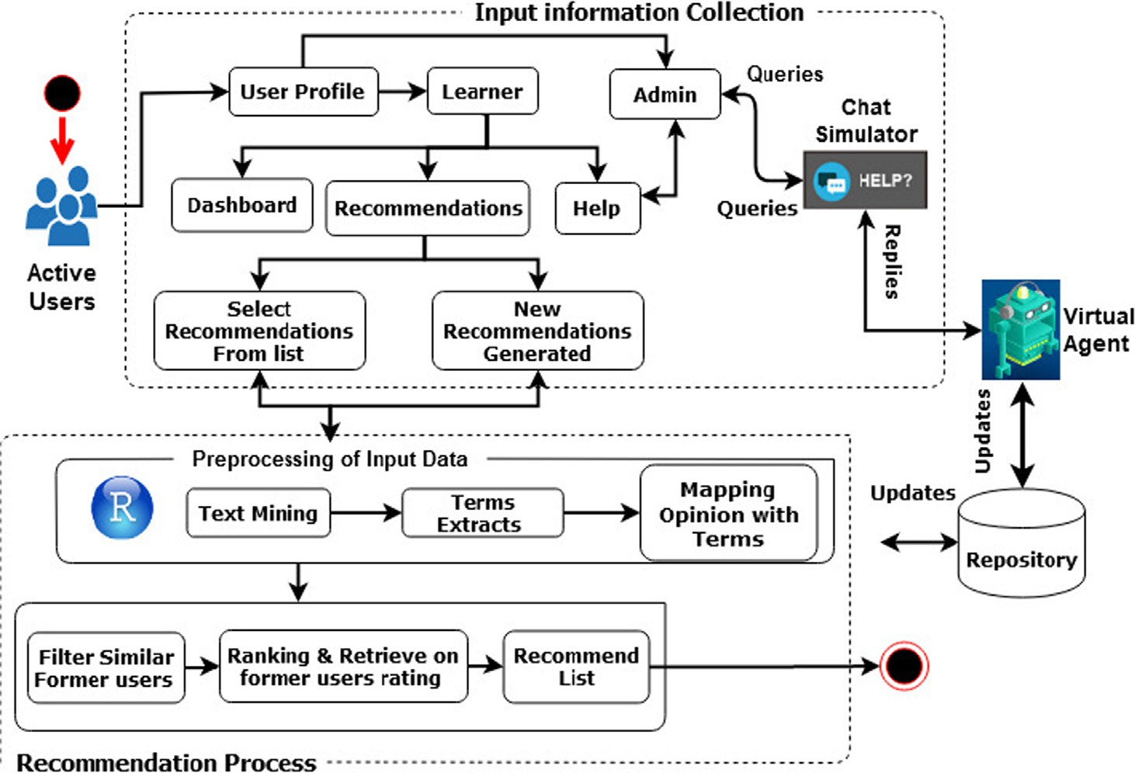

Fig. 1. E-Learning Recommendation Architecture (ELRA).



Fig. 2. Interface of Students’ Profile.

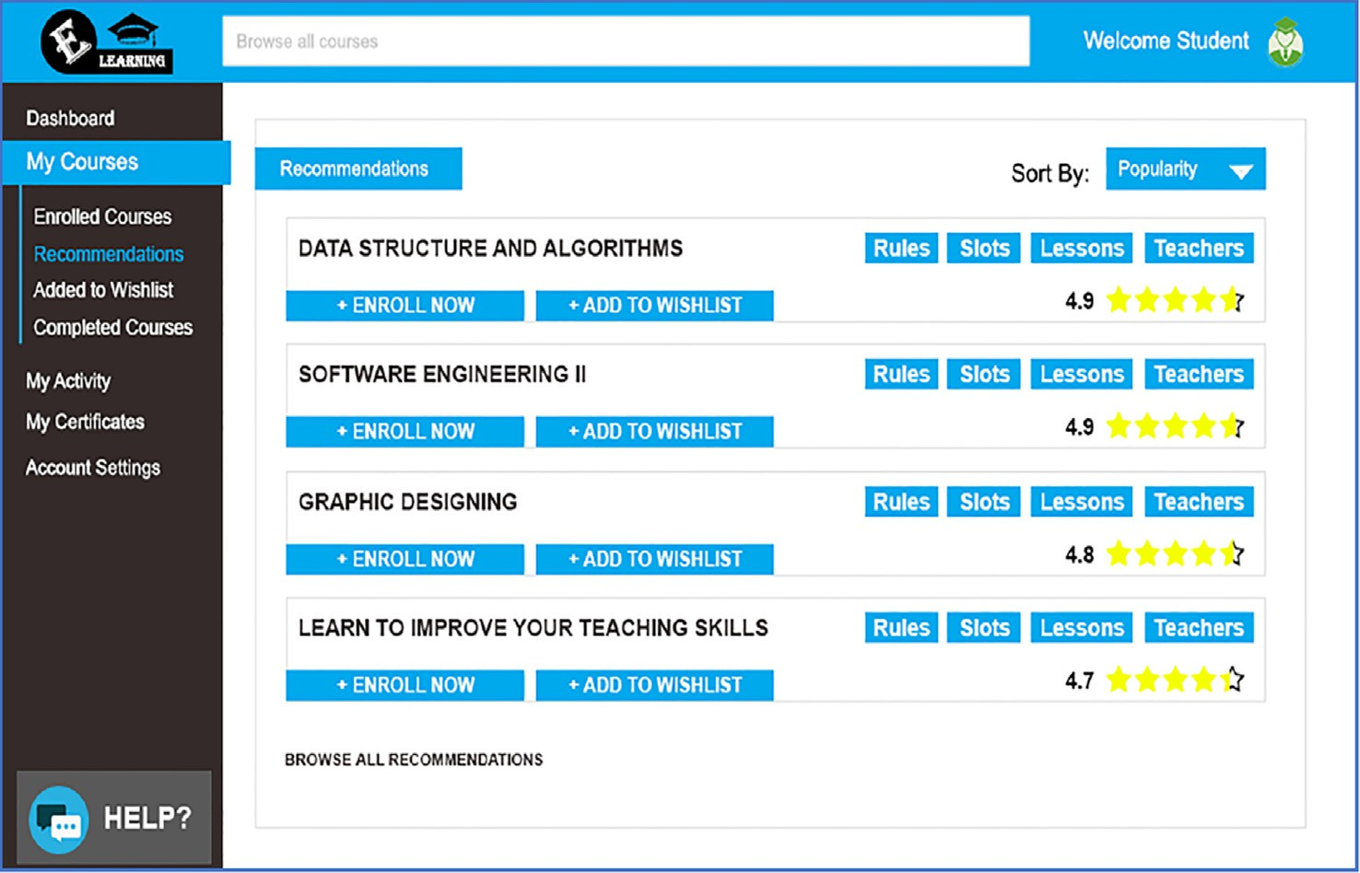

Fig. 3. Courses Recommendation Interface.

tors are stored in a database for future recommendations. As shown in Fig. 3, VA extracts data from this database and analyses semantic information by mining text for correct recommendations. We elaborate on the working of the proposed system with the help of an example: user searches course for learning and enhanc- ing data mining skills. Then, the user requests the recommendation for data mining courses and tutors after giving detail about his skills, job requirements, and experiences. After that virtual agent work on user request by using the information provided by the

user that is;

‘‘*He completed his education in computer science and is currently working in a software house as a project manager. His interest and past training have shown that users have the interest to learn different data mining techniques and tools. As a project manager,*

*his job requirement is to extract feedback of users from different platforms i.e. Twitter, Facebook, blogs, etc. about a product after lunch in the market*.”

Thus, VA extracts recommendations about which course and tutor are more relevant (from different user profiles who requested course recommendations) and enhances the request of a particular user based on previous users’ experiences. The VA also provides online assistance to users in the selection of courses up to the com- pletion of the course without any issues and difficulties.

* 1. *Recommendations process (RP) for input data*

During the RP process, VA helps users find the most appropriate courses by analyzing previous users’ preferences. There are various

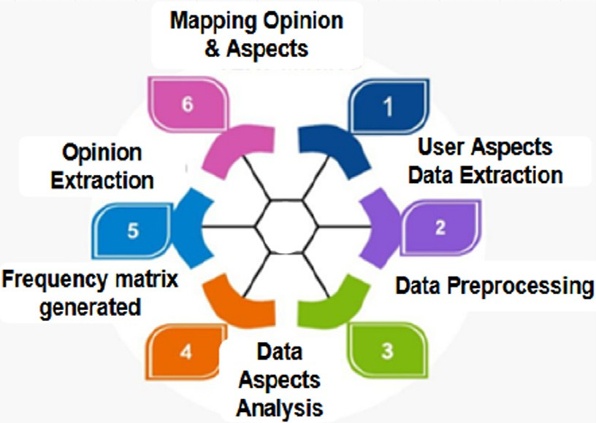

Fig. 4. Text Mining using ABSA Process.

forms of recommendation processes, one of which is CBF, which rates users’ interests based on the profiles of the most important previous users to pick recommendations with high-priority. Fur- ther, recommendations of CF are based on the present user’s prior course preferences selection and their relevance to new courses, and last but not least, the HF method used in this work, which incorporates both methods for better recommendations. The HF method is used to bring out the recommendation procedure in ELRA, and all of its measures are addressed in the following subsec- tions in detail. To implement algorithm 3 for the RP step, whose input is determined by algorithms 1–2. As a result, using algorithm 3, the RP interface offers a list of courses to learn. These courses were chosen based on previous users who had already completed the course and those who are currently completing similar required courses.

* + 1. *Input data preprocessing*

In this step, VA converts input data into the appropriate format to find the best course suggestions for dealing with semantic data. In this paper, we use R (R Core Team, 2019) text mining libraries with the RStudio tool (RStudio Team, 2019) to analyze text seman- tically, using ELRA architecture integration for perspective-based knowledge mining. Mined terms are kept in the proposed ELRA system’s repositories after input data preprocessing is completed. Fig. 4 depicts the entire flow of text mining steps. The preprocess- ing stage aims to reduce the lack of user-provided point of view information as well as to investigate/highlight/identify the hidden relationship between data. Table 1 shows a word extraction illus- tration from natural language text to terms of concepts based on various sentiments. To handle a new user request, VA extract infor-

Table 1

Text mining using ABSA example.

mation from new user’s profile and existing users’ preferences for correct recommendations. It also uses previous users’ feedbacks to rank and map similarities according to the experience of both new users and previous users. To do so, VA in the second and third col- umn is using the ABSA method in RStudio to extract new users’ aspects and sentiments according to course requirements and then identify similar user feedback about the similar courses and senti- ments to identify and rank recommendations. In the last column, the frequency of aspects appeared according to new requests for learning and previously learned courses. These frequencies from the new request perspective describe the number of new learners requested for these courses, and the previous user perspective describes the number of users who previously learned these courses based on their sentiments.

For text mining, we used aspect-based sentimental analysis (ABSA) based on the K-nearest machine learning algorithm. This algorithm is used to extract different aspects of the user request and user feedback about the required course after reviewing and classifying textual information [29,30]. The K-nearest algorithm map aspects and opinions according to similarity frequency and occurrence respectively. As discussed above, text mining help in extracting useful information and their relationships from the text. Thus, ABSA is a method of text mining to explore opinions, feelings, and experiences i.e. positive, negative, and neutral from the text about different aspects. Therefore; in the proposed ELRA, learners’ feedback is extracted to rank the courses for recommendations and identify correct recommendations to entertain the new request of users.

Algorithm 2 extracts different terms that represent the aspects of the course to identify similar courses. The first step of algorithm 2 is to define a path for input data extraction and saving output data. Then it loads libraries that are built-in in the R tool using the platform of R studio for data cleaning, filtering, term extrac- tions, and k-nearest algorithm to identify aspects and map opin- ions. The information used in the tool is based on users’ profiles and experiences about the required courses and output are inter- preted in the form of graphs. Thus, considering the example described in the above section, results about different aspects are depicted in Fig. 5, and mapping with opinions based on user feed- back is described in Table 2. According to example results in which the job of a project manager is to extract users’ opinion about a product, ABSA is a suitable choice because the feedback about the ABSA is more positive (i.e. 8 positive opinions) than the nega- tive and neutral (i.e. 5 opinions responses).

Similarly, for all the users, recommendations results were iden- tified as explained in an example using text mining based on ABSA steps to improve the recommendation process and selection of a user. Without semantic-based ABSA, it’s difficult to extract the cor- rect perspective or requirement of the user. The wrong interpreta- tion and identification of user perspective make correct recommendations identification difficult and cause loss of user’s

interest. Traditionally, most online learning systems recommend

Example Information Analysis Aspects Sentiments User

used Aspects

courses based on the rating of users’ feedback. Table 3 compares the example results of ELRA with another method i.e. without ELRA

to describe the improvement in the recommendations of the user

For a new learning request, VA

extracts information from

Machine

learning

Neutral 7

according to interest and experiences. According to ELRA results,

profiles of different users as

Data Mining Positives 9

users select courses as per their interests and requirements.

described in the example above and also in the user profile interface for text mining.

Then extract information from a review of the previous learners about relevant courses using ABSA.

Programming Language

Machine learning

Positive 5

Positive 9

Whereas, without the ELRA method, users select courses based on high ratings irrespective of interest and perspective.

* + 1. *Former similar users filtering*

Based on the term of concepts derived from text mining, the current user’s qualification and skills are balanced with the former

Data Mining Positive 8

Programming Negative 3

Language

user’s qualification and skills in this process. Some users, for exam- ple, request data mining (DM), machine learning (ML), and so on, and VA matches their qualifications and prerequisites with previ-

|  |  |  |  |  |  |  |  |  |
| --- | --- | --- | --- | --- | --- | --- | --- | --- |
|  |  |  |  |  |  |  |  |  |
|  | | |
|  |  |  |
|  | | | | |
|  |  |  |  |  |
|  | | | | | | |
|  |  |  |  |  |  |  |
|  | | | | | | | | |
|  |  |  |  |  |  |  |  |  |

Fig. 5. Text Mining Results of Example.



Table 2

Opinions mapping results.

|  |  |  |  |  |
| --- | --- | --- | --- | --- |
| Aspects | Sub Aspects | Positive | Negative | Neutral |
| Data mining | Aspect based sentimental analysis  Topic modeling | 8  9 | 2  1 | 3  4 |
|  | Clustering | 6 | 1 | 2 |

Table 3

Recommendation results.

Recommendation with ELRA Recommendation without ELRA

Courses Rating Courses Rating

ABSA 9 Clustering 9

Topic modeling 8 Classification 7

Clustering 6 K-Nearest 5

Table 4

Similar Courses.

with artificial intelligence (AI), but no one chooses a design pattern (DP). As a result, all students who request DM or ML have certain parallels with both courses. To satisfy students’ demands, we built algorithm 1 to obtain an existing set of alike prior student’s courses. We obtain a selection of related courses using this algo- rithm by filtering previous users’ tastes and matching their qualifications.

Algorithm 1: Available Similar Set of Learners Courses Input: *CR*(*Set of course*(*s*) *of student interest*)

*CS*(*Set of existingcourses in repository*)

Output: *UCS*(*Set of recommended courses as per the user requirements*)

1. *UCS* ←{}
2. *f or* each *CR* identification and tracing *do*
3. *If CRi* ∈ *CS then*
4. *f or* 6*CSi* ∈ *CS do*
5. *UCS* ← *CSi*
6. *end for*
7. *endif*
8. *endf or*
9. *Return UCS*

Student (S) DM ML NS FA

S1 U × × ×

S2 U U U ×

S3 U U × ×

ous users based on a set of specified requirements, such as qualifi- cations, skills, and experience. The VA then uses the recommended method to match terms of concepts and find related lists of topics, as seen in Table 4.

Table 4 data shows that all users with similar preferences choose SE, some prefer ML with DM, and some have combined it

Then algorithm 2, mined terms based on new/recent requests to extract correct course(s) needed to develop knowledge and skills to compete in a brighter profession. It extracts words semantically and eliminates redundant, unclear, and duplicate terms, resulting in accurate extraction and comprehension of new user’s requests in an e-learning environment. This also aids in the extraction of all specific and related users’ requests, as well as their frequency, to accommodate the needs of several learners.

Algorithm 2: Mining of Course(s) Terms

Input: *NLR*(*Current and new learner request of course*(*s*))

Output: *CR*(*Set of course*(*s*) *of student interest*)

1. *CR* ← {}

2. *wd* ← *path of current working directory*

3. *if wd is not set then*

4. *setwd*(*path*)

5. *while reading input data do*

6. *inputData* ← *loadInputData then*

7. *end while*

8. *while checking for code libraries do*

9. *if library does not exist then*

10. *install.packages(‘‘name*”*)*

11. *end if*

12. *end while*

13. *while reading inputData do*

14. *if data contains unwanted characters do*

15. *inputData* ← *eradicate numbers and puntuation marks*

16. *end if*

17. *if data contains uppercase characters do*

18. *inputData* ← *change uppercase characters*

19. *end if*

20. *end while*

21. *while terms mining do*

22. *inputData* ← *eradicate whitespace and stopword*

23. *inputData* ← *eradicate* }plural nouns}, }repeating characters}, }continuous verbs}, etc., to mine *keywords*

24. *end while*

25. *while words exist in inputData do*

26. *bagofwords* ← *inputData*

27. *end while*

28. *while processing frequemcy terms matrix do*

29. *CR* ← *t*/*fm*

30. *end while*

31. *Return CR*

Table 5

Ranking Calculations of Courses.

|  |  |  |  |  |  |
| --- | --- | --- | --- | --- | --- |
| Course(s) | *CS*1 | *CS*2 | *CS*3 | *CS*4 | *CS*5 |
| Ranks | 4 | 3 | 4 | 4 | 5 |
| *RL* | 2 | 3 | 1 | 3 | 1 |
| *NP* | 8 | 9 | 4 | 12 | 5 |

the previous ranking and preference chosen by the recent learner (RL).

Eq. (1) was used to collect RL values. Eq. (2) was used to mea- sure high-rank course recommendations for the current prefer- ences rating.

*RL* =

*k i*=1

*N*

P

*CSi*

# (1)

* + 1. *Ranking courses and retrieval*

From the index, we identified previous users’ rankings for an identical course(s) with recent and previously favored courses. We use this information to find new rankings in the above exam- ple, where the user requested to learn different courses, such as DM (CS1), ML (CS2), NS (CS3), and so on. After the courses are com- pleted, the learner’s satisfaction level (SL) with the relevance of the courses is determined, as shown in Table 4. Table 5 compares the ranking of a group of related courses to the ranking of previous courses learned by users, as determined by algorithm 3. We used two criteria to classify the highest-ranking and fulfill the recent needs of users for the current recommendation preference list:

However, *CS* characterizes as a set of similar courses; *N*is the representation of the total number of courses chosen by an individ- ual user; *k* represent courses set total numbers;

*NP* = *RL* × *M* (2)

While *M*is the representation of the number of users who have chosen a new course/s *CSi*.

The NPR values determined for courses i.e. CS4, CS2, CS1, CS5, CS3 are shown in Table 5. These courses have been given random rank values in Table 5. The formula specified in Eq. (1) was used to calculate RU values. Finally, Eq. (2) was used to determine NPR values.

Algorithm 3: Recommendation Identification Process

Input: *UCS*(*Set of recommended courses as per the user requirements*)

*ELP*(*Existing Learners profiles*)

Output: *RSC*(*List of recomended course*(*s*))

1. *RSC* ← {}

2. *f or RSC recommended list do*

3. *PU* ← £//*PU* : *Similar prior users set with experience of learned course*(*s*)

4. *for* each *ci* ∈ *UCS* ∩ *ELP do identify similar prior users from ELP then*

5. *if ELP learned more than one courses then*

6. *elp* ∈ *ELP*

7. *PU* ← *PU U elp*//save in *PU*

8. *end if*

9. *end f or*

10. *for estimating UCS Priority for NLR do*

11. *NP* ← £ {*NP* : *New priority of UCS*}

12. *f or each UCS Course priority do*

13. *extract UCS priority defined by recent and priror PU then*

14. *NP* ← *calulated priority*

15. *end f or*

16. *Order UCS using NP values*

17. *RSC* ← *Recommend highest priority Course*(*s*)

18. *endf or*

19. *Return RSC*

The ranks represent feedback from those users who completed the courses, while the *RL* represents feedback from current users who are just starting to learn the suggested courses; the *NPR* is determined by adding both feedbacks.

This study aims to show how a virtual agent-based recommen- dations framework can help enhance online learning education. To examine ELRA proficiency, the following research questions were used:

* Is the ELRA approach effective for e-learning?
* Is the ELRA useful in preventing inappropriate course selection in e-learning?

1. Results and discussion

We used a quasi-experiment to evaluate ELRA and divided par- ticipants into 2 groups i.e. experimental treatment (ET) and control treatment (CT).

* 1. *Participant (P)*

For online education, we have a total of 60 Ps, which involve learners, virtual agents, teachers, and learning managers. These Ps have worked in the field of E-education. The 30 ET Ps used the ELRA method, whereas 30 CT people used the conventional method without using virtual agent-based recommendation systems. The learner’s education, talent, experience, and knowledge are all different.

* 1. *Experimental process*

In an online university, the experiment was conducted during the spring semester for normal and short courses. The experi- ment’s goal is to suggest appropriate course/courses to the stu- dents that may help them improve their skills and knowledge based on their interests and preferences. The experiment’s method is depicted in Fig. 6. Fig. 6 shows, how we first apply the treatment to ET participants after some basic training to familiarise ourselves with the ELRA method. The ELRA approach was used by EG stu- dents to select and learn courses, while the conventional approach (TA) was used by CT students to select and learn courses.

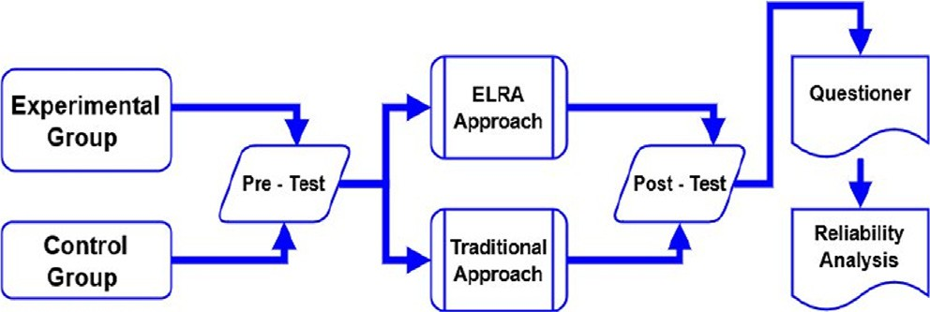

Fig. 6. Experiment Procedure.

To analyze the results, the dependent variables were the differ- ences in post-test scores between the two methods, while the independent variable was the method of offering and teaching courses. Besides, questionnaires were used to collect participants’ opinions on various methods.

* + 1. *Analysis of pre-post-tests*

These tests were created to determine a learner’s performance. Pre-tests were used to review the scores of participants for the course they studied before using the ELRA approach. The pre-test revealed that the ET and CT students had similar learning and ele- mentary knowledge skills. For post-tests, computer education material was included in the experiment. We created a questionnaire based on certain parameters found in the literature and used it to assess the proposed ELRA. These parameters include: Student Perfor- mance (SP), Understandability and Usage Easiness (EU), Increase satis- faction/motivation (IM), Less Complexity (LC), Effort/fatigue Reduction (RE), Learning ability (Le), Coordination/communication (Co), Social skills Enhancement/improvement (SE), Personalization of courses (Pe), User/learner Satisfaction (US), Semantic/sentiment Information extraction (SI), Virtualized Situation (VS), Useful Preferences/aspect analysis (UP) and Accurate/relevant Recommendations (AR).

Table 6

Statistical Test.

|  |  |  |  |  |  |
| --- | --- | --- | --- | --- | --- |
| Groups | Sum of Squares | df | MS | F | SigF |
| Between CT and ET | 1978.733 | 14 | 141.338 | 3.750 | 0.001 |
| Within CT and ET | 2018.467 | 15 | 134.564 |  |  |
| Total | 3997.200 | 29 |  |  |  |

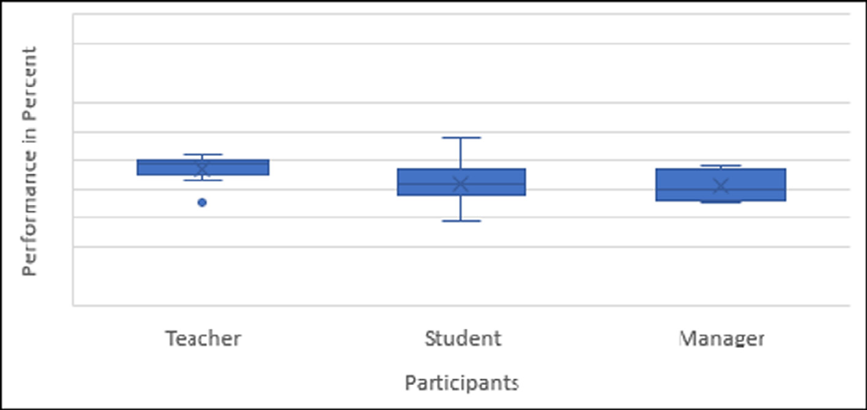

Fig. 7. Results TA Ps.

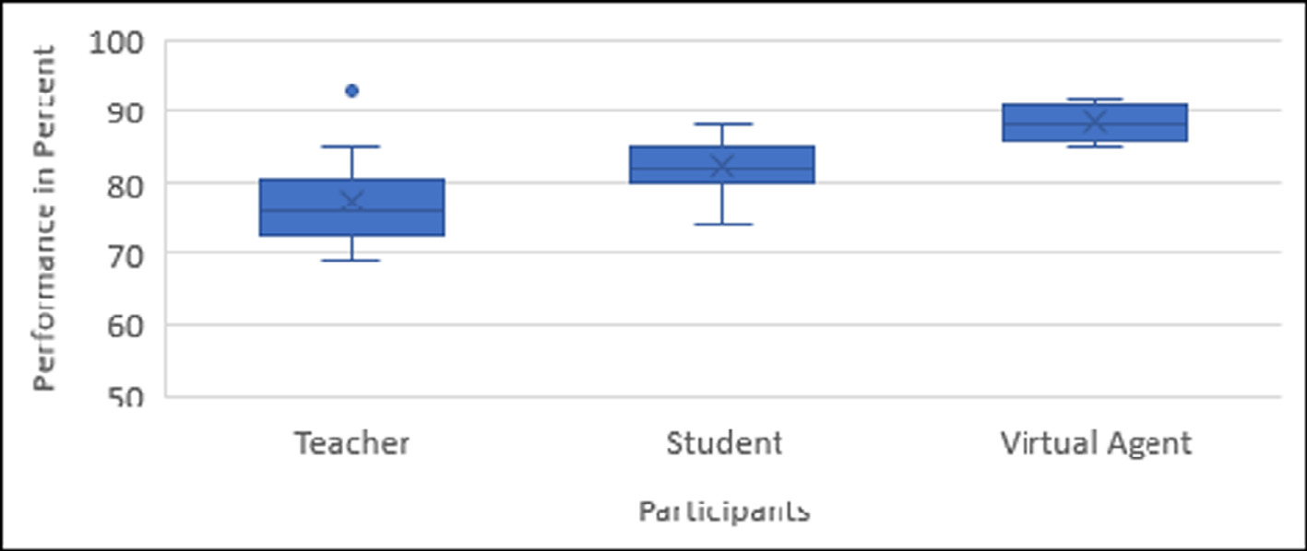

Fig. 8. SL of ELRA Participants.

The average output of learners using both methods was calcu- lated using the above-mentioned parameters. After that, each par- ticipant was required to complete a questionnaire. We used the statistical SPSS method to verify the statistical difference between the means of dependent variables. CT and ET have a mean of

28.008 with a standard deviation of 6.956 and 21.241 with a stan- dard deviation of 7.059, respectively. To test the hypothesis (H), an independent *t*-test was used to compare SigF between CT and ET. The p-value (i.e. less than 0.05) measured using an independent *t*-test for investigating CT and ET output shows that Ps of ET learn- ing ability improved. As a result, reject null H, which shows (t = 3.047, p = 0.009) that CT and ET participants have different levels of knowledge, perceptions, skills, and so on. It also demon- strated that in a virtualized environment, a semantic-based recom- mendation is needed. As a result, we used an ANOVA test i.e. one- way to compare CT and ET SigF (see Table 6). The findings show that there is an important SigF between the two methods, i.e. (F = 3.750, p = 0.001). Table 6 shows the difference in SigF between mean square (MS) values of CT and ET (i.e. 141.338 and 134.564). CT has a lower mean score than ET, indicating that ELRA improves the online course selection process. In terms of score, the ET per- formed better, as evident from the descriptive analysis.

Furthermore, as shown in Fig. 8, where the x-axis represents Ps’ SL and the y-axis represents the number of Ps, the results of a sur- vey show that ELRA outperforms traditional methods. The maxi- mum Ps using ELRA have SLs ranging from 0.5 (50%) to 1 (100%) (as shown in Fig. 8), while participants using the traditional approach have SLs ranging from 0 (zero percent) to 0.50 (Fifty per- cent) as shown in Fig. 7. Where P represents participants and these

are the combination of students, teachers, and managers in the TA method, while in ELRA Ps consist of students, teachers, and virtual agents. The role of virtual agents in ELRA is to manage the system and provide virtual assistance to users regarding recommendations and virtual queries handling without interrupting system perfor- mance during e-learning. Therefore, teachers, students, managers, and VA are considered as participants and their performance describe in Figs. 7 and 8 according to their roles.

According to the P’s findings, ELRA improves the e-learning platform and provides tailored feedback based on CF and CBF using multi-perspective semantic analysis. The ELRA method, on the other hand, reduced the time and effort required to prescribe a course list while also improving learning efficiency. Participants will have an immersive virtualized learning environment/platform, for example, if students have a question during a class/quizzes/ex- amination session, computer assistance can assist them in resolv- ing their issues. It makes learning more enjoyable by tailoring it to the tastes and needs of users in an engaging way, which is espe- cially useful for short courses.

We took the average of all participants’ SLs for each parametric comparison. (Figs. 9–13). This shows that all participants who used the ELRA approach were more satisfied than those who used the conventional online learning approach, Ps. As a result, ELRA out- performs other approaches and improves educational quality and efficiency.

This study explored that course recommendation plays a signif- icant role in e-learning performance. Further, course selection according to users’ interests and expectations is important for the success of e-learning. This research has suggested a novel

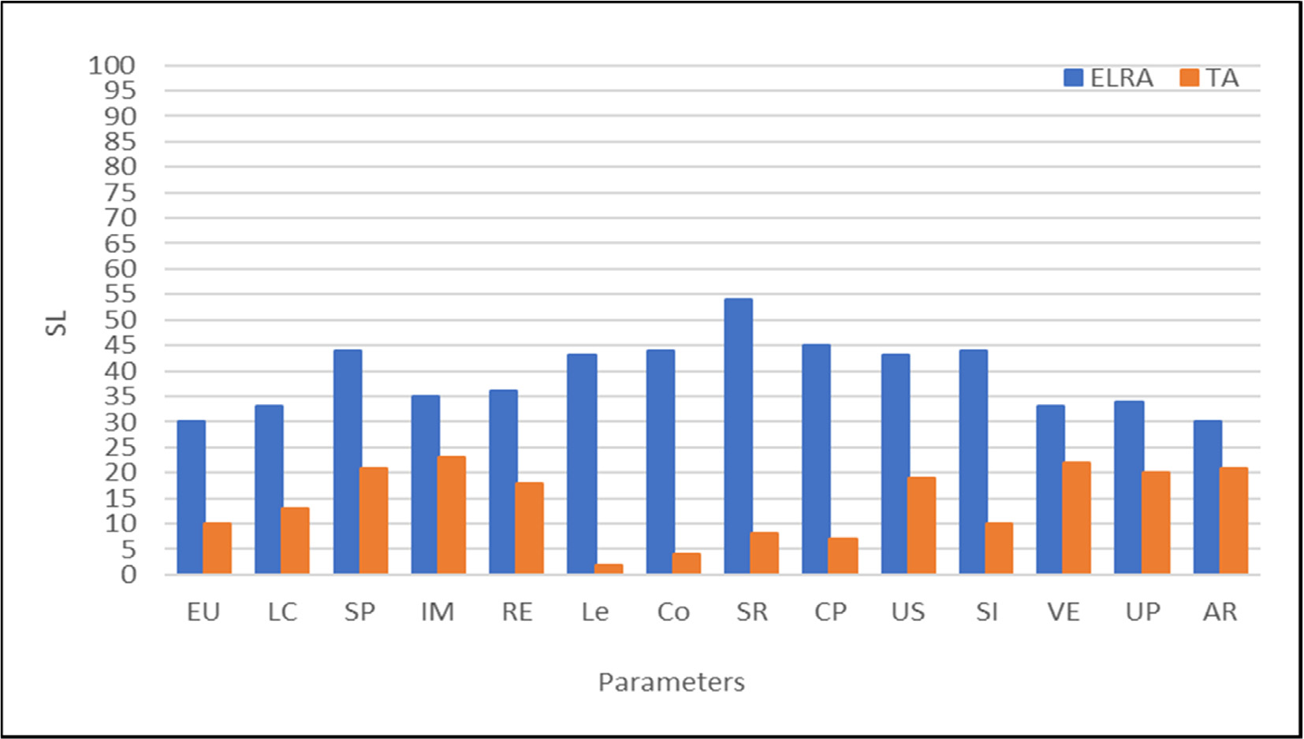

Fig. 9. Strongly Agreed Results.

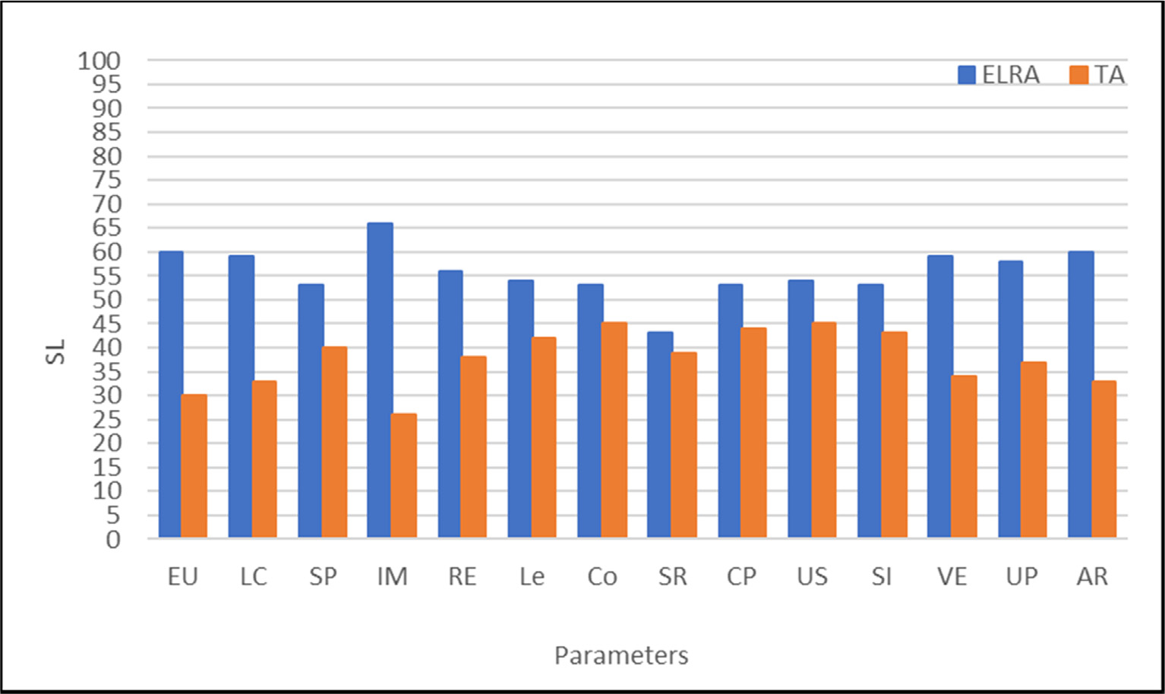

Fig. 10. Agreed Scale Results.

method called ELRA to enhance the course recommendation pro- cess. The suggested method is beneficial in the course selection process. A questionnaire and an experiment were used to evalu- ate the proposed solution. The statistical test reveals differences in SigF values between the ELRA and conventional approaches. The empirical findings show that adequate selection and learning in a virtualized environment with ELRA increases learner and tea- cher efficiency since they were not bored or fatigued during learning. In the modern age, semantic-based multi-perspective course selection in VE is critical for increasing motivation and improving skills. Traditional e-learning platforms usually recom- mend the same courses from different viewpoints to heteroge-

neous users at the same time, without virtual assistance, slowing down their learning process. The use of a semantic and interactive aided recommendation framework for boosting users’ enthusiasm and skills enhancement to achieve educational/orga- nizational goals. Students/tutors found it appealing to acquire and grow their professional/academic skills in a virtual world, where they could identify an interesting and appropriate plat- form for knowledge enhancement and sharing without disrup- tion. Besides, when learners and tutors used ELRA, they felt more positive and knowledgeable as it assisted them in study- ing/teaching courses semantically tailored to their preferences and business requirements.

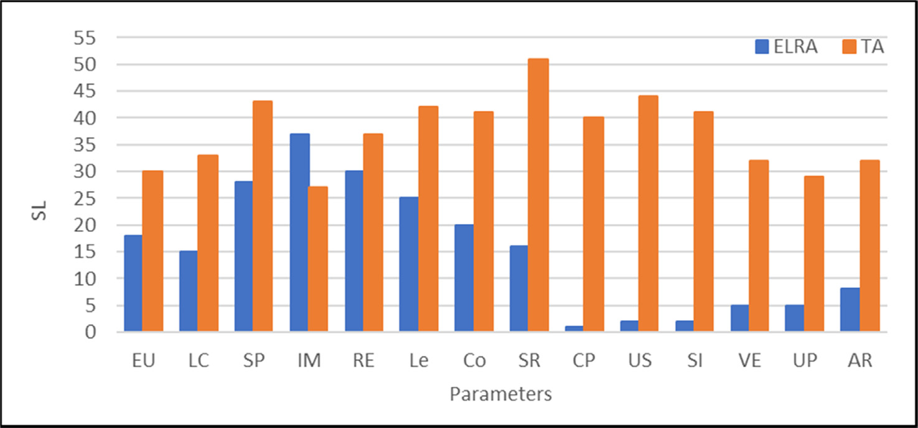

Fig. 11. Neutral Results.

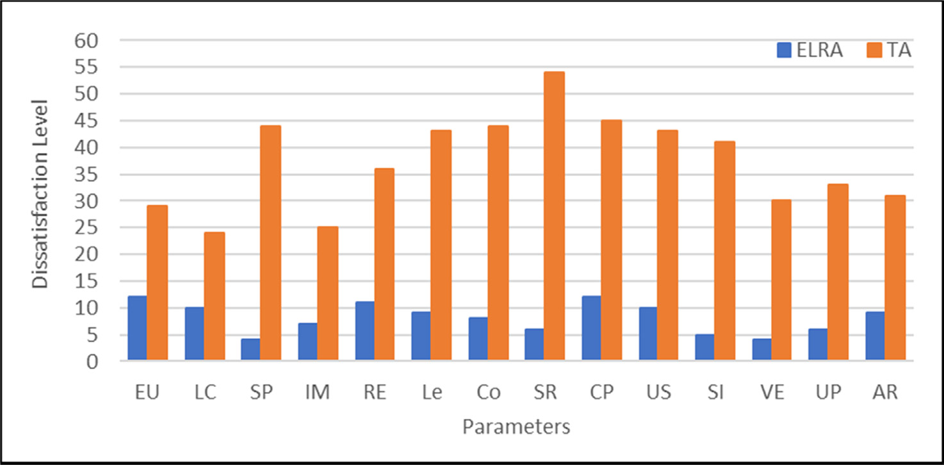

Fig. 12. Disagreed Results.

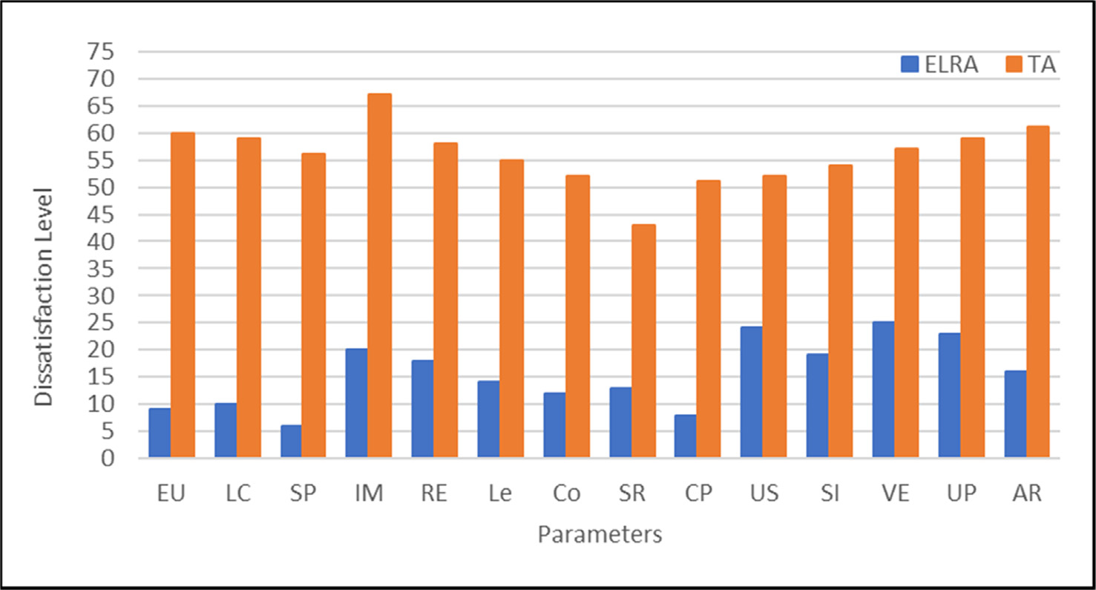

Fig. 13. Strongly Disagreed Results.

During the experiment, it was discovered that students in the control group become bored when they choose irrelevant courses from the available choices, resulting in a drop in student perfor-

mance when compared to previous performance or outcomes. They also had to deal with issues like their slot being given to another student on occasion, the interface not working properly

during quizzes, and the lack of an online agent to support them. In the case of ELRA, VA addressed these issues, and the recommenda- tion method reduced the chances of inappropriate course selection. As a result, participants in the experimental group (whether stu- dents, instructors, or virtual agents) reported higher levels of satis- faction than those in the control group. Besides, the parametric analysis revealed that ELRA users are happier than traditional approach users, with a satisfaction rate of more than 50% versus less than 50% for traditional approach users.

It was noted that participants in both groups experienced vary- ing levels of satisfaction during the course recommendation pro- cesses. The number of available courses was restricted in the conventional system, and learners had to choose from these lim- ited choices regardless of whether they were relevant to their interests or not. There was a lack of virtual assistance during course sessions, which caused learners to lose interest and, as a result, they would not be able to produce better results. By aiding learners in the course, ELRA eliminates the difficulties associated with online learning and increases participation in the course. Fur- ther, it develops users’ talents and expertise, as well as motivating them to give the course a good ranking to recruit more students. The study’s assessment results are positive, but there are some drawbacks. The fact that the trial implementation was only for a month was one of these disadvantages. The consequences of a longer-term introduction can have an impact on students’ partici- pation in and success with course content. As a result, the study has been extended to support tutors or content creators in devel- oping the syllabus and materials based on existing experience and requirements to verify the accuracy of the recommendations and the quality of the learners/tutors.

1. Conclusion and future work

The study proposed ELRA, a virtual agent-based semantic rec- ommendation system that provides customized multi- perspective suggestions using aspect-based feelings analysis and RStudio. ELRA supports students and tutors in picking relevant courses depending on their individual preferences and business demands. Furthermore, the VA not only assists in course selection but also offers real-time assistance during the course. When select- ing suitable and fascinating learning courses, the ELRA considers a variety of perspectives without making unnecessary recommenda- tions to improve and enhance both learners’ and teachers’ skills, comprehension, and online learning processes. The ELRA also has two distinct features: first, it assists learners and teachers in find- ing suitable specialized courses that develop their knowledge and skills based on their needs and requirements. Second, to reduce confusion and contact between consumers and the high-quality education team, ELRA manages online customer requests. When compared to other conventional techniques, the experimental results show that ELRA techniques greatly increase skills and accomplishments, as well as learning success (by more than 90%). Future research will focus on creating the ELRA to continu- ously update the syllabus and learning materials, as well as verify- ing the progress of both learners and teachers, to improve the course quality in an online learning environment.

Conflict of interest

The authors declared that there is no conflict of interest.

References

1. Dahdouh K, Dakkak A, Oughdir L, Ibriz A. Large-scale e-learning recommender system based on Spark and Hadoop. J Big Data 2019;6:2. doi: [https://doi.org/](https://doi.org/10.1186/s40537-019-0169-4) [10.1186/s40537-019-0169-4](https://doi.org/10.1186/s40537-019-0169-4).
2. Fu Q-K, Lin C-J, Hwang G-J, Zhang L. Impacts of a mind mapping-based contextual gaming approach on EFL students’ writing performance, learning perceptions and generative uses in an English course. Comput Educ 2019;137:59–77. doi: <https://doi.org/10.1016/j.compedu.2019.04.005>.
3. [Humayun M. Blockchain-Based secure framework for e-learning during](http://refhub.elsevier.com/S1110-8665(21)00030-X/h0015) [COVID-19. Indian J Sci Technol 2020;13(12):1328–41](http://refhub.elsevier.com/S1110-8665(21)00030-X/h0015).
4. Baloian N, Zurita G. Achieving better usability of software supporting learning activities of large groups. Inf Syst Front 2016;18(1):125–44. doi: [https://doi.](https://doi.org/10.1007/s10796-015-9580-3) [org/10.1007/s10796-015-9580-3](https://doi.org/10.1007/s10796-015-9580-3).
5. [Chavarriaga O, Florian-Gaviria B, Solarte O. A recommender system for](http://refhub.elsevier.com/S1110-8665(21)00030-X/h0025) [students based on social knowledge and assessment data of competences.](http://refhub.elsevier.com/S1110-8665(21)00030-X/h0025) [In: Rensing C, de Freitas S, Ley T, Muñoz-Merino PJ, editors. Open learning and](http://refhub.elsevier.com/S1110-8665(21)00030-X/h0025) [teaching in educational communities. Cham: Springer International](http://refhub.elsevier.com/S1110-8665(21)00030-X/h0025) [Publishing; 2014. p. 56–69](http://refhub.elsevier.com/S1110-8665(21)00030-X/h0025).
6. Qiu L, Qi L. E-learning assessment for tourism education LISREL assisted intercultural tourism perception and data integrated satisfaction perspectives. J Comput High Educ 2020;32(1):89–108. doi: [https://doi.org/10.1007/s12528-](https://doi.org/10.1007/s12528-019-09223-0) [019-09223-0](https://doi.org/10.1007/s12528-019-09223-0).
7. Sarwar S, Qayyum ZU, García-Castro R, Safyan M, Munir RF. Ontology based E- learning framework: A personalized, adaptive and context aware model. Multimed Tools Appl 2019;78(24):34745–71. doi: [https://doi.org/10.1007/](https://doi.org/10.1007/s11042-019-08125-8) [s11042-019-08125-8](https://doi.org/10.1007/s11042-019-08125-8).
8. Choi C-R, Jeong H-Y. Quality evaluation for multimedia contents of e-learning systems using the ANP approach on high speed network. Multimed Tools Appl 2019;78(20):28853–75. doi: <https://doi.org/10.1007/s11042-019-7351-8>.
9. [Campos R, Pereira dos Santos R, Oliveira J. Web-Based Recommendation](http://refhub.elsevier.com/S1110-8665(21)00030-X/h0045) [System Architecture for Knowledge Reuse in MOOCs Ecosystems. In: 2018 IEEE](http://refhub.elsevier.com/S1110-8665(21)00030-X/h0045) [International Conference on Information Reuse and Integration (IRI). Salt Lake](http://refhub.elsevier.com/S1110-8665(21)00030-X/h0045) [City, UT: IEEE; 2018. p. 193–200](http://refhub.elsevier.com/S1110-8665(21)00030-X/h0045).
10. Fraihat S, Shambour Q. A framework of semantic recommender system for e- learning. JSW 2015;10:317–30. doi: [https://doi.org/10.17706/jsw.10.3.317-](https://doi.org/10.17706/jsw.10.3.317-330) [330](https://doi.org/10.17706/jsw.10.3.317-330).
11. Hwang G-J, Fu Q-K. Trends in the research design and application of mobile language learning: a review of 2007–2016 publications in selected SSCI journals. Interact Learn Environ 2019;27(4):567–81. doi: [https://doi.org/](https://doi.org/10.1080/10494820.2018.1486861) [10.1080/10494820.2018.1486861](https://doi.org/10.1080/10494820.2018.1486861).
12. [Khribi MK, Jemni M, Nasraoui O. Automatic recommendations for e-learning](http://refhub.elsevier.com/S1110-8665(21)00030-X/h0060) [personalization based on web usage mining techniques and information](http://refhub.elsevier.com/S1110-8665(21)00030-X/h0060) [retrieval. In: 2008 Eighth IEEE International Conference on Advanced Learning](http://refhub.elsevier.com/S1110-8665(21)00030-X/h0060) [Technologies. Santander, Cantabria, Spain: IEEE; 2008. p. 241–5](http://refhub.elsevier.com/S1110-8665(21)00030-X/h0060).
13. Wray S. Electronic portfolios in a teacher education program. E-Learn Digital Media 2007;4(1):40–51. doi: <https://doi.org/10.2304/elea.2007.4.1.40>.
14. Fajar AN, Nurcahyo A, Sriratnasari SR. SOA system architecture for interconnected modern higher education in Indonesia. Procedia Comput Sci 2018;135:354–60. doi: <https://doi.org/10.1016/j.procs.2018.08.184>.
15. Palombi O, Jouanot F, Nziengam N, Omidvar-Tehrani B, Rousset M-C, Sanchez

A. OntoSIDES: ontology-based student progress monitoring on the national evaluation system of French Medical Schools. Artif Intell Med 2019;96:59–67. doi: <https://doi.org/10.1016/j.artmed.2019.03.006>.

1. Elazony M, Khalifa A, Nouh S, Hussein M. Design and Implementation of Adaptive Recommendation System; 2018:3:17.
2. [Sharif N, Afzal MT. Recommendation approaches for e-learners: a survey. In:](http://refhub.elsevier.com/S1110-8665(21)00030-X/h0085) [Proceedings of the 7th International Conference on Management of](http://refhub.elsevier.com/S1110-8665(21)00030-X/h0085) [computational and collective intElligence in Digital EcoSystems - MEDES](http://refhub.elsevier.com/S1110-8665(21)00030-X/h0085) [’15. Caraguatatuba, Brazil: ACM Press; 2015. p. 137–41](http://refhub.elsevier.com/S1110-8665(21)00030-X/h0085).
3. Beer UM, Neerincx MA, Morina N, Brinkman W-P. Virtual agent-mediated appraisal training: a single case series among Dutch firefighters. Eur J Psychotraumatol 2017;8(1). doi: [https://doi.org/10.1080/](https://doi.org/10.1080/20008198.2017.1378053) [20008198.2017.1378053](https://doi.org/10.1080/20008198.2017.1378053). 1378053.
4. [Brigui-Chtioui I, Caillou P, Negre E. Intelligent digital learning: agent-based](http://refhub.elsevier.com/S1110-8665(21)00030-X/h0095) [recommender system. In: Proceedings of the 9th International Conference on](http://refhub.elsevier.com/S1110-8665(21)00030-X/h0095) [Machine Learning and Computing - ICMLC 2017. Singapore, Singapore: ACM](http://refhub.elsevier.com/S1110-8665(21)00030-X/h0095) [Press; 2017. p. 71–6](http://refhub.elsevier.com/S1110-8665(21)00030-X/h0095).
5. Aher SB, Lobo LMRJ. Combination of machine learning algorithms for recommendation of courses in E-Learning System based on historical data. Knowl-Based Syst 2013;51:1–14. doi: [https://doi.org/10.1016/](https://doi.org/10.1016/j.knosys.2013.04.015) [j.knosys.2013.04.015](https://doi.org/10.1016/j.knosys.2013.04.015).
6. Klašnja-Milic´evic´ A, Ivanovic´ M, Vesin B, Budimac Z. Enhancing e-learning systems with personalized recommendation based on collaborative tagging techniques. Appl Intell 2018;48(6):1519–35. doi: [https://doi.org/10.1007/](https://doi.org/10.1007/s10489-017-1051-8) [s10489-017-1051-8](https://doi.org/10.1007/s10489-017-1051-8).
7. Pecori R. A virtual learning architecture enhanced by fog computing and big data streams. Future Internet 2018;10:4. doi: [https://doi.org/](https://doi.org/10.3390/fi10010004) [10.3390/fi10010004](https://doi.org/10.3390/fi10010004).
8. Aher, S.B., Lobo, L.M.R.J. Course Recommender System In E-Learning; 2012:6.
9. Fridin M, Belokopytov M. Embodied robot versus virtual agent: involvement of preschool children in motor task performance. Int. J. Hum. –Comput. Interact. 2014;30(6):459–69. doi: <https://doi.org/10.1080/10447318.2014.888500>.
10. [Mawane J, Naji A, Ramdani M. Recommender E-Learning platform using](http://refhub.elsevier.com/S1110-8665(21)00030-X/h0125) [sentiment analysis aggregation. In: Proceedings of the 13th International](http://refhub.elsevier.com/S1110-8665(21)00030-X/h0125) [Conference on Intelligent Systems: Theories and Applications. Rabat](http://refhub.elsevier.com/S1110-8665(21)00030-X/h0125) [Morocco: ACM; 2020. p. 1–6](http://refhub.elsevier.com/S1110-8665(21)00030-X/h0125).
11. Wan S, Niu Z. A hybrid E-learning recommendation approach based on learners’ influence propagation. IEEE Trans Knowl Data Eng 2020;32 (5):827–40. doi: [https://doi.org/10.1109/TKDE.6910.1109/](https://doi.org/10.1109/TKDE.6910.1109/TKDE.2019.2895033) [TKDE.2019.2895033](https://doi.org/10.1109/TKDE.6910.1109/TKDE.2019.2895033).
12. Cerezo R, Bogarín A, Esteban M, Romero C. Process mining for self-regulated learning assessment in e-learning. J Comput High Educ 2020;32(1):74–88. doi: <https://doi.org/10.1007/s12528-019-09225-y>.
13. Arias M, Buccella A, Cechich A. A framework for managing requirements of software product lines. Electron Notes Theor Comput Sci 2018;339:5–20. doi: <https://doi.org/10.1016/j.entcs.2018.06.002>.
14. Liu N, Shen Bo, Zhang Z, Zhang Z, Mi K. Attention-based Sentiment Reasoner for aspect-based sentiment analysis. Hum Cent Comput Inf Sci 2019;9(1). doi: <https://doi.org/10.1186/s13673-019-0196-3>.
15. de Kok S, Punt L, van den Puttelaar R, Ranta K, Schouten K, Frasincar F. Review- aggregated aspect-based sentiment analysis with ontology features. Prog Artif Intell 2018;7(4):295–306. doi: <https://doi.org/10.1007/s13748-018-0163-7>.