

[Egyptian Informatics Journal (2010) 11, 33](http://dx.doi.org/10.1016/j.eij.2010.06.005)–[38](http://dx.doi.org/10.1016/j.eij.2010.06.005)

Cairo University

Egyptian Informatics Journal

[www.elsevier.com/locate/eij](http://www.elsevier.com/locate/eij) [www.sciencedirect.com](http://www.sciencedirect.com/)

ORIGINAL ARTICLE

Energy-aware architecture for multi-rate ad hoc networks

Ahmed Yahya

*Department of Electrical Engineering, Faculty of Engineering, Al-Azhar University, Nasr City, Cairo-11371, Egypt*

Received November 2009; accepted 12 May 2010

Available online 17 July 2010

Abstract The backbone of ad hoc network design is energy performance and bandwidth resources limitations. Multi-rate adaptation architectures have been proposed to reduce the control overhead and to increase bandwidth utilization efficiency. In this paper, we propose a multi-rate protocol to provide the highest network performance under very low control overhead. The efficiency of the proposed auto multi-rate protocol is validated extensive simulations using QualNet network simu- lator. The simulation results demonstrate that our solution significantly improves the overall net- work performance.

© 2010 Faculty of Computers and Information, Cairo University. Production and hosting by

KEYWORDS

Power-aware protocols; Ad hoc networks performance;

MANET architectures

Elsevier B.V. All rights reserved.

1. Introduction

Finite battery energy and limited bandwidth resources are the most important constraints in ad hoc networks design. Therefore, most research on ad hoc networks has focused on optimization algorithms for reducing control overhead and increasing the efficiency of bandwidth utilizations. In other occasions, automatic data transmission rate selection protocols

[1] allow wireless devices to operate at high data rate when the

E-mail address: [ahmed_yahya_1@yahoo.com](mailto:ahmed_yahya_1@yahoo.com)

1110-8665 © 2010 Faculty of Computers and Information, Cairo University. Production and hosting by Elsevier B.V. All rights reserved.

Peer review under responsibility of Faculty of Computers and Infor- mation, Cairo University.

doi:[10.1016/j.eij.2010.06.005](http://dx.doi.org/10.1016/j.eij.2010.06.005)

Production and hosting by Elsevier

channels conditions are sufficiently clear so as to improve the network throughput and to increase the bandwidth efficiency. In this paper, we propose a novel solution for efficient net- work operations in ad hoc networks by introducing multi-rate algorithm with Multi-level power save protocol to achieve high network throughput with low overhead. The remainder of the paper is organized as follows. Section 2 discusses the multi-rate in ad hoc networks. Section 3 explains the multi-level power save protocol for MANET. Section 4 introduces the related work. Section 5 discusses the proposed auto multi-rate proto- cols performance. Simulation parameters and results with respect to our proposed protocol are briefed in Section 5. Finally we end up with some concluding remarks in Section 6.

1. Multi-rate in ad hoc network

The 802.11 PHYs (physical layers) provide multiple transmis- sion rates by employing different modulation and channel cod- ing schemes. For example, the 802.11b PHY [2,3] provides 4 rates up to 11 Mbps at the 2.4 GHz band, the 802.11a PHY

[4] provides 8 rates up to 54 Mbps at the 5 GHz band, and the 802.11g PHY [2,3] supports 12 rates up to 54 Mbps at

34 A. Yahya

the 2.4 GHz band. Furthermore, an increasing number of commercial 802.11 products support multiple transmit-power levels. For example, the Cisco Aironet 802.11A/B/G Wireless CardBus Adapter [4] is a wireless device and supports a lot of transmit-power levels from 0 dB m to 20 dB m (see Table 1). While multi-rate devices provide increased flexibility, they cannot change the inherent trade-off between speed and range. Both high speed and long range cannot be achieved simulta- neously. Long range communication must occur at low rates, and high-rate communication must occur at short range. This multi-rate capability merely provides a number of different

trade-off points (Fig. 1).

Multi-rate devices must have protocols that select the appropriate rate for a given situation. So there are various auto multi-rate mechanisms which have been proposed by exploiting the multiple transmission rates and multiple trans- mit-power levels provided by 802.11 devices like:

* Auto Rate Fallback (ARF) protocol [6,7] which is the first commercial implementation of a MAC that utilizes this fea- ture. With ARF, senders attempt to use higher transmission rates after consecutive transmission successes (which indicate high channel quality) and revert to lower rates after failures.
* Receiver Based Auto Rate (RBAR) [5,8,9] protocol. The core idea of RBAR is for receivers to measure the channel quality using physical-layer analysis of the request-to-send

|  |  |  |
| --- | --- | --- |
| Table 1 Data rate and corresponding range and modulation technique of Cisco Aironet Wireless CardBus Adapter (802.11  b). | | |
| Rate (Mbps) | Maximum range (m) | Modulation technique DSSS |
| 11 | 48 | Complementary Code Keying (CCK) |
| 5.5 | 91 | Differential Quadrature Phase Shift |
|  |  | Keying (DQPSK) |
| 1 | 124 | Differential Binary Phase |
|  |  | Shift Keying (DBPSK) |
|  |  |  |

(RTS) message. Receivers then set the transmission rate for each packet according to the highest feasible value allowed by the channel conditions.

* Opportunistic Auto Rate (OAR), an enhanced protocol for multi-rate IEEE 802.11 in wireless ad hoc networks. The key idea of OAR is to opportunistically exploit high quality channels when they occur via transmission of multiple back-to-back packets. In particular, when the multi-rate MAC (RBAR) indicates that the channel quality allows transmission above the base rate, OAR grants channel access for multiple packet transmissions in proportion to the ratio of the achievable data rate over the base rate. Con- sequently, OAR nodes transmit more packets under high quality channels than under low quality channels [5,8,9].

The key idea is to allow a wireless station to based on the link quality between itself and the receiver selects the most en- ergy-efficient transmission strategy, which consists of transmis- sion rate, transmit power and/or data payload length. In a typical 802.11 MANET, some stations may be far away from their neighbor and the quality of their radio transmissions is low, and some stations may be near their neighbor and experi- ence better wireless channel condition. As a result, different wireless stations may choose different transmission strategies to communicate with its neighbors. To elaborate, we note that the distance between sender and receiver is the primary factor of channel quality in wireless network.

For example, when two nodes move in opposite directions using IEEE 802.11b, the auto rate protocol [10] will gracefully reduce their link speeds from 11 Mbps down through 1 Mbps before the nodes are finally disconnected (Fig. 2). Thus no reli- ability problems are encountered until reaching opposite direc- tions with multi-rate capability.

1. Multi-level power save protocols for MANET

Multi-level power save protocol adds *k* power levels to PSM which may give rise to some problems:

* *Respective sleep and wakeup process*: Since the multi-level power save protocol assumes that the nodes traverse from level to level, respectively, if there are transmission or not it means

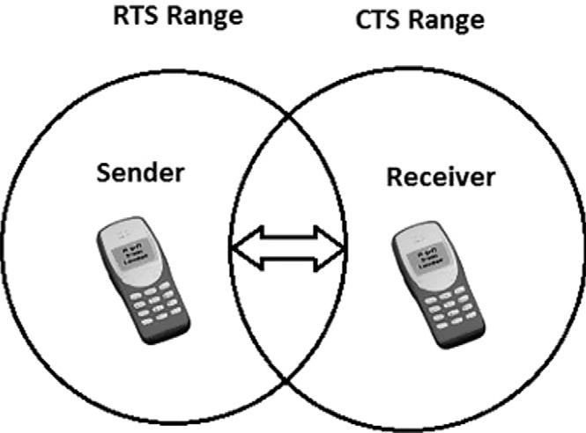

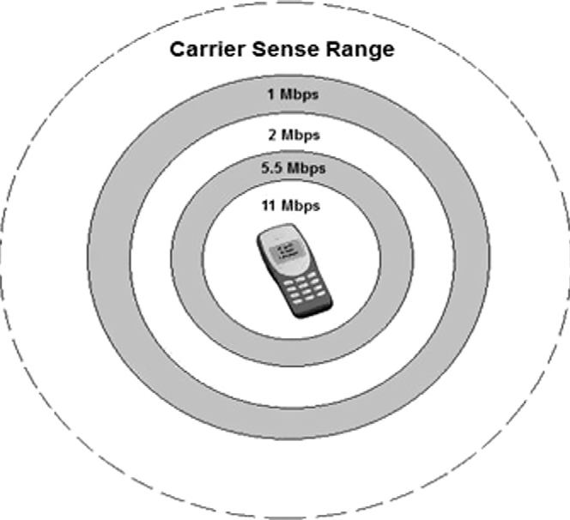Figure 1 802.11b ranges. Figure 2 Two nodes move in opposite way.

Energy-aware architecture for multi-rate ad hoc networks 35

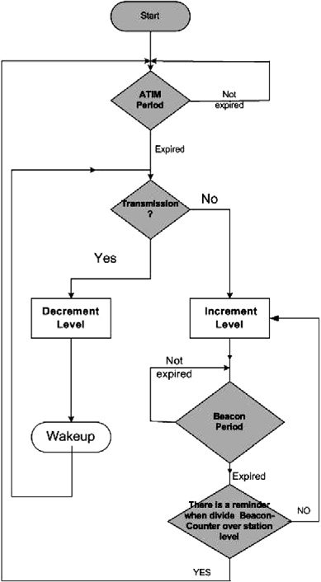

that the latency of the network will increase and the perfor- mance will decrease. If the nodes have a packet to send it will wait until the next ATIM (ad hoc traffic indication message) window which may be so far because the node is in level *k*.

* *Node sensitivity*: As long as the node goes into deep sleeping (level *k*) the node sensation about the outer environment change will decrease and this is a critical issue in ad hoc net- work which works in a cooperative manner.
* *Move from level to level by factor of 2*: At *k* = 1, the stan- dard ratio between ATIM (ad hoc traffic indication mes- sage) window interval and beacon window interval (Fig. 3) is 10%. By moving to level *k* = 2, this ratio will be 5% and for *k* = 3 the ratio will be 2.5% and so on. The difference between the first and the second ratio is very large, which will affect the performance of the network.

We determine the *k* level of multi-level power save protocol in two levels because it will save more power than standard PSM, with acceptable performance. Move from level to level by factor of 1 to decrease the latency of the network. Wake up immediately if there are packets to send benefit from the fact that some of the network nodes work at level 1 and some of them work at level 2 and so on.

Based on the above guidelines we propose three power saving protocols. For each PS host, it divides its time axis into a number of fixed-length intervals called beacon inter- vals. At each beacon interval, there is a subinterval called ATIM interval. During the ATIM interval, the PS host should turn on its receiver to listen to any packet and take proper actions as usual, and if the station has packets to send it will contend to send its ATIM frame to its neighbor. If the station is in ATIM window without any activity; it will send beacon frame periodically to its neighbors to syn- chronize the network stations. After ATIM interval, a PS host with no packet to send or receive may go to the sleep mode.

1. Related work

There have been many research efforts on power save mode (PSM) protocol for improving MAC performance. This improvement was conducted with the modification of the in- crease of sleep intervals like that of the multi-level power save mechanism introduced [8]. The general flow chart for the pro- posed protocols is shown in Fig. 4. The contribution of these improvements was as follows.

Figure 4 Flow chart for multi-level power save protocols.

* 1. *Multi-level power save protocol with k = 2 (M2)*

The basic idea of this approach is derived from the multi-level power save protocol with *k* = 2. This protocol is formally derived as follows. Each PS host divides its time axis into fixed-length beacon intervals, within each beacon, the lengths of ATIM window are fixed. Moving from level 1 to level 2 is respectively based on the fact that if there is transmission or not. If the PS host is in level 1, then the PS host will wake up at the ATIM window of every beacon interval. But if the PS host is in level 2 then the wakeup process will be based on the beacon sequence number. If the beacon sequence num- ber is divisible by the station level, wakeup else continue sleep- ing. We implement this protocol by modifying the standard PSM protocol implemented by QualNet [8].

* 1. *Multi-level power save protocol with k = 3 (M3)*

The basic idea of this approach is derived from the multi-level power save protocol with *k* = 3. This protocol is formally de-

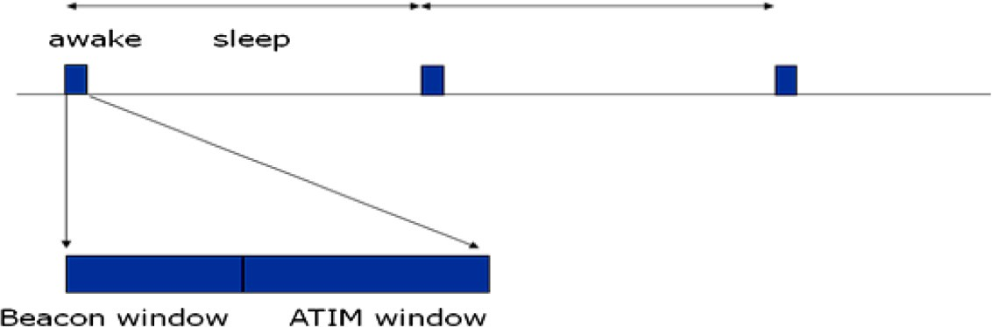

Figure 3 Power saving at MAC layer.

36 A. Yahya

rived as follows. Each PS host divides its time axis into fixed- length beacon intervals, within each beacon, the lengths of ATIM window are fixed. Moving from level 1 to level 3 through level 2 is respectively based on the fact that if there is transmission or not. If the PS host is in level 1; then the PS host wakes up at the ATIM window of every beacon inter- val. But if the PS host is in level 2 or 3 then the wakeup process will be based on the beacon sequence number. If the beacon sequence number is divisible by the station level, wakeup else continue sleeping. We implement this protocol by modifying the standard PSM protocol implemented by QualNet [9],

Throughput of Auto-Rate VS Fixed Rate

3500



Auto-Rate

Fixed Rate

3000

2500

Throughput (bps)

2000

1500

1000

500

0

PSM M2 M3 MM3

Protocol

Figure 5 Throughput vs. auto multi-rate (mobility 10 m/s, beacon 100 s, 30 nodes).

where *k* levels are achieved by increasing the sleep time for each level by a factor of 1.

* 1. *Modified multi-level power save protocol with k = 3 (MM3)*

The basic idea of this approach is derived from the multi-level power save protocol with *k* = 3. This protocol is formally derived as follows. Each PS host divides its time axis into fixed-length beacon intervals, within each beacon, the lengths of ATIM window are fixed. Moving from level 1 to level 3 without entering to level 2 is not respectively; if there is trans- mission the PS host will move to level 1; if not the PS host will go to level 3. If the PS host is in level 1, then the PS host wake- ups at the ATIM window of every beacon interval. But if the PS host is in level 3, the wakeup process will be based on bea- con sequence number. If the beacon sequence number is divided by the station level, wakeup else continue sleeping. We propose to use a multilevel protocol (with *k* = 3) to achieve low power while maintaining a good performance.

1. Proposed auto multi-rate protocols performance

In this section we use the auto multi-rate capability which is implemented in the QualNet simulator to send data between network elements and to measure the network performance.

* 1. *Simulation model*

To evaluate the performance of the proposed auto multi-rate protocols, we create scenarios using QualNet simulator and modify the standard PSM protocol implemented by QualNet to fit our characteristics of each protocol. Each scenario is configured with a stationary 30-node network randomly dis- tributed over a 1000 m · 1000 m terrain; each host has a to- tal energy of 100 mJ. Fifteen nodes are randomly chosen to

1.2



Delay of Auto-Rate VS Fixed Rate Auto-Rate

Fixed Rate

1

0.8

Time (Sec)

0.6

0.18

0.16



Auto-Rate

Fixed Rate

0.14

Consumed Energy (mJoule)

0.12

0.1

0.08

Energy Consumed of Auto-Rate VS Fixed Rate

0.4

0.06

0.04

0.2

0.02

0

PSM M2 M3 MM3

Protocol

0

PSM M2 M3 MM3

Protocol

Figure 6 Delay (time (s)) vs. auto multi-rate (mobility 10 m/s, beacon 100 s, 30 nodes).

Figure 7 Consumed energy vs. auto multi-rate (mobility 10 m/s, beacon 100 s, 30 nodes, fixed rate = 2 Mbps).

Energy-aware architecture for multi-rate ad hoc networks 37

100

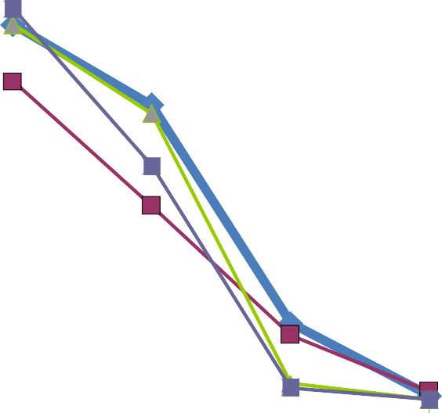

Fixed Rate

90

80

70

Survival Ratio (%)

60

PSM

50

M2

40

M3

30 MM3

20

10

0

250 300 350 400

Simulation Time (Sec)

Figure 8 Fixed rate survival ratio (mobility 10 m/s, beacon 100 s, 30 nodes, fixed rate = 2 Mbps).

be constant bit rate sources, each of which generate 512-byte data packet to a randomly chosen destination at a rate of 10 packets per second for 100 s. The network uses ad hoc on- demand distance vector routing for each constant bit rate source to discover a route to the destination. The 802.11 Mac and physical wireless parameter were modified to match the specifications of Cisco Aironet 802.11A/B/G wire- less CardBuss Adaptor.

* 1. *QualNet simulation parameters*

Four parameters are tunable in our simulations: host density (30–50 nodes), beacon interval (100–400 ms), mobility (pause

time is set to 30 s, a host will move at a speed between 0 and 20 m/s), and auto multi-rate (already implemented in the sim- ulator). The auto multi-rate capabilities are investigated with the multi-level power saving protocols discussed in Section 4 and compared with the fixed rate protocols (2 Mbps).

* 1. *Simulation results*

Fig. 5 plots throughput for the network protocols operated in auto multi-rate protocols (mobility 10 m/s, beacon 100 s, 30 nodes). Fig. 6 plots delay for the network protocols operated in auto multi-rate protocols (mobility 10 m/s, beacon 100 s, 30 nodes).

100

Auto-Rate

90

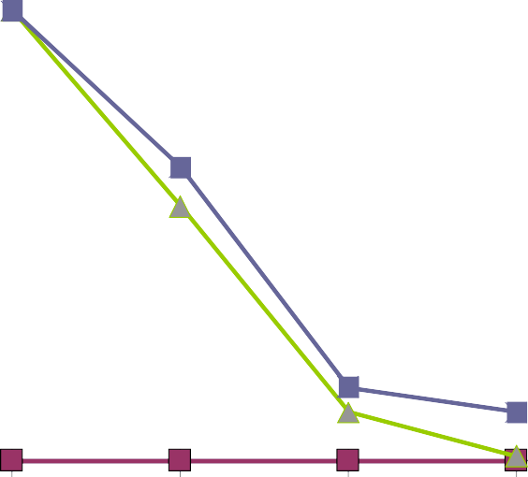

80

70

Survival Ratio (%)

60

PSM

50

M2

40  M3

30  MM3

20

10

0

250 300 350 400

Simulation Time (Sec)

Figure 9 Auto multi-rate survival ratio (mobility 10 m/s, beacon 100 s, 30 nodes, fixed rate = 2 Mbps).

38 A. Yahya

These figures show that the throughput increases using auto multi-rate for all protocols and so does the delay. This is ex- pected because if the throughput is high the delays in wireless networks are unavoidable. This result indicates the effect of propagation time and multipath problem. Fig. 7 plots con- sumed energy vs. auto multi-rate (mobility 10 m/s, beacon 100 s, 30 nodes, fixed rate = 2 Mbps). It shows the impact of using auto multi-rate protocols on the total consumed energy which is expected to be lower than using fixed rate. This is because sending with a higher rate at some links will consume more energy, but sending more data will keep the node idle for more time which will save the energy. This energy may be required to send and forward data than sending with fixed rate. The total network life time is almost the same as shown in Figs. 8 and 9, which plot survival ratio fixed rate and auto multi-rate (mobility 10 m/s, beacon 100 s, 30 nodes, fixed rate = 2 Mbps).

The impact of using auto multi-rate protocols on the se- lected protocols (PSM, M, M3, and MM3) is investigated by measuring the throughput and the delay for each protocol as shown in Figs. 6–9. These results indicate that the throughput of using auto multi-rate is better than using a fixed rate for PSM, M3 and MM3.

1. Conclusion

In this paper, we have investigated the possibility of reducing energy consumption by exploiting multi-rate in 802.11 wireless networks. We have proposed the auto multi-rate protocol, studied its impact on the multi-level power save protocols and compared it with the three issues of IEEE 802.11-based power save protocols. Simulation results have shown that by using auto multi-rate protocol the performance will increase and the consumed power will decrease. This will enhance the overall channel characteristics and then the active node can send more data at shorter time due to power for longer time. We strongly recommend activating an auto multi-rate protocol

in ad hoc networks especially if we are concerned with power consumption issues.

References

1. Chang J, Tassiulas L. Energy conserving routing in wireless ad hoc networks. In: Proceedings of IEEE INFOCOM; 2000.
2. IEEE 802.11. Wireless LAN Medium Access Control (MAC) and Physical Layer (PHY) specifications. USA: IEEE; 1999.
3. IEEE Standard for Information technology – telecommunications and information exchange between systems – Local and metro- politan area networks – specific requirements – Part 11: Wireless LAN Medium Access Control (MAC) and Physical Layer (PHY) specifications.
4. Cisco. Cisco Aironet 802.11A/B/G Wireless CardBus Adapter USA: Cisco; 2007.
5. Sadeghi B, Kanodia V, Sabharwal A, Knightly E. OAR: an opportunistic auto-rate media access protocol for ad hoc net- works. Department of Electrical and Computer Engineering Rice University supported by NSF Grants, TX; 2002.
6. Awerbuch B, Holmer D, Rubens H. Effects of multi-rate in ad hoc wireless networks. Johns Hopkins University, Baltimore, USA; 2003. p. 1–7.
7. Bin Li, Lianfen Huang, Chih-Heng Ke, Der-Jiunn Deng. Perfor- mance analysis of multi-rate IEEE 802.11 networks over Gaussian channel. In: Proceeding of the fifth IASTED Asian conference on communication systems and networks, Langkawi, Malaysia; 2008.

p. 50–55.

1. Yahya A. Performance evaluation of power save mode in an enhanced power aware protocol. Scientific Bulletin of the Faculty of Engineering, Ain-Shams University 2009;44(3).
2. Chen DR, Zhang YJ. Distributed MAC strategy for exploiting multi-user diversity in multi-rate IEEE 802.11 Wireless LANs[C]. In: Proceedings of IEEE international conference on mobile adhoc and sensor system, Pisa, Italy; 2007. p. 1–11.
3. Gavin Holland, Nitin Vaidya, Paramvir Bahl. A rate-adap- tive MAC protocol for multi-Hop wireless networks. In: Proceedings of the seventh annual international conference on mobile computing and networking; July 2001, Rome, Italy. p. 236–51.