

[Egyptian Informatics Journal (2015) 16, 167–174](http://dx.doi.org/10.1016/j.eij.2015.03.001)

Cairo University

Egyptian Informatics Journal

[www.elsevier.com/locate/eij](http://www.elsevier.com/locate/eij) [www.sciencedirect.com](http://www.sciencedirect.com/science/journal/11108665)

ORIGINAL ARTICLE

Energy eﬃcient distributed cluster head scheduling scheme for two tiered wireless sensor network



G. Kannan a,*, T. Sree Renga Raja b

a *Department of Electronics & Communication Engg, B.S.Abdur Rahman University, Chennai, Tamil Nadu, India*

b *Department of Electrical & Electronics Engg, Anna University: BIT Campus, Tiruchirappalli, Tamil Nadu, India*

Received 9 September 2014; revised 4 February 2015; accepted 1 March 2015

Available online 11 April 2015

Abstract Wireless Sensor Network (WSN) provides a significant contribution in the emerging fields such as ambient intelligence and ubiquitous computing. In WSN, optimization and load bal- ancing of network resources are critical concern to provide the intelligence for long duration. Since clustering the sensor nodes can significantly enhance overall system scalability and energy efficiency this paper presents a distributed cluster head scheduling (DCHS) algorithm to achieve the network longevity in WSN. The major novelty of this work is that the network is divided into primary and secondary tiers based on received signal strength indication of sensor nodes from the base station. The proposed DCHS supports for two tier WSN architecture and gives suggestion to elect the clus- ter head nodes and gateway nodes for both primary and secondary tiers. The DCHS mechanism satisfies an ideal distribution of the cluster head among the sensor nodes and avoids frequent selec- tion of cluster head, based on Received Signal Strength Indication (RSSI) and residual energy level of the sensor nodes. Since the RSSI is the key parameter for this paper, the practical experiment was conducted to measure RSSI value by using MSP430F149 processor and CC2500 transceiver. The measured RSSI values were given input to the event based simulator to test the DCHS mechanism. The real time experimental study validated the proposed scheme for various scenarios.

© 2015 Production and hosting by Elsevier B.V. on behalf of Faculty of Computers and Information, Cairo University. This is an open access article under the CC BY-NC-ND license ([http://creativecommons.](http://creativecommons/)

KEYWORDS

Energy efficiency; Wireless sensor network; Cluster head selection; RSSI

org/licenses/by-nc-nd/4.0/).

1. Introduction

* Corresponding author.

E-mail addresses: [kannan_ins@yahoo.co.in](mailto:kannan_ins@yahoo.co.in) (G. Kannan), [renga_raja@rediffmail.com](mailto:renga_raja@rediffmail.com) (T. Sree Renga Raja).

Peer review under responsibility of Faculty of Computers and Information, Cairo University.

**Production and hosting by Elsevier**

A wireless sensor network is a highly complex distributed sys-

tem comprising huge number of tiny wireless sensor nodes and base station (BS). Each wireless sensor node consists of sensor, processor, memory, RF transceiver (radio), peripherals, and power supply unit (battery) [1]. These wireless sensor nodes are deployed over a geographical area in an ad hoc fashion for event detection and observe data for various ambient con- ditions. The WSN could collect this real time data to design the

<http://dx.doi.org/10.1016/j.eij.2015.03.001>

1110-8665 © 2015 Production and hosting by Elsevier B.V. on behalf of Faculty of Computers and Information, Cairo University. This is an open access article under the CC BY-NC-ND license ([http://creativecommons.org/licenses/by-nc-nd/4.0/).](http://creativecommons.org/licenses/by-nc-nd/4.0/))

environment with more intelligence [2]. The WSN is also focused on disaster management such as tsunami warning, earthquake monitoring, flood forecasting and pipeline moni- toring systems.

The rapid deployment, self-organization and fault tolerance characteristics of sensor networks make them a very promising sensing technique for military applications [3,4]. Since WSN needs to operate on resource constrained environment, either changing or recharging batteries is an unmanageable task. Even the failure of single node due to low energy can prostrate the entire system. Hence this problem forced the academic researchers for developing an energy efficient protocols focus- ing node and network level [4,5]. In the network level a variety of energy efficient routing protocols were developed in the recent years [6–8]. The routing protocols in WSN are classified under three main heads: data centric protocols, location based protocols and hierarchical protocols.

This paper mainly focused on hierarchical protocols which deal with organizing WSN into a set of clusters. In each cluster,

1. Related works

This section takes the advantages of valuable prior work in WSN hierarchical clustering protocols which are primarily focused to improve the network lifetime.

Low Energy Adaptive Clustering Hierarchy (LEACH) pro- posed in [12] is one of the most popular hierarchical routing protocols designed to aggregate and *disseminate* data to the base station. LEACH obtains energy efficiency by partitioning the nodes into clusters. The LEACH operates on rounds where each round comprised of setup phase and steady state phase. During setup phase the sensor nodes will select a random num- ber between 0 and 1. If this random number is below the threshold value *T*(*n*), then the corresponding sensor node will act as a cluster head during the given period, called a round. LEACH distributes the role of cluster head among the member nodes in the cluster based on threshold value, which is calcu- lated by the following formula:

a dedicated node called cluster head (CH) node and remaining

*T*(*n*)=

*P*

1—*P*\*(*r* mod1)

(

*P*

if *n* ∈ *G*

(3)

sensor nodes are called as cluster nodes (CN). The role of each

CH is to carry out the following three tasks. The first task is to gather sensed data from the cluster nodes periodically and aggregates the data in an effort to remove redundancy among correlated values [9]. The second task of the cluster head is to generate a Time Division Multiple Access (TDMA) schedule through which sensor nodes receive a time slot for data trans- mission. The third task is to transmit the aggregated data to nearby CH or directly to the base station. Hence the lifetime of CH would be a very short span of time if the fixed node per- forms all the three tasks and it becomes essential to shift the cluster head periodically in a well-structured manner. In this work a new CH selection mechanism was proposed for the two tiered WSN architecture based on residual energy and communication distance between the sensor nodes.

Most of the existing papers [10] distance was estimated by the standard mathematical coordinate system. The proposed work performs real time experimental setup to carryout the estimation of distance among the sensor nodes based on RSSI values. RSSI value can be estimated by measuring the received power of radio signal and most of the IEEE 802.11 and 802.15.4 radio modules support the measurement of RSSI. The relationship between the received power (*P*Rx) and RSSI is shown in the following formula [11]:

RSSI = 10log10 *P*Rx (1)

The Friis transmission equation is generally described as

the propagation of radio communication. This equation gives the relation between transmission distance (*D*) and received power (*P*Rx) as follows:

*P*Tx*G*T*G*Rk2

0; otherwise

where *P* is the desired % of cluster heads, *r* is current round, and *G* is the set of nodes that have not been CH in the last 1/*P* rounds. During steady state phase the elected CH creates a TDMA schedule and assigns a time slot for each member node for data transmission. After a particular period of time the network returns into the setup phase to select new CH. This approach selects the cluster head based on a predeter- mined probability and does not follow any energy efficient mechanism while choosing *T*(*n*).

LEACH-Centralized (LEACH-C) uses centralized algo- rithm for the selection CH and the same steady state phase as LEACH [13]. In the setup phase, the base station collects the position and energy level of the sensor nodes and the node having greater energy than average energy of all sensor nodes would be elected as CH. Since this approach only considers the energy level of sensor nodes while selecting the CH, there may be a greater probability of elected CH is far away from BS which consume more energy when the communication between BS and CH.

Younis [14] presents a protocol, HEED (Hybrid Energy- Efficient Distributed clustering), that periodically selects clus- ter heads according to their residual energy. The authors do not make any assumptions about the presence of infrastructure or about node capabilities, other than the availability of multi- ple power levels in sensor nodes. However the proposed algo- rithms support only for building a two-level hierarchy, and lack for multilevel hierarchies.

Yu et al. [15] present a new energy-efficient dynamic clus- tering technique which deals with each node estimates the

number of active nodes in real-time and computes its optimal

*P*Rx =

(4p)2*D*2 (2)

probability of becoming a cluster head by monitoring the received signal power from its neighboring nodes. The authors

where *P*Tx is the transmission power, *G*T is transmitting

antenna gain, *G*R is the gain of receiving antenna and k is the wavelength of the RF signal.

This experimental report is organized as follows: Section 2 discusses about related work. Section 3 explains the network model and proposed DCHS mechanism in detail. Section 4 contains experimental setup and results. Eventually Section 5 concludes with future enhancement of this work.

also developed energy-efficient and power aware (EEPA) rout-

ing algorithm and lifetime is compared with AODV, MTE and MRE routing protocols.

Jung et al. [16] propose a cluster based energy-efficient for- warding scheme which ensures that while multiple nodes in a cluster receive a packet, only one node among them is elected to send the acknowledgment back. The binary exponential backoff algorithm was used to elect the node. Akhtar et al.

[17] present RSSI based energy aware intracluster routing tech- niques and are not focused on intercluster routing. The algo- rithm has got increased energy efficiency up to 17%. Also, the algorithm was tested with TOSSIM simulator and did not involve any real time hardware to measure the signal strength.

The probabilistic clustering algorithms described above are considering the two important parameters such as distance among the nodes and residual energy of the nodes. Most of the existing clustering algorithm experimental results were pro- duced based on the simulation results and being lack of real time behavior. In this report real time experimental setup was constructed to estimate the distance among the sensor nodes and incorporated with the simulation parameters to vali- date the proposed DCHS scheme.

1. Proposed scheme: Distributed cluster head scheduling algorithm

This section deals with network model and algorithm for the proposed DCHS.

* 1. *Network model*

Consider a group of sensors deployed in a field. The following properties were assumed about the sensor network:

* + - A homogeneous wireless sensor network is assumed to be the network model where nodes are randomly dispersed

throughout the sensor field.

* + - Nodes are left unattended after deployment. Battery recharge and replacement are almost impossible for the

entire operation.

* + - Base station has no restriction on energy constraint and is aware of the geographical locations of the nodes.
    - Every sensor node has similar features (sensing, processing,

that it considerably reduces the communication distance between the nodes CH and CN. Hence this approach creates the possibility of reducing the transmitting power of CH nodes which will further enhance the individual node lifetime. The DCHS approach involves three phases: IntEr-Cluster Communication (IECC) Phase, Data Communication (DC) Phase and IntrA-Cluster Communication (IACC) Phase. The clustering structure of DCHS is shown in Fig. 1.

* + 1. *IntEr-Cluster Communication Phase*

In this phase sensor nodes are communicating with the base station for the formation of tiers, election of cluster head and gateway nodes. At the initial stage of this phase, each node sends beacon message to the base station. From this message the base station creates the look up table with node id and its RSSI level for each node. The BS calculates the average RSSI values of nodes from the look up table by summing up the RSSI values of all the nodes and dividing by the total num- ber of nodes. Now the BS segregates the network into primary tier T1 and secondary tier T2. The nodes that have the RSSI values greater than the average RSSI value are grouped by set of nodes, denoted by N1 and the rest of the nodes are repre- sented by N2.

The BS indicates N1 belongs to primary tier and N2 belongs to secondary tier. Now the base station elects three types of nodes in T1 such as cluster head nodes which communicate with cluster nodes, gateway nodes G1 which for- ward the data between primary tier, BS and gateway nodes G2 which act as relay nodes between primary and secondary tiers. In the given sensor field the first cluster head is determined in such a way that the CH should not be far away from the BS and approximate center location from all the nodes in each cluster. To do so, the nodes which are close to the average RSSI value can be elected as CHs for the T1. The probability of becoming initial CHs (*P*CH(*i*)) was calculated by

*n*

X

and communication) and has the capability of changing their transmission power level dynamically based on RSSI

*P*CH(*i*)

= (RSSI)*i*

*i*=1 *n*

(4)

value.

* The communication among sensor nodes is multihop – sym- metric communication.
* Nodes and base station are not mobility supported and assumed to be stationary.
  1. *The distributed cluster head scheduling algorithm*

The proposed DCHS was developed to attain the following objectives:

* + - To develop a hierarchical clustering in WSN.
    - To implement the load balancing among the sensor nodes and avoid energy hole.
    - To identify a cluster head which covers the entire field with minimum communication distance.
    - The cluster heads should be distributed throughout the sen- sor field in an energy efficient manner.
    - To reduce the transmission cost.

The proposed DCHS approach divides the network into

two tiers. The main advantage of the two tier architecture is

where *n* is the number of sensor nodes in T1 and RSSI*i* is the *i*-

th received signal strength from a corresponding node. Since the energy level of all the sensor nodes would be same at initial stage, the energy level parameter is not considered at this phase

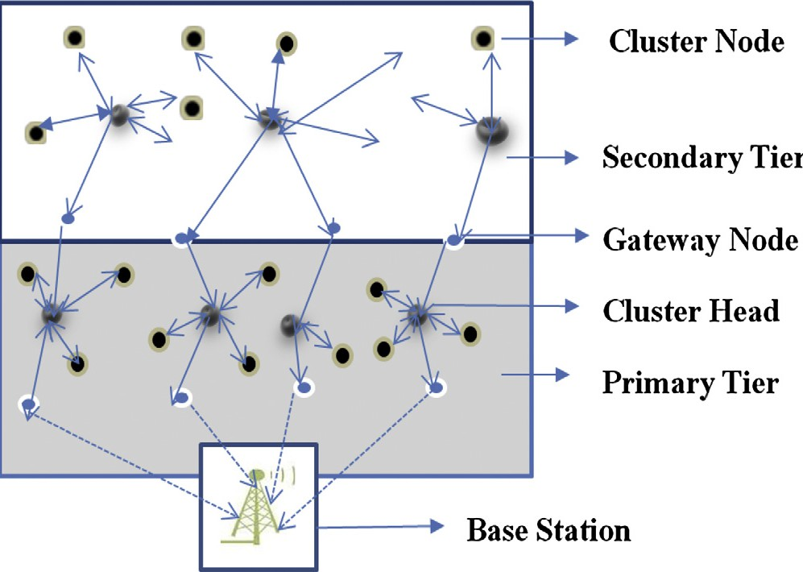

Figure 1 Clustering structure of DCHS scheme.

for finding first CHs. Similarly, the BS computes the average RSSI level of all nodes and identifies the set of cluster head nodes in the secondary tier T2. Hence the proposed DCHS scheme always tries to minimize the transmission distance among the base station, primary tier, and secondary tier.

* + 1. *Data Communication Phase*

This is the cluster formation phase. The base station broad- casts the message to all the sensor nodes for giving information about the newly elected cluster head. The nearby nodes send Join Request message to CH and CH acknowledges the com- mitment and forms a cluster. In primary tier, each CH elects one gateway node G1 to ensure that G1 is closer to the base station. Similar selection of one gateway node G2 in secondary tier made so that G2 is closer to the boundary between primary and secondary tiers. Now CH allocates TDMA schedule to each node in the cluster for transmitting data. During the allot- ted time slot cluster node will send the data. Now the cluster head aggregates and compresses the data gathered from cluster nodes. The CH will forward the compressed data to the gate- way nodes G1 if the CH belongs to the primary tier or else, to the gateway nodes G2.

* + 1. *IntrA-Cluster Communication Phase*

This phase mainly deals with communication among the sen- sor nodes within two tiers and re-election of cluster head. The selection of threshold value of the residual energy for clus- ter head switching is experimentally analyzed in Section 4.3 and set as half of the initial energy. If the residual energy of the current CH drops below half of the initial energy, then CH will broadcast CH_SCHEDULING message to cluster nodes through multi-casting method. This message represents, the current CH having insufficient residual energy to act as CH and immediate cluster head switching is required for prolong- ing the network lifetime. In response to the scheduling mes- sage, the cluster nodes send the parameter *Ti* which is the summation of its residual energy (*Ei*) and RSSI level (*Ri*) to the CH. Now the cluster head calculates the threshold value *T*CH(*i*) for identifying the next cluster head. The threshold value for becoming next CH can be expressed by

1. Experimental setup and analysis

The performance of the proposed system was estimated in two phases. In the first phase, the real time experimental setup was constructed to find the communication distance between two sensor nodes based on RSSI values. In second phase the pro- posed DCHS scheme was evaluated through simulation model by incorporating the RSSI value obtained from real time empirical values (first phase results).

* 1. *Phase a*

Since the WSN nodes are equipped with RF transceiver which has both transmission and receiving capabilities, the communi- cation distance can be estimated between the sensor nodes through received signal strength indication. A hardware plat- form consisting of MSP430F149 processor and CC2500 (RF transceiver) was developed for the experimental setup.

The CC2500 has built-in RSSI and gives an analog output signal at the RSSI pin [18]. In this work, the RSSI value was measured with nine wireless sensor nodes. The first node N1 was attached with PC through the serial port and the remain- ing eight nodes (N2–N9) were placed in various distances with different step angles as shown in Fig. 3. The sensor node N1 was programmed as transmitting node to send data packet through CC2500 transceiver and the rest of the nodes (N2– N9) were programmed as receiving nodes to collect the packet. The program was written for MSP430F149 processor to receive the RSSI values and displayed with command prompt. This experiment was carried out in an open space within B.S.Abdur Rahman University campus with good line of sight. The actual RSSI value is an 8 bit hexadecimal number and can be read from the RSSI status register [19]. The CC2500 datasheet says that the real RSSI value is a 2’s complement of the RSSI register value. The following procedure can be used to convert the RSSI reading to an absolute power level

(RSSI_dBm):

*T*CH(*i*) =

*n*

*i*=1

X

(*Ei* + *Ri*) (5)

*n*

1. When CC2500 is in receiving mode, get RSSI value from RSSI status register.
2. Convert the reading from a hexadecimal number to a decimal number.

(RSSI_dec).

1. If (RSSI_dec P 128).

RSSI_dBm = (RSSI_dec — 256)/2 — RSSI_offset.

1. Else if (RSSI_dec < 128).

RSSI_dBm = (RSSI_dec)/2 — RSSI_offset.

where *n* is the total number of nodes in the cluster. Now the

current CH compares the *T*CH(*i*) with *Ti* value for each node.

The node which has *Ti*

value nearer to *T*

CH(*i*)

will be elected

as the next CH. The intimation of new CH to cluster nodes fol- lows the similar procedure as in IECC phase.

Fig. 2 shows the flowchart of the initial cluster formation in the IECC phase for the proposed DCHS scheme. The initial CH selection is made on the basis of its proximity to the final mean of RSSI value of all the sensor nodes. Now the base sta- tion segregates the nodes in primary tier or secondary tier by checking whether the sensor node’s RSSI value is greater than the mean RSSI of all the sensor nodes. Since it is assumed that initial energy level of a sensor node is same for all the nodes, the residual energy level parameter is not considered at the IECC phase. This also reduces the computation overhead to the sensor nodes. After the cluster architecture has been formed the base station broadcasts the routing information to all the sensor nodes.

where RSSI_offset is a typical value corresponding to the data rate supplied by the manufacturer. The CC2500 is programmed for the operation at 250 kb/s; therefore, RSSI_offset = 72. [19]. In order to get the accurate measure- ment of RSSI value, about eight such values were taken for each distance with various step angles as shown in Table 1. The mean value of RSSI for each distance is taken as the final signal strength for accuracy. It can be observed from the table that as the distance increases RSSI value decreases which implies the nearer the node, the stronger will be the received signal strength.

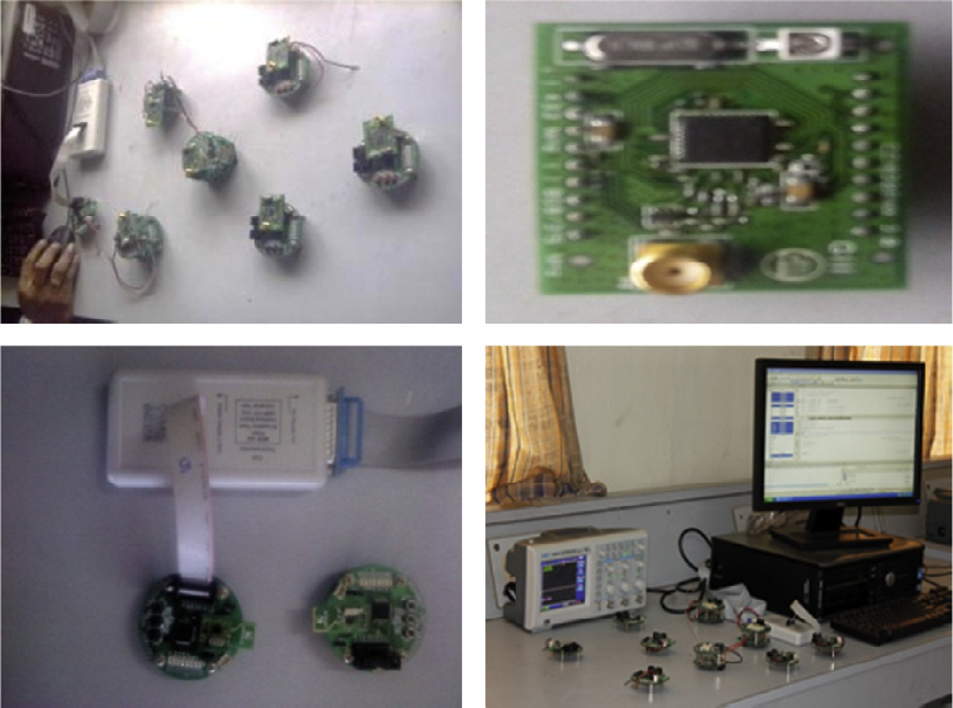

Nodes RSSI close to mean (RSSI) T1 are elected as CH and nodes having highest RSSI among T1 are elected as Gateway nodes

Compute mean RSSI among the primary tier nodes (RSSI) T1

Nodes RSSI close to mean (RSSI)T2 are elected as CH and nodes having highest RSSI among T2 are elected as Gateway nodes

Compute mean RSSI among the secondary tier nodes (RSSI)T2

Yes

IS

(RSSI)n > (RSSI)m

No

Node belongs to Secondary tier (T2)

Node belongs to Primary Tier (T1)

Base Station creates Look up table with sensor node ID and its corresponding RSSI values (RSSI)n, also computes the mean of RSSI values (RSSI)m

Sensor Nodes send beacon signals to Base Station and receives RSSI values of all the sensor nodes

End

Figure 2 Flowchart for CH and gateway node selection.

Start

Figure 3 Experimental setup.

|  |  |  |  |  |  |  |  |  |  |  |
| --- | --- | --- | --- | --- | --- | --- | --- | --- | --- | --- |
| Table 1 Measurement of RSSI values for various distances and step angles. | | | | | | | | | | |
| Step angle | RSSI (dbm) |  |  |  |  |  |  |  |  |  |
|  | 2m | 4 m | 7m | 9m | 12 m | 15m | 20 m | 30m | 40 m | 50m |
| 45° | —58.11 | —60.57 | —64.43 | —67.19 | —69.95 | —73.15 | —77.20 | —84.91 | —89.13 | —95.91 |
| 90° | —59.55 | —60.41 | —63.97 | —67.95 | —69.15 | —73.95 | —77.55 | —83.55 | —90.10 | —96.16 |
| 135° | —58.12 | —61.13 | —64.10 | —67.20 | —69.88 | —74.10 | —78.10 | —84.90 | —89.55 | —95.52 |
| 180° | —57.11 | —60.98 | —63.87 | —67.55 | —70.12 | —73.23 | —77.41 | —83.99 | —89.99 | —95.36 |
| 225° | —59.49 | —60.15 | —64.18 | —68.12 | —70.15 | —73.54 | —78.20 | —84.56 | —90.55 | —94.98 |
| 270° | —58.10 | —61.54 | —63.99 | —67.35 | —70.20 | —73.99 | —77.65 | —85.98 | —91.10 | —96.12 |
| 315° | —58.14 | —60.78 | —64.30 | —68.10 | —69.55 | —74.11 | —77.59 | —85.55 | —90.55 | —95.55 |
| 360° | —58.13 | —60.74 | —64.43 | —67.11 | —69.16 | —73.55 | —77.25 | —85.12 | —90.12 | —95.23 |
| Mean (RSSI) | —58.34 | —60.79 | —64.16 | —67.57 | —69.77 | —73.70 | —77.62 | —84.82 | —90.14 | —95.60 |
|  |  |  |  |  |  |  |  |  |  |  |

* 1. *Phase b*

The performance of the proposed DCHS scheme was evalu- ated through simulation model. The RSSI values were measured physically from the real time experimental setup and the values were tabulated as lookup table. The lookup table shows the value of distance with respective signal strength. This lookup table is then fed as input for the sim- ulation as a separate function.

The simulator version used here is NS-2.35. A total of 100 nodes were simulated in this environment with an area of 50 * 50 m. Packet size was considered as 500 bytes. IEEE

802.11 was used as MAC protocol. The simulation was carried over a period of 200 s.

* 1. *Experimental analysis to design a threshold value for cluster head switching*

This section deals with the experimental procedure to fix the threshold value for CH switching when the current CH depletes its energy level. The trial was made to get the relation between network lifetime and percentage of residual energy for CH. In this trial, CH was located at the distance of 100 m within the sensed zone and the total number of sensors was about 200. The initial energy for all types of sensor node was taken as 2 J. Hence total energy in the network would be 400 J. The remaining simulation parameter has been taken from Table 2.

From Fig. 4, if the percentage of residual energy is 10%, the network lifetime is about 520 rounds. When the residual energy is gradually increased from 10% to 50%, the number of rounds reaches to the maximum value. From Fig. 4, it can also be observed that when the residual energy of CH is

|  |  |
| --- | --- |
| Table 2 Simulation parameters. |  |
| Parameter | Value |
| WSN area | 50 m * 50 m |
| No of WSN nodes | 100 |
| WSN node initial energy | 2 J |
| *E*elec (for Tx and Rx) | 50 * 10—9 J/bit |
| eamp | 100 * 10—12 J |
| Broadcast message size | 100 bytes |
| Packet size (sensed parameter) | 500 bytes |
|  |  |

800

700



**Number of Rounds**

600

500

400

300

200

100

0

0 20 40 60 80 100

**Percentage of Residual Energy Level of CH**

Figure 4 Relationship between lifetime and residual energy for CH.

above 50%, the lifetime of network would decrease gradually. Hence the confirmation was made to fix the threshold value for CH switching to be 50% of the initial energy and this value was considered in IACC phase.

* 1. *Results and performance analysis*

This section describes the simulation model and simulation results, and illustrates the performance analysis of DCHS scheme with the classical LEACH, HEED, and LEACH-C to observe the network lifetime. The simulation parameters used in the experimental work for the four schemes DCHS, LEACH, HEED, and LEACH-C have been shown in Table 2. The performance analysis of the proposed DCHS was estimated based on four metrics namely total network energy consumed for different rounds, first node dead, half of the node alive and total number of data received at BS.

Fig. 5 shows the total network energy plotted against each round which is the summation of residual energy at all sensor nodes. It is clear from Fig. 5 that the residual energy level of DCHS scheme is higher than those of LEACH, HEED, and LEACH-C schemes even after nine hundred runs when the number of sensor nodes is taken as 100. The proposed system always ensures that the cluster head is close to the center of the cluster by considering the final mean of RSSI and will not be elected at the border within the sensor field which can greatly reduce the transmission distance in between CH, CN, and BS. It can also avoid longer latency of data packet. Further, the gateway nodes are also elected closer to the BS to reduce the overload of CH. Thus DCHS scheme contributes a significant

250

200

**Energy in Joules**

150

100

50

0

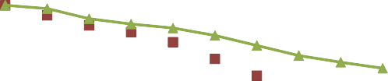

0 200 400 600 800 1000

1000

900

**850**

**901**

**590**

**320**

800

700

**No of Rounds**

600

500

400

300

200

100

**No. of Rounds**

LEACH HEED

LEACH -C DCHS

0

**LEACH HEED LEACH-C DCHS**

Figure 5 Total network energy over the simulation time.

amount of energy saving and provides better lifetime for the sensor nodes than LEACH, HEED and LEACH-C.

Fig. 6 represents results obtained from the simulation which was carried out between first node dead and number of rounds for different clustering algorithms such as LEACH, HEED, LEACH-C, and DCHS. It can be seen from Fig. 6 that the number of rounds LEACH, HEED, LEACH-C and DCHS take for first node dead is found to be 142, 241, 379, and

554 respectively. The proposed DCHS scheme takes more number of rounds for first node dead when compared with the other schemes.

Similarly Fig. 7 shows results obtained from the simulation

**Half of the Node Alive (HNDA)**

Figure 7 Half of the node alive when the number of sensor nodes = 50.

250

**No of Data received at BS**

200

150

100

50

0 200 400 600 800 1000 1200 1400 1600

which was carried out between half of the node alive and num- ber of rounds for different clustering algorithms such as

**Time in sec**

 LEACH  HEED  LEACH -C DCHS

LEACH, HEED, LEACH-C and DCHS. From Fig. 7, it is clear that the number of rounds LEACH, HEED, LEACH- C and DCHS take for half of the nodes alive is found to be 320, 590, 850, and 901 respectively. The proposed DCHS scheme takes more number of rounds for half of the node alive when compared with the other schemes. According to Figs. 6 and 7, the number of live nodes in DCHS is high when com- pared with LEACH, HEED and LEACH-C over the sim- ulation period and provides better node level energy management.

The transmission distance has been greatly reduced in the proposed scheme; there is further possibility of reducing the node energy by minimizing the transmitting power level based on the signal strength indication. Fig. 8 presents the number of data delivered to the base station. The results show that num- ber of data received at the BS in DCHS is more when com- pared with LEACH, HEED, and LEACH-C. Based on the

600

**554**

**379**

**241**

**142**

500

400

**No of Rounds**

300

200

100

0

LEACH HEED LEACH-C DCHS

**First Node Dead (FND)**

Figure 6 First node dead (FND) when the number of sensor nodes = 50.

Figure 8 Data delivery at base station.

above analysis, it is evidentially proved that the proposed DCHS achieves lower dissipation of energy, higher data deliv- ery rate, and network longevity.

1. Conclusion

The proposed distributed cluster head scheduling algorithm has significantly achieved 7.5–12% efficiency in energy con- servation as compared to LEACH-C protocol when the num- ber of rounds ranges from 500 to 700, whereas the LEACH-C protocol shows an energy efficiency of 17.5% and 39.7% as compared to HEED and LEACH protocols respectively. Hence the proposed scheme could achieve 7.5–39.7% overall reduction in consumed energy when compared with the exist- ing hierarchical protocols. The performance measure of the proposed scheme was also evaluated with the help of first node dead and half of the node alive. The first node dead was found to be 142, 241, 379 for LEACH, HEED and LEACH-C proto- cols respectively whereas DCHS took 554 rounds. Similarly, 50% of the node alive for LEACH, HEED, and LEACH-C protocol took 320, 590, 850 number of rounds whereas DCHS took 901 rounds.

The proposed DCHS uses scheduling of CH in each round on the basis of residual energy and RSSI level of the sensor nodes and outperforms the popular probabilistic clustering protocols such as LEACH, LEACH-C and HEED through fair distribution of energy load among the cluster network. Since the experimental setup involves both real time hardware and event driven simulator, the results obtained exhibit more real time behavior. In order to further increase energy effi- ciency and extend the lifetime of sensor node, node level energy

management scheme can be incorporated with DCHS scheme. Consequently, the proposed DCHS can be effectively adopted for energy sensitive applications in WSN.

Acknowledgment

The researchers record their sincere thanks to the Department of Electronics and Communication Engineering, B.S.Abdur Rahman University, Chennai, India, for their constant support and providing necessary facilities to carry out this investigation successfully.

References

1. [Akyildiz, Su W, Sankarasubramaniam Y, Cayirci E. A survey on](http://refhub.elsevier.com/S1110-8665(15)00009-2/h0005) [sensor networks. IEEE Commun Mag 2002;40(8):102–14](http://refhub.elsevier.com/S1110-8665(15)00009-2/h0005).
2. [Handy M, Haase M, Timmermann D. Low energy adaptive](http://refhub.elsevier.com/S1110-8665(15)00009-2/h0090) [clustering hierarchy with deterministic cluster head selection.](http://refhub.elsevier.com/S1110-8665(15)00009-2/h0090) [Stockholm, Sweden: IEEE MWCN; 2002](http://refhub.elsevier.com/S1110-8665(15)00009-2/h0090).
3. [Muruganathan Siva D, Daniel CFMA, Bhasin Rolly I, Fapojuwo](http://refhub.elsevier.com/S1110-8665(15)00009-2/h0010) [Abraham O. A centralized energy-efficient routing protocol for](http://refhub.elsevier.com/S1110-8665(15)00009-2/h0010) [wireless sensor networks. IEEE Radio Commun 2005;43(3):8–13](http://refhub.elsevier.com/S1110-8665(15)00009-2/h0010).
4. [Zhang Zhenghao, Ma Ming, Yang Yuanyuan. Energy-efficient](http://refhub.elsevier.com/S1110-8665(15)00009-2/h0075) [multihop polling in clusters of two-layered heterogeneous sensor](http://refhub.elsevier.com/S1110-8665(15)00009-2/h0075) [networks. IEEE Trans Comput 2008;57(2)](http://refhub.elsevier.com/S1110-8665(15)00009-2/h0075).
5. [Zong Ziliang et al. EAD and PEBD: two energy-aware duplica-](http://refhub.elsevier.com/S1110-8665(15)00009-2/h0080) [tion scheduling algorithms for parallel tasks on homogeneous](http://refhub.elsevier.com/S1110-8665(15)00009-2/h0080) [clusters. IEEE Trans Comput 2011;60(3)](http://refhub.elsevier.com/S1110-8665(15)00009-2/h0080).
6. [Wei Dali et al. An energy – efficient clustering solution for](http://refhub.elsevier.com/S1110-8665(15)00009-2/h0015) [wireless sensor networks. IEEE Trans Wireless Commun](http://refhub.elsevier.com/S1110-8665(15)00009-2/h0015) [2011;10(11)](http://refhub.elsevier.com/S1110-8665(15)00009-2/h0015).
7. [Chang, Ju. An efficient cluster-based power saving scheme for](http://refhub.elsevier.com/S1110-8665(15)00009-2/h0020) [wireless sensor networks. EURASIP J Wireless Commun Netw](http://refhub.elsevier.com/S1110-8665(15)00009-2/h0020) [2012:1–10](http://refhub.elsevier.com/S1110-8665(15)00009-2/h0020).
8. [Kianzad Vida et al. Efficient techniques for clustering and](http://refhub.elsevier.com/S1110-8665(15)00009-2/h0025) [scheduling onto embedded multiprocessors. IEEE Trans Parallel](http://refhub.elsevier.com/S1110-8665(15)00009-2/h0025) [Distrib Syst 2006;17(7)](http://refhub.elsevier.com/S1110-8665(15)00009-2/h0025).
9. [Hanza´lek Zdenek et al. Energy efficient scheduling for cluster-](http://refhub.elsevier.com/S1110-8665(15)00009-2/h0030) [tree wireless sensor networks with time-bounded data flows. IEEE](http://refhub.elsevier.com/S1110-8665(15)00009-2/h0030) [Trans Industr Inf 2010;6(3)](http://refhub.elsevier.com/S1110-8665(15)00009-2/h0030).
10. [Chamam Ali et al. On the planning of wireless sensor networks:](http://refhub.elsevier.com/S1110-8665(15)00009-2/h0035) [energy-efficient clustering under the joint routing and coverage](http://refhub.elsevier.com/S1110-8665(15)00009-2/h0035) [constraint. IEEE Trans Mob Comput 2009;8(8)](http://refhub.elsevier.com/S1110-8665(15)00009-2/h0035).
11. [Lau Erin-Ee-Lin et al. Enhanced RSSI-based high accuracy real-](http://refhub.elsevier.com/S1110-8665(15)00009-2/h0040) [time user location tracking system for indoor and outdoor](http://refhub.elsevier.com/S1110-8665(15)00009-2/h0040) [environments. Int J Smart Sens Intell Syst 2008;1(2)](http://refhub.elsevier.com/S1110-8665(15)00009-2/h0040).
12. Heinzelman W, Chandrakasan A, Balakrishnan H. Energy- efficient communication protocol for wireless micro sensor networks. In: Proceedings of the 33rd Hawaii international conference on system sciences; 2000.
13. [Heinzelman W, Chandrakasan A, Balakrishnan H. An applica-](http://refhub.elsevier.com/S1110-8665(15)00009-2/h0050) [tion specific protocol architecture for wireless microsensor](http://refhub.elsevier.com/S1110-8665(15)00009-2/h0050) [networks. IEEE Trans Wireless Commun 2002;1:660–70](http://refhub.elsevier.com/S1110-8665(15)00009-2/h0050).
14. [Younis Ossama, Fahmy Sonia. HEED: a hybrid, energy-efficient,](http://refhub.elsevier.com/S1110-8665(15)00009-2/h0055) [distributed clustering approach for ad hoc sensor networks. IEEE](http://refhub.elsevier.com/S1110-8665(15)00009-2/h0055) [Trans Mob Comput 2004;3(4)](http://refhub.elsevier.com/S1110-8665(15)00009-2/h0055).
15. [Yu Ming et al. A dynamic clustering and energy efficient routing](http://refhub.elsevier.com/S1110-8665(15)00009-2/h0060) [technique for sensor networks. IEEE Trans Wireless Commun](http://refhub.elsevier.com/S1110-8665(15)00009-2/h0060) [2007;6(8)](http://refhub.elsevier.com/S1110-8665(15)00009-2/h0060).
16. [Jung Jongsik, Park Taekeun, Kim Cheeha. A forwarding scheme](http://refhub.elsevier.com/S1110-8665(15)00009-2/h0065) [for reliable and energy-efficient data delivery in cluster-based](http://refhub.elsevier.com/S1110-8665(15)00009-2/h0065) [sensor networks. IEEE Commun Lett 2005;9(2):112–4](http://refhub.elsevier.com/S1110-8665(15)00009-2/h0065).
17. [Akhtar Adeel, Minhas Abid Ali, Jabbar Sohail. Energy aware](http://refhub.elsevier.com/S1110-8665(15)00009-2/h0070) [intra cluster routing for wireless sensor networks. Int J Hybrid](http://refhub.elsevier.com/S1110-8665(15)00009-2/h0070) [Inform Technol 2010;3(1):29–48](http://refhub.elsevier.com/S1110-8665(15)00009-2/h0070).
18. [Yan Ruqiang, Sun Hanghang, Qian Yuning. Energy-aware sensor](http://refhub.elsevier.com/S1110-8665(15)00009-2/h0085) [node design with its application in wireless sensor networks. IEEE](http://refhub.elsevier.com/S1110-8665(15)00009-2/h0085) [Trans Instrum Meas 2013;62(5)](http://refhub.elsevier.com/S1110-8665(15)00009-2/h0085).
19. Low Power RF ICs – 2.4GHz-CC2500 – Texas Instruments

<<http://focus.ti.com/docs/prod/folders/print/cc2500.html>>.