[Egyptian Journal of Basic and Applied Sciences 4 (2017) 55–66](http://dx.doi.org/10.1016/j.ejbas.2016.09.005)

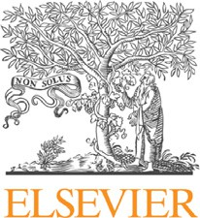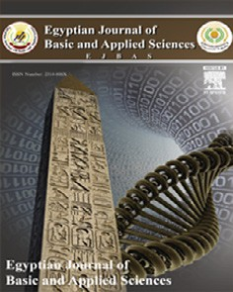

Contents lists available at [ScienceDirect](http://www.sciencedirect.com/science/journal/2314808X)

Egyptian Journal of Basic and Applied Sciences

journal homepage: [www.elsevier.com/locate/ejbas](http://www.elsevier.com/locate/ejbas)

Full Length Article

Evaluation and mapping spatial distribution of bottom sediment heavy metal contamination in Burullus Lake, Egypt



Yasser A. El-Amier a,⇑, Abdelhamid A. Elnaggar b, Muhammad A. El-Alfy c

a *Botany Department, Faculty of Science, Mansoura University, Egypt*

b *Department of Soil Science, Faculty of Agriculture, Mansoura University, Egypt*

c *Marine Pollution Department, National Institute of Oceanography and Fisheries, Egypt*

a r t i c l e i n f o

*Article history:*

Received 16 May 2016

Received in revised form 24 September 2016

Accepted 30 September 2016

Available online 1 November 2016

*Keywords:* Burullus Lake Pollution Sediments Heavy metals Indices and GIS

a b s t r a c t

Burullus Lake is one of most important lakes in north Delta of Egypt. It is exposed to huge amounts of serious pollutants especially heavy metals. The sediments within the lake aid in the dispersion of these metals. The main objectives of this research were to evaluate and map the spatial distribution of heavy metals in Burullus Lake sediments. Accordingly, 37 locations were randomly distributed within the lake. Sediment samples were taken from these locations. These samples were analyzed for seven metals including Fe, Cu, Zn, Cr, Co, Cd and Pb. Also, five indices were used to identify the status of metal pollu- tants in the Lake. These indices are: enrichment factor (EF), contamination factor (CF), degree of contam- ination (DC), pollution load index (PLI) and geo-accumulation index (I*geo*). Ordinary Kriging was used to interpolate the spatial distribution of the studied elements within the lake. The obtained results indicated that cadmium was the most enriched element in the lake sediments due to industrial and agricultural wastes drained into the lake. The I*geo* index revealed that Cd and Pb were the common pollutants in lake sediments. The DC values ranged between low (near El-Boughaz) and moderate (near drainage areas). The spatial distribution of pollutants within the lake indicated that the highly polluted areas are located close to the drains, whereas as the less polluted areas were close to El-Boughaz.

© 2016 Mansoura University. Production and hosting by Elsevier B.V. This is an open access article under

the CC BY-NC-ND license (<http://creativecommons.org/licenses/by-nc-nd/4.0/>).

1. Introduction

Burullus Lake of the central Nile Delta is a UNESCO-protected area and one of the most conspicuous wetland habitats in Egypt, which were taken into consideration according to RAMSAR convention in 1971 [1]. In the last decades, it has suffered from different types of pollutants which adversely affect its water and sediment quality.

The sediments of the aquatic environment act as major reser- voir of metals and source of contaminants. Enrichment of heavy metals due to industrialization and urbanization was recorded in the sediment of coastal areas all over the world. Sediments are not only functioning as heavy metal scavengers, but also as one of the potential sources of heavy metals to the ecosystem [2,3].

Heavy metals in high concentrations are considered as serious pollutants to aquatic ecosystems due to their high potential to enter and accumulate in the food chain [4]. Some heavy metals such as Fe, Co, Cu, and Zn are essential micronutrients for fauna and flora, but they are dangerous at high levels, whereas the most toxic heavy metals are Cr, Pb and Cd, which are considered carcinogenic elements [5]. Geographic information system (GIS)

* Corresponding author.

*E-mail address:* [yasran@mans.edu.eg](mailto:yasran@mans.edu.eg) (Y.A. El-Amier).

provides a very powerful tool for the analysis and creation of mod- els that integrate the relations between the different features on the earth’s surface and their effect on the environment. GIS can also be used to perform a number of fundamental spatial analyses and operations. Spatial distribution of some important heavy met- als is essential to assess their effects on sediments and to delineate contaminated areas [6,7].

The objectives of this work were to evaluate and study spatial distribution of heavy metals in Burullus lake sediments using GIS techniques. This is to provide decision makers with more accurate information about the status of pollution within the lake.

1. Study area

Burullus Lake is located in Kafr El-Sheikh Governorate (30° 22’ - 31° 35’N; 30° 33’ - 31° 08’E) with an area of about 460 km2. It is

situated on the eastern side of Rosetta branch of the River Nile. The lake receives an annual water volume of about 4.1 milliard cubic meters through a system of eight drains and a freshwater canal called Brinbal. The drainage system collects agricultural drai- nage water from about 998 thousand acres in the catchment area. Drainage water is discharged into the lake through a group of pumping stations at the end tail of the drains except Gharbia drain

<http://dx.doi.org/10.1016/j.ejbas.2016.09.005>

2314-808X/© 2016 Mansoura University. Production and hosting by Elsevier B.V.

This is an open access article under the CC BY-NC-ND license (<http://creativecommons.org/licenses/by-nc-nd/4.0/>).

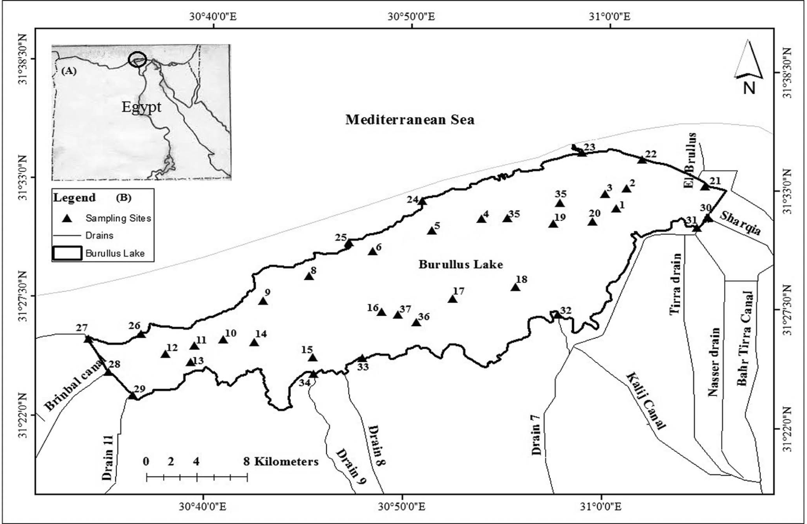

Fig. 1. Locations of (A) study area in Egypt and (B) sampling locations within the lake.

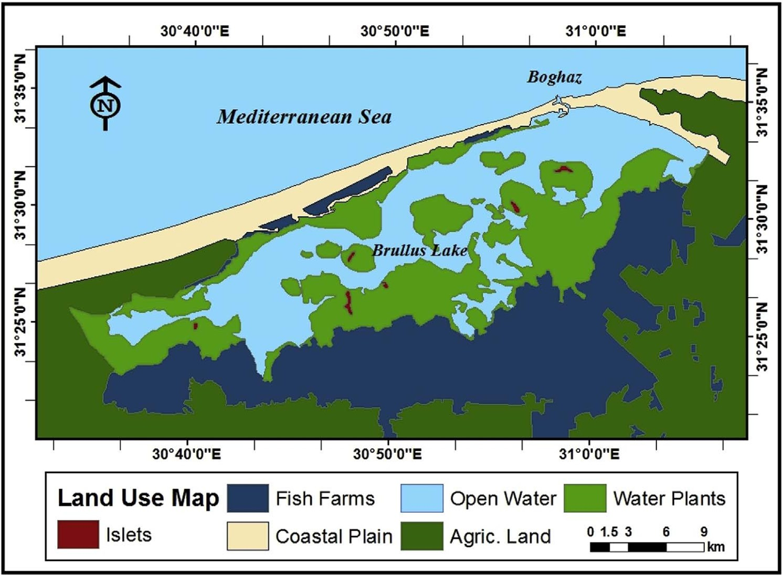

Fig. 2. Land use map of Burullus Lake area.

which discharges its water freely without pumping EMI [8]. The lake is connected to the Mediterranean Sea via Boughaz El- Burullus at the northeastern part of the Lake as illustrated in Fig. 1. The Lake is located within five districts of Kafr El-Sheikh Gover- norate. These districts are from the East to the West: Baltim, El- Hamoul, El-Riad, Sidi Salem and Metobes. The main activities of the population in and around the lake are fishing, weed cutting, grazing and agriculture. In the last decade, fish farms were devel- oped at the lake shores and they represent one of the most com- mon activities in the studied area. Fig. 2 shows the land use map within and around the studied area. This map was created based on Landsat 8 image acquired in August, 2015 and verified in the

field.

1. Materials and methods
   1. *Heavy metals analyses in sediments*

Thirty seven georeferenced sediment samples were collected using a Van-Veen grab coated with polyethylene [9]. Sub- samples were taken from the central part of the grab to avoid con- tamination. These samples were kept in self-sealed acid pre-cleaned plastic bags, rinsed with metal-free water. They were deep-frozen until analysis. They were dried in the oven at 70 oC, sieved using

0.75 mm plastic sieve, and stored for subsequent analyses. One gram of each sample was digested for about two hours in a mixture of

3:2:1 nitric acid (HNO3), perchloric acid (HClO4) and hydrofluoric acid (HF), as described by Oregioni and Aston [10]. Seven heavy met- als (Cu, Pb, Cd, Cr, Zn, Fe and Co) were measured in the digestion extract using Atomic Absorption Spectrophotometer (ASS). The con-

centrations of these metals were expressed as mg g—1.

* 1. *Indices of heavy metals*

Five indices were used to evaluate the status of the studied pol- lutants within the lake; these indices are described in Table 1:

* 1. *Statistical analysis*

The data of the different ecological habitats were compared using one-way ANOVA, which was conducted using the COSTAT program package.

* 1. *Geostatistics*

Kriging was used in this study to estimate the value of a random variable Z at one or more un-sampled points or locations, from more or less sparse sample data on a given support say:

{z(x1),.. ., z(xn)} at {x1,.. .,xn}.

Different kinds of Kriging methods exist, which pertain to the assumptions about the mean structure of the model: E [Z(x)] = m(x).

Table 1

The description of used indices of metals.

Indices Purposes Methods References

1. Enrichment factor (EF)
2. Contamination factor (CF)
3. Pollution Load Index (PLI)
4. Degree of contamination (DC)
5. Geo-

accumulation index (I*geo*)

* An effective tool to evaluate the magnitude of contaminants in the environment.
* Iron used as a conservative tracer to distinguish natural from anthropogenic components.

EF < 2 = natural EF>2 = anthropogenic Categories of EF:

≤1 = background concentration

1–2 = depletion to minimal enrichment

2–5 = moderate 5–20 = significant 20–40 = very high

>40 = extremely high

To find the contamination level of a metal. Categories of CF:

<1 = low CF 1–3 = moderate CF 3–6 = considerable CF

≥6 = very high

Provides some understanding to the public of the area about the

quantity of a component in the environment. Categories of PLI:

>1 = polluted

< 1 = no pollution

The sum of all contamination factors for a given site. Categories of DC:

<n (low DC)

n ≤ Dc < 2n (moderate DC) 2n ≤ Dc < 4n (considerable DC) Dc > 4n (very high DC)

To determine and define the metal contamination in sediments by comparing current concentrations with pre-industrial levels.

Categories of I*geo*:

I*geo* ≤ 0 (unpolluted)

0< I*geo* ≤ 1 (unpolluted to moderately polluted) 1< I*geo* ≤ 2 (moderately polluted)

2< I*geo* ≤ 3 (moderately to strongly polluted) 3< I*geo* ≤ 4 (strongly polluted)

4< I*geo* ≤ 5 (strongly to extremely polluted)

I*geo* (extremely polluted)

(M/Fe),sample

(M/Fe),background

EF =

Where:

(M/Fe) the ratio of metal and Fe concentrations of the sample, (M/ Fe) crust is the ratio of metal and Fe concentrations of a background. Where, M is the concentration of metal. The background value is that of average shale

C,metal

*CF* = C

,background

C metal: concentration of metal

C background: concentration of metal in average shale

*PLI* = *CF*1 * *CF*2 * *CF*3 * .. . *CFn*)1/n

n = number of metals (7 here)

CF = contamination factor

*DC* = X *CFi*

*n*

*i*=1

CF is the single CF

n = no. of metals

I*geo* = *log*2(1 *Cn* )

.5,*Bn*

C*n* is the measured concentration of heavy metals in sediments.

B*n* is the geochemical background value in average shale of element n.

1.5 is the background matrix correction

[11–13]

[13,14]

[14,15]

[16]

[17–19]

Table 2

Concentrations of heavy metals in four ecological habitats and their shale average, mean, least significant difference (LSD), and F-value.

|  |  |  |  |  |  |  |  |  |
| --- | --- | --- | --- | --- | --- | --- | --- | --- |
| Metal | Average shale | Ecological habitats | Mean | | | | LSD | F-Value |
|  |  | Open water | Shores | Drains | Islets | (n = 34) |  |  |
|  |  | (n = 20) | (n = 5) | (n = 9) | (n = 3) |  |  |  |
| Fe | 47,200 | 648.39a ± 1.45 | 632.53a ± 10.90 | 649.67a ± 3.72 | 576.06b ± 16.85 | 626.66 ± 8.23 | 42.05 | 7.92** |
| Zn | 95 | 129.23a ± 1.42 | 57.35a ± 6.49 | 65.29a ± 17.08 | 48.50a ± 20.01 | 75.09 ± 16.25 | 47.45 | 0.2ns |
| Cr | 90 | 71.51a ± 2.97 | 42.38b ± 13.32 | 80.97a,b ± 5.16 | 20.81c ± 5.64 | 53.91 ± 6.77 | 20.73 | 17.42*** |
| Cu | 45 | 32.06a ± 1.85 | 15.24b ± 4.19 | 38.45ab ± 7.71 | 8.70b ± 2.88 | 23.61 ± 4.16 | 17.38 | 6.82* |
| Co | 19 | 30.31a ± 2.79 | 11.52ab ± 3.71 | 26.64ab ± 6.25 | 7.16b ± 4.31 | 18.91 ± 4.27 | 37.47 | 2.06ns |
| Pb | 20 | 16.46a ± 0.82 | 15.05a ± 1.79 | 25.05a ± 3.19 | 34.56a ± 24.84 | 22.78 ± 7.66 | 41.66 | 0.67ns |
| Cd | 0.3 | 0.89a ± 0.07 | 0.21a ± 0.13 | 0.74a ± 0.11 | 0.91a ± 0.13 | 0.69 ± 0.11 | 0.68 | 1.62ns |

Different superscript letters (a–c) indicate significant differences (P ≤ 0.05) between heavy metals in different ecological sites. ns = not significant at P < 0.05.

* Values are significant at P < 0.05.

** Values are significant at P < 0.01.

*** Values are significant at P < 0.001.

for m(x), then Z(x) — m(x) is intrinsically stationary (or even weakly Z(x) is not intrinsically stationary. Having a deterministic model stationary).

# X

*n*

studied metals is in the highly significant category except for Cobalt, which ranged from moderate to extremely highly signifi- cant enrichment. Most of these metals come from the surrounding anthropogenic activities. The sequence of EF for heavy metals in

# Z(x0)— l =

(or)

*n*

*i*=1

# k*i*(Z(xi)— l)+ E(x0)

*n*

the sediments of Burullus Lake is in the following order: Cd>Pb> Zn>Co>Cu>Cr. This indicates that cadmium was more abundant when compared with the other metals, whereas Chromium had

the lowest appearance.

# Z(x0)= X k*i*(Z(xi)+ l(1 — X k*i*)+ E(x0)

*i*=1

*i*=1

*4.2.2. Contamination factor (CF)*

We filter the unknown mean by requiring that the Kriging weights sum to 1, leading to the ordinary kriging estimator:

Data represented in Table 4 and illustrated in Fig. 6 indicate that the CF for Fe is (<1) in all of the studied locations, which resides in

*n n* the low category. The CF for Cu was low in all of the studied loca-

# Z(x0)= X k*i*(Z(xi)+ E(x0) subject to X k*i* = 1

tions except those sites close to Baltim City, El-Hoks Drain, Drain

*i*=1

*i*=1

(7) and Drain (8), which were in the moderate category. The CF

The spatial distribution of heavy metals in the sediment sam- ples of Burullus Lake was carried using Kriging model in ArcGIS (10.1) program [20], as it used to develop prediction maps for the measured elements.

1. Results
   1. *Heavy metals concentration*

The concentrations of seven heavy metals in four ecological habitats are shown in Table 2. Chromium had the highest signifi- cant correlations (P < 0.05) among these habitats. The highest con-

centration of Cr was recorded in lake open water habitat (71.51 mg/g), whereas the lowest concentration was obtained in the Lake Islets habitat (20.81 mg/g). Moderate variations were observed in iron,

where Fe ranged between 576 and 648 mg/g. On the other hand,

Cu showed a low significance correlation among the different habi- tats. The lowest concentration of Cu was 8.7 in Lake Islets, whereas the highest concentration was 38.45 mg/g in the drains. No signifi- cance correlations were observed among the different habitats

regarding Zn, Co, Pb and Cd. The spatial distribution of these metals is illustrated in Figs. 3 and 4.

* 1. *Heavy metals indices in the sediments of Burullus Lake*
     1. *Enrichment factor (EF)*

The results of Enrichment Factor of heavy metals in Burullus Lake sediments are represented in Table 3 and illustrated in Fig. 5. They indicate that the EF of Cu ranged from 6.26 to 117, which is significant to extremely high enrichment, respectively. The EF for Zn ranged between 10.88 and 253, which is significant to extre- mely high enrichment. The EF of Cr varied from 13.24 to 79.5, which is significant to extremely high enrichment. The EF of Pb varied from 14.80 to 326, from 2 to 260 for Co, and from 62.69 to 393.37 for Cd. These results indicate that the EF for all of the

for Zn was low in some locations and moderate at Megataa, El-Zanqa, Mastrouh, El-Shakhloba, Drain (7) and Bar Bahry. How- ever, a significant contamination factor was shown at El-Bellaq and Abou Amer areas. The Cr had a low CF in most of the studied locations, whereas it had moderate values at El-Hoks Drain, Drain

(7) and Drain (8). The CF for Pb ranged between low and moderate at Abou Amer, Bashroush, near Drain 7, West El-Burullus Drain, Brinbal Canal, Elhoks, Houis Elkashaa, Tirra Drain and El-Shakhlouba Drain. However, it had a significantly high CF at El-Kome El-Akhdr Islet. The CF for Co varied also from low to mod- erate; however it was significantly high at El-Mahgra and Brinbal Canal. The CF was moderate for Cd in most of the studied locations, whereas it was highly significant especially at Abou Amer, Elberka El-Gharbia, El-Burullus area, N/W El-Burullus, near El-Shakhlouba, Bashroush, El-Mahgra, Brinbal Canal, Elhoks, El-Shakhlouba Drain and Megataa Islet.

* + 1. *The pollution load index (PLI) and degree of contamination (DC)* Both the PLI and DC results in the studied location within Burul- lus Lake are represented in Table 4 and Fig. 7. The PLI values were

<1 in the Lake, which indicates no significant pollution. On the other hand, the results of DC revealed low to moderate degree of contamination. The spatial distribution of DC for heavy metals in the Burullus Lake sediments is illustrated in Fig. 8.

* + 1. *Geo-accumulation index (Igeo)*

The results of I*geo* are as shown in Table 5 and illustrated in Fig. 9. The negative values of Fe depending on the classification of Muller [17] indicated that the Lake is not polluted with this metal. I*geo* values of lead showed moderate pollution at West El-Burullus Drain, Brinbal Canal, Elhoks and El Kome El-Akhdar Islet. For cobalt, the values of I*geo* showed moderate pollution degree at El-Burullus area, nearby Baltim City, Elbellaq, northwest of El-Burullus area, El-Maqsaba, El-Berka El-Gharbia, the sites in the southern part of the Lake, Bashroush, El-Mahgra, Brinbal Canal

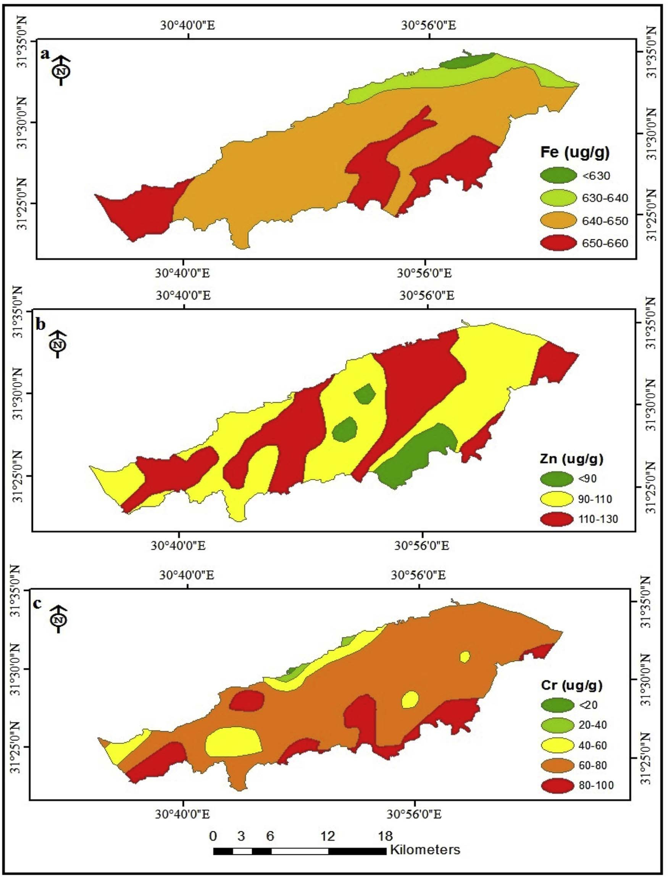

Fig. 3. Spatial distribution of (a) Fe, (b) Zn and (c) Cr in Burullus Lake sediments.

and Tirra Drain. For cadmium, the values of I*geo* showed moderate pollution degree except sites nos. 6, 20, 21, 23 and 27. The I*geo* values of zinc showed moderate degree of pollution as well at El-Bellaq, Megataa, near El-Shakhlouba, south/west El-Kome El-Akhdar and nearby El-Boughaz, whereas the I*geo* values of cop- per showed moderate pollution degree only at Drain 7.

1. Discussion

The distribution of heavy metals in lakes depends on some fac- tors such as hydrosoil texture, characteristics, amount and type of input water. High concentrations of heavy metals in Burullus Lake exist at locations near drains in the southern parts of the lake,

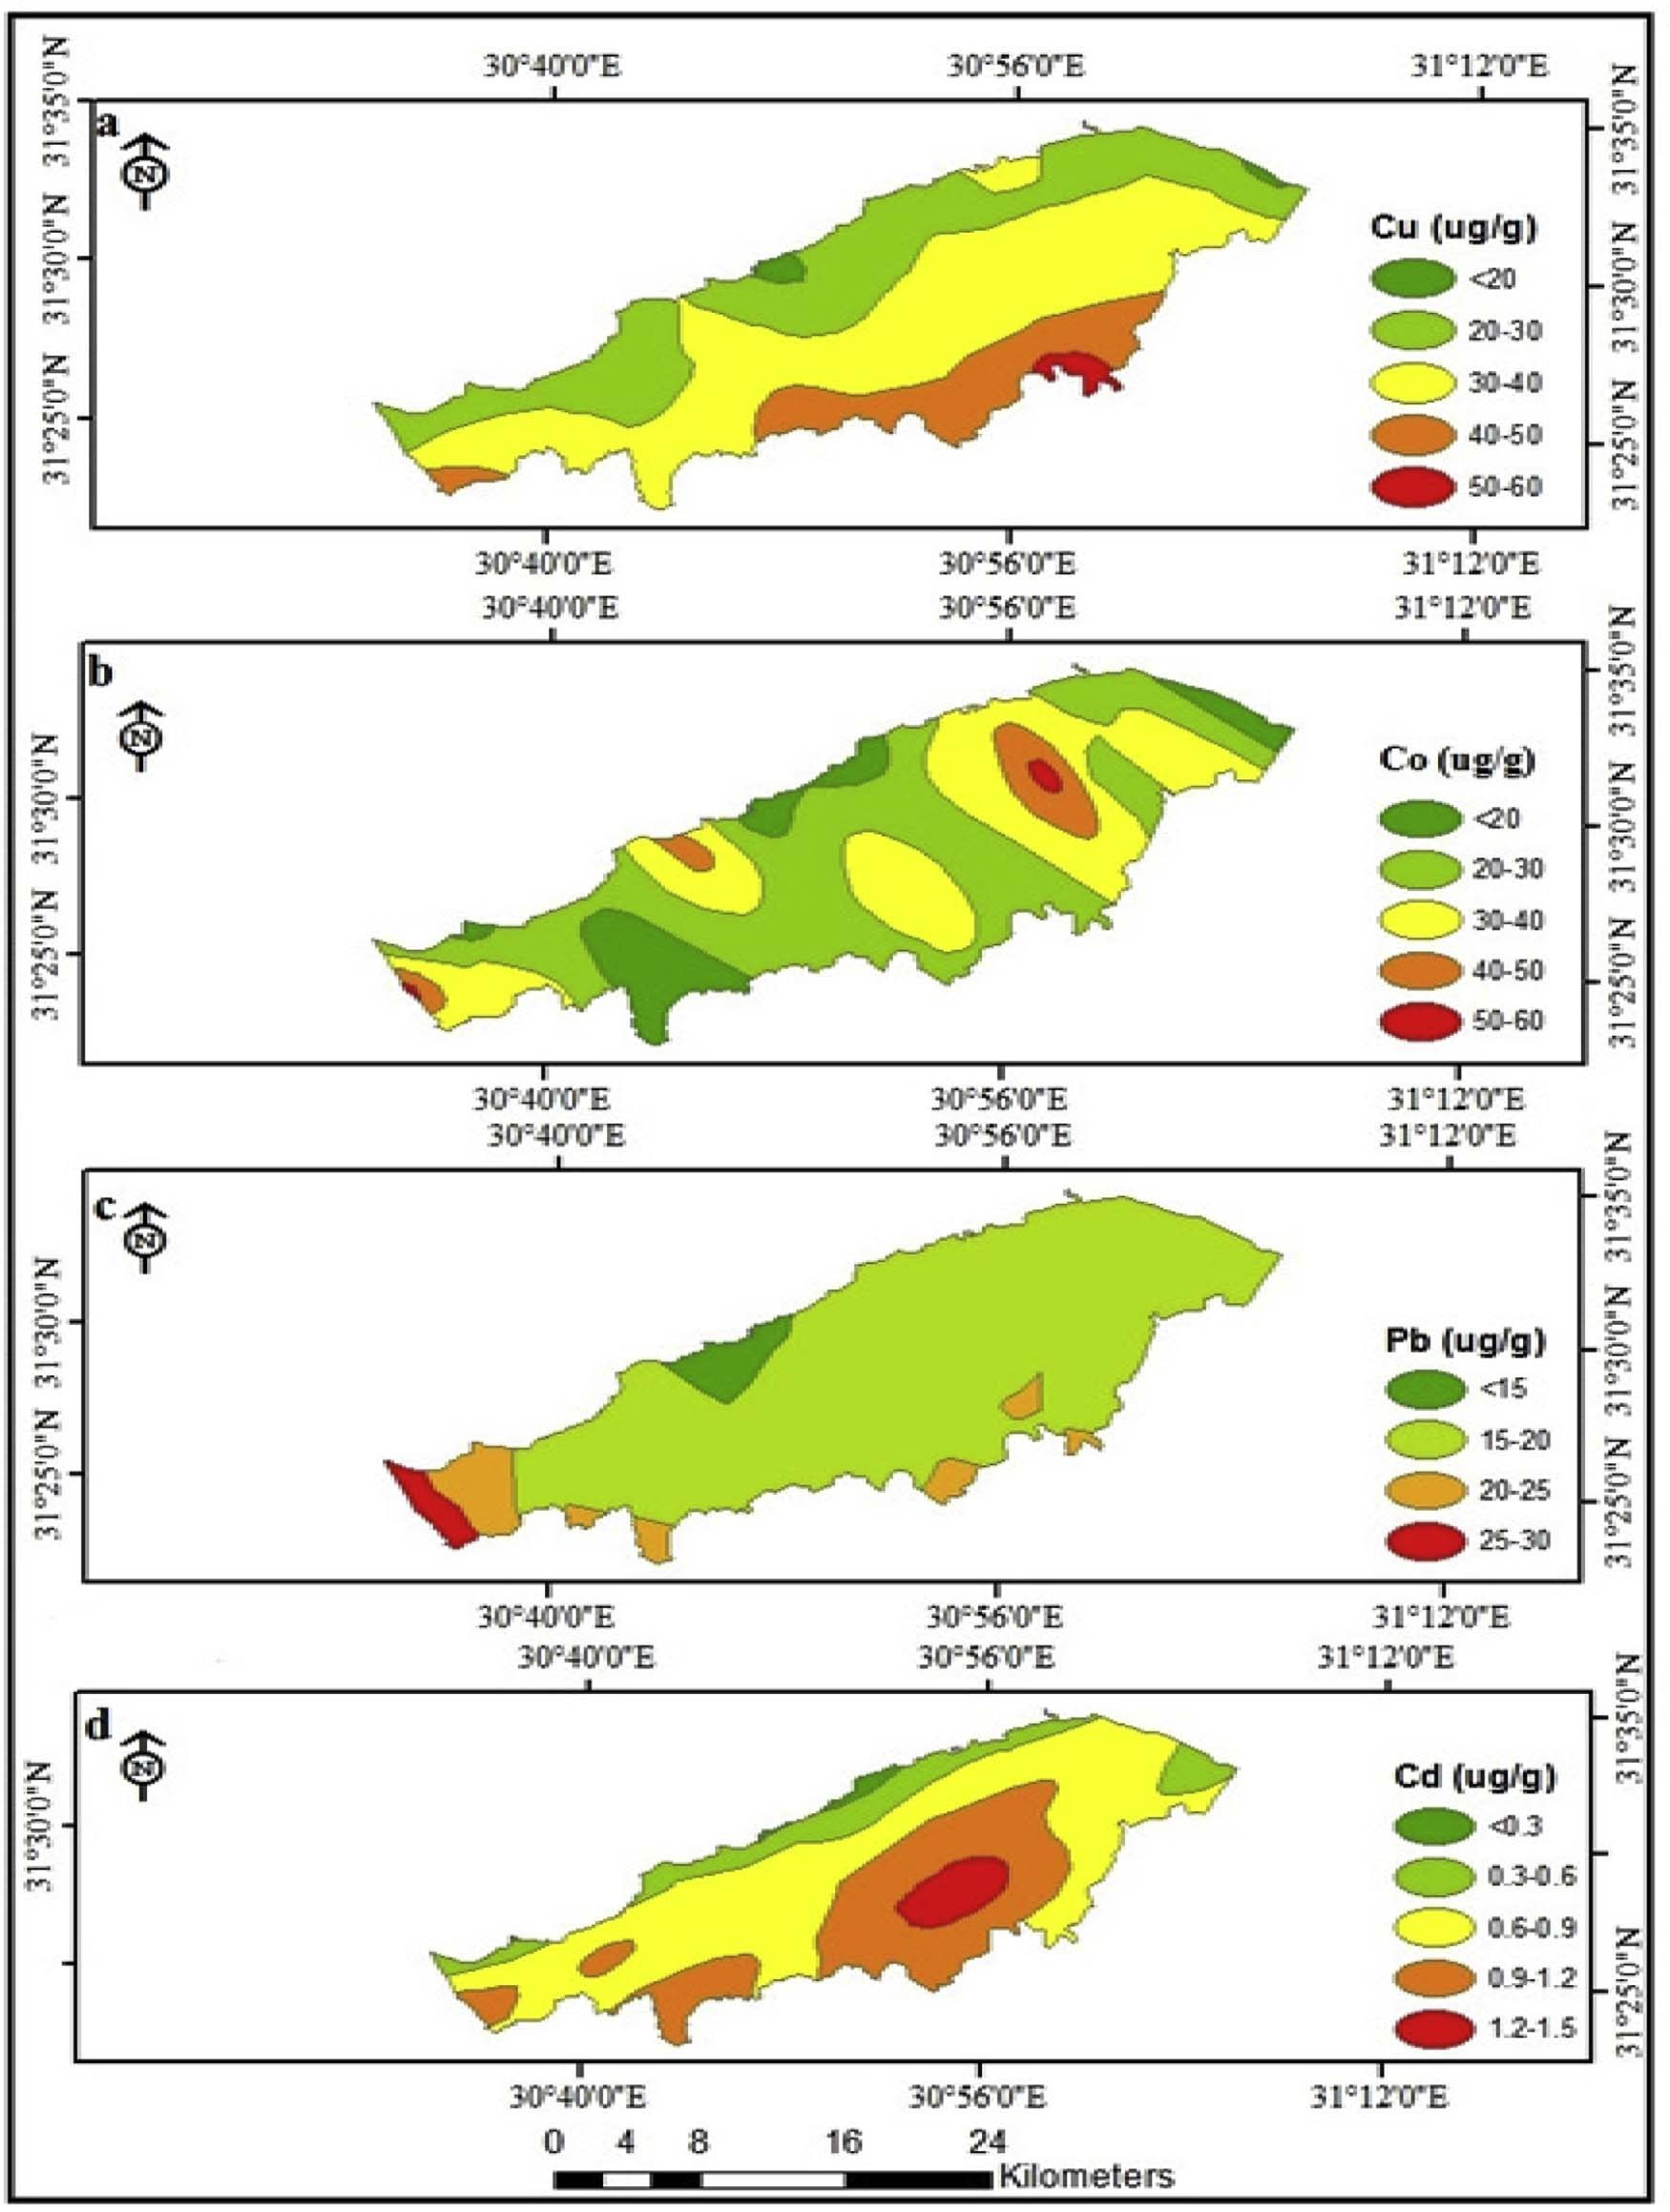

Fig. 4. Spatial distribution of (a) Cu, (b) Co, (c) Pb and (d) Cd in Burullus Lake sediments.

which are dominated by fine sediments. On the other hand, middle and northern parts of the lake are coarser in texture. These areas also have high contents of carbonate and low contents of organic carbon [21]. The studied heavy metals in Burullus Lake sediments are in the following order: Fe > Zn > Cr > Cu > Pb > Co > Cd.

Iron plays an important biochemical role in the life cycles of plants and animals. It is found in organic wastes and in plant debris in sediments. The maximum value of iron (662.2 mg/g) was dis- tributed at the southern and western parts of the lake. This could

be attributed to agricultural and sewage wastes in these areas. This also could be due to the nature of sediments, which are dominated by clay particles that play an important role in the distribution pat- tern of iron as reported by Masoud et al. [22]. This value (560 mg/g)

is higher than that recorded by Basiony [23], but lower than those

observed by Masoud et al. [22], Saeed and Shaker [24] and Chen et al [25]. The lowest values of iron in the hydrosoil of Burullus Lake were recorded in lake islets far away from drains and other wastes. In contrast, the maximum values were observed in nearby

Table 3

The enrichment factor (EF) of heavy metals in the sediment samples of Burullus Lake.

S. No. Enrichment factor (EF)

|  |  |  |  |  |  |  |  |  |
| --- | --- | --- | --- | --- | --- | --- | --- | --- |
|  | Fe | Cu | Zn | Cr | Pb | Co | Cd |  |
| 1 | 1.00 | 78.30 | 51.76 | 64.16 | 60.63 | 136 | 170.09 |  |
| 2 | 1.00 | 66.71 | 41.26 | 63.17 | 64.57 | 134 | 245.91 |  |
| 3 | 1.00 | 34.93 | 252.68 | 57.57 | 57.08 | 118 | 209.34 |  |
| 4 | 1.00 | 40.70 | 141.99 | 50.26 | 52.36 | 91 | 179.17 |  |
| 5 | 1.00 | 58.23 | 43.40 | 56.66 | 67.26 | 160 | 250.80 |  |
| 6 | 1.00 | 54.34 | 43.07 | 58.75 | 36.83 | 85 | 87.09 |  |
| 7 | 1.00 | 24.12 | 97.61 | 50.58 | 56.51 | 82 | 206.55 |  |
| 8 | 1.00 | 56.95 | 48.35 | 71.40 | 63.46 | 186 | 169.17 |  |
| 9 | 1.00 | 51.21 | 163.29 | 65.43 | 53.03 | 93 | 155.76 |  |
| 10 | 1.00 | 50.82 | 270.60 | 55.20 | 81.27 | 89 | 336.96 |  |
| 11 | 1.00 | 60.97 | 45.48 | 66.05 | 66.73 | 113 | 160.75 |  |
| 12 | 1.00 | 63.42 | 46.92 | 63.31 | 60.24 | 130 | 249.01 |  |
| 13 | 1.00 | 57.10 | 47.31 | 75.35 | 45.01 | 120 | 161.63 |  |
| 14 | 1.00 | 29.69 | 140.78 | 36.52 | 42.28 | 52 | 156.23 |  |
| 15 | 1.00 | 45.62 | 127.89 | 46.79 | 65.78 | 75 | 294.24 |  |
| 16 | 1.00 | 55.77 | 48.87 | 55.39 | 51.26 | 92 | 186.14 |  |
| 17 | 1.00 | 57.18 | 42.60 | 71.41 | 72.77 | 155 | 299.35 |  |
| 18 | 1.00 | 44.25 | 89.47 | 42.91 | 88.12 | 87 | 393.37 |  |
| 19 | 1.00 | 61.41 | 41.74 | 60.53 | 70.93 | 251 | 306.42 |  |
| 20 | 1.00 | 43.82 | 203.30 | 43.71 | 41.48 | 67 | 96.12 |  |
| 21 | 1.00 | 10.59 | 18.23 | 58.58 | 40.10 | 35 | 73.16 |  |
| 22 | 1.00 | 23.46 | 69.79 | 59.05 | 59.11 | 61 | 153.59 |  |
| 23 | 1.00 | 49.05 | 53.14 | 56.96 | 69.34 | 101 | 112.46 |  |
| 24 | 1.00 | 35.40 | 91.36 | 20.59 | 72.94 | 21 | 0.00 |  |
| 25 | 1.00 | 12.60 | 29.31 | 0.00 | 49.41 | 18 | 0.00 |  |
| 26 | 1.00 | 8.35 | 15.25 | 40.29 | 32.18 | 30 | 0.00 |  |
| 27 | 1.00 | 25.04 | 29.96 | 54.48 | 135.01 | 57 | 62.69 |  |
| 28 | 1.00 | 33.37 | 39.48 | 41.95 | 132.71 | 260 | 287.58 |  |
| 29 | 1.00 | 112.88 | 69.83 | 79.50 | 131.61 | 98 | 215.12 |  |
| 30 | 1.00 | 64.31 | 48.87 | 68.26 | 83.58 | 94 | 200.84 |  |
| 31 | 1.00 | 54.79 | 42.46 | 69.61 | 76.28 | 159 | 165.64 |  |
| 32 | 1.00 | 117.78 | 51.98 | 77.68 | 68.72 | 101 | 190.29 |  |
| 33 | 1.00 | 74.86 | 49.25 | 72.96 | 67.66 | 79 | 146.82 |  |
| 34 | 1.00 | 61.54 | 43.13 | 64.65 | 80.78 | 29 | 258.21 |  |
| 35 | 1.00 | 16.88 | 45.30 | 15.16 | 67.93 | 26 | 313.46 |  |
| 36 | 1.00 | 23.17 | 66.48 | 27.72 | 326.38 | 2 | 225.50 |  |
| 37 | 1.00 | 6.62 | 10.88 | 13.24 | 14.80 | 69 | 205.53 |  |

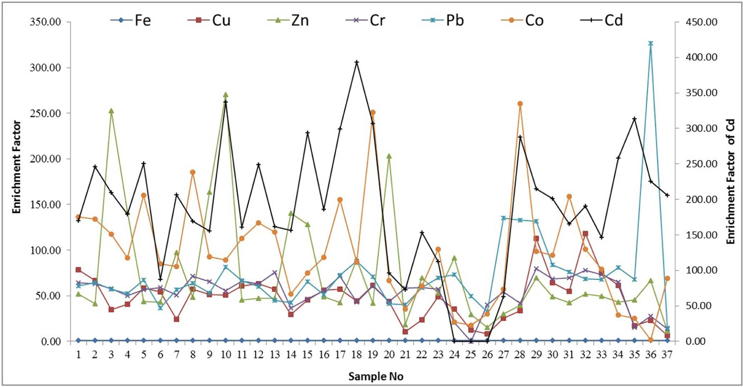

Fig. 5. The Enrichment Factor (EF) of heavy metals in the sediment samples of Burullus Lake.

Table 4

The contamination factor (CF), Pollution Load Index (PLI) and degree of contamination (DC) of sediments in Burullus Lake.

|  |  |  |  |  |  |  |  |  |  |
| --- | --- | --- | --- | --- | --- | --- | --- | --- | --- |
| No. | Contamination | factor (CF) |  |  |  |  |  | PLI | DC |
|  | Fe | Cu | Zn | Cr | Pb | Co | Cd |  |  |
| 1 | 0.014 | 1.08 | 0.71 | 0.88 | 0.84 | 1.89 | 2.35 | 0.62 | 7.79 |
| 2 | 0.014 | 0.92 | 0.57 | 0.87 | 0.89 | 1.86 | 3.42 | 0.62 | 8.58 |
| 3 | 0.014 | 0.47 | 3.46 | 0.78 | 0.78 | 1.61 | 2.87 | 0.68 | 10.0 |
| 4 | 0.014 | 0.55 | 1.94 | 0.68 | 0.71 | 1.25 | 2.45 | 0.58 | 7.63 |
| 5 | 0.014 | 0.80 | 0.60 | 0.78 | 0.93 | 2.21 | 3.47 | 0.63 | 8.83 |
| 6 | 0.014 | 0.74 | 0.59 | 0.80 | 0.50 | 1.17 | 1.19 | 0.45 | 5.03 |
| 7 | 0.014 | 0.32 | 1.33 | 0.69 | 0.77 | 1.12 | 2.82 | 0.52 | 7.08 |
| 8 | 0.014 | 0.78 | 0.67 | 0.98 | 0.87 | 2.57 | 2.34 | 0.63 | 8.26 |
| 9 | 0.014 | 0.70 | 2.24 | 0.89 | 0.72 | 1.27 | 2.13 | 0.63 | 7.99 |
| 10 | 0.014 | 0.69 | 3.70 | 0.75 | 1.11 | 1.22 | 4.61 | 0.78 | 12.1 |
| 11 | 0.014 | 0.84 | 0.62 | 0.91 | 0.92 | 1.55 | 2.22 | 0.58 | 7.10 |
| 12 | 0.014 | 0.87 | 0.64 | 0.87 | 0.82 | 1.78 | 3.42 | 0.62 | 8.44 |
| 13 | 0.014 | 0.78 | 0.65 | 1.04 | 0.62 | 1.654 | 2.23 | 0.56 | 7.00 |
| 14 | 0.013 | 0.39 | 1.88 | 0.48 | 0.56 | 0.69 | 2.09 | 0.46 | 6.14 |
| 15 | 0.014 | 0.62 | 1.74 | 0.63 | 0.89 | 1.02 | 4.00 | 0.62 | 8.93 |
| 16 | 0.014 | 0.76 | 0.67 | 0.76 | 0.70 | 1.26 | 2.55 | 0.53 | 6.74 |
| 17 | 0.014 | 0.79 | 0.59 | 0.98 | 1.00 | 2.15 | 4.14 | 0.67 | 9.69 |
| 18 | 0.014 | 0.60 | 1.21 | 0.58 | 1.19 | 1.17 | 5.35 | 0.64 | 10.14 |
| 19 | 0.014 | 0.85 | 0.58 | 0.84 | 0.99 | 3.50 | 4.28 | 0.71 | 11.0 |
| 20 | 0.014 | 0.59 | 2.74 | 0.59 | 0.56 | 0.89 | 1.30 | 0.51 | 6.71 |
| 21 | 0.013 | 0.13 | 0.24 | 0.77 | 0.52 | 0.46 | 0.96 | 0.26 | 3.12 |
| 22 | 0.013 | 0.31 | 0.94 | 0.79 | 0.79 | 0.81 | 2.07 | 0.46 | 5.76 |
| 23 | 0.013 | 0.61 | 0.67 | 0.71 | 0.87 | 1.27 | 1.42 | 0.48 | 5.59 |
| 24 | 0.013 | 0.46 | 1.21 | 0.27 | 0.96 | 0.28 | 0.00 | 0.00 | 3.22 |
| 25 | 0.014 | 0.17 | 0.39 | 0.00 | 0.67 | 0.23 | 0.00 | 0.00 | 1.50 |
| 26 | 0.014 | 0.11 | 0.21 | 0.56 | 0.45 | 0.41 | 0.00 | 0.00 | 1.78 |
| 27 | 0.014 | 0.34 | 0.41 | 0.75 | 1.86 | 0.79 | 0.86 | 0.41 | 5.06 |
| 28 | 0.014 | 0.46 | 0.54 | 0.57 | 1.832 | 3.59 | 3.97 | 0.66 | 11.0 |
| 29 | 0.014 | 1.57 | 0.97 | 1.11 | 1.838 | 1.37 | 3.00 | 0.78 | 9.89 |
| 30 | 0.014 | 0.88 | 0.67 | 0.94 | 1.156 | 1.30 | 2.77 | 0.61 | 7.76 |
| 31 | 0.014 | 0.75 | 0.58 | 0.96 | 1.053 | 2.18 | 2.28 | 0.61 | 7.85 |
| 32 | 0.014 | 1.64 | 0.72 | 1.08 | 0.960 | 1.41 | 2.65 | 0.68 | 8.49 |
| 33 | 0.014 | 1.03 | 0.68 | 1.00 | 0.934 | 1.09 | 2.02 | 0.57 | 6.79 |
| 34 | 0.014 | 0.84 | 0.59 | 0.88 | 1.109 | 0.39 | 3.54 | 0.51 | 7.39 |
| 35 | 0.012 | 0.20 | 0.55 | 0.18 | 0.830 | 0.31 | 3.83 | 0.31 | 5.93 |
| 36 | 0.013 | 0.29 | 0.85 | 0.35 | 4.183 | 0.02 | 2.89 | 0.31 | 8.61 |
| 37 | 0.012 | 0.07 | 0.12 | 0.15 | 0.171 | 0.79 | 2.38 | 0.18 | 3.72 |

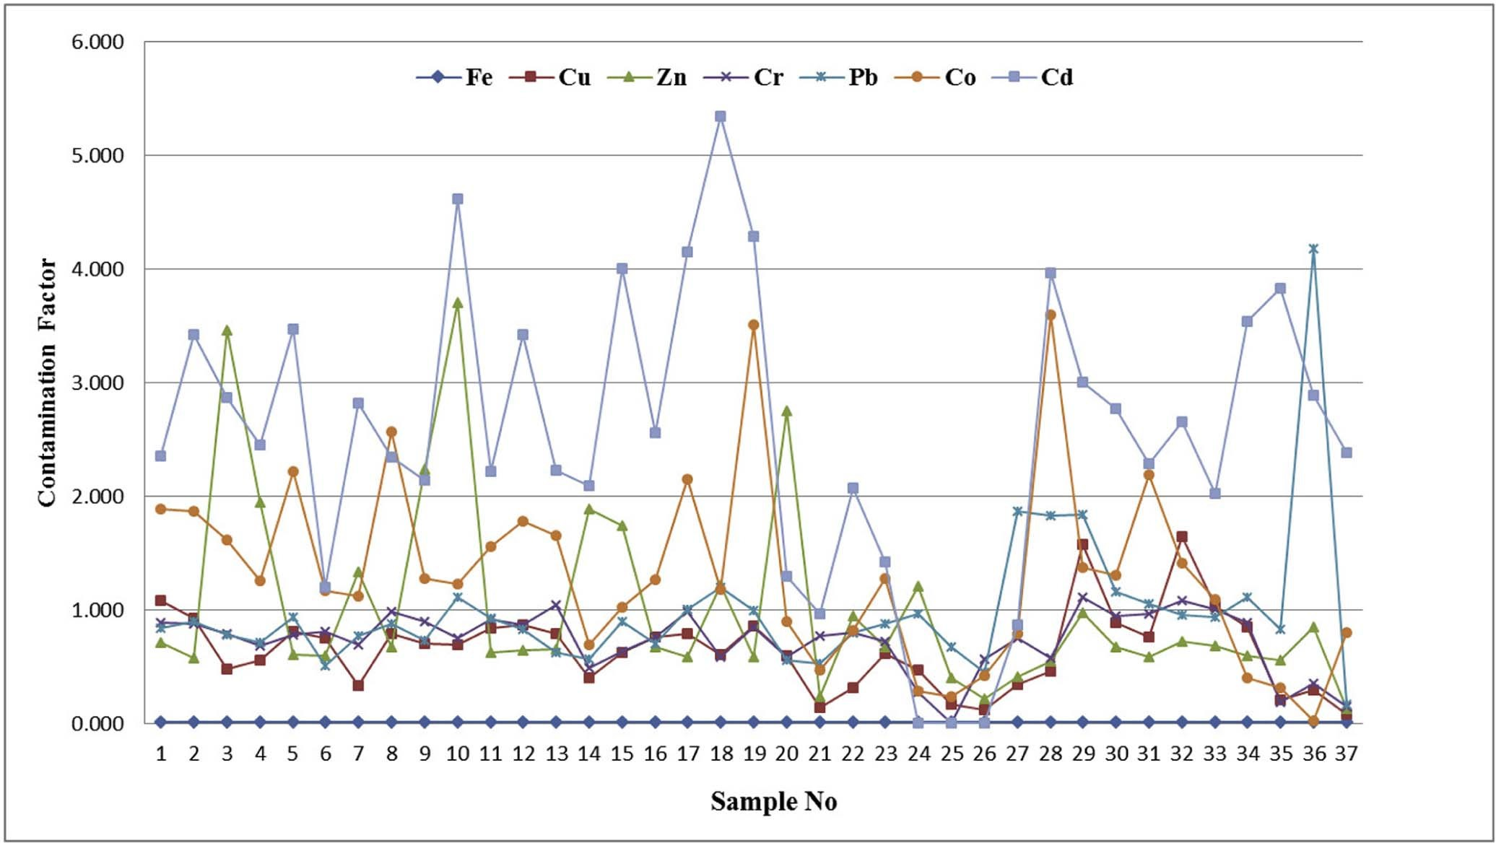

Fig. 6. The contamination factors of heavy metals in the sediment samples of Burullus Lake.

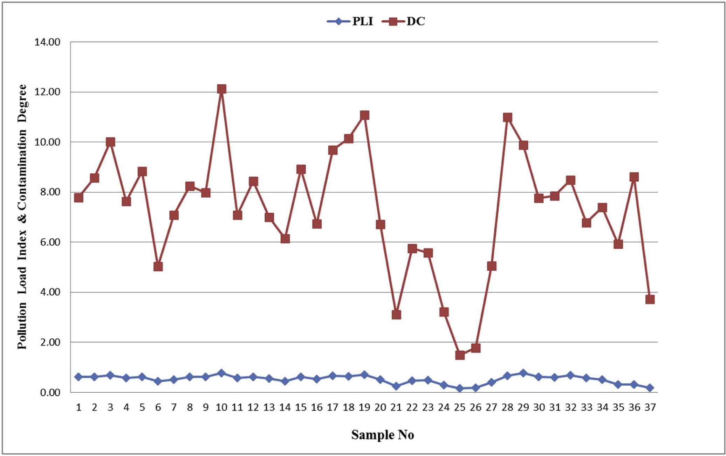

Fig. 7. The pollution load index and degree of contamination in the sediment samples of Burullus Lake.

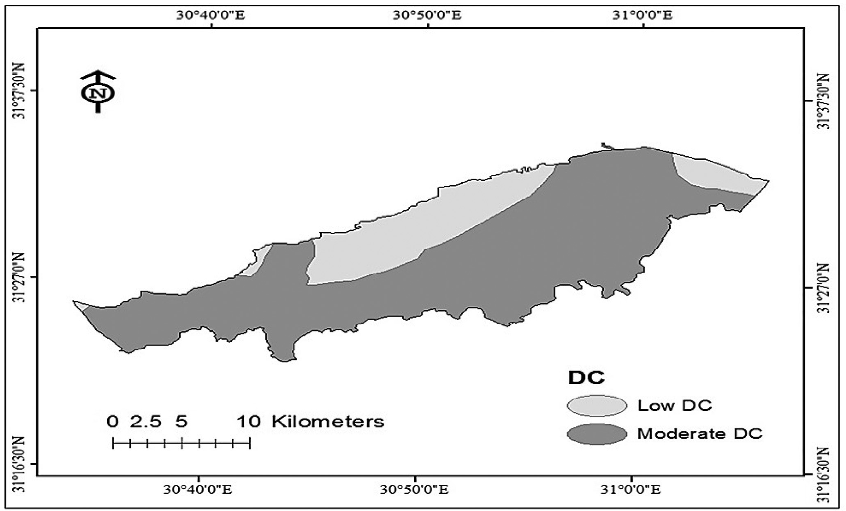

Fig. 8. The spatial distribution of contamination degree (DC) of heavy metals in the sediments of Burullus Lake.

drains; these values were higher than the limit (15 mg/g) [26]; see Appendix 1.

The highest concentration of copper (74 mg/g) was found at Drain no. 7 due to agricultural drainage. This value (45.8 mg/g) was higher than that recorded by Radwan and Lotfy [27]. On the other hand, the lowest value was observed at the lake islet where soil texture is sandy with poor organic carbon and low metals con- tent. The maximum value in the lake is within the limit (140 mg/g) of the European Union [28], but higher than that recognized by EPA (25 mg/g) [26].

The highest concentration of chromium (99.9 mg/g) was dis-

tributed at El-Hoks drain as it was described as an industrial drain which contains huge amounts of wastes that may increase the amounts of chromium in this area. However, the lowest concentra- tion of Cr was observed at El-Maqsba area far from drainage water. The values of Cr within the lake were higher than the limit value (25 mg/g) EPA [26] but within the limit value (150 mg/g) stated by

the European Union [28].

The primary anthropogenic sources of zinc in the environment (air–water–soil) are related to the use of commercial products con- taining zinc, domestic wastes and industrial effluents [29]. The highest concentration of zinc in the sediments of Burullus Lake

was estimated at Abou-Amer area (352.2 mg/g); this could be attributed to anthropogenic activities and this result is more than those (217.33, 96.5, 261.56 and 66.35 mg/g) recorded by Masoud et al. [22] and Chen et al. [25]. The minimum value of Zn was recorded at El-Kome El-Akdr Islet (11.97 mg/g); this may be attrib- uted to soil texture of Lake Islet and low content of organic matter which play an important role in various geochemical processes as

solubility, mobility, concentration and accumulation of metals [30]. The maximum value of Zn in the lake was higher than the lim- ited value (123 mg/g) of EPA [26] but within the limit stated by European Union (300 mg/g) [28].

The lowest concentration of Cd in Burullus Lake was observed

close to El-Boughaz area, whereas the highest concentrations were found next to Drain no. 7 due to the agricultural wastes. This value is lower than 4.08 and 10.35 mg/g which were recorded by Masoud et al. [22] and Radwan and Lotfy [27], but higher than that

recorded by Chen et al. [25] and Basiony [23] (0.57-0.086 mg/g). The maximum values of Cd in Burullus lake were within the limit value stated by EPA (6 mg/g) [26] and recognized by the European Union (3 mg/g) [28].

The lowest concentration of cobalt in Burullus Lake was in El-

Maksba area (4.55 mg/g), which is far away from the drains. How- ever, its concentration increased to 68.29 mg/g in the western parts of the lake, due to the drainage that flows into this part of the lake. This could be attributed to the impurities that exist in superphos- phate fertilizers that are commonly used in agricultural activities within the studied area.

Measuring enrichment factor (EF) plays an integral part in geo- chemical studies. It is generally used to differentiate between the metals originating from anthropogenic (non-crustal) and geo- genic (crustal) sources. It is also used to assess the degree of metal contamination [5,31–33]. Accordingly, to recognize the amount of anthropogenic input, enrichment factor (EF) was calculated for the studied heavy metals. The EF for these metals was in the following order: Cd > Pb > Zn > Co > Cu > Cr. This indicates that Cd is the most enriched and abundant element from anthropogenic activities

Table 5

The geo-accumulation index (I*geo)* of heavy metals in the sediments of Burullus Lake.

NO Geoaccumulation index (I*geo*)

|  |  |  |  |  |  |  |  |  |
| --- | --- | --- | --- | --- | --- | --- | --- | --- |
|  | Fe | Cu | Zn | Cr | Pb | Co | Cd |  |
| 1 | —2.03 | —0.14 | —0.32 | —0.23 | —0.25 | 0.10 | 0.20 |  |
| 2 | —2.03 | —0.21 | —0.42 | —0.23 | —0.22 | 0.09 | 0.36 |  |
| 3 | —2.04 | —0.50 | 0.36 | —0.28 | —0.28 | 0.03 | 0.28 |  |
| 4 | —2.04 | —0.43 | 0.11 | —0.34 | —0.32 | —0.08 | 0.21 |  |
| 5 | —2.03 | —0.27 | —0.40 | —0.28 | —0.21 | 0.17 | 0.36 |  |
| 6 | —2.04 | —0.30 | —0.40 | —0.27 | —0.47 | —0.11 | —0.10 |  |
| 7 | —2.04 | —0.66 | —0.05 | —0.34 | —0.29 | —0.13 | 0.27 |  |
| 8 | —2.03 | —0.28 | —0.35 | —0.18 | —0.23 | 0.23 | 0.19 |  |
| 9 | —2.04 | —0.33 | 0.17 | —0.22 | —0.31 | —0.07 | 0.15 |  |
| 10 | —2.04 | —0.33 | 0.39 | —0.30 | —0.13 | —0.09 | 0.49 |  |
| 11 | —2.04 | —0.25 | —0.38 | —0.22 | —0.21 | 0.02 | 0.17 |  |
| 12 | —2.04 | —0.24 | —0.37 | —0.24 | —0.26 | 0.08 | 0.36 |  |
| 13 | —2.04 | —0.28 | —0.36 | —0.16 | —0.38 | 0.04 | 0.17 |  |
| 14 | —2.05 | —0.58 | 0.10 | —0.49 | —0.42 | —0.33 | 0.14 |  |
| 15 | —2.04 | —0.38 | 0.06 | —0.37 | —0.22 | —0.17 | 0.43 |  |
| 16 | —2.04 | —0.29 | —0.35 | —0.29 | —0.33 | —0.07 | 0.23 |  |
| 17 | —2.03 | —0.28 | —0.41 | —0.18 | —0.17 | 0.16 | 0.44 |  |
| 18 | —2.04 | —0.40 | —0.09 | —0.41 | —0.10 | —0.11 | 0.55 |  |
| 19 | —2.03 | —0.24 | —0.41 | —0.25 | —0.18 | 0.37 | 0.46 |  |
| 20 | —2.04 | —0.40 | 0.26 | —0.40 | —0.43 | —0.22 | —0.06 |  |
| 21 | —2.06 | —1.03 | —0.80 | —0.29 | —0.45 | —0.51 | —0.19 |  |
| 22 | —2.05 | —0.68 | —0.20 | —0.27 | —0.27 | —0.26 | 0.14 |  |
| 23 | —2.07 | —0.38 | —0.35 | —0.32 | —0.23 | —0.07 | —0.02 |  |
| 24 | —2.05 | —0.50 | —0.09 | —0.74 | —0.19 | —0.72 | ND |  |
| 25 | —2.04 | —0.94 | —0.58 | ND | —0.35 | —0.80 | ND |  |
| 26 | —2.03 | —1.11 | —0.85 | —0.42 | —0.52 | —0.55 | ND |  |
| 27 | —2.04 | —0.64 | —0.56 | —0.30 | 0.09 | —0.28 | —0.24 |  |
| 28 | —2.04 | —0.51 | —0.44 | —0.41 | 0.09 | 0.38 | 0.42 |  |
| 29 | —2.03 | 0.02 | —0.19 | —0.13 | 0.09 | —0.04 | 0.30 |  |
| 30 | —2.04 | —0.23 | —0.35 | —0.20 | —0.11 | —0.06 | 0.27 |  |
| 31 | —2.04 | —0.30 | —0.41 | —0.19 | —0.15 | 0.16 | 0.18 |  |
| 32 | —2.03 | 0.04 | —0.32 | —0.14 | —0.19 | —0.03 | 0.25 |  |
| 33 | —2.04 | —0.16 | —0.34 | —0.17 | —0.21 | —0.14 | 0.13 |  |
| 34 | —2.04 | —0.25 | —0.40 | —0.23 | —0.13 | —0.58 | 0.37 |  |
| 35 | —2.09 | —0.86 | —0.43 | —0.91 | —0.26 | —0.68 | 0.41 |  |
| 36 | —2.07 | —0.70 | —0.25 | —0.63 | 0.45 | —1.86 | 0.28 |  |
| 37 | —2.11 | —1.29 | —1.08 | —0.99 | —0.94 | —0.27 | 0.20 |  |

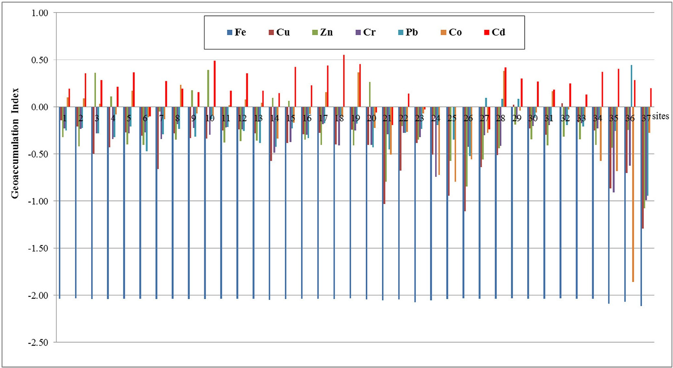

Fig. 9. The geo-accumulation index (I*geo*) for heavy metals in the sediment samples of Burullus Lake.

(e.g. chemical fertilizers and untreated wastewater from industrial and agricultural drains) in the studied area [34–36].

It is indicated that Cd is the most enriched and abundant ele- ment from anthropogenic activities; this could be attributed to phosphatic fertilizers and untreated wastewater from industrial and agricultural drains. Thus, in addition to invasion of contami- nated lake water, the application of pesticides is another probable source for sediment Cd contamination. According to Palma et al. [37], metals in sediments are divided into two important groups: first, metals that are characteristics of sediment and related with the mineralogical structure (i.e. Al, Fe, Mn and Li) and second, met- als that are related to the anthropogenic activities (i.e. Cd, Cr, Cu, Pb and Zn) and if present in high concentrations can be dangerous for the living organisms.

The pollution load index was in the range of low category as it

nomic sources in Egypt. These actions should include: pretreat- ment of wastewaters before being dumped into the lake, putting control on the additional pollutants from chemical fertilizers and pesticides to agricultural crops, renewing lake water with sea water, and incorporating the efforts of the different authorities responsible for protecting the lake.

Appendix 1. The concentrations of heavy metals in the sediments of different habitats in Burullus Lake

S. No Heavy metal in (mg/g)

Fe Zn Cr Cu Co Pb Cd

*Lake Open Water Habitat*

1 653.96 68.12 80.01 48.82 35.92 16.80 0.71

|  |  |  |  |  |  |  |  |  |
| --- | --- | --- | --- | --- | --- | --- | --- | --- |
| was lower than the baseline values; this result was less than the | 2 | 656.43 | 54.52 | 79.07 | 41.75 | 35.42 | 17.96 | 1.03 |
| findings of El-Bady [38] on his study on the region of Bahr | 3 | 647.10 | 329.10 | 71.03 | 21.55 | 30.64 | 15.65 | 0.86 |
| El-Baqar south to Manzala Lake and of Zahran et al. [39] on | 4 | 646.30 | 184.70 | 61.94 | 25.08 | 23.80 | 14.34 | 0.74 |
| Manzala Lake, which ranged between low to moderate degree of | 5 | 653.68 | 57.10 | 70.62 | 36.29 | 42.09 | 18.63 | 1.04 |
| pollution. The degree of contamination ranged between low | 6 | 648.52 | 56.22 | 72.65 | 33.60 | 22.25 | 10.12 | 0.36 |
| nearby El-Boughaz and moderate at the southern parts, attributed | 7 | 644.40 | 126.60 | 62.15 | 14.82 | 21.30 | 15.43 | 0.85 |
| to drainage water from different drains. | 8 | 653.82 | 63.63 | 89.01 | 35.50 | 48.86 | 17.58 | 0.70 |
|  | 9 | 647.48 | 212.80 | 80.78 | 31.61 | 24.17 | 14.55 | 0.64 |
| 6. Conclusion and recommendation | 10 | 646.67 | 352.20 | 68.07 | 31.33 | 23.27 | 22.27 | 1.39 |
|  | 11 | 651.83 | 59.66 | 82.09 | 37.89 | 29.63 | 18.43 | 0.67 |
| Burullus Lake is a natural protectorate in Egypt; therefore biodi- | 12 | 649.51 | 61.34 | 78.41 | 39.27 | 33.92 | 16.58 | 1.03 |
| versity has to be protected in this lake. Scenarios and strategies | 13 | 651.22 | 62.01 | 93.56 | 35.45 | 31.42 | 12.42 | 0.67 |
| used in lakes protection should be supported with modern moni- | 14 | 632.43 | 179.20 | 44.04 | 17.90 | 13.26 | 11.33 | 0.63 |
| toring and GIS techniques. Lake sediments work as important | 15 | 642.18 | 165.30 | 57.30 | 27.93 | 19.38 | 17.90 | 1.20 |
| sources of different toxic pollutants such as heavy metals which | 16 | 648.28 | 63.77 | 68.47 | 34.47 | 24.02 | 14.08 | 0.77 |
| in turn accumulate in aquatic organisms through food chains. It | 17 | 653.82 | 56.06 | 89.03 | 35.64 | 40.86 | 20.16 | 1.24 |
| was found that Cadmium was the dominant pollutant in Burullus | 18 | 641.94 | 115.60 | 52.52 | 27.08 | 22.36 | 23.97 | 1.61 |
| Lake sediments due to dumping of agricultural wastes (i.e. fertiliz- | 19 | 659.79 | 55.43 | 76.15 | 38.63 | 66.64 | 19.83 | 1.29 |
| ers and pesticides) into the lake. | 20 | 638.34 | 261.20 | 53.20 | 26.67 | 17.09 | 11.22 | 0.39 |

Accordingly, decision makers should take serious actions toward protecting Burullus Lake, which is one of the valuable eco-

(*continued on next page*)

Appendix 1 (*continued*)

S. No Heavy metal in (mg/g)

|  |  |  |  |  |  |  |  |
| --- | --- | --- | --- | --- | --- | --- | --- |
|  | Fe Zn Cr Cu | | | | Co Pb Cd | | |
| M | 648.39 | 129.23 | 71.51 | 32.06 | 30.31 | 16.46 | 0.89 |
| SE | ±1.45 | ±21.42 | ±2.97 | ±1.85 | ±2.79 | ±0.82 | ±0.07 |
| *Lake Shores Habitat* | | | | | | | |
| 1 | 637.16 | 89.50 | 71.74 | 14.25 | 15.53 | 15.96 | 0.62 |
| 2 | 595.98 | 63.75 | 64.73 | 27.87 | 24.17 | 17.51 | 0.43 |
| 3 | 625.42 | 115.00 | 24.56 | 21.11 | 5.39 | 19.33 | ND |
| 4 | 641.89 | 37.87 | ND | 7.71 | 4.55 | 13.44 | ND |
| 5 | 662.20 | 20.32 | 50.87 | 5.27 | 7.96 | 9.03 | ND |
| M | 632.53 | 65.29 | 42.38 | 15.24 | 11.52 | 15.05 | 0.21 |
| SE | ±10.90 | ±17.08 | ±13.32 | ±4.19 | ±3.71 | ±1.79 | ±0.13 |
| *Drains Habitat* | | | | | | | |
| 1 | 621.54 | 22.80 | 69.43 | 6.27 | 8.84 | 10.56 | 0.29 |
| 2 | 652.54 | 39.35 | 67.79 | 15.58 | 15.10 | 37.33 | 0.26 |
| 3 | 651.60 | 51.78 | 52.12 | 20.73 | 68.29 | 36.64 | 1.19 |
| 4 | 658.98 | 92.61 | 99.90 | 70.92 | 26.08 | 36.75 | 0.90 |
| 5 | 652.54 | 64.19 | 84.93 | 40.01 | 24.79 | 23.11 | 0.83 |
| 6 | 651.60 | 55.68 | 86.49 | 34.04 | 41.60 | 21.06 | 0.69 |
| 7 | 658.98 | 68.95 | 97.61 | 74.00 | 26.79 | 19.19 | 0.80 |
| 8 | 651.55 | 64.58 | 90.64 | 46.50 | 20.75 | 18.68 | 0.61 |
| 9 | 647.72 | 56.23 | 79.85 | 38.00 | 7.56 | 22.17 | 1.06 |
| M | 649.67 | 57.35 | 80.97 | 38.45 | 26.64 | 25.05 | 0.74 |
| SE | ±3.72 | ±6.49 | ±5.16 | ±7.71 | ±6.25 | ±3.19 | ±0.11 |
| *Lake Islets Habit*  1 576.71 | | *at*  52.58 | 16.67 | 9.28 | 5.93 | 16.60 | 1.15 |
| 2 | 604.92 | 80.94 | 31.97 | 13.36 | 0.39 | 83.66 | 0.87 |
| 3 | 546.56 | 11.97 | 13.80 | 3.45 | 15.16 | 3.43 | 0.71 |
| M | 576.06 | 48.50 | 20.81 | 8.70 | 7.16 | 34.56 | 0.91 |
| SE | ±16.85 | ±20.01 | ±5.64 | ±2.88 | ±4.31 | ±24.84 | ±0.13 |

References

1. [El-Asmar HM, Hereher ME, El Kafrawy SB. Surface area change detection of the](http://refhub.elsevier.com/S2314-808X(16)30097-5/sr0010) [Burullus Lagoon, North of the Nile Delta, Egypt, using water indices: a remote](http://refhub.elsevier.com/S2314-808X(16)30097-5/sr0010) [sensing approach. Egypt J Remote Sensing Space Sci 2013;16:119–23](http://refhub.elsevier.com/S2314-808X(16)30097-5/sr0010).
2. [Noegrohati S. Bioaccumulation dynamic of heavy metals in Oreochromis](http://refhub.elsevier.com/S2314-808X(16)30097-5/sr0015) [Nilotycus. Berkala MIPA 2006;16(2):29–40](http://refhub.elsevier.com/S2314-808X(16)30097-5/sr0015).
3. [El-Alfy MA. An integrated approach for monitoring the impact of industrial](http://refhub.elsevier.com/S2314-808X(16)30097-5/sr0020) [activities on the northeastern part of Manzala lagoon, Egypt, in Environmental](http://refhub.elsevier.com/S2314-808X(16)30097-5/sr0020) [Sciences Department, Faculty of Sciences, 2011. Mansoura University, Egypt](http://refhub.elsevier.com/S2314-808X(16)30097-5/sr0020).
4. [Erdog˘ rul Ö, Erbilir F. Heavy metal and trace elements in various fish samples](http://refhub.elsevier.com/S2314-808X(16)30097-5/sr0025) [from Sir Dam Lake, Kahramanmara](http://refhub.elsevier.com/S2314-808X(16)30097-5/sr0025) s[, Turkey. Environ Monit Assess](http://refhub.elsevier.com/S2314-808X(16)30097-5/sr0025) [2007;130:373–9](http://refhub.elsevier.com/S2314-808X(16)30097-5/sr0025).
5. [Moore F, Forghani G, Qishlaqi A. Assessment of heavy metal contamination in](http://refhub.elsevier.com/S2314-808X(16)30097-5/sr0030) [water and surface sediments of the Maharlu Saline Lake, SW Iran. Iran J Sci](http://refhub.elsevier.com/S2314-808X(16)30097-5/sr0030) [Technol Trans A 2009;33(A1):43–55](http://refhub.elsevier.com/S2314-808X(16)30097-5/sr0030).
6. [Donia N, Hussein M. Eutrophication assessment of Lake Manzala using GIS](http://refhub.elsevier.com/S2314-808X(16)30097-5/sr0035) [techniques Eighth International Water Technology Conference, IWTC8 2004,](http://refhub.elsevier.com/S2314-808X(16)30097-5/sr0035) [Alexandria, Egypt, 2004. 393–408](http://refhub.elsevier.com/S2314-808X(16)30097-5/sr0035).
7. [Omran EE, Abd El-Razek AA. Mapping and screening risk assessment of heavy](http://refhub.elsevier.com/S2314-808X(16)30097-5/sr0040) [metals concentrations in soils of the Bahr El-Baker Region, Egypt. J Soil Sci](http://refhub.elsevier.com/S2314-808X(16)30097-5/sr0040) [Environ Manag 2012;6(7):182–95](http://refhub.elsevier.com/S2314-808X(16)30097-5/sr0040).
8. [EMI. Egyptian ministry of irrigation, organization of mechanic and electricity,](http://refhub.elsevier.com/S2314-808X(16)30097-5/sr0045) [the amount of agricultural drainage water which entered the lake Burullus](http://refhub.elsevier.com/S2314-808X(16)30097-5/sr0045) [during 2012 Central administration of the Central Delta stations Kafr El-](http://refhub.elsevier.com/S2314-808X(16)30097-5/sr0045) [Sheikh, Egypt, 2012](http://refhub.elsevier.com/S2314-808X(16)30097-5/sr0045).
9. [Amini Ranjbar GH. Heavy metal concentration in surficial sediments from](http://refhub.elsevier.com/S2314-808X(16)30097-5/sr0050) [Anzali Wetland, Iran. Water Air Soil Pollut 1998;104:305–12](http://refhub.elsevier.com/S2314-808X(16)30097-5/sr0050).
10. [Oregioni B, Aston SR. The determination of selected trace metals in marine](http://refhub.elsevier.com/S2314-808X(16)30097-5/sr0055) [sediments by flameless/flam-atomic absorption spectrophotometry IAEA](http://refhub.elsevier.com/S2314-808X(16)30097-5/sr0055) [Monaco Laboratory Internal Report on Water and Sediment Quality of Al-](http://refhub.elsevier.com/S2314-808X(16)30097-5/sr0055) [Burullus Lake, Egypt. Water Resources Management II, 1984. 11](http://refhub.elsevier.com/S2314-808X(16)30097-5/sr0055).
11. [Franco-Uria A, Lopez-Mateo C, Roca E, Fernandez-Marcos ML. Source](http://refhub.elsevier.com/S2314-808X(16)30097-5/sr0060) [identification of heavy metals in pasture land by multivariate analysis in](http://refhub.elsevier.com/S2314-808X(16)30097-5/sr0060) [NW Spain. J Hazard Mater 2009;165:1008–15](http://refhub.elsevier.com/S2314-808X(16)30097-5/sr0060).
12. [Liaghati T, Preda M, Cox M. Heavy metal distribution and controlling factors](http://refhub.elsevier.com/S2314-808X(16)30097-5/sr0065) [within coastal plain sediments, Bells Creek catchments, southeast Queensland,](http://refhub.elsevier.com/S2314-808X(16)30097-5/sr0065) [Australia. Environ Int 2003;29:935–48](http://refhub.elsevier.com/S2314-808X(16)30097-5/sr0065).
13. [Turekian KK, Wedepohl KH. Distribution of the elements in some major units](http://refhub.elsevier.com/S2314-808X(16)30097-5/sr0070) [of the earth’s crust. Geol Soc Am Bull 1961;72(2):175–92](http://refhub.elsevier.com/S2314-808X(16)30097-5/sr0070).
14. [Tomlinson DC, Wilson DJ, Harris CR, Jeffrey DW. Problem in assessment of](http://refhub.elsevier.com/S2314-808X(16)30097-5/sr0075) [heavy metals in estuaries and the formation of pollution index. Helgol Wiss](http://refhub.elsevier.com/S2314-808X(16)30097-5/sr0075) [Meeresunlter 1980;33:566–75](http://refhub.elsevier.com/S2314-808X(16)30097-5/sr0075).
15. [Seshan BRR, Natesan U, Deepthi K. Geochemical and statistical approach for](http://refhub.elsevier.com/S2314-808X(16)30097-5/sr0080) [evaluation of heavy metal pollution in core sediments in southeast coast of](http://refhub.elsevier.com/S2314-808X(16)30097-5/sr0080) [India. Int J Environ Sci Technol 2010;7(2):291–306](http://refhub.elsevier.com/S2314-808X(16)30097-5/sr0080).
16. [Hökanson L. An ecological risk index for aquatic pollution control: a](http://refhub.elsevier.com/S2314-808X(16)30097-5/sr0085) [sedimentological approach. Water Res 1980;14:975–1001](http://refhub.elsevier.com/S2314-808X(16)30097-5/sr0085).
17. [Muller G. Index of geo-accumulation in sediments of the Rhine River. Geogr J](http://refhub.elsevier.com/S2314-808X(16)30097-5/sr0090) [1969;2(3):108–18](http://refhub.elsevier.com/S2314-808X(16)30097-5/sr0090).
18. [Chakravarty M, Patgiri AD. Metal pollution assessment in sediments of the](http://refhub.elsevier.com/S2314-808X(16)30097-5/sr0095) [Dikrong River, NE India. J Human Ecol 2009;27(1):63–7](http://refhub.elsevier.com/S2314-808X(16)30097-5/sr0095).
19. [Buccolieri A, Buccolieri G, Cardellicchio N, Dell’Atti A, Di Leo A, Maci A. Heavy](http://refhub.elsevier.com/S2314-808X(16)30097-5/sr0100) [metals in marine sediments of Taranto Gulf (Ionian Sea, Southern Italy). Mar](http://refhub.elsevier.com/S2314-808X(16)30097-5/sr0100) [Chem 2006;99:227–35](http://refhub.elsevier.com/S2314-808X(16)30097-5/sr0100).
20. [ESRI. ArcGIS Geostatistical Analyst Tutorial (ArcGIS®10.1) Printed in the USA,](http://refhub.elsevier.com/S2314-808X(16)30097-5/sr0105)

[2012](http://refhub.elsevier.com/S2314-808X(16)30097-5/sr0105).

1. [Franc S, Vinagre C, Cacador I, Henrique CN. Heavy metal concentrations in](http://refhub.elsevier.com/S2314-808X(16)30097-5/sr0110) [sediment, benthic invertebrates and fish in three salt marsh areas subjected to](http://refhub.elsevier.com/S2314-808X(16)30097-5/sr0110) [different pollution loads in the Tagus Estuary (Portugal). Mar Pollut Bull](http://refhub.elsevier.com/S2314-808X(16)30097-5/sr0110) [2005;50:993–1018](http://refhub.elsevier.com/S2314-808X(16)30097-5/sr0110).
2. [Masoud MS, Fahmy MA, Ali AE, Mohamed EA. Heavy metal speciation and](http://refhub.elsevier.com/S2314-808X(16)30097-5/sr0115) [their accumulation in sediments of Lake Burullus, Egypt. Afr J Environ Sci](http://refhub.elsevier.com/S2314-808X(16)30097-5/sr0115) [Technol 2011;5(4):280–98](http://refhub.elsevier.com/S2314-808X(16)30097-5/sr0115).
3. [Basiony AI. Environmental studies on heavy metals pollution and management](http://refhub.elsevier.com/S2314-808X(16)30097-5/sr0120) [of Lake Burullus, Egypt, in Faculty of Sciences, 2014. Port-Said University,](http://refhub.elsevier.com/S2314-808X(16)30097-5/sr0120) [Egypt](http://refhub.elsevier.com/S2314-808X(16)30097-5/sr0120).
4. [Saeed SM, Shaker IM. Assessment of heavy metals pollution in water and](http://refhub.elsevier.com/S2314-808X(16)30097-5/sr0125) [sediments and their effect on Oreochromis Niloticus in the Northern Delta](http://refhub.elsevier.com/S2314-808X(16)30097-5/sr0125) [Lakes, Egypt 8th International Symposium on Tilapia in Aquaculture, 2008.](http://refhub.elsevier.com/S2314-808X(16)30097-5/sr0125) [475:490](http://refhub.elsevier.com/S2314-808X(16)30097-5/sr0125).
5. [Chen Z, Salem A, Xu Z, Zhang W. Ecological implications of heavy metal](http://refhub.elsevier.com/S2314-808X(16)30097-5/sr0130) [concentrations in the sediments of Burullus lagoon of Nile Delta, Egypt](http://refhub.elsevier.com/S2314-808X(16)30097-5/sr0130) [Estuarine. Coastal and Shelf Science 2009;86:491–8](http://refhub.elsevier.com/S2314-808X(16)30097-5/sr0130).
6. [EPA. Environmental Protection Agency. National Recommended Water Quality](http://refhub.elsevier.com/S2314-808X(16)30097-5/sr0135) [Criteria USA, 822-R-02-047, 2002](http://refhub.elsevier.com/S2314-808X(16)30097-5/sr0135).
7. [Radwan AR, Lotfy MH. On the pollution of Burullus Lake water and sediments](http://refhub.elsevier.com/S2314-808X(16)30097-5/sr0140) [by heavy metals. Egypt J Aquat Biol Fish 2002;6(4):147–64](http://refhub.elsevier.com/S2314-808X(16)30097-5/sr0140).
8. European Union. Heavy metals in wastes European Commission on Environment; Available from: [http://ec.europa.eu/environment/waste/](http://ec.europa.eu/environment/waste/studies/pdf/heavymetalsreport.pdf) [studies/pdf/heavymetalsreport.pdf](http://ec.europa.eu/environment/waste/studies/pdf/heavymetalsreport.pdf); 2002 [Accessed February 2002].
9. [Garcia R, Millan E. Assessment of Cd, Pb and Zn contamination in roadside soils](http://refhub.elsevier.com/S2314-808X(16)30097-5/sr0150) [and grasses from Gipuzkoa (Spain). Chemosphere 1998;37:1615–25](http://refhub.elsevier.com/S2314-808X(16)30097-5/sr0150).
10. [Juned S, Arjun B. The study of zinc metal concentration by spectrophotometric](http://refhub.elsevier.com/S2314-808X(16)30097-5/sr0155) [method from Godavari River at Nanded, Maharashatra. Der Chem Sin 2010;1](http://refhub.elsevier.com/S2314-808X(16)30097-5/sr0155) [(2):104–9](http://refhub.elsevier.com/S2314-808X(16)30097-5/sr0155).
11. [Selvaraj K, Moha VR, Szefer P. Evaluation of metal contamination in coastal](http://refhub.elsevier.com/S2314-808X(16)30097-5/sr0160) [sediments of the Bay of Bengal, India: geochemical and statistical approaches.](http://refhub.elsevier.com/S2314-808X(16)30097-5/sr0160) [Mar Pollut Bull 2004;49:174–85](http://refhub.elsevier.com/S2314-808X(16)30097-5/sr0160).
12. [Olivares-Rieumont S, Rosa DDL, Lima L, Graham DW, Alessandro KD, Borroto J,](http://refhub.elsevier.com/S2314-808X(16)30097-5/sr0165) [et al. Assessment of heavy metal levels in Almendared River sediments-](http://refhub.elsevier.com/S2314-808X(16)30097-5/sr0165) [Havana City, Cuba. Water Res 2005;39:3945–53](http://refhub.elsevier.com/S2314-808X(16)30097-5/sr0165).
13. [Yongming H, Peixuan D, Junji C, Posmentier ES. Multivariate analysis of heavy](http://refhub.elsevier.com/S2314-808X(16)30097-5/sr0170) [metal contamination in urban dusts of Xi’an, Central China. Sci Total Environ](http://refhub.elsevier.com/S2314-808X(16)30097-5/sr0170) [2006;355:176–86](http://refhub.elsevier.com/S2314-808X(16)30097-5/sr0170).
14. [El Kammar MM, Eweida AE, El Kashootti MA. Hydrogeochemistry and](http://refhub.elsevier.com/S2314-808X(16)30097-5/sr0175) [environmental assessment of Manzala Lake, Egypt. Egypt J Geol](http://refhub.elsevier.com/S2314-808X(16)30097-5/sr0175) [1999;43:237–52](http://refhub.elsevier.com/S2314-808X(16)30097-5/sr0175).
15. ATSDR. Draft toxicological profile for cadmium. Atlanta: US Department of Health and Human Services Agency for Toxic Substances and Disease Registry; Available from: <http://www.atsdr.cdc.gov/toxprofiles/tp5-p.pdf>; 2008. Accessed June 2009.
16. [Ramadan S. Biomonitoring of water quality by aquatic plants: a case study of](http://refhub.elsevier.com/S2314-808X(16)30097-5/sr0185) [Bahr El-Baqar drain, Egypt Master Thesis; Botany Department, Mansoura](http://refhub.elsevier.com/S2314-808X(16)30097-5/sr0185) [University, Egypt, 2014](http://refhub.elsevier.com/S2314-808X(16)30097-5/sr0185).
17. [Palma C, Oliveira A, Filali A, Valenca M, Mhammdi N. Geochemical](http://refhub.elsevier.com/S2314-808X(16)30097-5/sr0190) [characteristics of water and sediment in summer period of the Loukkos and](http://refhub.elsevier.com/S2314-808X(16)30097-5/sr0190) [Sebou estuaries (NW Morocco): preliminary study. Bull. l’Inst. Sci., Rabat,](http://refhub.elsevier.com/S2314-808X(16)30097-5/sr0190) [section Sciences de la Terre 2012;34:69–77](http://refhub.elsevier.com/S2314-808X(16)30097-5/sr0190).
18. [El-Bady MSM. Spatial distribution of some important heavy metals in the soils](http://refhub.elsevier.com/S2314-808X(16)30097-5/sr0195) [south of Manzala Lake in Bahr El-Baqar region, Egypt. Nova J Eng Appl Sci](http://refhub.elsevier.com/S2314-808X(16)30097-5/sr0195) [2014;2(3):1–15](http://refhub.elsevier.com/S2314-808X(16)30097-5/sr0195).
19. [Zahran MA, El-Amier YA, Elnaggar AA, Abd El-Azim H, El-Alfy MA. Assessment](http://refhub.elsevier.com/S2314-808X(16)30097-5/sr0200) [and distribution of heavy metals pollutants in Manzala Lake, Egypt. J Geosci](http://refhub.elsevier.com/S2314-808X(16)30097-5/sr0200) [Environ Prot 2015;3:107–22](http://refhub.elsevier.com/S2314-808X(16)30097-5/sr0200).