[Egyptian Journal of Basic and Applied Sciences 4 (2017) 101–106](http://dx.doi.org/10.1016/j.ejbas.2017.04.003)

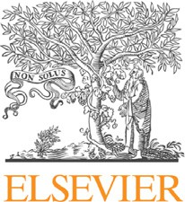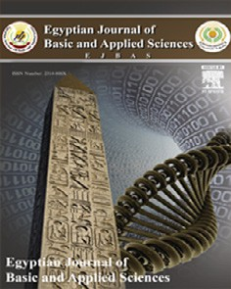

Contents lists available at [ScienceDirect](http://www.sciencedirect.com/science/journal/2314808X)

Egyptian Journal of Basic and Applied Sciences

journal homepage: [www.elsevier.com/locate/ejbas](http://www.elsevier.com/locate/ejbas)

Full Length Article

Evaluation of antioxidant and cytotoxic activities of different extracts of folk medicinal plant *Hapllophyllum tuberculatum*



Raqiya Mohsin Said Al-Muniri, Mohammad Amzad Hossain ⇑

*School of Pharmacy, College of Pharmacy and Nursing, University of Nizwa, P.O. Box 33, 616 Nizwa, Oman*

# a r t i c l e i n f o

*Article history:*

Received 19 January 2017

Received in revised form 17 February 2017 Accepted 21 April 2017

Available online 4 May 2017

*Keywords:*

*H. tuberculatum* Antioxidant activity Cytotoxic activity UV–visible spectroscopy Brine Shrimp method

# a b s t r a c t

*Hapllophyllum tuberculatum* (*H. tuberculatum*) is a folk medicine used traditionally in Oman for the treat- ment of arthritis, nausea, fever, gastric pains, intestinal worms and malaria. The design of this study is to prepare different polarity extracts of *H. tuberculatum* and to evaluate antioxidant and cytotoxic activities by using 2,2-diphenyl-1-picrylhydrazyl (DPPH) and brine shrimp lethality (BSL) methods. The coarse leave samples were extracted with methanol by using a Soxhlet method and the obtained methanol extract was defatted and fractionated by different polarity of solvents with increasing polarity to give hexane, chloroform, ethyl acetate, butanol, and water extracts, respectively. The high antioxidant activity was obtained in the ethyl acetate extract and the lowest was in the methanol extract and the order of activity was ethyl acetate > butanol > water > chloroform > hexane > methanol extract. The cytotoxic activity results showed that the hexane, chloroform and ethyl acetate extracts have killed all the shrimp

larvae at the concentration of 500 lg/ml. The highest IC50 was found in the chloroform extract and the

lowest IC50 was found in the butanol extract and the order of activity was chloroform > ethyl acetate > hexane > water > methanol > butanol extract. Significant antioxidant and cytotoxic activities results were found first time of Omani *H. tuberculatum* species which is traditionally used as folk medi- cine all over the world, including Oman. Therefore*,* the highest activity ethyl acetate extract could be used as a natural antioxidant. The present study is the first report on the evaluation of antioxidant and cyto- toxic activities of different polarity extracts of Omani *H. tuberculatum* species*.*

© 2017 Mansoura University. Production and hosting by Elsevier B.V. This is an open access article under

the CC BY-NC-ND license (<http://creativecommons.org/licenses/by-nc-nd/4.0/>).

1. Introduction

*Haplophyllum* is one of the most available genus belonging to the Rutaceae family. More than 68 species are available all over the world [1,2]. Its scientific name is *Haplophyllum tuberculatum* [3]. *Haplophyllum tuberculatum* (*H. tuberculatum*) species have orig- inated from Iran-Turanian and it is available now in eastern Anato- lia, Gobi desert, Sinai Peninsula, Tien Shan, Altai mountain ranges, Lebanon, Jordan, Israel, Palestine, Syria, Iran, Northern Iraq, Afgha- nistan, Pakistan, India, and Central Asia [1] Locally, it is called Tafar tase; however, in Muscat, Al-Sharqiya and other Governorates, it is known as Senan tase [3]. The Arabian common names of this plant are Sazab, Zeita, Kheisa and Mesaika. It has many synonyms such *as Haplophyllum arabicum, Haplophyllum candolleanum, Haplophyl- lum chesneyanum* and *Haplophyllum etremophilum* [4]. *H. tubercula- tum* is a medium herb about 40–60 cm of height. All stems are branched from the base. Its color is yellowish green to white color. It has many glands on all parts of this plant. Leaves are leaner,

* Corresponding author.

*E-mail address:* [amzad@unizwa.edu.om](mailto:amzad@unizwa.edu.om) (M.A. Hossain).

lobed or sometimes deeply cut into 3 lobes. The size of the leaves is 9–50 mm (Fig. 1). It has a special and an unpleasant odor, which makes it unattractive for animals to eat. *H. tuberculatum* is a flow- ering plant, which start flowering from May to July [4]. There are many flowers on the top with green color, and they are small and separated from each other. The size of fruits is about 2.5–

4.5 mm, and the seeds are about 1.5 mm long. The seed’s color is dark brown to brownish-black [2]. The essential oil has been col- lected from several parts of *H. tuberculatum.* It contains several chemical components which are different from country to country. In Iran, the collected essential oil contained 40 chemical compo- nents which are responsible for different biological activities. The

main components in the Iranian volatile oils are linalool, a-

pinene and limonene [5]. Similarly, in Oman, the collected essen- tial oil contains 30 compounds and the main chemical components are b-phellandrene, limonene, b-ocimene, a-caryophyllene, myr-

cene and a-phellandrene [6,7]. In Saudi Arabia, the oil contains

37 chemical compounds, and in Egypt, contains 88 chemical com- ponents [8]*.* In addition, *H. tuberculatum* also contains several sec- ondary metabolites such as alkaloids, flavonoids, terpenoids, lignins and their oxygenated derivatives [4]. The aerial parts of *H.*

<http://dx.doi.org/10.1016/j.ejbas.2017.04.003>

2314-808X/© 2017 Mansoura University. Production and hosting by Elsevier B.V.

This is an open access article under the CC BY-NC-ND license (<http://creativecommons.org/licenses/by-nc-nd/4.0/>).

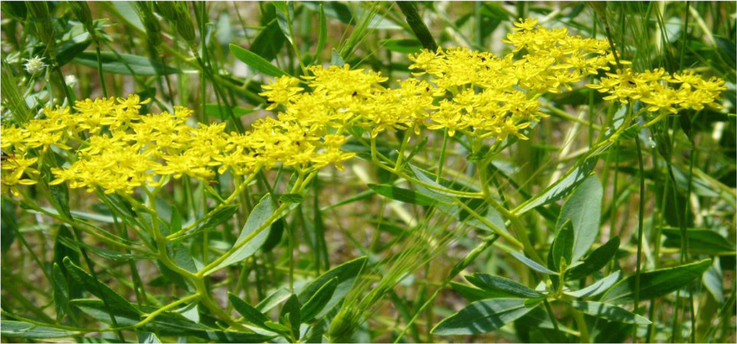

Fig. 1. Plant picture of *H. tuberculatum.*

*tuberculatum* are used traditionally for the treatment of fever, carminative and decongestant. The leaves and stems are externally applied for the treatment of ear and eye problems and the extract of the stem is rubbed onto the skin to protect animals from biting insects and flies. Also, it is used as an antispasmodic, antiflatulent and to treat allergic rhinitis [3]. In Oman, it is used traditionally for the treatment of fever, gastric pains, intestinal worms, malaria and fractures [7]. Due to its medical importance, now this plant is com- mercially cultivated worldwide. Several biological studies have been conducted on this plant worldwide [6,8]. However, there is not even single extensively research available on cytotoxic and antioxidant activities of the leaves of Omani *H. tuberculatum* spe- cies. Therefore, the major purpose of this present study is to pre- pare different polarities extracts of the leaves of selected plant and to evaluate their antioxidant, and cytotoxic activities by 2,2- diphenyl-1-picrylhydrazyl (DPPH) and brine shrimp lethality (BSL).

1. Material and methods
   1. *Chemicals and reagents*

Several chemicals and glassware have been used to performed this study. The methanol solvent was obtained from Nalar Norma- pur, France. Chloroform was obtained from Daejung, Korea. DPPH (2, 2-diphynyl-1-picryl-hydrazyl), gallic acid, shrimp egg, butanol and ethyl acetate were obtained from Sigma-Aldrich Company, Germany. Dimethyl sulphoxide (DMSO, purity 99%) was obtained from Sigma, St. Louis, USA. Acetone obtained from Nalar Normapur, EC. Sodium chloride and other chemicals were obtained from Sigma-Aldrich Company, USA.

* 1. *Instrument for sample analysis*

The absorbance of different concentrations of each polarities extract of *H. tuberculatum* was measured by Shimadzu UV–visible spectrophotometer (Model Shimadzu 1800, Japan).

* 1. *Sample collection*

The leaves sample of *H. tuberculatum* was collected from Farq, Al-Dakhiliya, Nizwa. It is about 25 km away from the University of Nizwa Campus. The samples were collected on January 24, 2016 around ~~at~~ 4 to 6 pm. Then the leaves were separated imme-

diately from the stems and kept in a plastic bag for transportation to the Research Laboratory (Room 29 K), Universaity of Nizwa. The separated leave samples were kept at room temperature for wash and drying.

* 1. *Sample preparation and extraction*

The separated leaves samples were washed with water and dried at room temperature under shade for several days until it completely dry. The dried samples were ground into coarse pow- der by using a kitchen blender machine. The dry coarse powder sample (134.43 gm) was extracted with methanol (550 gm) by using a Soxhlet extraction method for 72 h. Rotary evaporator was used for the evaporation of methanol solvent. After evapora- tion of methanol solvent, the extract (54.01 gm) was dissolved in 200 ml of water for fractionation. The dissolved extract was trans- ferred into a separatory funnel. Finally, it was fractionated by dif- ferent solvents with increasing polarities. The mother solvent

such as hexane, chloroform, ethyl acetate, and butanol were evap- orated by using rotary evaporator under pressure at 24 °C to give hexane (13.73 gm), chloroform (15.17 gm), ethyl acetate (0.88 gm), butanol (1.67 gm) and water (11.41 gm) extracts, respectively [9–12]. The remaining water solvent also evaporated by the same way to give water extract (3.75 gm).

* 1. *Antioxidant activity*

The antioxidant activity of different polarities extracts of *H. tuberculatum* was determined by free radical scavenging method as described by Alabri et al. [12,13] with modification. Five differ-

ent concentrations 12.5, 25, 50, 100 and 200 mg/ml were used for each extract such as hexane, chloroform, ethyl acetate, butanol, methanol, and water extracts. Each concentration from each extract (4 ml) was placed in a clean test tube and added 1 ml of

DPPH (2,2-diphenyl-1-picrylhydrazyl) solution to the same test tube and shaken vigorously by hand. Finally, all the test tubes were kept at room temperature in a dark place for 45 min for complete reaction. The gallic acid standard was prepared to follow the same procedure without adding any plant extract. After incubation, the absorbance was measured in all tested samples at a fixed wave- length 517 nm by using a UV spectrophotometer [10]. The EC50 value of each extract was calculated by log and antilog method.

Table 1

Antioxidant activity of different leaves organic crude extract of *H. tuberculatum.*

The percentage of inhibition of each concentration of plant extract was calculated by using the following formula,

Acontrol — Aextract

|  |  |  |  |
| --- | --- | --- | --- |
| Crude extracts | Concentration (mg/ml) | Inhibition (%) | EC50 (mg/ml) |
| Hexane | 12.5 | 71.88 |  |
|  | 25 | 71.88 |  |
|  | 50 | 71.88 | 17.46 |
|  | 100 | 72.91 |  |
|  | 200 | 73.81 |  |
| Chloroform | 12.5 | 72.52 |  |
|  | 25 | 72.78 |  |
|  | 50 | 72.86 | 16.80 |
|  | 100 | 72.86 |  |
|  | 200 | 76.12 |  |
| Ethyl acetate | 12.5 | 72.14 |  |
|  | 25 | 74.32 |  |
|  | 50 | 75.60 | 14.14 |
|  | 100 | 79.07 |  |
|  | 200 | 85.62 |  |
| Butanol | 12.5 | 73.55 |  |
|  | 25 | 76.50 |  |
|  | 50 | 77.79 | 13.64 |
|  | 100 | 79.97 |  |
|  | 200 | 85.23 |  |
| Methanol | 12.5 | 70.98 |  |
|  | 25 | 71.37 |  |
|  | 50 | 71.75 | 17.72 |
|  | 100 | 72.77 |  |
|  | 200 | 73.55 |  |
| Water | 12.5 | 72.40 |  |
|  | 25 | 74.58 |  |
|  | 50 | 74.58 | 15.11 |
|  | 100 | 76.50 |  |
|  | 200 | 81.25 |  |
| Gallic Acid | 12.5 | 80.90 |  |
|  | 25 | 82.44 |  |
|  | 50 | 84.75 | 11.66 |
|  | 100 | 85.39 |  |
|  | 200 | 87.00 |  |

%Inhibition = Acontrol × 100 (1)

The values are means ± SD of three replicates. *P* < 0.05 when compared with gallic acid. Data are expressed as EC50 in lg/ml which is the concentration of extract requires to inhibit growth by 50%.

* 1. *Cytotoxic activity*

The cytotoxic activity of each prepared extract of *H. tubercula- tum* was determined by the brine shrimp lethality method [14,15]. The brine shrimp eggs were hatched at the covered cham- ber of the duo compartment plastic container with sea water for 24 h. After hatching, the active nauplii were separated from the eggs, and used for cytotoxic activity. Six concentrations such as

500, 250, 125, 62.5, 31.25 and 15.62 lg/mg were prepared by using

dimethyl sulfoxide (DMSO). From each of extract solutions, 50 ml were added to pre-marked test tubes containing 5 ml of sea water. 10 nauplii were added each test tube. After 24 h, the number of

surviving nauplii in each test tube was counted using magnifying glass and recorded the surviving nauplii. The percentage of lethal- ity of brine shrimps was calculated for each concentration of the sample. The IC50 value of each extract was calculated by log and antilog method.

* 1. *Statistical analysis*

All experiments were performed in triplicate and the results were presented as mean ± SD. The concentration that killed 50% of the nauplii (LC50) was determined for each polarity extract by Statistical Analysis Systems (SAS) computer programme [16]. It was determined by plotting a graph of percentage mortality of shrimp larvae against the logarithmic concentrations of extracts tested (Log and Anti Log).

1. Results and discussion

Polyphenols, including phenolic and flavonoid compounds occur widely in food of plant origin and are highly diversified. All

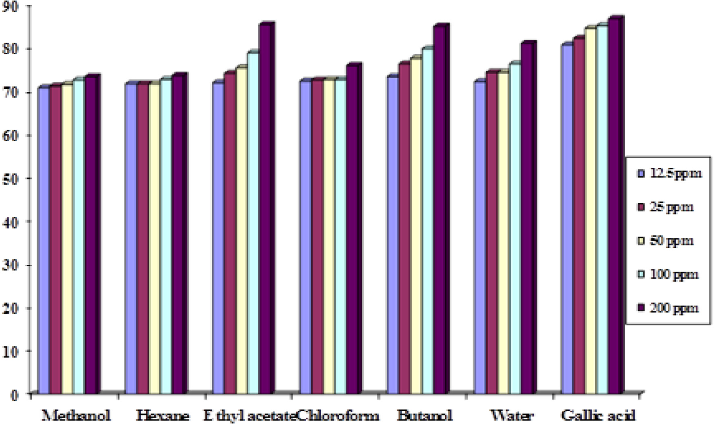

Fig. 2. Comparison antioxidant activity of different crude extracts of *H. tuberculatum.*

of them have played a vital role in the successful medical treat- ments since ancient times. Recently, some polyphenol compounds have gained interest because they exhibit beneficial health effects due to their potential antioxidant, *anti*-inflammatory and cancer- preventive activities [17–21]. They are present widely in the body cells and fluids as a result of ingestion of fruit, vegetables, and plant-derived food such as tea and chocolate [22]. Now-a-days, so many antioxidants based formulations drug are used for the prevention as well as treatment to cure some incurable diseases like arthritis, different stroke, diabetes mellitus, Alzheimer’s dis- ease and cancer [23]. More recently, interest has increased signifi- cantly in finding natural antioxidants from natural sources to replace pharmaceutical antioxidants drugs due to their toxicity/ carcinogenicity [24,25]. The selected Omani plant species are used extremely as a folk medicine by the local communities for the treatment of fever, gastric pains, intestinal worms, malaria, carmi- native and decongestant. However, there is not a single study available on the Omani species. Therefore, the present study was conducted on the screening of antioxidant and cytotoxic activities of locally grown *H. tuberculatum*. The collected dried leaves powder

samples were extracted with methanol and fractioned by different organic solvents with increasing polarities. The prepared organic extracts were used for the evaluation of antioxidant and cytotoxic activities by using DPPH and BSL methods [13,16].

The antioxidant activity of organic extracts was determined by the DPPH method with modification [10]. The highest antioxidant activity was in the ethyl acetate extract and the lowest was in the methanol extract and followed by the order of ethyl acetate > butanol > water > chloroform > hexane > methanol extracts. (Table 1 and Fig. 2). The experimental findings showed that differ- ent polarities leave extracts at different concentrations exhibited significant free radical scavenging activity (Table 1 and Fig. 2). The antioxidant activity of different organic extracts of leaves of

*H. tuberculatum* was determined through DPPH and the experi- mental results are presented in the Table 1 and Fig. 2. In this exper- iment, the role of stable free radical of DPPH is to react with antioxitive free radicals of organic extracts of *H. tuberculatum*. The deep violet color of stable free radical (DPPH) is converting to pale color with the progress of reaction of antioxitive free radi- cals of the leaves organic extracts. The rate of decolouration of

Table 2

Cytotoxic activity of different leaves crude extract of *H. tuberculatum.*

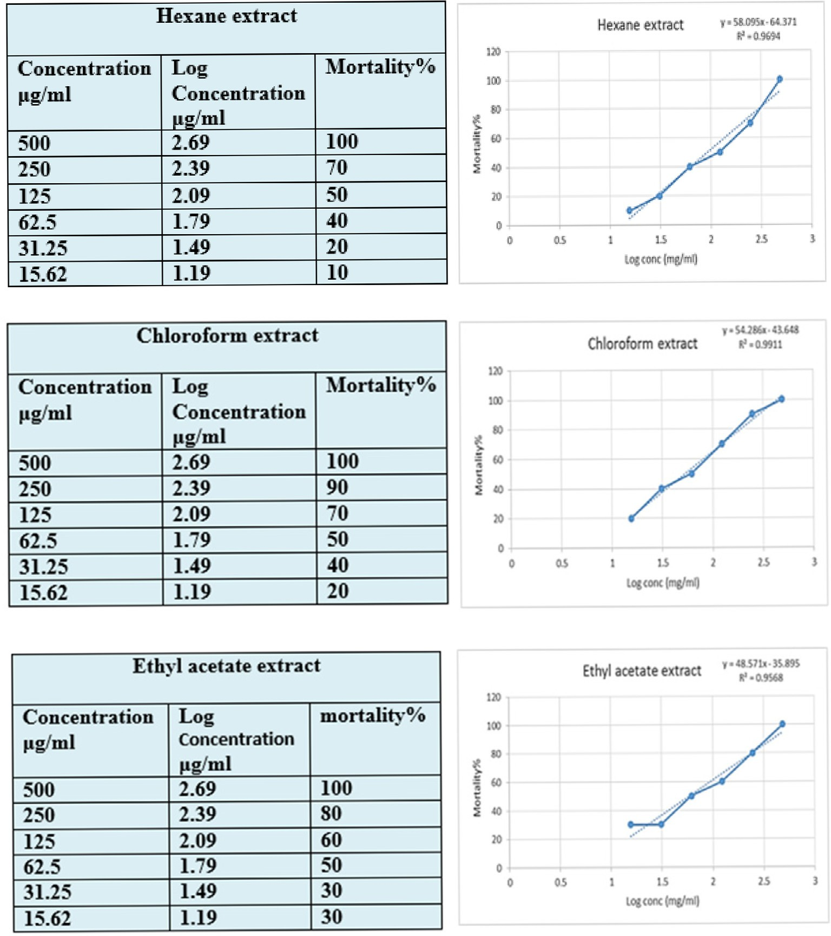

Table 2 (*continued*)

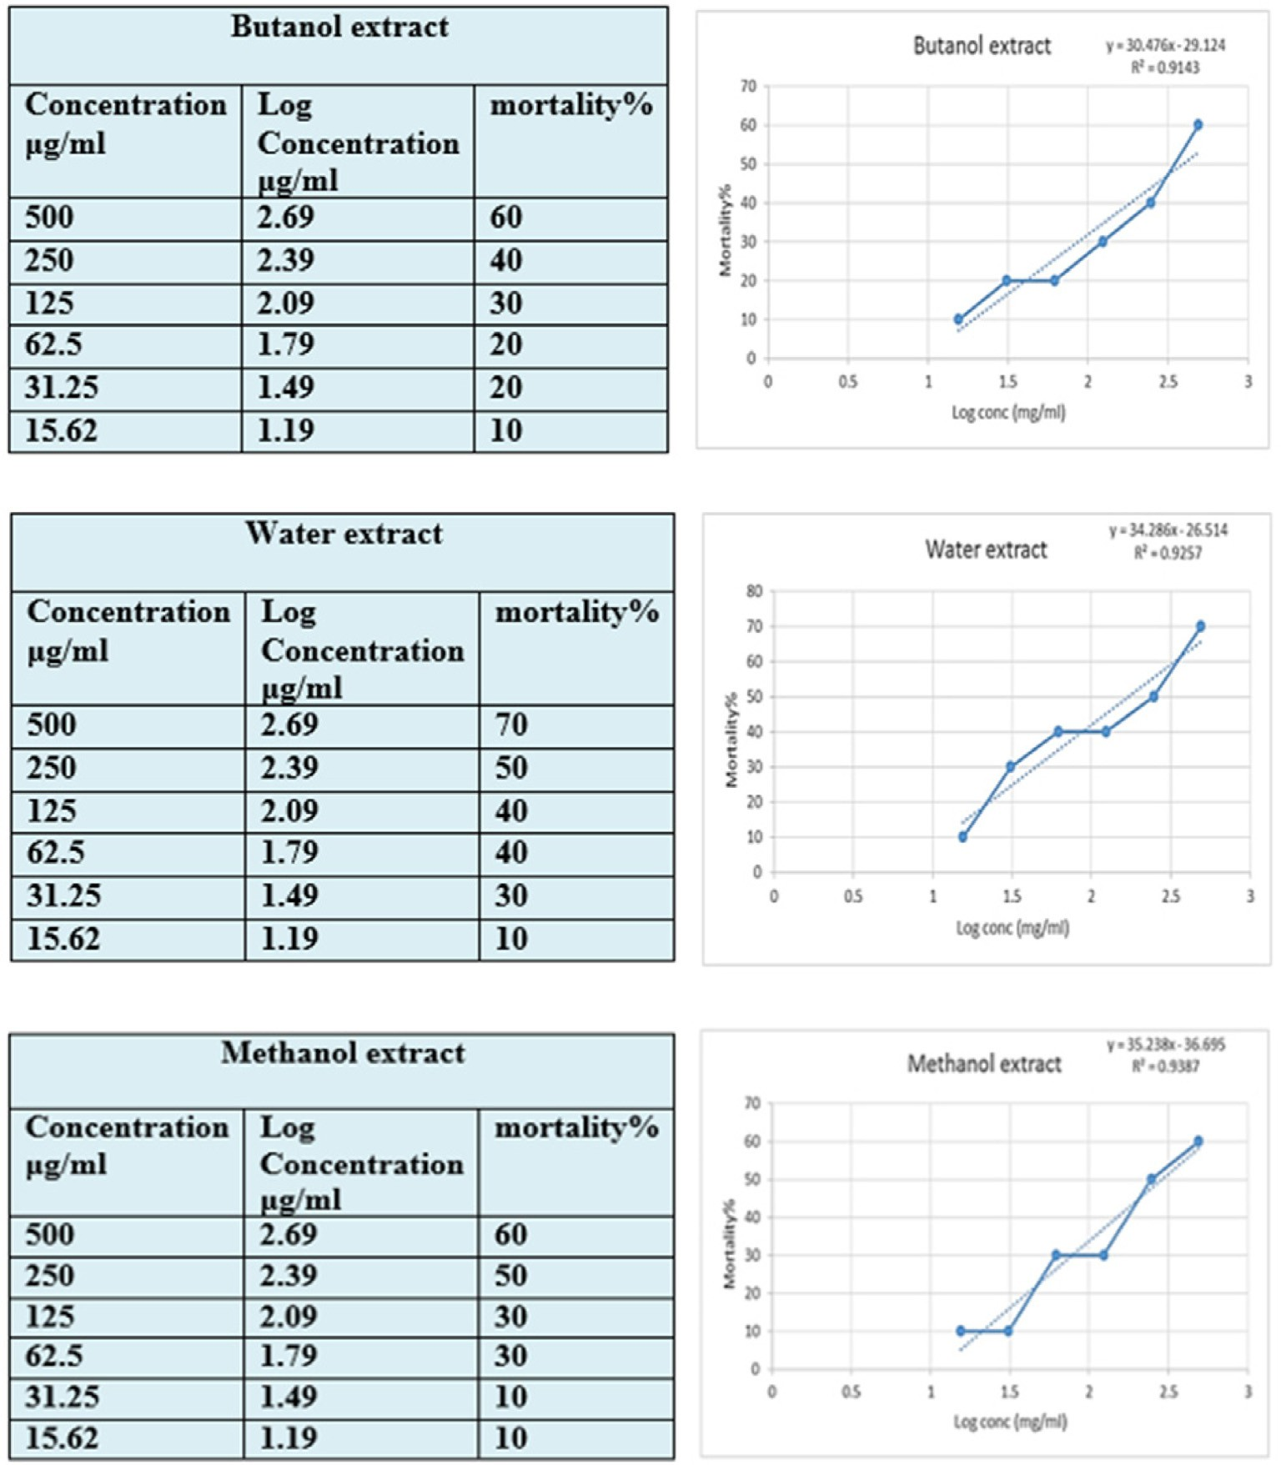

organic extracts represents the strength of antioxidant activity. In our experiment, all the extracts *H. tuberculatum* were capable to decolourise of DPPH. The antioxidant activity of the organic extracts was determined to be in the order of ethyl acetate > butanol > water > chloroform > hexane > methanol extracts. The literature search reveals that some bioactive organic com- pounds such as gallic acid, glutathione, ascorbic acid, tocopherol, flavonoids, phenols, amines are decolorizing DPPH gradually by the hydrogen donating capability [24,25]. The above mentioned statement, it was confirmed that the organic extracts of *H. tubercu- latum* possess hydrogen donating capabilities to act as antioxi- dants. In our experiment, the highest antioxidant activity was in the ethyl acetate extract and the lowest was in the methanol extract and followed by the order of ethyl acetate > butanol > water > chloroform > hexane > methanol extracts. The findings showed that different polarities leave extracts at different concen- trations exhibited significant free radical scavenging activity. The determination of antioxidant activity of *H. tuberculatum* was done in comparison with that of gallic acid in Table 1. Gallic acid showed a high activity with EC50 values of 11.66 mg/ml. In our present

experiment, the highest EC50 was found in the buatnol extract

and the lowest EC50 was found in the methanol extract with and in the order of EC50 values butanol > ethyl acetate > water > chloro- form > hexane > methanol extracts. Our experimental results are not similar to what has been reported for antioxidant activity of

*H. tuberculatum* extract [5–9]. It can be concluded that the butanol extract contains the maximum number of bioactive chemicals which could be responsible for its antioxidant and total antioxidant capacity. The significant antioxidant activity of extracts might be due to the high number of polyphenolic compounds or high con- centration of bioactive compounds present in this plant sample. This present study highlights that the extracts of *H. tuberculatum* is a good potential source of natural antioxidants to prevent free radical oxidative damage.

The selected plant species is used by Omani people for the treat- ment of different aliments. However, nobody works on antioxidant and cytotoxic activities of this Omani plant species. The cytotoxic activity of organic extracts was determined by brine shrimp larvae (BSL) method with modification [14]. In our experiment, the hex- ane, chloroform, ethyl acetate, butanol, methanol and water extracts of leaves of *H. tuberculatum* displayed significant cytotoxic activity against the brine shrimp larvae. The mortalities as a per-

Table 3

IC50 values of different leaves crude extract of *H. tuberculatum.*

|  |  |
| --- | --- |
| Exteract | IC50 (lg/ml) |
| Hexane | 1.96 |
| Chloroform | 1.72 |
| Ethyl acetate | 1.76 |
| Butanol | 2.59 |
| Water | 2.20 |
| Methanol | 2.46 |

Each value is expressed as mean ± standard deviation of triplicate measurements. Data are expressed as IC50 in lg/ml which is the concentration of extract requires to inhibit growth by 50%.

centage (%) of shrimp larvae of different extracts of leaves are shown in Table 2. The cytotoxicity results showed that hexane, chloroform and ethyl acetate extracts from leaves of *H. tubercula-*

*tum* have killed all the shrimp larvae at the concentration of 500 lg/ml. However, butanol, methanol and water extracts did not kill all the shrimp larvae at 500 lg/ml. In the present experi- ment, the highest IC50 was found in the chloroform extract and the lowest IC50 was found in the butanol extract and in the order

of IC50 values chloroform > ethyl acetate > hexane > water > methanol > butanol extracts. As shown in Table 3, the leaves extracts displayed significant toxicity against the brine shrimp lar- vae. The chloroform extract was the most active, exhibiting LC50 value of 1.72 ug/ml. These results are not similar to what has been reported for cytotoxic activity of *H. tuberculatum* extract [26,27]. Based on the cytotoxic results of different organic extracts of *H. tuberculatum*, it is probable that the highest toxicity shown by the chloroform extract may be due to the presence of semi polar bioactive compounds [28]. This difference in LC50 value could be due to differences in methodologies; while the present study used the BST assay other investigations used the *in vitro* and *in vivo* based assay [29].

1. Conclusion

In this study, the determination of antioxidant and cytotoxic activities of leaves extracts of *H. tuberculatum* by DPPH and brine shrimp method has been reported. All the extracts from the leaves showed significant antioxidant and cytotoxic activities. In our find- ings through this graduation project revealed that the leaves of *H. tuberculatum* species grown in Oman contain a significant number or amount of bioactive compounds which might be responsible for its biological activities. Further, more *in vitro* and *in vivo* studies are needed of the active selected extracts of leaves of *H. tuberculatum* to determine their potential for therapeutic uses of this plant to prevent some chronic diseases.

Acknowledgements

The authors wish to thank the University of Nizwa, Sultanate of Oman for providing all kind of support for the completion of the present study. Thanks to Sommya Saif Said Al Riyani, Lab Techni- cians, Natural Product Lab, University of Nizwa for her continuous help during the experiment.

References

1. [Gabriele S, Sara M, Farrokh G, Komiljon T, Louis Z, Elena C. Phylogeny,](http://refhub.elsevier.com/S2314-808X(17)30030-1/h0005) [morphology, and biogeography of Haplophyllum (Rutaceae), a species-rich](http://refhub.elsevier.com/S2314-808X(17)30030-1/h0005) [genus of the Irano-Turanian floristic region. Taxon 2011;60:1–15](http://refhub.elsevier.com/S2314-808X(17)30030-1/h0005).
2. Alexey S. Flora of Qatar, 2012.
3. [Ghazanfar SA, Al-Al-Sabahi AM. Medicinal plants of northern and central](http://refhub.elsevier.com/S2314-808X(17)30030-1/h0015) [Oman (Arabia). Econ Bot 1993;47(1):89–98](http://refhub.elsevier.com/S2314-808X(17)30030-1/h0015).
4. [Al-Burtamani SKS, Fatope MO, Marwah RG, Onifade AK, Al-Saidi SH. Chemical](http://refhub.elsevier.com/S2314-808X(17)30030-1/h0020) [composition, antibacterial and antifungal activities of the essential oil of](http://refhub.elsevier.com/S2314-808X(17)30030-1/h0020) [*Haplophyllum tuberculatum* from Oman. J Ethnopharm 2005;96(1):107–12](http://refhub.elsevier.com/S2314-808X(17)30030-1/h0020).
5. [Yari M, Masoudi S, Rustaiyan A. Essential oil of *Haplophyllum tuberculatum*](http://refhub.elsevier.com/S2314-808X(17)30030-1/h0025)

[(Forssk.) A. Juss. grown wild in Iran. J Essent Oil Res 2000;12(1):69–70](http://refhub.elsevier.com/S2314-808X(17)30030-1/h0025).

1. [El-Moataz BEN, El-Darier Salama M, Adel A, Sayeda EM, Emil Š, Milan Z.](http://refhub.elsevier.com/S2314-808X(17)30030-1/h0030) [Chemical composition of essential oil of *Haplophyllum tuberculatum* (Rutaceae)](http://refhub.elsevier.com/S2314-808X(17)30030-1/h0030) [grow wild in different habitats of Egyp. Glob J Pharmacol 2014;8(3):385–93](http://refhub.elsevier.com/S2314-808X(17)30030-1/h0030).
2. [Nehir ÜS, Gülen](http://refhub.elsevier.com/S2314-808X(17)30030-1/h0035) I_[K, Buket S, Mustafa AÖ, Canan Ö, Betül D, et al. Composition of](http://refhub.elsevier.com/S2314-808X(17)30030-1/h0035)

[the essential oil of endemic *Haplophyllum megalanthum* Bornm. Turkey Rec Nat](http://refhub.elsevier.com/S2314-808X(17)30030-1/h0035) [Prod 2012;6(1):80–3](http://refhub.elsevier.com/S2314-808X(17)30030-1/h0035).

1. [Al-Rehaily AJ, Alqasoumi SI, Yusufoglu HS, Al-Yahya MA, Demirci B, Tabanca N,](http://refhub.elsevier.com/S2314-808X(17)30030-1/h0040) [et al. Chemical composition and biological activity of *Haplophyllum*](http://refhub.elsevier.com/S2314-808X(17)30030-1/h0040)[*tuberculatum* Juss. essential oil. Planta Med 2013;79:48–52](http://refhub.elsevier.com/S2314-808X(17)30030-1/h0040).
2. [Abed EN, Guesmi F, Mejri M, Marzouki MN, Ahmed BHS. Phytochemical](http://refhub.elsevier.com/S2314-808X(17)30030-1/h0045) [screening and assessment of antioxidant, antibacterial and cytotoxicity](http://refhub.elsevier.com/S2314-808X(17)30030-1/h0045) [activities of five tunisian medicinal plants. Inter J Pharma Res Bio-Sci 2014;3](http://refhub.elsevier.com/S2314-808X(17)30030-1/h0045) [(4):770–89](http://refhub.elsevier.com/S2314-808X(17)30030-1/h0045).
3. [Aziza SB, Hebbatallah AA, Maha AH, Shah AK. Evaluation of antioxidant](http://refhub.elsevier.com/S2314-808X(17)30030-1/h0050) [potential, total phenolic content and phytochemical screening of aerial parts of](http://refhub.elsevier.com/S2314-808X(17)30030-1/h0050) [a folkloric medicine, *Haplophyllum tuberculatum* (Forssk) A. Juss. J Coast Life](http://refhub.elsevier.com/S2314-808X(17)30030-1/h0050) [Med 2016;4(4):315–9](http://refhub.elsevier.com/S2314-808X(17)30030-1/h0050).
4. [Al-Matani SK, Al-Wahaibi RNS, Hossain MA. In vitro evaluation of the total](http://refhub.elsevier.com/S2314-808X(17)30030-1/h0055) [phenolic and flavonoid contents and the antimicrobial and cytotoxicity](http://refhub.elsevier.com/S2314-808X(17)30030-1/h0055) [activities of crude fruit extracts with different polarities from *Ficus*](http://refhub.elsevier.com/S2314-808X(17)30030-1/h0055)[*sycomorus*. Pac Sci Rev A: Nat Sci Eng 2015;17(3):103–8](http://refhub.elsevier.com/S2314-808X(17)30030-1/h0055).
5. [Alabri THA, Al Musalami AHS, Hossain MA, Weli AM, Al-Riyami Q.](http://refhub.elsevier.com/S2314-808X(17)30030-1/h0060) [Comparative study of phytochemical screening, antioxidant and](http://refhub.elsevier.com/S2314-808X(17)30030-1/h0060) [antimicrobial capacities of fresh and dry leaves crude plant extracts of](http://refhub.elsevier.com/S2314-808X(17)30030-1/h0060) [*Datura metel* L. J King Saud Univ Sci 2014;26(3):237–43](http://refhub.elsevier.com/S2314-808X(17)30030-1/h0060).
6. [Zainab SSH, Hossain MA. Biological activities of different leaves crude extracts](http://refhub.elsevier.com/S2314-808X(17)30030-1/h0065) [of neem used locally in Ayurvedic medicine. Pac Sci Rev A: Nat Sci Eng](http://refhub.elsevier.com/S2314-808X(17)30030-1/h0065) [2016;18:128–31](http://refhub.elsevier.com/S2314-808X(17)30030-1/h0065).
7. [Rehab MH, Hossain MA. Evaluation of antimicrobial and cytotoxic activities of](http://refhub.elsevier.com/S2314-808X(17)30030-1/h0070) [polar solvents extracts of leaves of *Ammi majus* used by the Omanis. Pac Sci](http://refhub.elsevier.com/S2314-808X(17)30030-1/h0070) [Rev A: Nat Sci Eng 2016;18:62–5](http://refhub.elsevier.com/S2314-808X(17)30030-1/h0070).
8. [Weli AM, AL-Hinai JR, Al-Mjrafi JM, Alnaaimi JR, Hossain MA, Saeed S, et al.](http://refhub.elsevier.com/S2314-808X(17)30030-1/h0075) [Effect of different polarities leaves extracts of Omani Juniperus excels on](http://refhub.elsevier.com/S2314-808X(17)30030-1/h0075) [antioxidant, antimicrobial and cytotoxic activities and their biochemical](http://refhub.elsevier.com/S2314-808X(17)30030-1/h0075) [screening. Asian Pac J Reprod 2014;3(3):218–23](http://refhub.elsevier.com/S2314-808X(17)30030-1/h0075).
9. [Omar MS, Abeer MES, Amany AS. GC/MS Analysis and potential cytotoxic](http://refhub.elsevier.com/S2314-808X(17)30030-1/h0080) [activity of *Haplophyllum tuberculatum* essential oils against lung and liver](http://refhub.elsevier.com/S2314-808X(17)30030-1/h0080) [cancer cells. Pharmacogn J 2016;8(1):66–9](http://refhub.elsevier.com/S2314-808X(17)30030-1/h0080).
10. [Harborne JB. The Flavonoid; Advances in Research. New York: Chapman &](http://refhub.elsevier.com/S2314-808X(17)30030-1/h0085) [Hall; 1988](http://refhub.elsevier.com/S2314-808X(17)30030-1/h0085).
11. Cody W, Middleton E, Harborne JB, Beretz A, Plant Flavonoids in Biology and Medicine II: Biochemical, Cellular and Medicinal Properties. Alan R. Liss, New York. 1988.
12. [Geissmann TA. The Chemistry of Flavonoids. Oxford: Pergamon Press; 1962](http://refhub.elsevier.com/S2314-808X(17)30030-1/h0095).
13. [Prochazka K, Mandak T, Kocirik M, Bednar B, Tuzar Z. Antioxidant activity of](http://refhub.elsevier.com/S2314-808X(17)30030-1/h0100) [some medicinal plants. J Chem Soc 1990;86:1103–8](http://refhub.elsevier.com/S2314-808X(17)30030-1/h0100).
14. [Smyth WF, Ivaska A. Proanthocyanidin glycosides and related polyphenols](http://refhub.elsevier.com/S2314-808X(17)30030-1/h0105) [from cacao liquor and their antioxidant effects. Analyst 1985;110(11):1377–9](http://refhub.elsevier.com/S2314-808X(17)30030-1/h0105).
15. [Mosquera OM, Correa YM, Buitrago DC, Nio J. Antioxidant activity of twenty-](http://refhub.elsevier.com/S2314-808X(17)30030-1/h0110) [five plants from Colombian biodiversity. Mem Inst Oswaldo Cruz](http://refhub.elsevier.com/S2314-808X(17)30030-1/h0110) [2007;102:631–4](http://refhub.elsevier.com/S2314-808X(17)30030-1/h0110).
16. [Sasaki YF, Kawaguchi S, Kamaya A, Ohshita M, Kabasawa K, Iwama K. The](http://refhub.elsevier.com/S2314-808X(17)30030-1/h0115) [comet assay with 8 mouse organs: Results with 39 currently used food](http://refhub.elsevier.com/S2314-808X(17)30030-1/h0115) [additives. Mut Res: Gen Tox Environ Mutag 2002;519:103–9](http://refhub.elsevier.com/S2314-808X(17)30030-1/h0115).
17. [Al-Saeedi AH, Hossain MA. Evaluation of total phenols, total flavonoids and](http://refhub.elsevier.com/S2314-808X(17)30030-1/h0120) [antioxidant activity of the leaves extracts of locally grown pigeon pea](http://refhub.elsevier.com/S2314-808X(17)30030-1/h0120) [traditionally used in Sultanate of Oman for the treatment of jaundice and](http://refhub.elsevier.com/S2314-808X(17)30030-1/h0120) [diabetes. J Coast Life Med 2015;3(4):317–21](http://refhub.elsevier.com/S2314-808X(17)30030-1/h0120).
18. [Omar MS, Abeer MES, Amany AS. Potential anti-microbial, anti-inflammatory](http://refhub.elsevier.com/S2314-808X(17)30030-1/h0125) [and anti-oxidant activities of *Haplophyllum tuberculatum* growing in Libya. J](http://refhub.elsevier.com/S2314-808X(17)30030-1/h0125) [Pharmacog Nat Prod 2016;2:1–7](http://refhub.elsevier.com/S2314-808X(17)30030-1/h0125).
19. [Kuete V, Wiench B, Alsaid MS, Alyahya MA, Fankam AG, Shahat AA, et al.](http://refhub.elsevier.com/S2314-808X(17)30030-1/h0130) [Cytotoxicity, mode of action and antibacterial activities of selected Saudi](http://refhub.elsevier.com/S2314-808X(17)30030-1/h0130) [Arabian medicinal plants. BMC Compl Alter Med 2013;13(1):1–5](http://refhub.elsevier.com/S2314-808X(17)30030-1/h0130).
20. [Miret S, De Groene M, Klaffke W. Comparison of in vitro assays of cellular](http://refhub.elsevier.com/S2314-808X(17)30030-1/h0135) [toxicity in the human hepatic cell line HepG2. J Biomolecules Screen](http://refhub.elsevier.com/S2314-808X(17)30030-1/h0135) [2006;11:184–93](http://refhub.elsevier.com/S2314-808X(17)30030-1/h0135).
21. [Meyer BN, Ferrigni NR, Putnam JE, Jacobsen LB, Nichols DE, McLaughlin JL.](http://refhub.elsevier.com/S2314-808X(17)30030-1/h0140) [Brine shrimp: A convenient general bioassay for active plant constituents.](http://refhub.elsevier.com/S2314-808X(17)30030-1/h0140) [Plant Med 1982;45:31–4](http://refhub.elsevier.com/S2314-808X(17)30030-1/h0140).
22. [Sabry OMM, Sayed A. GC/MS and cytotoxic potentiality of essential oil of](http://refhub.elsevier.com/S2314-808X(17)30030-1/h0145)

[*Haplophyllum tuberculatum* growing in Libya. Pharmacog J 2016;8:1–4](http://refhub.elsevier.com/S2314-808X(17)30030-1/h0145).