HOSTE D BY

Available online at [www.sciencedirect.com](http://www.sciencedirect.com/science/journal/2314808X)

ScienceDirect

journal homepage: <http://ees.elsevier.com/ejbas/default.asp>

[e gypti an j o ur nal o f b a sic and a p p l i ed sci e n c e s 2 ( 201 5 ) 206](http://dx.doi.org/10.1016/j.ejbas.2015.04.002) e[220](http://dx.doi.org/10.1016/j.ejbas.2015.04.002)



Full Length Article

Exact travelling wave solutions of the coupled nonlinear evolution equation via the Maccari system using novel (G′/G)-expansion method



*M.G. Hafez* *a**,*\**, Bin Zheng* *b**, M.A. Akbar* *c*

a *Department of Mathematics, Chittagong University of Engineering and Technology, Bangladesh*

b *School of Science, Shangdong University of Technology, China*

c *Department of Applied Mathematics, University of Rajshahi, Bangladesh*

## a r t i c l e i n f o

*Article history:*

Received 2 July 2014 Received in revised form 2 April 2015

Accepted 5 April 2015

Available online 27 April 2015

*Mathematics Subject Classification:*

35C07

35C08

35P99

*Keywords:*

The novel (*G*'/*G*)-expansion method The Maccari system

Travelling wave solutions Solitary wave solutions

Auxiliary nonlinear ordinary differ- ential equation

## a b s t r a c t

In this article, the novel (*G*'/*G*)-expansion method is used to construct exact travelling wave solutions of the coupled nonlinear evolution equation. This technique is uncomplicated and simple to use, and gives more new general solutions than the other existing methods. Also, it is shown that the novel (*G*'/*G*)-expansion method, with the help of symbolic computation, provides a straightforward and vital mathematical tool for solving nonlinear evolution equations. For illustrating its effectiveness, we apply the novel (*G*'/*G*)-expansion method for finding the exact solutions of the (2 + 1)-dimensional coupled integrable nonlinear Maccari system.

Copyright 2015, Mansoura University. Production and hosting by Elsevier B.V. This is an open access article under the CC BY-NC-ND license ([http://creativecommons.org/licenses/](http://creativecommons.org/licenses/by-nc-nd/4.„0/)

[by-nc-nd/4.0/](http://creativecommons.org/licenses/by-nc-nd/4.„0/)).

# Introduction

The investigation of exact travelling wave solutions to nonlinear evolution equation plays an important role in the study of nonlinear physical phenomena for various fields of

science and engineering, especially in mathematical physics, plasma physics, fluid dynamics, quantum field theory, biophysics, chemical kinematics, geochemistry, propagation of shallow water waves, high-energy physics and so on. The analytical solutions of such equations are of fundamental

* *Corresponding author*.

E-mail address: [golam_hafez@yahoo.com](mailto:golam_hafez@yahoo.com) (M.G. Hafez).

Peer review under responsibility of Mansoura University. <http://dx.doi.org/10.1016/j.ejbas.2015.04.002>

2314-808X/Copyright 2015, Mansoura University. Production and hosting by Elsevier B.V. This is an open access article under the CC BY- NC-ND license ([http://creativecommons.org/licenses/by-nc-nd/4.0/](http://creativecommons.org/licenses/by-nc-nd/4.„0/)).

[e g ypti an j o ur nal o f b a sic and a pp l i e d sci en c e s 2 ( 201 5 ) 206](http://dx.doi.org/10.1016/j.ejbas.2015.04.002) e[220](http://dx.doi.org/10.1016/j.ejbas.2015.04.002) 207

importance since a lot of mathematical-physical models are described by nonlinear evolution equations (NLEEs). Many powerful and direct methods have been developed to find explicit solutions to the NLEEs, such as, wave of translation [1], the inverse scattering transform [2], the Hirota's bilinear

method [3], the Darboux transformation method [4], the

Backlund transformation method [5], the tanh method [6], the tanh-sech method [7], the symmetry method [8], the Painleve expansion method [9], the Exp-function method [10](#_bookmark39)e[14], the Adomian decomposition method [15], the homogeneous bal- ance [16] and so on to construct exact solution of NLEEs. Lately, Wang et al. [17] introduced an expansion technique called the (*G*'/*G*)-expansion method, and they verified that it is a simple technique look for analytic solutions of NLEEs. In order to show the efficiency of the (*G*'/*G*)-expansion method and to extend the range of its applicability, further research has been carried out by several researchers, such as, Zhang et al. [18] proposed a generalization of the (*G*'/*G*)-expansion method for solving the evolution equations with variable co- efficients. Zhang et al. [19] also presented an improved (*G*'/*G*)- expansion method to seek general traveling wave solutions. Zayed [20] obtainable a new approach of the (*G*'/*G*)-expansion method where *G*(x) satisfies the Jacobi elliptical equation

[*G*'(x)]2 = *e*2*G*4(x)+ *e*1*G*2(x)+ *e*0. Zayed [21] again proposed an

alternative approach of this method in which *G*(x) satisfies the Riccati equation *G*'(x)=*A*+*BG*2(x), where *A* and *B* are arbitrary

where *c* denotes the speed of the traveling wave. By use of Eq. (2), Eq. (1) is converted into an ODE for *u*=*u*(x):

*Q u*; *u*'; *u*'' ; *u*''' ; / = 0; (3)

where, *Q* is a function of *u*(x) and its derivatives wherein prime stands for derivative with respect to x.

Step 2: Assume the solution of Eq. (3) can be expressed in powers j(x):

*N*

X *j*

*u*(x)= a*j*(j(x)) (4)

*j*=—*N*

where

j(x)= (*d* + F(x)) (5)

and F x *G*'(x).

( )=

*G*(x)

Here a—*N* or a*N* may be zero, but both of them could not be zero simultaneously. a*j* (*j*=0, ±1, ±2, /,±*N*) and *d* are constants to be determined later, and *G*=*G*(x) satisfies the second order

nonlinear ODE:

*GG*'' = l*GG*' + m*G*2 + n(*G*')2 (6)

where prime denotes the derivative with respect x; l, m, and n

are real parameters.

constants. Akbar et al. [22] proposed a generalized and improved (*G*'/*G*)-expansion method which give more new so-

The Cole-Hopf transformation F(x)= ln(*G*(x))x

reduces the Eq. (6) into Riccati equation:

*G*'(x)

*G*(x)

=

lutions than the improved (*G*'/*G*)-expansion method [19]. Recently, Alam et al. [23] further improved the (*G*'/*G*)-expan- sion method known as novel (*G*'/*G*)-expansion method. They have solved only single NLEEs using this method.

The nonlinear Maccari system is an important mathe- matical model in physics. Currently, Lee et al. [24], Hafez et al. [25], and Manafian et al. [26,27] have solved the Maccari sys- tem using the Kudryashov method, the exp(—(F(x)))

-expansion method and the Exp-function method respec- tively. Therefore, the aim of this article is to investigate new exact travelling wave solutions to the Maccari system by use

of the novel (*G*'/*G*)-expansion method, which is more effective

( )

F'(x) = m + lF(x) + (n — 1)F2(x) (7)

Eq. (7) has individual twenty five solutions (see Zhu [28] for details).

Step 3: The value of the positive integer *N* can be deter- mined by balancing the highest order linear terms with the nonlinear terms of the highest order come out in Eq. (3). If the degree of *u*(x) is *D*[*u*(x)]=*n*, then the degree of the other expressions will be as follows:

than others methods.

*dpu* x

*D d*x*p*

= *n* + *p*; *D* *up*

*dqu*(x) *s*

*d*x*q*

= *np* + *s*(*n* + *q*).

# Description of the novel (G′/G)-expansion method

Step 4: Substitute Eq. (4) including Eqs. (5) and (6) into Eq.

*G*'(x) *j G*'(x) —*j*

Let us consider the nonlinear evolution equation

(3), we obtain polynomials in

*d* + *G*(x)

and

*d* + *G*(x)

,

*P u*; *ut*; *ux*; *uy*; *uxx*; *uyy*; *utt*; *utx*; … ; (1) where *P* is a polynomial in *u*(*x*,*y*,*t*) and its partial derivatives wherein the highest order partial derivatives and the nonlinear terms are concerned. The most important steps of the method are as follows:

Step 1: Combine the real variables *x*,*y* and *t* by a complex variable x, we suppose that

*u*(*x*; *y*; *t*)= *u*(x); x = *x* + *y*±*ct*; (2)

(*j*=0, 1, 2, /,*N*). Collect each coefficient of the resulted polynomials to zero, yields an over-determined set of algebraic equations for a*j* (*j*=0, ±1, ±2, /,±*N*), *d* and *V*.

Step 5: Suppose the value of the constants can be ob-

tained by solving the algebraic equations obtained in Step

4. Substituting the values of the constants together with the solutions of Eq. (6), we will obtain new and compre- hensive exact traveling wave solutions of the nonlinear evolution Eq. (1).

Discussion 1: It is noteworthy to examine that if we replace l by —l and m by —m and put n=0 in Eq. (6), then the novel (*G*'/*G*)- expansion method coincide with Akbar et al.'s [19] generalized

208 [e gypti an j o ur nal o f b a sic and a p p l i ed sci e n c e s 2 ( 201 5 ) 206](http://dx.doi.org/10.1016/j.ejbas.2015.04.002) e[220](http://dx.doi.org/10.1016/j.ejbas.2015.04.002)

and improved (*G*'/*G*)-expansion method. If we put *d*=0 in Eq.

(5) and n=0 in Eq. (6), this method is identical to the improved (*G*'/*G*)-expansion method presented by Zhang et al. [19]. Again if we put *d*=0, n=0 and negative the exponents of (*G*'/*G*) are zero in Eq. (4), then this method turn out into the basic(*G*'/*G*)- expansion method introduced by Wang et al. [17]. Finally, if we put n=0 in Eq. (6) and a*j* (*j*=1, 2, 3,/,*N*) are functions of *x* , *y*

where primes denotes the differentiation with regard to x. Inserting (4) and (6) and considering the homogeneous bal- ance between *U*'' and *U*3 in Eq. (12), we obtain 3*N*=*N*+2. i. e. *N*=1. Therefore, we have,

*U*(x)= a—1(j(x))—1 + a0 + a1(j(x)). (13)

Substituting Eq. (13) into Eq. (12), the left hand side is

'

and *t* instead of constants then the this method is trans-

formed into the generalized the (*G*'/*G*)-expansion method developed by Zhang et al. [18]. Therefore we observe that the

transformed into polynomials in

*j*

*d G* (x)

+

*G*(x)

, (*j*=0, 1, 2, /, *N*)

' —*j*

+

methods mentions in the refs. [17,19,22,29,30] are only special

*d G* (x)

*G*(x)

, (*j*=0, 1, 2, /, *N*). Equating the coefficients of

and

cases of the novel (*G*'/*G*)-expansion method.

# New exact travelling wave solutions of the (2 + 1)-dimensional Maccari system

Let us consider the (2 + 1)-dimensional coupled integrable nonlinear system in the following form

similar power of these polynomials to zero, we obtain a sys- tem of algebraic equations for a—1, a0, a1, *d*, *p*, *q*, *r* and *c*. Solving the obtaining system of algebraic equations by use of the symbolic computation software, such as Maple 13, we obtain

Set 1:

8> (2y*d* — l — 2*d*)a—1

>>< a—1 = a—1; a0 = —2(m — l*d* + n*d*2 — *d*2 ; *a*1 = 0; *p* = *p*; *q* = *q*; *d* = *d*; *r* = 2mn — 2 + *p*

l2 2 9>

> — 4m*d*2 + 2y2*d*4 — 4y*d*4 + 2l2*d*2 + 2m2 — 4l*d*3n + 4mn*d*2 + 4l*d*3 — 4ml*d* + 2*d*4 — *a*2 >

—1

— 2m; >>=

(14)

*c*

>: =—

2 m — l*d* + n*d*2 — *d*2 2 >;

*iut* + *uxx* + *uv* = 0 )

*vt* + *vy* +

8>

|*u*|2

*x* = 0

. (8)

l l2

)

>< a—1 = a—1; a0 = 0; a1 = 0; *p* = *p*; *q* = *q*; *d* = 2(n — 1 ; *r* = 2mn — 2 + *p*

Set 2:

2 9>

— 2m; >=

(15)

—1 —1 —1

> l4 + 8l2m — 8l2mn — 8y2*a*2

2

* 8*a*

+ 16*a*2 y + 16m2n2 + 16m2 — 32m2n >

>: *c* =—

l4 + 8l2m — 8l2mn + 16m2n2 + 16m2 — 32m2n >;

If we apply the following transformation

*u*(*x*; *y*; *t*)= *ei*u*U*(x); *v*(*x*; *y*; *t*)= *V*(x); (9)

where u=*px*+*qy*+*rt* and x=*x*+*y*+*ct* , the Maccari system in (8) can be reduced to a system of ODE form as follows:

Set 3:

8>a = 0; a = —(2n*d* — l— 2*d*)a1; a = a ; *p* = *p*; *q* = *q*; *d* = *d*; 9>

><

0

*U*'' — *r* + *p*2 *U* + *UV* = 0

—1

>

2

2(n — 1)

l2 *a*2

1 1

2 4y

2n2

>=>

(*c* + 1)*V*' + *U*2 ' = 0

(10)

>: *r* = 2mn —

+ *p* — 2m; *c* = 1 — + — >;

Integrating the second equation in (10) and neglecting the constant of integration we find

2

Set 4:

2(n2 + 1 — 2n)

(16)

*V* =— 1 *U*2 (11)

(*c* + 1)

0 1 1

2(n—1)

=

Substituting (11) into the first equation of system in Eq. (10),

we obtain

8>a—1 =

4mn— l2 — 4m a

4(n—1)2

1; a = 0; a =a ; *p* = *p*; *q* = *q*; *d* =

l ; 9>

> 2 2

<

*a*2 — 2+ 4y— 2n2 >

(*c* + 1)*U*'' — (*c* + 1) *r* — *p*2 *U* — *U*3 = 0; (12)

>: *r* = 4m+*p* +l — 4mn; *c* =

1

2(n2 + 1—2n)

(1;7)

[e g ypti an j o ur nal o f b a sic and a pp l i e d sci en c e s 2 ( 201 5 ) 206](http://dx.doi.org/10.1016/j.ejbas.2015.04.002) e[220](http://dx.doi.org/10.1016/j.ejbas.2015.04.002) 209

Set 5:

8> 4mn—l2 —4m a1

l 9>

Therefore, with the help of Eqs. (9), (11) and (19), the trav- elling wave solution of the Maccari system is given by

*u*1(x) = *a* 1*ei*(*px*+*qy*+*rt*) × n(*d* + (*G*'/*G*))—1 — *k*o

—

0, a1 =a1, *p*=*p*, *q*=*q*, *d*=2(n—1 , >=

)

><a—1 =— 4(n—1)2 , a0 =

*a*2 n —1 o2

(24)

> *a*2 —2+4y—2n2

'

> *v*1(x)=— × (*d* + (*G* /*G*)) — *k*

—1

>: *r*=—8m+*p*2 —2l2 +8mn, *c*=

1

2(n2 +1—2n)

(1;8)

where,

(*c* + 1)

(—4m*d*2 +2y2 *d*4 —4y*d*4 +2l2 *d*2 +2m2 —4l*d*3 n+4mn*d*2 +4l*d*3 —4ml*d*+2*d*4 —*a*2

By substituting Eqs. 14e18 to the Eq. (13), we get

x = *x* + *y* —

*k* = (2y*d*—l—2*d*) , *r* = 2mn

2(m—l*d*+n*d*2 —*d*2 )2

l *p*2 — 2m and *a*

2

—1 *t*,

,m,n,l,*d*,*p* and *q* are

2(m—l*d*+n*d*2 —*d*2 )

(*d* + (*G*' /*G*))—1 — (2y*d* — l — 2*d*)

arbitrary constants.

— 2 + —1

1 —1

*U* (x)= *a*

(19)

l

2(m — l*d* + n*d*2 — *d*2)

—1

By substituting the value of (*G*'/*G*) into Eq. (24), we obtain the following:when U=l2—4mn+4m>0 and l(n—1)s0 (orm(n—1)s0),

*U*2(x)= *a*—1

2(n —

1) + (*G*'/*G*)

(20)

we get that

( 1

,ﬃﬃﬃﬃ

1,ﬃﬃﬃﬃ —1 )

(2n*d* — l — 2*d*)

1 (x)=

2(n—1) 2

*U*3(x)= a1 —

(

2(n — 1) + (*d* + (*G*'/*G*))

(21)

*a*2 1

*v*11 (x)=— —

*u*1

( *d*—

1. l+

,ﬃUﬃﬃﬃtanh

1,ﬃﬃﬃﬃ —1 2

*d*—

l+

Utanh

Ux

—*k*

*U* (x)= a

)

—*k*

4mn — l2 — 4m

l 1

+ (*G*'/*G*)

(*c*+1)

2(n—1) 2

4 1

Ux

*a*—1*ei*(*px*+*qy*+*rt*)

2

4(n — 1)

2(n — 1)

(22)

(25)

+ l + (*G*'/*G*) )

2(n — 1)

*u*1 (x) = *a*—1*ei*(*px*+*qy*+*rt*)

( *d*— 1

l+,ﬃUﬃﬃﬃcot*h*

1,ﬃﬃﬃﬃ —1

—*k*)

( 4mn — l2 — 4m l

—1

2 2(n— 1) 2

( )

Ux

4(n — 1)

(

)

(23)

—1

*d*—

l+

Ucot*h*

Ux

—*k*

*U*5(x)= a1 —

—

2 2 n

1 + (*G*'/*G*)

*a*2 1

,ﬃﬃﬃﬃ

1,ﬃﬃﬃﬃ —1 2

+ l + (*G*'/*G*) )

2 (*c* +1)

2(n— 1) 2

2(n — 1)

*v*1 (x)=—

(26)

( 1 n

,ﬃﬃﬃﬃ ,ﬃﬃﬃﬃ

,ﬃﬃﬃﬃ o —1 )

*u*1 (x)= *a*—1*ei*(*px*+*qy*+*rt*)

—

3

*d* l

2(n — 1)

+

U tanh

Ux ±*i* sec *h* Ux — *k*

(27)

tanh

U x ±*i* sec *h*

U x

— *k*

*a*2 (

*v*1 (x)=—

—1

*d* —

l +

U

1 n ,ﬃﬃﬃﬃ

,ﬃﬃﬃﬃ

,ﬃﬃﬃﬃ

o —1 )2

3 (*c* + 1)

2(n — 1)

( 1

—

n ,ﬃﬃﬃﬃ

,ﬃﬃﬃﬃ

,ﬃﬃﬃﬃ

o —1 )

*u*1 4

(x) = *a*—1*ei*(*px*+*qy*+*rt*)

*d*

2 (n — 1)

coth

l + U

coth

U x ±csc *h* U x — *k*

(28)

U

U x ±csc *h*

U x

— *k*

*a*2 (

*v* 1 (x)= — —1

*d* —

l +

1 n ,ﬃﬃﬃﬃ

,ﬃﬃﬃﬃ

,ﬃﬃﬃﬃ

o —1 )2

4 (*c* + 1)

2 (n — 1)

( 1

,ﬃﬃﬃﬃ

U x

1 ,ﬃﬃﬃﬃ

1 ,ﬃﬃﬃﬃ

—1 )

*u*1 (x)= *a*—1*ei*(*px*+*qy*+*rt*)

—

5

*d*

4 (n — 1)

1. l +

U tanh 4

U x + coth 4 U x — *k*

(29)

+ coth

U x

*a*2 ( 1

*v*1 (x)=—

—1

*d* —

2 l +

tanh

4 (n — 1)

5

(*c* + 1)

,ﬃﬃﬃﬃ

U

1 ,ﬃﬃﬃﬃ

4

1 ,ﬃﬃﬃﬃ

4

—1 )2

— *k*

8<

1 ( ±pUﬃﬃﬃﬃﬃ(ﬃﬃ*A*ﬃﬃﬃﬃ2ﬃﬃﬃ+ﬃﬃﬃﬃﬃ*B*ﬃﬃ2ﬃﬃ)ﬃﬃ — *A* ,ﬃUﬃﬃﬃ cosh ,ﬃUﬃﬃﬃ x )!—1 9=

*u*1 (x)= *a*—1*ei*(*px*+*qy*+*rt*) *d* +

6

2

n — 1

*A* sinh

U x

*k*

— l +

,ﬃﬃﬃﬃ —

2 8< :

( )

( ±pﬃﬃﬃﬃﬃﬃﬃﬃﬃﬃﬃﬃﬃﬃﬃﬃﬃﬃﬃﬃﬃﬃﬃﬃﬃ

( + ) —

,ﬃﬃﬃﬃ

+ *B*

,ﬃﬃﬃﬃ

)!—1

9=2 ;

(30)

*a*

*u*1 (x)=— —1

6

*c* + 1)

*d* + 1

— l +

U *A*2 *B*2 *A*

,ﬃﬃﬃﬃ

U cosh U x

—

*k*

( : ;

2 (n — 1)

*A* sinh

U x

+ *B*

210 [e gypti an j o ur nal o f b a sic and a p p l i ed sci e n c e s 2 ( 201 5 ) 206](http://dx.doi.org/10.1016/j.ejbas.2015.04.002) e[220](http://dx.doi.org/10.1016/j.ejbas.2015.04.002)

8<

1. ( ±pUﬃﬃﬃﬃﬃ(ﬃﬃ*A*ﬃﬃﬃﬃ2ﬃﬃﬃ+ﬃﬃﬃﬃ*B*ﬃﬃﬃ2ﬃﬃ)ﬃﬃ + *A* ,ﬃUﬃﬃﬃ cosh ,ﬃUﬃﬃﬃ x )!—1 9=

*u*1 (x)= *a*—1*ei*(*px*+*qy*+*rt*) *d* +

7

*A* sinh

U x

*k*

* l +

,ﬃﬃﬃﬃ —

8 :

2 (n — 1)

( pﬃﬃﬃﬃﬃﬃﬃﬃﬃﬃﬃﬃﬃﬃﬃﬃﬃﬃﬃﬃﬃﬃﬃﬃﬃ

( + ) +

,ﬃﬃﬃﬃ

+ *B*

,ﬃﬃﬃﬃ

)!—1

92 ;

(31)

*a*2 *v*1 (x)=— —1

7

< *d* + 1

±

* l +

2 (n — 1)

U *A*2 *B*2 *A*

,ﬃﬃﬃﬃ

U cosh U x

* *k*=

( : ;

*c* + 1)

*A* sinh

U x

+ *B*

where, *A* and *B* are real non-zero constants.

80 ,ﬃﬃﬃﬃ

2 m cosh

1

U x

1—1 9

*i*(*px*+*qy*+*rt*) <B

2 C =

*u*18 (x) = *a*—1*e*

U sinh

:@*d* + ,ﬃﬃﬃﬃ

1 ,ﬃUﬃﬃﬃ x

* l cosh

1 ,ﬃUﬃﬃﬃ x A ;

(32)

—

2

2

*k*

80 ,ﬃﬃﬃﬃ

1—1 9

*a*2 <B

2

1. m cosh 1 U x 2

C

=

*v*18 (x)=— —

*c* + 1)

1

B@*d* + ,ﬃﬃﬃﬃ

,ﬃﬃﬃﬃ

,ﬃﬃﬃﬃ

CA — *k*

( : 2

U sinh

1

U x

— l cosh

1

U x

2

80 ,ﬃﬃﬃﬃ

2 m sinh

1

U x

;

1—1 9

=

*u a ei*(*px*+*qy*+*rt*) <B*d*

2

C *k*

—

19 (x)= —1

:@ + ,ﬃUﬃﬃﬃ cosh

1 ,ﬃUﬃﬃﬃ x

* l sinh

1 ,ﬃUﬃﬃﬃ x A ;

(33)

80 ,ﬃﬃﬃﬃ

2

2

1—1 9

*a*2 <B

2

2 m sinh 1 U x 2

C

1

U x

=

*v*19 (x)=— —

*c* + 1)

1

B@*d* + ,ﬃﬃﬃﬃ

,ﬃﬃﬃﬃ

,ﬃﬃﬃﬃ

CA — *k*

( :

U cosh

1

U x

— l sinh

8<

*u*1

(x) = *a*—1*ei*(*px*+*qy*+*rt*)

2 2

2 m cosh ,ﬃUﬃﬃﬃ x

*d* +

,ﬃﬃﬃﬃ

,ﬃﬃﬃﬃ

;

!—1 9=

,ﬃﬃﬃﬃ

±*i*

,ﬃUﬃﬃﬃ

— *k*

: U sinh

10

=

U x — l cosh U x ;

(34)

8<

*a*2

2 m cosh U x

,ﬃﬃﬃﬃ !—1 92

*v*1 (x)=— —1

*d* +

*k*

;

,ﬃﬃﬃﬃ ,ﬃﬃﬃﬃ

,ﬃﬃﬃﬃ ,ﬃﬃﬃﬃ —

10 (*c* + 1):

U sinh

U x — l cosh U x ±*i* U

8<

2 m sinh ,ﬃUﬃﬃﬃ x

!—1 9=

*u*1 (x)= *a*—1*ei*(*px*+*qy*+*rt*)

:

11

,ﬃﬃﬃﬃ

,ﬃﬃﬃﬃ ,ﬃﬃﬃﬃ

,ﬃﬃﬃﬃ —

8<

*d* +

U cosh

U x

,ﬃﬃﬃﬃ

!—1 92

*a*2 2 m sinh U x =

— l sinh

U x

±

U

(35)

*k*

*v*1 (x)=— —1 ,ﬃﬃﬃﬃ ,ﬃﬃﬃﬃ ,ﬃﬃﬃﬃ ,ﬃﬃﬃﬃ —

*d* +

;

11

*c* + 1)

U x ±

*k*

( : ;

U cosh

U x

— l sinh

U

when U=l2—4 m n+4 m<0 and l (n—1)s0 (orm (n—1)s0), we get that

( 1

,ﬃﬃﬃﬃﬃﬃﬃﬃ 1 ,ﬃﬃﬃﬃﬃﬃﬃﬃ

—1 )

*u*112

+

(x) = *a*—1*ei*(*px*+*qy*+*rt*)

*d*

2 (n — 1)

* l +

—U tan 2

—U x — *k*

(36)

—U x

*a*2 ( 1

*v*1

(x) =—

—1

*d* +

—U tan

2 (n — 1)

12

(*c* + 1)

,ﬃﬃﬃﬃﬃﬃﬃﬃ

— l +

1 ,ﬃﬃﬃﬃﬃﬃﬃﬃ

2

—1 )2

— *k*

*u*113

(x) = *a*—1*ei*(*px*+*qy*+*rt*)

( *d* —

1

2 (n — 1)

l +

,ﬃﬃﬃﬃﬃﬃﬃﬃ

1 ,ﬃﬃﬃﬃﬃﬃﬃﬃ

—1

— *k*)

(37)

—U cot

2 —U x

—U x

*a*2 ( 1

( )= —

*u*1

x —1

(*c* + 1)

*d* —

2 (n — 1)

—U cot

13

,ﬃﬃﬃﬃﬃﬃﬃﬃ

l +

1 ,ﬃﬃﬃﬃﬃﬃﬃﬃ

2

—1 )2

— *k*

( 1 n

,ﬃﬃﬃﬃﬃﬃﬃﬃ

,ﬃﬃﬃﬃﬃﬃﬃﬃ

,ﬃﬃﬃﬃﬃﬃﬃﬃ

o —1 )

*u*114

+

(x) = *a*—1*ei*(*px*+*qy*+*rt*)

*d*

2 (n — 1)

—U

tan

— l +

—U tan

—U x ±sec

—U x — *k*

(38)

— l +

—U x ±sec

—U x

*a*2 (

*v*1

(x) =—

—1

*d* +

14

(*c* + 1)

1 n ,ﬃﬃﬃﬃﬃﬃﬃﬃ

2 (n — 1)

,ﬃﬃﬃﬃﬃﬃﬃﬃ

,ﬃﬃﬃﬃﬃﬃﬃﬃ

o —1 )2

— *k*

[e g ypti an j o ur nal o f b a sic and a pp l i e d sci en c e s 2 ( 201 5 ) 206](http://dx.doi.org/10.1016/j.ejbas.2015.04.002) e[220](http://dx.doi.org/10.1016/j.ejbas.2015.04.002) 211

( 1

n ,ﬃﬃﬃﬃﬃﬃﬃﬃ

,ﬃﬃﬃﬃﬃﬃﬃﬃ

,ﬃﬃﬃﬃﬃﬃﬃﬃ

o —1 )

*u*115

—

(x) = *a*—1*ei*(*px*+*qy*+*rt*)

*d*

2 (n — 1)

l +

—U

cot

l + —U

cot

—U x ±csc

—U x — *k*

(39)

*a*2 (

*v*1

(x) =—

—1

*d* —

15

(*c* + 1)

1 n ,ﬃﬃﬃﬃﬃﬃﬃﬃ

2 (n — 1)

,ﬃﬃﬃﬃﬃﬃﬃﬃ

,ﬃﬃﬃﬃﬃﬃﬃﬃ

o —1 )2

— *k*

( 1

,ﬃﬃﬃﬃﬃﬃﬃﬃ

—U x ±csc

1 ,ﬃﬃﬃﬃﬃﬃﬃﬃ

—U x

1 ,ﬃﬃﬃﬃﬃﬃﬃﬃ

—1 )

*u*116

+

(x) = *a*—1*ei*(*px*+*qy*+*rt*)

*d*

4 (n — 1)

— 2 l +

—U tan 4

—U x

— cot 4

—U x — *k*

(40)

—U x

— cot

—U x

*a*2 ( 1

*v*1

(x) =—

—1

*d* +

— 2 l +

tan

4 (n — 1)

16

(*c* + 1)

,ﬃﬃﬃﬃﬃﬃﬃﬃ

—U

1 ,ﬃﬃﬃﬃﬃﬃﬃﬃ

4

1 ,ﬃﬃﬃﬃﬃﬃﬃﬃ

4

—1 )2

— *k*

8<

1 ( ±p—ﬃﬃﬃﬃUﬃﬃﬃﬃﬃ(ﬃﬃ*A*ﬃﬃﬃ2ﬃﬃﬃ—ﬃﬃﬃﬃﬃ*B*ﬃﬃﬃ2ﬃﬃ)ﬃﬃ — *A* ,—ﬃﬃﬃﬃUﬃﬃﬃﬃ cos ,—ﬃﬃﬃﬃUﬃﬃﬃﬃ x )!—1 9=

*u*1 (x)= *a*—1*ei*(*px*+*qy*+*rt*) *d* +

*k*

— l +

,ﬃﬃﬃﬃﬃﬃﬃﬃ —

17 2 (n — 1)

:

8 (

*A* sin

pﬃﬃﬃﬃﬃﬃﬃﬃﬃﬃﬃﬃﬃﬃﬃﬃﬃﬃﬃﬃﬃﬃﬃﬃﬃﬃﬃﬃﬃ

— ( — ) —

—U x

,ﬃﬃﬃﬃﬃﬃﬃﬃ

—

+ *B*

,ﬃﬃﬃﬃﬃﬃﬃﬃ

)!—1

92 ;

(41)

*a*2 *v*1 (x)=— —1

17

2 (n — 1)

< *d* + 1

±

— l +

*A* sin

—U x

U *A*2 *B*2 *A*

,ﬃﬃﬃﬃﬃﬃﬃﬃ

+ *B*

U cos

—U x

— *k*=

( :

*c* + 1)

8<

;

1. ( ±p—ﬃﬃﬃﬃUﬃﬃﬃﬃﬃ(ﬃﬃ*A*ﬃﬃﬃ2ﬃﬃﬃ—ﬃﬃﬃﬃﬃ*B*ﬃﬃﬃ2ﬃﬃ)ﬃﬃ + *A* ,—ﬃﬃﬃﬃUﬃﬃﬃﬃ cos ,—ﬃﬃﬃﬃUﬃﬃﬃﬃ x )!—1 9=

*u*1 (x)= *a*—1*ei*(*px*+*qy*+*rt*) *d* +

*k*

— l +

,ﬃﬃﬃﬃﬃﬃﬃﬃ —

18 2 (n — 1)

:

8 (

*A* sin

pﬃﬃﬃﬃﬃﬃﬃﬃﬃﬃﬃﬃﬃﬃﬃﬃﬃﬃﬃﬃﬃﬃﬃﬃﬃﬃﬃﬃﬃ

— ( — ) +

—U x

,ﬃﬃﬃﬃﬃﬃﬃﬃ

—

+ *B*

,ﬃﬃﬃﬃﬃﬃﬃﬃ

)!—1

92 ;

(42)

*a*2 *v*1 (x)=— —1

18

2 (n — 1)

< *d* + 1

±

— l +

U *A*2 *B*2 *A*

,ﬃﬃﬃﬃﬃﬃﬃﬃ

U cos

—U x

— *k*=

( : ;

*c* + 1)

*A* sin

—U x

+ *B*

where, *A* and *B* are constants such that*A*2—*B*2>0.

8<

(x) = *a*—1*ei*(*px*+*qy*+*rt*)

,ﬃﬃﬃﬃﬃﬃﬃﬃ

,ﬃﬃﬃﬃﬃﬃﬃﬃ

1. m cos ,—ﬃﬃﬃﬃUﬃﬃﬃﬃ x/2

!—1 9=

8< :

*d* —

*u*119

—U sin

—U x/2 + l cos

,ﬃﬃﬃﬃﬃﬃﬃﬃ

—U x/2

!—1

92 ;

(43)

,ﬃﬃﬃﬃﬃﬃﬃﬃ

— *k*

*a*2 2 m cos —U x/2 =

*v*1 (x)=— —1 ,ﬃﬃﬃﬃﬃﬃﬃﬃ ,ﬃﬃﬃﬃﬃﬃﬃﬃ ,ﬃﬃﬃﬃﬃﬃﬃﬃ —

*d* —

19

*c* + 1

—U x/2

*k*

( ):

8<

*d* +

(x) = *a*—1*ei*(*px*+*qy*+*rt*)

—U sin

—U x/2

+ l cos

2 m sin ,—ﬃﬃﬃﬃUﬃﬃﬃﬃ x/2

,ﬃﬃﬃﬃﬃﬃﬃﬃ

,ﬃﬃﬃﬃﬃﬃﬃﬃ

;

!—1 9=

,ﬃﬃﬃﬃﬃﬃﬃﬃ

— *k*

8< :

*u*120

—U cos

—U x/2

,ﬃﬃﬃﬃﬃﬃﬃﬃ

2 m sin —U x/2

— l sin —U x/2

!—1

—U x/2

92 ;

(44)

=

*k*

*v*1 (x)=— —1

*d* +

*a*2

20

*c* + 1)

,ﬃﬃﬃﬃﬃﬃﬃﬃ

,ﬃﬃﬃﬃﬃﬃﬃﬃ

,ﬃﬃﬃﬃﬃﬃﬃﬃ —

( :

8<

—U cos

—U x/2

— l sin

2 m cos ,—ﬃﬃﬃﬃUﬃﬃﬃﬃ x

—U sin

—U x

+ l cos

;

!—1 9=

—U x

±

—U

;

(45)

*k*

*u*1 (x)= *a*—1*ei*(*px*+*qy*+*rt*)

*d* —

:

21

,ﬃﬃﬃﬃﬃﬃﬃﬃ

,ﬃﬃﬃﬃﬃﬃﬃﬃ ,ﬃﬃﬃﬃﬃﬃﬃﬃ

,ﬃﬃﬃﬃﬃﬃﬃﬃ —

8<

*a*2

2 m cos —U x

,ﬃﬃﬃﬃﬃﬃﬃﬃ

!—1 92

*v*1 (x)=— —1 ,ﬃﬃﬃﬃﬃﬃﬃﬃ

*d* —

21

*c* + 1)

—U sin

,ﬃﬃﬃﬃﬃﬃﬃﬃ

,ﬃﬃﬃﬃﬃﬃﬃﬃ ,ﬃﬃﬃﬃﬃﬃﬃﬃ —

( :

8<

—U x

+ l cos

—U x ±

2 m sin ,—ﬃﬃﬃﬃUﬃﬃﬃﬃ x/2

=

—U

—U cos

—U x/2

— l sin

*k*

;

!—1 9=

—U x/2

±

—U

;

(46)

=

*k*

*u*1 (x)= *a*—1*ei*(*px*+*qy*+*rt*)

*d* +

:

22

,ﬃﬃﬃﬃﬃﬃﬃﬃ

,ﬃﬃﬃﬃﬃﬃﬃﬃ ,ﬃﬃﬃﬃﬃﬃﬃﬃ

,ﬃﬃﬃﬃﬃﬃﬃﬃ —

8<

*a*2

2 m sin —U x/2

,ﬃﬃﬃﬃﬃﬃﬃﬃ

!—1 92

*v*1 (x)=— —1 ,ﬃﬃﬃﬃﬃﬃﬃﬃ ,ﬃﬃﬃﬃﬃﬃﬃﬃ ,ﬃﬃﬃﬃﬃﬃﬃﬃ ,ﬃﬃﬃﬃﬃﬃﬃﬃ —

*d* +

22

*c* + 1)

—U x/2 ±

*k*

( : ;

—U cos

—U x/2

— l sin

—U

212 [e gypti an j o ur nal o f b a sic and a p p l i ed sci e n c e s 2 ( 201 5 ) 206](http://dx.doi.org/10.1016/j.ejbas.2015.04.002) e[220](http://dx.doi.org/10.1016/j.ejbas.2015.04.002)

when m=0 and l (n—1)s0, we get that

( l *k*

—1 )

*u*123

—

(x) = *a*—1*ei*(*px*+*qy*+*rt*)

*d k*

(n — 1) {*k* + cosh(l x)— sinh(l x)}

—

(47)

)

*a*2 *v*1 (x)=— —1

( *d* —

l *k* —1 2

— *k*

23 (*c* + 1) (n — 1) {*k* + cosh(l x)— sinh(l x)}

*u*124

(x) = *a*—1*ei*(*px*+*qy*+*rt*)

( *d* —

l {cosh(l x)+ sinh(l x)} —1

(n — 1) {*k* + cosh(l x)+ sinh(l x)}

— *k*)

(48)

*a*2 *v*1 (x)= — —1

( *d* —

l {cosh(l x)+ sinh(l x)}

—1 2

— *k*

)

24 (*c* + 1) (n — 1) {*k* + cosh(l x)+ sinh(l x)}

when (n—1)s0 and l=m=0, we get that

*u*125

(x) = *a*—1*ei*(*px*+*qy*+*rt*)

( *d* —

1 —1

(n — 1) x + *c*1

)

— *k*)

(49)

*a*2 *v*1 (x)=— —1

( *d* —

1 —1 2

— *k*

25 (*c* + 1) (n — 1) x + *c*1

Again, by use of (20) and the solutions *G*(x) of Eq. (6), the travelling wave solutions of the Maccari system are obtained in the following form:

l

—1

*u*2(x)= *a*—1 exp{*i*(*px* + *qy* + *rt*)} ×

2(n — 1) + (*G*'/*G*)

*a*2 *v*2(x)=— —1

× l

—2

+ (*G*'/*G*)

(*c* + 1) 2(n — 1)

—1

2

—1

*t*,

where, x = *x* + *y* —

(l4 + 8l2m — 8l2mn — 8y2*a*2

— 8*a*—1

+ 16*a*2 y + 16m2n2 + 16m2 — 32m2n)

*r* = 2mn — l2 + *p*2 — 2m and *a*

2

(l4 + 8l2m — 8l2mn + 16m2n2 + 16m2 — 32m2n)

,m,n,l,*p* and *q* are arbitrary constants.

—1

when U=l2—4 m n+4 m>0 and l (n—1)s0 (orm (n—1)s0),

U tanh

U x

l 1

*u*2 1 (x)= *a*—1 exp{*i*(*px* + *qy* + *rt*)} ×

2(n — 1) — 2 (n — 1)

,ﬃﬃﬃﬃ

l +

1 ,ﬃﬃﬃﬃ

2

—1

*a*2 *v*2 (x)=— —1

(50)

× l — 1

l + ,ﬃUﬃﬃﬃ tanh

1 ,ﬃUﬃﬃﬃ x

—2

1 (*c* + 1)

2(n — 1)

2 (n — 1)

l

*u*2 2 (x)= *a*—1 exp{*i*(*px* + *qy* + *rt*)} ×

2(n — 1) — 2 (n — 1)

2

1 ,ﬃﬃﬃﬃ

l +

U cot *h*

1 ,ﬃﬃﬃﬃ

U cot *h*

U x

2

—1

*a*2 l

U x

*v*2

(x) =—

—1

×

2(n — 1)

2

(*c* + 1)

1 ,ﬃﬃﬃﬃ

2 (n — 1)

1 ,ﬃﬃﬃﬃ

2

—2

Other families are ignored for convenience.when U=l2—4 m n+4 m<0 and l (n—1)s0 (or m (n—1)s0),

(51)

—

l +

l 1

*u*2 12 (x) = *a*—1 exp{*i*(*px* + *qy* + *rt*)} ×

2(n — 1) + 2 (n — 1)

,ﬃﬃﬃﬃﬃﬃﬃﬃ

— l +

1 ,ﬃﬃﬃﬃﬃﬃﬃﬃ

2

—1

*a*2 l 1

—U tan

—U x

*v*2

(x) =—

—1

×

+

,ﬃﬃﬃﬃﬃﬃﬃﬃ 1 ,ﬃﬃﬃﬃﬃﬃﬃﬃ

—2

12 (*c* + 1) 2(n — 1) 2 (n — 1)

(52)

— l +

—U tan

—U x

l

*u*2 13 (x)= *a*—1 exp{*i*(*px* + *qy* + *rt*)} ×

2(n — 1) — 2 (n — 1)

2

1 ,ﬃﬃﬃﬃﬃﬃﬃﬃ

l +

—U cot

1 ,ﬃﬃﬃﬃﬃﬃﬃﬃ

2

—1

*a*2 *v*2 (x) =— —1

—U cot

—U x

(53)

× l —

—U x

1 l +

,ﬃﬃﬃﬃﬃﬃﬃﬃ

1 ,ﬃﬃﬃﬃﬃﬃﬃﬃ

—2

13 (*c* + 1)

2(n — 1)

2 (n — 1) 2

Other families are ignored for convenience. when m=0 and l (n—1)s0,

[e g ypti an j o ur nal o f b a sic and a pp l i e d sci en c e s 2 ( 201 5 ) 206](http://dx.doi.org/10.1016/j.ejbas.2015.04.002) e[220](http://dx.doi.org/10.1016/j.ejbas.2015.04.002) 213

l

l *k*  —1

*u*2 23 (x)= *a*—1 exp{*i*(*px* + *qy* + *rt*)} ×

2(n — 1) — (n — 1) {*k* + cosh(l x)— sinh(l x)}

(54)

*a*2 *v*2 (x)=— —1

× l —

l *k*  —2

23 (*c* + 1)

2(n — 1)

(n — 1) {*k* + cosh(l x)— sinh(l x)}

Other families are ignored for convenience.

Again, by use of (21) and the solutions *G*(x) of Eq. (6), the travelling wave solutions of the Maccari system are obtained in the following form:

*u*3(x)= a1 exp{*i*(*px* + *qy* + *rt*)} × {*k*1 + (*d* + (*G*'/*G*))}

*v*3(x) =—

2

1 × {*k*1 + (*d* + (*G*'/*G*))}2

a

(*c* + 1)

where, x = *x* + *y* + *a*2 —2+4y—2n2 *t*, *k* =—(2n*d*—l—2*d*)/2(n—1), *r*=2mn—l2/2+*p*2—2m and *a* ,m,n, l,*p* and *q* are arbitrary constants.when

1

2(n2 +1—2n) 1 1

U=l2—4 m n+4 m>0 and l (n—1)s0 (or m (n—1)s0),

*u*3 1

(x) = a1

exp{*i*(*px* + *qy* + *rt*)} × *k*1

+ *d* — 1 l + ,ﬃUﬃﬃﬃ tanh 1 ,ﬃUﬃﬃﬃ x

2 (n — 1) 2

(55)

*v*3 (x)= —

2

× *k*1 +

a

1

*d* —

1 l +

,ﬃUﬃﬃﬃ tanh

1 ,ﬃUﬃﬃﬃ x

2

1 (*c* + 1) 2 (n — 1) 2

Other families are ignored for convenience.when U=l2—4 m n+4 m<0 and l (n—1)s0 (or m (n—1)s0),

*u* (x)= a

3 12

exp{*i*(*px* + *qy* + *rt*)} × *k*

+ *d* + 1

— l

,ﬃﬃﬃﬃUﬃﬃﬃﬃ tan 1 ,—ﬃﬃﬃﬃUﬃﬃﬃﬃ x

a2 1

1

1

2 (n — 1)

+

—

*v*3

(x) =—

1

×

*k*1 +

*d* +

2 (n — 1)

12

(*c* + 1)

,ﬃﬃﬃﬃﬃﬃﬃﬃ

—U tan

— l +

1 ,ﬃﬃﬃﬃﬃﬃﬃﬃ

2

—U x

2

2

Other families are ignored for convenience.when m=0 and l (n—1)s0,

(56)

*u*3 23

(x) = a1

exp{*i*(*px* + *qy* + *rt*)} × *k*1

*d* l *k*

(n — 1) {*k* + cosh(l x)— sinh(l x)}

+ —

(57)

a2

1

*v*3 23 (x) = —(*c* + 1) ×

*k*1 +

*d* l *k*

(n — 1) {*k* + cosh(l x)— sinh(l x)}

—

2

Other families are ignored for convenience.when (n—1)s0 and l=m=0,

+ —

*u*3 25

(x) = a1

exp{*i*(*px* + *qy* + *rt*)} × *k*1

*d*  1

(n — 1) x + *c*1

(58)

*v*3 (x)=—

2

× *k*1 +

a

1

1 2

*d* —

25 (*c* + 1) (n — 1) x + *c*1

Again, by use of (22) and the solutions *G*(x) of Eq. (6), the travelling wave solutions of the Maccari system are obtained in the following form:

*u*4(x)= a1*ei*(*px*+*qy*+*rt*) ×

( 4mn — l2 — 4m l

—1

+ (*G*'/*G*)

+ l

+ (*G*'/*G*) )

4(n — 1)2

2(n — 1)

2(n — 1)

*v*4(x)=—

2 ( 4mn — l2 — 4m l

—1

+ (*G*'/*G*)

+ l

2

+ (*G*'/*G*)

(*c* + 1)

a

1

×

4(n — 1)2

2(n — 1)

2(n — 1)

2 2

)

where, x = *x* + *y* + *a* —2+4y—2n

1

2(n2 +1—2n)

*t*, *r*=4m+*p*2+l2—4mn and *a*1,m,n, l,*p* and *q* are arbitrary constants.

when U=l2—4 m n+4 m>0 and l (n—1)s0 (or m (n—1)s0),

214 [e gypti an j o ur nal o f b a sic and a p p l i ed sci e n c e s 2 ( 201 5 ) 206](http://dx.doi.org/10.1016/j.ejbas.2015.04.002) e[220](http://dx.doi.org/10.1016/j.ejbas.2015.04.002)

( 4mn — l2 — 4m l

+

*u*4

(x) = a1*ei*(*px*+*qy*+*rt*) —

4(n — 1)2

2(n — 1)

1

1 ,ﬃﬃﬃﬃ

1 ,ﬃﬃﬃﬃ

2

—1

l

l +

2 (n — 1)

2(n — 1)

1

— 2 (n — 1)

l + ,ﬃUﬃﬃﬃ tanh 1 ,ﬃUﬃﬃﬃ x

(59)

U tanh

U x

a2 ( 4mn — l2 — 4m l

2

*v*4

(x) =—

1

U tanh

U x

1 ,ﬃﬃﬃﬃ

1 ,ﬃﬃﬃﬃ

—1

1 (*c* + 1)

l

+

2(n — 1) — 2 (n — 1)

4(n — 1)2

1

l +

2(n — 1)

,ﬃﬃﬃﬃ

U tanh

2 (n — 1)

1 ,ﬃﬃﬃﬃ

U x

2

2

2

—

l +

Other families are ignored for convenience. when U=l2—4 m n+4 m<0 and l (n—1)s0 (or m (n—1)s0),

( 4mn — l2 — 4m l 1

*u*4

(x) = a1 *ei*(*px*+*qy*+*rt*) +

4(n — 1)2

2(n — 1)

2 (n — 1)

12

,ﬃﬃﬃﬃﬃﬃﬃﬃ

— l +

1 ,ﬃﬃﬃﬃﬃﬃﬃﬃ

2

—1

+ l + 1 — l

—U tan

—U x

2(n — 1)

2 (n — 1)

,ﬃﬃﬃﬃUﬃﬃﬃﬃ tan 1 ,—ﬃﬃﬃﬃUﬃﬃﬃﬃ x

a2 ( 4mn — l2 — 4m l 1

+

—

2

(60)

*v*4

(x) =—

1

+

,ﬃﬃﬃﬃﬃﬃﬃﬃ

1 ,ﬃﬃﬃﬃﬃﬃﬃﬃ

—U tan

—U x

—1

12 (*c* + 1)

l

+

2(n — 1) + 2 (n — 1)

4(n — 1)2

1

2(n — 1)

,ﬃﬃﬃﬃﬃﬃﬃﬃ

—U tan

— l +

2 (n — 1)

1 ,ﬃﬃﬃﬃﬃﬃﬃﬃ

—U x

2

2

2

— l +

Other families are ignored for convenience. when m=0 and l (n—1)s0,

( 4mn — l2 — 4m l

*u*4

(x) = a1 *ei*(*px*+*qy*+*rt*) —

l *k*  —1

+

23 4(n — 1)2

2(n — 1)

(n — 1) {*k* + cosh(l x)— sinh(l x)}

l — l *k*

2(n — 1) (n — 1) {*k* + cosh(l x)— sinh(l x)}

(61)

*v*4 (x)=—

2 ( 4mn — l2 — 4m l

l *k* 1

+

23 (*c* + 1)

a

1

—

4(n — 1)2

2(n — 1)

(n — 1) {*k* + cosh(l x)— sinh(l x)}

l

l *k*  2

2(n — 1) — (n — 1) {*k* + cosh(l x)— sinh(l x)}

Other families are ignored for convenience.when (n—1)s0 and l=m=0,

4mn l2 4m

( — — l

*u*4 (x)= a1 *ei*(*px*+*qy*+*rt*) —

1 —1

+ l —

1 )

25 4(n — 1)2

2(n — 1)

(n — 1) x + *c*1

2(n — 1)

(n — 1) x + *c*1

(62)

*v*4 (x)=—

2 ( 4mn — l2 — 4m l

1 —1

—

+ l —

1 )2

25 (*c* + 1)

a

1

4(n — 1)2

2(n — 1)

(n — 1) x + *c*1

2(n — 1)

(n — 1) x + *c*1

Finally, by use of (23) and the solutions *G*(x) of Eq. (6), the travelling wave solutions of the Maccari system are obtained in the following form:

*u*5(x) = a1*ei*(*px*+*qy*+*rt*) × ( —

4mn — l2 — 4m l

—1

+ (*G*'/*G*)

+ l

+ (*G*'/*G*) )

4(n — 1)

2

(

2(n — 1)

2(n — 1)

*v*5(x)= —

2 4mn — l2 — 4m l

—1

+ (*G*'/*G*)

+ l

2

+ (*G*'/*G*)

(*c* + 1)

a

1

× —

4(n — 1)2

2(n — 1)

2(n — 1)

2 2

)

where, x = *x* + *y* + *a* —2+4y—2n

1

2(n2 +1—2n)

*t*, *r*=—8m+*p*2—2l2+8mn and *a*1,m,n, l,*p* and *q* are arbitrary constants.

when U=l2—4 m n+4 m>0 and l (n—1)s0 (or m (n—1)s0),

[e g ypti an j o ur nal o f b a sic and a pp l i e d sci en c e s 2 ( 201 5 ) 206](http://dx.doi.org/10.1016/j.ejbas.2015.04.002) e[220](http://dx.doi.org/10.1016/j.ejbas.2015.04.002) 215

( 4mn — l2 — 4m l

*u*5

(x) = a1*ei*(*px*+*qy*+*rt*)

—

4(n — 1)2

×

2(n — 1)

1

1 ,ﬃﬃﬃﬃ

1 ,ﬃﬃﬃﬃ

2

—1

+ l — 1 l + ,ﬃUﬃﬃﬃ tanh 1 ,ﬃUﬃﬃﬃ x

—

2 (n — 1)

l +

U tanh

U x

2(n — 1)

2 (n — 1)

2

a2 (

(63)

*v*5

(x) = —

1

(*c* + 1)

1

4mn — l2 — 4m l

l +

2

1 ,ﬃﬃﬃﬃ

1 ,ﬃﬃﬃﬃ

—

×

—

l +

U tanh

U x

4(n — 1)

2(n — 1)

2 (n — 1)

U tanh

U x

2

—1

l

+

2(n — 1) — 2 (n — 1)

1

,ﬃﬃﬃﬃ

1 ,ﬃﬃﬃﬃ

2

2

Other families are ignored for convenience. when U=l2—4 m n+4 m<0 and l (n—1)s0 (or m (n—1)s0),

( 4mn — l2 — 4m l 1

*u*5

(x) = a1*ei*(*px*+*qy*+*rt*)

—

4(n — 1)2

×

2(n — 1)

+

2 (n — 1)

12

,ﬃﬃﬃﬃﬃﬃﬃﬃ

— l +

1 ,ﬃﬃﬃﬃﬃﬃﬃﬃ

2

—1

+ l + 1 — l

—U tan

—U x

2(n — 1)

2 (n — 1)

,ﬃﬃﬃﬃUﬃﬃﬃﬃ tan 1 ,ﬃﬃﬃﬃUﬃﬃﬃﬃ x

a2 ( 4mn — l2 — 4m l 1

+

—

2

—

(64)

*v*5

(x) =—

1

—

×

+

(*c* + 1)

4(n — 1)2

2(n — 1)

2 (n — 1)

12

,ﬃﬃﬃﬃﬃﬃﬃﬃ

— l +

1 ,ﬃﬃﬃﬃﬃﬃﬃﬃ

—U tan

—U x

2

—1

l 1

+

2(n — 1) + 2 (n — 1)

,ﬃﬃﬃﬃﬃﬃﬃﬃ

— l +

1 ,ﬃﬃﬃﬃﬃﬃﬃﬃ

2

2

Other families are ignored for convenience. when m=0 and l (n—1)s0,

—U tan

—U x

*u*5 23

(x) = a1*ei*(*px*+*qy*+*rt*)( —

4mn l2 4m 4(n — 1)2 ×

— —

l

2(n — 1)

l *k*

— (n — 1) {*k* + cosh(l x)— sinh(l x)}

—1

+

l — l *k*

2(n — 1) (n — 1) {*k* + cosh(l x)— sinh(l x)}

(

(65)

*v*5 (x)=—

2 4mn — l2 — 4m l

—

a

1

—

×

l *k* 1

+

23 (*c* + 1)

4(n — 1)2

2(n — 1)

(n — 1) {*k* + cosh(l x)— sinh(l x)}

l

l *k*  2

2(n — 1) — (n — 1) {*k* + cosh(l x)— sinh(l x)}

Other families are ignored for convenience. when (n—1)s0 and l=m=0,

*u*5 (x)= a1*ei*(*px*+*qy*+*rt*)( —

4mn — l2 — 4m l

1 —1

—

+ l —

1 )

25

*v*5 (x)=—

4(n — 1)2

2 4mn — l2 — 4m

a

(

1

—

2(n — 1)

× l —

(n — 1) x + *c*1

1 —1

2(n — 1)

+ l —

(n — 1) x + *c*1

1 )2

(66)

25 (*c* + 1)

4(n — 1)2

2(n — 1)

(n — 1) x + *c*1

2(n — 1)

(n — 1) x + *c*1

# Physical explanation

Solitons are everywhere in the nature. Solutions *u*11 , *v*11 , *u*12 , *v*12 , *u*14 , *v*14 , *u*16 , *v*16 , *u*17 , *v*17 , *u*8, *v*18 , *u*19 , *v*19 , *u*111 , *v*111 , *v*3 1 ,

*u*4 12 , *v*4 12 , *u*5 12 , *v*5 12 , *u*5 23 and *v*5 23 of the Maccari system (8) are described the soliton. Solitons are special kinds of solitary waves. The soliton solution is a specially localized solution,

hence *u*'(x), *u*''(x), *u*'''(x)/0 as x/± ∞. Solitons have a remark- able property– it keeps its identity upon interacting with other solitons. Soliton solutions also give rise to particle-like struc-

tures, such as magnetic monopoles etc. Fig. 1 presented the soliton obtained from solutions *u*1 , *v*1 ,*u*1 and *v*1 with*p*=—*c*/2, *q*=1, l=1, m=—1, *d*=1.5, n=3, a—1=2 and —10≤*x*, *t*≤10, *y*=0

1

1

2

2

respectively.

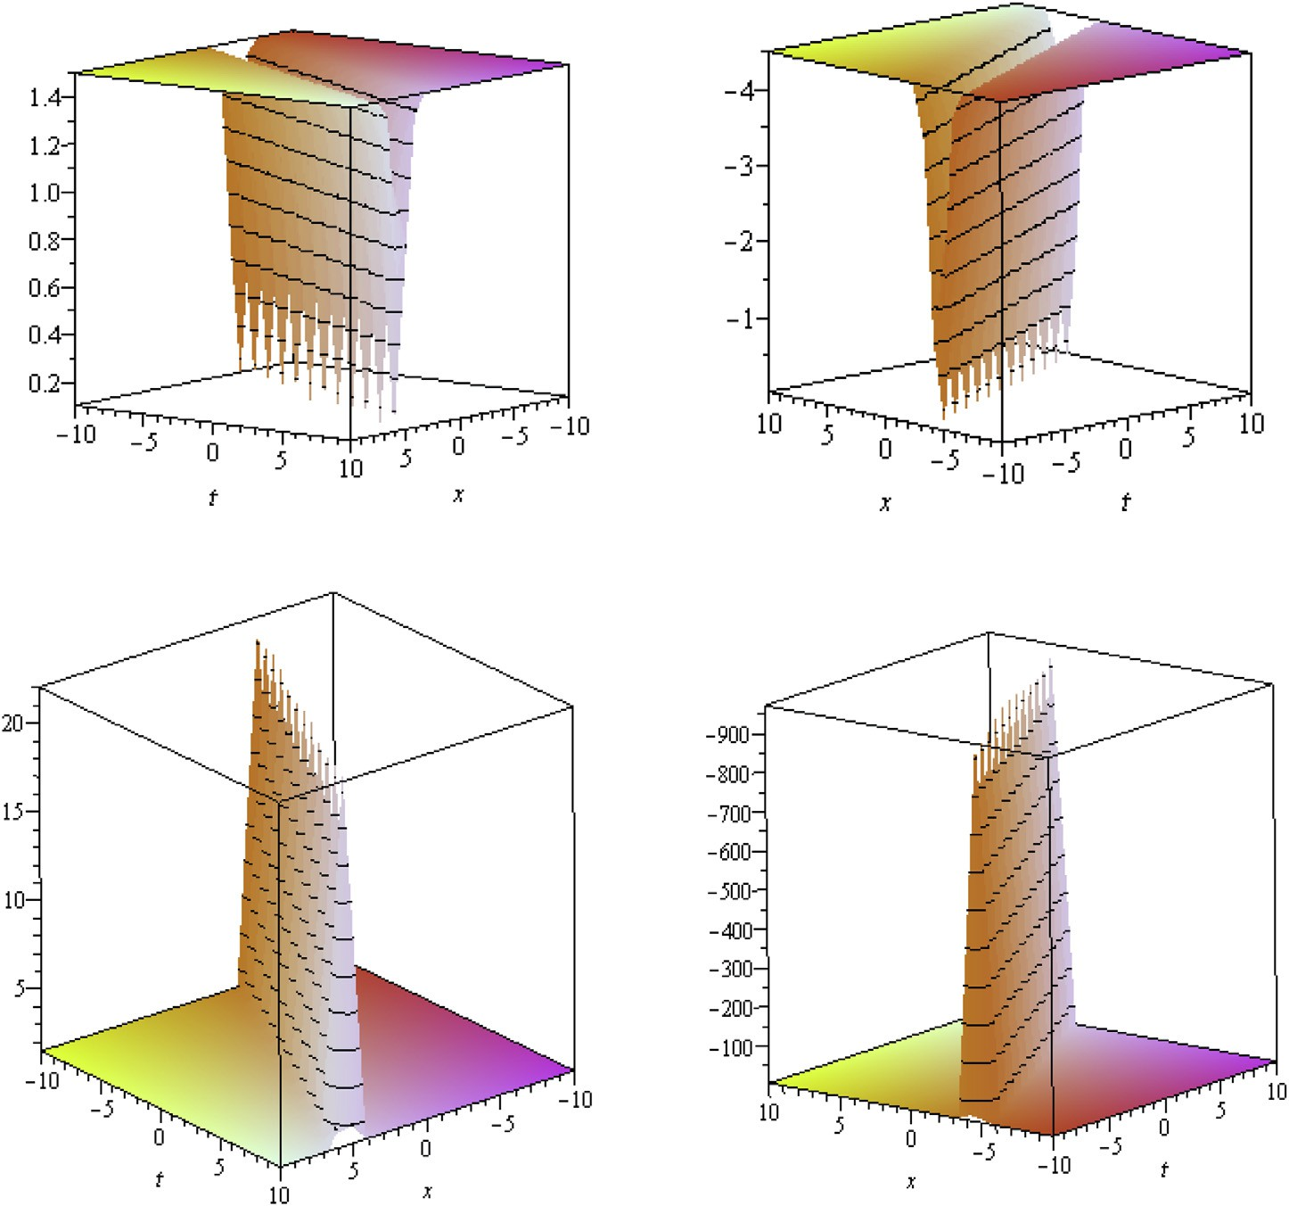

Fig. 1 e 3D plot of the soliton traveling wave solutions of u11 , v11 , u12 and v12 with ¡10≤x, t≤10, y¼0 respectively.

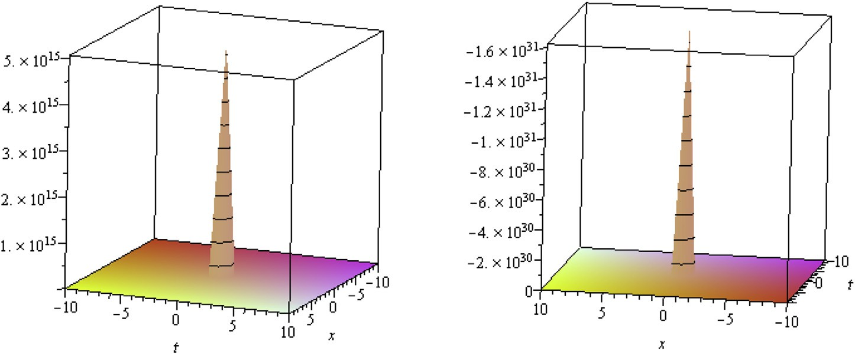

Fig. 2 e 3D plot of the single soliton traveling wave solutions of u2 1 and v2 1 with ¡10≤x, t≤10, y¼0 respectively.

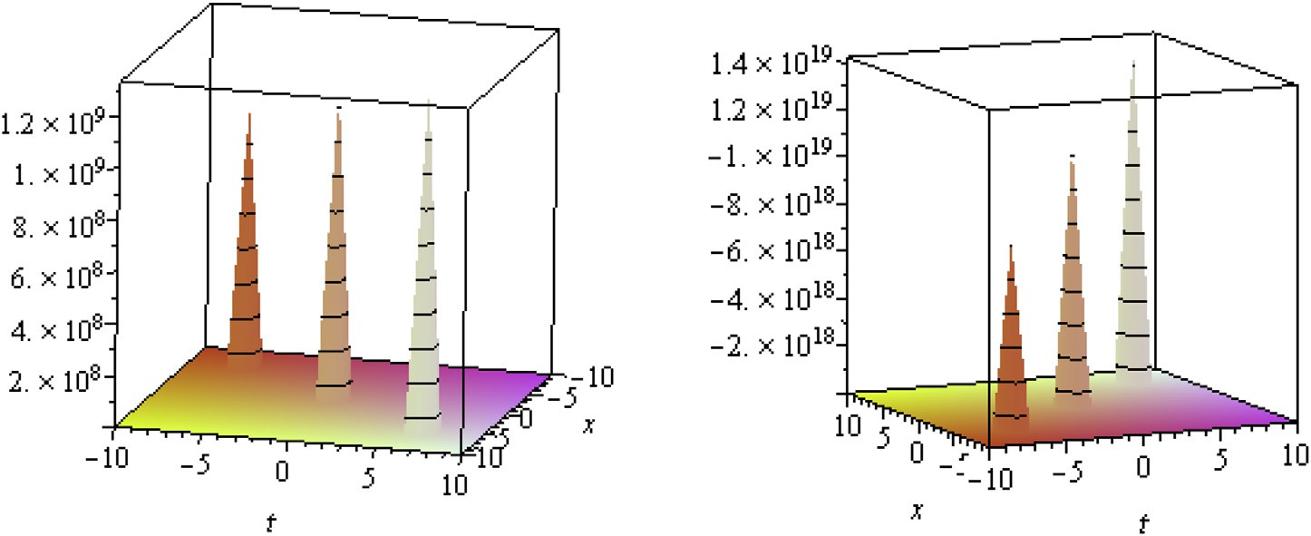

Fig. 3 e 3D plot of the multiple soliton traveling wave solutions ofu4 1 andv4 1 with ¡10≤x, t≤10, y¼0 respectively.

[e g ypti an j o ur nal o f b a sic and a pp l i e d sci en c e s 2 ( 201 5 ) 206](http://dx.doi.org/10.1016/j.ejbas.2015.04.002) e[220](http://dx.doi.org/10.1016/j.ejbas.2015.04.002) 217

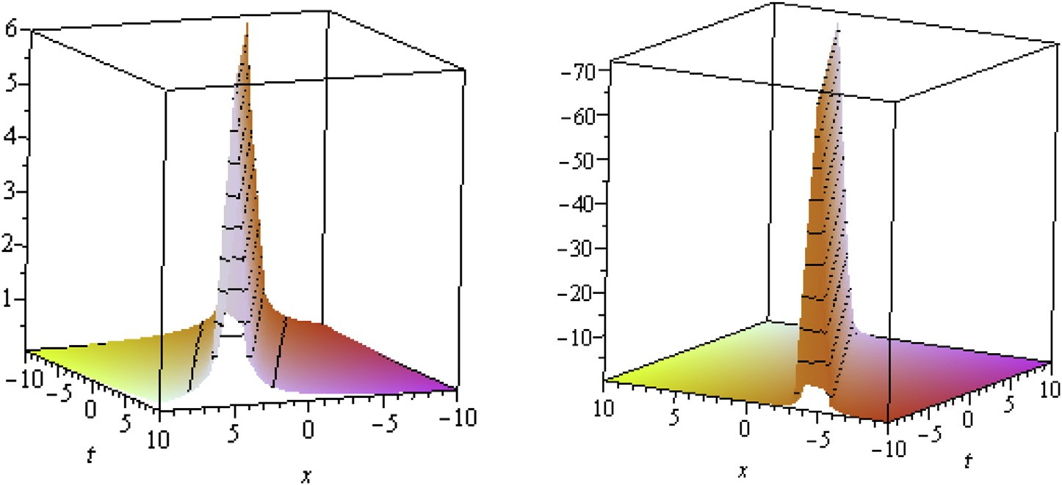

Fig. 4 e 3D plot of cuspon solution of u125 and v125 with ¡10≤x, t≤10,y¼0 respectively.

Solutions of *u*21 , *v*21 , *u*212 and *v*212 represents the single sol- iton solution. In Fig. 2, we have presented the single soliton solutions of *u*2 1 and *v*2 1 for*p*=—*c*/2, *q*=1, l=1, m=—1, n=3, a—1=2 with —10≤*x*, *t*≤10, *y*=0 respectively.

Solutions*u*3 1 , *u*4 1 , *v*4 1 *u*4 25 , *v*4 25 , *u*5 1 , *v*5 1 ,*u*5 25 and *v*5 25 de- scribes the multiple soliton solutions. In Fig. 3, we have

presented the multiple soliton solutions of *u*4 1 , *v*4 1 for*p*=—*c*/2, *q*=1, l=1, m=—1, n=3, a1=1 with —10≤*x*, *t*≤10, *y*=0 respectively. Solutions of *u*125 , *v*125 , *u*3 25 , *v*3 25 ,*u*4 23 and *v*4 23 are Cuspon of the Maccari system (8). Cuspons are other forms of solitons

where solution exhibits cusps at their crests. Unlike peakons where the derivatives at the peak differ only by a sign, the

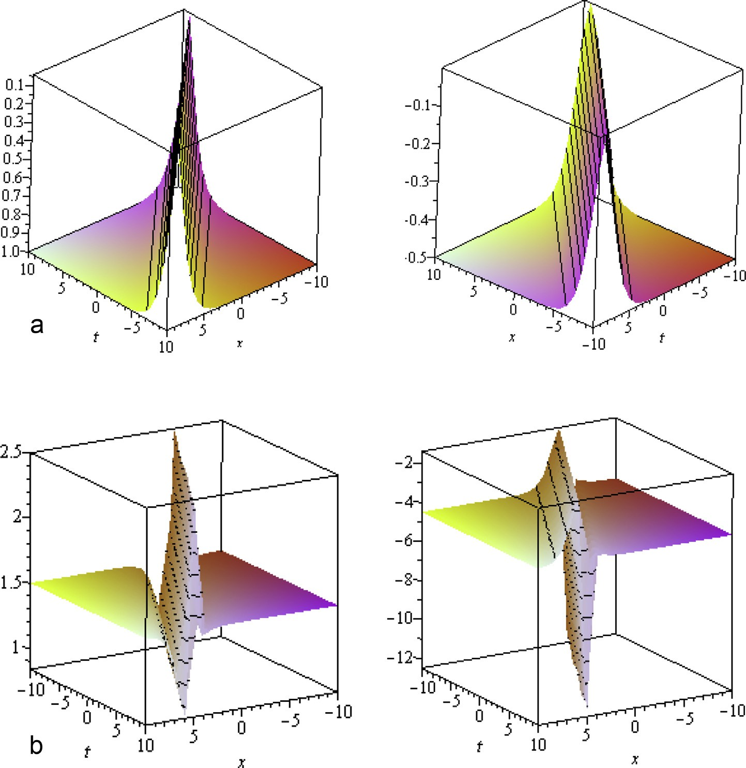

Fig. 5 e a) 3D plot of Bell-shape sec h2 solitary traveling wave solution of u123 and v123 with ¡10≤x, t≤10. b) 3D plot of the singular Kink traveling wave solution of u1 5 and v1 5 with ¡10≤x, t≤10,y¼0 respectively.

218 [e gypti an j o ur nal o f b a sic and a p p l i ed sci e n c e s 2 ( 201 5 ) 206](http://dx.doi.org/10.1016/j.ejbas.2015.04.002) e[220](http://dx.doi.org/10.1016/j.ejbas.2015.04.002)

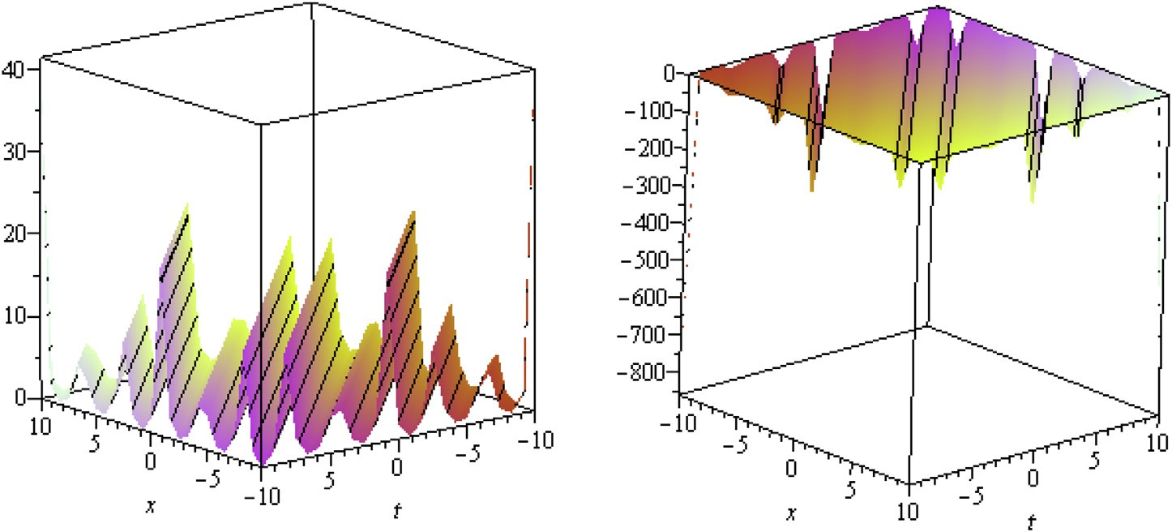

Fig. 6 e 3D plot of the periodic traveling wave solution of u3 12 and v312 with ¡10≤x, t≤10,y¼0.

derivatives at the jump of a cuspon diverge. The statement is

1/2

represented the periodic solution of *u*3 12 and *v*312 for *p*=—*c*/2,

that cuspon can be represented as *u*(*x*, *t*)= *e*—|*x*—*a*| , *n* > 1. It

*q*=1, l=—1, m=1, n=2, *d*=1, a1=1 with —10≤*x*, *t*≤10.

can easily be shown that *u*x/∞ at the cusp, and *u*x, *u*xx//0 to distinguish the soliton property. In Fig. 4, we presented the shape of the cuspon, obtain from solutions *u*125 and *v*125 of the

Maccari system (8) forl=0, m=0, n=3, *d*=1, a—1=2 , *c*1=0.5 with

—10≤*x*, *t*≤10,*y*=0 respectively.

Solutions *u*123 , *v*123 , *u*124 , *v*124 , *u*323 and *v*323 are bell-shape sec *h*2 solitary traveling wave solution. The Fig. 5 shows the shape of bell-shaped sec *h*2 solitary traveling wave solution (only shows the shape of solution of *u*123 and *v*123 only for *p*=—*c*/2, *p*=1, *k*=5, l=1, m=0, n=3, *d*=1, a—1=2 with

—10≤*x*, *t*≤10, *y*=0.

Solutions of *u*112 , *v*112 to *u*122 , *v*122 are represented the exact soliton periodic traveling wave solutions of the Maccari sys- tem (8). In Fig. 7, we have presented soliton periodic traveling wave solution of *u*113 , *v*113 for *p*=—*c*/2, *q*=1, l=—1, m=1, n=3, *d*=1,

a—1=2 with —10≤*x*, *t*≤10, *y*=0 respectively.

Solutions of *u*13 , *v*13 *u*110 and *v*110 are represented the exact singular kink periodic traveling wave solutions of the Maccari system (8). In Fig. 8, we have presented singular kink periodic traveling wave solution of *u*13 and *v*13 for *p*=—*c*/2, *q*=1, l=1, m=—1, n=3, *d*=1.5, a—1=2 with —10≤*x*, *t*≤10,*y*=0 respectively.

Singular kink solution is another kind of travelling wave

solution which comes from infinity as in trigonometry. The solution of *u*1 5 , *v*1 5 *u*2 23 and *v*2 23 comes infinity as in trigo- nometry, are singular kink solution. The Fig. 5 shows the shape of the exact singular kink-type solution (only shows the shape of solution of *u*1 5 , *v*1 5 for*p*=—*c*/2, *q*=1, l=1, m=—1, n=3, *d*=1.5, a—1=2 with —10≤*x*, *t*≤10,*y*=0 ).

Solutions of *u*3 12 and *v*312 represent the exact periodic traveling wave solutions. Periodic solutions are traveling wave solutions that are periodic such as *cos*(*x*—*t*). In Fig. 6, we have

# Conclusion

In this article, we have investigated a system of complex coupled equation. The novel (*G*'/*G*)-expansion method has been successfully applied to find more general travelling wave solutions of the coupled complex system. From the above solutions, we observe that if we take the particular values for the physical parameters, then these solutions are identical with the some particular solutions obtained by

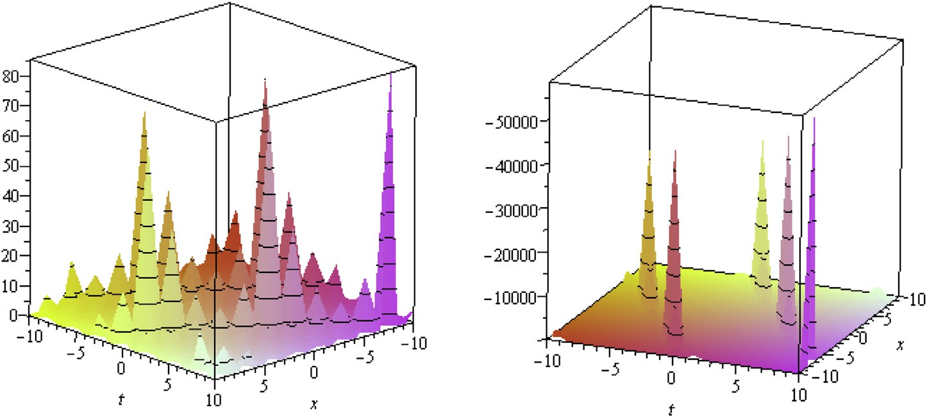

Fig. 7 e 3D plot of the soliton periodic traveling wave solution of u113 and v113 with ¡10≤x, t≤10,y¼0.

[e g ypti an j o ur nal o f b a sic and a pp l i e d sci en c e s 2 ( 201 5 ) 206](http://dx.doi.org/10.1016/j.ejbas.2015.04.002) e[220](http://dx.doi.org/10.1016/j.ejbas.2015.04.002) 219

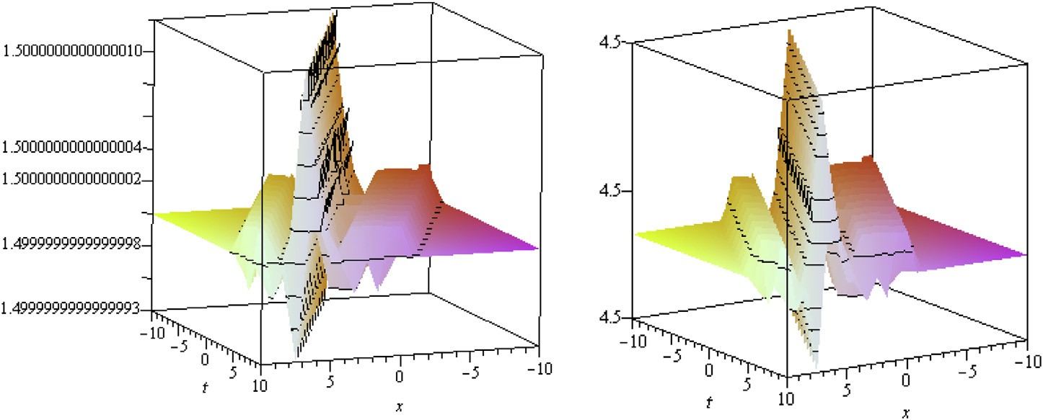

Fig. 8 e 3D plot of the singular kink periodic traveling wave solution of u13 , v13 with ¡10≤x, t≤10,y¼0.

other methods and give us more new exact solutions than the other existing methods. A variety of distinct physical struc- tures such as soliton solution, singular soliton solution, cus- pon, kink type solution, singular kink solution, periodic solution, bell type solitary wave solution and solitary wave solutions are formally derived. The various types of exact travelling wave solutions provide the mathematical founda- tion in physics and engineering. Therefore, it is examined that the novel (*G*'/*G*)-expansion method would be a vital mathematical tool for solving not only a single NLEEs but also the coupled NLEEs.

## referen c es

1. [Russell SJ. In: Report on waves, in proceedings of the 14th](http://refhub.elsevier.com/S2314-808X(15)00021-4/sref1) [meeting of the British Association for the advancement of](http://refhub.elsevier.com/S2314-808X(15)00021-4/sref1) [science; 1844](http://refhub.elsevier.com/S2314-808X(15)00021-4/sref1).
2. [Ablowitz MJ, Clarkson PA. Soliton, nonlinear evolution](http://refhub.elsevier.com/S2314-808X(15)00021-4/sref2) [equations and inverse scattering. Cambridge University](http://refhub.elsevier.com/S2314-808X(15)00021-4/sref2) [Press; 1991](http://refhub.elsevier.com/S2314-808X(15)00021-4/sref2).
3. [Hirota R. The direct method in soliton theory. Cambridge](http://refhub.elsevier.com/S2314-808X(15)00021-4/sref3) [University Press; 2004](http://refhub.elsevier.com/S2314-808X(15)00021-4/sref3).
4. [Matveev VB, Salle MA. Darboux transformation and solitons.](http://refhub.elsevier.com/S2314-808X(15)00021-4/sref4) [Berlin: Springer; 1991](http://refhub.elsevier.com/S2314-808X(15)00021-4/sref4).
5. [Hirota R, Bullough R, Caudrey P, editors. Direct method of](http://refhub.elsevier.com/S2314-808X(15)00021-4/sref5) [finding exact solutions of nonlinear evolution equations,](http://refhub.elsevier.com/S2314-808X(15)00021-4/sref5) [Backlund transformations. Berlin: Springer; 1980. p. 1157](http://refhub.elsevier.com/S2314-808X(15)00021-4/sref5)e[75](http://refhub.elsevier.com/S2314-808X(15)00021-4/sref5).
6. [Malfliet W, Hereman W. The tanh method: II. Perturbation](http://refhub.elsevier.com/S2314-808X(15)00021-4/sref6) [technique for conservative systems. Phys Scr](http://refhub.elsevier.com/S2314-808X(15)00021-4/sref6) [1996;54:569](http://refhub.elsevier.com/S2314-808X(15)00021-4/sref6)e[75](http://refhub.elsevier.com/S2314-808X(15)00021-4/sref6).
7. [Malfliet W, Hereman W. The tanh method: I. Exact solutions](http://refhub.elsevier.com/S2314-808X(15)00021-4/sref7) [of nonlinear evolution and wave equations. Phys Scr](http://refhub.elsevier.com/S2314-808X(15)00021-4/sref7) [1996;54:563](http://refhub.elsevier.com/S2314-808X(15)00021-4/sref7)e[8](http://refhub.elsevier.com/S2314-808X(15)00021-4/sref7).
8. [Bluman GW, Kumei S. Symmetries and differential](http://refhub.elsevier.com/S2314-808X(15)00021-4/sref8) [equations. Berlin: Springer-Verlag; 1989](http://refhub.elsevier.com/S2314-808X(15)00021-4/sref8).
9. [Weiss J, Tabor M, Carnevale G. The Painlev](http://refhub.elsevier.com/S2314-808X(15)00021-4/sref9)e´ [property for](http://refhub.elsevier.com/S2314-808X(15)00021-4/sref9) [partial differential equations. J Math Phys 1983;24:522](http://refhub.elsevier.com/S2314-808X(15)00021-4/sref9).
10. [Akbar MA, Ali NHM. New solitary and periodic solutions of](http://refhub.elsevier.com/S2314-808X(15)00021-4/sref10) [nonlinear evolution equation by exp-function method.](http://refhub.elsevier.com/S2314-808X(15)00021-4/sref10) [World Appl Sci J 2012;17(12):1603](http://refhub.elsevier.com/S2314-808X(15)00021-4/sref10)e[10](http://refhub.elsevier.com/S2314-808X(15)00021-4/sref10).
11. Naher H, Abdullah AF, Akbar MA. New traveling wave solutions of the higher dimensional nonlinear partial differential equation by the Exp-function method. J Appl

Math 2012:14. <http://dx.doi.org/10.1155/2012/575387>. article ID 575387.

1. O€ [zi](http://refhub.elsevier.com/S2314-808X(15)00021-4/sref12)s‚ [T, K](http://refhub.elsevier.com/S2314-808X(15)00021-4/sref12)o€[ro](http://refhub.elsevier.com/S2314-808X(15)00021-4/sref12)g˘[lu C. A novel approach for solving the Fisher](http://refhub.elsevier.com/S2314-808X(15)00021-4/sref12)

[equation using Exp-function method. Phys Lett A](http://refhub.elsevier.com/S2314-808X(15)00021-4/sref12) [2008;372(21):3836](http://refhub.elsevier.com/S2314-808X(15)00021-4/sref12)e[40](http://refhub.elsevier.com/S2314-808X(15)00021-4/sref12).

1. [K](http://refhub.elsevier.com/S2314-808X(15)00021-4/sref13)o€[ro](http://refhub.elsevier.com/S2314-808X(15)00021-4/sref13)g˘[lu C,](http://refhub.elsevier.com/S2314-808X(15)00021-4/sref13) O€ [zi](http://refhub.elsevier.com/S2314-808X(15)00021-4/sref13)s‚ [T. A novel traveling wave solution for](http://refhub.elsevier.com/S2314-808X(15)00021-4/sref13)

[Ostrovsky equation using Exp-function method. Comput](http://refhub.elsevier.com/S2314-808X(15)00021-4/sref13) [Math Appl 2009;58:2142](http://refhub.elsevier.com/S2314-808X(15)00021-4/sref13)e[6](http://refhub.elsevier.com/S2314-808X(15)00021-4/sref13).

1. O€ [zi](http://refhub.elsevier.com/S2314-808X(15)00021-4/sref14)s‚ [T, K](http://refhub.elsevier.com/S2314-808X(15)00021-4/sref14)o€[ro](http://refhub.elsevier.com/S2314-808X(15)00021-4/sref14)g˘[lu C. A novel approach for solving the Fisher](http://refhub.elsevier.com/S2314-808X(15)00021-4/sref14)

[equation using Exp-function method. Reply to: “Comment](http://refhub.elsevier.com/S2314-808X(15)00021-4/sref14) [on: Phys Lett A 2009;373:1198](http://refhub.elsevier.com/S2314-808X(15)00021-4/sref14)e[200](http://refhub.elsevier.com/S2314-808X(15)00021-4/sref14).

1. [Wazwaz AM. Partial differential equations: method and](http://refhub.elsevier.com/S2314-808X(15)00021-4/sref15) [applications. Taylor and Francis; 2002](http://refhub.elsevier.com/S2314-808X(15)00021-4/sref15).
2. [Wang M. Solitary wave solutions for variant Boussinesq](http://refhub.elsevier.com/S2314-808X(15)00021-4/sref16) [equations. Phy Lett A 1995;199:169](http://refhub.elsevier.com/S2314-808X(15)00021-4/sref16)e[72](http://refhub.elsevier.com/S2314-808X(15)00021-4/sref16).
3. [Wang W, Li X, Zhang J. The (G](http://refhub.elsevier.com/S2314-808X(15)00021-4/sref17)'[/G)-expansion method and](http://refhub.elsevier.com/S2314-808X(15)00021-4/sref17)

[traveling wave solutions of nonlinear evolution equations in](http://refhub.elsevier.com/S2314-808X(15)00021-4/sref17) [mathematical physics. Phys Lett A 2008;372:417](http://refhub.elsevier.com/S2314-808X(15)00021-4/sref17)e[23](http://refhub.elsevier.com/S2314-808X(15)00021-4/sref17).

1. [Zhang J, Wei X, Lu Y. A generalized (G](http://refhub.elsevier.com/S2314-808X(15)00021-4/sref18)'[/G)-expansion method](http://refhub.elsevier.com/S2314-808X(15)00021-4/sref18) [and its applications. Phys Lett A 2008;372:3653](http://refhub.elsevier.com/S2314-808X(15)00021-4/sref18)e[8](http://refhub.elsevier.com/S2314-808X(15)00021-4/sref18).
2. [Zhang J, Jiang F, Zhao X. An improved (G](http://refhub.elsevier.com/S2314-808X(15)00021-4/sref19)'[/G)-expansion](http://refhub.elsevier.com/S2314-808X(15)00021-4/sref19) [method for solving nonlinear evolution equations. Int J Com](http://refhub.elsevier.com/S2314-808X(15)00021-4/sref19) [Math 2010;87(8):1716](http://refhub.elsevier.com/S2314-808X(15)00021-4/sref19)e[25](http://refhub.elsevier.com/S2314-808X(15)00021-4/sref19).
3. [Zayed EME. New traveling wave solutions for higher](http://refhub.elsevier.com/S2314-808X(15)00021-4/sref20) [dimensional nonlinear evolution equations using a](http://refhub.elsevier.com/S2314-808X(15)00021-4/sref20) [generalized (G](http://refhub.elsevier.com/S2314-808X(15)00021-4/sref20)'[/G)-expansion method. J Phys A: Math Theor](http://refhub.elsevier.com/S2314-808X(15)00021-4/sref20) [2009;42:195202](http://refhub.elsevier.com/S2314-808X(15)00021-4/sref20)e[14](http://refhub.elsevier.com/S2314-808X(15)00021-4/sref20).
4. [Zayed EME. The (G](http://refhub.elsevier.com/S2314-808X(15)00021-4/sref21)'[/G)-expansion method combined with the](http://refhub.elsevier.com/S2314-808X(15)00021-4/sref21) [Riccati equation for finding exact solutions of nonlinear](http://refhub.elsevier.com/S2314-808X(15)00021-4/sref21) [PDEs. J Appl Math Informatics 2011;29(1](http://refhub.elsevier.com/S2314-808X(15)00021-4/sref21)e[2):351](http://refhub.elsevier.com/S2314-808X(15)00021-4/sref21)e[67](http://refhub.elsevier.com/S2314-808X(15)00021-4/sref21).
5. Akbar MA, Ali NHM, Zayed EME. A generalized and improved (G'/G)-expansion method for nonlinear evolution equations. Math Prob Engr 2012;12:22. [http://dx.doi.org/10.1155/2012/](http://dx.doi.org/10.1155/2012/459879) [459879](http://dx.doi.org/10.1155/2012/459879).
6. [Alam MN, Akbar MA, Mohyud-Din ST. A novel (G](http://refhub.elsevier.com/S2314-808X(15)00021-4/sref23)'[/G)-](http://refhub.elsevier.com/S2314-808X(15)00021-4/sref23) [expansion method and its application to the Boussinesq](http://refhub.elsevier.com/S2314-808X(15)00021-4/sref23) [equation. Chin Phys B 2014;23(2):020203](http://refhub.elsevier.com/S2314-808X(15)00021-4/sref23).
7. [Lee J, Sakthivel R. Exact travelling wave solutions for some](http://refhub.elsevier.com/S2314-808X(15)00021-4/sref24) [important nonlinear physical models. Pramana](http://refhub.elsevier.com/S2314-808X(15)00021-4/sref24) e [J Phys](http://refhub.elsevier.com/S2314-808X(15)00021-4/sref24) [2013;80:757](http://refhub.elsevier.com/S2314-808X(15)00021-4/sref24)e[69](http://refhub.elsevier.com/S2314-808X(15)00021-4/sref24).
8. [Hafez MG, Alam MN, Akbar MA. Traveling wave solutions for](http://refhub.elsevier.com/S2314-808X(15)00021-4/sref25) [some important coupled nonlinear physical models via the](http://refhub.elsevier.com/S2314-808X(15)00021-4/sref25) [coupled Higgs equation and the Maccari system. J King Saud](http://refhub.elsevier.com/S2314-808X(15)00021-4/sref25) [Uni Sci 2015;27:105](http://refhub.elsevier.com/S2314-808X(15)00021-4/sref25)e[12](http://refhub.elsevier.com/S2314-808X(15)00021-4/sref25).
9. [Manafian J, Zamanpour I. Analytical treatment of the](http://refhub.elsevier.com/S2314-808X(15)00021-4/sref26) [coupled Higgs equation and Maccari system via Exp-function](http://refhub.elsevier.com/S2314-808X(15)00021-4/sref26) [method. Acta Univ Apulensis 2013;33:203](http://refhub.elsevier.com/S2314-808X(15)00021-4/sref26)e[16](http://refhub.elsevier.com/S2314-808X(15)00021-4/sref26).

220 [e gypti an j o ur nal o f b a sic and a p p l i ed sci e n c e s 2 ( 201 5 ) 206](http://dx.doi.org/10.1016/j.ejbas.2015.04.002) e[220](http://dx.doi.org/10.1016/j.ejbas.2015.04.002)

1. [Manafian J, Zamanpour I. Modification of truncated](http://refhub.elsevier.com/S2314-808X(15)00021-4/sref27) [expansion method to some complex nonlinear partial](http://refhub.elsevier.com/S2314-808X(15)00021-4/sref27) [differential equations. Acta Univ Apulensis 2013;33:109](http://refhub.elsevier.com/S2314-808X(15)00021-4/sref27)e[216](http://refhub.elsevier.com/S2314-808X(15)00021-4/sref27).
2. [Zhu S. The generalized Riccati equation mapping method in](http://refhub.elsevier.com/S2314-808X(15)00021-4/sref28) [non-linear evolution equation: application to (2](http://refhub.elsevier.com/S2314-808X(15)00021-4/sref28)+[1)-](http://refhub.elsevier.com/S2314-808X(15)00021-4/sref28) [dimensional Boiti-Leon-Pempinelle equation. Chaos Solit](http://refhub.elsevier.com/S2314-808X(15)00021-4/sref28) [Fract 2008;37:1335](http://refhub.elsevier.com/S2314-808X(15)00021-4/sref28)e[42](http://refhub.elsevier.com/S2314-808X(15)00021-4/sref28).
3. [Akbar MA, Ali NHM, Mohyud-Din ST. The alternative (G](http://refhub.elsevier.com/S2314-808X(15)00021-4/sref29)'[/G)-](http://refhub.elsevier.com/S2314-808X(15)00021-4/sref29) [expansion method with generalized Riccati equation:](http://refhub.elsevier.com/S2314-808X(15)00021-4/sref29) [application to fifth order (1](http://refhub.elsevier.com/S2314-808X(15)00021-4/sref29)+[1)-dimensional Caudrey-Dodd-](http://refhub.elsevier.com/S2314-808X(15)00021-4/sref29) [Gibbon equation. Int J Phys Sci 2012;7(5):743](http://refhub.elsevier.com/S2314-808X(15)00021-4/sref29)e[52](http://refhub.elsevier.com/S2314-808X(15)00021-4/sref29).
4. [Zayed EME. The (G](http://refhub.elsevier.com/S2314-808X(15)00021-4/sref30)'[/G)-expansion method and its](http://refhub.elsevier.com/S2314-808X(15)00021-4/sref30) [applications to some nonlinear evolution equations in the](http://refhub.elsevier.com/S2314-808X(15)00021-4/sref30) [mathematical physics. J Appl Math Comput 2009;30:89](http://refhub.elsevier.com/S2314-808X(15)00021-4/sref30)e[103](http://refhub.elsevier.com/S2314-808X(15)00021-4/sref30).