 HOSTE D BY

Available online at [www.sciencedirect.com](http://www.sciencedirect.com/science/journal/2314808X)

**ScienceDirect**

journal homepage: [http://ees.elsevier.com/ejbas/default.asp](http://http//ees.elsevier.com/ejbas/default.asp)

**Full Length Article**

**Facile synthesis and vapochromic studies of Co(II) complexes bearing NO and OO donor ligands**



***A.C. Tella*** ***a******,******\*******, S.O. Owalude*** ***a******, L.O. Alimi*** ***b******, A.C. Oladipo*** ***a******, S.J. Olatunji*** ***a******,***

***O.G. Adeyemi*** ***c***

a *Department of Chemistry, University of Ilorin, Ilorin, P.M.B.1515, Nigeria*

b *Department of Chemistry and Polymer Science, Stellenbosch University, Stellenbosch 7602, South Africa*

c *Department of Chemical Sciences, Redeemer’s University, Mowe, Ogun State, Nigeria*

A R T I C L E I N F O A B S T R A C T

*Article history:*

Received 18 May 2015 Received in revised form 3 December 2015

Accepted 15 December 2015

Available online 20 January 2016

*Keywords:*

Solvent-free synthesis Spectroscopic analysis Vapochromic studies Sensors

Two Co(II) complexes containing malonic and isonicotinic acids have been prepared by manual grinding of stoichiometric amounts of the starting materials. Elemental analysis (CHN), IR, UV-vis spectroscopic techniques, TGA-DTG investigation and X-ray powder diffraction analy- sis were used to characterize the two compounds. Isonicotinic acid coordinated to the metal via the pyridine ring nitrogen and one oxygen atom of the carboxylic group while malonic acid coordinated via both oxygen atoms of the carboxylate groups indicating bidentate co- ordination mode in the two compounds. The compounds were exposed to some volatile organic compounds (VOCs) containing nitrogen or oxygen donor atoms in the solid state and their vapochromic behaviours studied using colour changes, FT-IR and solid state UV- vis spectroscopies. Heating the samples exposed to the VOCs for a few minutes at 100 °C regenerates the original material without degradation, even after several heating cycles.

© 2016 Mansoura University. Production and hosting by Elsevier B.V. This is an open access article under the CC BY-NC-ND license (<http://creativecommons.org/licenses/by->

nc-nd/4.0/).

# Introduction

Vapochromic materials that display colour or luminescence changes upon exposure to vapours have been a subject of con- tinued research in recent years due to their potential applications in chemical vapour detection in food and chemi- cal industries, electronic noses and safety in toxic ambient conditions [1–4]. Although a variety of chemical sensors have

been successfully commercialized, there still exists the need for improvement on their performance and several investiga- tions are ongoing in this regard. Applications of coordination complexes as sensors for VOCs detection have been reported [2–4]. Coordination complexes have several advantages such as structural diversity, possibility for post-synthetic modifica- tion and a wide range of chemical and physical properties over other sensor types [5,6]. Coordination complexes also compare well to zeolites in terms of large internal surface areas, extensive

* *Corresponding author.* Tel.: +234 8035019197.

*E-mail address:* [ac_tella@yahoo.co.uk](mailto:ac_tella@yahoo.co.uk) (A.C. Tella).

<http://dx.doi.org/10.1016/j.ejbas.2015.12.001>

2314-808X/© 2016 Mansoura University. Production and hosting by Elsevier B.V. This is an open access article under the CC BY-NC-ND license ([http://creativecommons.org/licenses/by-nc-nd/4.0/).](http://creativecommons.org/licenses/by-nc-nd/4.0/))

porosity, and high degree of crystallinity, consequently they have been utilized for many of the same applications including gas

Co(CH3COO)2.4H2O + H2L

Grinding, RT, 15 min No solvent

[Co(L)(H2O)2]n + 2CH3COOH

storage and separations [7,8].

Complexes are thermally robust with decomposition tem- peratures above 300 °C, in few cases they can be stable up to 500 °C and are also capable of overcoming the challenge of se- lectivity that plague other sensor materials [9]. Because complexes contain metal ions in addition to their organic com- ponents, they have characteristics similar to discrete coordination complexes, and changes in the coordination sphere of these metal centres can play a role in complex sensing. The

polymeric Prussian Blue complex Co2+/[Re6Q8(CN)6]4− (Q = S, Se)

produced dramatic changes in the visible spectrum when

exposed to specific VOCs; the colour changes were linked to the sensed solvent impacting the geometry and hydration around the Co(II) centres with a change in coordination envi- ronment from the octahedral to tetrahedral geometry [10]. Several metal organic framework materials and coordination polymers based on Au(I), Pd(II) and Pt(II) have been exten- sively investigated for vapochromic responses [11,12].

One of the major goals of green chemistry is to limit the extensive use of solvents or even better to carry out the synthetic reaction in the absence of them. Solvent-free syn- thesis has therefore been applied over the years both in academic and industrial laboratories [13,14]. Solvent-free re- actions are thought to occur in the solid phase, hence the problem of releasing toxic volatile organic compounds; low yield and slow reaction time associated with solution synthe- sis are avoided. Co(II) complexes are well-known for dramatic colour changes associated with inter-conversion between oc- tahedral and tetrahedral coordination geometries [10]. As a continuation of our work on the use of solvent-free tech- niques to prepare functional materials [15–18], we hereby report mechanochemical solvent-free synthesis of Co(II) com- pounds of isonicotinic and malonic acids. Their vapochromic responses to a series of analytes such as methanol, ethanol, benzene, dimethylformamide and dichloromethane were also investigated.

# Experimental

All reagents were purchased from Sigma-Aldrich and were used without further purification. The melting points were deter- mined in capillary tubes using a Gallen-Kamp melting point apparatus. FT-IR spectra were recorded in KBr pellets within

the range of 4000–400 cm−1 on a SHIMADZU scientific model

500 FITR spectrophotometer. Electronic spectra of the com- plexes in solution were recorded on SHIMADZU UV-1650pc UV- vis spectrophotometer. Elemental analyses were carried out in a 2400 Series II Perkin-Elmer CHN Analyzer. Powder XRD analy-

ses were performed on a Syntag PADS diffractometer at 294 K using Cu Kα radiation (λ = 1.54059 A´˚ ). Each sample was ana- lyzed between 4.0 and 40.01 2θ with a total scan time of 5.0 min.

The thermal analysis (TGA/DTG) was carried under nitrogen atmosphere with a heating rate of 10 °C/min using Shimadzu TGA Q500 V6.7 Build 203 thermal analyzer. Solid-state elec- tronic spectra were measured on polycrystalline samples on

*Analtikjena Specord 210*-*plus UV-Vis* spectrophotometer over the range 350–900 nm at scanning rate of 5 nm s−1.

(H2L = malonic acid, isonicotinic acid)

**Scheme 1 – Equation of reaction for solvent-free mechanochemical synthesis of** 1 **and** 2**.**

## *Synthetic methods*

The two complexes were prepared by modification of a litera- ture procedure [19].

### *[Co(Mal)].2H2O]n (1)*

Malonic acid (0.208 g, 2 mmol) and cobalt acetate tetrahydrate (0.332 g, 1 mmol) were weighed into a clean agate mortar and ground together continuously for 15 minutes. The orange powder obtained was washed with methanol to remove any unreacted starting material, dried at room temperature and then stored in a desiccator over CaCl2. The general chemical equa- tion of the reaction is as shown in Scheme 1. Yield: 92%, M.

wt. = 196.93 g/mol, m.pt. = 230 °C, Anal. Calcd for C3H6O6Co (%): C, 18.28; H, 3.05. Found: C, 18.28; H 3.07. IR (KBr, cm−1): 3288b

ν(O-H band of H2O), 1573 νasym(COO-), 1460 νsym(COO-), 542 ν(M– N), 457 ν(M–O); UV-vis (DMSO) nm: 260, 295, 532, 682, 930.

### *[Co(Ina)2].2H2O]n (2)*

Isonicotinic acid (0.246 g, 2 mmol) and cobalt acetate tetrahydrate (0.332 g, 1 mmol) were weighed into an agate mortar and ground together continuously for 15 minutes. The light pink powder obtained was washed with methanol to remove any starting material, dried at room temperature

and then stored in a desiccator over CaCl2. Yield: 93%, m.wt. = 341 g/mol, m.pt. = decomposed > 300 °C; Anal. Calcd for C12H12N2O6Co: C, 42.48; H, 3.54 N, 8.26. Found: C, 42.23, H, 3.52,

N, 8.21; IR (KBr, cm−1): 3244 ν(O-H band of H2O), 548 ν(M–N), 457

ν(M–O); UV-vis (DMSO) nm: 264, 302, 476, 516, 1078.

## *Vapochromic studies*

The vapochromic studies of compounds **1** and **2** were carried out following a literature procedure [20]. The compounds were activated by heating at 180 °C for 20 minutes and placed in small open vials. The vials containing the compounds were then placed in a larger vial containing each of the volatile oxygen or nitrogen donor solvent (methanol, ethanol, dimethylformamide, dichloromethane, benzene and NH4OH). The larger vials were then tightly closed for 24 hours. Changes in colour were observed and vapochromic properties were monitored by running IR and solid-state UV-Vis spectra of the samples before and after exposure.

# Results and discussion

The composition of the complexes was determined by elemen- tal analyses, FT-IR and PXRD. The experimentally determined elemental analysis data were in agreement with the calcu- lated values. The two compounds were obtained with good yields exceeding 90% for both compounds; they are crystalline

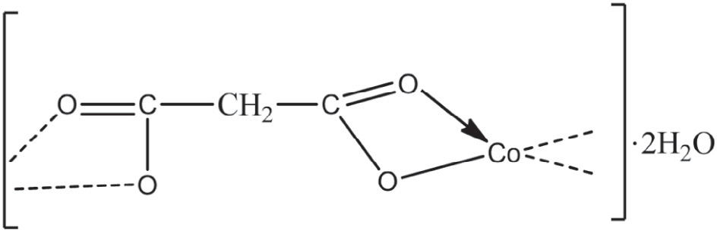and very stable in air compared to the highly hygroscopic start- a ing materials. Complex **1** has a sharp melting point at 230 °C while **2** decomposed at temperature above 300 °C.

## *Infrared spectra*

Malonic acid, HOOC-CH2-COOH, has one -CH2- function between the two carboxylic groups and in metal malonates, it can bind in a bidentate chelating manner through the two carboxylate oxygen at each of the two functional ends to form a four- membered metallocycle [21]. The characteristic broad band at

3075 cm−1 due to ν(O-H) in the free ligand H2(mal) was absent

in **1**, indicating the existence of deprotonated form of the malo- nate group in the complex. A broad peak at around 3288 cm−1 was observed in the complex which is characteristic of ν(O-

1. band of H2O, indicating the presence of water in the system in agreement with the elemental analysis data. Metal malo- nate complexes containing coordinated water molecules have

been reported [22]. The νasym(COO-) and νsym(COO-) peaks were

b

O

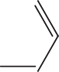

O

* 1. C Co

N

.2H2O

C

* 1. 

O

found at 1573 cm−1 and 1460 cm−1 respectively. Therefore, the

Δν(COO-) of 113 cm−1 indicates bidentate coordination of the

#### Fig. 1 – (a) The proposed structure of [Co(Mal)].2H2O]n (1). (b) The proposed structure of [Co(Ina)2].2H2O]n (2).

carboxylate group to cobalt atom, thereby making the malo- nate ions function as bridging moieties [22a,23]. The presence

of new band in the IR spectrum of **1** at 457 cm−1 attributed to

M–O also supports complex formation.

Isonicotinic acid has different coordination modes [24], and it is coordinated not only through the carboxylate group but also through the nitrogen atom of the pyridine ring. Some- times, the nitrogen of the pyridine ring does not participate in the coordination [25]. This property results in different con- structions in the Co(II) complex [26,27]. Important vibrational modes implying coordination of the isonicotinic ligand mol- ecule to the metal atom in this work were *ν*(O-H) and pyridine ring vibrations. The nitrogen of the pyridine ring was ob- served to have participated in the coordination due to the shift

in its band in the complex spectra from 1555 cm−1 to 1552 cm−1

in the spectrum of the Co(II) complex. These variations clearly indicate that coordination of isonicotinic acid takes place via the pyridine ring nitrogen to the metal atom. The O-H band

around 3490 cm−1 in the free ligand was observed to have been

shifted to 3362 cm−1 in the complex; this is also suggesting the

coordination through the hydroxyl oxygen. This coordination mode was also observed by Can et al. [28]. The Δν values of 121 cm−1 in this complex suggests a bidentate coordination of

the COO- to the Co(II) centre [29]. Band corresponding to metal– oxygen was observed at 457 cm−1 in the FT-IR spectrum of the complex. In addition, the presence of water was suggested due to appearance of a new band at 690 cm−1 in the complex. The

infrared spectroscopic data combined with elemental analy- sis results support the structures proposed for **1** and **2** in Fig. 1a and b respectively.

## *TGA-DTG analysis*

The TG and DTG thermogram of complex **1** is shown in Fig. 2a. The compound decomposed in three successive steps begin- ning from 93–115 °C attributed to the loss of two lattice water molecules (calcd./found: 18.10/19.23%) [30]. Then the com- pound is stable up to 163 °C. The malonic acid ligand is lost in the second step in the range 160–380 °C (calcd./found:

52.28/51.29%). The experimental values for the mass loss of the

dehydration stage and loss of malonic acid molecule are well consistent with the calculated values. After the loss of the ligand and water molecules, the network began to decompose with the continuous weight loss up to 480 °C. Complex **2** was ther- mally decomposed in four successive decomposition steps within the temperature range 95–550 °C. The first decompo- sition step (calcd./found: 5.57/4.92%) within the temperature range 95–102 °C may be attributed to loss of lattice water mol- ecule in the complex. At the temperature above 550 °C, loss of the two isonicotinic acid molecules was evident from the TGA curve in Fig. 2b (calcd./found: 76.10/72.24%). The water mol- ecules present in the two compounds were therefore confirmed to be lattice water.

## *Electronic spectra*

The selected UV-Vis spectra data of malonic and isonicotinic acids and their Co(II) compounds in solutions are given in Tables 1 and 2. It can be seen from the Tables that the UV-vis spectra of the carboxylic acids present two absorption bands

that are assigned to π-π* and n-π* of increasing wavelengths.

For the Co(II) compounds, i.e [Co(Mal)].2H2O]n and [[Co(Ina)2].2H2O]n, the visible region produced three bands that can be attributed to 4T1g - 4T1g(P), 4T1g - 4A2g and 4T1g - 4T2g of increasing wavelengths, thereby suggesting octahedral ge- ometry for the compounds [31]. It can be observed from Table 2 that the Co(II) complex of isonicotinic acid show UV-visible spectra along the expected lines. The complex exhibit three peaks around 476 nm, 516 nm and 1078 nm attributtable to 4T1g – 4T1g(P), 4T1g – 4A2g and 4T1g – 4T2g respectively. This is a char- acteristic of octahedral Co(II) species [31].

## *XRPD Pattern*

The solid powder obtained in the synthesis was used directly without any modifications. Evidence of formation of complexes

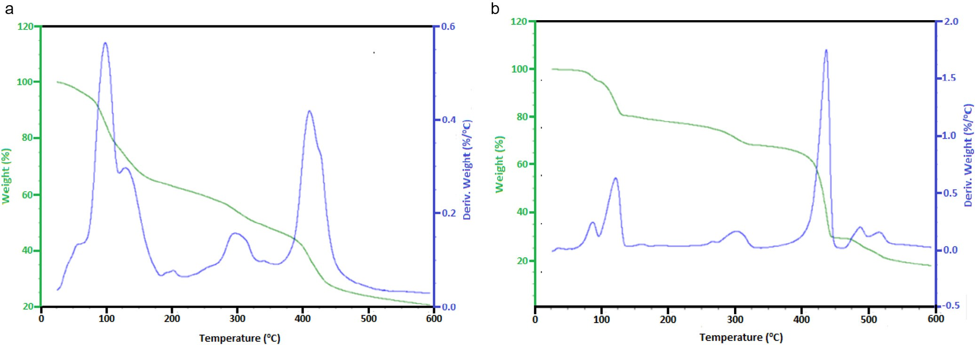

#### Fig. 2 – (a) TG–DTG curve of complex 1. (b) TG–DTG curve of complex 2.

was demonstrated by comparing the powder X-ray diffrac- tion patterns of the ligands with that of the products **1** and **2** as shown in Fig. 3. Comparing the XRPD patterns of **1** with those of the ligand (malonic acid), the major peaks in **1** were ob-

served at 2θ = 15.19, 16.26, 17.19, 22.93, 24.17, 26.00, 28.48, 30.42,

35.95, while those of malonic acid were found at 2θ= 10.94, 17.76,

18.86, 22.93, 23.89, 25.20, 27.11, 27.83, 33.35, 33.70, 34.87, 35.42

and 37.21. Quantitative estimation of XRPD patterns of **1** and malonic acid revealed appearance of new peaks in **1** that are absent in the malonic acid ligand indicating formation of a new phase. This suggests a complexation of malonic and cobalt acetate. Similarly, XRPD patterns of **2** were different from the diffraction patterns of the isonicotinic acid ligand. The peaks observed for the isonicotinic acid ligand are situated at

2θ = 12.25, 14.21, 15.09, 16.43, 19.74, 21.56, 22.79, 24.37, 26.25,

26.97, 28.09, 28.65 and 37.30. The peaks present in the **2** are

2θ = 10.15, 14.37, 16.14, 18.06, 19.39, 26.21, 27.68, 28.31, 28.85,

29.79 and 32.99. Some 2θ values appeared for complex **2** that are absent in the ligand suggesting complex formation.

## *Vapochromic behaviour studies*

To test for vapochromic behaviour, compounds **1** and **2** were activated by heating at 180 °C for 20 minutes. The complexes after activation were named **1a** and **2a**. Colour changes were observed after exposure to some solvents, namely ethanol, methanol, dimethyl formamide, benzene, dichloromethane and ammonium solution for 24 hours to give **1a**-EtOH, **1a**-MeOH, **1a**-DMF, **1a**-DMSO, **1a**-Benzene, **1a**-DCM and **1a**-NH3 respec- tively. So, also for compound **2**, change in colour in response to the solvents were observed and the FT-IR spectra before and after exposure were obtained. Solid-state exposure of the com- pounds to vapours of the above VOCs produces a selective and reversible change in their colours that is perceptible to the

|  |  |  |  |  |
| --- | --- | --- | --- | --- |
| **Table 1 – Selected UV-visible spectra data for malonic acid and its Co(II) complex.** | | | | |
| Complex/ ligand | Wavelength (nm) | Energy (cm−1) | Absorbance | Assignment |
| Malonic acid | 258 | 38760 | 0.123 | π-π* |
|  | 290 | 34483 | 0.093 | n-π* |
| [Co(mal)].2H2O]n | 260 | 38461 | 0.392 | π-π |
|  | 294 | 34014 | 0.784 | n-π* |
|  | 532 | 18797 | 0.666 | 4T1g→4T1g(P) |
|  | 682 | 14663 | 0.039 | 4T1g→4A2g |
|  | 930 | 10753 | 0.040 | 4T1g→4T2g |

|  |  |  |  |  |
| --- | --- | --- | --- | --- |
| **Table 2 – Selected UV-visible spectra data for isonicotinic acid and its Co(II) complex.** | | | | |
| Complex/ ligand | Wavelength (nm) | Energy (cm−1) | Absorbance | Assignment |
| Isonicotinic acid | 260 | 38462 | 0.112 | π-π* |
|  | 312 | 32051 | 2.501 | n-π* |
| [Co(Ina)2].2H2O]n | 264 | 37879 | 0.360 | π-π* |
|  | 302 | 33113 | 2.328 | n-π* |
|  | 476 | 21008 | 0.309 | 4T1g→4T1g(P) |
|  | 516 | 19380 | 0.306 | 4T1g→4A2g |
|  | 1078 | 9276 | 0.089 | 4T1g→4T2g |

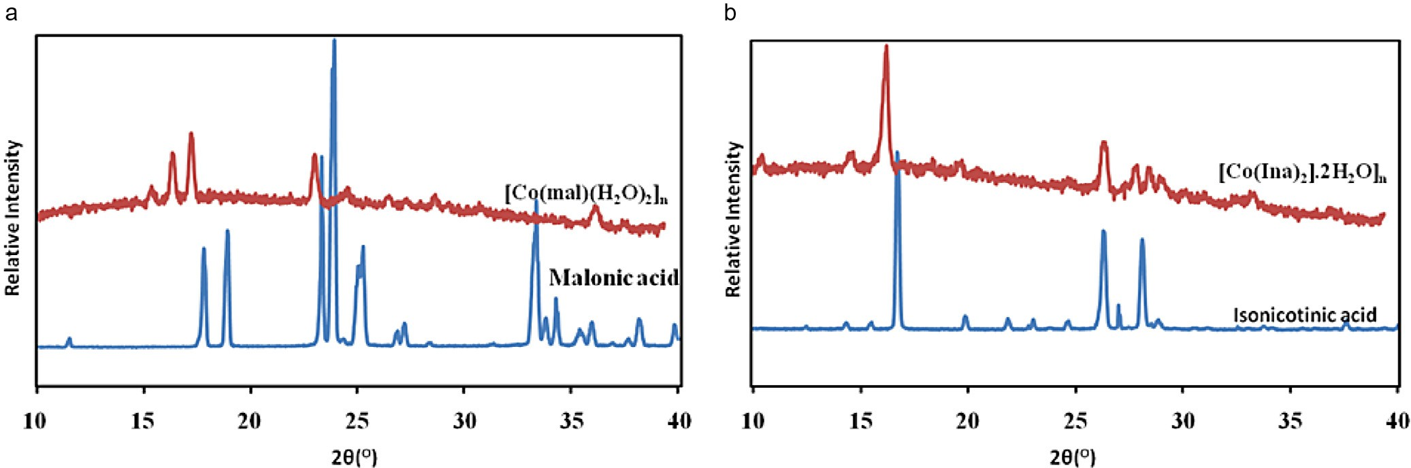

#### Fig. 3 – (a) PXRD pattern of malonic acid and [Co(mal)].2H2O]n (1). (b) PXRD pattern of isonicotinic acid [Co(Ina)2].2H2O]n (2).

human eyes and even deeper under UV irradiation, allowing them to function as sensors for these VOCs. In all the com-

pounds after heating, the O-H band intensity around 3400 cm−1

reduces with concomitant water loss, or just a single O-H band is seen. The IR spectra of the activated materials differ from those of the complexes, an indication of structural changes in response to the removal of water molecules. Thus, as a result of heating, the cobalt–aqua bonds were broken and water mol- ecules were lost, resulting in the colour change. Upon exposure of the activated complexes in ambient environment, water vapour is adsorbed and the colours change back to the origi- nal colours, or heating the samples exposed to the VOCs for a few minutes at 100 °C regenerates the original material without degradation, even after several exposures/heating

cycles, thus confirming the reversibility of the vapochromic properties.

### *Vapochromic behaviour of [Co(mal)].2H2O]n*

The change in colours of complex **1** with VOCs inclusion is given in Fig. 4a, and important FT-IR bands with the corresponding colour changes are recorded in Table 3. The FT-IR spectra of **1**, its activated form and after exposure to different solvents are given in Fig. 5a. The vapochromic characteristics of **1** were tested and gave some colour changes and differences in the IR spectra. Here, solvent peaks were observed in the spectra of the as synthesized material which disappear on activa- tion; also, the intensity of the O-H peak is reduced and shifted

from 3425 cm−1 to 3288 cm−1. Various shifts, either to lower or

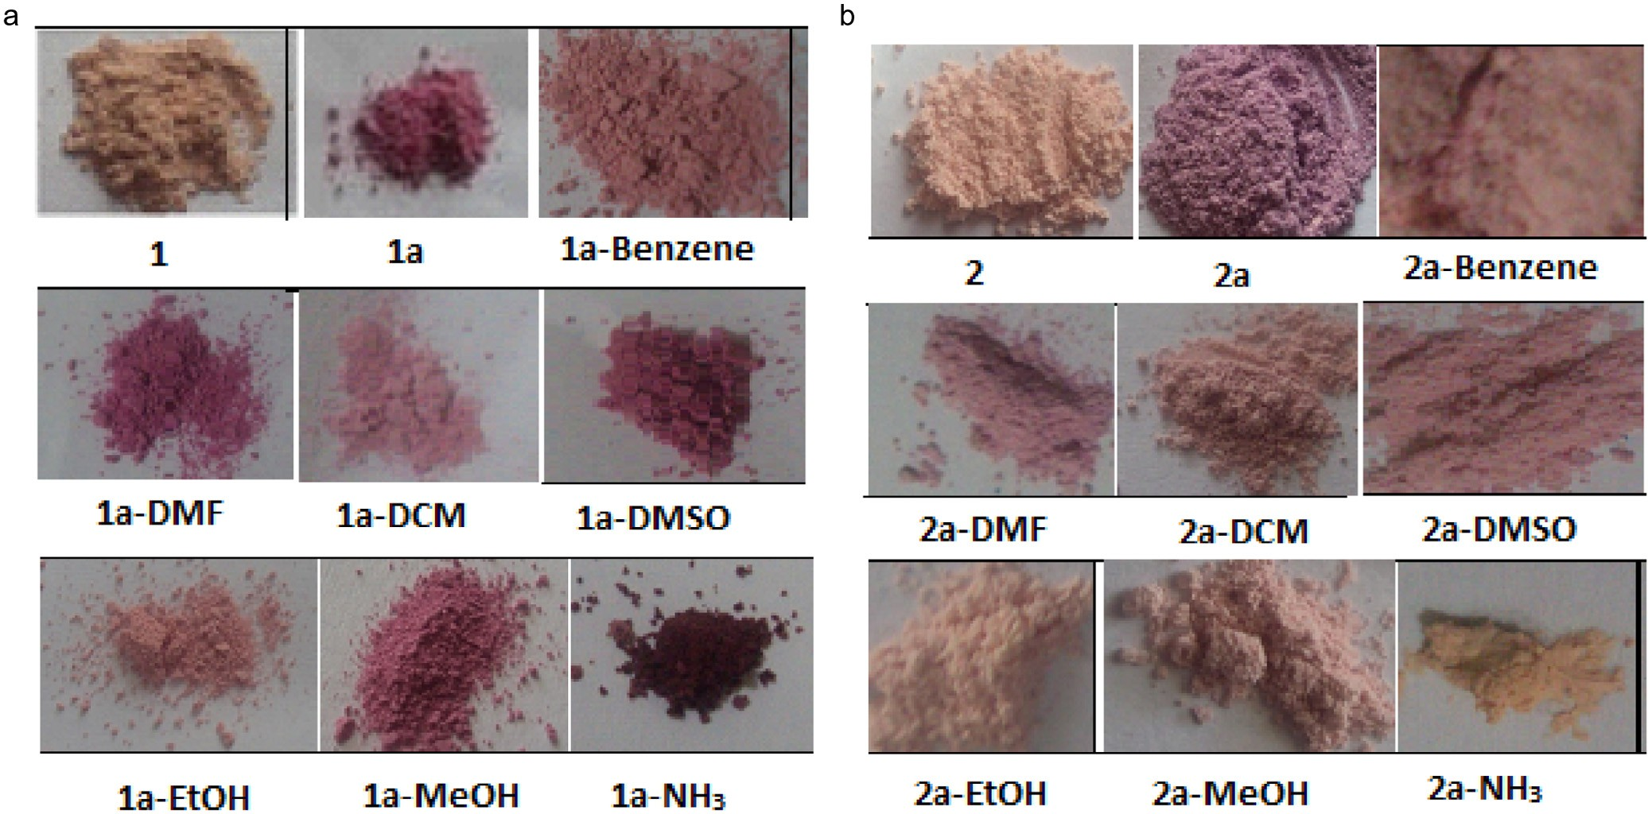

#### Fig. 4 – (a) Pictures of 1 as-synthesized, after activation and after exposure to VOCs. (b) Pictures of 2 as-synthesized, after activation and exposure to VOCs.

|  |  |  |  |  |  |  |  |  |  |  |
| --- | --- | --- | --- | --- | --- | --- | --- | --- | --- | --- |
| **Table 3 – Colours of** 1 **as-synthesized, activated and after exposure to VOCs and their selected FT-IR band frequencies.** | | | | | | | | | | |
| Complex Colour |  | **1**  Peach orange | **1a**  Dark pink | **1a**-Benzene Apricot | **1a**-DCM  Pale pink | **1a**-DMF  Amaranth pink | **1a**-DMSO  Amaranth pink | **1a**-EtOH  Apricot | **1a**-MeOH  Amaranth pink | **1a**-NH3  Brown |
| IR Peaks | ν(OH) | 3288 | 3425 | 3454 | 3454 | 3433 | 3456 | 3450–3200 | 3419 | 3327 |
| (cm−1) | ν(C-H) | 2949–2847 | 2972, 2914 | 2976 | 2916 | 2914 | 2916 | - | 2914 | 2997 |
|  | alkanes |  |  |  |  |  |  |  |  |  |
|  | δ (CH2) | 1460 | 1417 | 1450 | 1450 | 1415 | 1417 | 1452 | 1417 | 1417 |
|  | alkane |  |  |  |  |  |  |  |  |  |
|  | ν (C = O) | 1689 | 1664 | 1699 | 1666 | 1664 | 1664 | 1664 | 1664 | - |
|  | ν (C-O) | 1236 | 1290 | 1284 | 1284 | 1290 | 1236 | 1284 | 1290 | 1253 |
|  | ν (M-O) |  | 457 | 457 | 480 | 480 | 457 | 457 | 459 | 457 |
|  | δ (CH) | - | - | 775 | - | - | - | - | - | - |
|  | arom. |  |  |  |  |  |  |  |  |  |
|  | ν (C-Cl) | - | - | - | 572 | - | - | - | - | - |
|  | ν (N-H) | - | - | - | - | - | - | - | - | 3273 |

higher frequencies, were observed for the solvent-included complex, and appearance of peaks characteristic of the func-

tional groups of some of the solvents was observed. For instance, peak characteristic of aromatic C = C stretch was found at 3194 cm−1 for **1a**-Benzene, peak at 3273 cm−1 characteristic

of N–H stretch was also found for **1a**-NH3, C–N stretch peak was observed at 1236 cm−1 for **1a**-DCM and an additional O-H peak at 3200 cm−1 was found for ethanol. The appearance of

these solvent peaks after exposure is an evidence of solvents inclusion.

Fig. 6a shows the solid state UV-visible spectra of complex **1** before and after exposure to volatile organic solvents. The assignments are as shown in Table 4. Comparison of the solid state UV-visible spectra of complex **1** with those obtained after exposure to VOCs was carried out. The complexes containing the VOCs showed substantial shifts in wavelength and changes in intensity. The absorption band of the complexes after ex- posure to VOCs showed red shift in different solvents to higher wavelength relative to their corresponding complexes. Complex **1** showed absorption band at 383 nm, upon direct exposure to VOCs, the absorption band shifted to 400 nm in benzene, 407 nm in DCM, 421 nm in DMF and 400 nm in ethanol with

vapochromic shift λmax in the range 17–38 nm. Similar findings

were obtained for Cobalt(II) complex of 4-(pyridin-4-yl)benzoic acid after exposure to VOCs [32].

### *Vapochromic behaviour of [Co(Ina)2].2H2O]n*

For complex **2**, the colour changes after VOCs inclusion are given in Table 5 while their FT-IR spectra are given in Fig. 5b. The colour changes on exposure to the VOCs vary from light orange to light purple. In the IR spectrum of the as synthesized complex, solvent peaks were present which disappeared after

activation. Also, the intensity of C = O band at 1716 cm−1 in-

creased. The intensity of other bands either increased or decreased. Also, on inclusion of benzene, solvent peaks ap-

peared and the O-H band shifted. For DCM, DMSO and DMF inclusion, the O-H bands were also shifted to 3240 cm−1, 3356 cm−1 and 3240 cm−1, respectively, likewise for methanol

and ethanol inclusion. NH3 inclusion gave rise to new peaks at 3184 cm−1 and 3242 cm−1 corresponding to the N–H stretch. The FT-IR spectroscopic analysis indicated broad O-H band at around 3400 cm−1 the band observed at about 2950 cm−1 cor- responds to the aliphatic C-H group while the peak around 1683 cm−1 corresponds to C = O stretch. Mostly, the ν(O-H) region in the IR spectrum, and sometimes other functional group peaks

are sensitive to the presence of volatile vapours of oxygen and

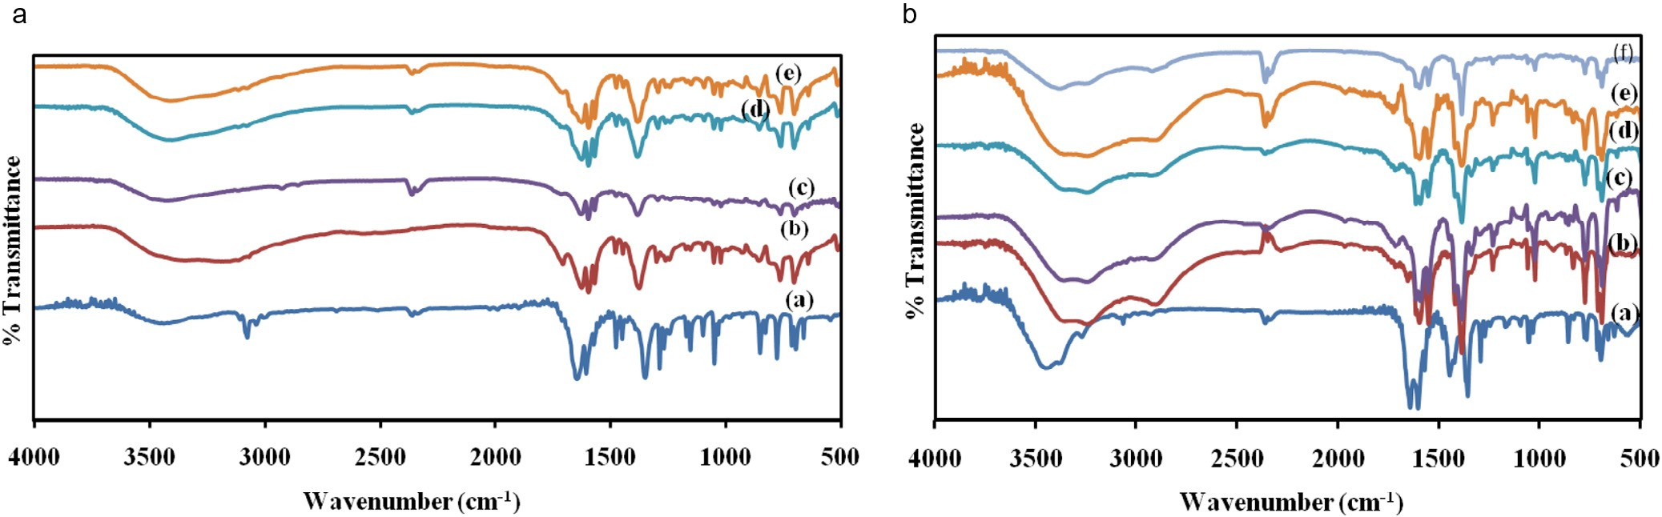

#### Fig. 5 – (a) FT-IR spectra of solvent-included Co-malonic complexes (a) 1 (b) 1-Activated (1a) (c) 1a-DMSO (d) 1a-DCM (e) 1a- DMF. (b) FT-IR spectra of solvent-included Co-isonicotinic complex (a) 2 (b) 2-activated (2a) (c) 2a-DCM (d) 2a-DMF (e) 2a- benzene (f) 2a-ethanol.

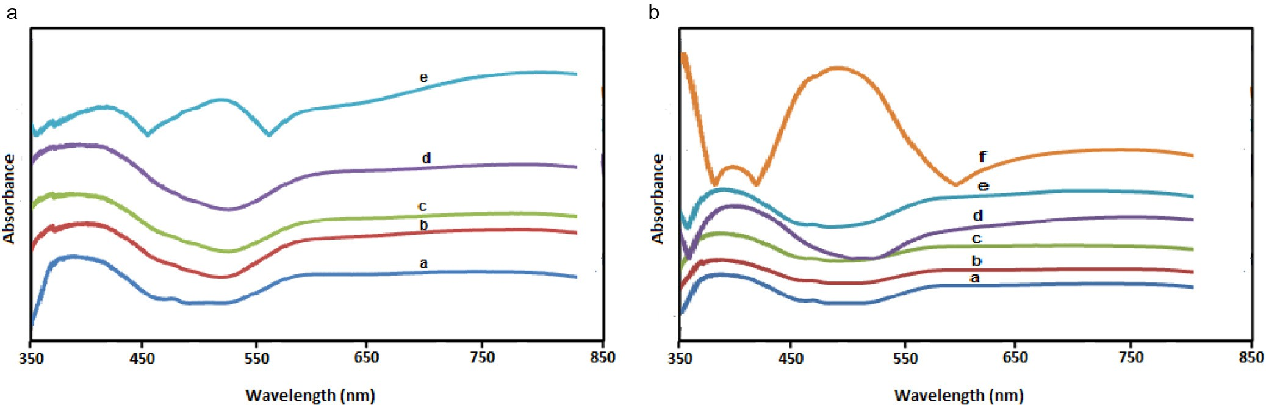

**Fig. 6 – (a) Solid state UV-visible spectra of complex** 1, a **(**1a**),** b **(**1a**-benzene),** c **(**1a**-DCM),** d **(**1a**-DMF),** e **(**1a**-ethanol). (b) Solid state UV-visible spectra of complex** 2, a **(**2a**),** b **(**2a**-benzene),** c **(**2a**-DCM),** d **(**2a**-DMF),** e **(**2a**-ethanol),** f **(**2a**-methanol).**

nitrogen donors. As seen above, there is shift of the O-H band and sometimes, the other bands to either higher or lower fre- quency for all the solvent-included complexes. Exposure of the complex to VOCs vapours led, in some cases, to compounds whose FT-IR spectra clearly show the bands corresponding to the characteristic absorptions of the functional groups of the VOCs employed, which appeared displaced with respect to those observed for the free VOCs, probably as a consequence of the coordination of the organic molecules to the metal atoms that weakens the bonds. In other cases, the characteristic absorp- tions were masked by other vibrational modes and assignments

|  |  |  |
| --- | --- | --- |
| **Table 4 – Electronic absorption maxima (**λ**max) and vapochromic shift for solid state complex** 1**.** | | |
| Absorption solvent (VOCs) | Electronic absorption  λmax (nm) | Vapochromic shift  λmax (nm) |
| None | 383 | 0 |
| Benzene | 400 | 17 |
| Dichloromethane | 407 | 24 |
| Dimethylformamide | 421 | 38 |
| Ethanol | 400 | 17 |
| Vapochromic shift λmax = λmax(VOC) – λmax(none). | | |

were not clear. Because complexes contain metal ions in ad- dition to their organic components, they have characteristics similar to discrete coordination complexes, and changes in the coordination sphere of these metal centres can play a role in complex sensing [19]. From a literature report, a system does not need to be porous in order to undergo guest uptake [33], a flexible metal–ligand structure can adapt in order to accom- modate guest molecules [34,35]. We therefore reasoned that the mechanism of guests’ uptake here most likely results from molecular distortions in the framework probably caused by solvent hydrogen bonding [36]. Such framework distortions may result to changes in d-d transitions in the visible region.

The solid-state UV-vis spectra of complex **2** before and after exposure to the VOCs are shown in Fig. 6b with the data re- corded in Table 6. Complex **2** exposed to the VOCs also showed red shifts in wavelength and changes in intensity attributed to electronic transitions to higher wavelength as a result of metal–ligand charge transfer. The characteristic absorption band at 370 nm in complex **2** upon direct exposure to VOCs has shifted to 378 nm (benzene), 381 nm (DCM), 397 nm (DMF), 387 nm (ethanol) and 493 nm (methanol) with vapochromic shift

λmax in the range 8–123 nm. This finding is in agreement with

a literature report [37]. Such distortion in structure of the complex may results to changes in d-d transitions in the visible region.

|  |  |  |  |  |  |  |  |  |  |  |
| --- | --- | --- | --- | --- | --- | --- | --- | --- | --- | --- |
| **Table 5 – Colours of** 2 **as synthesized, activated and after exposure to VOCs, and their selected FT-IR band frequencies.** | | | | | | | | | | |
| Complex Colour |  | **2**  Peach | **2a**  Purple | **2a**-Benzene Pale pink | **2a**-DCM  Pale pink | **2a**-DMF  Pink | **2a**-DMSO  Pink | **2a**-EtOH  Sunset orange | **2a**-MeOH  Champagne pink | **2a**-NH3  Peach yellow |
| IR (cm−1) | ν(O-H) | 3362, 3244 | 3362, 3232 | 3373, 3221 | 3371, 3240 | 3356, 3246 | 3371, 3240 | 3362, 3257 | 3362, 3238 | 3346, 3313 |
|  | ν(C = O) | 1716 | 1716 | 1726 | 1715 | - | 1705 | 1716 | 1716 | - |
|  | ν(C = C) | 1595 | 1891 | 1595 | 1591 | 1591 | 1591 | 1593 | 1593 | 1595 |
|  | ν(C-O) | 1232 | 1232 | 1232 | 1232 | 1232 | 1232 | 1232 | 1232 | 1242 |
|  | δ(O-H) | 1419 | - | 1419 | 1419 | - | 1419 | 1419 | 1419 | 1417 |
|  | δ(C-H) | 775 | 775 | 775 | 775 | 775 | 775 | 775 | 775 | 773 |
|  | ν(M-N) | 542 | - | 542 | 572 | - | - | - | 536 | - |
|  | ν(M-O) | 457 | 455 | 495 | 491 | 491 | - | - | 493 | 418 |
|  | ν(N-H) | - |  |  |  |  |  | - | - | 3242, 3184 |

|  |  |  |
| --- | --- | --- |
| **Table 6 – Electronic absorption maxima (**λ**max) and vapochromic shift for solid state complex** 2**.** | | |
| Absorption solvent (VOCs) | Electronic absorption  λmax (nm) | Vapochromic shift  λmax (nm) |
| None | 370 | 0 |
| Benzene | 378 | 8 |
| Dichloromethane | 381 | 11 |
| Dimethylformamide | 397 | 27 |
| Ethanol | 387 | 17 |
| Methanol | 493 | 123 |
| Vapochromic shift λmax = λmax(VOC) – λmax(none). | | |

# Conclusions

Two malonic and isonicotinic acid complexes of Co(II) were pre- pared using solvent-free mechanochemical technique. The method is simple, environmentally-friendly, efficient and affords products in good yields. Vapochromic properties of the two com- pounds were studied by exposing them to some volatile organic compounds namely ethanol, methanol, dimethyl formamide, dichloromethane, dimethyl sulphoxide and ammonia for 24 hours after activation by heating at 180 °C for 20 minutes. The changes in colour and the FT-IR spectra pattern were moni- tored. It was noticed that exposure of the water-desorbed complexes to various solvents results in the formation of several phases. The inclusion of these solvents gives rise to new struc- tural phases whose colours are different from those of the former. These effects are fully reversible, a desirable property for a potential sensor material for the detection of volatile organic compounds.

# Acknowledgement

ACT and SOO are grateful to the Royal Society of Chemistry for the award of 2015 RSC Research Fund Grant.

R E F E R E N C E S

1. [White-Morris RL, Olmstead MM, Jiang F, Tinti DS, Balch AL.](http://refhub.elsevier.com/S2314-808X(16)00002-6/sr0010) [Remarkable variations in the luminescence of frozen](http://refhub.elsevier.com/S2314-808X(16)00002-6/sr0010) [solutions of [Au(C(NHMe2)2](PF6) 0.5(Acetone). Structural and](http://refhub.elsevier.com/S2314-808X(16)00002-6/sr0010) [spectroscopic studies of the effects of anions and solvents in](http://refhub.elsevier.com/S2314-808X(16)00002-6/sr0010) [Gold(I) carbene complexes. J Am Chem Soc 2002;124:2327–36.](http://refhub.elsevier.com/S2314-808X(16)00002-6/sr0010)
2. [Strasser CE, Catalano VJ. “On–off” Au(I)–Cu(I) interactions in](http://refhub.elsevier.com/S2314-808X(16)00002-6/sr0015) [a Au(NHC)2 luminescent vapochromic sensor. J Am Chem](http://refhub.elsevier.com/S2314-808X(16)00002-6/sr0015) [Soc 2010;132:10009–11.](http://refhub.elsevier.com/S2314-808X(16)00002-6/sr0015)
3. [Lim SH, Olmstead MM, Balch AL. Molecular accordion;](http://refhub.elsevier.com/S2314-808X(16)00002-6/sr0020) [vapoluminescense and molecular flexibility in the orange](http://refhub.elsevier.com/S2314-808X(16)00002-6/sr0020)

[and green luminescent crystals of the dimer, Au2(μ-bis-](http://refhub.elsevier.com/S2314-808X(16)00002-6/sr0020)

[(diphenylphosphino)ethane)2Br2. J Am Chem Soc](http://refhub.elsevier.com/S2314-808X(16)00002-6/sr0020)

[2011;133:10229–38.](http://refhub.elsevier.com/S2314-808X(16)00002-6/sr0020)

1. [Mansour MA, Connick WB, Lachicotte RJ, Gysling HJ,](http://refhub.elsevier.com/S2314-808X(16)00002-6/sr0025) [Eisenberg R. Linear chain Au(I) dimer compounds as](http://refhub.elsevier.com/S2314-808X(16)00002-6/sr0025) [environmental sensors: a luminescent switch for the](http://refhub.elsevier.com/S2314-808X(16)00002-6/sr0025) [detection of volatile organic compounds. J Am Chem Soc](http://refhub.elsevier.com/S2314-808X(16)00002-6/sr0025) [1998;120:1329–30.](http://refhub.elsevier.com/S2314-808X(16)00002-6/sr0025)
2. [Tranchemontagne DJ, Mendoza-Cortes JL, O’Keeffe M, Yaghi](http://refhub.elsevier.com/S2314-808X(16)00002-6/sr0030) [OM. Secondary building units, nets and bonding in](http://refhub.elsevier.com/S2314-808X(16)00002-6/sr0030) [chemistry of metal–organic frameworks. Chem Soc Rev](http://refhub.elsevier.com/S2314-808X(16)00002-6/sr0030) [2009;38:1257–83.](http://refhub.elsevier.com/S2314-808X(16)00002-6/sr0030)
3. [Wang Z, Cohen SM. Postsynthetic modification of metal–](http://refhub.elsevier.com/S2314-808X(16)00002-6/sr0035) [organic frameworks. Chem Soc Rev 2009;38:1315–29.](http://refhub.elsevier.com/S2314-808X(16)00002-6/sr0035)
4. [Li J-R, Ma Y, McCarthy MC, Sculley J, Yu J, Jeong H-K, et al.](http://refhub.elsevier.com/S2314-808X(16)00002-6/sr0040) [Carbondioxide capture – related gas adsorption and](http://refhub.elsevier.com/S2314-808X(16)00002-6/sr0040) [separation in metal-organic frameworks. Coord Chem Rev](http://refhub.elsevier.com/S2314-808X(16)00002-6/sr0040) [2011;255:1791–823.](http://refhub.elsevier.com/S2314-808X(16)00002-6/sr0040)
5. [Li J-R, Kuppler RJ, Zhou H-C. Selective gas adsorption and](http://refhub.elsevier.com/S2314-808X(16)00002-6/sr0045) [separation in metal-organic frameworks. Chem Soc Rev](http://refhub.elsevier.com/S2314-808X(16)00002-6/sr0045) [2009;38:1477–504.](http://refhub.elsevier.com/S2314-808X(16)00002-6/sr0045)
6. [Cavka JH, Jakobsen S, Olsbye U, Guillou N, Lamberti C,](http://refhub.elsevier.com/S2314-808X(16)00002-6/sr0050) [Bordiga S, et al. A new zirconium inorganic building brick](http://refhub.elsevier.com/S2314-808X(16)00002-6/sr0050) [forming metal-organic frameworks with exceptional](http://refhub.elsevier.com/S2314-808X(16)00002-6/sr0050) [stability. J Am Chem Soc 2008;130:13850–1.](http://refhub.elsevier.com/S2314-808X(16)00002-6/sr0050)
7. [Beauvais LG, Shores MP, Long JR. Cyano – bridged Re6Q8 (Q =](http://refhub.elsevier.com/S2314-808X(16)00002-6/sr0055)

[S, Se) cluster- cobalt(II) framework materials: versatile solid](http://refhub.elsevier.com/S2314-808X(16)00002-6/sr0055)

[chemical sensors. J Am Chem Soc 2000;122:2763–72.](http://refhub.elsevier.com/S2314-808X(16)00002-6/sr0055)

1. [Lee H, Jung SH, Han WS, Moon JH, Kang S, Lee JY, et al.](http://refhub.elsevier.com/S2314-808X(16)00002-6/sr0060) [Chromo-fluorogenictetrazole based CoBr2 coordination](http://refhub.elsevier.com/S2314-808X(16)00002-6/sr0060) [polymer gel as a highly sensitive and selective chemosensor](http://refhub.elsevier.com/S2314-808X(16)00002-6/sr0060) [for volatile gases containing chloride. Chem Eur J](http://refhub.elsevier.com/S2314-808X(16)00002-6/sr0060) [2011;17:2823–7.](http://refhub.elsevier.com/S2314-808X(16)00002-6/sr0060)
2. [Lefebvre J, Korcˇok JL, Katz MJ, Leznoff DB. Vapochromic](http://refhub.elsevier.com/S2314-808X(16)00002-6/sr0065) [behaviour of M[Au(CN)2]2 based coordination polymers (M =](http://refhub.elsevier.com/S2314-808X(16)00002-6/sr0065) [Co, Ni). Sensors (Basel) 2012;12:3669–92.](http://refhub.elsevier.com/S2314-808X(16)00002-6/sr0065)
3. [Chen T, Liang B, Xin X. Studies on solid-solid reactions](http://refhub.elsevier.com/S2314-808X(16)00002-6/sr0070) [between 4-methylbenzenenamine and CuCl2.2H2O,](http://refhub.elsevier.com/S2314-808X(16)00002-6/sr0070) [CoCl2.6H2O, and NiCl2.6H2O. J Solid State Chem 1997;132:291–](http://refhub.elsevier.com/S2314-808X(16)00002-6/sr0070) [3.](http://refhub.elsevier.com/S2314-808X(16)00002-6/sr0070)
4. [Yao X, Zheng L, Xin X. Synthesis and characterization of](http://refhub.elsevier.com/S2314-808X(16)00002-6/sr0075) [solid-coordination compounds Cu(AP)2Cl2. J Solid State](http://refhub.elsevier.com/S2314-808X(16)00002-6/sr0075) [Chem 1995;117:333–6.](http://refhub.elsevier.com/S2314-808X(16)00002-6/sr0075)
5. [Tella AC, Eke UB, Isaac AY, Ojekanmi AC. Mechanically-](http://refhub.elsevier.com/S2314-808X(16)00002-6/sr0080) [induced solvent-less synthesis of cobalt and nickel](http://refhub.elsevier.com/S2314-808X(16)00002-6/sr0080) [complexes of cimetidine. Orbit Electron J Chem 2011;3:94–](http://refhub.elsevier.com/S2314-808X(16)00002-6/sr0080) [103.](http://refhub.elsevier.com/S2314-808X(16)00002-6/sr0080)
6. [Tella AC, Obaleye JA. Metal complexes as antibacterial](http://refhub.elsevier.com/S2314-808X(16)00002-6/sr0085) [agents: synthesis, characterizations and antibacterial](http://refhub.elsevier.com/S2314-808X(16)00002-6/sr0085) [activity of some 3d metal complexes of sulphadimidine.](http://refhub.elsevier.com/S2314-808X(16)00002-6/sr0085) [Orbit Electron J Chem 2010;2:11–26.](http://refhub.elsevier.com/S2314-808X(16)00002-6/sr0085)
7. [Tella AC, Owalude SO, Ojekanmi CA, Oluwafemi OS.](http://refhub.elsevier.com/S2314-808X(16)00002-6/sr0090) [Synthesis of copper–isonicotinate metal–organic](http://refhub.elsevier.com/S2314-808X(16)00002-6/sr0090) [frameworks simply by mixing solid reactants and](http://refhub.elsevier.com/S2314-808X(16)00002-6/sr0090) [investigation of their adsorptive properties for the removal](http://refhub.elsevier.com/S2314-808X(16)00002-6/sr0090) [of the fluorescein dye. New J Chem 2014;38:4494–500.](http://refhub.elsevier.com/S2314-808X(16)00002-6/sr0090)
8. [Tella AC, Owalude SO. A green route approach to the](http://refhub.elsevier.com/S2314-808X(16)00002-6/sr0095) [synthesis of Ni(II) and Zn(II) templated metal–organic](http://refhub.elsevier.com/S2314-808X(16)00002-6/sr0095) [frameworks. J Mater Sci 2014;49:5635–9.](http://refhub.elsevier.com/S2314-808X(16)00002-6/sr0095)
9. [Pichon A, Lazuen-Garey A, James SL. Solvent-free synthesis](http://refhub.elsevier.com/S2314-808X(16)00002-6/sr0100) [of a microporous metal-organic framework. CrystEngComm](http://refhub.elsevier.com/S2314-808X(16)00002-6/sr0100) [2006;8:211–14.](http://refhub.elsevier.com/S2314-808X(16)00002-6/sr0100)
10. [Jobbagy C, Tunyogi T, Palinkas G, Deak A. A versatile solvent-](http://refhub.elsevier.com/S2314-808X(16)00002-6/sr0105) [free mechanochemical route to the synthesis of](http://refhub.elsevier.com/S2314-808X(16)00002-6/sr0105) [heterometallic dicyanoaurate-based coordination polymers.](http://refhub.elsevier.com/S2314-808X(16)00002-6/sr0105) [Inorg Chem 2011;50:7301–8.](http://refhub.elsevier.com/S2314-808X(16)00002-6/sr0105)
11. [Zell A, Einspahr H, Bugg CE. Model for calcium binding to](http://refhub.elsevier.com/S2314-808X(16)00002-6/sr0110) [gamma-carboxyglutamic acid residues of proteins: crystal](http://refhub.elsevier.com/S2314-808X(16)00002-6/sr0110) [structure of calcium alpha-ethylmalonate. Biochemistry](http://refhub.elsevier.com/S2314-808X(16)00002-6/sr0110) [1985;24:533–7.](http://refhub.elsevier.com/S2314-808X(16)00002-6/sr0110)
12. [[a] Nakamoto K. Infrared and Raman spectra of inorganic](http://refhub.elsevier.com/S2314-808X(16)00002-6/sr0115) [and coordination compounds. 3rd ed. New York: John](http://refhub.elsevier.com/S2314-808X(16)00002-6/sr0115) [Wiley; 1978](http://refhub.elsevier.com/S2314-808X(16)00002-6/sr0115) [[b] Nagase K, Muraishi K, Sone K, Tanaka N.](http://refhub.elsevier.com/S2314-808X(16)00002-6/sr0120) [Thermal dehydration reactions of bivalent transition metal](http://refhub.elsevier.com/S2314-808X(16)00002-6/sr0120) [malonate dehydrate in solid state. Bull Chem Soc Jpn](http://refhub.elsevier.com/S2314-808X(16)00002-6/sr0120) [1975;48:3184–7.](http://refhub.elsevier.com/S2314-808X(16)00002-6/sr0120)
13. [Antolini L, Battaglia LP, Corradi AB, Marcotrigiano G,](http://refhub.elsevier.com/S2314-808X(16)00002-6/sr0125) [Menabue L, Pellacani GC, et al. Synthesis, spectroscopic and](http://refhub.elsevier.com/S2314-808X(16)00002-6/sr0125) [magnetic properties of mixed-ligand complexes of copper(II)](http://refhub.elsevier.com/S2314-808X(16)00002-6/sr0125) [with imidazole and nitrogen-protected amino acids. Crystal](http://refhub.elsevier.com/S2314-808X(16)00002-6/sr0125) [and molecular structure of](http://refhub.elsevier.com/S2314-808X(16)00002-6/sr0125) [bis(hippurate)bis(imidazole)copper(II). Inorg Chem](http://refhub.elsevier.com/S2314-808X(16)00002-6/sr0125) [1982;21:1391–5.](http://refhub.elsevier.com/S2314-808X(16)00002-6/sr0125)
14. [Das RK, Bora SJ, Chakrabortty M, Kalita L, Chakrabarty R,](http://refhub.elsevier.com/S2314-808X(16)00002-6/sr0130) [Barman R. Structural, thermal and spectroscopy properties](http://refhub.elsevier.com/S2314-808X(16)00002-6/sr0130) [of supramolecular coordination solids. J Chem Sci](http://refhub.elsevier.com/S2314-808X(16)00002-6/sr0130) [(Bangalore) 2006;118:487–94.](http://refhub.elsevier.com/S2314-808X(16)00002-6/sr0130)
15. [Hui HX, Hong LW, Zhuang XY, Guang WJ. Synthesis, crystal](http://refhub.elsevier.com/S2314-808X(16)00002-6/sr0135) [structure, thermal behaviour and sensitivity of](http://refhub.elsevier.com/S2314-808X(16)00002-6/sr0135) [[Mn(AZT)2(H2O)4] (HTNR)2.4H2O. Acta Phys Chim Sin](http://refhub.elsevier.com/S2314-808X(16)00002-6/sr0135) [2010;26:2410–16.](http://refhub.elsevier.com/S2314-808X(16)00002-6/sr0135)
16. [Bardak F, Atac A, Kurt M. Infrared and Raman study of some](http://refhub.elsevier.com/S2314-808X(16)00002-6/sr0140) [isonicotinic acid metal(II) halide and tetracyanonickelate](http://refhub.elsevier.com/S2314-808X(16)00002-6/sr0140) [complex. Spectrochim Acta [A] 2008;71:1896–900.](http://refhub.elsevier.com/S2314-808X(16)00002-6/sr0140)
17. [Lu JY, Babb AM. An unprecedented interpenetrating](http://refhub.elsevier.com/S2314-808X(16)00002-6/sr0145) [structure with two covalent-bonded open-framework of](http://refhub.elsevier.com/S2314-808X(16)00002-6/sr0145) [different dimensionality. Chem Commun 2001;821–2.](http://refhub.elsevier.com/S2314-808X(16)00002-6/sr0145)
18. [Can N, Atac A, Bardak F, Can SE. Spectroscopic and](http://refhub.elsevier.com/S2314-808X(16)00002-6/sr0150) [luminescence properties of an isonicotinic acid. Turk J Chem](http://refhub.elsevier.com/S2314-808X(16)00002-6/sr0150) [2005;29:589–95.](http://refhub.elsevier.com/S2314-808X(16)00002-6/sr0150)
19. [Hojnik N, Kristl M, Golobicˇ A, Jaglicˇic´ Z, Drofenik M. The](http://refhub.elsevier.com/S2314-808X(16)00002-6/sr0155) [synthesis, structure and physical properties of](http://refhub.elsevier.com/S2314-808X(16)00002-6/sr0155)

[lanthanide(III) complexes with nicotinic acid. Central Eur J](http://refhub.elsevier.com/S2314-808X(16)00002-6/sr0155) [Chem 2014;12:220–6.](http://refhub.elsevier.com/S2314-808X(16)00002-6/sr0155)

1. [Masoud MS, Enein SAA, Kamel HM. Structural chemistry and](http://refhub.elsevier.com/S2314-808X(16)00002-6/sr0160) [thermal properties of some pyrimidine complexes. Indian J](http://refhub.elsevier.com/S2314-808X(16)00002-6/sr0160) [Chem 2002;41A:297–303.](http://refhub.elsevier.com/S2314-808X(16)00002-6/sr0160)
2. [Lever ABP. Inorganic electronic spectroscopy. 2nd ed.](http://refhub.elsevier.com/S2314-808X(16)00002-6/sr0165) [Amsterdam: Elsevier; 1968. p. 534.](http://refhub.elsevier.com/S2314-808X(16)00002-6/sr0165)
3. [Mehlana G, Bourne SA, Ramon G. A new class of thermo-](http://refhub.elsevier.com/S2314-808X(16)00002-6/sr0170) [and solvatochromic metal-organic frameworks based on](http://refhub.elsevier.com/S2314-808X(16)00002-6/sr0170)

[4-(pyridin-4-yl)benzoic acid. Dalton Trans 2012;41:4224–31.](http://refhub.elsevier.com/S2314-808X(16)00002-6/sr0170)

1. [Atwood JL, Barbour LJ, Jerga A, Schottel BL. Guest transport](http://refhub.elsevier.com/S2314-808X(16)00002-6/sr0175) [in a non porous organic solid via dynamic Van der Waals](http://refhub.elsevier.com/S2314-808X(16)00002-6/sr0175) [cooperativity. Science 2002;298:1000–2.](http://refhub.elsevier.com/S2314-808X(16)00002-6/sr0175)
2. [Batten SR, Murray KS. Malleable coordination networks. Aust](http://refhub.elsevier.com/S2314-808X(16)00002-6/sr0180) [J Chem 2001;54:605–9.](http://refhub.elsevier.com/S2314-808X(16)00002-6/sr0180)
3. [Kitagawa S, Kitaura R, Noro SI. Functional porous](http://refhub.elsevier.com/S2314-808X(16)00002-6/sr0185) [coordination polymers. Angew Chem Int Ed Engl](http://refhub.elsevier.com/S2314-808X(16)00002-6/sr0185) [2004;43:2334–75.](http://refhub.elsevier.com/S2314-808X(16)00002-6/sr0185)
4. [Gong Y, Zhou Y, Li J, Cao R, Qin J, Li J. Reversible color](http://refhub.elsevier.com/S2314-808X(16)00002-6/sr0190) [changes of metal(II)-N1,N3-di(pyridin-4-yl)isophthalamide](http://refhub.elsevier.com/S2314-808X(16)00002-6/sr0190) [complexes *via* desolvation and solvation. Dalton Trans](http://refhub.elsevier.com/S2314-808X(16)00002-6/sr0190) [2010;39:9923–8.](http://refhub.elsevier.com/S2314-808X(16)00002-6/sr0190)
5. [Zhang R, Liang Z, Han A, Wu H, Du P, Lai W, et al. Structural,](http://refhub.elsevier.com/S2314-808X(16)00002-6/sr0195) [spectroscopic and theoretical studies of a vapochromic](http://refhub.elsevier.com/S2314-808X(16)00002-6/sr0195) [platinum(II) terpyidyl complex. CrystEngComm](http://refhub.elsevier.com/S2314-808X(16)00002-6/sr0195) [2014;16:5531–42.](http://refhub.elsevier.com/S2314-808X(16)00002-6/sr0195)