[Egyptian Journal of Basic and Applied Sciences 5 (2018) 165–170](https://doi.org/10.1016/j.ejbas.2018.04.003)

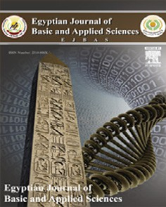

Contents lists available at [ScienceDirect](http://www.sciencedirect.com/science/journal/2314808X)

Egyptian Journal of Basic and Applied Sciences

journal homepage: [www.elsevier.com/locate/ejbas](http://www.elsevier.com/locate/ejbas)

Full Length Article

[](http://crossmark.crossref.org/dialog/?doi=10.1016/j.ejbas.2018.04.003&domain=pdf)Fatty acids and survival of bacteria in Hammam Pharaon springs, Egypt

Yehia A. Osman a,⇑, Mahmud Mokhtar Gbr b, Ahmed Abdelrazak a, Amr M. Mowafy a

a *Botany Department, Faculty of Science, Mansoura University, Mansoura 35516, Egypt*

b *Holding Company for Water and Waste Water, South Sinai West Tunnel, Central Laboratory, Egypt*

# a r t i c l e i n f o

*Article history:*

Received 21 January 2018

Received in revised form 22 March 2018 Accepted 1 April 2018

Available online 10 April 2018

*Keywords:* Thermophiles Bacteria

Central Composite Design Dodecanoic acid *Geobacillus*

*Rhodothermus* and *Thermus*

# a b s t r a c t

A great lack of knowledge of Hammam Pharaon’s microbial community; the most famous hot spring in Sinai, Egypt, derived this work. Three different hyperthermophilic bacterial were isolated from vents in the area, where the temperature was above 80 °C. Response Surface Methodology algorithm such as Central Composite Design determined the optimum cultivation conditions for these isolates. Accordingly, the best growth conditions were at 70 °C and at neutral to slightly acidic pH values. The con- structed phylogenetic tree built using the 16S rRNA gene sequences has shown that the isolated strains (HM101, HM102 and HM103) belong to *Geobacillus, Rhodothermus and Thermus* bacteria, respectively*.* The fatty acid profiles, an indicative of thermotolerance, dominated by the short chain Dodecanoic acid (Lauric acid; (12:0), which represented about 40% of the total fatty acid contents for each of the three iso-

lates. The enzymatic capabilities of the three strains were determined and a-amylase was found to be the

most prominent one. Our own data had led us to conclude that the length of the fatty acid chain and the degree of saturation could be species specific. Moreover, the biotechnological potentials of these local iso- lates could contribute to fighting viral diseases and/or improve their amylolytic activities for sugar indus- try; where thermotolerance is really an important factor.

© 2018 Mansoura University. Production and hosting by Elsevier B.V. This is an open access article under

the CC BY-NC-ND license (<http://creativecommons.org/licenses/by-nc-nd/4.0/>).

1. Introduction

Extremophiles are members of the extreme environment- tolerant organisms, which belong to Archaea, eubacteria, and eukaryote. These group of organisms can live, survive and flourish at temperatures above 50 °C and may reach 80 °C and up [1]. The normal temperature sensitive macromolecules (enzymes, proteins, lipids and nucleic acids) have demonstrated tolerance/resistance to

this denaturing high temperatures. This adaptability of the ther- mophiles and hyperthermophiles cellular components is simply described as thermostability. These thermophiles and hyperther- mophiles bacteria have been isolated from different habitats including hydrothermal vents and deep ocean-basin cores. From amongst them Gram positive/negative, spore or non-spore forming bacteria were isolated which exhibited aerobic or anaerobic meta- bolism [2] (See Table 1).

Overall, Thermophilic bacteria are the least explored due to diffi- culties in isolation and maintenance of pure culture. Biotechnologi- cal potentials of thermophiles and extremophiles were justified by their pools of amylases, proteases, lipases, xylanases and DNA poly- merases. Theses enzymes tolerate not only high temperature but also extreme pH and salinity [3]. Additionally, extremophiles were

* Corresponding author.

*E-mail address:* [lazeikyao@mans.edu.eg](mailto:lazeikyao@mans.edu.eg) (Y.A. Osman).

reported to produce several bioactive molecules such as antibiotics, sulfur-reducing enzymes and *exo*-polysaccharides [2].

Accurate identification of any bacteria is a must to proceed for- ward. Despite it has been established for over a century ago, cul- tural, phenotypic, biochemical techniques were not satisfying. Therefore, recent nucleic acid based techniques (e. g. 16S rRNA gene sequence) and fatty composition (microbial fatty acid methyl esters, FAME) of the cell membranes has gained popularity due to their undisputed reliability and reproducibility [4–6].

Amongst the many thermal vents localized in Egypt, Hammam Pharaon, that lies in South Sinai at latitude 29, 197112 and longi- tude 32, 956179 has gained popularity due to the tourist attraction. In the present study, an endeavor was made to explore the bacte- rial community of Hammam Pharaon. The bacterial isolates were characterized at the morphological and molecular and fatty acid levels. Moreover, the biotechnological potentials of the isolates were explored, especially their amylolytic, cellulolytic, lipolytic and proteolytic activities.

1. Materials and methods
   1. *Samples collection and isolation of bacteria*

Water samples and soil deposits from Hammam Pharaon (South Sinai, Egypt, at latitude 29, 197112 and longitude 32, 956179) were

<https://doi.org/10.1016/j.ejbas.2018.04.003>

2314-808X/© 2018 Mansoura University. Production and hosting by Elsevier B.V.

This is an open access article under the CC BY-NC-ND license (<http://creativecommons.org/licenses/by-nc-nd/4.0/>).

Table 1

Hammam Faraun water Sample analysis showing the high amount of sulfur pointed by the black arrow.

Sample no/name Hot vents inside Hammam Faraun Max values Sample type Saline hot water

Turbidity 4.25 1NTU

Residual chlorine ——— 0.2–2 PPM

pH 6.66 6.5–8.5

* 1. *Analysis of the fatty acid methyl ester (FAME)*

Fatty acids were extracted from each isolate as described by Gattinger (2002) [12]. Where 20 mg of each freeze-dried isolate was suspended in 2 ml of 5% Methanolic HCl, incubated at 70 °C water bath for 2 h, The mixture cooled at room temperature for 45 min, then 1 ml deionized water was added and vortexed. To

remove the unsaturated fat methyl esters (FAME) were obtained

TDS 12920 (calculated) 21854 (weighed at 120 °C)

1000 mg/L

by adding 2 ml hexane to each and the tubes were kept at ambient

EC 19,370 ms/Sec

T.alkalinity 1100 300 mg/L

chlorides 7742.3 250 mg/L

T.Hardness 4500 500 mg/L

Ca.Hardness 2700 350 mg/L

Mg.Hardness 1800 150 mg/L

Ca 1080 mg/L

Mg 432 mg/L

Sulfate 353.441 250 mg/L

Nitrate 0.875 45 mg/L

Iron 0.113 0.3 mg/L

Manganese 0.959 0.4 mg/L

Fluoride 1.797 0.8 mg/L

collected in 500 ml sterile thermal glass containers and immedi- ately transferred to the laboratory. The mineral composition of the water samples was determined according to the standard pro- tocols [7]. Native bacteria were isolated from one gram of wet soil deposits as described by [8]. Then a 1 ml of the sample was trans- ferred into 100 ml of Zobell broth marine medium containing g/L:

1.29 yeast extract, 3.75 peptone, 9 NaCl, 2 MgCl2 and 0.525 KCl dis- solved in Hammam Faraun water and pH was adjusted to 7.5. Cul- tures were incubated at 70 °C for two weeks, then, a 500 ml of each growing culture was transferred into fresh Zobell agar plates and

incubated for another two weeks at 70 °C. Morphological proper-

ties of colonies and cells were scored as size, colour, margin, eleva- tion and Gram stain preference, too. Morphologically distinct colonies were purified and stored in 25% glycerol at —80 °C for fur- ther studies.

* 1. *Molecular identification of the bacterial isolates*

This depended on the DNA sequencing of the gene encodes for the 16S rRNA by PCR using the universal primer pair of 518F: (5' CCAGCAGCCGCGGTAATACG3') and 800R: (5' TACCAGGGTATCTA

ATCC3') [9]. Subsequently; the PCR products were purified using the QIAquick PCR purification Kit protocol (Qiagen, Germany) and auto-sequenced by ABI PRISM using cycle sequencing kit (Macrogen, Korea). The sequences were analyzed and managed by the software CLUSTAL W 2.0, while the Phylogenetic trees were constructed by using Seaview software [10].

* 1. *Scanning electron microscopy (SEM)*

Bacterial isolates were further characterized by scanning elec- tron microscopy (JSM 6501LV, Joel Japan) [11] In short, bacteria were primarily fixed in a mixture of formaldehyde and glutaralde- hyde (1:1) for 24 h, followed by three washes (10 min each) with potassium phosphate buffer (pH 7.2). A post-fixation by 1% osmium tetraoxide was carried for two hours; samples washed with potassium phosphate buffer and dehydrated with different concentration of ethanol (50, 70, 80, 90, 95 and 100%) for 15 min each, in an Autosamdry-815 (USA) model. Finally, samples were coated with gold using SPI module sputter coater before being examined by SEM.

temperature for layers separation. The upper layer was moved into

a clean glass tube and dried under nitrogen and was analyzed by the Gas Chromatography/Mass Spectroscopy. This Agilent GC was provided with splitter injector at 280 °C connected to Agilent

MSD with the electron voltage 70 eV, source temperature 230 °C,

quad temperature 150 °C, multiplier voltage 1800 V and interface temperature 310 °C, controlled by HP Compaq PC. The specimen (1 ll) in hexane was infused utilizing autosampler with the split

open. After the fundamental dissolvable crest had passed the GC temperature system and the information obtaining initiated, parti- tion was performed on an Agilent-combined silica fine section (30

m × 0.25 mm i.d) covered with 0.25 lm dimethyl poly-siloxane

(HP-5) stage. The GC was temperature modified from 30 to 130

°C at 5 °C/min then to 300 °C at 20 °C/min and held at a last tem- perature for 5 min with helium as the bearer gas (stream rate of 1 ml/min, beginning weight of 50 kPa, split at 10 ml/min). Peaks were distinguished and named after correlation of their retention time and mass spectra [13].

* 1. *Optimum pH and temperature for growth*

The Central Composite Design (CCD) was used to determine the main effects and interaction between pH and temperature on bacterial growth in order to obtain the optimum condition for each isolate. All strains were grown in 50 ml of Zobell med- ium [14] at the optimum temperature and pH values for each isolate for 7 days. Final biomasses were collected by centrifuging at 4000 rpm for 15 min. The cell pellets were transferred into a

1.5 ml screw tube and freeze-dried and the dry weights were determined.

* 1. *Enzymes assays*

The amylolytic, cellulolytic, lipolytic and proteolytic activities of the three isolates were qualitatively assayed according to [15], [16] and [17], respectively. The a-amylase activity was tested by starch hydrolysis was monitored by Iodine reagent [15]. Lipase activity

was evaluated using Tween 80 medium and measuring the clearing zones around the bacterial colonies. The monitoring of cellulose degradation activity depended upon the diameter of the clear zones around the bacterial colonies growing onto carboxymethyl- cellulose (CMC) agar media.

1. Results
   1. *Water samples analysis*

There was a heavy smell of sulfur gas around the water sources of Hammam Pharaon and the water analysis confirmed the pres- ence of high percentage of sulfur. The in-situ measurement of tem-

perature and pH indicated that during the sampling period the temperature was in the range of 70–90 °C and the pH was recorded to be in the range of 6–7.5.

* 1. *Strains characterization*

The in-situ temperatures and pH degrees during the sampling period from October to February 2013 ranged from 70 to 90 °C and the pH was from 6 to 7.5 respectively. Three clearly distin- guishable strains HM101, HM102 and HM103 were isolated as indicated in Fig. 1. Morphological and cultural properties of these strains showed circular colonies with entire edges where colony

of strain HM101 was creamy white in color, colony of strain HM102 was greasy orange and colony of strain HM103 was greasy and yellow. The strain HM101was found to be Gram-positive and strains HM102, and HM103 were Gram-negative. The strain HM102 was found to belong bacilli and HM101& HM103 were none flagellated and rod-shaped.

* 1. *Phylogenetic analysis*

Based on their 16S rRNA sequences, HM101 was identified as *Geobacillus sp* which is most closely related to *Geobacillus ther-* *moglucosidasius* (95% identity), HM102was identified as *Rhodother- mus* sp which showed very high sequence identity to *Rhodothermus Marinus* (99.8% identity) and HM103 was identified as *Thermus sp* which was closely similar to *Thermus thermophiles* (99.2% identity) (Fig. 2). The obtained 16S rRNA sequences were submitted to the Genbank and assigned an accession numbers KU096044 (for HM101), KU096045 (for HM102) and KU096046 (for HM103)

(See Fig. 3).

*Rhodothermusmarinus*NR32AF217499.1 (98%) type strain and*Thermusthermophilus*HB8NR037066T (99%) type strain respectively.

* 1. *Scan electron microscope*

Scanning electron microscopic analysis showed that isolate HM101 is rod-shaped, non-motile with curvy smooth surface and the size is 2–3 mm in length and 0.4–0.5 mm in width. Isolate HM102 is long rod-shaped with spiny appendages on its surface

and it has a length of 3–6 mm and a width of 0.3–0.4 mm. Isolate HM103 is rod-shaped, non-motile, non-spore forming with a smooth surface and its size of 4–6 mm l 0.4–0.6 mm length.

* 1. *Fatty acid profile*

Analysis of the total fatty acid composition of the three isolates resulted in the identification of 13 different fatty acids (Table 2), with variable chain lengths that ranged from C10 to C27. The Peaks on the gas chromatogram were proportionate to carbon chain- lengths.

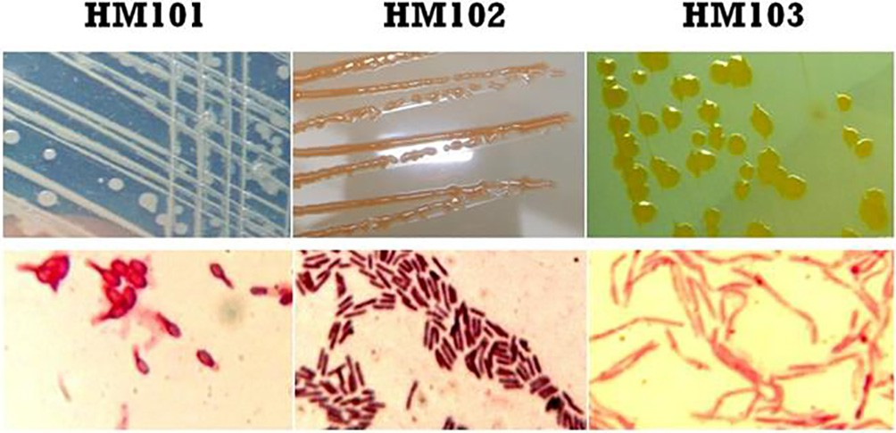

Fig. 1. The shape of the colonies on agar plates of the isolated strains (HM101, HM102 & HM103) and their Gram staining result under light microscope using oil lens (100X).

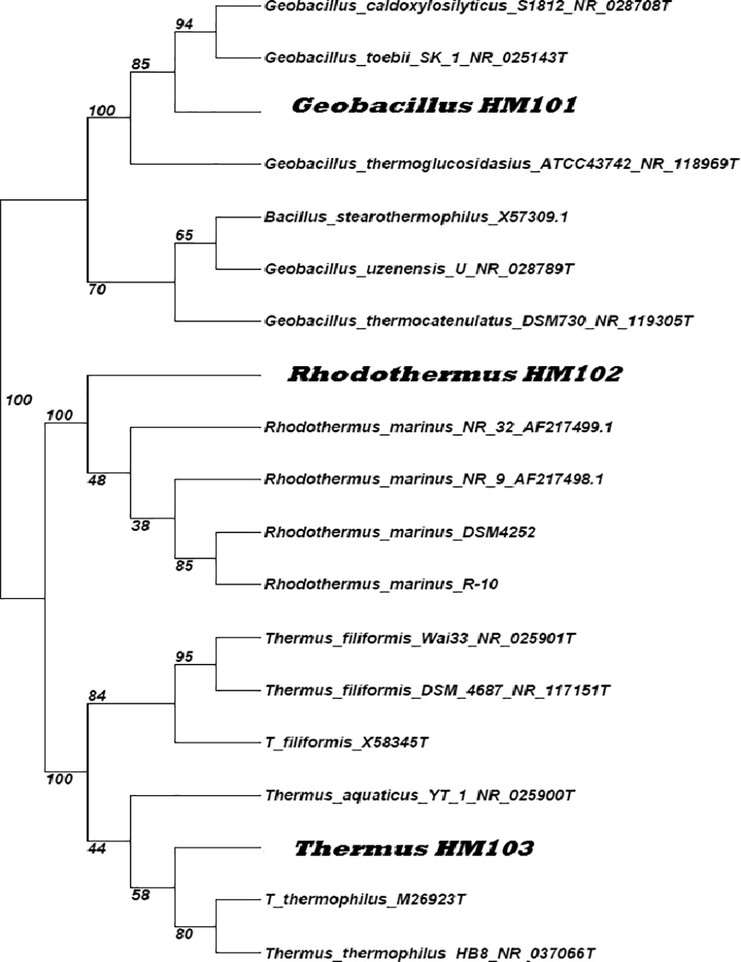

Fig. 2. Phylogenetic dendrogram based on 16S rRNA gene sequence analysis of the isolates HM101, HM102 and HM103 showing that the strains are most closely related to *Geobacillusthermoglucosidasius*ATCC43742NR118969T (95%) type strain, *Rhodothermusmarinus*NR32AF217499.1 (98%) type strain and*Thermusther- mophilus*HB8NR037066T (99%) type strain respectively.

Most of the fatty acids were saturated but three unsaturated fatty acids were also identified. In HM101, the saturated fatty acids Decanoic acid (10:0), Undecanoic acid (11:0), and Dodecanoic acid (12:0) were the most dominant fatty acids with 47.85% from the total fatty acids. In HM102, the dominance was for Undecanoic acid (11:0), Dodecanoic acid (12:0), and Heptadecanoic acid (17:0) with 43.88%. In HM103, Decanoic acid (10:0), Undecanoic acid (11:0), Dodecanoic acid (12:0), and Heptadecanoic acid (17:0) were found to be the highest constituents with 55.67% of the fatty acid profile.

* 1. *Optimum pH and temperature for growth using Central Composite Design (CCD)*

In terms of interaction between temperature and pH, for isolate HM101 the optimum pH for growth was 6.45 and the optimum temperature was 70 °C (Fig. 4A), for isolate HM102 the optimum

pH for growth was 6.65 and the optimum temperature was 62 °C

(Fig. 4B), and for isolate HM103 the optimum pH for growth was

7 and the optimum temperature was 70 °C (Fig. 4C). Isolates HM101 and HM103 grew optimally at 70 °C but at different pH val- ues of 6.45, and 7 respectively.

* 1. *Enzyme assays*

Isolate HM101 showed positive activities for all tested enzymes; while isolates HM102 and HM103 show significant activity to a-amylase and Cellulase (Table 3).

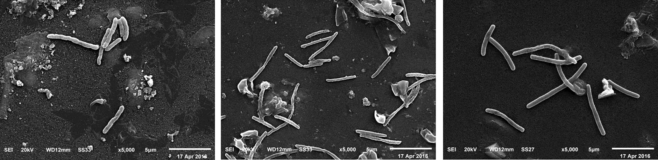

Fig. 3. SEM micrographs of the three isolate at 5000X magnification; the bar in the image represents 5 lm (A): *Geobacillus* HM101 (B): *Rhodothermus* HM102 (C): *Thermus*

HM103.

Table 2

The fatty acid profiles of all the isolates.

Fatty acid *Geobacillus*

HM101

*Rhodothermus*

HM102

*Thermus* HM103 Formula M.Wt

|  |  |  |  |  |  |  |  |  |  |  |
| --- | --- | --- | --- | --- | --- | --- | --- | --- | --- | --- |
|  | % | RT |  | % | RT |  | % | RT |  | |
| Decanoic acid (Capric acid) (10:0) | 18.71 | 3.54 |  | 1.60 | 3.20 |  | 17.72 | 3.53 | C10H20O2 | 172 |
| Undecanoic acid (Undecylic acid) (11:0) | 16.01 | 4.65 |  | 21.61 | 4.64 |  | 15.37 | 4.64 | C11H22O2 | 186 |
| Dodecanoic acid (Lauric acid) (12:0) | 40.06 | 6.53 |  | 49.44 | 6.51 |  | 36.95 | 6.54 | C12H24O2 | 200 |
| Tetradecanoicacid (Myristic acid) (14:0) | 1.93 | 5.56 |  | 2.60 | 5.83 |  | 1.67 | 5.57 | C14H28O2 | 228 |
| 2-Bromotetradecanoic acid (a.Bromomyristic acid) (14:1) | 0.63 | 13.23 |  | 0.78 | 13.23 |  | — | — | C14H27BrO2 | 307 |
| Pentadecanoic acid (Pentadecylic acid) (15:0) | 4.55 | 13.12 |  | — | — |  | — | — | C15H30O2 | 242 |
| Methyl tetradecanoate (Methyl myristate) (15:1) | 0.60 | 13.75 |  | — | — |  | 7.85 | 13.15 | C15H30O2 | 242 |
| Hexadecanoic acid (Palmitic acid) (16:0) | 7.99 | 14.91 |  | 5.52 | 14.91 |  | 0.371 | 15.83 | C16H32O2 | 256 |
| Heptadecanoic acid (Margaric acid) (17:0) | 6.07 | 17.50 |  | 13.02 | 17.50 |  | 16.4 | 17.49 | C17H34O2 | 270 |
| Octadecanoic acid (Stearic acid) (18:0) | 1.13 | 21.17 |  | 2.87 | 20.22 |  | 0.61 | 21.17 | C18H36O2 | 282 |
| 9,12,15-Octadecatrienoic acid (a-Linolenic acid) (18:3) | 2.05 | 27.69 |  | — | — |  | 3.00 | 27.69 | C28H34O4 | 434 |
| Nonadecanoic acid (19:0) | 0.35 | 10.04 |  | 2.14 | 8.68 |  | 0.35 | 10.04 | C19H38O2 | 298 |
| Heptacosanoic acid (Heptacosane) (27:0) | 0.40 | 10.05 |  | 0.61 | 10.04 |  | — | — | C27H54O2 | 410 |

1. Discussion

The similarity in the fatty acid profile of the three local isolates was striking and convinced us to believe that the prevalent envi- ronmental condition with the Hammam had driven this similarity. It is noticeable that the dodecanoic acid (12:0) and undecanoic acid (11:0) are the predominant fatty acids in the three isolates. More- over, they are short chain ones which fit nicely with the degree of fluidity of their membranes and survival in such environment niche. This is supported by the work of several investigators such as BROCK (1967), [18–23]. Lauric acid or dodecanoic acid which is the most dominant fatty acids with 47.85% was found to have medical importance, especially used for treating several viral infec- tions including (influenza; the flu); swine flu; avian flu; the com- mon cold; fever blisters, cold sores) also Lauric acid have significant role in the treatment of genital herpes caused by herpes simplex virus (HSV), genital warts caused by human papillo- mavirus (HPV) and HIV/AIDS [24]. It is also used for preventing the transmission of HIV from mothers to children. Lauric acid (C12: 0), is the most potent antimicrobial saturated fatty acid [25], and have Antimicrobial Property Against Propionibacterium Acnes which consider a Therapeutic Potential for Inflammatory Acne Vulgaris [26]. Other uses for Lauric acid include treatment of bronchitis, gonorrehoae, yeast infections, Chlamydia, intestinal infections caused by a parasite called Giardia lamblia, and ring- worm. Lauric acid also involved in food industry and manufactur- ing (soap and shampoo producing). The second prevalent and shortest fatty acid or the Capric acid (11:0) is characterized by hav- ing a good chemical stability combined with melting congruency; smaller volume change during phase transition and high latent heat of fusion per unit mass. All of these physical and chemical

properties are required to suit the seasonal, which recorded at 70 °C in the winter and 90 °C in the summer.

Cedeño, Baran and Sari, Sari and Kaygusuz [27–29] and Shilei et al. [30] have suggested that mixtures of Capric and Lauric acids; could be incorporated with building materials to form phase change wallboards used for building energy storage. The ratio and presence of these two fatty acids (Capric acid with Lauric acid) in our local Thermophilic bacterial isolates can be ultimately understood considering the phase transition and the values of latent heat leading to energy storage at winter. This is an excellent supportive evidence for survival and adaptability of the three bac- terial strains to their local environment.

The uniqueness of the local isolates resides in their fatty acid contents. These contents and their ratios showed slight divergence from the studies of Tindall [6], and that of Shen [5] about the length and degree of saturation of mesophiles (prefers C15.5 fatty acids) or thermophiles (prefers C16 or higher).

Exhaustive literature survey led us to admit that every living creature (species) establishes its own niche with its own living habitat. In which, a relationship is specifically invented between an organism and its living surrounding conditions including not only the different members of all populations living within the same niche but also temperature, pH and nutrients. Hence, adapt- ability of the cellular component of native species is expected for survival under these conditions. Accordingly, cell structure and specially the cell membrane lipids are the determinants of the sur- vival and flourish of the organisms. Temperature selectively affects the type of lipids, unsaturation status and the degree of membrane fluidity. This vital role played by temperature also dictates that cells cannot grow at temperatures lower than that of their lipids solidification point [21,22]. This is consistent with the first order

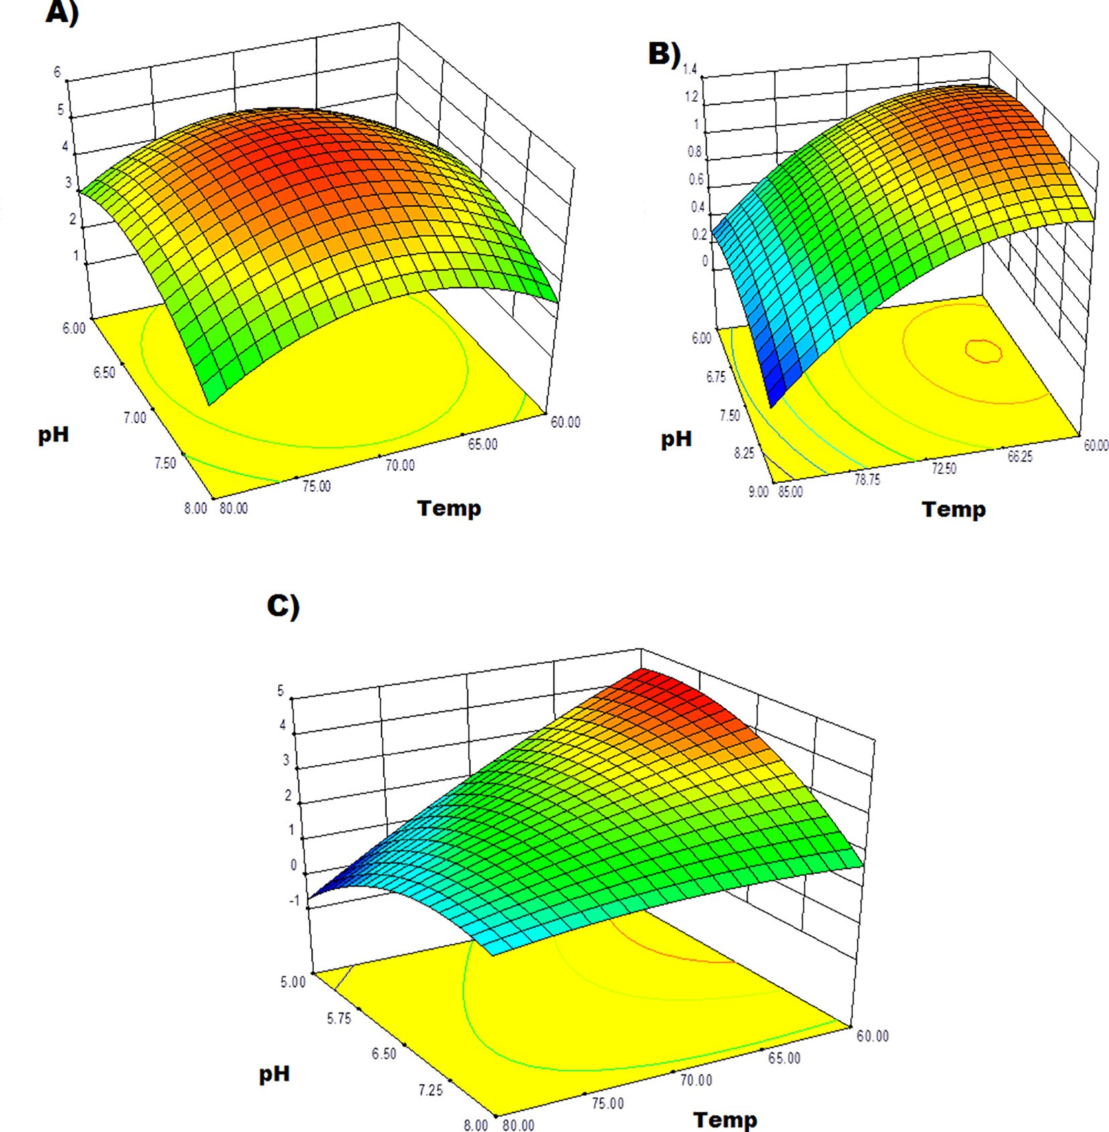

Fig. 4. Three-dimensional surface plot showing the effect of the interaction between pH and temperature, at the dry weight yield (dry weight (g/l)). (A): *Geobacillus* HM101, (B): *Rhodothermus* HM102 and (C): *Thermus.*

Table 3

Enzymatic activities of the isolates.

|  |  |  |  |  |
| --- | --- | --- | --- | --- |
| Isolate | a-Amylase | Lipase | Cellulase | Protease |
| HM101 | +++VE | +VE | +VE | +++VE |
| HM102 | +VE | —VE | +VE | —VE |
| HM103 | +VE | —VE | +VE | —VE |

+ = Clear zone was detected, the more the +the larger the zone. — = No enzymatic activity detected.

proposal of Brock and Ingraham [23,31] about the thermal death of the organism. The peculiarity of fatty acid unsaturation, chain length, branching and cyclization all contribute significantly to the adaptability of the thermophiles to their environments. How- ever, the type of fatty acids did change between moderate and extreme Thermophilic bacteria, except no hydroxy, cyclopropane, or unsaturated fatty acids were found [20].

Once again, careful analysis of the fatty acid profile of our local isolates revealed a surprising trend of the predominant; where, dodecanoic acid (12:0), undecanoic acid (11:0) and Decanoic acid (10:0) were represented by about 41, 20 and 17%, respectively. The dominance of these relatively short chains saturated fatty acid

correlates well with the increased membrane fluidity to tolerate and survive at the high temperature (75 °C) prevalent inside Ham- mam Pharaon spring. Although, the enzyme activities such as amy- lases derived from these isolates were discouraging, however their presence and thermotolerance can be employed for further studies. Additionally, the possibility to use these isolates or any of their

enzymes in production and/or degradation of bioactive compounds either alone or in co-cultures would be a future direction and extension for this work.

Acknowledgements

This work has been supported in part by a research grant from The Research Unit at Mansoura University, Egypt. Our thanks and gratitude are due to them.

References

1. [Khalil A. Screening and characterization of thermophilic bacteria (lipase,](http://refhub.elsevier.com/S2314-808X(18)30036-8/h0005) [cellulase and amylase producers) from hot springs in Saudi Arabia. J Food Agric](http://refhub.elsevier.com/S2314-808X(18)30036-8/h0005) [Environ 2011;9(2):672–5](http://refhub.elsevier.com/S2314-808X(18)30036-8/h0005).
2. [Aanniz T et al. Thermophilic bacteria in Moroccan hot springs, salt marshes](http://refhub.elsevier.com/S2314-808X(18)30036-8/h0010) [and desert soils. Brazilian J Microbiol 2015;46(2):443–53](http://refhub.elsevier.com/S2314-808X(18)30036-8/h0010).
3. [Venil CK, Lakshmanaperumalsamy P. Application of Response Surface](http://refhub.elsevier.com/S2314-808X(18)30036-8/h0015) [Methodology in Medium Optimization for Protease Production by the New](http://refhub.elsevier.com/S2314-808X(18)30036-8/h0015) [Strain of Serratia marcescens SB 08. Polish J Microbiol 2009;58(2):117–24](http://refhub.elsevier.com/S2314-808X(18)30036-8/h0015).
4. [Carballeira NM et al. Unusual fatty acid compositions of the hyperthermophilic](http://refhub.elsevier.com/S2314-808X(18)30036-8/h0020) [archaeon Pyrococcus furiosus and the bacterium Thermotoga maritima. J](http://refhub.elsevier.com/S2314-808X(18)30036-8/h0020) [Bacteriol 1997;179(8):2766–8](http://refhub.elsevier.com/S2314-808X(18)30036-8/h0020).
5. [Shen P et al. Fatty acid distribution in mesophilic and thermophilic strains of](http://refhub.elsevier.com/S2314-808X(18)30036-8/h0025) [the genus Bacillus. J Bacteriol 1970;103(2):479–81](http://refhub.elsevier.com/S2314-808X(18)30036-8/h0025).
6. [Tindall B. Lipid composition of Rhodothermus marinus. FEMS Microbiol Lett](http://refhub.elsevier.com/S2314-808X(18)30036-8/h0030) [1991;80(1):65–8](http://refhub.elsevier.com/S2314-808X(18)30036-8/h0030).
7. [Federation WE, Association APH. Standard methods for the examination of](http://refhub.elsevier.com/S2314-808X(18)30036-8/h0035) [water and wastewater. Washington, DC, USA: American Public Health](http://refhub.elsevier.com/S2314-808X(18)30036-8/h0035) [Association (APHA); 2005](http://refhub.elsevier.com/S2314-808X(18)30036-8/h0035).
8. [Rohwer F et al. The complete genomic sequence of the marine phage](http://refhub.elsevier.com/S2314-808X(18)30036-8/h0040) [Roseophage SIO1 shares homology with nonmarine phages. Limnol Oceanogr](http://refhub.elsevier.com/S2314-808X(18)30036-8/h0040) [2000;45(2):408–18](http://refhub.elsevier.com/S2314-808X(18)30036-8/h0040).
9. [Edwards U et al. Isolation and direct complete nucleotide determination of](http://refhub.elsevier.com/S2314-808X(18)30036-8/h0045) [entire genes. Characterization of a gene coding for 16S ribosomal RNA. Nucleic](http://refhub.elsevier.com/S2314-808X(18)30036-8/h0045) [Acids Res 1989;17(19):7843–53](http://refhub.elsevier.com/S2314-808X(18)30036-8/h0045).
10. [Drancourt M et al. 16S ribosomal DNA sequence analysis of a large collection](http://refhub.elsevier.com/S2314-808X(18)30036-8/h0050) [of environmental and clinical unidentifiable bacterial isolates. J Clin Microbiol](http://refhub.elsevier.com/S2314-808X(18)30036-8/h0050) [2000;38(10):3623–30](http://refhub.elsevier.com/S2314-808X(18)30036-8/h0050).
11. Reichelt, R., Scanning electron microscopy, in Science of microscopy2007, Springer. p. 133–272.
12. [Gattinger A, Schloter M, Munch JC. Phospholipid etherlipid and phospholipid](http://refhub.elsevier.com/S2314-808X(18)30036-8/h0060) [fatty acid fingerprints in selected euryarchaeotal monocultures for taxonomic](http://refhub.elsevier.com/S2314-808X(18)30036-8/h0060) [profiling. FEMS Microbiol Lett 2002;213(1):133–9](http://refhub.elsevier.com/S2314-808X(18)30036-8/h0060).
13. [El Razak AA, Ward AC, Glassey J. Screening of Marine Bacterial Producers of](http://refhub.elsevier.com/S2314-808X(18)30036-8/h0065) [Polyunsaturated Fatty Acids and Optimisation of Production. Microb Ecol](http://refhub.elsevier.com/S2314-808X(18)30036-8/h0065) [2014;67(2):454–64](http://refhub.elsevier.com/S2314-808X(18)30036-8/h0065).
14. ZoBell, C.E., Studies on marine bacteria. I. The cultural requirements of heterotrophic aerobes. J Mar Res, 1941. 4: p. 42–75.
15. [Khalil A. Screening and characterization of thermophilic bacteria (lipase,](http://refhub.elsevier.com/S2314-808X(18)30036-8/h0075) [cellulase and amylase producers) from hot springs in Saudi. Arabia 2011](http://refhub.elsevier.com/S2314-808X(18)30036-8/h0075).
16. [Prasad P, Bedi S, Singh T. In vitro cellulose-rich organic material degradation](http://refhub.elsevier.com/S2314-808X(18)30036-8/h0080) [by cellulolytic Streptomyces albospinus (MTCC 8768). Malaysian J Microbiol](http://refhub.elsevier.com/S2314-808X(18)30036-8/h0080) [2012;8(3):164–9](http://refhub.elsevier.com/S2314-808X(18)30036-8/h0080).
17. [Vashist H, Sharma D, Gupta A. A review on commonly used biochemical test](http://refhub.elsevier.com/S2314-808X(18)30036-8/h0085) [for bacteria. Innovare J Life Sci 2013;1(1)](http://refhub.elsevier.com/S2314-808X(18)30036-8/h0085).
18. [Nazina T et al. Taxonomic study of aerobic thermophilic bacilli: descriptions of](http://refhub.elsevier.com/S2314-808X(18)30036-8/h0090) [Geobacillus subterraneus gen. nov., sp. nov. and Geobacillus uzenensis sp. nov.](http://refhub.elsevier.com/S2314-808X(18)30036-8/h0090) [from petroleum reservoirs and transfer of Bacillus stearothermophilus,](http://refhub.elsevier.com/S2314-808X(18)30036-8/h0090) [Bacillus thermocatenulatus, Bacillus thermoleovorans, Bacillus kaustophilus,](http://refhub.elsevier.com/S2314-808X(18)30036-8/h0090) [Bacillus thermodenitrificans to Geobacillus as the new combinations G.](http://refhub.elsevier.com/S2314-808X(18)30036-8/h0090) [stearothermophilus, G. th. Int J Syst Evol Microbiol 2001;51(2):433–46](http://refhub.elsevier.com/S2314-808X(18)30036-8/h0090).
19. [Kleinschmidt M, McMahon VA. Effect of growth temperature on the lipid](http://refhub.elsevier.com/S2314-808X(18)30036-8/h0095) [composition of Cyanidium caldarium. Plant Physiol 1970;46(2):286–9](http://refhub.elsevier.com/S2314-808X(18)30036-8/h0095).
20. [Oshima M, Miyagawa A. Comparative studies on the fatty acid composition of](http://refhub.elsevier.com/S2314-808X(18)30036-8/h0100) [moderately and extremely thermophilic bacteria. Lipids 1974;9(7):476–80](http://refhub.elsevier.com/S2314-808X(18)30036-8/h0100).
21. [Heilbrunn L. The colloid chemistry of protoplasm. III. The viscosity of](http://refhub.elsevier.com/S2314-808X(18)30036-8/h0105) [protoplasm at various temperatures. Am J Physiol 1924;68:645–8](http://refhub.elsevier.com/S2314-808X(18)30036-8/h0105).
22. [Gaughran ER. The thermophilic microörganisms. Bacteriol Rev 1947;11](http://refhub.elsevier.com/S2314-808X(18)30036-8/h0110) [(3):189](http://refhub.elsevier.com/S2314-808X(18)30036-8/h0110).
23. [Marr AG, Ingraham JL. Effect of temperature on the composition of fatty acids](http://refhub.elsevier.com/S2314-808X(18)30036-8/h0115) [in Escherichia coli. J Bacteriol 1962;84(6):1260–7](http://refhub.elsevier.com/S2314-808X(18)30036-8/h0115).
24. Katz, D.H., et al. Long-chain alcohols, alkanes, fatty acids and amides in the treatment of burns and viral inhibition, 1999, Google Patents.
25. [Wille J, Kydonieus A. Palmitoleic acid isomer (C16: 1D6) in human skin sebum](http://refhub.elsevier.com/S2314-808X(18)30036-8/h0125)

[is effective against gram-positive bacteria. Skin Pharmacol Physiol 2003;16](http://refhub.elsevier.com/S2314-808X(18)30036-8/h0125) [(3):176–87](http://refhub.elsevier.com/S2314-808X(18)30036-8/h0125).

1. [Nakatsuji T et al. Antimicrobial property of lauric acid against](http://refhub.elsevier.com/S2314-808X(18)30036-8/h0130) [Propionibacterium acnes: its therapeutic potential for inflammatory acne](http://refhub.elsevier.com/S2314-808X(18)30036-8/h0130) [vulgaris. J Invest Dermatol 2009;129(10):2480–8](http://refhub.elsevier.com/S2314-808X(18)30036-8/h0130).
2. [Cedeño FO et al. Measurements of temperature and melting heat of some pure](http://refhub.elsevier.com/S2314-808X(18)30036-8/h0135) [fatty acids and their binary and ternary mixtures by differential scanning](http://refhub.elsevier.com/S2314-808X(18)30036-8/h0135) [calorimetry. Thermochim Acta 2001;369(1):39–50](http://refhub.elsevier.com/S2314-808X(18)30036-8/h0135).
3. [Baran G, Sari A. Phase change and heat transfer characteristics of a eutectic](http://refhub.elsevier.com/S2314-808X(18)30036-8/h0140) [mixture of palmitic and stearic acids as PCM in a latent heat storage system.](http://refhub.elsevier.com/S2314-808X(18)30036-8/h0140) [Energy Convers Manage 2003;44(20):3227–46](http://refhub.elsevier.com/S2314-808X(18)30036-8/h0140).
4. [Sari A, Kaygusuz K. Thermal energy storage system using some fatty acids as](http://refhub.elsevier.com/S2314-808X(18)30036-8/h0145) [latent heat energy storage materials. Energy Sources 2001;23(3):275–85](http://refhub.elsevier.com/S2314-808X(18)30036-8/h0145).
5. [Shilei L, Neng Z, Guohui F. Eutectic mixtures of capric acid and lauric acid](http://refhub.elsevier.com/S2314-808X(18)30036-8/h0150) [applied in building wallboards for heat energy storage. Energy Build 2006;38](http://refhub.elsevier.com/S2314-808X(18)30036-8/h0150) [(6):708–11](http://refhub.elsevier.com/S2314-808X(18)30036-8/h0150).
6. [Brock TD. Life at high temperatures. Science 1967;158(3804):1012–9](http://refhub.elsevier.com/S2314-808X(18)30036-8/h0155).