[Egyptian Informatics Journal 19 (2018) 11–19](http://dx.doi.org/10.1016/j.eij.2017.06.001)

Contents lists available at [ScienceDirect](http://www.sciencedirect.com/science/journal/11108665)

Egyptian Informatics Journal

journal homepage: [www.sciencedirect.com](http://www.sciencedirect.com/)

Full length article

He-SERIeS: An inventive communication model for data offloading in MANET



P. Rajeswari a,⇑, T.N. Ravi b

a *Department of Computer Science, Cauvery College for Women, Trichy, Tamil Nadu 620018, India*

b *Department of Computer Science, Periyar E.V.R College (Autonomous), Trichy, Tamil Nadu, India*

# a r t i c l e i n f o

*Article history:*

Received 13 October 2016

Revised 21 February 2017

Accepted 7 June 2017

Available online 16 June 2017

*Keywords:*

Mobile Ad-hoc Network (MANET) Data offloading

Clustering

Random Cache (RC) Centrality based Cache (CC) Message Digest 5 (MD5)

Secure Hash Algorithm1 (SHA1)

# a b s t r a c t

Mobile Ad-hoc Network (MANET) is the dynamic infrastructure-less network that contains a heteroge- neous wireless mobile devices. There are several issues that can occur in MANET such as limited band- width, dynamic topology, routing overhead, and battery constraints. In this paper, the heterogeneous MANET comprising of different MAC layer protocols are considered. The problems faced by the Heterogeneous Secure-dEed-Reflection-Inducement-eState (He-SERIeS) algorithm are scalability and offloading. In order to resolve these challenges of the existing SERIeS algorithm, a He-SERIeS algorithm is designed. The Cluster Head (CH) is elected using the on-demand clustering algorithm and the nodes with similar requirements are clustered into a distinct cluster using the similarity measure algorithm. The auxiliary key management schemes such as MD5 and SHA1 are used to predict the faulty nodes. The performance of the proposed He-SERIeS algorithm is analyzed with the existing algorithms such as Random Cache (RC), Centrality based Cache (CC), Set Cover Based Caching (SCBC) and SERIeS algo- rithm. The metrics used for comparison are throughput, Packet Delivery Ratio (PDR), end-to-end delay, replication overhead and offloading ratio. The proposed scheme achieved 92.8% PDR, a high throughput of 96.6% and a high offloading ratio of 0.532, less replication overhead, and end-to-end delay.

© 2018 Production and hosting by Elsevier B.V. on behalf of Faculty of Computers and Information, Cairo

University. This is an open access article under the CC BY-NC-ND license ([http://creativecommons.org/](http://creativecommons.org/licenses/by-nc-nd/4.0/)

[licenses/by-nc-nd/4.0/](http://creativecommons.org/licenses/by-nc-nd/4.0/)).

1. Introduction

Mobile Ad-hoc Network (MANET) contains a collection of inde- pendent nodes that are connected wireless [1]. In MANET the nodes tend to change their links in a frequent manner and their mobility is independent. The MANET has the following characteris- tics, autonomous terminal, distributed operation, multi-hop rout- ing, inconsistent link capacity, and self-altering network topology. There is a limitation in the resources of MANET including processing power, on-board memory and battery power. The rout- ing protocols in MANET are responsible for maintaining high degree of mobility that changes the topology of network. The

* Corresponding author.

*E-mail address:* [rajeswariphd15@hotmail.com](mailto:rajeswariphd15@hotmail.com) (P. Rajeswari).

Peer review under responsibility of Faculty of Computers and Information, Cairo University.

**Production and hosting by Elsevier**

nodes in MANET are heterogeneous with an enormous amount of resources. The mobile nodes with very high computational and communication power are more suitable for supporting the func- tions of ad hoc networks than other nodes. The heterogeneity and the routing information overhead are resolved by the cluster-based routing.

The main intention of clustering in MANET is to clutch the net- work nodes into several number of overlapping clusters. It is used for increasing the resource management and increasing the net- work performance in terms of routing delay, bandwidth, and throughput. Fig. 1 describes the clustering of nodes in MANET. A CH is selected as a representative for each cluster head during clustering.

The node that serves as an intermediate node is the gateway and the other members are the ordinary nodes. The non-ordinary nodes are considered as the dominant forwarding nodes. The CHs are responsible for holding the routing and the topology informa- tion. The three major types of clustering are active clustering, pas- sive clustering, and on-demand clustering. During active clustering, the mobile nodes elect the CH by periodically exchang- ing the information. The passive clustering suspends the clustering procedure until the data traffic starts and it eliminates the major

<http://dx.doi.org/10.1016/j.eij.2017.06.001>

1110-8665/© 2018 Production and hosting by Elsevier B.V. on behalf of Faculty of Computers and Information, Cairo University. This is an open access article under the CC BY-NC-ND license (<http://creativecommons.org/licenses/by-nc-nd/4.0/>).

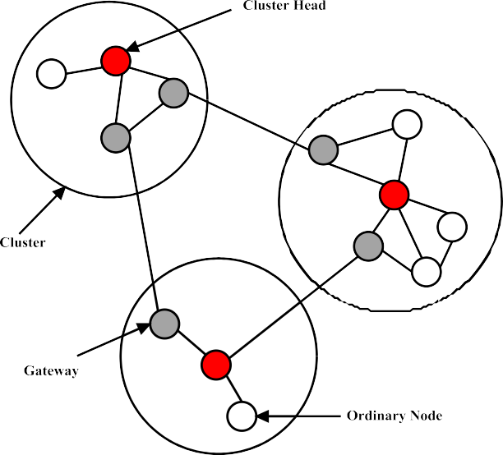

Fig. 1. Clustering in MANET [2].

control overhead of active clustering and it implies the larger setup latency. In the on-demand clustering, the cluster head is elected in an on-demand fashion. The dynamic election of the cluster head is used for minimizing the computation cost and the communication cost.

* 1. *Problems in the traditional works*

For minimizing the bandwidth and traffic in mobile nodes, the offloading concept plays a major role. The data offloading is used for allocating the load to several nodes. The mobile data offloading is often called as the Wi-Fi offload and is more similar to that of the 3G/4G offload. The mobile data offload through Wi-Fi (Wireless Fidelity) or the Wi-Fi offload is one of the implementations of using the small cell technologies like Wi-Fi. It offers services to the end users in an effective and economically best way. There are several reasons for using Wi-Fi offload and the following point justifies the reasons: it is useful for growing mobile data demand and the smart devices usage patterns having following characteristics such as short sessions, high throughput and low latency. It enhances the end-user experience by improving the service capacity and capa- bility. It reduces the operating expenditure of the service providers. In the existing works, some of the techniques are developed for data offloading in MANET, but it has some major drawbacks, such as:

* + - Required more amount of time for data retrieval
    - Consumed large amount of memory for storage
    - The data cannot be reusable, once it is broke
    - Also, it increases the problem at both user and server side
  1. *Motivation of the proposed work*

For these reasons, this work focused to develop a new offload- ing model for heterogeneous MANET. Typically, the nodes present in the heterogeneous network have varying speed, so it requires different data rates for retrieval. Thus, this work proposed a novel technique, namely, He-SERIeS for increasing the security and link stability of the network with data offloading mechanism. Initially, the network is formed with some set of nodes, which are dynamic in nature. The nodes with same requirements are grouped into a

single cluster. In the suggested research, the on-demand clustering is used for clustering the nodes. The clustering is performed when- ever and wherever needed, based on the requirements of the nodes. The major contributions of this paper are listed as follows,

* + - The proposed He-SERIeS algorithm is used for obtaining the knowledge about the network paths.
    - The node that has higher processing power, higher bandwidth capacity and memory capacity is elected as the CH.
    - The nodes with similar requirements are grouped together into a single cluster using the on-demand clustering algorithm. The CH’s are varied according to the requirements of the nodes. Therefore, CH is not fixed.
    - The mobile nodes are responsible for storing the information regarding the neighbors in the link state database.
    - The fault prediction and node authentication schemes are per- formed with the auxiliary key management scheme, then the data communication between the nodes is performed.

1. Related work

This section briefly explains the existing works related to Clus- tering and data offloading in MANET. Kaur et al. [3] suggested a Weightage based Secure Energy Efficient Clustering (WSEEC) algo- rithmic approach for clustering and securing the nodes. When compared to the traditional WCA, the proposed WSEEC provided optimal network lifetime, energy consumption, delay, throughput and packet delivery ratio. Bokhari et al. [4] surveyed various clus- tering algorithms that were applied in MANET. Among several algorithms, the Max-Min D-Cluster was the best clustering algo- rithm with a good controlled message complexity. Wang et al.

[5] modelled the mobile traffic data offloading as a multi- objective optimization problem for the minimization traffic in mobile data and the QoS aware service provision. It also investi- gated several traffic offloading models for Wi-Fi in MANET. The offloading mobile data traffic through Wi-Fi was considered as the promising solution for solving the traffic overloading problem. Li et al. [6] established a mathematical framework to solve the issue of different types of mobile data offloading in real time sce- narios. There were three optimal algorithms designed for handling the offloading scenarios such as Greedy, Approximation, and Homogeneous Algorithm. Conti et al. [7] explored the complemen- tary mobile solution, where the mobile nodes relied on other nodes. The nodes in MANET were contacted through the direct communication based on Wi-Fi or Bluetooth for offloading the traf- fic from the cellular network. Lee et al. [8] reviewed the offloading performance in the 3G data via Wi-Fi networks. Both the distribu- tion model-based simulator and a theoretical framework enabled the average performance of offloading. Han et al. [9] suggested opportunistic communication for facilitating data communication in the emerging Mobile Social Networks. The 3G networks were currently overloaded because of the increased popularity of vari- ous applications for smart phones. The promising solution to this problem was to offload the mobile data traffic through the oppor- tunistic communication. Liu et al*.* [10] proposed the offload mech- anism for mobile data in distributed environment like Software Defined Network (SDN). The Quality of Service (QoS) of the mobile was improved by avoiding the congestion using the data offloading concept.

Amani et al. [6] proposed an integrated Wi-Fi architecture with SDN. The offloading of Wi-Fi was considered as a vital approach for alleviating the mobile data traffic load. The main purpose of data offloading in MANET was to dynamically redirect the selected traffic towards the lower cost. Eom et al. [11] stud- ied the possibility of applying the machine learning techniques for addressing the adaptive scheduling problem in mobile

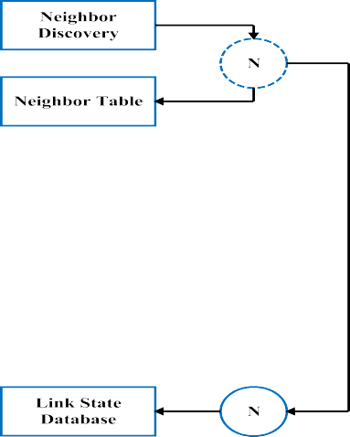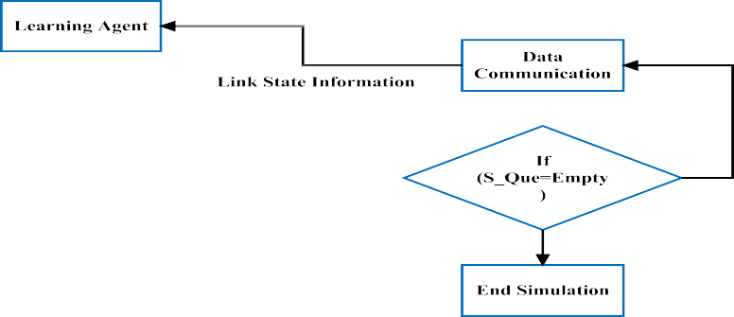

Fig. 2. Overall flow of the proposed He-SERIeS.

offloading framework. Budiyanto et al. [12] proposed a routing algorithm for MANET and the third generation Wireless Fidelity (Wi-Fi) offload networks. The Genetic Zone Routing (GZRP) and Vertical Handover (VHO) algorithms were combined in a 3G- Wi-Fi offload network. Xuyan et al. [13] proposed a centralized caching protocol for addressing the existing caching scheme issues. Experimental results proved that the suggested protocol enhanced the offloading revenues. It used the selective algorithm to cache the location based on set-cover. The proposed scheme outperformed the existing schemes in offloading scenario. Chen- get et al. [14] presented a popularity-based relaying user selec- tion algorithm for determining the amount of relaying users. The analytical model was also presented to estimate the number of reduced data traffic. Dias et al. [15] investigated the possibil- ity of video streaming offloading through opportunistic connec- tion sharing from a Long Term Evolution (LTE) network to a Wi-Fi ad hoc network. The AODV and OLSR protocols were com- bined and validated the streaming data performance. Novo et al.

[16] explored three mechanisms such as, Wi-Fi offloading, Mobile Smart Loading (MSL) and smart cells. The service provi- ders effectively managed the growing demands in mobile data traffic. Budiyanto et al. [17] suggested a Novel Genetic Zone Routing Protocol (N-GZRP) for optimizing 3G-Wi-Fi offload and load balancing among the nodes. It was based on the combina-

tion of Roulette Wheel Selections method and Rank Selection methods. It saved 60% of power consumption than the ZRP pro- tocol. Esnault et al. [18] presented the communication model to offload the data in intermittently connected hybrid networks. It was implemented in a middleware platform, a Nephila to improve the quality of service. Bravo-Torres et al. [19] offloaded the mobile data from or to the VANET. The routing protocol in data offloading achieved better performance in routing. Chung et al. [20] proposed an adaptive offloading of mobile applications to identify the optimal offloading points. The offloading of mobile devices consumed minimum energy of the smart devices. Valipour [21] suggested an optimized neural networks to improve the accuracy of network by detecting the drought and wet year alarms. In this investigation, the Artificial Neural Net- work (ANN), Non-linear Auto Regressive Neural Network (NARNN), Non-linear Input Output (NIO) and NARNN with exogenous input (NARNNX) techniques and its structures were analyzed. Yannopoulos et al. [22] examined the water lifting devices with its apparent characteristics over the centuries. Here, the timeline of the historical development of water pumps for the last 5500 years throughout the world was presented. Vali- pour and Eslamian [23] recommended various temperature based models for analyzing the potential evapotranspiration. In this paper, the methods that include modified Hargreaves

Samani 1, Samani 2 and Samani 3 were utilized to analyze the evapotranspiration of Iran. Valipour [24] introduced a transfer based models for predicting the crop evapotranspiration under different weather conditions. The main intention of this paper was to select the best transfer based model to estimate the crop evapotranspiration in the areas of northern (near the Caspian Sea) and southern (near the Persian Gulf). Here, the measures such as mean, maximum and minimum temperature, wind speed and relative humidity were utilized to analyze the perfor- mance of the model.

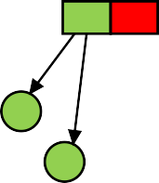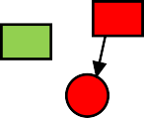

The existing techniques used for offloading the data has certain drawbacks such as,



* It did not scale well with the Heterogeneous networks
* Similar requests were not grouped accurately.



For resolving these downsides of the existing data offloading mechanisms, a novel algorithm is proposed and explained in the next section.

1. Proposed method

This section presents the detailed description for the proposed He-SERIeS for Scalability and Heterogeneity in MANET. Fig 2 depicts the general flow of the proposed SERIeS.

It includes the following stages such as,

* Network formation
* Neighbor discovery
* Electing the cluster head
* Cluster member selection
* Updating the link state database
* Route discovery
* Optimal path selection
* Node authentication
* Data offloading and communication.

Initially, the network is formed with certain number of nodes. Then, the neighbors are discovered for communicating among the nodes and the hello packets are transmitted among the nodes. If the node is the neighboring node then, the individual node IDs are updated in the neighboring table. After the discovering the neighboring nodes, the nodes with highest energy is preferred as the CH. The nodes’ requirements that are similar in nature are grouped together. In order to update the link state database, the link state advertisements are broadcasted among the nodes. The information available in the link state database is the queue length, energy, and bandwidth. Then, the learning agents are used for updating the link state database based on the link state informa- tion. After updating the link state database, the routes are discov- ered by using the forwarding table, then the optimal path is selected and the nodes are authenticated. If there is a necessity to offload the data then, the local data are stored in the CH and based upon the requirements, the data’s are grouped. If the nodes have a less receiving capacity for eg., 256 bps but, the CH has an extraordinary transmission capacity for eg.,1024 bps, then the entire data is partitioned into many 256 bps and stored in CH. In accordance with the needs of the node, the data is transmitted. Finally, the CH will move the offloaded data with requested mem- ber node.

* 1. *Network formation*

Initially, the network is formed with some set of nodes and the links are established among the nodes that are represented in

Fig. 3. Network formation.

Fig. 3. The nodes are dynamic and mobile in nature. Normally, 100 nodes are used for forming the network.

* 1. *Neighbor discovery*

After creating the network, the nodes are responsible for com- municating with one another. The neighboring nodes are discov- ered before the communication begins by transmitting the hello packets among the nodes. Once the hello packet is received by the node, it updates its neighbor table. The hello packet is the spe- cial packet and is responsible for simultaneously discovering the neighbors in the network. It is periodically broadcasted in order to approve the adjacency of the network relationships and also to discover the neighboring nodes. After the neighbors are discov- ered, the He-SERIeS algorithm is used for maintaining the topolog- ical information. This algorithm has many advantages,

* + - Robust in nature.
    - It equally splits the link state information among several nodes.
    - It provides highly secure and authenticated routing within the network.
  1. *Electing the cluster head*

After the neighboring nodes are discovered, the CH is elected based on the specifications of the node. The node with highest energy, queue length and bandwidth is chosen as the CH and is responsible for downloading the data from data service provi- der. The requirements of the nodes that are similar are gathered together within a single cluster. The data from the cluster is transferred to other nodes, which has low energy and low mem- ory. The clustering of similar requirements of the nodes is done with the on-demand clustering algorithms. The on demand clus- tering algorithm is briefly explained as follows, which initially starts by finding the neighbors of each node within its transmis- sion range. Then, the distance between the individual nodes in the network are calculated. Based on the processing power, memory capacity and bandwidth capacity, the CH is selected. The proposed algorithm is repeated till all the nodes are assigned to a cluster. The values of *Rv* is varied to greater extend, in order to avoid the fluctuations these weighting factors are used. It is used for controlling the fluctuations. The total capacity of the node is calculated for electing the CH. The node with highest capacity is selected as the CH.

Algorithm 1: On-demand clustering algorithm

*Step1*: Find the neighbors of each nodes within its transmission range *v*.

*Step 2*: Compute the absolute value of intensity as follows

[25],

*Nv* = |Variance in mobility| (1)

*Step 3:* For every node, compute the sum of the distances, *Sv* , with all its neighbors.

*Step 4:* The average speed of each and every node is computed. This gives a measure of mobility that is denoted by *Pv*.

*Step 5:* Compute the time, *Tv*, of a node *v* during which it acts

as a CH.

*Step 6:*For every node v, the total capacity is estimated using the following equation [25],

*Rv* = *c*1 *Nv* + *c*2 *Sv* + *c*3 *Pv* + *c*4 *Tv* (2)

*Step 7:* Choose the node with maximum *Rv*as the CH. All the neighbors of the chosen CH can no longer participate in the election algorithm.

*Step 8:* Repeat Steps 2–7 until all the nodes are assigned as

CHs at least once.

* 1. *Cluster member selection*

In this step, the cluster members are selected based on similar- ity in the request generation. Initially, the priority queue is assigned with the neighbor hop and the number of CH. Each and every node is checked, whether the node belongs to the cluster or not. The weight is computed for each request from the members. Based on the weight, the clusters are formed and the requests of each and every node are analyzed. Based on the requests, the nodes are grouped together under a single CH. For each and every cluster, the CH is elected and is responsible for the particular operation.

Algorithm 2: Cluster member selection based on similar request generation

*Step 1*: Initialize a priority queue (1-Hop-Neighbor, No. of CH,) pairs

*Step 2*:

*For each Member m belongs to Cluster Cl Do*

*{*

For every request Rk from the members, the weight is estimated using the following equation,

*Rk* = *rkTk sum i* ∈ *N*(c*s*;*i* ; *wi*;*k*); 6*k* ∈ *C* (3)

Create and update the weights of all the requests for quantization using Eq. (4),

(*r* = |log(max(*Rk*)/*c*1| (4)

*}*

*Step 3:*

Initialize T as Empty, P0 =0, Q0 = {(T, P0)}

(*continued*)

Algorithm 2: Cluster member selection based on similar request generation

*for all k* ∈ *length. Cl Do*

*{*

Extract highest Key node (Rk, CH) from the priority queue

*}*

*Step 4*:

*For every element Rk of Cl*

*{*

Load created by the user request is compared with the load limit of the CH.

*If* (load created by the user request < load limit of CH)

{

The additional load is added to the existing load of the

CH

}

else

{

The requested member is shifted to an alternate cluster

}

*Step 5:* If the requested member is a low profile member, the data is stored in the CH

*Step 6*: Else Forward data packet as per link rate

*Step 7*: If (local Storage (Req. Data).Size!=0)

*Step 8*: Forward Data to Mreq as per link rate

* 1. *Updating the link state database*

After the CH’s are elected and the nodes with similar require- ments are clustered, the nodes are responsible for updating the link state database. The link state information are queue length, energy and bandwidth. The learning agents are responsible for storing the up-to-date, correct and authenticated link state infor- mation that is responsible for routing the information. Here, the learning agents are responsible for identifying the specific path from the source node to the destination node. It also obtains the path information such as prior successful and unsuccessful path information. These agents are used for identifying the fake nodes in the network. Hence, the routes are discovered by the knowledge obtained from the learning agents (see Table 1).

* 1. *Route discovery*

After the links are established to the neighboring nodes the routes are discovered to the destination node. The transmission of data from the source to destination via an optimal path is

Table 1

Notations.

*Nv* Absolute value of intensity

*Rv* Total capacity

*c*1, *c*2, *c*3 and *c*4 Weighing factors

*Pv* Average speed of a node

*Tv* Total amount of time the node acted as the cluster head

*Sv* Sum of the neighboring distances

*Rk* Request of the nodes

*CH* Cluster Head

*rk* Length of the content

*Tk* Lifetime of the content

*N* Number of subscribers

c*s*;*i* Contact rate between the helper and subscriber

*wi*;*k* Content interest of the subscriber

*K* Data items

*C* Data items in the system

*R* Average of *rk*

termed as routing. Initially, the Route Request (RREQ) packets are broadcasted among the nodes in the network and the neighboring node receives the packet and broadcasts the same packet by just adding its own address to the packet header. The neighboring node replies with the Route Reply (RREP) packet.

* 1. *Optimal path selection*

After discovering the routes, the optimal path is selected by pre- dicting the faulty nodes. The optimal path is the best path from the source node to the destination node. In a network, there are several paths for forwarding the packets among the nodes. If the faulty nodes are predicted in the network then, the faulty nodes are removed from the network. If the optimal path is not selected then, it degrades the performance of the overall network. In order to detect the best optimal for data transmission, the end-to end delay across the network is computed. If the end-to-end delay is less then, a secure communication is established in the network. The behavior of the nodes is also considered to avoid the misbehaving

communication.

The existing techniques used for comparison of the proposed He-SERIeS algorithms are Random Cache (RC), Centrality based Cache (CC), Set Cover Based Caching (SCBC) and SERIeS. The follow- ing parameters are used for evaluating the performance of the pro- posed He-SERIeS algorithm,

* + - Throughput
    - Packet Delivery ratio (PDR)
    - Packet delivery ratio vs. number of nodes
    - End-to-end delay vs. number of nodes
    - Offloading ratio
    - Replication overhead
    - End-to-end delay.
  1. *Throughput*

The throughput is the total number of packets delivered within the total amount of time. Mathematically, it is given by the follow- ing Eq. (5).

* 1. *Node authentication*

## *Throughput* = *Total Number of packets*

*Total amount of time*

(5)

The nodes available in the best optimal path are authenticated to avoid the packet drops and malicious attacks in the network. During this stage, the nodes in the network are authenticated as faulty or normal. The node authentication scheme is usually done with an auxiliary key management scheme. In this work, the nodes are authenticated using the MD5 and SHA1 algorithm. This algo- rithm is discussed in our previous work.

* 1. *Data offloading and communication*

After the nodes are authenticated, the specifications of the nodes are gathered. The specifications of the nodes include the energy, bandwidth, length of queue, etc. If the nodes are having

Fig. 4 depicts the throughput for the proposed He-SERIeS algo- rithm. The existing algorithms used for comparison are RC, SCBC, SERIeS algorithms. The simulation-time (ms) is plotted in the X- axis, whereas the throughput (Kbps) is plotted against the y-axis. From Fig. 4, it is clear that the proposed enhanced SERIeS algorithm achieved higher throughput than the existing algorithms.

* 1. *Packet Delivery Ratio (PDR)*

PDR is the metric used for analyzing the performance of the proposed He-SERIeS algorithm. The PDR is defined as the percent- age of number of data packets received to the number of data pack- ets transmitted. The PDR is defined by the following Eq. (6).

low specifications such as memory or energy then, the data offloading mechanism is performed. The data is downloaded and

## *PDR* = *Sum of data packets received by the destination node* Sum of data packets generated by the source node

(6)

stored by the CH and according to the specifications of the nodes, then the data is offloaded from the CH to the remaining nodes. The CH is responsible for splitting the data according to the requirements of the nodes and the data is forwarded from the CH to the requesting node. Finally, if the data is authenticated as normal node then, the communication of data is accomplished. The communication takes place until the queue is empty.

* 1. *Advantages of the proposed work*

The major advantages of the proposed method over the existing methods are as follows:

* + - It enables the data reusability and re-sharing
    - Reduces the burden at both user and server side
    - In this environment, the master node (i.e. CH) can store the data that are obtained from the server, then it forwards to the requested nodes in the cluster. So, it reduces the delay time and increases the speed of processing
    - Moreover, it reduced the data cost and increased the data retrie- val rate.

1. Performance analysis

This section presents the performance analysis of the proposed He-SERIeS algorithm using on-demand clustering and similarity searching. The experimental analysis is performed using the simu- lation parameters represented in Table 2.

Fig. 5 describes the PDR vs. Simulation time. The x-axis denotes the simulation time in ms and the y-axis describes the PDR in %. When compared to the existing algorithms, the proposed He- SERIeS algorithm provides a higher PDR.

* 1. *Packet delivery ratio vs. number of nodes*

The comparison of PDR with respect to the number of nodes for the existing RC, SCBC, SERIeS algorithms and the proposed

Table 2

Simulation parameters.

Simulator NS 2.34

Simulation time 100 s

Simulation area 1000 × 1000 m2

MAC IEEE 802.11 b/g/n

Number of nodes 30, 50, 70, 90, 100

Speed of nodes 2–30 (m/s)

Mobility model Random waypoint

Transmission range 250 m

Packet size 512 Kbps-2048 Kbps

Packet rate 4 packets/ sec

Traffic type CBR

Routing protocol AODV/SERIeS/He-SERIeS

Channel bit rate 10 MB/s

ACK 112 bits + PHY header

MAC header 272 bits

PHY header 128 bits

Propagation delay 1 ms

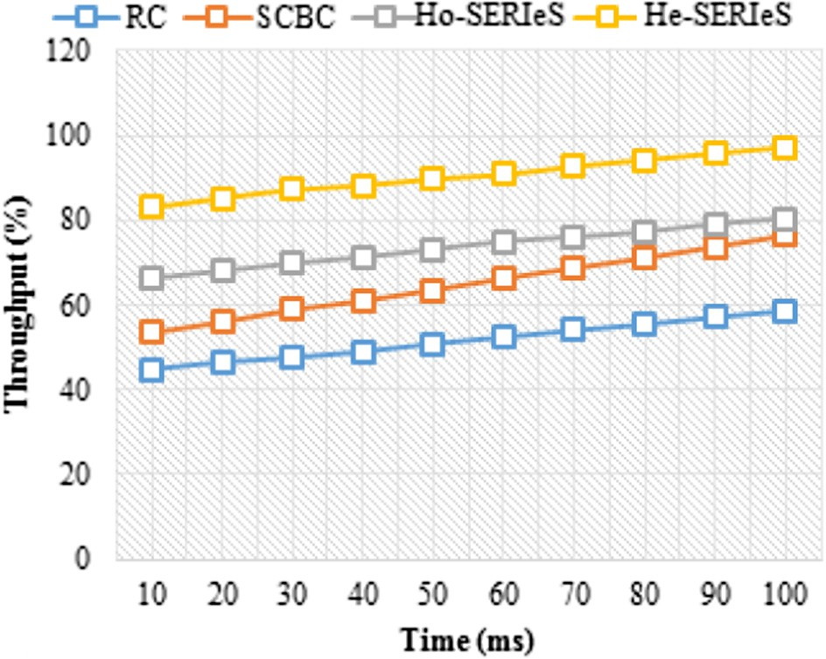

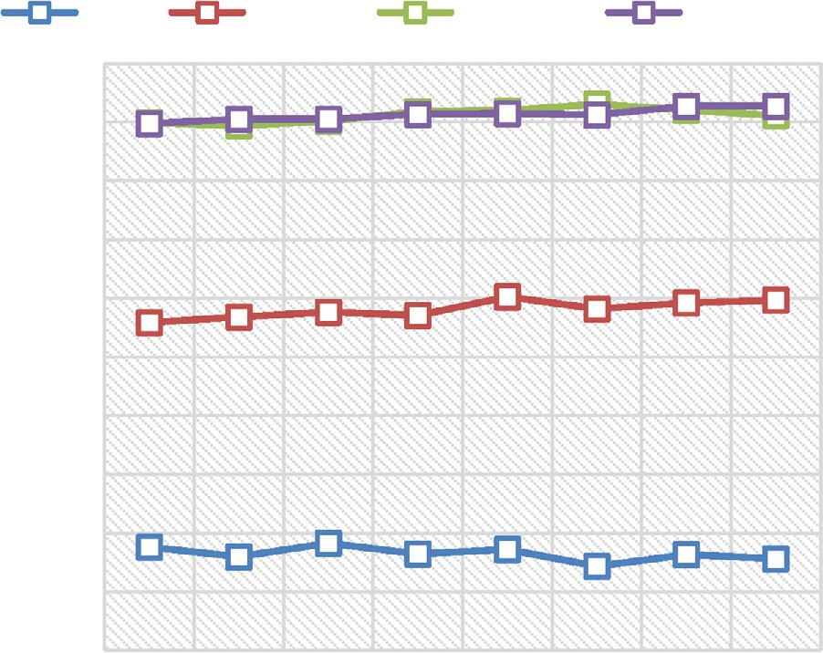

Fig. 4. Throughput vs. simulation time.

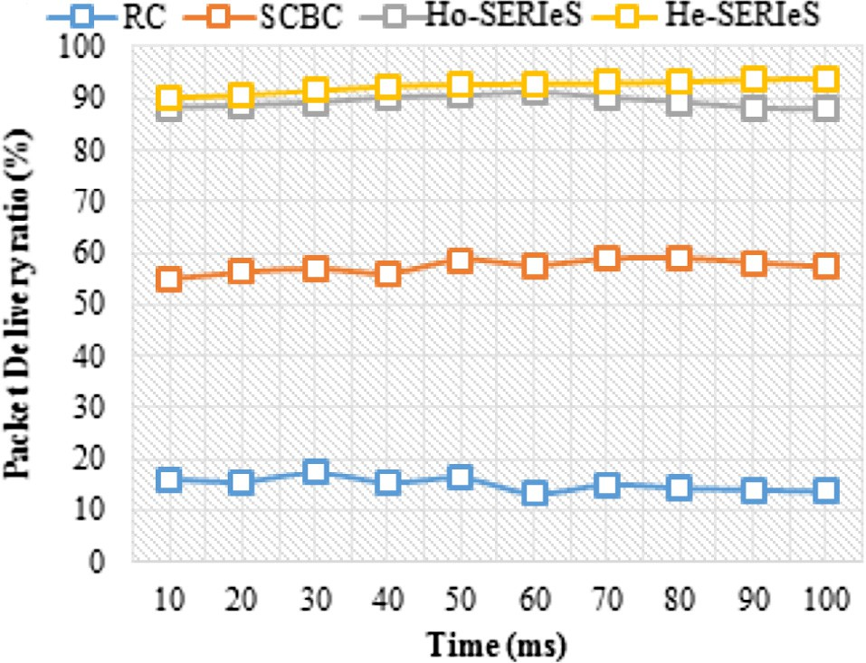

Fig. 5. PDR vs. simulation time.

He-SERIeS algorithm is represented in Fig. 6. From the results, it is analyzed that the suggested He-SERies algorithm provides higher PDR than the existing algorithms for varying number of nodes.

* 1. *End-to-end delay vs. simulation time*

The comparison of end-to-end delay with respect to the number of nodes for the existing RC, SCBC, SERIeS algorithms and the pro- posed He-SERIeS algorithm is represented in Fig.7. The comparison results show that the suggested algorithm provides minimal end- to-end delay than the existing algorithms.

* 1. *Offloading ratio*

The offloading ratio is defined as the ratio of offloading the data traffic to the overall traffic. It estimates the number of suc- cessful offloading performed by the CH. Fig. 8 explains the offloading ratio vs. the simulation time. The x-axis describes the simulation time in ms and the y-axis describes the offloading ratio. From graph it is clear that the proposed enhanced SERIeS algorithm is compared to that of the existing RC, CC and SCBC algorithms. The simulation time is varied from 10 to 100 ms. The offloading ratio is increased as the simulation time is increased. When compared to the existing algorithms, the pro-



Fig. 6. PDR vs. number of nodes.

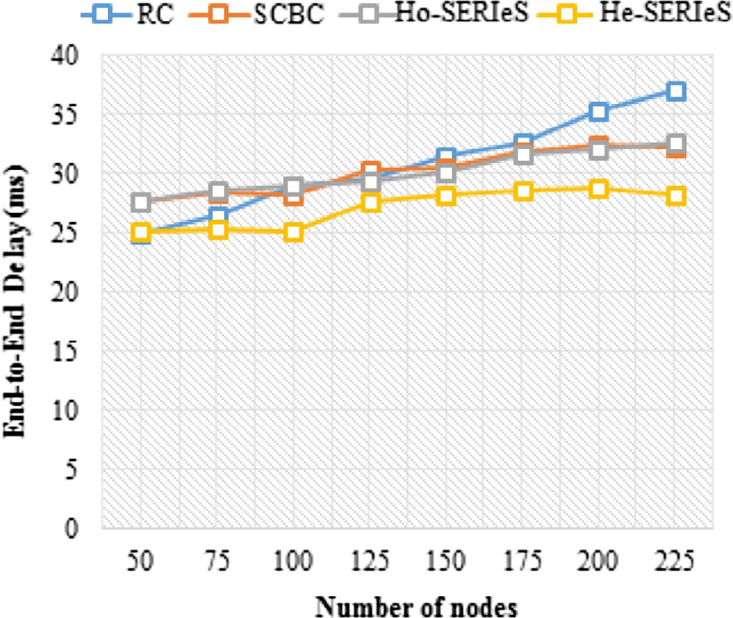

Fig. 7. End-to-end delay vs. number of nodes.

posed algorithms achieved high offloading ratio. Because, there is no self-downloading process in the network and it do not takes the time for downloading. Moreover, it represents how efficiently we provide the services based on the request. So, the offloading ratio can be increased in the proposed system.

* 1. *Replication overhead*

The replication overhead is the metric used for analyzing the performance of the He-SERIeS algorithm with that of the existing algorithms. It is defined as the total number of data copies gener- ated inside the network in which several paths are exploited to route the same data. Even if the data size increases, the replication overhead is unchanged. Fig. 9 depicts the replication overhead vs. the simulation time. The x-axis describes the simulation time, which is measured in milliseconds (ms) and the y-axis describes the replication overhead in %. From the figure, it is clear that the proposed He-SERIeS algorithm provides minimal replication over- head than the existing algorithms.

delivering a data packet to the total number of packets received at the destination. The estimation of the end-to-end delay is based on the following equation,

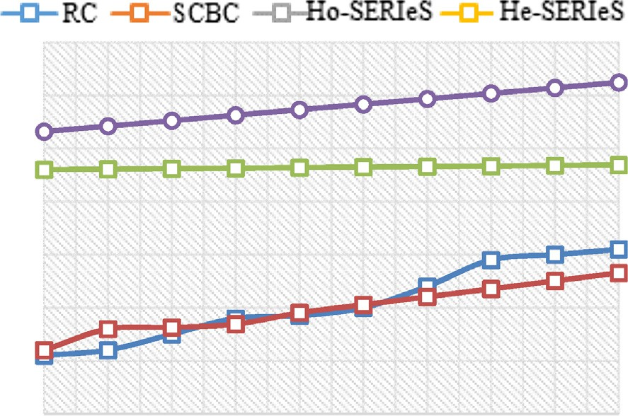

*End* — *to* — *End Delay* = *S*

## *N*

(7)





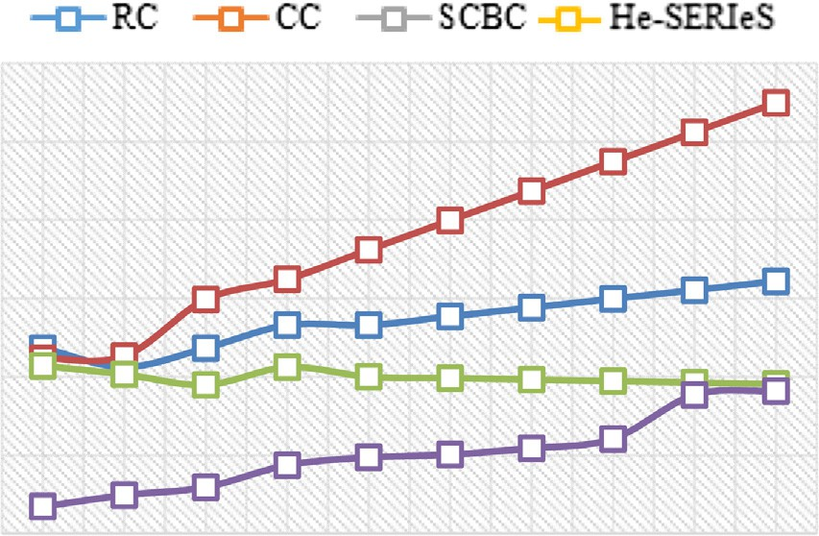Fig. 8. Offloading ratio vs. simulation time.



Fig. 9. Replication overhead vs. simulation time.



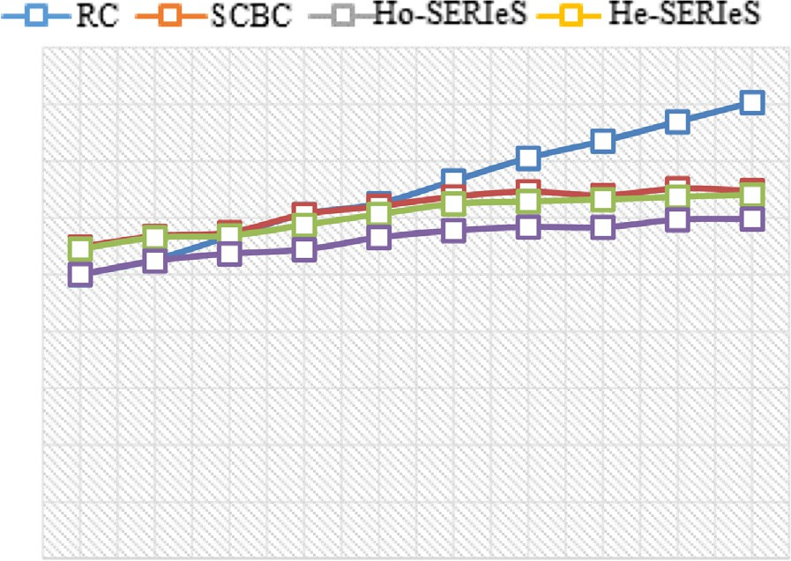

Fig. 10. End-to-end delay vs. simulation time.

* 1. *End-to-end delay*

The end-to-end delay is defined as the amount of time taken by the data packet to reach the destination. The delay time can be increased due to the reasons of route discovery, queuing and buffering. Also, it is defined as the ratio of the time spent on

where the S is the total time spent on delivering the data packets to the destination node and N is the total number of packets received by the destination nodes. Fig.10 represents the comparison of end- to-end delay for the existing RC, SCBC, SERIeS algorithms and the proposed He-SERIeS algorithm. The x-axis describes the simulation time in ms and y-axis describes the end-to-end delay in ms. The comparison results show that the suggested He-SERIeS algorithm provides minimal end-to-end delay than the existing algorithms. Because, the tradition techniques download the requested data with increased time, but the proposed He-SERIeS do not perform the routing process, so it efficiently reduces the delay time.

1. Conclusion and future work

This paper proposed a novel algorithm, namely, He-SERIeS algo- rithm for providing the scalability and Heterogeneity in MANET. The main aim of this work is to modify the existing SERIeS algo- rithm by using the learning agents, to cluster the similar requests from the nodes and to elect the CH that has the highest energy. There are two main algorithms developed for this purpose are Dynamic on-demand clustering and Cluster member selection based on the similar request generation. Our SERIeS protocol is extended in order to reduce the data management problems and to increase the throughput. The proposed system supports the ser- vice providers, who provides the services based on the factor of Quality of Service (QoS) and the service provides should support the data offloading mechanism. The performance of the proposed algorithm is compared with the existing RC, CC, SCBC and SERIeS algorithms. The metrics used for evaluating the performance of both existing and proposed techniques are throughput, delay, replication overhead, offloading ratio, and PDR. From the results, it is analyzed that the proposed enhanced SERIeS protocol achieved a high throughput of 96.6% and PDR of 92.8%, when compared to the existing algorithms. The advantage of the work is to balance the load among several nodes using the offloading mechanism.

As a part of our future work, multiple cellular networks are assumed with MANET communication and to examine the traffic offloading for multiple services in MANET cyber-physical systems.

References

1. [Raja ML, Baboo CDSS. An overview of MANET: applications, attacks and](http://refhub.elsevier.com/S1110-8665(17)30190-1/h0005) [challenges. Int J Comput Sci Mobile Comput 2014;3:408–17](http://refhub.elsevier.com/S1110-8665(17)30190-1/h0005).
2. Gavalas D et al. Clustering of mobile Ad hoc networks: an adaptive broadcast period approach. In: IEEE international conference on communications; 2006.

p. 4034–9.

1. Kaur K et al. Weightage based secure energy efficient clustering algorithm in MANET. In: International conference on advances in computing, communications and informatics (ICACCI); 2015. p. 1006–12.
2. [Bokhari DM et al. A review of clustering algorithms as applied in MANETs. Int J](http://refhub.elsevier.com/S1110-8665(17)30190-1/h0020) [Adv Res Comput Sci Softw Eng 2012;2:364–9](http://refhub.elsevier.com/S1110-8665(17)30190-1/h0020).
3. [Wang S et al. Offloading mobile data traffic for QoS-aware service provision in](http://refhub.elsevier.com/S1110-8665(17)30190-1/h0025) [vehicular cyber-physical systems. Future Gener Comput Syst 2015:118–27](http://refhub.elsevier.com/S1110-8665(17)30190-1/h0025).
4. [Amani M et al. SDN-based data offloading for SDN-based data offloading for 5G](http://refhub.elsevier.com/S1110-8665(17)30190-1/h0030) [mobile networks G mobile networks. ZTECOMMUNICATIONS 2014;12:34](http://refhub.elsevier.com/S1110-8665(17)30190-1/h0030).
5. Conti M et al. Offloading service provisioning on mobile devices in mobile cloud computing environments. In: Hunold S et al., editors. Euro-Par 2015: parallel processing workshops: Euro-Par 2015 international workshops, Vienna, Austria, August 24–25, 2015. Revised Selected Papers. Cham: Springer International Publishing; 2015. p. 299–310.
6. [Lee K et al. Mobile data offloading: how much can WiFi deliver? IEEE/ACM](http://refhub.elsevier.com/S1110-8665(17)30190-1/h0040) [Trans Netw (TON) 2013;21:536–50](http://refhub.elsevier.com/S1110-8665(17)30190-1/h0040).
7. [Han B et al. Mobile data offloading through opportunistic communications and](http://refhub.elsevier.com/S1110-8665(17)30190-1/h0045) [social participation. IEEE Trans Mob Comput 2012;11:821–34](http://refhub.elsevier.com/S1110-8665(17)30190-1/h0045).
8. Liu L et al. A distributed ADMM approach for mobile data offloading in software defined network. In: 2015 IEEE Wireless Communications and Networking Conference (WCNC); 2015. p. 1748–52.
9. Eom H et al. Machine learning-based runtime scheduler for mobile offloading framework. In: Proceedings of the 2013 IEEE/ACM 6th international conference on utility and cloud computing; 2013. p. 17–25.
10. [Budiyanto S et al. Performance analysis of genetic zone routing protocol](http://refhub.elsevier.com/S1110-8665(17)30190-1/h0060) [combined with vertical handover algorithm for 3G-WiFi offload. J ICT Res Appl](http://refhub.elsevier.com/S1110-8665(17)30190-1/h0060) [2014;8:49–63](http://refhub.elsevier.com/S1110-8665(17)30190-1/h0060).
11. [Xuyan B et al. Cellular traffic offloading utilizing set-cover based caching in](http://refhub.elsevier.com/S1110-8665(17)30190-1/h0065) [mobile social networks. J China Univ Posts Telecommun 2016;23(4):46–55](http://refhub.elsevier.com/S1110-8665(17)30190-1/h0065).
12. [Cheng R-G et al. Offloading multiple mobile data contents through](http://refhub.elsevier.com/S1110-8665(17)30190-1/h0070) [opportunistic device-to-device communications. Wireless Pers Commun](http://refhub.elsevier.com/S1110-8665(17)30190-1/h0070) [2015;84:1963–79](http://refhub.elsevier.com/S1110-8665(17)30190-1/h0070).
13. [Dias EV et al. Feasibility of video streaming offloading via connection sharing](http://refhub.elsevier.com/S1110-8665(17)30190-1/h0075) [from LTE to WiFi ad hoc networks. Int Workshop Telecommun (IWT)](http://refhub.elsevier.com/S1110-8665(17)30190-1/h0075) [2015;2015:1–6](http://refhub.elsevier.com/S1110-8665(17)30190-1/h0075).
14. [Novo RA et al. Measuring the impact of redirecting and offloading mobile data](http://refhub.elsevier.com/S1110-8665(17)30190-1/h0080) [traffic. Bell Labs Tech J 2013;18:81–103](http://refhub.elsevier.com/S1110-8665(17)30190-1/h0080).
15. [Budiyanto S et al. Improved performance of hybrid algorithm for 3G-WiFi](http://refhub.elsevier.com/S1110-8665(17)30190-1/h0085) [offload networks. Jurnal Teknologi 2016;78](http://refhub.elsevier.com/S1110-8665(17)30190-1/h0085).
16. [Esnault A et al. An anycast communication model for data offloading in](http://refhub.elsevier.com/S1110-8665(17)30190-1/h0090) [intermittently-connected hybrid networks. Procedia Comput Sci](http://refhub.elsevier.com/S1110-8665(17)30190-1/h0090) [2015;56:59–66](http://refhub.elsevier.com/S1110-8665(17)30190-1/h0090).
17. Bravo-Torres JF et al. Mobile data offloading in urban VANETs on top of a virtualization layer. In: 2015 International wireless communications and mobile computing conference (IWCMC); 2015. p. 291–6.
18. [Chung J-M et al. Adaptive cloud offloading of augmented reality applications](http://refhub.elsevier.com/S1110-8665(17)30190-1/h0100) [on smart devices for minimum energy consumption. KSII Trans Internet Inf](http://refhub.elsevier.com/S1110-8665(17)30190-1/h0100) [Syst (TIIS) 2015;9:3090–102](http://refhub.elsevier.com/S1110-8665(17)30190-1/h0100).
19. [Valipour M. Optimization of neural networks for precipitation analysis in a humid](http://refhub.elsevier.com/S1110-8665(17)30190-1/h0105) [region to detect drought and wet year alarms. Meteorol Appl 2016;23:91–100](http://refhub.elsevier.com/S1110-8665(17)30190-1/h0105).
20. [Yannopoulos SI et al. Evolution of water lifting devices (pumps) over the](http://refhub.elsevier.com/S1110-8665(17)30190-1/h0110) [centuries worldwide. Water 2015;7:5031–60](http://refhub.elsevier.com/S1110-8665(17)30190-1/h0110).
21. [Valipour M, Eslamian S. Analysis of potential evapotranspiration using 11](http://refhub.elsevier.com/S1110-8665(17)30190-1/h0115) [modified temperature-based models. Int J Hydrol Sci Technol](http://refhub.elsevier.com/S1110-8665(17)30190-1/h0115) [2014;4:192–207](http://refhub.elsevier.com/S1110-8665(17)30190-1/h0115).
22. [Valipour M. Calibration of mass transfer-based models to predict reference](http://refhub.elsevier.com/S1110-8665(17)30190-1/h0120) [crop evapotranspiration. Appl Water Sci 2015:1–11](http://refhub.elsevier.com/S1110-8665(17)30190-1/h0120).
23. Chatterjee M et al. An on-demand weighted clustering algorithm (WCA) for ad hoc networks. In: IEEE global telecommunications conference, vol. 3; 2000, p. 1697–701.