[Egyptian Journal of Basic and Applied Sciences 4 (2017) 15–21](http://dx.doi.org/10.1016/j.ejbas.2016.11.003)

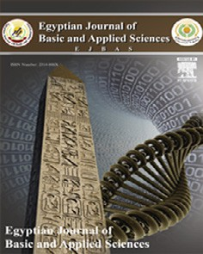

Contents lists available at [ScienceDirect](http://www.sciencedirect.com/science/journal/2314808X)

Egyptian Journal of Basic and Applied Sciences

journal homepage: [www.elsevier.com/locate/ejbas](http://www.elsevier.com/locate/ejbas)

Full Length Article

Histomorphological changes in induced benign prostatic hyperplasia with exogenous testosterone and estradiol in adult male rats treated with aqueous ethanol extract of *Secamone afzelii*



Mbaka Godwin a,⇑, Anunobi Charles b, Ogunsina Samson c, Osiagwu Daniel b

a *Department of Anatomy, Lagos State University College of Medicine, Ikeja, Lagos, Nigeria*

b *Department of Anatomic and Molecular Pathology, College of Medicine of the University of Lagos, Lagos, Nigeria*

c *Department of Anatomy, Olabisi Onabanjo University, Remo Campus, Ogun State, Nigeria*

# a r t i c l e i n f o

*Article history:*

Received 24 May 2016

Received in revised form 30 November 2016 Accepted 30 November 2016

Available online 24 December 2016

*Keywords:*

Benign prostatic hyperplasia Phytotherapy

*Secamone afzelii* Histopathology Male rats

# a b s t r a c t

*Secamone afzelii* (*S. afzelii*) used locally to manage benign prostatic hyperplasia (BPH) was used to treat exogenously induced BPH in adult male Wister rats. Male rats weighing 200 ± 10 g kg—1 had exogenous administration of testosterone and estradiol in staggered doses (three times weekly) for three weeks.

The induced animals were in five groups (6 rats per group). Groups 1 and 2 received extract at 200

and 400 mg kg—1 body weight (bwt) by gavages for thirty days; group 3, finasteride (0.1 mg kg—1); group 4, untreated for thirty days; group 5, negative control, which was sacrificed twenty-one days after induc- tion. Group 6 received extract (400 mg kg—1) and steroid hormones simultaneously; group 7, normal con-

trol. The extract caused marked decrease in prostate weight of BPH induced rats with the

photomicrograph of the prostate showing extensive shrinkage of glandular tissue whereas glandular hyperplasia occurred in the negative control. Prostate specific antigen (PSA) level significantly (*p* < 0.05) decreased in the treated groups compared to negative control. Treatment with the extract/fi- nasteride caused significant decrease in testosterone to a level comparable to normal. The BPH induced rats treated with *S. afzelii*/finasteride recorded marked increase in the levels of antioxidant enzymes com- pared to the negative control. *S. afzelii* effectively ameliorated prostatic hyperplasia exogenously induced by causing extensive shrinkage of glands and stroma. It also exhibited antioxidant properties and showed to be a good prophylaxis.

© 2016 Mansoura University. Production and hosting by Elsevier B.V. This is an open access article under

the CC BY-NC-ND license (<http://creativecommons.org/licenses/by-nc-nd/4.0/>).

1. Introduction

The term benign prostatic hyperplasia (BPH) denotes non cancerous enlargement of prostate gland. It is more discretely defined as a non malignant enlargement of prostate gland charac- terized by proliferation of the cellular elements such as its epithe- lial and stromal cells into a discrete mass or nodules [1]. An enlarged prostate means the gland has grown bigger and as the gland grows, it can press on the urethra causing difficulty in urina- tion. The discomfort presented by this condition during urination makes its occurrence worrisome. BPH is considered a normal part of the aging process in men which becomes apparent histological in about 40% of men in their fifties and nearly 90% of men in their eighties [2]. Although the actual cause of BPH remains incom-

* Corresponding author.

*E-mail addresses:* [mbaakagm@yahoo.com](mailto:mbaakagm@yahoo.com) (G. Mbaka), [dozieanunobi@yahoo.com](mailto:dozieanunobi@yahoo.com) (C. Anunobi), [Chiazuibe4@yahoo.com](mailto:Chiazuibe4@yahoo.com) (S. Ogunsina), [dosiagwu@unilag.edu.ng](mailto:dosiagwu@unilag.edu.ng) (D. Osiagwu).

pletely understood, it is clear that androgens have a central role to play in its development [3]. Dihydrotestosterone (DHT), an androgen derived from testosterone through the action of 5a-

reductase and its metabolite, 3a-androstanediol, seems to be the

major hormonal stimuli for stromal and glandular proliferation in men with nodular hyperplasia. Experimental work has also identi- fied age-related increases in estrogen levels that may increase the expression of DHT, the progenitor of BPH [4]. The incrimination of DTH in the pathogenesis of BPH forms the basis for the current use

of 5a-reductase inhibitors in the treatment of symptomatic nodu-

lar hyperplasia.

The 5a-reductase inhibitors inhibit the development of BPH via a reduction in dihydrotestosterone (DHT) production [5]. Other therapeutic agents include a1-adrenergic receptor antagonists con- sidered more suitable for the management of BPH complication

like lower urinary tract symptoms (LUTS) because they relax the smooth muscle in the prostate and the neck of the bladder [6,7]. These allopathic medications seem to trigger adverse effect like

<http://dx.doi.org/10.1016/j.ejbas.2016.11.003>

2314-808X/© 2016 Mansoura University. Production and hosting by Elsevier B.V.

This is an open access article under the CC BY-NC-ND license (<http://creativecommons.org/licenses/by-nc-nd/4.0/>).

severe myopathy owing to their structural similarities to the ster- oid hormones [8]. There are also incidences of ejaculatory or erec- tile dysfunction and decreased libido associated with the use of these drugs [9].

The more worrisome aspect is that the treatment option requires that the drugs be used permanently because if they are suspended there would be reoccurrence of the symptoms [10].

Alternative therapy such as herbal medicine has been popular since the ancient time for the treatment of BPH [11]. Their popular- ity is based on the assumption that they are of natural source and therefore not harmful. More importantly is the fact that they are readily assessable, cheap and can be acquired without medical pre- scription. The phytotherapeutic agents used in the treatment of BPH could be recipes from a single plant source or could be extracts from two or more plant sources.

*Secamone afzelii* (*S. afzelii*) is a therapeutic agent that has wide application. It belongs to the family Asclepiadaceae and is wide- spread in West and Central Africa [12]. *S. afzelii* occurs in secondary forest and savanna thickets, it is also common in abandoned fields and field boundaries, growing in a wide range of climatic condi- tions particularly in the sun or in light shade [12]. Its medicinal value includes the use in the treatment of gonorrhea, cough and catarrh and as galactogogue [13]. Its leafy twig infusion is taken to treat sexually transmitted diseases, diabetes and schistosomia- sis [14]. *S. afzelii* has been reported to show a high concentration of flavonoids, saponins, reducing sugars, coumarins and the triter- penoid friedelin [15]. Its leaf extract is used by traditional healers singly and in combination with other herbs to treat BPH with no known scientific proof. It is in this light that this study was designed to validate the claim.

1. Materials and methods
   1. *Plant materials*

The aerial part of *S. afzelii* was collected from Ikenne-Remo, Ogun State, Nigeria. The plant sample was authenticated in the Forestry Research Institute of Nigeria (FRIN), Ibadan, where the voucher specimen was deposited in the herbarium (FHI/108940).

* 1. *Preparation of aqueous ethanol extract of Sacamone afzelii*

The aerial part of the plant was dried in the sun within the tem- perature range of 30–42 °C for 5 days before being subjected to size reduction to a coarse powder with electric grinder. The coarse powder of the plant weighing 780 g was extracted with 90% aque- ous ethanol in three cycles using Soxhlet extractor. The crude extract was filtered with Whatman filter paper No. 4 and the fil- trate concentrated *in vacuo* at 30 °C to obtain 68 g residue weight (8.7% w/w). The residue was stored in an air tight bottle kept in a refrigerator at 4 °C till used.

* 1. *Animals*

Adult male Wister rats (200 ± 5 g) obtained from the Animal House of the University of Ibadan, Oyo State, Nigeria, were kept under standard environmental condition of 12/12 h light/dark cycle. They were housed in polypropylene cages (6 animals per cage), and were maintained on mouse chow (Livestock Feeds Nige- ria Ltd.) and provided with water *ad libitum*. They were allowed to acclimatize for 12 days to the laboratory conditions before the experiment. The use and care of the animals, and the experimental protocol were in strict compliance with the Institute of Laboratory Animals Research (ILAR) guidelines on the use and care of animals, in experimental studies [16].

* 1. *BPH induction*

Adult male rats weighing 200 ± 12 mg kg—1 were induced with BPH by exogenous administration of testosterone and estradiol in staggered doses (three times a week respectively) for three weeks. The steroid hormones were diluted with corn oil which served as

the solvent. The preparation and induction of BPH was as described by Mbaka et al. [17].

* 1. *Animal grouping and treatment*

The induced animals were divided into five groups each com-

prised of 6 male rats. Groups 1 and 2 received the extract at 200 and 400 mg kg—1 body weight (bwt) by gavages for thirty days. Group 3 received finasteride at 0.1 mg kg—1; group 4 was left untreated for thirty days before they were sacrificed to assess pos- sible reversal of the exogenous induction; group 5 (negative con- trol) was sacrificed immediately after the induction. Group 6 was given the extract (400 mg kg—1) simultaneously as benign hyper- plasia was being induced with the steroid hormones while group 7 served as normal control.

The animals were weighed prior to the commencement of the experiment and subsequently every five days till the end of the experiment. The prostate weight was equally recorded after the sacrifice.

* 1. *Assay for testosterone and prostate specific antigen (PSA)*

Enzyme immunoassay technique was used for the quantitative determination of testosterone concentration and PSA evaluation [18,19].

* 1. *Oxidative activities*

The oxidative activity assessment was conducted after over- night fast. The animals were sacrificed and the hepatic tissue har- vested were homogenized and used for the assays.

* + 1. *Superoxide dismutase assay*

Superoxide dismutase (SOD) was assayed utilizing the tech- nique of Kakkar et al. [20]. A single unit of the enzyme was expressed as 50% inhibition of Nitroblue Tetrazolium (NBT) reduc- tion/min/mg protein which was measured spectrophotometrically at 420 nm.

* + 1. *Catalase assay*

Catalase (CAT) was assayed colourimetrically at 620 nm and expressed as lmoles of H2O2 consumed/min/mg protein [21]. The hepatic tissue was homogenized in isotonic buffer (pH 7.4). The homogenate was centrifuged at 1000 rpm for 10 min. The

reaction mixture contained 1.0 mL of 0.01 M pH 7.0 phosphate buf- fers which was added 0.1 mL of tissue homogenate and 0.4 mL of

2.0 mL of dichromate-acetic acid reagent (5% potassium dichro- mate and glacial acetic acid mixed in 1:3 ratios).

* + 1. *Estimation of glutathione*

The glutathione (GSH) level was determined by the method of Ellman [21]. To the hepatic homogenate was added 10% trichloroa- cetic acid (TCA) and centrifuged. 10 mL of the supernatant was treated with 0.5 mL of Ellmans’ reagent in 100 mL of 0.1% of sodium nitrate and 3.0 mL of phosphate buffer (0.2 M, pH 8.0). The absorbance was read at 412 nm.

* + 1. *Estimation of lipid peroxidation*

Lipid peroxidation as evidenced by the formation of thiobarbi- turic acid reactive substances (TBARS) and hydroperoxides (HP)

were measured by the method of Niehaus and Samuelsson [21] and expressed as nmol/mL. In brief, 0.1 mL of hepatic tissue homo- genate (Tris–HCl buffer, pH 7.5) was treated with 2 mL of (1:1:1 ratio) TBA–TCA–HCl reagent (thiobarbituric acid 0.3%, 0.25 N HCl and 15% TCA) and placed in water bath for 10 min at 1000 rpm. The absorbance of clear supernatant was measured against refer- ence blank at 535 nm.

* 1. *Tissue histology*

The prostate tissues harvested from each group were fixed in Bouin’s fluid for five days. Before embedding in paraffin wax the fixed prostate gland was removed and dehydrated in increasing concentrations of alcohol; 70%, 80%, 90% and absolute alcohol (100%). The organ was treated with acetone and then cleared in xylene for 30 min to enhance the tissue transparency followed by impregnating and embedding in paraffin wax. The embedded tis-

sue was sectioned at 5 lm, mounted on a slide and stained with

Haematoxylin and Eosin (H&E) stains [22]. Each section was exam- ined under light microscope for structural changes and photomi- crographs were taken.

* 1. *Statistical analysis*

All values were expressed as mean ± standard error of mean and the statistical significance between treated and control groups were analyzed by means of Student’s *t*-test. *p* < 0.05 was consid- ered significant.

1. Results
   1. *Body and prostate weights*

The body weight changes of the control and the experimental animals are indicated in Fig. 1. It was observed that the amount of food consumed daily during BPH induction was far less indicat- ing decrease in appetite and this culminated to body weight loss. Following treatment with the extract/finasteride the animals were observed to show an improvement in appetite coupled with pro-

gressive weight gain until the end of the experimental period. However, progressive weight decrease occurred in the untreated animals. There were equally prostate weight changes in the ani- mals (Fig. 2). The BPH rats exhibited significant (*p* < 0.05) increase in prostate weight compared to normal control whereas, the pros- tate weight in the extract/finasteride treated decreased apprecia- bly. The extract group exhibited dose dependent (200 and 400 mg kg—1) decrease of 75.9% and 86.2% respectively compared

to the negative control while finasteride group exhibited 68.9%

decrease.

* 1. *Effect of the extract on PSA level*

There was an elevation in PSA level to 8 ng mL—1 in BPH induced rats (Fig. 3) which indicated marked increase compared to the nor-

mal (4 ng mL—1). The PSA level in the two extract dose treatments (200 and 400 mg kg—1) showed dose dependent decrease of 37.5% (5 ng mL—1) and 50% (4 ng mL—1) respectively. In the finasteride treatment, decrease of 37.5% (5 ng mL—1) occurred compared to the negative control. The simultaneous induction of BPH with

testosterone and estradiol and treatment with the extract showed a decrease of 25% (6 ng mL—1). The BPH induced animals that were untreated for 30 days of the experimental period indicated insignificant decrease of PSA level [5% (7 ng mL—1)].

* 1. *Effect of the extract on testosterone*

The testosterone level in the extract and finasteride treated (Fig. 4) decreased significantly (*p <* 0.05) compared to the untreated. The finasteride treated exhibited more effective decrease compared to the extract treated. The simultaneous induc- tion of BPH with testosterone and estradiol and treatment with the extract equally showed marked decrease in testosterone level. There was however unremarkable reduction in testosterone level after BPH induction without treatment for 30 days.

* 1. *Effect on antioxidant profile*

Induction of prostatic hyperplasia to the animals was character- ized with oxidative stress (Table 1). In the untreated groups, there



Fig. 1. Body weight increase in control and treated animals. Values represent mean ± *n* = 6.



Fig. 2. Prostate weight. Values represent mean ± *n* = 6.

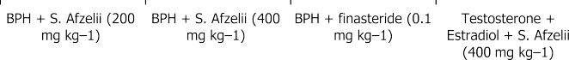

Fig. 3. Plasma prostate specific antigens (PSA) level post treatment. Values represent mean ± *n* = 6.

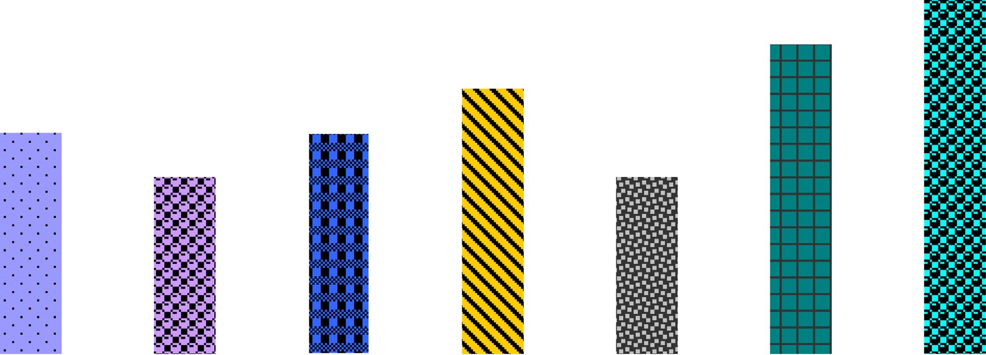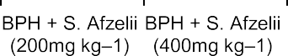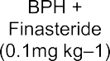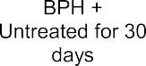

was significant decrease (*p <* 0.05) in the activities of CAT, SOD and GSH. In the extract/finasteride treated, there was marked recovery in the enzymes level with the extract treated exhibiting dose dependent increase compared to the untreated. The improvement in the activity of the enzymes was more marked in the extract trea- ted compared to the control drug treated. In the simultaneously induced with BPH and treatment with the extract, the level of the enzymes were within the normal range except that the SOD showed higher activity. The TBAR evaluation showed increase in peroxidative activity in the untreated groups. In the extract/finas- teride treated, the peroxidative activity showed marked decrease compared to the untreated with the level comparable to the normal.

* 1. *Histopathological studies*

In this study, all the animals administered with testosterone and estradiol exhibited prostatic hyperplasia after the third week of administration except for the group simultaneously induced and treated with the extract. The photomicrograph of a cross sec- tion of normal prostatic tissue histology (Fig. 5a) stained with H&E showed thick glandular epithelial lining that appeared convo- luted within which was deeply stained epithelial cells. The fibro- muscular matrix rich in vessels contained smooth muscle fibres that were poorly defined. The photomicrograph (Fig. 5b) of the negative control indicated hyperplasia of stroma. The glands unlike in the normal prostatic tissue formed an epithelial lining devoid of

Fig. 4. Plasma testosterone level post treatment. Values represent mean ± *n* = 6.

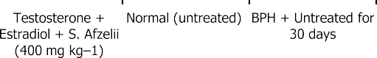

Table 1

shows lipid concentration during 30 days of extract/finasteride administration or 10 mg/kg distilled water (control).

Plasma lipid levels in control and treated animals (lmol/min/mg protein/100 mL)

|  |  |  |  |  |  |  |
| --- | --- | --- | --- | --- | --- | --- |
|  | Dose (mg/kg) | CAT | SOD | GSH | MDA |  |
| BPH + *S. afzelii* | 200 | 48.5 ± 2.7 | 5.3 ± 0.2 | 0.4 ± 0.1 | 0.06 ± 0.2 |  |
| BPH + *S. afzelii* | 400 | 49.7 ± 1.0 | 6.6 ± 0.4 | 0.5 ± 0.2 | 0.06 ± 0.0 |  |
| BPH + finasteride | 0.1 | 39.8 ± 1.1 | 3.9 ± 0.3 | 0.4 ± 1.0 | 0.05 ± 0.0 |  |
| Testosterone + estradiol + *S. afzelii* | 400 | 50.0 ± 0.1 | 5.2 ± 0.6 | 0.6 ± 0.1 | 0.07 ± 0.1 |  |
| Normal |  | 52.4 ± 1.2 | 3.9 ± 0.3 | 0.7 ± 0.2 | 0.05 ± 0.1 |  |
| BPH + untreated for 30 days |  | 17.7 ± 2.0 | 2.7 ± 0.3 | 0.3 ± 0.0 | 0.30 ± 0.1 |  |
| BPH |  | 22.9 ± 3.1 | 1.8 ± 0.3 | 0.1 ± 0.0 | 0.40 ± 0.1 |  |

Values are Mean ± SEM; *n* = 6, \**p* < 0.05 compared to control (Student’s *t*-test). BPH: Benign prostatic hyperplasia.

convolutions. The fibromuscular matrix was unremarkable. The cross section of prostatic tissue of the animals treated with the low dose of the extract (Fig. 5c) showed increased density of the fibromuscular matrix. The glands exhibited extensive shrinkage with comparably thick epithelial lining and large intraglandular vacuoles. The glandular stroma equally exhibited marked decrease in size. The photomicrograph of extract treated animals at high dose (Fig. 5d) showed more profound decrease of glandular size with thickened epithelium and intraglandular vacuolation. On the, contrary the fibromuscular matrix showed increase in density. The photomicrograph of the animals treated with finasteride (Fig. 5e) equally indicated appreciable decrease in the stroma with coalesced intraglandular vacuoles. The simultaneous induction of BPH with testosterone and estradiol and treatment with the extract (Fig. 5f) showed reduction in glandular population and stromal density with few glandular vacuolation. The epithelial lin- ing showed thick convolution that was comparable to normal.

1. Discussion

The inhibitory activity of *S. afzelii* on experimentally induced prostatic hyperplasia was evaluated on male Wister rats. The BPH animals induced with testosterone and estradiol exhibited body weight loss while showing significant increase (*p <* 0.05) in prostate weight compared to the normal control (un-induced rats). Prostatic weight increase is considered as one of the important biomarkers of BPH enlargement [23]. The enlargement of the organ

is seen as more of histological diagnosis characterized by prolifer- ation of the cellular elements of the prostate which involves the stromal and epithelial components [1]. In this study, the histopathology of the negative control showed glandular prolifera- tion with extensive stroma and unremarkable fibro-muscular matrix. A contrast was however observed after thirty days of treat- ment with S. *afzelii/*finasteride where extensive shrinkage of glands with marked increase in density of the fibro-muscular matrix was observed. The extract therefore, seems to have effectively attenu- ated the prostatic hyperplasia. It was also apparent that treatment with the extract/finasteride boosted appetite that was otherwise suppressed during BPH induction.

The prostate PSA level which was elevated following BPH induc- tion was observed to have decreased markedly after thirty days of administration of S. *afzelii/*finasteride. PSA, a glycoprotein found in serum is said to serve as a semi-quantitative indicator of prostatic cancer and also predictor of BPH [24]. However, much remains unknown about the interpretation of PSA levels as it pertains to test’s ability to discriminate cancer from benign prostate condi- tions, and the best course of action following a finding of elevated PSA. PSA level is noted to increase in both benign and malignant lesions of the prostate but is usually marked in prostatic cancer [25].

The level of free testosterone in the blood is considered to be pivotal in BPH progression. Testosterone is known to promote the proliferation of prostate cells by the activity of type II 5a-

reductase, an enzyme responsible for the conversion of testos- terone to a more potent androgen dihydrotestosterone (DHT)

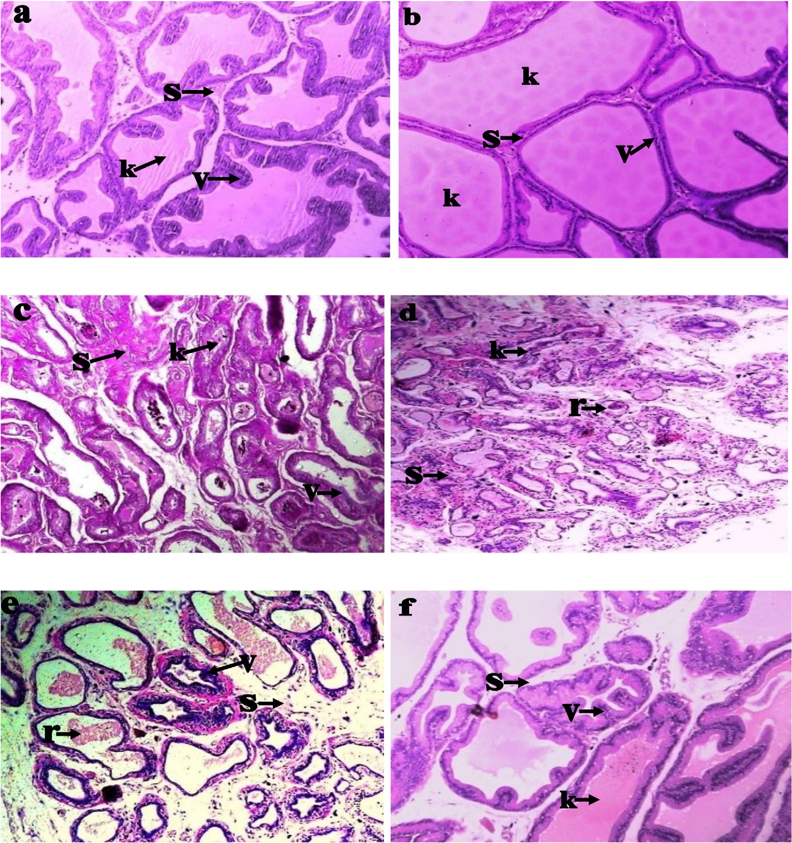

Fig. 5. (a) Photomicrograph of a cross section of normal prostate gland indicating interglandular smooth muscle fibres (s), thick intraglandular epithelia convolution (v) and glandular stroma (k). (H&E stain) Mag. ×400. (b) Photomicrograph of a cross section of prostate gland of negative control indicating a thin strip of interglandular smooth

muscle fibres (s), extensive glandular hyperplasia (k) and thin intraglandular epithelia lining (v). (H&E stain) Mag. ×400. (c) Treatment with low dose of the extract indicating reduced glandular stroma (k), thick intraglandular epithelia (v) and remarkable interglandular smooth muscle fibres (s). (H&E stain) Mag. ×400. (d) Treatment with high dose of the extract indicating corpora amylacea (r), increased density of interglandular smooth muscle fibres (s) and thick intraglandular epithelia (v). (H&E stain) Mag. ×400. (e) Treatment with finasteride indicating corpora amylacea (r), increased density of interglandular smooth muscle fibres (s) and thick intraglandular epithelia (v). (H&E stain)

Mag. ×400. (f) BPH induction with simultaneous treatment with the extract showing normal glandular stroma (k), thick intraglandular epithelia convolution (v) and scanty interglandular smooth muscle fibres (s). (H&E stain) Mag. ×400.

[26–28]. It was observed that the animals with BPH experienced elevated testosterone level while those treated for thirty days with the extract recorded appreciable decrease in the hormonal level. This showed that the extract enhanced the mopping up of free testosterone in the system to prevent its conversion to a more

potent DHT by 5a-reductase found mainly within the stromal cells

[3]. BPH is characterized by increase in oxidative stress that increases with age. To this effect, decreased levels of antioxidants resulting from increase in peroxidative activity have been observed in BPH case [29–31]. The study equally showed that the animals with prostatic hyperplasia exhibited reduced activity in antioxi- dant enzymes CAT, SOD and GSH while the peroxidative activity increased markedly. The BPH induced animals treated with *S. afze- lii/*finasteride recorded marked increase in the levels of these antioxidant enzymes while there was diminished peroxidative

activity. The plant antioxidant status from the phytochemical screening showed *S. afzelii* to be rich in a-tocopherol, a compound with established antioxidant properties [15]. Various herbal agents rich in antioxidant property have shown to be useful agent in ame-

liorating oxidative stress in BPH animal model [17,32]. *S. afzelii* also exhibited good prophylaxis because it inhibited BPH progression in simultaneous induction with the extract treatment.

1. Conclusion

The study showed *S. afzelii* to have effectively ameliorated pro- static hyperplasia exogenously induced by causing extensive shrinkage of glands and stroma. It also exhibited antioxidant prop- erties and showed to be a good prophylaxis. These findings support its therapeutic use by the herbalists in treating BPH.

Acknowledgement

Authors wish to thank Mr Musibau Sikiru who assisted with the plant collection.

References

1. [Seftel AD, Rosen RC, Rosenberg MT, Sadovsky R. Benign prostatic hyperplasia](http://refhub.elsevier.com/S2314-808X(16)30177-4/h0005) [evaluation, treatment and association with sexual dysfunction: practice](http://refhub.elsevier.com/S2314-808X(16)30177-4/h0005) [patterns according to physician specialty. Int J Clin Pract 2008;62:614–22](http://refhub.elsevier.com/S2314-808X(16)30177-4/h0005).
2. [Berry SJ, Coffey DS, Walsh PC, Ewing LL. The development of human benign](http://refhub.elsevier.com/S2314-808X(16)30177-4/h0010) [prostatic hyperplasia with age. J Urol 1984;132:474–9](http://refhub.elsevier.com/S2314-808X(16)30177-4/h0010).
3. Roehrborn CG, Nuckolls JG, Wei JT, Steers W, BPH, Registry and Patient Survey Steering Committee. The benign prostatic hyperplasia registry and patient survey: study design, methods and patient baseline characteristics. BJU Int. 2007;100:813–9. doi: <http://dx.doi.org/10.1111/j.1464-410X.2007.07061>.
4. [Kumar V, Cotran RS, Robbins SL. Basic pathology. 8th ed., vol. 8.](http://refhub.elsevier.com/S2314-808X(16)30177-4/h9000) [Philadelphia: Saunders/Elsevier; 2010. p. 696](http://refhub.elsevier.com/S2314-808X(16)30177-4/h9000).
5. Gravas S, Oelke M. Current status of 5alpha-reductase inhibitors in the management of lower urinary tract symptoms and BPH. World J Urol 2010;28:9–15. doi: <http://dx.doi.org/10.1007/s00345-009-0493-y>.
6. [Black L, Naslund MJ, Gilbert TD, Davis EA, Ollendorf DA. An examination of](http://refhub.elsevier.com/S2314-808X(16)30177-4/h0030) [treatment patterns and costs of care among patients with benign prostatic](http://refhub.elsevier.com/S2314-808X(16)30177-4/h0030) [hyperplasia. Am J Managed Care 2006;12:99–110](http://refhub.elsevier.com/S2314-808X(16)30177-4/h0030).
7. [Roehrborn CG, Rosen RC. Medical therapy options for aging men with benign](http://refhub.elsevier.com/S2314-808X(16)30177-4/h0035) [prostatic hyperplasia: focus on alfuzosin 10 mg once daily. Clin Interv Aging](http://refhub.elsevier.com/S2314-808X(16)30177-4/h0035) [2008;3:511–24](http://refhub.elsevier.com/S2314-808X(16)30177-4/h0035).
8. [Uygur MC, Gur E, Arik AI, Altug U, Erol D. Erectile dysfunction following](http://refhub.elsevier.com/S2314-808X(16)30177-4/h0040) [treatments of benign prostatic hyperplasia: a prospective study. Andrologia](http://refhub.elsevier.com/S2314-808X(16)30177-4/h0040) [1998;30:5–10](http://refhub.elsevier.com/S2314-808X(16)30177-4/h0040).
9. Hassani J, Guay AT, Zitzmann M, Hansen ML. Adverse side effects of 5a-

reductase inhibitors therapy: persistent diminished libido and erectile dysfunction and depression in a subset of patients. J Sex Med 2011;8:872–84. doi: <http://dx.doi.org/10.1111/j.1743-6109.2010.02157>.

1. [American urological association – AUA. Practice Guidelines Committee.AUA](http://refhub.elsevier.com/S2314-808X(16)30177-4/h0050) [guideline on management of benign prostatic hyperplasia. Chapter 1:](http://refhub.elsevier.com/S2314-808X(16)30177-4/h0050) [diagnosis and treatment recommendations. J Urol 2003;170(Suppl. 9):530–47](http://refhub.elsevier.com/S2314-808X(16)30177-4/h0050).
2. Zegarra L, Vaisberg A, Loza C, Aguirre RL, Campos RL, Fernandez I, et al. Double- blind randomized placebo-controlled study of *Bixa orellana* in patients with lower urinary tract symptoms associated to benign prostatic hyperplasia. Int Braz J Urol 2007;33:493–501. doi: [http://dx.doi.org/10.1590/S1677-](http://dx.doi.org/10.1590/S1677-55382007000400006) [55382007000400006](http://dx.doi.org/10.1590/S1677-55382007000400006).
3. [Goyder DJ. *Secamone afzelii* (Asclepiadaceaesubfam. Secamonoideae) in Africa.](http://refhub.elsevier.com/S2314-808X(16)30177-4/h0060) [Kew Bull 1992;47:437–74](http://refhub.elsevier.com/S2314-808X(16)30177-4/h0060).
4. [Odugbemi T. Outlines and pictures of medicinal plants in Nigeria. 6th](http://refhub.elsevier.com/S2314-808X(16)30177-4/h0065) [ed. University of Lagos Press; 2006. p. 43–4](http://refhub.elsevier.com/S2314-808X(16)30177-4/h0065).
5. [Kayode J. Ethnomedicinal survey of botanicals used in treating sexually](http://refhub.elsevier.com/S2314-808X(16)30177-4/h0070) [transmitted diseases in Ekiti State, Nigeria. Ethnobot Leaflets 2008;12:44–55](http://refhub.elsevier.com/S2314-808X(16)30177-4/h0070).
6. [Mensah AY, Houghton PJ, Akyirem GN, Fleischer TC, Mensah ML, Sarpong K,](http://refhub.elsevier.com/S2314-808X(16)30177-4/h0075) [et al. Evaluation of the antioxidant and free radical scavenging properties of](http://refhub.elsevier.com/S2314-808X(16)30177-4/h0075) [*Secamone afzelii* (Schum.). Phytother Res 2004;18:1031–2](http://refhub.elsevier.com/S2314-808X(16)30177-4/h0075).
7. Institute of Laboratory Animal Research (ILAR). Commission on life science. Washington: National Academy Press; 1996. Available from: [http://](http://www.nap.edu/%20catalog/5140.html) [www.nap.edu/ catalog/5140.html](http://www.nap.edu/%20catalog/5140.html).
8. [Mbaka GO, Ogbonnia SO, Olarewaju OT, Duru FI. The effects of ethanol seed](http://refhub.elsevier.com/S2314-808X(16)30177-4/h0085) [extract of *Raphia hookeri* (Palmaceae) on exogenous testosterone and estradiol](http://refhub.elsevier.com/S2314-808X(16)30177-4/h0085) [induced benign prostatic hyperplasia in adult male rats. J Morphol Sci](http://refhub.elsevier.com/S2314-808X(16)30177-4/h0085) [2013;30:235–43](http://refhub.elsevier.com/S2314-808X(16)30177-4/h0085).
9. Marcus GJ, Dumford. A simple enzyme-linked immunosorbent assay for testosterone. Steroids 1985;46:975–86. doi: [http://dx.doi.org/10.1016/S0039-](http://dx.doi.org/10.1016/S0039-128X(85)80005-2) [128X(85)80005-2](http://dx.doi.org/10.1016/S0039-128X(85)80005-2).
10. [Ekins RH. Free and bound testosterone. Ann Clin Biochem 1990;27:91–4](http://refhub.elsevier.com/S2314-808X(16)30177-4/h0095).
11. [Kakkar P, Das B, Viswanathan PN. A modified spectrophotometric assay of](http://refhub.elsevier.com/S2314-808X(16)30177-4/h0100) [superoxide dismutase (SOD). Indian J Biochem Biophys 1984;21:130–2](http://refhub.elsevier.com/S2314-808X(16)30177-4/h0100).
12. [Rukkumani R, Aruna K, Varma PS, Rajasekaran KN, Menon VP. Comparative](http://refhub.elsevier.com/S2314-808X(16)30177-4/h0105) [effects of curcumin and analog of curcumin on alcohol and PUFA induced](http://refhub.elsevier.com/S2314-808X(16)30177-4/h0105) [oxidative stress. J Pharm Sci 2004;7:274–83](http://refhub.elsevier.com/S2314-808X(16)30177-4/h0105).
13. [Mbaka GO, Ogbonnia SO, Olubamido TO, Awopetu PI, Ota DA. Evaluation of](http://refhub.elsevier.com/S2314-808X(16)30177-4/h0110) [acute and sub-chronic toxicities of aqueous ethanol root extract of *Raphia*](http://refhub.elsevier.com/S2314-808X(16)30177-4/h0110)[*hookeri* (Palmaceae) on Swiss Albino Rats. Br J Pharmacol Toxicol 2014;5](http://refhub.elsevier.com/S2314-808X(16)30177-4/h0110) [(4):129–35](http://refhub.elsevier.com/S2314-808X(16)30177-4/h0110).
14. [Veeresh Babu SV, Veeresh B, Patill AA, Warke YB. Lauric acid and myristic acid](http://refhub.elsevier.com/S2314-808X(16)30177-4/h0115) [prevent testosterone induced prostatic hyperplasia in rats. Eur J Pharmacol](http://refhub.elsevier.com/S2314-808X(16)30177-4/h0115) [2010;625:262–5](http://refhub.elsevier.com/S2314-808X(16)30177-4/h0115).
15. [McPartland JM, Pruitt PL. Benign prostatic hyperplasia treated with saw](http://refhub.elsevier.com/S2314-808X(16)30177-4/h0120) [palmetto: a literature search and an experimental case study. J Am](http://refhub.elsevier.com/S2314-808X(16)30177-4/h0120) [Osteopathic Assoc 2000;100:89–96](http://refhub.elsevier.com/S2314-808X(16)30177-4/h0120).
16. [Andriole GL, Grubb RL, Buy SS, et al. Mortality results from a randomized](http://refhub.elsevier.com/S2314-808X(16)30177-4/h0125) [prostate-cancer screening trial. New Engl J Med 2009;360:1310](http://refhub.elsevier.com/S2314-808X(16)30177-4/h0125).
17. [Griffiths K, Denis LJ. Exploitable mechanisms for the blockade of androgenic](http://refhub.elsevier.com/S2314-808X(16)30177-4/h0130) [action. Prostate 2000;10(Suppl. 10):43–51](http://refhub.elsevier.com/S2314-808X(16)30177-4/h0130).
18. [Canales BK, Zapzalka DM, Ercole CJ, Carey P, Haus E, Aeppli D, et al. Prevalence](http://refhub.elsevier.com/S2314-808X(16)30177-4/h0135) [and effect of varicoceles in an elderly population. Urol 2005;66:627–31](http://refhub.elsevier.com/S2314-808X(16)30177-4/h0135).
19. Levinger U, Gornish M, Gat Y, Bachar GN. Is varicocele prevalence increasing with age? Andrologia 2007;39:77–80. doi: [http://dx.doi.org/10.1111/j.1439-](http://dx.doi.org/10.1111/j.1439-0272.2007.00766.x) [0272.2007.00766.x](http://dx.doi.org/10.1111/j.1439-0272.2007.00766.x). PMid: 17683466.
20. [Mchedlidze MG, Shioshvili TI. Influence of antioxidants on the development of](http://refhub.elsevier.com/S2314-808X(16)30177-4/h0145) [benign prostatic hyperplasia. Georgian Med News 2006;140:23–7](http://refhub.elsevier.com/S2314-808X(16)30177-4/h0145).
21. Aydin A, Arsova-Sarafinovska Z, Sayal A, Eken A, Erdem O, Erten K, et al. Oxidative stress and antioxidant status in non metastatic prostate cancer and benign prostatic hyperplasia. Clin Biochem 2006;39:176–9. doi: [http://dx.doi.](http://dx.doi.org/10.1016/j) [org/10.1016/j](http://dx.doi.org/10.1016/j). PMid: 16413012.
22. [Aryal M, Pandeya A, Gautam N, Baral N, Lamsal M. Oxidative stress in benign](http://refhub.elsevier.com/S2314-808X(16)30177-4/h0155) [prostatic hyperplasia. Napal Coll J 2007;9:222–4](http://refhub.elsevier.com/S2314-808X(16)30177-4/h0155).
23. [Prasad S, Kalra N, Singh M, Shukla Y. Protective effects of lupeol and mango](http://refhub.elsevier.com/S2314-808X(16)30177-4/h0160) [extract against androgen induced oxidative stress in Swiss albino rats. Asian J](http://refhub.elsevier.com/S2314-808X(16)30177-4/h0160) [Androl 2008;10:313–8](http://refhub.elsevier.com/S2314-808X(16)30177-4/h0160).