[Computers](https://doi.org/10.1016/j.cexr.2023.100011) & [Education: X Reality 2 (2023) 100011](https://doi.org/10.1016/j.cexr.2023.100011)

 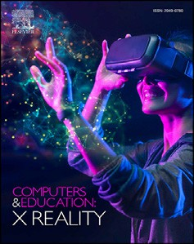

Contents lists available at [ScienceDirect](http://www.sciencedirect.com/science/journal/29496780)

Computers & Education: X Reality

journal homepage: [www.journals.elsevier.com/computers-and-education-x-reality](http://www.journals.elsevier.com/computers-and-education-x-reality)

[](http://crossmark.crossref.org/dialog/?doi=10.1016/j.cexr.2023.100011&domain=pdf)How augmented reality influences student learning and inquiry styles: A study of 1-1 physics remote AR tutoring

Iulian Radu a,*, Xiaomeng Huang a, Greg Kestin b, Bertrand Schneider a,**

a *Graduate School of Education, Harvard University, 6 Appian Way, Cambridge, MA, 02138, USA*

b *Department of Physics, Harvard University, 17 Oxford St, Cambridge, MA, 02138, USA*

A R T I C L E I N F O

*Keywords:* Augmented reality 1-1 tutoring Inquiry Representations

Collaborative learning

A B S T R A C T

While augmented reality (AR) technology is being considered by educators for its potential to help students visualize abstract concepts, currently there are barriers from the high cost of developing complex AR applications. In this study we investigate how the complexity of AR content impacts student learning in remote 1-1 tutoring scenarios, where an instructor uses an AR headset while teaching physics concepts to a remote student. This approach brings the benefits of augmented reality into the already-existing educational practices of 1-1 remote instruction, without requiring AR devices for every student. We present a system for AR-based physics instruction and perform a between-subjects study, measuring how student learning and inquiry behaviors differ between two experimental conditions that vary in the complexity of AR content. Through quantitative and qualitative analysis, our results show that students who are tutored with more complex AR content learn better and show a wider variety of inquiry styles. Furthermore, AR visual representations appear to stimulate students to think about a wide range of scientific ideas, to make deeper connections between scientific concepts, and encourage students to have a more active learning style with increased transitions between inquiry activities. We discuss possible reasons and wider implications for these findings.

1. Introduction and related work

Augmented reality (AR) technology is becoming known to educators due to its potential to visualize complex 3D phenomena and increase student engagement (Arici et al., 2019). As such, there is growing enthusiasm for integrating AR into educational settings (Akçayır & Akçayır, 2017; da Silva et al., 2019). In the present research we explore the effect of augmented reality for the underexplored purpose of 1-1 remote tutoring, while studying the difference in educational impact between low-complexity AR vs a high-complexity AR design. We focus on one-on-one tutoring because this is a common educational activity that occurs in a variety of situations, such as when students attend office hours to ask personalized questions to their instructors, or when students are enrolled in private tutoring outside of a formal class time, and it can occur in person or remotely through online videoconferencing services. Although augmented reality has been shown beneficial for physics edu- cation in situations where students independently interact with AR

content (Bellucci et al., 2018; Ib´an~ez et al., 2014; Radu & Schneider,

2019a), there is a lack of research exploring the impact of AR technology on student learning and inquiry styles specifically in 1-1 remote tutoring settings. Furthermore, there is a lack of research investigating how stu- dent learning is impacted by the design complexity of an AR experience. It is expected that stronger educational impact can be reached by increasing the complexity of an AR application, for example when the application can track real objects and anchor visualizations to moving objects (Bujak et al., 2013; Müller & Dauenhauer, 2016); when the vi- sualizations are dynamic and 3D rather than static and 2D (Ainsworth, 2008; Bujak et al., 2013; Mayer, 2002); or when the number of AR vi- sualizations is higher (Ainsworth, 2006, 2008). However, AR application development is costly, and increasing the complexity of applications is not trivial. One study estimates the cost of developing an AR application is between $50,000-$250,000 (Berman & Pollack, 2021), and the high cost of developing and supporting AR applications can be a barrier to creating and using AR (Alam et al., 2021; Berman & Pollack, 2021; da Silva et al., 2019). Thus, because of the high costs of developing and using AR applications, it is important to study how application design

* Corresponding author.

** Corresponding author.

*E-mail addresses:* [iulian_radu@gse.harvard.edu](mailto:iulian_radu@gse.harvard.edu), [iulian@gatech.edu](mailto:iulian@gatech.edu) (I. Radu), [xiaomenghuang108@163.com](mailto:xiaomenghuang108@163.com) (X. Huang), [kestin@fas.harvard.edu](mailto:kestin@fas.harvard.edu) (G. Kestin), [bertrand_schneider@gse.harvard.edu](mailto:bertrand_schneider@gse.harvard.edu) (B. Schneider).

<https://doi.org/10.1016/j.cexr.2023.100011>

Received 4 November 2022; Received in revised form 13 February 2023; Accepted 14 February 2023

2949-6780/© 2023 The Authors. Published by Elsevier Ltd. This is an open access article under the CC BY license (<http://creativecommons.org/licenses/by/4.0/>).

decisions impact learning outcomes. In the present research, we explore how an increase in complexity along these dimensions impacts student learning and inquiry processes.

We study the context where an instructor is teaching physics concepts while wearing an AR headset to view visualizations overlaid on real objects, and the student is viewing the instructor's perspective remotely through a computer screen (illustrated in the Fig. 1 image, and Appendix A video). Using AR headsets in this scenario is beneficial because the instructor and student can see the same perspective on the learning ac- tivity, and the instructor is free to use their hands to manipulate physical objects. This kind of AR-enhanced 1-1 remote tutoring scenario is an extension of existing 1-1 remote tutoring, and we envision that it will become popular with educators because it can address multiple limita- tions such as: instructors are able to illustrate learning content through carefully curated AR activities; personal AR devices for students are not required since they can view the AR visualizations through the computer screen; and students can still actively influence the investigation of the learning material through requests and discussions with the instructor, without special knowledge of how to actively control AR technology. Additionally, this context is valuable for research not only because it allows understanding of how AR can bring benefits to already existing 1- 1 tutoring situations, but also because of the methodological benefits that such a context affords, specifically in providing a window into the thought processes of students. For example, it is known that AR has the potential to improve learning gains, reduce cognitive load, improve performance time, improve collaboration, etc. (Buchner et al., 2022; Phon et al., 2014; Radu et al., 2021). However, it is unclear the mecha- nisms for how AR visualizations generate these outcomes. It is possible that when a student looks at AR visualizations, this prompts them to think of concepts they have not considered, to understand relationships between multiple concepts, to discover their own misconceptions, or to communicate more clearly, etc. The mechanisms how AR visualizations influence learning processes may be revealed through the 1-1 tutoring interaction between student and instructor. Unlike situations where a student interacts with an AR experience directly without speaking, dur- ing collaborations such as 1-1 tutoring the student questions and verbal

interactions can provide additional information about how the AR vi- sualizations are influencing students. For example, from student dialogue it is possible to detect what students are paying attention to, what topics are at the threshold of their understanding, and what they are thinking about at different stages of the activity (Chin & Brown, 2002; Hadzi- georgiou, 1999; Meyer & Land, 2005). These learning process metrics revealed through 1-1 tutoring interactions can provide a richer under- standing of how different aspects of the AR experience are influencing student learning behaviors, adding to what is already known about the general benefits of AR for influencing outcome metrics.

This AR remote tutoring situation meets the established criteria of augmented reality introduced by Azuma (1997), as this experience combines real and virtual content (e.g. virtual visualizations are overlaid on real-world physical objects), it is interactive (e.g. the instructor can act on the experience directly, and the student can act indirectly through requests to the instructor), and it is registered in 3D (e.g. the visualiza- tions remain anchored to the desk surface). This remote AR experience is a style of mediated interaction similar to other uses of augmented reality such as when an expert guides a remote worker (Bhanu et al., 2022; Obermair et al., 2020) or when a collaborator guides a remote tactical team member (Datcu et al., 2014). In our context, the student can directly see the impact of instructor actions in AR through the computer screen and they interact by asking questions and requesting actions from the instructor, to which the instructor responds by manipulating the AR experience. Thus, the student still has agency and can engage in active learning strategies (Faust & Paulson, 1998) such as testing their thinking, or generating questions and receiving feedback on their inquiries.

Through a novel AR system and a controlled study, we explore the effects of AR technology on student learning gains, and on students’ in- quiry and communication with the instructor. Since this kind of 1-on-1 tutoring involves (1) using augmented reality to teach scientific con- cepts through external representations while (2) supporting active in- quiry and (3) encouraging social interactions, we first review the literature on these subtopics in the sections below, prior to presenting our research questions and study design.

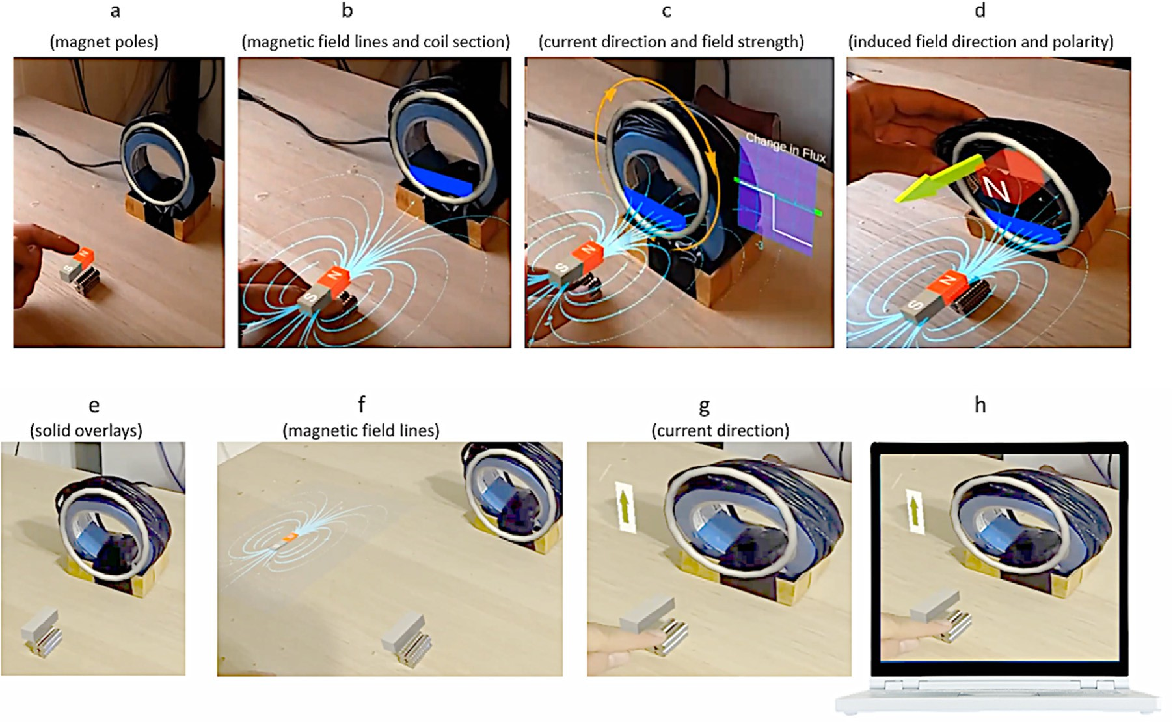

Fig. 1. Visualizations shown from the perspective of the instructor, in the two study conditions. Full-AR condition (top), vs. Basic-AR condition (bottom); and student's view on their computer screen (h). Brackets: Meaning of AR visualizations.

* 1. *Related work*

In the research literature, augmented reality has been shown to improve student learning outcomes in physics education, but research is sparse on studying interactions between students and instructors, and research typically does not compare between a variety of AR designs. For example, AR can improve understanding of energy transfer (Fidan &

Tuncel, 2019), magnetic fields (Abdusselam & Karal, 2020; Cai et al., 2017), electromagnetism concepts (Ib´an~ez et al., 2014; Radu & Schneider, 2019a), and circuits (Beheshti et al., 2017; Bellucci et al., 2018). Typically, such AR education research has studied settings where students learn individually or collaboratively with peers. However, there is a lack of research about AR-enabled 1-1 knowledge exchange between students and instructors, hence the need for the current research.

Furthermore, comparative studies of AR learning typically compare AR experience to a non-AR experience such as paper-based or computer-based learning; but such an approach is unable to control for the effects of novelty on student motivation, and for the different ways that information is represented between AR and non-AR conditions (Chang et al., 2022; Radu & Schneider, 2019a; Sahin & Yilmaz, 2020). For example, when experimental conditions use different media, such as comparing an AR experience to a textbook, they differ on multiple var- iables that can impact educational outcomes: the novelty of the tech- nology (i.e. using cutting-edge technology such as augmented reality devices) can make students more excited and motivated to persevere in the learning activity; the interactive nature of AR visualizations (i.e. students able to make inquiries and receive feedback) can make it easier for students to have agency, experiment and gain feedback than compared to a non-interactive textbook; and the sequence of how con- cepts are presented in the AR activity may differ from how they are presented in the textbook. Such studies where experimental conditions are widely different from each other can reveal the potential of AR technology for improving educational outcomes, but they have difficulty identifying which variables are influencing student learning. In the pre- sent study we minimize the difference between experimental conditions, to better identify how the AR application influences student learning: both conditions use AR technology to control for the effects of novelty; both conditions allow students agency to ask questions and gain feed- back; and both conditions follow a similar instructional sequence to ensure students are exposed to the same concepts in the same progression.

Previous research has presented taxonomies to guide AR application design. These taxonomies identify design dimensions that can be considered and which have the potential to benefit learning outcomes at the cost of increased AR application complexity. For example, the tax- onomy by Müller and Dauenhauer (2016) contains dimensions such as reference system (whether the AR content is anchored to the world or not), and visual connection (whether the AR visualizations are spatially anchored to objects, or loosely connected via other mechanics such as virtual lines to the objects). An AR application where virtual content is spatially anchored to objects can be educationally beneficial because it is easier to understand by users (Bujak et al., 2013), but requires more complex software development in object tracking (Müller & Dauenhauer, 2016). In the taxonomy by Gattullo, Evangelista, Uva, Fiorentino, and Gabbard (2020), the authors discuss the different types of visualizations that can be presented in AR applications, ranging between simpler visuals such as 2D text and 2D symbols and pictures, to more complex ones such as 3D models. Simpler 2D visual representations are easier to create, require less computer vision accuracy, and require fewer hardware re- sources than the more complex 3D visualizations (Gattullo et al., 2020). Other researchers have discussed how learners can be positively impacted by an increase in the number of visualizations in an experience (e.g., Ainsworth (2008)), and by having access to dynamically changing interlinked visualizations (Ainsworth, 2008; Moreno & Mayer, 2007). However, as described above, experimental studies on AR education typically do not study how students are impacted by these specific design

choices. In the present research we extend this existing work, by comparing between an AR application of higher complexity (containing multiple dynamically changing 3D visualizations that are anchored and moving with real objects) compared to a lower complexity version (which only uses a few 2D representations not moving with the real objects), and investigating how these differences in design impact stu- dent learning and inquiry processes.

We are specifically interested in exploring how students learn about complex physics phenomena. Understanding a complex phenomenon requires students to comprehend multiple scientific sub concepts and the relationships between them: Lemke (1990) highlighted that the useful- ness of scientific concepts stem from understanding the connections to each other, and Scott et al. (2011) argued that in order to learn scientific conceptual knowledge, students need to recognize how the scientific concepts themselves fit together in an interlinked system and how they function in relation to each other. Theories of social constructivism and distributed cognition argue that students build such complex under- standing through interactions with other people and artifacts (Vygotsky & Cole, 1978; Hutchins, 2000). Thus, while students learn about physics, they will gain knowledge from interaction with the tutor and through interaction with the instructor and with the information representations in the learning activity. Strømme and Mork (2021), while researching how students construct knowledge while using animated digital repre- sentations, argued that the conceptual link-making process is supported by both collaborative sense-making through interaction with other peo- ple, and through interaction with the animations visible on the computer screen. The specific ways in which information is represented in the learning environment can aid this process: Ainsworth (2006, 2008) argued that visual representations serve to focus the learner on different aspects of the learning content, and the presence of multiple represen- tations can be used to display different scientific concepts of a simulated body (e.g. values for mass, force, friction and velocity), can help students develop relational understanding by reducing the cognitive load, can aid construction of deeper understanding, and can support transfer of knowledge to new situations. In augmented reality systems, multiple interactive representations could allow students to recalibrate their un- derstanding of the complex concepts and construct deeper understanding of the phenomena by seeing the dynamic linking of individual repre- sentations. In our study, we investigate how the AR visual representa- tions influence student understanding of different scientific concepts, and their impact on student inquiry through communication with the instructor.

Student inquiry plays a crucial role in knowledge development and is

a valuable topic of research in augmented-reality collaborative learning environments. From a social-cognitive perspective, conceptual change in scientific thinking emerges from the students' inquiry process and their approach to asking questions (Hawkins & Pea, 1987). Chin and Brown (2002) found that student-generated questions can generate productive discussion and lead to meaningful knowledge construction. Specifically, asking questions allows students to check their understanding of the learning content, fill knowledge gaps, monitor and self-evaluate their learning, and redirect their use of learning strategies (King, 1989; Wong, 1985). Students' inquiries can also reveal their conceptual difficulties (Hadzigeorgiou, 1999; Meyer & Land, 2005), and can drive the students to look for patterns, connect with their prior knowledge and build bridges to new understanding (Chin & Osborne, 2008). In studying student-generated inquiries, it is found that less knowledgeable students ask more basic questions whereas more knowledgeable students ask more high-level questions (Marbach-Ad & Sokolove, 2000; Offerdahl & Montplaisir, 2014). To quantify student inquiry types and to understand how these connect to students’ thinking strategies, Chin and Chia (2004) developed a qualitative coding scheme that classifies different types of questions and inquiries. They found that students move between distinct types of inquiries ranging between basic information gathering, exper- imentation/exploration of the learning domain, and hypothesis gen- eration/reflection. Additionally, when students persevered and

continued to pose questions from multiple perspectives, they were able to channel their efforts to other directions, and to eventually arrive at meaningful insights. The authors also found that students who engaged in many distinct types of inquiry styles showed better learning, and, if the student questions reveal appropriate answers to proceed to the next step of the inquiry, then students are more likely to keep motivated and actively involved in the activity. In the present study we expand on the qualitative model from Chin and Chia (2004) and apply it to investi- gating how AR content influences student inquiry styles.

In the domain of augmented reality for education, research has shown that AR visualizations (also termed AR visual representations) serve to guide student inquiry, and can encourage active collaboration and improve problem solving approaches between peers. For instance, Una- halekhaka et al. (2019), in studying a collaborative AR physics activity, found that collaborators use AR visualizations as effective grounding representations when teaching each other, by easing the process of asking questions and providing explanations. Shared representations in AR can also enhance the balance of contributions and diminish leader- ship dominance, for example when student peers engage in AR-enhanced exploration of electromagnetism (Radu & Schneider, 2019b) or debug- ging robots (Radu et al., 2021). Fidan and Tuncel (2019) found that augmented reality visualizations enhanced the learning of student groups, as well as their attitudes towards problem-based learning activ- ities, compared to traditional learning activities without AR. Wang et al. (2014) studied student actions in a collaborative physics environment, and found AR representations were more supportive for learning and problem solving because they engaged greater active learning through experimentation; in contrast, when learning without AR, students engaged in less experimentation. These results indicate that, at least in the context of student-student collaborations, AR visualizations can be beneficial in engaging students in deeper thinking and more active learning because they encourage experimentation, rapid feedback, and easier communication. It is expected that AR instruction through remote tutoring may yield similar benefits, and that qualitative analysis of stu- dent inquiry can be used to measure the impact of AR visualizations.

* 1. *Research questions*

We expand on this existing literature by investigating how AR in- fluences student learning and inquiry processes in the context of 1-1 remote tutoring with an experienced instructor. We compare the ef- fects of two types of AR designs that vary in complexity, specifically in relation to spatial anchoring (e.g., AR visualizations are anchored on moving objects vs. not), number of visualizations (e.g., two AR visuali- zations vs. many), and complexity of visualizations (e.g., static 2D images vs. dynamic 3D models). We investigate the following research questions:

RQ1: How is student learning affected by increased complexity of AR visualizations?

RQ2. How is student inquiry affected by increased complexity of AR visualizations?

To answer these questions, we have designed an interactive AR sys- tem for physics education, developed a coding scheme to measure stu- dent inquiries and their relationship to AR visualizations, and performed a between-subjects study that measures learning and inquiry through quantitative and qualitative methods. In the next section, we describe the design of the AR application as well as our research metrics. We follow with a presentation of our results from student learning outcomes and analysis of how AR visualizations impact student learning. Following, we present our results regarding student inquiry styles, and analysis of how inquiry styles vary under different AR conditions, as well as analysis of how AR visualizations impact inquiry styles. We conclude with a dis- cussion and reflection on our findings.

1. Materials and methods
   1. *Activity design and experimental conditions*

Through collaboration with physics domain experts who typically teach undergraduate physics courses, we designed and implemented an AR system that instructors can use to teach the electromagnetism con- cepts of Faraday's Law and Lenz's Law. These laws apply in the context of moving a magnet near a coil of wire, and describe the relationship be- tween multiple scientific concepts, such as how the changing magnetic flux due to the moving magnet can induce an electric current and an opposing magnetic force in the coil. Students traditionally learn these concepts through formulas and figures in textbooks, or by observing behavior of physical objects (e.g., by measuring voltage near a coil of wire). Through our AR system, this content can be taught to a student by an instructor who wears a Microsoft Hololens 2 headset, and shows dy- namic 3D AR visualizations overlaid on a physical magnet and coil (Fig. 1).

Faraday's Law and Lenz's Law explain relationships among multiple scientific concepts, and the instructor can choose among a variety of AR visual representations during the instructional sequence to explain these concepts and their relationships. For example, Faraday's Law states that when a magnet is moved near a coil of wire, the change in the magnetic field leads to a current induced in the wire. In turn, this generates an opposing induced magnetic field due to the current in the wire, which is associated with an opposing force repelling the moving magnet. Lenz's Law explains that the direction of the current in the coil is such that the induced magnetic field counteracts the change in the external magnetic field. These concepts can be explained with AR while a student observes a physical magnet and coil, by first showing that the magnet has a north and south pole (Fig. 1a, N/S visualization on the magnet) and the mag- netic field has a shape (Fig. 1b, field lines visualization). When the magnet is moved toward the center of the coil (Fig. 1b/c, blue cross section visualization), there is a circular electric current induced in the coil (Fig. 1c, yellow arrow visualization). Additionally, there is an in- crease in the magnetic field inside the coil due to the magnet's presence (also called the “magnetic flux”) which has a strength (Fig. 1c, simplified graph visualization) and direction same as the magnet (a purple arrow, not shown in Fig. 1). The change in flux is associated with the coil inducing a magnetic field that is opposite to the field from the approaching magnet, and behaving like a magnet by producing an opposing physical force (Fig. 1d, green arrow visualization) similar to a magnet with opposite poles (Fig. 1d, coil poles visualization). While discussing with the student, the instructor can enable, disable, and move such visualizations to answer questions. Furthermore, the visualizations dynamically change with the movement of the magnet, and simulta- neously with each other, to show students how multiple physics concepts are interrelated (for example, the magnetic field lines shown in Fig. 1b. Move with the magnet and cause the graph and arrows in Fig. 1c and 1d to be changing in real time).

In a typical tutoring session, the presentation of the physics laws can be structured in 3 parts, which we follow in this study activity. In the first part, after introducing the physical objects the instructor first asks the student to predict what would happen if the magnet is moved towards the coil, then proceeds to teach and demonstrate the sequence outlined above while instructing the student to interrupt with questions at any time, and finishing with a prompt for any questions the student may have at the end. In the second part, the instructor covers the case when the magnet is moved away from the coil, which results in physical behaviors opposite to the first scenario and is aimed to solidify student knowledge about the concepts. This is done using the same AR visualizations as in the first part, and the same instructional structure (prediction question to the student, followed by instructional material, followed by prompt for further questions). Finally, in the third part, the instructor covers the scenario where the coil is moved towards the magnet while it remains stationary, which is similar to the first scenario except the concept of

induced forces becomes more salient. Similar to the first two parts, the student is asked prediction questions, given instructional material, and prompt for any questions. At the end of the 3 parts, the instructor asks if the student has any other questions that may be useful for their coursework.

Two conditions were used in this study to compare how the complexity of AR content influences student learning and inquiry. In the experimental condition (“Full-AR”), which experienced a high degree of AR complexity, the instructor used the visualizations described above. In the control condition (“Basic-AR”), which experienced a low degree of AR complexity, the instructor used basic visualizations such as a static visualization of magnetic field lines that does not follow the magnet (Fig. 1f), and a simplified up/down arrow matching electricity direction (Fig. 1g). The visualizations for the Basic-AR condition were chosen because they present information that could have been accessed during traditional instruction, for example through a paper drawing showing a magnet's field and a voltmeter for seeing current direction. The difference between the two conditions lies in the complexity of the AR content, where the Full-AR condition is higher complexity (containing multiple dynamically changing 3D visualizations that are anchored and moving with real objects) and the Basic-AR condition is lower complexity (which only uses a few 2D representations not moving with the real objects). Both conditions were designed to contain some degree of AR visualiza- tions and be viewed from the same instructor perspective (as opposed to a non-AR control condition on a textbook or 2D computer simulation), in order to control for differences in student excitement due to exposure to novel AR technology, and to maintain a similarity of seeing the in- structor's physical environment. Furthermore, both conditions followed the 3-part instructional sequence outlined above and were similar in terms of the instructional material taught to students, with the only difference in the script being when the instructor referred to specific AR visualizations. Students were provided with equal opportunities for engagement in both conditions, whereby in both cases the students were told at the beginning that they could interrupt and ask questions at any time and, when the instructor reached the end of the 3 instructional sections, they explicitly asked students if they have any questions.

* 1. *Participants and procedure*

Participants were recruited from introductory physics classes at a university in the United States and were required to be adults, currently enrolled in an introductory physics course covering the topics of Fara- day's Law and Lenz's Law, and to have attended at least one class lecture introducing these laws. Participation in the study did not count for course credit, was voluntary, and occurred outside of the course periods. All participants voluntarily consented to participate in the study, which was approved by the university's institutional ethics review board. A total of 44 students participated in the study and were randomly assigned to the two conditions (N ¼ 22 in each condition). For the full sample, partici- pant age was average 23.5 (SD ¼ 4.4; min ¼ 19; max ¼ 35) years, with genders: 28 female, 13 male, 2 nonbinary, and 1 did not disclose. For the Full-AR group, average age was 23.4 (SD ¼ 4.5; min ¼ 19; max ¼ 35) years, with genders: 15 female, 6 male, 1 nonbinary. For the Basic-AR group, average age was 23.6 (SD ¼ 4.4; min ¼ 19; max ¼ 33) years, with genders: 13 female, 7 male, 1 nonbinary, 1 did not disclose.

During the experiment, participants talked with the research instructor through Zoom video-conferencing, for a total duration of approximately 75 min. The experimental procedure consisted of a 15- min pre-test (administered through an online Google form), the 3-part instructional activity (described above) which lasted 35-min, a 15-min post-test, followed by an informal unstructured interview (in which the participant was asked to reflect on their experience) for the remainder of the time. For the instructional activity portion, the instructor wore the Microsoft Hololens AR headset and shared its view on the shared Zoom screen (Fig. 1), so that students could see the same view as the instructor. One researcher served as the instructor in all sessions, to ensure

similarities in personality and instructional style.

* 1. *Metrics*

We measured participants’ learning gains, inquiry styles, and refer- ences to AR visualizations and scientific concepts, which were collected and analyzed as follows:

* + 1. *Learning gains*

Learning was measured through pre- and post-tests containing ques- tions about physics. The test was created in collaboration with two physics domain experts who typically teach and assess students on the same content. The test questions (illustrated in Fig. 2) presented situa- tions relating to Faraday's Law and Lenz's Law, typically involving re- lationships between magnet movement, electric current, and physical forces. The test also contained transfer questions, measuring students' ability to transfer knowledge to situations beyond what was covered in the activity. The learning metrics were calculated using relative learning gains, which is a measure of the relative improvement that occurs be- tween pre-post test scores, accounting for the fact that it is difficult to score all the test points and a participant's score will not increase as much when they already know much of the content before the study. Relative learning gains are calculated as the ratio between actual improvement and the total amount of possible improvement: (post score – pre score)/ (max achievable score – pre score). Based on the learning test, relative learning gains metrics were collected for student overall learning score, ability to transfer, and conceptual understanding of induced magnetic field, coil current, and physical forces. Statistical differences between conditions were analyzed using T-tests when parametric assumptions were met, or non-parametric Wilcoxon–Mann–Whitney tests when parametric assumptions were not met.

* + 1. *Inquiry styles*

We performed qualitative analysis of participant videos, to under- stand how participants communicated with the instructor while engaging in inquiry-based learning. A coding scheme was constructed through iterative bottom-up coding. The coding scheme design was influenced by the four categories of the question-driven problem-based learning (Q- PBL) framework presented by Chin and Chia (2004). The Q-PBL frame- work was developed to measure student thinking during a time scale of multiple weeks across different mediums (ranging from student journals to in person conversations with peers), and it groups student questions by function: distinguishing between questions aimed at information gath- ering, bridging and integrating knowledge, extending and exploring beyond the current setting, and reflecting/hypothesizing. Based on this

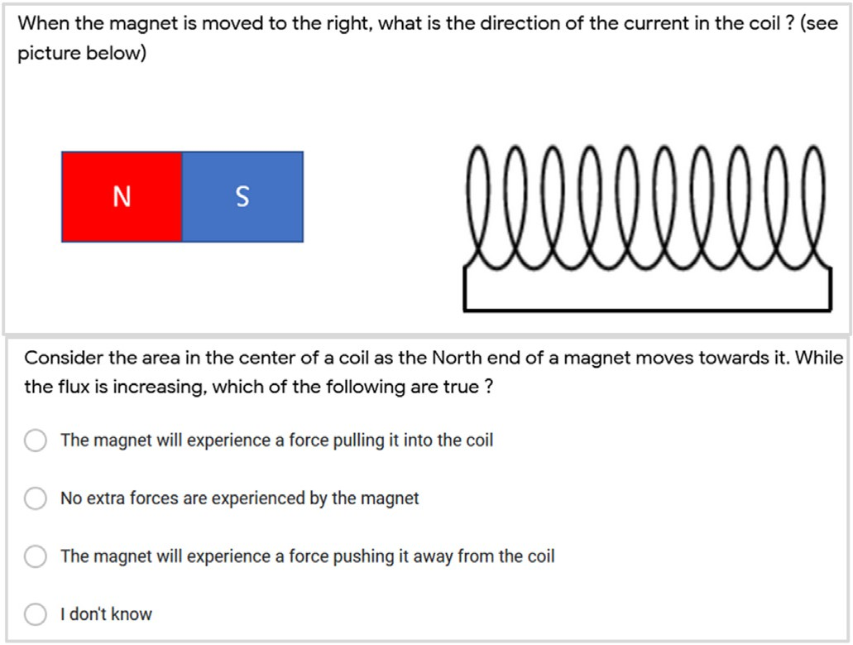

Fig. 2. Example questions from the knowledge test.

model we generated a coding scheme for our more limited context, of tutoring between a student and instructor during a short 35-min session, where student questions are in the form of verbal utterances in response to the instructor's actions or question prompts. Our resulting coding scheme, described below, groups question types into four categories similar to the Q-PBL framework; it also tracks whether a student utter- ance was a request for action or not; and it tracks whether a student utterance referred to a visualization or not.

Inter-rater reliability was assessed by two independent researchers coding 20% of the data where the study condition was blinded, and reached Cohen's kappa of 0.86 implying above substantial agreement (Cohen, 1960). Video recordings of all sessions were transcribed and analyzed using this process. During coding, the study conditions associ- ated with each utterance was hidden from the researchers performing the coding, although it was sometimes possible to know the condition (for example, when a student mentioned AR visual representations only available in the Full-AR condition). Every time a participant posed a question or request, the following codes were assigned. Statistical dif- ferences between conditions were analyzed using Mann-Whitney-Wilcoxon test. Furthermore, we used Markov Chains to differentiate the sequences of inquiry behaviors between the study conditions.

Question Type: Whenever a question was asked, it was assigned one of the following five codes. Basic Information questions attempt to fill knowledge about basic concepts (e.g., “*What is the magnetic flux?*”). Integration questions investigate the relationship between two or more concepts (e.g., “*How does the flux influence the induced force?*”). Explo- ration questions expand knowledge beyond the current problem or to novel situations (e.g., “*What happens if the magnet is flipped?*”). Hypoth- esis questions are about forming or testing hypotheses (e.g., “*Does that mean the force is flipped when we flip the magnet?*”). Finally, we used the category Other to capture all other questions not related to the learning content, such as questions about logistics (e.g., “*Will this be on the test?*”), about communication (e.g. “*Can you say that again?*”), or about tech- nology (e.g., “*Can you explain what is that arrow?*” *or* “*How did you make this application?*”).

Action Requests: A binary code was assigned whenever the student explicitly requested the instructor to take an action. For example, “*Can you pick the magnet up off the table, please?*”, or “*Can you pull it again? I'm interested in the purple one.*” or “*Let's see it if you flip the magnet!*”

Visual Reference: A binary code was assigned whenever the student inquiry referred to a visual element of the learning experience. For example, “*Are the green and purple arrows always going to be equal and opposite?*” or “*I see the magnetic field lines, what does that look like for the coil?*”

* + 1. *References to AR visual representations and scientific concepts*

To further understand how AR visual representations are used in the learning process, we performed a secondary qualitative analysis only on the student utterances that involved a visual reference. Whenever a student referred to a visual element, the inquiry was used in this dataset. A visual element may be a reference to the physical magnet or coil (e.g., “*If it's coming out the other end [of the coil] it's still making a north, south magnet, right?*”), or it may be a reference to the AR visual representations present in the application (e.g. “*Sorry, what is this arrow? It went down and*

*then went up, what was that?*”). For this analysis we only analyzed refer- ences to AR visual representations. Table 1 (top) lists the AR visual representations involved in the application that were coded through this process. Each student inquiry may have zero or more AR representations that were referenced. Furthermore, we recorded if the student mentioned scientific concepts - such as induced force, induced current direction, magnetic flux, etc. Table 1 (bottom) lists the scientific concepts coded through this process. The scientific concepts coded here are different from those initially measured in the pre-post learning tests because of the ability to detect them in student utterances. Finally, each student inquiry was associated with one of five possible Question Types as described above. If a student was referring to an AR visual representation or sci- entific concept but did not mention it explicitly (e.g., “*What does -that- mean?*“) then no code was assigned for AR visualization or for the sci- entific concept. Thus, one student inquiry could contain zero or more AR visual representations, zero or more scientific concepts, and one question type. During coding, the study conditions associated with each utterance was hidden from the researcher, although it was possible to know when a student mentioned AR visual representations only available in the Full- AR condition. Since the AR representations and scientific concepts could unambiguously be identified when they are explicitly mentioned, no inter-rater reliability was performed, and one researcher worked independently to code these dimensions. Due to the low number of such references, only a qualitative analysis was performed.

These metrics are used to answer the research questions as follows: In section 3.1 we will answer Research Question 1 “How is student learning affected by increased complexity of AR visualizations?” by using data from the metrics of student learning gains, references to AR visualization representations, and references to scientific concepts. Following in sec- tion 3.2 we will answer Research Question 2 “How is student inquiry affected by increased complexity of AR visualizations?“, with data from the student inquiry styles, references to AR visualization representations and references to scientific concepts.

1. Results

In the following section we first present the results for student learning gains, followed by results about student inquiry styles. In both sections we analyze differences between the two study conditions and provide evidence for how AR visualizations influence the observed results.

* 1. *RQ1. How is student learning affected by increased complexity of AR visualizations?*
     1. *Overall learning gains*

The starting knowledge is believed to be equivalent between the two conditions, since participant pretest scores did not significantly differ between Full-AR (M ¼ 8.18, SD ¼ 3.23) and Basic-AR (M ¼ 9.02, SD ¼ 3.26) conditions (*t*(42) ¼ —0.37, *p* ¼ .71).

Table 2

Group means, standard deviations, and statistical results for learning metrics. T- tests were performed when parametric assumptions were met, and Wilcox- on–Mann–Whitney tests otherwise. Stars ¼ sig (p < .05).

Table 1

Metric Basic-AR Mean (SD)

Full-AR Mean (SD)

Statistical Test

Example codes for AR visual representations, and for scientific concepts present in the activity.

Code Type Example codes

Overall Score 0.15 (0.29) 0.34 (0.19) *t*(42) ¼ 2.55, *p* ¼

.015 *

Transfer 0.11 (0.35) 0.24 (0.25) *t*(42) ¼ 1.42, *p* ¼

.163

AR

Representation

Magnetic N/S poles; Magnetic field lines; Coil cross section; Flux graph; Purple arrow; Green arrow; Yellow arrow

Induced Magnetic Field

0.71 (1.83) 0.66 (1.11) *W* ¼ 142, *p* ¼ .944

Scientific Concept

Magnet poles; Magnetic field lines, shape, or direction; Flux or change in flux; Induced coil current; Induced coil force; Coil induced polarity

Coil Current 0.16 (0.41) 0.20 (0.45) *t*(42) ¼ .291, *p* ¼

.773

Physical Forces 0.03 (0.42) 0.28 (0.27) *W* ¼ 338, *p* ¼ .022 *

Participant relative learning gains scores are shown in Table 2 and Fig. 3. Full-AR participants scored significantly higher than Basic-AR participants on their overall learning score by over a factor of two. Analysis of specific dimensions of the learning test revealed that Full-AR students scored significantly higher on questions about physical forces, and descriptive statistics show that Full-AR students tend to score higher on ability to transfer knowledge to new situations. Understanding of coil current and induced magnetic fields appear similar between groups. When observing how students communicated, we found that Full-AR participants made references to visualizations significantly more often (*W* ¼ 310, *p* ¼ .042), roughly 2x higher (Table 4). This data shows that the increased complexity of AR visualizations is helping students learn better. It is unclear, however, through which mechanisms the AR visualizations are involved in students’ learning.

* + 1. *Influence of AR visualizations on conceptual learning*

To understand how AR visual representations impact learning of specific concepts, we qualitatively analyzed how students mention in-

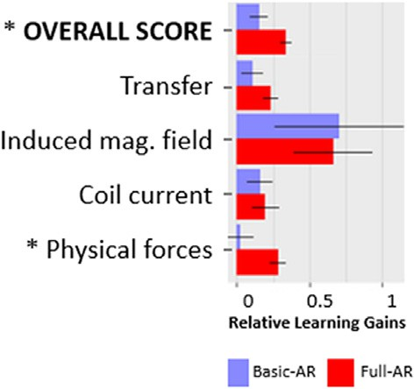

Fig. 3. Relative learning gains in each condition (percentage scale 0–1). N ¼ 44. Bars ¼ std. error. * ¼ sig. p < .05.

Table 4

Group means, standard deviations, and statistical results for student inquiries. Stars ¼ sig (p < .05).

dividual AR visual representations in relation to scientific concepts (presented below), and in relation to student inquiry types (presented in

Question Type Basic-AR Mean (SD)

Full-AR Mean (SD)

Statistical Test

RQ2). There were 32 questions asked by the Full-AR group which included references to visual elements, and 13 questions in the Basic-AR group which included reference to visual elements. In the resulting data, the number of AR visualizations referenced does not match the number of questions asked because (1) sometimes multiple AR visualizations were referenced in one question (for example: “*The magnetic field is going to- wards the south pole right, so it has this direction kind of the green arrow right*

*now?*”), and (2) sometimes students were looking at visual elements

Basic Information 1.36 (2.13) 1.52 (1.25) *W* ¼ 294, *p* ¼ .111

Integration 0.86 (1.21) 0.52 (0.68) *W* ¼ 214, *p* ¼ .642

Exploration 0.96 (0.90) 1.52 (1.25) *W* ¼ 288, *p* ¼ .136

Hypothesis 0.27 (0.55) 0.19 (0.51) *W* ¼ 212, *p* ¼ .518

Other 0.82 (1.01) 0.71 (1.10) *W* ¼ 210, *p* ¼ .571

Visual Reference 0.55 (0.67) 1.38 (1.24) *W* ¼ 310, *p* ¼ .042

*

Action Request 0.09 (0.29) 0.86 (1.35) *W* ¼ 313, *p* ¼ .010

*

while asking a question but no AR element was explicitly mentioned (for example: “*Do you mind to do it again so that I can see it?*”). Although the data is sparse due to the low number of visual-related questions asked by students, this data does hint at some effects of AR visualizations.

Figs. 4 and 5 show how often the Full-AR and Basic-AR participants made explicit references to AR visualizations (Fig. 4) and to scientific concepts (Fig. 5). We find that the AR visual representation of magnetic field lines was referenced a lot in both Full-AR and Basic-AR groups, not surprisingly since it was visible throughout the whole activity in both conditions. The Full-AR group also focused frequently on the visuals of purple arrows (corresponding to flux) and green arrows (corresponding to induced forces). Correspondingly, while counting the concepts that were mentioned in relation to AR visuals, we find that the Full-AR stu- dents talked about a larger number of concepts than the Basic-AR stu- dents, and the Full-AR students especially focused on field shapes, forces and flux. The AR visuals appear to encourage discussion of various concepts and may explain why the Full-AR group records better learning gains on the topic of forces, and overall learning.

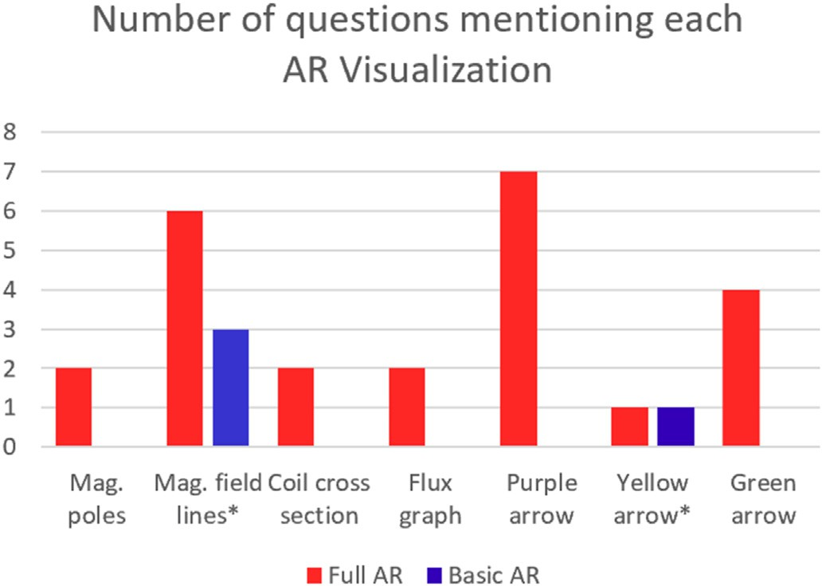To further understand the relationship between AR visualizations and learning, we analyzed their co-occurrence patterns. Fig. 6 shows how many questions are asked where an AR visual representation was

Total Number of Inquiries

4.59 (3.02) 4.48 (2.23) *W* ¼ 240, *p* ¼ .844

mentioned together with a scientific concept. First, we find, unsurpris- ingly, that each AR visual representation seems to focus students on a specific concept, thus making the concept visible for students to think

Fig. 4. Number of references to AR visualizations made in the Full-AR and Basic-AR groups (* ¼ visualizations available to the Basic-AR group).

Table 3

Coding scheme for question types and examples from students.

Question Type Definitions Examples

Basic

Information

Questions that attempt to fill in knowledge about basic concepts. “So, the flux is how much magnetic fields pass through a certain area?"

Integration Questions attempting to bridge connections between two or more concepts.

Exploration Questions to expand knowledge beyond the current problem or apply understanding to a novel situation.

“How does the induced current or the induced magnetic field affect the magnet itself?" “What happens as the magnet actually goes through the loop?"

Hypothesis Questions about forming and/or testing hypotheses. “Would it be true that the same distance between the magnet and the coil would be

maintained if the table is frictionless?”

Other Questions not related to the learning content, such as logistics, instructor background, AR technology.

“Can I ask you questions about how this demonstration was made?"

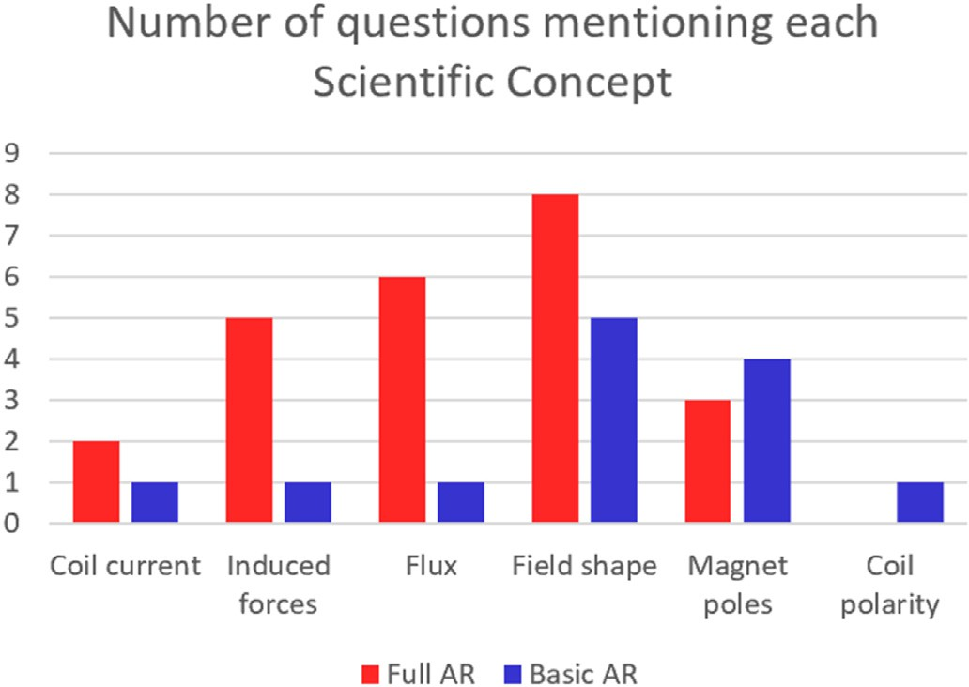

Fig. 5. Number of references to scientific concepts made in Full-AR and Basic- AR groups.

about. For example, the AR visual representation of magnetic field lines is most often used to discuss the concept of magnetic field shapes, and the AR green arrow is most often discussed in relation to induced force. Additionally, we find that when students talk about a single visual rep- resentation, they sometimes mention other different concepts. For instance, the AR visual representation of magnetic field lines is also discussed in relation to induced forces, flux, and polarity; the AR green arrow is also mentioned when asking about induced current, flux, mag- netic field shape or polarity; etc. In the following quote a student was looking at the field line visualization (marked here with “[V]”) while thinking of different concepts (marked here with “[C]”): “*I have a ques- tion, is it like the number of field lines [V], like does the direction of the field lines [C] impact flux [C] or..?".* In the following example, the student is referring to the magnetic field line visualization and mentioning the concepts of flux and cross section of the coil. “*Then the flux [C] is the quantification of how those magnetic field lines [V] are like disturbing a particular area [C]?*” Comparing Full-AR and Basic-AR groups (Fig. 6), we see that the different AR visualizations seem to be helping Full-AR stu- dents to talk about multiple different concepts.

This possibility of AR visualizations facilitating the integration be- tween multiple scientific concepts is further supported by the analysis of

how multiple scientific concepts are mentioned together (Fig. 7). For example, the concept of the shape of the magnet's field is mentioned in relation to multiple concepts such as the magnet's poles, flux, and induced forces. In the following quote, while observing the arrow visu- alizations, the student is thinking about the relationship between mag- netic field and flux, and whether they are related through a constant ratio: “*Are those arrows [V], I guess like they're going to be proportional, so the induced magnetic field [C] is going to be proportional to like how fast the flux [C] is changing right, but like how strong is the induced magnetic field [C] is there, like some reach like saying like is there some constant that relates?*”. The co-occurrence of multiple concepts happens more strongly in the Full-AR group indicating that students in that condition think about multiple concepts together. For example, in the following quote, the student is observing both the AR arrows, and thinking about their rela- tionship: “*Is that* … *is the green [V] and purple arrow [V] and they always going to be equal and opposite?*“. In contrast in the Basic-AR group, the AR magnetic field lines visualization is never mentioned together with the AR visualization of coil current, indicating that students might not be using those visualizations to build relationships between the concepts.

It is possible that each AR visual representation may function as an entry point to thinking about different scientific concepts, and the dy- namic linking between multiple representations may help the Full-AR students think about a wider diversity of concepts and how they are interrelated. In contrast, the Basic-AR group only has access to only two AR visual representations which are not dynamically linked (the field lines are stationary on the table, while the yellow current arrow changes with the magnet's movement), and this likely serves to limit students to think about a more reduced set of scientific concepts, and does not facilitate understanding of how the concepts are related. This mechanism may explain why students in the AR group gain a higher learning score overall.

* 1. *RQ2. How is student inquiry affected by increased complexity of AR visualizations?*

We examined how the complexity of AR visualizations impacted student inquiries, by comparing the types of inquiries made by partici- pants in both study conditions. We first report the difference in inquiries made between the experimental conditions, then discuss the differences in inquiry patterns, and conclude by analyzing how AR visualizations relate to the student inquiries.

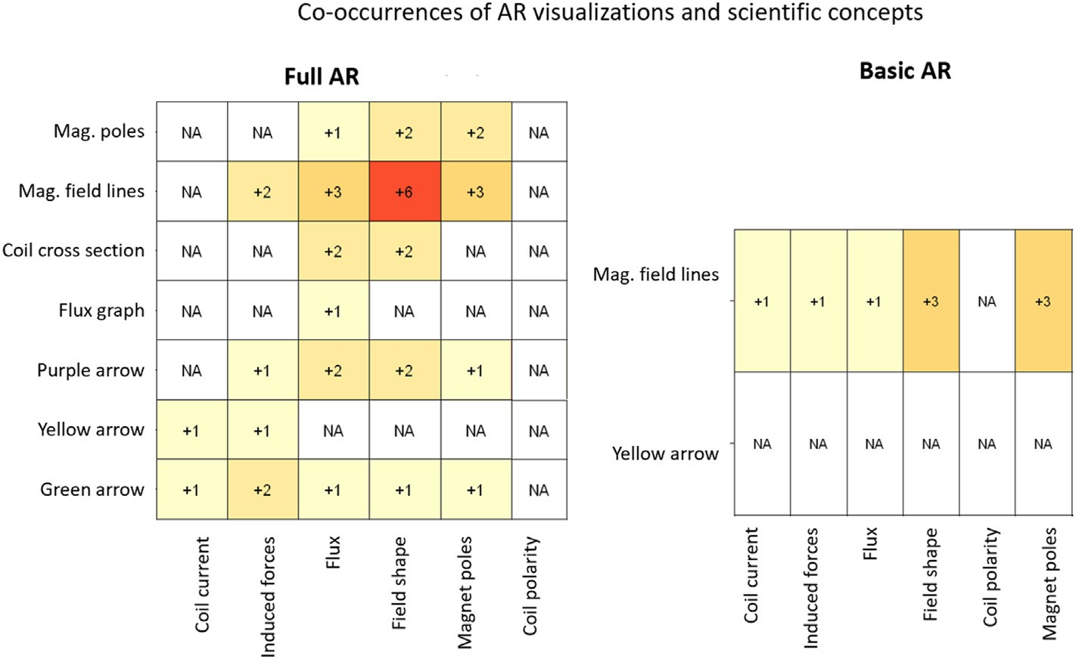

Fig. 6. Number of visual questions that mention each AR visualization and scientific concept (rows ¼ AR visualizations; columns ¼ scientific concepts).

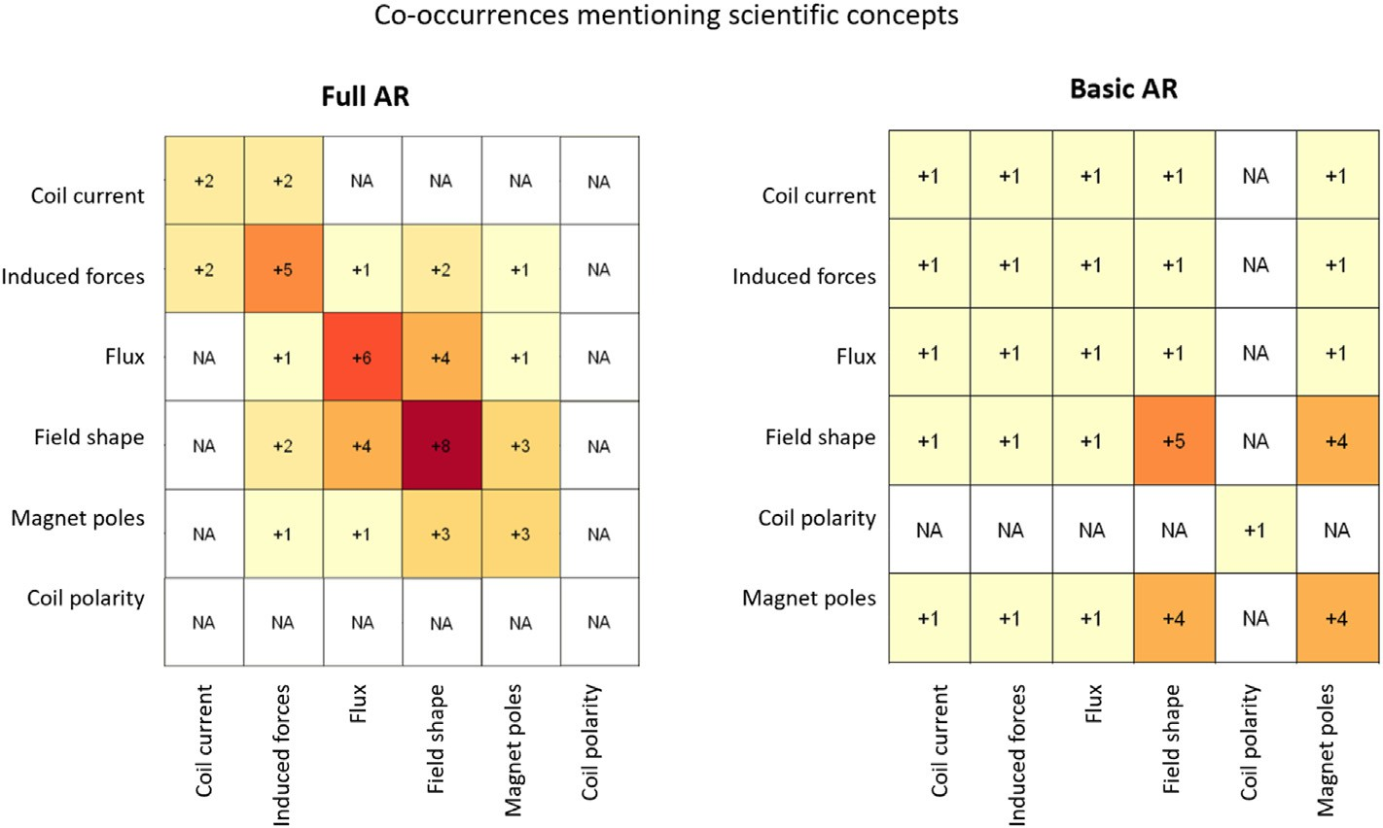

Fig. 7. Number of visual questions where concepts are mentioned at the same time (rows ¼ scientific concepts; columns ¼ scientific concepts).

* + 1. *Types of inquiries*

Participants generated 199 utterances in the form of questions and action requests (101 in Basic-AR and 98 in Full-AR). Table 3 shows the types of questions and examples, while the distribution of different questions asked by participants are shown in Fig. 8 and descriptive sta- tistics in Table 4. The total number of questions asked by each participant varied widely (ranging between 0 and 12 questions), and the average number of questions was roughly 5 questions per session by participants in both conditions. We note that this number is relatively low and, although participants were told they could interrupt and ask questions at any time, this number is likely due to the limited number of explicit question prompts and the length of the activity. Although this limits the ability to detect statistical differences between the conditions, we qualitatively analyze the data because it allows us to understand

patterns in student thinking when exposed to AR visualizations and provides possible avenues for investigation in future research.

When observing the types of questions asked by students, no signif- icant effects were detected statistically between any of the question types (Table 4), but Full-AR participants made significantly more action requests (roughly 10x higher) and, as reported in the previous section, Full-AR participants made references to visualizations significantly more often (roughly 2x higher).

We report the differences in descriptive statistics between question types since they are the proxy for understanding student thought pro- cesses. The Basic Information questions, which involve checking basic knowledge, were asked with less frequency but by more than twice as many Full-AR participants than compared to Basic-AR participants. Integration questions involve connections between multiple physics

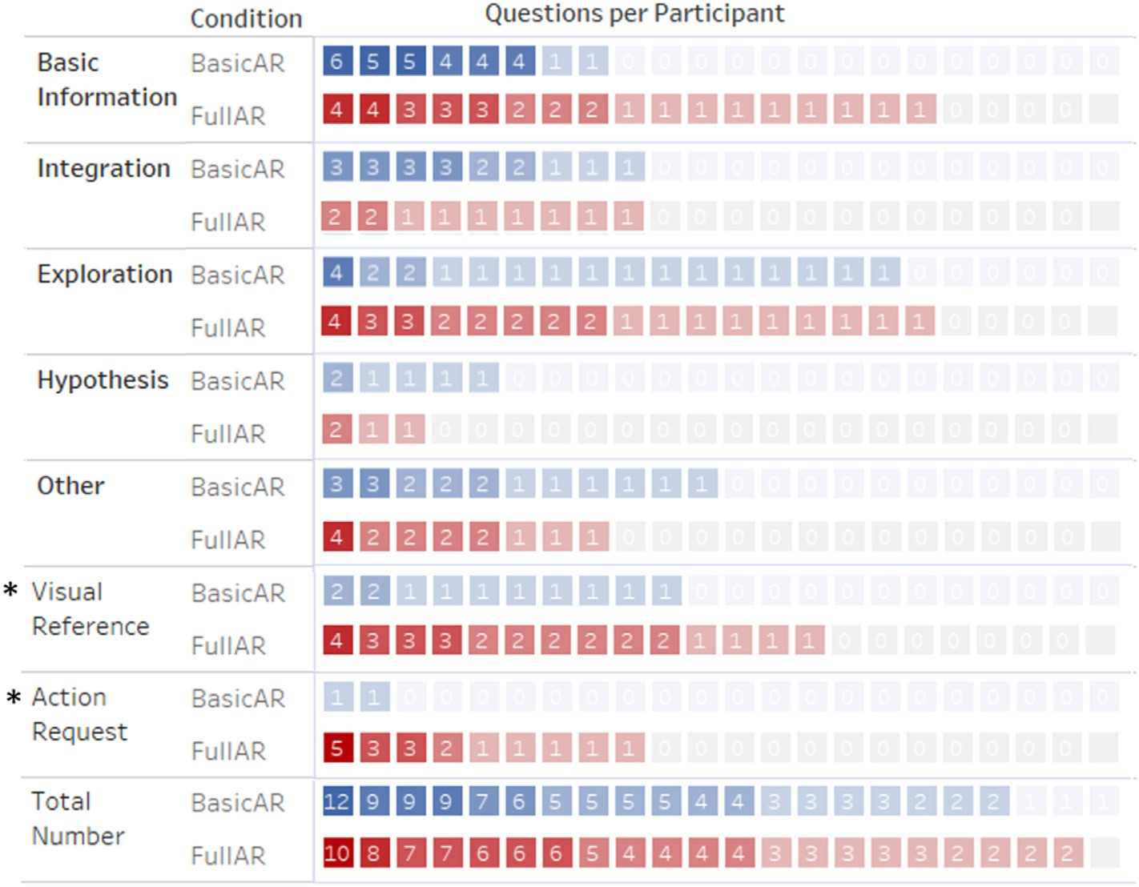

Fig. 8. Number of inquiries made by participants in each condition (each box represents one participant, sorted within each category), and group average. * ¼ sig. p

< .05.

concepts. Full-AR participants who asked these questions, asked 40% less integration questions than Basic-AR participants. In terms of Exploration beyond the problem, Full-AR participants on average asked almost one and a half times the number of exploration questions than Basic-AR participants. In terms of forming research Hypotheses to understand why a phenomenon happens, the number of questions is low, and Basic- AR participants used hypotheses more than Full-AR participants.

Although we do not know the reasons for these differences in con- ditions, the results may be explained by the possibility that, if students experienced misconceptions and desired to ask Basic Information ques- tions, in the Full-AR condition they could use the visualizations to detect misconceptions and check their understanding more quickly. On the other hand, Basic-AR participants either did not detect their mis- understandings or if they did, they needed more inquiries to clarify their misunderstandings. It is further plausible that the difference in Integra- tion questions may be explained because Full-AR participants could more readily observe the interplay between two or more visualizations, thus gaining integrative understanding from the visualizations themselves; as opposed to the Basic-AR participants which had to gain this information from the instructor's verbal explanations. The higher amount of Explo- ration questions may be explained by the possibility that Full-AR visu- alizations sparked participants' curiosity about physics and encouraged participants to consolidate their knowledge or explore new situations beyond what had been demonstrated by the instructor. Finally, the dif- ference in Hypothesis questions may be explained if Basic-AR might form hypothesis questions to check understanding, while Full-AR check un- derstanding through exploratory actions with the visualizations. To further understand these types of inquiries, in the following section we perform a sequential analysis of how students transition between inquiry types, followed by an analysis of how AR visualizations influence inquiry patterns.

* + 1. *Sequence of inquiries*

We used Markov chains to calculate and visualize the probabilities of students’ transitions between different question types. Markov chain modeling is a technique for analyzing sequential events to determine differences between student behavior patterns (Li & Yoo, 2006; Paxinou et al., 2021; Schneider & Blikstein, 2015). The resulting Markov models

show what behavioral states students spend most time in, and the probability of transitioning between states. Fig. 9 demonstrates how students transition between the types of questions in the Full-AR condi- tion (Fig. 9 left) and Basic-AR condition (Fig. 9 right). Distinct categories of questions are shown as nodes on the graph. Node sizes represent the number of individual questions asked within each category, and the ar- rows represent the transition probabilities between these types of ques- tions. For readability, we do not show arrows with a probability of 0; arrows are gray when their probability is below 0.25; and arrows a gray when they emanate from states where the number of questions is low, below 10 (only affects the “Hypothesis” questions), or if they emanate from the “Other” state which captures non-learning questions.

We observed different inquiry patterns and knowledge construction processes across the two study groups. The Full-AR group had a higher probability of transitioning to asking distinct types of questions (i.e., dark arrows between nodes), while Basic-AR students tended to keep asking the same type of questions repeatedly (i.e., self-loops). For example, after asking an integration question, in the Full-AR group the chances of continuing to ask integration questions are only 9%; in contrast, for the Basic-AR group, there is a 32% chance to keep asking integration ques- tions. Similarly, the probabilities for Full-AR students to ask repeated basic information questions is 41%, while there are 52% chances for the Basic-AR group to continue asking basic questions. The Full-AR group tends to transition to other types of questions more often, while the Basic- AR has a higher probability of repeating the same types of questions. Additionally, the Full-AR group was more likely to transition to explo- ration questions after asking basic information questions (34% proba- bility of transition in Full-AR, vs. 13% in Basic-AR) and after asking integration questions (36% in Full-AR, vs 21% in Basic-AR). Although the Full-AR group is less likely to remain stuck in one type of question, and is more likely to transition into exploration questions, we also observed a similarity in both groups regarding collection of basic information. We observed back-and-forth question type transitions, whereby students went back to collecting basic information after having asked other questions. For example, in both groups, students have a relatively high chance of asking basic information questions after exploration questions (32% chance of transition in both groups) or after asking integration questions (27% probability in Full-AR, and 21% in Basic-AR). This shows

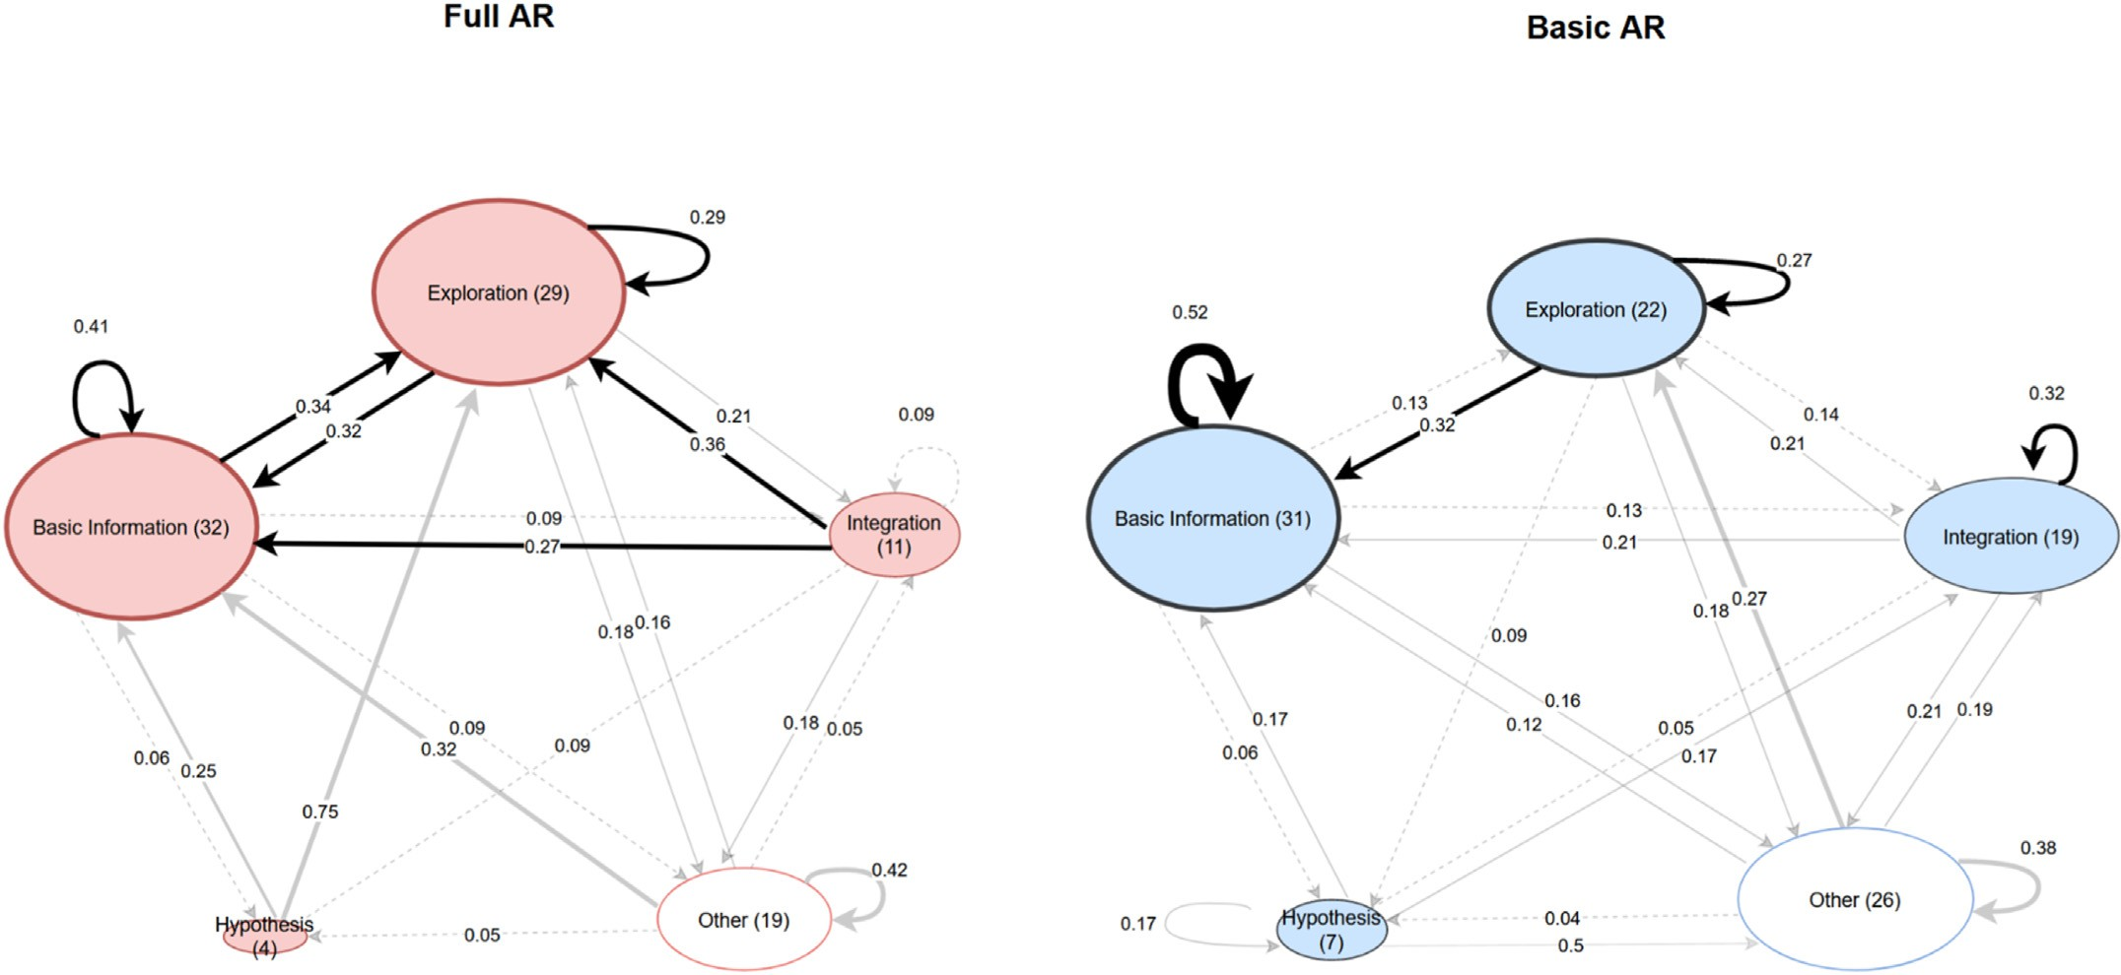

Fig. 9. Markov chains of all students in the Full-AR and Basic-AR groups, showing transitions between different question types (numbers on states ¼ total questions asked; numbers on arrows ¼ transition probabilities).

that inquiry about basic information is a popular and recurring activity in both groups, even though the Full-AR group has more diversity in their inquiry transitions.

To illustrate differences in inquiry transitions, Table 5 shows two excerpts selected from two participants (one Basic-AR, and one Full-AR) at different sections in the instructional activity. In the example tran- script, we use “[V]” to track when there is a mention to an AR

Table 5

Sequence of student inquiries in one Basic-AR student (left) vs. Full-AR student (right).

visualization. In both cases, after having been told of the “right-hand rule” law, the participants start by checking their basic understanding, then proceed with further questions. The Basic-AR participant kept wanting to gain information about basic concepts throughout the entire study, including at the end when they ask a confirmation question about a situation that had already been presented (i.e., confirming what hap- pens when the magnet is stationary while the coil is moved). In contrast, the Full-AR participant asked three different question types, starting with basic information, and switching between exploration and integration. These illustrate how the Full-AR participant changes their inquiries be- tween different types, possibly because the visualizations are stimulating their inquiries and/or providing a deeper understanding of the concepts.

Content Section #

Basic AR (Participant #26) Full AR (Participant #40) Question Type Question Type

In contrast, the Basic-AR participant keeps attempting to fill basic knowledge gaps without entering other inquiry styles.

Inquiry is a dynamic and iterative process (Chin & Chia, 2004), and

* + - 1. [after being presented the right-hand rule of Lenz's Law] “When you show the thumb in the screwdriver rule … the thumb is in the direction of the current, right?" “ … when it moves out, like, when it moves away from the coil, wouldn't field lines [V] still be in that direction, because it's still pointing North to South?"
      2. “When do you use the rule, when the thumb points in the direction of the current and the fingers point in the direction of the magnetic field?"

Basic Information (about right hand rule)

Basic Information (about magnetic field lines)

Basic Information (about right hand rule)

[after being presented the right-hand rule of Lenz's Law] “*What law is that, is that Faraday's or Lenz's?"*

“ … how does all of this change, when the south pole is the one facing the coil?"

“Is that the Green [V] and purple [V] arrow and they are always going to be equal and opposite?"

“ … when we're, like, pulling them away, there was being [an] attractive force, another resistance to change?"

Basic Information (about right hand rule)

Exploration (new orientation)

Integration (relationship between force vs. flux)

Integration (relationship between movement and force)

the nonlinear sequence observed in the data could mean that students seek to fill new knowledge gaps that are generated as they engage with the learning experience. However, the more frequent question transitions between inquiry states in Full-AR might mean that they were thinking from various perspectives about the problem domain. In the Basic-AR group, repeatedly asking one type of question, especially about basic information-gathering questions, might indicate that students had fundamental knowledge gaps to be filled and they had difficulty filling them or expanding beyond them. Additionally, the higher probabilities of asking exploration questions in Full-AR might indicate that students who saw AR visualizations were constructing deeper understanding of the concepts after grasping the basic knowledge. It is possible that a higher amount of AR visuals helped students fill in basic knowledge gaps more easily and encouraged them to apply knowledge and explore new situ- ations. In the next section we use data from student inquiries, to explore how students used AR visualizations in their thinking process.

* + 1. *Influence of AR visualizations on inquiry styles*

In this section we first discuss trends observed during the study ac- tivity involving AR visualizations, then we analyze how student question types were related to AR visualizations, and we conclude with quotes from students reflecting on the role of AR visualizations on their learning and inquiry process.

During the activity we informally noticed differences between Full- AR and Basic-AR in how students made use of visualizations to ask various kinds of questions. When asking Integration questions (Table 6

Table 6

Selected quotes of integration and exploration questions asked under each condition.

3

|  |  |  |  |  |  |  |
| --- | --- | --- | --- | --- | --- | --- |
| [at the end of  the activity, | Basic  Information | “ … when the  magnet is in the | Exploration  (new position) |  | Full-AR Quotes | Basic-AR Quotes |
| after they saw the same situation, in  response to | (about relative movement) | middle of that big coil, what happens?"  “I guess | Exploration | Integration | (Referring to the AR flux graph and magnet movement) “How come it is staying at like a flat line, while you're moving it like | “You are saying that when the magnet's moving, there is going to be a current induced in the coil, and when there is a current |
| being asked if they have any last questions] “So, in, like, the present position, if the coil is moved in, then it will  be the same |  | another way to think about that question is where the little blue rectangle  [V] we're looking at to, like, reference  all the flux, to | (new coil) |  | continue to move it forward like it goes up to a specific height and then it stays there until you stop doing, like plateaus for a while, and before it goes down to zero?" (After talking about moving the coil towards the magnet, in relation to the force) “*I have a*  *question, will that purple [flux]* | that induced in the coil, is it going to change the direction of the magnetic field?"  “Should it, like, increase as you move it further, and then just, like, not change when it stopped?” (talked about change in flux) |
| thing, right? By  keeping the |  | see if  something's |  | Exploration | *arrow still be changing?"*  “Can I see what happens when | “What would happen at the |
| magnet stationary." |  | increasing or decreasing. Where would that reference be when you're  looking at a |  |  | you move the magnet like through the other side?" “Let's flip the magnet !" | point when the magnets are in between the coil?"  “I was curious how the coil and the magnet would attract or repel each other now that the  South end is pointing towards |
|  |  | long coil?" |  |  |  | the coil?" |

top) we observed that students in the Full-AR group tended to refer to the visualizations to ground their questions and to show how they were thinking (for instance, to think about integrating the relationship be- tween magnet's movement in relation to change in flux). In contrast, the Basic-AR students, when asking about the same topic, instead asked questions while offering more verbal explanations. In this sense, the AR visualizations functioned as a grounding mechanism to make commu- nication easier, especially when questions involved dynamic concepts. Additionally, within Exploration inquiries (Table 6 bottom), Full-AR students were more direct in requesting the instructor to take actions. In contrast, the Basic-AR students tended to not ask to see the effects of actions, but instead asked more conceptually oriented questions. This illustrates that the AR visualizations are used as thinking and commu- nication aids.

To further understand the mechanism by which AR visualizations influence student inquiries, we performed a qualitative analysis on the same dataset as used for AR visualizations analysis in research question 1 (32 questions in Full-AR, and 13 questions in Basic-AR) in relation to the types of questions that were asked. For ensuring clarity in the following discussion about scientific concepts and AR visualizations, we only focus on concepts and AR visualizations that were mentioned two or more times by students (i.e., we do not discuss scientific concepts that were mentioned only once). When students in the Full-AR group asked Basic Information questions while mentioning visuals, 5 concepts occurred multiple times (field shape, flux, induced forces, coil current, and magnet poles), and when they asked Exploration questions, 1 concept occurred multiple times (field shape). In contrast, students in the Basic-AR group asked Basic Information about visuals involving 1 concept multiple times (field shape), and Exploration questions about 2 concepts multiple times (field shape and magnet poles). Other question types (Integration and Hypothesis) did not occur associated with a specific concept in more than one occurrence. It is likely that the AR visualizations are encouraging students to think about concepts and build up their basic understanding by reference to the visuals. In the following quote a student is using the visualization (marked with “[V]”) of magnetic field lines crossing into an area, to develop their understanding about the concept (marked with “[C]”) of flux: “*Then the flux [C] is the quantification of how those magnetic field lines [V] are like disturbing a particular area?*“. This way, the AR visualization is being used for developing knowledge about the flux concept. In an exploratory example, we see a student observing visuali- zation of the magnetic field lines, while wondering how this is impacted by a new situation where the magnet is flipped and moving in/out of the coil: “*So the part where the South end [C] is going inside of the coil, it seems like but looking at the directions on the magnet like the field lines [V] come out of the North and into the south, does that impact like the induced magnetic field of the coil [C], when you're like bringing this out and into the coil?*”*.* This shows how AR visualizations can stimulate students to think about new situations. Finally, in the following quote we see a student thinking about the relationship between two concepts of magnetic field and its direction, and north/south polarity, in relation to the AR visual of green arrow: “*The magnetic field [C] is going towards the south pole [C] right, so it has this direction [C] kind of the green arrow [V] right now?*”*.* This suggests that the AR visualizations may have encouraged students to think of integration between multiple concepts. It is worth noting that the Exploration questions in this dataset were associated with few concepts: Full-AR (1 concept) and Basic-AR (2 concepts), even though Full-AR students asked much more exploration questions than Basic-AR overall. The low numbers may be because when students asked about Exploration, they did not tend to refer to the visualizations explicitly - for example, making requests such as “*I'm just curious what would happen if you flip the magnet?*” and “*If we move the magnet to the left and the right, the flux stays the same?"*. Finally, we present several quotes from post-study participant re- flections about the value of the AR visualizations. In these statements, participants mention how AR was useful to clarify and check under- standing, to encourage asking questions, and to integrate between mul- tiple concepts. Participants mentioned that AR made it easier to

understand and to check misunderstandings, with one participant saying “*I had a completely different understanding of flux until I saw the graph side by side. I could see as we move this how it changed the graph, like, at the same time, as opposed to saying, like, a static picture of the graph and what the movement was.*” and another saying “*It was good pedagogy even without the augmented reality. But the augmented reality also made it easier and more concise to summarize concepts which otherwise in class took multiple diagrams and imagination to combine into a correct understanding of a concept in my mind. This was a force multiplier that prevented the need for that mental taxation to pull all those parts together. It's kind of like being able to see into someone else's mind as they see it, which is what learning from a class is ideally about. I think this is a great advance in that technology*”. Other participants stated the AR made it easier to ask questions or form hypotheses. One participant said: “*Interactive! That was a huge component for me. Being able to ask questions and see them immediately answered visually*”*,* and another: “*The experimental portion was helpful; if I wanted to see what would happen, if I tried something else, I could just ask to see that happen*”*,* and another: “*I feel like, throughout the.. throughout the activity, I would, like, kind of like, form, like, mini hypotheses kind of in terms of how to expect things to hear, and seeing it kind of, like, acted out was really helpful just to confirm that, more to see whether, like, I should adjust on any of my ideas "*. Finally, participants commented about how AR was valuable to integrate relationships be- tween multiple concepts, with one participant saying: “*It contributed visually, made me make connections between ideas that I did not have visual connections for*” and another: “*I really liked also because then it shows, like, also the magnetic field currently with the magnet and also the one that's being created [in the coil], so I think those two things really cleared it up*”, and another: “*It was a lot more helpful to have, you know, the arrows that were showing the induced magnetic field and the one that was being introduced by the magnet and the induced current with the wire, so that was actually very helpful to kind of keep things straight*”.

This data suggests that AR visuals may be useful for students to gain basic knowledge that fills their knowledge gaps about various concepts and may stimulate students to inquire about different concepts while exploring the learning domain. The presence of AR visuals may make students think of different concepts, and the dynamic nature of AR vi- sualizations may illustrate those concepts in changing situations, thus potentially helping students to develop deeper understanding and encouraging students to think about multiple concepts under various situations. Additionally, the presence of multiple AR visualizations may help to connect multiple concepts together, possibly explaining the lower number of Integration questions asked by the Full-AR group overall.

1. Discussion

In this study we observed that access to more complex AR content during 1-1 tutoring led to improvement in student learning and to changes in the student inquiry process. The condition with more complex AR content improved learning, increased students' interest in taking ac- tions with the learning activity, increased students’ likelihood of asking diverse types of inquiry questions, and stimulated students to think about a variety of scientific concepts. In contrast, the students who saw less complex AR content learned less, appeared more stuck in repeating in- quiries, and did not seem to use the visuals to make connections between multiple scientific concepts. The more complex AR content also appeared to permit students to observe the effects of actions more easily and encouraged more requests for further action. Additionally, with more complex AR visualizations, students asked more questions to gather basic information about multiple concepts, asked more exploration questions, and asked fewer questions to integrate knowledge. Based on these exploratory study results, there are several themes that can be applicable to using augmented reality for enhancing learning and 1-1 tutoring:

Multiple points of entry into the learning domain: Our results suggest that the presence of AR visualizations may make some scientific concepts more easily visible to students. For example, representing the concept of forces through AR arrows that change size and direction, may

help students to remember that concept and to understand more deeply than if it was just mentioned verbally. Students may use AR visualizations to check misunderstandings or ask questions to fill basic knowledge gaps. Consequently, students who see more visualizations representing different concepts are likely stimulated to think about multiple types of concepts, thus having multiple points of entry for thinking about the learning domain. Additionally, the dynamic nature of AR visual repre- sentations may help to illustrate how different scientific concepts behave under different conditions, in response to student inquiries. Through this process of using AR visualizations in the thinking process, AR technology may create a distributed cognition system (Abrahamson, 2009; Hutchins, 2000), where the AR visualizations are doing part of the cognitive work for the students. As students become able to see invisible concepts through the AR visualizations, this may free up students’ need to un- derstand the content from purely verbal explanations, or to perform mental simulations. This reduction in cognitive effort could explain why students are more interested in exploring other possibilities, as observed through increased action requests when they had more access to AR vi- sualizations. Future research can explore how AR visualizations serve to offload conceptual information, and how student cognitive load can be mediated by AR visual representations. Furthermore, future research can investigate why students show greater willingness to explore when observing AR visualizations, and what impact this may have on student agency and self-efficacy.

Interlinking of scientific concepts and deeper processing: Ac-

cording to Ainsworth (2006), different forms of representation, such as various visualizations that provide multiple representations with different properties, can support students’ learning by highlighting different aspects and relationships between the phenomena under study. In our study, the dynamic and linked nature of AR visualizations likely facilitated richer understanding of the relationships between scientific concepts, and likely encouraged active engagement to explore those re- lationships. Seeing how certain invisible properties change dynamically together (e.g., moving the magnet while observing changing forces and changing flux) is likely to provide students with knowledge about how concepts are integrated together, thus reducing the need to mentally think about how concepts are integrated together. These AR visualiza- tions seemed to encourage students to understand phenomena from multiple perspectives by asking different types of inquiry questions; this is in contrast to students in the condition lacking complex AR content, who appeared to be stuck asking similar types of inquiry questions, and not exploring the learning domain through more complex inquiry. This result is similar as observed by Chin and Chia (2004) who studied student inquiry styles with non-AR activities, and who found that when students persevered and continued to pose questions from multiple perspectives, they were able to arrive at a deeper understanding of the learning con- tent. Future work can investigate what kinds of AR visuals are most and least effective - for example, it is likely that multiple AR visuals that help to dynamically link multiple scientific concepts together would be more effective than AR visualizations that are isolated and only represent specific concepts. Furthermore, future work can investigate how the mode of representations (as physical objects, as virtual 2D simulations on a computer screen, or as 3D content in AR) mediates the learning of different types of content. This will help to specifically understand the role and benefits of augmented reality as a representational medium, compared to other mediums such as 2D computer displays or immersive 3D virtual reality displays, which have their own benefits and detriments. Communication and active engagement: Students appeared to use the AR visualizations as thinking and communication aids. The AR vi- sualizations likely provided common ground and seemed to be often used as anchors to ground the questions to the instructor. This strategy may make it easier for students to ask questions about concepts they do not understand, or to make it easier to check misconceptions while following an instructor's dialogue. This finding is related to previous research on AR for collaborative problem-solving activities between peers, which found that students use AR visualizations to more easily communicate

and make contributions to problem solving activities (e.g., Radu et al. (2021)). Furthermore, the presence of complex AR content also appeared to encourage students in wanting to explore and act upon the learning activity. This may be due to an increase in motivation as students watch interactive visualizations but may also be due to a curiosity generated by the presence of more information visible to students. AR-enhanced teacher-student interactions may thus lead to increases in motivation and active engagement, and encourage tutoring to become more student driven; in turn this may lead to greater self-efficacy and confidence in students. Future research is required to validate this hypothesis about increased student agency and interactivity in AR-enabled tutoring.

Implications for 1–1 tutoring: We expect that augmented reality will experience growth in future applications for 1-1 remote tutoring similar to our study, where the instructor wore an AR headset while the student remotely observed the AR view. This style of tutoring might become popular because students will not need individual AR devices, enabling easier integration of AR applications into educational settings. Furthermore, this style of AR-based remote tutoring has the potential to improve the accessibility of education, permitting students who are in remote or low-income environments to connect to quality instruction, potentially improving educational outcomes for marginalized groups. Future research can investigate how this style of tutoring impacts 1-many interactions between an instructor and a group of students. Additionally, we acknowledge the fact that, since the tutoring session was done remotely through Zoom, this may have impacted students’ sense of agency by reducing their ability to control the learning activity. Our re- sults show that students who experienced more AR visualizations wished to engage in more active learning. Future research can investigate how these findings compare to other configurations of AR-aided tutoring, such as one AR-aided instructor teaching multiple students in co-located setting, or configurations where students either have access to the AR content through their own devices or can see the AR content projected on a shared screen.

1. Limitations

The current research has several limitations. The two-condition study design makes it not possible to identify how the student learning and inquiry was impacted by the specific differences in complexity between conditions (which varied on the anchoring of AR representations, num- ber of AR representations, and types of AR representations). Future research is needed to study more controlled variation between AR application designs that differ along these specific dimensions. Further- more, the low sample size reduced the statistical power to detect dif- ferences between conditions, thus the results and discussion are speculative and provide directions for future research. Additionally, the instructional activity contained a limited number of prompts for student questions, possibly leading to a low number of student questions. It is expected that more statistical effects can be detected with a larger number of participants engaging in a more open-ended tutoring activity over a longer period of time. Furthermore, during the qualitative analyses of how AR visuals are mentioned by students, the data is only based on visual questions which mentioned AR visuals; however, students also asked many other questions without mentioning the visuals, and that data may yield better comparisons between the groups. Future research should investigate the replicability and statistical effects of the descrip- tive observations in the current study when applied to larger datasets. Additionally, our sample was not equally balanced in participant gen- ders, with females accounting for roughly two thirds of participants in each condition. No gender analysis was done in the present study and, although the gender imbalance appears equal between conditions, it is unknown if gender biased the study results. Future studies may validate whether the present results generalize to broader populations. Another limitation exists in the interpretation of student silences. Active learning can occur as an externally observable behavior (e.g., asking questions, requesting actions), but also can occur internally (e.g., students thinking

critically about the material). In our data we observed a lot of the external signs of active learning especially in the Full-AR group, but this does not mean that other students were not actively engaged. In fact, students in the Basic-AR group seemed to be engaged with the instructor, just communicating differently. Future studies can employ more measures to measure student internal processes, such as measuring cognitive load and asking students more focused pre-post questions. Finally, we acknowl- edge that the activity itself influences the types of inquiry students engage in; with other kinds of learning content, and other tutoring ac- tivities that are less instruction driven, students may exhibit different kinds of inquiry patterns. It is our hope that other researchers can use our coding scheme to investigate similar 1-1 tutoring sessions with AR, leading to generalizable findings across studies.

1. Conclusions

In this study we investigated how increased complexity of augmented reality content influences learning and inquiry in remote 1-1 tutoring of electromagnetism concepts. We constructed an AR tool that instructors can use during remote tutoring sessions of Faraday's Law and Lenz's Law, and conducted a between-subjects study where students were taught the same content under different levels of complexity of AR visualizations. Students who experienced a higher complexity (multiple dynamically changing 3D visualizations that are anchored and moving with real ob- jects) learned more, appeared to show a wider variety of inquiry styles, and showed more willingness to explore and take actions upon the learning activity, than compared to students experiencing the lower complexity application (which only used a few 2D representations not moving with the real objects). The AR visual representations seemed to stimulate students to think about multiple types of scientific concepts, to link relationships between concepts, and to encourage more active engagement.

Statements on open data and ethics

The data for this study is confidential and not available for open ac- cess. The study has approval from the university's Institutional Review Board and adheres to the institution's ethical guidelines. The participants participated voluntarily, and all data has been anonymized prior to publication.

Declaration of competing interest

We confirm that this work is original and has not been published in any other journal, and we have no conflicts of interest to disclose.

Acknowledgements

We wish to thank Zohal Shah, Bryan Janson, Kelly Miller, Alex Kontoyiannis, and Olivia Miller for their valuable formative input and assistance with recruitment, as well as our study participants and pub- lication reviewers. This material is based upon work supported by US National Science Foundation under grant no. 1917716.

Appendix A. Supplementary data

Supplementary data related to this article can be found at [https://do](https://doi.org/10.1016/j.cexr.2023.100011) [i.org/10.1016/j.cexr.2023.100011](https://doi.org/10.1016/j.cexr.2023.100011).

References

[Abdusselam, M. S., & Karal, H. (2020). The effect of using augmented reality and sensing](http://refhub.elsevier.com/S2949-6780(23)00005-3/sref1) [technology to teach magnetism in high school physics. *Technology, Pedagogy and*](http://refhub.elsevier.com/S2949-6780(23)00005-3/sref1)[*Education, 29*(4), 407](http://refhub.elsevier.com/S2949-6780(23)00005-3/sref1)–[424](http://refhub.elsevier.com/S2949-6780(23)00005-3/sref1).

Abrahamson, D. (2009). Embodied design: Constructing means for constructing meaning. *Educational Studies in Mathematics, 70*(1), 27–47. [https://doi.org/10.1007/s10649-](https://doi.org/10.1007/s10649-008-9137-1) [008-9137-1](https://doi.org/10.1007/s10649-008-9137-1)

[Ainsworth, S. (2006). DeFT: A conceptual framework for considering learning with](http://refhub.elsevier.com/S2949-6780(23)00005-3/sref3) [multiple representations. *Learning and Instruction, 16*(3), 183](http://refhub.elsevier.com/S2949-6780(23)00005-3/sref3)–[198](http://refhub.elsevier.com/S2949-6780(23)00005-3/sref3).

[Ainsworth, S. (2008). The educational value of multiple-representations when learning](http://refhub.elsevier.com/S2949-6780(23)00005-3/sref4) [complex scientific concepts. In *Visualization: Theory and practice in science education*](http://refhub.elsevier.com/S2949-6780(23)00005-3/sref4)[(pp. 191](http://refhub.elsevier.com/S2949-6780(23)00005-3/sref4)–[208). Springer](http://refhub.elsevier.com/S2949-6780(23)00005-3/sref4).

[Akçayır, M., & Akçayır, G. (2017). Advantages and challenges associated with augmented](http://refhub.elsevier.com/S2949-6780(23)00005-3/sref5) [reality for education: A systematic review of the literature. *Educational Research*](http://refhub.elsevier.com/S2949-6780(23)00005-3/sref5)[*Review, 20*, 1](http://refhub.elsevier.com/S2949-6780(23)00005-3/sref5)–[11](http://refhub.elsevier.com/S2949-6780(23)00005-3/sref5).

[Alam, S. S., Susmit, S., Lin, C. Y., Masukujjaman, M., & Ho, Y. H. (2021). Factors affecting](http://refhub.elsevier.com/S2949-6780(23)00005-3/sref6) [augmented reality adoption in the retail industry. *Journal of Open Innovation:*](http://refhub.elsevier.com/S2949-6780(23)00005-3/sref6)[*Technology, Market, and Complexity, 7*(2), 142](http://refhub.elsevier.com/S2949-6780(23)00005-3/sref6).

Arici, F., Yildirim, P., Caliklar, S¸ ., & Yilmaz, R. M. (2019). Research trends in the use of augmented reality in science education: Content and bibliometric mapping analysis. *Computers* & *Education, 142*, Article 103647. [https://doi.org/10.1016/](https://doi.org/10.1016/j.compedu.2019.103647) [j.compedu.2019.103647](https://doi.org/10.1016/j.compedu.2019.103647)

[Azuma, R. T. (1997). A survey of augmented reality. *Presence: Teleoperators and Virtual*](http://refhub.elsevier.com/S2949-6780(23)00005-3/sref8)[*Environments, 6*(4), 355](http://refhub.elsevier.com/S2949-6780(23)00005-3/sref8)–[385](http://refhub.elsevier.com/S2949-6780(23)00005-3/sref8).

[Beheshti, E., Kim, D., Ecanow, G., & Horn, M. S. (2017). Looking inside the wires:](http://refhub.elsevier.com/S2949-6780(23)00005-3/sref9) [Understanding museum visitor learning with an augmented circuit exhibit. In](http://refhub.elsevier.com/S2949-6780(23)00005-3/sref9) [*Proceedings of the 2017 CHI conference on human factors in computing systems* (pp.](http://refhub.elsevier.com/S2949-6780(23)00005-3/sref9) [1583](http://refhub.elsevier.com/S2949-6780(23)00005-3/sref9)–[1594)](http://refhub.elsevier.com/S2949-6780(23)00005-3/sref9).

[Bellucci, A., Ruiz, A., Díaz, P., & Aedo, I. (2018). Investigating augmented reality support](http://refhub.elsevier.com/S2949-6780(23)00005-3/sref10) [for novice users in circuit prototyping. In *Proceedings of the international conference on*](http://refhub.elsevier.com/S2949-6780(23)00005-3/sref10)[*advanced visual interfaces, 35*](http://refhub.elsevier.com/S2949-6780(23)00005-3/sref10).

[Berman, B., & Pollack, D. (2021). Strategies for the successful implementation of](http://refhub.elsevier.com/S2949-6780(23)00005-3/sref11) [augmented reality. *Business Horizons, 64*(5), 621](http://refhub.elsevier.com/S2949-6780(23)00005-3/sref11)–[630](http://refhub.elsevier.com/S2949-6780(23)00005-3/sref11).

[Bhanu, A., Sharma, H., Piratla, K., & Chalil Madathil, K. (2022). Application of augmented](http://refhub.elsevier.com/S2949-6780(23)00005-3/sref12) [reality for remote collaborative work in architecture, engineering, and](http://refhub.elsevier.com/S2949-6780(23)00005-3/sref12) [construction](http://refhub.elsevier.com/S2949-6780(23)00005-3/sref12)–[A systematic review. September. In *Proceedings of the human factors and*](http://refhub.elsevier.com/S2949-6780(23)00005-3/sref12)[*ergonomics society annual meeting, 66* pp. 1829](http://refhub.elsevier.com/S2949-6780(23)00005-3/sref12)–[1833). SAGE Publications. No. 1](http://refhub.elsevier.com/S2949-6780(23)00005-3/sref12).

[Buchner, J., Buntins, K., & Kerres, M. (2022). The impact of augmented reality on](http://refhub.elsevier.com/S2949-6780(23)00005-3/sref13) [cognitive load and performance: A systematic review. *Journal of Computer Assisted*](http://refhub.elsevier.com/S2949-6780(23)00005-3/sref13)[*Learning, 38*(1), 285](http://refhub.elsevier.com/S2949-6780(23)00005-3/sref13)–[303](http://refhub.elsevier.com/S2949-6780(23)00005-3/sref13).

[Bujak, K. R., Radu, I., Catrambone, R., MacIntyre, B., Zheng, R., & Golubski, G. (2013).](http://refhub.elsevier.com/S2949-6780(23)00005-3/sref14)

[A psychological perspective on augmented reality in the mathematics classroom.](http://refhub.elsevier.com/S2949-6780(23)00005-3/sref14)

[*Computers*](http://refhub.elsevier.com/S2949-6780(23)00005-3/sref14)& [*Education, 68*, 536](http://refhub.elsevier.com/S2949-6780(23)00005-3/sref14)–[544](http://refhub.elsevier.com/S2949-6780(23)00005-3/sref14).

[Cai, S., Chiang, F.-K., Sun, Y., Lin, C., & Lee, J. J. (2017). Applications of augmented](http://refhub.elsevier.com/S2949-6780(23)00005-3/sref15) [reality-based natural interactive learning in magnetic field instruction. *Interactive*](http://refhub.elsevier.com/S2949-6780(23)00005-3/sref15)[*Learning Environments, 25*(6), 778](http://refhub.elsevier.com/S2949-6780(23)00005-3/sref15)–[791](http://refhub.elsevier.com/S2949-6780(23)00005-3/sref15).

[Chang, H. Y., Binali, T., Liang, J. C., Chiou, G. L., Cheng, K. H., Lee, S. W. Y., & Tsai, C. C.](http://refhub.elsevier.com/S2949-6780(23)00005-3/sref16) [(2022). Ten years of augmented reality in education: A meta-analysis of (quasi-)](http://refhub.elsevier.com/S2949-6780(23)00005-3/sref16) [experimental studies to investigate the impact. *Computers*](http://refhub.elsevier.com/S2949-6780(23)00005-3/sref16)& [*Education, 191*, Article](http://refhub.elsevier.com/S2949-6780(23)00005-3/sref16) [104641](http://refhub.elsevier.com/S2949-6780(23)00005-3/sref16).

[Chin, C., & Brown, D. E. (2002). Student-generated questions: A meaningful aspect of](http://refhub.elsevier.com/S2949-6780(23)00005-3/sref17) [learning in science. *International Journal of Science Education, 24*(5), 521](http://refhub.elsevier.com/S2949-6780(23)00005-3/sref17)–[549](http://refhub.elsevier.com/S2949-6780(23)00005-3/sref17).

[Chin, C., & Chia, L.-G. (2004). Problem-based learning: Using students' questions to drive](http://refhub.elsevier.com/S2949-6780(23)00005-3/sref18) [knowledge construction. *Science Education, 88*(5), 707](http://refhub.elsevier.com/S2949-6780(23)00005-3/sref18)–[727](http://refhub.elsevier.com/S2949-6780(23)00005-3/sref18).

[Chin, C., & Osborne, J. (2008). Students' questions: A potential resource for teaching and](http://refhub.elsevier.com/S2949-6780(23)00005-3/sref19) [learning science. *Studies in Science Education, 44*(1), 1](http://refhub.elsevier.com/S2949-6780(23)00005-3/sref19)–[39](http://refhub.elsevier.com/S2949-6780(23)00005-3/sref19).

[Cohen, J. (1960). A coefficient of agreement for nominal scales. *Educational and*](http://refhub.elsevier.com/S2949-6780(23)00005-3/sref20)[*Psychological Measurement, 20*(1), 37](http://refhub.elsevier.com/S2949-6780(23)00005-3/sref20)–[46](http://refhub.elsevier.com/S2949-6780(23)00005-3/sref20).

[Datcu, D., Cidota, M., Lukosch, H., & Lukosch, S. (2014). Using augmented reality to](http://refhub.elsevier.com/S2949-6780(23)00005-3/sref21) [support information exchange of teams in the security domain. In *2014 IEEE*](http://refhub.elsevier.com/S2949-6780(23)00005-3/sref21)[*international symposium on mixed and augmented reality (ISMAR)* (pp. 263](http://refhub.elsevier.com/S2949-6780(23)00005-3/sref21)–[264). IEEE.](http://refhub.elsevier.com/S2949-6780(23)00005-3/sref21) [September](http://refhub.elsevier.com/S2949-6780(23)00005-3/sref21).

[Faust, J. L., & Paulson, D. R. (1998). Active learning in the college classroom. *Journal on*](http://refhub.elsevier.com/S2949-6780(23)00005-3/sref22)[*Excellence in College Teaching, 9*(2), 3](http://refhub.elsevier.com/S2949-6780(23)00005-3/sref22)–[24](http://refhub.elsevier.com/S2949-6780(23)00005-3/sref22).

[Fidan, M., & Tuncel, M. (2019). Integrating augmented reality into problem based](http://refhub.elsevier.com/S2949-6780(23)00005-3/sref23) [learning: The effects on learning achievement and attitude in physics education.](http://refhub.elsevier.com/S2949-6780(23)00005-3/sref23) [*Computers*](http://refhub.elsevier.com/S2949-6780(23)00005-3/sref23)& [*Education, 142*, Article 103635](http://refhub.elsevier.com/S2949-6780(23)00005-3/sref23).

[Gattullo, M., Evangelista, A., Uva, A. E., Fiorentino, M., & Gabbard, J. L. (2020). What,](http://refhub.elsevier.com/S2949-6780(23)00005-3/sref24) [how, and why are visual assets used in industrial augmented reality? A systematic](http://refhub.elsevier.com/S2949-6780(23)00005-3/sref24) [review and classi](http://refhub.elsevier.com/S2949-6780(23)00005-3/sref24)fi[cation in maintenance, assembly, and training (from 1997 to](http://refhub.elsevier.com/S2949-6780(23)00005-3/sref24) [2019). *IEEE Transactions on Visualization and Computer Graphics, 28*(2), 1443](http://refhub.elsevier.com/S2949-6780(23)00005-3/sref24)–[1456](http://refhub.elsevier.com/S2949-6780(23)00005-3/sref24).

[Hadzigeorgiou, Y. (1999). On problem situations and science learning. *School Science*](http://refhub.elsevier.com/S2949-6780(23)00005-3/sref25)[*Review, 81*(294), 43](http://refhub.elsevier.com/S2949-6780(23)00005-3/sref25)–[48](http://refhub.elsevier.com/S2949-6780(23)00005-3/sref25).

[Hawkins, J., & Pea, R. D. (1987). Tools for bridging the cultures of everyday and scientific](http://refhub.elsevier.com/S2949-6780(23)00005-3/sref26) [thinking. *Journal of Research in Science Teaching, 24*(4), 291](http://refhub.elsevier.com/S2949-6780(23)00005-3/sref26)–[307](http://refhub.elsevier.com/S2949-6780(23)00005-3/sref26).

[Hutchins, E. (2000). Distributed cognition. *International Encyclopedia of the Social and*](http://refhub.elsevier.com/S2949-6780(23)00005-3/sref27)[*Behavioral Sciences, 138*, 1](http://refhub.elsevier.com/S2949-6780(23)00005-3/sref27)–[10. Elsevier Science](http://refhub.elsevier.com/S2949-6780(23)00005-3/sref27).

[Ib´](http://refhub.elsevier.com/S2949-6780(23)00005-3/sref28)an~[ez, M. B., Di Serio,](http://refhub.elsevier.com/S2949-6780(23)00005-3/sref28) A´[., Villar´](http://refhub.elsevier.com/S2949-6780(23)00005-3/sref28)an, [D., & Kloos, C. D. (2014). Experimenting with](http://refhub.elsevier.com/S2949-6780(23)00005-3/sref28)

[electromagnetism using augmented reality: Impact on flow student experience and](http://refhub.elsevier.com/S2949-6780(23)00005-3/sref28) [educational effectiveness. *Computers*](http://refhub.elsevier.com/S2949-6780(23)00005-3/sref28)& [*Education, 71*, 1](http://refhub.elsevier.com/S2949-6780(23)00005-3/sref28)–[13](http://refhub.elsevier.com/S2949-6780(23)00005-3/sref28).

[King, A. (1989). Effects of self-questioning training on college students' comprehension of](http://refhub.elsevier.com/S2949-6780(23)00005-3/sref29) [lectures. *Contemporary Educational Psychology, 14*(4), 366](http://refhub.elsevier.com/S2949-6780(23)00005-3/sref29)–[381](http://refhub.elsevier.com/S2949-6780(23)00005-3/sref29).

[Lemke, J. L. (1990). *Talking science: Language, learning, and values*. 355 Chestnut Street,](http://refhub.elsevier.com/S2949-6780(23)00005-3/sref30) [Norwood, NJ 07648: Ablex Publishing Corporation. hardback: ISBN-0-89391-565-3;](http://refhub.elsevier.com/S2949-6780(23)00005-3/sref30) [paperback: ISBN-0-89391-566-1](http://refhub.elsevier.com/S2949-6780(23)00005-3/sref30).

[Li, C., & Yoo, J. (2006). Modeling student online learning using clustering. In *Proceedings*](http://refhub.elsevier.com/S2949-6780(23)00005-3/sref31)[*of the 44th annual Southeast regional conference* (pp. 186](http://refhub.elsevier.com/S2949-6780(23)00005-3/sref31)–[191). March](http://refhub.elsevier.com/S2949-6780(23)00005-3/sref31).

[Marbach-Ad, G., & Sokolove, P. G. (2000). Can undergraduate biology students learn to](http://refhub.elsevier.com/S2949-6780(23)00005-3/sref32) [ask higher level questions? *Journal of Research in Science Teaching: The Official Journal*](http://refhub.elsevier.com/S2949-6780(23)00005-3/sref32)[*of the National Association for Research in Science Teaching, 37*(8), 854](http://refhub.elsevier.com/S2949-6780(23)00005-3/sref32)–[870](http://refhub.elsevier.com/S2949-6780(23)00005-3/sref32).

[Mayer, R. E. (2002). Multimedia learning. *Psychology of Learning and Motivation, 41*,](http://refhub.elsevier.com/S2949-6780(23)00005-3/sref33) [85](http://refhub.elsevier.com/S2949-6780(23)00005-3/sref33)–[139. Academic Press](http://refhub.elsevier.com/S2949-6780(23)00005-3/sref33).

[Meyer, J. H., & Land, R. (2005). Threshold concepts and troublesome knowledge (2):](http://refhub.elsevier.com/S2949-6780(23)00005-3/sref34) [Epistemological considerations and a conceptual framework for teaching and](http://refhub.elsevier.com/S2949-6780(23)00005-3/sref34) [learning. *Higher Education, 49*(3), 373](http://refhub.elsevier.com/S2949-6780(23)00005-3/sref34)–[388](http://refhub.elsevier.com/S2949-6780(23)00005-3/sref34).

[Moreno, R., & Mayer, R. (2007). Interactive multimodal learning environments.](http://refhub.elsevier.com/S2949-6780(23)00005-3/sref35)

[*Educational Psychology Review, 19*(3), 309](http://refhub.elsevier.com/S2949-6780(23)00005-3/sref35)–[326](http://refhub.elsevier.com/S2949-6780(23)00005-3/sref35).

[Müller, T., & Dauenhauer, R. (2016). A taxonomy for information linking in augmented](http://refhub.elsevier.com/S2949-6780(23)00005-3/sref36) [reality. In *International conference on augmented reality, virtual reality and computer*](http://refhub.elsevier.com/S2949-6780(23)00005-3/sref36)[*graphics* (pp. 368](http://refhub.elsevier.com/S2949-6780(23)00005-3/sref36)–[387). Cham: Springer. June](http://refhub.elsevier.com/S2949-6780(23)00005-3/sref36).

[Obermair, F., Althaler, J., Seiler, U., Zeilinger, P., Lechner, A., Pfaffeneder, L., …](http://refhub.elsevier.com/S2949-6780(23)00005-3/sref37) [Wolfartsberger, J. (2020). Maintenance with augmented reality remote support in](http://refhub.elsevier.com/S2949-6780(23)00005-3/sref37) [comparison to paper-based instructions: Experiment and analysis. In *2020 IEEE 7th*](http://refhub.elsevier.com/S2949-6780(23)00005-3/sref37)[*international conference on industrial engineering and applications (ICIEA)* (pp.](http://refhub.elsevier.com/S2949-6780(23)00005-3/sref37)

[942](http://refhub.elsevier.com/S2949-6780(23)00005-3/sref37)–[947). IEEE. April](http://refhub.elsevier.com/S2949-6780(23)00005-3/sref37).

[Offerdahl, E. G., & Montplaisir, L. (2014). Student-generated reading questions:](http://refhub.elsevier.com/S2949-6780(23)00005-3/sref38) [Diagnosing student thinking with diverse formative assessments. *Biochemistry and*](http://refhub.elsevier.com/S2949-6780(23)00005-3/sref38)[*Molecular Biology Education, 42*(1), 29](http://refhub.elsevier.com/S2949-6780(23)00005-3/sref38)–[38](http://refhub.elsevier.com/S2949-6780(23)00005-3/sref38).

[Paxinou, E., Kalles, D., Panagiotakopoulos, C. T., & Verykios, V. S. (2021). Analyzing](http://refhub.elsevier.com/S2949-6780(23)00005-3/sref39) [sequence data with Markov chain models in scienti](http://refhub.elsevier.com/S2949-6780(23)00005-3/sref39)fi[c experiments. *SN Computer*](http://refhub.elsevier.com/S2949-6780(23)00005-3/sref39)[*Science, 2*(5), 1](http://refhub.elsevier.com/S2949-6780(23)00005-3/sref39)–[14](http://refhub.elsevier.com/S2949-6780(23)00005-3/sref39).

[Phon, D. N. E., Ali, M. B., & Abd Halim, N. D. (2014). Collaborative augmented reality in](http://refhub.elsevier.com/S2949-6780(23)00005-3/sref40) [education: A review. In *2014 international conference on teaching and learning in*](http://refhub.elsevier.com/S2949-6780(23)00005-3/sref40)[*computing and engineering* (pp. 78](http://refhub.elsevier.com/S2949-6780(23)00005-3/sref40)–[83). IEEE. April](http://refhub.elsevier.com/S2949-6780(23)00005-3/sref40).

[Radu, I., Hv, V., & Schneider, B. (2021). Unequal impacts of augmented reality on](http://refhub.elsevier.com/S2949-6780(23)00005-3/sref41) [learning and collaboration during robot programming with peers. In *Proceedings of the*](http://refhub.elsevier.com/S2949-6780(23)00005-3/sref41)[*ACM on human-computer interaction, 4* pp. 1](http://refhub.elsevier.com/S2949-6780(23)00005-3/sref41)–[23). CSCW3](http://refhub.elsevier.com/S2949-6780(23)00005-3/sref41).

Radu, I., & Schneider, B. (2019a). What can we learn from augmented reality (AR)?

Benefits and drawbacks of AR for inquiry-based learning of physics. In *Proceedings of the 2019 CHI conference on human factors in computing systems* (pp. 1–12). [https://](https://doi.org/10.1145/3290605.3300774) [doi.org/10.1145/3290605.3300774](https://doi.org/10.1145/3290605.3300774)

[Radu, I., & Schneider, B. (2019b). Impacts of augmented reality on collaborative physics](http://refhub.elsevier.com/S2949-6780(23)00005-3/sref43) [learning, leadership, and knowledge imbalance. In *The 13th international conference on*](http://refhub.elsevier.com/S2949-6780(23)00005-3/sref43)

[*computer supported collaborative learning*](http://refhub.elsevier.com/S2949-6780(23)00005-3/sref43)–[*, 1* pp. 128](http://refhub.elsevier.com/S2949-6780(23)00005-3/sref43)–[135). International Society of](http://refhub.elsevier.com/S2949-6780(23)00005-3/sref43) [the Learning Sciences](http://refhub.elsevier.com/S2949-6780(23)00005-3/sref43).

[Sahin, D., & Yilmaz, R. M. (2020). The effect of Augmented Reality Technology on middle](http://refhub.elsevier.com/S2949-6780(23)00005-3/sref44) [school students' achievements and attitudes towards science education. *Computers*](http://refhub.elsevier.com/S2949-6780(23)00005-3/sref44)& [*Education, 144*, Article 103710](http://refhub.elsevier.com/S2949-6780(23)00005-3/sref44).

[Schneider, B., & Blikstein, P. (2015). Unraveling students' interaction around a tangible](http://refhub.elsevier.com/S2949-6780(23)00005-3/sref45) [interface using multimodal learning analytics. *Journal of Educational Data Mining,*](http://refhub.elsevier.com/S2949-6780(23)00005-3/sref45)[*7*(3), 89](http://refhub.elsevier.com/S2949-6780(23)00005-3/sref45)–[116](http://refhub.elsevier.com/S2949-6780(23)00005-3/sref45).

[Scott, P., Mortimer, E., & Ametller, J. (2011). Pedagogical link-making: A fundamental](http://refhub.elsevier.com/S2949-6780(23)00005-3/sref46) [aspect of teaching and learning scienti](http://refhub.elsevier.com/S2949-6780(23)00005-3/sref46)fi[c conceptual knowledge. *Studies in Science*](http://refhub.elsevier.com/S2949-6780(23)00005-3/sref46)[*Education, 47*(1), 3](http://refhub.elsevier.com/S2949-6780(23)00005-3/sref46)–[36](http://refhub.elsevier.com/S2949-6780(23)00005-3/sref46).

[da Silva, M. M. O., Roberto, R. A., Radu, I., Cavalcante, P. S., & Teichrieb, V. (2019). Why](http://refhub.elsevier.com/S2949-6780(23)00005-3/sref47) [don't we see more of augmented reality in schools?. In *2019 IEEE international*](http://refhub.elsevier.com/S2949-6780(23)00005-3/sref47)[*symposium on mixed and augmented reality adjunct (ISMAR-Adjunct)* (pp. 138](http://refhub.elsevier.com/S2949-6780(23)00005-3/sref47)–[143).](http://refhub.elsevier.com/S2949-6780(23)00005-3/sref47) [IEEE. October](http://refhub.elsevier.com/S2949-6780(23)00005-3/sref47).

[Strømme, T. A., & Mork, S. M. (2021). Students' conceptual sense-making of animations](http://refhub.elsevier.com/S2949-6780(23)00005-3/sref48) [and static visualizations of protein synthesis: A sociocultural hypothesis explaining](http://refhub.elsevier.com/S2949-6780(23)00005-3/sref48) [why animations may be bene](http://refhub.elsevier.com/S2949-6780(23)00005-3/sref48)fi[cial for student learning. *Research in Science Education,*](http://refhub.elsevier.com/S2949-6780(23)00005-3/sref48)[*51*(4), 1013](http://refhub.elsevier.com/S2949-6780(23)00005-3/sref48)–[1038](http://refhub.elsevier.com/S2949-6780(23)00005-3/sref48).

Unahalekhaka, A., Radu, I., & Schneider, B. (2019). *How augmented reality affects collaborative learning of physics: A qualitative analysis*. [https://repository.isls.org//h](https://repository.isls.org//handle/1/1577) [andle/1/1577](https://repository.isls.org//handle/1/1577).

[Vygotsky, L. S., & Cole, M. (1978). *Mind in society: Development of higher psychological*](http://refhub.elsevier.com/S2949-6780(23)00005-3/sref50)[*processes*. Harvard university press](http://refhub.elsevier.com/S2949-6780(23)00005-3/sref50).

[Wang, H.-Y., Duh, H. B.-L., Li, N., Lin, T.-J., & Tsai, C.-C. (2014). An investigation of](http://refhub.elsevier.com/S2949-6780(23)00005-3/sref51) [university students' collaborative inquiry learning behaviors in an augmented reality](http://refhub.elsevier.com/S2949-6780(23)00005-3/sref51) [simulation and a traditional simulation. *Journal of Science Education and Technology,*](http://refhub.elsevier.com/S2949-6780(23)00005-3/sref51)[*23*(5), 682](http://refhub.elsevier.com/S2949-6780(23)00005-3/sref51)–[691](http://refhub.elsevier.com/S2949-6780(23)00005-3/sref51).

[Wong, B. Y. (1985). Self-questioning instructional research: A review. *Review of*](http://refhub.elsevier.com/S2949-6780(23)00005-3/sref52)[*Educational Research, 55*(2), 227](http://refhub.elsevier.com/S2949-6780(23)00005-3/sref52)–[268](http://refhub.elsevier.com/S2949-6780(23)00005-3/sref52).