

Cairo University

Egyptian Informatics Journal

[www.elsevier.com/locate/eij](http://www.elsevier.com/locate/eij) [www.sciencedirect.com](http://www.sciencedirect.com/science/journal/11108665)



FULL-LENGTH ARTICLE

Improved multi-objective weighted clustering algorithm in Wireless Sensor Network



Hicham Ouchitachen a,*, Abdellatif Hair a, Najlae Idrissi b

a *AMSC, FST, Sultan Moulay Slimane University, Beni Mellal, Morocco*

b *TIAD, FST, Sultan Moulay Slimane University, Beni Mellal, Morocco*

Received 14 July 2015; revised 11 May 2016; accepted 5 June 2016

Available online 12 August 2016

Abstract In Wireless Sensor Networks (WSNs), the network’s performance is usually influenced by energy constraint. Through a well-designed clustering algorithm, WSN’s energy consumption can be decreased evidently. In this paper, an Improved Multi-Objective Weighted Clustering Algo- rithm (IMOWCA) is proposed using additional constraints to select cluster heads in WSN. IMOWCA aims at handling a WSN in some critical circumstances where each sensor satisfies its own mission depending on its location. In addition to fulfill its mission, the sensor tries to improve the quality of communication with its neighboring nodes. Our proposed algorithm divides the net- work into different clusters and selects the best performing sensors based on residual energy to com- municate with the Base Station (BS). IMOWCA uses four critical parameters: EC*i*: Energetic Characteristic of sensor *i*, DD*i*: Degree Difference of sensor *i*, DC*i*: Sum of distances between sensor *i* and its neighbors and DM*i*: Mission distance of sensor *i*. To balance the consumed energy in dif- ferent formed clusters, a Base Station Genetic Algorithm (BGA) is developed. Simulation results demonstrate that the proposed algorithms are advantageous in terms of convergence to the appro- priate locations and efficients in regard to energy conservation in WSNs.

© 2016 Production and hosting by Elsevier B.V. on behalf of Faculty of Computers and Information,

KEYWORDS

Wireless Sensor Networks; Clustering;

Energy; Mission cost;

Genetic algorithm

Cairo University. This is an open access article under the CC BY-NC-ND license [(http://creativecommons.](http://creativecommons/)

org/licenses/by-nc-nd/4.0/).

1. Introduction

In recent years, wireless communication and sensor technolo- gies have seen tremendous evolution. Wireless Sensor Net-

* Corresponding author.

Peer review under responsibility of Faculty of Computers and Information, Cairo University.

**Production and hosting by Elsevier**

works (WSNs) have emerged as a promising research domain and have been used in a wide variety of applications [1]. They have been used in health field [2,3], Environmental field [4–6], and smart home-field [7]. By means of this recent technology, it becomes possible to interact with the surround- ing environment through the use of multiple tiny sensors. WSNs use sensors to co-operatively monitor complex environ- mental or physical conditions. Such sensors are generally equipped with communication capabilities and data processing in order to collect data and to route information back to a Base Station (BS) [8]. WSNs are examples of resource- constrained networks in which the processing resources, the

<http://dx.doi.org/10.1016/j.eij.2016.06.001>

1110-8665 © 2016 Production and hosting by Elsevier B.V. on behalf of Faculty of Computers and Information, Cairo University. This is an open access article under the CC BY-NC-ND license [(http://creativecommons.org/licenses/by-nc-nd/4.0/).](http://creativecommons.org/licenses/by-nc-nd/4.0/))

storage and the energy are limited [9]. As a result, this con- straint of energy is a critical issue which needs to be tackled so that WSNs can be widely employed. In WSN, the power source consists of a battery with a limited energy budget which results in a finite lifetime of nodes. Moreover, it could be impossible or inconvenient to recharge the battery because nodes may be deployed in a hostile or unpractical environment [10]. In the last few years, several studies have established for the extension of nodes’ battery life as much as possible. A sur- vey that offers a comprehensive view of energy-saving solu- tions in WSNs while taking applications’ requirements into consideration is presented in [11].

It is very important to note that in WSN both the network structure and the manner of communication between the nodes decide the energy expenditure. On the plain network, hierar- chical structures are generally preferred due to their reliability and improved energy conservation. Clustering is the promi- nent hierarchical architecture. Cluster formation is one of the early proposed methods for energy efficient operation in WSNs [12].

In clustering, the sensor nodes are divided into different vir- tual groups according to a set of rules [13]. Some nodes are selected as Cluster Heads (CHs) and the other nodes are called Cluster Members (CMs) [14]. The CHs are responsible for managing the CMs, and being charge of receiving and process- ing data from them. They are also the nodes having the ability to communicate with the BS directly, while each CM can make a communication just with its own CH (Fig. 1). As a result, CHs consume more energy than their CMs, since they have the responsibility of network organization, data gathering, and long distance data transmissions with the BS [15]. Cluster- ing the nodes in WSNs is performed with different objectives and purposes presented in [16]. The most important and com- mon goal of all these objectives is the energy conservation.

The main contribution of this paper can be summarized as follows: the WSN’s clustering in some mission-specific critical situations is not just a single-objective problem, but a multi- objective one; we should consider various aspects of a network concurrently. This optimization is used in several areas related to telecommunication. For example, we site the work pre- sented in [39] where the authors identified a multi-objective dynamic vehicle routing problem (M-DRP) and proposed a

Time Seed based solution using Particle Swarm Optimization (TS-PSO) for this problem. We also site the paper [40] aiming at maximizing fault tolerance and minimizing delay in virtual network embedding using Non-Dominated Sorting Genetic Algorithm (NSGA-II). Another approach based on multi- objective optimization is presented in [39], this work deals with a Geocast through Particle Swarm Optimization (GeoPSO) protocol. So, being motivated by the importance of network structure and the manner of communication between the nodes in the energy expenditure under WSN, this work considers jointly those factors (Network structure and communication manner). More precisely, the main objective was to develop a clustering algorithm to solve the energetic constraint in WSNs by the joint minimization of mission and communica- tion costs. In other words, the proposed algorithm aims at ensuring both efficient satisfaction of sensors’ mission and improving the quality of communication between them while minimizing jointly the costs of these two operations based on four metrics: EC*i*, DD*i*, DC*i* and DM*i*.

The paper is organized as follows: Section 2 deals with related works. Section 3 is reserved firstly to recall the interest of SGA algorithm in terms of joint minimization of mission and communication costs, secondly to explain and give more details concerning different phases of IMOWCA algorithm, and the final part of this section takes place to show the way to achieve the optimal position of BS using our algorithm BGA, to balance the consumed energy in formed clusters. The numerical result, the possible comparisons, the various analyses and the performances of proposed algorithms are provided in Section 4 which leads to the conclusion and per- spectives of our work.

1. Literature review

Many works have been considered for tacking clustering issue and finding good location of nodes in WSNs. For the first chal- lenge, in the last decade, a lot of approaches have been pro- posed in order to find an energy efficient solution for one of the following clustering problems: Cluster size [17], transmis- sion power load balancing between cluster members [18,19], and CH selection [20,21].

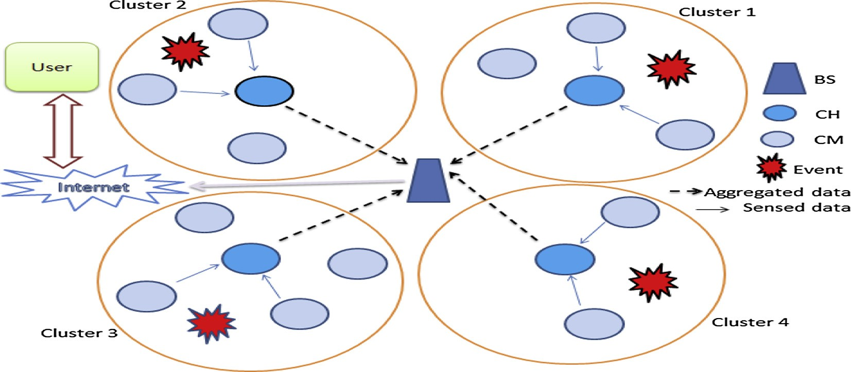

Figure 1 Clustering in WSN.

Moreover, numerous clustering algorithms for WSNs have been proposed in [22] typically aiming at reducing the power consumption. Another algorithm based on a clever strategy of cluster head (CH) selection, residual energy of the CHs and the intra-cluster distance for cluster formation is presented Table 1: Summary of notations in [23].

In 2014, one of the most important surveys on WSN algo- rithms has been presented in [16] where the authors describe some important clustering approaches in WSNs. Some other hierarchical clustering protocols including LEACH, HEED, TEEN, APTEEN, and EECS are discussed in [24]. In [25] LEACH and its recent advances are studied. A neural network based clustering approaches are presented in [26] which focuses on five neural network based algorithms: ART, ART1, FUZZY ART, IVEBF, and EBCS. In [18], the transmission load assignment in WSNs is modeled as a game. This work focuses on a cluster-based and surveillance-oriented sensor network.

In this context, there is another challenge which is finding a good location for the BS based on initial topological informa- tion such as distances between sensor nodes and the BS. How- ever, such schemes are not resource aware and may not lead to the best placement for the BS. In general the sink placement problem is NP-complete [27] and finding the best position of sink is very hard. In recent years, several papers report on BS positioning [28–30,27] and mainly design the network to ensure energy conservation and network lifetime extension. Since the optimal location of BS is one of the important factors in the present approach, recent attempts made in this research area are reminded. In 2015, some new protocols are presented in [31,32]. Others approaches are discussed in [27,33–35].

However, none of these papers considers jointly the cost of mission and the quality of communication, also the network considered is not critical. Our approach is clearly different in terms of these two contradictory objectives: minimizing mis- sion cost and maximizing the communication quality, mean- while. Thus, we propose a network containing multiple nodes to deploy in two-dimensional space. This network focuses on providing a good communication quality and all nodes are additionally interested in the satisfaction of their missions effectively. The established works in these critical cases are rare. Our previous papers [36–38] are three recent proposals in this context, where we model and solve some problems related to the optimal placement of sensors and BS in WSNs.

1. Materials and methods
   1. *Network model*

We suppose that a set of n sensors is deployed in a geo- graphic area of interest to supervise a given physical phe- nomenon. The topology of a WSNs is represented by the graph *G* = (*C*, *E*), where *C* = {1, 2, ... , *n*} is a set of n sen- sors and *E* ⊂ *C* × *C* is the set of wireless links between the various sensors. *Cv*(*i*) is the neighbor set of the sensor *i*. In Table 1, we present the meanings of the notations used in our modeling.

* 1. *Optimal placement of sensors using SAG algorithm*

Before determining the different clusters constituting the net- work, we briefly recall the objective of the first phase of our approach which is the reduction in mission and communica- tion costs of each node. For this, we used our SAG algorithm presented in [38]. SAG aims to find the optimal locations of sensors by solving the optimization problem given as follows:

*minf*(*x*; *y*)= X*fs*(*dis*)+ X X *cfc* (*dij*) (1)

*i*

*ij*

*i*

*i*

*j*∈*Cv*(*i*)

subject of (*xi*; *yi* )∈ *Si* 6(*i*; *j*)∈ *C* × *Cv*(*i*)

We put the following:

*fc*(*dij*)= X *fc* (*dij*) (2)

Table 1 Summuray of notations.

Notations

*C*

*Cv*(*i*)

*Si*

(*xi*; *yi* )

(*xs*; *ys*)

*i i*

(*xc*; *yc*)

*i i*

(*x*op; *y*op)

*i* *i*

(*x*op; *y*op)

bs bs

*dij dis*

*fc* (*dij*)

*jj*

*fs*(*dis*)

*i*

*a e*0 *c s R*

Max CH CM *S*CH *S*CM

Meaning

Set of sensors

Neighbors set of sensor i

Area in where each sensor i can move freely Current position of sensor i

Mission’s position of sensor i Communication’s position of sensor i Optimal location of sensor i

Optimal location of base station Distance between sensors i and j

Distance between current and mission’s position of a

sensor

Cost of communication between sensors i et j Mission cost of sensor i.

Path loss exponent

Energy needed to transmit one unit of data to BS Communication factor

Surveillance factor Transmission radius of a sensor

Maximal number of sensors managed by cluster head Cluster head

Cluster member Cluster heads set Cluster members set

*i*

*ij*

*j*∈*Cv*(*i*)

*V* = (*x*1; *y*1; *x*2; *y*2; .. . ; *xn*; *yn*) (3)

*F* (*x*; *y*)= X*fs*(*d* )(1) (4)

*i*

*s*

*i*

*is*

*F* (*x*; *y*)= X*fc*(*d* ) (5)

*i*

*F*(*V*)= *f*(*x*; *y*) (6)

*c*

*i*

*ij*

So (1) becomes

*minF*(*V*)= *sFs*(*V*)+ *cFc*(*V*) (7)

Subject of *V* ∈

*n*

*Si*

Y

*i*=1

* 1. *Description of our algorithm IMOWCA*

The pseudo code of the SAG algorithm is given below.

Algorithm 1. SGA algorithm.

Data: (*xm*, *ym*), (*xc*, *yc*), *i* ∈ *C*

*i i i i*

*i* *i*

Initialization of population *P*; Evaluate *P* using the function *F*; while No convergence

do

*P*' := Selection of parents in *P*;

*P*' := Apply the crossing operator on *P*';

*P*' := Apply the mutation operator on *P*';

*P* := Replace old parents of *P* by their descendants in *P*'; Evaluate *P* using the function *F*;

End

Result: (*x*op, *y*op), *i* ∈ *C*

Fig. 2 shows the flowchart of SGA.

SGA starts by generating an initial population *P* (Multiple values of *V* (Eq. (3)) *de* and evaluating the adaptation of all individuals (Multiple values of (*xi*, *yi* )) in initial population. Then the individuals are randomly selected for reproduction according to the principle of survival of the fittest. After that the children (or descendants) are generated applying the fol- lowing two genetic operators: crossover and mutation. Those

children are moved to a new population *P*' and replaced in whole or in part by the children of previous generations. The new population of individuals takes over from one generation to the next until reaching the stopping criterion. We note that after performing several simulations, we have chosen the value *e* = 0.0001 as stop criterion relatively to the evaluation step.

After calculating the optimal position for each sensor *i* using SAG, this section presents the main phase of the given approach. Indeed, to solve the energetic constraint and to opti- mize the resources in mission-critical sensor networks, we developed IMOWCA algorithm based on the following parameters:

* + - EC*i*: Energetic Characteristic of sensor *i*.
    - DD*i*: Degree Difference of sensor *i* that is the difference between the degree of sensor *i* (number of sensors within its transmission radius *R*) and a predefined ideal node num- ber Max in a cluster.
    - DC*i*: Sum of distances between sensor *i* and its neighbors.
    - DM*i*: Mission distance of sensor *i*.

To determine the different clusters, the IMOWCA algo- rithm follows these steps:

* + - Step 1: Compute EC*i* as follows:

EC*i* = (*Ti* × *A*)/*Ei* (1)

where *Ti* is the transmission rate, *Ei* is the initial energy of sen- sor *i* and *A* is a constant for amplification (*A* = 1000).

* + - Step 2: Determinate the neighbor set *Cv*(*i*) of each sensor *i*, where *Cv*(*i*) is defined by:

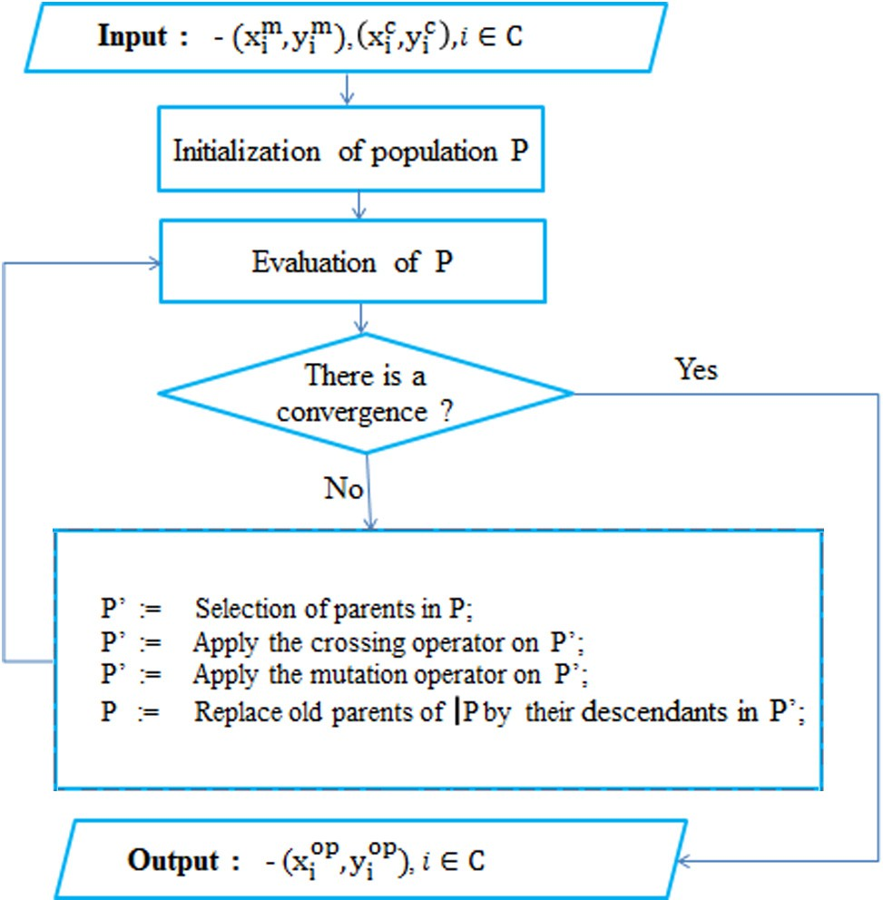

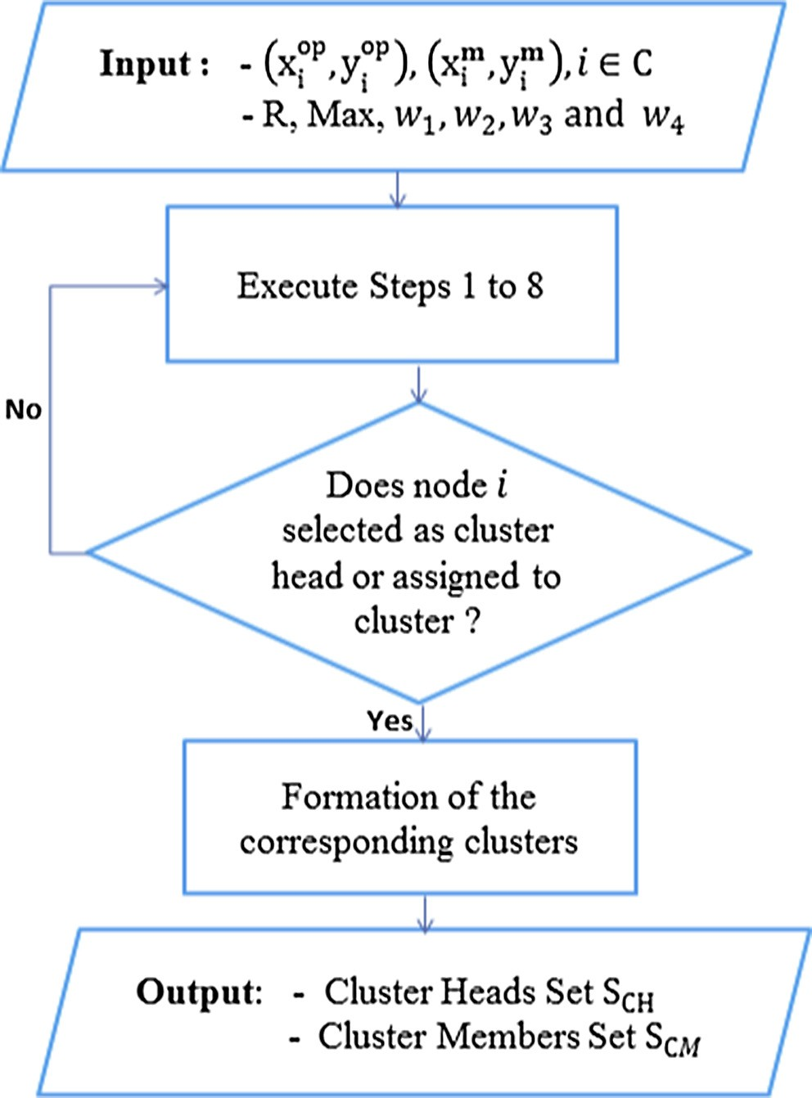Figure 2 SGA flowchart. Figure 3 IMOWCA flowchart.

,h i1

= *j* ∈ *C x*op — *x*op 2 + *y*op — *y*op 2 2 6 *R*

*C*

*v*(*i*)

*i*

*j*

*i*

*j*

* + - * The threshold number Max is set at 6, which means that a

(2)

cluster head can conveniently manage 6 sensors.

* The four weights *w*1, *w*2, *w*3 and *w*4 are respectively set to

– Calculate the degree *di* of each sensor *i* defined by:

*di* = Card(*Cv*(*i*))

* Step 3: Calculate the degree difference of each sensor *i* by this formula: DD*i* = |*di* — Max|.
* Step 4: Calculate the sum DC*i* of the distances between sen- sor *i* and its neighbors. That is:

*DC* = X h *x*op — *x*op 2 + *y*op — *y*op 2i1/2

*i*

*i*

*j*

*i*

*j*

*j*∈*Cv*(*i*)

the values 0.4, 0.2, 0.2 and 0.2. Our algorithm proceeds as follows:

Step 1: The Energetic Characteristic of each sensor *i* is cal- culated using formula (1).

Step 2: The neighbors set *Cv*(*i*) of each sensor *i* and its degree

*di* are obtained as shown in Table 3.

Step 3: The degree difference DDi of each sensor *i* is derived using formula (2).

Step 4: The different distances *DCi* are calculated by the

formula (3). For example,

* Step 5: Calculate the parameter DM*i* which represents the

distance between the optimal position (*x*op, *y*op) of the sen-

*i* *i*

*i xs*, *ys*):

sor

DM = h *x*op — *xm* 2

+ *y*op — *ym* 2i1/2

and the position of sensor’s mission ( *i i*

1

2 2 2

*DC*1 = [(50 — 75)

+ (64.3 — 65) ]2 + [(50 — 65)

*i*

*i*

*i*

*i*

*i*

.

* Step 6: Calculate the combined weight CW

*i*

as follows:

2 1 2

2 1

CW*i* = *w*1 × DD*i* + *w*2 × DC*i* + *w*3 × DM*i* + *w*4 × EC*i*

+(64.3 — 85.5) ]2 + [(50 — 69.8) + (64.3 — 115) ]2

= 105

where *w*1, *w*2 and *w*3 are different weights such that

*w*1 + *w*2 + *w*3 + *w*4 = 1

* Step 7: Select the sensor with the minimum combined weight CW*i* as a cluster head.
* Step 8: Eliminate the chosen cluster head and its neighbors from the set of original sensor nodes.
* Step 9: Execute Steps 1–8 for the remaining sensors until each one is assigned to a cluster.

After the execution of these steps successively, the different clusters are formed and all sensor nodes are regrouped into clusters with correspond CHs.

Fig. 3 shows the flowchart of our algorithm IMOWCA.

*3.3.1. Explanatory example*

This subsection provides on illustration how the IMOWCA algorithm is running by considering twelve sensors character- ized by their initial factors as shown in Table 2.

Also the parameters that are necessary for the operation of the algorithm are defined as follows:

Step 5: For each sensor *i*, the distance *DMi* is calculated by the formula (4). For example,

1

2

2

*DM*1 = [(50 — 50) 2+ (64.3 — 60) ] = 4.3

Step 6: For each sensor *i*, the combined weight *CWi* is cal- culated using formula (5).

After Step 6, the various parameters *DDi*, *DMi*, *DCi*, *ECi*

and *CWi* are calculated and listed in Table 4 (see Fig. 3).

Step 7: The sensor having the smallest value of combined weight *CWi* is chosen as a cluster head. Table 4 lists that *CW*1 is the minimum value of the combined weight. Thus, the sensor 10 is selected as the first cluster head. Fig. 4 pre- sents the obtained results.

Step 8: The chosen cluster head (CH: Sensor 1) and its neighbors (CMs: Sensors 2, 7 and 5) are eliminated from the set of original sensor nodes.

*i i i* *i*

|  |  |  |  |  |  |  |  |  |
| --- | --- | --- | --- | --- | --- | --- | --- | --- |
| Table 2 Sensors initial factors. | | | | |  | Table 3 *Cv*(*i*) and *di* values for each sensor *i*. | | |
| Sensor *i* | (*xm*, *ym*) | (*x*op, *y*op) | *Ei* | *Ti* |  | Sensor *i* | *Cv*(*i*) | *di* |
| 1 | (50, 60) | (50, 64.3) | 7500 | 5 |  | 1 | {2, 5, 7} | 3 |
| 2 | (80, 60) | (75, 65) | 7200 | 6 |  | 2 | {1, 3, 5, 7} | 4 |
| 3 | (120, 60) | (122, 66) | 6600 | 6 |  | 3 | {2, 4, 6, 9} | 4 |
| 4 | (170, 60) | (165, 65.5) | 8400 | 4 |  | 4 | {3, 6, 9} | 3 |
| 5 | (70, 80) | (65, 85.5) | 10,000 | 5 |  | 5 | {1, 2, 7, 8} | 4 |
| 6 | (140, 90) | (136, 90.5) | 7600 | 4 |  | 6 | {3, 4, 8, 9, 10} | 5 |
| 7 | (70, 110) | (69.8, 115) | 9600 | 4 |  | 7 | {1, 2, 5, 8, 11, 12} | 6 |
| 8 | (110, 120) | (107, 126) | 9000 | 5 |  | 8 | {5, 6, 7, 9, 10, 11, 12} | 7 |
| 9 | (150, 110) | (145, 114) | 8500 | 5 |  | 9 | {3, 4, 6, 8, 10, 11} | 6 |
| 10 | (140, 130) | (133, 137) | 9600 | 6 |  | 10 | {6, 8, 9, 11} | 4 |
| 11 | (110, 150) | (105, 155) | 9600 | 4 |  | 11 | {7, 8, 9, 10, 12} | 5 |
| 12 | (60, 150) | (57.4, 156) | 8000 | 5 |  | 12 | {7, 8, 11} | 3 |
|  |  |  |  |  |  |  |  |  |

@*g* @ "

*i*

*i*

*i*

*i*

@*x* = @*x e*0

|  |  |  |  |  |  |
| --- | --- | --- | --- | --- | --- |
| Table 4 | DC , D | M DD an | d CW | values for eac | h sensor *i*. |
| Sensor | *i* DC*i* | DM*i* | DD*i* | EC*i* | CW*i* |
| 1 | 105 | 4,3 | 3 | 0,133333 | 23,19333333 |
| 2 | 155 | 7,0711 | 2 | 0,166667 | 50,25466333 |
| 3 | 171 | 6,3246 | 2 | 0,181818 | 54,90647091 |
| 4 | 133 | 7,433 | 3 | 0,095238 | 43,80609048 |
| 5 | 163 | 7,2863 | 2 | 0,1 | 52,38589 |
| 6 | 184 | 4,0311 | 1 | 0,105263 | 57,33564579 |
| 7 | 269 | 5,004 | 0 | 0,083333 | 82,61786667 |
| 8 | 298 | 6,7082 | 1 | 0,111111 | 92,36801556 |
| 9 | 253 | 6,4031 | 0 | 0,117647 | 78,40916529 |
| 10 | 100 | 9,8995 | 2 | 0,125 | 34,39485 |
| 11 | 220 | 7,0711 | 1 | 0,083333 | 68,93799667 |
| 12 | 148 | 6,5391 | 3 | 0,125 | 48,18673 |
|  |  |  |  |  |  |

X qﬃﬃﬃﬃﬃoﬃﬃpﬃﬃﬃﬃﬃﬃﬃﬃﬃﬃﬃﬃ2ﬃﬃﬃﬃﬃﬃﬃﬃﬃﬃﬃﬃoﬃﬃpﬃﬃﬃﬃﬃﬃﬃﬃﬃﬃﬃﬃ2ﬃ*a* #

*i*∈*A*

= *e a*

(*xi* — *x*)

+ (*yi* — *y*)

X r ﬃﬃﬃﬃﬃﬃﬃﬃﬃﬃﬃﬃﬃﬃﬃﬃﬃﬃﬃﬃﬃﬃﬃﬃﬃﬃﬃﬃﬃﬃﬃﬃﬃﬃﬃﬃﬃﬃﬃﬃﬃﬃﬃﬃﬃﬃﬃﬃﬃ ﬃﬃﬃ *a*—1 @

0 *i* *i*

(*x*op — *x*)2 + (*y*op — *y*)2

×

@*x*

*i*∈*A*

× rﬃ ﬃﬃ(ﬃﬃ*x*ﬃﬃﬃoﬃﬃpﬃﬃﬃ—ﬃﬃﬃﬃ*x*ﬃﬃﬃ)ﬃﬃ2ﬃﬃﬃ+ﬃﬃﬃﬃﬃ(ﬃ*y*ﬃﬃﬃoﬃﬃpﬃﬃﬃ—ﬃﬃﬃﬃ*y*ﬃﬃﬃ)ﬃﬃ2ﬃ ﬃﬃﬃ

*i* *i*

(*a*—2)

= *e a*X(*x* — *x*op)h(*x*op — *x*)2 + (*y*op — *y*)2i 2 (10)

*i*∈*A*

0

*i*

*i*

*i*

and similarly:

@*g* X

= *e a*

(*y* — *y*op) (*x*op — *x*)2 + (*y*op — *y*)2

@*y*

0

h i(*a*—2)

*i*

*i*

*i*

*i*∈*A*

Unfortunately there is no closed formula solution to find the optimal coordinates (*x*op, *y*op), and thus we implement the fol-

2

(11)

*bs bs*

Fig. 5 shows the obtained results after removing the first cluster head and its neighbors.

The steps from 1 to 8 are repeated for the remaining sensors until each sensor is assigned to a cluster. The final results of clustering are shown in Fig. 6.

* 1. *Balancing consumed energy in formed clusters by placing BS in the best location*

The main goal here is to determine the best position BS rela- tively to different clusters formed. For this, we consider that the base station has relatively sufficient energy. We determine the optimization problem that minimizes the total energy con- sumed by active sensors in the network as follows:

*ming*(*x*, *y*)= *e* Xh(*x*op — *x*)2 + (*y*op — *y*)2i*a*/2 (8)

0

*i*

*i*

*i*∈*A*

lowing algorithm to find the best location of the base station

[38]. The pseudo code of the BGA algorithm is presented below.

Algorithm 2. BGA algorithm.

Data: (*x*op, *y*op), *i* ∈ *S*CH, *e*0, *a*

*i* *i*

bs bs

Initialization of population *P*; Evaluate *P* using the function *F*; while No convergence

do

*P*' := Selection of parents in *P*;

*P*' := Apply the crossing operator on *P*';

*P*' := Apply the mutation operator on *P*';

*P* := Replace old parents of *P* by their descendants in *P*'; Evaluate *P* using the function *F*;

End

Result: (*x*op, *y*op)

where *A* = *S*CH.

In order to determine the optimal solution (*x*op, *y*op), the BGA

bs bs

Theoretically, the solution is one of the critical points of *g*;

in other words, the total energy used is minimal when:

algorithm follows the same steps as SGA (Section 3.2).

1. Results and discussion

@*g* @*g*

@*x* = 0 and @*y* = 0 (9)

We have:

This section displays numerical results given by the three algo- rithms SGA, BGA and IMOWAC. The cost functions and parameters are defined as follows [38]:

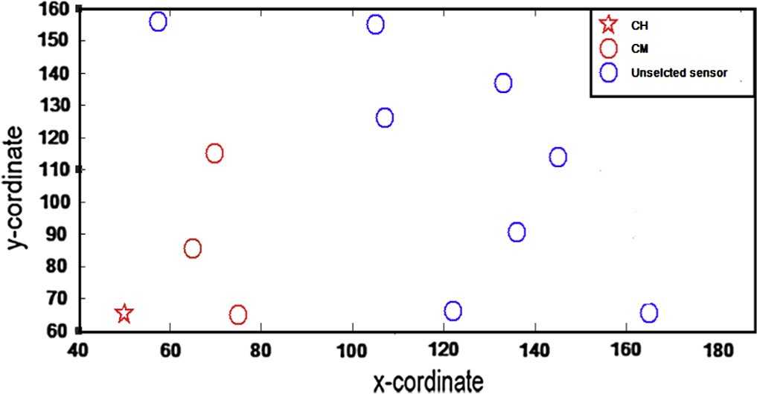

Figure 4 Selection of the first cluster head.

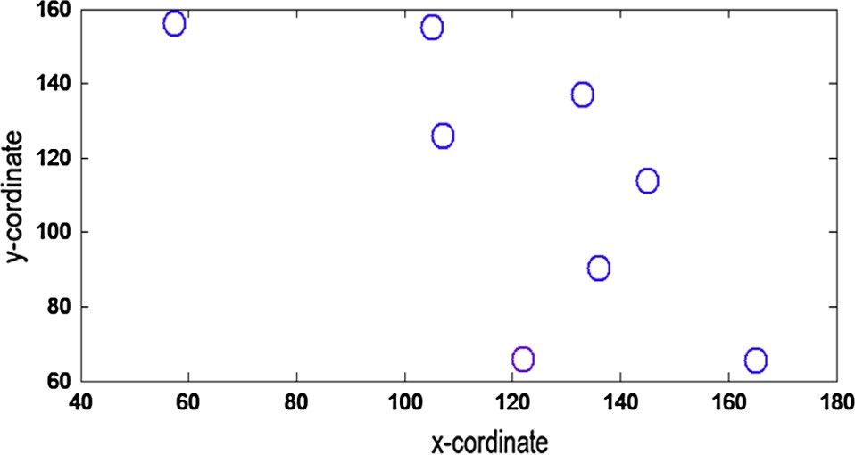Figure 5 The remaining sensor nodes after the first iteration. 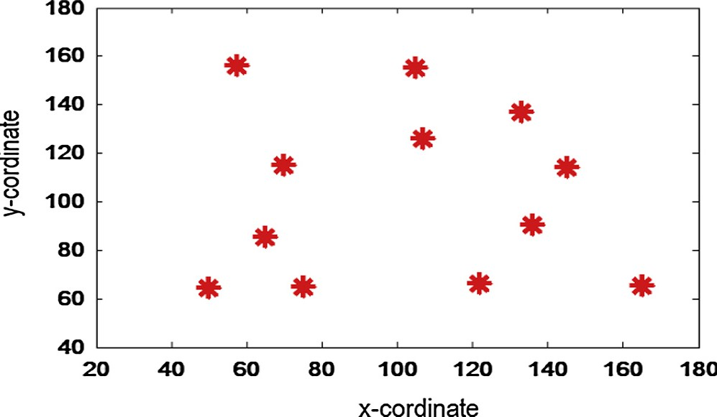

Figure 8 The best locations of sensors given by SGA.

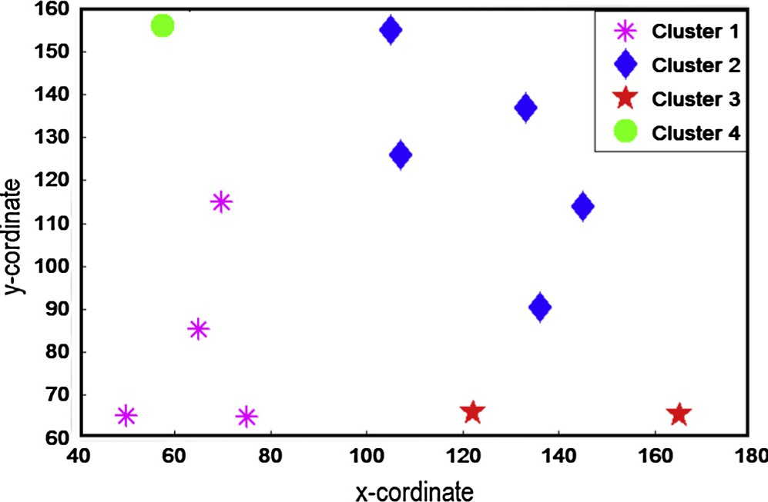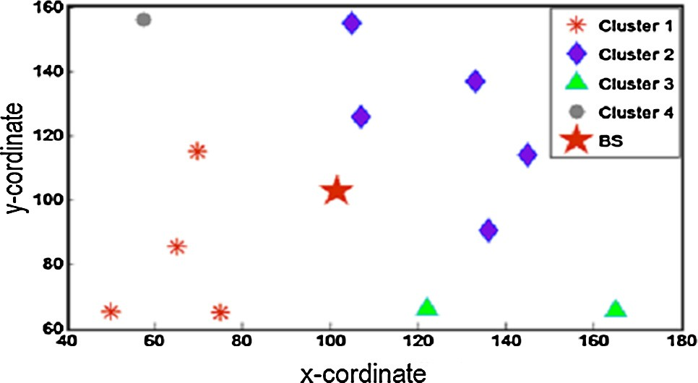

Figure 9 Different clusters given by IMOWCA.

Figure 6 The final results of clustering using IMOWCA.

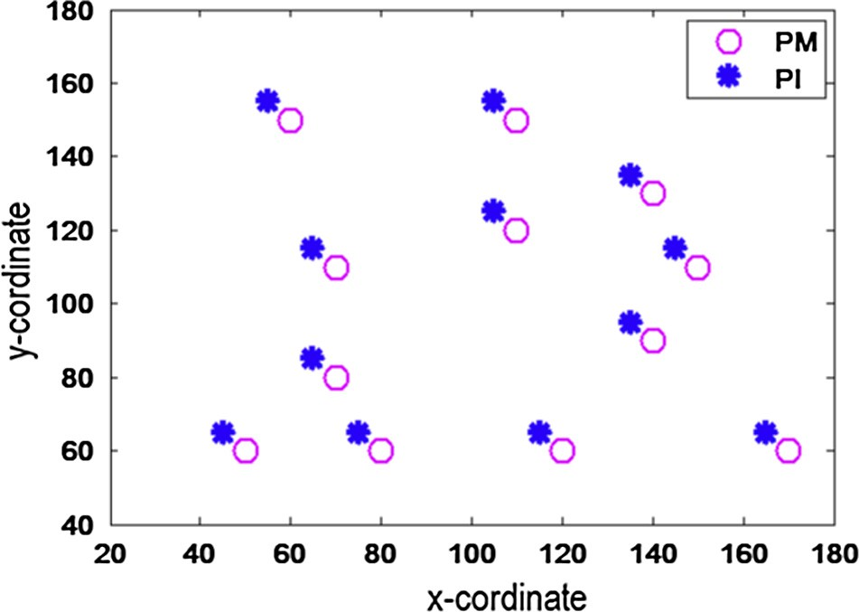 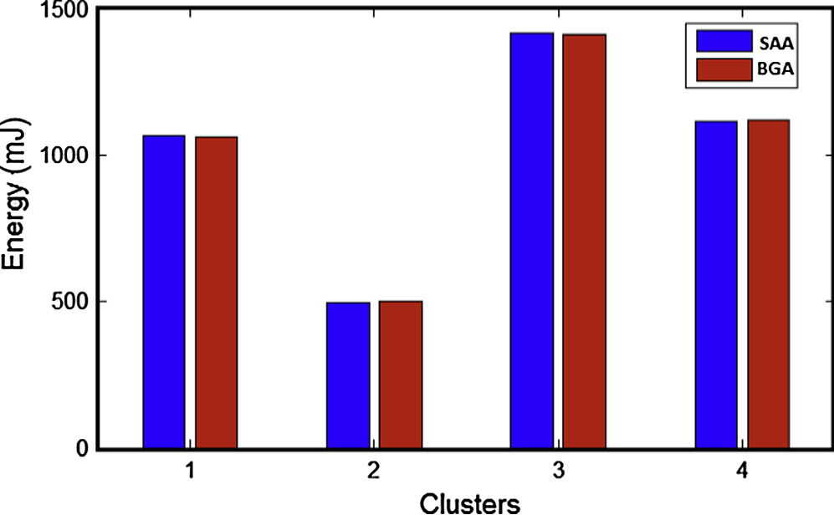

Figure 7 The mission and communication’s position of each sensor *i*.

* *f c* (*dij*)= 100 exp(10/12(log (106(*dij*)));

*ij* 2

* *f s* (*dis*)= 5 exp(10—2*dis* — 1);

*ij*

* *C* = {1, 2, ... , 12} and *e*0 = 15 · 10—3 mJ;
* *w*1 = 0.4, *w*2 = 0.3, *w*3 = 0.3 and Max = 6;
* For *i* ∈ *C*, the values of (*xm*, *ym*) and (*x*op, *y*op) are shown in

Figure 10 Consumed energy in different clusters.

The considered network is shown in Fig. 7, which consti- tuted of 12 nodes, where PM and PI denote respectively the mission and communication’s position of each sensor *i*.

The best locations of sensors calculated using SGA are rep- resented in Fig. 8.

After balancing mission and communication’s costs for each sensor, the IMOWCA algorithm is executed to form

the different clusters and determine explicitly the two sets

Table 2.

*i i i* *i*

*S*CH and *S*CM. Later on, the base station is placed in its best

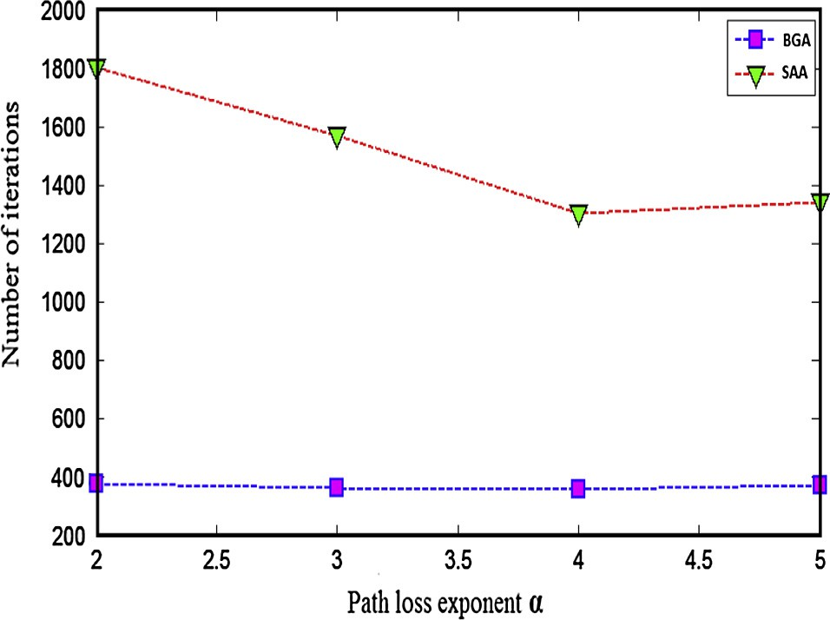

Figure 11 The convergence of SAA and BGA.

position relatively to the different clusters formed. The results of this clustering are shown in Fig. 9.

Note that the best position of BS is calculated using two methods: Simulating Annealing Algorithm SAA [42] and BGA. The total energy consumed by active sensors in the net- work is calculated. Fig. 10 illustrates this energy in both cases. The comparison between SAA and BGA shows that the amount of consumed energy is the same in both cases. While the BGA algorithm is very advantageous in terms of conver-

gence, this fact is shown clearly in Fig. 11.

The performance of the BGA algorithm against SAA is jus- tified by the advanced techniques of genetic algorithms that have passed from the stage of basic research to applied research. Indeed, in terms of convergence, SAA is negatively influenced by the choice of the initial solution which is one of the most important criteria for SAA. So, to achieve the final solution, SAA searches only in the vicinity of the initial solu- tion. By cons, after coding the chromosomes, the BGA algo- rithm (Algorithm 2) can start with any initial population, and then performs a global search to reach the best solution. Thus, BGA evolves this population by selecting the best indi- viduals. Then, thanks to the operation of croissant, it evolves also these individuals with possible mutations.

Later on, another distinguishing point of BGA algorithm is noted. Indeed, for optimizing the objective function, BGA does not impose any regularity (Continuity, differentiability, convexity, etc.) about this function.

By comparing the IMOWCA algorithm with SAG, it seems obvious, from Fig. 12, that MOWAC is more efficient. Specif- ically, it is clear that the total consumed energy (by millijoule [mJ]) in the network has decreased remarkably. This means that MOWAC saves a lot of energy which is to date a great challenge for researchers in the area of WSN.

On the one hand, the IMOWCA performance is justified by the fact of introducing the different metrics DD*i*, DC*i* and DM*i* (for each sensor *i*) in the function to be optimized. Indeed, the IMOWCA algorithm benefited greatly from the importance of multi-objective optimization used. This tech- nique allows IMOWCA to consider the different critical parameters in the network studied namely, the mission cost, the communication cost and also the distance between sensors and BS. On the other hand, thanks to the clustering performed by IMOWCA, only the best performing sensors in terms of power are selected to communicate with BS, which is advanta- geous as regards energy consumption in WSN.

1. Conclusion

In this work we have proposed an improved multi-objective weighted clustering algorithm in order to resolve the energy problem in critical WSNs where each node tries to minimize the weighted sum of mission and communication cost in a dis- tributed way. The proposal approach is based on advanced techniques of genetic algorithms. The obtained results show that, comparing to other techniques, the presented algorithms in this work are advantageous in terms of convergence to the optimal solution. Thus, thanks to the BGA algorithm the number of iterations has decreased clearly from 1600 to 400 (Fig. 11). The different simulations display that total con- sumed energy in the network has decreased remarkably with around 45% (Fig. 12). This means that the presented algo- rithms minimize more and more the energy which is the great challenge of WSN’s researches.

Therefore, our future work will have to deal with both objectives. The first one is the proposition of new protocols

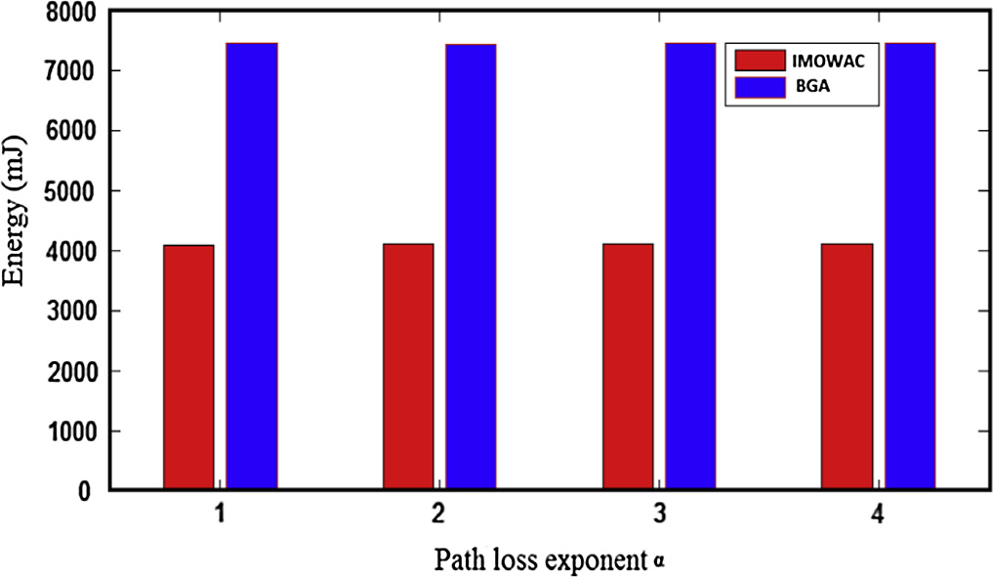

Figure 12 IMOWCA compared with SGA.

concerning node mobility. The second one takes part in rout- ing protocols incorporating the concept of clustering.

References

1. [Lo Chun, Lynch Jerome P, Liu Mingyan. Distributed model-](http://refhub.elsevier.com/S1110-8665(16)30016-0/h0005) [based nonlinear sensor fault diagnosis in wireless sensor networks.](http://refhub.elsevier.com/S1110-8665(16)30016-0/h0005) [Mech Syst Sig Process 2016;66–67:470–84](http://refhub.elsevier.com/S1110-8665(16)30016-0/h0005).
2. [Heal Dima Sofia Maria, Panagiotou Christos, Tsitsipis Dimitris,](http://refhub.elsevier.com/S1110-8665(16)30016-0/h0010) [Antonopoulos Christos, Gialelis John, Koubias Stavros. Perfor-](http://refhub.elsevier.com/S1110-8665(16)30016-0/h0010) [mance evaluation of a WSN system for distributed event detection](http://refhub.elsevier.com/S1110-8665(16)30016-0/h0010) [using fuzzy logic. Ad Hoc Netw 2014;23:87–108](http://refhub.elsevier.com/S1110-8665(16)30016-0/h0010).
3. [Hackmann G, Guo W, Yan G, et al. Cyber-physical code sign of](http://refhub.elsevier.com/S1110-8665(16)30016-0/h0015) [distributed structural health monitoring with wireless sensor](http://refhub.elsevier.com/S1110-8665(16)30016-0/h0015) [network. IEEE Trans Parallel Distrib Syst 2015;25(1):63–72](http://refhub.elsevier.com/S1110-8665(16)30016-0/h0015).
4. [Delamo Manuel, Felici-Castell Santiago, Pe´rez-Solano Juan J,](http://refhub.elsevier.com/S1110-8665(16)30016-0/h0020) [Foster Andrew. Designing an open source maintenance-free](http://refhub.elsevier.com/S1110-8665(16)30016-0/h0020) [environmental monitoring application for wireless sensor net-](http://refhub.elsevier.com/S1110-8665(16)30016-0/h0020) [works. J Syst Softw 2015;103:238–47](http://refhub.elsevier.com/S1110-8665(16)30016-0/h0020).
5. [Mesas-Carrascosa FJ, Verdu´Santano D, Meron˜ o JE, Sa´nchez de](http://refhub.elsevier.com/S1110-8665(16)30016-0/h0025) [la Orden M, Garcı´a-Ferrer A. Open source hardware to monitor](http://refhub.elsevier.com/S1110-8665(16)30016-0/h0025) [environmental parameters in precision agriculture. Biosyst Eng](http://refhub.elsevier.com/S1110-8665(16)30016-0/h0025) [2015;137:73–83](http://refhub.elsevier.com/S1110-8665(16)30016-0/h0025).
6. [Murat Dener, Yunus O¨ zko¨ k, Bostancıog˘lu Cevat. Fire detection](http://refhub.elsevier.com/S1110-8665(16)30016-0/h0030)

[systems in wireless sensor networks. Proc – Soc Behav Sci](http://refhub.elsevier.com/S1110-8665(16)30016-0/h0030) [2015;195(3):1846–50](http://refhub.elsevier.com/S1110-8665(16)30016-0/h0030).

1. [Wang JC, Lin CH, Siahaan E, et al. Mixed sound event](http://refhub.elsevier.com/S1110-8665(16)30016-0/h0035) [verification on wireless sensor network for home automation.](http://refhub.elsevier.com/S1110-8665(16)30016-0/h0035) [IEEE Trans Indust Inf 2014;10(1):802–12](http://refhub.elsevier.com/S1110-8665(16)30016-0/h0035).
2. [Di Stefano Alessandro, La Corte Aurelio, Leotta Marco, Lio](http://refhub.elsevier.com/S1110-8665(16)30016-0/h0040)´ [Pietro, Scata´Marialisa. It measures like me: an IoTs algorithm in](http://refhub.elsevier.com/S1110-8665(16)30016-0/h0040) [WSNs based on heuristics behavior and clustering methods. Ad](http://refhub.elsevier.com/S1110-8665(16)30016-0/h0040) [Hoc Netw 2013;11(8):2637–47](http://refhub.elsevier.com/S1110-8665(16)30016-0/h0040).
3. [Rocha Atslands R, Pirmez Luci, Delicato Fla´via C, Lemos E´rico,](http://refhub.elsevier.com/S1110-8665(16)30016-0/h0045)

[Santos Igor, Gomes Danielo G, et al. WSNs clustering based on](http://refhub.elsevier.com/S1110-8665(16)30016-0/h0045) [semantic neighborhood relationships. Comput Netw 2012;56](http://refhub.elsevier.com/S1110-8665(16)30016-0/h0045) [():1627–45](http://refhub.elsevier.com/S1110-8665(16)30016-0/h0045).

1. [Muruganantham Arunraja, Veluchamy Malathi, Erulappan Sak-](http://refhub.elsevier.com/S1110-8665(16)30016-0/h0050) [thivel. Energy conservation in WSN through multilevel data](http://refhub.elsevier.com/S1110-8665(16)30016-0/h0050) [reduction scheme. Microprocess Microsyst 2015;39(6):348–57](http://refhub.elsevier.com/S1110-8665(16)30016-0/h0050).
2. [Rault T, Bouabdallah A, Challal Y. Energy-efficiency in wireless](http://refhub.elsevier.com/S1110-8665(16)30016-0/h0055) [sensor networks: a top-down review approach. Comput Netw](http://refhub.elsevier.com/S1110-8665(16)30016-0/h0055) [2014;67:22–104](http://refhub.elsevier.com/S1110-8665(16)30016-0/h0055).
3. [Tarek AlSkaif, Zapata Manel Guerrero, Bellalta Boris. Game](http://refhub.elsevier.com/S1110-8665(16)30016-0/h0060) [theory for energy efficiency in wireless sensor networks: latest](http://refhub.elsevier.com/S1110-8665(16)30016-0/h0060) [trends. J Netw Comp Appl 2015;54:33–61](http://refhub.elsevier.com/S1110-8665(16)30016-0/h0060).
4. [Malathi L, Gnanamurthy RK, Chandrasekaran Krishnan. Energy](http://refhub.elsevier.com/S1110-8665(16)30016-0/h0065) [efficient data collection through hybrid unequal clustering for](http://refhub.elsevier.com/S1110-8665(16)30016-0/h0065) [wireless sensor networks. Comput Electr Eng 2015;48:358–70](http://refhub.elsevier.com/S1110-8665(16)30016-0/h0065).
5. [Zhou X, Wu M, Xu J. BPEC: an energy-aware distributed](http://refhub.elsevier.com/S1110-8665(16)30016-0/h0070) [clustering algorithm in WSNs. J Comput Res Develop 2009;46](http://refhub.elsevier.com/S1110-8665(16)30016-0/h0070) [():723–30](http://refhub.elsevier.com/S1110-8665(16)30016-0/h0070).
6. [Jiang Zhu, Lung Chung-Horng, Srivastava Vineet. A hybrid](http://refhub.elsevier.com/S1110-8665(16)30016-0/h0075) [clustering technique using quantitative and qualitative data for](http://refhub.elsevier.com/S1110-8665(16)30016-0/h0075) [wireless sensor networks. Ad Hoc Netw 2015;25(Part A):38–53](http://refhub.elsevier.com/S1110-8665(16)30016-0/h0075).
7. [Afsar Mehdi M, Mohammad -H, Tayarani -N. Clustering in](http://refhub.elsevier.com/S1110-8665(16)30016-0/h0080) [sensor networks: a literature survey. J Netw Comp Appl](http://refhub.elsevier.com/S1110-8665(16)30016-0/h0080) [2014;46:198–226](http://refhub.elsevier.com/S1110-8665(16)30016-0/h0080).
8. Yang Y, Lai C, Wang L, Wang X. An energy-aware clustering algorithm via game theory for wireless sensor network s. In: 12th International conference on control, automation and systems (ICCAS). Island (South Korea); 2012.
9. [Lin X-H, Kwok Y-K, Wang H, Xie N. A game theoretic approach](http://refhub.elsevier.com/S1110-8665(16)30016-0/h0090) [to balancing energy consumption in heterogeneous wireless sensor](http://refhub.elsevier.com/S1110-8665(16)30016-0/h0090) [networks. Wirel Commun Mob Comput 2015;15(1):170–91](http://refhub.elsevier.com/S1110-8665(16)30016-0/h0090).
10. [Lee D, Shin H, Lee C. Game theory-based resource allocation](http://refhub.elsevier.com/S1110-8665(16)30016-0/h0095) [strategy for clustering based wireless sensor network. In: Pro-](http://refhub.elsevier.com/S1110-8665(16)30016-0/h0095)

[ceedings of the sixth international conference on ubiquitous](http://refhub.elsevier.com/S1110-8665(16)30016-0/h0095) [information management and communication. Kuala Lumpur](http://refhub.elsevier.com/S1110-8665(16)30016-0/h0095) [(Malaysia): ACM; 2012. p. 112](http://refhub.elsevier.com/S1110-8665(16)30016-0/h0095).

1. [Zeng Y, Chen Z, Qiao C, Xu L. A cluster header election scheme](http://refhub.elsevier.com/S1110-8665(16)30016-0/h0100) [based on auction mechanism for intrusion detection in MANET.](http://refhub.elsevier.com/S1110-8665(16)30016-0/h0100) [International conference on network computing and information](http://refhub.elsevier.com/S1110-8665(16)30016-0/h0100) [security (NCIS), vol. 2. Guilin (China): IEEE; 2011. p. 433–7](http://refhub.elsevier.com/S1110-8665(16)30016-0/h0100).
2. [Tan L, Zhang S, Qi J. Cooperative cluster head selection based on](http://refhub.elsevier.com/S1110-8665(16)30016-0/h0105) [cost sharing game for energy-efficient wireless sensor networks. J](http://refhub.elsevier.com/S1110-8665(16)30016-0/h0105) [Comput Inf Syst 2012;8(9):3623–33](http://refhub.elsevier.com/S1110-8665(16)30016-0/h0105).
3. [Zhang Pengfei, Xiao Gaoxi, Tan Hwee-Pink. Clustering algo-](http://refhub.elsevier.com/S1110-8665(16)30016-0/h0110) [rithms for maximizing the lifetime of wireless sensor networks](http://refhub.elsevier.com/S1110-8665(16)30016-0/h0110) [with energy-harvesting sensors. Comput Netw 2013;57(14,](http://refhub.elsevier.com/S1110-8665(16)30016-0/h0110)

[):2689–704](http://refhub.elsevier.com/S1110-8665(16)30016-0/h0110).

1. [Tarachand Amgoth, Jana Prasanta K. Energy-aware routing](http://refhub.elsevier.com/S1110-8665(16)30016-0/h0115) [algorithm for wireless sensor networks. Comput Electr Eng](http://refhub.elsevier.com/S1110-8665(16)30016-0/h0115) [2015;41:357–67](http://refhub.elsevier.com/S1110-8665(16)30016-0/h0115).
2. [Joshi A, Lakshmi Priya M. A survey of hierarchical routing](http://refhub.elsevier.com/S1110-8665(16)30016-0/h0120) [protocols in wireless sensor network. MES J Technol Manage](http://refhub.elsevier.com/S1110-8665(16)30016-0/h0120) [2011:67–71](http://refhub.elsevier.com/S1110-8665(16)30016-0/h0120).
3. [Jindal P, Gupta V. Study of energy efficient routing protocols of](http://refhub.elsevier.com/S1110-8665(16)30016-0/h0125) [wireless sensor network and their further researches: a survey. Int](http://refhub.elsevier.com/S1110-8665(16)30016-0/h0125) [J Comput Sci Commun Eng 2013;2(2):57–62](http://refhub.elsevier.com/S1110-8665(16)30016-0/h0125).
4. [Subhai C, Malarkan S, Vaithinathan K. A survey on energy](http://refhub.elsevier.com/S1110-8665(16)30016-0/h0130) [efficient neural network based clustering models in wireless sensor](http://refhub.elsevier.com/S1110-8665(16)30016-0/h0130) [networks. In: International conference on emerging trends in](http://refhub.elsevier.com/S1110-8665(16)30016-0/h0130) [VLSI, embedded system, nano electronics and telecommunication](http://refhub.elsevier.com/S1110-8665(16)30016-0/h0130) [system (ICEVENT). Tamil Nadu, India. p. 1–6](http://refhub.elsevier.com/S1110-8665(16)30016-0/h0130).
5. Bogdanov A, Maneva E, Riesenfeld S. 2004. Power-aware base station positioning for sensor networks. In: Proceedings of the 23rd annualjoint conference of the IEEE computer and commu- nications societies (INFOCOM). Hong Kong.
6. [Akkaya K, Younis M, Bangad M. Sink repositioning for](http://refhub.elsevier.com/S1110-8665(16)30016-0/h0140) [enhanced performance in wireless sensor networks. Comput Netw](http://refhub.elsevier.com/S1110-8665(16)30016-0/h0140) [2005;49:512–34](http://refhub.elsevier.com/S1110-8665(16)30016-0/h0140).
7. Vincze Z, Vida R, Vidacs A. Deploying multiple sinks in multi- hop wireless sensor networks. In: IEEE international conference on pervasive services; 2007. p. 55–63.
8. Oyman EI, Ersoy C. Multiple sink network design problem in large scale wireless sensor networks. In: IEEE international conference on communications; 2004. p. 3663–7.
9. [Demin Gao, Lin Haifeng, Liu Xiaofeng. Routing protocol for k-](http://refhub.elsevier.com/S1110-8665(16)30016-0/h0155) [anycast communication in rechargeable wireless sensor networks.](http://refhub.elsevier.com/S1110-8665(16)30016-0/h0155) [Comp Stand Interfaces 2016;43:12–20](http://refhub.elsevier.com/S1110-8665(16)30016-0/h0155).
10. [Mottaghi Saeid, Zahabi Mohammad Reza. Optimizing LEACH](http://refhub.elsevier.com/S1110-8665(16)30016-0/h0160) [clustering algorithm with mobile sink and rendezvous nodes.](http://refhub.elsevier.com/S1110-8665(16)30016-0/h0160) [AEU – Int J Electron Commun 2015;69(2):507–14](http://refhub.elsevier.com/S1110-8665(16)30016-0/h0160).
11. [Liu W, Lu K, Wang J, Huang L, Wu DO. On the throughput](http://refhub.elsevier.com/S1110-8665(16)30016-0/h0165) [capacity of wireless sensor networks with mobile relays. IEEE](http://refhub.elsevier.com/S1110-8665(16)30016-0/h0165) [Trans Veh Technol 2012;61(4):1801–9](http://refhub.elsevier.com/S1110-8665(16)30016-0/h0165).
12. [Konstantopoulos C, Pantziou G, Gavalas D, Mpitziopoulos A,](http://refhub.elsevier.com/S1110-8665(16)30016-0/h0170) [Mamalis B. A rendezvous-based approach enabling energy-](http://refhub.elsevier.com/S1110-8665(16)30016-0/h0170) [efficient sensory data collection with mobile sinks. IEEE Trans](http://refhub.elsevier.com/S1110-8665(16)30016-0/h0170) [Parallel Distrib Syst 2012;23(5):809–17](http://refhub.elsevier.com/S1110-8665(16)30016-0/h0170).
13. Liang W, Luo J, Xu X. Prolonging network lifetime via a controlled mobile sink in wireless sensor networks. In: Global telecommunications conference (IEEE GLOBECOM); 2010. p. 1– 6.
14. Ouchitachen H, Hair A, Idrissi N. Joint mission and communi- cation aware node placement problem in mission-specific mobile sensor networks. In: Codes, cryptography and communication systems (WCCCS), IEEE Xplore; 2014.
15. [Ouchitachen H, Hair A, Idrissi N. Optimal placement of sensors](http://refhub.elsevier.com/S1110-8665(16)30016-0/h0185) [in mission-specific mobile sensor networks. TELKOMNIKA Ind](http://refhub.elsevier.com/S1110-8665(16)30016-0/h0185) [J Electr Eng 2015;15(3):401–8](http://refhub.elsevier.com/S1110-8665(16)30016-0/h0185).
16. Ouchitachen H, Hair A, Idrissi N. Minimizing energy consump- tion in mission-specific mobile sensor networks by placing sensors and base station in the best locations: genetic algorithms

approach. In: WINCOM’15, IEEE Conference Publications; 2015. p. 1–7.

1. Kaiwartya Omprakash, Kumar Sushil, Lobiyal DK, Tiwari Pawan Kumar, Abdullah Abdul Hanan, Hassan Ahmed Nazar. Multiobjective dynamic vehicle routing problem and time seed based solution using particle swarm optimization. J Sens 2014;2015:1–14.
2. [Bansal Angel, Kaiwartya Omprakash, Singh Ravindra Kumar,](http://refhub.elsevier.com/S1110-8665(16)30016-0/h0200) [Parkash Shiv. Maximizing fault tolerance and minimizing delay in](http://refhub.elsevier.com/S1110-8665(16)30016-0/h0200)

[virtual network embedding using NSGA-II. In: WCI’15 proceed-](http://refhub.elsevier.com/S1110-8665(16)30016-0/h0200) [ings of the third international symposium on women in computing](http://refhub.elsevier.com/S1110-8665(16)30016-0/h0200) [and informatics. New York (NY, USA): ACM; 2015. p. 124–30](http://refhub.elsevier.com/S1110-8665(16)30016-0/h0200).

[42] [Xiao Yiyong, Konak Abdullah. A simulating annealing algorithm](http://refhub.elsevier.com/S1110-8665(16)30016-0/h0210) [to solve the green vehicle routing & scheduling problem with](http://refhub.elsevier.com/S1110-8665(16)30016-0/h0210) [hierarchical objectives and weighted tardiness. Appl Soft Comput](http://refhub.elsevier.com/S1110-8665(16)30016-0/h0210) [J 2015;34(2015):372–88](http://refhub.elsevier.com/S1110-8665(16)30016-0/h0210).