HOSTE D BY

Available online at [www.sciencedirect.com](http://www.sciencedirect.com/science/journal/2314808X)

**ScienceDirect**

journal homepage: [http://ees.elsevier.com/ejbas/default.asp](http://http//ees.elsevier.com/ejbas/default.asp)

egyptian journal of basic and applied sciences 3 (2016) 164–1 7 1



**Full Length Article**

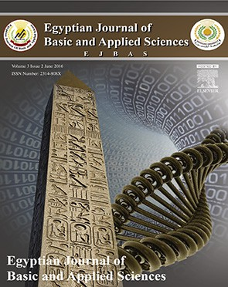***In vitro* study of aqueous leaf extract of *Chenopodium album* for inhibition of calcium oxalate and brushite crystallization**



***Deepti Sharma*** ***a******, Yadu Nandan Dey*** ***a******, Indu Sikarwar*** ***b******, Richa Sijoria*** ***a******,***

***Manish M. Wanjari*** ***a******,******\*******, Ankush D. Jadhav*** ***a***

a *National Research Institute for Ayurveda-Siddha Human Resource Development, Gwalior 474009, Madhya* *Pradesh, India*

b *Shri Ram College of Pharmacy, Banmore 476444, Madhya Pradesh, India*

A R T I C L E I N F O A B S T R A C T

*Article history:*

Received 12 August 2015 Received in revised form 15 February 2016

Accepted 18 February 2016

Available online 2 March 2016

*Keywords:* Bathua Urolithiasis Cystone Calcium oxalate Brushite

Citric acid

The leaves of *Chenopodium album* Linn. are traditionally used for treatment of kidney dis- eases and urinary stones. The present work investigated the effect of aqueous extract of leaves of *C. album* (CAAE) on *in-vitro* crystallization of CaOx and brushite crystals. Crystal- lization was studied by using nucleation and aggregation assay of calcium oxalate (CaOx) crystals and growth assay of calcium oxalate monohydrate and brushite crystals. The effects of CAAE and cystone on slope of nucleation and aggregation as well as growth of calcium oxalate crystallization were evaluated spectrophotometrically. The densities of the formed crystals were compared under microscope. The effects of CAAE and citric acid on growth of brushite crystals were studied by using single diffusion gel growth technique, and the parameters evaluated were length, morphology and average size of the deposited crystals. CAAE significantly inhibited the slope of nucleation and aggregation of CaOx crystalliza- tion, and decreased the crystal density. It also inhibited the growth and caused the dissolution of brushite crystals. The standard drug cystone or citric acid also exhibited similar effects. The study reveals that the leaves of *C. album* were found effective in the prevention of the experimentally induced urinary stones and substantiate the traditional claim. It is con- cluded that the leaves of *C. album* have beneficial inhibitory effect on *in-vitro* crystallization of CaOx and CHPD (brushite) crystals.

© 2016 Mansoura University. Production and hosting by Elsevier B.V. This is an open

access article under the CC BY-NC-ND license (<http://creativecommons.org/licenses/by->

nc-nd/4.0/).

# Introduction

Urolithiasis is defined as the presence of one or more calculi in any location within the urinary tract [1]. It is a common dis-

order estimated to occur in approximately 12% of the population, with a recurrence rate of 70–80% in male and 47–60% in female [2]. Majority of the stones are calcium- containing stones, especially calcium oxalate (80%) and others are 20% [3].

* *Corresponding author.* Tel.: +91 9229205231.

*E-mail address:* [manish.nriashrd@gmail.com](mailto:manish.nriashrd@gmail.com) (M.M. Wanjari). <http://dx.doi.org/10.1016/j.ejbas.2016.02.001>

2314-808X/© 2016 Mansoura University. Production and hosting by Elsevier B.V. This is an open access article under the CC BY-NC-ND license ([http://creativecommons.org/licenses/by-nc-nd/4.0/).](http://creativecommons.org/licenses/by-nc-nd/4.0/))

egyptian journal of basic and applied sciences 3 (2016) 164–1 7 1

**165**

The medical management of urolithiasis involves drug treat- ment and extracorporeal shock wave lithotripsy (ESWL). The various therapies including thiazide as diuretic and alkali- citrate are used to prevent the recurrence of hypercalciuria and hyperoxaluria, which induce calculi formation, but evi- dence for their efficacy is less [4]. The surgical endoscopic stone removal and extracorporeal shock wave lithotripsy have revo- lutionized the treatment of urolithiasis but does not prevent the likelihood of new stone formation [5]. Besides imposing the high cost, shock waves in therapeutic doses may cause acute renal injury, decrease in renal function and an increase in stone recurrence. The recurrence of stone formation is also very high (50–80%). In addition, persistent residual stone frag- ments and the possibility of infection after ESWL represent a serious problem in the treatment of stones. Thus, medical man- agement of urolithiasis is either costly or poses serious side effects.

The crystallization of the stone begins with increased urinary supersaturation, with the subsequent formation of the solid crystalline particles within the urinary tract. This is followed by nucleation, by which stone-forming salts in supersatu- rated urinary solution coalesce into clusters that then increase in size by the addition of new constituents [6]. These crystals then grow and aggregate with other crystals in solution, and are ultimately retained and accumulated in the kidney [7]. Therefore, if this progression of crystallization can be pre- vented, then lithiasis can also be prevented.

There is growing interest of public in herbal medicine, particularly in the treatment of urolithiasis partly because of limited choice in the pharmacotherapy. Data from *in-vitro*, *in-vivo* and clinical trials reveal that phytotherapeutic agents could be useful as either an alternative or an adjunctive therapy in the management of urolithiasis. Many Indian plants are useful as antilithiatic agents [5,8–13]. Hence, the Indian medicinal plants are constantly being evaluated for possible antilithiatic effects.

*Chenopodium album* L. (family: Chenopodiaceae) is a herba- ceous vegetable plant locally known as Bathua. It is cultivated as pot-herb and usually grown in gardens, but can be found in the corner of early grain fields in Bombay presidency and elsewhere in India (Kashmir and Sikkim). The medicinal prop- erty of this plant is mainly present in leaves and seeds. The leaves of *C. album* are used in ethno-medicinal practices for treatment of kidney diseases and urinary stones. Ethnobo- tanical studies of Aravalli region of Rajasthan (India) report the folk medicinal uses of cooked leaves of *C. album* in kidney stones and urinary tract troubles [14]. Cooked leaves of *C. album* are used as traditional medicine in the Shekhavati region of Ra- jasthan for treatment of urinary troubles and colic [15]. In Ladakh, leaves are also used traditionally for controlling painful urination [16]. *C. album* is an important medicinal weed of Mo- radabad useful in the treatment of urinary retention and kidney diseases [17].

In view of traditional and ethno-medicinal use of leaves of

*C. album* in the treatment of kidney stones, the present work demonstrated the effect of aqueous extract of the leaves of

*C. album* on *in-vitro* crystallization of CaOx and brushite crys- tals. As this plant is consumed as food substance by human beings and as weed fodder by cattle, its antilithiatic property would be good preventive option available.

# Materials and methods

## *Plant material*

The leaves of *C. album* were collected from the local market of Gwalior in December 2012 and identified by Dr. N.K. Pandey, Research Officer (Botany), National Research Institute for Ayurveda-Siddha Human Resource Development, Aamkho, Gwalior. A voucher specimen (Field Book No. 5-4/12–13/ NRIASHRD/Tech/Survey/134) of the authenticated *C. album* has been deposited in the herbarium of the institute.

## *Drugs and chemicals*

Cystone (Himalaya Drug Company) and citric acid 1-monohydrate (E. Merck (India) Ltd., Mumbai) were pur- chased from the local market. All remaining chemicals used in the experiment were of the highest grade commercially available.

## *Preparation of aqueous extract of the leaves of*

**C. album *(CAAE)***

The leaves were separated from other extraneous matter and subjected to shade drying. The dried leaves were subjected to a coarse powder by using dry grinder. The powder (100g) was soaked (maceration) in 1 L purified water and kept in dark and dry place for 48 h at a temperature range of 20–26 °C. Chloro- form was added in quantity of 1% total mixture to avoid microbial growth. After 48 h, solutions were filtered by Whatman Filter Paper No. 1. The filtered extracts were dried in a rotary evaporator to obtain a dark brown powdery extract (13.4% w/w).

## *Preliminary phytochemical screening and* quantitative estimation of phytoconstituents

Preliminary phytochemical screening [18] of CAAE was carried out to detect the presence of sterols, alkaloids, saponins, ter- penes, tannins, phenolic substances, carbohydrates, volatile oil and mucilage. The total phenolic content of the extracts was determined spectrometrically [19] and expressed as milli- gram of tannic acid equivalents (TAE) per gram of extract. Total flavonoid content was measured by aluminum chloride colo- rimetric assay [20] and expressed as milligram of quercetin equivalent per gram of extract. Total saponins were deter- mined according to the previously described methods by Obadoni and Ochuko (2002) with little modification [21].

## *Effect of CAAE on in-vitro crystallization*

* + 1. In-vitro *crystallization of calcium oxalate*
       1. *Nucleation and aggregation assay.* Nucleation and ag- gregation assay were performed as per method previously described by Hess et al. [2000] with minor modifications [22]. Briefly, freshly prepared solution of 10 mM calcium chloride di- hydrate and 1.0 mM sodium oxalate, containing 200 mM NaCl and 10 mM sodium acetate trihydrate, was adjusted to pH 5.7. All experiments were performed at 37 °C, using a circulating

**166** egyptian journal of basic and applied sciences 3 (2016) 164–1 7 1

water bath. For crystallization experiments, 25 ml of sodium oxalate solution was transferred into a beaker and placed in the hot plate magnetic stirrer (Model 2MLH, REMI), which was maintained at 37 °C and constantly stirred at 800 rpm. An ad- ditional 1 ml of distilled water/standard (cystone)/extract were added and finally calcium chloride solution (25 ml) was added. The optical density was measured at 620 nm in spectropho- tometer (UV 1800, Shimadzu Corporation, Japan) after addition of calcium containing solution, on every 15 s over 5 min and then every 1 min over 10 min. All the experiments were per- formed in triplicate. The final solutions were seen under a light microscope to analyze the density of formed crystals in the solution (Olympus, USA). Percent inhibition in the presence of cystone or CAAE was compared with the control by the fol- lowing formula.

The percentage inhibition was calculated as:

1  TsiTsc  100

where Tsc, the turbidity slope of the control; and Tsi, the tur- bidity slope in the presence of the inhibitor.

* + - 1. In vitro *calcium oxalate crystal growth assay.* Inhibitory activity of CAAE against CaOx crystal growth was measured using previously described methods [23,24]. Briefly, 20 ml each of 4 mM calcium chloride and 4 mM sodium oxalate were added to a 30 ml of solution, containing NaCl (90 mM) buffered with Tris HCl (10 mM) pH 7.2. To this 600 μl of calcium oxalate mono- hydrate (COM) crystal slurry (1.5 mg/ml acetate buffer) was added. Consumption of oxalate begins immediately after COM slurry addition and was monitored for 600 s by disappear- ance of absorbance at 214 nm. One ml of CAAE (500) and CAAE (1000 μg/ml) was added separately into this solution. The deple- tion of free oxalate ions will decrease if CAAE inhibits calcium oxalate crystal growth. Rate of reduction of free oxalate was calculated using the baseline value and the value after 30 s in- cubation with or without the extract. The relative inhibitory activity was calculated as follows:

% Relative inhibitory activity  C  SC  100

where C is the rate of reduction of free oxalate without any extract and S is the rate of reduction of free oxalate with CAAE.

### In-vitro *crystallization of brushite crystals*

* + - 1. *Growth assay.* Growth assay in single diffusion gel growth of brushite crystals was carried out according to the methods previously described by of Joshi et al. [2005b] with little modification [11]. Single diffusion gel growth method was fol- lowed to grow calcium hydrogen phosphate dihydrate (CHPD). When crystals achieved the maximum growth the inhibitive effects of citric acid solution having different concentrations were studied by adding them into the supernatant solution.

Glass test tubes of 2.5 cm diameter and 15 cm length were used for growing the crystals. Five milliliters of sodium meta- silicate solution of specific gravity 1.06 were acidified by adding appropriate amount (2.7 ml) of orthophosphoric acid so that

5.0 pH could be obtained for the mixture, which was subse- quently transferred into different test tubes. After gelation took

place, 10 ml of 1 M aqueous solution of calcium chloride was carefully poured on the set gels. Crystals were found growing very rapidly within two days from pouring the supernatant so- lutions. Elongated platelet type and star shaped crystals were grown in the gel. The apparent length of growing crystals was measured under microscope at different time intervals. The plot of apparent length of growing crystals versus time showed that the crystals achieved maximum length on the 5th day of pouring supernatant solution on set gel. Aqueous solution of citric acid as a standard and CAAE was added in the same volume as the calcium chloride solution on the 5th day after acquir- ing the maximum length of CHPD crystals, and their effect was studied on the growth of CHPD crystals up to the 8th day. For pH 5.0, many crystals having star and platelet star and plate- let type morphologies were observed. The photographs of the test tube showing the growth of the crystals were recorded.

## *Statistical analysis*

The data obtained were analyzed by one-way ANOVA, two- way ANOVA and linear regression analysis wherever necessary. A value of p < 0.05 was considered significant in all cases.

# Results

## *Preliminary phytochemical screening and* quantitative estimation of phytoconstituents

CAAE showed the presence of proteins, alkaloids, saponin gly- cosides, amino acids and flavonoids, while carbohydrates, sterols and tannins were absent. The total phenolic and flavonoid content of CAAE were found to be 239.8 mg TAE/g of extract and 87.23 mg quercetin equivalents/g of extract, respectively while the total saponins content was found to be 1.6 mg saponins/100g of powder mass.

* 1. ***Effect of CAAE on* in-vitro *crystallization***
     1. In-vitro *crystallization of calcium oxalate*
        1. *Nucleation and aggregation assay.* The changes in the turbidity or optical density of different solutions, *viz* control, cystone (1000 μg/ml), and CAAE (500 μg/ml and 1000 μg/ml), were plotted at different time intervals. The turbidity increased lin- early up to 5 minutes, which indicated the nucleation process and then decreased linearly up to 15 minutes indicating the aggregation process. CAAE (500 μg/ml and 1000 μg/ml) and cystone (1000 μg/ml) inhibited both the rate of nucleation and the rate of aggregation. The maximum optical density of the solutions, *viz* control, cystone (1000 μg/ml) and CAAE (500 μg/ ml) and CAAE (1000 μg/ml), recorded was 0.170, 0.072, 0.122 and

0.095. The percent inhibition rates of nucleation of CaOx by cystone (1000 μg/ml), CAAE (500 μg/ml) and CAAE (1000 μg/ ml) were found to be 58.33, 12.5 and 37.5 percent, respectively

(Fig. 1). The percent inhibition rates of aggregation of CaOx by cystone (1000 μg/ml), CAAE (500 μg/ml) and CAAE (1000 μg/ ml) were found to be 66.66, 66.66 and 33.33 respectively (Fig. 1). The photomicrographs of the CaOx crystals in solutions of

egyptian journal of basic and applied sciences 3 (2016) 164–1 7 1

**167**

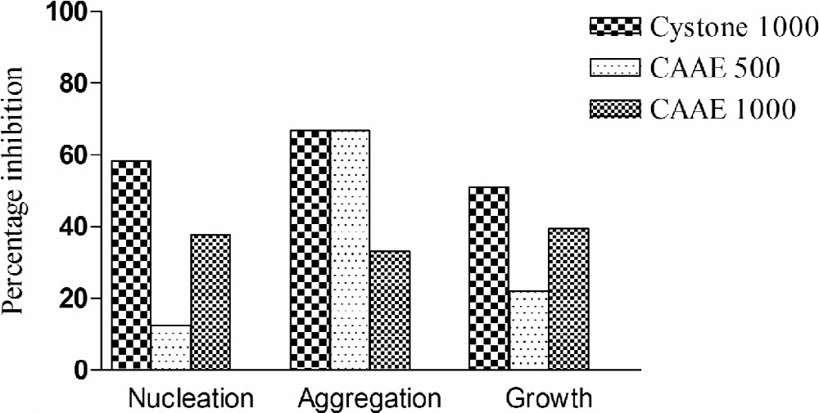**Fig. 1 – Effects of cystone and CAAE on CaOx nucleation,** 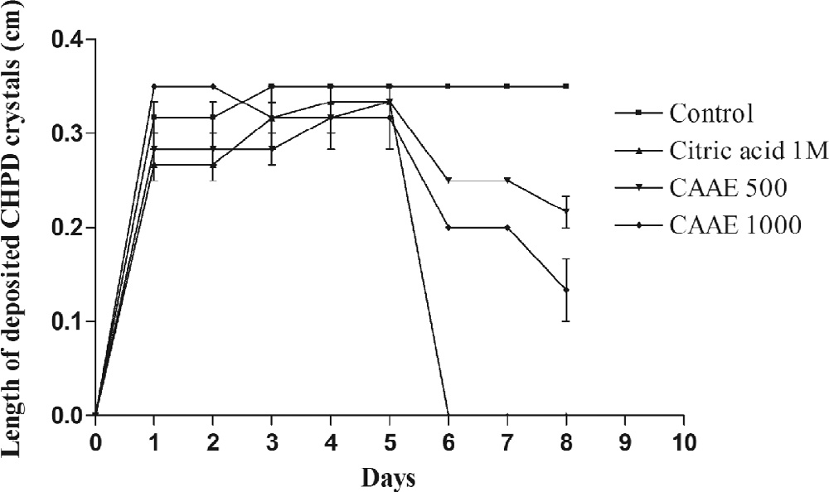 **aggregation and growth.**

**Fig. 3 – Effects of citric acid and CAAE on the length of**

**deposited CHPD crystals. Values are mean ± SEM.**

control, cystone (1000 μg/ml) and CAAE (500 μg/ml and 1000 μg/

ml) showed that CaOx crystals were less denser in cystone (1000 μg/ml), CAAE (500 μg/ml) and CAAE (1000 μg/ml) as com- pared to control (Fig. 2).

* + - 1. *In vitro calcium oxalate crystal growth assay.* In calcium oxalate growth assay, CAAE inhibited calcium oxalate mono- hydrate (COM) growth. The percentage inhibition of cystone (1000 μg/ml), CAAE (500 μg/ml) and CAAE (1000 μg/ml) were 50.96, 22.05, and 39.57 respectively (Fig. 1).

### In-vitro *crystallization of brushite crystals*

* + - 1. *Growth assay.* The growth of brushite crystals was mea- sured as length (thickness of crystal deposition). The crystals acquired maximum length (approximately 0.35 cm) on day 3 after gelation took place and then after the length of the crys- tals deposited became constant up to day 8. The average length

of the deposited CHPD crystals was decreased by citric acid (1 M), CAAE (500 μg/ml) and CAAE (1000 μg/ml) until day 8. The length of the crystals in control, CAAE (500 μg/ml) and CAAE (1000 μg/ml) were 0.35 cm, 0.21 cm and 0.133 cm, respec- tively; however, it could not be measured due to absence of any measurable size crystals in citric acid (1 M) group. Figs. 3 and 4 show the effects of citric acid and CAAE on the length of deposited CHPD crystals.

Fig. 5 shows the microphotographs of CHPD crystals in dif- ferent groups. Crystals in CAAE (500 and 1000 μg/ml) groups were very small compared to the control, whereas in citric acid

there was no appearance of observable crystals. Citric acid and CAAE (500 and 1000 μg/ml) significantly decreased the size of crystals (p < 0.001) as measured by its thickness using stage micrometer. The microphotographs of the CHPD crystals of the control showed the plate like crystals having an average

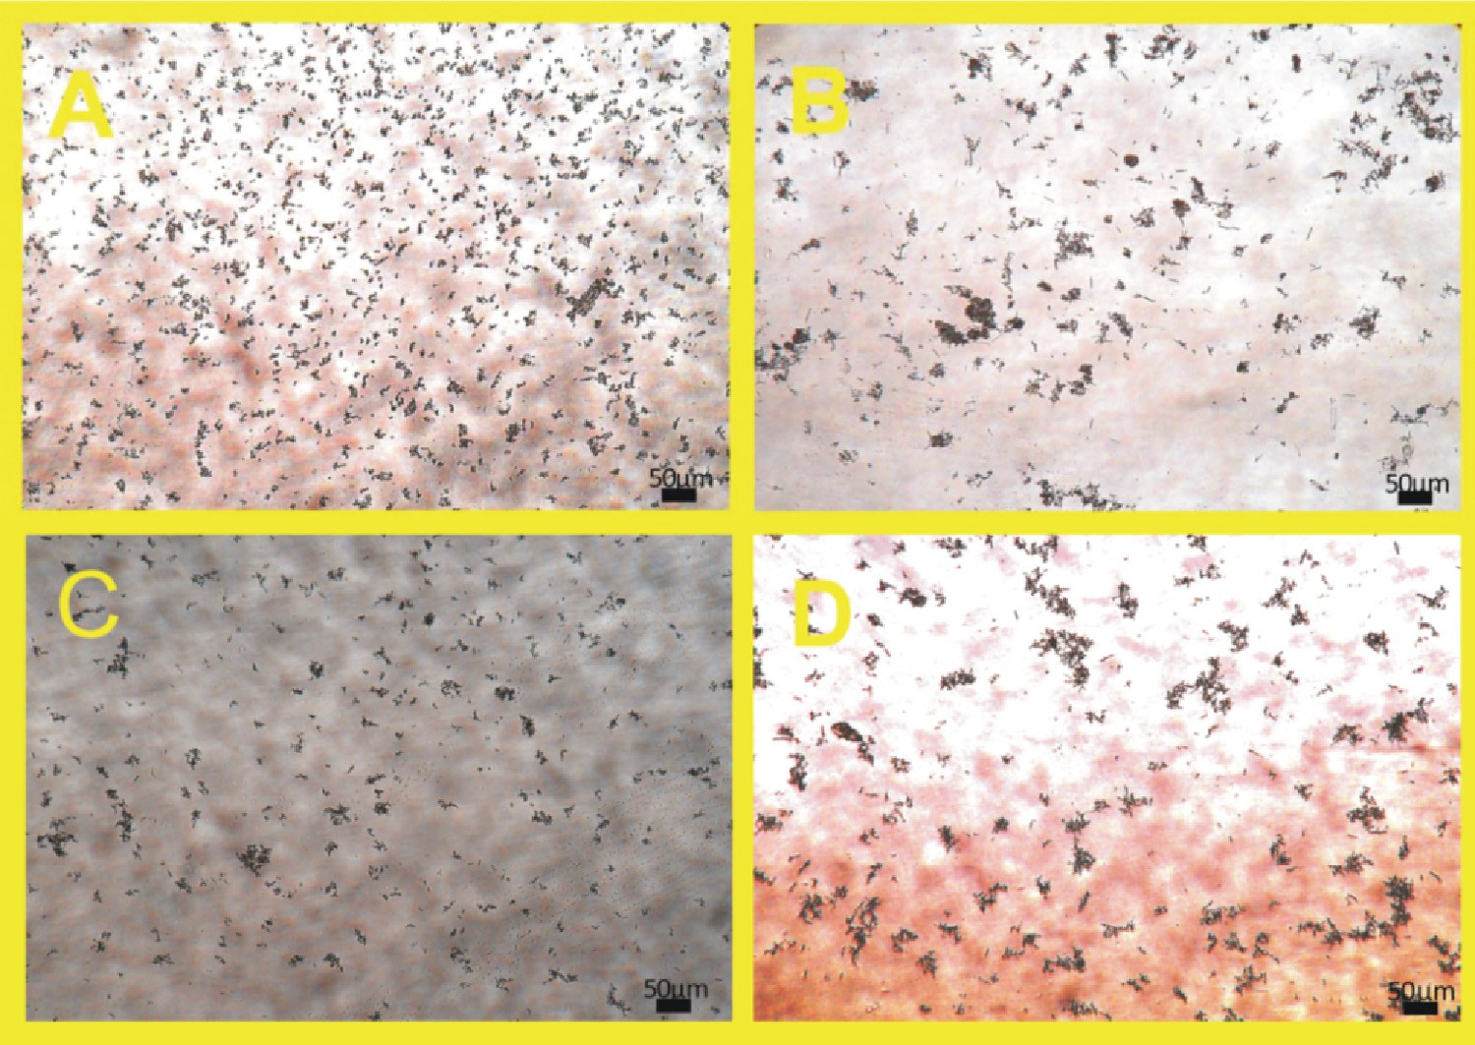

**Fig. 2 – Photomicrographs of CaOx crystal density in different solutions, *viz* control, cystone (1000 gg/ml), and CAAE (500 gg/ ml and 1000 gg/ml) [A = control, B = cystone, C = CAAE500, D = CAAE1000], magnification 100×.**

**168** egyptian journal of basic and applied sciences 3 (2016) 164–1 7 1

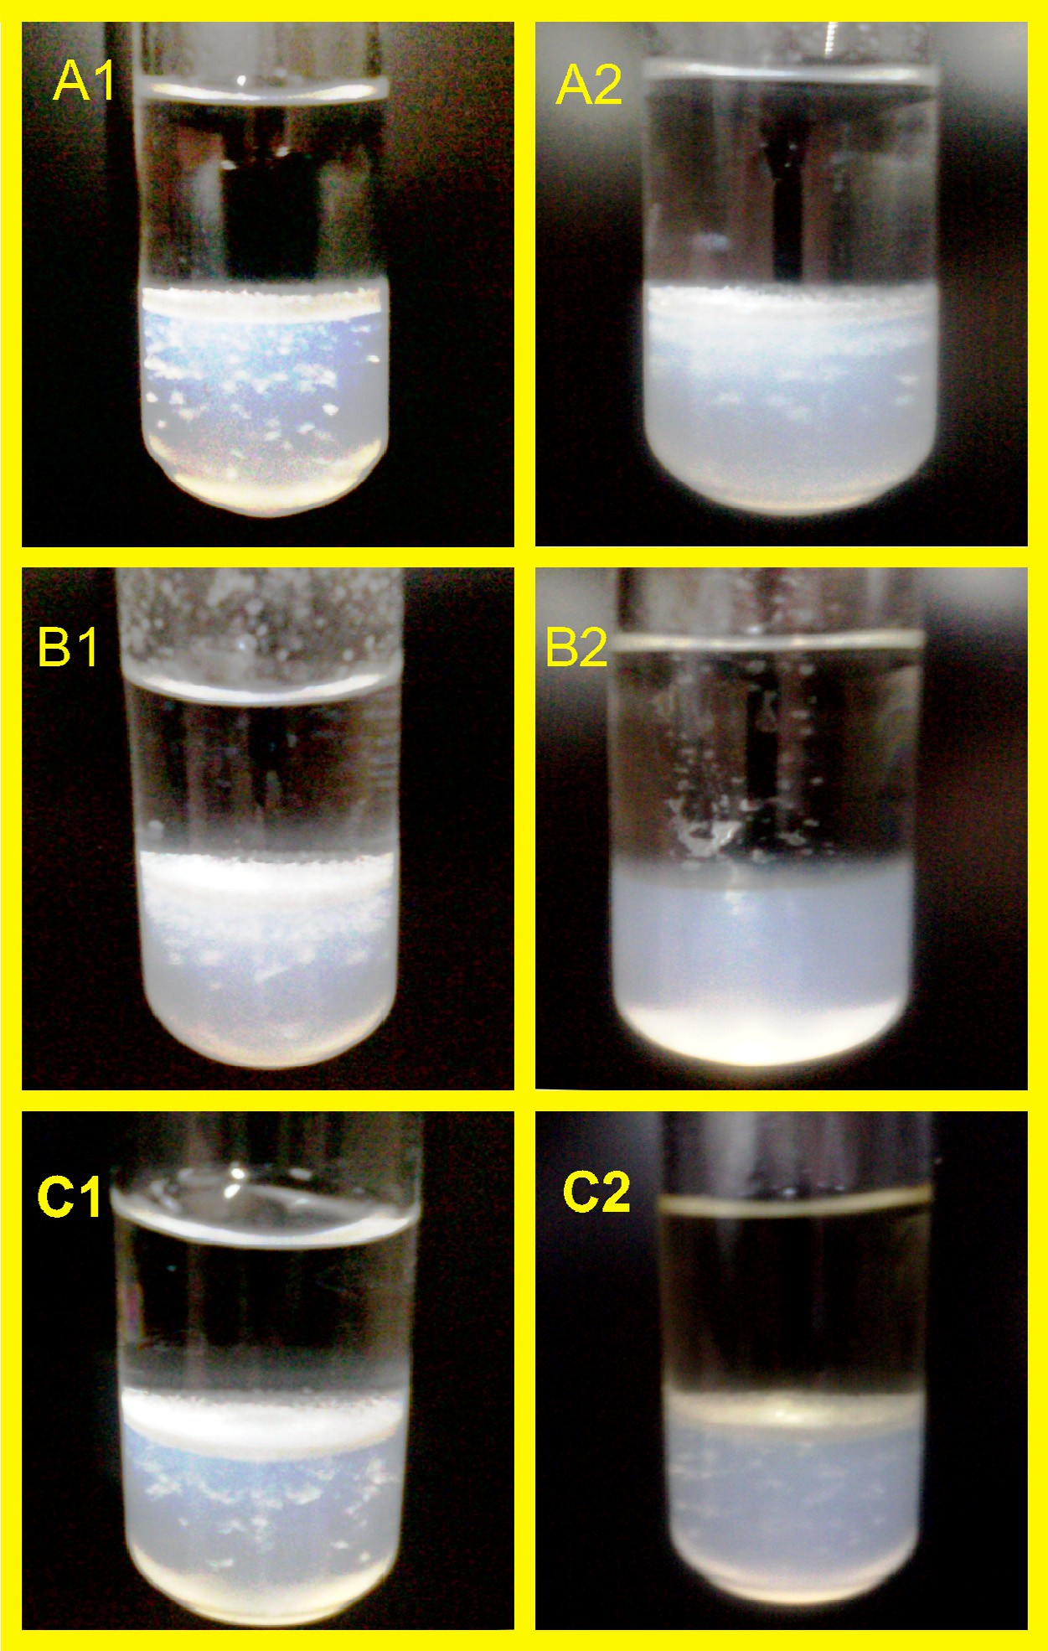

**Fig. 4 – Effects of citric acid and CAAE on the growth of CHPD (brushite crystals) [A1 = control (5th day), A2 = control (8th day), B1 = before treatment of citric acid (5th day), B2 = after treatment of citric acid (8th day), C1 = before treatment of CAAE (5th day), C2 = after treatment of CAAE (8th day)].**

thickness size of 52.64 μm, while the average thickness of the crystals in CAAE (500 μg/ml) and CAAE (1000 μg/ml) was

17.28 μm and 14.15 μm, respectively (Fig. 6). There were no ob-

servable crystals present in tube containing citric acid (1M).

# Discussion

The recurrence of stone is a very serious concern in the medical management of urolithiasis. Drug treatments like thiazide as diuretic and alkali-citrate, used to prevent the recurrence of hypercalciuria and hyperoxaluria, are considered to be less

efficacious [4]. Although the surgical endoscopic stone removal and extracorporeal shock wave lithotripsy have revolution- ized the treatment of urolithiasis, they increase the chances of new stone formation [5], and the shock waves in therapeu- tic doses may cause acute renal injury, decrease in renal function and an increase in stone recurrence (50–80%).

In view of these, the effect of leaves of *C. album*, having tra- ditional use in the treatment of kidney stones and urinary tract troubles, was studied in *in-vitro* models of urolithiasis. In *in- vitro* calcium oxalate crystallization study, the process of nucleation and aggregation was studied in sodium acetate buffer of pH 5.7 to simulate the conditions of urine so as to favor the above processes. In the crystallization study, the

egyptian journal of basic and applied sciences 3 (2016) 164–1 7 1

**169**

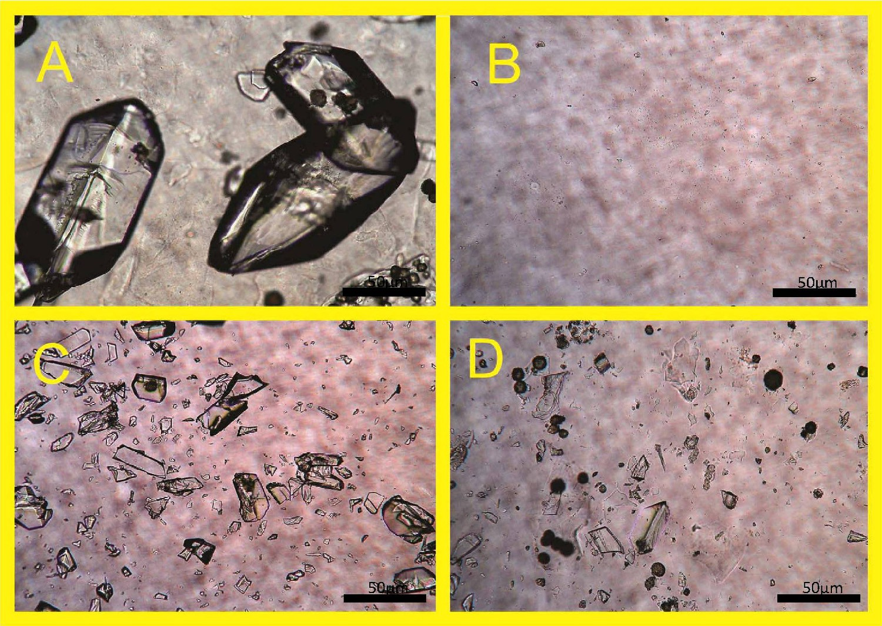

**Fig. 5 – Effects of citric acid and CAAE on the size of crystals [A = control, B = citric acid, C = CAAE500, D = CAAE1000], magnification 400×.**

turbidity increased linearly up to 5 min and then decreased lin- early up to 15 min after the addition of calcium chloride dihydrate. Earlier increase in the turbidity was suggestive of the nucleation phenomenon, while the decrease in the later part indicated the aggregation. These two phenomena repre- sented the complete process of *in-vitro* crystallization as observed previously by Hess et al. [2000] [22]. Simultaneous ad- dition of CAAE (500 and 1000 μg/ml) and cystone (1000 μg/ml) along with calcium chloride dihydrate inhibited the nucle- ation as well as aggregation process of CaOx crystallization as indicated by dose-dependent decrease in turbidity of the solution in both phenomena. The inhibition of *in-vitro* crys- tallization of CaOx suggests that CAAE has influence on the formation of crystals from sodium oxalate and calcium chlo- ride and/or their aggregation. Most of the previous papers [25,26] stated that the test drug or extract inhibited the crystalliza- tion by favoring the formation of calcium oxalate dihydrate

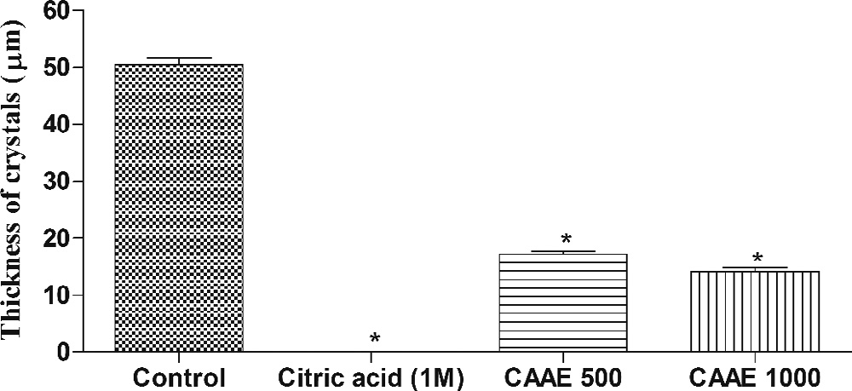

**Fig. 6 – Effects of citric acid and CAAE on microscopic thickness of crystals. Values are expressed as mean ± SEM;**

**\*p<0.001 when compared to control.**

(COD) crystals instead of calcium oxalate monohydrate (COM). The study needs a use of polarized light to differentiate between COM and COD crystals, which is a limitation of the present study and thus could not state whether the CAAE favored the formation of COD and less of COM, but the possibility of this cannot be ignored. The non-significant decrease in turbidity as observed in the process of aggregation may be due to the possibility of more amounts of COD crystals in the solution. Moreover, growth assay showed that CAAE also inhibited the growth of calcium oxalate monohydrate crystals with maximum inhibition at 1000 μg/ml concentration. This indicates that CAAE has inhibitory influence on nucleation/aggregation and growth of calcium oxalate crystals.

Similarly, CAAE also showed significant inhibition of growth of brushite (CHPD) crystals and caused their dissolution, in- dicated by the small length of the crystal deposition thickness in the test tube (See Figs. 3 and 4) and decreased microscopic

thickness of the crystals (P < 0.001) as compared to control (see

Figs. 5 and 6). CAAE exhibited effects comparable to standard drug citric acid, which showed the complete dissolution of the CHPD crystals. The effect of citric acid corroborates with pre- vious finding [27].The results indicated that CAAE has significant influence on the formation, growth and dissolution of crys- tals, and further suggest that the extract has beneficial effect in preventing the formation of crystals and their growth.

Literature of the previous studies is silent on the exact mechanism involved in the inhibition of *in-vitro* crystalliza- tion and stated that the extracts contained some chemical components that inhibited the crystallization. There are reports that flavonoids inhibit calcium oxalate crystallization in human urine as well as in animal models [28] and crystal deposition [29]. Saponins showed anti-crystallization properties by

**170** egyptian journal of basic and applied sciences 3 (2016) 164–1 7 1

disaggregating the suspension of mucoproteins, the promot- ers of crystallization [30]. Phytochemical screening and estimation of important constituents revealed that CAAE con- tains flavonoids and saponins. It has total flavonoid content of 87.23 mg quercetin equivalents/g of extract and total sa- ponins content of 1.6 mg saponins/100g of powder mass. Thus, the flavonoids and saponins present may be playing a con- tributing role in anti-crystallization action of CAAE. Fouda et al. [2006] studied the effect of *in-vitro* and *in-vivo* antilithiatic effects of saponins rich fraction of *Herniaria hirsuta* and stated that fraction contained a substance that promoted the nucleation of COD crystals [25]. Finally, the results of the present inves- tigations suggest that the leaves of the *C. album* have *in-vitro* anti-crystallization effect on CaOx and brushite crystals. These findings substantiate the traditional use of the leaves in the treatment of urinary stones and kidney problems. In order to substantiate its *in-vitro* effect, the *in-vivo* studies need to be carried out in experimental animals.

# Conclusion

The leaves of *C. album* have beneficial inhibitory effect on *in- vitro* crystallization of CaOx and CHPD (brushite) crystals.

# Acknowledgment

The authors acknowledge the Director General, Central Council for Research in Ayurvedic Sciences, New Delhi, India, for pro- viding necessary facilities to carry out the research work.

R E F E R E N C E S

1. [Thomas B, Hall J. Urolithiasis. Surgery (Oxford) 2005;23:129–](http://refhub.elsevier.com/S2314-808X(16)00016-6/sr0010) [33.](http://refhub.elsevier.com/S2314-808X(16)00016-6/sr0010)
2. [Smith CL, Guay DRP. Nephrolithiasis. In: Di Piro JT, Talbert](http://refhub.elsevier.com/S2314-808X(16)00016-6/sr0015) [RL, Hayes PE, Yee GC, Matzke GR, Posey LM, editors.](http://refhub.elsevier.com/S2314-808X(16)00016-6/sr0015) [Pharmacotherapy and pathophysiologic approach, vol. 2.](http://refhub.elsevier.com/S2314-808X(16)00016-6/sr0015) [Elsevier; 1992. p. 720–36.](http://refhub.elsevier.com/S2314-808X(16)00016-6/sr0015)
3. [Moe OW. Kidney stones: pathophysiology and medical](http://refhub.elsevier.com/S2314-808X(16)00016-6/sr0020) [management. Lancet 2006;367:333–44.](http://refhub.elsevier.com/S2314-808X(16)00016-6/sr0020)
4. [Pak CY. Prevention and treatment of kidney stones. Role of](http://refhub.elsevier.com/S2314-808X(16)00016-6/sr0025) [medical prevention. J Urol 1989;141(3 Pt 2):798–801.](http://refhub.elsevier.com/S2314-808X(16)00016-6/sr0025)
5. [Kalyan SB, Christina AJM, Syama SB, Selvakumar S, Sundara](http://refhub.elsevier.com/S2314-808X(16)00016-6/sr0030) [SK. Urolithiatic activity of *Hibiscus sabdariffa* Linn. on](http://refhub.elsevier.com/S2314-808X(16)00016-6/sr0030) [ethylene glycol-induced lithiasis in rats. Nat Prod Rad](http://refhub.elsevier.com/S2314-808X(16)00016-6/sr0030) [2009;8:43–7.](http://refhub.elsevier.com/S2314-808X(16)00016-6/sr0030)
6. [Basavaraj DR, Biyani CS, Browning AJ, Cartledge JJ. The role](http://refhub.elsevier.com/S2314-808X(16)00016-6/sr0035) [of urinary kidney stone inhibitors and promoters in the](http://refhub.elsevier.com/S2314-808X(16)00016-6/sr0035) [pathogenesis of calcium containing renal stones. EAU-EBU](http://refhub.elsevier.com/S2314-808X(16)00016-6/sr0035) [Update Ser 2007;5:126–36.](http://refhub.elsevier.com/S2314-808X(16)00016-6/sr0035)
7. [Kok DJ, Papapolous SE, Bijovet OL. Crystal agglomeration is a](http://refhub.elsevier.com/S2314-808X(16)00016-6/sr0040) [major element in calcium oxalate urinary stone formation.](http://refhub.elsevier.com/S2314-808X(16)00016-6/sr0040) [Kidney Int 1990;37:51–6.](http://refhub.elsevier.com/S2314-808X(16)00016-6/sr0040)
8. [Karadi RV, Gadge NB, Alagawadi KR, Savadi RV. Effect of](http://refhub.elsevier.com/S2314-808X(16)00016-6/sr0045) [*Moringa oleifera* Lam. root-wood on ethylene glycol induced](http://refhub.elsevier.com/S2314-808X(16)00016-6/sr0045) [urolithiasis in rats. J Ethnopharmacol 2006;105:306–11.](http://refhub.elsevier.com/S2314-808X(16)00016-6/sr0045)
9. [Garimella TS, Jolly CI, Narayanan S. *In-vitro* studies on](http://refhub.elsevier.com/S2314-808X(16)00016-6/sr0050) [antilithiatic activity of seeds of *Dolichos biflorus* Linn. and](http://refhub.elsevier.com/S2314-808X(16)00016-6/sr0050)

[rhizomes of *Bergenia ligulata* Wall. Phytother Res 2001;15:351–](http://refhub.elsevier.com/S2314-808X(16)00016-6/sr0050) [5.](http://refhub.elsevier.com/S2314-808X(16)00016-6/sr0050)

1. [Joshi VS, Parekh BB, Joshi MJ, Vaidya AB. Herbal extracts of](http://refhub.elsevier.com/S2314-808X(16)00016-6/sr0055) [*Tribulus terrestris* and *Bergenia ligulata* inhibit growth of](http://refhub.elsevier.com/S2314-808X(16)00016-6/sr0055) [calcium oxalate monohydrate crystals *in-vitro*. J Cryst](http://refhub.elsevier.com/S2314-808X(16)00016-6/sr0055) [Growth 2005a;275:e1403–8.](http://refhub.elsevier.com/S2314-808X(16)00016-6/sr0055)
2. [Joshi VS, Parekh BB, Joshi MJ, Vaidya ADB. Inhibition of the](http://refhub.elsevier.com/S2314-808X(16)00016-6/sr0060) [growth of urinary calcium hydrogen phosphate dihydrate](http://refhub.elsevier.com/S2314-808X(16)00016-6/sr0060) [crystals with aqueous extracts of *Tribulus terrestris* and](http://refhub.elsevier.com/S2314-808X(16)00016-6/sr0060) [*Bergenia ligulata*. Urol Res 2005b;33:80–6.](http://refhub.elsevier.com/S2314-808X(16)00016-6/sr0060)
3. [Barros ME, Schor N, Boim MA. Effects of an aqueous extract](http://refhub.elsevier.com/S2314-808X(16)00016-6/sr0065) [from *Phyllanthus niruri* on calcium oxalate crystallization *in-*](http://refhub.elsevier.com/S2314-808X(16)00016-6/sr0065)[*vitro*. Urol Res 2003;30:374–9.](http://refhub.elsevier.com/S2314-808X(16)00016-6/sr0065)
4. [Sangeeta D, Sidhu H, Thind SK, Vaidyanathan S, Nath R.](http://refhub.elsevier.com/S2314-808X(16)00016-6/sr0070) [Therapeutic response of *Tribulus terrestris* (Gokhru) aqueous](http://refhub.elsevier.com/S2314-808X(16)00016-6/sr0070) [extract on hyperoxaluria in male adult rats. Phytother Res](http://refhub.elsevier.com/S2314-808X(16)00016-6/sr0070) [1993;6:116–19.](http://refhub.elsevier.com/S2314-808X(16)00016-6/sr0070)
5. [Sharma N, Tanwar BS, Vijayavergia R. Study of medicinal](http://refhub.elsevier.com/S2314-808X(16)00016-6/sr0075) [plants in Aravalli regions of Rajasthan for treatment of](http://refhub.elsevier.com/S2314-808X(16)00016-6/sr0075) [kidney stone and urinary tract troubles. Int J Pharm Tech Res](http://refhub.elsevier.com/S2314-808X(16)00016-6/sr0075) [2011;3(1):110–13.](http://refhub.elsevier.com/S2314-808X(16)00016-6/sr0075)
6. [Kateva SS, Galav PK. Traditional herbal medicines from](http://refhub.elsevier.com/S2314-808X(16)00016-6/sr0080) [Shekhawati regions of Rajasthan. Indian J Trad Know](http://refhub.elsevier.com/S2314-808X(16)00016-6/sr0080) [2005;4(3):237–45.](http://refhub.elsevier.com/S2314-808X(16)00016-6/sr0080)
7. [Ballabh B, Chaurasia OP, Ahmed Z, Singh SB. Traditional](http://refhub.elsevier.com/S2314-808X(16)00016-6/sr0085) [medicinal plants of cold desert Ladakh – used against](http://refhub.elsevier.com/S2314-808X(16)00016-6/sr0085) [kidney and urinary disorders. J Ethnopharmacol](http://refhub.elsevier.com/S2314-808X(16)00016-6/sr0085) [2008;118:331–9.](http://refhub.elsevier.com/S2314-808X(16)00016-6/sr0085)
8. [Kumar A, Agarwal S, Singh A, Deepak D. Medico-botanical](http://refhub.elsevier.com/S2314-808X(16)00016-6/sr0090) [study of some weeds growing in Moradabad district of](http://refhub.elsevier.com/S2314-808X(16)00016-6/sr0090) [western Uttar Pradesh in India. Indian J Sci Res](http://refhub.elsevier.com/S2314-808X(16)00016-6/sr0090) [2012;3(1):107–11.](http://refhub.elsevier.com/S2314-808X(16)00016-6/sr0090)
9. [Khandelwal KR. Practical pharmacognosy. 15th ed. Pune:](http://refhub.elsevier.com/S2314-808X(16)00016-6/sr0095) [Nirali Prakashan; 2006. p. 149–56.](http://refhub.elsevier.com/S2314-808X(16)00016-6/sr0095)
10. [Singleton VL, Rossi JA Jr. Colorimetry of total phenolics with](http://refhub.elsevier.com/S2314-808X(16)00016-6/sr0100) [phosphomolybdic-phosphotungstic acid reagents. Am J Enol](http://refhub.elsevier.com/S2314-808X(16)00016-6/sr0100) [Viticult 1965;16:144–58.](http://refhub.elsevier.com/S2314-808X(16)00016-6/sr0100)
11. [Marinova D, Ribarova F, Atanasova M. Total phenolics and](http://refhub.elsevier.com/S2314-808X(16)00016-6/sr0105) [flavonoids in Bulgarian fruits and vegetables. J Univ Chem](http://refhub.elsevier.com/S2314-808X(16)00016-6/sr0105) [Technol Metall 2005;40(3):255–60.](http://refhub.elsevier.com/S2314-808X(16)00016-6/sr0105)
12. [Obadoni BO, Ochuko PO. Phytochemical studies and](http://refhub.elsevier.com/S2314-808X(16)00016-6/sr0110) [comparative efficacy of the crude extracts of some](http://refhub.elsevier.com/S2314-808X(16)00016-6/sr0110) [homeostatic plants in Edo and Delta States of Nigeria.](http://refhub.elsevier.com/S2314-808X(16)00016-6/sr0110) [Global J Pure Appl Sci 2002;8:203–8.](http://refhub.elsevier.com/S2314-808X(16)00016-6/sr0110)
13. [Hess B, Jordi S, Zipperle L, Ettinger E, Giovanoli R. Citrate](http://refhub.elsevier.com/S2314-808X(16)00016-6/sr0115) [determines calcium oxalate crystallization kinetics and](http://refhub.elsevier.com/S2314-808X(16)00016-6/sr0115) [crystal morphology-studies in the presence of Tamm-](http://refhub.elsevier.com/S2314-808X(16)00016-6/sr0115) [Horsfall protein of a healthy subject and a severely recurrent](http://refhub.elsevier.com/S2314-808X(16)00016-6/sr0115) [calcium stone former. Nephrol Dial Transplant 2000;15:366–](http://refhub.elsevier.com/S2314-808X(16)00016-6/sr0115) [74.](http://refhub.elsevier.com/S2314-808X(16)00016-6/sr0115)
14. [Chaudhary A, Singla SK, Tandon C. *In vitro* evaluation of](http://refhub.elsevier.com/S2314-808X(16)00016-6/sr0120) [*Terminalia arjuna* on calcium phosphate and calcium oxalate](http://refhub.elsevier.com/S2314-808X(16)00016-6/sr0120) [crystallization. Indian J Pharm Sci 2010;72(3):340–5.](http://refhub.elsevier.com/S2314-808X(16)00016-6/sr0120)
15. [Aggarwal A, Tandon S, Singla SK, Tandon C. Reduction of](http://refhub.elsevier.com/S2314-808X(16)00016-6/sr0125) [oxalate-induced renal tubular epithelial (NRK-52E) cell](http://refhub.elsevier.com/S2314-808X(16)00016-6/sr0125) [injury and inhibition of calcium oxalate crystallisation *in*](http://refhub.elsevier.com/S2314-808X(16)00016-6/sr0125)[*vitro* by aqueous extract of *Achyranthes aspera*. Int J Green](http://refhub.elsevier.com/S2314-808X(16)00016-6/sr0125) [Pharm 2010;4(3):159–64.](http://refhub.elsevier.com/S2314-808X(16)00016-6/sr0125)
16. [Fouda A, Yamina S, Nait MA, Mohammed B, Abdlekrim R.](http://refhub.elsevier.com/S2314-808X(16)00016-6/sr0130) [*In-vitro* and *in-vivo* antilithiatic effect of saponin rich](http://refhub.elsevier.com/S2314-808X(16)00016-6/sr0130) [fraction isolated from *Herniaria hirsuta*. J Bras Nefrol](http://refhub.elsevier.com/S2314-808X(16)00016-6/sr0130) [2006;28:199–203.](http://refhub.elsevier.com/S2314-808X(16)00016-6/sr0130)
17. [Saha S, Verma RJ. Inhibition of calcium oxalate](http://refhub.elsevier.com/S2314-808X(16)00016-6/sr0135) [crystallization *in-vitro* by an extract of *Bergenia ciliate*. Arab J](http://refhub.elsevier.com/S2314-808X(16)00016-6/sr0135) [Urol 2013;11:187–92.](http://refhub.elsevier.com/S2314-808X(16)00016-6/sr0135)
18. [Parekh BB, Joshi MJ. Crystal growth and dissolution of](http://refhub.elsevier.com/S2314-808X(16)00016-6/sr0140) [brushite crystals by different concentration of citric acid](http://refhub.elsevier.com/S2314-808X(16)00016-6/sr0140) [solutions. Indian J Pure Appl Phys 2005;43:675–8.](http://refhub.elsevier.com/S2314-808X(16)00016-6/sr0140)

egyptian journal of basic and applied sciences 3 (2016) 164–1 7 1

**171**

1. [Zhong YS, Yu CH, Ying HZ, Wang ZY, Cai HF. Prophylactic](http://refhub.elsevier.com/S2314-808X(16)00016-6/sr0145) [effects of *Orthosiphon stamineus* Benth. extracts on](http://refhub.elsevier.com/S2314-808X(16)00016-6/sr0145) [experimental induction of calcium oxalate nephrolithiasis](http://refhub.elsevier.com/S2314-808X(16)00016-6/sr0145) [in rats. J Ethnopharmacol 2012;144:761–7.](http://refhub.elsevier.com/S2314-808X(16)00016-6/sr0145)
2. [Noorafshan A, Doust SK, Karimi F. Diosmin reduces calcium](http://refhub.elsevier.com/S2314-808X(16)00016-6/sr0150) [oxalate deposition and tissue degeneration in](http://refhub.elsevier.com/S2314-808X(16)00016-6/sr0150)

[nephrolithiasis in rats: a stereological study. Korean J Urol](http://refhub.elsevier.com/S2314-808X(16)00016-6/sr0150) [2013;54:252–7.](http://refhub.elsevier.com/S2314-808X(16)00016-6/sr0150)

1. [Gurocak S, Kupeli B. Consumption of historical and current](http://refhub.elsevier.com/S2314-808X(16)00016-6/sr0155) [phytotherapeutic agents for urolithiasis: a critical review.](http://refhub.elsevier.com/S2314-808X(16)00016-6/sr0155)

[J Urol 2006;176:450–5.](http://refhub.elsevier.com/S2314-808X(16)00016-6/sr0155)