

[Egyptian Informatics Journal (2015) 16, 9–22](http://dx.doi.org/10.1016/j.eij.2014.11.004)

Cairo University

Egyptian Informatics Journal

[www.elsevier.com/locate/eij](http://www.elsevier.com/locate/eij) [www.sciencedirect.com](http://www.sciencedirect.com/science/journal/11108665)

ORIGINAL ARTICLE

Information systems performance evaluation, introducing a two-level technique: Case study call centers



Hesham A. Baraka *,a, Hoda A. Baraka b, Islam H. EL-Gamily c

a *National Telecom Regulatory Authority (NTRA), Egypt*

b *Faculty of Engineering, Cairo University, Egypt*

c *GIS Unit, Information Center, National Telecom Regulatory Authority (NTRA), Egypt*

Received 28 January 2014; revised 25 November 2014; accepted 30 November 2014

Available online 29 December 2014

Abstract With the emergence of Information and Communication technologies, and the relatively cheap cost of calls (voice and data), the use of call centers to provide new services to citizens has grown extensively. Evolution in call centers technologies, systems and infrastructures allowed the transformation of industries and services in big enterprises and organizations, customer support ser- vices, marketing services and after sales support are examples of such transformations.

The objective of this paper was to introduce a new technique that can support decision makers in the call centers industry to evaluate, and analyze the performance of call centers. The technique pre- sented is derived from the research done on measuring the success or failure of information systems. Two models are mainly adopted namely: the Delone and Mclean model first introduced in 1992 and the Design Reality Gap model introduced by Heeks in 2002. Two indices are defined to calculate the performance of the call center; the success index and the Gap Index. An evaluation tool has been developed to allow call centers managers to evaluate the performance of their call centers in a sys- tematic analytical approach; the tool was applied on 4 call centers from different areas, simple applications such as food ordering, marketing, and sales, technical support systems, to more real time services such as the example of emergency control systems. Results showed the importance of using information systems models to evaluate complex systems as call centers. The models used allow identifying the dimensions for the call centers that are facing challenges, together with an

KEYWORDS

Call centers system (CCS); Design-Reality Gap model; Delone and Mclean; Information systems evaluation;

Call centers indicators

* Corresponding author.

E-mail addresses: [hbaraka@tra.gov.eg](mailto:hbaraka@tra.gov.eg) (H.A. Baraka), [hbaraka@eng.](mailto:hbaraka@eng.cu.edu.eg) [cu.edu.eg](mailto:hbaraka@eng.cu.edu.eg) (H.A. Baraka), [ihamdy@tra.gov.eg](mailto:ihamdy@tra.gov.eg) (I.H. EL-Gamily).

Peer review under responsibility of Faculty of Computers and Information, Cairo University.

**Production and hosting by Elsevier**

<http://dx.doi.org/10.1016/j.eij.2014.11.004>

1110-8665 © 2014 Production and hosting by Elsevier B.V. on behalf of Faculty of Computers and Information, Cairo University. This is an open access article under the CC BY-NC-ND license [(http://creativecommons.org/licenses/by-nc-nd/4.0/).](http://creativecommons.org/licenses/by-nc-nd/4.0/)

identification of the individual indicators in these dimensions that are causing the poor performance of the call center.

1. Introduction

With the emergence of Information and Communication tech- nologies, and the relatively cheap cost of calls (voice and data), the use of call centers to provide new services to citizens has grown extensively [1]. Evolution in call centers technologies, systems and infrastructures allowed the transformation of industries and services in big enterprises and organizations, customer support services, marketing services and after sales support are examples of such transformations. Moreover, the use of call centers in real time critical services is growing.

In Egypt, call centers have been used to improve the service of emergency control systems. Call centers have been used for call taking, dispatching and tracking of emergency calls [2]. The system monitors the overall performance and response time to guarantee the quality of service provided to the citi- zens. The system has successfully proved the improvement in the services provided by the ambulance system during the cir- cumstances that Egypt has faced since the 25th of January rev- olution. An example of using specialized call centers in other countries is India, where first line health consultations have been provided by a specialized call center in order to reduce the referral of cases to primary care health units [3]. Outsourc- ing critical services to specialized call centers will definitely help in improving the quality of services provided by the gov- ernment, companies and organizations to the targeted customers.

This new shift in services provisioning necessitates a thor- ough analysis of the design, implementation and performance evaluation of call centers. This analysis should not only include the call center system design, infrastructure, connectivity, reli- ability, and information systems used, but also organizational, management structures, and agents’ skills should be consid- ered. Different techniques have been used in the literature for the evaluation of the performance call centers. Due to the complexity of the system, simulation based techniques are the most commonly used [4], these techniques do not take

into consideration recent trends such as skill-based routing, electronic channels and interactive call handling. On the other hand, analytical techniques and operation research and queu- ing theory techniques are also adapted to model and analyze call centers.

Queuing theory approach is usually associated with assumptions in order to ease the modeling and the analytical complexity. These techniques do not reflect the reality due to the complexity of the system and the assumptions and the sim- plifications in the models proposed. The models are used to calculate the blocking rate, the average waiting time for the calls, the number of customer retrials [5]. A survey of the recent literature on call center operation management is pro- vided [6]. Special focus has been given to new management challenges that have been caused by emerging technologies, to behavioral issues associated with both call center agents and customers, and to the interface between call center opera- tions and sales and marketing.

Many researchers and call centers industry associations and institutions have proposed a number of performance indica- tors [7,8] to be used to measure call centers operation. Some of these performance indicators are targeting measurement of the call center overall performance, others target the quality of service provided to the customers, while other indicators target the quality and skills of the individual employee accord- ing to North American Quitline Consortium (NAQC) [7] as presented by Tables 1–3.

The objective of this paper was to introduce a new tech- nique that can support decision makers in the call centers industry to evaluate, and analyze the performance of call cen- ters. The technique presented in this work is derived from the research done on measuring the success or failure of informa- tion systems. Two models are mainly adopted to measure the performance of success and failures of information systems namely: the Delone and Mclean model first introduced in 1992 [9] and the Design Reality Gap model introduced by Heeks in 2002, [10]. Applying the models to include Internet

Table 1 NAQC service indicators.

*Accessibility*

Blockage Blockage is an accessibility measure that indicates what percentage of callers will not be able to access the call center

Hours of operation The defined period of time of operation

Abandons The abandon rate is measured by looking at the calls that abandon during the defined period of time compared with all calls for that period

Self-service availability Many contacts today are being oﬄoaded from call center agents to self-service alternatives, such as an upfront telephone menu using IVR and/or Web interactions

*Speed of service*

Service level It denotes the percentage of calls that are answered in a defined wait threshold and is most commonly stated as *x* percent of calls answered in *y* seconds

Average speed of answer Average speed of answer (ASA) is the average delay of all calls for the period Longest delay in queue The ‘‘worst-case’’ experience of a customer over a period of time, such as a day

Table 2 NAQC quality indicators.

*Call-handling process*

Telephone etiquette The degree to which general telephone communications skills and etiquette are displayed is generally measured via observation or some form of quality monitoring

Knowledge and competency Is the ability of the agent or counselor to provide correct and thorough product and service information, and to be competent at handling caller questions and problems

Error/rework rate The error and rework rate is the degree to which errors have to be corrected or work redone Adherence to protocol Ensuring callers receive a consistent call-handling experience regardless of the contact channel or the

individual agent involved in the contact is particularly important to the perceived quality of the contact

*Resolution*

First-call resolution rate The percentage of calls completed within a single contact, often called the ‘‘one and done’’

Transfer rate The transfer percentage indicates what portion of calls has to be transferred to another person to be handled

Table 3 NAQC efficiency indicators.

*Contact handling*

Average handle time

After-call work time On-hold time

*Resource utilization*

Agent occupancy

(AHT), which is talk time plus after-call work. AHT is used when determining overall workload and staﬃng

requirements

ACW is the time, after the conversation, that the agent spends filling out associated paperwork, updating files, and doing similar work related to the call before the agent is ready to handle the next contact

On-hold time is the amount of time a caller spends on hold during the course of the conversation

Staff shrinkage

Schedule eﬃciency Schedule adherence Availability

The percentage of logged-in time an agent is busy on a call or doing after-call work compared with available

time. It is calculated by dividing workload hours by staff hours

The percentage of paid time that agents are not available to handle calls

The degree of overstaﬃng and understaﬃng that exists as a result of scheduling design The degree to which the agents work the specific hours scheduled

The percentage of time that staff are logged in and available to take calls

*Cost eﬃciency*

Conversion rate The standard conversion rate in a call center refers to the percentage of calls in which a sales opportunity is translated into an actual sale

Cost per call The cost-per-call rate can track just labor costs per call or it can include all the telecommunications, facilities, and other service costs in addition to labor costs

based information systems has been experimented by Delone and Mclean for eCommerce systems [11]. The use of the Design Reality Gap model to evaluate the performance of ERP systems, and eGovernment systems has been studied by Heeks [12,13].

This research has adopted the Delone and Mclean model to analyze the performance of the call centers [14]. A call center performance index reflecting the success index of the call center was proposed to measure the overall performance of the call center. A total of 43 indicators were proposed and mapped to the six dimensions of the Delone and Mclean model. The results obtained demonstrate that using multi-dimensional modeling for call centers gives the possibility of analyzing indi- vidual dimensions and identifying the impact of each dimen- sion on the overall performance [14]. Moreover, weighted dimensions indicators would reflect the priorities given by the top management for the calculation of the performance index.

As a contribution of this work, this article highlights the possibility of applying the Design Reality Gap model, in this respect it is proposed a Gap Index in addition to the perfor- mance index already proposed in [14]. An overall performance Gap Index is introduced in this article using the seven

dimensions of the design-reality gap model. Additionally, a Call Center Performance Evaluation (CCPE) tool is developed to be applied in the two models to calculate the performance success index and the Gap Index.

The reason behind developing the Gap Index is to measure the existing gap between the benchmarked values for the indi- cators and the resulting values of the indicators during the operation of the call centers.

This paper applies the Design Reality Gap model to ana- lyze the performance of call centers by mapping the call centers indicators introduced for the Delone and Mclean model in [14] to the seven dimensions of the Design Reality Gap model. It also compares both the Delone and Mclean model in [14] and the Design Reality Gap model presented in this paper.

The rest of the paper is described as follows: Section 2 describes the design-reality gap model as applied to call cen- ters, together with the mapping of the call centers indicators to the design-reality gap model dimensions. Section 3 presents the Call Center Gap Index. Section 4 presents the results of the proposed methodology, and the effect of proposed indicators on the performance assessment of the call centers under study. Finally, Section 5 concludes the paper and provides insights for future work.

1. The Design Reality Gap model for call centers

The foundation of the ‘‘design-reality gap’’ model is expressed in simple terms as the degree of fit between, on the one hand, the requirements and assumptions built into the information system design and, on the other, the real situation found in the organizational context of implementation. Based on the analysis of the Information Systems literature, Heeks indicated that seven dimensions – summarized by the ITPOSMO acro- nym – are necessary and sufficient to provide a comprehensive understanding of design-reality gaps [10]:

**I**nformation **T**echnology **P**rocesses

**O**bjectives and Values

**S**taffing and Skills

**M**anagement Systems and structures

**O**ther Resources

**Reality**

**Gap**

**I**nformation **T**echnology **P**rocesses

**O**bjectives and Values

**S**taffing and Skills

**M**anagement Systems and structures

**O**ther Resources

**Design**

* *Information*: includes both formal and informal informa- tion, held on both IT based and other types of information

system.

* *Technology*: mainly focuses on information handling tech- nology (particularly IT but also paper, telephones, etc.),

but can cover other types of technology such as production machinery.

* *Processes*: the activities undertaken by the relevant part of the organization – both information related processes and

broader business processes.

* *Objectives and values*: often the most important dimension since the ‘objectives’ component covers issues of self-inter-

est and organizational politics, and can even be seen to incorporate formal organizational strategies; the ‘values’ component covers organizational culture: what stakehold- ers feel are the right and wrong ways to do things.

* *Staffing and skills*: cover both the number of staff and their competencies (particularly skills, but also knowledge).
* *Management systems and structures*: the overall manage- ment systems required to organize plus the way in which

the organization is structured, both formally and informally.

* *Other resources*: time and money.

Putting these dimensions together with the notion of gaps produces the model (Fig. 1) for understanding success and fail- ure of information systems.

Following the same conceptualization method, this paper is applying the Design Reality Gap model as a framework to measure the Gap Index of call centers. The seven dimensions of the Heeks IS Design Reality Gap model can be applied to the call centers environment as follows:

1. *Information*, customers in call centers should be properly authenticated; agents should address the customers with personalized, complete, relevant, easy to understand, and secure content especially in case of customers that perform financial transactions.
2. *Technology*, measures the essential characteristics of call center systems including availability, reliability, intelligent routing, channels of communications, as well as the response time represented by calls abandoned, waiting time to answer, and average call-handling time (time actually on phone with customer).

Table 4 Mapping Heeks’ Design Reality Gap model dimen- sion 1 – information.

Relevant and correct Complete

Secure

Accuracy in data entry and call coding Personalized

Grammar and spelling in text communication (email and chat)

1. *Processes*, this dimension reflects the quality of services provided by the agents to the customers. Examples of services may include information retrieval, marketing, technical support, remote diagnosis, remote data entry as in medical transcriptions, mobile, etc.

Figure 1 Design-reality gaps dimensions.

1. *Objectives and values*, measure the objectives set by the call center, these objectives may include maximizing the number of customers using the call center, the growth rate of cus- tomers using the system, as well as the rate of re-utilization of the same customer for the call center. Other targets may reflect the net profit and the return on investment for the call center.
2. *Staffing and skills*, the number of agents and staff in the call center. A critical parameter to be measured for the agents’ skills is the rate of the escalation of calls beyond the agent representative as the existing system failed to answer the customer query. Measuring customers’ feedback of the call center system should cover the entire customer experience cycle based on the services provided from the call center.
3. *Management systems and structures*, this dimension reflects the internal organization structure for the call center, the scheduling design and the degree of overstaffing and understaffing that exists as a result of the scheduling design. Also, it reflects the efficiency of utilization of avail- able resources and the productivity of agents in the call center.
4. *Other resources*, cost of service to customer, profit of call center.

Tables 4–10 propose the indicators defined for each dimen- sion of the Design Reality Gap model. Tables 11–16 propose the indicators defined for each dimension of the Delone and Mclean model. Table 17 depicts the proposed mapping between the different call centers indicators, the Delone and Mclean model dimensions, and the Design-Reality gap model dimensions. As it is seen from the tables, different grouping for the indicators is made based on the definition of the dimen- sions for each model.

Table 6 Mapping Heeks’ Design Reality Gap model dimen- sion 3 – processes.

First-call resolution rate Inquiry

Orders

Technical support Financial transactions Other services

Table 7 Mapping Heeks’ Design Reality Gap model dimen- sion 4 – objectives and values.

User retention rate New customers Customer re-occurrence

Growth in customer base Increased sale

Market share Global reach

Table 12 Mapping Delone and Mclean model dimension 2 – information quality.

Relevant and correct Complete

Secure

Accuracy in data entry and call coding Personalized

Courtesy and professionalism

Grammar and spelling in text communication (email and chat)

Table 13 Mapping Delone and Mclean model dimension 3 – service quality.

Call-handling process Resolution

Telephone etiquette First-call resolution rate

Knowledge and competency Transfer rate Error/rework rate

Adherence to protocol

Table 14 Mapping Delone and Mclean model dimension 4 – usage.

Nature of use Amount of use

Inquiry User retention rate

Orders New customers

Technical support Customer re-occurrence Financial transactions

Other services

Table 5 Mapping Heeks’ Design Reality Gap model dimen- sion 2 – technology.

Blockage

Hours of operation Abandons

Self-service availability Service level

Average speed of answer Longest delay in queue Availability Error/network rate Transfer rate

On-hold time

Table 11 Mapping Delone and Mclean model dimension 1 –

system quality.

Accessibility

Blockage

Hours of operation

Abandons

Speed of service

Service level Average speed of answer Longest delay in queue

Resource utilization

Agents occupancy Staff shrinkage

Schedule eﬃciency

Self-service availability Schedule adherence

Availability

1. Call Center Gap Index

Table 8 Mapping Heeks’ Design Reality Gap model dimen- sion 5 – staffing and skills.

Agents occupancy Staff shrinkage

Courtesy and professionalism Telephone etiquette Knowledge and competency Adherence to protocol Average handle time

After-call work time

Table 9 Mapping Heeks’ Design Reality Gap model dimen- sion 6 – management systems and structures.

Schedule eﬃciency Schedule adherence Productivity

Table 15 Mapping Delone and Mclean model dimension 5 – user satisfaction.

Contact handling Cost eﬃciency

Average handle time Conversion rate

After-call work time Cost per call On-hold time

In order to analyze the performance of call center and to diag- nose the challenges and the reasons of success or failure of a specific dimension or indicator in call centers, two indices are proposed in this work namely: the Linear Call Center Perfor- mance Index (L-CCPI) and the Call Center Gap Index (CCGI). The success index has been introduced in [14] with the objective of evaluating the overall performance of the call

Table 10 Mapping Heeks’ Design Reality Gap model dimen- sion 7 – other resources.

Conversion rate Cost per call Profit

Return on investment

Table 16 Mapping Delone and Mclean model dimension 6 – net benefits.

Growth in customer base Increased sale

Market share Global reach Profit Productivity

Return on investment

**Dimensions**

**Weights**

**Indicators for each Dimension**

**Performance Evaluation Model Module**

**Input DATA Module**

***CALC***

**Reporting Module**

**Performance Index**

**Performance Indices Model Module**

**Gap Index**

center based on the success index for each of the dimensions of

the Delone and Mclean evaluating model.

The L-CCPI in its simplest form can be calculated as the sum- mation of the D&M dimensions’ performance index as follows:

L-CCPI (Linear Call Center Performance Index).

Figure 2 CCPET main modules.

*m n*

X

X

L-CCPI = 1/*m* (*aji*)/(*n*) (1)

*j*=1 *i*=1

|  |  |  |
| --- | --- | --- |
| Table 17 Mapping call centers indicators to D&M and design-reality gap model dimensions. | | |
| Call center indicators | D&M dimensions | Heeks dimensions |
| 1 Blockage | System quality | Technology |
| 2 Hours of operation | System quality | Technology |
| 3 Abandons | System quality | Technology |
| 4 Self-service availability | System quality | Technology |
| 5 Service level | System quality | Technology |
| 6 Average speed of answer | System quality | Technology |
| 7 Longest delay in queue | System quality | Technology |
| 8 Agents occupancy | System quality | Staﬃng and skills |
| 9 Staff shrinkage | System quality | Staﬃng and skills |
| 10 Schedule eﬃciency | System quality | Management systems and structures |
| 11 Schedule adherence | System quality | Management systems and structures |
| 12 Availability | System quality | Technology |
| 13 Relevant and correct | Information quality | Information |
| 14 Complete | Information quality | Information |
| 15 Secure | Information quality | Information |
| 16 Accuracy in data entry and call coding | Information quality | Information |
| 17 Personalized | Information quality | Information |
| 18 Courtesy and professionalism | Information quality | Staﬃng and skills |
| 19 Grammar and spelling in text communication (email and chat) | Information quality | Information |
| 20 Telephone etiquette | Service quality | Staﬃng and skills |
| 21 Knowledge and competency | Service quality | Staﬃng and skills |
| 22 Error/network rate | Service quality | Technology |
| 23 Adherence to protocol | Service quality | Staﬃng and skills |
| 24 First-call resolution rate | Service quality | Processes |
| 25 Transfer rate | Service quality | Technology |
| 26 Inquiry | Usage | Processes |
| 27 Orders | Usage | Processes |
| 28 Technical support | Usage | Processes |
| 29 Financial transactions | Usage | Processes |
| 30 Other services | Usage | Processes |
| 31 User retention rate | Usage | Objectives and values |
| 32 New customers | Usage | Objectives and values |
| 33 Customer re-occurrence | Usage | Objectives and values |
| 34 Average handle time | User satisfaction | Staﬃng and skills |
| 35 After-call work time | User satisfaction | Staﬃng and skills |
| 36 On-hold time | User satisfaction | Technology |
| 37 Conversion rate | User satisfaction | Other resources |
| 38 Cost per call | User satisfaction | Other resources |
| 39 Growth in customer base | Net benefits | Objectives and values |
| 40 Increased sale | Net benefits | Objectives and values |
| 41 Market share | Net benefits | Objectives and values |
| 42 Global reach | Net benefits | Objectives and values |
| 43 Profit | Net benefits | Other resources |
| 44 Productivity | Net benefits | Management systems and structures |
| 45 Return on investment | Net benefits | Other resources |
|  |  |  |

where *n* is the number of indicators for dimension *j*, *m* repre- sents the six dimensions of the D&M model, *aji* represents the value for the indicators for the dimension (*Dj*).

In this paper, CCGI is proposed to measure the discrepancy of each dimension in reality from the design value. It should also be noted that in case of availability of benchmark values for the different indicators as in the case of call centers [15], the Design Reality Gap model will be substituted by the Benchmark Reality Gap model, where the benchmark values will be used for the gap calculations.

The Call Center Gap Index CCGI in its simplest form can be calculated as the summation of the Design Reality Gap model dimensions’ index as follows:

CCGI (Call Center Gap Index).

*m*

X

CCGI = GI(*Dj*)/(*m*) (2)

*j*=1

where *m* represents the seven dimensions of the Design Reality Gap model and *GI*(*Dj*) is the Gap Index value for each dimension.

The Gap Index value for each dimension of the model *GI*(*Dj*) is calculated based on the values of the indicators defined for each dimension as follows:

*n*

X

GI(*Dj*) = (*gji* )/(*n*) (3)

*i*=1

where *n* is the number of indicators for dimension *j*, gji repre- sents the value for the Gap indicators for the indicator *I* in dimension *Dj*, *gji* is calculated as the difference between the design value for the indicator and the real or measured value.

*gji* = (Design value — Real value) for indicator *i*

In the case of Benchmark Reality Gap model, the *gji* is cal- culated as the difference between the benchmark value for the indicator and the real or measured value.

*gji* = (Design or Benchmark value

— Real value) for indicator *i*

Based on Eq. (2) and (3) the Call Center Gap Index is cal- culated as follows:

CCGI (Call Center Gap Index)

X

X

proposed indicators were collected based on the type of indica- tor whether hard or soft indicator. Data for hard indicators (example: blockage rate) are collected using call centers man- agement systems, these systems generate reports that actually include a lot of data, the main challenge resides in the analysis of these reports and to make it easy for decision makers to identify whether a problem exists, and then to identify the source of the problem. The four call centers vary in their nature and location representing two different food sector, marketing, and IT support and a capital city and small city call location.

On the other hand, in order to collect the data for soft indi- cators (example: knowledge and competency, user satisfac- tion), call centers use a variety of methods that may include the following:

* Test calling where calls are made to the call center by staff pretending to be customers.
* Silent monitoring of calls where a manager or supervisor lis- tens in on certain calls.
* Call recording where recording the entire call is made.
* Making follow-up outbound call where calls are made after the initial interaction and the customer is questioned about

their experience of the original interaction.

These methods are resource intensive, especially for test calling, silent monitoring and follow-up outbound calls where someone should actually do the monitoring of the outbound call. Moreover, the results of these methods are subjective and dependent on the interpretation of the person in charge of the monitoring and measurement process. With the evolu- tion of call centers and Interactive Voice Response (IVR) systems, automated feedback and surveys are done automati- cally by the system upon approval of the customer. Survey scripts (i.e. the questions asked to customers) can be created online over the Internet or through the IVR system. This means that customer satisfaction can be measured almost immediately. The results of these surveys are used for the soft indicators.

For this research, hard indicators data were collected for the four call centers monthly for one year. Four sets of surveys have been conducted for 100 users for each call center using IVR, and phone calls.

Due to the complexity of the system and the large number of indicators included in the study, an evaluation tool was designed, namely the Call Center Performance Evaluation

CCGI = 1/*m*

*m j*=1

*n i*=1

(*gji* )/(*n*) (4)

Tool (CCPET) that can be used by the call centers to make self-assessment. Results for the Delone and Mclean model are presented. Using Heeks’ Design Reality Gap model, results for Gap Index are presented with a comparison between the

1. Data analysis and results

In recent years, Egypt has become one of the most prominent outsourcing countries, offering a large variety of products meeting the internal and external needs of customers. Existing call centers in Egypt vary in size, the number of clients served, the priority of services provided (real time service vs. nonreal time service, example emergency call centers) and the location of the call center (capital city, big cities, small cities). Four call centers in Egypt were studied during the work, data for the

two models under study with the two performance indices

used: the performance index and the Gap Index.

* 1. *Call Center Performance Evaluation Tool (CCPET)*

Based on the two performance indices proposed in Section 3, a Call Center Performance Evaluation Tool is designed to be used by the call center industry. The tool can be used to analyze the performance of any information system. In its general form, it can also be considered as a generic tool for

|  |  |  |  |  |  |  |  |  |
| --- | --- | --- | --- | --- | --- | --- | --- | --- |
| Table 18 Performance and gap indices using D&M model.  (D&M) final gap dimensions rating (D&M) final performance dimensions rating | | | | | | | | |
|  | CC1 | CC2 | CC3 | CC4 | CC1 | CC2 | CC3 | CC4 |
| D1 | 18.67 | 16.00 | 13.33 | 10.67 | 8.00 | 10.67 | 13.33 | 16.00 |
| D2 | 12.44 | 4.67 | 4.67 | 9.33 | 3.11 | 10.89 | 10.89 | 6.22 |
| D3 | 12.00 | 8.67 | 8.00 | 7.33 | 1.33 | 4.67 | 5.33 | 6.00 |
| D4 | 16.22 | 14.67 | 13.78 | 13.11 | 1.56 | 3.11 | 4.00 | 4.67 |
| D5 | 10.00 | 10.00 | 7.78 | 7.11 | 1.11 | 1.11 | 3.33 | 4.00 |
| D6 | 15.56 | 14.67 | 13.11 | 13.11 | 0.00 | 0.89 | 2.44 | 2.44 |
| D&M L-CCPI (Linear Call Center gap performance index) | 84.89 | 68.67 | 60.67 | 60.67 | 15.11 | 31.33 | 39.33 | 39.33 |
|  |  |  |  |  |  |  |  |  |

|  |  |  |  |  |  |  |  |  |  |
| --- | --- | --- | --- | --- | --- | --- | --- | --- | --- |
| Table 19 Performance and gap indices using design-reality gap model.  Design-reality final gap dimensions Design-reality final performance rating dimensions rating | | | | | | | | | |
|  | CC1 | CC2 | CC3 | CC4 |  | CC1 | CC2 | CC3 | CC4 |
| D1 | 10.44 | 4.22 | 3.33 | 8.00 |  | 2.89 | 9.11 | 10.00 | 5.33 |
| D2 | 18.67 | 14.44 | 12.89 | 10.00 |  | 5.78 | 10.00 | 11.56 | 14.44 |
| D3 | 12.22 | 10.89 | 9.78 | 9.33 |  | 1.11 | 2.44 | 3.56 | 4.00 |
| D4 | 14.89 | 13.56 | 12.67 | 12.44 |  | 0.67 | 2.00 | 2.89 | 3.11 |
| D5 | 14.67 | 11.78 | 10.00 | 9.78 |  | 3.11 | 6.00 | 7.78 | 8.00 |
| D6 | 5.56 | 5.33 | 4.44 | 3.56 |  | 1.11 | 1.33 | 2.22 | 3.11 |
| D7 | 8.44 | 8.44 | 7.56 | 7.56 |  | 0.44 | 0.44 | 1.33 | 1.33 |
| Design-reality gap model L-CCPI (Linear Call Center performance Gap Index) | 84.89 | 68.67 | 60.67 | 60.67 |  | 15.11 | 31.33 | 39.33 | 39.33 |
|  |  |  |  |  |  |  |  |  |  |

50

45

**System Quality Index %**

40

35

30

25

20

15

10

5

0

CC1 CC2 CC3 CC4

Transfer rate

First-call resolutio n rate

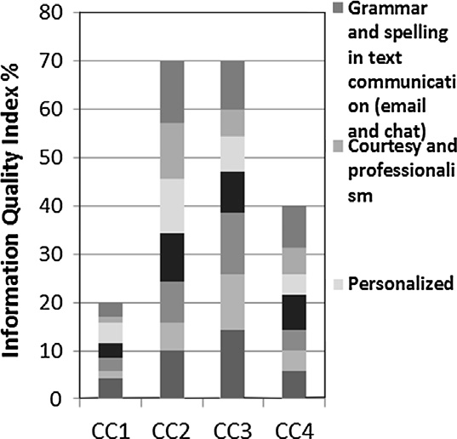

Adheren ce to protocol

Error/re work rate

50

45

40

**Service Quality Index %**

35

30

25

20

15

10

5

0

CC1 CC2 CC3 CC4

 Transfer rate

 First-call resolutio n rate

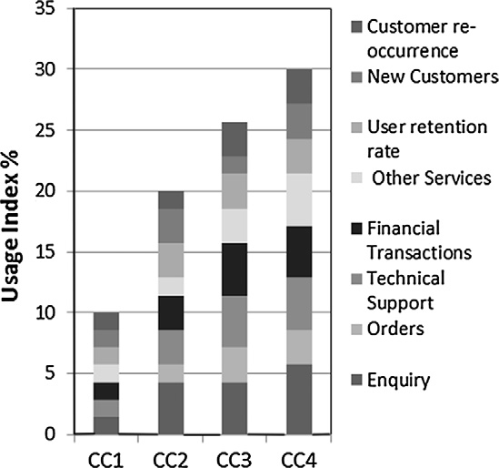

 Adheren ce to protocol

 Error/re work rate

 Knowled ge and compete

Figure 3 Distribution of system quality success index indicators.

ncy

Figure 5 Distribution of service quality success index indicators.

Figure 4 Distribution of information quality success index indicators.

Figure 6 Distribution of usage success index indicators.

performance evaluation. The tool is composed of five main modules: the model definition module, the performance indices module, the Input Data module, the calculation module, and the reporting module. Fig. 2 shows the different modules of CCPET as applied to the call centers.

The model definition module allows the definition of the evaluation models to be adopted in the evaluation, i.e. several models can be used through the assessment. The user needs to define the name of the model and the number and names of dimensions for this model. For example 6 dimensions in the case of the Delone and Mclean model, seven dimensions for the Heeks’ Design Reality Gap model, three dimensions for the NAQC [7], and in the case of a single dimension model (SDM) the number of dimensions is one without any categori- zation. This module also defines the indicators for each dimen- sion and the relative weight of the dimension.

Two performance indices are defined for the performance indices module: the success index and the Gap Index. The user

* 1. *Analytical results using success index and Gap Index for Delone and Mclean and Heeks’ Design Reality Gap model models*
     + In this section, the performance evaluation for four call cen- ters using both the Delone and Mclean model and Heeks’

Design Reality Gap model is studied. The objective of this section is to apply the two models studied in this paper, and analyze the results obtained.

* + - Indicators values calculation: for hard indicators the data for the four call centers were collected monthly for one year.

Four sets of surveys have been conducted for 100 users using IVR, and phone calls. Aggregation of the results is based on averaging the values collected for each indicator.

 Availability

100

selects the index to be used in the analysis. The Input Data 90

module allows the user to provide the system with the required

data: the values of the different indicators, the value of the 80

design values or benchmark values, and the values of the

weights used for the different dimensions. The calculation 70

**System Quality Index %**

module calculates the performance index based on the Input 60

Data and the choices of the user.

50

40

30

Schedule adherence

Schedule efficiency

Staff shrinkage

Agents occupancy

Longest delay in queue

Average speed of answer

40 Cost per

35 call

**User Satisfaction Index %**

30 Conversi

25 on rate

20

On-hold

15 time

10

After-call

20

10

0

CC1 CC2 CC3 CC4

 Service level

 Self-service availability

 Abandons

 Hours of operation

 Blockage

5

0

CC1 CC2 CC3 CC4

work time

Average

Figure 9 Distribution of system quality Gap Index indicators.

handle time

Figure 7 Distribution of user satisfaction success index indicators.

100

90

80

70

**Information Quality Index %**

Grammar and spelling in text communicatio n (email and chat)

Courtesy and

professionalis m

18

16

14

**Net Benefits Index %**

12

10

8

6

4

2

0

CC1 CC2 CC3 CC4

Return on Investment

Productivit y

Profit

Global Reach

Market share

Increased sale

Growth in customer base

60

50

40

30

20

10

0

CC1 CC2 CC3 CC4

 Personalized

 Accuracy in data entry and call coding

 Secure

 Complete

Figure 8 Distribution of net benefits success index indicators.

Figure 10 Distribution of information quality Gap Index

indicators.

* + - * CCPET allows to define the indicators used, entering the values, and the calculation of the average value per

indicator.

* + - * The tool also allows the calculation of the two indexes suc- cess and Gap Index.
      * Table 18 depicts the resulting data for the four call centers under study for the Delone and Mclean model. The two

indices proposed are calculated, for example for dimension D1, GI for D1 is 18.67%, the overall Gap Index for call center 1 is 84.89%, while the success index for the same call center is 15.11%. it is clear from the data collected to this call center that the performance of the call center for all the dimensions of Heeks is poor, this means that the design of this call center from a technology and skills needed to operate the call center needs a serious revision.

* + - * Table 19 depicts the results of calculations of the case of applying Heeks’ Design Reality Gap model. It is to be

noted that the resulting overall Gap Index and success index are equal to those resulting from the Delone and Mclean model; this is due to using the same parameters in the two models. Moreover, the calculation of the Gap Index

quality dimension. For the net benefits dimension, the call cen- ter 3 has the lowest value of gap as shown in Fig. 8. Similarly, Figs. 9–14 show the distribution of the Gap Index for the Delone and Mclean model. Results using the Gap Index con- firm the results of the success index; call center 4 has the lowest system quality dimension Gap Index.

*4.4. Call center evaluation using Heeks’ Design Reality Gap model*

In this section, the performance evaluation for the four call centers using Heeks’ Design Reality Gap model is imple- mented. CCGI in its simplest form was calculated as the sum- mation of the Design Reality Gap model dimensions’ index (Review Section 3 of ‘‘Call Center Gap Index’’ and Eq. (2)).

Figs. 15–21 depict the Gap Index distribution for the different indicators for each of the seven dimensions of the Heeks’ Design Reality Gap model. For example, Fig. 15 shows the distribution of the information gap dimension function of the indicators defined for this dimension. For the

is not based on benchmarking values. This interprets the value of the gap dimension to be equal to (100 – Success Dimension). It is clear that the main strength for the Design Reality Gap model is to use Benchmarking values to reflect the real gap.

* 1. *Call center evaluation using Delone and Mclean model*

In this section, the success index as well as the Gap Index for the Delone and Mclean model is calculated. Applying the Design Reality Gap model in the Delone and Mclean model means that the same approach proposed by Heeks was applied to the dimensions proposed by the Delone and Mclean model. Figs. 3–8 depict the Gap Index distribution for the different indicators defined for the six dimensions of the Delone and Mclean model. Call center 4 as shown in Fig. 3 is the top center in the system quality dimension index. Call centers 2 and 3 as shown in Fig. 4 have the best performance for the Information

100

90

80

70

60

**Usage Index %**

50

40

30

20

10

0

CC1 CC2 CC3 CC4

 Customer re- occurrence

 New Customers

 User retention rate

 Other Services

 Financial Transactions

 Technical Support

Orders

 Enquiry

Figure 12 Distribution of usage Gap Index indicators.

100

90

80

70

**Service Quality Index %**

60

50

40

30

20

10

0

CC1 CC2 CC3 CC4

 Transfer rate

 First-call resolution rate

 Adherence to protocol

 Error/rework rate

 Knowledge and competency

 Telephone etiquette

100

90

80

**User Satisfaction Index %**

70

60

50

40

30

20

10

0

CC1 CC2 CC3 CC4

Cost per call

Conversion rate

On-hold time

After-call work time

Average handle time

Figure 11 Distribution of service quality Gap Index indicators. Figure 13 Distribution of user satisfaction Gap Index indicators.

100

90

80

70

**Net Benefits Index %**

60

50

40

30

20

10

0

 Return on Investment

 Productivity

Profit

Global Reach

 Market share

 Increased sale

 Growth in

100

90

80

**Processes gap index (%)**

70

60

50

40

30

20

10

0

CC1 CC2 CC3 CC4

 Financial Transactions

 Other Services

 First-call resolution rate

 Technical Support

Orders

 Enquiry

CC1 CC2 CC3 CC4

customer base

Figure 17 Distribution of processes Gap Index indicator.

Figure 14 Distribution of net benefits Gap Index indicators.

100

90

80

**Information Gap index (%)**

70

60

50

40

30

20

10

0

Grammar and spelling in text communicatio n (email and

chat) Personalized

Accuracy in data entry and call coding

Secure

Complete

100

90

**Objectives and values gap index (%)**

80

70

60

50

40

30

20

10

0

CC1 CC2 CC3 CC4

 Market share

 Increased sale  Growth in

customer base

 Customer re- occurrence

 New Customers

 User retention rate

 Global Reach

CC1 CC2 CC3 CC4

Figure 15 Distribution of information Gap Index indicator.

Figure 18 Distribution of objectives and values Gap Index

indicator.

100

90

80

**Technology Gap index (%)**

70

60

50

40

30

20

10

0

CC1 CC2 CC3 CC4

 Availability

 Transfer rate  Error/rework

rate

On-hold time

 Longest delay in queue

Average speed of answer

 Service level

Self-service availability

 Abandons

 Hours of operation

 Blockage

100

90

**Staffing and Skills gap index (%)**

80

70

60

50

40

30

20

10

0

CC1 CC2 CC3 CC4

 Knowledge and competency

 After-call work time

 Average handle time

 Adherence to protocol

 Telephone etiquette

 Courtesy and professionalis m

 Staff shrinkage

 Agents occupancy

Figure 16 Distribution of technology Gap Index indicator.

Figure 19 Distribution of staffing and skills Gap Index

indicator.

100

**Management Systems and structures gap index (%)**

90

80

70

60

50

40

30

20

10

0

CC1 CC2 CC3 CC4

 Schedule adherence

 Productivity

 Schedule efficiency

Gap Index the lower is the performance of the call center. From Fig. 15, it can be deduced that call center 3 is the best call center from the information dimension. Call center 2 has the lowest value of gap for the blockage indicator under tech- nology dimension as shown in Fig. 16.

*4.5. Comparison of performance and gap indices for call centers using both Delone and Mclean model and Heeks’ Design Reality Gap model*

In this section, a comparison is made for the two models under study using the two performance indices used: the performance index and the Gap Index. Call center 1 is the highest perfor- mance call center according to Delone and Mclean model and Heeks’ Design Reality Gap model. Figs. 22 and 23 repre-

Figure 20 Distribution of management systems and structures Gap Index indicator.

100

90

sent the analysis for the Delone and Mclean model, while Figs. 24 and 25 represent the results for the Heeks’ Design Reality Gap model.

Analyzing these results and comparing it with the results obtained for the Delone and Mclean model, a number of observations can be deduced as follows:

80

**Other Resources gap index (%)**

70

60

50

40

30

20

10

0

CC1 CC2 CC3 CC4

 Return on Investment

 Profit

 Conversion rate

Cost per call

* Application of success index and Gap Index for the two models is valid.
* The two models are providing the same results in case the reality value used for Heeks’ Design Reality Gap model is

equal to 100.

* In order to get the maximum benefit of the Heeks’ Design Reality Gap model, the real benchmark value for the

indicators should be used otherwise the two models are very much similar.

* The use of an overall index for the call center whether suc- cess index or Gap Index is providing the top management

an overall figure that reflects the overall performance of the call centers.

* Grouping indicators under one dimension whether in the

Figure 21 Distribution of other resources Gap Index indicator.

sub-dimension indicators are proposed for each of the seven dimensions. Six indicators are defined for the information gap dimension. The overall Gap Index for dimension informa- tion gap for call center 1 is 78%. The higher the value of the

Delone and Mclean model or Heeks’ Design Reality Gap

model allows the identification of the area or dimension that faces challenges. The grouping model should be aligned with the priorities the call center provider is setting.

* + - Proposing success index and Gap Index at the level of the dimension allows analyzing the issues related to a certain

dimension, i.e. diagnosing the points of weakness and strength for the dimension.

20

18

16

14

**Gap Index (%)**

12

10

8

6

4

2

0

D1 D2 D3 D4 D5 D6

 CC1  CC2  CC3  CC4

Figure 22 D&M Gap Index distribution by dimension.

Information systems performance evaluation 21

Figure 23 D&M performance distribution index by dimension.

Figure 24 Heeks Gap Index distribution by dimension.

Figure 25 Heeks performance index distribution by dimension.

* The call centers’ scorecard can be composed of 14 values in the case of Delone and Mclean model and 16 values in the

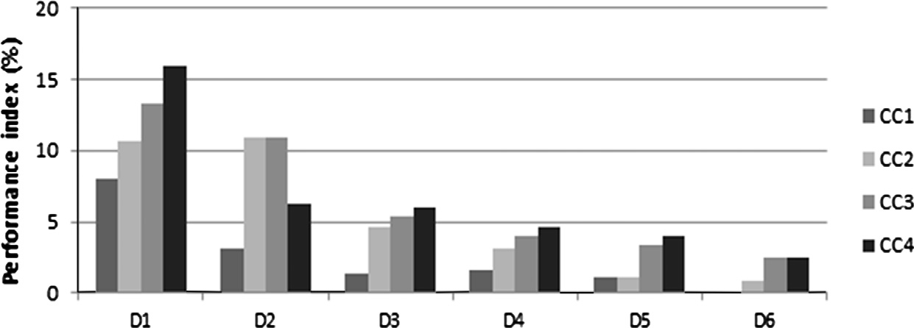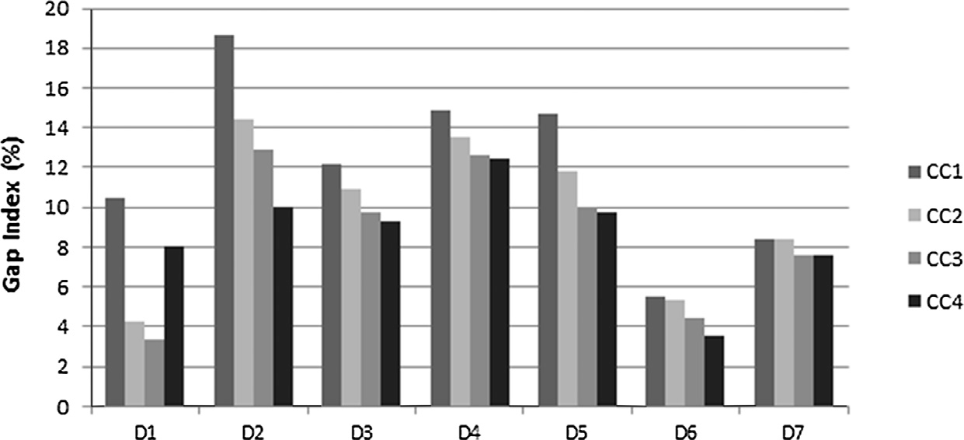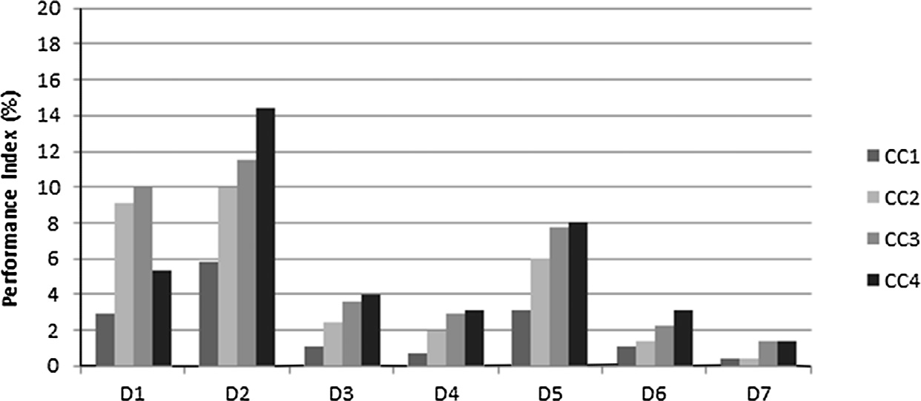

case of Heeks’ Design Reality as follows:

* + The success index.
  + The Gap Index (measured by the benchmark values).
  + The dimensions indices/gap values (6 figures in the case of Delone and Mclean model and 7 figures in the case of Heeks’ Design Reality model).
* The scorecard is a simple way to monitor such complex sys- tems such as call centers. A maximum of 16 values are mon-

itored periodically by the top management.

1. Conclusion and future research

This paper studies the performance evaluation techniques for information systems with the call centers as a case study.

Two models have been used, the Delone & Mclean model and the Design Reality Gap model.

The two levels evaluation technique used is summarized as follows: the first level is simply not to use any modeling tech- nique, so using the indicators for the call centers as if they are mapped to one single dimension, and you get the system to cal- culate your success index and the Gap Index. If the results are satisfactory then actually you do not need to get into more detailed analysis. If results are not satisfactory then you need to select one of the two models the Delone and Mclean model or Heeks’ Design Reality Gap model in order to analyze the overall result obtained from the first step. This will allow iden- tifying which dimension is impacting call center performance. So, first level means to use the tool without any model to get the overall call center performance.

The work presented in this paper is a continuation to our previous report [14], which has shown the applicability of Delone and Mclean model to call centers, and introduced the

success index to measure the performance of each dimension and the overall index.

The overall approach for the two papers is the same, sum- marized in the following three main steps:

* The modeling using Heeks’ Design Reality Gap model.
* The modeling using Delone and Mclean model.
* Measuring using the success index and Gap Index, and the analysis using the CCPET.

In this paper and our previous report [14] the models introduced by Delone and Mclean model and Heeks’ Design Reality Gap model were applied without modification; hence the figures are the same as these figures represent the two models.

The Design Reality Gap model introduced by Heeks was used in this paper to evaluate the performance of call centers. A new metric is used for measuring the performance ‘‘Gap Index’’.

A comparison is made between the Delone and Mclean model and Heeks model. A tool is developed to facilitate the evaluation process and to be used to analyze different model- ing techniques.

The main benefit of the Design Reality Gap model is to measure the gap, the gap between the design value and the real value during the operation and implementation of the informa- tion system. The gap is measured for every dimension; the overall Gap Index gives an overall metric for the call center. Use of Benchmark values for the Heeks’ Design Reality Gap model gives the call centers mangers a method to benchmark their centers.

The work demonstrates that using Heeks’ Design Reality Gap model and/or Delone model can be a feasible technique to model call centers. Gap Index is a better metric to measure the performance especially when Industry Benchmark values are used.

As a conclusion of this research, it was found that the two models reflect the same results when no benchmark values are used for the Heeks’ Design Reality model, especially that the same indicators are used. Hence, it is really crucial in the case of applying Heeks’ Design Reality model to calculate the Gap Index based on the Industry Benchmark values for the differ- ent indicators. Two indices are defined to calculate the perfor- mance of the call center namely the success index and the Gap Index. Indicators grouping per dimension and calculation of an index on the level of dimension make it clear for the deci- sion maker to see the scorecard for the call center. The score- card will be composed of the success index, the Gap Index, and the success index per dimension (6 or 7 numbers based on the model used Delone and Mclean or Heeks’ Design Reality model) and the Gap Index per dimension (6 or 7 numbers based on the model used). This scorecard should be generated monthly so that top managers monitor continuously the per- formance of their call centers. An evaluation tool has been developed to allow call centers managers to evaluate the per- formance of their call centers in a systematic analytical approach. Results showed the importance of using informa- tion systems models to evaluate complex systems as call cen- ters. The models used allow identifying the dimensions for the call centers that are facing challenges, together with an identification of the individual indicators in these dimensions that are causing the poor performance of the call center.

As future work, a study for specific indicators related to specific verticals may enhance the analysis of the call centers specialized in specific field, for example includes financial sec- tors, or health sectors. This may result in adding a specific dimension that is a vertical specific to include indicators related to the vertical. Moreover, analyzing the association of different weights for the model is based on numerical anal- ysis, more research should be done in this area in order to iden- tify the proper weights for each dimension, and whether there is any correlation between these weights and the type of the product or service provided by the call center. Also, there is a need to develop an automated assessment tool that can be used by decision makers to evaluate and benchmark the call centers. One important characteristic of this tool is that it could be integrated to the existing call center monitoring sys- tems, allowing seamless communication and exchange of data between the tool developed (similar to CCPET) and the mon- itoring system in place.

References

1. [Duening Thomas N, Click Rick L. Essentials of business process](http://refhub.elsevier.com/S1110-8665(14)00038-3/h0005) [outsourcing. John Wiley & Sons, Inc.; 2005](http://refhub.elsevier.com/S1110-8665(14)00038-3/h0005).
2. Ministry of Communications and Information Technology Egypt.

<[http://www.mcit.gov.eg](http://www.mcit.gov.eg/)>.

1. [Ganapathy K. Telehealth in India: the Apollo contribution and an](http://refhub.elsevier.com/S1110-8665(14)00038-3/h0015) [overview. Apollo Med 2014;11(3):201–7](http://refhub.elsevier.com/S1110-8665(14)00038-3/h0015).
2. Bapat V, Pruitte EB, Jr. Using simulation in call centers. In: 1998 winter simulation conference. Proceedings, IEEE, Piscataway, NJ, USA; 1998. p. 1395–99.
3. [Aguir S, Karaesmen Fikri, Ak](http://refhub.elsevier.com/S1110-8665(14)00038-3/h0025)←s[in O Zeynep, Chauvet Fabrice.](http://refhub.elsevier.com/S1110-8665(14)00038-3/h0025) [The impact of retrials on call center performance. OR Spectrum](http://refhub.elsevier.com/S1110-8665(14)00038-3/h0025) [2004;26(3):353–76](http://refhub.elsevier.com/S1110-8665(14)00038-3/h0025).
4. [Aksin Z, Armony Mor, Vijay M. The modern call center: a multi-](http://refhub.elsevier.com/S1110-8665(14)00038-3/h0030) [disciplinary perspective on operations management research. Prod](http://refhub.elsevier.com/S1110-8665(14)00038-3/h0030) [Oper Manage 2007;16(6):665–88](http://refhub.elsevier.com/S1110-8665(14)00038-3/h0030).
5. NAQC issue paper. North American Quitline Consortium, 2010. Call center metrics: best practices in performance measurement and management to maximize quitline efficiency and quality.

<[http://c.ymcdn.com/sites/www.naquitline.org/resource/resmgr/](http://c.ymcdn.com/sites/www.naquitline.org/resource/resmgr/issue_papers/callcentermetricspaperbestpr.pdf) [issue_papers/callcentermetricspaperbestpr.pdf](http://c.ymcdn.com/sites/www.naquitline.org/resource/resmgr/issue_papers/callcentermetricspaperbestpr.pdf)>.

1. [Jaiswal, Kumar Anand. Customer satisfaction and service quality](http://refhub.elsevier.com/S1110-8665(14)00038-3/h0040) [measurement in Indian call centres. Managing Service Qual](http://refhub.elsevier.com/S1110-8665(14)00038-3/h0040) [2008;18 4:405–16](http://refhub.elsevier.com/S1110-8665(14)00038-3/h0040).
2. [Delone W, Mclean E. Information systems success: the quest for](http://refhub.elsevier.com/S1110-8665(14)00038-3/h0045) [the dependent variable. Inform Syst Res 1992;3(1):60–95](http://refhub.elsevier.com/S1110-8665(14)00038-3/h0045).
3. [Heeks R. Information systems and developing countries: failure,](http://refhub.elsevier.com/S1110-8665(14)00038-3/h0050) [success, and local improvisations. Inform Soc 2002;18(2):101–12](http://refhub.elsevier.com/S1110-8665(14)00038-3/h0050).
4. [Delone W, Mclean E. Measuring e-commerce success: applying](http://refhub.elsevier.com/S1110-8665(14)00038-3/h0055) [the Delone & Mclean information systems success model. Int J](http://refhub.elsevier.com/S1110-8665(14)00038-3/h0055) [Electron Commerce 2004;9(1):31–47](http://refhub.elsevier.com/S1110-8665(14)00038-3/h0055).
5. [Heeks R. Most e-government-for-development projects fail: how](http://refhub.elsevier.com/S1110-8665(14)00038-3/h0060) [can risks be reduced? Manchester: Institute for Development](http://refhub.elsevier.com/S1110-8665(14)00038-3/h0060) [Policy and Management, University of Manchester; 2003](http://refhub.elsevier.com/S1110-8665(14)00038-3/h0060).
6. [Hawari A, Heeks R. Explaining ERP failure in a developing](http://refhub.elsevier.com/S1110-8665(14)00038-3/h0065) [country: a Jordanian case study. J Enterprise Inform Manage](http://refhub.elsevier.com/S1110-8665(14)00038-3/h0065) [2010;23(2):135–60](http://refhub.elsevier.com/S1110-8665(14)00038-3/h0065).
7. [Baraka Hesham A, Baraka Hoda A, EL-Gamily Islam H.](http://refhub.elsevier.com/S1110-8665(14)00038-3/h0070) [Assessing call centers success: a validation of the Delone and](http://refhub.elsevier.com/S1110-8665(14)00038-3/h0070) [Mclean model for information system. Egyptian Inform J](http://refhub.elsevier.com/S1110-8665(14)00038-3/h0070) [2013;14(2):99–108](http://refhub.elsevier.com/S1110-8665(14)00038-3/h0070).
8. Anton, Jon, Gustin, David. Call center benchmarking: how good is. Purdue University Press e-books. Book 1; 2000.