

[Egyptian Informatics Journal (2015) 16, 23–28](http://dx.doi.org/10.1016/j.eij.2014.11.002)

Cairo University

Egyptian Informatics Journal

[www.elsevier.com/locate/eij](http://www.elsevier.com/locate/eij) [www.sciencedirect.com](http://www.sciencedirect.com/science/journal/11108665)

ORIGINAL ARTICLE

Innovative energy resourceful merged layer technique (MLT) of node deployment to enhance the lifetime of wireless sensor networks



S.G. Susila a,b,*, J. Arputhavijayaselvi c

a *Anna University Chennai, Tamil Nadu 600 025, India*

b *Dept. of ECE, Anna University Chennai, BIT Campus, Tiruchirappalli, Tamil Nadu 620 024, India*

c *Dean R&D, Kings College of Engineering, Pudukottai, Tamil Nadu 613 303, India*

Received 20 February 2014; accepted 30 November 2014

Available online 29 December 2014

Abstract A wireless sensor network (WSN) is consisting of anthology of large number of small sensor nodes which are deployed in a defined area to observe the surroundings parameters. Since, energy con- sumption is significant challenge in WSN. As sensor nodes are equipped with battery which has limited energy. Energy efficient information processing is most importance for many routing protocols were proposed to increase the lifetime of WSN. In order to improve the lifetime of WSN, the proposed MLT routing protocol has implemented where the sensor nodes are randomly deployed in the field. The merged layer node deployment pattern of the sensor nodes system operation maximizes the working time of full coverage in a given WSN. MLT provides energy-balancing while selecting cluster head (CH) for each round. The cluster head selection mechanism is essential and has same procedure like Low Energy Adaptive Clustering Hierarchy (LEACH) in MLT protocol. The main idea of this paper is combine two layers of sensor nodes which are belonging to the same set but in different group to improve the lifetime of WSN. MATLAB simulations are performed to analyze and compare the per- formance of MLT with LEACH protocol. The obtained simulation output has enhanced results and superfluous lifetime compared to other protocols.



* Corresponding author at: Dept. of ECE, Anna University Chennai, BIT Campus, Tiruchirappalli, Tamil Nadu 620 024, India.

KEYWORDS

Clustering concept; Homogeneous system; Heterogeneous system; Merged Layer node deploy- ment techniques (MLT); Wireless sensor network

E-mail addresses: [rsksusi@gmail.com](mailto:rsksusi@gmail.com) (S.G. Susila), [dean@kingsindia.](mailto:dean@kingsindia.net) [net](mailto:dean@kingsindia.net) (J. Arputhavijayaselvi).

Peer review under responsibility of Faculty of Computers and Information, Cairo University.

**Production and hosting by Elsevier**

1. Introduction

Wireless sensor networks (WSNs) are serene of many small sensor nodes with limited battery power. Routing techniques are the most important issue for networks to save the energy in [1,2]. Each sensor is limited in their energy level, by limit the processing power and sensing ability. Thus a network of these sensors gives rise to a more robust, reliable and accurate

<http://dx.doi.org/10.1016/j.eij.2014.11.002>

1110-8665 © 2014 Production and hosting by Elsevier B.V. on behalf of Faculty of Computers and Information, Cairo University. This is an open access article under the CC BY-NC-ND license [(http://creativecommons.org/licenses/by-nc-nd/4.0/).](http://creativecommons.org/licenses/by-nc-nd/4.0/)

24 S.G. Susila, J. Arputhavijayaselvi

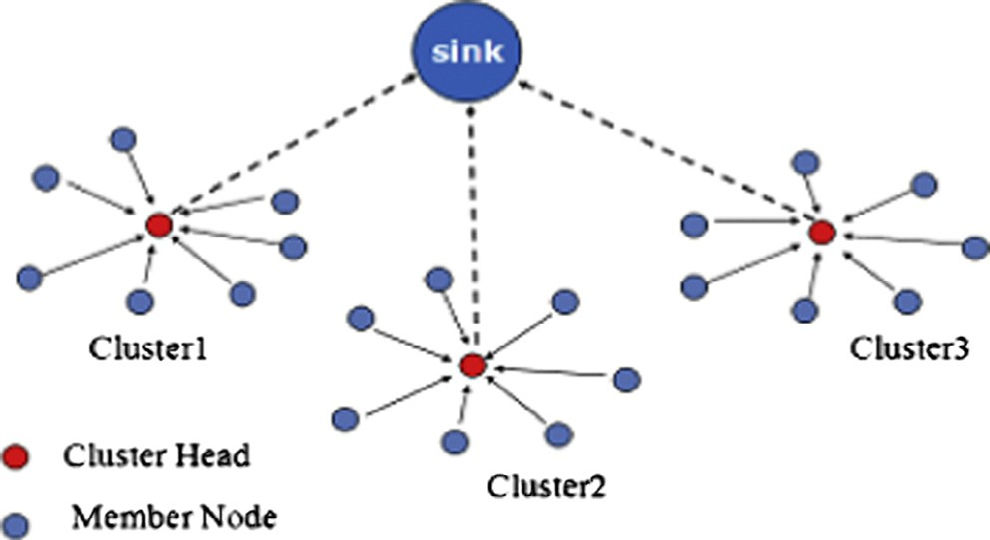

network. New applications have been introduced by many research scholars in various areas, like remote and hostile regions as seen in the military for battle field surveillance, mon- itoring the enemy land, detection of attacks and security pro- priety information delivery.

An extravagant use of the available energy leads to poor performance the network. To this end, energy in these sensors is a rare resource and must be managed in an efficient manner. In this chapter, we proposed algorithm is implemented in homogeneous and heterogeneous system where merged layer technique (MLT) node deployment system of network helps to improve the power economy in WSN. In this case random deployment of nodes is deployed in two layers with same energy and same probability of head selection procedure. Two layer sensor nodes are belonging to same set but in differ- ent group. According to the LEACH principle the sensor nodes are transmitting their sensed data to CH and CH trans- mits aggregated data to base station (BS). The merged layer concept network has better results compared with LEACH protocol.

The formations of these chapters are as follows. We briefly review the related work in Section 2. Section 3 describes heterogeneous sensor network system. A sensor network model is analyzed in Section 4. In Section 5, we present MLT protocol. Simulation results of the proposed protocol are discussed in terms of energy consumption, num- ber of live nodes per round, separate base station location for two layer sensor nodes and comparative result graphs in Section 6. Finally, in Section 7 bring to an end of the pro- posed algorithm and future works.

1. Related works

Hierarchical routing technique in [3,4] is one of the effective techniques to maintain the energy saving of sensor nodes to improve the lifetime of the WSNs in [5,6]. It has multi-hop communication within a particular cluster and sensor nodes by performing data aggregation and transmits the data to the sink in [7,8].

* 1. *Low-energy adaptive clustering hierarchy (LEACH) protocol*

LEACH (Heinemann et al., 2002) is the first hierarchical rout- ing protocol for sensors networks. The idea proposed in LEACH has been an encouragement for many protocols in [9–11]. In LEACH, formation of clusters among the sensor nodes is based on the elected cluster heads for routers to the base station (BS) in [12]. The selection of cluster heads in [13,14] is followed by Eq. (1).

Figure 1 LEACH protocol.

* 1. *Stable Election Protocol (SEP)*

A Stable Election Protocol (SEP) is improved version of LEACH protocol in [15]. In this protocol heterogeneous sen- sor nodes are used in wireless sensor networks. This protocol has operation like LEACH but in two different energy nodes. SEP based on weighted election probabilities of each node to become cluster head according to their respective energy. This approach ensures that the cluster head election is randomly selected and distributed based on the fraction of energy of each node assuring a uniform use of the nodes energy. In SEP, two types of nodes (normal and advanced) are considered [16]. It is based on weighted election probabilities of each node to become cluster head. This prolongs the stability period i.e. the time interval before the death of the first node.

* 1. *Cluster head relay routing protocol for heterogeneous sensor networks*

A cluster head relay (CHR) routing protocol for heteroge- neous sensor networks in [17]. This protocol uses two types of sensors to form a heterogeneous network with a single sink: a large number of lower-energy sensors and a small number of higher-energy sensors. Both types of sensors are static and aware of their locations using some location service. More- over, both types are uniformly and randomly distributed in a defined area. The CHR protocol partitions the heterogeneous network into clusters, each being composed of both lower and higher energy sensors. Within a cluster, the lower energy sen- sors are in charge of sensing the environment and forwarding data packets originated by other lower energy sensors toward their cluster head in a multi-hop transmission. The higher energy sensors, on the other hand, are responsible for data fusion within their own clusters and forwarding aggregated data packets from other cluster heads toward the sink in a multi-hop transmission by only cluster heads.

*T*(*n*) =

*p*

1—*p*\*(*r mod* 1)

(

*p*

if *n* ∈ *G*

(1)

1. Performance measures of heterogeneity

0 otherwise

where ‘*P*’ is desired percentage of cluster head nodes in the sen- sor network, ‘*r*’ is current round number and ‘*G*’ is the set of nodes that have not been cluster heads in the last 1*/P* rounds. The concept of LEACH is depicted in Fig. 1.

Some performance measures that are used to evaluate the per- formance of clustering protocols are listed below for heteroge- neity of WSNs in [18]. Network lifetime (stability period): It is the time interval from the start of operation (of the sensor net- work) until the death of the first alive node. Number of cluster heads per round: Instantaneous measure reflects the number of

nodes which would send directly to the base station, informa- tion aggregated from their cluster members. Energy Efficiency: The Innovative ways for Smart Energy consumption. Number of live nodes per round: This instantaneous measure reflects the total number of nodes and that of each type that has not yet expended all of their energy. Throughput: This includes the total rate of data sent over the network, the rate of data sent from cluster heads to the base station as well as the rate of data sent from the nodes to their cluster heads

1. Energy model of sensor network
   1. *Network model*

The following properties are assumed for the sensor nodes in the network energy model in Fig. 2.

* + - The sink node locates at the center of field area and has enough memory and computing capability.
    - The WSNs consist of the heterogeneous sensor nodes. Per- centage of sensor nodes are equipped with more energy

resources than the rest of the nodes. Let ‘*m*’ be the fraction of the total number of nodes ‘*n*’ which are equipped with alpha times more energy than the others.

* + - The distance can be measured based on the wireless radio

signal power.

* + - All sensor nodes are immobile and have a limited energy.
    - All nodes are equipped with power control capabilities to vary their transmitting power.

Radio energy dissipation model adopted wireless channel models in the reference. Thus, to transmit a 1-bit message a distance ‘*d*’, the radio expends:

( *kEelec* + *k*e*fsd*2 *d* < *d*0

are deployed in two layers with same energy and same proba- bility of head selection procedure. These two layers are sand- wiched and belonging to same set, but in different group. According to the LEACH formula the nodes are transmitting their data to the CH and CH transmits aggregated data to the BS. The merged layer concept network has better results com- pared with LEACH Protocol which is followed the same procedure.

* 1. *Homogeneous merged layer LEACH system*

In proposed HHMTL algorithm, Homogeneous Merged Layer LEACH system of sensor node deployment has 50 sen- sor nodes are in blue color and other 50 sensor nodes are in red color. These two layer sensor nodes are deployed and merged in the same set but in different group. As like the LEACH operation, after certain rounds the sensor nodes are lose their energy and going to be a dead node. Dead nodes are indicated as red dot after drain out its energy at certain rounds. The sen- sor node deployment for two layers with its base station located at (45 m, 45 m) and (55 m, 55 m) indicated in Fig. 3.

The data transmission from each sensor node to its CH and CH to BS could consume large amount of energy in separate BS of two layers. The two base-stations are located at (45 m, 45 m) and (55 m, 55 m). As a result, by providing common base station at center (50 m, 50 m) for each layer sensor nodes to have less consumption of energy for data communication than the separate base station for both layers is shown in Fig. 4. From the graph the homogeneous merged layer LEACH with common BS system yield better result of energy consumption with lifetime improvement.

* 1. *Heterogeneous sensor networks*

Two different energy level sensor nodes are forming heteroge-

*ETX*(*k*; *d*)=

*kEelec*

+ *k*e

*amp*

*d*4 *d* P *d*0

(2)

neous system of network, such as fewer nodes are having higher energy than the other nodes in the same random

The electronics energy *Eelec* depends on factors such as the dig-

ital coding, filtering and reading of the signal, whereas the amplifier energy, e*fs*, *d*2, e*mp*, *d*4, depends on the distance to the receiver and the acceptable bit error rate and do is a dis- tance constant.

To receive this message, the radio expends:

*ERx*(*d*) = *kEelec* (3)

1. Proposed merged layer node deployment technique (MLT)

routing algorithm to enhance lifetime of WSN

The proposed algorithm is for homogeneous and heteroge- neous system of merged layer node deployment leach tech- nique (MLT). In these random deployments of sensor nodes

deployment of defined area. Energy efficient cluster head elec- tion protocol for heterogeneous wireless sensor network is pro- posed by LI Han 2010. One of the improved algorithms to construct an inter cluster routing in wireless sensor networks. It considered three types of sensor nodes.

1. Normal nodes which are lower energy.
2. Some fraction of the sensor nodes is assign higher energy than that of nodes called advanced nodes.
3. Cluster head nodes, sets up a TDMA schedule and trans- mits this schedule to the nodes in the cluster.

It assumed that all the sensor nodes are uniformly distrib- uted. In this protocol, the cluster head node and also allows the radio components of each non-cluster head node to be

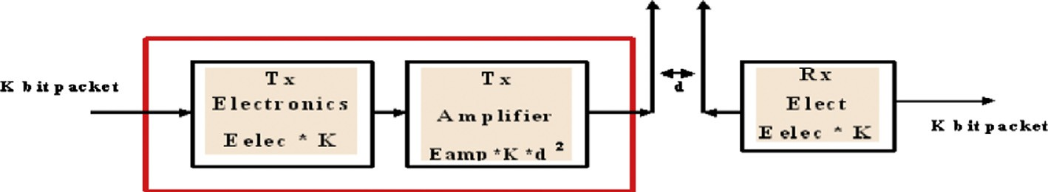

Figure 2 Radio energy model.

100

90

80

70

60

50

40

30

20

10

0

HOMO MER LAYER-SBS

HOMO MER LAYER LEACH NODE DEPLOYMENT 100

90

80

70

60

50

40

30

20

10

0

0 10 20 30 40 50 60 70 80 90 100 0 10 20 30 40 50 60 70 80 90 100

Figure 3 Homogeneous merged layer node deployment with two and single BS.

100

Homo LEACH

Homo Mer LEACH( 45,45)m,(55,5) Homo Mer LEACH (50,50)m

90

80

No. of Alive Nodes

70

60

50

40

30

20

10

0

HomoLEACH Vs Homo Merged Layer LEACH

at certain rounds. The sensor node deployment for two layers with its base station located at (45 m, 45 m) and (55 m, 55 m) indicated in Fig. 5. The data transmission from each sensor node to its CH and CH to BS could consume large amount of energy in separate BS of two layers. The two base-stations are located at (45 m, 45 m) and (55 m, 55 m). As a result, by providing common base station at center (50 m, 50 m) for each layer sensor nodes to have less consumption of energy for data communication than the separate base station for both layers is shown in Fig. 6. From the graph the heterogeneous merged

layer LEACH with common BS for two layers yield better

0 500 1000 1500 2000 2500

No. of Rounds

Figure 4 Comparison of homogeneous merged layer LEACH with separate BS and common BS with homogeneous LEACH protocol.

turned off at all times except during their transmit time, thus minimizing the energy dissipated by the individual sensors.

In order to reduce the energy consumption of the cluster heads which are far away from the base station and balance the energy consumption of the cluster heads which are close to the base station, a multi-hop routing algorithm of cluster head has been presented, which introduces into the restriction factor of remainder energy when selects the short-term nodes between cluster heads and base station, and also the minimum spanning tree algorithm has been included. The protocol can not only reduce the consumption of transmit energy of cluster head, but also the consumption of communication energy between non-cluster head and cluster head nodes. Simulation results show that this protocol performs better than LEACH in terms of network lifetime. For that our proposed algorithm also implements the heterogeneity properties to improve the lifetime of WSN. Such as in merged layer 10% of nodes are higher energy advanced nodes than the normal nodes deploy- ment in (100 m, 100 m) field. This made better performance than that of normal LEACH heterogeneity.

In proposed HHTML algorithm, Heterogeneous Merged Layer LEACH node deployment has 50 nodes are in blue color and other 50 nodes are in red color. These two layer nodes are deployed and merged in the same set but in different group. In this heterogeneity 10% of nodes have higher energy from each layer. Those nodes are indicated by green (+) and red (+) col- ors. As like the LEACH operation, after certain rounds the sensor nodes are lose their energy and going to be a dead node. Dead nodes are indicated as red dot after drain out its energy

result of energy consumption with lifetime improvement.

1. Analysis of simulation results
   1. *Energy consumption analysis*

The performance of HHMLT is compared with the original LEACH in terms of energy is shown in Fig. 7. The energy con- sumption of the network is decreased while using merged layer technique of sensor node deployment for data transmission from CHs to the BS. This is due to the gain of the energy dis- sipated by cluster heads to the base station. From the graph it is clear that HHMLT can achieve better energy savings than LEACH protocol. The used simulation parameters are shown in Table 1.

* 1. *Network lifetime*

The number of nodes alive for each round of data transmission is observed for HHMLT algorithm to evaluate the lifetime of the network. The overall homogeneous and heterogeneous merged layer concept of separate BS and single BS is evidently compared with homogeneous and heterogeneous LEACH pro- tocol. The foremost observation is heterogeneous merged layer single BS for both layer LEACH concept is produced the best result of energy consumption and lifetime improvement. It is clearly depicted in Fig. 7.

* 1. *Result analysis*

From our simulation, we observed the followings from Fig. 7.

* + - HHMLT achieves better energy savings than LEACH protocol.

Heterogeneous merged layer with separate base station Heterogeneous merged layer with single BS

|  |  |
| --- | --- |
| 100 | 100 |
| 90 | 90 |
| 80 | 80 |
| 70 | 70 |
| 60 | 60 |
| 50 | 50 |
| 40 | 40 |
| 30 | 30 |
| 20 | 20 |
| 10 | 10 |

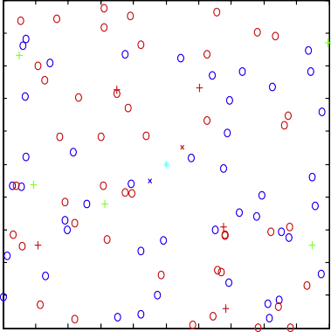00 10 20 30 40 50 60 70 80 90 100

0

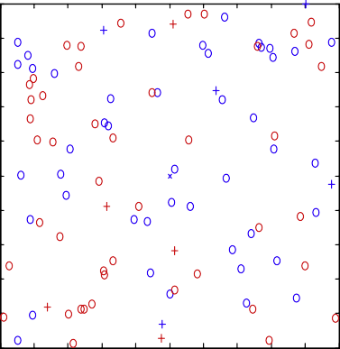0 10 20 30 40 50 60 70 80 90 100

Figure 5 Heterogeneous merged layer with separate BS and single BS.

100

Hetero LEACH

Hetero Merged layer LEACH (50,50)m Hetero Mereged layer LEACH(45,45),(55,55)

90

80

70

No. of Alive Nodes

60

50

40

30

20

10

0

Heterogeneous LEACH Vs Hetero Merged Layer

1000 2000 3000 4000 5000 6000

No. of Rounds

Figure 6 Comparison of heterogeneous merged layer of separate BS and single BS with LEACH.

Table 1 Simulation parameters.

Name of the parameter Network area (variable)

Number of sensor nodes (variable)

Parameter values

100 m · 100 m

100

Initial energy for homogeneous nodes (variable) 0.5 J

*Eelec* 50 nJ/bit

*Etx* = *Erx* 50 nJ/bit

e*fs* (Friss-amp) 10 pJ/bits/m2

e*amp* 0.0013 pJ/bit/m4

Distance *do* sqrt(e*fs*/e*mp*)

*EDA* 50 nJ/bit/signal

Packet size (variable) 4000 bits Initial energy for heterogeneous nodes (variable) 1 J

* For two separate base stations, the energy efficiency perfor- mance of HHMLT improves when compared to LEACH.
* In heterogeneous WSNs, HHMLT provides an extended lifetime of LEACH protocol and the stability period of

100

Hetero LEACH

Hetero Mer LEACH BS (50m,50m)

Hetero Mer LEACH BS (45m,45m)&(55m,55m) Homo LEACH

Homo Mer LEACH BS (50m,50m)

Homo Mer LEACH BS (45m,45m)&(55m,55m)

90

80

Number of Alive Nodes

70

60

50

40

30

20

10

0

Homo & Hetero Merged LEACH Vs Normal LEACH

the HHMLT was prolonged than LEACH.

1. Conclusion with future works

We have proposed Homogeneous and Heterogeneous Merged Layer Technique (HHMLT) energy efficient routing protocol for wireless sensor networks. The energy efficiency and allevi- ate of node deployment make HHMLT routing protocol is enviable and robust protocol for wireless sensor networks. In order to improve the lifetime and performance of the network

HHMLT routing is proposed.

0 1000 2000 3000 4000 5000 6000

Number of Rounds

Figure 7 Comparison between homogeneous and heterogeneous merged layer system with homogeneous and heterogeneous LEACH protocol.

* HHMLT with two layer merged technique to balanced energy dissipation of each nodes in WSN, which helps to

extend the network lifetime.

Simulation consequences show that the HHMLT improves the stable region of the clustering hierarchy, decrease probabil- ity of failure nodes and increase the lifetime of the network due to MERGED layer node deployment concept with balanced energy dissipation of individual node throughout the network and extends network lifetime. Balancing the energy consump- tion, reducing the occurrence of fast death node in single BS locations has better energy efficiency than two BS of merged layer node deployment concept. As the base station moves fur- ther away from the network, the energy proficient performance may improves than LEACH. Finally, HHMLT is scalable and

achieves better performance compared to LEACH in both het- erogeneous and homogenous environments.

Plan to implement node scheduling in merged layer tech- nique for both homogeneous and heterogeneous system of LEACH protocol.

References

1. Akyildiz IF, Su Weilian, Sankarasubramaniam, Cayirci E. A survey on sensor networks. IEEE Communications August 2002.
2. [Singh Shio Kumar, Singh MP, Singh DK. Routing protocols in](http://refhub.elsevier.com/S1110-8665(14)00036-X/h0010) [wireless sensor networks – a survey. Int J Comput Sci Eng Survey](http://refhub.elsevier.com/S1110-8665(14)00036-X/h0010) [(IJCSES) 2010;1(2)](http://refhub.elsevier.com/S1110-8665(14)00036-X/h0010).
3. [Patel Rajesh, Pariyani Sunil, Ukani Vijay. Energy and throughput](http://refhub.elsevier.com/S1110-8665(14)00036-X/h0015) [analysis of hierarchical routing protocol (LEACH) for wireless](http://refhub.elsevier.com/S1110-8665(14)00036-X/h0015) [sensor network. Int J Comput Appl 2011;20(4)](http://refhub.elsevier.com/S1110-8665(14)00036-X/h0015).
4. [Venkataramanan C, Girirajkumar SM. Hierarchical energy and](http://refhub.elsevier.com/S1110-8665(14)00036-X/h0020) [delay aware MAC protocol for wireless sensor networks. Int Rev](http://refhub.elsevier.com/S1110-8665(14)00036-X/h0020) [Comput Software 2013;8(3):762–9](http://refhub.elsevier.com/S1110-8665(14)00036-X/h0020).
5. Fan Xiangning, Song Yulin. Improvement on LEACH protocol of wireless sensor network. In: International conference on sensor technologies and applications; 2007.
6. [Elleithy Abdel rahman, Liu Gonhsin. A simulation model for the](http://refhub.elsevier.com/S1110-8665(14)00036-X/h0030) [life-time of wireless sensor networks. Int J Ad hoc Sensor](http://refhub.elsevier.com/S1110-8665(14)00036-X/h0030) [Ubiquitous Comput (IJASUC) 2011;2(4)](http://refhub.elsevier.com/S1110-8665(14)00036-X/h0030).
7. Ye M, Li C, Chen G, Wu J. EECS: an energy efficient clustering scheme in wireless sensor networks. In: Performance, computing, and communications conference, 2005. IPCCC 2005. 24th IEEE international; April 2005. p. 535–40.
8. [Long Chengzhi, Li Yixing, Li Yihong. An improved multi-hop](http://refhub.elsevier.com/S1110-8665(14)00036-X/h0040) [communication algorithm based on SEP protocol. Int Rev](http://refhub.elsevier.com/S1110-8665(14)00036-X/h0040) [Comput Software 2012;7(5 Part C):2779–84](http://refhub.elsevier.com/S1110-8665(14)00036-X/h0040).
9. [Heinzelman WB, Chandrakasan AP, Balakrishnan H. An appli-](http://refhub.elsevier.com/S1110-8665(14)00036-X/h0045) [cation-specific protocol architecture for wireless microsensor](http://refhub.elsevier.com/S1110-8665(14)00036-X/h0045) [networks. IEEE Trans Wireless Commun 2002:660–70](http://refhub.elsevier.com/S1110-8665(14)00036-X/h0045).
10. Ye W, Heidemann J, Estrin D. An energy-efficient MAC protocol for wireless sensor networks. In: Proceedings of IEEE INFO- COM; 2001.
11. [Heinzelman W, Chandrakasan A, Balakrishnan H. An applica-](http://refhub.elsevier.com/S1110-8665(14)00036-X/h0055) [tion-specific protocol architecture for wireless micro-sensor net-](http://refhub.elsevier.com/S1110-8665(14)00036-X/h0055) [works. IEEE Trans Wireless Commun 2002;1(4):660–70](http://refhub.elsevier.com/S1110-8665(14)00036-X/h0055).
12. [Saravanakumar R, Susila SG, Raja J. Energy efficient constant](http://refhub.elsevier.com/S1110-8665(14)00036-X/h0060) [cluster node scheduling protocol for wireless sensor networks.](http://refhub.elsevier.com/S1110-8665(14)00036-X/h0060) [WSEAS Trans Commun 2011;10(4)](http://refhub.elsevier.com/S1110-8665(14)00036-X/h0060).
13. Hu Xinghua, Luo Jian, Xia Zhen, Maomao. Adaptive algorithm of cluster head in wireless sensor network based on LEACH; 2011 IEEE.
14. Pal Vipin, Singh Girdhari, Yadav Rajender Prasad. Cluster head selection scheme for clustering algorithms in wireless sensor networks (<<http://www.SciRP.org/journal/wsn>>); 2012.
15. Khan AA, Javari N, Qasim U, Lui Z, Khan ZA. HSEP: heterogeneity-aware hierarchical stable election protocol for WSNs. COMSATS Institute of Information Technology; August 2012.
16. [Bala Manju, Awasthi Lalit. Proficient D-SEP protocol with](http://refhub.elsevier.com/S1110-8665(14)00036-X/h0080) [heterogeneity for maximizing the lifetime of wireless sensor](http://refhub.elsevier.com/S1110-8665(14)00036-X/h0080) [networks. Int J Intelligent Syst Appl 2012;7:1–15](http://refhub.elsevier.com/S1110-8665(14)00036-X/h0080).
17. [Shringi Sakshi, Taruna S. A cluster based routing protocol for](http://refhub.elsevier.com/S1110-8665(14)00036-X/h0085) [prolonging network lifetime in heterogeneous wireless sensor](http://refhub.elsevier.com/S1110-8665(14)00036-X/h0085) [networks. Int J Adv Res Comput Sci Software Eng 2013;3(4)](http://refhub.elsevier.com/S1110-8665(14)00036-X/h0085).
18. [Saravanakumar R, Mohankumar N, Raja J. Proficient node](http://refhub.elsevier.com/S1110-8665(14)00036-X/h0090) [scheduling protocol for homogeneous and heterogeneous wireless](http://refhub.elsevier.com/S1110-8665(14)00036-X/h0090) [sensor networks. Int J Distributed Sensor Networks 2013;2013.](http://refhub.elsevier.com/S1110-8665(14)00036-X/h0090) [Article ID 826482 July](http://refhub.elsevier.com/S1110-8665(14)00036-X/h0090).