

Electronic Notes in Theoretical Computer Science 225 (2009) 457–468

[www.elsevier.com/locate/entcs](http://www.elsevier.com/locate/entcs)

Integration of Multiple Classifiers for Chinese Semantic Dependency Analysis

Jiajun Yana*,*1 *,*2 David B. Bracewella*,*3 Fuji Rena*,*b*,*4 Shingo Kuroiwaa*,*5

a *Department of Information Science and Intelligent Systems The University of Tokushima*

*Tokushima, Japan*

b *School of Information Engineering Beijing University of Posts and Telecommunications*

*Beijing 100876, China*

Abstract

Semantic Dependency Analysis (SDA) has extensive applications in Natural Language Processing (NLP). In this paper, an integration of multiple classifiers is presented for SDA of Chinese. A Naive Bayesian Classifier, a Decision Tree and a Maximum Entropy classifier are used in a majority wins voting scheme. A portion of the Penn Chinese Treebank was manually annotated with semantic dependency structure. Then each of the three classifiers was trained on the same training data. All three of the classifiers were used to produce candidate relations for test data and the candidate relation that had the majority vote was chosen. The proposed approach achieved an accuracy of 86% in experimentation, which shows that the proposed approach is a promising one for semantic dependency analysis of Chinese.

*Keywords:* Semantic Dependency Analysis, Multi-Classifier System, Naive Bayesian Classifier, Decision Tree, Maximum Entropy, Chinese, Natural Language Processing

# Introduction

Semantic Dependency Analysis (SDA) has been gaining interest in theoretical lin- guistics and natural language processing. There are many uses for SDA such as

1 This research has been partially supported by the Ministry of Education, Culture, Sports, Science and Technology of Japan under Grant-in-Aid for Scientific Research (B), 19300029, 17300065, Exploratory Research, 17656128 2005 and the Outstanding Overseas Chinese Scholars Fund of the Chinese Academy of Sciences (No.2003-1-1).

2 Email:[yanjj@is.tokushima-u.ac.jp](mailto:yanjj@is.tokushima-u.ac.jp)

3 Email:[davidb@is.tokushima-u.ac.jp](mailto:davidb@is.tokushima-u.ac.jp)

4 Email:[ren@is.tokushima-u.ac.jp](mailto:ren@is.tokushima-u.ac.jp)

5 Email:[kuroiwa@is.tokushima-u.ac.jp](mailto:kuroiwa@is.tokushima-u.ac.jp)

1571-0661/© 2008 Elsevier B.V. Open access under [CC BY-NC-ND license.](http://creativecommons.org/licenses/by-nc-nd/3.0/)

doi:10.1016/j.entcs.2008.12.092

knowledge representation, Question & Answer [12], cross-language information re- trieval, and machine translation [3]. Because of its explicit structure and extensive applications in NLP, a number of studies have been proposed in recent years.

A great deal of research has been done for European languages and in particular, English. Semantic parsing using statistical and machine learning methods [5] has been heavily studied. Annotated corpora such as FrameNet [8] and the proposition Bank [13] have been created.

However, for Chinese much less research has been undertaken. This is largely due to the lack of publicly available semantically annotated corpora. There are corpora such as the work done by Gan and Wong [4] on the Sinica Treebank [7] and the 1,000,000 word scale corpora created by Li et al. [10]. However, these corpora are either not publicly available or have problems for certain researchers.

Some research on partial semantic information assignment has been carried out, such as [26] and [22]. Some research, such as [22], looks at semantic role labeling (SRL). SRL can be thought of as a sub-problem of semantic dependency analysis (SDA) as it is only concerned with the semantic roles between arguments and the main verb. Research in automatic methods for determining semantic relations for a full sentence in Chinese is limited.

This paper presents an integrated multi-classifier approach for semantic depen- dency analysis. It combines three classifiers, Naive Bayesian, Decision Tree and Maximum Entropy, to achieve good accuracy on headword-dependent semantic re- lation assignment. The classifiers are combined using a majority wins selection mechanism and produces better results than using a single classifier.

The rest of this paper will continue as follows. In section 2 the description of dependency grammar and SDA are given. In section 3, related work in SDA will be shown. In section 4, an overview of the integrated multi-classifier approach and each of the individual classifiers will be described. In section 5, information about the semantic tag set and the corpus will be given. In section 6, experimental results are shown. Finally, in section 7 concluding remarks are made and future work discussed.

# Dependency Grammar and Semantic Dependency Analysis

This section will introduce what a dependency grammar is and what semantic de- pendency analysis involves. First, a brief introduction to dependency grammar will be given. Then, an introduction to semantic dependency analysis is given. Finally, particular aspects of Chinese and semantic dependency analysis are discussed.

* 1. *Dependency Grammar*

A Dependency Grammar (DG) is a grammar describing the dependency structure among words or constituents of a sentence. A dependency tree is a parse tree for a dependency grammar showing the dependency structure of a sentence. Robinson

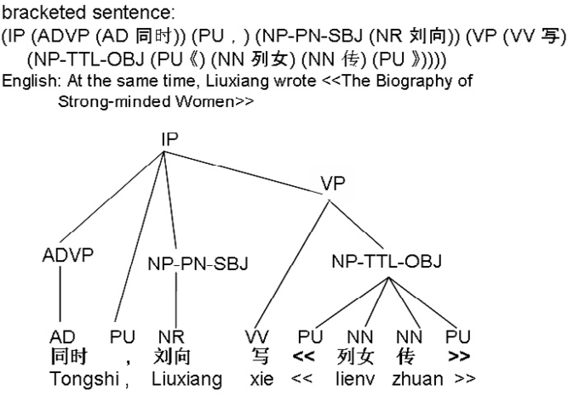

Fig. 1. Phrase structure for Chinese sentences from the Penn Chinese Treebank

[17] formulates four axioms to govern the well-formedness of dependency structures, shown below.

1. One and only one element is independent
2. All others depend directly on some element
3. No element depends directly on more than one other
4. If A depends directly on B and some element C intervenes between them (in linear order of the string), then C depends directly on A or B or some other intervening element
   1. *Semantic Dependency Analysis*

Generally, Semantic Dependency Analysis (SDA) builds a dependency tree with the optimal semantic relationship for the parent node (headword) and child node (dependent) between which there is a dependency link according to DG. In semantic dependency grammar, the word that is able to best represent the meaning of the headword-dependent pair is chosen as the headword. The headword of a sentence represents the main meaning of the entire sentence and the headword of a headword- dependent pair represents the main meaning of the pair. In a compound constituent the headword inherits the headword of the head sub-headword-dependent pair and headwords of other sub-headword-dependent pairs are dependent on that headword.

* 1. *Chinese Semantic Dependency Analysis*

Normally, in the phrase structure, the sentence is broken down into its component parts of speech with an explanation of the syntactical relationship of each part. Even though we can know the logical structure in the sentence, it is difficult to know the potential sense. Figure 1 gives the phrase structure for a Chinese sentence from the Penn Chinese Treebank [19].

Figure 2 gives an example of a sentence annotated with dependency structure

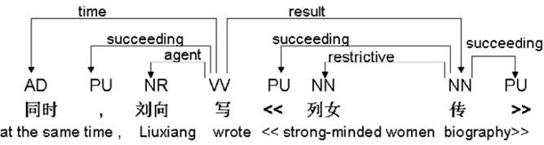

Fig. 2. Manually annotated sentence with dependency structure and semantic relationships

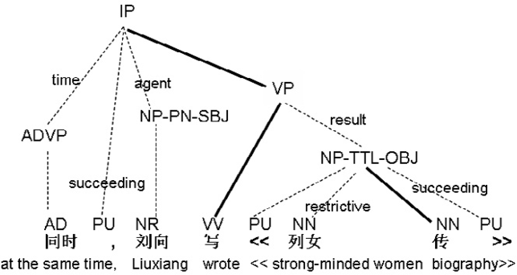

Fig. 3. Another representation of a semantic dependency analysis tree

and semantic relationships. The dependency structure is a tree with directed arrows as the dependency link and the main verb as the headword of the sentence. The set of labeled arrows represent dependency relations from headwords to dependents. For example, the interpretation labeled on the directed arrows, such as “result”, “succeeding”, “restrictive” and so forth, are the semantic dependency relations that represent the meaning that every dependent contains or implies with respect to its headword.

In DG, a sentence is represented as a sequence of dependent-headword pairs based on the four axioms. In SDA, the meaning of the sentence can be then rep- resented as the synthesis of semantic dependency relations of every dependent- headword pair. Such text annotated with semantic dependency structure can make implicit knowledge in sentences and documents more explicit, allowing a deeper un- derstanding that can aid knowledge extraction and information retrieval. It is also easy to explain agreement, or any semantic relations between words or constituents according to such word-to-word dependency links.

Figure 3 shows another representation of a semantic dependency analysis tree which preserves the phrase structure from the Penn Chinese Treebank. In this tree the bold lines denote headwords.

# Related Work

This section will look at some of the related work done in semantic role labeling and semantic dependency analysis. It will also look at the differences between the two and why we believe semantic dependency analysis to be the better choice.

* 1. *Related work in semantic role labeling and semantic dependency analysis*

There has been much research concentrating on semantic role labeling. It can be considered as a sub-problem of semantic dependency analysis. Some of the notable research is by Li et al. [10], You and Chen [26] and Xue and Palmer [22]. How- ever, little research has been done on automatic methods of determining semantic dependency relations for a complete sentence. Recently, research of automatically determining semantic dependency relation is implemented by Yan et al. [23] [24] [25].

Some of the more prominent research that has been done for Chinese is Xue and Palmer [22] that reported results on semantic role labeling for Chinese verbs using a pre-release version of the Chinese Proposition Bank [21]. They use a Maximum Entropy classifier with a tunable Gaussian.

Li et al. [10] built a large corpus annotated with semantic knowledge using de- pendency grammar structure. The selections of semantic relations were taken from HowNet, which is a Chinese lexical database. A computer-aided tagging tool was developed to assist annotators in tagging semantic dependency relations. Manual checking and semiautomatic checking were carried out. Auto-tagging this type of semantic information still has not been completed and is the goal of the current research.

You and Chen [26] presented a system for semantic role labeling of structured trees from the Sinica corpus. The system adopts dependency decision making and example based approaches. There are significant differences between the current research and their’s. The main difference is that they chose semantic role labeling where as we choose to use semantic dependency. Also, the corpus You and Chen used was the Sinica Treebank [2], in which sentences are segmented on punctuation. When annotating the semantic relations, punctuations were out of consideration; moreover the parse trees were not deep. In their sample data 6 , out of 1000 tree structures only about half (462) of them are complete sentences and most of the trees are only tagged for single words or phrases. Accordingly, even though their system achieves 92.71% accuracy in labeling the semantic roles for pre-structure- bracketed texts, maybe it would not perform as well when dealing with realistic text.

* 1. *Differences between semantic role labeling and semantic dependency analysis*

From the above related research, the main difference of SRL and SDA can be sum- marized as follows. SRL only focuses on the main verb of the sentence. SDA focuses on the complete sentence. SRL only describes the relationships between the main verb and its modifiers or complements. SDA determines any relationship for two words or chunks only if there is a dependency link according to DG between them. In SRL, the main verb becomes the unique headword. Since only one headword exists, the structure can be considered as a branch of a tree. In SDA, the headword

6 <http://treebank.sinica.edu.tw/>

is not limited to the main verb. Under the main headword (the main verb), there can be many other sub headwords. SRL is based on predicate-argument structure. SDR is based on semantic dependency structure, which means DG is the supporting grammar for SDA.

An example of the difference is shown in Figure 4, which shows the results of SRL on the same sentence in Figure 2. The main verb is “wrote” and the modifier and complement are “Liuxiang” and “strong-minded women biography” with “agent” and “result” assigned as the semantic roles. However, from Figure 2 it can be seen that SDA is not limited to verb-modifier pairs. Extra semantic relationships such as “time” and “restrictive” are assigned between dependents and non-verbal headwords. The utilization of these extra relationships could prove to be useful in different NLP tasks.

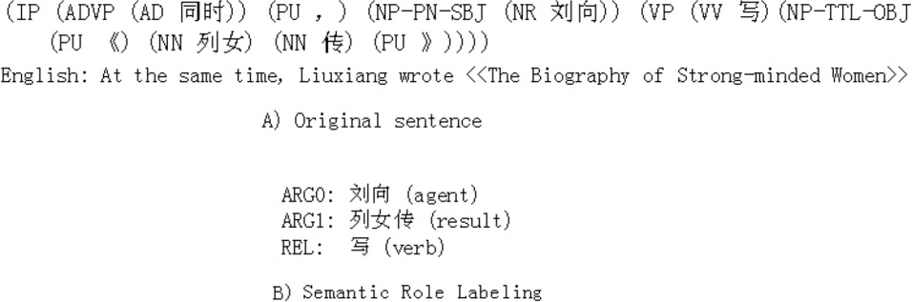

Fig. 4. Semantic Role Labeling Results

# Overview of Proposed Approach

Multi-classifier approaches have been used for everything from handwriting recog- nition [20] to segmentation of biomedical images [18]. They combine many different classifiers to create better results than individual classifiers could do alone.

Recently, these techniques have found their way into NLP applications. Zelai et al. used a mutli-classifier technique with singular value decomposition for document classification [27]. Giuglea and Moschitti used multi-classifiers for semantic parsing using FrameNet [6].

In this paper we implement a multi-classifier approach for semantic dependency analysis of Chinese. An overview of the proposed approach can be seen in figure 5. A headword-dependent pair is given to the multi-classifier. It then passes the pair to each of the classifiers which output a semantic relation. A selection mechanism then chooses which semantic relation should be the final answer.

The important part is in choosing the selection method. Through testing, which will be shown in the experimental results section, we found that a simple majority wins approached works well. This approach outperformed a probabilistic selection method and the individual classifiers.

Currently, three classifiers are used in the system: Naive Bayesian, Decision Tree and Maximum Entropy. The majority wins selection method works as follows

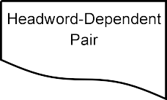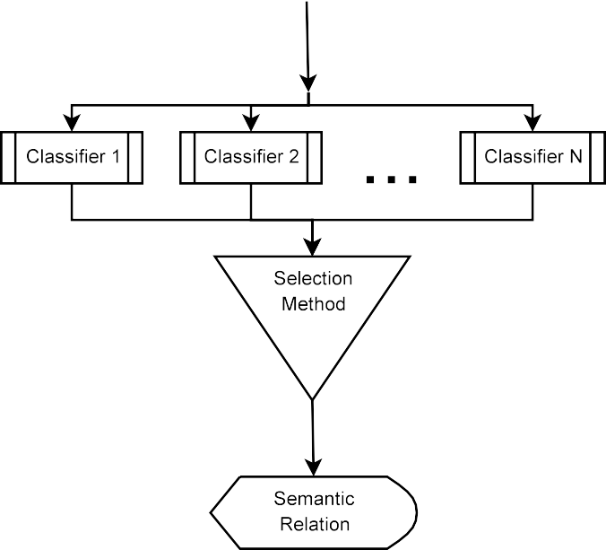

Fig. 5. Overview of Multi-Classifier Approach

using these three classifiers. If two of the classifiers agree on a relation then that relation is chosen. If no two classifiers agree then the Maximum Entropy classifier’s relation is chosen, as it has a higher overall accuracy in our experiments. In the following sections a brief explanation of each of the used classifiers is given. After the explanations of the classifiers an introduction to the features used in classification will be given.

* 1. *Naive Bayesian Classiﬁer (NBC)*

The NBC is widely used in machine learning due to its efficiency and its ability to combine evidence from a large number of features [11]. It is a probabilistic model that assigns the most probable class to a feature vector. Even though it relies on an assumption that the features are independent and this is not normally true, it has been shown to generally do well in classification [16]. In text classification it is widely used in spam detection, such as SpamBayes 7 .

The NBC is based on Bayes theorem. The idea of Bayes theorem is that the probability of a class (*C*) given observed data for a set of features (*X*) can be determined by equation 1. The naive part of the Naive Bayesian classifier comes in its assumption that the features are independent of one another. After simplification of equation 1 and making the independence assumption a classifier can be built using

7 [http://spambayes.sourceforge.net](http://spambayes.sourceforge.net/)

equation 2.

(1)

*P* (*C*|*X ,* ··· *,X* )= *P* (*X*1*,* ··· *, Xn*|*C*) × *P* (*C*)

1 *n P* (*X*1*,* ··· *, Xn*)

*n*

(2)

*C*ˆ = arg max *P* (*C*) *P* (*Xi*|*C*)

*C*

*i*=1

* 1. *Decision Tree*

Decision Trees use a tree structure where at each node a decision is made until a leaf node is reached where the class is given. The most widely used variant is the ID3 decision tree introduced by [14]. The ID3 decision tree uses information gain which is based on entropy to induce the tree structure, see equation 3. One of the main reasons of using a decision tree is that they are very easy to understand and to visualize, while also giving good results.

*N*

(3) *IGain*(*i*)= − Σ *f* (*i, j*) log2 *f* (*i, j*)

*j*=1

* 1. *Maximum Entropy*

Maximum Entropy modeling creates a model based on facts from the underlying data while trying to stay as uniform as possible [1]. As a classifier it uses the principal of maximum entropy to estimate the probability distribution of a model based on observed events. It achieves state-of-the-art results and often performs as well or better than Support Vector Machines. It is also extremely useful for NLP, as [15] shows, and has been widely adopted in the NLP field. For a more in depth explanation we refer the reader to [15].

* 1. *Features*

Five features, shown below, were chosen to be used in classification. All these five features can be directly extracted from the tree structure. They make up the features that were thought to be the most useful for determining the semantic relations. Figure 6 shows a sample cut from a semantic analysis tree. Using the NP in the tree, we will describe the features.

* + - Phrase Type (PT) - The phrase type feature uses the phrase head. In the example, the phrase type is NP.
    - Phrase Length (PL) - The phrase length is the number of dependents that makes up the phrase plus one for the headword. In the example the NP phrase has a length of 4.
    - Headword & Dependent (WORDS) - The headword and dependent feature is the words that make up the headword and the currently looked at dependent. When semantic relations are assigned, each headword-dependent pair will be looked at separately, so in the example there are 3 headword-dependent pairs.

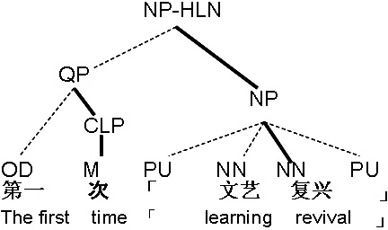

Fig. 6. Sample semantic analysis tree

* + - * Headword & Dependent Part-of-Speech (POS) - The headword and dependent part-of-speech feature is the parts-of-speech for the headword-dependent pair. In the example these are “NN PU,” “NN NN,” and another “NN PU.”
      * Context (CON) - Finally, the context feature is the set of dependent parts-of- speech that fall between the headword and the currently looked at dependent. In the example only one headword-dependent pair has a context that is not empty. For the first “NN PU” pair, the context is “NN(learning)” as it is located in between the dependent “PU” and the headword “NN(revival).”

# Corpus and Tag Set

The dependency relation tag set used in this research is made up of 84 tags, which includes 68 semantic relations and 15 syntactic relations. Furthermore, one special tag ”succeeding” to describe the relation between punctuations and other words was defined. The tag set is shown in Figure 7.

In this paper, the semantic dependency relation tag set was imported directly from HowNet 8 . HowNet is a Chinese thesaurus that shows the lexical knowledge in semantic network. It is getting more popular in NLP research because semantic hierarchy is constructed between Chinese and English [9].

Semantically labeled corpora for Chinese are still scarce, due to the fact that the corpora that have been created are rarely made publicly available. Because of this, the Penn Chinese Treebank 5.0 was chosen as original data for this research. A portion (4000 sentences) of the Treebank was manually annotated with headwords and semantic relations according to DG, which means that only the words between which there is a unique dependency link will be assigned a relation. This resulted in 27,000 words with 24,487 semantic relations.

# Experimentation

For testing, a 10-fold-cross-validated experiment was used. Table 1 shows the av- erage accuracy and the standard deviation for the individual classifiers using all

8 <http://www.keenage.com/>

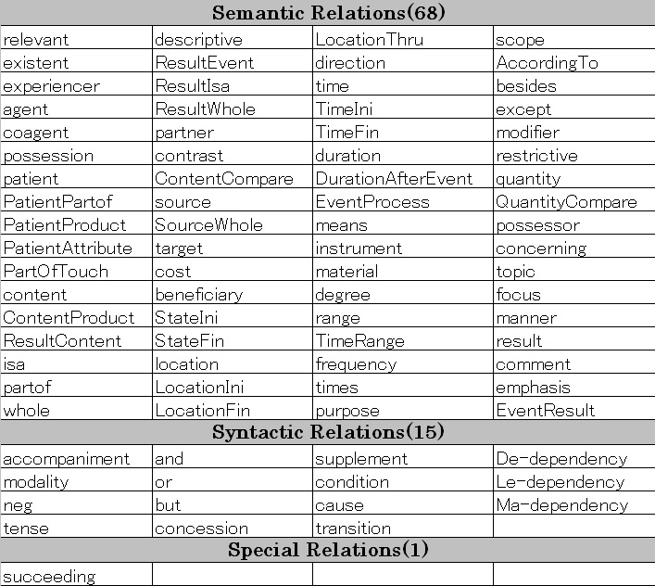

Fig. 7. Semantic Dependency Relation Tag Set

four features. All three of the classifiers achieved better than 80% accuracy. The Decision Tree and Maximum Entropy classifiers had very similar accuracies, but the standard deviation of the maximum entropy classifier was much lower.

|  |  |
| --- | --- |
| Classifier | Avg. Accuracy |
| Naive Bayesian | 80.5% (±3*.*3%) |
| Decision Tree | 83.4% (±5*.*8%) |
| Maximum Entropy | 83.6% (±3*.*4%) |

Table 1

Results for Individual Classifiers

These tests were the basis for choosing the Maximum Entropy classifier as the fall back classifier. Table 2 shows the results for using the multi-classifier with majority wins selection and probabilistic selection methods. The probabilistic se- lection method used a second set of training data to determine the precision of the classifiers. The relation with the highest precision was then chosen as the semantic relation. As can be seen the majority wins approach gave a better average accuracy with a lower standard deviation.

|  |  |
| --- | --- |
| Selection Method | Avg. Accuracy |
| Majority Wins | 86.0% (±2*.*9%) |
| Probabilistic Selection | 83.7% (±3*.*3%) |

Table 2

Results for Multi-Classifiers

The probabilistic selection method probably requires a great deal more training data than the 1,000 headword-dependent pairs we used. Perhaps with a large enough amount of data its results would improve and overtake that of the majority wins selection method.

# Conclusion and Future work

In this paper, we presented a multi-classifier approach for analyzing semantic depen- dency in Chinese. It integrated three different classifiers, Naive Bayesian, Decision Tree and Maximum Entropy. We tested two different methods for selecting the best results: majority wins and probabilistic selection. Both methods gave improvements over the individual classifiers. The simpler majority wins selection method outper- formed the probabilistic method.

We have shown that classification based methods are capable of assigning se- mantic dependency relations between headword-dependent pairs. The fusion of in- formation brought together when dealing with multiple classifiers helps to overcome weaknesses in any of the individual classifiers. This allows for a higher accuracy to be obtained.

From these promising results there is a lot of future work that can be done. First, the corpus needs to be enlarged. This will allow us to see if probabilistic selection can perform better than the majority wins approach when it is able to determine the precision based on a larger amount of data. Next, we need to look at new classifiers, specifically support vector machines. In addition to new classifiers we can also explore new features and combining classifiers using different feature sets in the multi-classifier approach.

# References

1. Berger, A., S. D. Pietra and V. D. Pietra, *A maximum entropy approach to natural language processing*, Computational Linguistics 22 (1996), pp. 39–77.
2. Chen, F.-Y., P.-F. Tsai, K.-J. Chen and C.-R. Hunag, *The construction of sinica treebank*, Computational Linguistics and Chinese Language Processing 4 (1999), pp. 87–104.
3. Fox, H. J., *Dependency-based statistical machine translation*, in: *Proceedings of the 2005 ACL Student Workshop*, Ann Arbor, America, 2005.
4. Gan, K. W. and P. W. Wong, *Annotating information structures in chinese texts using hownet*, in:

*Proceedings of Second Chinese Language Processing Workshop*, HongKong, 2000.

1. Gildea, D. and D. Jurafsky, *Automatic labeling of semantic roles*, Computational Linguistic 28 (2002),

pp. 496–530.

1. Giuglea, A.-M. and A. Moschitti, *Towards free-text semantic parsing: A unified framework based on framenet, verbnet and propbank*, in: *Proceedings of the workshop on Learning Structured Information* *in Natural Language Applications*, 2006.
2. Huang, C., K. Chen, F. Chen, Z. Gao and K. Chen, *Sinica treebank: Design criteria, annotation* *guidelines, and on-line interface*, in: *Proceedings of 2nd Chinese Language Processing Workshop*, Hong Kong, China, 2000, pp. 29–37.
3. Johnson, C. R. and C. J. Fillmore, *The framenet tagset for frame-semantic and syntactic coding of predicate-argument structure*, in: *Proceedings of the 1st Meeting of the North American Chapter of the Association for Computational Linguistics (ANLP-NAACL 2000)*, Seattle, WA, 2000, pp. 56–62.
4. Levow, G.-A., B. J. Dorr and M. Katsova, *Construction of chinese-english semantic hierarchy for cross- language retrieval*, in: *Proceedingd of the workshop on English-Chinese Cross Language Information Retrieval, International Conference on Chinese Language Computing*, Chicago, IL, 2000.
5. Li, M., J. Li, Z. Dong, Z. Wang and D. Lu, *Building a large chinese corpus annotated with semantic* *dependency*, in: *Proceedings of the Second SIGHAN Workshop*, Sapporo, Japan, 2003.
6. Manning, C. D. and H. Schutze, “Foundations of Statistical Natural Language Processing,” The MIT Press, Cambridge, Massachusetts, 1999.
7. Molla, D. and B. Hutchinson, *Dependency-based semantic interpretation for answer extraction*, in: *5th AUSTRALASIAN NATURAL LANGUAGE PROCESSING WORKSHOP (ANLP2002)*, 2002.
8. Palmer, M., D. Gildea and P. Kingsbury, *The proposition bank: An annotated corpus of semantic roles*, Computational Linguistics Journal 31 (2005), pp. 71–106.
9. Quinlan, J., *Induction of decision trees*, Machine Learning 1 (1986), pp. 81–106.
10. Ratnaparkhi, A., *A simple introduction to maximum entropy models for natural language processing*, Technical report, Institute for Research in Cognitive Science, University of Pennsylvania (1997).

URL <citeseer.ist.psu.edu/128751.html>

1. Rish, I., *An empirical study of the naive bayes classifier*, in: *Proceedings of IJCAI-01 workshop on* *Empirical Methods in Artificial Intelligence*, 2001, pp. 41–46.
2. Robinson, J. J., *Dependency structures and transformation rules*, Language 46 (1970), pp. 259–285.
3. Rohlfing, T., D. Russakoff, R. Brandt, R. Menzel and C. Maurer, *Performance-based multi-classifier decision fusion for atlas-based segmentation of biomedical images*, in: *Proceedings of the IEEE* *International Symposium on Biomedical Imaging: Macro to Nano*, 2004.
4. Xia, F., M. Palmer, N. Xue, M. E. Okurowski, J. Kovarik, F.-D. Chiou, S. Huang, T. Kroch and

M. Marcus, *Developing guidelines and ensuring consistency for chinese text annotation*, in: *Proceedings of the 2nd International Conference on Language Resources and Evaluation (LREC-2000)*, Athens, Greece, 2000.

1. Xu, L., A. Krzyzak and C. Suen, *Methods of combining multiple classifiers and their applications to* *handwriting recognition*, IEEE Transaction on systems Man and Cybernetics 22 (1992), pp. 418–435.
2. Xue, N. and M. Palmer, *Annotating the propositions in the penn chinese treebank*, in: *Proceedings of the Second Sighan Workshop*, Sapporo, Japan, 2003, pp. 47–54.
3. Xue, N. and M. Palmer, *Automatic semantic role labeling for chinese verbs*, in: *Proceedings of the 19th International Joint Conference on Artificial Intelligence*, Edinburgh, Scotland, 2005.
4. Yan, J., D. B. Bracewell, F. Ren and S. Kuroiwa, *Automatically determining semantic relations in chinese sentences*, in: *2005 IEEE International Conference on Natural Language Processing and* *Knowledge Engineering (IEEE NLP-KE 2005)*, Wuhan, China, 2005, pp. 262–267.
5. YAN, J., D. B. Bracewell, F. REN and S. KUROIWA, *A machine learning approach to determine semantic dependency structure in chinese*, in: *Special Track at the Proceedings of the 19th International FLAIRS Conference*, Melbourne Beach, FL, 2006, pp. 782–786.
6. YAN, J., D. B. Bracewell, F. REN and S. KUROIWA, *A semantic analyzer for chinese*, WSEAS Transactions on Computers 5 (2006), pp. 1886–1892.
7. You, J. and K. Chen, *Automatic semantic role assignment for a tree structure*, in: *Proceedings of the third SIGHAN Workshop*, Barcelona, Spain, 2004, pp. 109–115.
8. Zelai, A., I. Alegria, O. Arregi and B. Sierra, *A multiclassifier based document categorization system: profiting from the singular value decomposition dimensionality reduction technique*, in: *Proceedings of the workshop on Learning Structured Information in Natural Language Applications*, 2006.