

[Egyptian Informatics Journal (2013) 14, 109–115](http://dx.doi.org/10.1016/j.eij.2013.03.002)

Cairo University

Egyptian Informatics Journal

[www.elsevier.com/locate/eij](http://www.elsevier.com/locate/eij) [www.sciencedirect.com](http://www.sciencedirect.com/science/journal/11108665)

ORIGINAL ARTICLE

Intelligent Sleeping Mechanism for wireless sensor networks

Anar A. Hady *, Sherine M. Abd El-kader, Hussein S. Eissa

*Electronics Research Institute, Computers and Systems Dept., Cairo, Egypt*

Received 10 December 2012; accepted 31 March 2013

Available online 30 April 2013

Abstract In this paper, a Low-Energy Adaptive Clustering Hierarchy Centralized Sleeping Proto- col (LEACH-CS) for wireless sensor networks has been proposed. LEACH-CS extends the lifetime of wireless sensor networks by proposing a mechanism that performs an intelligent choice of func- tioning nodes depending on the data sensed at the time being. If the data received from certain clus- ters appears insignificant in a period of time, these clusters are set to sleeping mode till the next data round. An algorithm named Intelligent Sleeping Mechanism (ISM) has been proposed for choice of nodes modes of functionality. When comparing LEACH-CS to the famous LEACH-C protocol through simulations, LEACH-CS succeeds in extending the lifetime of the network by on average 35% more than LEACH-C through network scaling and minimizing the end-to-end delay of data sending by an average 50% less than LEACH-C. LEACH-CS has been proposed for cultivation applications, where conditions may remain stable for a while and are not critical from one second to the other.

© 2013 Production and hosting by Elsevier B.V. on behalf of Faculty of Computers and Information,

KEYWORDS

Hierarchical protocols; Sleeping nodes; Lifetime;

LEACH-C;

Wireless sensor networks

Cairo University.

1. Introduction

Wireless sensor networks (WSNs) consist of small sized sensor nodes, which form an ad hoc distributed sensing [1] and data propagation network to collect the context information on

* Corresponding author. Address: Computers and Systems Depart- ment, Electronics Research Institute, 33 El-Tahrir St., El-Dokki, Giza 12622, Egypt. Tel.: +20 100 636 499 4; fax: +20 2 333 516 31.

E-mail addresses: [redpearloo@hotmail.com](mailto:redpearloo@hotmail.com), [anar_abdelhady@eri.s-](mailto:anar_abdelhady@eri.sci.eg) [ci.eg](mailto:anar_abdelhady@eri.sci.eg) (A.A. Hady).

Peer review under responsibility of Faculty of Computers and Information, Cairo University.

**Production and hosting by Elsevier**

the physical environment. WSN is widely used to collect reli- able and accurate information in the distance and hazardous environments; it can be used in National Defense, Military Af- fairs, Industrial Control, Environmental Monitor, Traffic Management, Medical Care, and Smart Homes [2–4] etc. The sensor whose resources are limited is cheap and depends on batteries to supply energy, so it is important for the adopted routing protocol to efficiently utilize its power in both military and civilian applications such as target tracking, surveillance, and security management. The sensor node has four basic components: sensing unit, processing unit, radio unit, and power unit [5].

The main mission of sensor networks is to periodically gather data from a remote terrain where each node continually senses the environment and sends back the data to the base station (BS) for further analysis; the BS is usually located con- siderably far from the target area. The most restrictive factor

1110-8665 © 2013 Production and hosting by Elsevier B.V. on behalf of Faculty of Computers and Information, Cairo University. <http://dx.doi.org/10.1016/j.eij.2013.03.002>

in the lifetime of wireless sensor network is limited energy re- source of the deployed sensor nodes. Because the sensor nodes carry limited and generally irreplaceable power source, the protocols designed for the wireless sensor networks must take the issue of energy efficiency into consideration. Also, the net- work protocol should take care of other issues [5] such as self- configuration, fault tolerance, and delay. Another important criterion in the design of a sensor network is data delivery time since it is critical in many applications including battlefield and medical/security monitoring system. Such applications require receiving the data from sensor nodes within some time limit. Communication protocols highly affect the performance of wireless sensor networks by an evenly distribution of energy load and decreasing their energy consumption and thereupon prolonging their lifetime. Thus, designing energy efficient pro- tocols is crucial for prolonging the lifetime of wireless sensor networks. A lot of research work has been done to evaluate and improve routing protocols in wireless sensor network such as [6].

In this paper, a protocol for extending the lifetime of wire- less sensor networks is proposed. Section 2 reviews the work related to the proposed protocol. The remaining part of this paper is organized as follows: Section 3 describes in details LEACH-C protocol as a base to the proposed protocol. Sec- tion 4 describes LEACH-CS protocol and its detailed function- ality. Section 5 discusses the evaluation of LEACH-CS in comparison to LEACH-C through simulation results. Finally, Section 6 discusses the conclusions and future work.

1. Related work

Many ideas have been proposed using clustering techniques in routing to increase the energy efficiency of the network [7–12]. Heinzelman et al. [7] proposed a clustering based single le- vel algorithm, called Low-Energy Adaptive Clustering Hierar- chy (LEACH). It assumes that all the sensor nodes can communicate with the base station directly. In order to save energy, LEACH only chooses a fraction *p* of all sensor nodes to serve as cluster heads. The rest of the sensor nodes join the proper clusters according to the signal strength from cluster heads. The operation of cluster heads is divided into rounds, each round consists of a cluster set-up phase to form clusters, and a steady-state phase where the cluster heads aggregate the data received from their cluster members and send the aggre- gated data to the base station by single hop communication. After a round, new coordinators are being selected. The selec- tion rule is to randomly select a node from the nodes that have never been selected as a coordinator or such that the times to

be a coordinator are minimal.

Although there are advantages to using LEACH’s distrib- uted cluster formation algorithm, it offers no guarantee about the placement and/or number of cluster head nodes. Since the clusters are adaptive, obtaining a poor clustering setup during a given round will not greatly affect overall performance. However, using a central control algorithm to form the clusters may produce better clusters by dispersing the cluster head nodes throughout the network. This is the basic idea for LEACH-centralized (LEACH-C) [8] protocol, a protocol that uses a centralized clustering algorithm and otherwise the same functionality as LEACH as follows. In this protocol, the base station receives data from sensor nodes about their current

location and energy level then decides the cluster heads, forms the clusters, and sends the transmission schedule. LEACH-C performs better than LEACH as the base station gets the whole picture of the topology for cluster head selection and saves the sensor nodes’ energy.

LEACH and LEACH-C although still standing up in the technology till now, they still can be introduced to enhance- ments in lifetime and other aspects. LEACH and LEACH-C do not consider different modes of functionality of nodes, such as the modes considered in this paper which switch nodes from functioning to sleeping modes depending on an intelligent analysis of data.

In [9], LEACH-CE protocol had been proposed where 5% of alive nodes in the network are cluster heads. The base sta- tion makes 10% of the nodes in the network to go to sleep mode. This is done before the selection of cluster heads. The nodes in sleep mode do not sense any data nor do they receive cluster head information from the base station. Base station controls the operation of all nodes. The base station chooses 5% to be cluster heads, and the cluster heads of previous rounds are not eligible to participate in the cluster head selec- tion unless all nodes in the network have become cluster heads. This model chooses randomly the nodes switched to sleeping mode which does not guarantee the quality of data even if it preserves the lifetime.

In [5], the proposed routing scheme employs node schedul- ing in each cluster in the network. The structure of the pro- posed routing scheme is the same procedure as in the normal LEACH protocol. Calculating the number of sensor nodes, the formation of the clusters and also the cluster head selection is the same in this proposed protocol as LEACH. By doing this procedure repeatedly, the total energy efficiency increased be- cause of the proper node scheduling inside the cluster. In this node scheduling the total available residual energy is equally distributed, and the cluster head is also elected as per the resid- ual energy comparison. Whenever the node is under sleep mode in each cluster, it consumes very small energy. Here, the total rounds are increased by doing both changing of sleep- ing and active modes and the available energy is distributed in a balanced manner. Although this protocol does not choose the sleeping nodes randomly, it does not put into consideration the quality of sent data.

In [10], a protocol had been proposed which also switches a percentage of nodes into the sleeping mode using three factors which are; the energy level, the number of neighbors, and the average distance among neighbors. Nodes that have a lot of neighbors and have a high energy level are good candidates to be switched to sleeping mode, as the more the number of neighbors of a node is the more overlap it has, and also the lower the energy the more likely it is to die. This protocol as others does not consider sleep- ing mode according to the sensed data which is the novel approach of this paper.

This research proposes a novel algorithm for choosing a percentage of clusters to be switched to sleeping mode. Clus- ters are formed of neighborhood nodes, these nodes usually have common data and that is why it is aggregated by the clus- ter head to send a single data packet. In cultivation areas, if the conditions are stable in one data packet, it is not likely to change critically hastily and that is why switching such clusters to sleeping mode for the rest of the round will save energy and not affect the data quality.

1. Low-Energy Adaptive Clustering Hierarchy Centralized Protocol (LEACH-C)

Although there are advantages to using LEACH’s distributed cluster formation algorithm, it offers no guarantee about the placement and/or number of cluster head nodes. Since the clus- ters are adaptive, obtaining a poor clustering setup during a gi- ven round will not greatly affect overall performance. However, using a central control algorithm to form, the clus- ters may produce better clusters by dispersing the cluster head nodes throughout the network. This is the basic idea for LEACH-centralized (LEACH-C) [8] protocol, a protocol that uses a centralized clustering algorithm and otherwise the same functionality as LEACH as follows:

* 1. *Base station cluster formation*

During the set-up phase of LEACH-C, each node sends infor- mation about its current location (possibly determined using a GPS receiver) and energy level to the base station. Not only does the base station need to determine good clusters, but it also has to ensure that the energy load is evenly distributed among all the nodes. To do this, the base station computes the average node energy, and any node having energy below this average cannot be a cluster head for the current round. Using the remaining nodes as possible cluster heads, the base station finds clusters using the simulated annealing algorithm to solve the NP-hard problem of finding optimal clusters. This algorithm attempts to minimize the amount of energy for the non-cluster head nodes to transmit their data to the cluster head, by minimizing the total sum of squared distances be- tween all the non-cluster head nodes and the closest cluster head. Once the cluster heads and associated clusters are found, the base station broadcasts a message that contains the cluster head ID for each node. If a node’s cluster head ID matches its own ID, the node is a cluster head; otherwise, the node deter- mines its TDMA slot for data transmission and goes to sleep until it is time to transmit data.

* 1. *Steady-state phase*

The steady-state phase of LEACH-C is identical to that of LEACH. Once the clusters are created and the TDMA sche- dule is fixed, data transmission can begin and thus the stea- dy-state operation of LEACH-C networks. Assuming nodes always have data to send, they send it during their allocated transmission time to the cluster head using a minimal amount of energy. This allows the radio components of each non-clus- ter head node to be turned off at all times except during its’ transmit time, thus minimizing the energy dissipated in the individual sensors. The cluster head node must keep its recei-

ver on all the time to receive all the data from the nodes in the cluster. Once the cluster head has all the data from the nodes in its cluster, the cluster head node aggregates the data and then transmits the compressed data to the base station. Since the base station is usually far away, this is a high energy transmission. Fig. 1 shows the timeline for LEACH-C operation.

LEACH-C is also an example of a proactive network pro- tocol. LEACH is not as efficient as LEACH-C (LEACH-C delivers about 40% more data per unit energy than LEACH). This is because the base station has global knowledge of the location and energy of all the nodes in the network, so it can produce better clusters that require less energy for data trans- mission. The authors of [8] cite two key reasons for the improvement: configuration of better clusters and producing the optimal number of cluster heads. The number of cluster heads in each round of LEACH-C equals a predetermined optimal value, whereas for LEACH, the number of cluster heads is randomly chosen from round to round.

Although LEACH and LEACH-C provide significant en- ergy saving, due to dense deployment in WSNs, redundant nodes exist in the network, in which sensing ranges are fully overlapped by their on-duty neighbors [13]. And this issue cre- ated the main motivation of this research, how to save the en- ergy of the network but this time not by eliminating the redundant data, but by eliminating the insignificant data.

1. Low-Energy Adaptive Clustering Hierarchy Centralized Sleeping Protocol (LEACH-CS)

This section explains in details the functionality of LEACH- CS protocol which is a modified version of LEACH-C. Sec- tion A explains the proposed network model in designing the protocol. Section B describes the adopted radio model in the protocol operation. Section C finally defines LEACH-CS oper- ation in details.

* 1. *Network model*

Assumptions adopted in designing the protocol network are as follows:

1. The base station is fixed at a far distance from the sensor nodes.
2. The sensor nodes are homogeneous and energy constrained with uniform energy.
3. No mobility of sensor nodes.
4. All nodes are able to reach each other and the base station.
5. Symmetric propagation channel.
6. Each node senses the environment at a fixed rate and always has data to send to the base station.

Set up  Steady-State

|  |  |  |
| --- | --- | --- |
| Clusters formed | Slot for node i | Slot for node i |

Frame

Time

Figure 1 LEACH-C Operation.

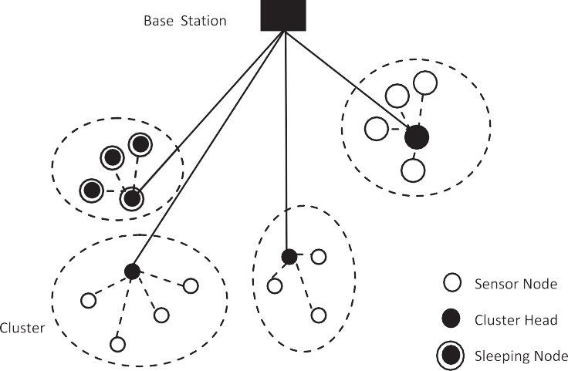

Figure 2 A typical LEACH-CS network.

Startup Time

Round 1

Subsequent Rounds

BS Cluster Formation Phase

Steady State Phase

Cluster Formation Cluster Send/Receive TDMA Send/Receive

Cycle

1

Cycle Cycle

2

3

If awake

Data Data mode Relay Analysis

Frame1 Flag

Send/Receive

# Slots = # Active

Members

Slot Slot

1 2

Slot

n

Time

Figure 3 LEACH-CS Timeline.

* 1. *Radio energy dissipation model* ETx(l, d)= ETx—elec(l)+ ETx—amp(l, d)

( *l* * *Eelec* + *l* * e*fs* * *d*2 if *d* < *do*

(1)

A simple model for the radio hardware dissipation is used as LEACH-C where the transmitter dissipates energy to run the radio electronics and the power amplifier, and the receiver dis- sipates energy to run the radio electronics. For the experiments

described here, both the free space (*d*2 power loss) and the mul-

4

ETx(l, d)=

where *do* is:

rﬃﬃeﬃﬃﬃﬃﬃﬃ

*do*

=

*fs*

e

*amp*

*l* * *E*

*elec*

+ *l* * e

*amp*

* *d*4 if *d* P *do*

depending on the distance between the transmitter and the re- ceiver, where the radio dissipates *Eelec* = 50 nJ/bit to run the

ti path fading (*d*

power loss) channel models were used,

transmitter or receiver circuitry and e*fs* = 10 pJ/bit/m2,

The electronics energy (Eelec) depends on many factors such as the digital coding, the modulation, the filtering, and the spreading of the signal, whereas the amplifier energy e*fsd*2 or

e*amp* = 0.0013 pJ/bit/m2 for the transmit amplifier. Thus, to

e*amp*

*d*4, depends on the distance to the receiver and the accept-

transmit an l-bit message a distance *d* using this radio model,

the radio expends:

able bit-error rate. To receive this message, the radio expends:

ERx(k)= ERx—elec(*l*)



*SCH*

*SCH*

*SNCH SCH*

*SCH*

*SNCH*

*SNCH*

*SCH*

*SCH*

*Salive*

*Salive*

*k*

*Nalive*

*k*

*Salive*

*Salive k Nalive SCH SNCH SNCH* 2

ERx(k)= *Eelec* * *l*

(2)

* 1. *LEACH-CS protocol operation*

In this section, a detailed description of LEACH-CS protocol is given; LEACH-CS protocol employs a Sleeping Intelligent Mechanism (ISM) for nodes in the network to extend the life- time of nodes and the overall lifetime of the network.

LEACH-CS protocol adopts the ISM for nodes in the net- work by analyzing the data sent by nodes, depending on this data clusters are either selected to complete data sending in a round or are switched to sleeping mode until the next round. The nodes in sleep mode do not sense any data through the round. This intelligent scheme is a novel scheme for deciding nodes in the sleeping mode, all previous protocols adopting the sleeping mode for nodes did not consider the quality of data sent as packets are missed after deciding the sleeping mode. Most of them depended on the geographic position of nodes and the number of neighbors and thus the expectation of redundancy in data. Using the proposed intelligent scheme, the initial packet of all alive nodes in the network is analyzed intelligently to expect whether the consequent packets in the round will be of significance or not. Thus, the ISM is a scheme that adds QoS (Quality of Service) analysis to LEACH-C and extends its lifetime depending on the decision taken upon this analysis.

A typical LEACH-CS network is shown in Fig. 2 where some clusters are put to sleep and some clusters are operating and sending data.

Before each round, the base station receives a packet from every node in the network with its current energy level. Depending on this energy level, the base station sorts the nodes descendingly and chooses 5% of the alive nodes to be cluster heads of the round. This approach has been concluded by authors of [8] to be the optimal number of cluster heads for en- ergy minimization.

The remaining nodes are assigned by the base station to their corresponding cluster heads by choosing the minimum square distance between the node and the cluster heads.

After assigning the nodes to their cluster heads a time TDMA frame slot is assigned and sent by the cluster head to its cluster nodes to start sending data.

Thus, nodes start sending data to their corresponding clus- ter heads in sequential TDMA slots. The cluster head aggre- gates the received and sends it to the base station. The base station employs the ISM on the first packet to decide the sleep- ing and the awake clusters in Section 4.3.1.



*SCH SNCH*

* + 1. *Intelligent Sleeping Mechanism (ISM)*





Figure 4 LEACH-CS Pseudo Code.



*SNCH*

*SCH SCH*

* Cluster heads receive the data packets from their corre- sponding cluster nodes and aggregate the data packets to

get an average of the received data.

* The base station receives the first data packet in the round from cluster heads.
* The base station analyzes the received data of the first frame and compares it to a defined threshold, if this data is below

that threshold, this means that this data is not likely to be significant in that round. This threshold will be defined by

the user according to the sensed application. For example, it may be humidity in an agricultural land, if this humidity is under a user defined threshold, then it does seem that it will reach a critical value in that data round and that it will remain stable for a while.

* According to this analysis, the base station decides which

clusters to be switched to sleeping mode in that round. It

broadcasts packets with a QoS flag set to 1 with the address of the cluster nodes that will be switched to sleeping mode set as 1. The nodes with their address specified as destina- tion receive the packet and stop sending data during this round.

These nodes and their cluster heads in return send their en- ergy information to the base station ending their role in the round.

The rest of the clusters continue the round and send their data to the base station in their fixed TDMA slots conse- quently. Fig. 3 shows the timeline of LEACH-CS protocol as described.

The following pseudo code in Fig. 4 describes the function- ality of LEACH-CS protocol:

1. LEACH-CS protocol evaluation

OMNet++ discrete event simulator [14] has been used to implement LEACH-CS protocol. The number of nodes in the network ranges from 100 up to 1000 nodes. LEACH-CS protocol is compared to LEACH-C in terms of network life- time, end-to-end delay, and throughput. Network lifetime is defined as the round number until only less than ten nodes are alive in the network. The parameters used in simulations are shown in Table 1.

* 1. *Lifetime*

Fig. 5 shows the number of rounds the network is alive before no nodes are alive in the network. The figure shows that the propose LEACH-CS protocol increases the lifetime by about 20% in the range from 50 to 500 nodes, and it increases until it reaches its peak at the 1000 nodes network by a factor of 45% increase in lifetime. It is concluded that LEACH-CS per- forms far much better than LEACH-C at larger networks as the number of sleeping nodes increase as the clusters become larger, and thus, the overall network lifetime increases.

Fig. 6 also shows that in most scenarios the first node to die is affected by the modification done in LEACH-CS and that it

Figure 5 Number of rounds before the network is dead.

Figure 6 Number of rounds before the first node is dead.

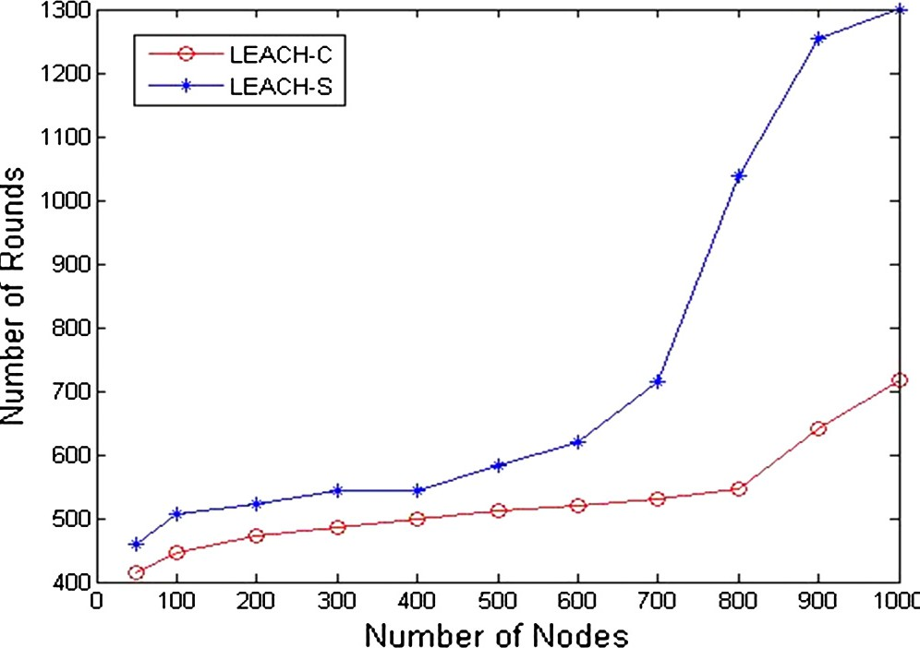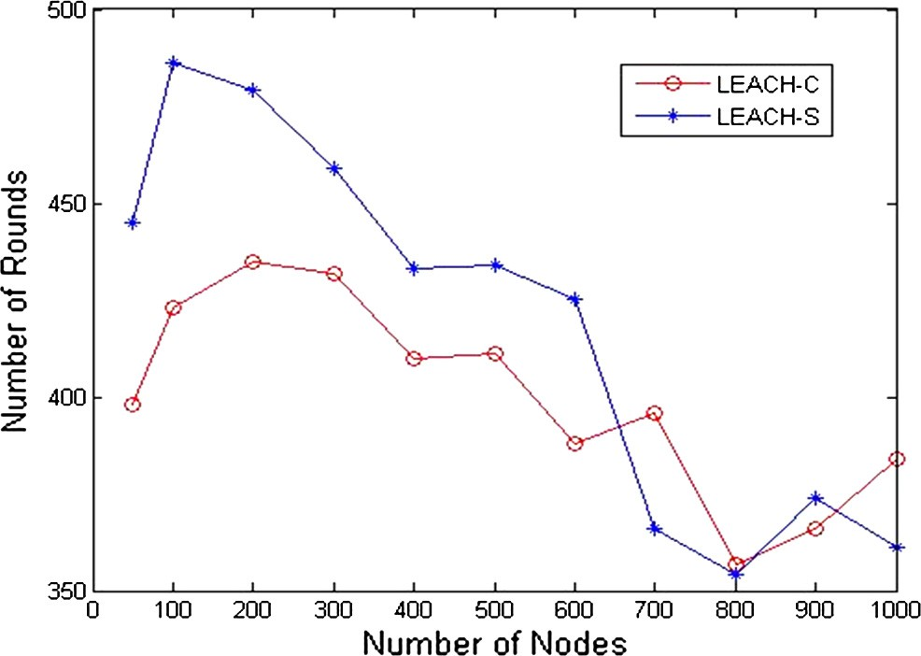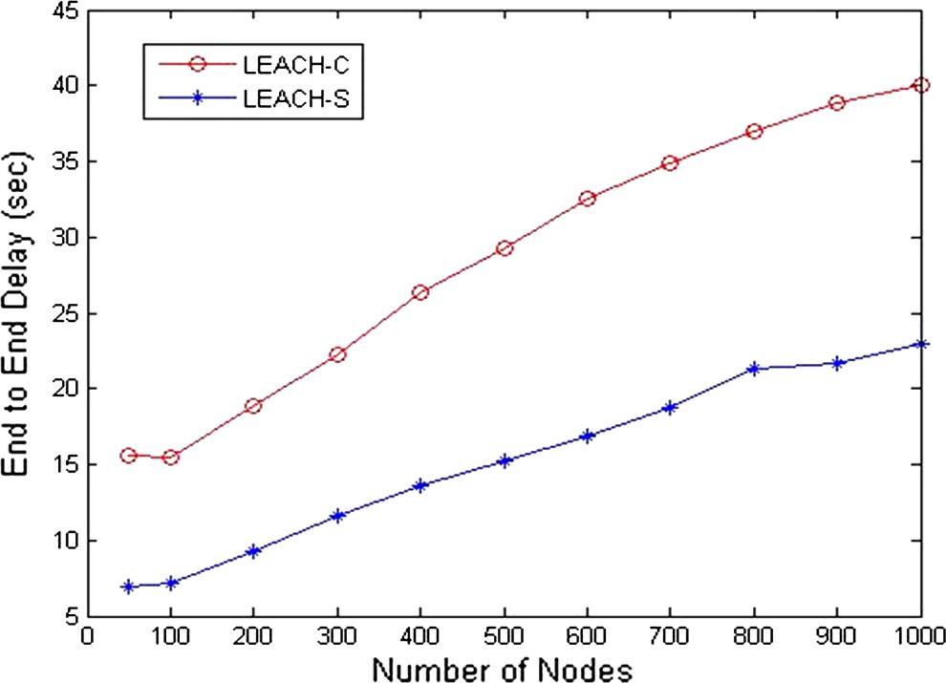

Table 1 Summary of the parameters used in the simulation.

Parameter

Field size (*M* · *M*)

Initial energy of sensor node Transmitter/receiver Electronics *ETx* and *ERx* (*Eelec*)

Transmitter amplifier where *d* < *do*

Transmitter amplifier where *d* P *do*

The energy for aggregation The data packet size

Value

1000 · 1000

0.5 J

50 nJ/bit

e*fs* = 0.0013 pJ/bit/m2 e*amp* = 10 pJ/bit/m2 5 nJ/bit/signal

4000 bits

Figure 7 End-to-end delay.

will die after more rounds than LEACH-C. In some scenarios, this is not the case as shown in the figure as the same node may not be chosen to be switched to the sleeping mode as it depends on the significance of data, and in such case, a node will be

loaded as the ordinary LEACH-C, and thus, the first node to die may die sooner or the same as LEACH-C.

* 1. *Delay*

Delay in wireless sensor networks is defined as the difference in time between sending a packet from a node and its arrival at the base station. This value is averaged across the network life- time to determine the mean end-to-end delay in the network. Fig. 7 shows that LEACH-CS decreases the delay by a factor of 50% as the sleeping mode may target the large numbered clusters in any round, and thus, the overall mean delay will show a reasonable decrease.

1. Conclusions

In this paper, a Low-Energy Adaptive Clustering Hierarchy Sleeping Protocol (LEACH-CS) is being proposed for routing in wireless sensor networks employing a novel algorithm named Intelligent Sleeping Mechanism (ISM) that adopts a sleeping mode for a percentage of nodes in the network depending on the data sent at a certain period of time from these nodes and its significance. LEACH-CS when compared to LEACH-C proves to be more efficient through simulation results. The results show that LEACH-CS extends the lifetime of wireless sensor networks by an average 45% when com- pared to LEACH-C; it also decreases the end-to-end delay of data sending by an average 50% less than LEACH-C. Hence, it is concluded that LEACH-CS protocol is well suited for applications that demand data quality and lifetime extension as precision agricultural applications where data will not be ex- pected to change dramatically or critically in small time frames. LEACH-CS is the first protocol that introduces intel- ligent data analysis to sleeping mechanisms in wireless sensor networks which besides having the advantages of using lifetime extensions encountered by using sleeping modes it considers the significance of the data of sleeping nodes. Throughput which is defined in WSN as the expected number of successful packet transmissions per timeslot [15] suffers a dramatic de- crease in LEACH-CS as not all nodes function in the network, and thus, not the same number of packets is delivered. Though this may seem a disadvantage, it may be on the contrary an advantage if the packets sent in a certain period of time are insignificant. LEACH-CS protocol will not be suitable for applications where data is crucial from one moment to another as most military applications or applications that are con- cerned with life safety.

1. Future work

In the future work, it is intended to extend LEACH-CS proto- col with more improvements in choice of the sleeping nodes. Also trying to consider mobility of nodes is a big challenge in wireless sensor networks that could be considered deeply.

References

1. [Saeidmanesh M, hajimohammadi M, Movaghar A. Energy and](http://refhub.elsevier.com/S1110-8665(13)00018-2/h0005) [distance based clustering: an energy efficient clustering method for](http://refhub.elsevier.com/S1110-8665(13)00018-2/h0005) [WSNs. World Acad Sci Eng Technol 2009;55](http://refhub.elsevier.com/S1110-8665(13)00018-2/h0005).
2. Saravanakumar R, Kavitha M. Performance evaluation of energy aware data centric routing algorithm in wireless sensor networks. National level conference on Intelligent systems and their appli- cations held at Sudharsan Engineering College, Pudukkottai, Tamilnadu, India during 24th and 25th, August-2007.
3. Saravanakumar R, Susila SG. iPower – an energy conservation system for intelligence building by WSNs. In: International conference on data warehousing, data mining and networking held at Jayaram College of Engineering and Technology, Tiru- chirappalli, Tamilnadu, India during 4th and 5th October 2007.
4. Saravanakumar R, Malaisamy K. Energy-efficient MAC for WSNs. National conference on application of emerging technol- ogies held at Adhiyaman College of Engineering, Hosur, Tamiln- adu, India during 24th and 25th 2008.
5. Saravanakumar R, Susila SG, Raja J. An energy efficient cluster based node scheduling protocol for wireless sensor networks. Solid-state and integrated circuit technology (ICSICT), 2010 10th IEEE international conference on, November 2010. p. 2053–57.
6. [Abd El-Kader SM. Performance evaluation for flat and hierar-](http://refhub.elsevier.com/S1110-8665(13)00018-2/h0010) [chical WSN routing protocols. Mediterr J Comput Networks](http://refhub.elsevier.com/S1110-8665(13)00018-2/h0010) [United Kingdom 2011;7(3):237–43, 1744-2397](http://refhub.elsevier.com/S1110-8665(13)00018-2/h0010).
7. Heinzelman WB. Application-specific protocol architectures for wireless networks. PhD thesis. Massachusetts Institute of Tech- nology; June 2000.
8. [Heinzelman WB, Chandrakasan AP, Balakrishnan H. An appli-](http://refhub.elsevier.com/S1110-8665(13)00018-2/h0015) [cation-specific protocol architecture for wireless microsensor](http://refhub.elsevier.com/S1110-8665(13)00018-2/h0015) [networks. IEEE Trans Wire Commun 2002;1(4):660–70](http://refhub.elsevier.com/S1110-8665(13)00018-2/h0015).
9. Manjula SH, Reddy EB, Shaila K, Nalini L, Venugopal KR, Patnaik LM. Base-station controlled clustering scheme in wireless sensor networks. Wireless Days, 2008. WD ‘08. 1st IFIP. November 2008. p. 1–5.
10. [Soleimani M, Ghasemzadeh M, Sarram MA. A new cluster based](http://refhub.elsevier.com/S1110-8665(13)00018-2/h0020) [routing protocol for prolonging network lifetime in wireless](http://refhub.elsevier.com/S1110-8665(13)00018-2/h0020) [sensor networks. Middle-East J Sci Res 2011;7(6):884–90](http://refhub.elsevier.com/S1110-8665(13)00018-2/h0020).
11. El-Basioni BM, Abd El-kader SM, Eissa HS, Zahra MM. Clustering in wireless sensor network: studying a three well- known clustering protocols. Book chapter in ‘‘Theory, applica- tion, and experimentation of wideband wireless networks’’ IGI global, 2012.
12. [El-Basioni BM, Abd El-kader SM, Eissa HS. Improving LLEAP](http://refhub.elsevier.com/S1110-8665(13)00018-2/h0025) [performance by determining sufficient number of uniformly](http://refhub.elsevier.com/S1110-8665(13)00018-2/h0025) [distributed sensor nodes. CiiT Int J Wire Commun](http://refhub.elsevier.com/S1110-8665(13)00018-2/h0025) [2012;4(13):777–89](http://refhub.elsevier.com/S1110-8665(13)00018-2/h0025).
13. Noh Y, Lee S, Kim K. Basestation-aided coverage-aware energy- efficient routing protocol for wireless sensor networks. In: WCNC 2008, IEEE wireless communications & networking conference, March 31 2008–April 3 2008, Las Vegas, Nevada, USA, confer- ence proceedings. IEEE, 2008. p. 2486–91.
14. Varga A. The OMNeT++ discrete event simulation system. European simulation multiconference. Prague, Czech Republic, June 2001.
15. [Liu X, Haenggi M. Throughput analysis of fading sensor](http://refhub.elsevier.com/S1110-8665(13)00018-2/h0030) [networks with regular and random topologies. EURASIP J Wire](http://refhub.elsevier.com/S1110-8665(13)00018-2/h0030) [Commun Network 2005;2005(4):11 [doi: 10.1155/WCN.2005.554,](http://refhub.elsevier.com/S1110-8665(13)00018-2/h0030)

[Article ID 397962]](http://refhub.elsevier.com/S1110-8665(13)00018-2/h0030).