[Egyptian Informatics Journal 24 (2023) 173–190](https://doi.org/10.1016/j.eij.2023.02.004)

Contents lists available at [ScienceDirect](http://www.sciencedirect.com/science/journal/11108665)

Egyptian Informatics Journal

journal homepage: [www.sciencedirect.com](http://www.sciencedirect.com/)

[](http://crossmark.crossref.org/dialog/?doi=10.1016/j.eij.2023.02.004&domain=pdf)Intelligent deep analysis of DNA sequences based on FFGM to enhancement the performance and reduce the computation

Zena A. Kadhuim a, Samaher Al-Janabi b,⇑

a *Department of Software/College of Information Technology, University of Babylon, Babylon, Iraq*

b *Department of Computer Science, Faculty of Science for Women (SCIW), University of Babylon, Babylon, Iraq*

a r t i c l e i n f o

*Article history:*

Received 6 May 2022

Revised 21 February 2023

Accepted 24 February 2023

Available online 7 March 2023

*Keywords:*

Intelligent deep analysis DNA sequence

RNA sequence

Graph Mining Techniques FFGM

a b s t r a c t

In an attempt to improve the analysis DNA sequence, a new intelligent deep analysis algorithm called reduce frequency bast on fast frequency graph mining (RF-FFGM) is established; This algorithm at the beginning converts the DNA sequence into RNA sequences after that split these sequence into multi sub- sequence through determined specific equation for start and end point of each sequence. After that each subsequence represent as subgraph after label to the bonds between each pair of components related to RNA (i.e., A, G, U, C) these bounds include 16 labels used as Knowledge Constructions (KC)) for this work. After that apply the steps of FFGM that select after deep analysis to graph mining techniques *(GSpan, FFSM, Hybrid-Tree-Miner, Approximate Frequent Sub-graph, CloGraMi and FFSM)* this analysis focus on determined *(the main programming steps, main parameters, advantages, disadvantages) for each algorithm.* We discovery FFGM finds the frequent in a short time, because it building matrix code for con- nection edge and transforming matrices into incidence matrix, also; we found FFGM can get all the edges that have the highest contact with the other edges, so from the second stage therefore it avoids us from going through a sequential path to find duplicate edges. RF-FFGM appears as a pragmatic algorithm, it proves their robust to work with DNA sequence to reduce the computation and time.

© 2023 THE AUTHORS. Published by Elsevier BV on behalf of Faculty of Computers and Artificial Intel-

ligence, Cairo University. This is an open access article under the CC BY-NC-ND license ([http://creative-](http://creativecommons.org/licenses/by-nc-nd/4.0/)

[commons.org/licenses/by-nc-nd/4.0/](http://creativecommons.org/licenses/by-nc-nd/4.0/)).

1. Introduction

Deoxyribonucleic acid (DNA), is a good potential for understand the human genome of society. The major benefit from studying DNA is to detect and analysis the genome structure of living organ- isms. DNA represented by four basic elements called base or nucle- ate, these elements are Adenine (A), Thymine (T), Guanine (G) and Cytosine (C) [22]. DNA can be analysis using many software and tools available called Basic Local Alignment Search, Tools (BLAST). it was used to scan sequences, from more than 260,000 species, including more than 190 billion nucleotides [19,25].

*Abbreviations:* A, Adenine; AP-FSM, Approximate frequent sub-graph; C, Cytosine; CloGraMi, Closed Frequent Sub-graph Mining; Close, Close frequent edge; DNA, Deoxyribonucleic acid; M(S), Minimum supported threshold; MF(S), Maximum frequent edge; mRNA, Messenger Ribonucleic acid; FFSM, Frequent, sub- graph mining; GSpan, Graph based substructure pattern mining; G, Guanine; RF- FFGM, Remove duplication of frequency based on fast frequency graph mining; T, Thymine; U, Uracil.

* Corresponding author.

*E-mail address:* [samaher@itnet.uobabylon.edu.iq](mailto:samaher@itnet.uobabylon.edu.iq) (S. Al-Janabi).

Data is important for knowing knowledge, it can be defined as an information that have been converted to a suitable form for pro- cessing, in other word data is a collection of objects and their attri- bute related to it or object with collection of features or object with a specific single feature that recognize it [24]. It comes in several forms and get by observation, search, or recording. While the data science is integration among three domain (statistical or mathe- matical, computer science and knowledge) domain [7]. Small, nor- mal, and big data are three type of data science; small data organized in uniform structure such as list or a table, and the size of data no greater than 30 samples, and not submitted to the nor- mal distribution and cannot be, used to make any decisions; nor- mal data, on the other hand, is structured data that is submitted to, the normal distribution and can be used to make various deci- sions, such as (clustering, classification, prediction and optimiza- tion, etc.). Finally, large data, which can be structured, semi structured, or unstructured, has a size range of 1 TB to 1 ZB. It can extract important information or pattern it using a mix ML and Cloud computing [20]. Different type data science have been introduced with their used in different field and advantage of it. Most programmers used normal data because of simplicity in gen-

<https://doi.org/10.1016/j.eij.2023.02.004>

1110-8665/© 2023 THE AUTHORS. Published by Elsevier BV on behalf of Faculty of Computers and Artificial Intelligence, Cairo University. This is an open access article under the CC BY-NC-ND license (<http://creativecommons.org/licenses/by-nc-nd/4.0/>).

eration model and move away from using cloud computing. The term of Finding, gathering, cleaning, evaluating, and modelling data in order obtain relevant information and insights and inter- pret the derived information, for data-driven decision-making is refer to data analysis [11,13].

It is hard to understanding the structure of DNA, includes protein structure or any chemical structure. DNA represented in form of graph as a large collection of nodes and edge. There is a lot of search algorithm in graph have been used recently [22], graph mining has become an active, and important in data mining, The most basic fre- quent patterns that may be detected in a collection of graphs are known as frequent substructures. They can be used to characterize graph sets, distinguish between distinct groups of graphs, categorize and cluster graphs, generate graph indices, and make similarity searches in graph databases easier. Several graph mining approaches have recently been created and applied to the detection of intriguing patterns in a variety of applications [2].

The reminder of this paper organized as followed: section two the related work that people research in the same field, section three represents the important of graph mining and algorithm related to it. Section four represents the methodology of our paper; section five shows the implementation of our work while section six present the result of our method finally section seven is conclu- sion and future work.

1. Related work

Mining of frequency sub graph is one of the most important concerns that directly effect on computation of all sequence later As a result, in this section of the paper, we will attempt to review previous research in the same field as our topic and compare these works in terms of five essential characteristics, namely the data- base/ dataset employed. The methods for evaluating the findings, as well as the benefits and drawbacks of each method, are dis- cussed, as well as evaluation.

Lopamudra et al.[16] built different ML model in order to pre- dict Protein -Protein Interaction between human protein and viruses to discover anti-COVID drug, first must prepare model to accept various length of Protein human sequences. For preprocess- ing data they used LVQ for feature subset selection and then used different supervised learning algorithm (SVM), (NB), (RF), (KNN) with multilayer perceptron used for prediction and classification. For performance measurers they used confusion matrix for evalu- ating the performance of prediction. Our method similar with this method for preparing sequence of structure but different in tech- nology used based on Frequency sub-graph mining algorithm.

Xiujuan et al. [27] design a new method called Deep learning based protein-binding site prediction with feature based non- redundancy from level of RNA (DFpin) for predicting protein inter- action related to different type of human Disease, they used sliding window, and for each window apply preprocessing technique, they Remove feature redundancy based on the RNA mono-nucleotide composition to maintain the diversity, of RNA samples and avoid the residue of redundant data then they used SVM to identify PIN of protein interaction related to varies type of protein, for data- set used they used different length of RNA dataset: RNA587, RNA208 for predict protein interaction. Our method similar with this method for preparing sequence of structure but different in technology used based on Frequency sub-graph mining algorithm. Chang [4] built deep new learning mechanism named (F UTUSA) to predict protein function based on information of

sequence of RNA only, First sequence is segmented in order to improve the prediction of protein function by a CNN, for train the regional sequence patterns and their relationship. FUTUSA also performed admirably in terms of predicting acetyl transferase and demethylase activity. The next step was to see if FUTUSA could anticipate the functional consequences of a point mutation. FUTUSA was successful after being trained for monooxygenase activity, predicted the effect of point mutations on the enzyme phenylalanine hydroxylase, which causes an inherited condition. KU is a metabolic disorder. This deep-learning algorithm can be used to characterize newly discovered objects as a first step. Pro- teins that haven’t been identified or that haven’t been well exam- ined. For performance measurers they used accuracy for evaluating the performance of prediction. Our work similarity with this work in the idea of predicting protein for identify which family cased disease and which is stop it, and in evaluation measurement but we use confusion matrix include not only accuracy but differ in method used to discover protein based on intelligent data analysis technique. Our method similar with this method for preparing sequence of structure based segmentations of mRNA sequence but different in technology used based on Frequency sub-graph mining algorithm.

Minghui Wang et al. [17] design a new model called Malsite- Deep for prediction malonylation sites that protein occurs in response to lipopolysaccharide (LPD). At the first stage apply seven feature extraction methods to protein to extract feature informa- tion from it. Second stage handle imbalance data by applying the under-sampling NearMiss-2 and sellect best feature subset. Last stage these data go to Deep Neural Networks predict sites of malonylation. Evaluation of model by 10-fold cross model perfor- mance is evaluated by 10-fold validation and independent test sets shows that the AUC value on the training dataset reaches 0.99. The AUC values on the four independent test datasets all reach above

0.95. Our method similar with this method for preparing sequence of structure but different in technology used based on Frequency sub-graph mining algorithm.

Zicheng et al. [28] design method to identify immune-related Retinol-binding proteins (RBP) are a family of proteins with diverse functions to predict prognosis and therapy response in prostate can- cer. Before work must segment the mRNA sequence to improve work. They used mRNA dataset and used Pearson Correlation analy- sis for select Immune-related RBP and they found this method able to distinguish among the high-risk and low-risk groups of prostate cancer. high-risk suffer from higher rates of genomic alterations, and were more sensitive to targeted and immunotherapy, than the low-risk group by using sensitivity measurement. Our method sim- ilar with this method for preparing sequence of structure based seg- mentations of mRNA sequence but different in technology used based on Frequency sub-graph mining algorithm.

1. Graph mining

A well-establish research field, in computer science and many other field of science is a Data mining. It can be found in many dif- ferent area such as text [23], image mining [9], sound mining [3], video mining [26] and graph mining [5].

Recently, graph mining used in many area such as Chemical, Compound, Structure of Protein, Social Network and Flow of Pro- gram [8]. It allows to analyze, process, discover meaningful knowl- edge from graph data. In general, graph mining is the process of extracting non-trivial graph structures from a single graph or a

set of graphs. The following is a definition of frequent sub-graph mining, which is a common example of graph mining difficulties. Find all sub-graphs whose support is no less than a user- specified minimum supported threshold, given a graph data set D = G1, G2,.. ., Gn, where Gi = (Vi, Ei) (1 I n) is a graph with a vertex set Vi and an edge set Ei, and the support of a sub-graph g is the number of graphs in D that g is sub-graph isomorphic to [5]. Fre- quent sub-graph mining In graph mining is one of the most chal- lenging tasks of graph mining. Frequent sub-graph mining divided into two important strategies first, FSM based a priori approaches that used for transactional data and small graph while second, FSM based pattern growth approaches for largest graph or multiple graph[21].

The first algorithm is the basic one algorithm used for extract- ing all frequent subsequence / sub-graph from data and then accepting the most frequent subsequence according to some min- imum support. Apriori algorithm generate sub-graph of, size- (k + 1) of k sub-graph and uses breadth first,search strategy for vis- iting nodes. FSG and AGM is the most used Apriori algorithm it used edge based method for growing the size of sub-graph by add- ing one edge for each iteration [2]. The second algorithm used for extracting all frequent sub-graph from data and then accepting the most frequent subsequence according to some minimum support. Pattern growth algorithm uses depth first,search strategy for visit- ing nodes. gSpan, FFSM, AP- FSM, Hybrid-Tree-Miner and CloGraMi is the most used pattern growth algorithm and used edge based method for growing the size of sub-graph by adding one edge for each iteration [11,13].

* 1. *Graph based substructure pattern mining (GSpan)*

Graph based substructure pattern mining, (GSpan) is a complet frequent sub-graph mining, work on large fix graph and also labeled graph, GSpan uses pattern growth, strategy for extension the graph, by adding new edge to generate set of candidate, sub- graph and using DFS for building frequent sub-graph bottom up, then remove redundancy by minimal DFS cods according to lexical ordering. The performance of this, algorithm is improved over Apriori extensions to graphs through DFS Code representation and candidate pruning [20]. GSpan Discovered by Yan, X., & Han,

J. in 2002, And publish this algorithm in Journal of Chemical, Infor- mation and Modeling (Yan, 2002). main goal of GSpan is to finding all frequent sub-graphs without candidate generation frequent sub-graph using DFS and false positives pruning, and also reduces duplicate, graph generation. The main parameters of GSpan algo- rithm is G: represent a large fix graph contain set of edge e and

nodes n, M(S): that represent minimum supported threshold of selected sub-graph desire. Algorithm bellow discusses how GSpan based Frequent Sub-graph mining work. Algorithm 1 show GSpan.

* 1. *Frequent, sub-graph mining (FFSM)*

To reduce computation of counting frequent sub-graph, another algorithm based graph is represented Frequent, Sub- graph Mining (FSM). In this algorithm (FSM) represent graph in canonical adjacency matrix (CAM), for each edge and vertices of the graph and uses a vertical search technique within an alge- braic graph structure. FSM outperforms the current state-of-the- art sub-graph mining technique GSpan by a significant margin. The FSM discovered by Huan[10] and published in UNC com- puter science technique. And later modified and publish in IEEE. FSM outperforms GSpan and Apriori techniques by efficiently tackling the time-consuming underlying sub-graph isomorphism problem and proposing two efficient sub-graph enumeration operations, as well as an algebraic graph framework built to limit the number of duplicate candidates presented [10]. The main parameters of FSM algorithm is G: represent a large fix graph and M(S): that represent minimum supported threshold of selected sub-graph desire and also Sa the canonical adjacency matrix of the frequent node, Pa canonical adjacency matrix of the frequent edge. The algorithm bellow discuss how FSM based Frequent Sub-graph mining work. Algorithm 2 shown Frequent, Sub-graph Mining.

* 1. *Hybrid-Tree-Miner*

Hybrid-Tree-Miner is a computationally efficient program that finds all frequently occurring patterns in a tree. Sub-trees in a rooted unordered tree database by traversing an enumeration, the method finds frequent sub-trees. A tree that counts all sub- trees in a systematic manner The enumeration tree is based on a new canonical model. The breadth-first canonical form for rooted unordered trees. This approach can efficiently handle databases of free trees by extending the definitions of our canonical form and enumeration tree to free trees. Extensive tests on this algo- rithm based on both synthetic data and datasets but used in static graph from real-world examples. Algorithm discovered by [6]. As a result, this algorithm of finding frequent subtree mining approach works on both rooted and unrooted trees. Rooted unordered trees and free trees have similar canonical forms, enumeration trees, operations on the enumeration trees, and frequent subtree mining strategies in our construction [6].

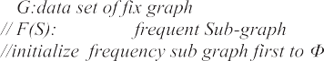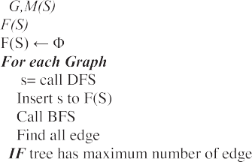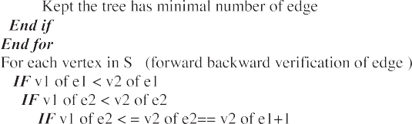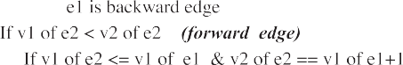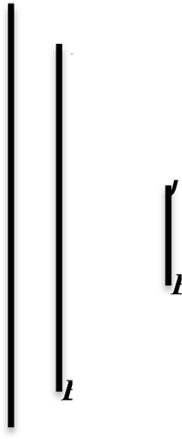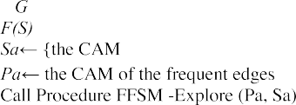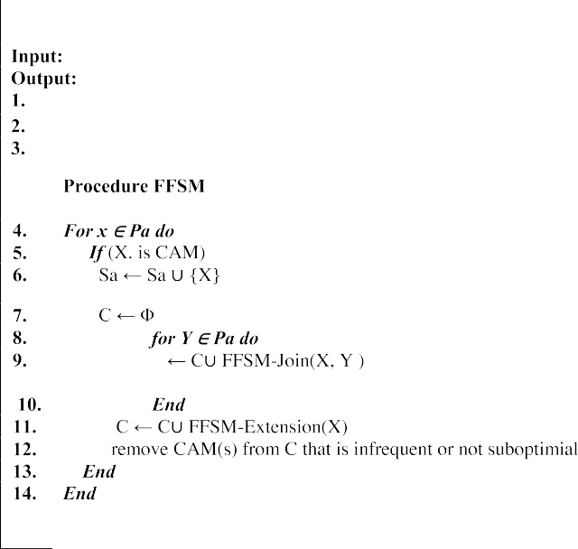

* 1. *Approximate frequent sub-graph AP-FSM*

The majority of available frequent sub-graph mining techniques are centralized algorithms that can’t efficiently manage a single huge graph and have substantial communication costs. However Pregl, a distributed graph environment, was used to implement Ap-FSM. Ap-operation FSM’s is divided into two parts. There are three stages. The first step selects a representative graph from the original graph while maintaining the original graph’s integrity. The qualities of the original graph Sub-graph extension is effi- ciently performed in the second step. In Phase 3, a novel two- step optimization for performing sub-graph trimming is intro- duced. Graph data of this size is difficult to analyze. Vandana Bha- tia and Rinkle Rani [2] and published at Expert Systems with Applications in Elsevier journal. Approximate sub-graph mining can be used to reduce the computing cost of sub-graph mining by capturing similar structural sub-graphs. As far as accurate sub-graph mining is concerned. Will be advantageous from the standpoint of an expert and intelligent systems, as discovered pat- terns can be used for knowledge discovery and decision making. Vandana Bhatia, Rinkle Rani [2]. The main parameters of AP-FSM algorithm is G: represent a sample graph and M(S): that represent

minimum supported threshold of selected sub-graph desire and also Sa the adjacency matrix of the frequent node, Pa adjacency matrix of the frequent edge. Algorithm 3 shown AP-FSM. Algorithm

3 shown Ap-FSM while 3.A shown execution and 3.B AND 3.C shown the local and global of that algorithm.

* 1. *CloGraMi*

CloGraMi (Closed Frequent Sub-graph Mining) is a GraMi-based approach for locating all closed frequent sub-graphs in a big graph. The first is a new level order traversal approach for quickly deter- mining closed sub-graphs in the search process, and The second is to define a requirement for early trimming of a significant number of non-closed candidates,to increase the performance of the pro- posed system by reducing the running time and memory require- ments algorithm (LAM et al., 2021). Algorithm bellow discuss how CloGraMi based Frequent Sub-graph mining work. Algorithm above discovered by LAM[18] and published at IEEE access the main goal for this algorithm is to reducing the running time of cal- culating all frequent sub-graph and also for reducing memory requirements of frequent sub-graph storage. Algorithm 4 shown CloGraMi.

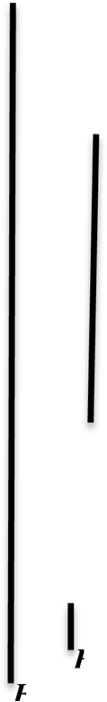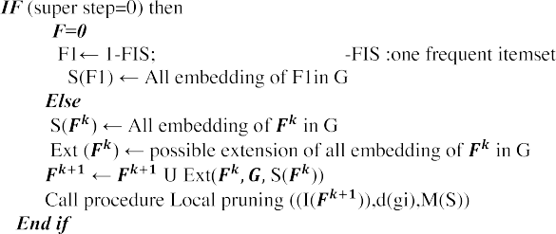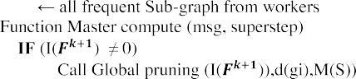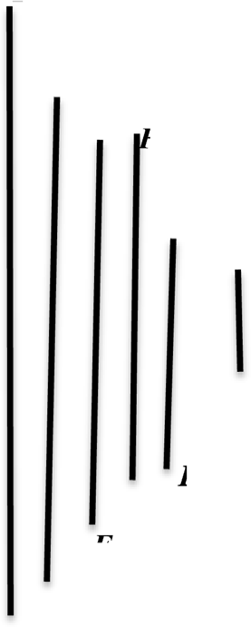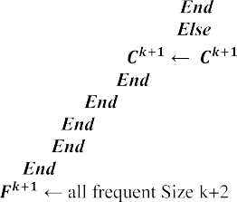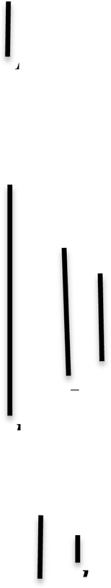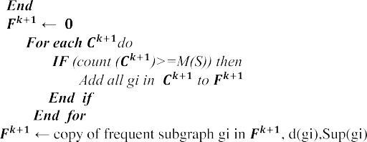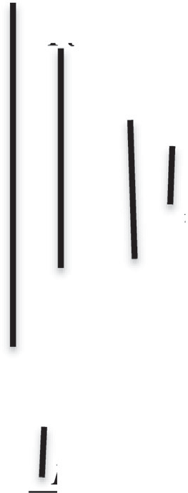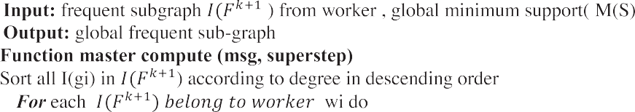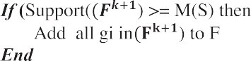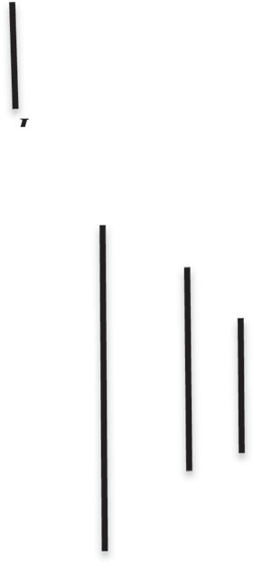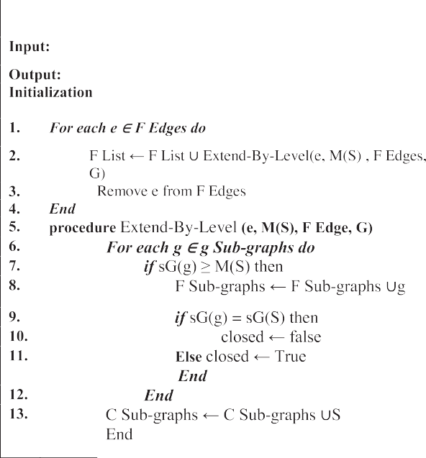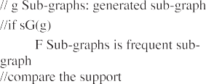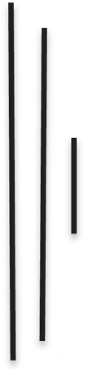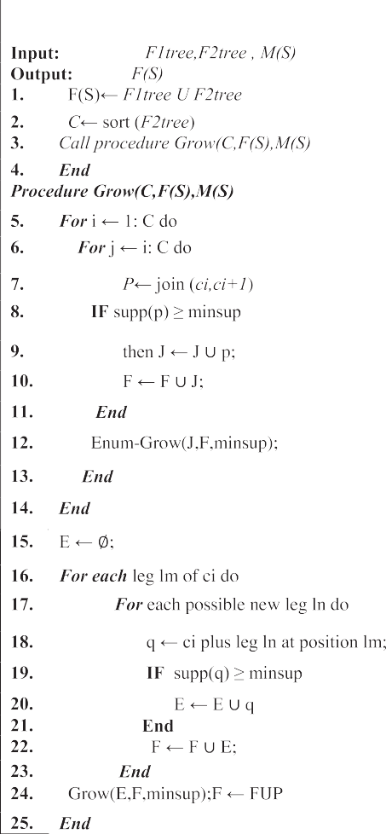

*Where:* G is a graph database, d(g) is degree of each sub-graph,F(S) is frequency of all sub-graph, MF(S) is a max- imum frequent sub-graph extracted, I and j is iteration of

algorithm, C code is a candidate code in form of binary, Gn is a normalize incidence matrix, close is a close frequent sub-graph.

1. A Novel algorithm to enhancement the performance and reduce the computations (RF-FFGM)

Fast Frequent sub-graph mining (FSM) is an important part of graph mining (Jia Wu1, 2008). It has gotten a lot of attention in fields including web data mining, social networks and bioinformat- ics. Within the topic of data mining, graph mining has become a well-established discipline. It has sparked a lot of interest in the previous decade, thanks to developments in computer hardware that have enabled large-scale graph data mining to be done. [21,1] The task of mining common sub-graphs from graph data- bases is a simple one with a wide range of applications. Finding all sub-graphs that appear more than a certain threshold value is known as frequent sub-graph mining. Candidate creation and fre- quency calculation are the two basic phases. Most existing work in the candidate generation stage starts with a frequent edge or vertex to generate frequent candidate patterns. Kavitha[14] The extract useful knowledge from complex network of DNA is a

complex phenomenon which plays an important role in clinical, treatment. For this problem, mining of frequent sub-structure of DNA is important issue for extracting meaningful knowledge from DNA. However, using this method may increase the computing time of calculating such important knowledge. [29] In this, work, we extract all frequent sub-structure in large complex DNA by using RD-FSMA algorithm. Algorithm begin by entering complex large network of DNA from bank of DNA available online. This algo- rithm divided into three main Step, first step is preprocessing for preparing network for using in farther stage. In this stage large complex network of DNA is transferring into mRNA structure to extract meaningful knowledge from it. Second step is splitting net- work of mRNA into multiple Sub-graph of mRNA. Third step mul- tiple sub-graph enter to RD-FSM algorithm that contained multiple stage to calculate and save different sub-graph extracted from RD-FSMA algorithm in buffer to reduce the computation time for calculated all frequent sub-structure mRNA. Figure bellow illus- trate the main step of algorithm.

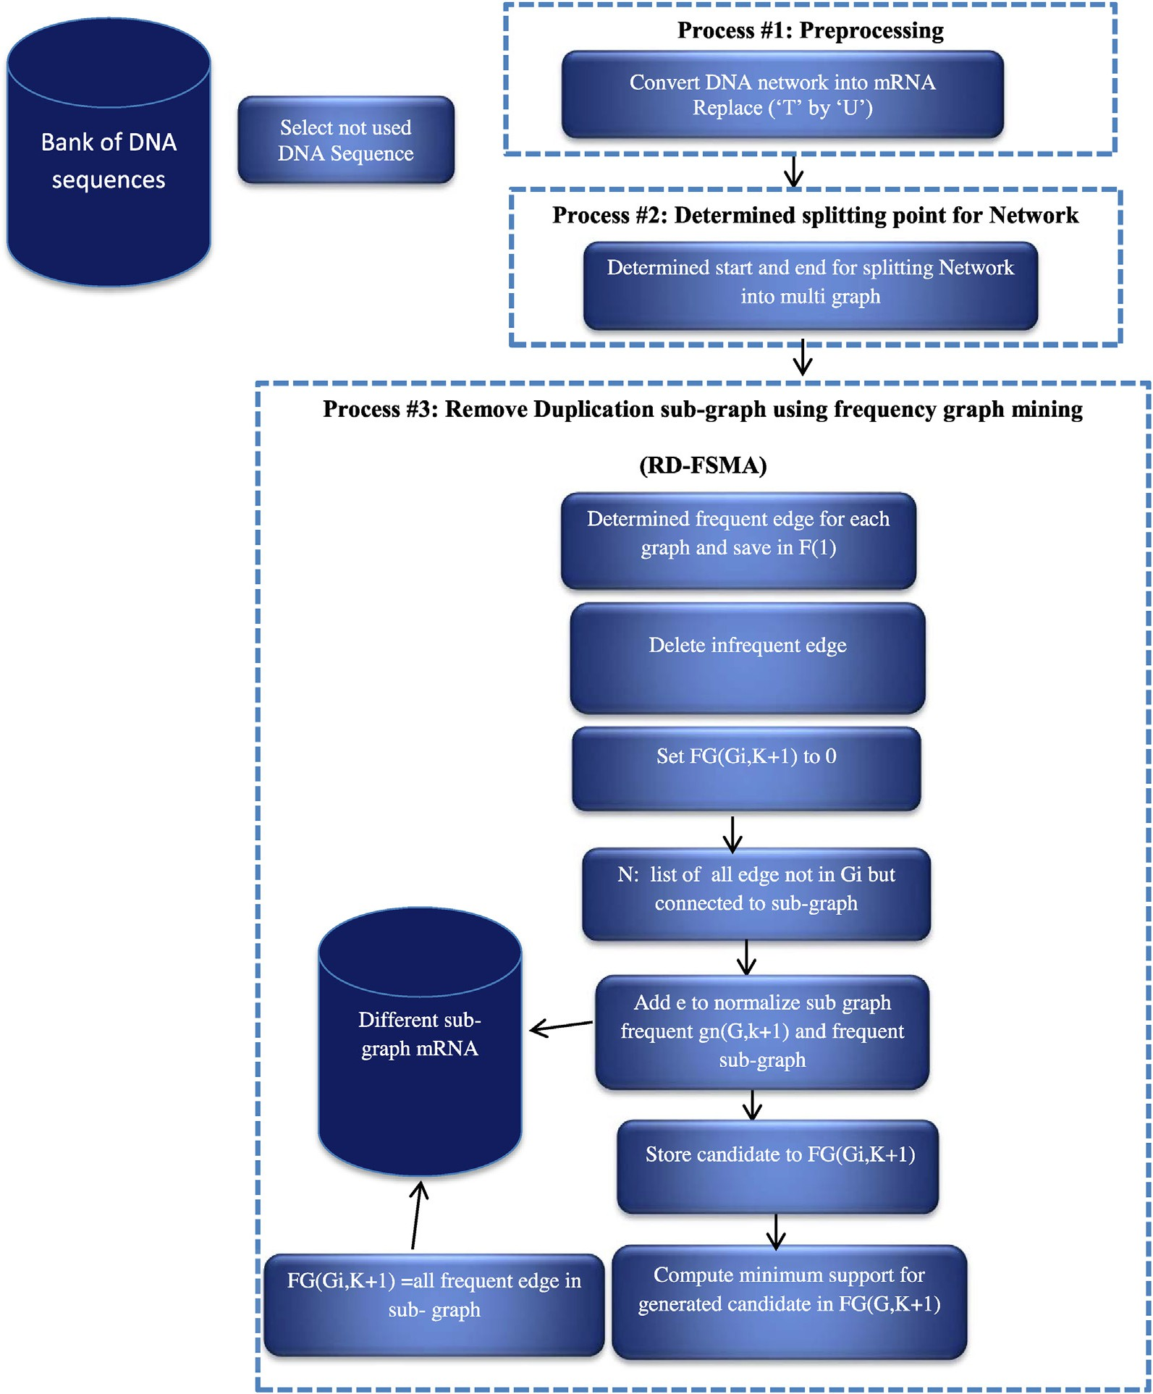

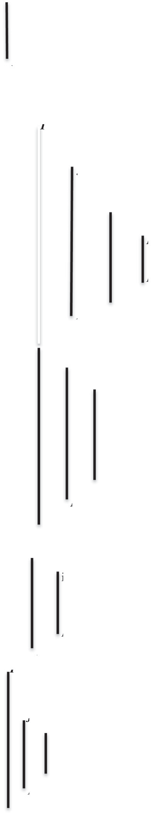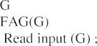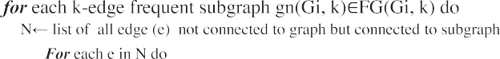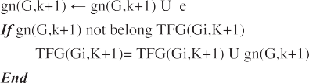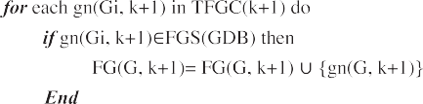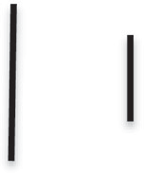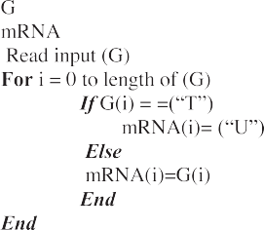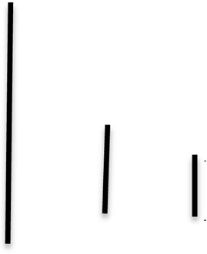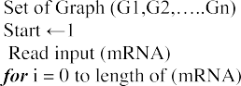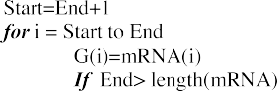

1. Implementation of A novel algorithm (RD-FFGM)

Given a Graph Data set represent (graph of double helix DNA Structure) that continue huge number of four element,(A, T, C, G) connected from one side of DNA strand to another side. Connection element is not arbitrary it done in legal form: (A with T) and (C with G). These elements connected in one strand by three components (phosphate, sugar and base itself). Frist algorithm begin by take one strand of DNA by separate it from

double helix and work with it. Then convert these structures of DNA into Messenger RNA (mRNA) this step can be done by replacing every Thymine (T) element by Uracil (U) element and stay Cytosine (C) and Guanine (G) without change for all structures of mRNA. After this step all graph (mRNA Strand) must cut into multiple sub-graph dataset then enter to RD- FSM algorithm to find different Sub-graph possible for given minimum supported threshold. Example bellow can show how process will done.

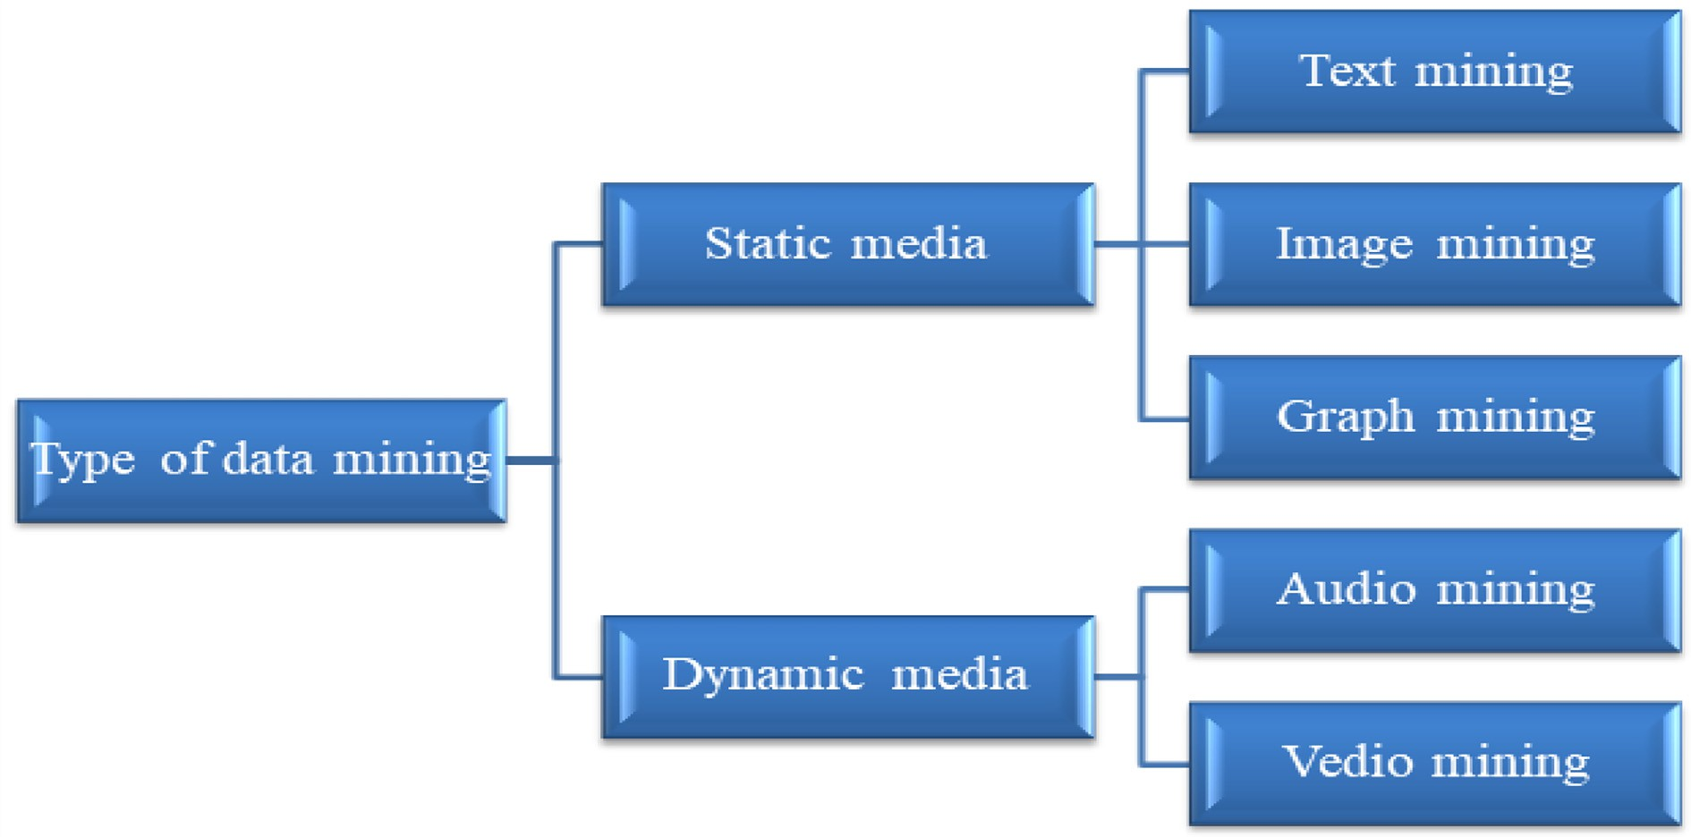

Fig. 1. General data mining area used (Perner, 2002) (ManjunathS. Balaji, 2014).

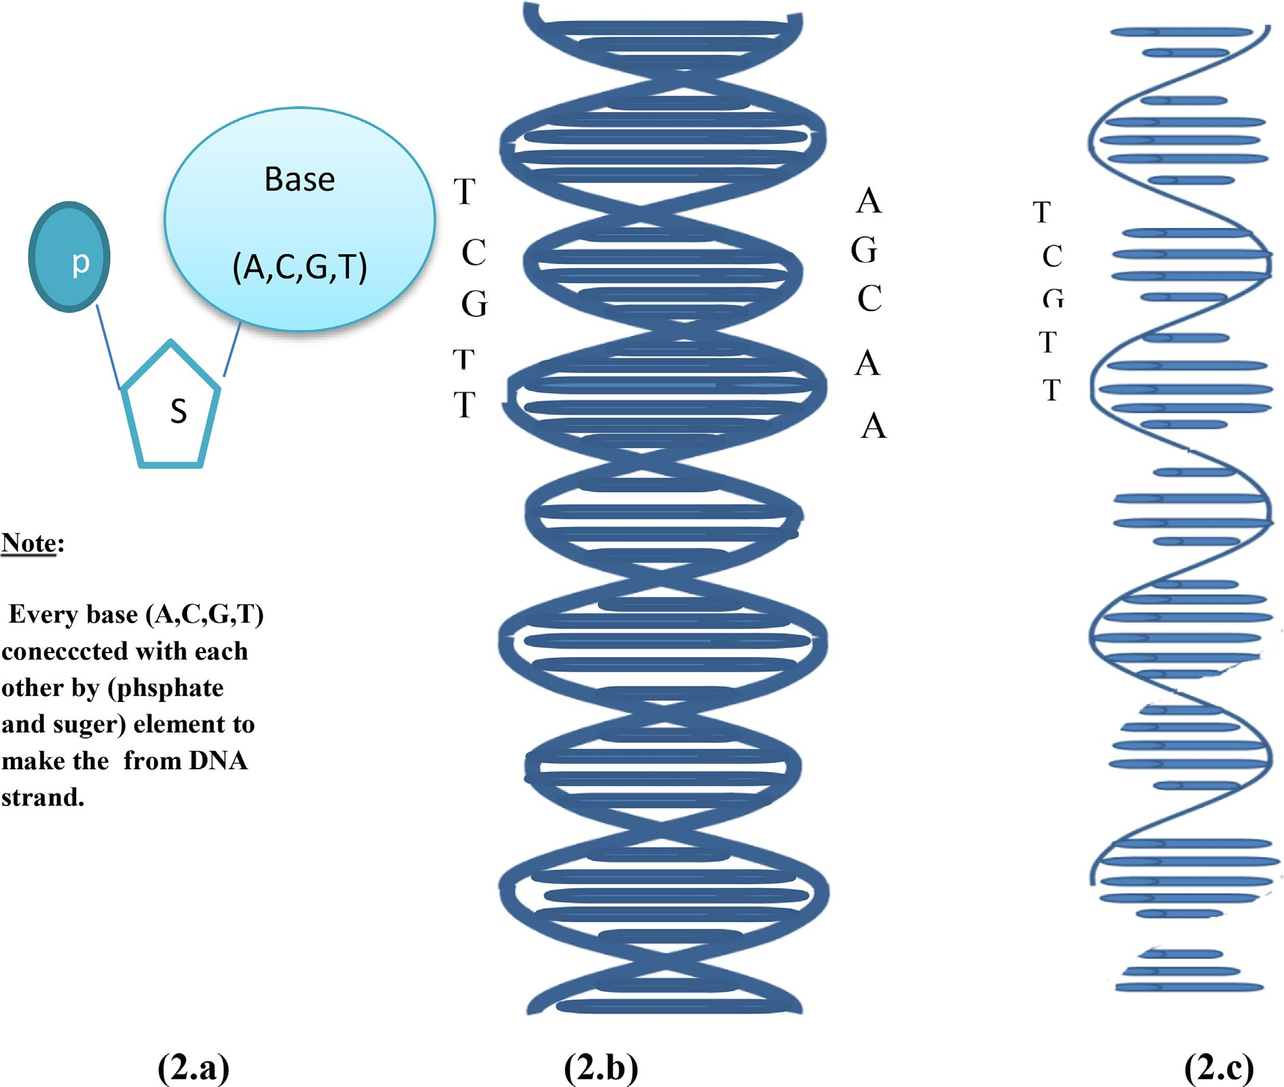

Fig. 2. DNA form (2.a) specification of one element connection in one strand (2.b) Double helix DNA connection one side to another in legal form (2.c) one strand DNA.

Table 1

The main concepts of researcher related to literature survey.

|  |  |  |  |  |  |  |  |
| --- | --- | --- | --- | --- | --- | --- | --- |
| Author(s) | Data set/ Database |  | Preprocessing | Methodology | Evaluation tools | Advantage | Disadvantage |
| Lopamudra [16] | * RNA Sequence |  | LVQ for | (SVM), (NB), (RF), | * confusion | * predict Protein -Protein Interac- | * Need bio- |
|  | * SARS-CoV-2-human   database | PPI | feature subset  selection | (KNN) with  multilayer | matrix | tion between human protein  and viruses | logical  knowledge |
|  | * Negative dataset * independent dataset |  |  | perceptron |  | * discover anti-COVID drug * various length of Protein human |  |

Minghui Wang [17]

Xiujuan Zhao et al. [27]

independent test set (protein sequence) [https://](https://github.com/QUST-AIBBDRC/SulSite-GTB/) [github.com/QUST-AIBBDRC/](https://github.com/QUST-AIBBDRC/SulSite-GTB/) [SulSite-GTB/](https://github.com/QUST-AIBBDRC/SulSite-GTB/).

RNA Sequence)[https://](https://github.com/zhaoxj-tech/DFpin.git) [github.com/zhaoxj-tech/](https://github.com/zhaoxj-tech/DFpin.git) [DFpin.git](https://github.com/zhaoxj-tech/DFpin.git).(

Feature encoding

remove feature redundancy

sequences

SulSite-GTB & Accuracy & identification of protein S-

sulfenylation

high accuracy of prediction

* DF pin & Accuracy & predicting protein interaction

related to different type of human Disease

* Time

complexity

* Time

complexity

Zicheng [17] RNA SequenceMSKCC dataset

(https:// [https://www.mskcc.](https://www.mskcc.org/) [org/](https://www.mskcc.org/))TCGAPRAD dataset ([https://portal.](https://portal.gdc.cancer.gov/) [gdc.cancer.gov/](https://portal.gdc.cancer.gov/))

Segmentation A novel immune–

related RNA– binding proteins signature

* + Pearson

Correlation analysis

* + identify immune-related Reti-

nol-binding proteins (RBP) are a family of proteins with diverse functions

* + predict prognosis and therapy

response in prostate cancer

* + Time

complexity

Chang Woo el al 2022

RNA sequence ([https://www.](https://www.uniprot.org/downloads) [uniprot.org/downloads](https://www.uniprot.org/downloads))

Segmentation od RNA

F UTUSA & Accuracy & predict protein function based

on information of sequence of RNA only

Large computation

Table 2

Comparison between famous five type of graph mining.

|  |  |  |  |  |
| --- | --- | --- | --- | --- |
| T | Advantage | Disadvantage | Main parameter | Secondary parameter |
| *GSpan (Yan,2002)* | * GSpan algorithm have high accuracy for generate all frequent sub-graph mining for a given graph dataset. | * Large computation because it used Depth first search algorithm DFS algorithm and backward search for verification. | * G: labelled graph dataset. * S: code of depth first search. | * M(s):mini- mum sup- ported |
|  | * Find all frequent sub-graphs without all candidate generation, and false positives pruning. * Efficient algorithm for reducing | * Take large time complexity. * Used for small graph. * Problem with unlabelled graph. * Work on static graph |  | Threshold |

duplicate, graph generation.

* + - Work on labelled graph.
    - Less memory consuming.

FSM *(Huan, 2003)* & FFSM algorithm have good accuracy

for generate all frequent sub-graph mining for a given graph dataset

* + - Take fast time for calculate all fre-

quency sub-graph, because scanning all at once.

Work on labelled graph.

* + - Vertical search technique that limit number of candidate
  + FFSM algorithm have Large Memory require- ment because of (canonical adjacency matrix (CAM)) for both frequency edge and vertex.
  + Problem with unlabelled graph.
  + Work on static graph
  + G: labelled graph datasetM (s)

:minimum supported Threshold desired for choos- ing frequent sub-graph mining

* + CAM, matrixes (Pa,Sa)
  + M(s):mini- mum sup- ported Threshold
  + N: Graph

size

Hybrid-Tree- Miner (Yun Chi et, al., 2004).

* + - Work on huge dataset
    - Work on Large tree works on both rooted and un rooted trees
  + Time Complexity because used breadth – first search in enumeration tree stage
  + Work on static graph
  + F1tree,F2tree: frequent one and two respectively
  + M(S): minimum supported Threshold desired for choos- ing frequent sub-graph mining
  + M(s):mini- mum sup- ported Threshold
  + N: Graph

size

AP-FSM

(Vandana Bhatia and Rinkle Rani, 2018)

CloGraMi (LAM et, al 2021)

* + - AP-FSM algorithm have good accu- racy for generate all frequent sub- graph mining for a given graph dataset.
    - Take one large sample graph for a

given many graph.

* + - Work on distributed environment
    - Work on huge dataset
    - Work on Large graph

Work on direct and underact graph

* + - Less memory require
  + Take only one large sample graph for a given many graph.
  + Work only on parallel environment
  + Work on static graph
  + Time Complexity
  + Work on static graph
  + G: labelled graph dataset. & M(s):mini-

mum sup- ported Threshold

* + G: labelled graph dataset. & M(s):mini-

mum sup- ported Threshold

Table 3

Comparison in the Main Parameters, which affect mining sub-graph techniques.

|  |  |  |  |  |  |  |  |  |  |  |
| --- | --- | --- | --- | --- | --- | --- | --- | --- | --- | --- |
| Algorithm/ parameter | G | d(g) | M(S) | F(S) | MF(S) | i | j | C code | Gn | close |
| Gspan |  | × | U | U | × | U | × | × | × | × |
| Fsm | U | × | U | U | × | U | × | × | × | × |
| Hybrid tree miner |  | × | U | U | × | U | × | × | × | × |
| Ap-FSM | U | U | U | U | × | U | × | × | × | × |
| CoGrami | U | × | U | × | × | U | × | × | × | U |
| FFSM | U | × | U | U | U | U | U | U | U | U |

Table 4

Splitting whole network of mRNA extracted into multi-graph.

Graph Start End

G1 1 4

G2 5 8

G3 9 12

G4 13 19

G5 20 26

G6 27 35

Table 5

Splitting whole network of mRNA extracted into multi-graph.

Graph Sequence

G1 ACGA

G2 ACCG

G3 AUUU

G4 AUACAUU

G5 UAUUUAC

G6 CGAUUUUAC

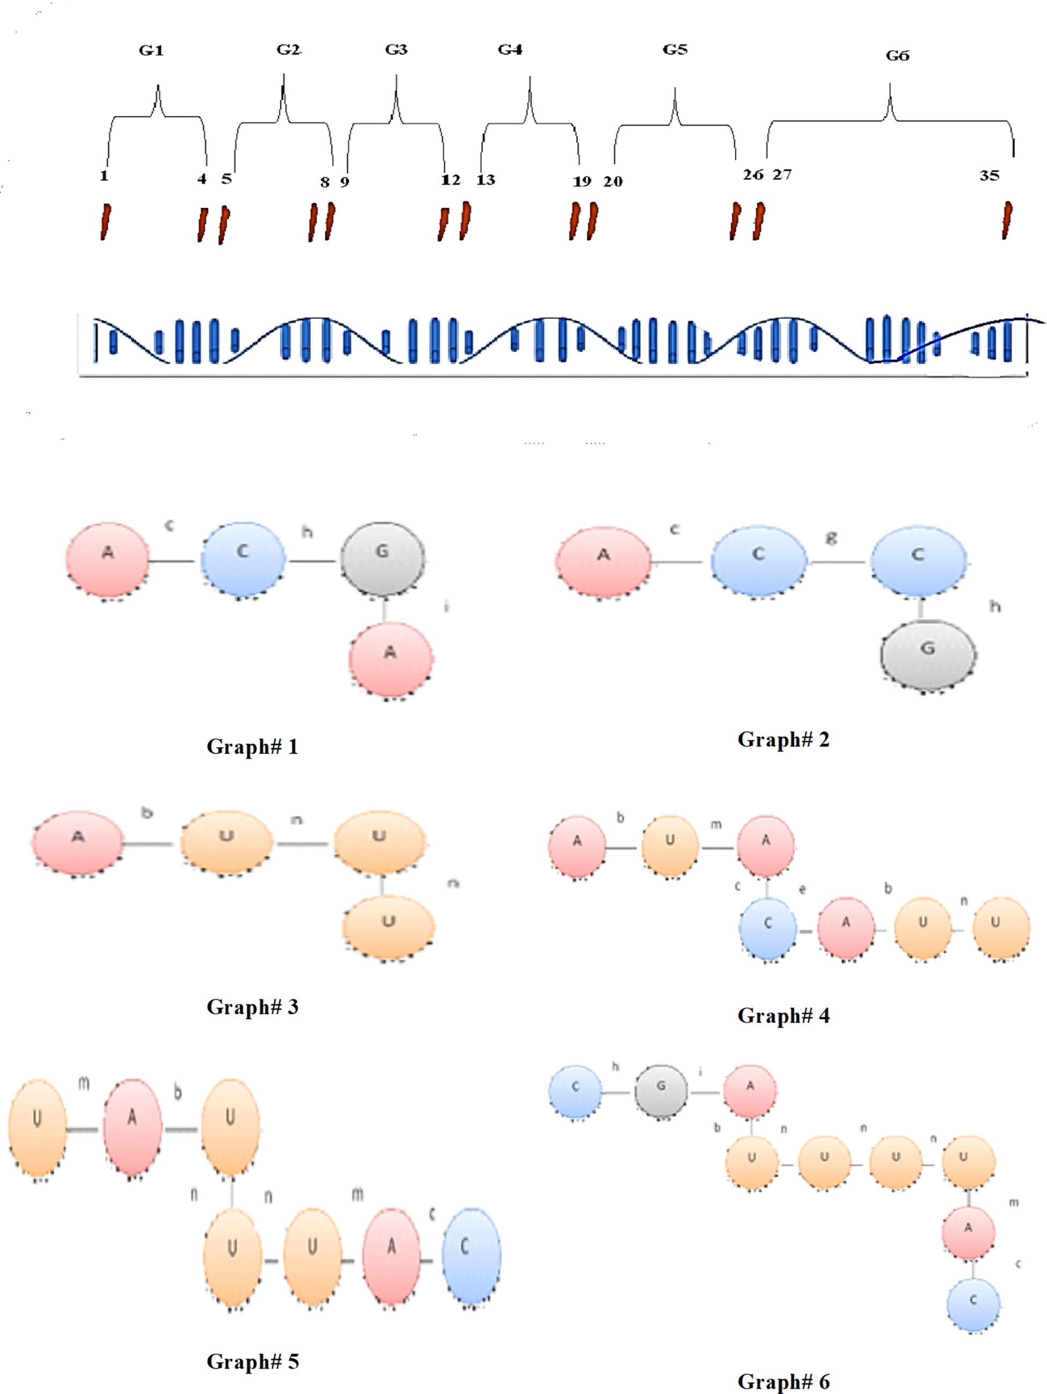

Fig. 3. Splitting whole network of mRNA extracted into multi-graph.

* 1. *Complex network of DNA*

*Step 1:* for a given complex Network of DNA, take one strand of it and start work on it.

*Step 2:* convert one strand of taken DNA into mRNA by replace

every ‘‘Thymine” base into ‘‘Uracil” base and keep both ‘‘Cytosine” and ‘‘Guanine” without change.

*Step 3:* Split whole mRNA network into multiple sub-graph G1,

G2,.. G n. this process cannot be done randomly therefore, we cal- culate start and end point to segment network into multiple graphs in legal form, according to start and end point calculated. Suppose first start point begin from begin of Network and end point accord- ing to equation bellow from given length of mRNA and start point so the start an end point illustrate bellow.

Suppose sequence of mRNA is: ACGAACCGAUUUAUACAUUUAUUUACCGAUUUUAC.

End = Round (Len(mRNA)/Len(mRNA)-Start))*3 + Start. Figs. 1 and 2. Tables 1-5.

Our first stage of work of segmented network of mRNA illus- trates in Fig. 3 bellow:

Then for each graph extracted we proposed a label on each base connection according to four elements of one connection, illus- trated in Table 6:

*Step 4:* For all graph in database of network mRNA must find

frequent for one edge and save it into F(1) and must compute for each Graph extracted from network Incidence matrix normaliza- tion (Iia Wu, 2008) to compute all frequent sub-graph from all graph from Incidence matrix normalization, this process repre- sented bellow:

All other edge not found in graph ignore, {a, d, j, k, l, o, p}. Now for every graph extracted we build type connection between base in form of row column matrix, if edge connected between nodes represent 1, otherwise 0. And build incidence matrix normalization for every graph according to (Jia Wu et al., 2008). row at the first time and then column ordered descending according to coding content and represented bellow for each graph. Tables 7-23.

*Step 5:* Now for each frequent one edge calculated, find frequent

sub-graph of (K + 1). In each graph collect set of N edge not belong to graph itself but connected to sub-graph frequent in its node in other graph.

Then store each unique candidate from each graph in (TFGC edge) for use it in next (K + 1) frequent sub-graph generation.

Table 6

Connection label on connected base.

# Nods Edge AA a

AU b

AC c

AG d

CA e

CU f

CC g

CG h

GA i

GU j

GC k

GG l

UA m

UU n

UC o

UG p

Table 7

Frequent one edge.

|  |  |  |
| --- | --- | --- |
| # | Edge | F(1) edge |
| 1 | (A, c, C,) | 5 |
| 2 | (C, h, G) | 3 |
| 3 | (G, I, A) | 2 |
| 4 | (A, b, U) | 5 |
| 5 | (U, n, U) | 8 |
| 6 | (U, m, A) | 4 |
| 7 | (C, e, A) | 1 |
| 8 | (C, g, C) | 1 |

Table 8

(8.a) matrix code binary connection of graph #1. (8.b) normalize incidence in form of row. (8.c) normalize incidence in form of column.

|  |  |  |  |  |  |  |  |
| --- | --- | --- | --- | --- | --- | --- | --- |
| G1 | c | h | | | i | | |
| A | 1 |  |  | 0 |  |  | 0 |
| C | 1 |  |  | 1 |  |  | 0 |
| G | 0 |  |  | 1 |  |  | 1 |
| A | 0 |  |  | 0 |  |  | 1 |
| Gn1(row) |  | c |  |  | h |  | i |
| C |  | 1 |  |  | 1 |  | 0 |
| A |  | 1 |  |  | 0 |  | 0 |
| G |  | 0 |  |  | 1 |  | 1 |
| A  Gn1(row,colomn) |  | 0 | c |  | 0 | h | 1  i |
| C |  |  | 1 |  |  | 1 | 0 |
| A |  |  | 1 |  |  | 0 | 0 |
| G |  |  | 0 |  |  | 1 | 1 |
| A |  |  | 0 |  |  | 0 | 1 |

Table 9

(9.a) matrix code binary connection of graph# 2. (9.b) normalize incidence in form of row. (9.c) normalize incidence in form of column.

|  |  |  |  |  |  |  |  |
| --- | --- | --- | --- | --- | --- | --- | --- |
| G2 | c |  |  | g |  |  | h |
| A | 1 |  |  | 0 |  |  | 0 |
| C | 1 |  |  | 1 |  |  | 0 |
| C | 0 |  |  | 1 |  |  | 1 |
| G | 0 |  |  | 0 |  |  | 1 |
| G2(row) |  | c |  |  | g |  | h |
| C |  | 1 |  |  | 1 |  | 0 |
| A |  | 1 |  |  | 0 |  | 0 |
| C |  | 0 |  |  | 1 |  | 1 |
| G  G2(row,column) |  | 0 | c |  | 0 | g | 1  h |
| C |  |  | 1 |  |  | 1 | 0 |
| A |  |  | 1 |  |  | 0 | 0 |
| C |  |  | 0 |  |  | 1 | 1 |
| G |  |  | 0 |  |  | 0 | 1 |

Therefore for each sub-graph extracted in each incidence normalize add another edge from graph to each sub graph extracted a according to adjacent edge in each frequent two edge calculated, at this way compute all frequent sub-graph so.

Take one different four edge and store it in buffer for use it.

(10.a) matrix code binary connection of graph 3. (10.b) normalize incidence in form of row. (10.c) normalize incidence in form of column.

(13.a) matrix code binary connection of graph #6. (13.b) normalize incidence in form of row. (13.c) normalize incidence in form of column.

|  |  |  |  |  |  |  |  |  |  |  |  |  |  |  |
| --- | --- | --- | --- | --- | --- | --- | --- | --- | --- | --- | --- | --- | --- | --- |
| G3 | b |  | n | n |  | G6 | h | i | b | n | n | n | m | c |
| A | 1 |  | 0 | 0 |  | C | 1 | 0 | 0 | 0 | 0 | 0 | 0 | 0 |
| U | 1 |  | 1 | 0 |  | G | 1 | 1 | 0 | 0 | 0 | 0 | 0 | 0 |
| U | 0 |  | 1 | 1 |  | A | 0 | 1 | 1 | 0 | 0 | 0 | 0 | 0 |
| U | 0 |  | 0 | 1 |  | U | 0 | 0 | 1 | 1 | 0 | 0 | 0 | 0 |
|  |  |  |  |  |  | U | 0 | 0 | 0 | 1 | 1 | 0 | 0 | 0 |
| G3(row) |  | b | n | n |  | U | 0 | 0 | 0 | 0 | 1 | 1 | 0 | 0 |

Table 11

(11.a) matrix code binary connection of graph# 4. (11.b) normalize incidence in form of row. (11.c) normalize incidence in form of column.

G4 b m c e b n

Gn6(row) h i b n n n m c

|  |  |  |  |  |  |  |  |  |  |  |  |  |  |
| --- | --- | --- | --- | --- | --- | --- | --- | --- | --- | --- | --- | --- | --- |
| G | 1 | 1 | 0 | | 0 | | 0 | | 0 | | 0 | | 0 |
| C | 1 | 0 | 0 | | 0 | | 0 | | 0 | | 0 | | 0 |
| A | 0 | 1 | 1 | | 0 | | 0 | | 0 | | 0 | | 0 |
| U | 0 | 0 | 1 | | 1 | | 0 | | 0 | | 0 | | 0 |
| U | 0 | 0 | 0 | | 1 | | 1 | | 0 | | 0 | | 0 |
| U | 0 | 0 | 0 | | 0 | | 1 | | 1 | | 0 | | 0 |
| U | 0 | 0 | 0 | | 0 | | 0 | | 1 | | 1 | | 1 |
| A | 0 | 0 | 0 | | 0 | | 0 | | 1 | | 1 | | 1 |
| C | 0 | 0 | 0 | | 0 | | 0 | | 0 | | 0 | | 1 |
| Gn6(row, column) | | h | i | b | | n | | n | | n | | m | c |
| G | 1 | | 1 | 0 | | 0 | | 0 | | 0 | | 0 | 0 |
| C | 1 | | 0 | 0 | | 0 | | 0 | | 0 | | 0 | 0 |
| A | 0 | | 1 | 1 | | 0 | | 0 | | 0 | | 0 | 0 |

|  |  |  |  |  |  |  |  |  |
| --- | --- | --- | --- | --- | --- | --- | --- | --- |
| U | 0 | 0 | 0 | 0 | 0 | 1 | 1 | 1 |
| A | 0 | 0 | 0 | 0 | 0 | 1 | 1 | 1 |
| C | 0 | 0 | 0 | 0 | 0 | 0 | 0 | 1 |

|  |  |  |  |  |  |  |  |
| --- | --- | --- | --- | --- | --- | --- | --- |
| U |  | 1 |  |  | 1 |  | 0 |
| A |  | 1 |  |  | 0 |  | 0 |
| U |  | 0 |  |  | 1 |  | 1 |
| U  G3(row,column) |  | 0 | b |  | 0 | n | 1  n |
| U |  |  | 1 |  |  | 1 | 0 |
| A |  |  | 1 |  |  | 0 | 0 |
| U |  |  | 0 |  |  | 1 | 1 |
| U |  |  | 0 |  |  | 0 | 1 |

|  |  |  |  |  |  |  |  |  |  |  |  |  |  |  |  |  |  |  |  |  |  |  |  |
| --- | --- | --- | --- | --- | --- | --- | --- | --- | --- | --- | --- | --- | --- | --- | --- | --- | --- | --- | --- | --- | --- | --- | --- |
| A | 1 |  | 0 |  | 0 | |  | 0 | |  | 0 | | 0 | | U | 0 | 0 | 1 | 1 | 0 | 0 | 0 | 0 |
| U | 1 |  | 1 |  | 0 | |  | 0 | |  | 0 | | 0 | | U | 0 | 0 | 0 | 1 | 1 | 0 | 0 | 0 |
| A | 0 |  | 1 |  | 1 | |  | 0 | |  | 0 | | 0 | | U | 0 | 0 | 0 | 0 | 1 | 1 | 0 | 0 |
| C | 0 |  | 0 |  | 1 | |  | 1 | |  | 0 | | 0 | | U | 0 | 0 | 0 | 0 | 0 | 1 | 1 | 1 |
| A | 0 |  | 0 |  | 0 | |  | 1 | |  | 1 | | 0 | | A | 0 | 0 | 0 | 0 | 0 | 1 | 1 | 1 |
| U | 0 |  | 0 |  | 0 | |  | 0 | |  | 1 | | 1 | | C | 0 | 0 | 0 | 0 | 0 | 0 | 0 | 1 |
| U | 0 |  | 0 |  | 0 | |  | 0 | |  | 0 | | 1 | |  |  |  |  |  |  |  |  |  |
| Gn4(row) |  | b |  | m |  | | c |  | | e | b | | n | |  |  |  |  |  |  |  |  |  |
| U | | 1 |  | 1 |  | 0 | |  | 0 | |  | 0 |  | 0 |  | | | | | | | | |
| A | | 1 |  | 0 |  | 0 | |  | 0 | |  | 0 |  | 0 |  | | | | | | | | |
| A | | 0 |  | 1 |  | 1 | |  | 0 | |  | 0 |  | 0 |  | | | | | | | | |
| C | | 0 |  | 0 |  | 1 | |  | 1 | |  | 0 |  | 0 | Table 14 | | | | | | | | |
| A | | 0 |  | 0 |  | 0 | |  | 1 | |  | 1 |  | 0 | (14.a) frequent one edge from normalize incidence matrix and set of n edge not in | | | | | | | | |
| U | | 0 |  | 0 |  | 0 | |  | 0 | |  | 1 |  | 1 | graph but connected with frequent edge in this graph in other graph. (14.b) frequent | | | | | | | | |
| U  Gn4(row, column) | | 0 | b | 0 | m | 0 | | c | 0 | | e | 0 | b | 1  n | k + 1. | | | | | | | | |
| U | 1 | | | 1 | | 0 | | | 0 | | | 0 | | 0 | Gn1 frequent K | F (1) Edge | | | F (1) edge | | | | |
| A | 1 | | | 0 | | 0 | | | 0 | | | 0 | | 0 | (A, c, C) | (A, c, C) | | | 5 | | | | |
| A | 0 | | | 1 | | 1 | | | 0 | | | 0 | | 0 | (C, h, G) | (C,h,G) | | | 3 | | | | |
| C | 0 | | | 0 | | 1 | | | 1 | | | 0 | | 0 | (G, i, A) | (G, i, A) | | | 2 | | | | |
| A | 0 | | | 0 | | 0 | | | 1 | | | 1 | | 0 | N(set of edge not belong to G1 but connected with edge of sub graph above in | | | | | | | | |
| U | 0 | | | 0 | | 0 | | | 0 | | | 1 | | 1 | other graph,so N= {c,(g, e, m), h,(g), I,(0)} | | | | | | | | |

U 0 0 0 0 0 1

|  |  |
| --- | --- |
| Gn1 frequent K+1 | F (2) edge |
| (A, c, C, g, C) | 1 |
| (A,c, C,e,A) | 1 |
| (U, m, A, c, C) | 3 |
| (C, g,C,h, G) | 1 |

Table 12

(12.a) matrix code binary connection of graph# 5. (12.b) normalize incidence in form of row. (12.c) normalize incidence in form of column.

|  |  |  |  |  |  |  |  |  |  |  |  |  |  |
| --- | --- | --- | --- | --- | --- | --- | --- | --- | --- | --- | --- | --- | --- |
| U  A | 0  0 |  | 0  0 | 0  0 |  | 1  0 |  | 1  1 |  | 0  1 | Gn2 frequent K + 1 | F(1) Edge | F(1) edge |
| C | 0 |  | 0 | 0 |  | 0 |  | 0 |  | 1 | (A, c, C) | (A, c, C) | 5 |
| Gn5 (row, coumn) |  | m | b | | n |  | n |  | m | c | (C, g, C)  (C, h, G) | (C, g, C)  (C, h, G) | 1  3 |

|  |  |  |  |  |  |  |  |
| --- | --- | --- | --- | --- | --- | --- | --- |
| A | 1 | 1 | 0 | 0 | 0 | 0 | N(set of edge not belong to c, g, h) but connected with edge of sub graph above |
| U | 1 | 0 | 0 | 0 | 0 | 0 | in other graph,so N= {c=(e, m), g=(0),h=(i) |
| U | 0 | 1 | 1 | 0 | 0 | 0 | Gn2 frequent K+1 F(2) edge |

|  |  |  |  |  |  |  |  |
| --- | --- | --- | --- | --- | --- | --- | --- |
| Gn5 (row) | m | b | n | n | m | c |  |
| A | 1 | 1 | 0 | 0 | 0 | 0 | Table 15 |
| U | 1 | 0 | 0 | 0 | 0 | 0 | (15.a) frequent one edge from normalize incidence matrix and set of n edge not in |
| U | 0 | 1 | 1 | 0 | 0 | 0 | graph but connected with frequent edge in this graph in other graph. (15.b) frequent |
| U | 0 | 0 | 1 | 1 | 0 | 0 | k + 1. |

|  |  |  |  |  |  |  |  |  |
| --- | --- | --- | --- | --- | --- | --- | --- | --- |
| U | 0 | 0 | 1 | 1 | 0 | 0 |  | |
| U | 0 | 0 | 0 | 1 | 1 | 0 | (A, c, C, e, A) | 1 |
| A | 0 | 0 | 0 | 0 | 1 | 1 | (U, m, A, c, C) | 3 |
| C | 0 | 0 | 0 | 0 | 0 | 1 | (C, h, G, i, A) | 2 |

Table 16

(16.a) frequent one edge from normalize incidence matrix and set of n edge not in graph but connected with frequent edge in this graph in other graph. (16.b) frequent k + 1.

Table 19

(19.a) frequent one edge from normalizes incidence matrix and set of n edge not in graph but connected with frequent edge in this graph in another graph. (19.b) frequent k + 1.

Gn3 frequent F(1) Edge F(1) edge

(A, b, U) A b U 5

Gn6 frequent F(1)

Edge

F(1)

edge

(U, n, U) U n U 8

N(set of edge not belong to c, h, i) but connected with edge of sub graph above in other graph,so N= {b=(i, m), n=(m).

Gn3 frequent K+1 F(2) edge

(G, i, A, b, U) 1

(U, n, U, m, A) 2

(C, h, G) A c C 5

(G, i, A) C h G 3

(A, b, U) G i A 2

(U, n, U)

(U, m, A)

(A,c,C)

N(set of edge not belong to G6 but connected with edge of sub graph above in other graph,so N= {h=(g), i=(0), b= (0), n = 0, m = 0, c = g

Gn6 frequent K+1 F(2) edge

(C, g, C, h,G) 1

(A, c, C, g,C) 1

Table 17

(17.a) frequent one edge from normalize incidence matrix and set of n edge not in graph but connected with frequent edge in this graph in other graph. (17.b) frequent k + 1.

|  |  |  |  |  |
| --- | --- | --- | --- | --- |
| Gn4 frequent | F(1) Edge | F(1) edge | (C, h, G, i, A)  (G, i, A, b, U) | 2  1 |
| (A, b, U) | A b U | 2 | (U, n, U, m, A) | 2 |
| (U, m, A) | U m A | 4 | (A, c, C, g,C) | 1 |
| (A, c, C) | A c C | 5 | (A, c, C, h,G) | 1 |
| (C, e, A) | C e A | 1 | (A, c, C, e,A) | 1 |
| (A, b, U) | A b U | 5 | (C, g, C, h,G) | 1 |

Table 20

Frequent of two edges.

# Edge TFGC edge (U, m, A, c, C) 3

(U, n, U) U n U 8

N(set of edge not belong to b, m, c, e, n) but connected with edge of sub graph above in other graph,so N= {b=(i), n=(0) c= (g, h). e = 0, m=(0)

|  |  |
| --- | --- |
| Gn4 frequent K+1 | F(2) edge |
| (G, i, A, b, U) | 1 |
| (A, c, C, g,C) | 1 |
| (A, c, C, h,G) | 1 |

Table 18

(18.a) frequent one edge from normalizes incidence matrix and set of n edge not in graph but connected with frequent edge in this graph in another graph. (18.b) frequent k + 1.

Table 21

Frequent three edge.

|  |  |  |
| --- | --- | --- |
| # | Edge | FG(G, k + 1) + 1 |
|  | (U,n,U, m, A, c, C) | 2 |
|  | (A,c,C, h, G, i, A) | 1 |
|  | (C, h,G, i, A, b, U) | 1 |
|  | (U,n,U, n, U, m, A) | 2 |
|  | (U, n, U, m, A, c, C) | 2 |
|  | (A, c, C, g,C, h, G) | 1 |
|  | (A, c, C, h,G, I, A) | 1 |
|  | (A, c, C, e,A,b,U) | 1 |

Gn5 frequent F(1)

Edge

(U, m, A) U, m,

A

F(1)

edge 4

Table 22

Frequent four edge.

# Edge FG(G, k + 1) + 1

(A, b, U) A, b, U 5

(U,n, U) U, n, U 8

(A,c, C) A c C 5

N(set of edge not belong to b, m, c, n) but connected with edge of sub graph above in other graph,so N= {m=(0), b=

(i) n= (0). c=(e,h,g)

Table 23

(U,n,U,n,U, m, A, c, C) 2

(U,n,U,n,U, n, U, m, A) 1

(A, c, C, e,A, b,U, n, U) 1

Gn5 frequent K+1 F(2) edge

(G, i, A, b, U) 1

(A, c, C, e,A) 1

(A, c, C, g,C) 1

(A, c, C, h,G) 1

Buffer of Different Frequent Edge.

# Buffer Number

(U,n,U,n,U, m, A, c, C) 1

(U,n,U,n,U, n, U, m, A) 1

(A, c, C, e,A, b,U, n, U) 1

1. Conclusions

In this work a new intelligent deep analysis algorithm called reduce frequency based on fast frequency graph mining (RF- FFGM) is established; also it shown deep analysis to graph mining techniques *(GSpan, FFSM, Hybrid-Tree-Miner, Approximate Fre-* *quent Sub-graph, CloGraMi and FFSM) this analysis focus on determined (the main programming steps, main parameters,* *advantages, disadvantages) for each algorithm.* Finally determine the association rules for the sub-qstructure after running the algo- rithm and identifying the final sub-structure [15]. An association rule’s confidence is a percentage value that indicates how often the rule head appears in all of the groups that contain the rule body. This rule’s confidence value reflects how trustworthy it is. If all body items are known to be contained in a group, the greater the value, the more probable the head items will exist in that group. JesminNahar[12] We discovery FFGM finds the frequent in a short time, because it building matrix code for connection edge and transforming matrices into incidence matrix, also; we found FFGM can get all the edges that have the highest contact with the other edges, so from the second stage therefore it avoids us from going through a sequential path to find duplicate edges. RF- FFGM appears as a pragmatic algorithm, it proves their robust to work with DNA sequence to reduce the computation and time.

Author contributions

All authors contributed to the study’s conception and design. Design the system, test and analysis were performed by [Samaher Al-Janabi and Zena A. Kadhuim]. The first draft of the manuscript was written by [Samaher Al-Janabi]. All authors have read and agreed to the published version of the manuscript.

Declaration of Competing Interest

The authors declare that they have no known competing finan- cial interests or personal relationships that could have appeared to influence the work reported in this paper.

References

1. Al-Janabi S, Alkaim AF. A nifty collaborative analysis to predicting a novel tool (DRFLLS) for missing values estimation. Springer, Soft Comput 2020;24 (1):555–69. doi: <https://doi.org/10.1007/s00500-019-03972-x>.
2. [Bhatia V, Rani R. Ap-FSM: A parallel algorithm for approximate frequent](http://refhub.elsevier.com/S1110-8665(23)00014-2/h0010) [subgraph mining using Pregel. Expert Syst Appl 2018;106:217–32](http://refhub.elsevier.com/S1110-8665(23)00014-2/h0010).
3. Bhatt CA, Kankanhalli MS. (2011) ‘‘Multimedia data mining: state of the art and challenges. Multimed Tools Appl 2011;51:35–76. doi: [https://doi.org/](https://doi.org/10.1007/s11042-010-0645-5) [10.1007/s11042-010-0645-5](https://doi.org/10.1007/s11042-010-0645-5).
4. Ko CW, Huh J, Park J-W. Deep learning program to predict protein functions based on sequence information. MethodsX 2022;9:32. doi: [https://doi.org/](https://doi.org/10.1016/j.mex.2022.101622) [10.1016/j.mex.2022.101622](https://doi.org/10.1016/j.mex.2022.101622).
5. Cheng H., Yu J.X. (2018) ‘‘Graph Mining. In: Liu L., Özsu M.T. (eds) Encyclopedia of Database Systems. Springer, New York, NY. https://doi.org/10.1007/978-1- 4614-8265-9_80737.
6. Chi, Yun & Yang, Yirong & Muntz, Richard. (2004). ‘‘HybridTreeMiner: An Efficient Algorithm for Mining Frequent Rooted Trees and Free Trees Using Canonical Forms. 10.1109/SSDM.2004.1311189.
7. S. H. Ali. ‘‘A novel tool (FP-KC) for handle the three main dimensions reduction and association rule mining,” IEEE, 2012 6th International Conference on Sciences of Electronics, Technologies of Information and Telecommunications (SETIT), Sousse. 2012. 951-961. doi: 10.1109/SETIT.2012.6482042.
8. Hand DJ. ‘‘Principles of Data Mining. Drug-Safety 2007;30:621–2. doi: [https://](https://doi.org/10.2165/00002018-200730070-00010) [doi.org/10.2165/00002018-200730070-00010](https://doi.org/10.2165/00002018-200730070-00010).
9. Hsu W., Lee M.L., & Zhang J. (2002) ‘‘Image Mining: Trends and Developments*: Journal of Intelligent Information Systems.* 19. 7–23. https://doi.org/10.1023/ A:1015508302797.
10. Huan J., Wang W., & Prins J. (2003) ‘‘Efficient mining of frequent subgraphs in the presence of isomorphism. In The proceedings of 3rd IEEE international conference on data mining (pp. 2–5). https://doi.org/10.1109/ ICDM.2003.1250974.
11. [Al-Janabi S, Mahdi MA. Evaluation prediction techniques to achievement an](http://refhub.elsevier.com/S1110-8665(23)00014-2/h0055) [optimal biomedical analysis. Int J Grid and Utility Computing 2019;10](http://refhub.elsevier.com/S1110-8665(23)00014-2/h0055) [(5):512–27](http://refhub.elsevier.com/S1110-8665(23)00014-2/h0055).
12. Nahar J, Imam T, Tickle KS, Chen Y-P. ‘‘ssociation rule mining to detect factors which contribute to heart disease in males and females. Expert Syst Appl 2013;40(4). doi: <https://doi.org/10.1016/j.eswa.2012.08.028>.
13. S. H. Ali, ‘‘Miner for OACCR: Case of medical data analysis in knowledge discovery,” IEEE, 2012 6th International Conference on Sciences of Electronics, Technologies of Information and Telecommunications (SETIT), Sousse, 2012,

pp. 962-975. Doi: 10.1109/SETIT.2012.6482043.

1. Kavitha, D., Haritha, Padma, Y. (2021) ‘‘Optimized Candidate Generation for Frequent Subgraph Mining in a Single Graph. In: Chaki, N., Pejas, J., Devarakonda, N., Rao Kovvur, R.M. (eds) Proceedings of International Conference on Computational Intelligence and Data Engineering. Lecture Notes on Data Engineering and Communications Technologies, vol 56. Springer, Singapore. doi.org/10.1007/978-981-15-8767-2_23.
2. Li H, Sheu PCY. A scalable association rule learning heuristic for large datasets. J Big Data 2021;8:86. doi: <https://doi.org/10.1186/s40537-021-00473-3>.
3. Lopamudra Dey, Sanjay Chakraborty, Anirban Mukhopadhyay.. (2020) ‘‘Machine learning techniques for sequence-based prediction of viral–host interactions between SARS-CoV-2 and human proteins,”, Biomedical Journal., pp 438-450. 32. 10.1016/ j.bj.2020.08.003.
4. Wang M, Song L, Zhang Y, Hongli Gao Lu, Yan BY. Malsite-Deep: Prediction of protein malonylation sites through deep learning and multi-information fusion based on NearMiss-2 strategy. Knowl-Based Syst 2022;vol 240 ISSN:0950–7051. doi: <https://doi.org/10.1016/j.knosys.2022.108191>.
5. [Nguyen LB, Nguyen LT, Zelinka I, Snasel V, Nguyen HS, Vo B. ‘‘A method for](http://refhub.elsevier.com/S1110-8665(23)00014-2/h0095) [closed frequent subgraph mining in a single large graph. IEEE Access](http://refhub.elsevier.com/S1110-8665(23)00014-2/h0095) [2021;9:165719–33](http://refhub.elsevier.com/S1110-8665(23)00014-2/h0095).
6. Patel, H., Bhatt, D., Shakhreliya, S., Lam, N. L., Maurya, R., & Singh, V (2021) ‘‘An Introduction and Applications of Bioinformatics,”, In *Advances in Bioinformatics* , (pp. 1-14). Springer, Singapore.
7. [Al_Janabi S, Al_Shourbaji I, Salman MA. Assessing the suitability of soft](http://refhub.elsevier.com/S1110-8665(23)00014-2/h0105) [computing approaches for forest fires prediction. Applied Computing and](http://refhub.elsevier.com/S1110-8665(23)00014-2/h0105) [Informatics 2018;14(2):214–24](http://refhub.elsevier.com/S1110-8665(23)00014-2/h0105).
8. Rehman SU, Asghar S. ‘‘Online social network trend discovery using frequent subgraph mining. Soc Netw Anal Min 2020;10:67. doi: [https://doi.org/](https://doi.org/10.1007/s13278-020-00682-3) [10.1007/s13278-020-00682-3](https://doi.org/10.1007/s13278-020-00682-3).
9. Al-Janabi S, Alkaim A. A novel optimization algorithm (Lion-AYAD) to find optimal DNA protein synthesis. Egyptian Informatics Journal 2022;23 (2):271–90. doi: <https://doi.org/10.1016/j.eij.2022.01.004>.
10. Salloum, S. A., AlHamad, A. Q., Al-Emran, M., & Shaalan, K. (2018) ‘‘A survey of Arabic text mining. In: *Intelligent Natural Language Processing: Trends and Applications* . (pp. 417-431). Springer, Cham.
11. Al-Janabi S. Overcoming the Main Challenges of Knowledge Discovery through Tendency to the Intelligent Data Analysis. International Conference on Data Analytics for Business and Industry (ICDABI) 2021;2021:286–94. doi: [https://](https://doi.org/10.1109/ICDABI53623.2021.9655916) [doi.org/10.1109/ICDABI53623.2021.9655916](https://doi.org/10.1109/ICDABI53623.2021.9655916).
12. Singh, V., & Kumar, A. V (2021) ‘‘An Introduction and Applications of Bioinformatics,” *Advances in Bioinformatics*, Springer. DOI: 10.1007/978-981- 33-6191-1_11.
13. Vijayakumar V, Nedunchezhian RA. A study on video data mining. Int J Multimed Info Retr 2012;1:153–72. doi: [https://doi.org/10.1007/s13735-012-](https://doi.org/10.1007/s13735-012-0016-2) [0016-2](https://doi.org/10.1007/s13735-012-0016-2).
14. [Kadhuim ZA, Al-Janabi S. Codon-mRNA prediction using deep optimal](http://refhub.elsevier.com/S1110-8665(23)00014-2/h0150) [neurocomputing technique (DLSTM-DSN-WOA) and multivariate analysis.](http://refhub.elsevier.com/S1110-8665(23)00014-2/h0150) [Results in Engineering 2023;17:100847](http://refhub.elsevier.com/S1110-8665(23)00014-2/h0150).
15. Zhang, C., Han, J. (2021) ‘‘Data Mining and Knowledge Discovery. In: Shi, W., Goodchild, M.F., Batty, M., Kwan, MP., Zhang, A. (eds) Urban Informatics,”, The Urban Book Series, Springer, Singapore .Volume 142. [https://doi.org/10.1007/](https://doi.org/10.1007/978-981-15-8983-6_42) [978-981-15-8983-6_42](https://doi.org/10.1007/978-981-15-8983-6_42).
16. Zhao, G., Li, M., Jiang, Y. (2022) ‘‘Prediction of Drug-Gene Interaction by Using Biomedical Subgraph Patterns. In: Chu, SC., Lin, J.CW., Li, J., Pan, JS. (eds) Genetic and Evolutionary Computing. ICGEC 2021. Lecture Notes in Electrical Engineering, vol 833. Springer, Singapore. [https://doi.org/10.1007/978-981-](https://doi.org/10.1007/978-981-16-8430-2_15) [16-8430-2_15](https://doi.org/10.1007/978-981-16-8430-2_15).