Available online at [www.sciencedirect.com](http://www.sciencedirect.com/)

[Electronic Notes in Theoretical Computer Science 343 (2019) 117–130](https://doi.org/10.1016/j.entcs.2019.04.014)

[www.elsevier.com/locate/entcs](http://www.elsevier.com/locate/entcs)

IoT sensors in sea water environment: Ahoy!

Experiences from a short summer trial

Chrysanthi Tziortzioti1

*Hellenic Open University, School of Applied Arts, Patras, Greece*

Dimitrios Amaxilatis2

*Computer Technology Institute and Press, “Diophantus” & Computer Engineering and Informatics Department, University of Patras,*

*Patras, Greece*

Irene Mavrommati3

*Hellenic Open University, School of Applied Arts & Computer Technology Institute and Press, “Diophantus”, Patras, Greece*

Ioannis Chatzigiannakis4

*Sapienza University of Rome, Italy &*

*Computer Technology Institute and Press, “Diophantus”, Patras, Greece*

**Abstract**

IoT sensors for measuring various sea water parameters, are explored here, aiming towards an educational context, in order to lead to a deeper understanding of the use of aquatic environments as natural resources, and towards the adoption of environmentally friendly behaviors. Sea-water sensing via IoT has not been extensively explored, due to practical difficulties in deployment, and the same applies to devising appropriate scenaria for understanding aquatic parameters in STEM education. A short hands-on IoT sensing trial, that has been conducted in various location of the Aegean sea, is reported in this paper. This research set out to gain insight into real data sets on which to base observations for devising realistic educational scenaria pertaining aquatic parameters. The results of this experiment are meant to guide research further, by shedding light into the IoT sensing issues that are involved in an educational scientific context. The goal is conducting broader research in the area of IoT water sensing towards its further utilization in STEM education.

*Keywords:* IoT, water sensors, Science Technology Engineering and Mathematics education (STEM), crowd sensing

1 Email: [tziortzio@gmail.com](mailto:tziortzio@gmail.com)

2 Email: [amaxilat@cti.gr](mailto:amaxilat@cti.gr)

3 Email: [mavrommati@eap.gr](mailto:mavrommati@eap.gr)

4 Email: [ichatz@diag.uniroma1.it](mailto:ichatz@diag.uniroma1.it)

<https://doi.org/10.1016/j.entcs.2019.04.014>

1571-0661/© 2019 The Author(s). Published by Elsevier B.V.

This is an open access article under the CC BY-NC-ND license (<http://creativecommons.org/licenses/by-nc-nd/4.0/>).

# Introduction

Challenges to ocean ecosystems and marine resources on which society depends on, are growing, and so is the need for a well-trained ocean science workforce. The ocean economy contribution as percentage of gross domestic product for the EU (2008- 2011) is 4.0% [20], and expected projections is for it to double by 2030 in the fields of aquaculture, offshore wind, fish processing, and shipbuilding and repair sectors [3]. To meet the need of a scientifically trained workforce in this area, researchers and educators need to consider introducing scientific understanding of aquatic resources, in educational activities . Starting at the schools where students can be motivated to get interested in this area and provide them with technology-rich experiences that develop their knowledge and skills.

Nevertheless, use of water sensors data in STEM education is an area which has not yet received a lot of attention. In an attempt to respond to this chal- lenge, IoT water sensing scenaria and practices, addressing children via scientific discovery and gameful learning, are discussed in [22]. Different deployments and experiments towards this goal have been conducted in 2018, in Rome, Italy, and the Cyclades islands, Greece. The Rome experiment is reported in [21]; it aimed to en- able children’s involvement in the process, of measuring and understanding aquatic parameters; Based on appropriate educational scenaria, a game has been devised, implemented, and tested in an initial deployment with a basic IoT sensor-set for measuring water parameters. School children then engaged in an initial quest to measure a number of parameters of sweet-water sources in Rome.

While this work is still in progress, parallel paths of a stepwise approach has lead to another hands-on experiment: with an alternative IoT water sensing set up, trial measurements were taken in sea water, in the Cycladic islands, in order to gather real data with the goal to inquiry the data correlations and come up with possible and realistic educational scenaria. Students can use the actual data and explain phenomena related to the parameters monitored (for example: Why does the sea get warmer or cooler more slowily than the land? Why does the air temperature show large daily and seasonal contrasts above land and smaller above sea surface?). This was necessary in order to lead to an informed understanding of what is a very complex aquatic system, as well as for facing the hardware related issues earlier on, to know what will be the challenges, and to prepare and design appropriate educative activities. This paper therefore records the researcher’s experiences from plunging sensors in salty sea water.

The rest of the paper is structured as following: Section 2 presents some base work in the area of water quality monitoring and its usage in education. Section 3 presents the base parameters that need to be monitored to measure the quality of water. The design of our device is presented in Section 4 together with its measuring capabilities. The execution of our experiment is presented in Section 5 and the collected data in Section 6. Finally, we present the lessons learnt from the experiment in Section 7 and the educational applications that can be implemented from this work in Section 8.

# Related work

Certain aspects of the system discussed here, place users in the monitoring loop, as a first step towards raising awareness. This aspect, categorized as crowdsensing or participatory sensing [10] in which users collect relevant data for applications such as urban planning, public health, creative expression, etc., aims at emphasiz- ing the personalization factor of such systems, among other aspects. This approach has been employed by the Cornell Laboratory of Ornithology [8] in a science educa- tional project on bird biology, while in [16] the authors describe trials for air quality, water quality and plant disease monitoring. Similarly to our context, [19] presents a solution combining a deployed and participatory sensing system for environmen- tal monitoring. In [14] the authors discuss the value of participating in projects like these for students, concluding that “Students are gaining deep domain-specific knowledge through their citizen science campaign, as well as broad general STEM knowledge through data-collection best practices, data analysis, scientific methods, and other areas specific to their project”.

At the University of Minnesota, a large number of water-quality measurement data per day are taken, with use of underwater sensors that relay the data to mobile phones and then to the University Laboratory. Buckets to get water samples, is the traditional way, in which water quality in urban water resources is measured. Nevertheless sensor measurements give a faster and more accurate picture of how much pollution is going through water and the effectiveness of cleanup methods in the water resources is made visible in a fast and practical way . The sensors used, measure the flow and depth of the water, as well as its turbidity, temperature, salinity, pH, nitrate and oxygen levels [5].

The Central Pollution Control Board in Delhi conducted an experiment (in April 2015) to monitor river Yamuna’s water quality. Eight critical parameters were measured as often as every minute; the parameters were: biochemical oxygen demand, pH, ammoniacal nitrogen, chemical oxygen demand, total organic carbon, temperature, nitrates and total dissolved solids - they try to track the level of pollution and detect the discharge of untreated water [1].

In order to enrich STEM education the National Science Foundation (NSF) - funded Innovative Technology Experiences for Students and Teachers (ITEST) to design the SENSE-IT project [15]. SENSE-IT enriches science, technology, engineer- ing and mathematics by using educational modules that teach students to construct, program, and test different types of sensors used to monitor water quality. Students gather a data set, in order to consider and research potential water quality issues in their region. The use of mathematical skills, science skills, technology (data analy- sis) and teamwork skills are required. Mathematical skills include data plotting and curve fitting as well as statistics; Science skills pertain water science and chemistry associated with water quality tests (and specifically how certain parameters interact with each other, i.e. temperature and dissolved oxygen); Technology skills involve using computers for data analysis and display; and last but not least teamwork, communication and cooperation are required as general skills.

Andrei Florian, as reported at huckster.io website [2], describes an improvised device for remote use. It is constructed by an Arduino 5 MKR FOX, a pH sensor, a water level sensor, a LED and a photo-resistor (for assessing water clarity and water transmission properties), and 2AA batteries. The device is plunged in a river or lake and then the user can read the measurements on his smart phone or computer anywhere, as they are relayed to wia (the IoT cloud platform providing a simple way for people and things to communicate via a few lines of code).

A starter’s course in IoT is offered by Skyfilabs: it pertains a Water Monitoring System, using an Arduino Architecture and Arduino Programming. The system can detect the flow of water and record the volume of water that flows through a pipe for a given period of time. The data is then sent to the cloud for storage and analysis. When placing this system in a building, collection of data makes it possible to analyse the water usage patterns of the residents and prevent the unnecessary wasting of water [4].

IoT sensing for aquatic environments that ultimately aims to be used off the shelf by many students, has to be based on cheap sensors and is also more sensitive to wear and tear. This can end up in not accurate values taken. The initial deployment in the Rome [21] experiment has shown that there is often a slack between the measurements produced from the IoT sensors, that are inexpensive and are not meant as scientific measurement tools to start with. Similar differences in values of sensor readings have also been noted in the GAIA project [7,11,12], a project reporting on an IoT environment sensing approach used for education.This reported slack in measuring parameters can result in important differences to the conclusions drawn; for example, during the Rome game deployment, water has been measured and found alkaline (pH 8.1). It is therefore very important, to ensure the quality and output of the measurements tools used, from the start and in intervals while using such IoT sensors systems in education. Students who follow the scientific method, can be guided to always question their tools, to choose the right method for taking measurements, and to test, calibrate or repair the tools they use if needed. Robustness of the tools used and accuracy of the values received, is crucial, and therefore such issues have to be addressed from the early design of packaging IoT sensors as well as in the activity and scenario design level [6].

# Parameters for understanding the aquatic conditions

In order to understand the conditions of an aquatic system, scientists need to have values of several parameters, such as water temperature, dissolved oxygen levels, salinity, pH, and turbidity. In brief, this selected set of parameters, some of which are interdependent, can be considered as the basis for students and scientists alike, and is explained in more detail in this section.

**Temperature:** Is one of the most easily measured water quality parameters, but also one of the most crucial factors in the workings of an aquatic ecosystem. The distribution of sea surface temperature depends on the latitude and corresponds to

5 <https://www.arduino.cc/>

the distribution of the solar radiation entering the water. At mid-latitudes, due to the large variations in atmospheric temperature, the temperature of sea surface layer exhibits seasonal fluctuations. In winter as the waves intensify, and the surface layer undergoes complete mixing, the water temperature is low. In the summer, the atmospheric temperature is high, and the wave intensity is small, turbulent mixing is minimal and the surface layer temperature increases significantly. A variation in the surface temperature during the day is also intense in spring, summer and autumn. It is important to measure the water temperature as it affects several water parameters such as Dissolve Oxygen (DO), phytoplankton blooms, bacteria, pH.

**Dissolved Oxygen (DO):** The amount of oxygen gas dissolved in a given quantity of water at a given temperature and atmospheric pressure. Dissolved Oxy- gen is the most crucial parameter to characterize environmental water quality, since Oxygen deficiency results in the collapse of aquatic ecosystems and the death of aquatic organisms from asphyxia. The presence of oxygen in seawater is due to the interaction of seawater with the atmosphere and the photosynthesis production from aquatic plants. At the sea surface, oxygen from the atmosphere dissolves in the water. The phenomenon is favored by intense waves, which cause mixing of surface water, but also by the low water temperatures, as it is known that the solu- bility of gases in water increases as the temperature decreases. A difference in DO levels may be detected if it is tested early in the morning when water is cool and then later in the afternoon on a sunny day when the water temperature has risen. Similarly, a difference in DO levels may be seen at different water depths if there is a significant change in water temperature. Oxygen is produced during photosynthesis from aquatic plants and consumed during organisms respiration and decomposition. Large daily variations in DO concentrations could be measured in a water body as photosynthesis occurs only during daylight hours while respiration and decompo- sition occur 24 hours a day. During the night DO concentrations steadily decline and they take the lowest value just before dawn, when photosynthesis resumes. The most common reasons for the reduction of dissolved oxygen concentrations are the limited renewal of water through sea currents, the existence of large organic load from waste and the occurrence of eutrophic phenomena. Oxygen’s small generic concentrations at sea often lead to ecological disasters: When human polluting ac- tivities feed the sea with organic load, it consumes all the dissolved Oxygen during its bacterial degradation and thus creates anoxic conditions.

**Salinity:** Sea water is a solution containing almost all known elements. These are ions from rivers containing the dissolved products of the chemical weathering of rocks, and the volcanic activity (surface and submarine). Water conduction is

directly related to ion concentration and in 1978, the relevant UN Commission for oceanography, has established internationally, that salinity calculation is done by measuring the conductivity. The seawater conductivity depends mainly on salinity, but also on temperature and pressure. When water temperature rises, the conduc- tivity increases. For every **1C** temperature increase**,** conductivity increases by 2-4% (0.02-0.04). This is attributed to increased ion mobility and increased solubility of

many salts and oxides, and can be observed daily, as during the day the sun warms the sea and increases its conductivity, while at night the conductivity decreases, as the temperature reduces. The surface salinity of seawater in the oceans has a zonal distribution. The geographical distribution of salinity is mainly associated with precipitation and evaporation. Maximum salinity values are found at latitudes where annual evaporation is greater than annual precipitation and minimum salin- ity values are found at latitudes where precipitation is greater than evaporation. Near land, salinity values deviate significantly due to freshwater pouring and lim- ited communication with the sea. Conductivity levels can be affected by discharges. A failing sewage system or runoff would raise the values because of chloride, phos- phate, and nitrate ions. On the other hand, an oil spill would lower the conductivity of the water body.

**pH:** Measures the hydrogen ion concentration and relative acidity or alkalinity of water. PH is a crucial water quality indicator. Humans and aquatic organisms are dependent on water with pH levels within a range near neutral. Natural waters, in general, have a pH of between 5 and 9 and most aquatic organisms survive in waters within this range. With the exception of some bacteria and microbes, if pH goes higher or lower than this range, aquatic life is likely to perish. The pH level of an aquatic system could be affected by the bacterial activity, the rate of photosynthesis (as DO rises and carbon dioxide declines with photosynthesis, the pH will increase), water turbulence and chemical constituents in runoff flowing into the water body. Water with low pH increases the solubility of nutrients like phosphates and nitrates. The increased amount of available nutrients to aquatic plants and algae, can promote harmful overgrowth called algal blooms. As these blooms die, the number of bacteria increases in response to the greater food supply. They, in turn, consume more dissolved oxygen from the water, often stressing or killing fish and aquatic macroinvertebrates. Water with low pH can also corrode pipes in drinking water distribution systems and release lead, cadmium, copper, zinc and solder into drinking water.

**Turbidity:** The degree of cloudiness of water caused by suspended particles of organic or inorganic compounds - plant or animal organisms. It is a key parameter for controlling water quality. Determination of the degree of turbidity is based on the scattering of light from the suspended particles (plankton, silt, clay, sewage, organic matter, industrial waste). High turbidity decreases the amount of sunlight able to penetrate the water, and therefore reduces aquatic plants photosynthesis. High turbidity also, leads to higher water temperature because cloudy water absorbs more of the suns energy than clear water. Thats why turbidity is an indication of eutrophication in water of lakes and seas.

For measuring the aforementioned water parameters a sensor kit set up, utilizing IoT sensors and an Arduino, was devised, that is explained in the following section.

# The IoT water sensor set up

The sensor unit used in our experiments is based on the open-source (hardware and software) Arduino platform. The Arduino platform was selected as it is a well-established electronics prototyping platform and offers multiple variations that provide us with the appropriate core components for building sensing devices with the lowest cost and effort. The use of the Arduino platform for delivering measur- ing devices within education, has been studied in the past with extremely positive outcomes [18] and is in total accordance with the principles of the Arduino commu- nity. Arduino was built by instructors and artists that wanted to build and teach electronics and interactive design easily, without the need for deep knowledge in electronics and hardware design.

Our goal has been to develop a small, relatively inexpensive, portable device that can easily be deployed and packed after the measurements are collected. Due to the area of our test, the open sea and island beaches, we wanted an easy way to collect measurements without the need of a deployed communications infrastructure (e.g., a mobile data network connection). Therefore, an Arduino device that is equipped with an SD card reader module was used. An Arduino Ethernet module was used. Although the Ethernet module is not important for our project it offers the easiest way to interface with the SD card reader, as it is embedded on the board. Using the SD card allows us to store the measurements collected in each session locally. After the data collection, the SD card can be removed from the Arduino and the measurements can be easily transferred to a laptop or a smartphone. In a future version of our device this could become a more automated process, by transmitting the data using Bluetooth or WiFi to a smartphone application, including geolocation and the local time, as this information is not available in our design.

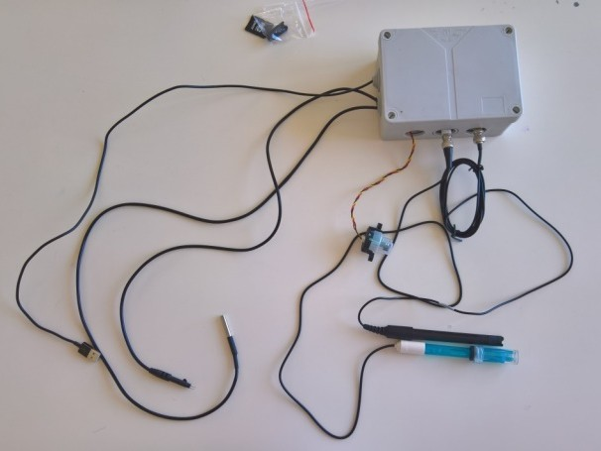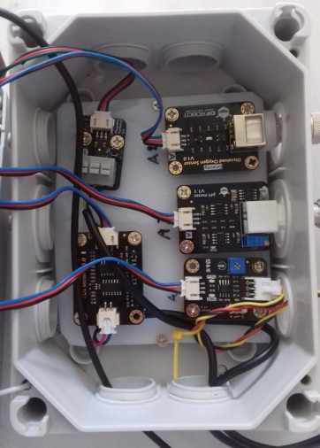

Fig. 1. The Arduino-based water sensor kit, that was used for the experiment.

The device (Figure 1) is equipped with the following sensors:

* + DS18B20 Digital Temperature Sensor for measuring the water temperature at

the sampling location 6

* Total Dissolved Solids Meter for measuring the soluble solids dissolved in the water at the sampling location 7
* Analog Turbidity Sensor for measuring the suspended particles in water by mea- suring the light transmittance and scattering rate which changes with the amount of total suspended solids in water 8
* Analog Dissolved Oxygen Meter for measuring the oxygen available in the water at the sampling location 9
* Analog pH Meter for measuring the pH value at the sampling location 10

The Arduino program follows an extremely simplified approach to collect the measurements. As soon as the device is powered a file is created in the SD card to append new data. Each sensor is polled sequentially and once data are retrieved for all sensors, the collected data are appended to the file together with a relative timestamp. This timestamp shows the time since the device’s power on time (as the device has no real time clock or battery to maintain a constant time reference). It is therefore important to store the measurements after each sampling session and properly tag them for location and time manually. The final application code is available on GitHub 11 .

It has to be noted at this point that each sensor that is used as a measuring tool, is characterized by its accuracy, sensitivity, precision, and range. The tools used in any experiment have an important impact on the results, depending on these characteristics, and these have to be especially considered when low cost sensors are used for making sensing infrastructure available to students.

**Accuracy:** is how close a measured or calculated quantity is to its actual (true) value.

**Repeatability:** (or reproducibility) is closely related to accuracy but has a distinct meaning. A measuring device is repeatable if many measurements of the same parameter all give the same result under identical conditions.

**Sensitivity:** is the minimum size change in the “parameter to be measured” that will be noticed by the measuring device. For example, if you use a digital ther- mometer, and the smallest detectable change corresponds to temperature change of

0*.*1 *◦*C, then your temperature measurement system has a “sensitivity of 0*.*1 *◦*C”. **Range:** sensors device differ at the range of measuring values and accuracy. The characteristics of the sensors used in our device are the following:

* The accuracy of the Temperature sensor is 0*.*5 *◦*C in the *−*10 *◦*C to 85 *◦*C measuring range but can measure temperatures from *−*55 *◦*C to 125 *◦*C.

6 <https://www.dfrobot.com/product-689.html>

7 <https://www.dfrobot.com/product-1662.html>

8 <https://www.dfrobot.com/product-1394.html>

9 <https://www.dfrobot.com/product-1628.html>

10 <https://www.dfrobot.com/product-1025.html>

11 <https://github.com/amaxilat/waterQualitySensing>

* + The Total Dissolved Solids Meter works in water with temperature up to 55 *◦*C.

It can measure concentrations from 0 to 1000*ppm* with and accuracy of 2*.*1*ppm*.

* + The Dissolved Oxygen Sensor measures oxygen concentrations from 0 to 20*mg/L*. Its accuracy is approximately 0*,* 033*mg/L*.
  + The pH Sensor measures values from 0 to 14*pH* with an accuracy of 0*.*1*pH*. The sensor operates in temperatures from 0 *◦*C to 60 *◦*C.

The final set up of the Arduino and the sensors for measuring water parameters, can be seen in Figure 1 and in use, in water, in Figure 2.

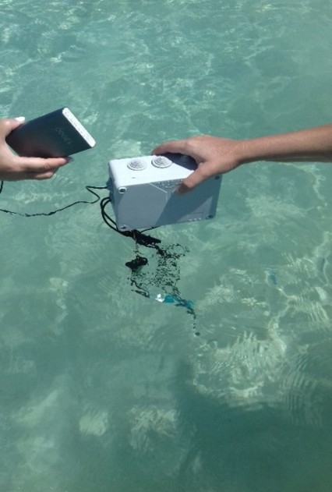

Fig. 2. Sensors plunged into the sea.

# The experiment

After the set-up of the IoT sensors, in August 2018, a sailing trip with the boat Hoy- Hoy was the means to put the sensors into practice, for initial hands on experience. Measurements were taken, in the period between 10 - 18 August, in three different islands of the Cyclades, at the Aegean Sea of Greece: Ios, Schinousa, and Ano Koufonisi. The locations visited are added as pins in the map seen in Figure 3. The measurements were taken in different time intervals, during the day, in morning, midday and evening hours, so that differences between the changes in the parameter values could be documented.

In Ios island, seven measurements were taken in the marina, and two in the island’s desalination unit estuary. At Maganary bay three (3) measurements were taken, while at Aligaria bay of Schinousa island four (4). In Ano Koufonisi fourteen

(14) measurements were taken at the island’s marina and five at the local beach.

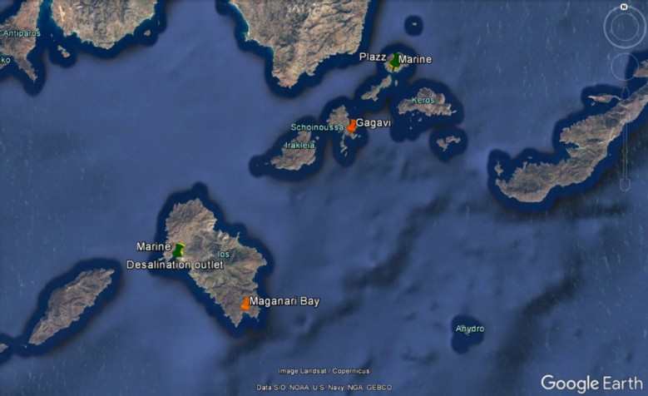

Fig. 3. The locations where measurements were taken.

# The Data collected and the challenges that occurred

Most notable observations from the measurements taken in this experiment were the following: Small fluctuations in water temperature were observed during daytime (i.e. at 11/8/2018 in Ios marina at 07:00h *>* temperature of 25*.*06 *◦*C, at 15:00h

*>* 25*.*56 *◦*C, and at 22:00h *>* 25*.*25 *◦*C). A slightly lower pH value and Dissolved Oxygen was recorded at Ios Marina, from what was recorded at Maganari bay area, at the same time of the day (07:00h), in different dates (11/8 and 14/8 respectively). Moreover the Dissolved Solids value at Ios marina harbor were increased, compared to any other location. This may owe to the islands desalination unit estuary at this bay.

The data from sampling in one location, as a sample log file of the measurements taken with the IoT-water kit described earlier, can be seen in Table 1.

The turbidity sensor was plunged in sweet water after every measurement taken in sea water, nevertheless, after a few days it failed to measure correctly, due to rust issues (Figure 4). On August 16th, at the Ano Koufonisi marina, at 15:00h, the turbidity sensor had already rusted and the values recorded from the sensor are lower than the actual ones in the area.

The challenges in this short initial trial involved mostly the turbidity sensor: The turbidity sensor was floating; a small weigh was added to it so that it could plunge under water for measurements. The sensor’s cable was too short, resulting in water coming into the sensor box even when there were slight waves in the sea. The most important challenge though, was that turbidity sensor parts that went rusty in less than a week, although special care was taken to rinse them in sweet water after each measurement was taken. This resulted in unreliable data after a week’s use.

|  |  |  |  |  |  |
| --- | --- | --- | --- | --- | --- |
| Time  (ms) | Temperature  (Celsius) | Dissolved Solids  (V) | Turbidity  (V) | Dissolved Oxygen  (V) | Acidity  (pH) |
| 2544 | 25.19 | 2.57 | 1.04 | 1.69 | 6.15 |
| 4407 | 25.19 | 2.58 | 1.12 | 1.66 | 6.19 |
| 6268 | 25.19 | 2.57 | 1.15 | 1.56 | 6.24 |
| 8131 | 25.19 | 2.58 | 1.18 | 1.46 | 6.28 |
| 9994 | 25.19 | 2.57 | 1.19 | 1.43 | 6.28 |
| 11855 | 25.19 | 2.57 | 1.18 | 1.44 | 6.31 |
| 13718 | 25.19 | 2.57 | 1.17 | 1.52 | 6.31 |
| 15581 | 25.19 | 2.57 | 1.14 | 1.63 | 6.36 |
| 17443 | 25.19 | 2.57 | 1.11 | 1.73 | 6.37 |
| 19306 | 25.19 | 2.57 | 1.09 | 1.84 | 6.39 |
| 21168 | 25.19 | 2.56 | 1.10 | 1.83 | 6.37 |
| 23030 | 25.19 | 2.56 | 1.04 | 1.75 | 6.36 |
| 24893 | 25.19 | 2.57 | 1.03 | 1.61 | 6.36 |
| 26756 | 25.19 | 2.57 | 1.00 | 1.46 | 6.37 |
| 28622 | 25.19 | 2.56 | 0.96 | 1.50 | 6.42 |
| 30485 | 25.19 | 2.56 | 0.98 | 1.64 | 6.39 |
| 32347 | 25.19 | 2.55 | 0.68 | 1.61 | 6.47 |
| 34209 | 25.19 | 2.56 | 0.60 | 1.81 | 6.39 |
| 36072 | 25.19 | 2.39 | 0.88 | 1.84 | 6.72 |
| 37935 | 25.19 | 2.54 | 0.56 | 1.63 | 6.47 |
| 39797 | 25.19 | 2.02 | 0.87 | 1.55 | 6.57 |
| 41660 | 25.19 | 2.52 | 0.58 | 1.37 | 6.69 |
| 43523 | 25.25 | 2.55 | 0.42 | 1.17 | 6.37 |
| 45385 | 25.25 | 2.42 | 0.58 | 1.31 | 6.61 |
| 47247 | 25.25 | 2.55 | 0.33 | 1.44 | 6.35 |
| 49110 | 25.25 | 2.56 | 0.34 | 1.60 | 6.39 |
| 50972 | 25.25 | 2.55 | 0.34 | 1.71 | 6.36 |
| 52835 | 25.25 | 2.55 | 0.33 | 1.62 | 6.41 |
| 54697 | 25.25 | 2.52 | 0.52 | 1.49 | 6.80 |
| 56560 | 25.25 | 2.58 | 0.29 | 1.23 | 6.37 |
| 58427 | 25.25 | 2.56 | 0.31 | 1.40 | 6.38 |

Table 1

The log file of the data collected in a single sampling location

# Lessons learned

Two main challenges occurred from the experiences reported from using the Arduino sensor IoT kit in water: Malfunctioning of sensors after several (a few) uses and Calibration of sensors measurements.

The robustness of the sensors in such systems pose important challenges for the distribution and wider use of such systems to students. Specifically the turbid- ity sensor malfunctioned, due to rust caused by the salty sea water, and the salt deposition within.

There are two suggestions towards remedying this challenge: Replacement of sensors, that eventually needs to be done by the students, when using such kits in educational context. Alternatively, omitting turbidity sensors, as they have a limited life span.

Calibration issues that have been encountered, especially in the pH sensor, in

the related experiment reported in [21], earlier in Spring 2018 with water pH in tap water in Rome being measured as alkaline, due to the discrepancy of the sensors calibration. When low cost sensors are used, for reasons of easier and broader distribution, what gives is the sensor manufacturing quality, its robustness, and the measuring effectiveness.

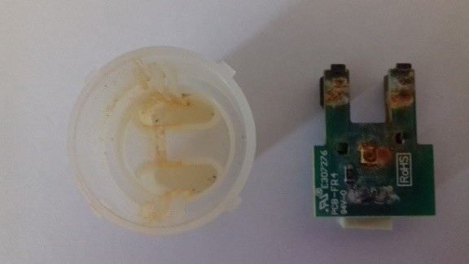

Fig. 4. The turbidity sensor when it starts displaying rust.

In order to turn this interesting challenge to an opportunity, educational sce- narios can be devised to teach the specifics of sampling in a scientific and accurate way. A learning activity can be devised, to set up/ calibrate the sensors before they are used in experiments. Several checks of the equipment can be introduced as interim sensing activities, by which students gain experience in scientific ways of measuring, and verifying the quality to ensure accuracy and repeatability of the data produced.

# Exploration aimed at students

Students immersion in authentic learning environments has been shown to be a very effective approach to learning ([9] & [17]). The ultimate purpose of the research reported here is to pave the way for design educational activities that lead students to acquire experience by participating in coastal field exercises and collecting data with IoT technologies. The aim is to engage experiences that speak to their interests in an active learning concept that moves beyond strict classroom delivery and mem- orization to interaction with teachers, peers and the environment ([13]). The way for students to investigate the process of water-monitoring is to design a study that supports their own student project. The study design process follows the scientific method, that strives to answer a research question, collecting and analyzing data, drawing conclusions and offering recommendations from the analysis. A systematic and carefully designed monitoring procedure could identify water quality problems and help to answer questions that lead to problems solution. The first step is to define the purpose: for example, if the issue is the threat of pollution entering a bay from the sewage pipeline of a large hotel unit, you might ask the question: Is the hotel sewage pipeline affecting the aquatic bays life? The answer to this will

determine what, where, when and how to monitor. Second step is to identify which water quality parameters are needed: how will these parameters attain the monitor- ing purpose? For example, is there a relationship between Dissolved Oxygen levels and the types of plants, animal or other organisms one has observed in the water? If so, one should describe this relationship. Next step is to decide on the location; review a map of the area of interest, describe the selected points, note latitude/ lon- gitude, local weather conditions during the sampling, conditions of the water body. The sampling procedure is the next question; that means to describe how data will be collected, analyzed and reported. After that, the deployment period and sam- pling frequency (seasonally, monthly, daily) must be considered, as conditions of a water body can change slowly or rapidly depending on several factors. And finally, as a last step, managing, analyzing and reporting the data, which in turn entail the actions of entering and validating the data procedure, reaching certain conclusions and presenting the results. Students can finally answer if the experimental results support the initial hypothesis and if they discovered important water quality issues impacting the water body.

Students have therefore the opportunity to gain and utilize Science and Tech- nology (STEM) skills while at the same time they get instilled in a real-world application of science within the overall umbrella theme of coastal water quality.

# Acknowledgement

We would like to thank the captain and the crew of the sailing boat Hoy-Hoy, for making this experiment possible. We would like to acknowledge SparkWorks 12 for their generous guidance and support in acquiring the sensors and equipment needed, for which we are deeply grateful.

# References

1. *Instant quality check of rivers*,

<https://www.downtoearth.org.in/news/instant-quality-check-of-rivers-33502>.

1. *Myriver*, <https://www.hackster.io/LightPro/myriver-352bfa?ref=topnav>.
2. *Organisation*

*for economic co-operation and development. the ocean economy in 2030, (published by oecd, 2016)*,

[https://www.oecd-ilibrary.org/economics/the-ocean-economy-in-2030_9789264251724-en.](https://www.oecd-ilibrary.org/economics/the-ocean-economy-in-2030_9789264251724-en)

1. *Smart water monitoring using iot*,

<https://www.skyfilabs.com/online-courses/smart-water-monitoring-using-iot?v2>.

1. *Underwater sensors help monitor water*,

<http://www.startribune.com/underwater-sensors-help-monitor-water/45540567/>.

1. Akribopoulos, O., I. Chatzigiannakis, C. Koninis and E. Theodoridis, *A web services-oriented architecture for integrating small programmable objects in the web of things*, in: *2010 Developments in E-systems Engineering*, 2010, pp. 70–75.
2. Amaxilatis, D., O. Akrivopoulos, G. Mylonas and I. Chatzigiannakis, *An iot-based solution for monitoring a fleet of educational buildings focusing on energy efficiency*, Sensors **17** (2017), p. 2296.

12 [https://sparkworks.net](https://sparkworks.net/)

1. Brossard, D., B. Lewenstein and R. Bonney, *Scientific knowledge and attitude change: The impact of a citizen science project*, International Journal of Science Education **27** (2005), pp. 1099–1121.
2. Brown, J. S., A. Collins and P. Duguid, *Situated cognition and the culture of learning*, Educational researcher **18** (1989), pp. 32–42.
3. Burke, J., D. Estrin, M. Hansen, A. Parker, N. Ramanathan, S. Reddy and M. B. Srivastava, *Participatory sensing*, in: *In: Workshop on World-Sensor-Web (WSW06): Mobile Device Centric* *Sensor Networks and Applications*, 2006, pp. 117–134.
4. Chatzigiannakis, I., H. Hasemann, M. Karnstedt, O. Kleine, A. Kro¨ller, M. Leggieri, D. Pfisterer,

K. Romer and C. Truong, *True self-configuration for the iot*, in: *3rd IEEE International Conference on the Internet of Things, IOT 2012, Wuxi, Jiangsu Province, China, October 24-26, 2012* (2012),

pp. 9–15.

1. Chatzigiannakis, I., G. Mylonas and S. Nikoletseas, *The design of an environment for monitoring and controlling remote sensor networks*, International Journal of Distributed Sensor Networks **5** (2009),

pp. 262–282.

URL <https://doi.org/10.1080/15501320701343869>

1. Council, N. R. et al., “Taking science to school: Learning and teaching science in grades K-8,” National Academies Press, 2007.
2. Heggen, S., *Participatory sensing: Repurposing a scientific tool for stem education*, interactions **20**

(2013), pp. 18–21.

1. Hotaling, L., *Sense it student enabled network of sensors for the environmental using innovative technology*, OCEANS, ISBN:978-1-4244-4960-6 (2009).
2. Kotovirta, V., T. Toivanen, R. Tergujeff and M. Huttunen, *Participatory sensing in environmental monitoring - experiences*, in: *2012 6th International Conference on Innovative Mobile and Internet Services in Ubiquitous Computing*, 2012.
3. Lave, J., E. Wenger and E. Wenger, **521423740**, Cambridge university press Cambridge, 1991.
4. Pocero, L., D. Amaxilatis, G. Mylonas and I. Chatzigiannakis, *Open source iot meter devices for smart and energy-efficient school buildings*, HardwareX **1** (2017), pp. 54 – 67.

URL <http://www.sciencedirect.com/science/article/pii/S2468067216300293>

1. Sun, W., Q. Li and C. K. Tham, *Wireless deployed and participatory sensing system for environmental monitoring*, in: *2014 Eleventh Annual IEEE International Conference on Sensing, Communication, and Networking (SECON)*, 2014.
2. Sur´ıs-Regueiro, J. C., M. D. Garza-Gil and M. M. Varela-Lafuente, *Marine economy: a proposal for its definition in the european union*, Marine Policy **42** (2013), pp. 111–124.
3. Tziortzioti, C., G. Andreetti, L. Rodino, I. Mavrommati, A. Vitaletti and I. Chatzigiannakis, *Raising awareness for water pollution, based on game activities using internet of things*, in: *Proceedings of the European conference on Ambient Intelligence*, AmI2018, 2018.
4. Tziortzioti, C., I. Mavrommati, G. Mylonas, V. A. and I. Chatzigiannakis, *Scenarios for educational and game activities using internet of things data*, in: *Proceedings of the conference on Computational Intelligence and Games*, CIG2018, 2018.