[Egyptian Journal of Basic and Applied Sciences 5 (2018) 157–164](https://doi.org/10.1016/j.ejbas.2018.04.004)

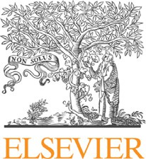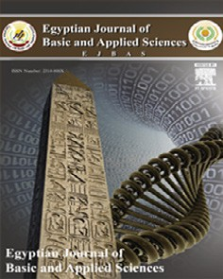

Contents lists available at [ScienceDirect](http://www.sciencedirect.com/science/journal/2314808X)

Egyptian Journal of Basic and Applied Sciences

journal homepage: [www.elsevier.com/locate/ejbas](http://www.elsevier.com/locate/ejbas)

Full Length Article

[](http://crossmark.crossref.org/dialog/?doi=10.1016/j.ejbas.2018.04.004&domain=pdf)Isolation, structure characterization and prediction of antioxidant activity of two new compounds from the leaves of *Dodonaea viscosa* native to the Sultanate of Oman

Asila Ahmed Salim Al Habsi, Mohammad Amzad Hossain ⇑

*School of Pharmacy, College of Pharmacy and Nursing, University of Nizwa, P.O. Box 33, Postal Code 616, Nizwa, Oman*

# a r t i c l e i n f o

*Article history:*

Received 4 September 2017

Received in revised form 2 April 2018 Accepted 24 April 2018

Available online 4 May 2018

*Keywords: Dodonaea viscosa* Hot extraction Antioxidant activity Pure compounds Chromatography Spectroscopy

# a b s t r a c t

Traditionally, *Dodonaea viscosa* (*D. viscosa*) is used worldwide for the treatment of different chronic dis- eases. The current investigation involves the isolation, structure characterization and prediction of antioxidant compounds from the leaves of *D. viscosa*, which was collected from AL-Hamra, Sultanate of Oman. The leaves samples were used for the extraction of plant constituents with methanol by using hot extraction method. The methanol solvent was evaporated by usual method and the crude extract was dissolved in water and fractionation successively with different polarity solvents to give hexane, chloroform, ethyl acetate, butanol and water extracts, respectively. The antioxidant activity of different polarity crude extracts and isolated pure compounds was determined by modified 1,1-diphenyl-2- picryl-hydrazyl (DPPH) method. The highest antioxidant activity was found in hexane extract and the lowest antioxidant activity was found in butanol extract and followed by hexane > chloroform > ethyl acetate > methanol > water > butanol extract. The hexane and ethyl acetate crude extracts were used for the isolation and separation of antioxidant compounds by using different chromatographic tech- niques. The isolated pure compounds were characterized as 3,30 ,40 ,5,7-pentahydroxyflavane (1) and 4- methoxylstigmasterol (2) by MS, 1H NMR, 13C NMR, and 2D NMR. Both the compounds, 3,30 ,40 ,5,7-penta hydroxyflavane (1) and 4-methoxylstigmasterol (2) were isolated for the first time from the selected Omani plant species. The pure compounds obtained from hexane and ethyl acetate extracts of the selected plant species could be a good source of natural antioxidant.

© 2018 Mansoura University. Production and hosting by Elsevier B.V. This is an open access article under

the CC BY-NC-ND license (<http://creativecommons.org/licenses/by-nc-nd/4.0/>).

1. Introduction

Plants are considered as essential source of medicines for humans. Plant parts like leaves, flowers, roots, stems, seeds, and fruit are used as food resources for human as well as safe medicine for the treatment of different diseases. Plant-derived herbal medi- cine is used as main sources for the treatment of diseases since the ancient time [1]. Antioxidants are the most important chemical components that may prevent or delay different types of cell dam- age. Foods, fruits, and vegetables are the main sources of natural antioxidants. The prevention or recovery of cell damage in the human body could be used foods, fruits, and vegetables as natural antioxidants. The main mechanism of antioxidants is to improve the immune system in the human body by producing the free rad- ical. Some of natural antioxidants are also available as dietary sup- plements. Recently, vegetables and fruits are considered as rich

* Corresponding author.

*E-mail address:* [amzad@unizwa.edu.om](mailto:amzad@unizwa.edu.om) (M.A. Hossain).

sources of natural antioxidants. Several recent scientific evidences are available that eating lots of vegetables and fruits are very good sources for human health and to prevent the cell damage. There- fore, the risks of certain chronic or incurable diseases are lowered due to natural antioxidants [2].

*Dodonaea viscosa* (*D. viscosa*) is an evergreen woody plant belongs to the family Sapindaceae [3]. The selected plant species originates from Australia and recently it is available throughout the tropical and subtropical countries. The selected plant is mostly available in certain parts of Australia, Africa, Mexico, New Zealand, India, Northern Mariana Islands, Virgin Islands, Florida, Arizona, South America, and elsewhere. *D. viscosa* is a dioecious or monoe- cious multi stems shrub small tree up to 7 m tall (Fig. 1). The bark is blackish, thin and exfoliating in long thin strips. Several varieties are available all over the world, including Oman. It is one of the rarest medicinal plant species indigenous to Al Jabal Al Akhdar, Northern Oman, Al Hamra and Salalah [1]. Its Arabic name is Zaitoon Alramal and locally known as Shahs [4]. It possesses

<https://doi.org/10.1016/j.ejbas.2018.04.004>

2314-808X/© 2018 Mansoura University. Production and hosting by Elsevier B.V.

This is an open access article under the CC BY-NC-ND license (<http://creativecommons.org/licenses/by-nc-nd/4.0/>).

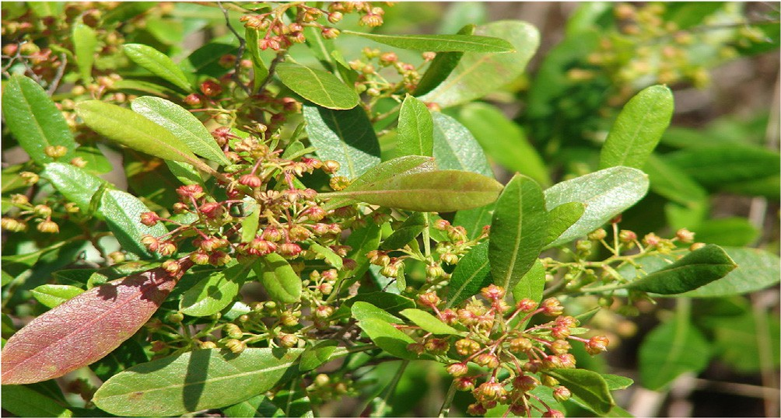

Fig. 1. Plant picture.

medicinal values promoted by the plant being easy to harvest and blend into a variety of therapeutic preparations [1,2].

*D. viscosa* is usually administered by local communities of sev- eral regions for the administration as poultice for treating a variety of diseases [2,5]. The traditional use of this plant covers a signifi- cant range of conditions, including pain relief in dental cases and headache, chronic inflammatory disorders, rheumatoid arthritis, fever, cold, gastrointestinal system disorders and female reproduc- tive conditions [6–8]. In Saudi Arab, the mixture of leaves, steam and seed with honey is used to treat malaria [7,9].

Recently, *D. viscosa* extends to infectious agents where it was found to be antiviral and antimicrobial activities. In addition to its special use as a spasmolytic and hypotensive agent. Regarding medicinal effects of the plant parts, the leaves were reported to possess bioactive elements resembling the activity of local anes- thetic, smooth muscle relaxant, antimicrobial, anti-inflammatory and anti-ulcerogenic agents [1,10]. However, lack of literature on medicinal properties of the selected plant indicates that no work has been done on the Omani species. On the basis of medical importance of the selected plant, now, it is commercially cultivated all over the world including Sultanate of Oman. Therefore, it is nec- essary to evaluate the biological activities of *D. viscosa*, which is abundantly available in Oman mainly in Al Jabal Al Akhdar and Al Hamra. The present investigation involves to prepare different crude extracts from the leaves of Omani *D. viscosa* species, and to isolate and characterize antioxidant compounds from crude extract having the highest antioxidant activity and to determine their antioxidant activity.

1. Materials and methods
   1. *Chemicals and reagents*

The solvents like hexane, ethyl acetate, butanol, chloroform, and acetone were used in this experiment obtained from Sigma

Aldrich Company, Germany. Methanol, silica gel, preparative TLC,

0.25 lm). Injector and mass transfer line temperature were set at 250 and 300 °C, respectively. 1H and 13C NMR spectra were mea-

sured on a Brucker (600 MHz) spectrometer with TMS as the inter- nal standard. DMSO was used as solvent and chemical shifts values were given in d (ppm).

* 1. *Sample collections*

The leaves of *D. viscosa* sample were collected from AL-Hamra in the month of September 2016 at 10 am and identified at the Bio- logical Science Division, University of Nizwa, Oman. The leaves of the selected plant were identified by local people and confirm by the website. The collected leaves sample was transported to the Research Laboratory, University of Nizwa, Oman for cleaning and the healthy clean leaves were separated from the stems and dried under the shade for 7 days.

* 1. *Extraction*

The dried leave samples (500 g) were coarse into powder by blender machine and the coarse powder samples (200 g) were extracted with methanol (300 ml) by using a hot extraction method for 3 days. After 3 days extraction, the solvent was evapo- rated from the extract by using rotary evaporator at under reduced pressure at ambient temperature. Then, the solvent free extract (10 g) was dissolved in water (200 ml) and fractionated with n- hexane, chloroform, ethyl acetate and n-butanol [3] with increas- ing polarity. The four fractions such as n-hexane, chloroform, ethyl acetate, n-butanol and the remaining water fraction were dried separately by using a rotary evaporator to give n-hexane (1.30 g), chloroform (2.81 g), ethyl acetate (1.82 g), n-butanol (1.09 g) and water extract (1.64 g), respectively. All prepared crude extracts from the leaves powder of *D. viscosa* were used for the determina- tion of their antioxidant activity.

* 1. *Antioxidant activity*

The antioxidant activity of different crude extracts and isolated pure compound of the selected plant was estimated by 1,1- diphenyl-2-picryl-hydrazyl (DPPH) method with modification [11]. Various concentrations (12.5, 25, 50, 100 and 200 mg/ml) of

each crude extract and pure compound were used for the determi-

nation of antioxidant activity. Each concentration of each crude extract (4 ml) was placed in a clean test tube and DPPH solution (1 ml) was added to the same test tube. The mixture was shaken vigorously by hand and kept in a dark place at ambient tempera- ture for 45 min. DPPH and methanol solvent were used as blank samples. The absorbance of all working samples was measured at a fixed wavelength 517 nm by using a UV–visible spectrophotome- ter [11]. The percentage of inhibition of each concentration plant crude extract was calculated by using the following formula:

Acontrol — Aextract

gallic acid and 1,1-diphenyl-2-picrylhydrazyl (DPPH) were obtained from BDH, UK. In addition, other chemicals were used

## %Inhibition =

Acontrol

## × 100

analytical grade. All glassware used in this experiment was from borosil, India.

* 1. *Instruments*

The absorbance of various polarities extracts and isolated pure compounds at different concentration was measured by UV–visible spectroscopy (Shimadzu, Model 1800, Japan) for the determination of antioxidant activity. The MS spectra were performed using a Varian GC–MS/MS (Model Varian CP 3800) equipped with a VF-5 fused silica capillary column (30 m × 0.25 i. d., film thickness

* 1. *Isolation and characterization antioxidant compounds*

The highest antioxidant hexane extract (1.20 g) and ethyl acet- ate crude extract (1.50 g) was used for the separation of antioxi- dant compounds by using column chromatography with different organic solvents as a mobile phase. According to the same Rf val- ues, the isolated fractions from the column chromatography were combined together and evaporated the mother solvent at ambient temperature. Based on the TLC, these similar TLC pattern eluents were combined together to give Fraction 1, Fraction 2, Fraction 3, Fraction 4, Fraction 5 and Fraction 6. Similarly, the same

chromatographic techniques were used to separate the ethyl acet- ate crude extract by using different polar solvents. According the TLC, four fractions (Fraction 1, Fraction 2, Fraction 3, and Fraction 4) were obtained from the ethyl acetate extract. All fractions were evaporated at ambient temperature inside the fume hood. The iso- lated fraction was again purified by preparative thin layer chro- matography (PTLC) to give the pure compounds. The structures of purified compounds from both crude extracts were elucidated by using MS and 1D and 2D NMR.

* 1. *Fraction 1*

The obtained fraction 1 from ethyl acetate crude was further purified by PTLC over silica gel 60 G using hexane-ethyl acetate (1:1) as developing solvent. Fraction 1 gave one major compound with several minor compounds. The separated major compound was crystallized from ethyl acetate-chloroform to give yellowish power (5.4 mg), Rf 0.44 (hexane–ethyl acetate; 1:1); (M+, 291); 1H NMR (600 MHz, DMSO *d*6): 2.44 (m, 1H, H-4b), 2.64 (dd, 1H, *J*

= 4.38 and 4.5 Hz, H-4a), 3.98 (d, 1H, *J* = 2.76 Hz, H-3), 4.63 (d,

1H, *J* = 4.38 Hz, H-2), 4.71 (s, 1H, 3-OH), 5.69 (d, 1H, *J* = 2.16 Hz,

H-6), 5.87 (d, 1H, *J* = 2.22 Hz, H-8), 6.87 (s, 1H, H-20 ), 6.62 (m, 2H,

H-50 and H-60 ), 8.70 (s, 1H, –OH), 8.77 (s, 1H, –OH), 8.87 (s, 1H, – OH), 9.08 (s, 1H, –OH); 13C NMR (600 MHz, DMSO *d*6): 28.18 (C- 4), 64.88 (C-3), 78.03 (C-2), 94.04 (C-8), 95.02 (C-6), 98.45 (C-10),

114.72 (C-20 ), 114.86 (C-50 ), 117.91 (C-60 ), 130.58 (C-10 ), 144.41

(C-40 ), 144.47 (C-30 ), 155.75 (C-5), 156.20 (C-9), 156.50 (C-7). On

the basis of 1H and 13C and MS spectral data it was characterized as 3,30 ,40 ,5,7-pentahydroxyflavane (1).

* 1. *Fraction 2*

Fraction 2 obtained from hexane extract by column chromatog- raphy was repeated column chromatography to give one major and three minor fractions (A-D). The major fraction C was further puri- fied by preparative thin layer chromatography (PTLC) to give two compounds (1 and 2). The compound 1 with high amount was col- lected from the preparative TLC by spatula. The compound 1 was eluted from the silica gel by methanol. The amount of purified compound 1 was 13 mg by weight. Finally, the compound 1 was crystallized from dichloromethane to give a white crystals (5 mg), Rf 0.64 (hexane-ethyl acetate; 7:2); (M+, 442); 1H NMR (600 MHz, CDCl3): d 0.77 (d, 3H, *J* = 2.04 Hz, CH3-27), 0.81 (d, 3H,

*J* = 1.5 Hz, CH3-26), 0.82 (d, 3H, *J* = 7.4 Hz, CH3-29), 0.84 (d, 3H, *J*

= 4.8 Hz, CH3-21), 0.93 and 0.96 (2s, 6H, CH3-19 and CH3-18),

0.88 (m, 2H, H-1), 1.00 (m, 4H, H-15 and H-16), 1.02 (s, 2H, H-2),

1.26 (m, 4H, H-11 and H-12), 2.01 (s, 1H, H-25), 4.43 (m, 1H, H-

3), 4.04 (s, 3H, –OCH3), 5.00 (s, 1H, H-8), 5.05 (s, 1H, H-24), 5.09

(m, 2H, H-22 and H-23), 5.00 (s, 1H, H-23), 5.11 (m, 1H, H-6);

13C NMR (600 MHz, CDCl3): d 140.6 (C-5), 138.4 (C-22), 129.1 (C-

23), 121.8 (C-6), 71.9 (C-3), 56.7 (C-17), 56.9 (C-14), 50.9 (C-9),

50.7 (C-24), 42,6 (C-13, 4), 39.6 (C-12), 37.4 (C-1), 40.2 (C-20),

36.7 (C-10), 31.4 (C-8, 7), 31.7 (C-2), 30.9 (C-25), 29.23 (C-OCH3),

28.8 (C-16), 24.8 (C-15), 24.7 (C-28), 21.5 (C-11), 20.8 (C-26),

20.4 (C-19), 19.7 (C-27), 19.1 (C-21). On the basis of 1H and 13C

and MS spectral data, it was characterized as 4- methoxystigmasterol (1).

1. Results

The methanol solvent was used for the preparation of crude extract from the leaves of *D. viscosa*, which was collected from Al Hamra. After extraction, the methanol solvent was evaporated by rotary evaporator at ambient temperature and then defatted with water and fractionation with different polarity of solvent to give

hexane; chloroform, ethyl acetate, butanol, and water extract (Table 1).

* 1. *Antioxidant activity*

The antioxidant activity of different crude extracts of leaves of

*D. viscosa* was evaluated by DPPH method with modification (Aziza et al., 2015). The highest antioxidant activity was found in hexane extract with percentage of inhibition value of 94.41 ± 0.12 and the lowest activity of found in butanol extract with percentage of inhi- bition value of 78.57 ± 0.08 (Table 2). The other crude extracts of the selected plant species also showed significant inhibition com- pare to standard gallic acid.

* 1. *Isolation and characterization antioxidant compounds*

The high antioxidant hexane and ethyl acetate crude extract was used for the isolation and separation of antioxidant com- pounds by different chromatographic system with different polar and non polar organic solvents. According to the similar Rf values, the separated fractions were combined together. The pure com- pounds were purified from the fraction 2 of hexane extract and fraction 1 of ethyl acetate extract which was obtained from column chromatography. The major compounds from both fractions were purified again by preparative thin layer chromatography (PTLC) to give pure compounds 1 and compound 2 (Fig. 2). The structures of the purified compound 1 and compound 2 were elucidated by using MS and NMR.

* 1. *Antioxidant activity of pure compounds*

The antioxidant activity of the isolated pure compound 1 and compound 2 at different concentrations obtained from ethyl acet- ate and hexane extracts of *D. viscosa* was determined by the same modified DPPH method. Both pure compounds showed significant percentage of inhibition at all applied concentrations against DPPH method and presented in Table 3. The compound 1 showed the highest percentage of inhibition compare to compound 2.

1. Discussion

Huge number of medicinal plants has been investigated world- wide by the scientists for their biological activities. Most of the sci- entists are interested to find out the naturally occurring new drugs with significant medicinal values from the nature without side effect for the treatment of diseases. The plant crude extract con- tains several chemical compounds which is responsible for biolog- ical activities. The bioactivities of crude extracts obtained from the plants are completely depends on the bioactive constituents. The selected medicinal plant species showed several biological activi- ties like antioxidant, antimicrobial, anticandidal, antidiabetic, anti- fungal, and antidiarrheal activities [1,12] and the plant is used traditionally for the treatment of different diseases. The leaves of the selected medicinal plant species are used traditionally world- wide including Oman for the treatment of itching, swelling, aches,

Table 1

Yield of different polarity of crude extracts of *D. viscosa.*

|  |  |
| --- | --- |
| Crude extracts | Yield (g) |
| Hexane | 1.30 |
| Chloroform | 2.81 |
| Ethyl acetate | 1.82 |
| Butanol | 1.09 |
| Methanol | 19.30 |
| Water | 1.64 |

Table 2

Antioxidant potential of hexane, ethyl acetate, chloroform, butanol, *methanol and water crude extracts D. viscosa.*

|  |  |  |  |  |
| --- | --- | --- | --- | --- |
| Crude extracts | Concentration (lg/ml) | Absorption of standard | Absorption of standard | % Inhibition |
|  | 200 | 1.787 | 0.134 | 92.78 ± 0.48 |
|  | 100 |  | 0.136 | 92.38 ± 0.10 |
| Methanol | 50 |  | 0.145 | 91.88 ± 0.09 |
|  | 25 |  | 0.150 | 91.60 ± 0.03 |
|  | 12.5 |  | 0.185 | 89.64 ± 0.11 |
|  | 200 | 1.787 | 0.350 | 94.41 ± 0.12 |
|  | 100 |  | 0.366 | 90.51 ± 0.13 |
| Hexane | 50 |  | 0.370 | 89.29 ± 0.20 |
|  | 25 |  | 0.392 | 79.03 ± 0.19 |
|  | 12.5 |  | 0.399 | 77.62 ± 0.08 |
|  | 200 | 1.787 | 0.109 | 93.90 ± 0.03 |
|  | 100 |  | 0.110 | 93.84 ± 0.11 |
| Chloroform | 50 |  | 0.115 | 93.56 ± 0.28 |
|  | 25 |  | 0.220 | 87.76 ± 0.10 |
|  | 12.5 |  | 0.250 | 86.09 ± 0.08 |
|  | 200 | 1.787 | 0.089 | 95.01 ± 0.18 |
|  | 100 |  | 0.108 | 93.84 ± 0.18 |
| Ethyl acetate | 50 |  | 0.270 | 84.89 ± 0.07 |
|  | 25 |  | 0.330 | 81.53 ± 0.18 |
|  | 12.5 |  | 0.378 | 78.84 ± 0.13 |
|  | 200 | 1.787 | 0.365 | 78.57 ± 0.08 |
|  | 100 |  | 0.390 | 78.17 ± 0.07 |
| Butanol | 50 |  | 0.456 | 74.48 ± 0.04 |
|  | 25 |  | 0.488 | 72.69 ± 0.13 |
|  | 12.5 |  | 0.499 | 72.07 ± 0.18 |
|  | 200 | 1.787 | 0.249 | 86.06 ± 0.09 |
|  | 100 |  | 0.289 | 83.82 ± 0.18 |
| Water | 50 |  | 0.370 | 79.29 ± 0.13 |
|  | 25 |  | 0.401 | 77.56 ± 0.17 |
|  | 12.5 |  | 0.479 | 73.19 ± 0.16 |

Each value is a mean of three biological replicates.

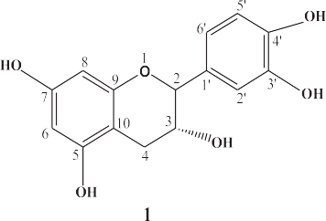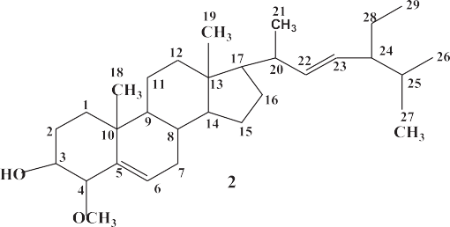

Fig. 2. Structure of compound 1 and compound 2.

Table 3

Antioxidant activity for four pure samples different antioxidant activity for four samples.

|  |  |  |  |  |
| --- | --- | --- | --- | --- |
| Crude extracts | Concentration lg/ml | Absorption of standard | Absorption of standard | % Inhibition |
| 1 | 200 | 1.787 | 0.596 | 98.09 ± 0.17 |
|  | 100 |  | 0.301 | 98.48 ± 0.11 |
|  | 50 |  | 0.065 | 87.20 ± 0.22 |
|  | 25 |  | 0.051 | 98.43 ± 0.10 |
|  | 12.5 |  | 0.039 | 97.64 ± 0.09 |
| 2 | 200 | 1.787 | 0.095 | 94.68 ± 0.15 |
|  | 100 |  | 0.128 | 92.83 ± 0.71 |
|  | 50 |  | 0.059 | 96.69 ± 0.15 |
|  | 25 |  | 0.080 | 95.50 ± 0.19 |
|  | 12.5 |  | 0.111 | 93.70 ± 0.23 |

Each value is a mean of three biological replicates.

trachoma, antispasmodic agent, gout, bone fraction, rash, and fever [7,9]. In addition, in Oman, the leaves and roots are mixed together and used traditionally for the treatment of toothache, headache, indigestion, ulcer, diarrhea and constipation [7,9,13]. Recently,

scientists and researcher are interested to find and isolate the bioactive compounds from natural sources which have showed the biological activities. They are trying to discover new drugs from plant sources for the treatment of different diseases to avoid the

synthetic drugs. The Sultanate of Oman is considered as mega diversity with plenty of plant sources. In Oman, the selected plant species has been used widely by the local ethnic communities as traditional healing for a variety of conditions. However, until to- date, there is no scientific study conducted to prove the presence of antioxidant compounds of the selected plant. On the basis of medical importance, we are intended to work on the leaves of *D. viscosa*, which was collected from AL-Hamra. The collected samples were used for the preparation of different crude extracts by differ- ent polarities solvents. The antioxidant activity of the crude extracts of *D. viscosa* was determined by DPPH method and the results are presented in Table 2. In our experimental results showed that the highest antioxidant activity was found in hexane and ethyl acetate extract and lowest antioxidant activity was found in the butanol extract and followed by hexane > ethyl acetate > chloroform > methanol > water > butanol extract. Due to the sig- nificant antioxidant activity, the hexane and ethyl acetate crude extracts were selected for the isolation and separation of antioxi- dant compounds.

Different chromatography techniques such as thin layer chro- matography (TLC), column chromatography (CC) and preparative TLC were used normally for the separation of compounds from the plant crude extract. As a stationary phase silica gel particle (120–260 mesh) and as mobile phase different polarity of solvents were used for the separation of compounds. Initially, in our exper- iment as mobile phase hexane-ethyl acetate (7:1) was used for col- umn chromatography then increase the polarity of mobile phase by addition of ethyl acetate. The polarity of the mobile phase plays a significant role for the isolation of pure chemical compounds from the crude extracts by different chromatographic system. Based on the TLC behavior, fraction 1 contains lots of compounds compare to another fraction of ethyl acetate extract. In addition, the chemical compounds inside the fraction 1 are separated nicely by using hexane-ethyl acetate (9:1) developing solvent. The same

developing solvent was used to separate the pure compounds from the fraction 1 by using preparative TLC. Again, repeat the prepara- tive TLC and crystallization to get the pure compound 1. Similarly, the pure compound 2 was obtained from fraction 2 of hexane extract by several chromatographic systems.

The pure compound 1 was obtained as a yellowish powder. It had the molecular ion peak at [M]+ *m*/*z* 291, which corresponds to the molecular formula C15H15O6. In 1H NMR spectrum, the iso- lated compound 1 showed one multiplet and one doublet of dou- blets at d 2.44 and d 2.64 indicated the presence of two protons at the same position of H-4. Two doublets at d 3.98 and d 4.63 indi- cated the presence of one proton each position at H-2 and H-3. One multiple peaks at d 6.62 indicated the presence of one protons each position at the position H-50 and H-60 on the B-ring. One sharp sin- glet at d 6.87 indication the presence of one proton at H-20 . Two doublets at d 5.69 and d 5.87 indicated the presence of two aro- matic protons at the position H-6 and H-8 on the A-ring. One upfield singlet at d 4.71 and four downfield sharp singlets at d 8.70, 8.77, 8.87 and 9.08 indicated the presence of five –OH at dif- ferent places on the A, B and C-rings (Fig. 3). In the 13C NMR and DEPT spectrum showed that the isolated compound 1 contained total fifteen carbon signals which consisted one methylene, seven methine and seven quaternary carbons (Fig. 4). The 1H–1H COSY correlations showed that the compound 1 coupling between H-2 and H-3 protons and H-3 and H-4 protons. These correlations between the positions were confirmed by HMBC (Fig. 5). Based on the above spectral data, the structure of compound 1 was estab- lished as 3,30 ,40 ,5,7-pentahydroxyflavane. The compound 1 was isolated by several authors from different plant species; however, the compound 1 was isolated from the selected plant species for the first time in our laboratory.

According to TLC behavior, out of two compounds (compound 1 and compound 2) from fraction 2 of hexane extract, Compound 2 is almost pure, however, the compound 1 is not 100% pure. The

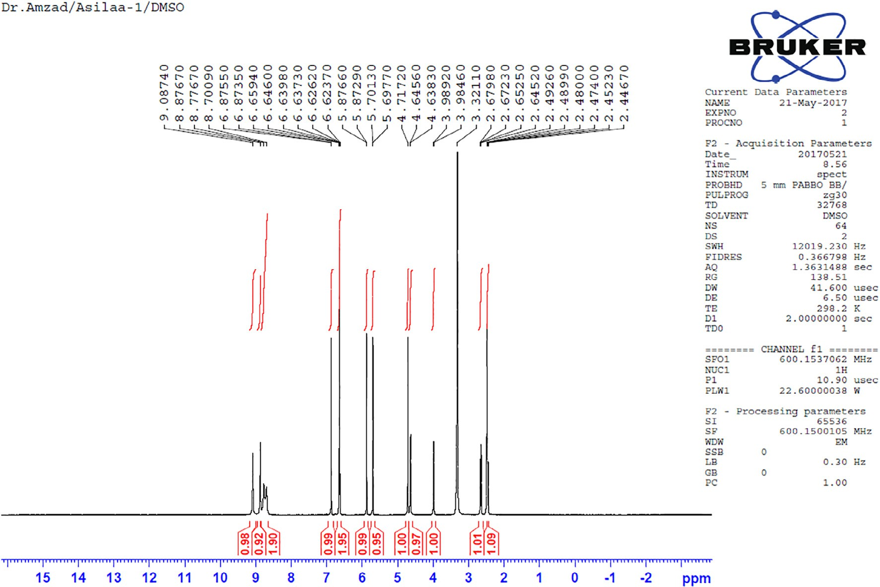

Fig. 3. 1H NMR spectrum of pure compound 1.

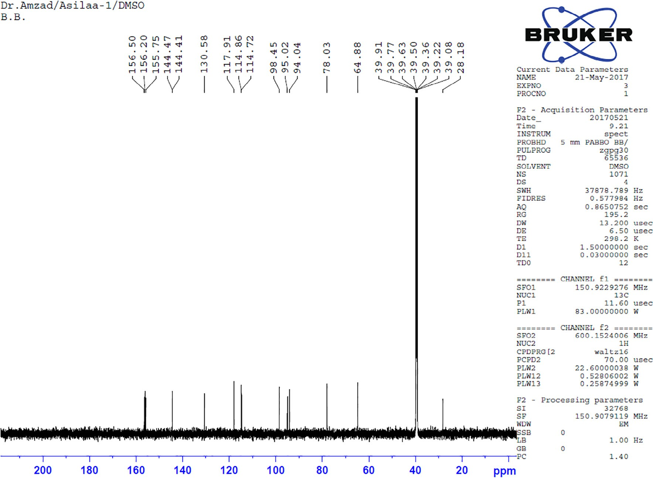

Fig. 4. 13C NMR spectrum of pure compound 1.

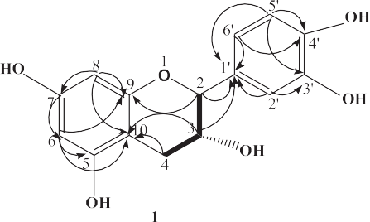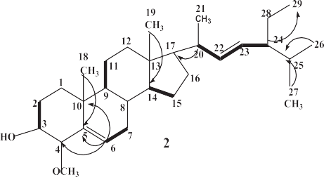

Fig. 5. HMBC and COSY correlation of compound 1 and compound 2.

separated compound 2 was crystallized from dichloromethane to give white crystals. The pure isolated compound 2 was identified on the basis of MS and 1H NMR, 13C NMR and 2D NMR. It had molecular weight (M+, 442) with corresponding molecular formula is C29H50O2. In the 1H NMR spectrum, the isolated compound 2 showed one proton each position at C-3 and C-6 as multiples at d

5.11 and d 4.43 indicating the presence of steroidal nucleus. Two protons appeared at d 5.09 as a multiplet in the 1H NMR spectrum which was identical with the chemical shift of C-22 and C-23 respectively of stigmasterol [14,15]. One sharp singlet at d 4.00 indicated the presence of –OCH3 at the position of C-4. Two signets at d 0.93 and d 0.96 indicated the presence of two –CH3 at the posi- tion of C-19 and C-18 on the ring system and four doublets at d 0.77, 0.81, 0.82 and 0.84 indicating the presence of four –CH3 at the position of C-27, C-26, C-29 and C-21, respectively (Fig. 6). Two olefinic protons appeared as downfield in the 1H NMR spec- trum as multiplet at d 5.09 indicated the presence of one proton

each position at H-22 and H-23, respectively of stigmasterol [14,15]. From the DEPT 90 and 135 experiments showed that the compound 2 was having six methyl (CH3) groups, eight methylene (CH2), twelve methane (CH), one methoxyl (–OCH3) group and three quaternary carbons groups. The 1H–1H COSY correlations showed that the compound 2 coupling between H-2 and H-3, H- 5 and H-6, H-9 and H-11, H-13 and H-14, H-20 and H-22 and H- 23 and H-24 protons. These correlations between the positions were confirmed by HMBC (Fig. 5). Based on the above spectral data structure of compound 2 was identified as 4-methoxystigmasterol

(2). It was also isolated from the selected plant species for the first time in our laboratory.

* 1. *Antioxidant activity of pure compounds*

The evaluation of antioxidant activity of the isolated pure com- pound 1 and 2 from ethyl acetate and hexane extract by the same

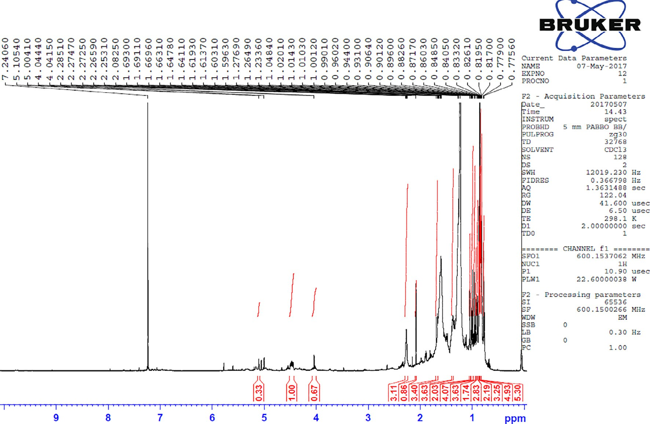

Fig. 6. 1H NMR spectrum of pure compound 2.

method described earlier [16]. The compounds 1 and 2 showed sig- nificant antioxidant activity against DPPH as compared to standard gallic acid (Table 3). However, the isolated compound 1 at all con- centrations showed very high antioxidant activity compare to compound 2. According to 1D and 2D NMR, the compound 2 hav- ing –OH and –OCH3 groups. The highest antioxidant activity of pure compound 1 may be due to the –OH groups. The –OH group is free in compound 1 and it is significantly enhancing its antioxi- dant activity. This observation is in agreement with the earlier structural-activity study [15,17,18].

1. Conclusion

Antioxidants are an important parameter to produce of free rad- ical in the body to improve the human immune system. Therefore, the risks of certain diseases are lowered due to antioxidants. *D. vis- cosa* is a medicinal plant, which contains high levels of antioxidant activity [19,20]. Due to the antioxidant activity, the hexane and ethyl acetate crude extract were selected for the isolation and sep- aration of antioxidant compounds. All the isolated pure com- pounds showed significant antioxidant activity against DPPH as compared to standard gallic acid. From our experimental results, 3,30 ,40 ,5,7-pentahydroxyflavane (1) and 4-methoxystigmasterol

(2) were isolated from the leaves of locally available *D. viscosa* and their chemical structures characterized based on 1D and 2D NMR. Further *in vivo* study is required for the isolated compound 1 and compound 2 to confirm the mode biological activities as well as structure-activity relationship.

Acknowledgements

The authors are grateful to the Oman Research Council, Sultanate of Oman for funding this work through the FURAP pro- ject (Call 4, 2016). Thanks to the University of Nizwa, Sultanate of Oman for facilitating the execution of this TRC funded project

work. Authors are grateful to Prof. Ahmed Al-Harrasi, Chairperson, Chair of Oman’s Medicinal Plants and Marine Natural Products, University of Nizwa, Sultanate of Oman for his kind help in connec- tion with DEPT, 1H NMR, 13C NMR, 1H-COSY. They are also grateful to Ms. Nadiya, Mr. Mustafa, Ms. Summaya, and Ms. Ahlam for their help in connection with samples handling and UV-visible spec- troscopy. Authors would like to thank the Writing Center at the University of Nizwa for their professional assistance throughout the writing process of my research manuscript.

References

1. [Hussain J, Rehman NU, Al-Harrasi A, Ali L, Khan AL, Albroumi MA. Essential oil](http://refhub.elsevier.com/S2314-808X(17)30414-1/h0005) [composition and nutrient analysis of selected medicinal plants in Sultanate of](http://refhub.elsevier.com/S2314-808X(17)30414-1/h0005) [Oman. Asian Pac J Trop Dis 2013;3(6):421–8](http://refhub.elsevier.com/S2314-808X(17)30414-1/h0005).
2. [Veerapur VP, Prabhakar KR, Kandadi MR, Srinivasan KK, Unnikrishnan MK.](http://refhub.elsevier.com/S2314-808X(17)30414-1/h0010) [Antidiabetic effect of Dodonaea viscosa aerial parts in high fat diet and low](http://refhub.elsevier.com/S2314-808X(17)30414-1/h0010) [dose streptozotocin-induced type 2 diabetic rats: a mechanistic approach.](http://refhub.elsevier.com/S2314-808X(17)30414-1/h0010) [Pharm Biol 2010;48(10):1137–48](http://refhub.elsevier.com/S2314-808X(17)30414-1/h0010).
3. [AL-Oraimi AA, Hossain MA. In vitro total flavonoids content and antimicrobial](http://refhub.elsevier.com/S2314-808X(17)30414-1/h0015) [capacity of different organic crude extracts of *Dodonaea viscosa*. J Biol Act Prod](http://refhub.elsevier.com/S2314-808X(17)30414-1/h0015) [Nat 2016;6(2):150–65](http://refhub.elsevier.com/S2314-808X(17)30414-1/h0015).
4. [Mehmood A, Murtaz G, Nasir M. Antibacterial and antifungal activity of *D.*](http://refhub.elsevier.com/S2314-808X(17)30414-1/h0020)[*viscosa* (L.) Jacq., a wild plant of Azad Jammu and Kashmir. Int J Biosci 2013;3](http://refhub.elsevier.com/S2314-808X(17)30414-1/h0020) [(9):1–7](http://refhub.elsevier.com/S2314-808X(17)30414-1/h0020).
5. [Forestrania RC, Munoz-Acuña U, Freitas NF, Blanco EJ. Biological activity of](http://refhub.elsevier.com/S2314-808X(17)30414-1/h0025) [compounds from *Dodonaea viscosa* (L.) Jacq. Var. *Angustifolia*. Planta Med](http://refhub.elsevier.com/S2314-808X(17)30414-1/h0025) [2016;82:210–20](http://refhub.elsevier.com/S2314-808X(17)30414-1/h0025).
6. [Lawal D, Yunusa I. *Dodonea Viscosa* Linn: its medicinal, pharmacological and](http://refhub.elsevier.com/S2314-808X(17)30414-1/h0030) [phytochemical properties. Int J Innov Appl Stud 2013;2(4):477–83](http://refhub.elsevier.com/S2314-808X(17)30414-1/h0030).
7. [Anilreddy B. Preparation, characterization and biological evaluation of some](http://refhub.elsevier.com/S2314-808X(17)30414-1/h0035) [overview of *Dodonaea viscosa* Linn. J Pharm Sci Tech 2009;1(1):1–9](http://refhub.elsevier.com/S2314-808X(17)30414-1/h0035).
8. [Prakash NU, Selvi CR, Sasikala V, Dhanalakshmi S, Prakash SBU.](http://refhub.elsevier.com/S2314-808X(17)30414-1/h0040) [Phytochemistry and bio-efficacy of a weed, *Dodonaea viscosa*. Int J Pharm](http://refhub.elsevier.com/S2314-808X(17)30414-1/h0040) [Pharmacol Sci 2012;4(2):509–12](http://refhub.elsevier.com/S2314-808X(17)30414-1/h0040).
9. [Teffo LS, Aderogba MA, Eloff JN. Antibacterial and antioxidant activities of four](http://refhub.elsevier.com/S2314-808X(17)30414-1/h0045) [kaempferol methyl ethers isolated from *Dodonaea viscosa* Jacq. var. *Angustifolia*](http://refhub.elsevier.com/S2314-808X(17)30414-1/h0045)[leaf extracts. South Afr J Bot 2010;76(1):25–9](http://refhub.elsevier.com/S2314-808X(17)30414-1/h0045).
10. [Khaloud KA, Hossain MA. New prenylated flavonoids from the leaves of](http://refhub.elsevier.com/S2314-808X(17)30414-1/h0050) [*Dodonea viscosa* native to the Sultanate of Oman. Pac Sci Rev A: Nat Sci Eng](http://refhub.elsevier.com/S2314-808X(17)30414-1/h0050) [2016;18:53–61](http://refhub.elsevier.com/S2314-808X(17)30414-1/h0050).
11. [Aziza ASR, Hossain MA. Study on total phenolics and antioxidant activity of](http://refhub.elsevier.com/S2314-808X(17)30414-1/h0055) [leaves crude extracts of Annona squamosa traditionally used for the treatment](http://refhub.elsevier.com/S2314-808X(17)30414-1/h0055) [of cancerous tumours. Asian Pac J Trop Dis 2015;5:S142–4](http://refhub.elsevier.com/S2314-808X(17)30414-1/h0055).
12. [Rani MS, Pippalla RS, Mohan K. *Dodonaea viscosa* Linnan overview. Asian J](http://refhub.elsevier.com/S2314-808X(17)30414-1/h0060) [Pharm Res Health Care 2009;1(1):97–112](http://refhub.elsevier.com/S2314-808X(17)30414-1/h0060).
13. [Al-Snafi AE. A review on *Dodonaea viscosa*: a potential medicinal plant. IOSR J](http://refhub.elsevier.com/S2314-808X(17)30414-1/h0065) [Pharm 2017;7(2):10–21](http://refhub.elsevier.com/S2314-808X(17)30414-1/h0065).
14. [Habib MR, Nikkon F, Rahman ME, Karim MR. Isolation of stigmasterol and beta](http://refhub.elsevier.com/S2314-808X(17)30414-1/h0070) [sitosterol from methanolic extract of root of bark of *Calotropis gigantean* (Linn).](http://refhub.elsevier.com/S2314-808X(17)30414-1/h0070) [Pak J Biol Sci 2007;10:4174–6](http://refhub.elsevier.com/S2314-808X(17)30414-1/h0070).
15. [Jain VC, Patel NM, Shah DP, Patel PK, Joshi BH. Antioxidant and antimicrobial](http://refhub.elsevier.com/S2314-808X(17)30414-1/h0075) [activities of *Alangium salvifolium* (lF) Wang root. Global J Pharm 2010;4](http://refhub.elsevier.com/S2314-808X(17)30414-1/h0075) [(1):13–8](http://refhub.elsevier.com/S2314-808X(17)30414-1/h0075).
16. [Raqiya MSM, Hossain AM. Evaluation of antioxidant and cytotoxic activities of](http://refhub.elsevier.com/S2314-808X(17)30414-1/h0080) [different extracts of folk medicinal plant *Hapllophyllum tuberculatum*. Egypt J](http://refhub.elsevier.com/S2314-808X(17)30414-1/h0080) [Basic Appl Sci 2017;2017(4):101–6](http://refhub.elsevier.com/S2314-808X(17)30414-1/h0080).
17. [Ali H, Kabir N, Muhammad A, Shah MR, Musharraf SG, Iqbal N, et al.](http://refhub.elsevier.com/S2314-808X(17)30414-1/h0085) [Hautriwaic acid as one of the hepatoprotective constituent of *Dodonaea*](http://refhub.elsevier.com/S2314-808X(17)30414-1/h0085)[*viscosa*. Phytomed 2014;21(2):131–40](http://refhub.elsevier.com/S2314-808X(17)30414-1/h0085).
18. [Martina D, Carmen ED, Ricardo GÁ, Andrés G, Lucía C, Azucena G, et al.](http://refhub.elsevier.com/S2314-808X(17)30414-1/h0090) [Differential anti-insect activity of natural products isolated from *Dodonaea*](http://refhub.elsevier.com/S2314-808X(17)30414-1/h0090)[*viscosa* Jacq. (Sapindaceae). J Plant Prot Res 2015;55(2):172–8](http://refhub.elsevier.com/S2314-808X(17)30414-1/h0090).
19. [Akhtar M, Gülsen Ç, Mehmet Ö, Mehmet ED, Said N, Itrat A, et al.](http://refhub.elsevier.com/S2314-808X(17)30414-1/h0095) [Phytochemicals from Dodonaea viscosa and their antioxidant and](http://refhub.elsevier.com/S2314-808X(17)30414-1/h0095) [anticholinesterase activities with structure–activity relationships. Pharm Biol](http://refhub.elsevier.com/S2314-808X(17)30414-1/h0095) [2016;54(9):1649–55](http://refhub.elsevier.com/S2314-808X(17)30414-1/h0095).
20. [Zia U, Yeong HS, Mahboob U, Zuopeng L, Jeong YK, Ki HP. Isolation and](http://refhub.elsevier.com/S2314-808X(17)30414-1/h0100) [characterization of protein tyrosine phosphatase 1b (ptp1b) inhibitory](http://refhub.elsevier.com/S2314-808X(17)30414-1/h0100) [polyphenolic compounds from *Dodonaea viscosa* and their kinetic analysis.](http://refhub.elsevier.com/S2314-808X(17)30414-1/h0100) [Forti Chem 2018;6:1–10](http://refhub.elsevier.com/S2314-808X(17)30414-1/h0100).