

Electronic Notes in Theoretical Computer Science

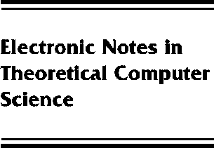[www.elsevier.com/locate/entcs](http://www.elsevier.com/locate/entcs)

Iterated Duals of Certain Topological Spaces

Bruce S. Burdick

**Abstract**

Problem 540 in Open Problems in Topology (1990) asks whether iteratingthe operation of taking the dual topology eventually leads to a mutually dual pair of topologies. Some special cases of the Problem 540 are discussed. These are: all T1 spaces, the lower Vietoris topology of any hyperspace, the Scott topology for reverse inclusion on any hyperspace, and upper Vietoris topologies on certain bitopological spaces. We find in all these cases that

Tdd = Tdddd, and therefore at most four distinct topologies, T, Td, Tdd, Tddd, can be created by iterating the dual operator starting with one of these special cases.

1571-0661 *⃝*c Elsevier Ltd Open access under [CC BY-NC-ND license.](http://creativecommons.org/licenses/by-nc-nd/3.0/)

10.1016/S1571-0661(05)80033-7