HOSTE D BY

Available online at [www.sciencedirect.com](http://www.sciencedirect.com/science/journal/2314808X)

ScienceDirect

journal homepage: <http://ees.elsevier.com/ejbas/default.asp>

[e g ypti an j o ur nal o f b a sic and a pp l i e d sci en c e s 1 ( 2014) 1 5 1](http://dx.doi.org/10.1016/j.ejbas.2014.07.002) e[160](http://dx.doi.org/10.1016/j.ejbas.2014.07.002)



Full Length Article

Land use assessment of barren areas in Damietta Governorate, Egypt using remote sensing



*Maie I. El-Gammal* *a**, Rafat R. Ali* *b**, Rasha Eissa* *a**,*\*

a *Department of Environmental Sciences, Faculty of Science, Damietta University, New Damietta, Egypt*

b *Soils and Water Use Department, National Research Centre, Cairo, Egypt*

## a r t i c l e i n f o

*Article history:*

Received 5 April 2014 Received in revised form 20 July 2014

Accepted 20 July 2014

Available online 4 August 2014

*Keywords:* Damietta Land use

Remote sensing Soil rating

## a b s t r a c t

Damietta occupies an area of about 910 km2 north of the Nile Delta and hosts about 1.3 million persons living within four administrative centers. The region comprises agricultural lands, water bodies, urban area and barren lands. Agriculture is the most land use while there is a significant development of barren lands, which occur at the north and east of Damietta. The present study aims to evaluate and assess the suitability of using barren lands in Damietta for the different uses. Satellite images have been utilized in order to make an accurate inventory of barren lands. The physico-chemical characteristics and soil rating were carried out to evaluate soil quality. Results showed that soils of Damietta belong to *Entisols* (recent soils) and there are five classes of soil quality, ranging from excellent to very poor. It was found that barren lands at the north of Damietta have poor potentiality for agriculture. They could be utilized for other land use, such as residential, industrial or for touristic activities. While those occur east of Damietta could be utilized for aquaculture or as bioremediation facilities for biological treatment of agricultural wastewaters.

Copyright 2014, Mansoura University. Production and hosting by Elsevier B.V. All rights

reserved.

# Introduction

Damietta Governorate occurs at the tip of the Nile Delta along the western fringes of the Lake Manzala (Fig. 1). The capital of the Government is Damietta City, which was one of the ancient cities of Egypt and it was the Egyptian gate along the Mediterranean Sea before the construction of Alexandria

about 300 years BC. Today, Damietta is one of the most important industrial centers of Egypt and its importance has increased as a new container platforms harbor along the Mediterranean Sea was constructed in 1980s. Damietta Governorate consists of four administrative centers, Kafr Saad, Faraskour, El-Zarka and Damietta center. Population of Damietta is about 1.3 million during the last formal census with most population lives in Damietta City. Agricultural land

* *Corresponding author*.

E-mail address: [noran_rasha@yahoo.com](mailto:noran_rasha@yahoo.com) (R. Eissa).

Peer review under responsibility of Mansoura University. <http://dx.doi.org/10.1016/j.ejbas.2014.07.002>

2314-808X/Copyright 2014, Mansoura University. Production and hosting by Elsevier B.V. All rights reserved.

152 [e gypti an j o ur nal o f b a sic and a p p l i ed sci e n c e s 1 ( 2014) 1 5 1](http://dx.doi.org/10.1016/j.ejbas.2014.07.002) e[160](http://dx.doi.org/10.1016/j.ejbas.2014.07.002)

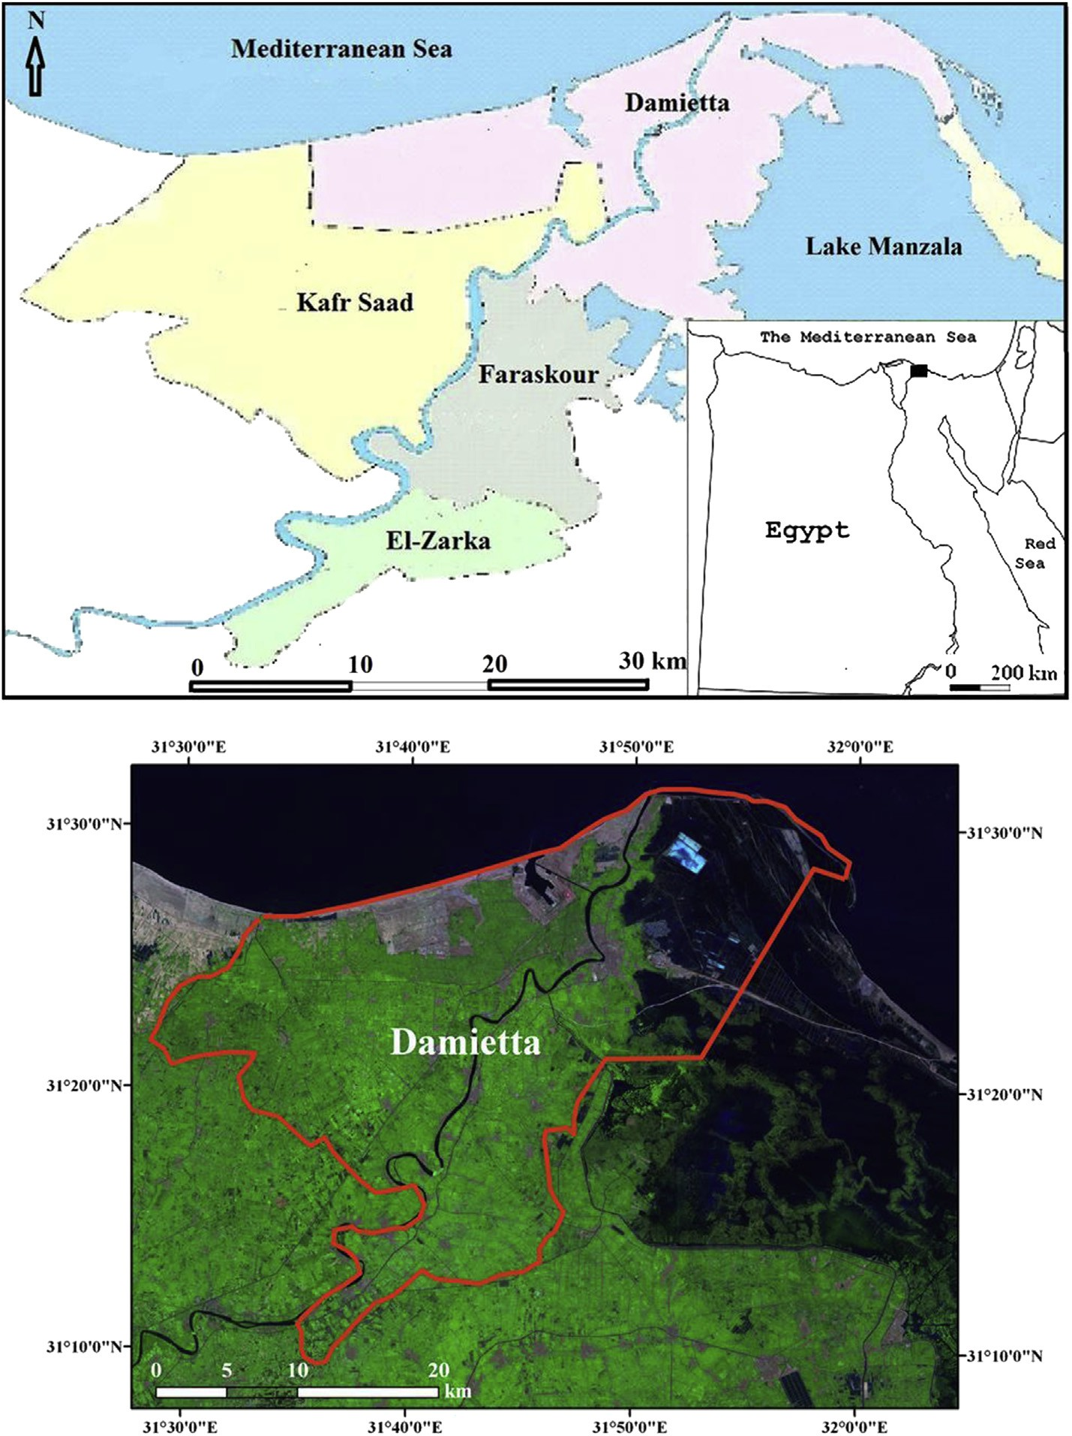

Fig. 1 e Location map and a satellite image of Damietta.

constitutes the majority of Damietta area. There are other lands that are barren mainly at the north and east of the Governorate. The northern barren lands represent the coastal sandy strip bordering the Mediterranean Sea and covered by sand dunes [1] while the eastern strip constitutes the western fringes of the Lake Maznala. According to the Central Labo- ratory of Agricultural Climate ([www.clac.edu.eg](http://www.clac.edu.eg/)) of the Min- istry of Agriculture, climate of Damietta is generally Mediterranean, where dry summer predominates with mild

dry winter. Annual winter temperatures fall to 13 ◦C in January

and rise to 26 ◦C in August with a mean annual temperature of 20 ◦C. Precipitation (P) is generally low and does not exceed

125 mm/y. Due to its occurrence close to the Mediterranean Sea, the humidity is generally high with maximum value during summer months (up to 76%). Evapotranspiration (ET) is

much greater than precipitation rates. Maximum ET occurs in June (198 mm) with a total annual ET of 1374. Wind is generally bimodal. Most of incoming winds blow from the northwest direction in summer, spring and autumn and the other wind direction is from the southwest during winter. According to the UNESCO classification of arid lands [2], Damietta occurs within the arid zone, where its aridity index (the annual P/ annual ET) is 0.07.

Soils generally have distinctive characteristics from one to another. The soil classification deals with the systematic categorization of soils based on distinguishing their own characteristics. A comprehensive soil classification system provides a hierarchical grouping of natural soil bodies. The soil classification system now widely used worldwide is the American Soil Classification System developed by the United

[e g ypti an j o ur nal o f b a sic and a pp l i e d sci en c e s 1 ( 2014) 1 5 1](http://dx.doi.org/10.1016/j.ejbas.2014.07.002) e[160](http://dx.doi.org/10.1016/j.ejbas.2014.07.002) 153

States Department of Agriculture (USDA) and published as the *Soil Taxonomy* [3]. This system is designed to classify all the world's soils because expanding soil survey programs entailed

more precise definitions of soil properties than with previous

soil classification systems. In addition, land assessment has attained the concern of soil scientists throughout the world. The Storie Index (SI) [4] is one of the accepted and widely known soil rating systems. It is a quantitative index, where, percentage values are assigned to the characteristics of the soil itself, including the soil profile (Factor A); the texture of the surface soil (Factor B); the slope (Factor C); and the con- ditions of the soil, for example, soil salinity (Factor X). A score rating from 0 to 100% is determined for each factor, and the scores are then multiplied together as:

SI ¼ [(Factor A/100) × (Factor B/100) × (Factor C/100) × (Factor X/100)] × 100

Awareness of the land use and land cover is an important process for many planning and management activities and is considered an essential element for modeling and under- standing the earth as a system [5]. Land cover maps are presently being developed from local to national to global scales. The use of satellite data and aerial photographs has been an accepted practice to map land use. The term land cover relates to the type of feature present on the surface of the earth. Lakes, rivers, deserts, and forests are all examples of land cover types. On the other hand, the term land use relates to the human activity or economic function associated with a specific piece of land [6]. Remote sensing is one of the bur- geoning and indispensable tools for assessment the best use of land in the natural/human ecosystems. NASA began a

successful program for monitoring earth's resources from

space in July 1972. All satellites in the series carried the Landsat designation [5]. Eight generations of satellites have been launched into space since 1972. The latest one is the Landsat-8 or the Operational Land Imager (OLI) which was launched in 2013. It has 12 bands in the visible and infrared bands and has 30 m spatial resolution. Features in satellite images can be identified using visual or automated methods. The most common approach is the automated image classi- fication, in which a computer algorithm groups pixels in the image into classes that the analyst defines. There are many studies on the land use and land cover mapping close to the study area. Most of these studies operated satellite images in order to highlight temporal changes [7](#_bookmark16)e[10]. The main objec- tives of the present study are to highlight the spatial distri- bution of barren lands in Damietta; to determine the soil quality at such barren lands; and to rate their suitability for different land use.

# Materials and methods

### *Satellite data*

In this study, an image was acquired from the most recent Landsat-8 satellite (OLI) in August, 3rd 2013, the time which is synchronous with the field visits and sampling. The image

(path 176 and row 38) covers an area of 185 × 185 km and in- cludes the northern part of the Nile Delta. In addition to the OLI image, a digital elevation model (DEM) was acquired from the Shuttle Radar Topography Mission (SRTM), which is an active sensor that radiates electromagnetic energy in the mi- crowave portion of the spectrum and is used to estimate the absolute elevation of the earth's surface. This DEM (path 176

and row 38) has a spatial resolution of 90 m. It was acquired in

February 2000 by the Space shuttle *Endeavor* during its mission to scan the earth's topography.

### *Field investigation and soil sampling*

Many field trips were performed in order to recognize the different land cover units at the study area in summer 2013. During field visits, sheets of satellite data were printed and were used to recognize different land cover units. Soil samples were acquired from natural soil bodies to avoid any distur- bance or contamination to the soil from surrounding envi- ronment. Soil samples were collected from: *1* e *Agricultural land*; *2* e *non-vegetated land; 3* e *sabkhas*; and *4* e *Lake Manzala shores.* A total of 20 soil samples were collected, including: 17 surface samples (at 10 cm) and three subsurface samples (at 100 cm) (Fig. 2). A hand-held portable GPS unit was used to determine the accurate position for each sampling station.

### *Image processing*

Image processing was carried out using ERDAS Imagine soft- ware. An unsupervised classification was performed using the iterative self organizing data analysis (ISODATA) algorithms. It uses cluster analysis techniques to create a user-defined number of clusters or classes in an image that must later be labeled to create a land cover map [11]. The ISODATA algo- rithms were applied for clustering the image into 50 different classes. A careful recoding of each class was done and these fifty classes were reduced to four land cover units according to the USGS Land Use/Cover Scheme [6]: *water*, *urban*, *agricultural* and *barren lands*. Finally, a majority filter of 3x3 was applied to remove odd and random pixels and to enhance the appear- ance of the classification process. Finally, the DEM of the re- gion was classified using ArcGIS software to generate five

vertical elevation classes: <0, 0e1, 1e2, 2e3, and more than

3 m. An elevation map was then produced.

### *Soil analysis*

In the field, some parameters were extracted directly, such as the soil structure, soil depth, drainage efficiency and occur- rence of gravel and hard strata, The collected samples were dried in the air and the dry color was determined using the Munsell Soil Color Charts. The samples were passed through a mesh (#20) to remove gravel particles. The soil texture, was determined using the standard hydrometer methods [12] and the relative percent of sand, silt and clay as well as the soil texture were determined. Calcium carbonate content was determined by acid/base titration methods [13]. Saturation percentage was calculated from the amount of water required for soil saturation. A soil extract (1 W:1 V) was prepared and in the filtrate, the pH and the total salinity expressed as electric

154 [e gypti an j o ur nal o f b a sic and a p p l i ed sci e n c e s 1 ( 2014) 1 5 1](http://dx.doi.org/10.1016/j.ejbas.2014.07.002) e[160](http://dx.doi.org/10.1016/j.ejbas.2014.07.002)

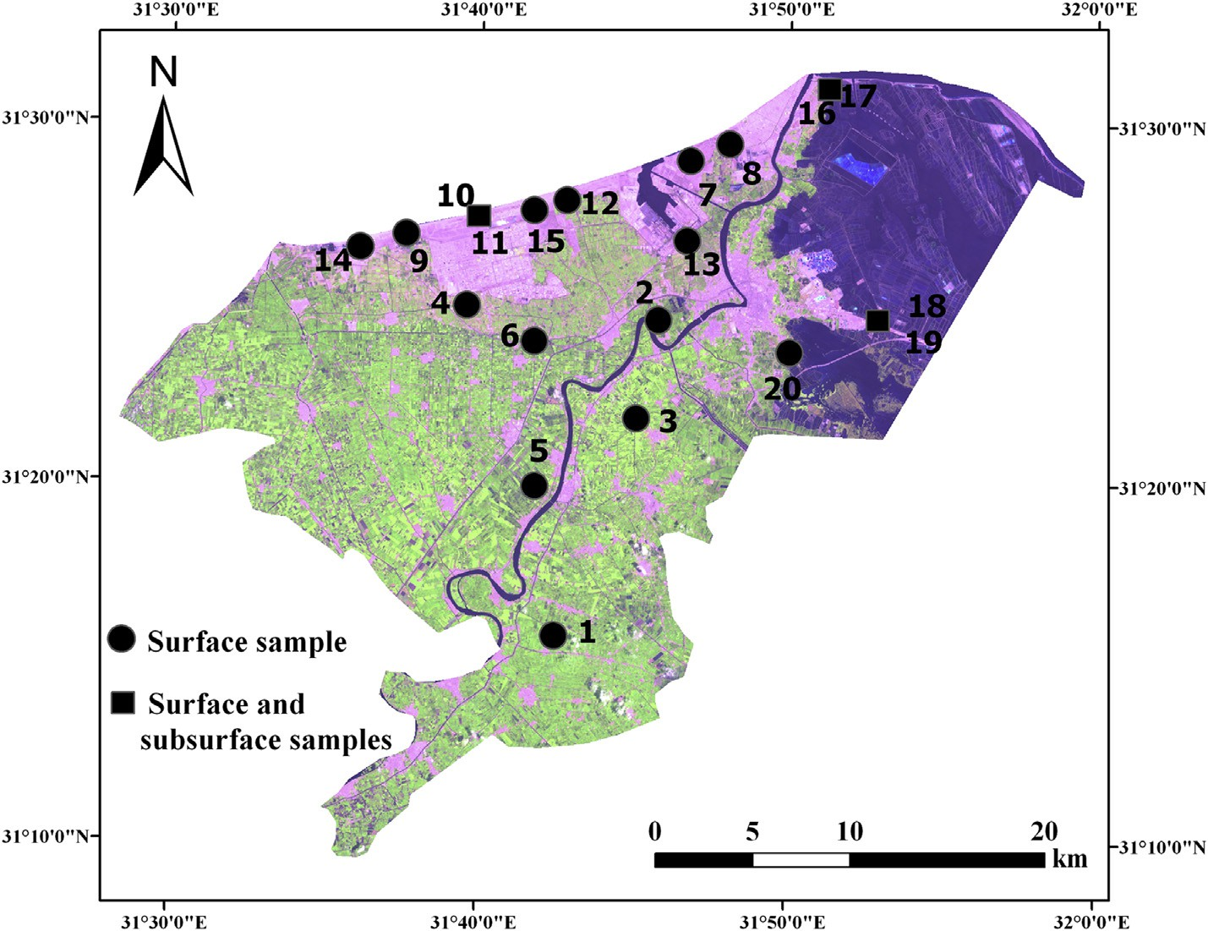

Fig. 2 e Location map of Damietta showing the sampling points. Circles show the locations of surface samples and the squares show the location of the profiles.

conductivity of each soil sample was measured and expressed in dS/m. The nutrients (potassium, phosphorous and nitro- gen) were determined in each dry sample. Available potas- sium in the soil was determined by the flame photometer

method [14]. Available phosphorous in the soil was deter- mined by the spectrophotometer method [15]. The total ni- trogen of the soil was determined by the Kjeldahl digestion method [14].

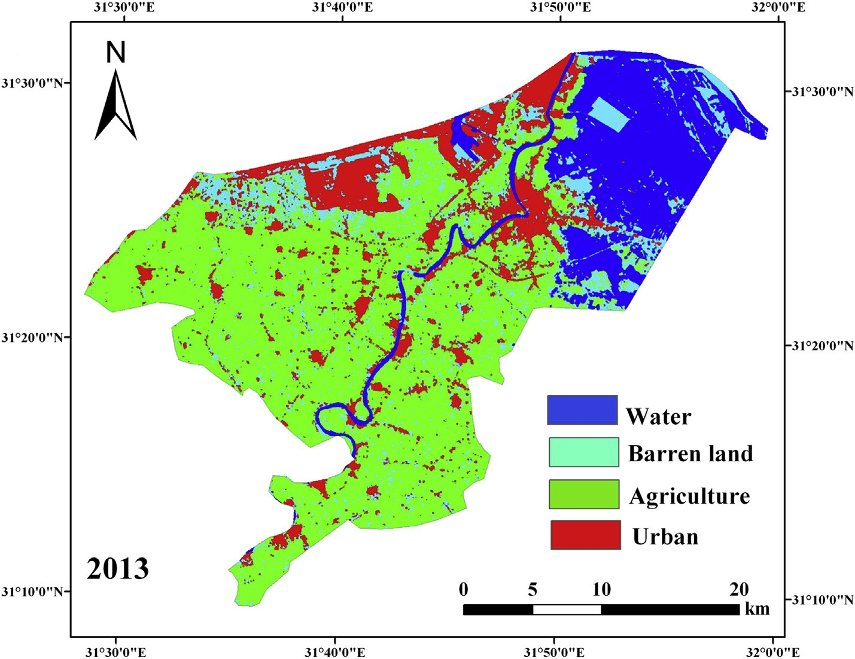

Fig. 3 e The land use/cover map of Damietta Governorate as obtained from the Landsat-8 OLI image classification.

[e g ypti an j o ur nal o f b a sic and a pp l i e d sci en c e s 1 ( 2014) 1 5 1](http://dx.doi.org/10.1016/j.ejbas.2014.07.002) e[160](http://dx.doi.org/10.1016/j.ejbas.2014.07.002) 155

### *Soil formation, classification and rating*

Factors of soil formation at Damietta region (parent materials, climate, topography, biota and time) [16] were examined in order to highlight the maturity of the soils in the region. Parent materials were identified using the soil characteristics and the Field Book for Describing and Sampling Soils [17]. The climate was studied in terms of the temperature, precipitation, and evapotranspiration. Topography was obtained from digital elevation models. Biota and time information were extracted from previous literature. The formal soil classification of Damietta was applied using the American System of Soil Classification [3]. The point of strength in this system is that it apply a full taxonomy to the soil based not only on the geo- morphology, but also upon the pedon characteristics, chemi- cal and physical characteristics as well as the climatic characteristics of the region. In this study, the soil was clas- sified to the Subgroup level in the classification hierarchy. Soil rating was determined using the soul rating index of Storie [4], which contains four factors: the soil profile (Factor A); the texture (Factor B); the slope (Factor C); and the salinity of the soil (Factor X). Each of these factors was assigned the appro- priate percentage ranging from 0 to 100% depending on the characteristics of this factor. The Storie's Index was then

determined by multiplying the four factors and the result was

rated as one of the following classes: *Excellent (100%*e*80%)*, *Good (79%*e*60%)*, *Fair (59%*e*40%)*, *Poor (39%*e*20%)*, *Very poor (20%*e*10%)* and *Nonagricultural (less than 10%).*

# Results and discussion

### *Land cover classification*

The use of satellite data to map land use/cover has been an acceptable practice since the launch of the first earth re- sources satellites in early 1970s. The synoptic view of the land, the regional coverage, the digital format, and the non-visible spectral information provided in satellite images are impor- tant advantages that make remote sensing superior to other traditional methods of land use/cover mapping. The land use/ cover map of Damietta produced from the Landsat-8 OLI image of 2013 (Figs. 3 and 4) reveals that there are four land use/cover units: agricultural, urban, water and barren lands. The total area of Damietta is 910 km2. Agricultural land

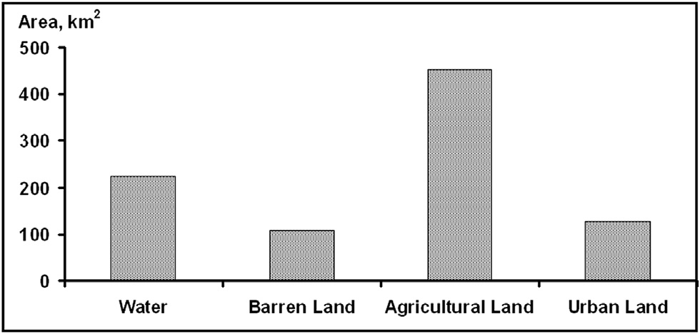

Fig. 4 e The extent of the individual land use/cover units of Damietta.

accounts for about 452 km2 (49%). It occupies the southern, western and most of the eastern sides of Damietta. During the field visits (August 2013), most crops cultivated are rice, maize, and vegetables. Water is the second abundant land cover of Damietta. It comprises 223 km2 (25%) and includes the Lake Manzala, the Nile and the Damietta harbor. Urban land ap- proaches 128 km2 (14%) while barren lands occupy 107 km2 (12%) of Damietta.

The accuracy of the land cover map is relatively high. The overall accuracy of the classification approaches 97%. The overall Kappa is also high (0.94). At the class level, maximum producer accuracy is determined for urban land (100%), whereas minimum accuracy is for water (75%). Maximum user accuracy is observed for water (100%) and the minimum is for urban land (88%). The individual Kappa statistics is maximum for water (1.0) and minimum for barren land (0.88) (Table 1).

### *Soil characteristics*

Soil color. The collected soil samples (Table 2) show small variations within their colors. All the soil samples fall within the Hue page 10 YR. Clayey soils are darker and have a general Value/Chroma reading of 4/1. The soils turn to lighter color along the coastal area as the grain size moves toward coarser sediments mainly of the sand size. Value/Chroma readings of sandy soils range from 4/2 to 6/3 values.

Soil texture. The fluvial soils of the Nile have generally clayey textures. These soils are the typical deltaic sediments predominating the entire Nile Delta, which are the real agri- cultural land of the country. On the other hand, the coastal strip of Damietta is covered by sediments of sand size. The course sediments along the coast differ in the origin from those of the deltaic sediments.

Electric conductivity. Agricultural lands have the lowest EC (1.13 dS/m) with a mean value of 3.38 dS/m. This lower salinity is attributed to the origin of these soils from the Nile sedi- ments and the quality of irrigation water. Other bare soils have a mean EC value of 139 dS/m and soils along the lake Manzala shores have a mean salinity value of 227 dS/m.

Soil pH. The soil reactivity in terms of the hydrogen ion concentration falls within the neutral/alkaline range. The majority of soil sediments have a pH around 8.0 and only one sample (sample #15) has a greater pH than 8.5 and falls within the alkaline range.

Saturation Percent. The saturation means that all the pore spaces within the soils are completely filled with water. It is correlated directly with the soil texture, where clayey soils of agricultural land have saturation percent of 79%. Soils of bare

|  |  |  |  |
| --- | --- | --- | --- |
| Table 1 e Classification accuracy of the land use/cover map of Damietta. | | | |
| Land use/ cover | Kappa | Accuracy producer | Accuracy user |
| Water | 1.00 | 75.00 | 100.00 |
| Barren land | 0.88 | 90.00 | 90.00 |
| Agricultural | 0.92 | 94.00 | 94.00 |
| land |  |  |  |
| Urban land | 0.86 | 100.00 | 88.00 |
| Overall | 0.94 | 97.00 |  |

156 [e gypti an j o ur nal o f b a sic and a p p l i ed sci e n c e s 1 ( 2014) 1 5 1](http://dx.doi.org/10.1016/j.ejbas.2014.07.002) e[160](http://dx.doi.org/10.1016/j.ejbas.2014.07.002)

|  |  |  |  |  |  |  |  |  |  |  |  |  |  |
| --- | --- | --- | --- | --- | --- | --- | --- | --- | --- | --- | --- | --- | --- |
| Table 2 e Soil physical and chemical properties of the samples. Sat. means the saturation %. | | | | | | | | | | | | | |
| Sample | Description | Color | Sand  % | Silt  % | Clay  % | Texture | Sat.  % | CaCO3  % | pH | EC  dS/m | K | P  mg/kg | N |
| 1 | Agricultural land | 10 YR 4/1 | 24 | 44 | 32 | Clay loam | 85 | 1.26 | 7.93 | 1.13 | 493 | 8 | 1800 |
| 2 | Agricultural land | 10 YR 4/1 | 28 | 19 | 53 | Clay | 90 | 1.16 | 7.9 | 2.67 | 1080 | 16 | 1650 |
| 3 | Agricultural land | 10 YR 4/1 | 20 | 32 | 48 | Clay | 100 | 0.87 | 8.06 | 2.60 | 635 | 10 | 1350 |
| 4 | Agricultural land | 10 YR 4/2 | 92 | 6 | 2 | Sand | 40 | 1.06 | 8.19 | 7.13 | 155 | 22 | 535 |
| Mean |  |  | 41 | 25 | 34 | Clay loam | 79 | 1.08 | 8.02 | 3.38 | 591 | 14 | 1334 |
| 5 | Bare land | 10 YR 4/1 | 12 | 34 | 54 | Clay | 120 | 2.91 | 8.11 | 15.02 | 702 | 7 | 1390 |
| 6 | Bare land | 10 YR 4/1 | 14 | 24 | 62 | Clay | 105 | 1.94 | 7.96 | 10.55 | 817 | 3 | 1481 |
| 7 | Bare land | 10 YR 4/2 | 92 | 5 | 3 | Sand | 34 | 2.91 | 8.07 | 142 | 62 | 0 | 924 |
| 8 | Bare land | 10 YR 4/2 | 91 | 6 | 3 | Sand | 35 | 2.01 | 8.11 | 166 | 53 | 0 | 800 |
| 9 | Bare land | 10 YR 4/2 | 92 | 7 | 1 | Sand | 37 | 2.69 | 8.09 | 225 | 52 | 0 | 845 |
| 10 | Bare land | 10 YR 4/3 | 90 | 7 | 3 | Sand | 38 | 0.67 | 7.95 | 164 | 68 | 0 | 822 |
| 11 | Bare land* | 10 YR 6/3 | 90 | 8 | 2 | Sand | 34 | 1.57 | 8.08 | 205 | 53 | 0 | 907 |
| 12 | Bare land | 10 YR 6/3 | 93 | 6 | 1 | Sand | 37 | 0.34 | 7.89 | 168 | 61 | 0 | 858 |
| 13 | Bare land | 10 YR 4/2 | 92 | 7 | 1 | Sand | 37 | 2.35 | 8.13 | 158 | 45 | 0 | 788 |
| Mean |  |  | 74 | 12 | 14 | Sandy loam | 53 | 1.93 | 8.04 | 139 | 216 | 1.1 | 979 |
| 14 | Sabkha | 10 YR 4/2 | 80 | 13 | 7 | Loam sand | 38 | 1.65 | 7.1 | 567 | 1368 | 16 | 116 |
| 15 | Sabkha | 10 YR 4/2 | 92 | 7 | 1 | Sand | 39 | 1.16 | 8.85 | 158 | 977 | 30 | 52 |
| 16 | Sabkha | 10 YR 4/2 | 92 | 7 | 1 | Sand | 37 | 0.26 | 8.05 | 246 | 706 | 0 | 61 |
| 17 | Sabkha* | 10 YR 4/2 | 90 | 9 | 1 | Sand | 38 | 0.17 | 7.95 | 214 | 857 | 0 | 19 |
| Mean |  |  | 88 | 9 | 3 | Sand | 38 | 0.81 | 7.99 | 296 | 977 | 11 | 62 |
| 18 | Lake shore | 10 YR 3/2 | 48 | 32 | 20 | Loam | 84 | 4.46 | 8.05 | 237 | 4114 | 27 | 1850 |
| 19 | Lake shore* | 10 YR 3/2 | 56 | 28 | 16 | Loam sand | 80 | 3.88 | 8.19 | 283 | 4356 | 21 | 1862 |
| 20 | Lake shore | 10 YR 4/2 | 75 | 14 | 11 | Sand loam | 55 | 0.67 | 8.09 | 162 | 959 | 6 | 175 |
| Mean |  |  | 60 | 25 | 15 | Loamy sand | 73 | 3.0 | 8.11 | 227 | 3143 | 18 | 1296 |

lands with sandy texture have saturation percent of 53% and the sabkha soils have a value of 38%. The soils of the Lake Manzala have a saturation percent of 73%.

Calcium Carbonates. Soils of the study area are generally non-calcareous. The least calcium carbonate was observed within the bare Sabkha soils that have a mean value of 0.81. The highest carbonate content was in Lake Manzala shore sediments (3%) due to the presence of remnants of marine fauna skeletons and shells. Agricultural land soils range from

0.87 to 1.26%, with a mean value of 1.08%.

Available Potassium. Potassium is a minor cation that presents in the soil and coincides with the total salinity of the soil. The most available K+ is observed in the Lake Manzala shore soils (3143 mg/kg), which are mainly of marine origin. The lowest available K+ is observed at the bare soils (216 mg/ kg). Agricultural lands have available K+ of 155 mg/kg in the sandy textured soil and rises to 1080 mg/kg in the clayey textured soils. Fertilization is the primary source of K+ in these

soils.

Available Phosphorous. Soil phosphorous is another nutrient that affects the fertility of the soil. The highest available phosphorous was observed in the soils of the Lake Manzala shores with a mean value of 18 mg/kg. This high availability of phosphorous may be attributed to the use of fish fodders rich in this element. Available phosphorous of agri- cultural land accounts for 14 mg/kg, which may be attributed to the use of fertilizers.

Total Nitrogen. Nitrogen may enter the soil through rain- fall, plant residues, nitrogen fixation, animal manures and fertilizers. Agricultural land has the most mean total nitrogen content (1334 mg/kg) due to fertilizers application. Soils in the shores of Lake Manzala have the second abounded in nitrogen (1296 mg/kg).

### *Soil formation*

Soil analysis in terms of texture, color and chemical charac- teristics reveals different origins of parent materials. Dark clayey soils are those formed from the Nile flooding, which are the typical deltaic sediments of the River Nile. The majority of Damietta is covered by this kind of soils and are herein referred to as the *alluvial stream deposits*. These soils are deep, fertile, non-saline and under cultivation all the year round. Mineralogical studies of these alluvial soils indicate that they are rich in *monmorillonite*, *illite* and *kaolinite* from the basaltic rocks weathering in the Upper Nile countries [18]. The lighter color (gray) sandy soils occur along the northern section of Damietta bordering the Mediterranean Sea coast and are covered by sand mounds and sand sheets. Sands along this sector were transported and deposited by the action of wind [1]. The continuous action of wind leads to the formation of a sandy belt along the northern part of the entire Nile Delta coast. Soils along this part are consequently of *aeolian* parent material. Soils along the shores of the Lake Manzala are under the influence of marine agents, where they were formed from the coastal processes in terms of erosion and accretion. Hence, they have sandy loam texture and are of *marine sedi- ments* parent materials.

The climateesoil relationship can be seen by comparing

the world soil map with maps of soil moisture and tempera- ture. These two climatic parameters are the most controlling factors of soil properties and consequently soil development. Precipitation at Damietta is low (100 mm/y) and the amount of rainfall is not enough to have significant impacts in the soil development in terms of pedogenic processes. In addition,

annual temperatures are high (20 ◦C) and can accelerate

decomposition of the soil organic matter, if presents.

[e g ypti an j o ur nal o f b a sic and a pp l i e d sci en c e s 1 ( 2014) 1 5 1](http://dx.doi.org/10.1016/j.ejbas.2014.07.002) e[160](http://dx.doi.org/10.1016/j.ejbas.2014.07.002) 157

Moreover, the amount of evapotranspiration is high (1374 mm/y) and can accelerate salt accumulation in the soil profile.

The topography is the third influencing factor of soil for- mation. Generally soils at flat topography have much oppor- tunity to develop more than soils formed along sloping terrains and mountainous ranges [16]. The alluvial soils of the River Nile are generally deep due to the gentle topographic nature of the River Nile and its flood plain. Fig. 5 reveals that regional topography of Damietta is very gentle. This is man- ifested by the deep profile of the fluvial soil as well as the soils formed along the coastal area. Although the topography of the region could help develop a deep soil profile, the maturity of this profile requires integration and suitability of the other factors.

Organisms or biotic factors are mostly contingent to plant

action in the soil profile. Regions under grasses are influenced by the plant residues and their effects on the maturity of the soil profile. However, in arid climate, where vegetation is scarce and soils are exposed to wind action, biotic factors do not have significant impact upon soil formation [19]. With the exception of the agricultural lands, which are under the cultivation management practices, the bare soils of the governorate are generally poor in natural vegetation. The only vegetation cover is represented by *halophytic* vegetation. Plant species occurring at the region are *Arthrocnemum macro- stachyum* and *Atriplex portulacoides* [20].

The time is the last factor that control soil formation; simply soils require suitable time to form. The broader concept of time is that it is more concerned with the devel- opment and maturity of the soil profile. The age of the soil in Damietta as well as the soils of the Nile Delta is the same age of the River Nile itself. The absolute age of sediments along the coastal area at Gamasa (west of Damietta) was reported to

range from 2548 to 3280 years [8]. This age combined with climatic conditions is not enough to form matured soil profiles within the study area and thus the soils are considered young.

### *Soil classification*

The soil temperature regime, which is determined by adding 1 to the mean annual air temperature of the region [21] is 21.2 ◦C for Damietta, which means that the regime is *thermic*. When the soil is dry in all parts for more than half of the cumulative days per year, the soil moisture regime is then termed *aridic*, the case that occurs along the soils of Damietta. As the soil is mostly either cultivated, an *Anthropic* Epipedon characterize this soil, while bare lands have an *Ochric* Epipedon (light sur- face). Diagnostic subsurface horizons, which are the most controlling factors for soil classification are absent. Field ob-

servations and soil profiles have shown that no indication of aridic accumulations of salts, such as gypsic, calcic, salic ho- rizons occur within the soil profile. Although the soil profile is deep, the soils have one or two horizons. Cultivated soils, which are under plowing activities, have an “Ap” surface ho- rizon and another “A2” subsurface horizon. Soils of the bare coastal area have an *Ochric* horizon referred to “A” and have another “A2” horizon formed by the episodes of sedimenta- tion in previous times. The shorelines of the Manzala Lake have only one shallow “A” horizon.

Although the climatic conditions along the study area favor the formation of the *Aridisols*, the lack of diagnostic subsurface horizons due to the absence of diagnostic Endo- pedons and relatively young age of the soil lead to have a soil order of *Entisols* (recent soils). *Entisols* include a wide range of suborders depending on the nature and characteristics of the soils. *Entisols* of Damietta are suggested to have three sub- orders, according to their abundance (Fig. 6): 1 e *fluvents*,

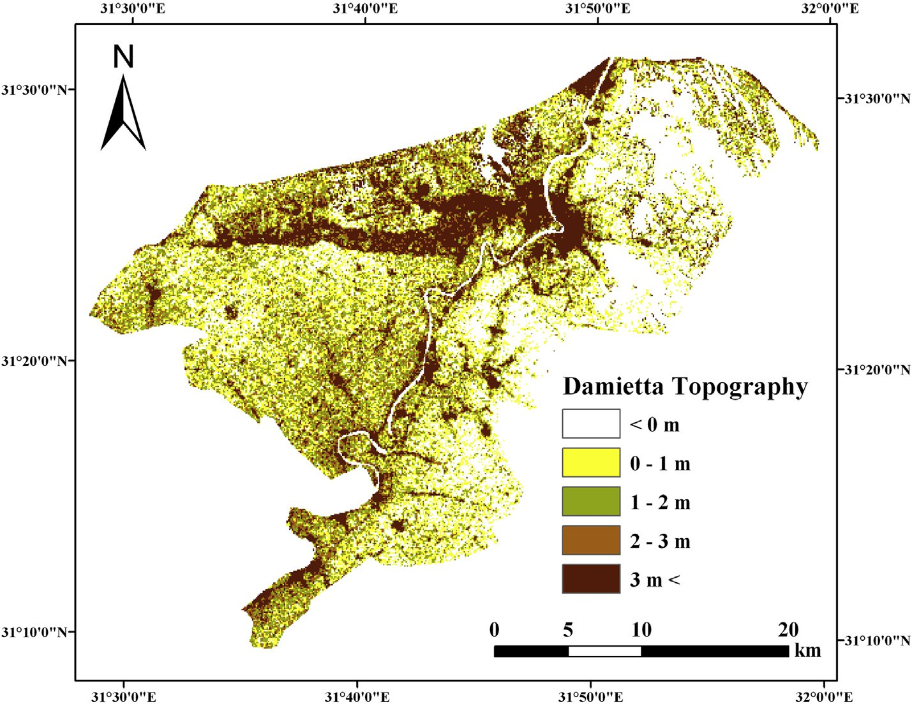

Fig. 5 e Regional topography of Damietta as revealed by digital elevation modes.

158 [e gypti an j o ur nal o f b a sic and a p p l i ed sci e n c e s 1 ( 2014) 1 5 1](http://dx.doi.org/10.1016/j.ejbas.2014.07.002) e[160](http://dx.doi.org/10.1016/j.ejbas.2014.07.002)

which represents the heavy clayey dark soils formed from the River Nile and are under cultivation. 2 e *psamments*, which occurs along the northern coastal plain of Damietta and have coarse texture soils (at least loamy sand). 3 e *Aquents*, which occurs along the fringes of the Lake Manzala and constitutes a narrow belt encompassing the lake shores. For the *fluvents*, there are two most probable Great Groups: *fluvents* soils that have xeric moisture regime and *fluvents* soils that have *aridic* moisture regime. As the moisture regime of the soil is *aridic* (torric), then the Great Group of the *fluvents* is the *torrifluvents*. In a same manner the Great Group of the *psamments* is the *torripsaments*. For the *aquents*, the most suitable Great Group is the *psamaquents* as the soil texture is mostly loamy sand. The fourth level in the soil classification incorporates the presence of specific character in the soil profile. As the soil profile is generally homogeneous, all the three soil Great Groups are described as “typical”. Then the three subgroups of the soils are: 1 e *Typic torrifluvents*; 2 e *Typic torripsamments* and 3 e *Typic psamaquents*.

### *Soil rating*

The Storie's index is a quantitative ranking system for soil suitability. The four factors applied to this index are given in Table 3. Factor (A), which describes the physical profile in terms of its formation and depth. This factor takes scores of

100 and 60% in the studied soils, as they are formed along flood plains or from aeolian/coastal processes. Soils having 100% are deep, whereas those having 60% are shallow. Factor B describes the texture of the soil in each site, where fine texture soils have a higher score than coarser soils. Factor C describes the slope of land in each site, where all the sites take the score of 100 because soils are flat. Factor *X* describes the

conditions of the soil in terms of the degree of soil salinity. Three classes of salinity could be identified in the soils under considerations: low salinity soils of the cultivated fine soils (100%); moderate soil salinity in the reclaimed cultivated land and in the clayey bare soils (90%); and high soil salinity in the sabkhas and lake shore soils (30%). Multiplying these four factors yields the Storie's Index, which produced five classes

of soil suitability: 1 e Excellent soils; those represents agri-

cultural lands of the fine texture (sample 1). 2 e Good soils; those include agricultural lands of the coarser texture (sam- ples 2, 3, 5 and 6). 3 e Fair soils; those have a sandy texture (sample 4). 4 e Poor soils; those include bare soils which have a finer texture (sample 14). 5 e Very poor soils; those comprise all the other bare soils (samples 7, 8, 9, 10, 11, 12, 13, 15, 16, 17, 18, 19, 20). The most obvious results of these classification systems indicate that bare lands of Damietta Governorates are not suitable for agricultural purposes. They could be used for other land use activity.

### *Suitable uses of bare land*

Depending on the results obtained from the soil analysis, rating, and land cover mapping, barren lands (12% of Dam- ietta) occur mostly at the coastal strip along the Mediterra- nean Sea coast and rarely along the shores of the Lake Manzala, do not have a potential for agriculture. The primary reason is that these lands have extremely high salinity. The sources of salinity of salts can include: flooding of seawater during winter surges and the high groundwater table. For coastal bare lands along the Mediterranean Sea, salt crusts have been observed with their white-color. Other coastal bare lands include sand flats covered by little dunes and ripple marks, particularly along the coast. The sands of these flats

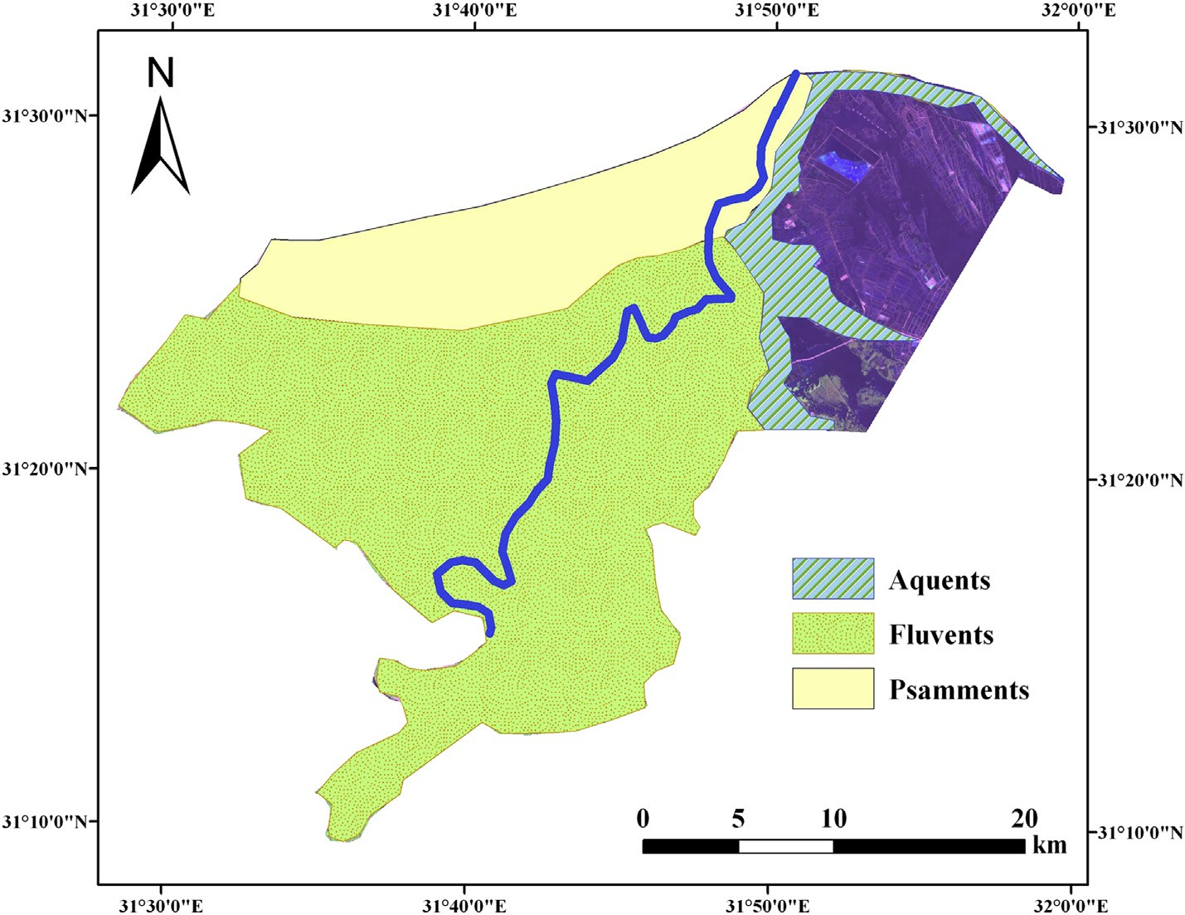

Fig. 6 e Soil classification of Damietta Governorate.

[e g ypti an j o ur nal o f b a sic and a pp l i e d sci en c e s 1 ( 2014) 1 5 1](http://dx.doi.org/10.1016/j.ejbas.2014.07.002) e[160](http://dx.doi.org/10.1016/j.ejbas.2014.07.002) 159

have been inherited originally from the beach, therefore they add salinity to the receiving areas.

|  |  |  |  |  |  |
| --- | --- | --- | --- | --- | --- |
| Table 3 e Storie Index Soil Rating of the study area. | | | | | |
| S. Factor A  Physical profile | | Factor B  Texture | Factor C  Slope | Factor X  Soil condition | Soil Rating |
| 1 | 100 | 90 | 100 | 100 | 90% e Excellent |
| 2 | 100 | 70 | 100 | 100 | 70% e Good |
| 3 | 100 | 70 | 100 | 100 | 70% e Good |
| 4 | 100 | 60 | 100 | 90 | 54% e Fair |
| 5 | 100 | 70 | 100 | 90 | 63% e Good |
| 6 | 100 | 70 | 100 | 90 | 63% e Good |
| 7 | 100 | 60 | 100 | 30 | 18% e Very poor |
| 8 | 100 | 60 | 100 | 30 | 18% e Very poor |
| 9 | 100 | 60 | 100 | 30 | 18% e Very poor |
| 10 | 100 | 60 | 100 | 30 | 18% e Very poor |
| 11 | 100 | 60 | 100 | 30 | 18% e Very poor |
| 12 | 100 | 60 | 100 | 30 | 18% e Very poor |
| 13 | 100 | 60 | 100 | 30 | 18% e Very poor |
| 14 | 100 | 80 | 100 | 30 | 24% e Poor |
| 15 | 100 | 60 | 100 | 30 | 18% e Very poor |
| 16 | 100 | 60 | 100 | 30 | 18% e Very poor |
| 17 | 100 | 60 | 100 | 30 | 18% e Very poor |
| 18 | 60 | 60 | 100 | 30 | 11% e Very poor |
| 19 | 60 | 80 | 100 | 30 | 14% e Very poor |
| 20 | 60 | 95 | 100 | 30 | 17% e Very poor |
| Grade 1 Excellent (80e100%). Grade 2 Good (60e79%).  Grade 3 Fair (40e59%). Grade 4 Poor (20e39%). Grade 5 Very poor (10e19%).  Grade 6 Non-agricultural (Less than 10%). | | | | | |

The suitable use of these bare lands could include urban, industrial, commercial and touristic use. One of the industrial activity that is proposed by this study is to establish plants of table-salt extraction, particularly along the north tip of Dam- ietta promontory. DEM could be used to locate low-lands that receive water naturally from the sea. Coastal resorts and vil- lages could be established along the coastal bare land from north of New Damietta City until the western border of the Governorate. This sandy strip has a lower salinity and, hence, could be used for urbanization. Bare lands bordering the Lake Manzala could be used for extending current aquaculture ac- tivities. Soils are rich in nutrients and could be used efficiently

pedogenic and soil genesis processes are not observed and no diagnostic epipedon or endopedons have been recognized. Soil classification reveals the presence of one soil order; *Enti- sols*, with three sub orders: *fluvents*, *psamments* and *aquents*. Five classes of Soil Storie's Index are identified: 1 e Excellent, 2 e Good, 3 e Fair soils, 4 e poor, and 5 e Very poor. Bare soils

are not recommended for agricultural purposes. They could be utilized for residential, commercial, industrial, touristic, aquaculture or biological treatment of wastewater. Remote sensing technology is proved to be an effective tool for map- ping and classification of land use/cover.

## references

for fish production. In addition, bioremediation basins could

be constructed for biological treatment of agricultural wastes.

Domestic wastewater could be diverted after a primary treatment. There, swamp vegetation should be grown in these basins to reduce nutrient levels. It is not recommended to convert these areas for agricultural purposes due to the high salinity of the soil, otherwise expensive and careful manage- ment are needed.

# Conclusions

Damietta Governorate occupies an area of about 910 km2 with barren lands occupying 12%. Soils are generally either: agri- cultural non-saline of alluvial origin or barren saline of aeolian or marine origins. Soils have a *thermic* temperature regime and an *aridic* moisture regime. They are generally deep, however,

1. [El Banna M, Frify O. Human-induced changes in the](http://refhub.elsevier.com/S2314-808X(14)00030-X/sref1) [geomorphology of the northeastern coast of the Nile delta,](http://refhub.elsevier.com/S2314-808X(14)00030-X/sref1) [Egypt. Geomorph 2009;107:72](http://refhub.elsevier.com/S2314-808X(14)00030-X/sref1)e[8](http://refhub.elsevier.com/S2314-808X(14)00030-X/sref1).
2. [United Nations Educational, Scientific and Cultural](http://refhub.elsevier.com/S2314-808X(14)00030-X/sref2) [Organization (UNESCO). Map of the world distribution of arid](http://refhub.elsevier.com/S2314-808X(14)00030-X/sref2) [regions: map at scale 1:25,000,000 with explanatory note.](http://refhub.elsevier.com/S2314-808X(14)00030-X/sref2) [MAB Technical Notes 7. Paris: UNESCO; 1979](http://refhub.elsevier.com/S2314-808X(14)00030-X/sref2).
3. [Soil Survey Staff. Soil taxonomy: a basic system of soil](http://refhub.elsevier.com/S2314-808X(14)00030-X/sref3) [classification for making and interpreting soil surveys.](http://refhub.elsevier.com/S2314-808X(14)00030-X/sref3) [Washington, DC: U.S. Dept. of Agric; 1975. Handb. 436. U.S.](http://refhub.elsevier.com/S2314-808X(14)00030-X/sref3) [Govt. p. 754](http://refhub.elsevier.com/S2314-808X(14)00030-X/sref3).
4. [Storie R. Storie index soil rating. Oakland: The University of](http://refhub.elsevier.com/S2314-808X(14)00030-X/sref4) [California Division of Agricultural Sciences Special](http://refhub.elsevier.com/S2314-808X(14)00030-X/sref4) [Publication; 1978. p. 3203](http://refhub.elsevier.com/S2314-808X(14)00030-X/sref4).
5. [Lillesand TM, Kiefer RW, Chipman RW. Remote sensing](http://refhub.elsevier.com/S2314-808X(14)00030-X/sref5) [and image interpretation. 5th ed. USA: John Wiley](http://refhub.elsevier.com/S2314-808X(14)00030-X/sref5) & [Sons;](http://refhub.elsevier.com/S2314-808X(14)00030-X/sref5) [2004](http://refhub.elsevier.com/S2314-808X(14)00030-X/sref5).

160 [e gypti an j o ur nal o f b a sic and a p p l i ed sci e n c e s 1 ( 2014) 1 5 1](http://dx.doi.org/10.1016/j.ejbas.2014.07.002) e[160](http://dx.doi.org/10.1016/j.ejbas.2014.07.002)

1. [Anderson JR, Hardy EE, Roach JT, Witmer RE. A land use and](http://refhub.elsevier.com/S2314-808X(14)00030-X/sref6) [land cover classification system for use with remote sensor](http://refhub.elsevier.com/S2314-808X(14)00030-X/sref6) [data. Geological Survey Professional Paper 964. Washington,](http://refhub.elsevier.com/S2314-808X(14)00030-X/sref6) [DC: United States Government Printing Office; 1976](http://refhub.elsevier.com/S2314-808X(14)00030-X/sref6).
2. [Salem B, El-Cibahy A, El-Raey M. Detection of land cover](http://refhub.elsevier.com/S2314-808X(14)00030-X/sref7) [classes in agro-ecosystem of northern Egypt by remote](http://refhub.elsevier.com/S2314-808X(14)00030-X/sref7) [sensing. Int J Remote Sens 1995;16:2581](http://refhub.elsevier.com/S2314-808X(14)00030-X/sref7)e[94](http://refhub.elsevier.com/S2314-808X(14)00030-X/sref7).
3. [El-Asmar H. Geoenvironmental changes along Gamasa-](http://refhub.elsevier.com/S2314-808X(14)00030-X/sref8) [Baltim coast, north of the Nile Delta, Egypt. Z. Geomorphol N.](http://refhub.elsevier.com/S2314-808X(14)00030-X/sref8) [F 2000;44:59](http://refhub.elsevier.com/S2314-808X(14)00030-X/sref8)e[73](http://refhub.elsevier.com/S2314-808X(14)00030-X/sref8).
4. [Dewidar Kh. Detection of land use/land cover changes for the](http://refhub.elsevier.com/S2314-808X(14)00030-X/sref9) [northern part of the Nile delta (Burullus region), Egypt. Int J](http://refhub.elsevier.com/S2314-808X(14)00030-X/sref9) [Rem Sens 2004;25:4079](http://refhub.elsevier.com/S2314-808X(14)00030-X/sref9)e[89](http://refhub.elsevier.com/S2314-808X(14)00030-X/sref9).
5. [Mohamed E, Morgun EG, Goma Bothina S. Assessment of soil](http://refhub.elsevier.com/S2314-808X(14)00030-X/sref10) [salinity in the Eastern Nile Delta (Egypt) using](http://refhub.elsevier.com/S2314-808X(14)00030-X/sref10) [geoinformation techniques. Mosc Univ Soil Sci Bull](http://refhub.elsevier.com/S2314-808X(14)00030-X/sref10) [2011;66:11](http://refhub.elsevier.com/S2314-808X(14)00030-X/sref10)e[4](http://refhub.elsevier.com/S2314-808X(14)00030-X/sref10).
6. [Jensen JR. Introductory digital image processing: a remote](http://refhub.elsevier.com/S2314-808X(14)00030-X/sref11) [sensing perspective. Upper Saddle River, NJ: Pearson Prentice](http://refhub.elsevier.com/S2314-808X(14)00030-X/sref11) [Hall; 2005. 7458, 544](http://refhub.elsevier.com/S2314-808X(14)00030-X/sref11).
7. [Baruah TC, Barthakur HP. A textbook of soil analysis. New](http://refhub.elsevier.com/S2314-808X(14)00030-X/sref12) [Delhi: Viskas Publishing House PVT Ltd; 1997](http://refhub.elsevier.com/S2314-808X(14)00030-X/sref12).
8. [Black CA, Evans DD, Ensminger LE, White JL, Clark FE.](http://refhub.elsevier.com/S2314-808X(14)00030-X/sref13) [Methods of soil analysis. Madison, Wisconsin, USA: Am. Soc.](http://refhub.elsevier.com/S2314-808X(14)00030-X/sref13) [of Agron. Inc.; 1965](http://refhub.elsevier.com/S2314-808X(14)00030-X/sref13).
9. [American Public Health Association (APHA). Standard](http://refhub.elsevier.com/S2314-808X(14)00030-X/sref14) [methods for examination of water and sewage water. 20th](http://refhub.elsevier.com/S2314-808X(14)00030-X/sref14) [ed 1998. Washington, D.C., USA](http://refhub.elsevier.com/S2314-808X(14)00030-X/sref14).
10. [Olsen SR, Cole CV, Watanabe FS, Dean LA. Estimation of](http://refhub.elsevier.com/S2314-808X(14)00030-X/sref15) [available phosphorus in soils by extraction with sodium](http://refhub.elsevier.com/S2314-808X(14)00030-X/sref15) [bicarbonate. USDA; 1954. 939](http://refhub.elsevier.com/S2314-808X(14)00030-X/sref15).
11. [Birkeland PW. Soils and geomorphology. 3rd ed. New York,](http://refhub.elsevier.com/S2314-808X(14)00030-X/sref16) [USA: Oxford University Press; 1999](http://refhub.elsevier.com/S2314-808X(14)00030-X/sref16).
12. [Schoeneberger PJ, Wysocki DA, Benham EC, Broderson WD,](http://refhub.elsevier.com/S2314-808X(14)00030-X/sref17) [editors. Field book for describing and sampling soils, version](http://refhub.elsevier.com/S2314-808X(14)00030-X/sref17)

[2.0. Natural resources conservation service. Lincoln, NE,](http://refhub.elsevier.com/S2314-808X(14)00030-X/sref17) [USA: National Soil Survey Center; 2002](http://refhub.elsevier.com/S2314-808X(14)00030-X/sref17).

1. [Hamdi H. The mineralogy of the fine fraction of the alluvial](http://refhub.elsevier.com/S2314-808X(14)00030-X/sref18) [soils of Egypt. Egypt J Soil Sci 1967;7:15](http://refhub.elsevier.com/S2314-808X(14)00030-X/sref18)e[21](http://refhub.elsevier.com/S2314-808X(14)00030-X/sref18).
2. [Brady NC, Weil RR. Elements of the nature and properties of](http://refhub.elsevier.com/S2314-808X(14)00030-X/sref19) [soils. New Jersey, USA: Published by Prentice-Hall, Inc.; 2000](http://refhub.elsevier.com/S2314-808X(14)00030-X/sref19).
3. [Mashaly IA, El-Habashy IE, El-Halawany EF, Omar G. Habitats](http://refhub.elsevier.com/S2314-808X(14)00030-X/sref20) [and plant communities in the Nile Delta of Egypt I. Deltaic](http://refhub.elsevier.com/S2314-808X(14)00030-X/sref20) [Mediterranean Coastal Habitat. Pak J Biol Sci](http://refhub.elsevier.com/S2314-808X(14)00030-X/sref20) [2008;11:2532](http://refhub.elsevier.com/S2314-808X(14)00030-X/sref20)e[44](http://refhub.elsevier.com/S2314-808X(14)00030-X/sref20).
4. [Soil Survey Division Staff. Soil survey manual. U.S.](http://refhub.elsevier.com/S2314-808X(14)00030-X/sref21) [Department of Agriculture Handbook 18. Soil Conservation](http://refhub.elsevier.com/S2314-808X(14)00030-X/sref21) [Service; 1993](http://refhub.elsevier.com/S2314-808X(14)00030-X/sref21).