[Egyptian Informatics Journal 22 (2021) 411–416](https://doi.org/10.1016/j.eij.2020.12.005)

Contents lists available at [ScienceDirect](http://www.sciencedirect.com/science/journal/11108665)

Egyptian Informatics Journal

journal homepage: [www.sciencedirect.com](http://www.sciencedirect.com/)

[](http://crossmark.crossref.org/dialog/?doi=10.1016/j.eij.2020.12.005&domain=pdf)Lane prediction optimization in VANET

Ghassan Samara

*Department of Computer Science, Zarqa University, Jordan*

# a r t i c l e i n f o

*Article history:*

Received 14 June 2020

Revised 21 November 2020

Accepted 14 December 2020

Available online 30 December 2020

*Keywords:*

VANET

Lane prediction Optimization V2V

# a b s t r a c t

Among the current advanced driver assistance systems, Vehicle-to-Vehicle (V2V) technology has great potential to increase Vehicular Ad Hoc Network (VANET) performance in terms of security, energy effi- ciency, and comfortable driving. In reality, vehicle drivers regularly change lanes depending on their assumptions regarding visual distances. However, many systems are not quite well-designed, because the visible range is limited, making it difficult to achieve such a task. V2V technology offers high potential for VANET to increase safety, energy efficiency, and driver convenience. Drivers can make more intelli- gent options in terms of lane selection using predicted information of downstream lane traffic, which is essential for obtaining mobility benefits. An assistant lane selection system is proposed in this research, which helps the driver locate an optimal lane-level travel path in order to minimize travel time. The decision-making criteria are based on the predicted lane traffic conditions via V2V technology. This paper aims to create a specific V2V system to support lane selection based on the predicted traffic states to find the best travel lane. In this paper, a Spatial–Temporal (ST) prototype is developed and then applied to predict future traffic conditions for road cells using spatial and temporal information. The suggested lane selection assistance system uses this information to select the optimized lane sequence. Then, an inten- sive simulation-based assessment is conducted in different scenarios. Results indicate that the proposed system outperforms other published systems.

© 2021 THE AUTHOR. Published by Elsevier BV. on behalf of Faculty of Computers and Artificial Intelli-

gence, Cairo University. This is an open access article under the CC BY-NC-ND license ([http://creative-](http://creativecommons.org/licenses/by-nc-nd/4.0/)

[commons.org/licenses/by-nc-nd/4.0/](http://creativecommons.org/licenses/by-nc-nd/4.0/)).

1. Introduction

In recent years, advanced driving aid schemes have been influ- enced by Connected Vehicle (CV) technology, which allows wire- less communication between cars and between cars and facilities (i.e., Vehicle-to-Everything or V2X). To improve the security, effec- tiveness, and convenience of riding vehicles [1,2] different trials on V2X information return methodologies have been conducted [3,4]. Current CV apps are primarily intended for two kinds of communi- cation: Dedicated Short-Range Communication (DSRC) and mobile-oriented communication depending on Wireless Access in the Vehicular Environment (WAVE) [5]. By using the IEEE 802.11p norm [6] the DSRC systems can provide elevated accessi- bility and low-latency streams for critical security apps [7]. How- ever, they require comparatively costly embedded units for all communication-capable terminals [2]. Due to the accessibility of several embedded detectors, mobile devices (e.g., smartphones) can readily be incorporated with separate advanced driving aid

Peer review under responsibility of Faculty of Computers and Artificial Intelligence, Cairo University.

schemes [8,9]. The CV technique has drawn enhanced interest because of its ability to improve car security and safety [10,11] economic sustainability, and riding comfort [1,12]. In [10] the authors concentrated on the safety of road lane change and built secure pathways for conductors using predictive power models. In order to properly direct the rider around the junction in an envi- ronmentally friendly manner, the authors of another work [13] suggested an eco-approach and departure request, which could obtain signaling stage and time data from the upcoming traffic sig- nal. One study [14] suggested an in-car scheme that utilizes the position of traffic light and time to reach an optimum personal rid- ing rate. In addition, various organizations have created several efforts to encourage CV studies. For example, a wide range of apps created under the safety pilot program [15] the dynamic mobility application program, have been described in the CV reference implementation architecture [16]. Examples of environmental applications include the real-time information synthesis [17] pro- gram and US funding program for road weather CVs [18] and the US Department of Transport (USDOT). Moreover, several studies on CV apps have been financed by the European Union and other countries [19].

<https://doi.org/10.1016/j.eij.2020.12.005>

1110-8665/© 2021 THE AUTHOR. Published by Elsevier BV. on behalf of Faculty of Computers and Artificial Intelligence, Cairo University. This is an open access article under the CC BY-NC-ND license (<http://creativecommons.org/licenses/by-nc-nd/4.0/>).

The vehicular ad hoc network (VANET) faces several difficult sit- uations, which differentiate it from other Mobile Ad Hoc Networks (MANETs). A highly complex network topology is accomplished by the amount of traffic under varying conditions, such as hours of traffic and traffic jams. Furthermore, the high mobility feature of the vehicles results in an intermittent communication between vehicles and/or between cars and Roadside Units (RSUs) [20,21]. Due to the behavioral instability of close-knit human drivers, changing lanes has become a critical bottleneck in the secure deployment of autonomous vehicles. Human drivers can adap- tively respond to the increasingly differing traffic situations according to their understanding and experiences. However, it remains difficult to illustrate clear rules for all scenarios from gath- ered raw data, simply because the data flood can overpower human insight and interpretation. In this paper, a lane selection system is proposed, which helps drivers find an ideal lane route to minimize journey time. The decision-making process is focused on the prediction of lane-level traffic by means of CV technology. The rest of this paper is organized as follows: Section II presents the related works, followed by problem formulation in Section III. Section IV presents the detailed description of the lane selection algorithm. In Section V, simulation studies are conducted to evalu- ate the performance of the proposed system. The final section con-

cludes this paper with further discussion on future works.

1. Related Work

A wide range of CV apps for riding help have been suggested and created, but only a few of these have focused on side control support. Examples include the allocation of the zone [22,23] and the choice of an ideal zone [24] as suggested by past works [22,23] by means of inter-vehicle communications, which is a decentralized track strategy to a set of cars and car pilots on/off roads. An additional track choice study project has been suggested to regulate uncoordinated track modifications by means of two- way communication between vehicles and infrastructures (vehicle-to-infrastructure, V2I) by minimizing possible clashes in the car [23]. The findings in [23] indicated that the median journey moment is relatively lower with the non-lane choice situation as a result of controlled lane change behaviors. All of these studies assumed that all cars on the highway are applied vehicles, making it difficult, in the following decades or more, to achieve these vehi- cle allocation methods. Yet, to date, the movement has not been well researched in the area of advanced driving aid schemes fea- turing directional command help. Meanwhile, traffic-state predic- tions, such as sampling Kalman, non-parametric correlation model, or cellular networks, have been well-researched for years [25,26]. One study [25] proposed a linear regression model relying on results from loop detectors for transport moments in the free- way. Another work [27] suggested a straightforward, stable time series system for a segment of a motorway to predict transport times. Many model- and data-driven models, such as the hidden Markov models [28,29] K-nearest neighbors method to traffic- state forecast [30] the particle filter model [31,32] the Kalman filter

[33] and deep neural networks in [34] have also been suggested for short-term flow government forecast.

A number of vehicle prediction techniques were created on the basis of the Markov chain [28,35]. The Markov (binary) system was used mostly for determining the vehicle state of the next interval depending on the signal models. In conjunction with the Markov variable-length strings, for instance, the closest neighboring rank- ing was used to forecast traffic patterns [28]. Following classifica- tion into a group of the vehicle status for each fresh time step, a specific speed score is calculated using the suitable weighted regression model tracked only with information from the corre-

sponding group. In order to ensure the elevated predictability of the short-term traffic flow predicting technique [35] a mixed fore- cast technique centered on Markov’s loop hypothesis and Grey Verhulst’s model was also suggested. The volatility of the informa- tion was addressed in the Markov chain principle, which is based on the Gray Verhulst model, in an attempt to enhance the precision of the forecasts.

Findings showed that a relative error of traffic flows from one section over 16 times (5 min per time step) between 0 and 13 times (between real-world information and predictive informa- tion). All previous studies, however, relied on a Markov chain although it is not very helpful in describing events and, in the majority of cases, cannot be the actual model of the underlying sit- uation. At the same moment, a short-term forecast technique depending on space–time correlations was also suggested. In [36] the authors pointed out that the transport status of a particular location has been extremely influenced by flow upstream and out- going circumstances and that free flow rates (cell-to-cell, lane-to- lane correlation) are spatially linked. An extended stochastic cell transmission model has been used in support of short traffic state prediction in light of the spatial time correlation of the transmis- sion traffic flux. In [36] the I210-W segment was split into four cells with a per-cell range of around 0.5 miles. In order to validate the efficacy, the general average relative percentage error has been calculated, ranging from 10.8 to 14 times [36]. In [37] an assess- ment method for traffic statuses using correlations between high- way networks and scarce traffic samples was suggested in order to assess traffic circumstances in various highway sections. Their sug- gested method focused on the mathematical structure of the multi-linear regression (MLR) representing road connections. The MLR system and the compressive detection technology were used to estimate congestion at urban scale by monitoring a tiny amount of sampled cars. A comprehensive experimentation on real-world traffic information (within a big network of 1826 highway sections in the town of Shanghai) helped validate the template for traffic estimations. Results showed that, for various road situations, the complete velocity difference between the findings expected and the soil truths is 5.2–11.0 km/h. However, the experiment should be further investigated for higher speeds to further test the results. Another way of estimating and predicting the road state is to use an enhanced Kalman Filter ensemble to assess and forecast realistic highway network which, thanks to lower matrix reversals, can decrease computing time [32]. However, Kalman Filter consid- ers both equations between the device and the monitoring model to be linear, which in many real-life circumstances, is not realistic. In [34] the development of the road state in a highway was mod- elized through a computer training neural network. All these methods are concentrated instead of lane point on the forecast of

link-level congestion state.

In recent years, lane-based surveys have drawn increasing interest, including, but not limited to projections of car travel, queue alert efficiency assessment, and the lateral movement pre- diction of independent cars [38,39]. Lane-level guide techniques, such as those using improved global positioning system (GPS)/ multilayer chart systems for ego-lane evaluation and lane-level mapping system, have also been proposed to facilitate the execu- tion of lane-level apps in practice [40,41]. However, GPS does not scale up with high speed networks like VANET. Advanced detecting systems, such as the radio-frequency identification (RFID) technol- ogy [42,43] have also been created as the main facilitator for pre- cise location monitoring, which can help countless transit apps in the future [44]. The RFID technology, however, is slower compared to VANET. In [45] the OLS application has been proposed for achieving optimal lane selection. For practical usage, the utility function has been built with longitudinal and lateral safety consid- erations in mind. The OLS app was initially assessed in a highway

segment. Results revealed that the OLS implementation reduced travel time and delay compared to the base case without control inside the linked transportation system. The application also improved efficiency on such higher traffic demands, but not under capacity conditions, which caused lane changes to prevent CVs from moving in congested areas. High-efficiency lane-level predic- tion can help automated CVs select and plan the optimum lane paths based on the predicted traffic flow in terms of the level of service. Sequentially, a more balanced overall distribution of differ- ent vehicles can be achieved and, correspondingly, an increased capacity for roads [46]. Inspired by this study, we suggested a model of regression in the forecast of lane-level state vehicles through the use of inter-lane data (intra-lane data) and inter- lane interconnections between neighboring highway sections on the same lane.

1. Problem formulation

The optimization problem is developed to determine what room (i.e., part of the range) the car should occupy at some stage in order to find the finest range route for an application.

See Fig. 3 for the proposed information flow.

1. Proposed system
   1. *Beacon upload*

Each vehicle uploads ten beacons per second to an RSU; the received beacons by the RSU are then used to analyze driver pat- tern and current traffic conditions. The beacons received will be analyzed in two steps: (1) obtaining the average of the current speed (ACS) by computing the current average speed of the sender vehicle in relation to the average speed of other cars in the same location and (2) comparing that to the traffic density. This can be calculated using Eq. (1):

P*S*

In real conditions, riders generally change distances, many of which are not well-planned, depending on their assumptions. Con-

*ACS* = *T*

## *N*

(1)

sider, for instance, a decider car (the car of concern for individuals) riding a five-lane highway under high congestion circumstances (see Fig. 1). The driver’s destination zone has to decide which spot to shift to (i.e., the first choice room in lane three or second choice room in lane five).

As the traffic upstream of the decider car (in lane 4) is congested

where S is the vehicle speed, T is the time, and N is the number of current vehicles connected to the RSU. The ACS ratio is then com- pared to the average of all vehicles speed (AAVS) registered to the RSU. The AAVS can be computed using Eq. (2):

P*n ACS*

in the driver’s sight, it is difficult for the rider to precisely under-

*AAVS* = 1

## *N*

(2)

stand which lane has heavier vehicles because of the restricted viewing range. Assuming that the decider in lane four switches to room in the second choice and faces two options, either to con- tinue in this blocked lane or go back to the previous lane, the rider is likely to switch back to his previous lane. The rider may also decide to switch to space first choice in lane three, as there is more room there. In this case, it may be a better option to stay in lane three or the decider may switch the room in lane 2. Therefore, anticipated upstream lane-level data are vital to achieve mobility advantages, which would allow deciders to create better decisions in route choice.

We describe as communications-capable those cars that can communicate fundamental data (i.e., speed and position). RSUs are small routers placed on the roads [21]; vehicles send beacon messages to RSUs periodically at a frequency of ten messages every second containing specific data (i.e., speed, position, and direction) [47]. Fig. 2 presents the beacon structure.

Note that road conditions change over a moment, so vibrant designs are necessary to predict traffic conditions. The forecast for the road level can be performed by using regression designs.

where AAVS computes the average speed of all vehicles connected to the current RSU in the network. Eq. (3) compares the ACS to AAVS:

*Anlaysedspeed* = *if* (*ACS* > *AAVS*) (3)

If Eq. (3) is fulfilled, then the current vehicle is faster than the aver- age of the current vehicles on the network. The AAVS must take into account the percentage of sudden moves that could occur in the current situation, such as sudden breaks or sudden lane changes at high speeds performed by any driver. Using Eq. (4), we can calcu- late the overall average for a particular vehicle:

*AvSud* = (X*n Sud*.*brk*/*n*)+ (X*n Chg*.*Loc*/*n*) (4)

*k*=0

*k*=0

where n is the number of times the sudden action is measured for each car, sud.brk is the number of sudden breaks performed by that driver at high speed, and Chg. Loc is the number of sudden lane changes executed by this driver at high speed. If the average AvSud in the current network is high, then the unexpected behavior can be predicted to suddenly change the shape of the traffic. Going back to

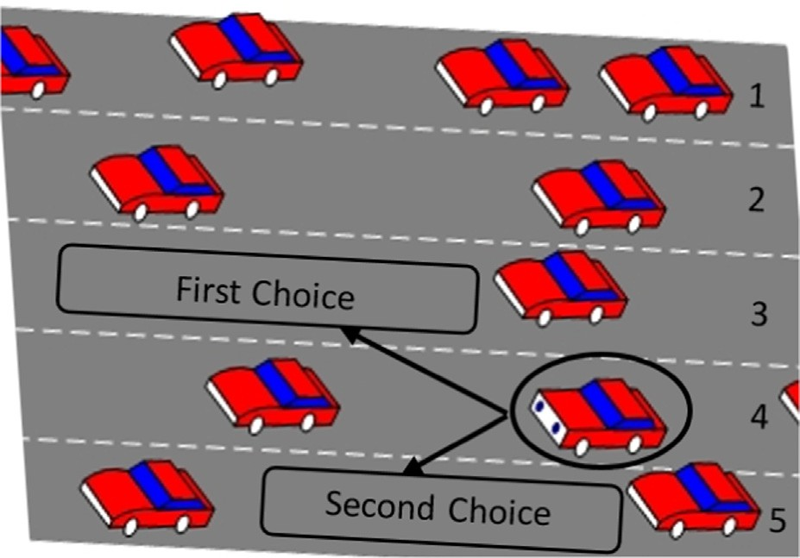 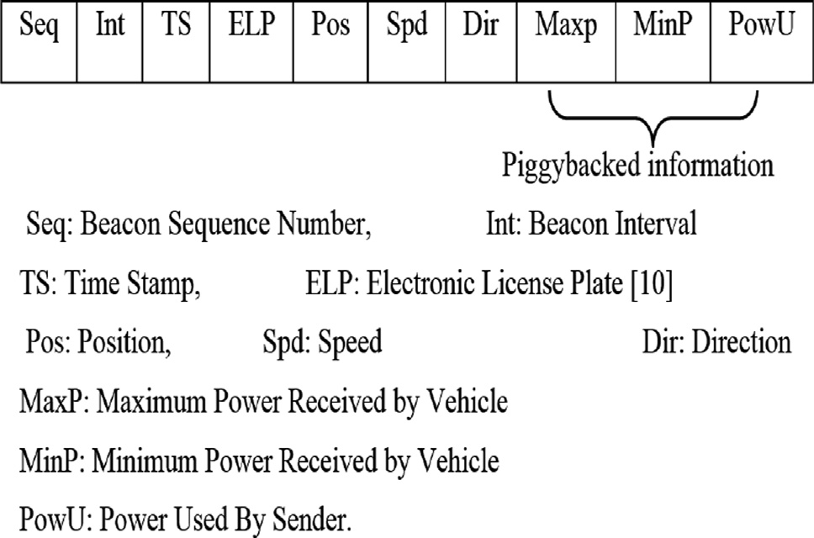

Fig. 1. An example of the problem description. Fig. 2. Beacon structure.

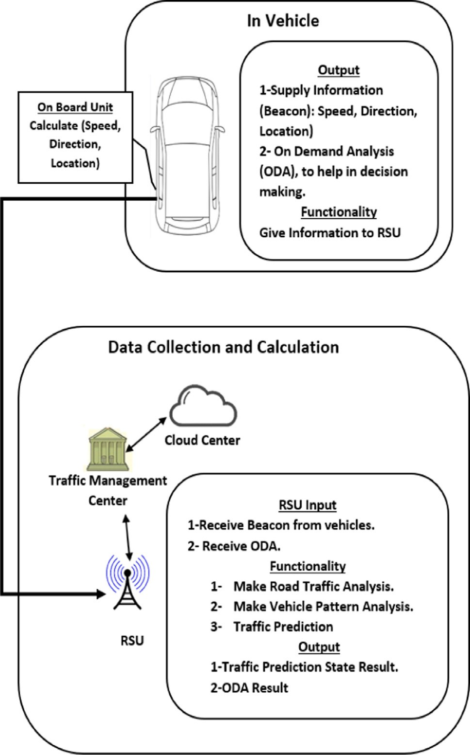

Fig. 3. Information flow of the lane selection.

the example in Fig. 1, the circled vehicle has two options for select- ing the first or second choice: either the vehicle will send ODA to RSU or the ODA will contain beacon and ACS about decider vehicle. The RSU will then evaluate the vacant choices for each option by measuring the current AAVS and the current average AvSud. As the vehicles around each choice vary, this can result in some AAVS and AvSud reaching the results listed in Table 1.

In the first and second case, the decider is slower than the vehi- cle around him, and will not be given the opportunity to move to the vacant position as other vehicles may move before him. There- fore, this choice is not preferred.

In the third case, the vehicle has a higher speed than other vehi- cles, but there is a high likelihood of sudden breaks or lane changes, so that there is a risk of possible crashes. Therefore, this choice is not preferred. For the fourth choice, the decider vehicle is faster than other network vehicles, and the other vehicles have no habit of changing lanes or unexpected breaks; in this case, this option is preferred. Hence, the RSU will send its analysis to the

Table 1

Traffic prediction decision.

|  |  |  |  |
| --- | --- | --- | --- |
| 1 | No | High | Not preferred |
| 2 | No | Low | Not preferred |
| 3 | Yes | High | Not preferred, possible danger |
| 4 | Yes | Low | preferred |

ACS > AAVS AvSud Decision

decision-makers’ vehicle to help it decide which choice is better in terms of fulfilment and safety.

1. Experiments, results and analysis

Intensive simulation with the new MATLAB R2019a was per- formed to demonstrate the accuracy of the proposed protocol [48]. The new interactive wireless environment is included in the MATLAB R2019a, and the same environment has been created with the same parameters. The implementation focuses on showing a boost in the system’s performance in relation to the proposed St- Model [46] framework. The simulation included 25,000 runs to achieve more precise results. The parameters of the simulation for the entire experiment are shown in Table 2.

In the first experiment shown in Fig. 4, we tested the relation- ship between congestion and travel time, which in high-traffic con- ditions, is expected to increase. There are three levels in the test of

congestion (traffic density): low — 25% of the total number of vehi-

cles in the experiment, medium — 50% of the total number of vehi- cles in the experiment, and high — 75% of the total number of vehicles in the experiment. The experiment shows that the St- Model has scores ranging between 9% and —7%, with a mean of

—8% of the total journey time when the level is low. The proposed

model’s scores vary from —10% to —8%, with a mean of —9% of the total journey time. When the level is medium, the St-Model ranges from —7% to —3%, with a mean of —5% of the total journey time. Meanwhile, the proposed model varies from —9% to —5% with a mean of —7% of the total journey time. At a high level, the St-

Model scores range between —3% and 3%, with a mean of —1% of

the overall journey time. The proposed model’s scores vary from

—8% to —2%, with a mean of —5% of the total journey time.

This experiment demonstrates that the proposed system pro- duces better results in heavy traffic situations, because it collects richer information on traffic conditions using ODA, which in turn, leads to better choices.

The second test shows what is achieved with the system in terms of the effects and benefits of implementing such a system when the proposed system is activated and turned off. The test examined the relationship between low, medium, and high levels of traffic and the average travelling time.

The results indicate the mean values for both systems when the system is deployed and turned off. The results in Fig. 5 show that

Table 2

Simulation parameters.

Parameter Value

Simulation Grid 1000 × 1000

Simulation time 300 sec

Vehicle speed 15–45 m/s

Number of runs 25,000 veh/run

Maximum Number of vehicles 200

Number of lanes 6 (3 in each direction)

Scenario Two-way highway

Network interface Phy/WirelessPhyExt

MAC interface Mac/802 11Ext

Interface queue Queue/DSRC

Propagation model Propagation/Nakagami

Number of TDMA slots/frames 10

Time slot 2.5 ms

Message size (safety) 100 bytes

Message size (nonesafety) 512bytes

Transmission range 300 m, 500 m

Modulation type BPSK

Antenna type Antenna/omniantenna

Channel type Channel/wireless channel

Data transfer rate 6, 12, 18, 27Mbps

Minimum beaconing interval 100 ms

Maximum beaconing interval 500 ms

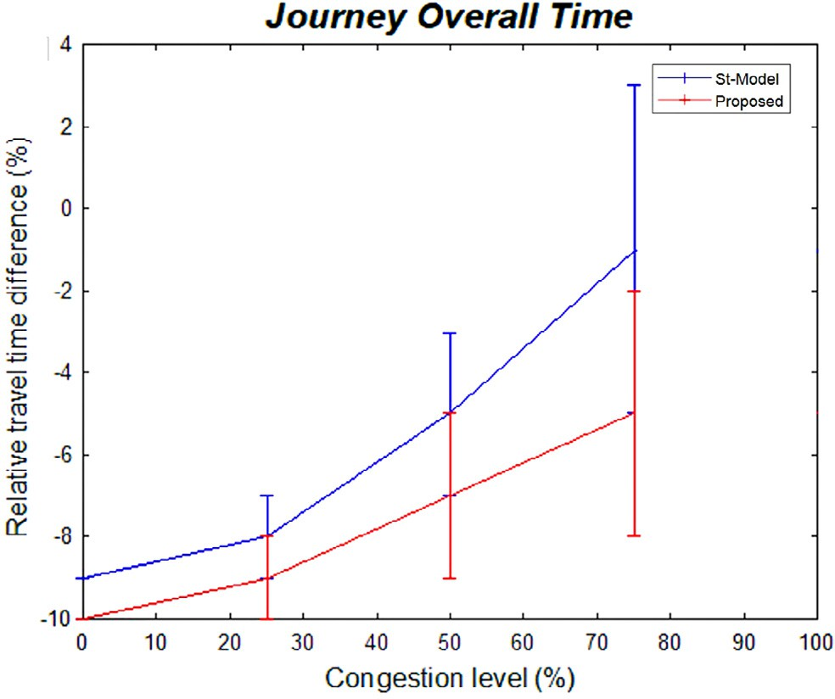



Fig. 4. Congestion effect on travel time.

Fig. 6. Impact of the ODA on travel time.

a driver choose an optimal lane travel direction to reduce driving time. The system can be used for the estimation of future condi- tions of road cell traffic by spatial and temporal details. The simu- lation results reveal that, depending on the congestion level, the proposed system has good performance scores ranging from 12.5% to 20%. Furthermore, the simulation results indicate that the heavy-traffic scenarios with richer traffic information can lead to optimal decisions.



A further experiment was conducted to compare the effect when the system is deployed and when it is off. As revealed by the results, when the system is off, there is always a delay, whereas system performance is much higher when the system is on. The third experiment shows the impact of the ODA. More ODAs mean more information that can help drivers arrive at optimum deci- sions. In order to enhance the robustness of the system, the secu- rity of the system should be investigated in future works.



Fig. 5. Proposed system effect.

delays are always occurring, particularly when the traffic becomes heavier when the system is off; meanwhile the proposed system can help drivers obtain improved information on the best space they can occupy without surprises.

The third experiment shown in Fig. 6 examines the impact of the ODA on travel time, while more ODA provides further informa- tion about the vehicle around the deciding vehicle, thus leading to optimum decisions. The experiment was conducted with a maxi- mum of 50 ODAs; as the moving vehicle loses its connection to the fixed RSU when reaching this number, this is the highest level achieved. However, when using ODA, the decision from a single ODA may not be sufficient, and the vehicle may sometimes send multiple ODAs to make the best decision.

1. Conclusions and future work

V2V drivers frequently turn lanes according to visual distance expectations, but many of them are not too well-planned-as the visible range is limited, making it difficult to achieve such a task. This research proposed an assistant lane selection model to help

Conflict of interest

The authors declare that they have no known competing finan- cial interests or personal relationships that could have appeared to influence the work reported in this paper.

Acknowledgments

This research is funded by the Deanship of Research in Zarqa University /Jordan.

Reference

1. G. Samara An improved CF-MAC protocol for VANET International Journal of Electrical & Computer Engineering 9 4 2668.
2. [Samara G, Ali Alsali WAH. Message broadcasting protocols in VANET. Inform](http://refhub.elsevier.com/S1110-8665(20)30164-X/h0010) [Technol J 2012;11(9):1235–42](http://refhub.elsevier.com/S1110-8665(20)30164-X/h0010).
3. [Zeadally S, Hunt R, Chen YS, Irwin A, Hassan A. Vehicular ad hoc networks](http://refhub.elsevier.com/S1110-8665(20)30164-X/h0015) [(VANETS): status, results, and challenges. Telecommun Syst 2012;50](http://refhub.elsevier.com/S1110-8665(20)30164-X/h0015) [(4):217–41](http://refhub.elsevier.com/S1110-8665(20)30164-X/h0015).
4. Dang, R., Ding, J., Su, B., Yao, Q., Tian, Y. and Li, K., 2014, October. A lane change warning system based on V2V communication. In 17th International IEEE Conference on Intelligent Transportation Systems (ITSC) (pp. 1923-1928). IEEE.
5. [Samara Ghassan, Ramadas Sureswaran, Al-Salihy Wafaa. Design of Simple and](http://refhub.elsevier.com/S1110-8665(20)30164-X/optOJ28DQyDMr) [Efficient Revocation List Distribution in Urban areas for VANET’s. International](http://refhub.elsevier.com/S1110-8665(20)30164-X/optOJ28DQyDMr) [Journal of Computer Science and Information Security 2010;8(1):151–5](http://refhub.elsevier.com/S1110-8665(20)30164-X/optOJ28DQyDMr).
6. [Kenney JB. Dedicated short-range communications (DSRC) standards in the](http://refhub.elsevier.com/S1110-8665(20)30164-X/h0025) [United States. Proc IEEE 2011;99(7):1162–82](http://refhub.elsevier.com/S1110-8665(20)30164-X/h0025).
7. Guan, W., He, J., Bai, L. and Tang, Z., 2011, October. Adaptive congestion control of DSRC vehicle networks for collaborative road safety applications. In 2011 IEEE 36th Conference on Local Computer Networks (pp. 913-917). IEEE.
8. [Samara G. Intelligent reputation system for safety messages in VANET. Int J](http://refhub.elsevier.com/S1110-8665(20)30164-X/h0035) [Artificial Intell 2020;9(3):439–47](http://refhub.elsevier.com/S1110-8665(20)30164-X/h0035).
9. [Samara G. An intelligent routing protocol in VANET. Int J Ad Hoc Ubiquitous](http://refhub.elsevier.com/S1110-8665(20)30164-X/h0040) [Comput 2018;29(1–2):77–84](http://refhub.elsevier.com/S1110-8665(20)30164-X/h0040).
10. Schildbach, G. and Borrelli, F., 2015, June. Scenario model predictive control for lane change assistance on highways. In 2015 IEEE Intelligent Vehicles Symposium (IV) (pp. 611-616). IEEE.
11. Morris, B., Doshi, A. and Trivedi, M., 2011, June. Lane change intent prediction for driver assistance: On-road design and evaluation. In 2011 IEEE Intelligent Vehicles Symposium (IV) (pp. 895-901). IEEE.
12. Samara, G. and Alsalihy, W.A.A., 2012, June. A new security mechanism for vehicular communication networks. In Proceedings Title: 2012 International Conference on Cyber Security, Cyber Warfare and Digital Forensic (CyberSec) (pp. 18-22). IEEE.
13. [Wu G, Boriboonsomsin K, Xia H, Barth M. Supplementary benefits from partial](http://refhub.elsevier.com/S1110-8665(20)30164-X/h0060) [vehicle automation in an ecoapproach and departure application at signalized](http://refhub.elsevier.com/S1110-8665(20)30164-X/h0060) [intersections. Transp Res Rec 2014;2424(1):66–75](http://refhub.elsevier.com/S1110-8665(20)30164-X/h0060).
14. [Butakov VA, Ioannou P. Personalized driver assistance for signalized](http://refhub.elsevier.com/S1110-8665(20)30164-X/h0065) [intersections using V2I communication. IEEE Trans Intell Transp Syst](http://refhub.elsevier.com/S1110-8665(20)30164-X/h0065) [2016;17(7):1910–9](http://refhub.elsevier.com/S1110-8665(20)30164-X/h0065).
15. U.S. Department of Transportation (USDOT). Connected Vehicle Safety Pilot. Accessed: Jan. 25,2020. [https://www.its.dot.gov/research_archives/safety/cv_](https://www.its.dot.gov/research_archives/safety/cv_safetypilot.htm) [safetypilot.htm](https://www.its.dot.gov/research_archives/safety/cv_safetypilot.htm).
16. Applications (CVRIA) – Iteris, Accessed: Feb. 18,2020 [https://local.iteris.com/](https://local.iteris.com/cvria/html/applications/applications.html) [cvria/html/applications/applications.html](https://local.iteris.com/cvria/html/applications/applications.html).
17. AERIS - Intelligent Transportation Systems, Accessed: Feb. 18,2020 [http://](http://www.its.dot.gov/aeris/index.htm) [www.its.dot.gov/aeris/index.htm](http://www.its.dot.gov/aeris/index.htm).
18. ITS Infographics - Intelligent Transportation Systems, Accessed: Feb. 18,2020 <http://www.its.dot.gov/road_weather/index.htm>.
19. CVIS, Cooperative Vehicle-Infrastructure Systems , Accessed: Feb. 18,2020
20. [Samara G, Alsalihy WAA, Ramadass S. Increasing network visibility using](http://refhub.elsevier.com/S1110-8665(20)30164-X/h0095) [coded repetition beacon piggybacking. World Appl Sci J 2011;13(1):100–8](http://refhub.elsevier.com/S1110-8665(20)30164-X/h0095).
21. [Samara G, Abu Salem AO, Alhmiedat T. Dynamic safety message power control](http://refhub.elsevier.com/S1110-8665(20)30164-X/h0100) [in VANET using PSO. World Comput Sci Inform Technol J 2013;3(10)](http://refhub.elsevier.com/S1110-8665(20)30164-X/h0100).
22. Dao, T.S., Clark, C.M. and Huissoon, J.P., 2007, June. Optimized lane assignment using inter-vehicle communication. In 2007 IEEE Intelligent Vehicles Symposium (pp. 1217-1222). IEEE.
23. Dao, T.S., Clark, C.M. and Huissoon, J.P., 2008, June. Distributed platoon assignment and lane selection for traffic flow optimization. In 2008 IEEE Intelligent Vehicles Symposium (pp. 739-744). IEEE.
24. Jin, Q., Wu, G., Boriboonsomsin, K. and Barth, M., 2014, June. Improving traffic operations using real-time optimal lane selection with connected vehicle technology. In 2014 IEEE Intelligent Vehicles Symposium Proceedings (pp. 70- 75). IEEE.
25. [Kwon Jaimyoung, Coifman Benjamin, Bickel Peter. Day-to-day travel-time](http://refhub.elsevier.com/S1110-8665(20)30164-X/h0120) [trends and travel-time prediction from loop-detector data. Transp Res Rec](http://refhub.elsevier.com/S1110-8665(20)30164-X/h0120) [2000;1717(1):120–9](http://refhub.elsevier.com/S1110-8665(20)30164-X/h0120).
26. [Goves C, North R, Johnston R, Fletcher G. Short term traffic prediction on the](http://refhub.elsevier.com/S1110-8665(20)30164-X/h0125) [UK motorway network using neural networks. Transp Res Procedia 2016;13](http://refhub.elsevier.com/S1110-8665(20)30164-X/h0125) [(Supplement C):184–95](http://refhub.elsevier.com/S1110-8665(20)30164-X/h0125).
27. [Rice J, vanZwet E. A simple and effective method for predicting travel times on](http://refhub.elsevier.com/S1110-8665(20)30164-X/h0130) [freeways. IEEE Trans Intell Transp Syst 2004;5(3):200–7](http://refhub.elsevier.com/S1110-8665(20)30164-X/h0130).
28. [Qi Yan, Ishak Sherif. A Hidden Markov Model for short term prediction of](http://refhub.elsevier.com/S1110-8665(20)30164-X/h0135) [traffic conditions on freeways. Transport Res Part C Emerg Technol](http://refhub.elsevier.com/S1110-8665(20)30164-X/h0135) [2014;43:95–111](http://refhub.elsevier.com/S1110-8665(20)30164-X/h0135).
29. Antoniou, C., Koutsopoulos, H.N. and Yannis, G., 2007, July. Traffic state prediction using Markov chain models. In 2007 European Control Conference (ECC) (pp. 2428-2435). IEEE.
30. [Oh Simon, Byon Young-Ji, Yeo Hwasoo. Improvement of search strategy with](http://refhub.elsevier.com/S1110-8665(20)30164-X/h0145) [k-nearest neighbors approach for traffic state prediction. IEEE Trans Intell](http://refhub.elsevier.com/S1110-8665(20)30164-X/h0145) [Transp Syst 2016;17(4):1146–56](http://refhub.elsevier.com/S1110-8665(20)30164-X/h0145).
31. Ren, S., Bi, J., Fung, Y.F., Li, X.I. and Ho, I.T., 2010, August. Freeway traffic estimation in Beijing based on particle filter. In 2010 Sixth International Conference on Natural Computation (Vol. 1, pp. 292-296). IEEE.
32. Chen, H., Rakha, H.A. and Sadek, S., 2011, October. Real-time freeway traffic state prediction: A particle filter approach. In 2011 14th International IEEE Conference on Intelligent Transportation Systems (ITSC) (pp. 626-631). IEEE.
33. Yuan, Y., Scholten, F. and van Lint, H., 2015, September. Efficient traffic state estimation and prediction based on the ensemble Kalman filter with a fast implementation and localized deterministic scheme. In 2015 IEEE 18th International Conference on Intelligent Transportation Systems (pp. 477- 482). IEEE.
34. Elhenawy, M. and Rakha, H., 2016, November. Stretch-wide traffic state prediction using discriminatively pre-trained deep neural networks. In 2016 IEEE 19th International Conference on Intelligent Transportation Systems (ITSC) (pp. 1065-1070). IEEE.
35. Huang, D., Deng, Z., Zhao, L. and Mi, B., 2017, May. A short-term traffic flow forecasting method based on Markov Chain and Grey Verhulst model. In 2017 6th Data Driven Control and Learning Systems (DDCLS) (pp. 606-610). IEEE.
36. [Min Wanli, Wynter Laura. Real-time road traffic prediction with spatio-](http://refhub.elsevier.com/S1110-8665(20)30164-X/h0175) [temporal correlations. Transport Res Part C Emerg Technol 2011;19](http://refhub.elsevier.com/S1110-8665(20)30164-X/h0175) [(4):606–16](http://refhub.elsevier.com/S1110-8665(20)30164-X/h0175).
37. [Liu Zhidan, Li Zhenjiang, Li Mo, Xing Wei, Lu Dongming. Mining road network](http://refhub.elsevier.com/S1110-8665(20)30164-X/h0180) [correlation for traffic estimation via compressive sensing. IEEE Trans Intell](http://refhub.elsevier.com/S1110-8665(20)30164-X/h0180) [Transp Syst 2016;17(7):1880–93](http://refhub.elsevier.com/S1110-8665(20)30164-X/h0180).
38. Kim, J.H. and Kum, D.S., 2015, June. Threat prediction algorithm based on local path candidates and surrounding vehicle trajectory predictions for automated driving vehicles. In 2015 IEEE Intelligent Vehicles Symposium (IV) (pp. 1220- 1225). IEEE.
39. Yoon, S. and Kum, D., 2016, June. The multilayer perceptron approach to lateral motion prediction of surrounding vehicles for autonomous vehicles. In 2016 IEEE Intelligent Vehicles Symposium (IV) (pp. 1307-1312). IEEE.
40. Rabe, J., Necker, M. and Stiller, C., 2016, June. Ego-lane estimation for lane-level navigation in urban scenarios. In 2016 IEEE Intelligent Vehicles Symposium

(IV) (pp. 896-901). IEEE.

1. Lee, J.W., Yoon, C.R., Kang, J., Park, B.J. and Kim, K.H., 2015, July. Development of lane-level guidance service in vehicle augmented reality system. In 2015 17th International Conference on Advanced Communication Technology (ICACT) (pp. 263-266). IEEE.
2. Khan, S.F., 2017, March. Health care monitoring system in Internet of Things (IoT) by using RFID. In 2017 6th International Conference on Industrial Technology and Management (ICITM) (pp. 198-204). IEEE.
3. Takizawa, O., Hosokawa, M., Takanashi, K.I., Hada, Y., Shibayama, A. and Jeong, B.P., 2008, March. Pinpointing the place of origin of a cellular phone emergency call using active RFID tags. In 22nd International Conference on Advanced Information Networking and Applications-Workshops (aina workshops 2008) (pp. 1123-1128). IEEE.
4. Sharma, V., Vithalkar, A. and Hashmi, M., 2018, January. Lightweight security protocol for chipless RFID in Internet of Things (IoT) applications. In 2018 10th International Conference on Communication Systems & Networks (COMSNETS) (pp. 468-471). IEEE.
5. Kang, K., Bichiou, Y., Rakha, H.A., Elbery, A. and Yang, H., 2019, October. Development and Testing of a Connected Vehicle Optimal Lane Selection Algorithm. In 2019 IEEE Intelligent Transportation Systems Conference (ITSC) (pp. 1531-1536). IEEE.
6. [Tian Danyang, Wu Guoyuan, Hao Peng, Boriboonsomsin Kanok, Barth Matthew](http://refhub.elsevier.com/S1110-8665(20)30164-X/h0225)

[J. Connected vehicle-based lane selection assistance application. IEEE Trans](http://refhub.elsevier.com/S1110-8665(20)30164-X/h0225) [Intell Transp Syst 2019;20(7):2630–43](http://refhub.elsevier.com/S1110-8665(20)30164-X/h0225).

1. [Samara G, Ramadas S, Al-Salihy WA. Safety message power transmission](http://refhub.elsevier.com/S1110-8665(20)30164-X/h0230) [control for vehicular ad hoc networks. J Comput Sci 2010;6(10)](http://refhub.elsevier.com/S1110-8665(20)30164-X/h0230).
2. ‘‘Wireless Communications - MATLAB & Simulink Solutions - MATLAB & Simulink.” [Online]. Available: [https://uk.mathworks.com/solutions/wireless-](https://uk.mathworks.com/solutions/wireless-communications.html) [communications.html](https://uk.mathworks.com/solutions/wireless-communications.html). [Accessed: 11-June-2020].