

Electronic Notes in Theoretical Computer Science 252 (2009) 55–75

[www.elsevier.com/locate/entcs](http://www.elsevier.com/locate/entcs)

Larger Than Life’s Invariant Measures

# Kellie Michele Evans 1 *,*2

*Department of Mathematics California State University Northridge, USA*

Abstract

*Larger than Life* (LtL) is a four-parameter family of two-dimensional cellular automata that generalizes John Horton Conway’s celebrated *Game of Life* (Life) to large neighborhoods and general birth and survival thresholds. If T is an LtL rule, and *A* a random configuration, then T *t*(*A*) denotes the state of the system at

time *t* starting from *A*. T *t*(*A*) may be thought of as a Markov process since the sites update independently from all preceding times except the current one. The Markov process is degenerate since the transitions are deterministic. Nevertheless, it has a compact state space, so there exists a measure *μ* that is invariant under the rule. Since the dynamics are translation invariant, *μ* can be chosen so. In this paper, we prove that there are upper bounds, sometimes sharp, on the density of such measures. We also prove that there are upper bounds on the densities of LtL’s *still life measures*, which are fixed points for given rules. Calculating these bounds requires a large neighborhood combinatorial calculation, which is done only for certain cases. The remaining cases are left as open problems.

*Keywords:* Cellular automata, Larger than Life, Game of Life, invariant measures.

# Introduction

The *Game of Life* (Life) is a two-dimensional cellular automaton (CA) that was discovered by John Horton Conway in the late 1960’s and studied intensively ever since ([1,2,3]). Nevertheless, most stable states of Life’s infinite system remain a mystery. This is because Life’s apparently simple rule is nonlinear. David Griffeath first imagined *Larger than Life* (LtL) in the early 1990’s [4] and it has been studied ever since (e.g. [5,6]). LtL’s numerous “Life-like” rules are, like Life, nonlinear and complex and hence the ergodic classifications of many of these rules continue to be an enigma. Some of the most complex CAs, such as Life and many LtL rules, support invariant and still life measures, the exploration of which enables us to say something rigorous about the infinite systems of even the most nonlinear rules.

1 Thanks to Carl, Duncan, Jadyn, and Joan for supporting this work.

2 Email: [kellie.m.evans@csun.edu](mailto:kellie.m.evans@csun.edu)

1571-0661 © 2009 Elsevier B.V. Open access under [CC BY-NC-ND license.](http://creativecommons.org/licenses/by-nc-nd/3.0/)

doi:10.1016/j.entcs.2009.09.014

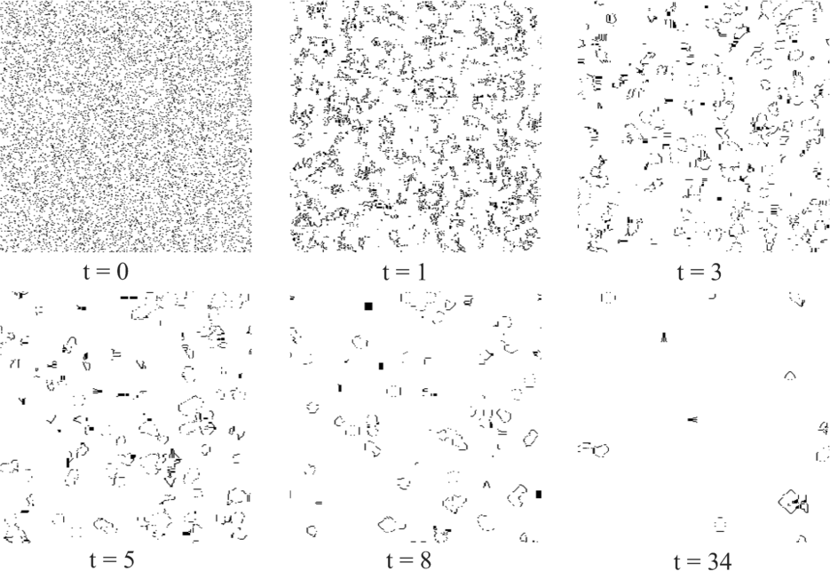

Fig. 1. Product measure with density 0*.*1 at time 0 and times 1, 3, 5, 8, and 34 under iteration by the Extra Action Rule, which is a linear scaling of Life to a range 5 LtL rule.

LtL’s *Extra Action Rule*, which is a linear scaling of Life to *range* 5 (meaning the neighborhood is an 11 × 11 box), is “Life-like” in the sense that, starting from a random initial configuration with density *p* = 0*.*1, “glider-like” coherent structures emerge (Fig. 1). However, the rule seems to support no finite still lifes and, ex- perimental results suggest that starting from a random product measure (that is, a uniform random initial configuration), the density decreases as time goes to infinity. On the other hand, various infinite still lifes with fixed densities are supported by the rule (Fig. 2). It is extremely unlikely for these still life measures to emerge from random initial conditions on a finite lattice. Instead, they must be “engineered.”

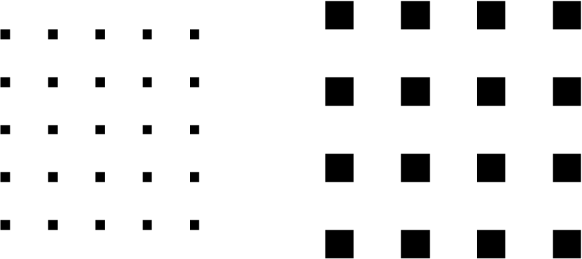

Fig. 2. Still life measures for the Extra Action Rule. On the left are individual live sites, each separated by four dead sites to the north, south, east and west. On the right are 3 by 3 blocks of live sites, each separated by dead sites in rectangles of length five to the north, south, east and west. Both patterns continue in all directions.

Life has a nontrivial limiting state with density 1*/*2 that, due to its instability in the face of other live sites, could never survive in the infinite system started from product measure. Let us introduce Max (Fig. 3), a creature that was created by

David Bell in September 1993 with engineering by Hartmut Holzwart and input from Al Hensel, to generate this density 1*/*2 limiting state, provided it begins on a background consisting of all 0'*s*. Max is so named because it is the fastest-growing known pattern in Conway’s Game of Life. Max grows at a rate of 1*/*2 in each of the four directions (north, south, east, and west) and fills space to a density of 1*/*2.



Fig. 3. Life’s Max

To illustrate the unstable limiting state, let us depict the evolution of Max under Life and see what happens when it faces one of Life’s gliders. Figures 4 and 5 show times 150 and 250, respectively from an initial state consisting of Max and one of Life’s gliders positioned northwest of Max. By time 150, Max has begun to fill the lattice, and the glider has made its way to the boundary of Max’s evolution. At time 156 (not pictured), Max and the glider collide. This sends a wave of activity through the alternating stripes of live and dead sites. Eventually all of the stripes are destroyed, leaving the complex dynamics more typically seen when Life is run from a random initial configuration. Time 250 is the midst of the destruction – a wave of activity emanating from the collision site has destroyed almost half of the stripes. Such sensitive dependence on initial conditions is one illustration that finite and infinite nonlinear systems can behave very differently, especially when the dynamics are non-monotone. The instability of the alternating stripes of 0'*s* and 1'*s* should further illustrate the unlikely event that one would see that configuration emerge from a random initial state on such a finite system as one’s computer screen.

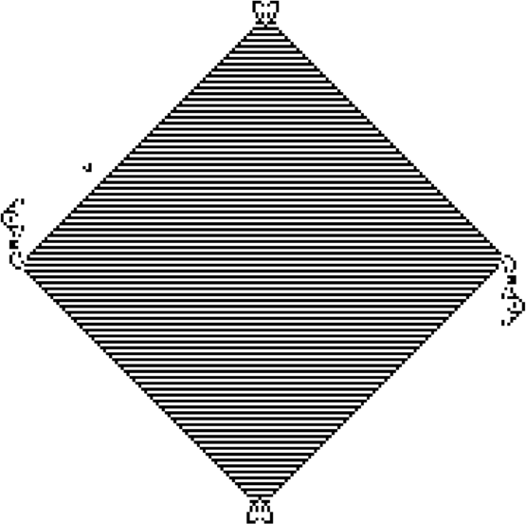

Fig. 4. Max and the glider at time 150.

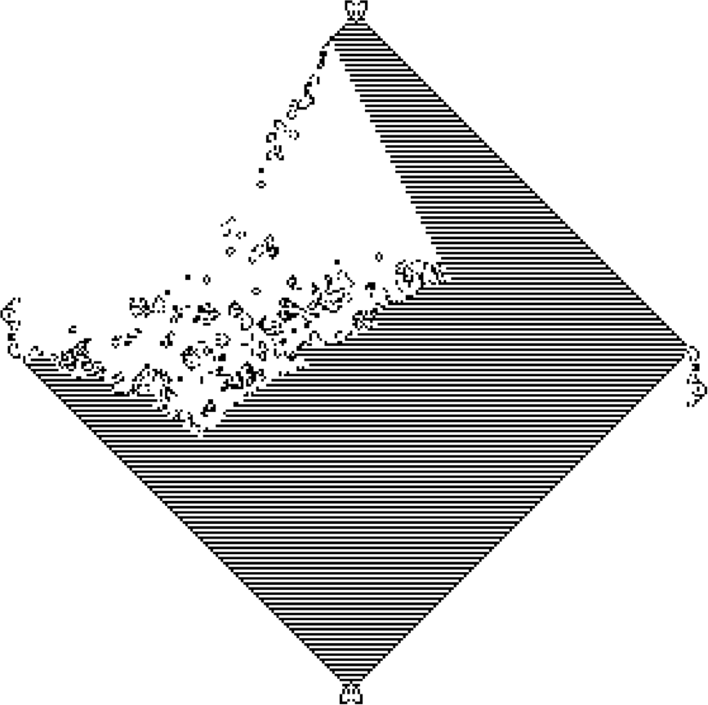

Fig. 5. Time 250; Life’s glider has begun its destruction of the density 1*/*2 pattern.

Without the glider, over time, Max will generate an example of a density 1*/*2 still Life. It turns out that a still Life (for Life) cannot have density greater than 1*/*2. This still Life conjecture was proved by Noam Elkies in the late 1990s [7]. In Theorem 3.3 below we find upper bounds on still life measures for all LtL rules. Life is one such rule and the still life measure bound given by Theorem 3.3 is 6*/*11, not Elkies’ 1*/*2. However, Elkies’ result is restricted to nearest neighbor CAs and thus gives no bound for, say, the large neighborhood Extra Action Rule. Our interest is in LtL, which is a much more vast set of rules since neighborhoods can be arbitrarily large.

# Larger than life definitions and notation

Larger than Life (LtL) generalizes Life to large neighborhoods and general birth and survival thresholds as follows: At each time *t* each site *x* ∈ Z2 is either *live* or *dead*. We think of a live site as being in state 1 and a dead site as being in state 0. At each time step, the sites update (meaning they switch state or not) according to the number of 1'*s* in their neighborhoods. Let us define the rule precisely.

* + Let N , a finite subset of Z2, be the neighborhood of the origin so that the translate

*x* + N is the neighborhood of the site *x* ∈ Z2.

* + - Let T denote the CA rule. That is, T : {0*,* 1}Z2 '−→ {0*,* 1}Z2 .
    - Let *ξt*(*x*) ∈ {0*,* 1} denote the state of the site *x* = (*x*1*, x*2) ∈ Z2 at time *t*.
    - Let *ξt* denote the system at time *t*. The collection of 1'*s* in *ξt* comprises some set Λ, which is contained in Z2. As is customary in this area we will confound this configuration, consisting of all 1'*s* on Λ, with the set Λ itself. Hence, if Λ = {*x* ∈ Z2 : *ξt*(*x*) = 1}, we write *ξt* = Λ ⊂ Z2. Suppose that the initial set of 1'*s*, *ξ*0, lies on the set Λ and that everywhere else (on Λ*c*) there are 0'*s*. Then we write *ξ*0 = Λ. We use *ξ*Λ = *B* to mean that starting with *ξ*0 = Λ and updating *t* time steps yields a set of 1'*s* that lies on the set *B*. In other words, *ξ*Λ = T *t*(Λ) = *B*.

*t*

*t*

* + - The update rule for Larger than Life is given by:

⎧⎪ 1 if *ξt*(*x*)=0 and |(*x* + N ) ∩ *ξt*| ∈ [*β*1*, β*2]

*ξt*+1(*x*)= ⎪⎨

⎪

or

if *ξt*(*x*)=1 and |(*x* + N ) ∩ *ξt*| ∈ [*δ*1*, δ*2];

⎪⎩ 0 otherwise*.*

Translated into words, if a dead site sees between *β*1 and *β*2 live sites in its neighborhood at time *t*, it will become live at time *t* + 1. Otherwise it will remain dead at time *t* + 1. If a live site sees between *δ*1 and *δ*2 live sites (including itself) in its neighborhood at time *t*, it will remain live at time *t* + 1. Otherwise it will become dead at time *t* + 1. Thus, if Λ ⊂ Z2 is a set of 1'*s* (on a background of 0'*s*), then the mapping T is defined by

T (Λ) = {*x* ∈ Λ*c* : *β*1 ≤ |(*x* + N ) ∩ Λ| ≤ *β*2}∪ {*x* ∈ Λ: *δ*1 ≤ |(*x* + N ) ∩ Λ| ≤ *δ*2}*.*

Starting from an initial set Λ0 ⊂ Z2 of 1'*s* and iterating, Λ*t*+1 = T (Λ*t*) generates *LtL dynamics*. To reiterate, we denote the CA mapping from one time step to the next by T , and use *ξt* to denote an LtL rule that has updated *t* time steps.

The LtL cellular automata form a four-parameter family of rules indexed by the endpoints of the intervals which determine each rule: *β*1, *β*2, *δ*1, and *δ*2. As such, LtL can be viewed as a four-dimensional hyperspace with points (*β*1*, β*2*, δ*1*, δ*2) representing 2-dimensional cellular automaton rules.

In what follows, N is the generalized Moore neighborhood, or range *ρ box neigh- borhood*, defined by N = {*y* ∈ Z2 : ||*y*||∞ ≤ *ρ*} (*ρ* ∈ N). The cardinality, | · | , of N is |*N* | = (2*ρ* + 1)2 since N is a box with side length 2*ρ* + 1. For *x* ∈ Z2, the translate *x* + N denotes the range *ρ* box neighborhood of *x*. When discussing a par- ticular rule, we will write it as (*ρ, β*1*, β*2*, δ*1*, δ*2). Thinking about it this way yields a five-parameter family of rules. However, we usually fix the range and cruise around the hyperspace that it determines thus dealing with a four-parameter family. In this framework, Life has parameters (*ρ, β*1*, β*2*, δ*1*, δ*2)= (1*,* 3*,* 3*,* 3*,* 4) and the Extra Action Rule has parameters (*ρ, β*1*, β*2*, δ*1*, δ*2)= (5*,* 9*,* 9*,* 9*,* 9).

Let us define *periodic* and *aperiodic* dynamics, which will be discussed in Sec- tion 3.

* + *ξt* is *periodic* if for each *x*, *ξt* is eventually periodic in *t* with probability one. That is, for each *x*, there is a positive finite integer *n* and a large positive finite integer *N* such that *ξt*(*x*)= *ξt*+*n*(*x*) for all *t > N* .

We point out that any finite system is periodic. This holds since there are only a finite (perhaps very large) number of possible configurations the system can attain. Thus, eventually *ξt* will comprise some configuration for a second time. Since the dynamics are deterministic, *ξt* will cycle as it did after the first time it passed through that particular configuration. We are working with a *two state* system so a universe consisting of *n* sites admits 2*n* possible configurations. This is the upper bound on the period of the system.

* + *ξt* generates *aperiodic dynamics* if it is not periodic. Such rules, though determin- istic, behave like traditional stochastic processes. Specifically, with probability one, for any site *x* in the system, the sequence of 0'*s* and 1'*s* that occurs at that site (i.e. {*ξt*(*x*)}*t*=0*,*1*,*2*,...*) never cycles.

# Bounds and applications

A number of years ago (before it was common to have a personal computer), John Conway, Dean Hickerson, and Hartmut Holzwart informally discussed (via electronic messages) various bounds for Life. The first two theorems of this section formulate these bounds mathematically in terms of measures and generalize them to the LtL family of rules.

Let *ξ*0 be product measure with density *p*. Running the deterministic CA rule *ξt* on this random initial state yields a stochastic process, with updates determined by (*ρ, β*1*, β*2*, δ*1*, δ*2). *ξt* may be thought of as a Markov process since the sites update independently from all preceding times except the current one. The Markov process is degenerate since the transitions are deterministic. Nevertheless, it has a compact state space, {0*,* 1}Z2 , so there exists a measure *μ* that is invariant under the rule. (See [8], Theorem 1.8f.) Since the dynamics are translation invariant, *μ* can be chosen so.

Theorem 3.1 *Let μ be a translation invariant measure for the LtL rule ξt, which is determined by* (*ρ, β*1*, β*2*, δ*1*, δ*2)*. Let Pμ be the probability measure induced by μ. Let p* = *μ*(*ξ*(*x*)= 1) = *Pμ*(*ξ*0(*x*)= 1) *and q* = *μ*(*ξ*(*x*)= 0) = *Pμ*(*ξ*0(*x*)= 0) = 1 − *p. Then p* ≤ 4*ρ*(*ρ* + 1)*/*(8*ρ*(*ρ* + 1) − *M* )*, where M* = *max*{*β*2*, δ*2 − 1}*.*

Proof. Since *ξt* is translation invariant and N is symmetric,

## Σ

*y*∈*x*+N

*Pμ*(*ξ*0(*x*)= 0*, ξ*1(*y*)= 1) = Σ

*x*∈*y*+N

*Pμ*(*ξ*0(*x*)= 0*, ξ*1(*y*)= 1)*.*

We compute an upper bound for the left-hand side of the above:

## Σ

*y*∈*x*+N

*Pμ*(*ξ*0(*x*)= 0*, ξ*1(*y*)= 1) ≤ 4*ρ*(*ρ* + 1)*Pμ*(*ξ*0(*x*)= 0) = 4*ρ*(*ρ* + 1)(1 − *p*)*.*

The following will be used to obtain a lower bound for the right-hand side: (i)

*Pμ*(*ξ*0(*x*)= 0*, ξ*1(*y*)= 1) = *Pμ*(*ξ*0(*x*)= 0|*ξ*1(*y*)= 1)*Pμ*(*ξ*1(*y*)= 1)

= *Pμ*(*ξ*1(*y*)= 1)[1 − *Pμ*(*ξ*0(*x*)= 1|*ξ*1(*y*)= 1)]

= *Pμ*(*ξ*1(*y*)= 1) − *Pμ*(*ξ*0(*x*)= 1*, ξ*1(*y*)= 1)*.*

(ii)

*Pμ*(*ξ*0(*x*)= 1*, ξ*1(*y*)= 1) = *Pμ*(*ξ*0(*x*)= 1*, ξ*1(*y*)= 1*, ξ*0(*y*)= 0)

+*Pμ*(*ξ*0(*x*)= 1*, ξ*1(*y*)= 1*, ξ*0(*y*)= 1)*.*

(iii) For *a* = 0*,* 1,

*Pμ*(*ξ*0(*x*)= 1*, ξ*1(*y*)= 1*, ξ*0(*y*)= *a*)= *E*(1*ξ*0 (*x*)=1 · 1*ξ*1 (*y*)=1 · 1*ξ*0 (*y*)=*a* )*.*

(iv)

Σ

*x*∈*y*+N

*E*(1*ξ*0(*x*)=1 · 1*ξ*1(*y*)=1 · 1*ξ*0(*y*)=*a*)= *E*( Σ

*x*∈*y*+N

1*ξ*0(*x*)=1 · 1*ξ*1(*y*)=1 · 1*ξ*0(*y*)=*a*)

≤ *E*(*M* · 1*ξ*1(*y*)=1 · 1*ξ*0(*y*)=*a* )*.*

The inequality in (iv) holds because if *a* = 0, then since *y* is 0 at time 0 and 1 at time 1, it sees at most *β*2 1'*s* at time 0. If *a* = 1, then since *y* remains 1 at time 1, it sees at most *δ*2 − 1 other 1'*s* at time 0.

(v)

*E*(1*ξ*1(*y*)=1 · 1*ξ*0(*y*)=0)+ *E*(1*ξ*1(*y*)=1 · 1*ξ*0(*y*)=1)= *E*(1*ξ*1(*y*)=1)= *Pμ*(*ξ*1(*y*)= 1)*.*

Using the above in the order they appear yields:

## Σ

*x*∈*y*+N

## Σ

*x*∈*y*+N

*Pμ*(*ξ*0(*x*)= 0*, ξ*1(*y*)= 1) =

[*Pμ*(*ξ*1(*y*)= 1) − *Pμ*(*ξ*0(*x*)= 1*, ξ*1(*y*)= 1)]= 4*ρ*(*ρ* + 1)*p*

## — Σ

*x*∈*y*+N

[*Pμ*(*ξ*0(*x*)= 1*, ξ*1(*y*)= 1*, ξ*0(*y*)= 0) + *Pμ*(*ξ*0(*x*)= 1*, ξ*1(*y*)= 1*, ξ*0(*y*)= 1)]

≥ 4*ρ*(*ρ* + 1)*p* − *M* [*E*(1*ξ*1 (*y*)=1 · 1*ξ*0 (*y*)=0)+ *E*(1*ξ*1 (*y*)=1 · 1*ξ*0 (*y*)=1)]

= 4*ρ*(*ρ* + 1)*p* − *Mp.*

Combining this bound with the upper bound attained above yields:

4*ρ*(*ρ* + 1)*p* − *Mp* ≤ 4*ρ*(*ρ* + 1)(1 − *p*) and hence the desired inequality.

What does Theorem 3.1 say about the invariant measures of specific rules? Let us mention three examples. It says that the density *p* of any translation invari-

ant measure for the Game of Life satisfies, *p* ≤ 8*/*13. For the range 2 LtL rule (2*,* 4*,* 4*,* 5*,* 5) it says that *p* ≤ 6*/*11 and for the Extra Action Rule, *p* ≤ 40*/*77.

Theorem 3.1 obtains an upper bound on the density of an invariant measure, *μ*. What about measures for which the time average densities of any trajectory of the rule are constant? In other words, can we find an upper bound on the density of a fixed, or *still life measure*? The answer is yes, and we prove it in Theorem 3.3; first let us define a still life measure.

Definition 3.2 A *still life measure* is a fixed measure *μ*. That is, starting from *μ*, the dynamics will remain fixed for all time: *ξμ* = *ξμ* for all *t*.

*t* 0

Theorem 3.3 *Let μ be a still life measure. Let p* = *μ*(*ξ*(*x*)= 1)= *Pμ*(*ξ*0(*x*) = 1) *and q* = *μ*(*ξ*(*x*)= 0) = *Pμ*(*ξ*0(*x*)= 0) = 1 − *p. Then p* ≤ *σ/*(4*ρ*(*ρ* + 1) −(*δ*2 − 1) + *σ*)*, where σ* = *the maximum number of live sites x can have at time t* = 0 *when ξ*0(*x*) = 0*. σ depends on δ*2 *since it is determined by computing the maximum number of live sites that can coexist in x* + N *without overcrowding one another.*

Proof. Since *ξt* is translation invariant and N is symmetric,

## Σ

*x*∈*y*+N

*Pμ*(*ξ*0(*y*)= 1) = Σ

*y*∈*x*+N

*Pμ*(*ξ*0(*y*)= 1).

Since the summands do not depend on *x*, the left-hand side of the above becomes:

## Σ

*x*∈*y*+N

*Pμ*(*ξ*0(*y*)= 1) = 4*ρ*(*ρ* + 1)*p*.

Also, Σ

*y*∈*x*+N

*Pμ*(*ξ*0(*y*)= 1)

## = Σ

*y*∈*x*+N

Σ

=

*y*∈*x*+N

[*Pμ*(*ξ*0(*y*)= 1*, ξ*1(*x*)= 1) + *Pμ*(*ξ*0(*y*)= 1*, ξ*1(*x*)= 0)]

[*E*(1*ξ*0(*y*)=1 · 1*ξ*1(*x*)=1)+ *E*(1*ξ*0(*y*)=1 · 1*ξ*1(*x*)=0)]

## = *E*( Σ

*y*∈*x*+N

1*ξ*0(*y*)=1 · 1*ξ*1(*x*)=1)+ *E*( Σ

*y*∈*x*+N

1*ξ*0(*y*)=1 · 1*ξ*1(*x*)=0)

≤ *E*((*δ*2 − 1) · 1*ξ*1 (*x*)=1)+ *E*((*σ* · 1*ξ*1 (*x*)=0)= (*δ*2 − 1)*p* + *σ*(1 − *p*).

Combining this bound with the equality on the first line yields:

4*ρ*(*ρ* + 1)*p* ≤ (*δ*2 − 1)*p* + *σ*(1 − *p*) and hence the desired inequality.

Note that the maximum number of live neighbors that *x* can have at time *t* =0 when *ξ*0(*x*)= 0 (*σ* from Theorem 3.3) also depends on the rule’s birth thresholds, *β*1 and *β*2. That is, since *μ* is a still life measure, *ξ*1(*x*) = 0 implies *ξ*0(*x*)= 0. Thus, the number of live sites in the neighborhood of *x* must not be in the interval [*β*1*, β*2]. Therefore, if *σ* ∈ [*β*1*, β*2], then *σ* may be reduced to *β*1 − 1 and the inequality in Theorem 3.3 becomes *p* ≤ (*β*1 − 1)*/*(4*ρ*(*ρ* + 1) − *δ*2 + *β*1).

Theorem 3.3 says that the density, *p* of any still life measure for Life satisfies *p* ≤ 6*/*11 (since *δ*2 = 4 implies that *σ* = 6, see Appendix A). For the range 2 LtL rule (2*,* 4*,* 4*,* 5*,* 5) it says that *p* ≤ 3*/*8 (since *δ*2 = 5 implies that *σ* = 12, again see Appendix A) and for the Extra Action Rule, *p* ≤ 9*/*37 (*δ*2 = 9 implies that *σ* = 36,

since 3 by 3 squares of live sites can be placed in each of the four corners of a range 5 neighborhood independently; that is, the neighborhoods of the sites in one corner have empty intersections with the neighborhoods of the sites in different corners).

Let us show that the bound obtained in Theorem 3.3 is attained by an entire set of LtL rules. To do this we need the following proposition.

Proposition 3.4 *Let* Λ *be a conﬁguration consisting of inﬁnite strips of* 1'*s, each with width ρ, and separated by inﬁnite strips of* 0'*s, each with width* 1 *(see Fig.* *6**). Then* Λ *is a still life under any range ρ LtL rule such that* 4*ρ*2 − 1 ∈ [*δ*1*, δ*2] *and* 2*ρ*(2*ρ* + 1) ∈*/* [*β*1*, β*2]*.*

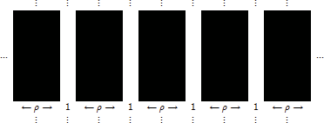

Fig. 6. Λ from Proposition 3.4. Λ is an infinite still life for any range *ρ* LtL rule such that 4*ρ*2 − 1 ∈ [*δ*1*, δ*2] and 2*ρ*(2*ρ* + 1) ∈*/* [*β*1*, β*2].

Proof. Suppose *ξ*0 =Λ and *ξ*0(*x*)= 1. Then |(*x*+N )∩ *ξ*0| = (2*ρ* + 1)2 − 2(2*ρ* + 1) = 4*ρ*2 − 1 (we get equality because all of the occupied sites see exactly two strips of 0'*s*). Thus, by hypothesis, *ξ*1(*x*) = 1. If *ξ*0(*x*) = 0, then |(*x* + N ) ∩ *ξ*0| = (2*ρ* + 1)2 − (2*ρ* + 1) = 2*ρ*(2*ρ* + 1). Thus, by hypothesis, *ξ*1(*x*)= 0.

The density of Λ is *ρ/*(*ρ* + 1) and it goes to 1 as *p* → ∞. We point out that Λ will actually be fixed under any two-state CA rule, not restricted to the LtL family, provided a 1 survives when it sees 4*ρ*2 − 1 1'*s* and a 0 does not become a 1 when it sees 2*ρ*(2*ρ* + 1) 1'*s*.

One can construct many infinite still lifes similar to Λ, fixed under different LtL rules. This is done by varying the widths of the infinite strips of 0'*s* and 1'*s*. We are interested in the one from Proposition 3.4 because in the case that *ρ* ≥ 2 and *δ*2 = 4*ρ*2 − 1, it provides an example whose density is close to the bound obtained in Theorem 3.3 (see Figure 7). Appendix A gives *σ* = 4*ρ*(*ρ* + 1) − 4, so by Theorem 3.3, *p* ≤ (4*ρ*2 + 4*ρ* − 4)*/*(4*ρ*2 + 8*ρ* − 2).

Observe that if *ρ* = 2, then (4*ρ*2 + 4*ρ* − 4)*/*(4*ρ*2 + 8*ρ* − 2) = 2*/*3, which is the density of the range 2 version of Λ. Since Λ is an infinite still life for all range 2 rules with *δ*2 = 15 and 20 ∈*/* [*β*1*, β*2], if *μ* is the still life measure determined by Λ, then it has the largest possible density of any such measure.

It is important to note that Λ is an “engineered” example. Starting a rule from a random initial state may often yield a density that is much smaller. For example, if we run the rule (2*,* 10*,* 13*,* 6*,* 15) starting from product measure with density 1*/*2 for 100 time steps with wrap around boundary conditions, the result is aperiodic

|  |  |  |
| --- | --- | --- |
| Range *ρ* | (4*ρ*2 + 4*ρ* − 4)*/*(4*ρ*2 + 8*ρ* − 2) | *ρ/*(*ρ* + 1) |
| 2 | 2*/*3 | 2*/*3 |
| 3 | 22*/*29 ≈ 0*.*7586 | 3*/*4= 0*.*75 |
| 4 | 38*/*47 ≈ 0*.*8085 | 4*/*5= 0*.*8 |
| 5 | 58*/*71 ≈ 0*.*8169 | 5*/*6= 0*.*83 |
| 10 | 218*/*239 ≈ 0*.*9121 | 10*/*11 = 0*.*90 |
| 100 | 20198*/*20399 ≈ 0*.*9901 | 100*/*101 = 0*.*9900 |

Fig. 7. Bounds given by Theorem 3.3 compared to those of the Proposition 3.4 example.

dynamics with a density that is approximately 0*.*42. (That is, the dynamics of the infinite system would be aperiodic. On this finite lattice, the dynamics eventually cycle (see Section 2), but the period is extremely large.) If we take that configuration and place a portion of Λ over part of it and then run the rule, the aperiodic dynamics beat up on the still life portion. The pictures in Fig. 8 show that, by time 50, the still life portion has been almost completely destroyed by the aperiodic dynamics. We see that, by time 75, all of Λ has been completely destroyed and the configuration looks as it did before Λ was inserted.

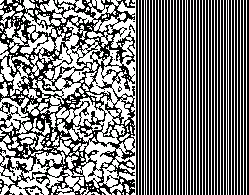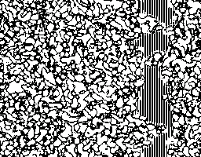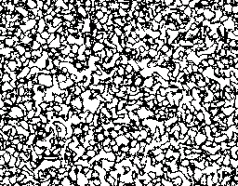

Fig. 8. Iteration of the LtL rule (2*,* 10*,* 13*,* 6*,* 15). From left to right are times 0, 50, and 75.

Now let us vary the parameters, to the rule (2*,* 5*,* 16*,* 2*,* 20), and place a portion of Λ on the aperiodic configuration generated by that rule after being run for 100 time steps on a random initial configuration with density 0*.*33. In this case, the portion of Λ grows, though very slowly, and eventually locks into periodicity where the two propagating edges meet (see Fig. 9). In the infinite system, it would fill in the lattice to yield an exact copy of Λ.

The third and final example we give is the rule (2*,* 8*,* 18*,* 11*,* 22). Again we run the rule on an initial product measure, with density 1*/*5 in this case and wrap- around boundary conditions. Then we insert a portion of Λ and use that as the initial configuration. In this case, however, neither Λ, nor the other configuration “wins.” Rather, the eventual state is locally periodic, with much of it fixed in a tile-like pattern that appears to be an approximation of Λ (see Fig. 10). If we had let this run indefinitely, from the random initial state, it also would have yielded a locally periodic limiting state (though probably not such a large chunk tiled by

 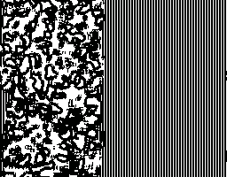 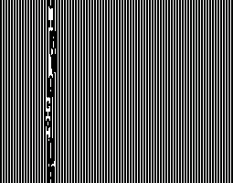

Fig. 9. Iteration of the LtL rule (2*,* 5*,* 16*,* 2*,* 20). From left to right are times 0, 50, and 700.

perfect stripes).

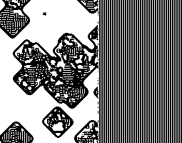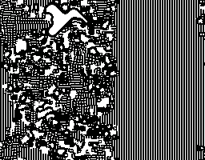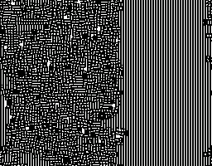

Fig. 10. Iteration of the LtL rule (2*,* 8*,* 18*,* 11*,* 22). From left to right are times 0, 25, and 250.

We illustrated the cases above to show that first, although the experimental density of a rule may be low, there may exist invariant sets with high densities that do not arise out of random initial states. Second, these examples show that, when started from random initial configurations, the limiting states for rules which support invariant measures consisting of vertical stripes, vary dramatically. The last example we gave would seem to be the only “likely” candidate for such an invariant measure.

Let us describe three more infinite still lifes, one with a density that can be as close to 1 as we like, one with density 1*/*2, and the third with a density as close to 0 as we like.

Proposition 3.5 *Let* Λ *be a conﬁguration consisting of inﬁnite strips of* 1'*s, each with width n, n* ≥ 2*ρ, and separated by inﬁnite strips of* 0'*s, each with width* 1 *(see Fig.* *11**). Then* Λ *is a still life under any range ρ LtL rule such that both* 2*ρ*(2*ρ* + 1) *and* (2*ρ* + 1)2 ∈ [*δ*1*, δ*2] *and* 2*ρ*(2*ρ* + 1) ∈*/* [*β*1*, β*2]*.*

Proof. Suppose *ξ*0 = Λ and *ξ*0(*x*) = 1. Then |(*x* + N ) ∩ *ξ*0| = (2*ρ* + 1)2 or 2*ρ*(2*ρ* + 1) (we get equality because all of the occupied sites see either zero or one strips of 0'*s*, respectively). Thus, by hypothesis, *ξ*1(*x*) = 1. If *ξ*0(*x*) = 0, then

|(*x* + N ) ∩ *ξ*0| = (2*ρ* + 1)2 − (2*ρ* + 1) = 2*ρ*(2*ρ* + 1). Thus, by hypothesis, *ξ*1(*x*)= 0.

The density of the infinite still life from Proposition 3.5 is *n/*(*n* + 1), which goes to 1 as *n* goes to ∞. (Note that *n* ≥ 2*ρ* implies that *n* automatically goes to ∞ as the range does.) Since *δ*2 = (2*ρ* + 1)2, *σ* = (2*ρ* + 1)2 (see Appendix A), and Theorem 3.3 yields the bound, *p* ≤ 1 (so our example agrees with the theorem).

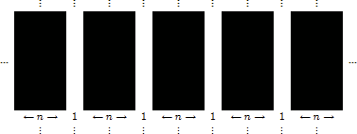

Fig. 11. Λ from Proposition 3.5. Λ is an infinite still life for any range *ρ* LtL rule such that both 2*ρ*(2*ρ* + 1) and (2*ρ* + 1)2 ∈ [*δ*1*, δ*2] and 2*ρ*(2*ρ* + 1) ∈*/* [*β*1*, β*2].

Proposition 3.6 *Let* Λ *be a conﬁguration consisting of inﬁnite strips of* 1'*s, each with width* 1*, and separated by inﬁnite strips of* 0'*s, each with width* 1 *(see Fig.* *12**). Then* Λ *is a still life under any range ρ LtL rule such that if ρ is odd, then ρ*(2*ρ*+1) ∈ [*δ*1*, δ*2] *and* (*ρ* + 1)(2*ρ* + 1) ∈*/* [*β*1*, β*2]*, or, if ρ is even, then* (*ρ* + 1)(2*ρ* + 1) ∈ [*δ*1*, δ*2] *and ρ*(2*ρ* + 1) ∈*/* [*β*1*, β*2]*.*

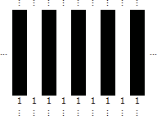

Fig. 12. Λ from Proposition 3.6. Λ is an infinite still life for any range *ρ* LtL rule such that if *ρ* is odd, then *ρ*(2*ρ* + 1) ∈ [*δ*1*, δ*2] and (*ρ* + 1)(2*ρ* + 1) ∈*/* [*β*1*, β*2], or, if *ρ* is even, then (*ρ* + 1)(2*ρ* + 1) ∈ [*δ*1*, δ*2] and *ρ*(2*ρ* + 1) ∈*/* [*β*1*, β*2].

Proof. Suppose *ξ*0 =Λ and *ξ*0(*x*)= 1. If *ρ* is odd then |(*x* + U ) ∩ *ξ*0| = *ρ*(2*ρ* + 1) (we get equality because all of the occupied sites see exactly *ρ* strips of 1'*s*). Thus, by hypothesis, *ξ*1(*x*)= 1. If *ξ*0(*x*)= 0, then |(*x* + U ) ∩ *ξ*0| = (*ρ* + 1)(2*ρ* + 1) (we get equality because all of the 0'*s* see exactly *ρ* +1 strips of 1'*s*). Thus, by hypothesis, *ξ*1(*x*)= 0. If *ρ* is even, the 1'*s* see exactly *ρ* +1 strips of 1'*s* and the 0'*s*, exactly *ρ* strips of 1'*s*.

For any range 1 rule with *δ*2 =3 and 6 ∈*/* [*β*1*, β*2] the Λ from Proposition 3.6 is an infinite still life. The density of Λ is 1*/*2. Since *δ*2 = 3 Appendix A gives *σ* = 6. By Theorem 3.3 the density, *p*, of any still life measure for any range 1 rule with *δ*2 = 3 and 6 ∈*/* [*β*1*, β*2] satisfies *p* ≤ 1*/*2. Thus, again we have a set of examples that attain the bound given in Theorem 3.3.

Proposition 3.7 *Let* Λ *be a conﬁguration consisting of inﬁnite strips of* 0'*s, each with width n, n* ≥ 2*ρ and separated by inﬁnite strips of* 1'*s, each with width* 1 *(see Fig.* *13**). Then* Λ *is a still life under any range ρ LtL rule such that* 2*ρ* +1 ∈ [*δ*1*, δ*2] *and* 2*ρ* +1 ∈*/* [*β*1*, β*2] *(and β*1 /= 0*).*

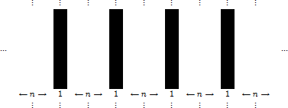

Fig. 13. Λ from Proposition 3.7. Λ is an infinite still life for any range *ρ* LtL rule such that 2*ρ* +1 ∈ [*δ*1*, δ*2] and 2*ρ* +1 ∈*/* [*β*1*, β*2] (and *β*1 /= 0).

Proof. Suppose *ξ*0 =Λ and *ξ*0(*x*)= 1. Then |(*x*+U )∩*ξ*0| = 2*ρ*+1 (we get equality because all of the occupied sites see exactly one strip of 1'*s*). Thus, by hypothesis, *ξ*1(*x*) = 1. If *ξ*0(*x*) = 0, then |(*x* + U ) ∩ *ξ*0| = 2*ρ* + 1 or 0. Thus, by hypothesis, *ξ*1(*x*)= 0.

The density of the infinite still life from Proposition 3.7 is 1*/*(*n* + 1), which goes to 0 as *n* goes to ∞. (Note that *n* ≥ 2*ρ* implies that *n* automatically goes to ∞ as the range does.)

Rules that support finite still lifes also support a large number of still life mea- sures. This is part of the reason we call them still life measures – using finite still lifes, we are able to construct a huge number of still life measures. To illustrate this point, let us do one such construction.

Let Λ ⊂ Z2 be a *λ*1 × *λ*2 rectangle with periodic boundary conditions. Assume that Λ is painted in such a way that everything is fixed under *ξt*. That is, *ξ*Λ∩*ξ*0 = Λ ∩ *ξ*0 for all times *t*. Tile Z2 with Λ, beginning by placing one of the vertices of Λ at the origin and forcing the rest of its elements to have coordinates that are greater than or equal to zero. That is, Λ = {*x* = (*x*1*, x*2) ∈ Z2 : 0 ≤ *xi < λi,i* = 1*,* 2}. The remaining tiles are identically oriented, so that the sites in each tile see the equivalent of the assumed periodic boundary conditions (see Fig. 14). Then the tiling, which we denote by Λ˜, is fixed under *ξt*. There are *λ*1*λ*2 distinct shifts of the tiling. Form the average of all the shifts, *μ* ≡ 1 *θv*(Λ˜), where *v* = *α*1*e*1 + *α*2*e*2,

*t*

*λ*1*λ*2

Σ

*v*∈Λ

(0 ≤ *αi < λi*, *i* = 1*,* 2) is a vector in Λ and *θv* is the shift operator which translates the entire tiling to the right *α*1 units, and up *α*2 units. Then, by construction, *μ* is translation invariant and is fixed under *ξt* in the sense that *Pμ*(*ξ*1 = *ξ*0)= 1.

Theorems 3.1 and 3.3 give upper bounds for various non-trivial invariant mea- sures. All meaningful rules support the trivial still life measure since any finite set consisting of all 0'*s* is fixed for all such rules. The question thus arises: Can we obtain lower bounds for the non-trivial invariant measures? For starters, Proposi- tion 3.7 shows that for any rule with 2*ρ* +1 ∈ [*δ*1*, δ*2] and 2*ρ* +1 ∈*/* [*β*1*, β*2] (and *β*1 /= 0), there exists a still life measure with density that can be as small as we like, by taking the number of infinite strips of 0'*s* in Λ to be as large as we like. We can also show that there are more rules for which we can construct still life measures

|  |  |  |  |  |
| --- | --- | --- | --- | --- |
|  |  | . |  |  |
|  | Λ | Λ | Λ |  |
| ··· | Λ | Λ | Λ | ··· |
|  | Λ | Λ | Λ |  |
|  |  | . |  |  |

Fig. 14. Tiling of Z2 by Λ.

with densities that are as small as we like. To illustrate this, let us show how one can construct a still life measure, with density as small as we like, from a finite still life.

Let Γ be a finite still life under *ξt*. Then for some positive integer *n*, |Γ| = *n <* ∞, *ξ*Γ = Γ, and there exists a rectangle, Λ ⊂ Z2, with dimensions *λ*1 × *λ*2 such that Γ ⊂ Λ. Choose Λ so that Γ fits inside in such a way that there is a band of 0'*s* of width *w* ≥ *ρ/*2 surrounding the smallest rectangle, B, that contains all of Γ. Place Γ inside Λ and fill in the remainder of Λ with 0'*s* as shown in Fig. 15. If Λ has periodic boundary conditions and is painted as described above, then everything in it is fixed under *ξt*. Thus, we can use Λ to construct a still life measure *μ*.

*t*

↑

0'*s*

← *ω* →

↓

← *ω* →

*ω*↑

*ω*↑

↓

∪ 0'*s*B

*λ*2

↓

← *λ*1 →

Fig. 15. Finite still life used to construct a still life measure.

Observe that, for each fixed pair (*ξt,* Γ), where Γ is a finite still life under *ξt*, there is a family of still life measures, each of which is determined by the size of the rectangle Λ, which is described above, and the placement of Γ inside Λ. We can make the densities of these measures as small as we like by increasing the width, *ω*, of the band of 0'*s* surrounding Γ in Λ. Hence, for a fixed Γ, a rectangle Λ, and the still life measure, *μ*, that they determine, simply increasing the dimensions of Λ yields another still life measure *μ*˜ that has smaller density. Thus, there is no positive lower bound on the densities of still life measures.

The discussion above shows that invariant measures for rules which support finite still lifes do not have lower bounds. Suppose we look at a set of rules which do not support finite still lifes. Do their invariant measures have lower bounds? We claim that the answer is yes, if we add the condition that the set of rules support neither periodic objects, nor bugs. (A *periodic object* is a finite configuration Λ for which there exists a positive, finite integer *n* so that T *t*(Λ) = T *t*+*n*(Λ) for all *t* ≥ 0. A *bug* is a finite configuration Λ for which there exists a finite time, *τ* , and a nonzero displacement vector, d = (*d*1*, d*2) such that T *τ* (Λ) = Λ + d [9].) How does one

come up with even one such rule? It is necessary to check that for such a candidate rule, any seed started on a background of 0'*s* either shrinks and eventually dies, or grows forever, covering Z2 with all 1'*s* or some pattern, with density less than 1, of 1'*s*. We have discovered several rules which appear through empirical data to have these properties. However, we are not yet convinced that the rules are indeed examples.

A *period two measure* is similar to a still life measure but, rather than remaining constant, the time average densities of any trajectory of the rule are period two. We conclude this section with the construction of a period two measure along with a theorem that gives an upper bound on its density.

Construction of a period 2 measure.

Let Λ ⊂ Z2 be a *λ*1 × *λ*2 rectangle with periodic boundary conditions. Assume that Λ is painted in such a way that everything in it is period 2 under *ξt*. That is, every site changes state every time step. As we did in the construction of a still life measure, tile Z2 with Λ, assuming that each tile is identically oriented, so that the sites in each tile see the equivalent of the assumed periodic boundary conditions. Then every site in the tiling, which we denote by Λ˜, flip flops every time step under *ξt*. There are *λ*1*λ*2 distinct shifts of the tiling. Form the average of all the shifts, *μ* ≡ 1 *θv*(Λ˜), where *v* = *α*1*e*1 + *α*2*e*2, (0 ≤ *αi < λi*, *i* = 1*,* 2) is a vector in Λ

*λ*1*λ*2

Σ

*v*∈Λ

and *θv* is the shift operator which translates the entire tiling to the right *α*1 units,

and up *α*2 units. Then, by construction, *μ* is translation invariant and it is period 2 under *ξt* in the sense that *Pμ*(*ξ*2 = *ξ*0)= 1.

Theorem 3.8 *Let* Λ *be a λ*1 × *λ*2 *rectangle with periodic boundary conditions. As- sume that all sites in* Λ *are period* 2 *under ξt. Let μ be the period* 2 *measure determined by* Λ*. Let p* = *μ*(*ξ*(*x*) = 1) = *Pμ*(*ξ*0(*x*) = 1) *and q* = *μ*(*ξ*(*x*) =

0) = *Pμ*(*ξ*0(*x*) = 0) = 1 − *p. Then p* ≤ (4*ρ*(*ρ* + 1) − *β*1)*/*(8*ρ*(*ρ* + 1) − *β*1 − *β*2)*, (*8*ρ*(*ρ* + 1) − *β*1 − *β*2 /= 0)*.*

Proof. Let *x, y* ∈ Λ. As in the proof of Theorem 3.3, Σ

*y*∈*x*+*N*

*Pμ*(*ξ*0(*y*) = 1) =

*E*( Σ

*y*∈*x*+N

1*ξ*0(*y*)=1 ·1*ξ*1(*x*)=1)+*E*( Σ

*y*∈*x*+N

1*ξ*0 (*y*)=1 ·1*ξ*1 (*x*)=0) ≤ *β*2*p*+[4*ρ*(*ρ*+1)−*β*1](1−*p*).

The first part of the inequality holds because *ξ*1(*x*) = 1 implies that *ξ*0(*x*) = 0. Thus, *β*1 ≤ |*ξ*0 ∩ (*x* + U )| ≤ *β*2. The second part of the inequality holds because *ξ*1(*x*) = 0 implies that *ξ*0(*x*) = *ξ*2(*x*) = 1. Thus, *β*1 ≤ |*ξ*1 ∩ (*x* + U )| ≤ *β*2 (in particular, *x* must see at least *β*1 1'*s* at time 1). Since Λ is period 2, all sites flip every time step (so all of the 1'*s* at time 0 become 0'*s* at time 1). Thus,

4*ρ*(*ρ* + 1) − *β*2 ≤ |*ξ*0 ∩ (*x* + U )| ≤ 4*ρ*(*ρ* + 1) − *β*1. (Otherwise, |*ξ*1 ∩ (*x* + U )| will

be strictly less than *β*1.) We also have that Σ

*y*∈*x*+N

*Pμ*(*ξ*0(*y*) = 1) = 4*ρ*(*ρ* + 1)*p*.

Combining these yields: 4*ρ*(*ρ* + 1)*p* ≤ *β*2*p* + [4*ρ*(*ρ* + 1) − *β*1](1 − *p*) and hence the

desired inequality.

# Open problems, questions, and conclusion

The upper bound given in Theorem 3.3 for LtL’s still life measures relies on knowing the value of *σ*, which is defined to be the maximum number of live neighbors a dead site can have. This value has been calculated for certain cases in Appendix A, but its value in the remaining instances remains an open question (or is forthcoming). The question of *σ*'*s* value is of interest in its own right as a combinatorial problem in discrete mathematics. As such, it may be useful for other applications.

Theorem 3.3 gives upper bounds on still life measures for all LtL rules. Life is one such rule and, as discussed in the introduction, its still life measure bound given by Theorem 3.3 is 6*/*11, not Elkies’ 1*/*2. Can some of the techniques Elkies’ used to prove the still Life conjecture be generalized to improve the bounds in Theorems 3.1 and 3.3?

As discussed in Section 3, many LtL rules that would seem (based on experimen- tal results) not to have finite fixed points support still life measures. The questions thus arise: Do all LtL rules support still life measures? What are the necessary and sufficient conditions that guarantee an LtL rule has a still life measure?

In Section 3 we showed that invariant measures for rules which support finite still lifes do not have lower bounds. Do there exist rules whose invariant measures have lower bounds?

Invariant measures are interesting mathematically because their invariance makes problems about them tractable. They are also interesting graphically due to the patterns that emerge from varying initial conditions. For example, the graphic in Fig. 16 was generated by the LtL rule (5*,* 1*,* 26*,* 12*,* 98), starting at time 0 with a circle of radius 32 centered at the origin (in the middle of Fig. 16). The grid is size 300 × 300 with wrap around boundary conditions (a.k.a. a torus). The graphic is shown at time 25 after which it never changes (i.e. it is a still life). A gallery of other such images can be found in [10].

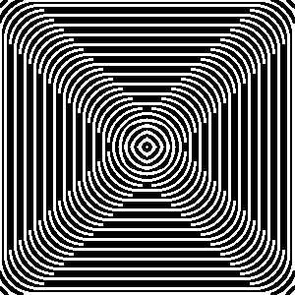

Fig. 16. Still life for LtL rule (5*,* 1*,* 26*,* 12*,* 98).

# References

1. Gardner, M. *Mathematical Games – The Fantastic Combinations of John Conway’s New Solitaire Game, Life*, Scientific American 223 (1970), 120–123.

URL: <http://www.ibiblio.org/lifepatterns/october1970.html>.

1. Berlekamp, E., J. Conway, and R. Guy, “Winning Ways for Your Mathematical Plays,” 2, Academic Press, New York, 1982.
2. Silver, S., *Stephen Silver’s Life Page*, <http://www.argentum.freeserve.co.uk/life.htm>, accessed May 29, 2009.
3. Griffeath, D., *Self-organization of random cellular automata: Four snapshots*, in “Probability and Phase Transitions,” (G. Grimmett Ed.), Kluwer Academic, Dordrecht/Norwell, MA, 1994.
4. Evans, K., *Is Bosco’s rule universal?*, in “Lecture Notes in Computer Science,” 3354, (M. Margenstern Ed.), Springer-Verlag GmbH, 2005, 188-199. URL for companion page to paper: [http://www.csun.edu/∼kme52026/bosco/bosco.html](http://www.csun.edu/~kme52026/bosco/bosco.html) .
5. Evans, K., *Threshold-range scaling of Life’s coherent structures*, Physica D: Nonlinear Phenomena,

183 Issues 1-2 (2003), 45-67.

1. Elkies, N.D., *Still-Life density problem and its generalizations*, in “Voronoi’s Impact on Modern Science,” Book 1 (P. Engel, H. Syta, Eds.), Institute of Math., Kyiv, 1998, 228-253.
2. T. M. Liggett, “Interacting Particle Systems,” Springer-Verlag, New York, 1985.
3. Evans, K., *Larger than Life: digital creatures in a family of two-dimensional cellular automata,* in “Discrete Mathematics and Theoretical Computer Science,” AA, (R. Cori, J. Mazoyer, M. Morvan, R. Mosseri, Eds.), 2001, 177-192.
4. Evans, K., *Larger than Life’s invariant measures: a gallery of images*,

[http://www.csun.edu/∼kme52026/invariant.html](http://www.csun.edu/~kme52026/invariant.html) .

# A Appendix: A Large range counting problem

In order to use the bound we obtained in Theorem 3.3 for still life measures, we must compute *σ*. The table in Fig. A.1 gives the value of *σ* for each possible value of *δ*2 in range 1.

|  |  |  |  |  |  |  |  |  |  |
| --- | --- | --- | --- | --- | --- | --- | --- | --- | --- |
| *δ*2 | 1 | 2 | 3 | 4 | 5 | 6 | 7 | 8 | 9 |
| *σ* | 4 | 4 | 6 | 6 | 8 | 8 | 8 | 8 | 8 |

Fig. A.1. Value of *σ* for each possible value of *δ*2 in range *ρ* = 1.

Let us explain Fig. A.1. By definition, *σ* = *max*{|*y* ∈ (*x*+U| : *ξ*0(*y*)= 1*, ξ*0(*x*)= 0}. Thus, to compute *σ* we need to determine the largest number of 1'*s* that can coexist in the neighborhood of a dead site. This value depends on *δ*2. Without the loss of generality, we can consider the neighborhood of the origin, and assume *ξ*0(*origin*) = 0. Assume then that the range 1 neighborhood, U , of the origin is filled with 1'*s* and the origin is a 0. The neighborhood, along with the number of 1'*s* in each site’s neighborhood, is depicted in Fig. A.2.

|  |  |  |
| --- | --- | --- |
| 3 | 5 | 3 |
| 5 | 0 | 5 |
| 3 | 5 | 3 |

Fig. A.2. The table lists the number of 1'*s* in the depicted range 1 neighborhood that each 1 sees assuming all sites not labeled 0 are 1'*s*.

If *δ*2 ≥ 5 then *σ* = 8 since no site sees more than 5 other sites (and hence no more than 5 other 1'*s*). If *δ*2 = 3 or 4 then *σ* = 6 since in the cases of 7 or 8 live sites, the configurations would look like one of those depicted in Fig. A.3 (or can be turned into one via a plane isometry). In each case, the neighborhood of at least one of the live sites contains more than 4 live sites. If *δ*2 = 2 then *σ* = 4 since in the case of 5 live sites, the possible configurations are depicted in Fig. A.4 (or can be turned into one via a plane isometry). In each case the neighborhood of at least one of the live sites contains at least 3 live sites. Similarly, if *δ*2 = 1 then *σ* = 4 since the maximum configuration in that case is depicted in Fig. A.5. (Adding a 1 anywhere will yield a live site with 2 live neighbors.)

|  |  |  |
| --- | --- | --- |
| 0 | 1 | 1 |
| 1 | 0 | 1 |
| 1 | 1 | 1 |

|  |  |  |
| --- | --- | --- |
| 1 | 0 | 1 |
| 1 | 0 | 1 |
| 1 | 1 | 1 |

|  |  |  |
| --- | --- | --- |
| 1 | 1 | 1 |
| 1 | 0 | 1 |
| 1 | 1 | 1 |

Fig. A.3. All possible configurations of range 1 neighborhood (up to an isometry) with 7 or 8 live sites.

|  |  |  |
| --- | --- | --- |
| 1 | 1 | 0 |
| 0 | 0 | 1 |
| 1 | 0 | 1 |

|  |  |  |
| --- | --- | --- |
| 1 | 1 | 0 |
| 1 | 0 | 1 |
| 0 | 0 | 1 |

|  |  |  |
| --- | --- | --- |
| 1 | 1 | 0 |
| 1 | 0 | 0 |
| 0 | 1 | 1 |

|  |  |  |
| --- | --- | --- |
| 1 | 0 | 1 |
| 1 | 0 | 1 |
| 0 | 1 | 0 |

|  |  |  |
| --- | --- | --- |
| 1 | 1 | 1 |
| 1 | 0 | 0 |
| 1 | 0 | 0 |

|  |  |  |
| --- | --- | --- |
| 1 | 1 | 0 |
| 1 | 0 | 1 |
| 1 | 0 | 0 |

|  |  |  |
| --- | --- | --- |
| 1 | 1 | 0 |
| 1 | 0 | 0 |
| 1 | 0 | 1 |

|  |  |  |
| --- | --- | --- |
| 1 | 1 | 0 |
| 1 | 0 | 0 |
| 1 | 1 | 0 |

|  |  |  |
| --- | --- | --- |
| 1 | 0 | 1 |
| 1 | 0 | 1 |
| 1 | 0 | 0 |

|  |  |  |
| --- | --- | --- |
| 1 | 0 | 1 |
| 1 | 0 | 0 |
| 1 | 0 | 1 |

Fig. A.4. All possible configurations of range 1 neighborhood (up to an isometry) with exactly 5 live sites.

|  |  |  |
| --- | --- | --- |
| 1 | 0 | 1 |
| 0 | 0 | 0 |
| 1 | 0 | 1 |

Fig. A.5. Configuration with maximum number of live sites when *δ*2 = 1.

The table in Fig. A.6 gives the value of *σ* for each possible value of *δ*2 in range 2. Let us explain the table. Assume that the range 2 neighborhood, U , of the origin is filled with 1'*s*, and the origin is a 0. The neighborhood, along with the number of

1'*s* in each site’s neighborhood is depicted in Fig. A.7. For each *x* ∈ U , *x* /= origin 8 ≤ |(*x* + U ) ∩ U | ≤ 19. Thus, if *δ*2 ≥ 19, then *σ* = 24. Since the sites nearest the origin see the most other sites, let us assume one of those is a zero. Then all of the others will see fewer than 18 1'*s*. Thus, if *δ*2 = 18, then *σ* = 23. Similarly, if *δ*2 = 17, then *σ* = 22, and if *δ*2 = 16, then *σ* = 21. If the four sites nearest the origin (N, S, E, W) are all zeros, then the new count of the non-zero neighbors is shown in Fig. A.8 (table to the left). All of the remaining 1'*s* see at most 11 1'*s*. Thus, if 11 ≤ *δ*2 ≤ 15, then *σ* = 20.

|  |  |  |  |  |  |  |  |  |  |  |  |  |  |  |  |
| --- | --- | --- | --- | --- | --- | --- | --- | --- | --- | --- | --- | --- | --- | --- | --- |
| *δ*2 | 1 | 2 | 3 | 4 | 5 | 6 | 7 | 8 | 9 | 10 | 11 | 12 | 13 | 14 | 15 |
| *σ* | 4 | 8 | 8 | 12 | 12 | 13 | 15 | 16 | 17 | 18 | 20 | 20 | 20 | 20 | 20 |
| *δ*2 | 16 | 17 | 18 | 19 | 20 | 21 | 22 | 23 | 24 | 25 |  |  |  |  |  |
| *σ* | 21 | 22 | 23 | 24 | 24 | 24 | 24 | 24 | 24 | 24 |  |  |  |  |  |

Fig. A.6. Value of *σ* for each possible value of *δ*2 in range *ρ* = 2.

|  |  |  |  |  |
| --- | --- | --- | --- | --- |
| 8 | 11 | 14 | 11 | 8 |
| 11 | 15 | 19 | 15 | 11 |
| 14 | 19 | 0 | 19 | 14 |
| 11 | 15 | 19 | 15 | 11 |
| 8 | 11 | 14 | 11 | 8 |

Fig. A.7. The table lists the number of 1'*s* in the depicted range 2 neighborhood that each 1 sees assuming all sites not labeled 0 are 1'*s*.

Now suppose one of the sites that sees 11 1'*s* is a zero. Then at least one other site will still see 11 1'*s*. However, if the sites two to the north of the origin and two to the south of the origin, respectively, are zeros, then each remaining site will see at most 10 live sites. Thus, if *δ*2 = 10, then *σ* = 18. If the site northwest of the origin is switched to a zero, then each remaining 1 will see at most 9 1'*s*, so if *δ*2 = 9, then *σ* = 17. At this point, the count is shown in the rightmost table of Fig. A.8.

Switching either the northeast or southeast neighbors of the origin to a zero will have all remaining 1'*s* seeing at most 8 1'*s*. Thus, if *δ*2 = 8, then *σ* = 16, and the count is shown in the leftmost table of Fig. A.9.

Now, at least two sites must be switched to zeros before all sites will see at most 7 1'*s*. However, once those two sites are turned to 0'*s* we can add a site to get the rightmost table depicted in Fig. A.9. Thus, if *δ*2 = 7, then *σ* = 15. Again two sites must be switched to zero before all sites see fewer than 6 1'*s*. For *δ*2 = 6, *σ* = 13 since at least two 1'*s* from the rightmost table pictured in Fig. A.9 must be turned to zeros and no extra sites may be added. Then we’ll have the leftmost table pictured in Fig. A.10.

|  |  |  |  |  |
| --- | --- | --- | --- | --- |
| 6 | 8 | 11 | 8 | 6 |
| 8 | 11 | 0 | 11 | 8 |
| 11 | 0 | 0 | 0 | 11 |
| 8 | 11 | 0 | 11 | 8 |
| 6 | 8 | 11 | 8 | 6 |

|  |  |  |  |  |
| --- | --- | --- | --- | --- |
| 4 | 6 | 0 | 6 | 5 |
| 6 | 0 | 0 | 9 | 7 |
| 8 | 0 | 0 | 0 | 9 |
| 6 | 9 | 0 | 9 | 7 |
| 5 | 7 | 0 | 7 | 5 |

Fig. A.8. Each table lists the number of 1'*s* in the depicted range 2 neighborhood that each 1 sees assuming all sites not labeled 0 are 1'*s*.

|  |  |  |  |  |
| --- | --- | --- | --- | --- |
| 4 | 5 | 0 | 5 | 4 |
| 6 | 0 | 0 | 0 | 6 |
| 8 | 0 | 0 | 0 | 8 |
| 6 | 8 | 0 | 8 | 6 |
| 5 | 7 | 0 | 7 | 5 |

|  |  |  |  |  |
| --- | --- | --- | --- | --- |
| 4 | 5 | 7 | 5 | 4 |
| 6 | 0 | 0 | 0 | 6 |
| 0 | 0 | 0 | 0 | 0 |
| 5 | 7 | 0 | 7 | 5 |
| 4 | 6 | 0 | 6 | 4 |

Fig. A.9. Each table lists the number of 1'*s* in the depicted range 2 neighborhood that each 1 sees assuming all sites not labeled 0 are 1'*s*.

|  |  |  |  |  |
| --- | --- | --- | --- | --- |
| 3 | 4 | 0 | 4 | 3 |
| 5 | 0 | 0 | 0 | 4 |
| 0 | 0 | 0 | 0 | 0 |
| 5 | 6 | 0 | 0 | 4 |
| 4 | 5 | 0 | 5 | 3 |

|  |  |  |  |  |
| --- | --- | --- | --- | --- |
| 2 | 2 | 0 | 0 | 2 |
| 0 | 0 | 0 | 0 | 2 |
| 0 | 0 | 0 | 0 | 0 |
| 2 | 0 | 0 | 0 | 0 |
| 2 | 0 | 0 | 2 | 2 |

Fig. A.10. Each table lists the number of 1'*s* in the depicted range 2 neighborhood that each 1 sees assuming all sites not labeled 0 are 1'*s*.

For *δ*2 = 5, *σ* = 12 since the leftmost table of Fig. A.10 less the site that sees 6 other 1'*s* contains the maximum number of 1'*s*. If *δ*2 = 4, *σ* = 12, using the same table. However, for *δ*2 = 2 or 3, since the maximum valid configuration for those is depicted in the rightmost table of Fig. A.10. (Adding a 1 anywhere will give a site that sees at least 4 1'*s*.) Finally, if *δ*2 = 1 then *σ* = 4 since the only valid configuration is that with four 1'*s* in the corners.

In general, if *ρ* ≥ 2 we argue as we did above for the higher values of *δ*2. That is, the four sites nearest the origin (that is, due N, S, E, W of origin) see at most (4*ρ*2 + 2*ρ* − 1) 1'*s*. Thus, if *δ*2 ≥ (4*ρ*2 + 2*ρ* − 1), then *σ* = 4*ρ*(*ρ* + 1). If *δ*2 = (4*ρ*2+2*ρ*−2), then *σ* = 4*ρ*(*ρ*+1)−1. If *δ*2 = (4*ρ*2+2*ρ*−3), then *σ* = 4*ρ*(*ρ*+1)−2 and if *δ*2 = (4*ρ*2 + 2*ρ* − 4), then *σ* = 4*ρ*(*ρ* + 1) − 3. If 4*ρ*2 − 5 ≤ *δ*2 ≤ (4*ρ*2 + 2*ρ* − 5), then *σ* = 4*ρ*(*ρ* + 1) − 4. Similarly, for the lower values of *δ*2: if *δ*2 = 1, then *σ* =4 and if *δ*2 = 2, then *σ* = 8. These results are summarized in Fig. A.11. Note that the symbol ♠ is used there to indicate the values of *δ*2 for which we have not yet

|  |  |
| --- | --- |
| *δ*2 | *σ* |
| 1 | 4 |
| 2 | 8 |
| ♠ |  |
| . |  |
| ♠ |  |
| 4*ρ*2 − 5 | 4*ρ*(*ρ* + 1) − 4 |
| . | . |
| 4*ρ*2 + 2*ρ* − 5 | 4*ρ*(*ρ* + 1) − 4 |
| 4*ρ*2 + 2*ρ* − 4 | 4*ρ*(*ρ* + 1) − 3 |
| 4*ρ*2 + 2*ρ* − 3 | 4*ρ*(*ρ* + 1) − 2 |
| 4*ρ*2 + 2*ρ* − 2 | 4*ρ*(*ρ* + 1) − 1 |
| 4*ρ*2 + 2*ρ* − 1 | 4*ρ*(*ρ* + 1) |
| . | . |
| (2*ρ* + 1)2 | 4*ρ*(*ρ* + 1) |

Fig. A.11. Values of *σ* for each possible value of *δ*2 in ranges *ρ* ≥ 2.

computed *σ* (or for which results are forthcoming).