[Engineering Science and Technology, an International Journal 45 (2023) 101474](https://doi.org/10.1016/j.jestch.2023.101474)



Contents lists available at [ScienceDirect](http://www.sciencedirect.com/science/journal/22150986)

Engineering Science and Technology, an International Journal

journal homepage: [www.elsevier.com/locate/jestch](http://www.elsevier.com/locate/jestch)

[](http://crossmark.crossref.org/dialog/?doi=10.1016/j.jestch.2023.101474&domain=pdf)Low-profile dual-polarized differential-fed filtering antenna and its novel array with low sidelobe level

Quanwei Wu, Yan Shi ⇑, Long Li

*School of Electronic Engineering, Xidian University, Xi’an 710071, Shaanxi, China*

a r t i c l e i n f o

*Article history:*

Received 20 February 2023

Revised 8 May 2023

Accepted 26 June 2023

Available online 12 July 2023

*Keywords:* Filtering antenna Low profile

Dual-polarized Microstrip antenna array Low sidelobe level

a b s t r a c t

This paper presents a single-layer dual-polarized filtering antenna with good out-of-band suppression. By using inherent characteristic of the patch’s eigenmode and meanwhile merging four filtering strategies, i.e., parasitic patches, slot on the driving patch, and defected ground structure (DGS), a low-profile filter- ing antenna design with five radiation nulls has been realized. With the designed filtering antenna, a con- ventional 1×2 array with a spacing of 0.91k is first developed. In order to reduce the sidelobe level of the array, a sharing patching scheme is introduced to decrease the interspace between the elements as 0.44k, with the same physical size as the conventional array. In addition, a concept to measure total isolation between two kinds of the polarized ports in the array, i.e., *SddVH*, has been derived for the first time. The prototype of the proposed array is fabricated with a profile of 0.038k. Measured results indicate that the designed novel array has an operational band of 3.53–4.06 GHz, *SddVH* better than 41 dB, a sidelobe level below —18 dB, and a suppression level above 20 dB with the stopband up to 0.5 GHz and 5 GHz.

© 2023 Karabuk University. Publishing services by Elsevier B.V. This is an open access article under the CC

BY-NC-ND license (<http://creativecommons.org/licenses/by-nc-nd/4.0/>).

1. Introduction

With the rapid development of the fifth-generation (5G) mobile communication system and space-borne synthetic aperture radar (SAR) system, more and more communication frequency bands and standards have been put forward, inevitably leading to electro- magnetic interference and crosstalk. Therefore, as shown in Fig. 1, it is necessary for the transceiver system to have an ability to filter out the interference. Wireless communication system and space- borne SAR system have the trend of miniaturization and integra- tion, which imposes higher requirements on the sizes of the RF front-ends including filter, antenna, and its array.

The integration of antenna and filter is called filtering antenna, which can effectively reduce the volume and the loss of the RF front-end. The design methods of the filtering antenna can be divided into two categories. The first one is a filtering antenna with a filter as the main body. By cascading the antenna after the filter [1,2] or replacing the last stage of the filter with an antenna [3–6], the filtering characteristics are achieved to some extent. Thus, the focus of the design is biased toward the radiation performance [7,8], such as bandwidth, gain, and polarization, etc. The second kind of the filtering antennas is based on the antenna [9–22], by introducing specific structures into the feeding structure and radi-

* Corresponding author.

*E-mail address:* [shiyan@mail.xidian.edu.cn](mailto:shiyan@mail.xidian.edu.cn) (Y. Shi).

ators of the antenna, for instance slot [10,14], parasitic patch [11,15], defected ground structure (DGS) [18,21], and so on, to achieve the frequency selectivity responses. Its design emphasis is on the frequency selectivity characteristics [17–24], including out-of-band suppression, steep roll-off, stopband width, etc. The latter design method has a higher integration than the former. However, it can be found from the published designs that when the dual-polarized filtering antenna by using the slot, parasitic patch, and DGS is designed, the multilayer structure is often employed, thus giving rise to high antenna profile.

With the filtering antenna element, design of the filtering antenna array has been a hot topic. In [13], a 1-by-3 dual- polarized filtering antenna array with an inter-element spacing of 0.5k for the base station application was designed, and mean- while two 1-to-3 power dividers are used to feed the array. The isolation between the input ports of two power dividers used to measure polarization isolation is 17 dB, and the sidelobe level of the array is 12 dB. In [20], two 1-by-6 antenna arrays fed by two 1-to-6 power dividers, respectively, was proposed to operate in DCS and WCDMA bands. By measuring the input ports of two power dividers, the isolation of two frequency bands is 35 dB. And the sidelobe level is 16 dB with the antenna spacing of 0.78k in the DCS band/0.89k in the WCDMA band. In [17], a 4-by-4 dual-polarized array with a compact size of

3.13k 3.13k 0.16k fed by two power dividers is designed. The

× ×

polarization isolation between the input ports of two power divi-

<https://doi.org/10.1016/j.jestch.2023.101474>

2215-0986/© 2023 Karabuk University. Publishing services by Elsevier B.V.

This is an open access article under the CC BY-NC-ND license (<http://creativecommons.org/licenses/by-nc-nd/4.0/>).

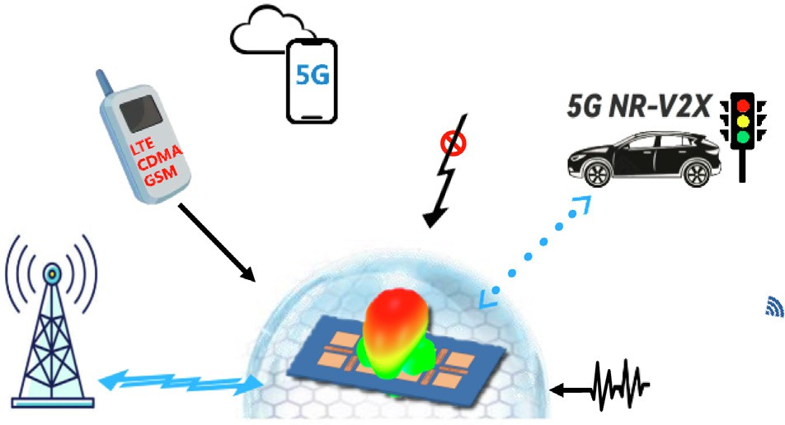

Fig. 1. Application scenario and function diagram of filtering antenna for 5G.

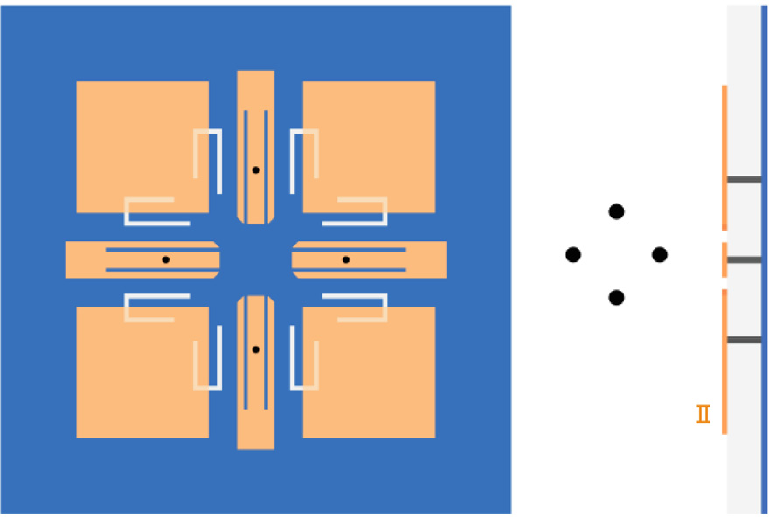

S2

GND

W1 L1

L0

W4

L2

L4

Differential Port

Port3

S4

S3

Port2

Port4

W2

L3

W3

Radiation Patch

G

Port1

S1

Differential Port

DGS

Driven Patch

H

W0

Substrate

ders is 30 dB. However, in order to reduce the mutual coupling, an extra isolation wall was introduced, thus increasing design com- plexities. Therefore, it can be found from the reported references that the isolation of the array is measured after the array is con- nected to the power divider. The resultant isolation depends on not only antenna array itself but also the power divider. In addi- tion, how to obtain both high polarization isolation and low side- lobe is still a challenging problem in the filtering antenna array design.

In this paper, a dual-polarized filtering antenna consisting of driven patches and radiation patches and its novel low-profile array with both high polarization isolation and low sidelobe level have been proposed. The contribution of the paper has two folds. One is to fuses several filtering methods including inherent eigen- mode, parasitic patches, slot, and defected ground structure (DGS) to achieve good filtering performance without increase of the antenna profile. The second is to develop a dual-polarized filtering antenna array with both high polarization isolation and low side- lobe performance. The designed filtering antenna fabricated on a single-layer substrate, and with five radiation nulls, the resultant stopband covers GSM, CDMA and LTE bands. Based on the symme- try of the antenna structure, the interspace between the antenna elements can be reduced from 0.91k to 0.44k by sharing the radiat- ing patches, and thus sidelobe level of the proposed array decreases from 12.36 dB to 18.11 dB. In addition, the polariza- tion isolation of the array itself without the consideration of the power divider, i.e., the total isolation between two kinds of the polarized ports in the array named *SddVH* and *SddHV*, are proposed for the first time. The designed array has high polarization port iso- lation above 41.1 dB. Good agreement between the simulation and the measurement verifies the proposed design.

— —

1. Filtering antenna design

Fig. 2. Configuration of the proposed filtering antenna (unit: mm): *W*0 = 100,

*W*1 = 6.2, *W*2 = 2.9, *W*3 = 10.5, *W*4 = 7.9, *L*0 = 20.9, *L*1 = 25.7, *L*2 = 19, *L*3 = 4.2, *L*4 = 0.7,

*S*1 = 28.4, *S*2 = 61.8, *S*3 = 18, *S*4 = 9.1, *G* = 0.5, *H* = 3.

patches and four square radiation patches evenly distributed around them are fabricated on the top surface of the substrate. Four pairs of slots are etched on four driven patches, and four pairs of C-shaped slots are etched on the ground to improve low- frequency and high-frequency selectivities, respectively. Two kinds of polarized waves are excited by two pairs of the differential probes connected to the driven patches. Here, the differential port I consisting of ports 1 and 3 excites *x*-polarization wave and the differential port II composed of ports 2 and 4 excites *y*- polarization wave.

* 1. *Operating mechanism of filtering antenna*

To clearly demonstrate the design idea and working mechanism of the proposed antenna, the design process of the antenna is shown in Fig. 3. Antenna I consists of two pairs of the chamfered rectangular patches which are placed along *x* and *y* axes, respec- tively, and are fed by two pairs of differential ports. Antenna II adds four square radiation patches placed around the driven patches. Antenna III is formed by introducing a pair of slots on each driven patch. And then, four pairs of C-shaped DGSs are introduced on the ground around the probes to form the antenna IV, i.e., the proposed antenna.

Fig. 4 gives the simulated differential S-parameter |S*dd*11| and broadside gains of the antennas I IV. Here, we only discuss the case of *x*-polarization. Due to the symmetry of the antenna struc- ture, the same conclusions hold for the *y*-polarization. For a typical four-port network including two pairs of the differential ports, the widely used differential S-parameters can be written as

~

8> *Sdd*11 = (*S*11 — *S*31 — *S*13 + *S*33)/2

Various filtering antennas have been developed hitherto. Among these filtering antenna designs, a large number of dual- polarized filtering antennas have been studied, but most of them are multilayer structures, with the higher profiles [2,5,13,14,20]. In addition, a number of single-layer filtering antennas with single polarization have been proposed [10,16,19]. Here, an integrated design of a single-layer low-profile dual-polarization filtering antenna is proposed. This section includes the antenna configura- tion, the design process of the proposed antenna, and performance comparison between the simulated and measured results.

*2.1. Filtering antenna configuration*

>< *Sdd*22 = (*S*22 — *S*42 — *S*24 + *S*44)/2

*Sdd*12 = (*S*12 — *S*32 — *S*14 + *S*34)/2

>>:

*Sdd*21 = (*S*21 — *S*41 — *S*23 + *S*43)/2

(1)

Fig. 2 shows the proposed filtering antenna, which consists of one single layer copper-coated substrate with relative permittivity of 2.65 and loss tangent of 0.001. Two pairs of chamfered driven

Fig. 3. The design procedure from antenna I to antenna II to antenna III. The geometric dimensions of each antenna (unit: mm): *L*1 = 26.7, *S*1 = 32.4, *S*2 = 63.8 for antenna I; *L*0 = 21, *L*1 = 27.6, *S*1 = 27.6, *S*2 = 63.6 for antenna II; *L*0 = 21, *L*1 = 25.9,

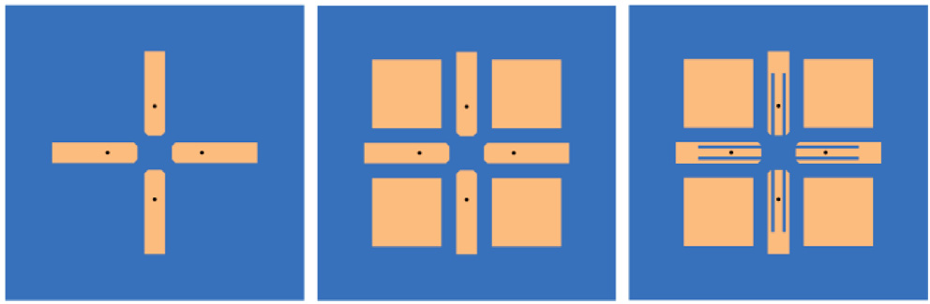

y Driven Patch

Radiation Patch

Slot

x

Ant.

Ant.

Ant.

Substrate

*S*1 = 27, *S*2 = 60.2 for antenna III.

0

-5

|S*dd*11| (dB)

-10

-15

-20

10

0

Realized Gain (dBi)

-10

-20

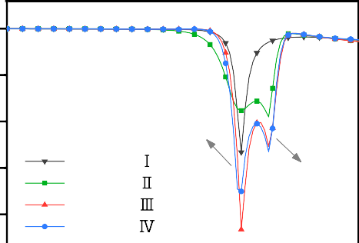

*f*1

Antenna Antenna Antenna Antenna

*f*2

1 2 3 4 5

# Frequency (GHz)

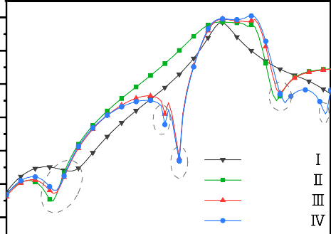



*f*n2

respectively, as shown in Fig. 6(a). When two patches along *x* axis are excited by the differential signals, i.e., two signals with the equal magnitude and 180° out of phase, the opposite electric field distributions of the eigenmode 3 on the two patches along *x* axis are obtained, as shown in Fig. 6(b). On the other hand, without the excitations for two patches along *y* axis, there are no electric fields of the eigenmode 3 on the two patches along *y* axis. In addi- tion, the similar operating frequencies for the eigenmode 3 and the

radiation null are observed. Therefore, the radiation null at *f*n1 is an inherent radiation null corresponding to the eigenmode 3.

*2.2.2. Analysis of resonance and radiation null of antenna II*

When the radiation patches are placed around the driven patch (antenna II), a new resonance at *f*2 = 3.85 GHz is excited and thus the working bandwidth is widened, as shown in Fig. 4. Meanwhile, a radiation null at *f*n2 = 4.25 GHz is generated to improve the high- frequency roll-off. Fig. 7 shows the surface current distributions of antenna II at *f*1, *f*2, and *f*n2. It can be seen that the driven patch is still in resonance at *f*1 = 3.5 GHz, and the radiation patch resonates at *f*2 = 3.85 GHz. Besides, at *f*2 the currents on the four radiation patches are superimposed on each other in the *x* direction and can-

-30

-40

-50

*f*n1

*f*n4

*f*n3

Antenna Antenna Antenna Antenna

*f*n5

celled out in the *y* direction, thus achieving the *x*-polarization radi- ation. The opposite current distributions on the radiation patches and the driven patches are due to the capacitive coupling between them. However, the currents flowing on the driven patches are far weaker than those on the radiation patches. It means that the energy is well coupled from the driven patches to the radiation

1 2 3 4 5

# Frequency (GHz)



Fig. 4. The |S*dd*11| and realized gain of antennas I, II, III, IV. (a) |S*dd*11|. (b) Realized gain.

* + 1. *Analysis of resonance and radiation null of antenna I*

As shown in Fig. 4, antenna I has a resonance at *f*1 = 3.5 GHz and a radiation null at *f*n1 = 1.4 GHz. Fig. 5 gives the surface current dis- tributions of the antenna I at *f*1 and *f*n1. At *f*1, the surface current on each of two driven patches along *x*-axis is maximal in the middle and zero at the two ends, and therefore the resonant mode is TM10 mode. The corresponding length of each driven patch is a quarter wavelength at *f*1. On the other hand, it can be observed from the surface current distribution at *f*n1 that the currents on the both sides of the feeding location flow in an opposite direction,

resulting in radiation cancellation in broadside direction. In order

patches. Therefore, good radiation is generated by the radiation patches at 3.85 GHz. At *f*n2 = 4.25 GHz, the weak currents on the radiation patches are observed, compared with those at *f*2. As shown in Fig. 8, an equivalent model for the coupling between the driven and radiation patch is built to investigate the operating mechanism of the radiation null at *f*n2. With the symmetry of the antenna, only a quarter of the whole antenna structure, i.e., a dri- ven patch and a radiation patch, is analyzed. The driven and radi- ation patches are close together, and thus can be equivalent to two parallel coupling lines with four ports, i.e., ports (i), (ii), (iii) and

(iv). It is worthwhile pointing out that the four ports different from the actual feeding ports are used to analyze the coupling effect in the parallel coupling lines. According to the even and odd analysis of the parallel coupling line in [25], when the port (i) is driven by an input voltage of 2 *V*0, the voltages of the ports (ii), (iii) and (iv), i.e., *V*2, *V*3 and *V*4, can be solved, respectively, as

p1ﬃﬃﬃﬃ—ﬃﬃﬃﬃﬃ*C*ﬃﬃﬃ2ﬃﬃ

h +

to better explore the inherent radiation null, the eigenmodes of the antenna I are solved. The electric field distributions of the

*V* 2 = *V* 0 p1ﬃﬃﬃﬃﬃﬃﬃﬃﬃ*C*ﬃﬃﬃ2ﬃﬃ cos

*j* sin h

(2)

eigenmode 3 at the resonant frequency *f*mode3 = 1.435 GHz are

—

*jC* tan[03*B*8]

given in Fig. 6. For comparison, the electric field distributions of the antenna I at *f*n1 = 1.4 GHz are given. Considering that the driven

—

*V* 3 = *V* 0 p1ﬃﬃﬃﬃﬃﬃﬃﬃﬃ*C*ﬃﬃﬃ2ﬃﬃ

+ *j* tan h

(3)

patch consists of four same rectangular patches, the eigenmode 3 has four same electric fields distributing on the four patches,

*V* 4 = 0 (4)

Ant. I 3.5GHz 1.4GHz

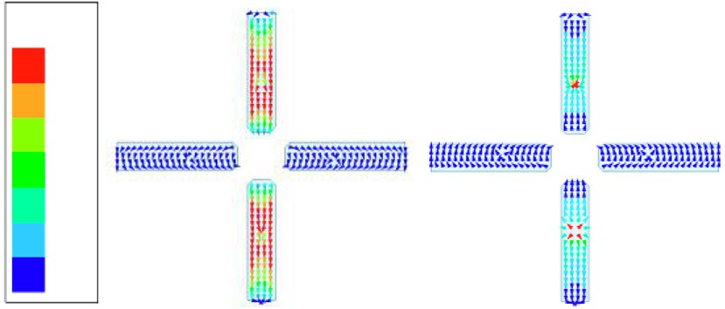

**J[A/m]**

**50.0**

**42.8**

**35.7**

**28.6**

***y***

***x***

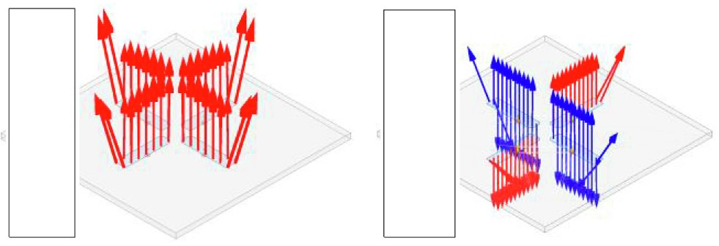

**E[V/m]**

**0.20**

**E[V/m]**

**3000**

**0.16 2400**

**0.12 1800**

**0.08 1200**

|  |  |  |  |  |  |
| --- | --- | --- | --- | --- | --- |
| **21.4** |  | | | | |
| **14.3** |  | **0.04** |  | **600** |  |
| **7.1** |  | **0.00** |  | **0** |  |
| **0.0** |  |  | (a) |  | (b) |

Fig. 5. Surface current distributions on the driven patch of the antenna I at 3.5 GHz and 1.4 GHz.

Fig. 6. Electric field distributions on the driven patch of the antenna I. (a) Model electric field at *f*mode3. (b) Surface electric field at *f*n1.

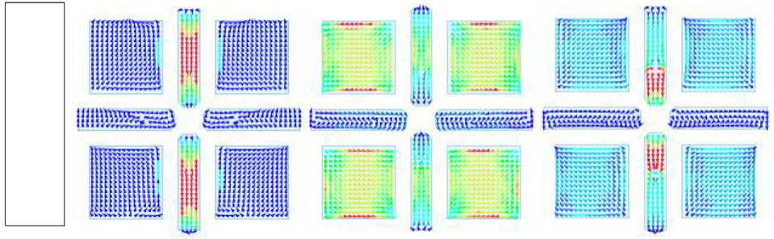

Ant. II

**J [A/m] 30**

**25**

**20**

**15**

**10**

**5**

**0**

3.5GHz

***y*** 3.85GHz

4.25GHz

***x***

Fig. 7. Surface current distributions on the driven patches and radiation patches of the antenna II at *f*1 = 3.5 GHz, *f*2 = 3.85 GHz, and *fn*2 = 4.25 GHz.

Fig. 10. Surface current distributions of antenna III at *f*n4 = 2.7 GHz and

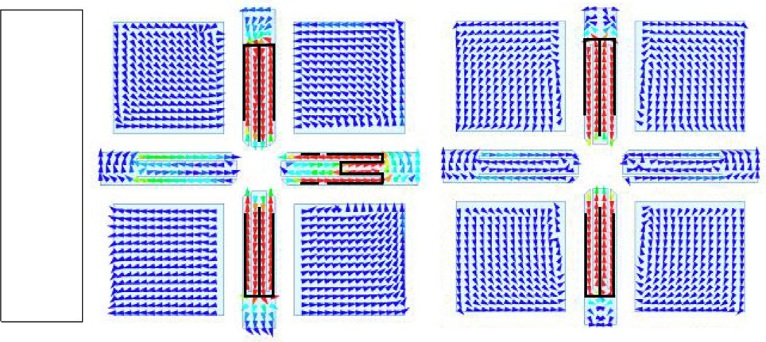

Ant. III

**J [A/m]**

**30**

**25**

**20**

**15**

**10**

**5**

**0**

2.7GHz

y

2.9GHz

x

*f*n3 = 2.9 GHz.

Fig. 8. The equivalent circuit model of parallel coupled lines composed of a driven patch and a radiation patch.

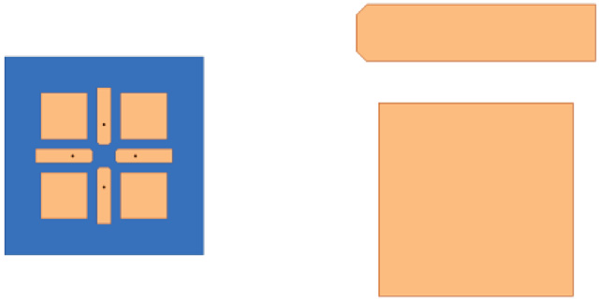

**Port (i) *V*1=2*V*0**

**Driven patch**

***V*2 Port (ii)**

**Port (iii) *V*3**

***V*4 Port (iv)**

**Radiation patch**

where *C* is voltage coupling coefficient, h is the electric length of the radiation patch. Fig. 9 shows the variations of *V*2 and *V*3 with the h. It can be seen that when h = *n*p (*n* = 0,1, .. .), the *V*3 is zero, meaning that electromagnetic energy cannot be coupled from the driven

patch to the radiation patch.

When h = p, the length of the radiation patch is equal to half of the wavelength at *f*n2. In this scenario, the radiation null is formed, and the corresponding frequency *f*n2 is obtained as

*c*

the *f*n3. In addition, there is a small convex of the gain curve between *f*n3 and *f*n4, as shown in the Fig. 11. That is due to the cou- pling between the driving patch along *x* direction and the driving patch along *y* direction which are too close together. The coupling between the driving patches can be reduced by corner-cutting to avoid sharp convex.

In order to analyze the two radiation nulls, an equivalent circuit is established, as shown in Fig. 12. Each of the driven patches appears as a shunt RLC circuit consisting of the inductor *Ld*, the capacitor *Cd* and the resistor *Rd* with the band-pass response. A pair of the slots is regarded as a shunt LC circuit composed of the induc- tor *Ls*, the capacitor *Cs* with the band-stop characteristic, which is connected to the RLC circuit in series. At the resonant frequency of the band-pass circuit, the impedance of the RLC circuit is the *Rd*, thus achieving the radiation of the driven patch. On the other hand, at the resonant frequency of the band-stop circuit, the impe- dance of the LC circuit becomes infinite. Therefore, the energy can- not be transmitted from the feeding port to the radiation resistor *Rd* but is concentrated around the slot, thus generating the radia-

*f n*2 = 2(*L*0

+ 2D*L*),eﬃﬃﬃ*e*ﬃ*f*ﬃ*f*ﬃﬃ

(5)

tion null. At *f*n3 = 2.9 GHz, the length of the slot *L*2 is a quarter of the wavelength at the resonant frequency of the LC circuit. As a

where *c* represents the speed of light, *L*0 represents the length of the

result, the relationship between the *f*n3 and the *L*2 is

radiation patch, D*L* represents the fringing length extension, and e*eff* 1 *c*

represents the effective relative permittivity. With (5), the theoret-

*f n*3 = 2p,*L*ﬃﬃﬃﬃ*C*ﬃﬃﬃﬃﬃ = 4(*L*2 + D*L*),ﬃeﬃﬃ*e*ﬃ*f*ﬃ*f*ﬃﬃ

(6)

*s s*

ical estimation of the *f*n2 is given as 4.2 GHz, approximately equal to

the full-wave simulation results of 4.25 GHz.

* + 1. *Analysis of resonance and radiation nulls of antenna III*

A pair of the slots is etched on each driven patch to form the antenna III. As shown in Fig. 4(b), the use of the slot is to introduce two adjacent radiation nulls at *f*n3 = 2.9 GHz and *f*n4 = 2.7 GHz for improvement of the low-frequency roll-off. Fig. 10 gives the sur- face current distributions of the antenna III at *f*n3 and *f*n4. At *f*n3 = 2.9- GHz, the currents mainly distribute near the slots of the excited driven patches along *x* direction. By contrast, the currents at *f*n4 = 2.7 GHz distribute near the slots of the driven patches along both *x* and *y* directions. Compared to the currents at *f*n3, the cur- rents at *f*n4 flow in a longer path, and thus the *f*n4 is lower than

In addition to the radiation null at *f*n3 = 2.9 GHz, there is a radi- ation null at *f*n4 = 2.7 GHz, which can be still analyzed according to the equivalent circuit model shown in Fig. 12. The only difference between two radiation nulls is a coupling between the excited dri- ven patches along *x* direction and the unexcited driven patches along *y* direction at *f*n4. Therefore, the electromagnetic energy excited by the feeding probe distributes on the slots along both *x* and *y* directions.

10



After cutting Before cutting

*f*s

*f*n4

*f*n3

0

Realized Gain (dBi)

-10

*V*

1

1-*C*2

*C*2

2

2

*V*2



*V*0

2

*V*3

*V*0

3 5 3

2

2 2

-20

-30

-40

-50

1 2 3 4 5

Frequency (GHz)

Fig. 9. Variation of the port voltage with the coupling line length.

Fig. 11. Influence of driven patches without and with corner-cutting on realized gain curve.

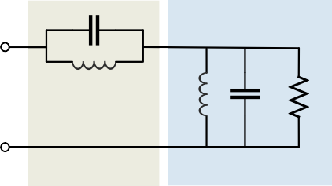

*Cs*

*Ls*

*Ld*

*R*

*d*

Slots

Driven patch

*Cd*

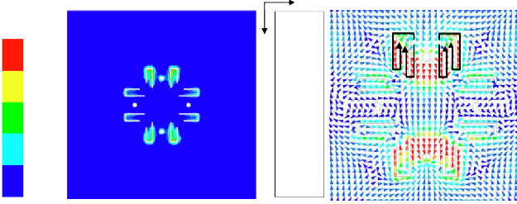

**y**

**J [A/m]**

**x 30**

**25**

**20**

**15**

**10**

**5**

**0**

**E [V/m]**

20000

16000

12000

8000

4000

0

 

Fig. 12. The equivalent circuit of the driven patch and slots.

* + 1. *Analysis of resonance and radiation null of antenna IV*

The antenna IV, i.e., the proposed antenna, is achieved by etch-

Fig. 14. (a) The electric field and (b) the current distributions on GND of antenna IV at *f*n5 = 4.95 GHz.

ing a pair of the DGSs around each probe on the ground. According to Fig. 4(b), an extra radiation null at *f*n5 = 4.95 GHz is generated to extend the high-frequency stopband. The operating mechanism of the DGS for the radiation null can be explained in terms of the equivalent circuit, as shown in Fig. 13. The DGS is regarded as a parallel LC circuit with a bandstop response including the inductor *Lg* and the capacitor *Cg* [26], which is cascaded before the equiva- lent circuit shown in Fig. 12. Similar to the slots on the driven

10

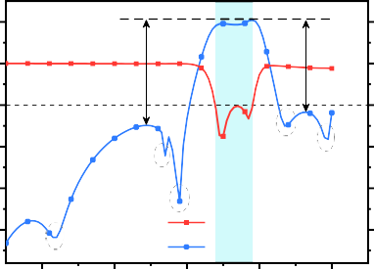0

-10

|S*dd*11| (dB)

-20

-30

**25.4 dB**

*f*n4

*f*n3

Sim. |S

*f*n2

|

**22.2 dB**

*f*n5

10

0

Realized Gain (dBi)

-10

-20

-30

patches, at the resonant frequency of the LC circuit of the DGS,

-40 *f*

*dd*11

-40

i.e., *f* , the corresponding impedance is infinite, thus binding the

n1 Sim. Realized Gain

n5

energy around the DGS to achieve a radiation null, as shown in Fig. 14. The overall length of the DGS is 2*(*L*3 + *W*3 + *W*4), which equals a wavelength at *f*n5. Thus, the *f*n5 can be given as

1 2 3 4 5

Frequency (GHz)

Fig. 15. Simulated |S*dd*11| and realized gain of the proposed antenna.

1 *c* **10**

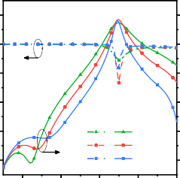

***f*n1**

*S*1=30.4 *S*1=32.4 *S*1=34.4

**10 10 10**

*f n*5 = 2pp*L*ﬃﬃﬃﬃﬃ*C*ﬃﬃﬃﬃﬃ = 2(*L*3 + *W*3 + *W*4 ),ﬃeﬃﬃ*e*ﬃ*f*ﬃ*f*ﬃﬃ

*g*

*g*

(7)

**0**

**0**

**0**

**0**

It is worthwhile noticing that the equivalent circuit for the DGS shown in Fig. 13 is established without the considerations of the radiation patches.

As shown in Fig. 15, the antenna IV operates in a band of 3.39–

3.91 GHz with an in-band gain about 10 dBi. Five radiation nulls

**-10**

**-20**

**|S*dd*11**|| **(dB)**

**-30**

**-40**

**1 2 3 4 5**

**Frequency (GHz)**

**-10**

**-20**

**Realized Gain (dBi)**

**|S*dd*11**|| **(dB)**

**-30**

**-40**

**-10**

**-20**

**-30**

**-40**

**1 2 3 4 5**

**Frequency (GHz)**

**-10**

**-20**

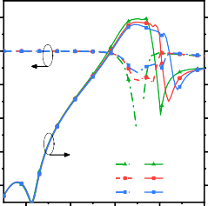

***f*n2**

*L*0=22.5 *L*0=21 *L*0=19.5

**Realized Gain (dBi)**

**-30**

**-40**

achieve a wide out-of-band suppression, i.e., above 25.4 dB at

(a) (b)

low-frequency band greater than 0.5 GHz and above 22.2 dB at high-frequency band up to 5 GHz.

The obtained radiation nulls in the process of the antenna design can be controlled independently. Fig. 16(a) shows the inher- ent radiation null at *f*n1 can be adjusted in terms of the feeding

position *S* . As *S* increases, the inherent null shifts toward higher

**10**

**0**

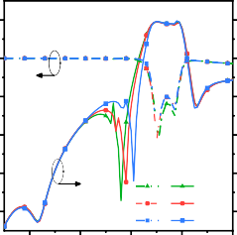

***f*n3 / *f*n4**

*L*2=20 *L*2=19 *L*2=18

**-10**

**|S*dd*11**|| **(dB)**

**-20**

**10**

**0**

**Realized Gain (dBi)**

**|S*dd*11**|| **(dB)**

**-10**

**-20**

**10**

**0**

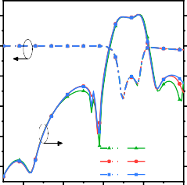

***f*n5**

*W*3=10.5

*W*3=10 *W*3=9.5

**-10**

**-20**

**10**

**0**

**Realized Gain (dBi)**

**-10**

**-20**

1 1

frequencies. Fig. 16(b) depicts variation of the radiation null at *f*n2 with the *L*0. As the *L*0 decreases, the *f*n2 shifts toward the higher frequencies with the fixed *f*n1, as shown in (5). Fig. 16(c) shows that

the radiation nulls at *f*n3 and *f*n4 can be controlled by tuning the

**-30**

**-40**

**1 2 3 4 5**

**Frequency (GHz)**

**-30**

**-40**

**-30**

**-40**

**1 2 3 4 5**

**Frequency (GHz)**

**-30**

**-40**

length of the slot *L*2. As *L*2 increases from 18 mm to 20 mm, two radiation nulls move toward the lower frequencies simultaneously, whereas other radiation nulls remain unchanged. Fig. 16(d) shows the variation of the *f*n5 with the *W*3. The *f*n5 increases with the decrease of *W*3.

(c) (d)

Fig. 16. (a) Variation of the radiation null at *f*n1 with the *S*1 in antenna I. (b) Variation of the radiation null at *f*n2 with the *L*0 in antenna II. (c) Variation of the radiation nulls at *f*n3 and *f*n4 with the *L*2 in antenna III. (d) Variation of the radiation null at *f*n5 with the *W*3 in antenna IV.

* 1. *Measurement results and discussions*

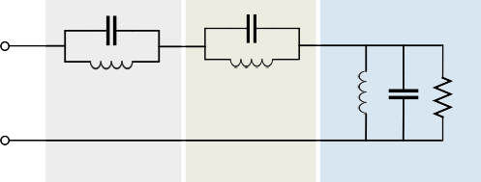

*Cg*

*Cs*

*Lg*

*Ls*

*L*

*Cd*

*d*

*Rd*

DGS

Slots

Drivenn patch

Fig. 13. The equivalent circuit of the DGS and radiation patch.

—

To validate the designed filtering antenna, a prototype is fabri- cated and measured, as shown in Fig. 17. Here, due to the symme- try of the antenna, only the measurement results for *x* polarization are given. The simulated and measured results of |S*dd*11|, gain, and | S*dd*21| are shown in Fig. 18. The simulated operating bandwidth of the proposed antenna (|S*dd*11|< 10 dB) is 3.39–3.91 GHz (14.3%) and the measured bandwidth is 3.53–4.06 GHz (14%). The slight

E-Plane H-Plane

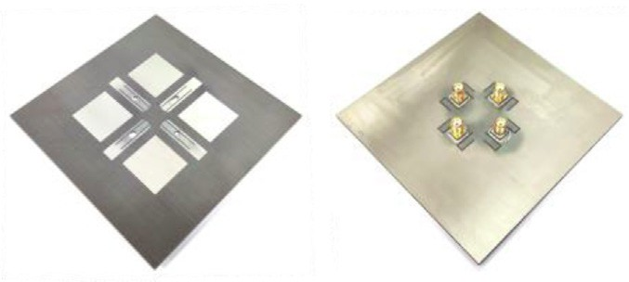

**Front**

**Back**

300

3.5 GHz 270

330

0

-20



-40

-60

30

60 300

90 270

330

0

30



-20

60

-40

-60

90

240

120

240

120

Fig. 17. Photographs of the proposed filtering antenna.

frequency offset is mainly attribute to fabrication error, SMA sol- dering error, substrate tolerance, etc. The simulated out-of-band suppression levels are better than 25.4 dB at low-frequency band

300

3.65 GHz 270

210

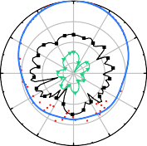330

180

0

-20

-40

-60

150

30

60 300

90 270

210

330



180

0

-20

-40

-60

150

30

60

90

greater than 0.5 GHz and 22.2 dB at high-frequency band up to 5 GHz, respectively, whereas the measured results are 25.8 dB and 22.1 dB, respectively with the same suppression bandwidths. The five radiation nulls are well observed according to the mea- sured gain curve, and the simulated and measured broadside gains have the same peak value of 10 dBi. The simulated differential port isolation |S*dd*21| is greater than 46.8 dB in the whole band. By com- parison, the measured one is above 41 dB, with the similar varia- tion trend to the simulated result.

Fig. 19 gives the normalized radiation patterns in E-plane and

240

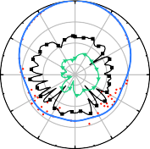300

3.8 GHz 270

240

210

330

210

180

0

-20

-40

-60

180

150

30

150

120

60

90

120

240

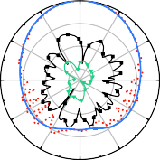300

270

240

210

330

210

180

0

-20

-40

-60

180

150

30

150

120

60

90

120

H-plane at 3.5 GHz, 3.65 GHz, and 3.8 GHz, respectively. The sim-

Sim. co-pol  Sim. x-pol

ulated and measured cross-polarization ratios are above 51.5 dB

Mea. co-pol

Mea. x-pol

and 27 dB, respectively. Here, the discrepancy between them mainly comes from the fabricating and measuring errors. To sum up, an integrated design of a single-layer filtering antenna is veri- fied, and its frequency selectivity and radiation characteristics meet the expectations.

1. Novel filtering antenna array

With the designed filtering antenna, the filtering antenna array has been developed in this section.

Fig. 19. Simulated and measured normalized radiation patterns of the proposed antenna in E-plane and H-plane at 3.5 GHz, 3.65 GHz, and 3.8 GHz.

* 1. *Conventional 1* × *2 array design (array I)*

Firstly, a conventional 1 2 antenna array is designed based on the proposed filtering antenna element with an element spacing of *D* = 0.91k, which is called array I, as shown in Fig. 20. Here k is wavelength at the center frequency. As shown in Fig. 21(a), a pro- totype is fabricated, and comparison of the simulated and mea- sured gains for *x* and *y* polarizations is given in Fig. 22. The measured out-of-band suppression levels for *x* polarization are

×

above 26.1 dB in low-frequency band greater than 0.5 GHz and

10

0

-10

|S*dd*11| (dB)

-20

-30

-40

-40

-60

|S*dd*21| (dB)

-80

1 2 3 4 5

Frequency (GHz)

Sim. |S*dd*11| Mea. |S*dd*11|

Sim. Realized Gain Mea. Realized Gain



10

0

Realized Gain (dBi)

-10

-20

-30

-40

above 27 dB in high-frequency band up to 5 GHz, respectively, and those for *y* polarization are 24.1 dB and 26.4 dB in the same bands, respectively.

In order to evaluate and measure the overall polarization isola- tion performance of the antenna itself, two kinds of the polariza- tion ports in the array are considered. Specifically, all *x*- polarization ports are denoted as the port *V*, and all *y*- polarization ports are denoted as the port *H*. Thus, *SddHV* is the dif- ferential S parameter from the port *V* to the port *H*, and *SddVH* rep- resents the differential S parameter from the port *H* to the port *V*, which distinguishes them from widely used polarization isolation of the antenna array with the power divider. The *SddHV* and S*ddVH*

-100

Mea. |S*dd*21| Sim. |S*dd*21|

1 2 3 4 5

Frequency (GHz)



Fig. 20. Layout of the proposed filtering antenna array I and the diagram of port

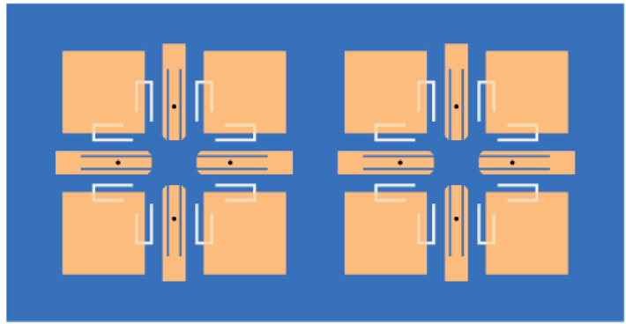

y

x

P3

D

P7

P2

P4 P6

P8

P1

P5

Fig. 18. Simulated and measured |*Sdd*11|, realized gain, and |*Sdd*21| of the proposed filtering antenna. (a) |*Sdd*11| and realized gain. (b) |*Sdd*21|.

distribution. The geometric dimensions of the array I (unit: mm): *L*0 = 21, *S*1 = 29,

*L*1 = 24.8, *D* = 72.2 (0.91k).

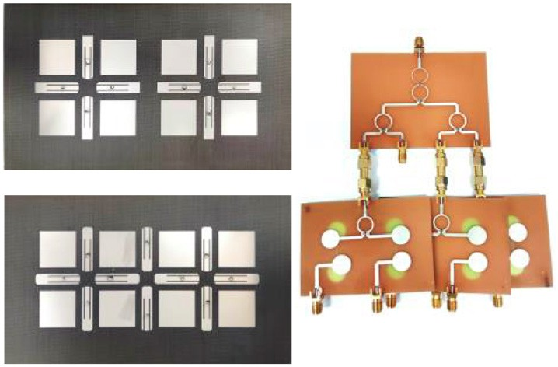-40

-60

(a)

(b)

(c)

-80

-100

|S*dd*VH| (dB)

-120

Mea. Sim.

1 2 3 4 5

Frequency (GHz)

Fig. 21. Photographs of the filtering antenna array and feed network: (a) Array I. (b) Array II. (c) Feeding network.

Fig. 23. Simulated and measured |*SddVH*| of the array I.

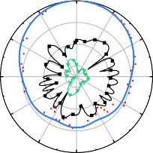E-Plane H-Plane

10

0

Realized Gain (dBi)

-10

-20

*x-*pol

300

270

330

0

-20

-40

-60

30

60 300

90 270

330

0

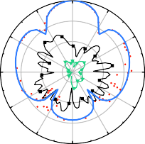30

-20

60

-40

-60

90

-30

-40

10

0

Realized Gain (dBi)

-10

Sim. Mea.

1 2 3 4 5

Frequency (GHz)



*y-*pol

240

300



270

240

210

330

210

180

0

-20

-40

-60

180

Sim. Mea.

150

30

150

120

60

90

120

240

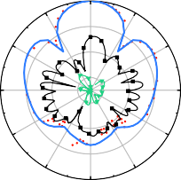300

270

240

210

330

210

180

0

-20

-40

-60

180

150

30

150

120

60

90

120

Sim. co-pol  Sim. x-pol

-20

Mea. co-pol

Mea. x-pol

-30

-40

1 2 3 4 5

Frequency (GHz)



Fig. 24. Simulated and measured normalized radiation patterns in E-plane and H- plane of the array I at 3.65 GHz for *x*-polarization feeding ports and *y*-polarization feeding ports.

As shown in Fig. 21(c), the feed network is composed of a 1-to-2

Fig. 22. Simulated and measured realized gains of the array I. (a) *x* polarization. (b)

*y* polarization.

are defined to measure the polarization purity of the ports to some extent. It is worthwhile pointing out that *SddHV* and S*ddVH* are differ- ent from the cross-polarization ratio. The former is the port-related parameter, whereas the latter is radiation-related parameter. As for the array I with the port distribution shown in Fig. 20, *SddVH* is given as

*SddVH* = 1 [(*S*12 — *S*32 + *S*52 — *S*72) — (*S*14 — *S*34 + *S*54 — *S*74)

0

Wilkinson power divider and several power dividers with two

±90° output phase shifts. Here, microstrip-slotline-microstrip tran- sition is used to achieve the desirable phase shift. Due to different directions of the coupling from the slotline to the microstrip, two output signals of equal amplitude with a difference of ±90° are generated within the ultra-wideband. The measurement results of the phase shifter are shown in the Fig. 25. The operating band (|*S*11|< 10 dB) covers 1.1 GHz to 5 GHz. The |*S*21|, which represents the insertion loss of the phase shifter, is about 5 dB, and a nearly perfect 180° phase difference is obtained.

—

4

## +(*S*16

## — *S*36

## + *S*56

## — *S*76

)— (*S*18

## — *S*38

## + *S*58

## — *S*78

)] (8)

200

Phase Difference

The derivation details of Eq. (8) can be found in the Appendix. As shown in Fig. 23, the simulated and measured *SddVH* are higher than

58.1 dB and 39.8 dB in the entire frequency band, respectively. Fig. 24 gives the simulated and measured normalized radiation pat- terns in E-plane and H-plane at 3.65 GHz, in good agreement, with the simulated and measured sidelobe levels of 10.9 dB and

—

12.36 dB, respectively. The simulated and measured cross- polarization ratios are above 48.4 dB and 27 dB, respectively.

—

In order to measure the in-band radiation and out-of-band sup-

-10

-20

S-Parameters (dB)

-30

-40

-50

|S11|

|S21|

|S23|

1 2 3 4 5

Frequency (GHz)



100

0

Phase (deg)

-100

-200

|S21| |S31|

1 2 3 4 5

Frequency (GHz)



pression characteristics, an ultra-wideband phase-shift power splitter is designed to provide the desirable signals of the array I.

Fig. 25. The measured result of (a) S parameter of phase shifter and (b) the phase difference between the two output ports.

* 1. *Improved array design (array II)*

Owing to the conventional array arrangement, the sidelobe level of the above 1 2 array is high. In order to reduce the side- lobe level, the driven patches and radiation patches can be reused to decrease the interspace between the elements. Specifically, one driven patch and two radiation patches are shared between two adjacent elements, and the resulting filtering array is called array II, as shown in Fig. 26. The improved array has the same physical size as the conventional 1 × 2 array, and the corresponding ele- ment spacing is reduced from *D* = 0.91k to *D* = 0.44k. It should be noted that to better share the adjacent patches, all corners on the driven patches are cut off. Besides, it can be noticed that the ele- ments 1 and 2 at two sides of the array are exactly same, different from the element 3 in the middle of the array. Specifically, the ori- entations of the slots on driven patches and the DGS and the feed position of the element 3 are opposite to those of the elements 1 and 2. But the difference between them has no effect on the overall performance of the array II. In order to achieve the differential feeding for all elements, the used feeding scheme is shown in Fig. 27.

×

The array II is also fabricated and shown in Fig. 21(b). The sim- ulated and measured gains are shown in Fig. 28, in good agree- ment. For comparison, the simulated and measured results of the array I are also given. Similar gains are obtained by the arrays I and II. The measured out-of-band suppression levels for *x* polariza- tion are above 22.1 dB in low-frequency band greater than 0.5 GHz and above 19.7 dB in high-frequency band up to 5 GHz, respec- tively, and those for *y* polarization in the same bands are 24.8 dB and 23.8 dB, respectively. As shown in Fig. 29, the simulated and measured |*SddVH*| are 47 dB and 41.1 dB, respectively, meaning that the array II has better polarization isolation performance. Here, the *SddVH* of the array II is solved as

*SddVH* = 1 [(*S*12 — *S*32 + *S*52 — *S*72 — *S*92 + *S*102 )



4

**180°**

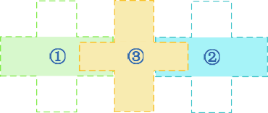

**0°**

**180°**

**0°**

**180°**

**0°**

**180°**

**0°**

**180°**

**0°**

Fig. 27. Scheme of feeding phases in array II.

10

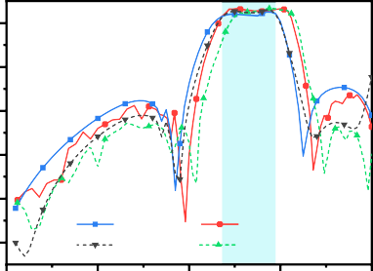

Sim. Mea.

Array II Array II

Array I Array I

0

Realized Gain (dBi)

-10

-20

-30

-40

1 2 3 4 5

Frequency (GHz)



10

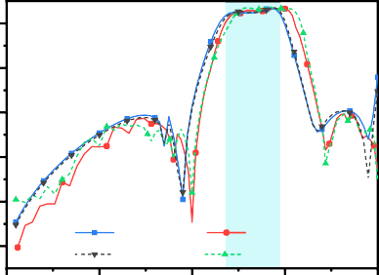

Sim.

Array II Array I

Mea.

Array II Array I

0

Realized Gain (dBi)

-10

-20

-30

-40

1 2 3 4 5

Frequency (GHz)

—(*S*14 — *S*34 + *S*54 — *S*74 — *S*94 + *S*104 )

## +(*S*16 — *S*36 + *S*56 — *S*76 — *S*96 + *S*106)

—(*S*18 — *S*38 + *S*58 — *S*78 — *S*98 + *S*108)]

Derivations about the *SddVH* can be found in the Appendix.

(9)



Fig. 28. Simulated and measured realized gains of the arrays I and II. (a) *x*

polarization. (b) *y* polarization.

Besides, Fig. 30 shows the simulated and measured normalized patterns of the array II at 3.65 GHz. The simulated and measured sidelobe levels are 20 dB and 18.11 dB, respectively, and the simulated and measured cross-polarization ratios are above 46 dB and 26 dB, respectively. As shown in Fig. 31, compared to the array I with the same physical size, the simulated and mea- sured sidelobe levels of the array II decrease by 9.1 dB and 6 dB, respectively. It is worthwhile pointing out that the proposed shar- ing patch method can be easily extended to *m* × *n* array by adding (*m*-1)×(*n*-1) elements.

— —

-40

-60

|S*dd*VH| (dB)

-80

-100

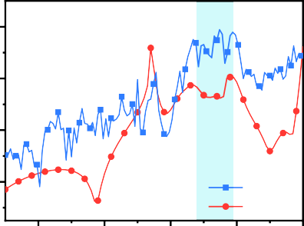Mea. Sim.

1 2 3 4 5

Frequency (GHz)

Fig. 29. Simulated and measured |*SddVH*| of the array II.

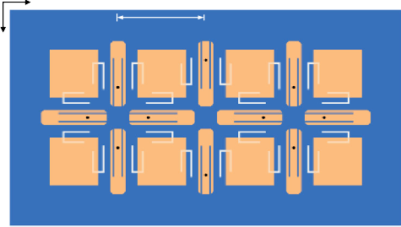

y

x

P3 D

P10

P7

P2

P4 P6

P8

P1

P9

P5

Fig. 26. Layout of the array II and the diagram of port distribution. The geometric dimensions of array II (unit: mm): *L*0 = 21.2, *W*1 = 6, *L*1 = 26.1, *W*3 = 10.4, *L*3 = 4, *W*4 = 8.2, *S*1 = 27.4, *S*2 = 61, *S*4 = 8.4, *D* = 34.9 (0.44k).

* 1. *Performance comparison*

The proposed arrays I and II are compared with previously reported filtering antenna arrays in Table 1. It can be found from that the proposed array is highly integrated and has a low profile owing to the single layer substrate. Meanwhile, the novel array design results in a lower sidelobe level. Moreover, higher polariza- tion isolations and better cross polarization ratios are achieved, with moderate gain and suppression levels. It is worthwhile notic- ing that an extra pair of the differential ports is used in the array II,

E-Plane H-Plane



1. Conclusions

*x-*pol

300

270

330

0

-20

-40

-60

30

60 300

90 270

330

0

30



-20

60

-40

-60

90

In this paper, an integrated filtering antenna and its improved array has been presented. The single-layer dual-polarized filtering antenna element consisting of four driven patches and four radiation patches has two in-band resonances. The patches with the slots and the DGS are used to generate five controllable radiation nulls, and

thus good out-of-band suppression is achieved. The prototype of

*y-*pol

240

300



270

240

210

330

210

180

0

-20

-40

-60

180

150

30

150

120

60

90

120

240

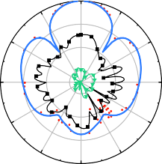300

270

240

210

330

210

180

0

-20

-40

-60

180

150

30

150

120

60

90

120

the filtering antenna is fabricated, and the measured |S*dd*21| is 41 dB with the peak gain of 10.5 dBi. With the designed filtering antenna element, a novel array is developed by sharing the radiating patches. The designed array with the same size as the conventional

1 2 array has a smaller element spacing, thus resulting in the lower sidelobe level. The array prototype is fabricated and measured. The overall isolation related to two kinds of the polarized ports in the array itself is proposed, and the measured *SddVH* of the improved fil- tering antenna array is 41.1 dB. As a result, the proposed filtering array is of good radiation and filtering performance, which is good candidate for the base station MIMO array in 5G applications.

—

×

Sim. co-pol  Sim. x-pol

Declaration of Competing Interest

Mea. co-pol  Mea. x-pol

Fig. 30. Simulated and measured normalized radiation patterns in E-plane and H- plane of the array II at 3.65 GHz for *x* polarized feeding ports and *y* polarization feeding ports.

The authors declare that they have no known competing finan- cial interests or personal relationships that could have appeared to influence the work reported in this paper.

10

0

Realized Gain(dBi)

-10

-20

-30

-40

-150 -100 -50 0 50 100 150

 (deg)



10

0

Sim. Array I Sim. Array II

Realized Gain (dBi)

-10

-20

-30

-40



Mea. Array I Mea. Array II

-150 -100 -50 0 50 100 150

 (deg)



Acknowledgments

This work was supported by the National Key Research and Development Program of China (No. 2021YFA1401001).

Appendix

In this section, the isolation between two kinds of polarized ports in the multi-port differential network is derived. Consider a network diagram with 2*n* ports (*n* is even) shown in Fig. 32. In this

network, 2*n* ports are successively called as *P*1+ ; *P*1— ; *P*2+ ; *P*2— ; ··· ;

*Pn*+ ; *Pn*— . Assume that the port *Pi*+ and *Pi*— form a differential port

*Di* (*i* = 1, 2, 3, .. ., *n*). In this scenario, there are *n* differential ports

Fig. 31. Radiation pattern in H-plane of the arrays I and II at 3.65 GHz for *x*

polarization. (a) Simulation. (b) Measurement.

compared with the array I. The use of the extra pair of the differen- tial ports doesn’t increase the overall size of the array II and the complexities of the feeding structure. Instead, better polarization isolation can be achieved. To sum up, the improved array has the better radiation performance while remaining the filtering response, compared with the conventional filtering antenna array.

in this network. Without loss of generality, the differential ports *D*1, *D*3, *D*5, .. ., and *Dn*-1 excite *x* polarized wave, and the differential ports *D*2, *D*4, *D*6, .. ., and *Dn* excite *y* polarized wave.

Without loss of generality, we denote *SddHV* and *SddVH* as the total isolation between two kinds of the polarized ports in the array. Here, the port *V* is composed of the all ports which excites *x* polar- ized wave, and the port *H* consists of the all ports which excite *y* polarized wave. From the input port *V* to the output port *H*, one has

Table 1

Performance comparison between reported dual-polarized filtering antenna arrays and proposed array.

Element Spacing (k0)

Operation Band (GHz)/ Fractional Band (%)

Average Gain (dBi)/ Number of Elements

Cross- pol (dB)

PolarizationIsolation (dB)

SuppressionLevel (dB)

Sidelobe (dB)

Size (k3)

0

[2] 0.4 5.05–5.3/4.8 10/(2 × 2) < —24 > 25* > 19 – 1 × 1 × 0.063

0.8 9.6–10.3/7 12/(2 × 2) < —26 > 23* > 14.5 —11 1.9 × 1.9 × 0.12

[5] 0.72 3.43–3.81/10.5 14/(1 × 4) < —19 > 19* > 9 —13 3.25 × 2.25 × 0.38

[8] 0.53 4.96–5.48/10 10.5/(2 × 2) < —22 > 32* > 17.5 —11 1.04 × 1.04 × 0.041

[13] 0.52 3.2–4.02/22.7 9.5/(1 × 3) – > 17* > 20 —12 2.59 × 0.72 × 0.14

[21] 0.7 3.12–3.9/22.2 13.4/(1 × 4) < —15 – > 17.1 —12.5 2.81 × 0.7 × 0.15

[17] 0.54 24.25–29.5/19.5 11.2/(4 × 4) < —20 > 30* > 24 —13 3.13 × 3.13 × 0.16

Array I

Array II

0.91 3.53–4.06/14 13.2/(1 × 2) < —27 > 39.8 > 24.1 —12.36 2.07 × 1.22 × 0.038

0.44 13.1/improved (1 × 2) < —26 > 41.1 > 19.7 —18.11

aThe ‘*’ in Table 1 means that the measured polarization isolation takes the effect of the power divider into account.

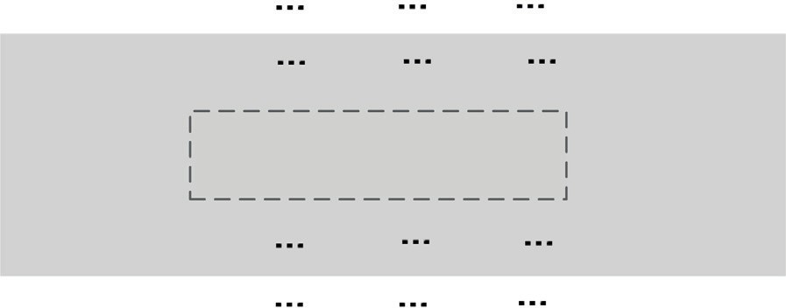

*a*1 *b*1 *a*2 *b*2 *a*3 *b*3

*P*1 *P*2 *P*3

*aj bj*

*Pj*

*ak bk*

*a*(*n* 1) *b*(*n* 1) *an*

*P*(*n* 1)

*bn*

*Pk*

*Pn*

*D D*

1 2

**2*N*-port Network**

***N*-port Differential Network**

*D*

*n*-1

*D*

*n*

*P*1 *P*2 *P*3

*Pj*

*bj*

*Pk*

*bk*

*P*(*n* 1)

*Pn*

*a*1 *b*1 *a*2 *b*2 *a*3 *b*3

*aj*

*ak*

*a*(*n* 1) *b*(*n* 1) *an*

*bn*

Fig. 32. 2*n*-port network corresponding to *n*-port differential network schematic diagram.

8>< *V* +/*n*, *i* = 1+, 3+, ·· · , (*n* — 1)+

References

1. [J. Qian, F. Chen, Y. Ding, H. Hu, Q. Chu, A wide stopband filtering patch antenna](http://refhub.elsevier.com/S2215-0986(23)00152-0/h0005) [and its application in MIMO system, IEEE Trans. Antennas and Propag. 67 (1)](http://refhub.elsevier.com/S2215-0986(23)00152-0/h0005) [(2019) 654–658](http://refhub.elsevier.com/S2215-0986(23)00152-0/h0005).
2. [C.X. Mao, S. Gao, Y. Wang, Q. Luo, Q.X. Chu, A shared-aperture dual-band dual-](http://refhub.elsevier.com/S2215-0986(23)00152-0/h0010) [polarized filtering-antenna-array with improved frequency response, IEEE](http://refhub.elsevier.com/S2215-0986(23)00152-0/h0010) [Trans. Antennas Propag. 65 (4) (2017) 1836–1844](http://refhub.elsevier.com/S2215-0986(23)00152-0/h0010).
3. [K.R. Xiang, F.C. Chen, Q. Tan, Q.X. Chu, High-selectivity filtering patch antennas](http://refhub.elsevier.com/S2215-0986(23)00152-0/h0015) [based on multipath coupling structures, IEEE Trans. Microw. Theory Technol.](http://refhub.elsevier.com/S2215-0986(23)00152-0/h0015) [69 (4) (2021) 2201–2210](http://refhub.elsevier.com/S2215-0986(23)00152-0/h0015).
4. [C. Lin, S. Chung, A filtering microstrip antenna array, IEEE Trans. Microw.](http://refhub.elsevier.com/S2215-0986(23)00152-0/h0020) [Theory Technol. 59 (11) (2011) 2856–2863](http://refhub.elsevier.com/S2215-0986(23)00152-0/h0020).
5. [C. Hua, R. Li, Y. Wang, Y. Lu, Dual-Polarized filtering antenna with printed](http://refhub.elsevier.com/S2215-0986(23)00152-0/h0025) [Jerusalem-cross radiator, IEEE Access 6 (2018) 9000–9005](http://refhub.elsevier.com/S2215-0986(23)00152-0/h0025).
6. [H. Hu, F. Chen, J. Qian, Q. Chu, A differential filtering microstrip antenna array](http://refhub.elsevier.com/S2215-0986(23)00152-0/h0030) [with intrinsic common-mode rejection, IEEE Trans. Antennas Propag. 65 (12)](http://refhub.elsevier.com/S2215-0986(23)00152-0/h0030) [(2017) 7361–7365](http://refhub.elsevier.com/S2215-0986(23)00152-0/h0030).

*ai* = —*V* +/*n*, *i* = 1—, 3—, ··· , (*n* — 1)—

>:

0 , *else*

Therefore, the *SddHV* can be solved as

## (A-1)

1. [Z.H. Jiang, D.H. Werner, A compact, wideband circularly polarized co-designed](http://refhub.elsevier.com/S2215-0986(23)00152-0/h0035) [filtering antenna and its application for wearable devices with low SAR, IEEE](http://refhub.elsevier.com/S2215-0986(23)00152-0/h0035) [Trans. Antennas Propag. 63 (9) (2015) 3808–3818](http://refhub.elsevier.com/S2215-0986(23)00152-0/h0035).
2. [C.X. Mao, S. Gao, Y. Wang, F. Qin, Q.X. Chu, Multimode resonator-fed dual-](http://refhub.elsevier.com/S2215-0986(23)00152-0/h0040) [polarized antenna array with enhanced bandwidth and selectivity, IEEE Trans.](http://refhub.elsevier.com/S2215-0986(23)00152-0/h0040)

*SddHV*

*b*2+ —*b*2— +*b*4+ —*b*4— +···+*bn*+ —*bn*—

*a*1+ —*a*1— +*a*3+ —*a*3— +···+*a*(*n*—1)+ —*a*(*n*—1)—

=

1

[Antennas Propag. 63 (12) (2015) 5492–5499](http://refhub.elsevier.com/S2215-0986(23)00152-0/h0040).

1. [D.-S. La, J.-H. Zhao, S.-M. Chen, C.-X. Zhang, M.-J. Qu, J.-W. Guo, Dual-band](http://refhub.elsevier.com/S2215-0986(23)00152-0/h0045) [omnidirectional coupled-fed monopolar filtering antenna, Int. J. Eng. Sci.](http://refhub.elsevier.com/S2215-0986(23)00152-0/h0045)

= *a*1+ —*a*1— +*a*3+ —*a*3— +···+*a*(*n*—1)+ —*a*(*n*—1)— ·

[*a*1+ (*S*2+ 1+ — *S*2— 1+ + *S*4+ 1+ — *S*4— 1+ +· · · + *Sn*+ 1+ — *Sn*— 1+ )

+*a*1— (*S*2+ 1— — *S*2— 1— + *S*4+ 1— — *S*4— 1— +· · · + *Sn*+ 1— — *Sn*— 1— )+· · ·

+*an*+ (*S*2+ *n*+ — *S*2— *n*+ + *S*4+ *n*+ — *S*4— *n*+ +· · · + *Sn*+ *n*+ — *Sn*— *n*+ )

+*an*— (*S*2+ *n*— — *S*2— *n*— + *S*4+ *n*— — *S*4— *n*— +· · · + *Sn*+ *n*— — *Sn*— *n*— )]

= *n* [(*S*2+ 1+ — *S*2— 1+ + *S*4+ 1+ — *S*4— 1+ +· · · + *Sn*+ 1+ — *Sn*— 1+ )

1

—(*S*2+ 1— — *S*2— 1— + *S*4+ 1— — *S*4— 1— +· · · + *Sn*+ 1— — *Sn*— 1— )+· · ·

+(*S*2+ *n*+ — *S*2— *n*+ + *S*4+ *n*+ — *S*4— *n*+ + ··· + *Sn*+ *n*+ — *Sn*— *n*+ )

—(*S*2+ *n*— — *S*2— *n*— + *S*4+ *n*— — *S*4— *n*— + ··· + *Sn*+ *n*— — *Sn*— *n*— )]

## (A-2)

[Technol. 35 (2022) 101188](http://refhub.elsevier.com/S2215-0986(23)00152-0/h0045).

1. [W.J. Yang, Y.M. Pan, X.Y. Zhang, A single-layer low-profile circularly polarized](http://refhub.elsevier.com/S2215-0986(23)00152-0/h0050) [filtering patch antenna, IEEE Antennas Wirel. Propag. Lett. 20 (4) (2021) 602–](http://refhub.elsevier.com/S2215-0986(23)00152-0/h0050)

[606](http://refhub.elsevier.com/S2215-0986(23)00152-0/h0050).

1. [J.F. Qian, F.C. Chen, Q.X. Chu, Q. Xue, M.J. Lancaster, A novel electric and](http://refhub.elsevier.com/S2215-0986(23)00152-0/h0055) [magnetic gap-coupled broadband patch antenna with improved selectivity](http://refhub.elsevier.com/S2215-0986(23)00152-0/h0055) [and its application in MIMO system, IEEE Trans. Antennas Propag. 66 (10)](http://refhub.elsevier.com/S2215-0986(23)00152-0/h0055) [(2018) 5625–5629](http://refhub.elsevier.com/S2215-0986(23)00152-0/h0055).
2. [Y.M. Pan, P.F. Hu, X.Y. Zhang, S.Y. Zheng, A low-profile high-gain and wideband](http://refhub.elsevier.com/S2215-0986(23)00152-0/h0060) [filtering antenna with metasurface, IEEE Trans. Antennas Propag. 64 (5) (2016)](http://refhub.elsevier.com/S2215-0986(23)00152-0/h0060) [2010–2016](http://refhub.elsevier.com/S2215-0986(23)00152-0/h0060).
3. [K. Xue, D. Yang, C. Guo, H. Zhai, H. Li, Y. Zeng, A dual-polarized filtering base-](http://refhub.elsevier.com/S2215-0986(23)00152-0/h0065) [station antenna with compact size for 5G applications, IEEE Antennas Wirel.](http://refhub.elsevier.com/S2215-0986(23)00152-0/h0065) [Propag. Lett. 19 (8) (2020) 1316–1320](http://refhub.elsevier.com/S2215-0986(23)00152-0/h0065).
4. [Y. Li, Z. Zhao, Z. Tang, Y. Yin, Differentially-fed, dual-band dual-polarized](http://refhub.elsevier.com/S2215-0986(23)00152-0/h0070) [filtering antenna with high selectivity for 5G sub-6 GHz base station](http://refhub.elsevier.com/S2215-0986(23)00152-0/h0070)

Similarly, from the input port *H* to the output port *V*, *SddVH* can be expressed as

[applications, IEEE Trans. Antennas Propag. 68 (4) (2020) 3231–3236](http://refhub.elsevier.com/S2215-0986(23)00152-0/h0070).

1. J. Zeng, C. Wang, S. Zheng, X. Wang, A wideband filtering patch antenna array based on hybrid feeding scheme, in: 2019 International Symposium on

*SddVH* = 1 h(*S*1+ 2+ —

*n*

*S*1— 2+ +

*S*3+ 2+ — ··· +

*S*(*n*—1)+ 2+ —

*S*(*n*—1)— 2+ )

Antennas and Propagation (ISAP) (2019).

1. [M. Li, S. Tian, M.C. Tang, L. Zhu, A compact low-profile hybrid-mode patch](http://refhub.elsevier.com/S2215-0986(23)00152-0/h0080) [antenna with intrinsically combined self-decoupling and filtering properties,](http://refhub.elsevier.com/S2215-0986(23)00152-0/h0080)

—(*S*1+ 2— — *S*1— 2— + *S*3+ 2— —· · · + *S*(*n*—1)+ 2— — *S*(*n*—1)— 2— ) + ···

+(*S*1+ *n*+ — *S*1— *n*+ + *S*3+ *n*+ —· · · + *S*(*n*—1)+ *n*+ — *S*(*n*—1)— *n*+ )

i

—(*S*1+ *n*— — *S*1— *n*— + *S*3+ *n*— —· · · + *S*(*n*—1)+ *n*— — *S*(*n*—1)— *n*— )

## (A-3)

[IEEE Trans. Antennas Propag. 70 (2) (2022) 1511–1516](http://refhub.elsevier.com/S2215-0986(23)00152-0/h0080).

1. [Y. Zhang, W. Yang, Q. Xue, J. Huang, W. Che, Broadband dual-polarized](http://refhub.elsevier.com/S2215-0986(23)00152-0/h0085) [differential-fed filtering antenna array for 5G millimeter-wave applications,](http://refhub.elsevier.com/S2215-0986(23)00152-0/h0085) [IEEE Trans. Antennas Propag. 70 (3) (2022) 1989–1998](http://refhub.elsevier.com/S2215-0986(23)00152-0/h0085).
2. [W. Yang, M. Xun, W. Che, W. Feng, Y. Zhang, Q. Xue, Novel compact high-gain](http://refhub.elsevier.com/S2215-0986(23)00152-0/h0090) [differential-fed dual-polarized filtering patch antenna, IEEE Trans. Antennas](http://refhub.elsevier.com/S2215-0986(23)00152-0/h0090) [Propag. 67 (12) (2019) 7261–7271](http://refhub.elsevier.com/S2215-0986(23)00152-0/h0090).

In the array II, some ports are reused, which is different from the conventional differential-fed arrays. As shown in Fig. 26, there are 6 differential ports, i.e., *D*1, *D*2, *D*3, *D*4, *D*5 and *D*6. The differential ports *D*1 ~ *D*4 are same as those of the array I. The *D*5 is composed of port *P*9 and *P*10. Besides, the ports *P*4 and *P*6 also form a differen- tial port *D*6 for the reuse. The port *V* composed of the differential ports *D*1, *D*3 and *D*5 excites *x* polarized wave, while the port *H* con- sisting of the differential ports *D*2, *D*4 and *D*6 excites *y* polarized wave. In this scenario, we have

1. [X. Zhang, Y. Zhang, Y. Pan, W. Duan, Low-Profile dual-band filtering patch](http://refhub.elsevier.com/S2215-0986(23)00152-0/h0095) [antenna and its application to LTE MIMO system, IEEE Trans. Antennas Propag.](http://refhub.elsevier.com/S2215-0986(23)00152-0/h0095) [65 (1) (2017) 103–113](http://refhub.elsevier.com/S2215-0986(23)00152-0/h0095).
2. [Y. Zhang, X. Zhang, L. Ye, Y. Pan, Dual-band base station array using filtering](http://refhub.elsevier.com/S2215-0986(23)00152-0/h0100) [antenna elements for mutual coupling suppression, IEEE Trans. Antennas](http://refhub.elsevier.com/S2215-0986(23)00152-0/h0100) [Propag. 64 (8) (2016) 3423–3430](http://refhub.elsevier.com/S2215-0986(23)00152-0/h0100).
3. [Y. Li, Z. Zhao, Z. Tang, Y. Yin, Differentially-fed, wideband dual-polarized](http://refhub.elsevier.com/S2215-0986(23)00152-0/h0105) [filtering antenna with novel feeding structure for 5G sub-6 GHz base station](http://refhub.elsevier.com/S2215-0986(23)00152-0/h0105) [applications, IEEE Access 7 (2019) 184718–184725](http://refhub.elsevier.com/S2215-0986(23)00152-0/h0105).
4. [J.A. Liu, Y.F. Cao, X.Y. Zhang, A pattern-reconfigurable filtering patch antenna](http://refhub.elsevier.com/S2215-0986(23)00152-0/h0110) [using embedded resonators and switchable elements, IEEE Trans. Antennas](http://refhub.elsevier.com/S2215-0986(23)00152-0/h0110) [Propag. 70 (5) (2022) 3828–3833](http://refhub.elsevier.com/S2215-0986(23)00152-0/h0110).
5. [Q. Wu, Y. Shi, L. Li, P. Gas, Wideband dual-polarized differential-fed filtering](http://refhub.elsevier.com/S2215-0986(23)00152-0/h0115)

*ai* =

8><

*V* +/4, *i* = 2, 6

—*V* +/4, *i* = 4, 8

## (A-4)

[microstrip patch antenna with high suppression and wide stopband, Int. J. RF](http://refhub.elsevier.com/S2215-0986(23)00152-0/h0115) [Microw. Comput.-Aided Eng. 2023 (2023) 1–10](http://refhub.elsevier.com/S2215-0986(23)00152-0/h0115).

1. [K. Li, Y. Shi, Filtering antenna synthesis based on characteristic mode theory,](http://refhub.elsevier.com/S2215-0986(23)00152-0/h0120)

>: 0 , *i* = 1, 3, 5, 7, 9, 10

Furthermore, the *SddVH* can be obtained as

*S b*1—*b*3+*b*5—*b*7—*b*9+*b*10 *a*2—*a*4+*a*6—*a*8

*ddVH* =

[IEEE Trans. Antennas Propag. 70 (5) (2022) 3308–3319](http://refhub.elsevier.com/S2215-0986(23)00152-0/h0120).

1. [D.M. Pozar, Microwave Engineering, 3nd ed.,](http://refhub.elsevier.com/S2215-0986(23)00152-0/h0125) [Wiley, New York, NY, USA, 1998,](http://refhub.elsevier.com/S2215-0986(23)00152-0/h0125)

[pp. 293–297](http://refhub.elsevier.com/S2215-0986(23)00152-0/h0125).

1. [D. Ahn, J.S. Park, C.S. Kim, J. Kim, Y. Qian, T. Itoh, A design of the low-pass filter](http://refhub.elsevier.com/S2215-0986(23)00152-0/h0130) [using the novel microstrip defected ground structure, IEEE Trans. Microw.](http://refhub.elsevier.com/S2215-0986(23)00152-0/h0130) [Theory Technol. 49 (1) (2001) 86–93](http://refhub.elsevier.com/S2215-0986(23)00152-0/h0130).

= 4 [(*S*12 — *S*32 + *S*52 — *S*72 — *S*92 + *S*10 2)

1

—(*S*14 — *S*34 + *S*54 — *S*74 — *S*94 + *S*10 4)

+(*S*16 — *S*36 + *S*56 — *S*76 — *S*96 + *S*10 6)

—(*S*18 — *S*38 + *S*58 — *S*78 — *S*98 + *S*10 8)]

(A-5)