

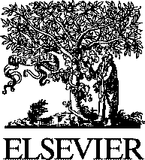Electronic Notes in Theoretical Computer Science

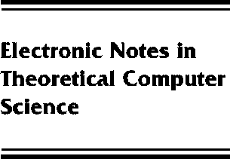[www.elsevier.com/locate/entcs](http://www.elsevier.com/locate/entcs)

Mathematics, Computer Science, Software Engineering

Dick Hamlet

**Abstract**

In this talk I want to examine three ideas: First, the traditional relationship between a science, the mathematics it uses, and the engineering for which it is the basis. Second, the role of mathematics in the practice of software engineering, which is sometimes called “formal methods.” And finally, the role of theory in computer science, and the impatience of practical people with theoretical knowledge. These three ideas turn on the first of them, since it defines the “scientific” worldview that the study of software naturally assumes.

1571-0661 *⃝*c Elsevier Ltd Open access under [CC BY-NC-ND license.](http://creativecommons.org/licenses/by-nc-nd/3.0/)

10.1016/S1571-0661(05)80044-1