[Egyptian Journal of Basic and Applied Sciences 4 (2017) 350–357](http://dx.doi.org/10.1016/j.ejbas.2017.04.004)

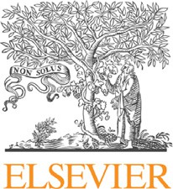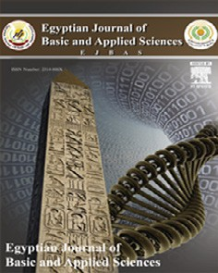

Contents lists available at [ScienceDirect](http://www.sciencedirect.com/science/journal/2314808X)

Egyptian Journal of Basic and Applied Sciences

journal homepage: [www.elsevier.com/locate/ejbas](http://www.elsevier.com/locate/ejbas)

Full Length Article

Mitigating potential of *Ginkgo biloba* extract and melatonin against hepatic and nephrotoxicity induced by Bisphenol A in male rats



Mayssaa M. Wahby a,⇑, Zaynab M. Abdallah a, Heba M. Abdou b, Mokhtar I. Yousef c, Al-Sayeda A. Newairy a

a *Faculty of Science, Biochemistry Department, Alexandria University, Alexandria 21311, Egypt*

b *Faculty of Science, Zoology Department, Alexandria University, Alexandria 21311, Egypt*

c *Department of Environmental Studies, Institute of Graduate Studies and Research, Alexandria University, Alexandria 21526, Egypt*

## a r t i c l e i n f o

*Article history:*

Received 1 February 2017

Received in revised form 14 April 2017 Accepted 29 April 2017

Available online 15 May 2017

*Keywords:*

Bisphenol A

*Ginkgo biloba* extract Melatonin

Lipid peroxidation Antioxidant enzymes Histopathological analysis

## a b s t r a c t

Bisphenol A is one of the anthropogenic chemicals produced worldwide, currently released into the envi- ronment and causes endocrine-disruption. The largest environmental compartments of BPA are abiotic associated with water and suspended solids that becomes an integrated part of the food chain. The pre- sent study aimed to examine the possible protective role of *Ginkgo biloba* extract (GBE), melatonin and their combination against BPA-induced liver and kidney toxicity of male rats. Fifty rats were divided into five equal groups: control, BPA, BPA plus GBE, BPA plus melatonin and BPA plus GBE plus melatonin. The elevated activities of plasma ALT and AST in addition to increased levels of urea and creatinine concomi- tant with the decreased total plasma protein could reflect the injurious effect of BPA. Liver and kidney levels of TBARS were significantly increased, while GSH, SOD and GPX were decreased in BPA-treated rats. Also, CAT and GST activities were significantly disrupted in the liver and kidney of rats treated with BPA.

Moreover, BPA significantly increased the proinflammatory cytokine TNF-a in the liver and kidney tis-

sues. The histopathological analysis confirmed these results. All the previous alterations in the liver and kidney could be ameliorated when BPA-treated rats were co-administrated either with GBE, mela- tonin or their combination. These natural substances could exhibit protective effects against BPA- induced hepato- and nephrotoxicity owing to their antioxidative and anti-inflammatory potentials.

© 2017 Mansoura University. Production and hosting by Elsevier B.V. This is an open access article under

the CC BY-NC-ND license (<http://creativecommons.org/licenses/by-nc-nd/4.0/>).

1. Introduction

Bisphenol A (2,2-bis (4-hydroxyphenyl) propane, (BPA) is an environmental chemical contaminant that is widely used in the manufacture of polycarbonate plastics and epoxy resins [1]. Also, BPA is used in the production of thermal stabilizers, plasticides, paints and dental materials [2]. Human extensive exposure to BPA through the food chain is widespread because BPA is released by food and beverage containers [3]. High doses of BPA altered liver weights and decreased the viability of rat hepatocytes [4]. BPA is a nephrotoxic agent due to the accumulation of its toxic metabolites and inability of the kidney to eliminate those metabo- lites [5]. Also, BPA induce the formation of reactive oxygen species (ROS) which cause tissue injury in the liver, kidney and other organs [6]. Furthermore, the low doses of BPA generate ROS by means of decreasing the activities of the antioxidant enzymes and increasing lipid peroxidation thereby causing oxidative stress [7]. Nowadays, natural supplements are used in the treatment of

* Corresponding author.

*E-mail address:* [dr.mayssaamoharm@hotmail.com](mailto:dr.mayssaamoharm@hotmail.com) (M.M. Wahby).

many diseases either by improving the efficacy of the drug or by minimizing the toxic side effects [8].

*Ginkgo biloba* leaf extract (GBE) is one of the most widely used herbal supplements in the traditional Chinese medicine for cen- turies [9]. Several investigators reported that *G. biloba* polysaccha- rides (GBP) have different biological actions, such as anti- oxidation, anti-inflammation, immunomodulation and anti-tumor [10]. It could protect the liver from an induced injury by means of reducing lipid peroxidation and GSH depletion concomitant with enhancing gene expression of the antioxidant enzymes [11]

and inhibiting TNF-a expression [12]. *In vivo* results showed that

GBL-treatment is a potent protector against uranium-induced tox- icity [13].

Melatonin (5-methoxy-N-acetyltryptamine) is natural hormone secreted mainly from the pineal gland [3]. Also, other organs such as eyes, brain, gut, skin and immune cells can synthesize melatonin [14]. Melatonin is also synthesized in the gastrointestinal tract [15]. Melatonin participates in the regulation of many physiologi- cal processes. Melatonin can reduce oxidative stress via stimulat- ing the activities of the anti-oxidative enzymes; superoxide dismutase (SOD) and glutathione peroxidase (GSH-Px) [16]. Addi-

<http://dx.doi.org/10.1016/j.ejbas.2017.04.004>

2314-808X/© 2017 Mansoura University. Production and hosting by Elsevier B.V.

This is an open access article under the CC BY-NC-ND license (<http://creativecommons.org/licenses/by-nc-nd/4.0/>).

tionally, melatonin can protect DNA, protein and lipids [17]. More- over, melatonin reduces the level of proinflammatory cytokines, such as tumor necrosis factor alpha (TNF-a), inteleukin-6 (IL-6) and interleukin 1beta (IL-1b) [18]. Consequently, the present study

was carried out to evaluate the protective effect of *G. biloba* extract and/or melatonin against Bisphenol A-induced hepatotoxicity and nephrotoxicity in adult male rats. This is accomplished by the assessment of liver and kidney function tests, apoptotic marker

(TNF-a), lipid peroxidation end product (TBARS), enzymatic and

non-enzymatic antioxidants in addition to histological examina- tion of the liver and kidney tissues.

1. Materials and methods
   1. *Experimental animals*

Adult male rats weighing (180–200 g) were used in the current study. They were obtained from the animal house, Faculty of Med- icine, Alexandria University, Egypt. Rats were housed in stainless steel cages and maintained at 25–28 °C with 12-h light-dark cycle. Animals were allowed to food and water *ad libitum*.

* 1. *Experimental design*

Rats were randomly distributed into five groups as follows: Control group; rats were used as negative control. Bisphenol A (BPA)-treated group (positive control); rats were orally treated with BPA at a dose of 40 mg/kg body weight [19] and [20]. Bisphe- nol A + *G. biloba* extract (BPA + GBE)-treated group; rats of this group were treated with BPA (40 mg/kg b. w.) and GBE used as 100 mg/kg b. w. [21]. Bisphenol A + melatonin (BPA + Mel)- treated group; rats were treated with BPA (40 mg/kg b. w.) and Mel of a dose 10 mg/kg b. w. [22] Bisphenol A + *G. biloba* extract

+ melatonin (BPA + GBE + Mel)-treated group; rats were treated with a combination of BPA, GBE and Mel. All the selected doses were orally and daily administered for 70 days.

* 1. *Blood collection*

At the end of the experimental period, rats were fasted for 12 h then they were scarified by decapitation under diethyl ether anes- thesia. Blood samples were collected by heart puncture in tubes containing EDTA (anti-coagulant) and placed immediately on ice.

Plasma was obtained by centrifugation of samples at 860 × *g* for 20 min and stored at —80 °C until used for analyses.

* 1. *Tissue preparation*

Livers and kidneys were excised and washed using saline solu- tion (0.9%). Parts from the livers and kidneys of each group were fixed in 10% formalin for histological examination. Other parts were minced and homogenized in ice-cold sodium phosphate buf- fer (0.01 M, pH 7.4) containing 1.15% KCl (10% w/v) using a poly-

tron (Tekmar model TR-10, West Germany) homogenizer. The homogenate was centrifuged at 10,000 × *g* for 20 min at 4 °C using high speed cooling centrifuge (Universal 32 R, Germany). The resultant supernatants were used for the different investigations.

* 1. *Assessment of the biochemical parameters*

Total plasma protein was determined using biuret reaction [23]. Urea and creatinine plasma levels were also measured [24] and [25], respectively. Plasma and hepatic Aspartate aminotransferase (AST; EC 2.6.1.1) activity was assayed [26]. While, plasma and hep- atic alanine aminotransferase (ALT; EC 2.6.1.2) activity was

assayed using the methods of International Federation of Clinical Chemistry [27]. Glutathione peroxidase (GPX; EC. 1.1.1.9) activity was assayed in hepatic tissues [28]. Also, reduced glutathione level was determined in both livers and kidneys [29]. Hepatic and renal Glutathione-S-transferase (GST, EC 2.5.1.18) activities were assayed using p-nitrobenzyl chloride in 95% ethanol as a substrate [30]. Moreover, Superoxide dismutase (SOD; EC 1.15.1.1) activity was estimated in Hepatic and renal tissues [31]. Also, Catalase activity (CAT; EC1.11.1.6) was assayed in livers and kidneys [32]. The level of the lipid peroxidation end products, Malondialdehyde, which react with thiobarbituric acid-reactive substances (TBARS), was also evaluated in both livers and kidneys [33]. The pro-

inflammatory cytokine TNF-a (K0331196) level was quantified

by the enzyme-linked immunosorbent assay (ELISA) using ELISA kit specific for rat cytokines (Biosource International, Nivelles, Belgium).

* 1. *Histological section preparation*

Liver and kidney sections were fixed in formalin (10%), treated with alcohol and xylol then embedded in paraffin and sectioned at thickness of 4–6 lm. These sections were stained with Haema- toxylin and Eosin stain (H&E, X 400) for the examination of

histopathological changes [34].

* 1. *Statistical analysis*

Results were reported as means ± SE and data were statistically analyzed [35]. The statistical significant difference in values of the experimental animals was calculated by (F) test at 5% significance level. All parameters were calculated using the general linear model produced by Statistical Analysis Systems Institute [36]. Beside, Duncan’s New Multiple Range Test was used in assessment of the significant differences between groups. Values of *P* < 0.05 were considered statistically significant.

1. Results
   1. *Assessment of biochemical parameters*

The current study indicated that plasma activities of ALT and AST were significantly (*p* < 0.05) increased while hepatic ALT and AST specific activities were significantly (*p* < 0.05) decreased in BPA-treated group compared to the control. On the other hand, plasma ALT and AST activities were significantly (*P* < 0.05) decreased whereas hepatic ALT and AST specific activities were sig- nificantly (*p* < 0.05) increased in groups treated with BPA + GBE, BPA + Mel and their combination compared to BPA-treated ones (Table 1).

It was observed that hepatic GST and CAT activities were signif- icantly (*p* < 0.05) increased in BPA-treated rats when compared to control, while significantly (*p* < 0.05) decreased after BPA co- treatment with GBE, Mel and their combination in comparison to BPA-treated ones (Table 1). Liver activities of GPx and SOD were significantly (*p* < 0.05) decreased in BPA-treated group as com- pared to control. On the contrary, treatment with GBE, Mel and their combination together with BPA resulted in significant (*p* < 0.05) increases in the activities of these enzymes (Table 1).

In addition, our results indicated that renal activities of GST, SOD and CAT showed significant (*p* < 0.05) decreases with BPA treatment compared to control. While, these enzyme activities were significantly (*p* < 0.05) increased when BPA co-administered with GBE, Mel and their combination (Table 1).

Furthermore, the results revealed that BPA induction caused significant (*p* < 0.05) increases in the plasma urea and creatinine

Table 1

The effect of BPA, GBE and melatonin administration on the liver function tests and the activities of the antioxidant enzymes.

|  |  |  |  |  |  |  |
| --- | --- | --- | --- | --- | --- | --- |
| Parameter | Experimental groups |  | | | | |
|  | Control | BPA | BPA + GBE | BPA + Mel | BPA + GBE + Mel |  |
| *Plasma*  ASTA | 79.53 ± 3.55a | 177.14 ± 8.22b | 68.5 ± 6.09a | 73.99 ± 3.91a | 60.6 ± 4.6c |  |
| ALTA | 23 ± 1.51a | 80.29 ± 1.58b | 19.88 ± 0.88a | 20.29 ± 2.11a | 25 ± 2.16a |  |
| *Hepatic*  ASTB | 105.3 ± 1.5a | 95.20 ± 2.4b | 106 ± 1.8a | 112 ± 2.8a | 112 ± 2.6a |  |
| ALTB | 104.5 ± 1.7a | 69.50 ± 4.6b | 126.7 ± 3.1c | 121 ± 3.1c | 125.8 ± 4.8c |  |
| GSTB | 1.69 ± 0.055a | 2.17 ± 0.066b | 1.649 ± 0.09a | 1.67 ± 0.065a | 1.64 ± 0.092a |  |
| CATB | 291.6 ± 6.4a | 313 ± 4.4b | 269.6 ± 7.46c | 279 ± 5.28a | 294.7 ± 4.08a |  |
| SODB | 1.81 ± 0.04a | 1.07 ± 0.023b | 1.88 ± 0.043a | 1.98 ± 0.059c | 1.99 ± 0.063c |  |
| GPxB | 12.55 ± 0.418a | 4.3 ± 0.31b | 10.9 ± 0.78a | 10.26 ± 0.55c | 9.07 ± 0.792c |  |
| *Renal*  GSTB | 2.73 ± 0.07a | 1.65 ± 0.044b | 2.49 ± 0.13a | 2.69 ± 0.144a | 2.29 ± 0.058c |  |
| SODB | 3.30 ± 0.072a | 2.18 ± 0.093b | 3.26 ± 0.075a | 3.23 ± 0.091a | 2.81 ± 0.08c |  |
| CATB | 332.9 ± 72a | 271 ± 5.2b | 321.8 ± 7.55a | 315.4 ± 4.8a | 304 ± 6.5c |  |

Values are expressed as means ± SE. Mean values within a row not sharing a common superscript letters (a, b, c) were significantly different at *P* < 0.05. A: l/l, B: l/mg protein.

levels compared to the controls. While, the co-administration of GBE, Mel and their combination together with BPA significantly (*p* < 0.05) reduced these elevations (Table 2).

Comparing to control, the hepatic TBARS level was significantly (*p* < 0.05) increased next to BPA-treatment. GBE, Mel and their combination diminished this significant increase that induced by BPA. Conversely, BPA caused significant (*p* < 0.05) decrease in the hepatic GSH level as compared with the control group. However, the co-administration of GBE, Mel and their combination with BPA significantly increased (*p* < 0.05) GSH to control level (Table 2). Similarly, renal TBARS level showed significant (*p* < 0.05) increase in the BPA-induced rats concomitant with significant (*p* < 0.05) decrease in the renal GSH level when both compared with the control. But, co-administration of GBE, Mel and their com- bination attenuated the increase in renal TBARS while caused sig-

nificant (*p* < 0.05) increase in the renal GSH (Table 2).

The level of TNF-a in both livers and kidneys of BPA-treated groups showed significant (*P* 0.05) increase when comparing its level with controls. This increase was diminished after the co- treatment of BPA with GBE, Mel and their combination as in Figs. 1 and 2.

Liver tissues examination of the different experimental groups was illustrated in Fig. 3. Sections of the control group showed nor- mal cellular architecture Fig. 3A with distinct hepatic cells (H), sinusoidal spaces (S) and central vein (C.V). Whereas, liver sections of BPA-induced group indicated remarkable histopathological

alteration as in Fig. 3B1 and B2. This alteration was indicated from the loss of normal hepatocytes architecture, degenerated hepato- cytes (Black Square) with pyknotic nuclei (blue dotted arrows). In addition, hepatocyte vacuolization (black arrow), dilation and hemorrhage of hepatic sinusoids (S) were seen. Also, diffusion of kupffer cells (k) in dilated sinusoids (S) between the hepatocytes as well as lymphocytes aggregation (yellow circle) was observed. Moreover, distention and hemorrhage in the central vein beside dilatation and congestion of the portal veins (green arrow) with inflammatory cellular infiltration (black circle). However, most of the histological alterations induced by BPA were markedly reduced and attenuated in liver sections of rats treated with either BPA

+ GBE, BPA + Mel or BPA + GBE + Mel as shown in Fig. 3C, D & E, respectively.

Histological examination of kidney tissues of the different experimental groups was represented in Fig. 4. Kidney sections of the control group revealed normal cortical architecture with nor- mal glomerular tuft (G), proximal (P) and distal (D) convoluted tubules (Fig. 4A). On the other hand, BPA induced kidneys histopathological changes (Fig. 4B). These changes represented by shrinkage of capillaries in the glomerulus (G) with the capsular space (black arrow), considerable degeneration in the epithelial cells of both proximal and distal tubules (black circle) with pykno- tic nuclei and cellular debris in the renal tubules (red arrow). Co- administration of GBE and/or Mel in combination with BPA showed

Table 2

The effect of BPA, GBE and melatonin administration on the levels of urea, creatinine, TBARS and GSH in the plasma samples and the hepatic and renal extracts of male rats.

|  |  |  |  |  |  |  |
| --- | --- | --- | --- | --- | --- | --- |
| Parameters | Experimental groups |  | | | | |
|  | Control | BPA | BPA + GBE | BPA + Mel | BPA + GBE + Mel |  |
| *Plasma*  UreaA | 44.57 ± 1.15a | 69.7 ± 2.3b | 47 ± 1.175a | 47.57 ± 0.9a | 51.7 ± 0.99c |  |
| CreatinineA | 0.469 ± 0.048a | 1.19 ± 0.033b | 0.589 ± 0.0428a | 0.619 ± 0.042c | 0.749 ± 0.047c |  |
| *Hepatic*  TBARSB | 80.94 ± 1.96a | 117.56 ± 2.31b | 87.53 ± 1.16c | 82.94 ± 2.96a | 91.45 ± 1.11c |  |
| GSHC | 8.025 ± 0.115a | 5.84 ± 0.15b | 7.79 ± 0.1737a | 8.463 ± 0.155a | 7.56 ± 0.306a |  |
| *Renal*  GSHC | 8.68 ± 0.22a | 6.46 ± 0.16b | 9.538 ± 0.2c | 9.625 ± 0.253c | 7.975 ± 0.164c |  |
| TBARSB | 58.76 ± 1.43a | 105.4 ± 1.3b | 57.58 ± 2.11a | 57.7 ± 2.1a | 66.02 ± 2.19c |  |

Values are expressed as means ± SE.

Mean values within a row not sharing a common superscript letters (a, b, c) were significantly different at *P* < 0.05. A: mg/dl, B: nmol/g tissue, C: mmol/g tissue.

2500



**BPA**

**BPA+GBE**

**BPA+Mel**

**Control**

**BPA+GBE+Mel**

**Fold change of color intensity**

2000

1500

1000

500

0

1 2 3 4 5

**Experimental groups**

Fig. 1. Changes in the hepatic level of TNF-a in the adult male rats treated with BPA, BPA + GBE, BPA + Mel and BPA + GBE + Mel.

2500

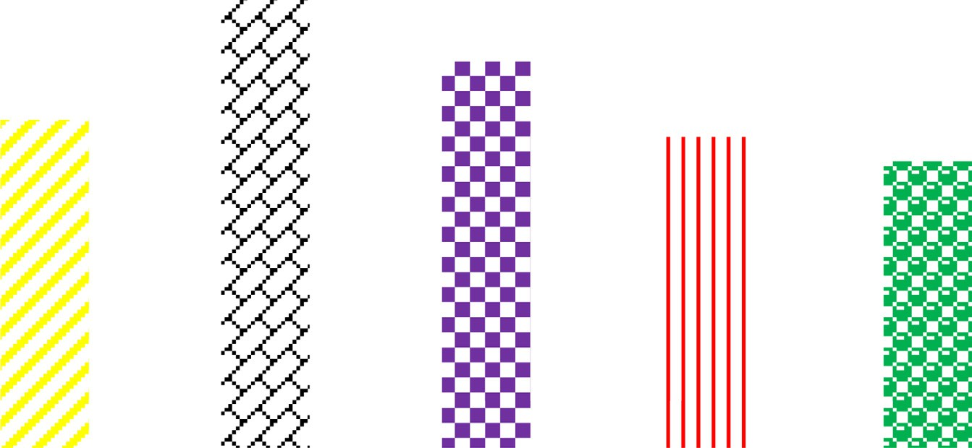

**BPA**

**BPA+GBE**

**Control**

**BPA+Mel**

**BPA+GBE+Mel**

**Fold change of color intensity**

2000

1500

1000

500

0

1 2 3 4 5

# Experimental groups

Fig. 2. Changes in the renal level of TNF-a in the adult male rats treated with BPA, BPA + GBE, BPA + Mel and BPA + GBE + Mel.

evident improvement in the histopathological alterations com- pared with those indicated in BPA-treated group (Fig. 4C, D & E).

1. Discussion

This study was intended to examine the antioxidative effect of GBE and/or Mel against BPA-induced oxidative damage in the liver and kidney tissues of adult male rats. The present data showed that BPA caused significant increases in the plasma AST and ALT activ- ities indicating liver damage. These two enzymes are the most indicative markers of hepatocellular damage [37]. The enhanced activities of the plasma liver markers point out the cellular leakage and the loss of the functional integrity of membrane architecture [38]. The BPA-induced hepatotoxicity was ameliorated after the administration of Mel and/or GBE as indicated from the significant decreases in the hepatic activities of both AST and ALT as shown in. It was reported that GBE ameliorated the toxic effect of CCL4 [39]. Pre-treatment with Mel prior to thioacetamide induction in rats

resulted in the decrease of both AST and ALT activities. Also, mela- tonin tends to restrain liver damage, reserves the integrity of the plasma membranes and hence restores these enzymes [40].

TBARS, GSH, GST, CAT, SOD and GPx are important biomarkers of oxidative damage [41]. Our results indicated the increase in the level of TBARS and the decrease in the GSH level in the BPA- treated rats. The significant increase in the levels of hepatic TBARS was concomitant with significant decrease in the GSH level at a dose of 50 mg/kg BPA [42].

Conversely, our results indicated that the hepatic TBARS level was significantly decreased while hepatic GSH level was signifi- cantly increased in the GBE plus BPA-administered group. Flavo- noids in the GBE can discharge the tissue damage caused by oxygen-derived free radicals consequently reduces lipid peroxida- tion [39].

Moreover, the presence of melatonin with BPA caused signifi- cant decrease in the hepatic TBARS level. A significant decrease in the hepatic TBARS level was observed in melatonin plus lead- treated group [38]. In our study, the treatment with Mel signifi-

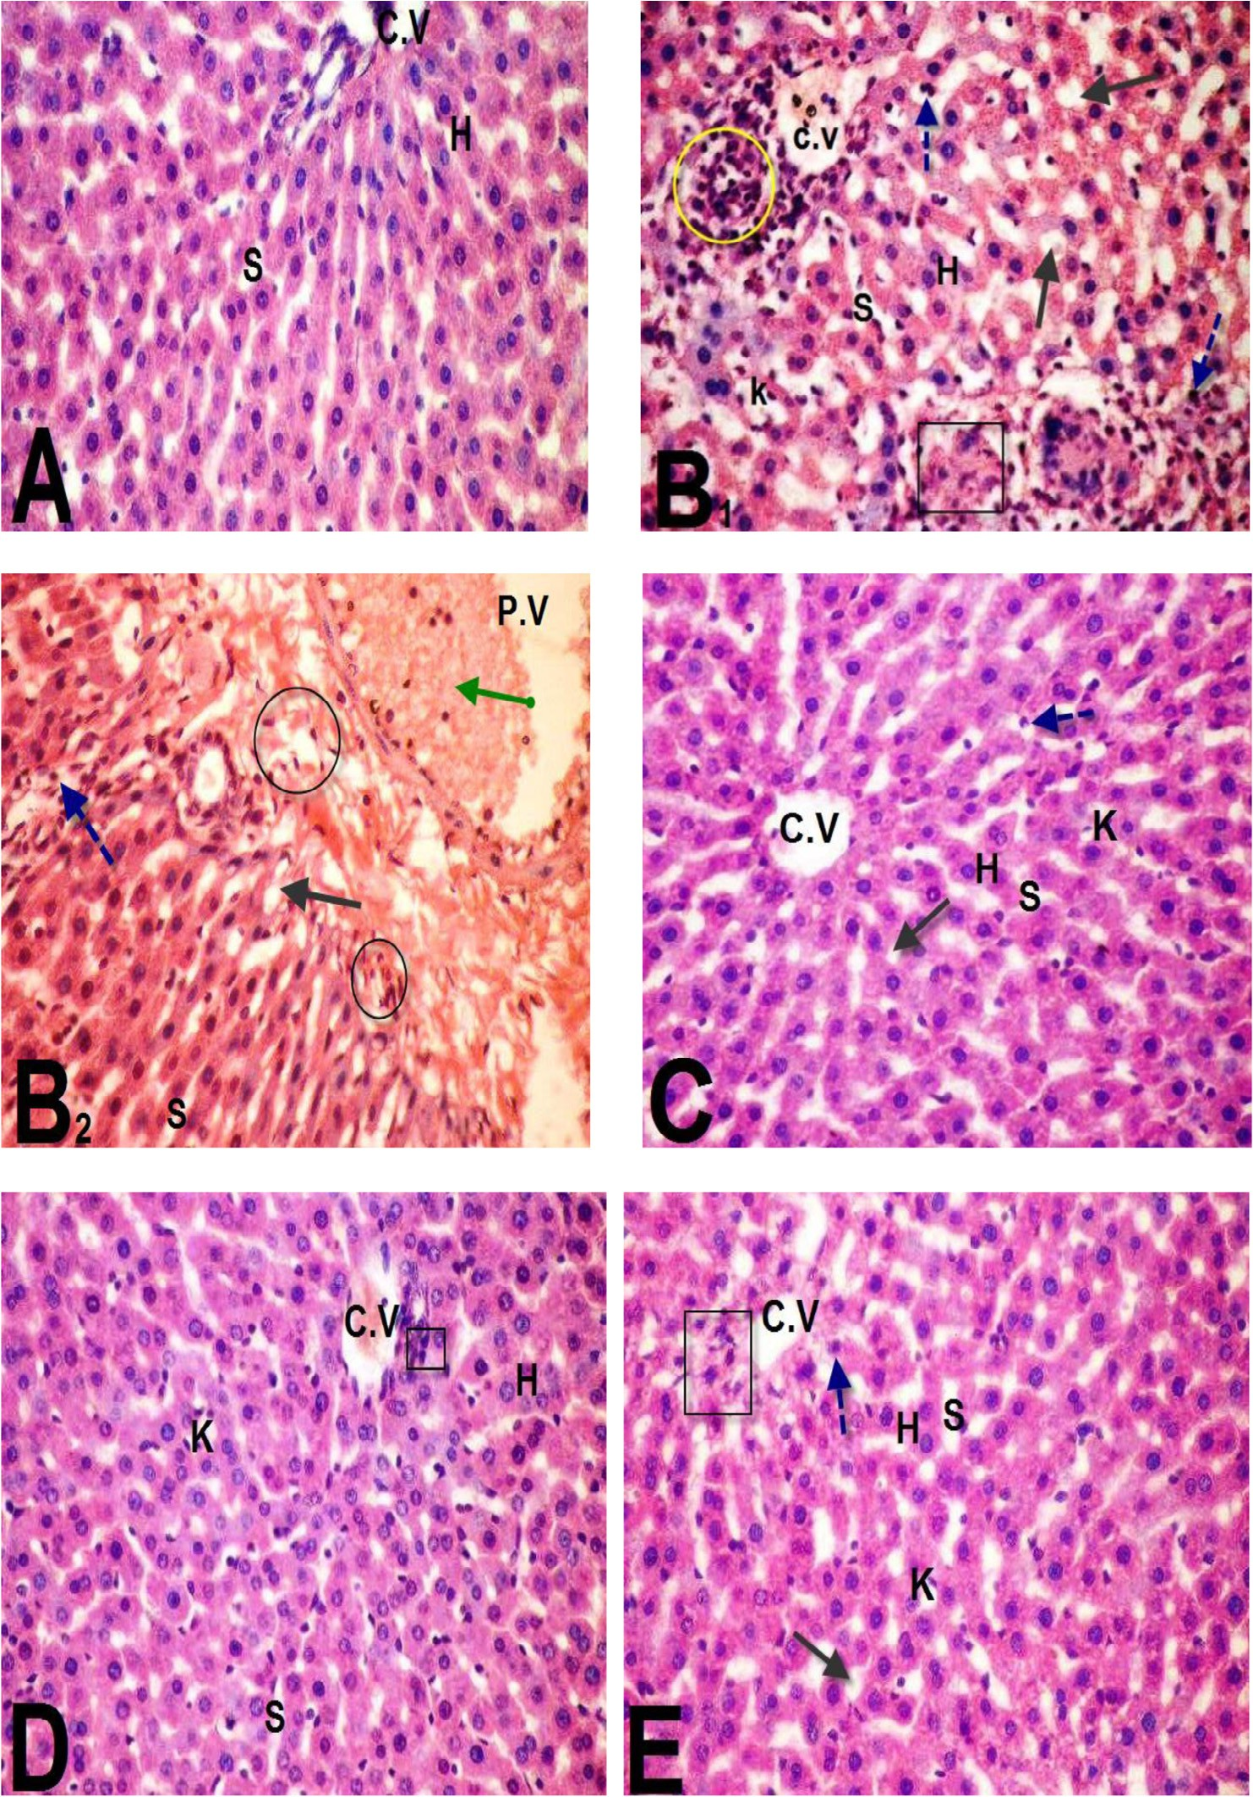

Fig. 3. Microscopic examination of liver sections of rats treated as follow: control group (A), BPA-treated rats (B), BPA + GBE-treated rats (C), BPA + Mel-treated rats (D), BPA

+ GBE + Mel-treated rats (E).

cantly attenuated the decreased level of GSH by BPA [43]. GSH is an essential intracellular hydrophilic antioxidant that participates in the catalytic cycles of many antioxidant enzymes such as glu- tathione peroxidase, glutathione reductase and glutathione-S- transferase [44,45]. The decreases in the specific activities of GPx and SOD in the liver of BPA-treated rats were recorded [42]. Glu- tathione peroxidase catalyzes the dismutation of the superoxide

anion (O—) into hydrogen peroxide (H O ) which is then converted

from the attack of superoxide [47]. However, the treatments of the BPA-intoxicated rats with GBE and/or melatonin ameliorated the oxidative stress. Thus, the hepatic activities of SOD and GPx were significantly increased after GBE or Mel co-treatment with BPA. Previous findings indicated significant increases in the hepatic SOD and GPx activities after administration of either GBE or mela- tonin [48,45]. Our results showed significant increases in the activ-

ities of both hepatic GST and CAT in the BPA-treated rats. GST

2 2 2

into water [42]. In this manner, it effectively removes toxic perox- ides and protects living cells from ROS [46]. In addition, superoxide dismutase protects the mitochondrial lipids, proteins and DNA

activity was significantly increased at the expense of the content of GSH that acts as a catalyst for GST after induction with BPA [49]. When GPx is present at low concentration, it is responsible

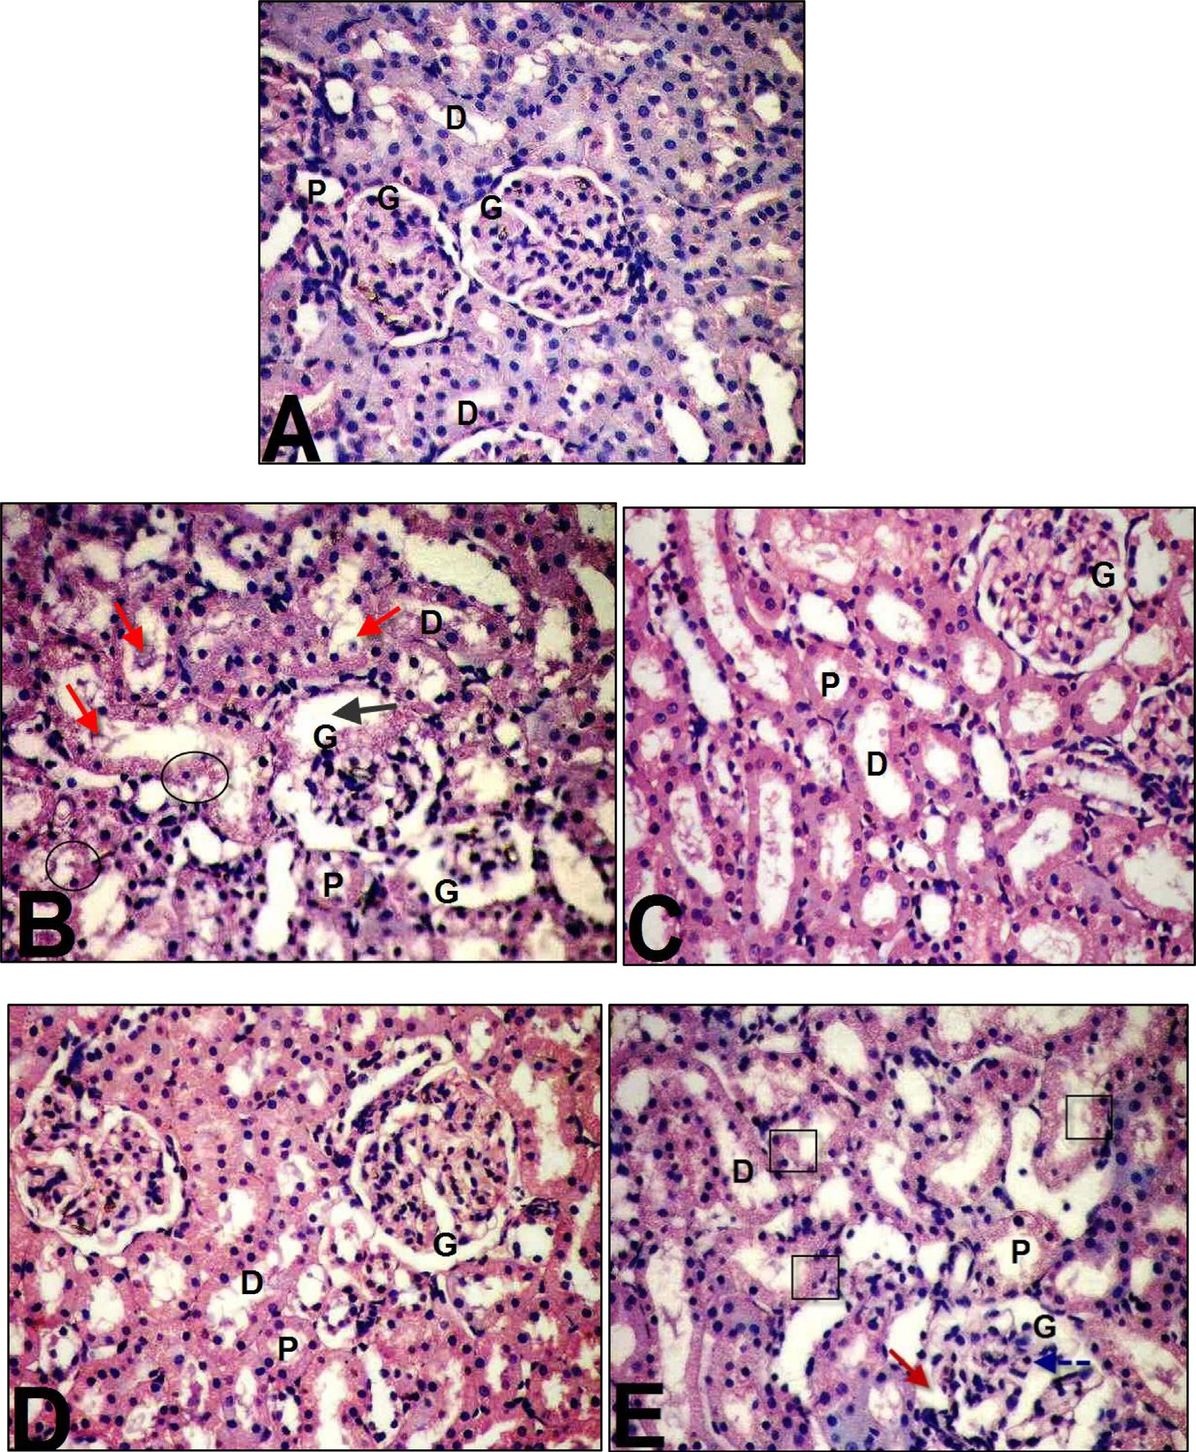

Fig. 4. Microscopic examination of the kidney tissues of rats treated as follow: control (A), BPA-treated rats (B), BPA + GBE-treated rats (C), BPA + Mel-treated rats (D) and BPA + GBE + Mel-treated rats (E).

for the detoxification of H2O2, whereas CAT plays its role when GPx reaches the saturation state with its substrate [50]. This could explain the significant increase in the hepatic CAT activity con- comitant with the highly significant decrease in the hepatic GPx activity that was observed in the present study. Catalase has a higher km than GPx. This recommends a major role for CAT at higher levels of H2O2 and minor role at the physiological H2O2 levels [51]. On the other hand, we observed significant decreases in the hepatic GST and CAT activities upon co-administration of GBE with BPA as compared with BPA-treated group as in Table 2. An ameliorative effect of GBE on the hepatic GST and CAT induced by MnCl2 has been indicated in adult male rats [52]. Moreover, the significant decreases in the activities of the hepatic CAT and GST

enzymes in BPA + Mel-treated rats. Mel attenuated the hepatic increase in CAT induced by gamma-irradiation in adult male rats [53]. Regarding the BPA induction of renal toxicity, our study showed significant increase in the urea and creatinine levels in BPA-treated group. The accumulation of BPA-toxic metabolites and the inability of the kidney to eliminate them resulted in nephrotoxicity [54]. However, our study revealed that the treat- ment with BPA + GBE, BPA + Mel and BPA + GBE + Mel caused sig- nificant decrease in the urea and creatinine levels as compared with the BPA-treated group. These results are supported by previ- ous studies that showed the ameliorative role of GBE against nephrotoxicity [56]. Also, Mel prohibited acetaminophen-induced nephrotoxicity in adult male rats [55]. Our study revealed that

there is a significant decrease in the renal GSH level in the BPA- treated group compared with the control. While, the renal TBARS level was significantly increased after BPA administration. The increased TBARS and decreased GSH levels indicate an increased ROS generation and hence lipid peroxidation in the kidney. How- ever, our results indicated that there is a significant decrease in renal TBARS accompanied with a significant increase in the renal GSH in the BPA + GBE-treated group as compared with BPA- treated group. The protective role of GBE in nephro-hepato toxicity induced in male rats was investigated [56]. Also, the present study showed that co-administration of BPA + Mel exhibited a significant decrease in the renal TBARS and this was accompanied with a sig- nificant increase in the renal GSH level. The treatment of male rats intoxicated by CCl4 with Mel leads to a significant decrease in the renal TBARS and increase in GSH levels [57]. The depletion of GSH diminishes the overall kidney’s antioxidant potential as a result of increased lipid peroxidation after BPA-treatment. The activities of the renal GST, SOD and CAT were significantly decreased after administration of BPA as compared with the control It is well known that SOD and CAT possess sequential functions in ROS

removing, by O. dismutation, followed by H O decomposition to

In conclusion, the wide use of BPA in the different plasticizers and other industries has a hazard effects on human today. Thus, we should limit the consumption of its products. GBE and Mel were observed as potent natural antioxidants. Owing to their antioxidant capacities; GBE, Mel and their combination exhibited protective effect on liver and kidney tissues against BPA-induced injury in rats. They could restore the liver and kidney functions, enzymatic and nonenzymatic antioxidants to control values. They also attenuated the lipid peroxidation and the proinflammatory status in livers and kidneys which was evidently appeared in the histopathological investigations. Thus, consumption of GBE and Mel could introduce health benefits to human against the hazards of BPA.

References

1. [Eid JI, Eissa SM, El-Ghor AA. Bisphenol A induces oxidative stress and DNA](http://refhub.elsevier.com/S2314-808X(17)30055-6/h0005) [damage in hepatic tissue of female rat offspring. J Basic Appl Zool](http://refhub.elsevier.com/S2314-808X(17)30055-6/h0005) [2015;71:10–9](http://refhub.elsevier.com/S2314-808X(17)30055-6/h0005).
2. [Ahmed WMS, Moselhy WA, Nabil TM. Bisphenol A toxicity in adult male rats:](http://refhub.elsevier.com/S2314-808X(17)30055-6/h0010) [hematological, biochemical and histopathological approach. Global Vet](http://refhub.elsevier.com/S2314-808X(17)30055-6/h0010)

[2015;14:228–38](http://refhub.elsevier.com/S2314-808X(17)30055-6/h0010).

2 2 2

H2O and O2 [49]. However, the renal activities of GST, SOD and CAT were significantly increased in BPA + GBE-treated group com- pared to BPA-treated one. There was an increase in the renal SOD activity when adult male rats were administered with GBE plus gentamycin compared with gentamycin-administration [56]. Also, the current study showed that there were significant increases in the activities of the renal GST, SOD and CAT in the BPA + Mel- treated group compared with BPA-treated one. Furthermore, it has been indicated that these renal antioxidant enzymes were sig- nificantly increased in CCl4 plus melatonin treated-rats [57].

In different inflammatory processes, TNF-a is considered as one

of the key released cytokines, which activates signaling pathways associated with inflammatory response. In response to inflamma- tion and infection, TNF-a is produced mainly by the immune sys-

tem [58]. Our study showed significant increase in the level of TNF-a following BPA-treatment in both liver and kidney tissues Fig. 1. TNF-a level was increased significantly in the liver tissues when the mice were treated with different doses of BPA [4]. While,

our results indicated that Mel co-treatment along with BPA resulted in a significant decrease in the hepatic and renal TNF-a level as compared with BPA-treated group [58]. Melatonin signifi- cantly reduced hepatic TNF-a level in thioacetamide-induced rats [40]. Also, our data demonstrate that there is a significant decrease in both hepatic and renal TNF-a level in rats co-treated with BPA

+ GBE [59].

Histopathological alterations in livers and kidneys indicated tis- sue injury after Bisphenol A administration accompanied by degenerative changes in the hepatic cells [4]. The cell rupture and membrane damage of human erythrocytes as a result of the oxidative damage was induced by Bisphenol A [4]. Moreover, our histological examination revealed markers of inflammatory cellu- lar infiltration, hepatocytes vacuolations and congestion in central and portal veins with the elevation in numbers of Kupffer cells [49]. Moreover, BPA-treated rats exhibited morphological changes in the kidney tissue compared to the control group. It caused dila- tion in Bowman’s space and hypercellularity of glomerulus. Also, it induced degeneration of proximal tubules’ epithelial cells [60,61]. In the present study, co-administration of GBE and/or Mel in com- bination with BPA revealed remarkable improvement in the liver and kidney tissues compared to BPA-treated group [62]. They demonstrated that the histopathological score of fibrosis together with liver function were improved in rats treated with CCl4 plus GBE. Furthermore, our results showed appreciable improvement in the liver and kidney tissues after supplementation with Mel which serves as a powerful, naturally occurring antioxidant [63].

1. [El-Missiry MA, Othman AI, Al-Abdan MA, El-Sayed AA. Melatonin ameliorates](http://refhub.elsevier.com/S2314-808X(17)30055-6/h0015) [oxidative stress, modulates death receptor pathway proteins, and protects the](http://refhub.elsevier.com/S2314-808X(17)30055-6/h0015) [rat cerebrum against Bisphenol-A-induced apoptosis. J Neurol Sci](http://refhub.elsevier.com/S2314-808X(17)30055-6/h0015) [2014;347:251–6](http://refhub.elsevier.com/S2314-808X(17)30055-6/h0015).
2. [Moon MK, Kim MJ, Jung IK, Koo YD, Ann HY, Lee KJ, et al. Bisphenol A impairs](http://refhub.elsevier.com/S2314-808X(17)30055-6/h0020) [mitochondrial function in the liver at doses below the no observed adverse](http://refhub.elsevier.com/S2314-808X(17)30055-6/h0020) [effect level. J Korean Med Sci 2012;27:644–52](http://refhub.elsevier.com/S2314-808X(17)30055-6/h0020).
3. [Sangai NP, Verma RJ, Trivedi MH. Testing the efficacy of quercetin in mitigating](http://refhub.elsevier.com/S2314-808X(17)30055-6/h0025) [Bisphenol A toxicity in liver and kidney of mice. Toxicol Ind Health](http://refhub.elsevier.com/S2314-808X(17)30055-6/h0025) [2012;30:581–97](http://refhub.elsevier.com/S2314-808X(17)30055-6/h0025).
4. [Kabuto H, Hasuike S, Minagawa N, Shishibori T. Effects of Bisphenol A on the](http://refhub.elsevier.com/S2314-808X(17)30055-6/h0030) [metabolisms of active oxygen species in mouse tissues. Environ Res](http://refhub.elsevier.com/S2314-808X(17)30055-6/h0030) [2004;93:31–5](http://refhub.elsevier.com/S2314-808X(17)30055-6/h0030).
5. [Bindhumol V, Chitra KC, Mathur PP. Bisphenol A induces reactive oxygen](http://refhub.elsevier.com/S2314-808X(17)30055-6/h0035) [species generation in the liver of male rats. Toxicology 2003;188:117–24](http://refhub.elsevier.com/S2314-808X(17)30055-6/h0035).
6. [Salem H, Mohamed A, Saleh E, Shalaby K. Influence of Hesperidin combined](http://refhub.elsevier.com/S2314-808X(17)30055-6/h0040) [with Sinemet on genetical and biochemical abnormalities in rats suffering](http://refhub.elsevier.com/S2314-808X(17)30055-6/h0040) [from Parkinson’s disease. Life Sci J 2012;9:930–45](http://refhub.elsevier.com/S2314-808X(17)30055-6/h0040).
7. [Chan PC, Xia Q, Fu PP. *Ginkgo biloba* leave extract: biological, medicinal, and](http://refhub.elsevier.com/S2314-808X(17)30055-6/h0045) [toxicological effects. J Environ Sci Health 2007;25:211–44](http://refhub.elsevier.com/S2314-808X(17)30055-6/h0045).
8. [Yan Z, Fan R, Yin S, Zhao X, Liu J, Li L, et al. Protective effects of *Ginkgo biloba*](http://refhub.elsevier.com/S2314-808X(17)30055-6/h0050)[leaf polysaccharide on nonalcoholic fatty liver disease and its mechanisms. Int](http://refhub.elsevier.com/S2314-808X(17)30055-6/h0050) [J Biol Macromol 2015;80:573–80](http://refhub.elsevier.com/S2314-808X(17)30055-6/h0050).
9. [Rimbach G, Minihane AM, Majewic J, Fischer A, Pallauf J, Virgli F, et al.](http://refhub.elsevier.com/S2314-808X(17)30055-6/h0055) [Regulation of cell signalling by vitamin E. Proc Nutr Soc 2002;61:415–25](http://refhub.elsevier.com/S2314-808X(17)30055-6/h0055).
10. [Yuan G, Gong Z, Li J, Li X. Ginkgo biloba extract protects against alcohol-](http://refhub.elsevier.com/S2314-808X(17)30055-6/h0060) [induced liver injury in rats. Phytother Res 2007;21:234–8](http://refhub.elsevier.com/S2314-808X(17)30055-6/h0060).
11. [Yapar K, Cavu](http://refhub.elsevier.com/S2314-808X(17)30055-6/h0065)s [og˘ lu K, Oruç E, Yalçin E. Protective role of *Ginkgo biloba* against](http://refhub.elsevier.com/S2314-808X(17)30055-6/h0065) [hepatotoxicity and nephrotoxicity in uranium-treated mice. J Med Food](http://refhub.elsevier.com/S2314-808X(17)30055-6/h0065) [2010;13:179–88](http://refhub.elsevier.com/S2314-808X(17)30055-6/h0065).
12. [Sehajpal J, Kaur T, Bhatti R, Singh AP. Role of progesterone in melatonin-](http://refhub.elsevier.com/S2314-808X(17)30055-6/h0070) [mediated protection against acute kidney injury. J Surg Res 2014;191:441–7](http://refhub.elsevier.com/S2314-808X(17)30055-6/h0070).
13. [Czechowska G, Celinski K, Korolczuk A, Wojcicka G, Dudka J, Bojarska A, et al.](http://refhub.elsevier.com/S2314-808X(17)30055-6/h0075) [Protective effects of melatonin against thioacetamide-induced liver fibrosis in](http://refhub.elsevier.com/S2314-808X(17)30055-6/h0075) [rats. J Physiol Pharmacol 2015;66:567–79](http://refhub.elsevier.com/S2314-808X(17)30055-6/h0075).
14. [Tomas-Zapico C, Coto-Montes A. A proposed mechanism to explain the](http://refhub.elsevier.com/S2314-808X(17)30055-6/h0080) [stimulatory effect of melatonin on antioxidative enzymes. J Pineal Res](http://refhub.elsevier.com/S2314-808X(17)30055-6/h0080) [2005;39:99–104](http://refhub.elsevier.com/S2314-808X(17)30055-6/h0080).
15. [Wu HJ, Liu C, Duan WX, Xu SC, He MD, Chen CH, et al. Melatonin ameliorates](http://refhub.elsevier.com/S2314-808X(17)30055-6/h0085) [Bisphenol A-induced DNA damage in the germ cells of adult male rats. Mutat](http://refhub.elsevier.com/S2314-808X(17)30055-6/h0085) [Res 2013;752:57–67](http://refhub.elsevier.com/S2314-808X(17)30055-6/h0085).
16. [Sidhu S, Pandhi P, Malhotra S, Vaiphei K, Khanduja KL. Melatonin treatment is](http://refhub.elsevier.com/S2314-808X(17)30055-6/h0090) [beneficial in pancreatic repair process after experimental acute pancreatitis.](http://refhub.elsevier.com/S2314-808X(17)30055-6/h0090) [Eur J Pharmacol 2010;628:282–9](http://refhub.elsevier.com/S2314-808X(17)30055-6/h0090).
17. [AIHA, American Industrial Hygiene Association. Bisphenol A. Am Ind Hyg](http://refhub.elsevier.com/S2314-808X(17)30055-6/h0095) [Assoc J 1967;28:301–4](http://refhub.elsevier.com/S2314-808X(17)30055-6/h0095).
18. [NIOSH, National Institute for Occupational Safety and Health. Registry of toxic](http://refhub.elsevier.com/S2314-808X(17)30055-6/h0100) [effects of chemical substances. U. S. Department of Health, Education and](http://refhub.elsevier.com/S2314-808X(17)30055-6/h0100) [Welfare, Public Health Service; 1987. p. 8571–82](http://refhub.elsevier.com/S2314-808X(17)30055-6/h0100).
19. [Yang XF, Wang NP, Lu WH, Zeng FD. Effects of *Ginkgo biloba* extract and](http://refhub.elsevier.com/S2314-808X(17)30055-6/h0105) [tanshinone on cytochrome P-450 isozymes and glutathione transferase in rats.](http://refhub.elsevier.com/S2314-808X(17)30055-6/h0105) [Acta Pharmacol Sin 2003;24:1033–8](http://refhub.elsevier.com/S2314-808X(17)30055-6/h0105).
20. [Sulaiman AA, Al-shawi NN, Jwaied HA, Mahmood MD, Hussain AS. Protective](http://refhub.elsevier.com/S2314-808X(17)30055-6/h0110) [effect of melatonin against chlorpromazine-induced liver disease in rats. Saudi](http://refhub.elsevier.com/S2314-808X(17)30055-6/h0110) [Med J 2006;27:1477–82](http://refhub.elsevier.com/S2314-808X(17)30055-6/h0110).
21. [Gornall AG, Bardawill CJ, David MM. Determination of serum proteins by](http://refhub.elsevier.com/S2314-808X(17)30055-6/h0115) [means of the biuret reaction. J Biol Chem 1949;177:751–66](http://refhub.elsevier.com/S2314-808X(17)30055-6/h0115).
22. [Fawcett JK, Scott JE. A rapid and precise method for the determination of urea.](http://refhub.elsevier.com/S2314-808X(17)30055-6/h0120) [J Clin Pathol 1960;13:156–9](http://refhub.elsevier.com/S2314-808X(17)30055-6/h0120).
23. [Fabiny DL. Automated reaction-rate methods for determination of serum](http://refhub.elsevier.com/S2314-808X(17)30055-6/h0125) [creatinine. Clin Chem 1971;17:696–700](http://refhub.elsevier.com/S2314-808X(17)30055-6/h0125).
24. [Reitman S, Frankel S. A colorimetric method for the determination of serum](http://refhub.elsevier.com/S2314-808X(17)30055-6/h0130) [glutamic oxalocetic and glutamic pyruvic transaminases. Am J Clin Pathol](http://refhub.elsevier.com/S2314-808X(17)30055-6/h0130) [1957;26:56–63](http://refhub.elsevier.com/S2314-808X(17)30055-6/h0130).
25. [IFCC. Methods for the measurement of catalytic concentrations of enzymes.](http://refhub.elsevier.com/S2314-808X(17)30055-6/h0135) [Part 3: IFCC method for Alanine aminotransferase. J Clin Chem Clin Biochem](http://refhub.elsevier.com/S2314-808X(17)30055-6/h0135) [1986;1:497–510](http://refhub.elsevier.com/S2314-808X(17)30055-6/h0135).
26. [Chiu DTY, Stults FH, Tappel AL. Purification and properties of rat lung soluble](http://refhub.elsevier.com/S2314-808X(17)30055-6/h0140) [glutathione peroxidase. Biochim Biophys Acta 1976;445:558–66](http://refhub.elsevier.com/S2314-808X(17)30055-6/h0140).
27. [Jollow DJ, Michell JR, Zampaglionic N, Gillete JR. Bromobenzene-induced Liver](http://refhub.elsevier.com/S2314-808X(17)30055-6/h0145) [necrosis: protective role of glutathione and evidence for 3, 4-Bromobenzene](http://refhub.elsevier.com/S2314-808X(17)30055-6/h0145) [oxide as hepatotoxic metabolite. Pharmacology 1974;11:151–69](http://refhub.elsevier.com/S2314-808X(17)30055-6/h0145).
28. [Habig WH, Pabst MJ, Jakoby WB. Glutathione S-transferases. The first](http://refhub.elsevier.com/S2314-808X(17)30055-6/h0150) [enzymatic step in mercapturic acid formation. J Biol Chem 1974:7130–9](http://refhub.elsevier.com/S2314-808X(17)30055-6/h0150).
29. [Misra HP, Fridovich I. The role of superoxide anion in the autoxidation of](http://refhub.elsevier.com/S2314-808X(17)30055-6/h0155) [epinephrine and a simple assay for superoxide dismutase. J Biol Chem](http://refhub.elsevier.com/S2314-808X(17)30055-6/h0155) [1972;247:3170–5](http://refhub.elsevier.com/S2314-808X(17)30055-6/h0155).
30. [Luck H. Catalase. In: Bergmayer MV, editor. Method of enzymatic](http://refhub.elsevier.com/S2314-808X(17)30055-6/h0160) [analysis. New York: Verlag Chemic Academic Press; 1974. p. 885–8](http://refhub.elsevier.com/S2314-808X(17)30055-6/h0160).
31. [Tappel AL, Zalkin H. Inhibition of lipid peroxidation in mitochondria by](http://refhub.elsevier.com/S2314-808X(17)30055-6/h0165) [vitamin E. Arch Biochem Biophys 1959;80:333–6](http://refhub.elsevier.com/S2314-808X(17)30055-6/h0165).
32. [Lillie RD. Histopathologic technic and practical histochemistry. 3rd ed. New](http://refhub.elsevier.com/S2314-808X(17)30055-6/h0170) [York: McGraw Hill Book Co.; 1965](http://refhub.elsevier.com/S2314-808X(17)30055-6/h0170).
33. [Steel RGD, Torrie J. Principles and procedures of statistics. A biometric](http://refhub.elsevier.com/S2314-808X(17)30055-6/h0175) [approach. 2nd ed. Singapore City: Mc Graw Hill International Book Co.; 1981](http://refhub.elsevier.com/S2314-808X(17)30055-6/h0175).
34. [Institute SAS. SAS/QC user’s guide. Cary, NC: SAS Institute Inc.; 1986. version 5](http://refhub.elsevier.com/S2314-808X(17)30055-6/h0180) [edition](http://refhub.elsevier.com/S2314-808X(17)30055-6/h0180).
35. [Moselhy WA, Ahmed WMS, Nabil TM. Bisphenol A toxicity in adult male rats:](http://refhub.elsevier.com/S2314-808X(17)30055-6/h0185) [hematological, biochemical and histopathological approach. Global Vet](http://refhub.elsevier.com/S2314-808X(17)30055-6/h0185) [2015;14:228–38](http://refhub.elsevier.com/S2314-808X(17)30055-6/h0185).
36. [Ghosh D, Mitra E, Dey M, Firdaus SB, Ghosh A, Mukherjee D, et al. Melatonin](http://refhub.elsevier.com/S2314-808X(17)30055-6/h0190) [protects against lead-induced oxidative stress in rat liver and kidney. Asian J](http://refhub.elsevier.com/S2314-808X(17)30055-6/h0190) [Pharm Clin Res 2013;6:137–45](http://refhub.elsevier.com/S2314-808X(17)30055-6/h0190).
37. [Aljadaani BS, Bakr AA, Hamza AH. Effect of *Ginkgo biloba* and *Commiphora*](http://refhub.elsevier.com/S2314-808X(17)30055-6/h0195)[*opobalsamum* extracts on liver fibrosis and kidney injury induced by carbon](http://refhub.elsevier.com/S2314-808X(17)30055-6/h0195) [tetra chloride in experimental models. World J Pharm Sci 2016;4:148–52](http://refhub.elsevier.com/S2314-808X(17)30055-6/h0195).
38. [Abdalfattah AA, El-Ebiary AA, Hantash EM. Study of the effects of melatonin on](http://refhub.elsevier.com/S2314-808X(17)30055-6/h0200) [experimentally induced hepatic fibrogenesis in rats. Int J Adv Res](http://refhub.elsevier.com/S2314-808X(17)30055-6/h0200) [2016;4:1187–97](http://refhub.elsevier.com/S2314-808X(17)30055-6/h0200).
39. [Erikson K, Dobson A, Dorman D, Aschner M. Manganese exposure and induced](http://refhub.elsevier.com/S2314-808X(17)30055-6/h0205) [oxidative stress in rat brain. Sci Total Environ 2004;334:409–16](http://refhub.elsevier.com/S2314-808X(17)30055-6/h0205).
40. [Hassan ZK, Elobeid MA, Virk P, Omer SA, ElAmin M, Daghestani MH, et al.](http://refhub.elsevier.com/S2314-808X(17)30055-6/h0210) [Bisphenol A induces hepatotoxicity through oxidative stress in rat model. Oxid](http://refhub.elsevier.com/S2314-808X(17)30055-6/h0210) [Med Cell Longevity 2012:1–6](http://refhub.elsevier.com/S2314-808X(17)30055-6/h0210).
41. [Saad RA, Fath El-Bab M, Shalaby AA. Attenuation of acute and chronic liver](http://refhub.elsevier.com/S2314-808X(17)30055-6/h0215) [injury by melatonin in rats. J Taibah Univ Sci 2013:88–96](http://refhub.elsevier.com/S2314-808X(17)30055-6/h0215).
42. [Melov S. Animal models of oxidative stress, aging, and therapeutic antioxidant](http://refhub.elsevier.com/S2314-808X(17)30055-6/h0220) [interventions. Int J Biochem Cell Biol 2002;34:1395–400](http://refhub.elsevier.com/S2314-808X(17)30055-6/h0220).
43. [Biswas SK, Rahman I. Environmental toxicity, redox signaling and lung](http://refhub.elsevier.com/S2314-808X(17)30055-6/h0225) [inflammation: the role of glutathione. Mol Aspects Med 2009;30:60–76](http://refhub.elsevier.com/S2314-808X(17)30055-6/h0225).
44. [Sayed-Ahmed MM, Aleisa AM, Al-Rejaie SS, Al-Yahya AA, Al-Shabanah OA,](http://refhub.elsevier.com/S2314-808X(17)30055-6/h0230) [Hafez MM, et al. Thymoquinone attenuates diethylnitrosamine induction of](http://refhub.elsevier.com/S2314-808X(17)30055-6/h0230) [hepatic carcinogenesis through antioxidant signaling. Oxid Med Cell Longevity](http://refhub.elsevier.com/S2314-808X(17)30055-6/h0230) [2010;3:254–61](http://refhub.elsevier.com/S2314-808X(17)30055-6/h0230).
45. [Holley AK, Bakthavatchalu V, Velez-Roman JM, Clair DKSt. Manganese](http://refhub.elsevier.com/S2314-808X(17)30055-6/h0235) [superoxide dismutase: guardian of the powerhouse. Int J Mol Sci](http://refhub.elsevier.com/S2314-808X(17)30055-6/h0235) [2011;12:7114–62](http://refhub.elsevier.com/S2314-808X(17)30055-6/h0235).
46. [Cheng D, Liang B, Li Y. Antihyperglycemic effect of *Ginkgo biloba* extract in](http://refhub.elsevier.com/S2314-808X(17)30055-6/h0240) [streptozotocin-induced diabetes in rats. Biomed Res Int 2013;162724:1–7](http://refhub.elsevier.com/S2314-808X(17)30055-6/h0240).
47. [Mourad IM, Khadraw YA. The sensitivity of liver, kidney and testis of rats to](http://refhub.elsevier.com/S2314-808X(17)30055-6/h0245) [oxidative stress induced by different doses of Bisphenol A. Int J Life Sci Pharma](http://refhub.elsevier.com/S2314-808X(17)30055-6/h0245) [Res 2012;2:19–28](http://refhub.elsevier.com/S2314-808X(17)30055-6/h0245).
48. [Hussain AL, Jakoniuk JM. Liver catalase, glutathione peroxidase and reductase](http://refhub.elsevier.com/S2314-808X(17)30055-6/h0250) [activity, reduced glutathione and hydrogen peroxide levels in acute](http://refhub.elsevier.com/S2314-808X(17)30055-6/h0250) [intoxication with chlorfenvinphos, an organophosphate insecticide. Pol J](http://refhub.elsevier.com/S2314-808X(17)30055-6/h0250) [Environ Stud 2004;13:303–9](http://refhub.elsevier.com/S2314-808X(17)30055-6/h0250).
49. [Halliwell B. Oxidants and human diseases. FASEB J 1987;1:441–5](http://refhub.elsevier.com/S2314-808X(17)30055-6/h0255).
50. [Mahmoud SM, Bahr HI. Potential protective effects of *Ginkgo biloba* and](http://refhub.elsevier.com/S2314-808X(17)30055-6/h0260) [rosemary on hepato encephalopathy and chromosomal aberrations induced by](http://refhub.elsevier.com/S2314-808X(17)30055-6/h0260) [manganese chloride in rats. Int J Adv Res 2015;3:483–97](http://refhub.elsevier.com/S2314-808X(17)30055-6/h0260).
51. [Bharti VK, Srivastava RS, Kumar H, Bag S, Majumdar AC, Singh G, et al. Effects](http://refhub.elsevier.com/S2314-808X(17)30055-6/h0265) [of melatonin and epiphyseal proteins on fluoride-induced adverse changes in](http://refhub.elsevier.com/S2314-808X(17)30055-6/h0265) [antioxidant status of heart, liver, and kidney of rats. Adv Pharmacol Sci](http://refhub.elsevier.com/S2314-808X(17)30055-6/h0265) [2014;532969:1–6](http://refhub.elsevier.com/S2314-808X(17)30055-6/h0265).
52. [Sangai NP, Verma RJ, Trivedi MH. Testing the efficacy of quercetin in mitigating](http://refhub.elsevier.com/S2314-808X(17)30055-6/h0270) [Bisphenol A toxicity in liver and kidney of mice. Toxicol Ind Health](http://refhub.elsevier.com/S2314-808X(17)30055-6/h0270) [2012;30:581–97](http://refhub.elsevier.com/S2314-808X(17)30055-6/h0270).
53. [Ilbey YOZ, Ozbek E, Cekmen M, Somay A, Ozcan L, Otünctemur A, et al.](http://refhub.elsevier.com/S2314-808X(17)30055-6/h0275) [Melatonin prevents acetaminophen-induced nephrotoxicity in rats. Int Urol](http://refhub.elsevier.com/S2314-808X(17)30055-6/h0275) [Nephrol 2009;41. 695–02](http://refhub.elsevier.com/S2314-808X(17)30055-6/h0275).
54. [Hamdy MM, El-Sers DA, Abdelhamid MM. Protective effect of curcumin and](http://refhub.elsevier.com/S2314-808X(17)30055-6/h0280) [*Ginkgo biloba* l. Extract against gentamicin-induced nephrotoxicity in rats.](http://refhub.elsevier.com/S2314-808X(17)30055-6/h0280) [Assiut Med J 2013;37:135–46](http://refhub.elsevier.com/S2314-808X(17)30055-6/h0280).
55. [Adewole SO, Salako AA, Doherty OW, Naicker T. Effect of melatonin on carbon](http://refhub.elsevier.com/S2314-808X(17)30055-6/h0285) [tetrachloride-induced kidney injury in wistar rats. Afr J Biomed Res](http://refhub.elsevier.com/S2314-808X(17)30055-6/h0285) [2007;10:153–64](http://refhub.elsevier.com/S2314-808X(17)30055-6/h0285).
56. [Ahmed ME, Ahmed HI, El-Morsy EM. Melatonin protects against diazinon-](http://refhub.elsevier.com/S2314-808X(17)30055-6/h0290) [induced neurobehavioral changes in rats. Neurochem Res 2013;38:2227–36](http://refhub.elsevier.com/S2314-808X(17)30055-6/h0290).
57. [Tabl G, Elwy AM. Evaluation of *Ginkgo biloba* as alternative medicine on ova-](http://refhub.elsevier.com/S2314-808X(17)30055-6/h0295) [induced eotaxin and eosinophilia in asthmatic lung. Life Sci J 2013;10:2131–6](http://refhub.elsevier.com/S2314-808X(17)30055-6/h0295).
58. [Rahimi O, Farokhi F, Khojasteh SM, Ozi SA. The effect of Bisphenol A on serum](http://refhub.elsevier.com/S2314-808X(17)30055-6/h0300) [parameters and morphology of kidney’s tissue. Biol Int J 2015;7:79–90](http://refhub.elsevier.com/S2314-808X(17)30055-6/h0300).
59. [Bhattacharya H, Xiao Q, Lun L. Toxicity studies of nonylphenol on rosy barb](http://refhub.elsevier.com/S2314-808X(17)30055-6/h0305) [(*Puntius conchonious*): a biochemical and histopathological evaluation. Tissue](http://refhub.elsevier.com/S2314-808X(17)30055-6/h0305) [Cell 2008;40:243–9](http://refhub.elsevier.com/S2314-808X(17)30055-6/h0305).
60. [Mahboub FA, Lamfon HA. Protective effect of *Ginkgo biloba* extract on](http://refhub.elsevier.com/S2314-808X(17)30055-6/h0310) [carbendazim-induced hepatotoxicity in albino rats. Food Nutr Sci](http://refhub.elsevier.com/S2314-808X(17)30055-6/h0310) [2013;4:866–72](http://refhub.elsevier.com/S2314-808X(17)30055-6/h0310).
61. [Fouad D. Antioxidant and modulatory effect of melatonin on hepatotoxicity](http://refhub.elsevier.com/S2314-808X(17)30055-6/h0315) [and oxidative stress induced by orange yellow S in male rats. Pak J Zool](http://refhub.elsevier.com/S2314-808X(17)30055-6/h0315) [2015;47:383–91](http://refhub.elsevier.com/S2314-808X(17)30055-6/h0315).