[Egyptian Informatics Journal 21 (2020) 191–199](https://doi.org/10.1016/j.eij.2020.01.002)

Contents lists available at [ScienceDirect](http://www.sciencedirect.com/science/journal/11108665)

Egyptian Informatics Journal

journal homepage: [www.sciencedirect.com](http://www.sciencedirect.com/)

[](http://crossmark.crossref.org/dialog/?doi=10.1016/j.eij.2020.01.002&domain=pdf)Modeling of the development of the fetus cognitive map from the sensorimotor system

Eman Ahmed a,b,⇑, Reda A. El Khoribi a, Gamal Darwish a, Alexandre Muzy b, Gilles Bernot b

a *Faculty of Computers and Information, Cairo University, Egypt*

b *Laboratoire d’ Informatique, Signaux et Systémes de Sophia-Antipolis (I3S) UNS CNRS, Université Côte d’Azur, France*

# a r t i c l e i n f o

*Article history:*

Received 12 December 2019

Revised 22 January 2020

Accepted 27 January 2020

Available online 27 February 2020

*Keywords:*

Clustering algorithm

*k*-means Cognitive map Fetus

Brain

Sensorimotor system

# a b s t r a c t

The human cognitive map formation is still an open question. Based on biological facts, the cognitive map origin goes back to the age of the fetus human. In this paper, our aim is to provide a possible answer to that question. Accordingly, we present a theoretical model of the development of the cognitive map of a fetus human using its sensorimotor data. We define positions of the cognitive map as associations between high-level perceptions created from different sensory sources. We use a proposed method referred to as Frequency-based-means clustering algorithm to develop the perceptions that form the association map. Our proposed theoretical model is tested on simulated data. Results show that our model is a possible candidate for demonstrating how the cognitive map is formed. In addition, compar- ison with *k*-means clustering is presented and results show that the frequency-based-means clustering has a better performance than *k*-means clustering and is more suitable for this application.

© 2020 Production and hosting by Elsevier B.V. on behalf of Faculty of Computers and Artificial Intelli-

gence, Cairo University. This is an open access article under the CC BY-NC-ND license ([http://creative-](http://creativecommons.org/licenses/by-nc-nd/4.0/)

[commons.org/licenses/by-nc-nd/4.0/](http://creativecommons.org/licenses/by-nc-nd/4.0/)).

1. Introduction

There is a sharp distinction between perception which is defined as the processing of sensory information that occurs at sev- eral levels) and cognition which is the judging of representational contents related to reasoning [16]. Tolman proposed the term cog- nitive map, which is an internal mental representation (or image) of external environmental feature or landmark. He thought that individuals acquire large numbers of cues (i.e. signals) from the environment and could use these to build a mental image of the environment (i.e. a cognitive map) [9,1]. A cognitive map consists of ‘‘positions”. By using this internal representation of a physical space they could get to the goal by knowing where it is in a com- plex environment through different paths. Cognitive mapping is usually divided into building two internal representations: one for developing person to object relation (egocentric) and another

* Corresponding author.

*E-mail address:* [e.ahmed@fci-cu.edu.eg](mailto:e.ahmed@fci-cu.edu.eg) (E. Ahmed).

Peer review under responsibility of Faculty of Computers and Information, Cairo University.

**Production and hosting by Elsevier**

for object to object relation (allocentric). Imperfections in encoding either relations can introduce imperfections in representations of environments in memory [18]. Some studies done on cognitive map consider it allows one to locate oneself in a familiar environ- ment and to go from one place to another even through parts of the environment never visited before. Others see that it is not a unitary integrated representation, but consists of stored discrete pieces including landmarks, route segments, and regions [15]. There are many studies performed on high-level cognitive maps of adults whose purpose is to navigate to go from one route to another, how to link routes to go from one location to another, and how people have different abilities to form cognitive maps. But, there are no studies done on the origin of the cognitive maps in the fetus stage despite that fetus is able to move its hand to suck its thumb, which means it has the ability to recognize its mouth location and learn how to reach it. Similarly, it can grab its umbilical cord which means it is able to reach it. From these simple moves, we believe that the fetus forms a simple cognitive map that enables him to reach different objects in the womb. Proprioception and perceptual learning affects the generation of a cognitive map. The influence of proprioception on human spatial cognition is investigated in [19] and it is found that proprioception can influence the time neces- sary to use spatial representations while other factors such as visio-spatial abilities can influence the capacity to form accurate spatial representations [20]. This was done by the study of the

<https://doi.org/10.1016/j.eij.2020.01.002>

1110-8665/© 2020 Production and hosting by Elsevier B.V. on behalf of Faculty of Computers and Artificial Intelligence, Cairo University. This is an open access article under the CC BY-NC-ND license (<http://creativecommons.org/licenses/by-nc-nd/4.0/>).

navigation of blind individuals and comparing to the navigation and way finding in individuals without any visual impairments [10]. It is found that the combination of both proprioception and auditory sense helps the blind individuals to build their cognitive map for the surrounding environment and are able to navigate easily after a number of trials [18]. These studies included the sense of touch with the proprioception. Some applications are made to help blind individuals move freely based on these findings [14]. Accordingly, the spatial positions can be represented in terms of proprioceptions and the sense of touch (i.e. pressure perception). Unlike vision and auditory senses, the proprioception development is not studied much due to the difficulty to measure its perfor- mance, but in [11], a study was presented to explain the proprio- ception development in children and it concluded that its precision improves with age. Recently, a study [12] highlighted that the sensorimotor system of the fetus plays an important role in forming the cognitive map. In addition, it is suggested that the sensorimotor data can be used to obtain higher level propriocep- tions which provide the fetus with interpretation about his limbs positions in [2]. Perceptual learning is the discovery of new struc- ture in sensory stimulation [13]. Although the sensory stimulation are the same, with repetitions, new structures start to appear which changes our perceptions. For instance, a student reading an article, s/he perceives more information each time s/he reads it. Similarly, experienced chefs are able to perceive structures in their sensory environment, i.e. they are able to easily detect ingre- dients in a given dish, where there was none before and that is invisible to those who do not have the same level of experience. Perceptual learning can be seen as a form of clustering as men- tioned in [8]. In the same sense, the fetus starts by making random movements and the received sensory feedbacks are used for gener- ating proprioceptions and perceptions about the environment. As noticed, no previous work built a model that integrates the senso- rimotor system, the proprioceptions and perceptions with the cog- nitive map. Moreover, there was no study presented to model the cognitive map formation for the fetus. Working on the fetus is dif- ferent from working on the adults. The fetus has no vision capabil- ity so it is not able to see objects in its environment and determine their places. Instead, it depends on its immature, developing pro- prioception and touch sensation rather than vision for recognizing objects and positions. Consequently, the fetus is able to identify positions and built his primary cognitive map using its propriocep- tion and touch perceptions only. In this paper, we propose a theoretical model that shows how the sensory data obtained by the sensorimotor system can be used to make higher level percep- tions and proprioceptions by using the frequency-based-means clustering algorithm, and how these, in turn, generate positions that form the cognitive map. We refer to the proprioceptions as length perceptions because proprioceptions can be seen as a form of perception regarding the self position. Section 2 demonstrates the suggested model. Section 3 illustrates how the proprioceptions and perceptions are obtained and developed through a proposed clustering method. Section 4 presents integrat- ing the generated proprioceptions and perceptions to produce positions saved in the cognitive map. The simulation and the results are presented in Section 5 and the paper is concluded in Section 6.

include the pressure felt by the tactile sensation [5]. All these sen- sory data are collected and processed. Accordingly, proprioceptions are produced from the sensory length and perceptions are gener- ated from the sensory pressure. Next, all the obtained perceptions and proprioceptions obtained from different sensory neurons are collected in the mechanoreceptors-association-map where associ- ation links are created connecting the perceptions that exist together. The pairs of the proprioceptions and perceptions repre- sent a position in the cognitive map.

3. The Generation of perceptions and proprioceptions using clustering

In the fetus stage, there is no knowledge about how it can iden- tify its sensations, it starts learning on its own the process of cre- ating perceptions. This can be seen as unsupervised learning. It may use clustering to group similar data together and separate them from different groups to identify its surrounding environ- ment. Accordingly, its cognition ability increases with time as more clusters are formed. There are many adaptive clustering techniques in literature [4,21,7]. But, they can not be applied in our problem because the creation of clusters has no biological interpretation. As explained above, we hypothesize that fetus human develops its cognition through the repetition of certain values with time. Ini- tially, the fetus groups all the sensory values it receives in one clus- ter. In other words, it considers it is at the same position even when the muscle length changes. When a sensory value is repeated a lot with time, its mind starts to distinguish it from the rest of val- ues. This creates a new cluster for this value as the center of the cluster, the cluster members will be its similar values. The brain is not very precise and full of noise [3,17], so the center is updated to be the average value of the cluster member. The creation of a new cluster in our algorithm is based on that the frequency of a value starts exceeding either a pre-defined threshold or the maxi- mum frequency of its cluster. In other words, the proposed cluster- ing process groups similar values together until one of them becomes significantly repeated, hence, form a new cluster on its own and take its similar members with it. Through time, it is be able to recognize all the values incrementally by repeating its actions and receiving the same sensory values. The frequency- based-means clustering follows this idea. Assume we have a set of clusters *C* and a set of input length values *L*. For any cluster

*c* ∈ *C*, we define *count*(*l*(*t*)) as the count of sample *l* at time *t* and *maxcount*(*c*) as the maximum count in cluster *c* such that if *count*(*l*(*t*)) P *maxcount*, then *l*(*t*) is expelled from the cluster and forms a cluster on its own. *Threshold* is a threshold value for the

*count*(*L*(*t*)) P *Threshold*, then *l*(*t*) is expelled from the cluster and allowed frequency of the sample in any cluster such that If forms a cluster on its own. For any input sample *l*(*t*)∈ *L* at time *t*, we use *dist*(*ccenter*; *l*) as the euclidean distance between cluster *c*

Table 1

Comparison between *K*-means clustering and the Frequency-based-means clustering.

Point of Comparison *K*-Means Frequency-based Means

2. From the sensorimotor system to the cognitive map

When the muscle moves, different sensory feedbacks are

Requires Pre-determined Number of Clusters

Results may be altered from one run to another

True False

True False

received from the body and from the environment. Sensory feed- backs from the body are received from the proprioceptors such as the muscle spindle and the golgi tendon organs whereas the sensory feedbacks from the interaction with the environment

Number of Required Parameters 1 1

Suitable for Online Input Data False True Clustering Criteria Distance-based Distance-based

Type of data Quantitative Repetitive Quantitative data

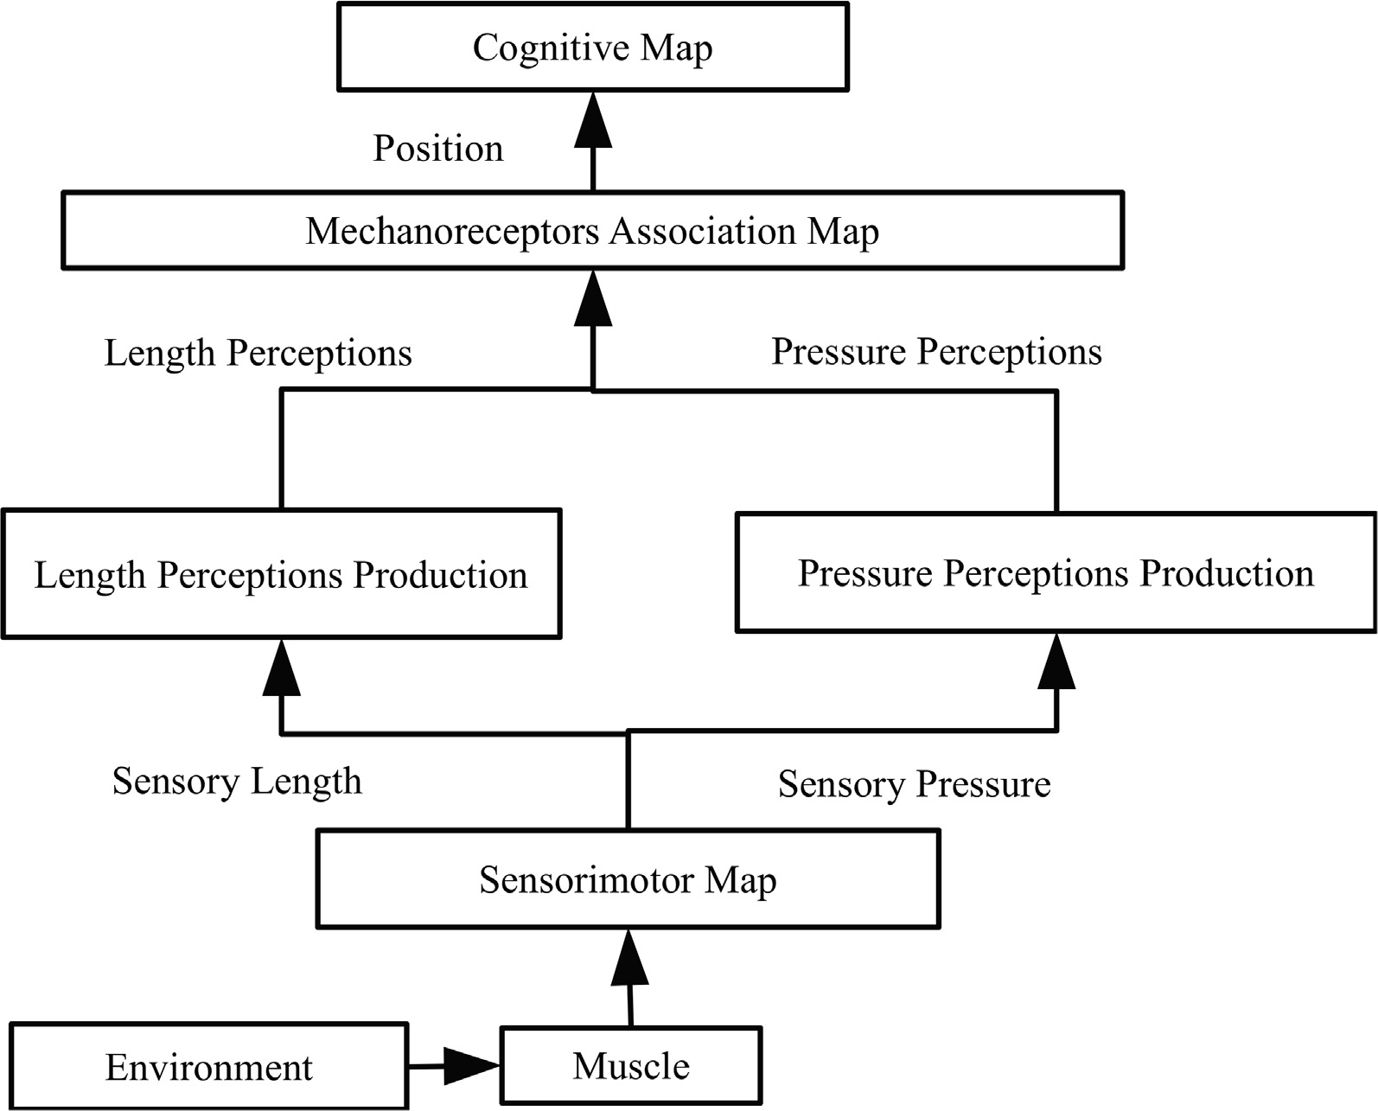

Fig. 1. The System Framework.

with center *ccenter* and sample *l* to assign *l* to the nearest cluster. Fig. 2 describes the algorithm. We are using the frequency- based-means clustering to obtain perceptions over time. The clus- ter centers are referred to as the perceptions in our case. This way the human mind perceptions evolve with time; which represents cognition improvement. The frequency-based-means clustering algorithm can work on sequential online data. Its time of conver- gence is independent on the data values but it is dependent on the frequency of the data values and the repetition threshold that is chosen. Table 1 summarizes the main differences between the

*k*-means clustering and the Frequency-based-means clustering algorithms. Fig. 1.

1. Creating the cognitive map

Depending on the collected sensory data, higher level percep- tions are created. The perceptions obtained from different sensory neurons are associated in a map called a mechanoreceptors map. Different identified proprioceptions and perceptions that occur together are associated together. This association defines a position

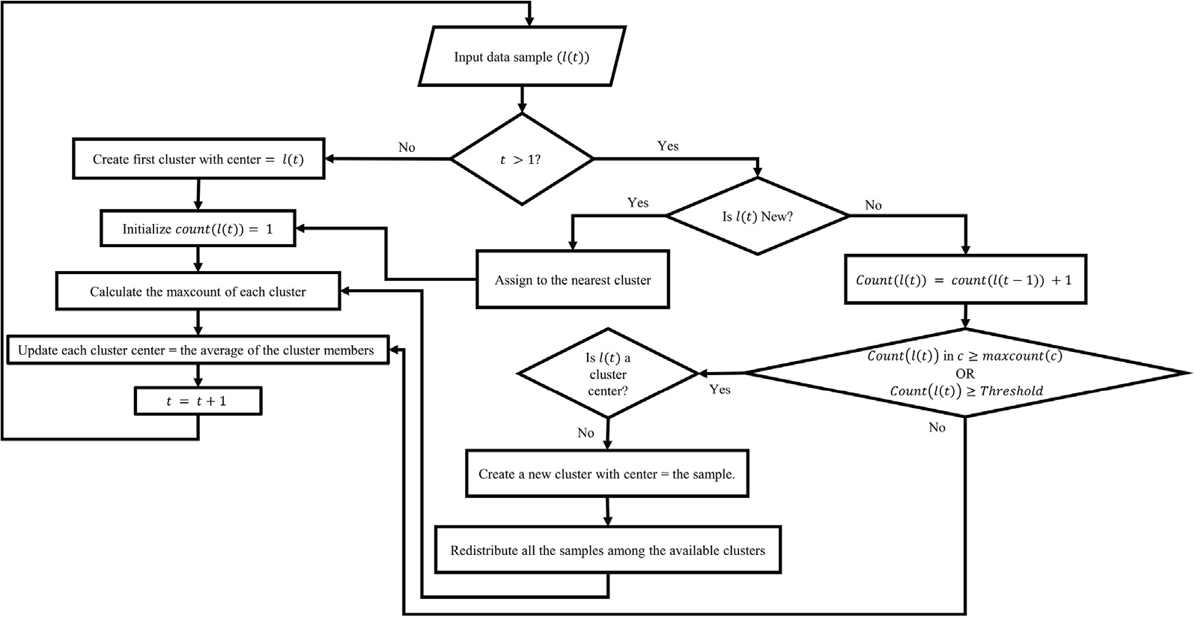

Fig. 2. Frequency-based-means Clustering.

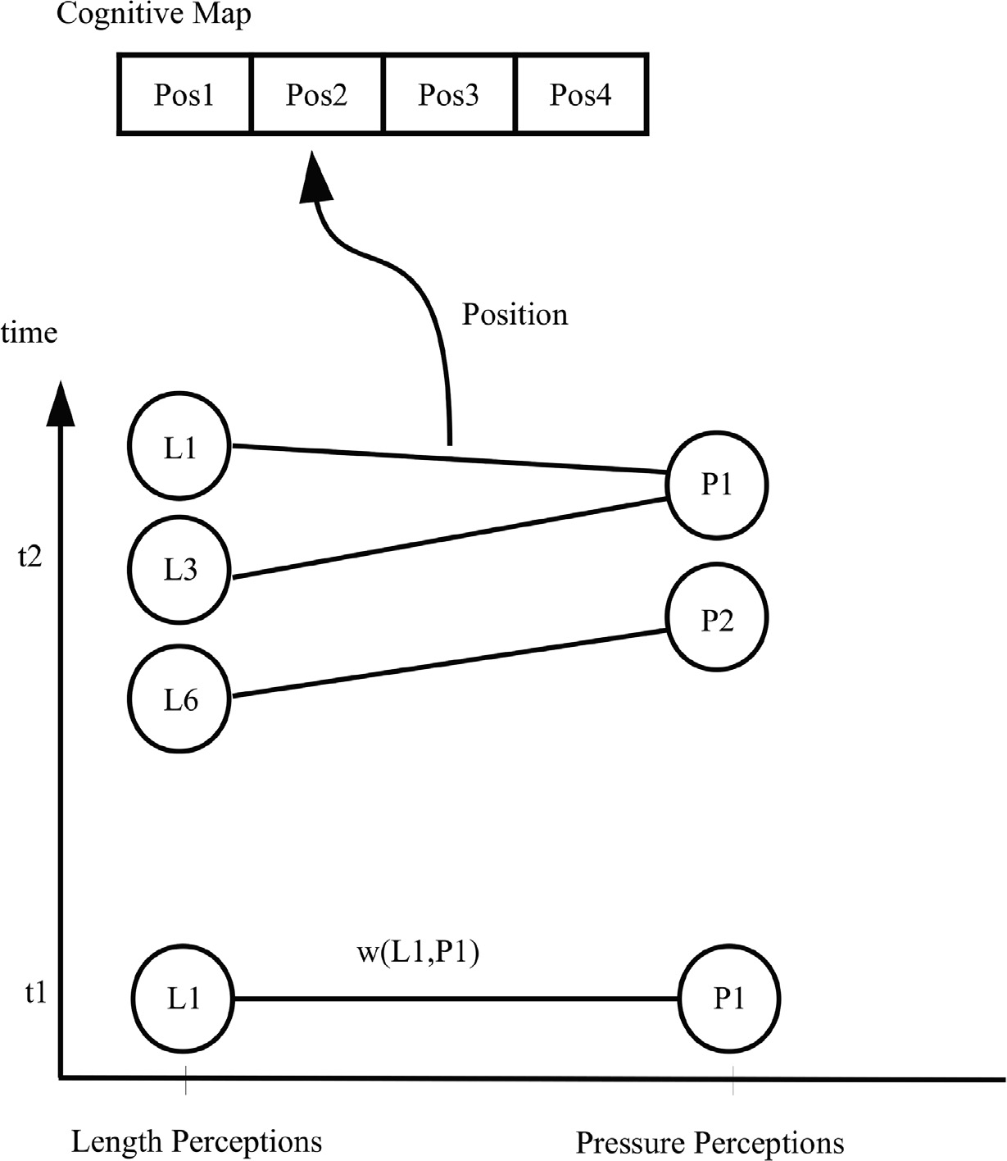

Fig. 3. The mechanoreceptors-association-map showing defined positions in the cognitive map. In time t = 1, only one position is defined between L1 and P1. At time t = 2, positions are formed for (L1,P1), (L3,P1) and (L6,P2) because they occured together many times. On the other hand, no positions are defined between L1 and P2 or L3 and P2 or L6 and P1 because they didn’t exist simultaneously.

in the cognitive map. The association links are dynamically updated with time as more cognitive abilities are acquired or as there is a change in the environment. Once an ensemble of percep- tions are produced together, they are linked together using links with small weights. These weights will be increased everytime this ensemble is repeated in order to strengthen the association between them. This way, the association link weights between dif- ferent perceptions of an ensemble are proportional to the strength of the ensemble. This means that the perceptions that do not occur together should have zero weights for their association links. In case of a dynamically changing environment, some ensembles may exist for some times then they no longer do. In that case, the association link weights of that ensemble should decrease gradually until they become zero. Fig. 3 demonstrates the associa- tion between length perceptions and pressure perceptions in the mechanoreceptors-association-map. The sensory length values form length perceptions and the sensory pressures form the pres- sure perceptions that reflects whether there is an object in the environment or not. Both the proprioceptions and perceptions that occur together have association link created with weight greater than or equals to 1. If any proprioception does not exist simultane- ously with a perception, their link weights are zeros. These associ-

ations are updated through time when new perceptions are added or even deleted from one or more sensory neurons. For any length

proprioception (*Li*) and pressure proprioception *Pj* , there is a

sequence (*Qt*) results in perceptions *Li*; *Pj*, then the weight is associations *Li*; *Pj* , with weight = *wLiPj*. When a command updated according to algorithm 1. When a pair of a length propri-

oception and pressure proprioception occurs at the same time, their link weight will increase by one unless it reached a maximum threshold to prevent domination. Similarly, the links between pairs of this length and other pressures will decrease. This is to model the case of dynamic environment where an object exists some- times then disappears due to either its movement or the body movement. Accordingly, the object is not in the same previous place and does not correspond to this length anymore. Despite this change, the mind does not forget that this length corresponds to that pressure (of the object) instantly. It needs some time to forget this link. That’s why the link weight decreases gradually by one each time this link is not correct until it reaches zero when it is assumed it does not exist anymore.The resulted weights will be saved in memory for future use in making goal directed movements.

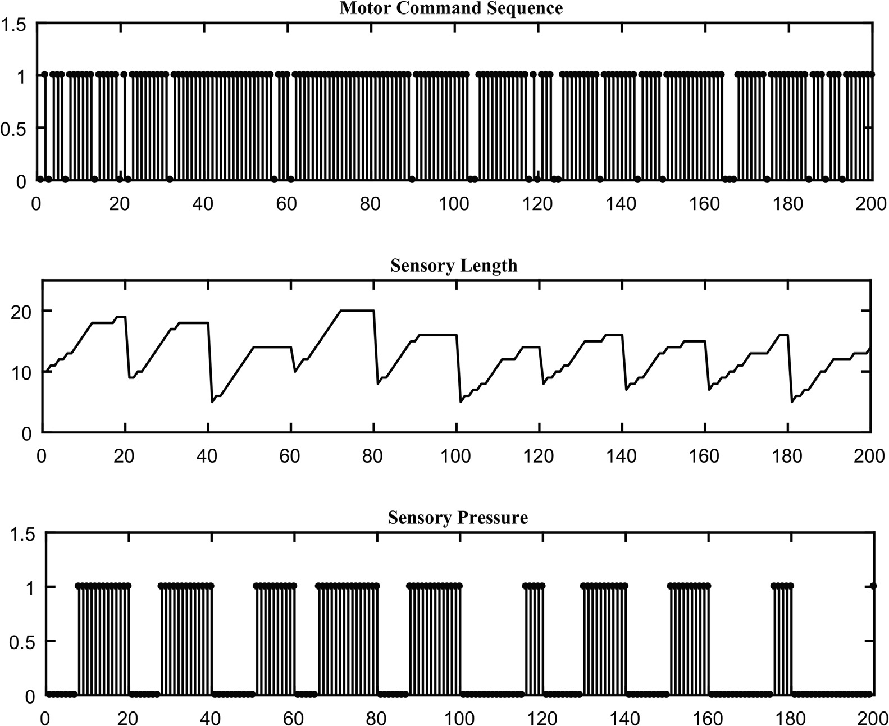

Fig. 4. An example of the generated data.

Algorithm 1: The relation between length perceptions and pressure perceptions

Variables:

*T*: The final time.

*L*: The set of length values.

*P*: The set of pressure values.

*Li* ∈ *L*: Length value.

*Pj* ∈ *P*: Pressure value.

*wLiPj*: The connection weight between length value *Li* and

pressure value *Pj*.

Begin

Foreach *Li* ∈ *L* Foreach *Pj* ∈ *P* Fort = 1: T

If(*Lt* == *Li*) Λ *Pt* == *Pj*

*wLi Pj* (*t*)=*wLi Pj* (*t* — 1) + 1

1. Experimental setup
   1. *Data generation*

To make a voluntary movement, command sequences are given to the motor neuron that controls the muscle and causes muscle contraction. There are involuntary movements that can also result in changing the muscle length. In the end, all muscle lengths will be covered, each with a certain frequency. We will explain in details the data generation for obtaining muscle lengths that corre- sponds to muscle movements, to be used in our experiment.

* 1. *The command sequence*

Motor neurons fire when they receive a command so that the corresponding muscle fibers contract. Hence, there will be a spike coming out from the firing neuron when there is a command.

Accordingly, the command sequence *Q* is a sequence of a command

*wLi Pk* (*t*)=*max* 0, *wLi Pk* (*t* — 1) — 1

such that *k* – *j*.

EndIf EndFor

EndFor EndFor

End

Hence, this architecture is dynamic as the number of perceptions changes with time until it reaches stability, when the change in weights is nearly constant and no new perceptions are created.

*qt* at time *t* represents whether there is a spike (1) or not (0). In other words, a command state sequence is represented by a binary

sequence such that 1 implies contraction and 0 implies no contrac- tion. The command state sequence *Q* is generated from a Bernoulli distribution given by:

*qt* = *pt*(1 — *p*)1—*t* (1)

such that *t* = 1 refers to issuing a command with probability *p* and *t* = 0 implies the absence of command with probability (1 — *p*). We have used *p* = 0.9 to model the spontaneous large number of input command sequence to be given to the muscle. The generated

sequence is of duration 20 for each movement. For 10 consecutive movements, the total duration of the generated sequences is 200.

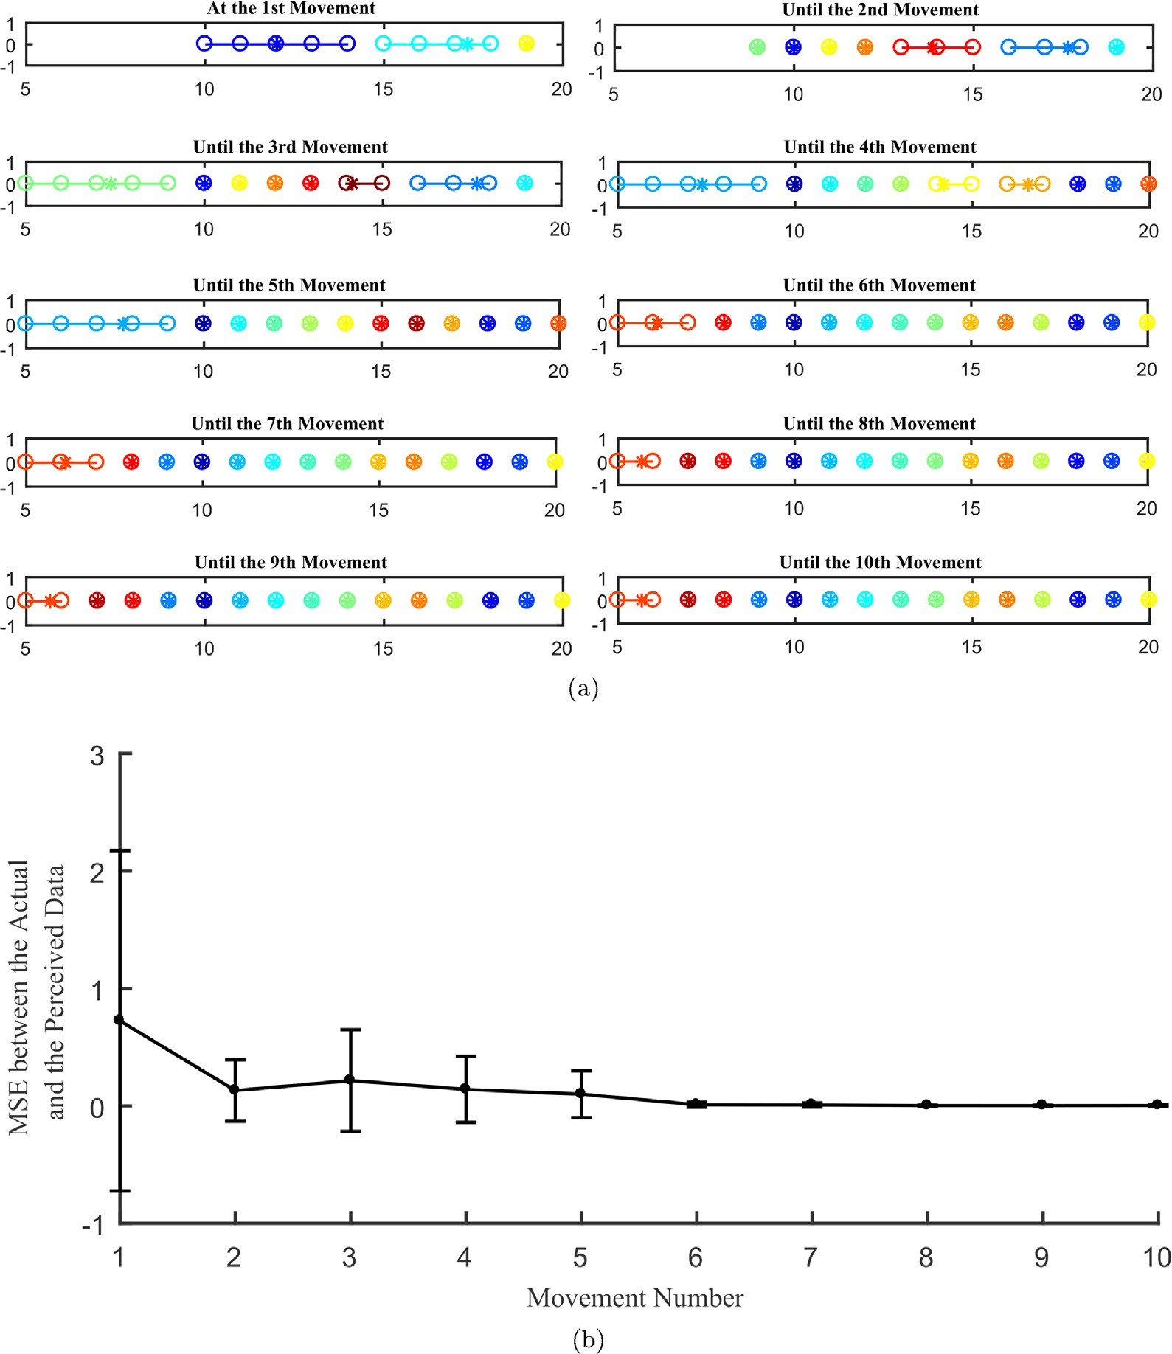

Fig. 5. An example of perceptions evolution across movements in one simulation. (a) The x-axis shows the sensory length values found per movement. Each color represents a cluster with cluster center marked by ‘‘x”. Initially, all the obtained length values are assigned to one cluster. With the repetition of length values, they will be recognized as perceptions, hence, the number of perceptions increases with time. Here, the presented maximum length is the assumed maximum muscle length. (b) depicts the mean squared error between the actual length values and the perceived length values as well as the standard deviation across all movements. From (a) and (b), It is noticed that some movements that have the same perceptions incorporate an increase in the error as seen in the 2nd and the 3rd movements. This is due to the inclusion of either new length values or old values that are larger than the recognized perceptions which increases the error as well as the variance, those will be discriminated with time.

* 1. *The sensory data*

It dictates the sensory length values are obtained after using a given command sequence. When a command is given to a muscle, a force is generated causing increase in its fibers tension. Muscles differ in terms of the number of fibers and size such that increasing them means the ability to get more force. Each muscle is repre- sented by a Gaussian function with large variance for large muscles and small variance for small muscles.

*contraction* = *Muscle*H*Q* (3)

where H denotes the convolution operator and *Q* is that state

sequence. The length sensory values are generated based on the fact it increases by increasing the contraction and it is constant when the contraction is either constant or decreasing. For an action with duration T, the length is given by:

8>< *lengthinit*(*t*) *t*mod*T* = 0

*Muscle* = *exp* —

(*x* — *mean*)2

r2

!

(2)

*length*(*t*) =

*length*(*t* — 1) + D*contraction* D*contraction* > 0

>: *length*(*t* — 1) D*contraction* ≤ 0

(4)

where *x* represents the fiber sizes. The contraction is given by a con- volution function between the muscle and the command sequence:

The pressure appears when the fetus senses an obstacle (ex: his face) that brings a different sensation. Initially, when the fetus has low energy, his muscle won’t be able to reach any obstacle and

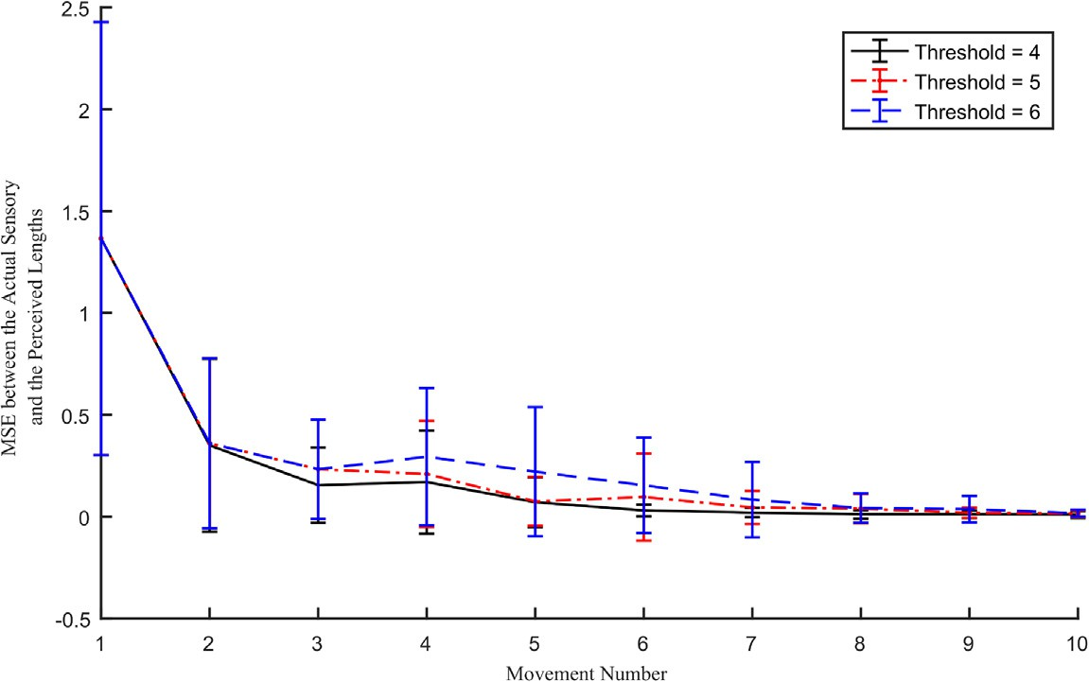

Fig. 6. Threshold effect in Frequency-based-means clustering algorithm. Mean Squared Error between the actual sensory length values and the perceived ones are shown when the input data are clustered using Frequency-based-means clustering using different threshold values. When the threshold decreases, more clusters are produced. Hence, the average approaches the cluster members resulting in smaller MSE.

hence, the pressure is zero. For simplicity, the pressure is modeled

as either there is an object or not. The pressure is modeled as a unit step function.

XX

Error (MSE) between every cluster member sample and the center of the cluster.

*N M*

*pressure*(*t*) = 1 *length*(*t*) P *Thresholdlength*

0 *length*(*t*) < *Thresholdlength*

(5)

‘*i* — *cj* 2

*MSE* = [*i*=1][*j*=1]

*MN*

(6)

object is assumed to be at *Thresholdlength* = 14. Fig. 4 shows an The generated sensory length have values from 5 to 20 and an example of the data generated for the motor command sequenc,

the sensory length and the sensory pressure.

* 1. *Performance measures*

For comparing the performance of *k*-means clustering and the Frequency-based-means clustering, we calculates the intra- cluster distance in which the distance between the every point to the center of the cluster is measured. We use the Mean Squared

where *N* is the number of samples in the cluster and *M* is the num- ber of clusters. We apply this equation to the length such that ‘ is the sensory length and *c* represents a proprioception for each movement.

* 1. *Simulation and results*

Using the above mentioned equation, we have generated ten different simulated data. Frequency-based-means clustering is applied to the sensory length data to get length perceptions and to the sensory pressure data to get pressure perceptions. Fig. 5 depicts the resulted perceptions of one simulation for 10 consecu-

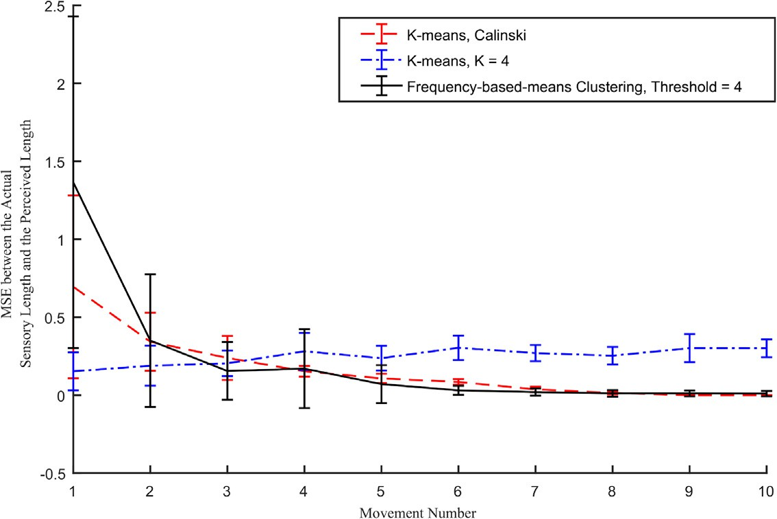

obtained from 10 simulations are depicted for the frequency-based-means with a threshold values equal to 4, *k*-means with *k* = 4, and *k*-means where *k* is chosen by Caliniski Fig. 7. Comparison between the performance of the Frequency-based-means clustering and *K* -means clustering. The results of generating perceptions for 10 movements Harabasz. Mean Squared Error is calculated between the actual sensory length values that are clustered and the perceived lengths in each case. The frequency-based-means

clustering gets nearly similar results to the *k*-means with the Caliniski Harabasz. The constant *k*-means has the worst performance because as the number of movements increase, more data are obtained and are distributed among the same number of clusters resulting in large clusters with increased intra-cluster distance. Accordingly, using a constant number of clusters is not suitable for data that increases with time and this demonstrates that perceptions must be increasing with time.

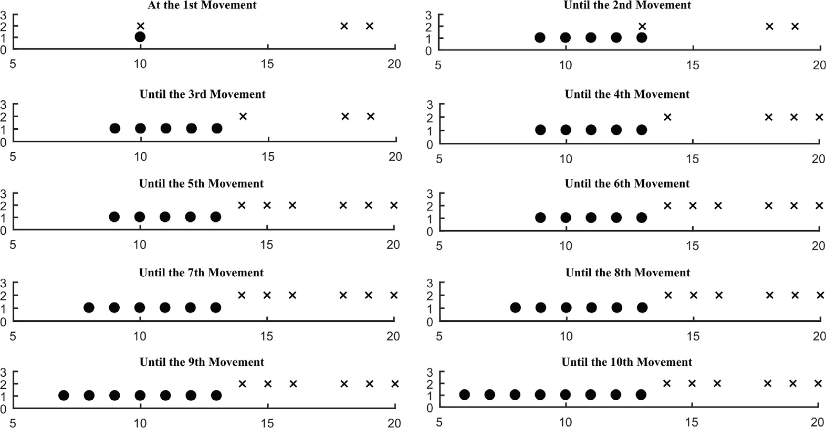

Fig. 8. An example of the mechanoreceptors-association-map. The x-asix represents the length perceptions and the y-axis represents the pressure perceptions.

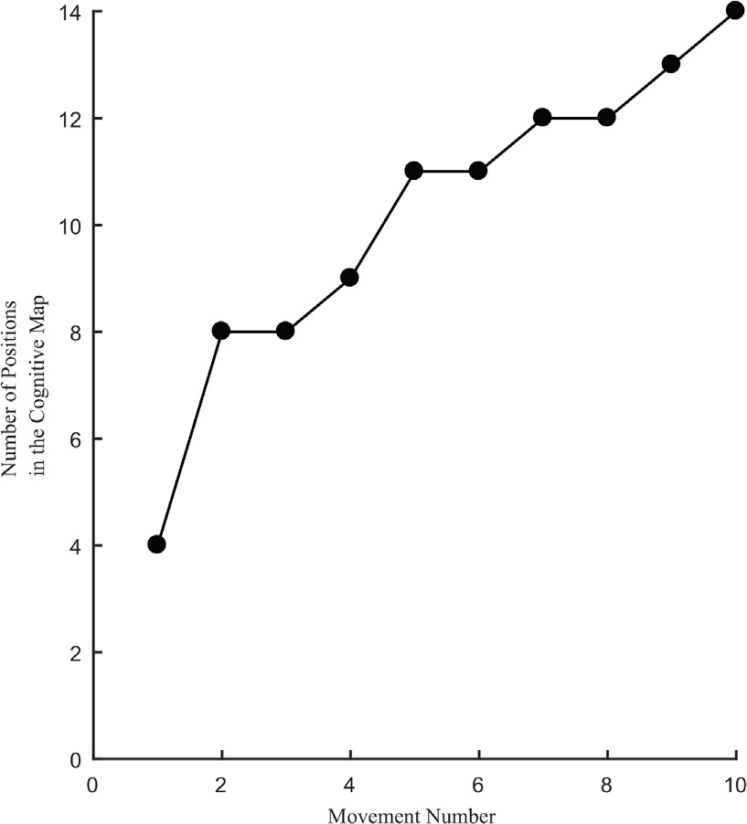

Fig. 9. An example of the resulting cognitive map.

tive movements upwards with repetition threshold equal to 4. It is shown how the perceptions approach the length values with time as more movements are produced. Fig. 6 demonstrates the effect of the threshold on the Frequency-based-means clustering. Using smaller thresholds results in faster clustering and lower mean squared error. We have repeated the experiments using *k*-means clustering where *k* is constant (chosen empirically as 4) or chang- ing in an increasing order with the movements. In the latter, we chose the Calinski Harabasz index [6] as a criteria for choosing the optimal number of clusters. The input range was increasing with the number of movements. Results are presented in Fig. 7 and shows that the Frequency-based-means clustering has a com- parable performance to *k*-means using the Calinski Harabasz index and is better than using a constant number of clusters. This result emphasizes that perceptions must be increasing with time. Other- wise, human cognition ability of his surrounding deteriorates. After getting the perceptions, the mechanoreceptors-association-map is created using algorithm 1 and is shown in Fig. 8. It can be seen that

there can be a length having two pressure perceptions in early movements. This is due to the immature differentiation between the different perceptions and mixing different sensory values that have different sensations in one group. This will be solved in the next movements as the sensory values with the same sensations are grouped together and the old association links fade. Fig. 9 demonstrates how the cognitive map is formed through consecutive movements. The number of positions of the cognitive map increases as more movements are done an as the mechanoreceptors-association-map is updated.

1. Conclusion and future work

We have investigated the problem of how the human mind builds cognitive perceptions from the sensory data provided by the body at the fetus stage. We have proposed a model that process the sensory data and built a mechanoreceptors-association-map which outputs positions in the cognitive map. The Frequency- based-means clustering algorithm is used to generate perceptions from the sensory data. A detailed study was presented for this clus- tering algorithm and comparison with *k*-means clustering is pro- vided. This algorithm can only work on data that is characterized by having repetitions. As a future work, it will be extended to elim- inate this limitation to be valid for use for a greater number of applications. In addition, we have proposed an algorithm to build the mechanoreceptors-association-map and dynamically update its association links to mimic storing new positions and forgetting old positions. This work can benefit in the Biology field to help in understanding how the human gain his navigational skills. In addi- tion, knowing which brain areas are responsible for each function can be useful in detecting the cause of any deterioration in move- ment or perceptions. This can help in the medical field to better understand the cause of many syndromes. On the other hand, the frequency-based clustering can be useful in numerous fields. It can be used in other biological applications such as modeling and tracking of gaining new skills or habits of a person or a group of people. It can also be used in a number of machine learning applications such as the recommendation systems by identifying new interests of any user and recommending goods that will inter- est him, in chaotic systems to identify an repeating patterns and in environmental applications that tracks natural phenomena in cer- tain areas and identify any new phenomena that starts to exist.

Declaration of Competing Interest

The authors declare that they have no known competing finan- cial interests or personal relationships that could have appeared to influence the work reported in this paper.

Acknowledgement

The authors would like to thank the NeuroMod Institute, the ComputaBrain Project [(http://univ-cotedazur.fr/en/idex/projet-](http://univ-cotedazur.fr/en/idex/projet-) structurant/neuromod/projects/computabrain/) for funding this research.

References

1. McLeod SA. Tolman – latent learning; 2018. Retrieved from[https://www.](https://www.simplypsychology.org/tolman.html) [simplypsychology.org/tolman.html](https://www.simplypsychology.org/tolman.html). Last access(21/10/2019). .
2. [Ahmed Eman, Wahab Reda Abdel, Muzy Alexandre, Bernot Gilles, Darwish](http://refhub.elsevier.com/S1110-8665(19)30370-6/h0010) [Gamal. Modeling of goal-oriented human motion evolution using hidden](http://refhub.elsevier.com/S1110-8665(19)30370-6/h0010) [markov models. In: Proceedings of International Conference of Pattern](http://refhub.elsevier.com/S1110-8665(19)30370-6/h0010) [Recognition Applications and Methods (ICPRAM 2019)](http://refhub.elsevier.com/S1110-8665(19)30370-6/h0010).
3. [Wolpert DM, Bays PM. Computational principles of sensorimotor control that](http://refhub.elsevier.com/S1110-8665(19)30370-6/h0015) [minimize uncertainty and variability. J Physiol 2007;578(Pt 2):387–96](http://refhub.elsevier.com/S1110-8665(19)30370-6/h0015).
4. [Dai Bi-Ru, Huang Jen-Wei, Yeh Mi-Yen, Chen Ming-Syan. Adaptive clustering](http://refhub.elsevier.com/S1110-8665(19)30370-6/h0020) [for multiple evolving streams. IEEE Trans Knowl Data Eng 2006;18](http://refhub.elsevier.com/S1110-8665(19)30370-6/h0020) [(9):1166–80](http://refhub.elsevier.com/S1110-8665(19)30370-6/h0020).
5. Byrne JH, Dafny N. (Eds.). Neuroscience online: an electronic textbook for the neurosciences. URL:<http://nba.uth.tmc.edu/neuroscience/>. Chapter 1: Motor Units and Muscle Receptors, page Section 3. Department of Neurobiology and Anatomy, The University of Texas Medical School at Houston (UTHealth); 1997. .
6. [Calinski T, Harabasz J. A dendrite method for cluster analysis. Commun Stat](http://refhub.elsevier.com/S1110-8665(19)30370-6/h0030) [1974;3(1):1–27](http://refhub.elsevier.com/S1110-8665(19)30370-6/h0030).
7. [Câmpan Alina,](http://refhub.elsevier.com/S1110-8665(19)30370-6/h0035) S [erban Gabriela. Adaptive clustering algorithms. In:](http://refhub.elsevier.com/S1110-8665(19)30370-6/h0035) [Lamontagne Luc, Marchand Mario, editors. Advances in Artificial](http://refhub.elsevier.com/S1110-8665(19)30370-6/h0035) [Intelligence. Berlin, Heidelberg: Springer, Berlin Heidelberg; 2006. p. 407–18](http://refhub.elsevier.com/S1110-8665(19)30370-6/h0035).
8. [Connolly Kevin. Perceptual learning. In: Zalta Edward N, editor. The stanford](http://refhub.elsevier.com/S1110-8665(19)30370-6/h0040) [encyclopedia of philosophy. Metaphysics Research Lab, Stanford University;](http://refhub.elsevier.com/S1110-8665(19)30370-6/h0040) [2017. summer 2017 edition](http://refhub.elsevier.com/S1110-8665(19)30370-6/h0040).
9. [Honzik Charles H, Tolman Edward Chace. Introduction and removal of reward](http://refhub.elsevier.com/S1110-8665(19)30370-6/h0045) [and maze performance in rats, vol. 4. Berkeley, Calif.: University of California](http://refhub.elsevier.com/S1110-8665(19)30370-6/h0045) [Press; 1930](http://refhub.elsevier.com/S1110-8665(19)30370-6/h0045).
10. [Golledge Reginald G, Klatzky Roberta L, Loomis Jack M. Cognitive mapping and](http://refhub.elsevier.com/S1110-8665(19)30370-6/h0050) [wayfinding by adults without vision. Netherlands, Dordrecht: Springer; 1996.](http://refhub.elsevier.com/S1110-8665(19)30370-6/h0050)

[p. 215–46](http://refhub.elsevier.com/S1110-8665(19)30370-6/h0050).

1. [Holst-Wolf Konczak J, Jessica M, I-Ling Yeh. Development of proprioceptive](http://refhub.elsevier.com/S1110-8665(19)30370-6/h0055) [acuity in typically developing children: normative data on forearm position](http://refhub.elsevier.com/S1110-8665(19)30370-6/h0055) [sense. Front Human Neurosci 2016;10](http://refhub.elsevier.com/S1110-8665(19)30370-6/h0055).
2. [Fagard J, Esseily R, Jacquey L, O’Regan K, Somogyi E. Fetal origin of](http://refhub.elsevier.com/S1110-8665(19)30370-6/h0060) [sensorimotor behavior. Front Neurorobot 2018;12(23)](http://refhub.elsevier.com/S1110-8665(19)30370-6/h0060).
3. [Kellman Philip J, Garrigan Patrick. Perceptual learning and human expertise.](http://refhub.elsevier.com/S1110-8665(19)30370-6/h0065) [Phys Life Rev 2009;6(20416846):53–84](http://refhub.elsevier.com/S1110-8665(19)30370-6/h0065).
4. [Koukourikos Panagiotis, Papadopoulos Konstantinos. Development of](http://refhub.elsevier.com/S1110-8665(19)30370-6/h0070) [cognitive maps by individuals with blindness using a multisensory](http://refhub.elsevier.com/S1110-8665(19)30370-6/h0070) [application. Proc Comput Sci 2015;67:213–22. Proceedings of the 6th](http://refhub.elsevier.com/S1110-8665(19)30370-6/h0070) [International Conference on Software Development and Technologies for](http://refhub.elsevier.com/S1110-8665(19)30370-6/h0070) [Enhancing Accessibility and Fighting Info-exclusion](http://refhub.elsevier.com/S1110-8665(19)30370-6/h0070).
5. [Montello Daniel R. Spatial cognition. In: Wright James D, editor. International](http://refhub.elsevier.com/S1110-8665(19)30370-6/h0075) [encyclopedia of the social &; behavioral sciences. p. 111–5](http://refhub.elsevier.com/S1110-8665(19)30370-6/h0075).
6. [Montemayor Carlos, Haladjian Harry H. Perception and cognition are largely](http://refhub.elsevier.com/S1110-8665(19)30370-6/h0080) [independent, but still affect each other in systematic ways: arguments from](http://refhub.elsevier.com/S1110-8665(19)30370-6/h0080) [evolution and the consciousness-attention dissociation. Front Psychol](http://refhub.elsevier.com/S1110-8665(19)30370-6/h0080) [2017;8:40](http://refhub.elsevier.com/S1110-8665(19)30370-6/h0080).
7. [Prinz Wolfgang, Bridgeman Bruce. Handbook of perception and action volume](http://refhub.elsevier.com/S1110-8665(19)30370-6/h0085) [1: perception, vol. 1. Academic Press; 1995](http://refhub.elsevier.com/S1110-8665(19)30370-6/h0085).
8. [Kitchin Robert, Golledge Reginald G, Daniel Jacobson R, Blades Mark. Cognitive](http://refhub.elsevier.com/S1110-8665(19)30370-6/h0090) [maps, spatial abilities, and human wayfinding. Geogr Rev Jpn 2000;73](http://refhub.elsevier.com/S1110-8665(19)30370-6/h0090) [(2):93–104](http://refhub.elsevier.com/S1110-8665(19)30370-6/h0090).
9. [Renault AG, Auvray M, Parseihian G, Miall RC, Cole J, Sarlegna FR. Does](http://refhub.elsevier.com/S1110-8665(19)30370-6/h0095) [proprioception influence human spatial cognition? A study on individuals](http://refhub.elsevier.com/S1110-8665(19)30370-6/h0095) [with massive deafferentation. Front Psychol 2018;9(1322)](http://refhub.elsevier.com/S1110-8665(19)30370-6/h0095).
10. [Schinazi VR, Thrash T, Chebat DR. Spatial navigation by congenitally blind](http://refhub.elsevier.com/S1110-8665(19)30370-6/h0100) [individuals. Wiley interdisciplinary reviews. Cogn Sci 2016;7(1):37–58](http://refhub.elsevier.com/S1110-8665(19)30370-6/h0100).
11. [Shi Bing, Han Lixin, Yan Hong. Adaptive clustering algorithm based on knn and](http://refhub.elsevier.com/S1110-8665(19)30370-6/h0105) [density. Pattern Recogn Lett 2018;104:37–44](http://refhub.elsevier.com/S1110-8665(19)30370-6/h0105).