HOSTE D BY

Available online at [www.sciencedirect.com](http://www.sciencedirect.com/science/journal/2314808X)

ScienceDirect

journal homepage: <http://ees.elsevier.com/ejbas/default.asp>

[e gypti an j o ur nal o f b a sic and a pp l i ed sci e n c e s 2 ( 201 5 ) 5 0](http://dx.doi.org/10.1016/j.ejbas.2014.10.004) e[5](http://dx.doi.org/10.1016/j.ejbas.2014.10.004) 4



Modified Laguerre Wavelets Method for delay differential equations of fractional-order

*Muhammad Asad Iqbal* *a**, Umer Saeed* *b**, Syed Tauseef Mohyud-Din* *a**,*\*



a *Department of Mathematics, Faculty of Sciences, HITEC University Taxila, Pakistan*

b *School of Natural Sciences, National University of Sciences and Technology, Islamabad, Pakistan*

## a r t i c l e i n f o

*Article history:*

Received 26 February 2014 Received in revised form 10 October 2014

Accepted 20 October 2014

Available online 4 December 2014

*Keywords:*

Method of steps

Laguerre Wavelets Method Fractional delay differential equations

*Mathematics subject classification:*

35Q79

42C15

39B9

## a b s t r a c t

In this article, Laguerre Wavelets Method (LWM) is proposed and combined with steps Method to solve linear and nonlinear delay differential equations of fractional-order. Computational work is fully supportive of compatibility of proposed algorithm and hence the same may be extended to other physical problems also. A very high level of accuracy explicitly reflects the reliability of this scheme for such problems.

Copyright 2015, Mansoura University. Production and hosting by Elsevier B.V. This is an open access article under the CC BY-NC-ND license ([http://creativecommons.org/licenses/](http://creativecommons.org/licenses/by-nc-nd/3.„0/)

[by-nc-nd/3.0/](http://creativecommons.org/licenses/by-nc-nd/3.„0/)).

# Introduction

Fractional differential equations are applied to model wide range of physical problems including nonlinear oscillation of earth quakes [1], fluid-dynamic traffic [2], frequency depen- dent damping behavior of many viscoelastic materials, signal processing [5] and control theory [6]. Moreover, in several areas of applied mathematics [1,7](#_bookmark13)e[11] fractional differential equations are often used. These are also used in the study of

epidemics, age-structured population growth [12], automa- tion, traffic flow and in many engineering problems. The basic motivation of this paper is to develop a Laguerre Wavelets Method (LWM) and combine it with the steps Method [13] to solve linear and nonlinear delay differential equations [4] of fractional-order. It is observed that proposed method is fully compatible with the complexity of such problems and is very user-friendly. The error estimates explicitly reveal the very high accuracy level of the suggested technique.

* *Corresponding author*.

E-mail address: [syedtauseefs@hotmail.com](mailto:syedtauseefs@hotmail.com) (S.T. Mohyud-Din).

Peer review under responsibility of Mansoura University. <http://dx.doi.org/10.1016/j.ejbas.2014.10.004>

2314-808X/Copyright 2015, Mansoura University. Production and hosting by Elsevier B.V. This is an open access article under the CC BY- NC-ND license ([http://creativecommons.org/licenses/by-nc-nd/3.0/](http://creativecommons.org/licenses/by-nc-nd/3.„0/)).

[e g ypti an j o ur nal o f b a sic and a pp l i e d sci en c e s 2 ( 201 5 ) 5 0](http://dx.doi.org/10.1016/j.ejbas.2014.10.004) e[5](http://dx.doi.org/10.1016/j.ejbas.2014.10.004) 4 51

# Laguerre Wavelets

from dilation and translation of a single function j(*x*) called Wavelets [2,3,5] constitute a family of functions constructed the mother wavelet. When the dilation parameter *a* and the

translation parameter *b* vary continuously we have the following family of continuous wavelets as [10]

j (*x*)= |*a* —1 *x* — *b* ; *a*; *b*2*R*; *a*s0.

*a*;*b*

| 2 j

*a*

*y*a(*x*)= *f* (*y*)+ *g*(*x*)*y* *x* — *c* ; 0 < *x* < *b*; 1 < a ≤ 2; (3)

*y*(*x*)= *p*(*x*); —*b* ≤ *x* ≤ 0.

*a*

where *g*(*x*) is a source term function, *f* (*y*) is a given continuous linear or nonlinear function.

According to the proposed method, first use the method of step to convert the delay differential equation (3) to inhomo- geneous ordinary differential equation by using initial func-

tion, *p*(*x*), Equation (3) implies

If we restrict the parameters *a* and *b* to discrete values as

*a* = *a*—*k*; *b* = *nb*0*a*—*k*; *a*0 > 1; *b*0 > 0; we have the following family

*a*

*y*a(*x*)= *f* (*y*)+ *g*(*x*) *p* *x* — *c* ; 0 < *x* < *b*; 1 < a ≤ 2; (4)

0 0

of discrete wavelets

which is a fractional differential equation and

The solution of the Equation (4) can be expanded as a

j*n*;*m*(*x*);

*n*=1

*m*=0 *n*;*m*

*k*

j (*x*)= |*a akx* — *nb* ; *k*; *n*2Z;

*k*;*n*

|2 j

0

0

Laguerre wavelets series as follows:*y*(*x*)= P∞ P∞ *c*

where j*k*;*n* form a wavelet basis for *L*2(*R*). In particular, when

*a*0 = 2 and *b*0 = 1, then j*k*;*n*(*x*) form an orthonormal basis.

The Laguerre wavelets j*n*;*m*(*x*)= j(*k*; *n*; *m*; *x*) involve four

where j*n*;*m*(*x*) is given by the Equation (1). We approximate

*y*(*x*) by the truncated series

2*k*—1 *M*—1

X X

arguments *n* = 1; 2; /; 2*k*—1; *k* is assumed any positive integer,

*m* is the degree of the Laguerre polynomials and it is the

*yk*;*M*

(*x*) = *cnm*

*n*=1 *m*=0

j*n*;*m*

(*x*). (4a)

normalized time. They are defined on the interval [0; 1) as

Then a total number of 2*k*—1*M* conditions should exist for

8>>< 2*k L*~ 2*kx* — 2*n* + 1 ; *n* — 1 ≤ *x* < *n* ;

j*n*;*m*(*x*)=

2 *m*

2*k*—1

2*k*—1

(1)

determination of 2*k*—1*M* coefficients *c*10;

*c*20; *c*21; …; *c*2*M*—1; …; *c*2*k*—10; *c*2*k*—11; /; *c*2*k*—1 *M*—1.

Since two conditions are furnished by the initial condi-

*c*11

; ….; *c*1*M*—1;

> 0; otherwise

:

where

*L*~ (*x*  1 *L* (*x*); (2)

)=

tions, namely

2*k*—1 *M*—1

X X

*yk*;*M*(0)= *cnm*j*n*;*m*(0)= *p*(0);

*n*=1 *m*=0

*k*—1

X

(5)

*m m*! *m*

d d 2

*yk*;*M*(0)=

*M*X—1

*cnm*j*n*;*m*(0)= *p*'(0).

*m* = 0; 1; 2; /; *M* — 1. In eq. (2) the coefficients are used for orthonormality. Here *Lm*(*x*) are the Laguerre polynomials of degree *m* with respect to the weight function *w*(*x*)= 1 on the interval[0; ∞], and satisfy the following recursive formula

d*x* d*x n*=1 *m*=0

We see that there should be 2*k*—1*M* — 2 extra conditions to recover the unknown coefficients *cnm*. These conditions can be

obtained by substituting Equation (4) in Equation (3);

*L*0(*x*)= 1; *L*1(*x*)= 1 — *x*;

*Lm*+2(*x*)=

((2*m* + 3 — *x*)*Lm*+1(*x*)— (*m* + 1)*Lm*(*x*))

*m* + 2 ; *m* = 0; 1; 2; 3; /.

da 2*k*—1 *M*—3

*n*=1 *m*=0

X X

d*x*a

2*k*—1 *M*—3

*n*=1 *m*=0

*cnm*j*n*;*m* (*x*)= *f*

*cnm*j*n*;*m*(*x*)

X X

! *x*

(6)

+ *g*(*x*) *p a* — *c* .

Modified Laguerre Wavelet Method (MLWM): In the present paper, we consider the Delay Differential Equation of the form

We, now assume Equation (6) is exact at 2*k*—1*M* — 3 points *xi*

as follows:

|  |  |  |  |  |  |  |
| --- | --- | --- | --- | --- | --- | --- |
| Table 1 e Numerical results of Example 1. | | | | | | |
| *t* | Exact solution | Solution by proposed method | Error in | proposed method  *M* = 5 | Error in proposed method  *M* = 10 | Error in proposed method  *M* = 20 |
| 0.0 | 1.00000000000 | 1.00000000200 |  | 2.00000E-09 | 2.70000E-08 | 1.00000E-09 |
| 0.1 | 0.90031699980 | 0.90033016590 |  | 1.31661E-05 | 2.04000E-08 | 9.00000E-10 |
| 0.2 | 0.80241064730 | 0.80244245410 |  | 3.18068E-05 | 1.75000E-08 | 1.10000E-09 |
| 0.3 | 0.70773067800 | 0.70774110310 |  | 1.04251E-05 | 1.78000E-08 | 9.00000E-10 |
| 0.4 | 0.61740564790 | 0.61737305130 |  | 3.25966E-05 | 2.83000E-08 | 1.00000E-09 |
| 0.5 | 0.53228073020 | 0.53222793850 |  | 5.27917E-05 | 4.12000E-08 | 8.00000E-10 |
| 0.6 | 0.45295378910 | 0.45293810650 |  | 1.56826E-05 | 4.87000E-08 | 5.00000E-10 |
| 0.7 | 0.37980938990 | 0.37987859860 |  | 6.92087E-05 | 5.91000E-08 | 5.00000E-10 |
| 0.8 | 0.31305050400 | 0.31316715980 |  | 1.16656E-04 | 7.68000E-08 | 3.00000E-10 |
| 0.9 | 0.25272775330 | 0.25266423690 |  | 6.35164E-05 | 9.57000E-08 | 1.00000E-10 |
| 1.0 | 0.19876611040 | 0.19797297850 |  | 7.93132E-04 | 1.30400E-07 | 7.00000E-10 |

52 [e gypti an j o ur nal o f b a sic and a pp l i ed sci e n c e s 2 ( 201 5 ) 5 0](http://dx.doi.org/10.1016/j.ejbas.2014.10.004) e[5](http://dx.doi.org/10.1016/j.ejbas.2014.10.004) 4

# Solution procedure

Example 1. Consider the Fractional Delay Differential Equa- tion of the form

|  |  |  |  |
| --- | --- | --- | --- |
| Table 2 e Numerical results of Example 2. | | | |
| *t* | Exact solution | Solution by proposed method | Error in proposed method  *M* = 5 |
| 0.0 | 0.00000000000 | —0.00000000141 | 1.41421E-09 |
| 0.1 | 0.01000000000 | 0.01000004758 | 4.75800E-08 |
| 0.2 | 0.04000000000 | 0.04000009693 | 9.69300E-08 |
| 0.3 | 0.09000000000 | 0.09000014701 | 1.47010E-07 |
| 0.4 | 0.16000000000 | 0.16000019820 | 1.98200E-07 |
| 0.5 | 0.25000000000 | 0.25000025090 | 2.50900E-07 |
| 0.6 | 0.36000000000 | 0.36000030550 | 3.05500E-07 |
| 0.7 | 0.49000000000 | 0.49000036240 | 3.62400E-07 |
| 0.8 | 0.64000000000 | 0.64000042200 | 4.22000E-07 |
| 0.9 | 0.81000000000 | 0.81000048480 | 4.84800E-07 |
| 1.0 | 1.000000000000 | 1.00000055100 | 5.51000E-07 |

a —*t*

*t* *t*

—3*t*

*t*

*t* *t*

*u* (*t*)= — *u*(*t*)— *e* 2 sin 2 *u* 2

— 2*e* 4 cos

4 sin 4 *u* 4 ,

0 ≤ *t* ≤ 1, 0 < a ≤ 1,

da 2*k*—1 *M*—3

X X

X2*k*—1 *M*X—3

! *x*

subject to the initial condition *u*(0)= 1.

The exact solution of the above system is *u*(*t*)= *e*—*t*cos(*t*).

Table 1 shows the comparison of the absolute error be-

*M* = 5, 10, 20 and *K* = 1 by Modified Laguerre Wavelet Method tween exact solution and approximate solution for (MLWM).

d*x*a

*n*=1 *m*=0

*cnm*j

*n*,*m*

(*xi*) = *f*

*n*=1 *m*=0

*cnm*j

*n*,*m*

(*xi*)

+ *g*(*xi*) *p*

*i* — *c* .

*a*

(7)

Example 2. Consider the Fractional Delay Differential Equa- tion of the form

The best choice of the *x* points are the zeros of the shifted *u*a(*t*)= 3 *u*(*t*)+ *u* *t* — *t*2 + 2, 0 ≤ *t* ≤ 1, 1 < a ≤ 2,

*i* 4 2

Laguerre polynomials of degree 2*k*—1*M* — 2 in the interval [0, 1]

that is *xi* = *si* +1 , where *si* = cos (2*i*—1)p , *i* = 1, …, 2*k*—1*M* — 2.

2

2*k*—1 *M*—1

Combine Equations (5) and (7) to obtain 2*k*—1*M* linear equations from which we can compute values for the un-

known coefficients, *cnm*. Same procedure is repeated for delay differential equations of first and second order also.

subject to the initial conditions *u*(0)= 0, *u*'(0)= 0.

The exact solution of the above system is *u*(*t*)= *t*2.

tween exact solution and approximate solution for *M* = 5, Table 2 shows the comparison of the absolute error be- and *k* = 1 by Modified Laguerre Wavelet Method (MLWM).

|  |  |  |  |  |  |
| --- | --- | --- | --- | --- | --- |
| Table 3 e Numerical results of Example 3. | | | | | |
| *t* | Exact solution | Solution by proposed method | Error in proposed method  *M* = 5 | Error in proposed method  *M* = 10 | Error in proposed method  *M* = 20 |
| 0.0 | 1.00000000000 | 0.99999999950 | 5.00000E-10 | 6.30000E-09 | 0.00000E+00 |
| 0.1 | 0.90483741800 | 0.90483743970 | 2.17000E-08 | 1.49000E-08 | 1.00000E-10 |
| 0.2 | 0.81873075310 | 0.81872927080 | 1.48230E-06 | 2.35000E-08 | 1.00000E-10 |
| 0.3 | 0.74081822070 | 0.74081168180 | 6.53890E-06 | 3.17000E-08 | 1.00000E-10 |
| 0.4 | 0.67032004600 | 0.67031009600 | 9.95000E-06 | 4.00000E-08 | 0.00000E+00 |
| 0.5 | 0.60653065970 | 0.60653917080 | 8.51110E-06 | 4.82000E-08 | 1.00000E-10 |
| 0.6 | 0.54881163610 | 0.54890279800 | 9.11619E-05 | 4.82000E-08 | 1.00000E-10 |
| 0.7 | 0.49658530380 | 0.49689410400 | 3.08800E-04 | 6.50000E-08 | 0.00000E+00 |
| 0.8 | 0.44932896410 | 0.45009544900 | 7.66485E-04 | 7.39000E-08 | 1.00000E-10 |
| 0.9 | 0.40656965970 | 0.40817842780 | 1.60877E-03 | 8.27000E-08 | 3.00000E-10 |
| 1.0 | 0.36787944120 | 0.37090386940 | 3.02443E-03 | 8.62000E-08 | 2.00000E-10 |

|  |  |  |  |  |  |  |
| --- | --- | --- | --- | --- | --- | --- |
| Table 4 e Numerical results of Example 4. | | | | | | |
| *t* | Exact solution | Solution by proposed method | Error in proposed method  *M* = 5 | Error in proposed method  *M* = 10 | Error in | proposed method  *M* = 20 |
| 0.0 | 1.00000000000 | 0.99999999950 | 5.00000E-10 | 5.20000E-08 |  | 2.10000E-08 |
| 0.1 | 0.99500416530 | 0.99500423090 | 6.56000E-08 | 6.33000E-08 |  | 2.11000E-08 |
| 0.2 | 0.98006657780 | 0.98006756710 | 9.89300E-07 | 7.78000E-08 |  | 2.09000E-08 |
| 0.3 | 0.95533648910 | 0.95533840950 | 1.92040E-06 | 9.32000E-08 |  | 2.09000E-08 |
| 0.4 | 0.92106099400 | 0.92106174490 | 7.50900E-07 | 1.10700E-07 |  | 2.08000E-08 |
| 0.5 | 0.87758256190 | 0.87757914590 | 3.41600E-06 | 1.27600E-07 |  | 2.06000E-08 |
| 0.6 | 0.82533561490 | 0.82532877020 | 6.84470E-06 | 1.44500E-07 |  | 2.04000E-08 |
| 0.7 | 0.76484218730 | 0.76484536080 | 3.17350E-06 | 1.62800E-07 |  | 2.03000E-08 |
| 0.8 | 0.69670670930 | 0.69676024620 | 5.35369E-05 | 1.79200E-07 |  | 2.00000E-08 |
| 0.9 | 0.62160996830 | 0.62180134050 | 1.91372E-04 | 1.95600E-07 |  | 1.99000E-08 |
| 1.0 | 0.54030230590 | 0.54079314330 | 4.90837E-04 | 2.21800E-07 |  | 1.97000E-08 |

[e g ypti an j o ur nal o f b a sic and a pp l i e d sci en c e s 2 ( 201 5 ) 5 0](http://dx.doi.org/10.1016/j.ejbas.2014.10.004) e[5](http://dx.doi.org/10.1016/j.ejbas.2014.10.004) 4 53

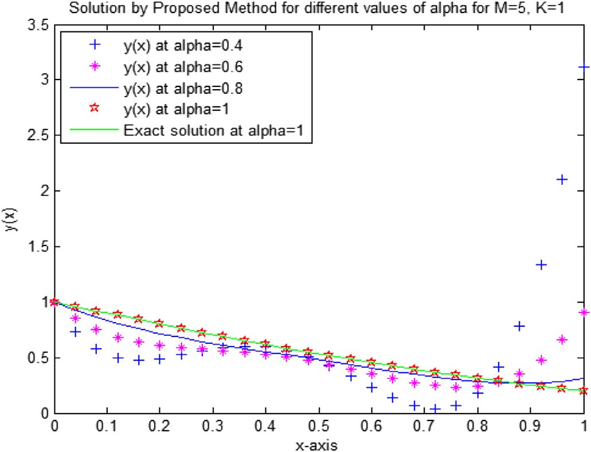

Fig. 1 e Modified Laguerre Wavelets Method solution for fractional DDE given in Example 1 and its comparison with exact solution.

Example 3. Consider the Fractional Delay Differential Equa- tion of the form

*u*a(*t*)= —*u*(*t*)— *u*(*t* — 0.3)+ *e*—*t*+0.3, 0 < *t* ≤ 1, 2 < a ≤ 3,

subject to the initial condition *u*(0)= 1,

*u*'(0)= —1, *u*'' (0)= 1.

The exact solution of the above system is *y*(*x*)= *e*—*t*.

Table 3 shows the comparison of the absolute error be-

*M* = 5, 10, 20 and *k* = 1 by Modified Laguerre Wavelet Method tween exact solution and approximate solution for (MLWM).

Example 4. Consider the Nonlinear Fractional Delay Differ- ential Equation of the form

*u*a(*t*)= 1 — 2*u*2 *t* , 0 ≤ *x* ≤ 1, 1 < a ≤ 2,

2

subject to the initial condition *u*(0)= 1, *u*'(0)= 0.

The exact solution of the above system is *u*(*t*)= cos(*t*). exact solution and approximate solution for *M* = 5, 10, 20 and Table 4 shows the comparison of the absolute error between

*k* = 1 by Modified Laguerre Wavelet Method (MLWM).

# Conclusion

Linear and Nonlinear Delay Differential Equations of fractional-order are successfully tackled by Modified Laguerre Wavelets Method (MLWM). The solutions of the fractional delay differential equation converge to the solution of integer delay differential equation, as shown in Figs. 1e4. According to the Tables, we get more accurate results while increasing

M. Computational work and numerical results explicitly reflect that the proposed method (MLWM) is very user-friendly but extremely accurate.

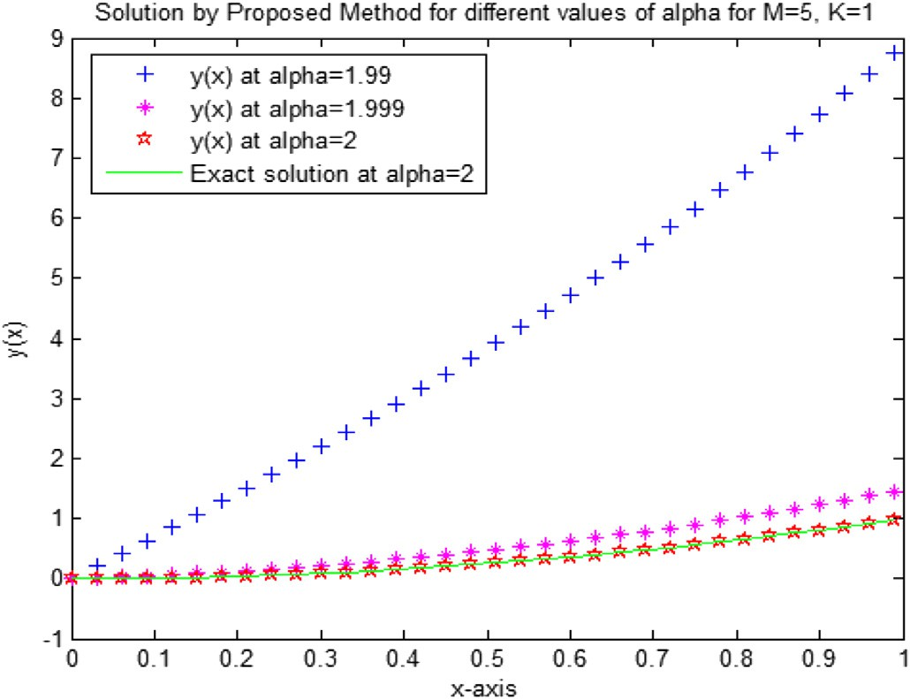Fig. 2 e Modified Laguerre Wavelets Method solution for fractional DDE given in Example 2 and its comparison with exact solution.

54 [e gypti an j o ur nal o f b a sic and a pp l i ed sci e n c e s 2 ( 201 5 ) 5 0](http://dx.doi.org/10.1016/j.ejbas.2014.10.004) e[5](http://dx.doi.org/10.1016/j.ejbas.2014.10.004) 4

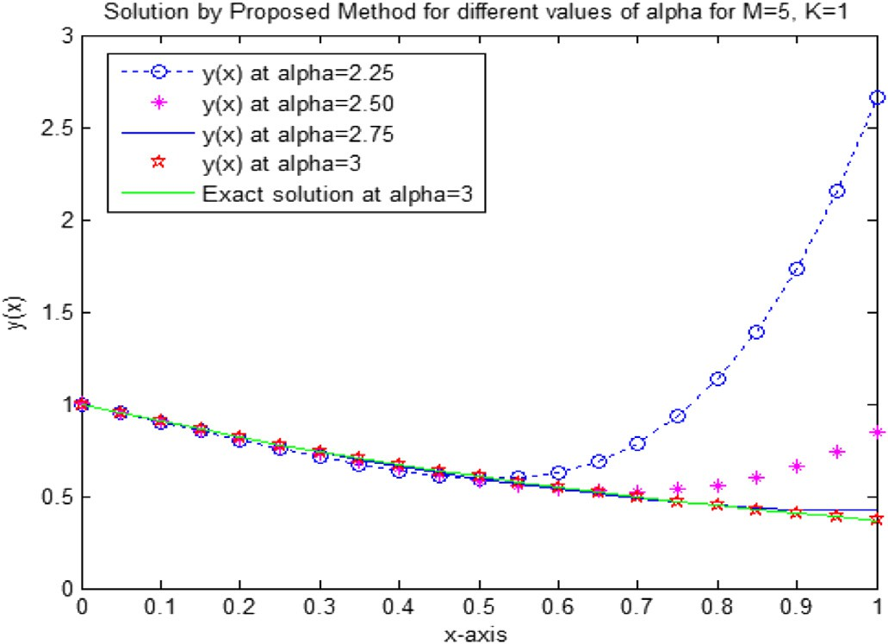

Fig. 3 e Modified Laguerre Wavelets Method solution for fractional DDE given in Example 3 and its comparison with exact solution.

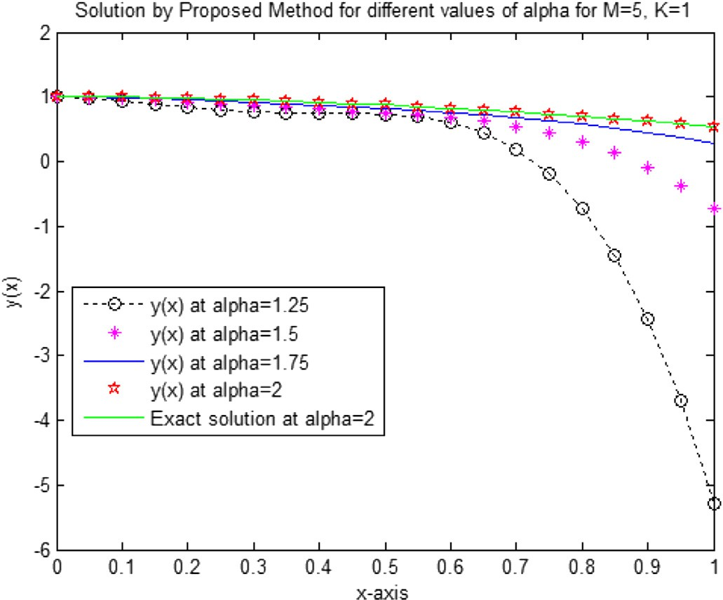

Fig. 4 e Modified Laguerre Wavelets Method solution for fractional DDE given in Example 4 and its comparison with exact solution.

## references

1. [He JH. Nonlinear oscillation with fractional derivative and its](http://refhub.elsevier.com/S2314-808X(14)00044-X/sref1) [applications. Int Conf Vibr Eng 1998:288](http://refhub.elsevier.com/S2314-808X(14)00044-X/sref1)e[91](http://refhub.elsevier.com/S2314-808X(14)00044-X/sref1).
2. [He JH. Some applications of nonlinear fractional differential](http://refhub.elsevier.com/S2314-808X(14)00044-X/sref2) [equations and their approximations. Bull Sci Tech](http://refhub.elsevier.com/S2314-808X(14)00044-X/sref2) [1999;15(2):86](http://refhub.elsevier.com/S2314-808X(14)00044-X/sref2)e[90](http://refhub.elsevier.com/S2314-808X(14)00044-X/sref2).
3. [Bagley RL, Torvik PJ. A theoretical basis for the application of](http://refhub.elsevier.com/S2314-808X(14)00044-X/sref3) [fractional calculus to viscoelasticity. J Rheol 1983;27(3):201](http://refhub.elsevier.com/S2314-808X(14)00044-X/sref3)e[10](http://refhub.elsevier.com/S2314-808X(14)00044-X/sref3).
4. [Davis AR, Karageorghis A, Phillips TN. Spectral Galerkin](http://refhub.elsevier.com/S2314-808X(14)00044-X/sref4) [methods for the primary two- point bour problem in](http://refhub.elsevier.com/S2314-808X(14)00044-X/sref4) [modeling viscoelastic flows. Int J Numer Meth Eng](http://refhub.elsevier.com/S2314-808X(14)00044-X/sref4) [1988;26:647](http://refhub.elsevier.com/S2314-808X(14)00044-X/sref4)e[62](http://refhub.elsevier.com/S2314-808X(14)00044-X/sref4).
5. [Panda R, Dash M. Fractional generalized splines and signal](http://refhub.elsevier.com/S2314-808X(14)00044-X/sref5) [processing. Signal Process 2006;86:2340](http://refhub.elsevier.com/S2314-808X(14)00044-X/sref5)e[50](http://refhub.elsevier.com/S2314-808X(14)00044-X/sref5).
6. [Bohannan GW. Analog fractional order controller in](http://refhub.elsevier.com/S2314-808X(14)00044-X/sref6) [temperature and motor control applications. J Vib Control](http://refhub.elsevier.com/S2314-808X(14)00044-X/sref6) [2008;14:1487](http://refhub.elsevier.com/S2314-808X(14)00044-X/sref6)e[98](http://refhub.elsevier.com/S2314-808X(14)00044-X/sref6).
7. [Asl FM, Ulsoy AG. Analysis of a system of linear delay](http://refhub.elsevier.com/S2314-808X(14)00044-X/sref7) [differential equations. J Dyn Sys Meas Cont 2003;125:215](http://refhub.elsevier.com/S2314-808X(14)00044-X/sref7)e[23](http://refhub.elsevier.com/S2314-808X(14)00044-X/sref7).
8. [Aiello WG, Freedman HI. A time-delay model of single-](http://refhub.elsevier.com/S2314-808X(14)00044-X/sref8) [species growth with stage structure. Math Biosci](http://refhub.elsevier.com/S2314-808X(14)00044-X/sref8) [1990;101:139](http://refhub.elsevier.com/S2314-808X(14)00044-X/sref8)e[53](http://refhub.elsevier.com/S2314-808X(14)00044-X/sref8).
9. [Gourley SA, Kuang Y. A stage structured predator](http://refhub.elsevier.com/S2314-808X(14)00044-X/sref9)e[prey](http://refhub.elsevier.com/S2314-808X(14)00044-X/sref9) [model and its dependence on maturation delay and death](http://refhub.elsevier.com/S2314-808X(14)00044-X/sref9) [rate. J Math Biol 2004;49:188](http://refhub.elsevier.com/S2314-808X(14)00044-X/sref9)e[200](http://refhub.elsevier.com/S2314-808X(14)00044-X/sref9).
10. [Insperger T, Stepan G. Remote control of periodic robotic](http://refhub.elsevier.com/S2314-808X(14)00044-X/sref10) [motion. In: Proceed Thirt Symp Theo Pract Robot Manipul.](http://refhub.elsevier.com/S2314-808X(14)00044-X/sref10) [Zakopane 2000:197](http://refhub.elsevier.com/S2314-808X(14)00044-X/sref10)e[203](http://refhub.elsevier.com/S2314-808X(14)00044-X/sref10).
11. [Nesbit R. Delay differential equations for structured](http://refhub.elsevier.com/S2314-808X(14)00044-X/sref11) [populations. Structured population models in marine,](http://refhub.elsevier.com/S2314-808X(14)00044-X/sref11) [terrestrial and freshwater systems 1997](http://refhub.elsevier.com/S2314-808X(14)00044-X/sref11).
12. [Kuang Y. Delay differential equations with applications in](http://refhub.elsevier.com/S2314-808X(14)00044-X/sref12) [population dynamics. Boston: Academic Press; 1993](http://refhub.elsevier.com/S2314-808X(14)00044-X/sref12).
13. [Myshkis AD. Differential equations, ordinary with](http://refhub.elsevier.com/S2314-808X(14)00044-X/sref13) [distributed arguments 3. Boston: Encycl Math Kluwer](http://refhub.elsevier.com/S2314-808X(14)00044-X/sref13) [Academic Publishers; 1989. p. 144](http://refhub.elsevier.com/S2314-808X(14)00044-X/sref13)e[7](http://refhub.elsevier.com/S2314-808X(14)00044-X/sref13).